Students:

Cristian Guba

Christian Schou Sørensen

Flemming Vindelev

Ionel-Cristinel Putinica

Mihail Rumenov Kanchev

Supervisors:

Erland Ketil Larsen

Jakob Knop Rasmussen

Jan Munch Pedersen

Line Lindhardt Egsgaard

Project Description

SEP3

# Background Description

The concept of transportation by roads exists since ancient times, where it is mainly seen in the Greek empire with the rising of Greek roads[1]. Nowadays roads are common, but some people are burdened to spend a lot of money to get around. The modern society has entered a mobile age where transport becomes a necessity. The process of urbanization[2] is at a level where the majority of a country’s population is packed in certain regions where the economy is blooming and the private sector is continuously growing. As the size of the populated areas expands, people are forced to live in the nearby villages and cities.

Countless problems arise if the previously said is taken in consideration and applied to big cities such as Aarhus for instance, where the population is more than 300 000[3]. Alternative ways of transport have risen as a result for the demand. Bike lanes provide the necessary encouragement for people to ride bikes. Public transport has advanced and improved over the years, following strict schedules and stops. Cars have been made more efficient and eventually electric. But the sheer number of human beings using these services makes everything costly and air-polluting.

Cars for insistence are an expensive comfort and not a lot of people can afford one. Vehicles can provide space for more people than the person driving them, a feature not utilized completely. A statistic made by the Danish government dating from the year 2007 and continuing, has shown that families without children have registered twice as many vehicles as families with children[4]. And these statistics do not include people that have not formed a family but purchased a car. This leads us to a conclusion that the free space in these registered vehicles can be used to a certain extent.

Similar projects already address the problem such as “Uber”[5], application providing job opportunities to people with cars, which unpleasantly is unavailable in Denmark or the Danish system “GoMore”[6], which serves a similar purpose as the one mentioned above. Both the applications are filling the gap impressively well, but are also leaving behind a crucial part of a functional society – the working class.

Therefore, the more specific problem of the working class should be carefully examined and discussed in order for a proper and accurate response to be made.

# Purpose.

The purpose of this project is to provide a service that offers a faster and more affordable approach towards to-work transportation, by reducing the unused seats in driver’s cars as well as establishing a connection between drivers and potential passengers.

# Problem statement.

The following part contains an overall question that encompasses the projects goal. The overall question is afterwards answered by smaller and more specific questions. The answers are meant to outline the expectations of the challenges during the project.

## Overall Question:

Workers all over in Denmark could use a new possibility of transportation. One, which is faster, cheaper, more reliable and better for the environment. Plenty of options for transportation already exists. So how do we make a better option?

## Partial Question:

How does the passenger find an available car for a ride to work?

How can the drivers rent out available seats in their cars?

How does the passenger pay the driver for the ride?

How will we design rides where a detour is imminent?

How to make a reliable way of transportation without hiring drivers?

How do we spread the load through all the servers?

How do we design GUI using C#?

What type of server-client connection should the system use?

## Delimitation

* The system will not offer jobs to people.
* The connection between the servers and the clients of the system will be local.
* The system will be built as a 3-tier architecture.
* The system will include a PostgreSQL Database.
* The system will run on multiple servers.
* SCRUM will be used through the process of work.
* The system will be coded in Java, C#, SQL, HTML5 and CSS3.

# Models and Methods

In the section “Problem Statement”, we learn what problems the group has to solve at some point. In this section, the group brainstorm on how they plan to solve these problems. The group also decided to follow the system development methodology called Scrum. Scrum is the perfect way to work when doing system development. The group have a small amount of experience with this methodology, which means it is not introducing anything new to the members. However, they have only used it once before, so they are still working on perfecting it.

## Problems

In the table below the problems is shown, as well as how the team plan on finding/creating a solution for a given problem. It is important to think ahead and find the problems one are trying to solve, before the problem shows up.

|  |  |  |  |
| --- | --- | --- | --- |
| **WHAT**  Partial problem? | **WHY**  Do we wish to study this problem? | **WHICH**  Methods will be used? | **HOW**  Will we make our research? |
| How do the passengers find an available car for a ride to work? | The whole premise of the system is for people to “give” rides to each other. | Research from books and online articles. | Through pubic surveys. |
| How can the drivers rent out available seats in their cars? | Drivers can have more than one passenger, so they should be able to communicate this to other users. | Research from books and online articles. | Through public surveys. |
| How does the passenger pay the driver for the ride? | In our system the passengers are not required to pay, but they can tip the driver if they want. | Research from the books and online articles. | Through public surveys. |

# Time Schedule

For a better time management, SCRUM will be used through the project period. The sprints will contain roughly the same rate of Analysis, Design, Implementation and Testing. Analysis and Design will take up the biggest portion of the work process, because the main goal is to produce a system that comes the closest to the desired design, and that aims to fulfill all the requirements.

The planned time in the Analysis phase will provide a comprehensive idea of what exactly should be tackled in the Design part. The features will be carefully analyzed, reviewed researched and planned, with the purpose that the group is prepared to commence a fitting Design phase.

New problems will be faced, and that is why the Design phase will take up most of the time that is used on the project. Every single feature will be discussed and examined in detail, as well as alternative solutions, in case different problems appear and feature cuts have to be made. The more time will be spent on the Analysis and Design, less time will need to be used on Implementation and Testing.

Changes to the Design can appear, and, as a response to that, the group has planned to spend extra time into Implementation and Testing. Bearing in mind that for one ECTS, 27,5 hours of work are required, every group member will have to put up roughly 280 hours of work on the project. The combined work time of the group members will sum up to 1400 hours.

The following diagram is a visual representation of the amount of time that each phase will take up in the project.

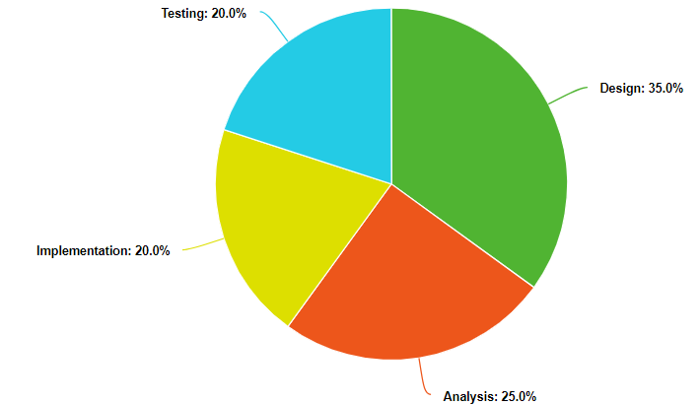

The following chart is a visual representation on the amount of hours spent on each of the phases of the project.

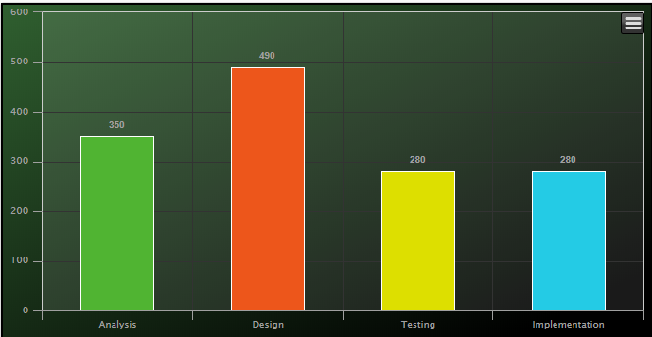

# Risk Assessment

*The higher the risk is on the list, the higher is the likelihood of the risk to occur.*

## Personal events

Personal affairs can differ from person to person inside the group, taking into consideration the fact that the group consists of five members, which leads to a high probability of personal events being a problem. Job calls, extracurricular activities, traveling and a lot of other factors can interrupt or delay a meeting, or an assigned task. Three out of five members are not from Denmark, thus the workflow of the team can slow down during the holiday periods, as a direct aftereffect of traveling. Exams, family and spouses also have a high chance of delaying the work on the project.

**Solution:**

As a precaution, work will begin earlier than as planned on the time-schedule in order to mitigate any complications, as the likelihood of the above mentioned risk to happen is extremely high. In case chance of occurring is imminent and it interferes with the workflow, the tasks of the “burdened” member will be equally split amongst others and extra work will be put from the rest of the members.

## Lack of Constant Verification

The lack of regular endorsement and check-ups from the supervisors, and also the struggle to always find them available, it will easily make the team feel more hesitant and unsure about certain aspects and specifications of the project, which can lead to delays in the workflow of the team. There is also a probability that the team won’t understand correctly the feedback and indications from the supervisors, which can lead to frustration and resentment.

**Solution:**

If a certain task or an exception is considered a conundrum, the problem is put aside, replaced by a simpler solution and the focus of the workflow will be redirected to another requirement until a solution to the problem is executed.

## Time Schedule

A time schedule has the main purpose of improving the work of any group. The problem is when a wrong time schedule is put to use, which creates the possibility that work on the project will be delayed too much, which can lead to consequences such as missing a deadline. There is also a chance that, even if the group has the perfect time schedule, they might not follow it accordingly, which, once again, can lead to the postponement. It is of great importance that the time schedule is checked-up constantly, so that the team knows if they have enough time to finish what they decided to do regarding the project.

**Solution:**

The group should sallow their pride and accept that cuts to the requirements shall be done and all low priority system features shall be removed.

# Sources

<https://www.google.dk/publicdata/explore?ds=z5567oe244g0ot_&met_y=population&hl=en&dl=en#!ctype=l&strail=false&bcs=d&nselm=h&met_y=population&scale_y=lin&ind_y=false&rdim=area&idim=city_proper:014250&ifdim=area&hl=en_US&dl=en&ind=false> [Accessed September 20, 2018]

<https://www.dst.dk/en/Statistik/emner/priser-og-forbrug/biler> [Accessed September 20, 2018]

<https://www.uber.com/da/dk/> [Accessed September 20, 2018]

<https://en.wikipedia.org/wiki/Historic_roads> [Accessed September 20, 2018]

<https://gomore.dk/> [Accessed September 20, 2018]

<https://en.wikipedia.org/wiki/Urbanization> [Accessed September 20, 2018]

1. <https://en.wikipedia.org/wiki/Historic_roads>
2. <https://en.wikipedia.org/wiki/Urbanization>
3. <https://www.google.dk/publicdata/explore?ds=z5567oe244g0ot_&met_y=population&hl=en&dl=en#!ctype=l&strail=false&bcs=d&nselm=h&met_y=population&scale_y=lin&ind_y=false&rdim=area&idim=city_proper:014250&ifdim=area&hl=en_US&dl=en&ind=false>
4. <https://www.dst.dk/en/Statistik/emner/priser-og-forbrug/biler>
5. <https://www.uber.com/da/dk/>
6. <https://gomore.dk/>