This document presents results from a brief performance and accuracy comparison between HORAYZON and the algorithm presented in Dozier (2022). The latter algorithm can be obtained from

<https://www.mathworks.com/matlabcentral/fileexchange/94800-topographic-horizons>

and the below comparison was conducted with version 4.3.

Similar to Fig. 7 from our GMD manuscript, we compared both algorithm for two DEM domains with various sizes and centred at latitude/longitude (46.5851°, 7.9607°) and (47.37174°, 8.54226°). We directly applied NASADEM data (without any coordinate transformation to rotated latitude/longitude coordinates as described in the GMD manuscript). Both algorithms were run in a single thread mode (i.e. without parallelisation) and with an azimuth sampling number of 180.

**Computational performance**



**Figure 1**. Computational performance of both algorithm as a function of terrain size. The rectangular terrain domain was extended at the edges with a 15 km wide boundary zone (to prevent an underestimation of horizon angles near the edges). For the Dozier (2022) algorithm, performance is also displayed for runs without a boundary zone (blue line). The grey range for the ray casting algorithm stems from the slight terrain complexity dependence of the algorithm: the algorithm is faster for the domain centred at (47.37174°, 8.54226°), which represents a hilly landscape, and slightly slower for the domain centred at (46.5851°, 7.9607°), which represents extremely rugged and complex terrain.

Both analysed algorithms distinctively outperform “conventional and unaccelerated” horizon algorithms, like the one presented in Pillot et al. (2016). The ray casting algorithm is approximately twice as faster as the Dozier (2022) algorithm, if the latter is run without a boundary zone. The performance difference increases further in case a 15 km wide boundary zone is applied in both algorithms. An additional advantage of the ray casting algorithm is its negligible performance dependence on the boundary zone width. In case the algorithm would be run with a 50 or even a 100 km width boundary zone, the performance would be almost identical (not shown). We were not able to run the Dozier (2022) algorithm for a terrain size of 5 • 106 grid cells and a 15 km wide boundary zone on our test machine because the memory requirements exceeded 16 GB. Monitoring the memory demand of the algorithm during execution revealed a steady increase – this might be related to a memory leak.

**Accuracy**

In a second step, we compared the accuracy of both algorithms. The terrain horizon for two example locations, computed from an experiment with 1000 x 1000 grid cells and centred at (46.5851°, 7.9607°), is illustrated below.

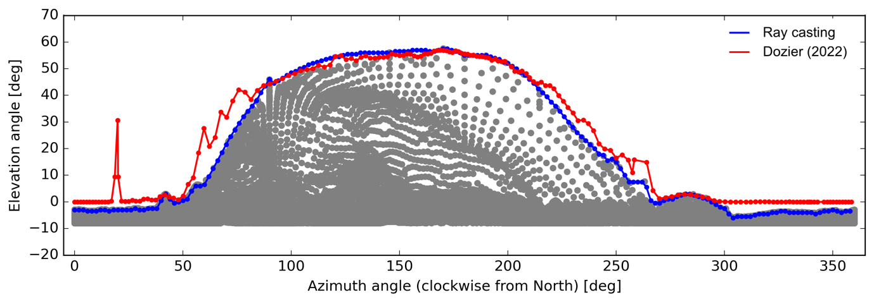

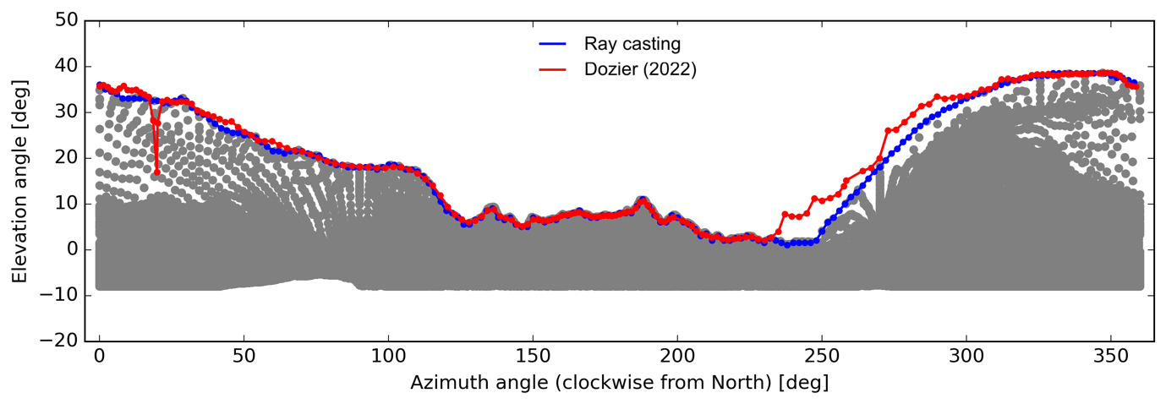

**Figure 2**. Accuracy of both algorithm for two example locations. The grey dots represent gridded NASADEM elevation as a reference. These data points were transformed to local spherical coordinates in the following order: Geodetic coordinates 🡪 Cartesian ECEF coordinates 🡪 local ENU coordinates (at the observer’s location) 🡪 spherical coordinates (i.e. all points were projected on a unit sphere centred at the observer’s location).

For most azimuth directions, the terrain horizon is well captured by both horizon algorithm. However, the Dozier (2022) algorithm reveals some deviations: Distinctive deviations at an azimuth angle of ~20° are visible for both example locations. These deviations might be related to erroneous gap-filling / interpolation for rare cases. Some smaller deviations are also evident for other azimuth directions from the above figure – these might be related to gap filling / interpolation issues as well or to the “discontinuous” representation of the DEM in a raster (we discuss this issue in Sect. 4.2 of our GMD manuscript).

**References**

Dozier, J. (2022): Revisiting the topographic horizon problem in the era of big data and parallel computing, IEEE Geosci. Remote Sens. Lett., 19, 1-5, <https://doi.org/10.1109/LGRS.2021.3125278>

Pillot, B., Muselli, M., Poggi, P., Haurant, P. and Dias, J. B. (2016): Development and validation of a new efficient SRTM DEM-based horizon model combined with optimization and error prediction methods, Sol. Energy, 129, 101-115, <https://doi.org/10.1016/j.solener.2016.01.058>