**Microprocessor Lab**

Laboratory Activity No. 2

**Arduino and Tinkercad Interface**

|  |
| --- |

Score

*Submitted by:*

**Libunao, Christian Harold O.**

**<10:00am - 1:00pm> / <CPE 0412.1-1>**

*Date Submitted*

**30-09-2023**

*Submitted to:*

**Engr. Maria Rizette H. Sayo**

1. Objectives

This laboratory activity aims to implement the principles and techniques of hardware programming using Arduino through:

- creating an Arduino programming and circuit diagram.

II. Method/s

- Perform a task problem given in the presentation.

- Write a code and perform an Arduino circuit diagram of a ring counter that display

eight (8)LEDs starting from left.

III. Results

**TinkerCad**

**Exercise 1: Write a code that does a ring counter display for eight (8) LEDs starting from left.**

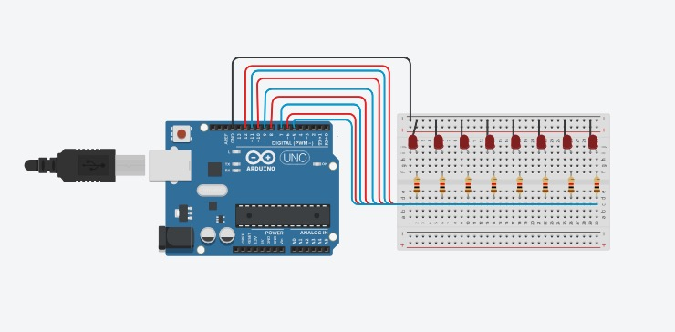

Figure No.1 Ring Counter Display Circuit Diagram

**Components Used**

1. 8 LEDs
2. Resistor
3. Breadboard

**CODE:**

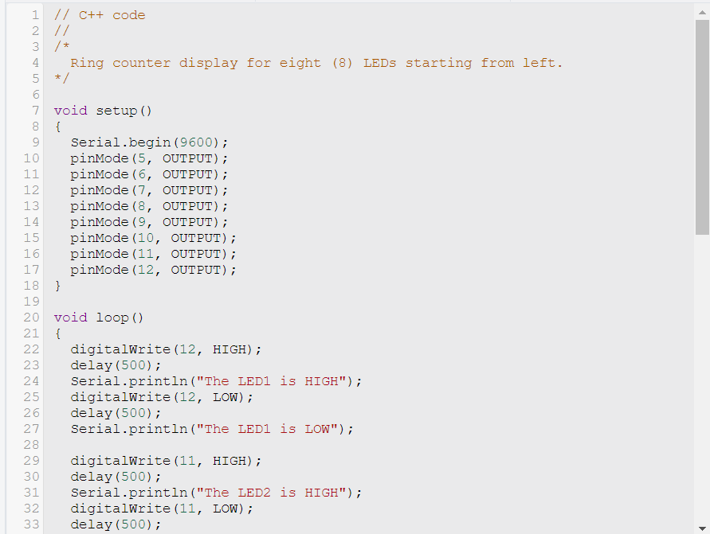

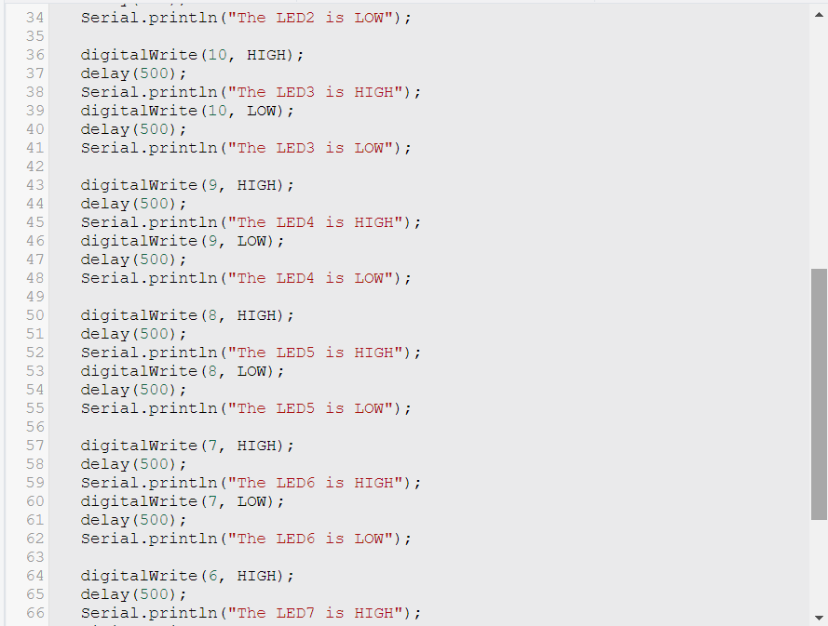

IV. Conclusion

*The conclusion expresses the summary of the whole laboratory report as perceived by the authors of the report.*

In summary, this lab activity helped us learn and apply the principles and techniques of Arduino hardware programming. We were able to successfully create an Arduino program and circuit diagram to display eight LEDs in a left-to-right sequence. This hands-on experience not only deepened our understanding of Arduino programming and circuit design, but it also helped us improve our practical skills in controlling hardware components with software logic. It was a valuable learning experience that contributed significantly to our knowledge and proficiency in embedded systems and electronics.

In other words, this lab activity was a great way for us to learn how to use Arduino to control hardware. We were able to create a simple program and circuit to display LEDs in a sequence, which helped us understand the basics of Arduino programming and circuit design. We also learned how to use software logic to control hardware components. This is a valuable skill for anyone who wants to work with embedded systems and electronics.

Overall, this lab activity was a great way for us to learn and practice Arduino programming and circuit design. It was a challenging but rewarding experience, and we are grateful for the opportunity to have participated in it.

**References**

[1] D.J.D. Sayo. “University of the City of Manila Computer Engineering Department Honor Code,” PLM-CpE Departmental Policies, 2020.

*<This is in a separate page>*