Title

**Alarm Clock**

GUI Code In

**Intermediate Programming**

By: Christian Jhey A. Santos

To: Ma’am Unife Cagas

**What is my code/title all about?**

My code, is alarm clock is a device or application designed to alert a person at a specific time, typically in the form of an audible signal or sound, to wake them up or remind them of an event or task. Alarm clocks have been used for centuries and have evolved from simple mechanical devices to sophisticated digital and electronic systems, including those found on computers and mobile devices.

**BENEFITSPURPOSE? OF MY CODE**

****Wake-Up Reminder****:

The primary purpose of an alarm clock is to wake individuals from sleep at a desired time. This helps ensure punctuality for work, school, or other daily activities.

****Time Management****:

Alarm clocks are essential tools for time management, allowing people to schedule and structure their day effectively. They help in setting and meeting deadlines, appointments, and tasks.

**Improved sleep patterns:**

Consistent wake-up times set by alarm clocks can contribute to healthier sleep patterns by regulating the body's internal clock (circadian rhythm).

**Productivity:**

By providing a reliable method of waking up on time, alarm clocks contribute to increased productivity and efficiency throughout the day.

**Emergency Preparedness:**

Alarm clocks can also serve as emergency alerts or reminders for important events or tasks that need to be attended to promptly.

**Medical Health Reasons:**

In certain medical conditions or situations, such as medication schedules or medical treatments, alarm clocks can be critical for timely interventions.

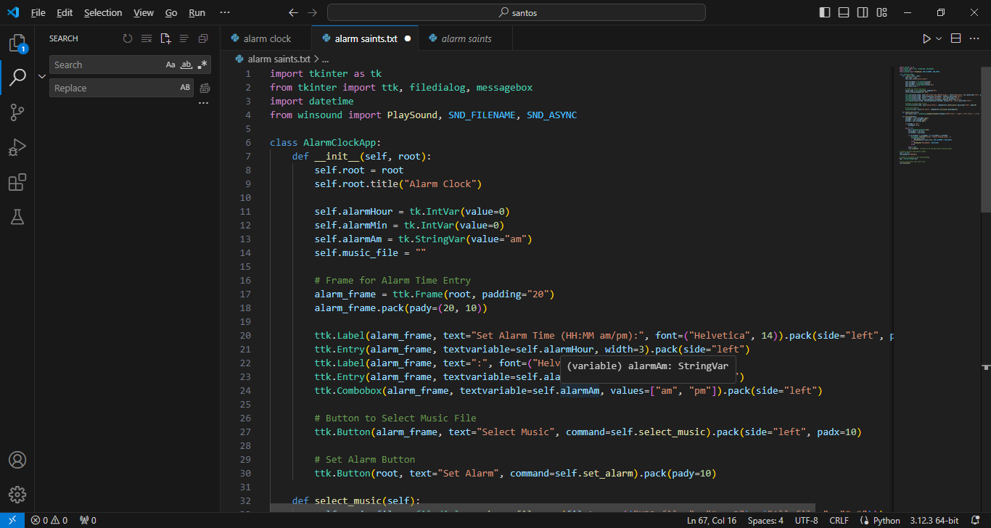**Code/Input:**

Application Initialization (__init__):

The __init__ method initializes the AlarmClockApp class by setting up the main application window (root) and defining initial attributes:

GUI Components:

The GUI components are organized within the main application window (root). These include:

Alarm Time Entry:

Widgets for setting alarm time (self.alarmHour, self.alarmMin, self.alarmAm) are arranged using a ttk.Frame (alarm_frame).

ttk.Label to display instructions for setting the alarm time.

ttk.Entry fields for entering hours and minutes.

ttk.Combobox for selecting "am" or "pm".

ttk.Button to choose a music file for the alarm (self.select_music).

Alarm List Display:

tk.Listbox (self.alarm_listbox) to display the list of set alarms.

ttk.Button to delete a selected alarm from the list (self.delete_alarm).

Action Buttons:

ttk.Button labeled "Set Alarm" (self.add_alarm) to add a specified alarm time to the list.

ttk.Button labeled "Delete Selected Alarm" to remove a selected alarm from the list.

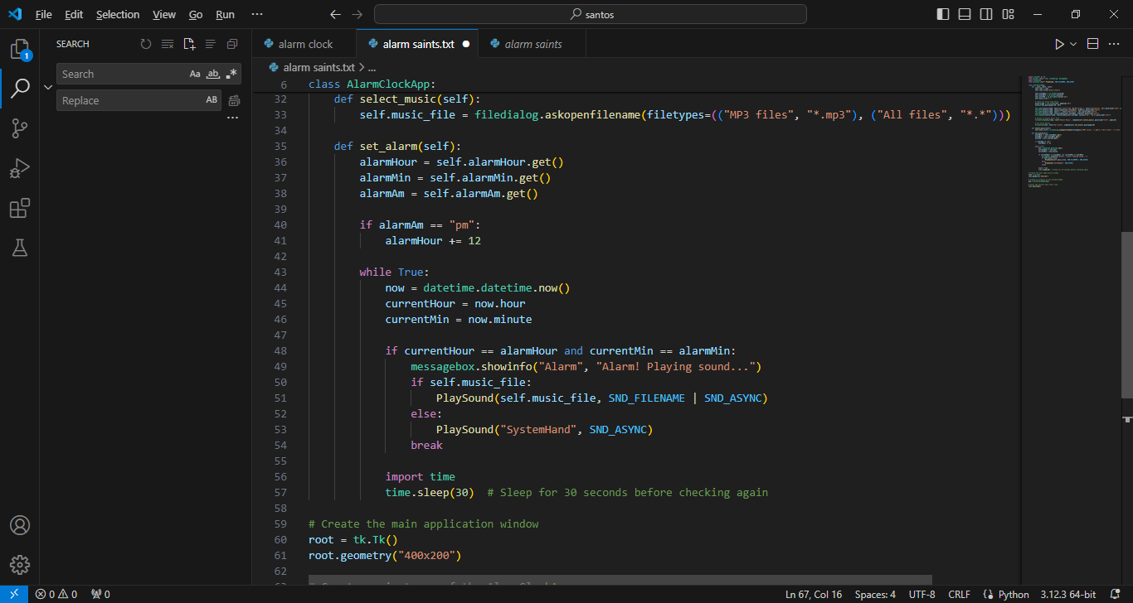

Alarm Management:

Adding Alarms (add_alarm method):

Parses and validates the entered alarm time.

Converts the time to a 24-hour format.

Adds the validated alarm time to the self.alarms list.

Updates the displayed alarms in the list box using update_alarm_listbox.

Updating Alarm List Display (update_alarm_listbox method):

Clears the existing content of the alarm list box (self.alarm_listbox).

Inserts each alarm from self.alarms into the list box with a formatted string.

Deleting Alarms (delete_alarm method):

Removes the selected alarm from the self.alarms list based on the selected index in the list box.

Calls update_alarm_listbox to reflect the deletion in the GUI.

Checking Alarms (check_alarms method):

Continuously checks the current time against the list of set alarms (self.alarms).

When a matching alarm time is detected, displays a message box and plays the selected music file (if provided) using winsound.PlaySound.

Utilizes self.root.after(10000, check) to schedule the check function to run every 10 seconds for continuous monitoring.

File Selection and Sound Playback:

The select_music method allows the user to select an MP3 file for the alarm sound using filedialog.askopenfilename.

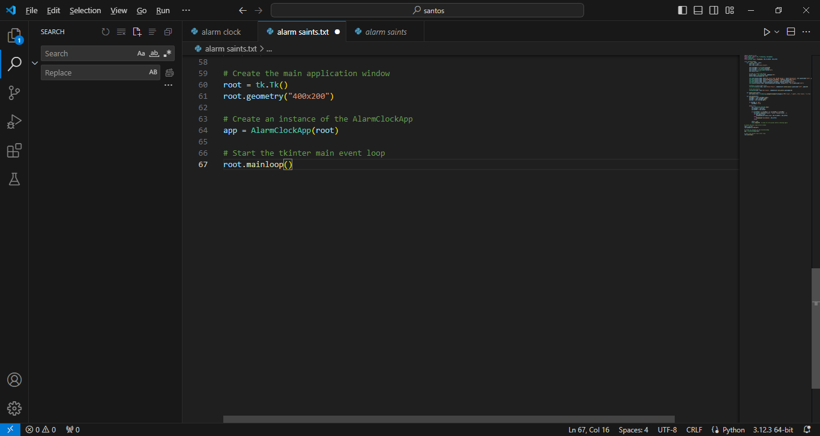

Main Application Execution:

Creates the main application window (root) using tk.Tk().

Initializes an instance of AlarmClockApp within the main application window.

Starts the main event loop (root.mainloop()) to run the tkinter application.

This structure allows users to interactively set multiple alarms, select custom alarm sounds, and receive notifications when alarms trigger based on the current time. The application provides a basic alarm clock functionality with a graphical interface using tkinter for GUI components and event handling.

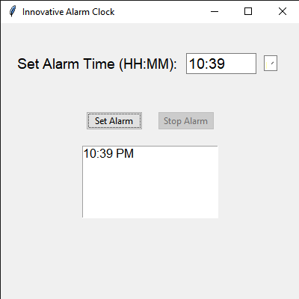

This is the main frame were you can set the time and make it am or pm at the same time you will see the next set alarrm time and you can make it multiple times just set a time and set it alarm so it would be listed in the box

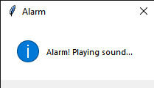

This notification will pop up if it reach the settled time to alarm



**Personal Information**

**Name: Christian Jhey A. Santos**

**Contact Number: 09617413452**

**Email Address [csantos@ssct.edu.ph](mailto:jgubot@ssct.edu.ph)**

**Date of Birth: December 24, 2004**

**Place of Birth: Bacoor,Cavite**

**Address: Vasquez corner Borja**

**Age: 19**

**Nationality: Filipino**

**Religion: Roman Catholic**

**Civil Status: Single**

**Father’s Name: Jonathan D. Santos**

**Mother’s Name: Jane B. Amguis**

**EDUCATIONAL BACKGROUND**

**Elementary CayawanElementary High School**

**Cayawan Malimono S.D.N**

**Junior High Malimono National High School**

**San Isidro Malimono S.D.N**

**Senior High Malimono National High School**

**San Isidro Malimono S.D.N**

**College Surigao Del Norte State University**

**Narciso Street, Surigao City, 8400 Surigao del Norte**