Supporting information for: Unbiased estimation of the number of segregating sites across unequal sample sizes
William Hemstrom*, Mark R. Christie*

Corresponding author information:
* William Hemstrom; email: hemstrow@gmail.com
* Mark Christie; email: christ99@purdue.edu

This PDF includes:
Supplementary Methods
Supplementary Example
Supplementary References
Supplementary Figures 1-6
Supplementary Methods:

Coalescent simulations:
To test S’ estimations with a realistic site frequency spectrum, we used the coalescent simulator scrm (Staab et al., 2015) with a relatively low per-bp mutation rate of 1x10⁻⁶, a per-bp recombination rate of 2x10⁻⁸, and N_{e} of 1,000 alongside a chromosome size of 1x10⁶ bp to generate a relatively small number of variant sites for both 5,500 and 250 gene copies. We then subset the resulting data randomly to 10,000 SNPs, then added missing data and calculated S’ and S via manual rarefaction for a range of γ and iteration numbers as described in the main text.

Simulating inbred, outbred, and neutral populations:
To test the accuracy and precision of S’, projected S, and Watterson’s θ in either inbred or outbred populations, we used genotypic data from Hemstrom et al (2022) with no minor allele frequency filter, phased and imputed it using beagle 5.4 (Browning et al., 2018) with the default settings, then subset individuals to keep those from either North America or Queensland, Australia. The North American population was used as our inbred population.
To simulate outbreeding, we conducted forward simulations with a high rate of migration between the North American and Queensland populations following the general simulation approach of Lee et al (2025). Briefly, we sampled 50 individuals from each population, randomly assigned sexes to all individuals, and then randomly mated individuals within populations to produce a total of four offspring per pair. We allowed chromosomes to recombine by randomly placing $r$ recombination events, where $r$ was determined using a Poisson distribution with $λ$ = 1 for an average of one recombination event per chromosome, the location of which determined randomly. Maternal and paternal chromosomes were combined (crossed-over) at any recombination loci; multiple crossing over events were allowed and resulted in swapping at one or more regions of each chromosome. 50% of offspring were then swapped between populations, 50 individuals from each resulting pool of individuals were randomly selected as parents and randomly assigned sexes, and mating with recombination was repeated for a second generation as above to generate two outbred offspring populations, one of which was randomly used as our ‘outbred’ population for further analysis. To simulate a neutral population, we forward simulated the “North American” population using the same framework as above for five generations without migration. No selection was applied to either population.

Supplementary Example:
The unbiased expected number of segregating sites after standardizing sample sizes, S’, can be calculated with γ automatically set to the smallest sample size across all sample groups automatically across multiple sample groups using the R package “snpR” (W. Hemstrom & Jones, 2023). First, install snpR if needed (this can be skipped if already installed) and load it:
# Install and load snpR. Comment out first two lines if not needed.

install.packages("remotes")
remotes::install_github("hemstrow/snpR")
library(snpR)
Next, download the example data:
# download the metadata (if copy/pasting, check line breaks)
meta <- read.table(url("https://raw.githubusercontent.com/ChristieLab/seg_sites_rarefaction/main/data/example_vcf.vcf"),
header = TRUE)
# download the vcf (if copy/pasting, check line breaks)
download.file("https://raw.githubusercontent.com/ChristieLab/seg_sites_rarefaction/main/data/example_vcf.vcf",
destfile = "example_vcf.vcf")
This VCF file contains a subset of data from Hemstrom et al. (Hemstrom et al., 2022) which includes genotypes for 1,000 SNP loci from five populations. The VCF file can be loaded in alongside the metadata into a single object using “read_vcf”:
monarchs <- read_vcf("example_vcf.vcf", sample.meta = meta)
Population size information can be accessed using “summarize_facets” by referring to the column name in the metadata read in earlier (“pop”). “Facets” in snpR refer to any metadata column in the data (including both sample metadata, like we read in above, and locus metadata if supplied). We can view the number of individuals per population using “summarize_facets”:
summarize_facets(monarchs, "pop")
Running this will show the number of samples per population.
The expected number of segregating sites per population can be calculated using the function “calc_seg_sites”, supplying the object we imported above and naming the facet which contains our population information. The rarefaction level (γ) per locus will be automatically calculated according to the argument “g”. If “g” is zero (the default), γ = n_{min}, where n_{min} is the smallest sample size across all populations for each locus after accounting for missing data. On the other hand, if g < 0, γ will be set to n_{min} – g and if g > 0, γ will be set to g. Either way, the result can be fetched with “get.snpR.stats”, referring to the object, facet, and statistic we are fetching:
# g = 0, gamma = Nmin
monarchs <- calc_seg_sites(monarchs, "pop", g = 0)
get.snpR.stats(monarchs, "pop", "seg_sites")$weighted.means
# g = -1, gamma = Nmin - 1
monarchs <- calc_seg_sites(monarchs, "pop", g = -1)
get.snpR.stats(monarchs, "pop", "seg_sites")$weighted.means
# g = 10, gamma = 10
monarchs <- calc_seg_sites(monarchs, "pop", g = 10)
get.snpR.stats(monarchs, "pop", "seg_sites")$weighted.means
Note that the addition of “$weighted.means” to the end of each “get.snpR.stats” means that we are fetching the mean values specifically, not the per-locus data. We can fetch that instead by using “$single”, referring to the statistics for each single locus. The mean results will contain the columns “seg_sites” and “seg_sites_var” containing S’ and its variance $σ_{S'}^{2}$, respectively. The per-locus results will contain the columns “g_prob_seg”, “prob_seg”, and “prob_seg_var” which note γ, the probability the site segregates at γ in a specific population ($\hat{P}(S_{ij}))$, and the variance of $\hat{P}(S_{ij})$, $σ_{\hat{P}(S_{ij})}^{2}$, respectively.

Supplementary References:
Browning, B. L., Zhou, Y., & Browning, S. R. (2018). A One-Penny Imputed Genome from Next-Generation Reference Panels. The American Journal of Human Genetics, 103(3), 338–348. https://doi.org/10.1016/j.ajhg.2018.07.015
Hemstrom, W. B., Freedman, M. G., Zalucki, M. P., Ramírez, S. R., & Miller, M. R. (2022). Population genetics of a recent range expansion and subsequent loss of migration in monarch butterflies. Molecular Ecology, 31(17), 4544–4557. https://doi.org/10.1111/mec.16592
Hemstrom, W., & Jones, M. (2023). snpR: User friendly population genomics for SNP data sets with categorical metadata. Molecular Ecology Resources, 23(4), 962–973. https://doi.org/10.1111/1755-0998.13721
Lee, A., Hemstrom, W., Molea, N., Luikart, G., & Christie, M. R. (2025). ‘Highly-Informative’ Genetic Markers Can Bias Conclusions: Examples and General Solutions. Molecular Ecology Resources, n/a(n/a), e70011. https://doi.org/10.1111/1755-0998.70011
Staab, P. R., Zhu, S., Metzler, D., & Lunter, G. (2015). scrm: Efficiently simulating long sequences using the approximated coalescent with recombination. Bioinformatics, 31(10), 1680–1682.

Supplementary Figures:
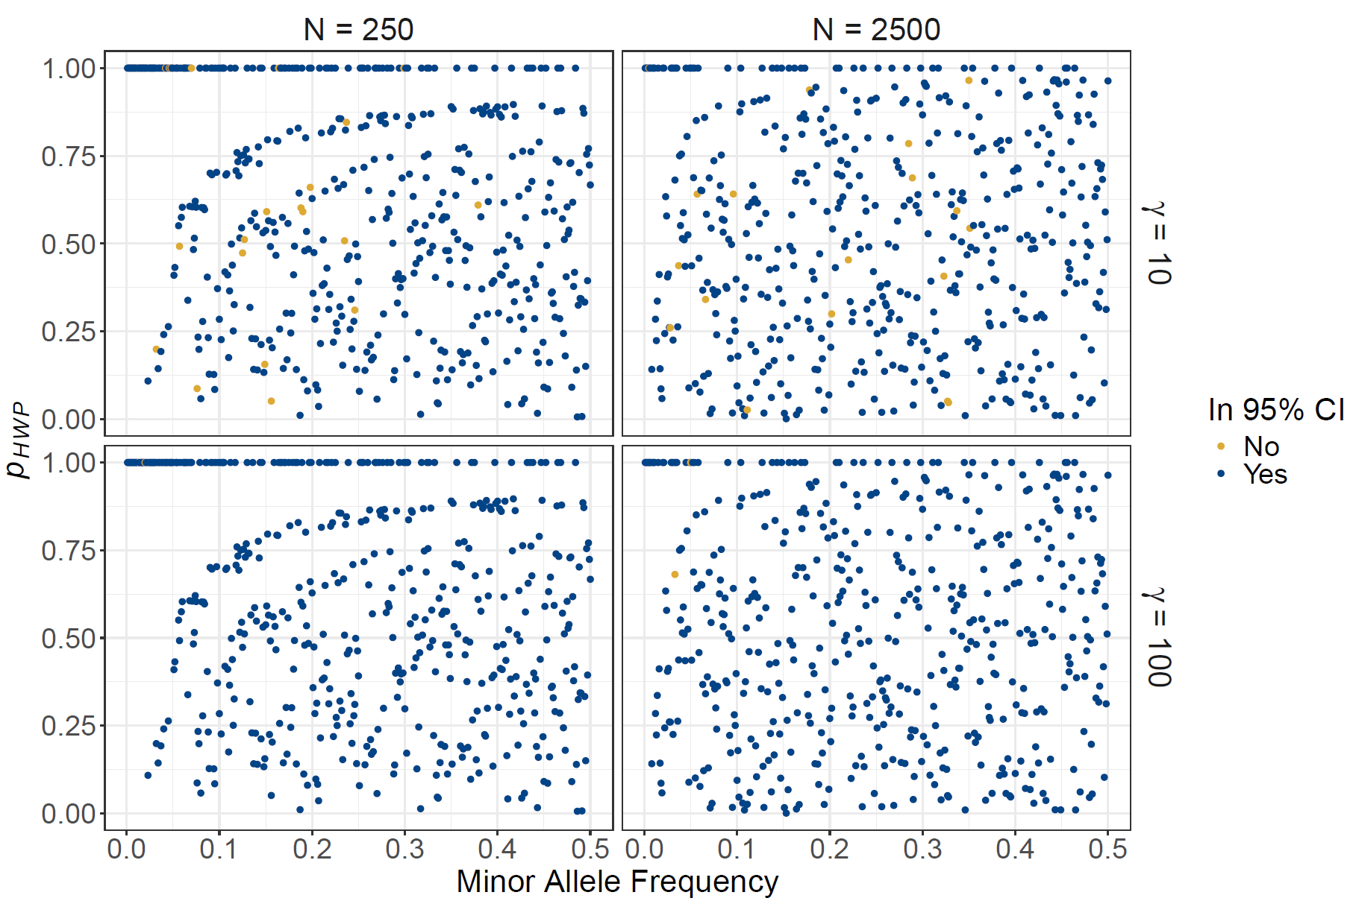
Figure S1: Deviation from Hardy-Weinberg proportions (exact test p-values; p_{HWE}) vs. minor allele frequencies for simulated test data. Points are colored to note if the expected segregation probabilities from mathematical rarefaction ($\hat{P}\left(S_{j,q}\right)$) are outside of the 95% confidence intervals derived from the observed probability of segregation ($P\left(S_{j,q}\right)$) from simulations.
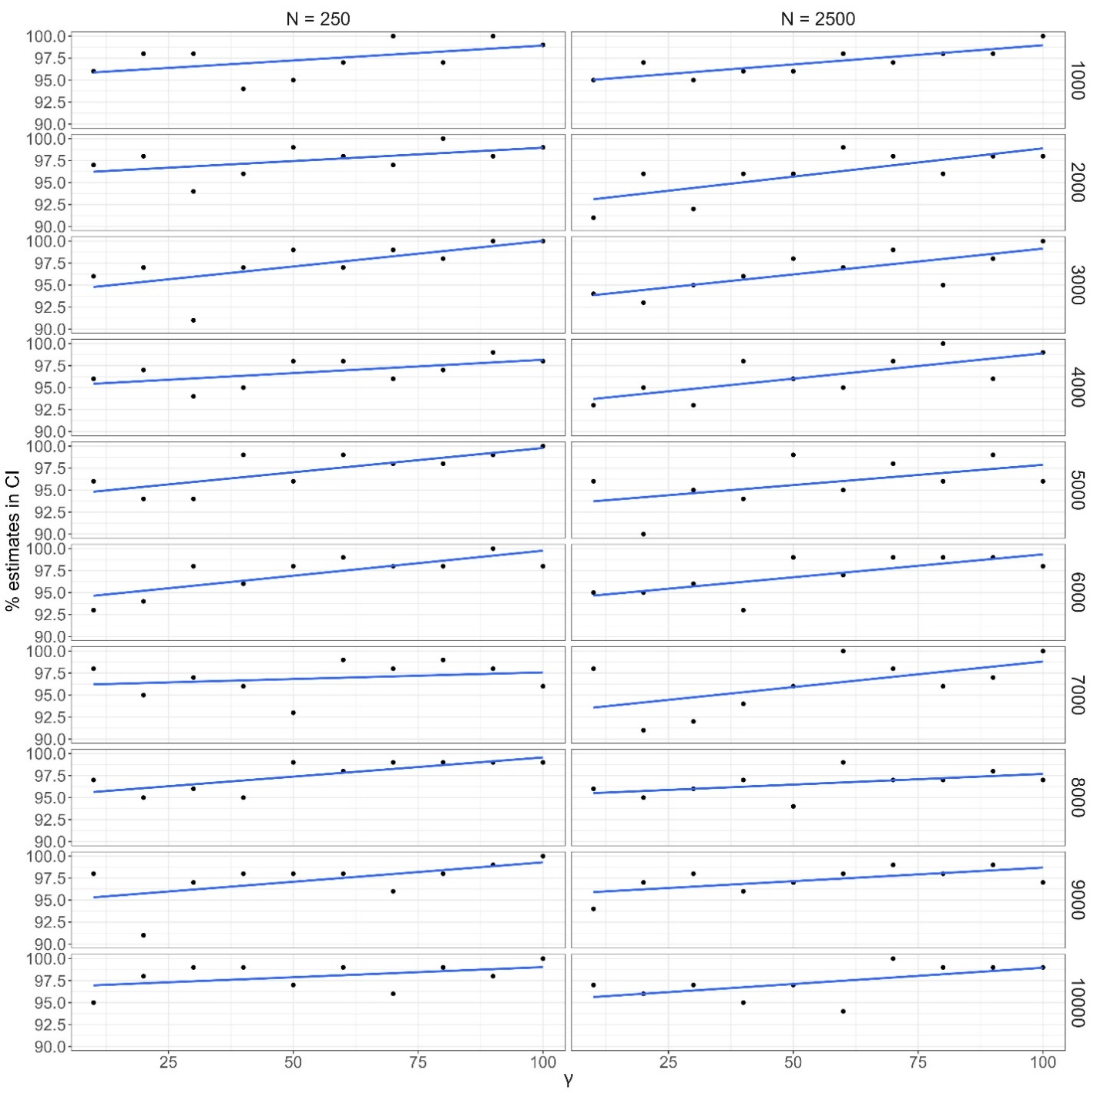
Figure S2: The percentage of expected segregation probabilities $\hat{P}(S_{iq})$ for which the probability a loci was segregating was inside the 95% confidence interval derived from simulations for different γ values and numbers of simulations for both a population of size 250 and 2,500.

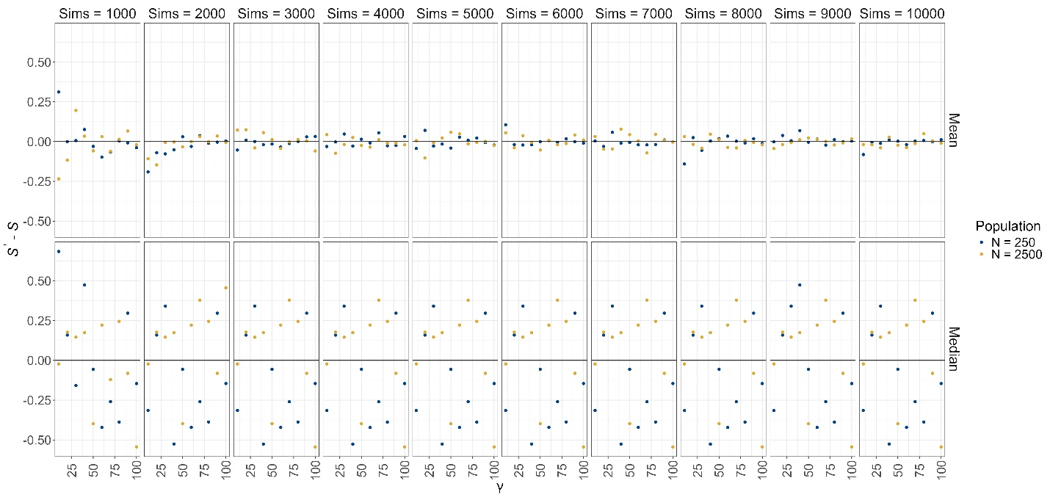
Figure S3: The difference between the expected number of segregating sites (S’ ) and the mean and median observed number of segregating sites (S) from simulations across different numbers of simulations and γ values for populations of both size 250 and 2,500.
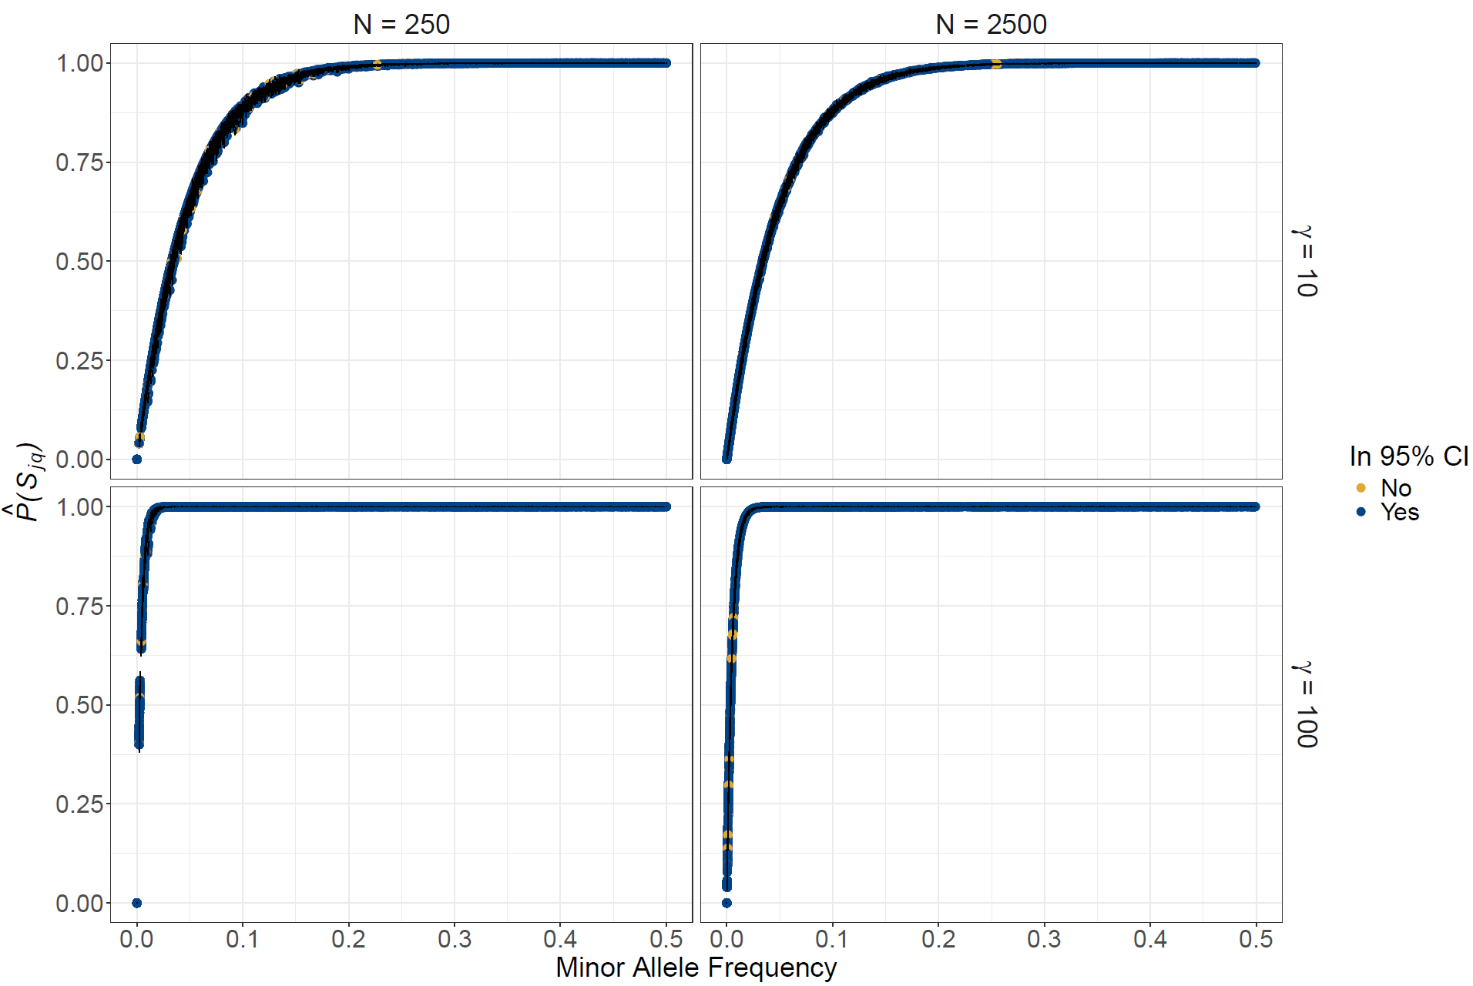
Figure S4: The expected probabilities of observing a segregating site at each locus ($\hat{P}\left(S_{j,q}\right)$) for loci generated with the coalescent simulator scrm. Probabilities are derived from Equation 4 for each locus for population sizes of 250 and 2500, rarefacted to sample sizes of either 10 or 100 (corresponding to $γ$ = 10 or 100). Since loci were not simulated in HWP, points vary to a small degree due to variation in genotype frequencies for a given minor allele frequency. Each locus had a random, independent percentage of missing data between 0% and 30%. Points are colored depending on estimates were contained within a 95% confidence intervals (marked with error bars) based on 10,000 simulated rarefaction trials for each minor allele frequency at each sample size. Compare to main text Figure 1, which was generated with known, pre-defined allele frequencies.
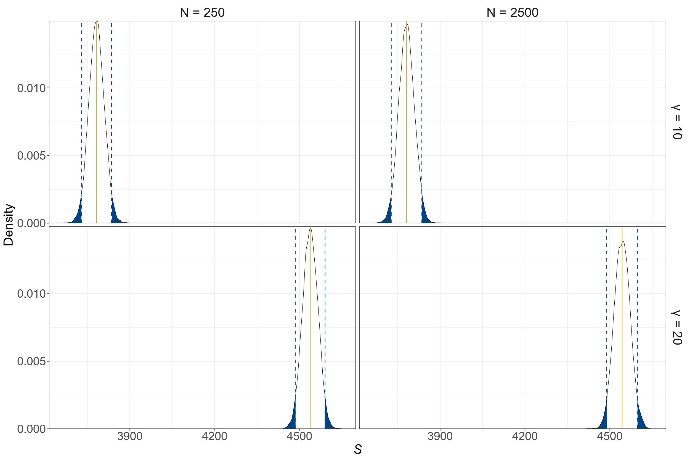
Figure S5: The distribution of the total number of segregating sites (S) observed for 10,000 replicate simulated trials, rarefacted to either 10 or 200 samples (corresponding to either $γ$ = 10 or 20, respectively) for starting population sizes of either N = 250 or N = 2500. The mathematically expected number of segregating sites (S’) and 95% prediction are shown with solid yellow and dashed blue lines, respectively, for each distribution. Data was generated with the coalescent simulator scrm; compare to Figure 3 in the main text, which was generated with known, pre-defined allele frequencies.
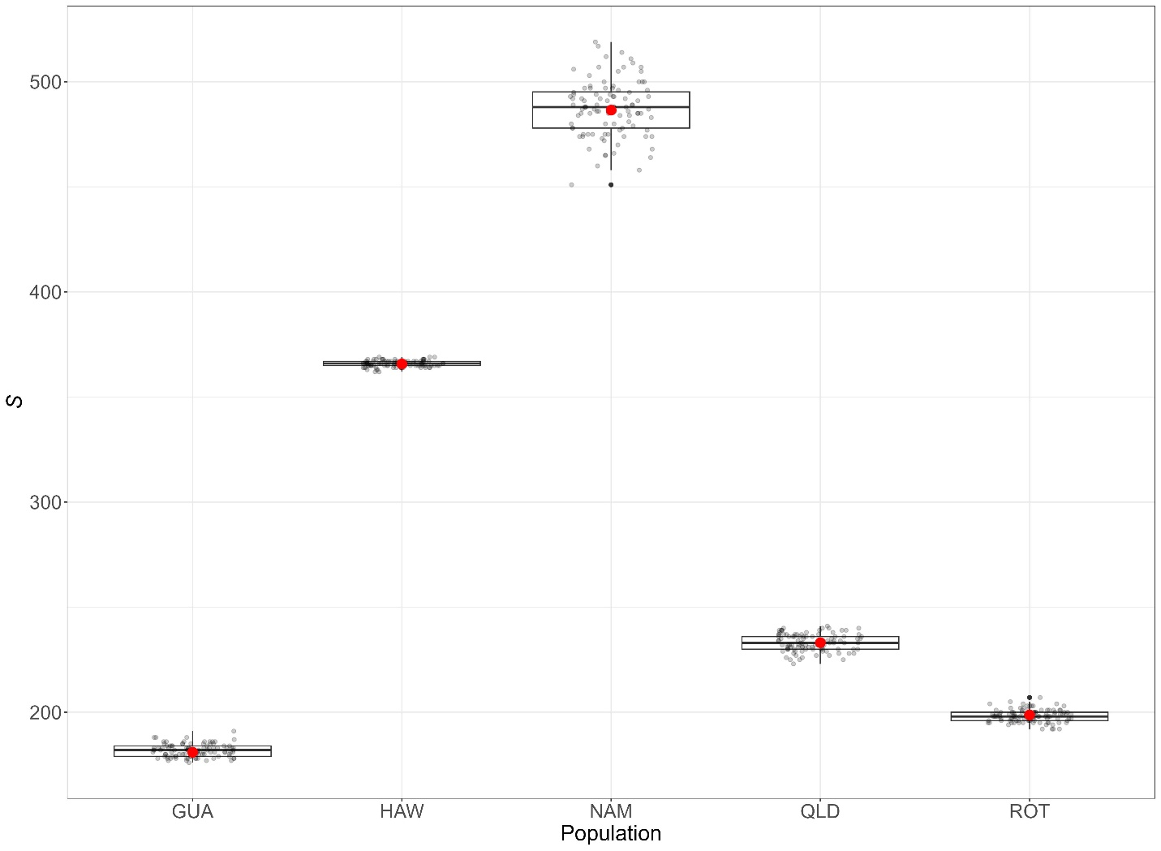
Figure S6: The expected number of segregating sites (S’, red) compared to the distributions of the number of segregating sites observed after rarefaction based on 100 simulations (black) from Monarch butterfly populations. S’ values were obtained using the “calc_seg_sites” function in snpR using “g = 0”, which sets γ equal to the minimum sample size across all populations for each locus.

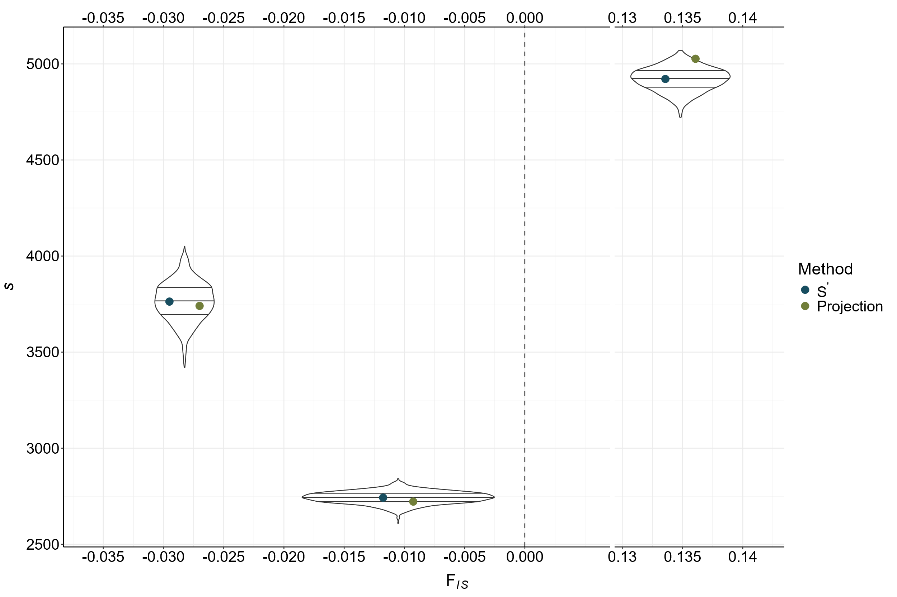
Figure S7: Comparison between the number of segregating sites (S) calculated via projection (green), S’ (blue), and observed, rarefacted S (black distributions, sampled 1,000 times) following projection or rarefaction to 25 individuals (or γ = 25 for S’) for outbred, neutral, or inbred populations (left to right, with corresponding F_{IS} values). Points (not distributions) are offset on the x axis for clarity—each value is plotted for the specific F_{IS} of the corresponding population.

