**20MCA132**

**OBJECT ORIENTED PROGRAMMING LAB**

**CYCLE- 1**

**1. Define a class ‘product’ with data members pcode, pname and price. Create 3 objects of the class and find the product having the lowest price.**

**CODE:**

public class product

{

int pcode;

String pname;

double price;

double lowest;

void data(int c, String n, double p){

pcode=c;

pname=n;

price=p;

}

void display(){

System.out.println(pcode+"\t\t"+pname+"\t\t"+price);

}

static void findLowest(double price1,double price2, double price3){

if(price1<=price2 && price1<=price3){

System.out.println("\nLAPTOP is the lowest price!");

}

else if(price2<=price1 && price2<=price3){

System.out.println("\nWATCH is the lowest price!");

}

else{

System.out.println("\n MOBILE is the lowest price!");

}

}

public static void main(String[] args){

System.out.println("Name:Christin Benny\nReg No:22MCA021

\nCourse Code and Name: 20MCA132, Object Oriented Programming Lab\nDate:24/03/2023");

product obj1 = new product();

product obj2 = new product();

product obj3 = new product();

obj1.data(101,"LAPTOP",57000.00);

obj2.data(102,"WATCH",3000.00);

obj3.data(103,"MOBILE",20000.00);

System.out.println("ProductInformation:\nProduct_Code\tProduct_Name\t

Product_Price");

obj1.display();

obj2.display();

obj3.display();

findLowest(obj1.price,obj2.price,obj3.price);

}

}

**OUTPUT:**

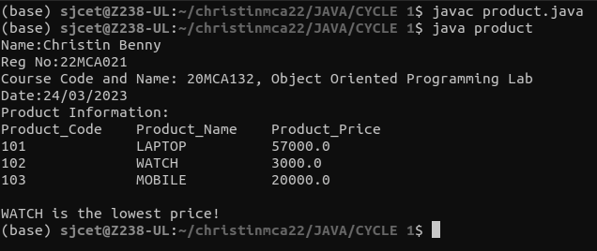

**2. Read 2 matrices from the console and perform matrix addition.**

**CODE:**

import java.util.Scanner;

public class add_matrix

{

public static void main(String args[])

{

System.out.println("\nName:Christin Benny\nReg No:22MCA021\nCourse Code and Name: 20MCA132, Object Oriented Programming Lab\nDate:24/03/2023\n\n");

int row, col,i,j;

Scanner in = new Scanner(System.in);

System.out.println("Enter the number of rows");

row = in.nextInt();

System.out.println("Enter the number columns");

col = in.nextInt();

int mat1[][] = new int[row][col];

int mat2[][] = new int[row][col];

int res[][] = new int[row][col];

System.out.println("Enter the elements of matrix 1");

for ( i= 0 ; i < row ; i++ )

{

for ( j= 0 ; j < col ;j++ )

mat1[i][j] = in.nextInt();

System.out.println();

}

System.out.println("Enter the elements of matrix 2");

for ( i= 0 ; i < row ; i++ )

{

for ( j= 0 ; j < col ;j++ )

mat2[i][j] = in.nextInt();

System.out.println();

}

for ( i= 0 ; i < row ; i++ )

for ( j= 0 ; j < col ;j++ )

res[i][j] = mat1[i][j] + mat2[i][j] ;

System.out.println("Sum of matrices:-");

for ( i= 0 ; i < row ; i++ )

{

for ( j= 0 ; j < col ;j++ )

System.out.print(res[i][j]+"\t");

System.out.println();

}

}

}

**OUTPUT:**

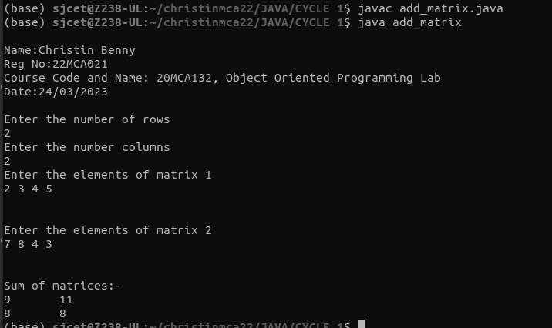

**3. Add complex numbers.**

**CODE:**

public class complex

{

double real, img;

complex(double r, double i){

this.real = r;

this.img = i;

}

public static complex sum(complex c1, complex c2){

complex temp = new complex(0, 0);

temp.real = c1.real + c2.real;

temp.img =c1.img + c2.img;

return temp;

}

public static void main(String args[]){

System.out.println("\nName: Christin Benny\nReg No: 22MCA021\nCourse Code and Name: 20MCA132, Object Oriented Programming Lab\nDate:24/03/2023\n");

complex c1 = new complex(5.5, 4);

complex c2 = new complex(1.2, 3.5);

complex temp = sum(c1, c2);

System.out.println("Sum is :" + temp.real+" + "+ temp.img + "i");

}

}

**OUTPUT:**

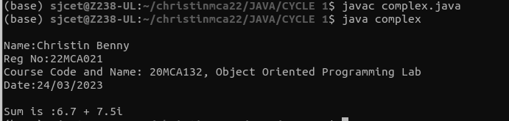

**4. Read a matrix from the console and check whether it is symmetric or not.**

**CODE:**

import java.util.Scanner;

public class SymmetricMatrix

{

public static void main(String[] args)

{

System.out.println("\nName:Christin Benny\nReg No:22MCA021\nCourse Code and Name: 20MCA132, Object Oriented Programming Lab\nDate:28/03/2023\n");

Scanner sc = new Scanner(System.in);

System.out.println("Enter the no. of rows : ");

int rows = sc.nextInt();

System.out.println("Enter the no. of columns : ");

int cols = sc.nextInt();

int matrix[][] = new int[rows][cols];

System.out.println("Enter the elements :");

for (int i = 0; i < rows; i++)

{

for (int j = 0; j < cols; j++)

{

matrix[i][j] = sc.nextInt();

}

}

System.out.println("The matrix is :");

for (int i = 0; i < rows; i++)

{

for (int j = 0; j < cols; j++)

{

System.out.print(matrix[i][j]+"\t");

}

System.out.println();

}

if(rows != cols)

{

System.out.println("The given matrix is not a square matrix");

}

else

{

boolean symmetric = true;

for (int i = 0; i < rows; i++)

{

for (int j = 0; j < cols; j++)

{

if(matrix[i][j] != matrix[j][i])

{

symmetric = false;

break;

}

}

}

if(symmetric)

{

System.out.println("The given matrix is symmetric...");

}

else

{

System.out.println("The given matrix is not symmetric...");

}

}

sc.close();

}

}

**OUTPUT:**

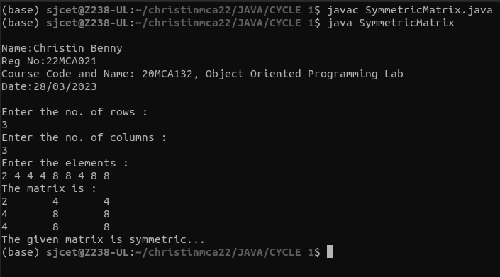

**5. Create CPU with attribute price. Create inner class Processor (no. of cores, manufacturer) and static nested class RAM (memory, manufacturer). Create an object of CPU and print information of Processor and RAM.**

**CODE:**

public class cpu

{

class processor{

int cores;

String producer;

processor(int noC, String manu){

cores=noC;

producer=manu;

}

void display(){

System.out.println("\nPROCESSOR DETAILS");

System.out.println("No. of Cores = "+cores);

System.out.println("Manufacturer = "+producer+"\n");

}

}

static class ram{

int mem;

String manuf;

ram(int memory,String producer ){

mem=memory;

manuf=producer;

}

void display(){

System.out.println("\nName:Christin Benny\nReg No:22MCA021\nCourse Code and Name: 20MCA132, Object Oriented Programming Lab\nDate:28/03/2023\n");

System.out.println("\nRAM DETAILS");

System.out.println("Memory = "+mem+" GB");

System.out.println("Manufacturer = "+manuf+"\n");

}}

public static void main(String[] args) {

cpu.ram obj1= new cpu.ram(8,"Intel");

cpu obj2 = new cpu();

cpu.processor obj3 = obj2.new processor(8,"Samsung");

obj1.display();

obj3.display();

}

}

**OUTPUT:**

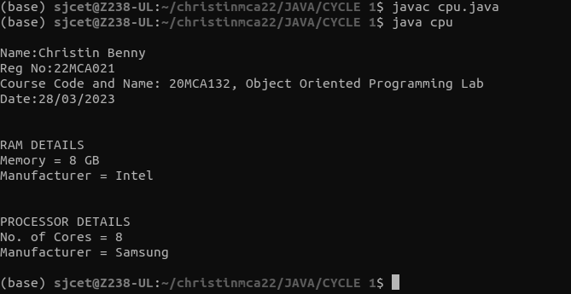

**CYCLE- 2**

**1. Program to Sort strings.**

**CODE:**

import java.util.Arrays;

import java.util.Scanner;

public class StringSort{

public static void main(String[] args){

System.out.println("\nName:Christin Benny\nReg No:22MCA021\nCourse Code and Name: 20MCA132, Object Oriented Programming Lab\nDate:04/04/2023\n\n");

int count=0;

String tmp;

Scanner scan=new Scanner(System.in);

System.out.println("Enter the number of strings:");

count=scan.nextInt();

String str_list[]= new String[count];

Scanner scan1=new Scanner(System.in);

System.out.println("Enter the strings:");

for(int i=0;i<count;i++)

str_list[i]=scan1.nextLine();

System.out.println("1. Inbuilt Sort\n2. User Defined Sorting");

int choice;

choice=scan.nextInt();

switch (choice){

case 1:

Arrays.sort(str_list);

System.out.println(Arrays.toString(str_list));

break;

case 2:

for(int i=0;i<count-1;i++)

for(int j=i+1;j<str_list.length;j++)

if(str_list[i].compareTo(str_list[j])>0)

{

tmp=str_list[i];

str_list[i]=str_list[j];

str_list[j]=tmp;

}

System.out.println(Arrays.toString(str_list));

break;

}

}

}

**OUTPUT:**

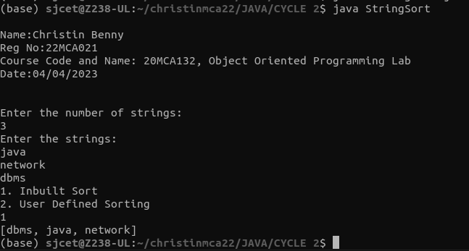

**2. Search an element in an array.**

**CODE:**

import java.util.Scanner;

public class Search {

public static void main(String[] args) {

System.out.println("\nName:Christin Benny\nReg No:22MCA021\nCourse Code and Name: 20MCA132, Object Oriented Programming Lab\nDate:27/04/2023\n\n");

int i,j,x=0,s=0;

boolean state = false;

Scanner sc = new Scanner(System.in);

System.out.println("Enter the number of elemets in array");

int num=sc.nextInt();

String word[]=new String[num];

sc.nextLine();

for( i=0;i<num;i++){

System.out.println("\nEnter a Word\n");

word[i]=sc.nextLine();

}

System.out.println("Enter the element to Search");

String search = sc.nextLine();

for( i=0;i<num;i++){

if(word[i].equals(search)){

x = i;

state = true;

s=x+1;

}

}

if(state){

System.out.println("Element found at position = "+s);

}

else{

System.out.println("Element found not found");

}

}

}

**OUTPUT:**

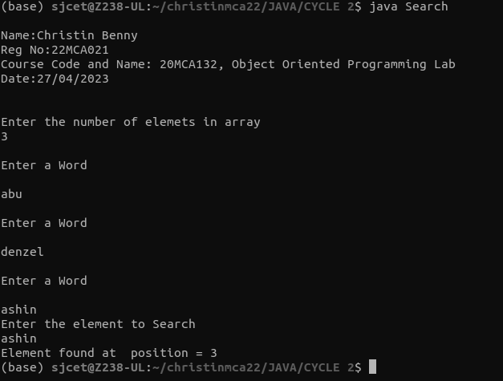

**3. Perform string manipulations.**

**CODE:**

import java.util.Scanner;

public class String_man{

public static void main(String[] args) {

System.out.println("\nName:Christin Benny\nReg No:22MCA021\nCourse Code and Name: 20MCA132, Object Oriented Programming Lab\nDate:27/04/2023\n\n");

System.out.println("Enter The String");

Scanner sc = new Scanner(System.in);

String str1 = sc.nextLine();

System.out.println("Length of String = "+str1.length());

System.out.println("Character at First position = "+str1.charAt(0));

System.out.println("String Contains 'Col' sequence :"+str1.contains("col"));

System.out.println("String ends with e : "+str1.endsWith("e"));

System.out.println("Replace'col' with 'kol' : "+str1.replaceAll("col","kol"));

System.out.println("LOWERCASE : "+str1.toLowerCase());

System.out.println("UPPERCASE : "+str1.toUpperCase());

}

}

**OUTPUT:**

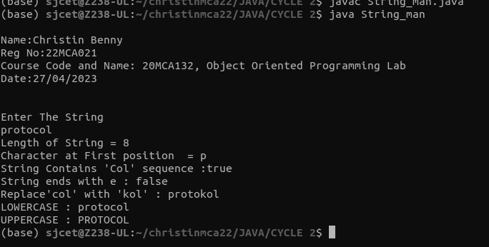

**4. Program to create a class for Employee having attributes eNo, eName eSalary. Read n employ information and Search for an employee given eNo, using the concept of Array of Objects.**

**CODE:**

import java.util.Scanner;

public class employee {

int eNo;

String eName;

double eSalary;

public void getdetails(){

System.out.println("\nEnter the Employee details");

Scanner sc = new Scanner(System.in);

System.out.println("Employee number : ");

eNo=sc.nextInt();

System.out.println("Name : ");

sc.nextLine();

eName=sc.nextLine();

System.out.println("Salary : ");

eSalary=sc.nextDouble();

}

void display(){

System.out.println("Empolyee No :"+eNo);

System.out.println("Name :"+eName);

System.out.println("Salary Amount :"+eSalary+"\n");

}

public static void main(String[] args) {

System.out.println("\nName:Christin Benny\nReg No:22MCA021\nCourse Code and Name: 20MCA132, Object Oriented Programming Lab\nDate:27/04/2023\n");

System.out.println("\nEnter the No. of Employee's");

Scanner sc1 = new Scanner(System.in);

int num = sc1.nextInt();

employee arr[]=new employee[num];

for(int i =0;i<num;i++){

arr[i]=new employee();

arr[i].getdetails();

}

System.out.println("Informations of all the employee's");

for(int i=0;i<num;i++){

arr[i].display();

}

boolean state = false;

System.out.println("\nEnter the Employee Number to get details of a employee");

int num2= sc1.nextInt();

for(int i=0;i<num;i++){

if(arr[i].eNo==num2){

System.out.println("\nEmployee details");

arr[i].display();

}

}

}

}

**OUTPUT:**

