**1.cpu**

import java.util.Scanner;

public class Cpu {

int price;

Cpu(int p) {

this.price = p;

}

class Processor {

int cores;

String manufacture;

Processor(int n, String m) {

this.cores = n;

this.manufacture = m;

}

void display() {

System.out.println("No of Cores : " + this.cores);

System.out.println("Processor manufactures : " + this.manufacture);

}

}

static class Ram {

int memory;

String manufacture;

Ram(int n, String m) {

this.memory = n;

this.manufacture = m;

}

void display() {

System.out.println("Memory Size : " + this.memory);

System.out.println("Memory manufactures : " + this.manufacture);

}

}

void display() {

System.out.println("Price of CPU : " + this.price);

}

public static void main(String[] args) {

Scanner scanner = new Scanner(System.in);

System.out.println("Enter the price of CPU: ");

int price = scanner.nextInt();

Cpu cpu = new Cpu(price);

System.out.println("Enter the number of cores for the processor: ");

int cores = scanner.nextInt();

System.out.println("Enter the manufacturer of the processor: ");

String manufacturer = scanner.next();

Cpu.Processor processor = cpu.new Processor(cores, manufacturer);

System.out.println("Enter the memory size for RAM: ");

int memory = scanner.nextInt();

System.out.println("Enter the manufacturer of RAM: ");

String ramManufacturer = scanner.next();

Cpu.Ram ram = new Ram(memory, ramManufacturer);

cpu.display();

processor.display();

ram.display();

}

}

**Cycle 2:**

**1.**

import java.util.Scanner;

public class Search_Element

{

public static void main(String[] args)

{

int n, x, flag = 0, i= 0;

Scanner s = new Scanner(System.in);

System.out.print("Enter no. of elements you want in array:");

n = s.nextInt();

int a[] = new int[n];

System.out.println("Enter all the elements:");

for(i = 0; i < n; i++)

{

a[i] = s.nextInt();

}

System.out.print("Enter the element you want to find:");

x = s.nextInt();

for(i = 0; i < n; i++)

{

if(a[i] == x)

{

flag = 1;

break;

}

else

{

flag = 0;

}

}

if(flag == 1)

{

System.out.println("Element found at position:"+(i + 1));

}

else

{

System.out.println("Element not found");

}

}

}

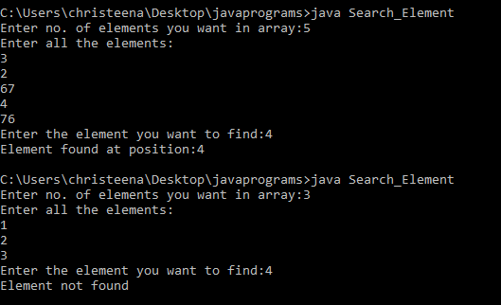

2.

import java.util.Scanner;

public class StringManipulation {

public static void main(String[] args) {

Scanner sc = new Scanner(System.in);

System.out.print("Enter a string: ");

String str = sc.nextLine();

System.out.println("The length of the string is: " + str.length());

System.out.println("The string in uppercase is: " + str.toUpperCase());

System.out.println("The string in lowercase is: " + str.toLowerCase());

System.out.println("The first character of the string is: " + str.charAt(0));

System.out.println("The last character of the string is: " + str.charAt(str.length() - 1));

System.out.print("Enter a character to search for: ");

char searchChar = sc.next().charAt(0);

int count = 0;

for (int i = 0; i < str.length(); i++) {

if (str.charAt(i) == searchChar) {

count++;

}

}

System.out.println("The character '" + searchChar + "' occurs " + count + " times in the string.");

}

}

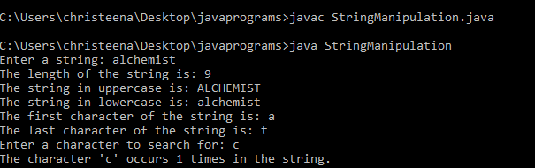

3.

import java.util.*;

public class SortStrings {

public static void main(String[] args){

Scanner sc1 = new Scanner(System.in);

System.out.println("Enter the length :");

int length = sc1.nextInt();

String[] names = new String[length];

System.out.println("Enter the strings:");

for (int i = 0; i < length; i++) {

names[i] = sc1.next();

}

Arrays.sort(names);

System.out.println("\nThe names in alphabetical order : ");

for (int i = 0; i < names.length; i++) {

System.out.println(names[i]);

}

sc1.close();

}

}

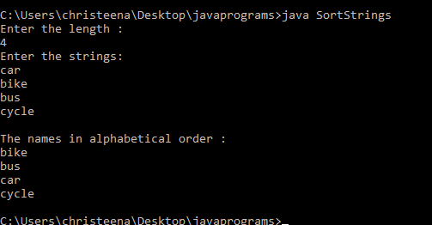

4.Program to create a class for Employee having attributes eNo, eName eSalary. Read n

employ information and Search for an employee given eNo, using the concept of Array

of Objects.

import java.util.*;

public class Employee {

int eNo;

String eName;

float eSalary;

public void empl() { read employee information

Scanner s = new Scanner(System.in);

System.out.print("Enter the Employee Number:");

eNo = s.nextInt();

System.out.print("Enter the Employee Name:");

eName = s.next();

System.out.print("Enter the Employee Salary:");

eSalary = s.nextFloat();

}

public void display() {

System.out.println(" Employee Number : " + eNo);

System.out.println(" Employee Name : " + eName);

System.out.println(" Employee Salary : " + eSalary);

}

public static void main(String args[]) {

int n;

Scanner sc = new Scanner(System.in);

System.out.print("Enter the number of Employees:");

n = sc.nextInt();

Employee obj[] = new Employee[n];

for (int i = 0; i < n; i++) {

obj[i] = new Employee();

obj[i].empl();

}

System.out.println(".............Employee Details............ ");

for (int i = 0; i < n; i++) {

obj[i].display();

}

System.out.println("Enter the number to search an employee");

int x = sc.nextInt();

int flag = 0;

for (int i = 0; i < n; i++) {

if (obj[i].eNo == x) {

flag = 1;

obj[i].display();

break;

}

}

if (flag == 0) {

System.out.println("Employee with given number not found.");

}

}

}

The program then displays the details of all the employees entered by the user using a for loop and calling the display() method of the Employee class for each object.

The program then asks the user to input a number to search for an employee. It searches for the employee with the entered employee number and displays the details of that employee if found, else it displays a message saying that the employee with the given number is not found.

