Course: Unix Name: Christina Kallas  
Section: 00001 License: CC by 4.0

Part 1 – Software Licenses and Free Software:

**Question 1)**

According to Wikipedia, this is a possibility. “Proprietary software can be distributed at no cost or for a fee, and free software can be distributed at no cost or for a fee.” (https://en.wikipedia.org/wiki/Proprietary_software)

Freeware is proprietary software that is distributed at no cost, according to the same Wikipedia page. This same page lists MYSQL, Sendmail and ssh as examples of free proprietary software.   
 Although there is not many sources when discussing free proprietary software, Oracle does list GPLv2 (a proprietary license) as their license, and their software is free, making me believe that a software can indeed be proprietary and free at the same time.

**Question 2)**

Considering that free software is about freedom regarding the copying, running, distribution, studying, changing and improving said software, I would consider that the “free” in the “free software” term is more a matter of freedom than it is of price. Free software is more similar to free speech as it allows users to be creative and have a sense of freedom with their software, see listed actions above.

An example that may further prove my point is “libreoffice”. Libre is the French term for free as in freedom, not free as in price-wise. Libreoffice is part of a free software. The freedom that free software allows its’ users is the reason I believe that “free beer” is not similar to “free software” and “free speech” is similar to it.

Part 2 – Running Linux on a Virtual Machine:

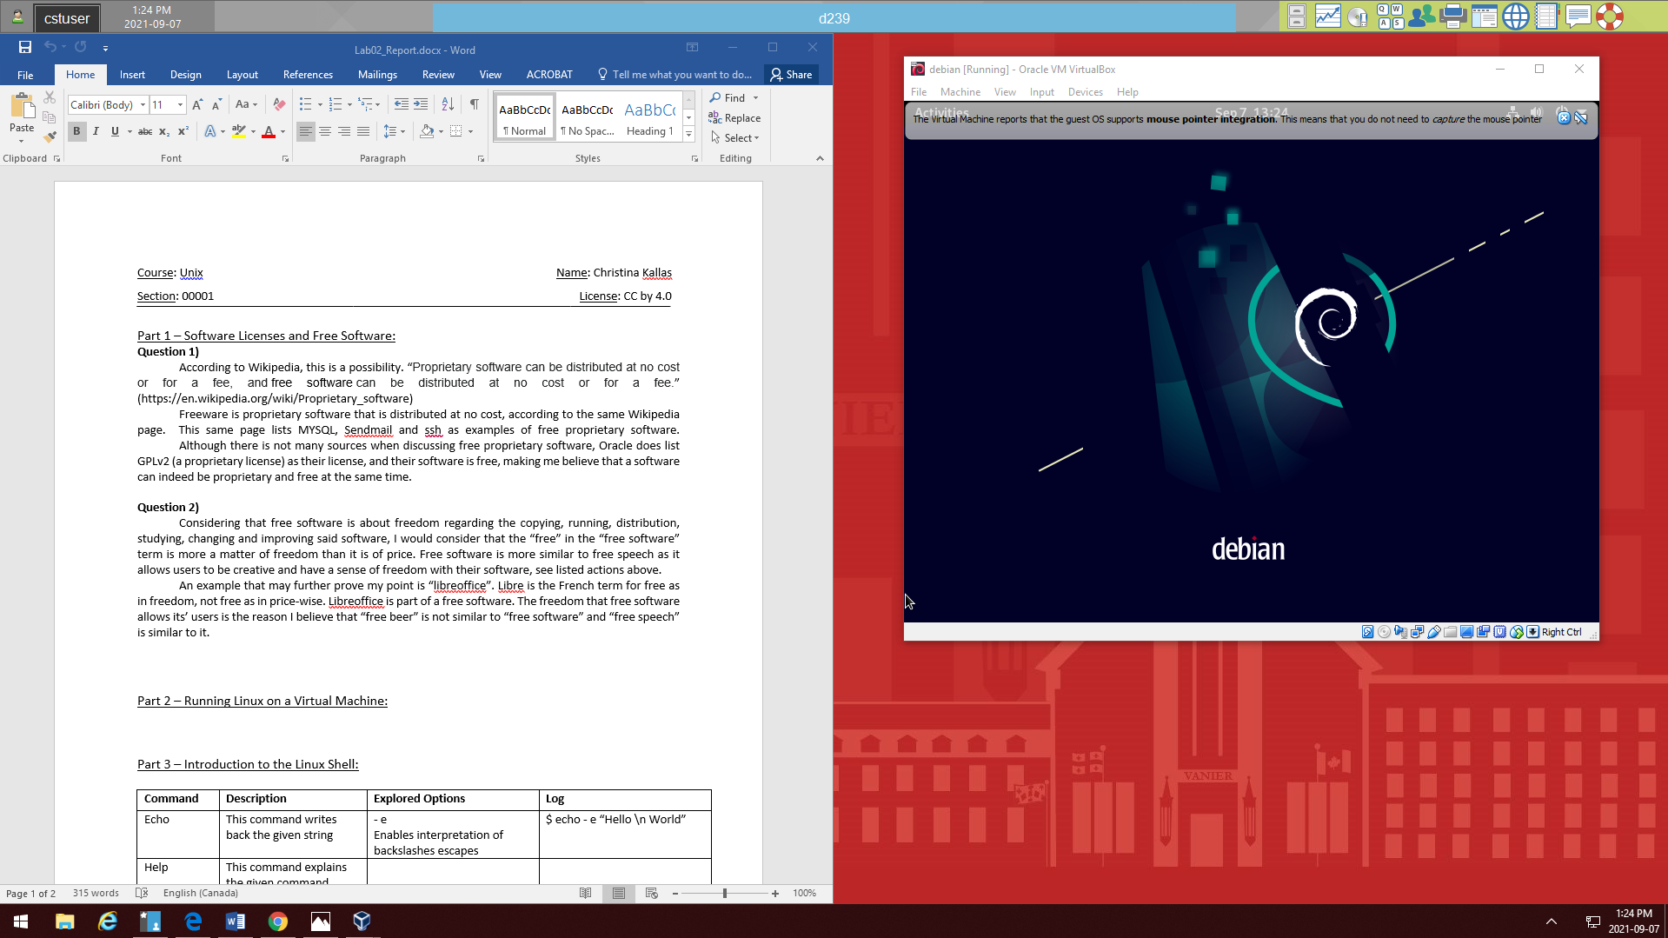

Part 3 – Introduction to the Linux Shell:

|  |  |  |  |
| --- | --- | --- | --- |
| **Command** | **Description** | **Explored Options** | **Log** |
| Echo | This command writes back the given string | - e  Enables interpretation of backslashes escapes | $ echo - e “Hello \n World” |
| Help | This command explains the given command | history explains the history command | $ help history |
| Man | This command sends you to the manual page of the given command | Man  Sends me to the manual page about manual pages  - k  Output: apropos wat? | $ man man  $ man -k |
| Mkdir | This command makes a directory if it des not exist | -v  Prints out a message for each created directory | $ mkdir –v directories |
| Clear | This command clears the entire terminal of previous entries and outputs | (none) | $ clear |
| Cd | This command allows you to enter a directory | Downloads  Enters the Downloads file  cd ..  exits the directory (goes back one) | $ cd Downloads  /Downloads$ cd .. |
| Ls | This command shows a list of all the directories | -l  Shows all the permissions of the directories | $ ls -l |
| Alias | Creates a shortcut for a command | none | $ alias ll=’ls –alF’  $ ll |
| Touch | Creates a file | -c  Does not create a file | $ touch -c Testing  $ ls |
| Cat | Concatenates files and print on the standard ouput | -E  Displays $ at the end of each output | $ cat –E  G  Output: G$  C^ |
| More | Files perusal filter for crt viewing (displays what is inside of a file) | -p  Moves the whole screen up to the file contents | $ more –p sample.txt |
| Less | Opposite of more | --version  Shows me the version of the OS | $ less --version |