Course: Unix Name: Christina Kallas  
Section: 00001 License: CC by 4.0

Part 1 – Shell and Environment variables:

**Question 1)**



\u is for the username of the current user

\h is for the hostname until the first ‘.’

@ is simply @

\$ is for if the effective UID is 0, a # otherwise a $

**Question 2 & 3)**



Through nano I changed the colour of my prompt

**Question 4)**

**Question 5)**

**Question 6)**

PWD tells you the path from root to your current directory – the fact that there is a slash followed by nothing tells me that I am in the root directory

Cd – changes the current working directory and threw me into the tmp directory

**Question 7 & 8)**

When I go into a directory, PWD gives me the path to the directory and when I go back home, oldpwd gives me the pwd from when I was in the directory.

Part 2 – File System Practice:

**Question 1)**





**Question 2)**



**Question 3)**

(no pictures of it – sorry)

Touch again modifies the access time only

**Question 4)**

What changes is the times of access and change have been updated

**Question 5)**

All the times have been updated except or birth time

**Question 6)**

**Question 7)**



Part 3 – Connecting Shell Commands:

**Question 1)**



**Question 2)**



**Question 3)**



**Question 4)**



**Question 5)**

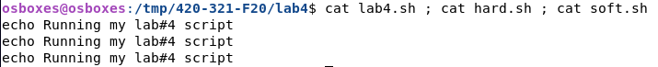

**Question 6)**

**Question 7)**

**Question 8)**

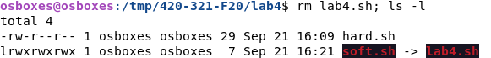

**Question 9)**

The hard link I have created is fine, but the soft link is now inaccessible and in red due to the fact that lab4.sh does not exist in this file anymore. The file lab4.sh is also no longer listed.

**Question 10)**



**Question 11)**



**Question 12)**

The difference between now and before is that the second line (aka sleep3) returns command not found as it said echo “sleep 3” and not echo “echo sleep3”

**Question 13)**



**Question 14)**

**Question 15)**

**Question 16)**



**Question 17)**



**Question 18)**



**Question 19)**



I will be honest – I needed to look this one up

**Question 20)**



Part 4 – Commands:

**Question 1)**

|  |  |  |  |
| --- | --- | --- | --- |
| **Command** | **Description** | **Explored Options** | **Log** |
| Type | Used to find out information about other commands | (none)  -t  Finds out only the type  -p  Finds absolute path of a command  -a  Displays all info | $ type bash  $ type -t bash  $ type -p bash  $ type -a bash |
| Chown | Used to change file ownership | (none) | $ mkdir file  $ sudo chown root file  (osboxes password) |
| Chmod | Used to change directory permissions | (none) | $ sudo chmod 775 file |
| Pwd | Shows file path to current directory or file | (none) | $ pwd |
| history | Shows the history of the commands used this session | (none) | $ history 5 |

**\*\*\* so sorry I could not think/find the list of the ones we had done this week**