**Mosicas, a simple R process-based crop model to study the growth of giant C4 grasses**

|  |  |
| --- | --- |
| Christina M.1,2, Martiné J.-F.1,2  1CIRAD, UPR AIDA, F-97743 Saint-Denis, La Réunion.  2AIDA, Univ Montpellier, CIRAD, Montpellier, France. | Contact : [mathias.christina@cirad.fr](mailto:mathias.christina@cirad.fr)  Project : DPP SIAAM |

Model access: <https://github.com/ChristinaMathias/MOSICAS>

ChristinaMathias. (2020, April 25). ChristinaMathias/MOSICAS: First realease (Version v1.0.0). Zenodo. <http://doi.org/10.5281/zenodo.3766222>

**Abstract**

The Mosicas model was designed to model semi-perenial giant C4 crops (in particular sugar and energy cane) under different climatic and management conditions. The model simulates the carbon accumulation and partitioning within the crop, influenced by temperature and water balance, using a relatively limited set of plant parameters. The following document describes the model formalisms and present a global sensitivity analysis.

**Table of contents**

1. Mosicas model overview 2

2. Model formalism 3

2.1. Crop emergence 3

2.2. LAI calculation 3

2.3. Intercepted radiation 4

2.4. Radiation conversion into dry mass 4

2.5. Dry mass partitioning 4

2.6. Sugar accumulation in stem 5

2.7. Aboveground and stem water content 6

2.8. Water balance principles 6

2.9. Rainfall and irrigation infiltration 6

2.10. Gravimetric drainage 6

2.11. Soil evaporation 7

2.12. Upwards water flow 7

2.13. Maximum crop transpiration 7

2.14. Root growth and potential water uptake 8

2.15. Actual crop transpiration 9

2.16. Soil water deficit factor for growth 9

3. Input plant parameter in the Mosicas model 10

4. Example of application 11

4.1. Simple simulation run 11

4.2. Local sensitivity analysis 11

4.3. Local uncertainty analysis 12

4.4. Model calibration 12

5. Model input files 12

6. Model output file 15

# Mosicas model overview

The Mosicas model is a simple crop model adapted to annual or semi-perenial giant C4 crops. The model simulates the crop growth in biomass influenced by soil water balance and air temperature. According to plant parameters defining if the crop is harvest for the first time or if it’s a regrowth after harvest, the model simulate a daily growth of the leaf area index. Intercepted radiation are then converted to dry mass accumulation through the radiation use efficiency. Carbon is partitioned into various compartments: roots, leaves, stem and eventually sugar reserve. Necessary weather data includes daily temperature, precipitation, global radiations and evapotranspiration. Necessary soil data includes the soil water holding capacity and an estimation of soil depth.

The Mosicas model was developed as an R project (R Core Team, 2020). The code is open-source (GNU GPLv3 license) and available on Github repositories (R: https://github.com/Christina/Mosicas) and archived on Zenodo (https://doi.org/10.5281/zenodo.3766222). Full documentation is available on Github repositories. The project includes R script to run simple simulations, sensitivity analysis and parameter optimization. It also includes R script to create model input from the sugarcane ECOFI database (Christina et al., 2020). The Mosicas model has been originally developed by Martiné and Todoroff (2002) as a fortran source code associated to an excel plateforme and its original code and manual are also open-source in Github repositories. Additionally a web version of the model (named Mosiweb) was developed using an html source code (REF). An overview of the Mosicas model is presented in Fig. 1.

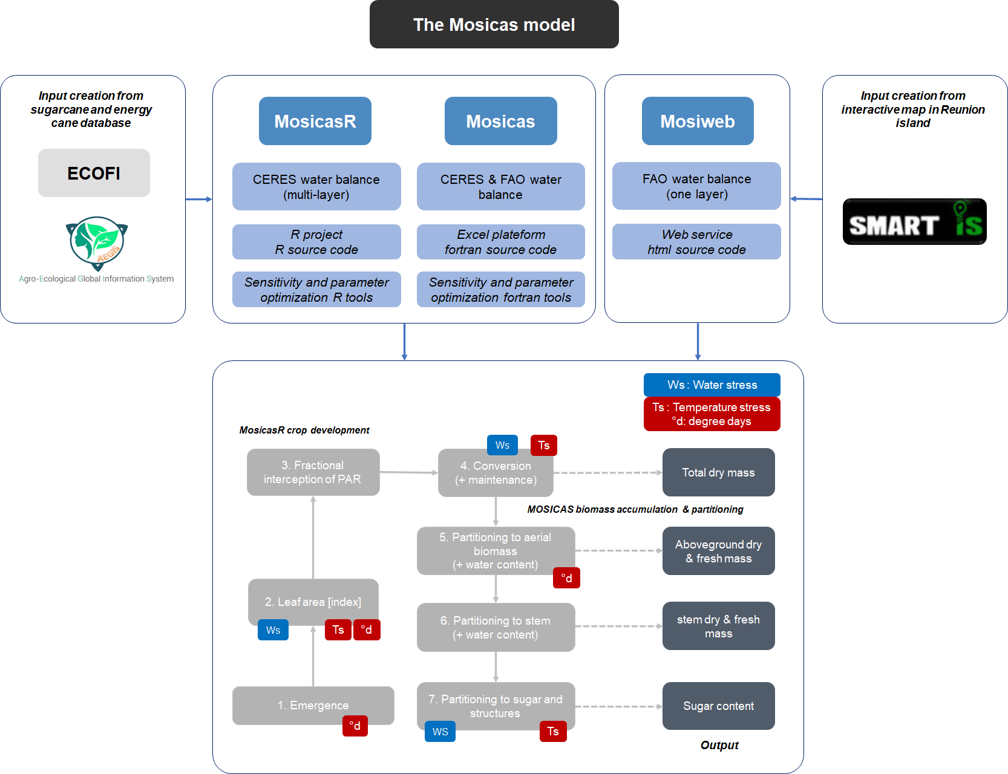

**Fig 1**. Overview of the Mosicas model and its different version (Mosicas, MosicasR and Mosiweb). The main step of crop growth within the model and how water (Ws), temperature stress (Ts) or thermal time( °d) influence growth are presented.

# Model formalism

In the following sections, all plant parameters are indicated as ${name}_{P}$).

## Crop emergence

Emergence occurs when an accumulated thermal energy during following days ($∑T_{Emerge}$) reached a threshold (${emergtt}_{p}$):

$${∑T}_{emerg}= \sum_{planting}^{day}{\frac{{Tmax}_{d}-{Tmin}_{d}}{2}- {emergtb}_{p}}$$

Where ${Tmax}_{d}$ and ${Tmin}_{d}$ are the maximum and minimum daily temperature, and ${emergtb}_{p}$ is a plant parameter and represents the base temperature for emergence.

## LAI calculation

After emergence, the leaf area index (, m2 m-2) for a given day $d$ is a variable that grows as a function of temperature, water stress and intra-specific competition. The daily growth in lai ($glai$) is computed as follow:

$$glai={laigrowth}_{P}*{LAI}_{d-1}*\left(1-\frac{{LAI}_{d-1}}{{laimax}_{p}}\right)*T_{LAI}*{swdf}_{LAI}$$

Where ${laigrowth}_{p}$ is a growth parameter, ${LAI}_{d-1}$, the $LAI$ of the previous day, ${laimax}_{p}$ the maximum leaf area, ${swdf}_{LAI}$ the soil water deficit factor for ${LAI}_{d}$. $T_{LAI}$ is the accumulated thermal energy during the day and is defined as:

$$T_{LAI}= \frac{{Tmax}_{d}-{Tmin}_{d}}{2}- {laitb}_{p}$$

Where ${laitb}_{p}$ is the base temperature for growth in ${LAI}_{d}$.

The leaf mortality due to water stress ($slai$) is calculated as follows:

$$slai={laiwksen}_{p}*\left(1-{swdf}_{LAI}\right)*{LAI}_{i-1}$$

Where laiwksenp is a parameter of sensitivity to water stress.

Finally, ${LAI}_{d}$ is calculated as:

$${LAI}_{d}={LAI}_{d-1}+glai-slai$$

## Intercepted radiation

The daily photosynthetic active radiation intercepted by the canopy ($pari$) is calculated based on the bear-lamber law:

$$pari=0.5*R_{g}*\left(1-e^{-{ke}_{p}*{LAI}_{d}}\right)*\left(1-{p04}_{p}*\left(\frac{R_{g}}{R_{e}}-0.75\right)\right)$$

Where $R_{g}$ is the daily global incident radiation and ${ke}_{p}$ its extinction coefficient within the canopy, ${p04}_{p}$ takes into account for the diffuse radiation effect and $R_{e}$ is the global extraterrestrial radiation.

## Radiation conversion into dry mass

The total dry mass (${dmt}_{d}$) at a given day $d$ is calculated as the sum of the total dry mass of the previous day and the daily growth in dry mass ($gdmt$). The daily $gdmt$ is calculated as:

$$gdmt= {ruemax}_{p}*pari*{swdf}_{rue}*k_{age}*k_{T}$$

And:

$${dmt}_{d}= {dmt}_{d-1}+ gdmt$$

Where ${ruemax}_{p}$ is the maximum radiation use efficiency $,{ swdf}_{rue}$, the soil water deficit factor for radiation use, and $k_{age}$ and $k_{T}$ some parameter defining the effect of maintenance respiration and temperature, respectively.

The effect of temperature on radiation conversion is defined as:

$$k_{T}= 1-{ruetk}_{p}*\sqrt{|T_{diu}-{ruetopt}_{p}|}$$

Where ${ruetopt}_{p}$ and ${ruetk}_{p}$ are plant parameters that define the optimal temperature for radiation use efficiency and a parameter used in the response of this efficiency to temperature, respectively. $T_{diu}$ defines the average temperature during daylight:

$$T_{diu}=0.25 Tmin+0.75 Tmax$$

The effect of maintenance respiration is calculating based on the total dry mass (${dmt}_{d}$)

$$k_{age}=1-{\left({dmt}_{d}*\frac{{p01}_{p}}{{10}^{4}}\right)}^{3}$$

Where ${p01}_{p}$ is a plant parameter to take into account maintenance respiration.

## Dry mass partitioning

The daily total dry mass accumulated ($gdmt$) is firstly allocated to aerial part vs roots. In case of plant crop, the dry mass allocated to roots ($k_{rac}$) decreases with thermal time:

$$k_{rac}={prootini}_{p}-{prootdec}_{p}*sdd$$

And

$$k_{rac}=min⁡(k_{rac}, {prootend}_{p})$$

Where ${prootini}_{p}$, ${prootdec}_{p}$ and ${prootend}_{p}$ are plant parameters (Table 1), and $sdd$ is the sum of degree days since planting (base temperature = 0°C).

In case of a regrowth after harvest, the dry mass allocated to roots is assumed constant and equal to ${prootend}_{p}$. Consequently, the aerial dry mass (${dmaer}_{d}$) and daily dry mass allocated to aerial parts are equal to:

$${dmaer}_{d}={dmaer}_{d-1}+gdmaer$$

And

$$gdmaer=gdmt*(1-k_{rac})$$

The aboveground dry mass is partitioned into stem dry mass (${dmstm}_{d}$), as follows:

$${dmstm}_{d}={dmstm}_{d-1}+gdmstm$$

$$gdmstm=gdmaer* {pstemend}_{p}*\left(1-e^{-\frac{{pstemdec}_{p}}{1000}\left({dmaer}_{d}-{pstemini}_{p}\right)}\right)$$

Where ${pstemend}_{p}$, ${pstemdec}_{p}$ and ${pstemini}_{p}$ are plant parameters (Table 1). Allocation to stem increases with aerial dry mass and starts when ${dmaer}_{d}$ > ${pstemini}_{p}$.

## Sugar accumulation in stem

In case of crop with sugar accumulating in stem (e.g. sugarcane), the model also simulated the sucrose accumulation as a function of stem dry mass, temperature and water stress.

The daily increase in structural dry mass in the stem ($gdmstst$) is calculated as:

$$gdmstst=\left(1- {psugend}_{p}*\left(1-e^{-\frac{{pstrudec}_{p}}{1000}\left({dmstm}_{d}\right)}\right)\right)*gdmstm* T_{stru}* {swdf}_{stru}$$

Where ${psugend}_{p}$ and ${pstrudec}_{p}$ are plant parameters and $T_{stru}$ and ${swdf}_{stru}$ takes into account for temperature and water influence, respectively:

$$T_{stru}=1+{ptrutgrowth}_{P}*(T_{MEAN}- {pstrutb}_{P})$$

Where ${ptrutgrowth}_{P}$ to takes into account the temperature effect on allocation to structure and ${pstrutb}_{P}$ the respective base temperature. $T_{MEAN}$ is the daily average temperature:

$$T_{MEAN}=\frac{{Tmax}_{d}-{Tmin}_{d}}{2}$$

Structural accumulation decrease with water stress, following:

$${swdf}_{stru}=1-({swdf}_{rue}- {swdf}_{LAI})$$

Note that for daily average temperature below ${pstrutb}_{P}$, there is no sucrose accumulation.

## Aboveground and stem water content

Aboveground water content ($humaer$) is assumed constant and equal to ${humaerini}_{P}$ up to a thermal time threshold ($∑T_{humaer}$) which is defined by the plant parameter ${humaerend}_{P}$.

$${∑T}_{humaer}= \sum_{planting}^{day}{T_{MEAN}- {humaertb}_{P}}$$

Where ${humaertb}_{p}$ is a base temperature.

Once reaching this threshold, aboveground water content starts to decrease with thermal time as follows:

$${humaer}_{d}= {humaer}_{d-1}-T_{humaer}* {humaerdec}_{P}$$

Finally, the stem water content is assumed to decrease linearly with days since stem appearance ($d_{stem})$:

$${humstem}_{d}= {humstemini}_{P}-d_{stem}* {humstemdec}_{P}$$

## Water balance overview

Soil water balance, including soil evaporation, soil drainage, plant evaporation and rainfall infiltration, can be simulate using a multi-layer module (based on Ceres) or a one-layer module (based on FAO). In the current study, only the multi-layer module was used and described in the following sections. The multi-layer soil water balance module is based on the CERES adaptation from Gabrielle et al. (1995) slightly adapted to sugarcane (Martiné and Todoroff, 2002).

## Rainfall and irrigation infiltration

Currently, no water interception by foliage and runoff are simulated in the model. Consequently, all water coming from the precipitation and irrigation reaches the first soil layer. The first layer is filled with water up to reaching the saturated soil water content (${swcsat}_{1}$). If infiltration excess the water holding capacity of the first layer, the second layer is filled up to ${swcsat}_{2}$ and so on.

## Gravimetric drainage

Drain occurs under gravimetric forces only and each layer loses water above field capacity independently (within a day) from what may drip from the upper layer. In each layer, drain occurs when soil water content ($swc$) is higher than field capacity ($swcfc$).

In that case the water flux from layer $i$ to layer (, cm d-1) is calculated as:

$${fluxout}_{i}= K_{S}* e^{α*({swc}_{i}-{swcsat}_{i})}$$

Where $K_{S}$ is the soil saturated hydraulic conductivity (cm/d) and $α$ a soil parameter. This downwards water flux is limited by the water available in the layer $i$ as well as the water capacity of the layer below:

$$\left\{\begin{aligned}{fluxout}_{i}<\left({swc}_{i}-{swcfc}_{i}\right)*{dlayer}_{i} \\ {fluxout}_{i}<\left({swcsat}_{i+1}-{swc}_{i+1}\right)*{dlayer}_{i+1}\end{aligned}\right.$$

Where $dlayer$ is the layer width (cm).

Deep drainage is equal to the downwards flux of the last layer.

## Soil evaporation

Potential soil evaporation (, mm d-1) is calculated based on potential evapotranspiration (, mm d-1) and crop $LAI$:

$$\left\{\begin{aligned}eos=etp*\left(1-0.43 LAI\right) ; if LAI<1 \\ eos=\frac{etp}{1.1}*e^{-0.4*LAI} ; if LAI>1 \end{aligned}\right.$$

$$\left\{\begin{aligned}eos=etp*\left(1-0.43 LAI\right) ; if LAI<1 \\ eos=\frac{etp}{1.1}*e^{-0.4*LAI} ; if LAI>1 \\ eos≤\left({swc}_{1}-{swcwp}_{1}\right)*{dlayer}_{1}*10\end{aligned}\right.$$

Soil evaporation is limited by the water available in the first layer down to welting point ($swcwp$).

## Upwards water flow

When soil water content is below field capacity, upwards water flow can reach layer $i$ from layer $i+1$ below (${flowup}_{i}$):

$${flowup}_{i}= K_{S}e^{α\frac{\left({swc}_{i}-{swcsat}_{i}\right)+({swc}_{i+1}-{swcsat}_{i+1})}{2}}*\frac{(e^{\sqrt{\frac{\log\left(\frac{{swcsat}_{i}}{{swc}_{i}}\right)}{γ}}}-e^{\sqrt{\frac{\log\left(\frac{{swcsat}_{i+1}}{{swc}_{i+1}}\right)}{γ}}}-{{(dlayer}_{i}+{dlayer}_{i+1})}/2)}{{{(dlayer}_{i}+{dlayer}_{i+1})}/2}$$

Where $γ$ is a dimensionless parameter that depends on soil texture (Driessen, 1986).

$flowup$ calculation follows the same iterative computation as in drainage, the flow fill the upper layer and empty the lower layer only at the end of the procedure.

## Maximum crop transpiration

Maximum crop transpiration ($ep$) by plant (before limiting by soil water content) is dependent on the maximum crop coefficient (${Kcmax}_{P}$) and approximated by:

$$ep=etp*{Kcmax}_{P}*\sqrt{min⁡(1,\frac{LAI}{3})}$$

According to the approximation, crop coefficient value is reached for $LAI$ higher than 3. $ep$ calculation is limited by $es$ and $etp$:

$$ep≤etp*{Kcmax}_{P}-es$$

The maximum evapotranspiration ($etm$) is then defined as:

$$etm=ep+es$$

## Root growth and potential water uptake

The root front ($rootfront$) is assumed to increase under the influence of temperature only up to a maximum depth ($rootfrontmax$, define in the simulation unit input) as follow:

$$\left\{\begin{aligned}{rootfront}_{d}={rootfront}_{d-1}+\left(T_{mean}-{roottb}_{P}\right)*{rootgrowth}_{P} \\ {rootfront}_{d}≤ rootfrontmax \\ T_{mean}≥{roottb}_{P}\end{aligned}\right.$$

Where ${roottb}_{P}$ is the base temperature for root front growth and ${rootgrowth}_{P}$ the root front growth velocity (cm °d-1).

In each layer $i$ above the root front, the root length density (, cm cm-3) is increasing daily (${drld}_{i}$) and influenced by temperature and water stress:

$$drld={rldmax}_{P}*1.6 {10}^{-2}*\left(T_{mean}-{roottb}_{P}\right)*{rootgrowth}_{P}*{swdf}_{rld}$$

Where ${rldmax}_{P}$ is the maximum root length density (cm cm-3) per soil layer. ${swdf}_{rld}$ is a soil water deficit factor influencing root length density growth in each layer:

$$\left\{\begin{aligned}{swdf}_{rld}=4\frac{swc-swcwp}{swcsat-swcwp} \\ {swdf}_{rld}≤1\end{aligned}\right.$$

Potential root water uptake ($rwu$, cmwater cmsoil-1 cmroot-1) per soil layer is calculated using the empirical equation:

$$\left\{\begin{aligned}rwu=2.67 {10}^{-3}* \frac{e^{62(swc-swcwp)}}{6.68-log⁡(rld)} \\ rwu≤{rwumax}_{P} \\ rwu*rld≤swc-swcwp\end{aligned}\right.$$

Total potential water uptake ($trwu$, mm) of the crop is then calculated as the sum of root water uptake in each layer:

$$trwu= \sum_{layer}{rwu*10}$$

## Actual crop transpiration

Actual plant transpiration is defined as the minimum between total potential water uptake ( $trwu)$ and maximum crop transpiration ($ep$). A water use factor ($wu$ f) is defined as:

$$wuf=min⁡(1,\frac{ep}{trwu})$$

And used to actualized the soil water content in each layer:

$${swc}_{i}={swc}_{i}-\frac{{rwu}_{i}}{{dlayer}_{i}}$$

## Soil water deficit factor for growth

Two soil water deficit factors are calculated for $LAI$ growth (${swdf}_{LAI}$) and radiation conversion into dry mass (${swdf}_{RUE}$):

$${swdf}_{LAI}={\left(\frac{{swdf}_{rf}}{0.94-0.26*\frac{{psilb}_{P}}{ep}}\right)}^{{sthydlai}_{p}}$$

$${swdf}_{RUE}={\left(\frac{{swdf}_{rf}}{1.25\left(0.94-0.26*\frac{{psilb}_{P}}{ep}\right)}\right)}^{{sthydrue}_{p}}$$

Where ${psilb}_{P}$ is a pression parameter defined as 8 according to Brisson 1992 and Slabber 1982, $ep$ the maximum transpiration of the day according to actual canopy, ${sthydrue}_{p}$ and ${sthydlai}_{p}$ are plant parameters defining the sensitivity to water stress.

${swdf}_{rf}$ is a global soil water deficit down to root front and calculated as follows:

$${swdf}_{rf}= \frac{{swc}_{rf}-{swcwp}_{rf}}{{swcfc}_{rf}-{swcwp}_{rf}}$$

Where ${swc}_{rf}$ is the total soil water content down to root front and ${swcfc}_{rf}$ and ${swcwp}_{rf}$ the field capacity and welting point down to the root front.

# Input plant parameter in the Mosicas model

**Table 1**. Mosicas model parameter description depending on each process.

|  |  |  |  |  |
| --- | --- | --- | --- | --- |
| **Process** | **Parameter** | **Description** | **Default value** | |
| **plant** | **ratoon** |
| Emergence | emergtb | Base temperature for stalk appearance (°C) | 10 | 10 |
| emergtt | Beginning of stalk appearance (°Cd) | 200 | 40 |
| Leaf area growth | laigrowth | growth rate of LAI | 0.004 | 0.004 |
| laimax | Maximum LAI (m2 m-2) | 7 | 7 |
| laitb | base temperature for LAI calculation (°C) | 10 | 10 |
| laiwksen | sensitivity of lai to water stress | 0.01 | 0.01 |
| Radiation interception | ke | extinction coefficient | 0.65 | 0.65 |
| p04 | coefficient for diffused radiation effect on conversion. | 0 | 0 |
| Radiation conversion | ruemax | conversion coefficient of intercepted photosynthetic radiation into total dry mass (g MJ-1) | 4.2 | 4.2 |
| ruetopt | Optimum temperature for conversion (°C) | 32 | 32 |
| ruetk | Effect of temperature on conversion. | 0.0015 | 0.0015 |
| p01 | coefficient for maintenance effect on conversion (used in FAO water balance model). | 1 | 1 |
| Dry mass partitioning | prootini | Initial proportion of daily fraction of total DM allocated to roots | 0.7 | 0.7 |
| prootdec | Rate of decrease in proportion allocated to roots with thermal time | 0.0005 | 0.0005 |
| prootend | Final proportion of DM allocated to roots | 0.15 | 0.15 |
| pstemini | Initial proportion of daily fraction of aboveground DM allocated to stem | 200 | 200 |
| ptemdec | Extinction coefficient of daily fraction of aboveground DM allocated to stem | 1.16 | 1.16 |
| pstemend | Final daily fraction of aboveground DM allocated to stem | 0.75 | 0.75 |
| Structural vs sugar partitioning | pstrudec | Extinction coefficient of daily fraction of stem DM allocated to structures | 1.2 | 1.2 |
| psugend | Final daily fraction of stem DM allocated to sucrose | 0.6 | 0.6 |
| pstrutb | Temperature threshold from which fraction of stem DM allocated to structures is decreasing. | 20 | 20 |
| pstrutgrowth | Temperature effect on daily fraction of stem DM allocated to structures | 0.03 | 0.03 |
| Water content | humaerini | Initial above ground biomass water content (%) | 85 | 85 |
| humaerdec | Rate of decrease in above ground biomass water content | 0.006 | 0.006 |
| humaerend | Thermal time begining in decrease of above ground biomass water content (°Cd) | 914 | 914 |
| humaertb | Base temperature for above ground biomass water content | 12.5 | 12.5 |
| humstemini | Initial stem water content (%) | 88 | 88 |
| humstemdec | Rate of decrease in stalk water content | 0.07 | 0.07 |
| Water requirement | kcmax | Crop coefficient for crop evapotranspiration calculation | 1.25 | 1.25 |
| psilb | Pression parameter (mm) for water stress calculation | 8 | 8 |
| sthydrue | Sensitivity to water stress index for mass accumulation. | 0.6 | 0.6 |
| sthydlai | Sensitivity to water stress index for LAI growth. | 0.5 | 0.5 |
| Roots | roottb | Base temperature for root growth (°C) | 10 | 10 |
| rootgrowth | Root growth velocity (cm °d-1) | 0.17 | 0.17 |
| rldmax | Maximum root length density (cm cm-3 soil) | 5 | 5 |
| rwumax | Maximum rate of root water uptake (cmwater cmsoil-1 cmroot-1) | 0.035 | 0.035 |

# Example of application

## Simple simulation run

In progress

## Local sensitivity analysis

A sensitivity analysis was performed on one irrigated ratoon crop cycle from the SYPECAR project (ECOFI database, Christina et al., 2020). The sampling method used was the FAST method on all 36 plant parameters with a 350 sample size (12600 parameter combinations). Each parameter was sampled within ±5% around a central value. Parameter sensitivity was assessed using the fast99 function from sensitivity package.

.

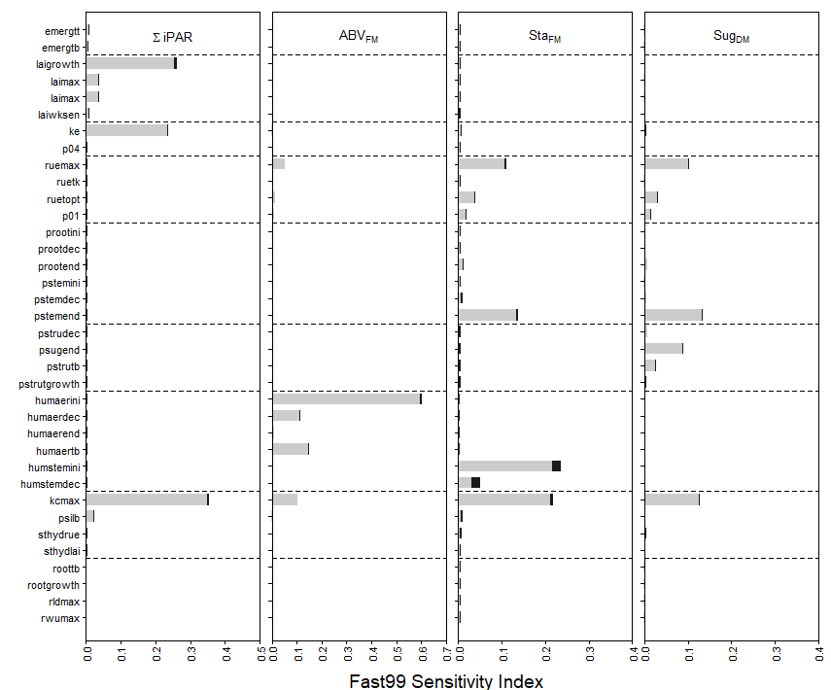

*Fig. 2. Sensitivity index of MOSICAS parameters using the Fast99 methods for different output variables. Indices are presented in blue for an irrigated sugarcane and in red for a rainfed one in the same crop cycle. Light bars indicated the main parameter effect while dark color indicated the interaction effect with other parameters.*

## Local uncertainty analysis

In progress

## Model calibration

In progress

# Model input files

General simulation options are in the “sim” file (SIM_Mosicas.csv and sim.txt in R and Fortran version, respectively). These files can be written from R script (both version) or SimMosicas.xlsm excel plateform (Fortran version only). All the input files are linked to the main data input file “treatment” that give a general description of each simulation unit (i.e. one crop cycle). The system is like a relational database (Fig. 5). The input files can be linked to file containing plant or soil observations (not mandatory). In that case, the name of the observed variables (and unites) should be the same that output.

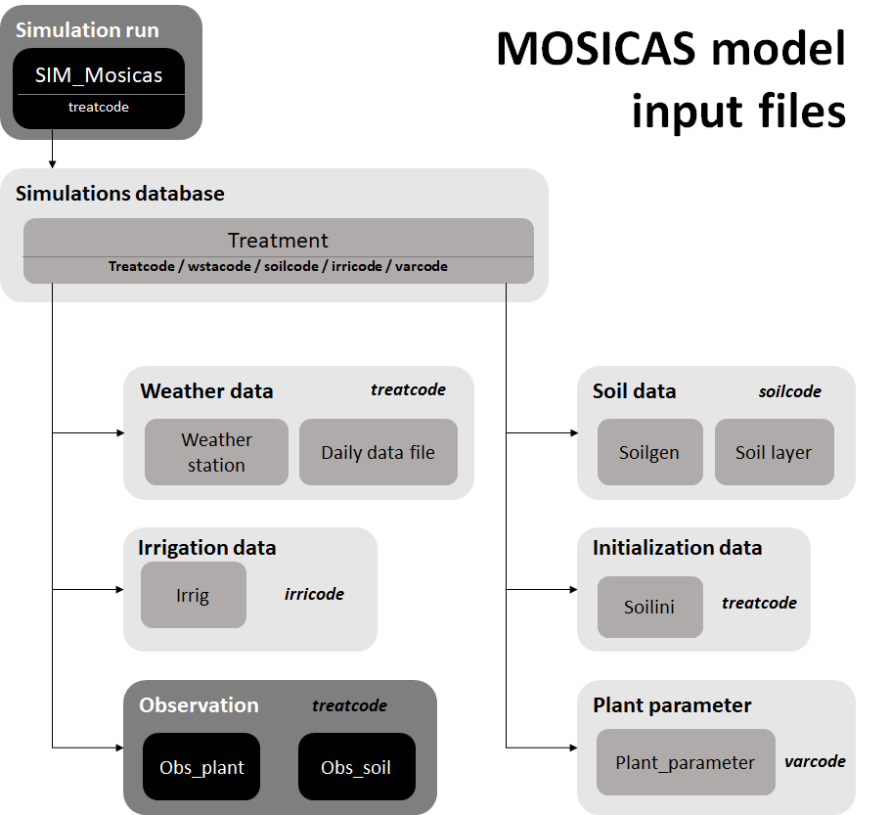

**Fig. 5**. Overview of the Mosicas model input file structure.

**Table 2**. Input name and description

|  |  |  |
| --- | --- | --- |
| **File** | **Input** | **Description** |
| SIM | outname | Output file name |
| watmodel | Water balance model - choice between MOSICASWATBAL (multi-layer water balance) or MOSICASFAO (one layer water-balance) |
| ifreq | Output frequency in days (0 = only at the end ;1 = all day) |
| iobs | Output at observations dates (0 = no, 1 = yes) |
| iwatbal | Water stress effect (0 = no effect, 1 = with effect) |
| inbal | Nitrogen stress effect (0 = no effect, 1 = with effect (not implemented yet)) |
| irrigmode | Irrigation (0= no irrigation, 1 = irrigation read in file, 2 = automatic irrigation) |
| irrigfreq | Irrigation frequency in days (if irrigmode=2) |
| irrigmm | Irrigation quantity per day in mm (if irrigmode=2) |
| nbrun | Number of run |
| run | List of simulated treatcode |
| TREATMENT | nbbgi | Number of buds at plantation (/m2) |
| treatcode | Treatment name |
| cycle | Crop cycle code: 0 for plant crop, 1 for first ratoon, ….) |
| varcode | Cultivar (variety) name |
| rowspace | Row spacing (m) - informative |
| begdate | begining date of simulation : Plantation date or previous harvest date (format: dd/mm/yyyy) |
| enddate | Ending date of simulation: harvest date of the crop cycle (dd/mm/yyyy) |
| trialat | Trial latitude in decimal degrees (+ at the North, - a the south) |
| trialong | Trial longitude in decimal degrees |
| trialalt | Trial altitude (m) |
| soilcode | Soil name (muste existe in SOILGEN table) |
| inisoilvol | fraction (0-1) of the available water capacity at the begining date if not indicated in SOILINI table |
| rootdepth | maximum root depth (cm) |
| irricode | Irrigation code of actual irrigation applied to the treatment. The code and the caracteristics (dates, ammounts, ...) must exist in irrig.txt. |
| wstacode | code of main weather station (weather text file name). Must exist in stamet.txt and the weather text file must exist. |
| WEATHER_  STATION | wstacode | code of main weather station (must be the same that the name of the daily weather file) |
| wsalt | weather station altitude (m) |
| wslat | weather station latitude (decimal degree) |
| wslong | weather station longitude (decimal degree) |
| wsname | weather station name - informative |
| daily weather file | date | date (dd-mm-yyyy) |
| rr | daily rainfall (mm) |
| etp | daily potential evapotranspiration (Pennman-Monteith, mm) |
| tn | Daily minimum temperature (°C) |
| tm | Daily average temperature (°C) |
| tx | Daily maximum temperature (°C) |
| rg | global radiation (MJ/m²/d) |

**Table 3**. Input name and description (2nd part)

|  |  |  |
| --- | --- | --- |
| **File** | **Input** | **Description** |
| SOILGEN | soilcode | soil code name |
| soiltype | Type of soil - informative |
| nblayer | number of soil layer |
| p0 | Treshold for transpiration (0 to 1, generally 0.5).  Used only with water balance using only one layer (MOSICASFAO) |
| ru | soil water capacity (mm) |
| soildepth | soil depth (cm) |
| SOILLAYER | soilcode | soil code name |
| layernum | Number of the layer. Layer 1 is the top layer |
| thickness | Thickness of the layer (cm) |
| swcwp | Soil water content (0-1: cm3/cm3) at permanent welting point (lower limit) |
| swcfc | Soil water content (0-1: cm3/cm3) at field capacity (drained upper limit) |
| swcsat | Soil water content (0-1: cm3/cm3) at saturated water-holding capacity |
| bdens | Bulk density (g/cm3) |
| SOILINI | treatcode | Treatment name |
| layernum | layer ID |
| swc | soil water content (cm3/cm3) |
| irrig | irricode | irrigation code of actual irrigation applied to the treatment. |
| irritype | Type of applied irrigation - informative |
| efficiency | Fraction of irrigated water that actually reached the soil surface |
| irridose | Amount of irrigated water (mm/d) |
| dateirri | (dd-mm-yyyy) |

# Model output file

**Table 4**. Output variable code and description

|  |  |
| --- | --- |
| **Code** | **Description** |
| nosimul | Simulation number |
| treatcode | Treament name |
| lati | Latitude |
| longi | Longitude |
| alti | altitude (m) |
| dates | Date of output (dd-mm-yyyy) |
| age | Age in days since plantation (plant crop) or last harvest (ratoon) |
| agestem | Age since appearance of millable stalk biomass (days) |
| glai | Simulated Green leaf area index (m2/m2) |
| ei | Simulated Interception efficiency (0-1) |
| stemnb | Simulated Number of alive stalks (/m2) |
| stemfm | Simulated Fresh mass of millable stalks (T/ha) (= Yield) |
| stemdm | Simulated Dry mass of millable stalks (T/ha) |
| stemwc | Simulated humidity of millable stalks (% fresh mass) |
| stemsu | Simulated sucrose production (T/Ha) |
| stemsuc | Simulated sucrose content in millable stalk (% fresh mass) |
| rue | radiation use efficiency (g/MJ) |
| agrfm | Simulated fresh mass of aboveground biomass including trash and dead stalks (T/ha) |
| agrdm | Simulated dry mass of aboveground biomass including trash and dead stalks (T/ha) |
| agrwc | Simulated humidity of aboveground biomass including trash and dead stalks (% fresh mass) |
| bladm | Simulated dry mass of total blades (T/Ha) |
| rootdm | root dry mass (t/ha) |
| hv1 | Simulated soil water content (cm3/cm3) of layer 1 |
| hv2 | Simulated soil water content (cm3/cm3) of layer 2 |
| hv3 | Simulated soil water content (cm3/cm3) of layer 3 |
| hv4 | Simulated soil water content (cm3/cm3) of layer 4 |
| hv5 | Simulated soil water content (cm3/cm3) of layer 5 |
| hv6 | Simulated soil water content (cm3/cm3) of layer 6 |
| stock | Simulated available water capacity down to soil depth (mm) |
| stockfr | Simulated available water capacity down to front root (mm) |
| runoff | Simulated daily runoff (mm/d) |
| deepdrain | deep drainage below the deepest layer (mm/d) |
| rootfront | depth ot the deepest roots (cm) |
| droot1 | Simulated root length density of layer 1 |
| droot2 | Simulated root length density of layer 2 |
| droot3 | Simulated root length density of layer 3 |
| droot4 | Simulated root length density of layer 4 |
| droot5 | Simulated root length density of layer 5 |
| droot6 | Simulated root length density of layer 6 |

**Table 5**. Output variable code and description (2nd part)

|  |  |
| --- | --- |
| **Code** | **Description** |
| precip | Rainfall of the day (mm) |
| tmin | Minimum temperature of the day (mm) |
| tmax | Maximum temperature of the day (mm) |
| tmean | Actual average temperature of the day (mm) |
| solrad | Global incident radiation of the day (MJ/m2) |
| etp | Evapotranspiration Pennman-Monteith of the day (Eto mm). |
| etm | Maximum evapotranspiration of the day (mm). |
| etr | Actual evapotranspiration of the day (mm). |
| tmp | Maximum transpiration of the day (mm) |
| trp | Actual transpiration of the day (mm) |
| eos | potential soil evaporation (mm/d) |
| es | actual soil evaporation (mm/d) |
| swdef | Soil water defficiency index of the day (0-1) |
| swdfrue | Water defficiency index of the day (0-1) for biomass acuumulation |
| swdflai | Water defficiency index of the day (0-1) for leaf growth |
| swan | Water anaerobic index of the day (0-1) |
| pari | Intercepted photosynthetic radiation of the day (MJ/m2) |
| stmean | Sum of mean temperatures since beginning of simulation ((Tempmn+tempmx)/2) |
| spar | Sum of incident photosynthetic radiation (solrad/2) since the beginning of simulation (MJ/m2) |
| spari | Sum of intercepted photosynthetic radiation since the beginning of simulation (MJ/m2) |
| spr | Sum of rainfall since beginning of simulation (mm) |
| sirr | Sum of irrigation since beginning of simulation (mm) |
| setp | Sum of Evapotranspiration Pennman-Monteith (eeq) since beginning of simulation (mm) |
| setm | Sum of maximum evapotranspiration (etm) since beginning of simulation (mm) |
| setr | Sum of actual evapotranspiration (etr) since beginning of simulation (mm) |
| stmp | Sum of maximum transpiration (tmp) since beginning of simulation (mm) |
| strp | Sum of actual transpiration (trp) since beginning of simulation (mm) |
| swdefm | Average soil water defficiency index since beginning of simulation (0-1) |
| swdfruem | Average water defficiency index since beginning of simulation (0-1) for biomass accumulation |
| swdflaim | Average water defficiency index since beginning of simulation (0-1) for leaf growth |
| sdrain | Sum of drained water since beginning of simulation (mm) |
| srunoff | Sum of runoff since beginning of simulation (mm) |
| sevap | Sum of soil evaporation since beginning of simulation (mm) |
| durjour | Day length of the day (h) |
| srgx | Global extraterrestrial solar radiation of the day (MJ/m2) |