Rocket League Agent

Phase2 **(implementation & testing stages)**

Stage #1:

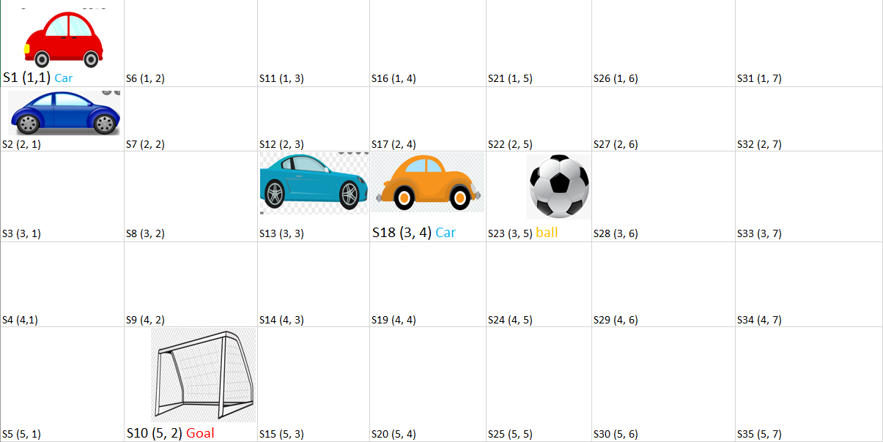In order to traverse in our problem, since it depends on distance between objects and target we choose to represent our problem as a grid

* the grids are an representation of the playground
* moving from a grid to another is a distance of one
* In this we have two only states, driving to reach to the ball and dribbling with the ball until scoring
* Other cars are considered as an obstacle that I cannot traverse through
* For instance, in the below grid if our agent is at S1 coordinate (1,1), S2 is an obstacle so it cannot traverse
* f(n) = g(n) + h(n)
* g(n) = cost so far to reach to , as we said before we determine moving from state to another (grid to another) as a cost of 1
* h(n) = estimated cost from n to goal, we assume that it is the Euclidian distance between initial to our ball in case of driving or the goal in state of dribbling