

**Faculty of Engineering & Technology – Computer Science Department**

**SOFTWARE ENGINEERING – COMP433**

**First Semester 2023 – 2024**

**TimeSymph-Pal**

**Prepared By:**

Pierre Backleh – 1201296

Christina Saba – 1201255

Samuel Tannous – 1201123

Hussein Radwan – 1200475

Instructor: Dr. Ahmad Sabbah

Date: 7th Nov. 2023

**Table of Contents**

Team Formation 4

Introduction 5

System Features 7

**Data Analysis** 7

**Communication Analysis** 7

**Scheduling Analysis** 8

**Non-functional Requirements** 9

Software Development Process 10

Use case Diagram 11

**Actors** 12

**Description** 12

User and System Requirements (UR&SR) 14

**Functional URs and SRs** 14

**Non-functional System Requirements (NF-SR)** 18

Class Diagram 20

Use-case Specification Documents 21

Employee Initiates Leave Request Use-case (Christina Saba 1201255) 21

**1.** **Basic Description** 21

**2.** **Flow of Events** 21

**3.** **Special Requirements** 23

**4.** **Entry Conditions** 23

**5.** **Exit Conditions** 23

INITIATE LEAVE REQUEST - UML-Activity Diagram 24

Manager Approve Requests (Pierre Backleh 1201296) 25

1. Brief Description 25

2. Flow of events 25

3. Special Requirements for the "Approve Requests" Use Case: 26

4. Entry Conditions for the "Approve Requests" Use Case: 27

4.3 Active Requests Exist 27

5. Exit Conditions for the "Approve Requests" Use Case: 27

Manager Approve Request - UML-Activity Diagram 28

Update Balance use case (Samuel Tannous 1201123) 29

**1.** **Basic Description** 29

**2.** **Flow of Events** 29

**3 Special Requirements** 30

**4** **Entry Conditions** 30

**5** **exit Conditions** 31

Update Balance – UML – Activity Diagram 31

Employee Requests Vacation (Hussain Radwan - 1200475) 32

1. Brief Description 32

2. Flow of Events 32

3. Special Requirements 33

4. Entry Conditions 33

5. Exit Conditions 33

Vacation Request - UML-Activity Diagram 34

Design Goals 35

Component Diagram 35

Deployment Diagram 38

# Team Formation

Our team’s name is CSPH and consists of 4 members:

* Pierre Backleh – 1201296
* Christina Saba – 1201255
* Samuel Tannous – 1201123
* Hussein Radwan – 1200475

Since planning for the project, we decided to use zoom as an online meeting in addition to face-to-face meetings for the future phases. We have Christina as our team leader and divided the work on each member fairly for a specified deadline, then after there is a meeting to discuss the achievements of each one, then arrange the ideas and details in an agreed way.

# Introduction

The Palestinian state's Ministry of Higher Education and Scientific Research understands the need to update its HR management systems in a world governed by technological evolution. A creative solution is required to replace the manual and costly inefficiencies HR processes currently in use. Our team is developing an advanced HR management system is a web application called "TimeSymph-Pal" in collaboration between team members which is specifically designed to meet the specific requirements of the Ministry and follow to Palestinian labor laws.

Under the guidance of Palestinian Labor Law and Civil Service Law, the "HRMS Evolution" deals with the Ministry's many issues, including managing leaves and keeping track of attendance. This system will be created accessible to both managers and staff in the form of an application. It has a number of features designed to improve productivity and make it easier to access employee data and work schedules. Employee registration through a unique ID connected to their biometric information is one of these features. Furthermore, this application allows remote work via the internet, providing managers with easy-to-follow steps and procedures to access employee details.

In order to guarantee accurate tracking of attendance records and their analysis to produce reports and statistics, the application also has an extra set of features. These reports are helpful for the work manager's overall review, allowing for efficient handling of overtime, emergencies, and other issues. The system intelligently links working hours to leave calculations, to ensure accurate balance tracking and adherence to labor laws. As a result, the application is prepared to provide data analysis with professionalism and efficiency.

Our application also gives employees the option to change or cancel authorized vacation time. This feature is supported by clearly defined policies and guidelines, which guarantee that modifications are handled effectively and in accordance with accepted practices. It gives managers and staff the flexibility to adjust to changing conditions while preserving clear guidelines about the vacation modification procedure.

Additionally, our system can handle the early and late departures of employees. It establishes out specific procedures for handling these situations, including documenting events and implementing the required corrective actions. This feature ensures that changes to the work schedule are handled appropriately and in accordance with business policies.

One essential component of the benefits our system offers to employees is annual leave. A standard two-week annual leave is provided to all employees for each working year. It is important that employees are encouraged to utilize the time given to them off by the fact that annual leaves cannot be gained for a period longer than two years. Employees can comply with labor laws and preserve a positive work-life balance due to these yearly leave rules.

Effective communication between employees and their manager can be challenging at certain points. There may be an issue if an employee is unable to communicate with the manager directly to get particular details, like reviewing the reasons for their leave rejection. This problem can be resolved by turning on the Private Messaging feature, which allows managers and employees to communicate directly.

Data management and storage are among the issues that modern companies face, these can be difficult at times. The program might need a lot of storage space, which could be a challenging issue to resolve. One of the suggested solutions is to use cloud storage, which enables employees to use it while working from home instead of using the company's main server.

Weak internet connections also cause problems, which can lead to data storage errors and mistakes when calculating the total working hours. One of the solutions proposed is to add an offline mode feature to the application to avoid this problem.

Overall, the application can be accessed by employees and managers and make their communication easier with a user-friendly interface.

# System Features

Any software engineer needs to specify all the features and data in order to start planning and building a web application. The main features of the system are determined in the following:

## **Data Analysis**

1. Employees’ personal information indicating their profiles including their contact details such as age and gender, job title, and department. In addition to using biometric attendance machine such as their face ID and username and password to recognize when logging in to ensure a secure login system that only account users can access the HRMS. The data can also be transmitted to a cloud-based system for storage and analysis.
2. The system supports access for the database of employees such as searching and updating data.
3. Daily reports and statistic which are controlled and represented daily according to the HR needs. These reports include:
4. Attendance reports which analyze the patterns, early departures, late arrivals.
5. Leave reports elaborate the leave requests, approvals, rejections, and balances while indicating the reasons and type for leave and the duration.
6. Statistical reports analyzing each department based on the average percentage of the number of leave usage and absence to specify the historical data to help with future plans and policy adjustments based on the given performance.
7. It allows employees to log their start and end times working hours, whether they're

in the office or working from home. Real-time tracking provides an accurate record of when employees are actively working.

1. The employees can access their historical absence and leave information, work hours, and performance.
2. Employees can request different types of leave (sick, vacation, personal days) through the system. Managers can review and approve these requests, and a calendar view helps visualize approved leaves.
3. Employees can upload supporting documents for their leave requests, such as medical certificates. This feature organizes documentation and makes it readily available when required.
4. The HRMS tracks the remaining balance of vacation days for each employee. It provides a clear overview of accrued and utilized vacation days, helping both employees and managers to plan and manage time off effectively.

## **Communication Analysis**

The system provides a daily communication which involves staying up to date with the latest news by refreshing the newsfeed regularly.

The application offers to enhance communication between managers and employees is sending notifications for urgent updates to leave request applicants, indicating the status of their submitted requests and whether they have been approved or denied, in addition to the date and description of the leave.

There’s also an online discussion forums and messaging technique to facilitate the connection between the employees and management for commenting and discussing a current situation or ask questions or share information. It can also be connected and integrated within the emails of employees to notify them about their leave status or upcoming schedules or important update or changing of performance.

The application can also provide an AI-based chatbots which can automatically provide instant response to employees regarding their leave and absence balances, requests and related policies.

## **Scheduling Analysis**

In order for the system to avoid any technical or unexpected issues, scheduling can be an important feature to arrange the critical incidents. Using the application in many cases such as:

1. Each employee is required to come to the workplace daily at the time specified for attendance. If there was any absence for a reasonable excuse reviewed and approved and accepted by the manager then the period of absence is deducted from the annual leave balance, and when it runs out, then it is deducted from the salary of the employee.
2. Each employee is given a credit of 7-hour leave each month, the employee should be able to apply to fill the approved departure form and with the acceptance of the direct manager based on the excuse and date. If the permissible limit is exceeded, the increase will be deducted from the annual leave balance, and when it runs out, it will be deducted from the salary.
3. The application would be able to set calendars in order to send reminders to the employees and display their scheduled leaves, absence, and workhours to ensure the visibility of them and ensure avoiding any scheduling conflicts.
4. The system studies sick leaves excuses applied by the employees, where they are asked to obtain a medical report stating the cause and diagnosis of the illness, the name and address of the doctor, the date the report was issued, and the days of sick leave that the doctor addresses. The employee is given an official paid sick leave of 14-days.
5. The application also supports maternity leave, when the employee gives birth, she is given a 14-week paid leave for baby care if the employee has spent at least 12-months in the company, if she’s spent 6-months she’s given 10-weeks of paid leave. The male employees whose been given a child has a paid leave of three days to help with the baby.
6. There is also a consideration for up to second degree relative death excuse absence, the employee is given three consecutive days leave starting from the day of death, provided that he/she submits documents proving the case of death.
7. The Muslim employees may obtain paid Hajj leave up to 15 continuous days including Eid Al-Adha leave only once throughout his/her work duration with the company. This leave is granted only after at least 5 years of service and especially for a certain percentage annually in light of work requirements, in order to ensure continuity of work.

## **Non-functional Requirements**

1. Performance: This requirement ensures that the HRMS responds quickly to user actions, providing an easy experience. A short response time enhances user satisfaction and productivity by minimizing waiting periods with maximum 2 seconds to open the system and 3 seconds for various transactions applied.
2. Scalability: Scalability is essential because it ensures that the HRMS can handle an increase in users without seeing a significant loss in performance. This is critical for handling an increase in the number of employees that use the system.
3. Reliability: this indicates that the HRMS is available and operating nearly all of the time. This high degree of dependability reduces interruptions and ensures that employees have access to the system when they need it. The system undergoes a controllable failure during late times especially after work hours at midnight for maximum 2 hours a month.
4. Security: Encrypting user data during transmission and storage prevents unwanted access to sensitive information in addition to traffic encryption.
5. Portable: the system ensures easy installation and updating techniques, reducing complexities and technical requirements. In addition to the ability to work in different operating systems such as Windows and macOS and can run on computers or mobile phones allowing users to access the system's features and functionalities and handling the probability of having various kinds for devices while supporting secure access data transfer across these platforms for data privacy and maintenance.
6. User-friendly interface: installing creative and easy designs to facilitates usage, access, and navigations across multiple transactions in multiple platforms used by different skilled employees.

The HRMS system is enhanced with new features that solve important business issues. Using face recognition makes logins super secure. Storing data in the cloud not only keeps things safe but also helps analyze information better. Daily reports help manage the work smartly, and tracking working hours in real-time is a good addition, especially for remote work. The system simplifies communication with daily news updates, and everyone can chat and discuss things online. Managers can notify employees about urgent leave updates. It even connects with emails to keep everyone in the loop about leave status and important info. Plus, there are smart chatbots ready to answer questions about leave and policies in a snap this feature is really a good addition. Scheduling is a key feature in the system that helps everything to be accurate. The system uses calendars to remind employees of schedules, leaves, and work hours, preventing scheduling conflicts. Overall, these features make HR tasks easier, safer, and more efficient.

# Software Development Process

The HR Management System project of the Palestinian state's Ministry of Higher Education and Scientific Research has adopted the Incremental Development software development process. This approach offers several benefits that cater to the project's complexity and requirements. The Incremental Development process allows the project to progress in manageable segments, each focusing on specific features, ensuring steady and measurable progress. This iterative approach facilitates efficient development and enables the early delivery of essential features, such as attendance tracking and leave management, providing immediate value to the Ministry and its employees.

The flexibility and adaptability of Incremental Development are among its key strengths. This approach handles change well when the needs of the business can evolve. New features can be integrated easily, and existing features can be modified in subsequent increments without disrupting the entire development process. These changes are well aligned with potential changes in service delivery requirements, and ensure that the system remains responsive to evolving needs.

Stakeholder engagement is essential to project success, and incremental improvements encourage ongoing communication. After each increment, stakeholders can provide feedback, ensuring that the system is well aligned with their expectations. This ongoing feedback enhances the relevance and usefulness of the program, making it a valuable asset for the Ministry and its staff.

Furthermore, increased mobility facilitates effective risk management. By addressing risks incrementally, the company can identify and mitigate issues earlier in the development process. Every improvement is rigorously tested, allowing defects and challenges to be identified and fixed quickly. This approach reduces project risk and ensures system stability and reliability.

Cost efficiency is another benefit of high growth. Resources can be allocated more efficiently by focusing on specific areas in each development. This targeted allocation provides for more efficient budget management, ensuring that resources are used more efficiently for the most important projects. This process contributes to a more cost-effective project cost by providing a high-quality finish product.

Moreover, incremental Development increase time efficiency. This often results in the expedited delivery of key features, allowing the ministry to deploy manpower faster. Agile implementation immediately improves human resource management processes and improves service delivery efficiency and effectiveness.

To summarize, Incremental Development emerges as the suitable choice for this project due to its capacity to provide iterative progress, deliver essential features early on, accommodate evolving requirements, involve stakeholders effectively, manage risks efficiently, optimize costs, and enhance time efficiency. These attributes position Incremental Development as the ideal approach to ensure the successful development and implementation of the HR Management System for the Palestinian state's Ministry of Higher Education and Scientific Research.

# Use case Diagram

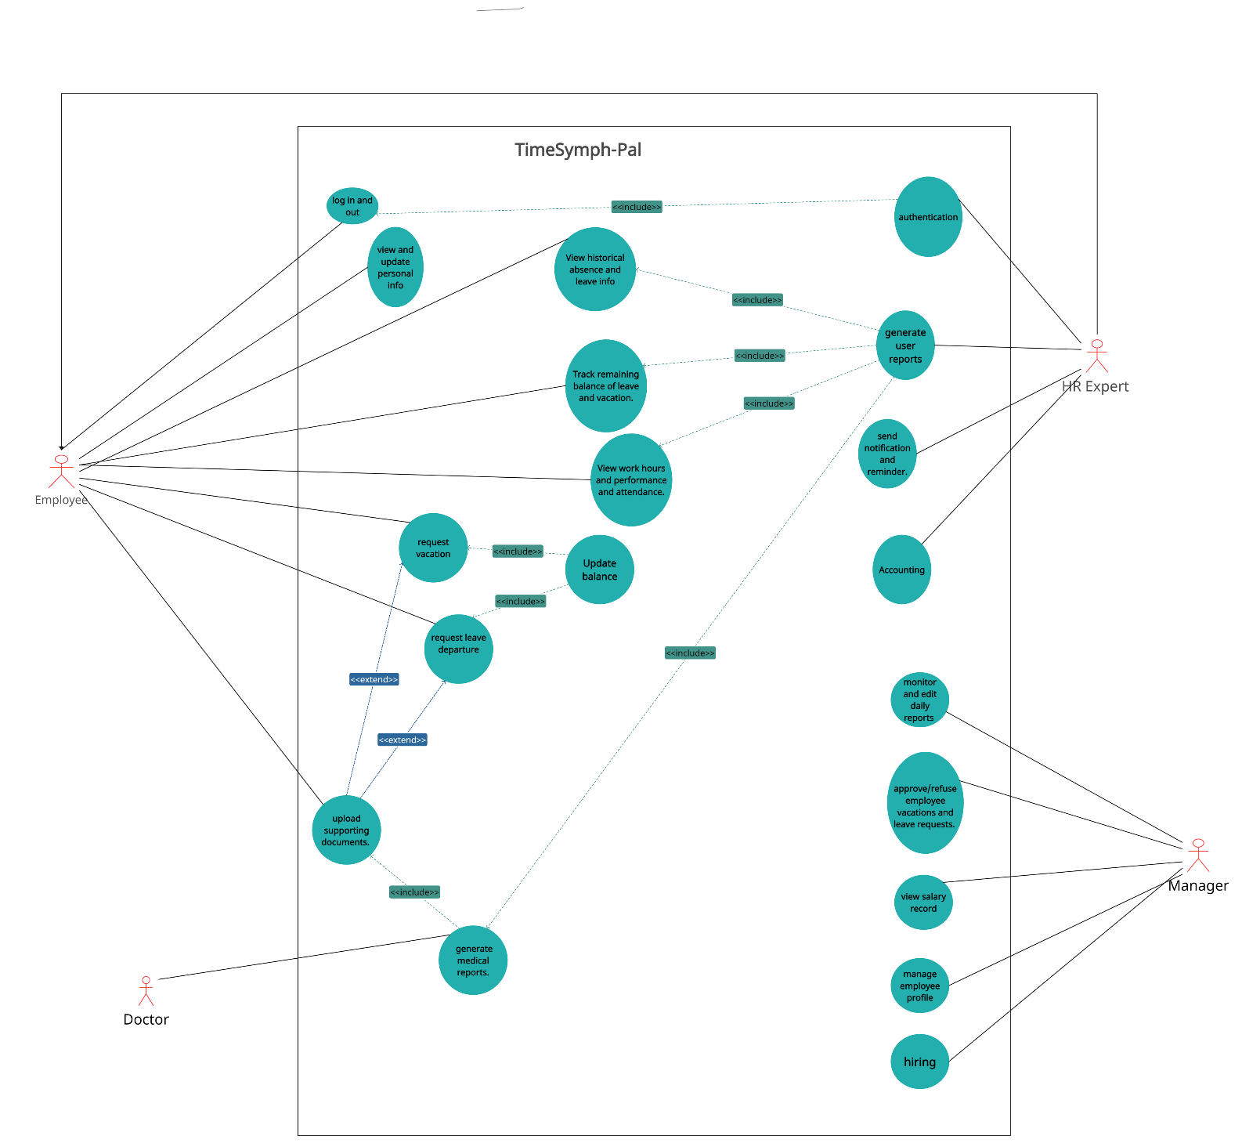The use case diagram is displayed below in figure1:

Figure : Use case Diagram

## **Actors**

1. Primary Actors:
2. Employee
3. Manager
4. HR Expert
5. Secondary Actors:
6. Doctor

## **Description**

The use case diagram outlines the various tasks that are performed within the system:

1. User login and out of the system: allows the employee to securely and privately enter their own account using biometric registration or username and password.
2. View and Update personal info: the employees have the ability to view and edit their personal data including contact information, age, username and password, department, etc.
3. View the generated reports: employees can view and track their personal reports which are generated by the HR department explained in 3.1.

3.1 HR Expert generates user reports: HR expert has the ability to generate the categorized reports, these reports include the historical absence and leave info, remaining balance of leave and vacation, work hours, performance, attendance records, and medical reports. They can be view by employees, and edited by the managers.

1. Request leave: each employee can request their leave from the manager by initiating and submitting the request specifying the type and start and end dates, and wait for the approval of the manager. Then when approved, the balance is updated, discussed in details in 5.1
2. Request Vacation: Each employee can request their vacation request from their manager, specifying the desired vacation dates, duration, and any additional details. Then when approved, the balance is updated, discussed in details in 5.1

5.1 Update Balance: when the request is submitted and approved by the manager, the leave or vacation request balance is deducted based on the days requested, if the limit is exceeded then the salary is deducted accordingly.

1. Upload Supporting Documents: if the employee submits a request whether a leave or vacation one, then they should upload reasons such as supporting documents which can be a medical report generated by the doctor or any other attachments based on the type.
2. Employees upload supporting documents: they are asked to support their leave request excuses by applying a candid reason in addition to uploading supporting attachments and certificates based on the type of request submitted.
3. HR Expert ensure the authentication of system: HR ensures all data is encrypted which prevents any unauthorized access to user data during logging in, data transmission or storage.
4. Send notification and reminders: HR department keeps all the employees informed of the various scenarios including the leave request approval or denial, attendance tracking, and upcoming or urgent schedules and events.
5. Accounting: HR expert manages the financial transactions, when the employee takes a leave or vacation, the system deducts the leave balance based on the policies and laws applied. If the employee exceeds the available leave or vacation balance, the system deducts the salary for the given days.
6. Authentication: HR expert makes sure that each employee is limited within the accepted access and each can be in their own personal account where no other employee can manage to interfere with other’s data.
7. Generate Medical reports: the doctor can be assigned to generate medical certificates based on the medical diagnosis of the sick leave request submitted to support their excuse, which then can be added to the reports of that employee.
8. Hiring: Manager has the ability to add, edit, or delete an employee based on their job title, department, and responsibilities, by reviewing the integrated HR data reports and indicate the official position needs to ensure the employee’s lifecycle experience.
9. Monitor and edit daily reports: the manager has the authority to monitor and edit any data records of each employee which are saved in the reports which are categorized and generated by HR expert.
10. Approve or refuse the leave or vacation request: the manager has the authority to approve or deny the submitted leave or vacation request, based on the feedback uploaded by the user and he/she can apply reasons for the approve or denial by the private and easy communication between each employee and manager built by the system.
11. Manage employee profile: managers have the capabilities to view and edit each employee’s profile, by accessing their personal data such as contact details, personal preferences, and the historical timeline of the employee's activities.
12. View salary records: the manager can click on an individual name then view their salary in details such as base salary, deductions or bonuses which are organized based on time periods monthly or yearly.

# User and System Requirements (UR&SR)

## **Functional URs and SRs**

**UR1:** The user should be able to login and logout of the system.

**SR1.1:** The program shall provide for every user a secure login to the system by providing a unique username and password for authentication.

**SR1.2:** All users should be able to access their personalized dashboards, which will lead the user to access all the features and the necessary information based on their roles after successfully logging in.

**SR1.3:** In order to maintain security, the system should have a session timeout feature that automatically logs users out after a specific time of inactivity.

**SR1.4:** The system should provide multi-factor authentication options. Making users use biometric scans such as face ID to authenticate themselves and improves security even more.

**SR1.5:** The system should keep a full record of all login and logout events, including timestamps and user IDs. This will enable audit trails for security analysis and guarantee user responsibility.

**SR1.6:** Users should be able to reset their passwords through a safe verification process by using the "Forgot Password" feature of the system.

**SR1.7:** The user should be able to edit and manage their profiles, including changing security settings, personal details, and passwords.

**UR2:** Manager should have the capability to monitor and edit team-related details.

**SR2.1:** The system shall provide the capability for the manager to monitor all the activities of employees and the system will offer the manager with monitoring interface that will enable real-time tracking of employee activities, such as work schedules, leave requests, and attendance records.

**SR2.2:** The system will automatically send managers notifications. These notifications will include timely updates on critical events, like pending leave requests.

**SR2.3:** Role-based access controls built into the system will guarantee that only managers with the proper authorization can view and modify employee-related data.

**SR2.4:** Managers should be able to track and control the leave requests that the employees have submitted, having the power to accept or reject requests as well as add remarks or suggestions.

**SR2.5:** The system should be able to access each team member's entire profile, which includes contact details, job descriptions, and past performance information.

**UR3:** The Employee should be able to request leave departure or vacation by initiating and submitting them.

**SR3.1:** The system shall feature a user-friendly form for the employees to initiate and submit the leave or vacation request.

**SR3.2:** The system should specify the various categories of leaves including personal days, sick, or vacation.

**SR3.3:** The request status can be one of the following: approved, denied, or pending.

**SR3.4:** The system should capture the following data, the leave request type, reasons of leave, duration including start and end time, and additional supporting documents.

**SR3.5:** The system offers a document upload advantage for any document attachments such as medical certificates supporting their excuses so that the employee will be capable of providing detailed reasons for the leave or vacation request.

**SR3.6:** The system shall send the employees the confirmation notification of a successful submission of the request.

**SR3.7:** The system should notify the employees informing them of the approval or denial of their leave or vacation requests.

**SR3.8:** The system shall update the leave or vacation balance of the employee after the request has been submitted and approved by the manager.

**SR3.9:** The system offers a calendar so that each employee can only see their personal regular work schedule, in addition to their historical leave periods records and absence patterns which are color-coded for easier identification. Furthermore, the system should allow the user to check and visualize their pending leave or vacation request to clarify that they demanded a time-off and are waiting for the manager’s approval.

**UR4:** The Employee shall be able to easily maintain successful communication with the manager.

**SR4.1:** The system shall provide direct private messaging between each employee and the manager for discussions including leave requests, applying their excuses, or sharing important notes.

**SR4.2:** The system shall ensure timely responses by setting a notification mechanism to notify the manager or employee of the latest messages.

**SR4.3:** The system shall integrate with each employee’s email, in order to have a synchronized connection so the manager can be able to send the leave and vacation status and upcoming schedules.

**SR4.4:** The system’s messaging shall be integrated with the HR data enabling the employees to directly access their performances or leave balances.

**SR4.5**: The system’s discussion should apply multiple languages by selecting their preferred language for easier communication.

**SR4.6:** The system introduces an AI-based tool which automatically responds to the employee in regards of the absence or attendance policies for the type of request submitted by the user.

**UR5:** As an employee the user should be able to view or add to their own record in the database, and as a manger the user should be able to view, add, and edit all records in the database.

**SR 5.1:** The system should have interface for the employees and managers to interact with the database.

**SR 5.2:** The system should have tables for employee and manger with the following fields: name, email, address, rate, and ID.

**SR 5.3**: The system should include a control to make sure that only managers can add and edit other employees’ records.

**SR 5.4**: The system should have an action table for the Employees and Managers Actions with a relation between employee, action, and manager tables.

**SR 5.5**: The system should record the details such as who made the changes in the database and in what time and the specific changes then store the record in actions table.

**SR 5.6** The system should have a notification system to alert the managers about the changes in the database such as the edits and additions in database.

**SR 5.7** The system should provide errors for invalid additions or edits.

**SR 5.8** The system should restrict any unauthorized access to the database and interfaces.

**UR6:** The Manager should be able to deny or approve the requests applied by the employees

**SR6.1:** The system should have a notification system in the interface to inform the manager for the requests’ details submitted with a message written in details such as which employee sent the request, what request type, start and end time, and the reasons and documents attached.

**SR6.2:** The system should have an interface that allows the managers to review the submitted requests details and have the ability to reply to that employee.

**SR 6.3**: The system should inform and notify the employee of the manager actions details such as an approval or denial with the feedback.

**SR 6.4**: The interface should have an action buttons for enabling the managers to approve or deny the requests.

**SR6.5**: The interface should have an additional button for enabling the manager to review all their employees’ related decisions.

**SR6.6**: The interface should have a comment field for managers to comment the reasons for approval or denial and give the related feedback.

**SR6.7**: The system should control the authority access by ensuring that only managers can approve or deny the requests.

**UR7:** Employees should be able to view reports based on their work hours, performance, historical absence, attendance, and health diagnosis.

**SR7.1:** the system shall collect the login details, attendance records, achievements, medical details, and working start and end times for each employee.

**SR7.2:** Reports should be visually appealing, with graphs and charts for easy understanding of the record and data included.

**SR7.3:** the system should show a list of the report types: the report for work hours, and attendance, the historical vacations, absences and leave record report, the performance report, and finally the medical report.

**SR7.4:** The system shall generate a clear and detailed report of the working hours and attendance through an analysis of daily, weekly, and monthly working hours, along with any starting and ending intervals chosen by the employee, this report should also show the late arrivals.

**SR7.5:** The performance report should highlight achievements, providing a comprehensive overview of the employee's contributions.

**SR7.6:** The absence report should display historical data on leaves taken, categorized by leave types, and should be filterable by date range also the system shall display the remaining balance of vacation days and leave.

**SR7.7**: Medical reports should include details such as the cause and diagnosis of the illness, treatment plans, and any accommodations recommended from the medical details.

**SR7.8:** The system allows the employee to export their reports in common formats (e.g., PDF or Excel) for offline access or sharing with managers.

**UR8:** The HR expert can view the accounting functionalities and access full financial management.

**SR8.1:** The system should support the recording and categorization of all expenses which is the electricity and water expenses, allowing for detailed tracking and analysis.

**SR8.2:** The system provides a Linkage with the leave request and attendance systems to automatically adjust payroll calculations based on employee leave and attendance records, and check if the employee is out of balance for the limited annual leave, if so a discount of 10 dollars for one hour of leave and 80 dollars for a day of absence from the total salary.

**SR8.3:** The system will produce detailed financial reports that can be seen by the manager only, such as balance sheets, and income statements.

**SR8.4:** The system should create a link with banking services to facilitate transactions and real-time financial updates.

**SR8.5:** The system provides a salary record view for each employee and the facility to edit each salary.

## **Non-functional System Requirements (NF-SR)**

**NF-SR1:** The system should provide a fast response time, with users being able to access the system in just three seconds after starting the login process.

**NF-SR2:** The system should provide efficient error-handling procedures and provide managers with brief, helpful messages to help them resolve problems.

**NF-SR3:** The system shall support simultaneous and concurrent leave requests, handling up to minimum 500 request submissions per hour accommodating the growing numbers of employees.

**NF-SR4:** The system should provide an offline mode for requests submission in case of weak internet connection then save and synchronize the data as soon as the internet is stable.

**NF-SR5:** The system shall show results and support the connection in no more than 3 seconds for loading the messages.

**NF-SR6:** The system shall ensure the security and privacy of each employee by encrypting all the communications to be one-on-one conversations, improving the data confidentiality.

**NF-SR7:** The system shall Response time for generating reports should be within 5 seconds under normal load conditions**.**

**NF-SR8:** The system must ensure the confidentiality and integrity of employee data. Access to reports and sensitive details should be restricted and viewed only by the wanted employee, and the system should employ encryption for data transmission and storage.

**NF-SR9:** the system should ensure Regular automated backups of the system data and the reports generated should be performed and ensure that backups are stored in a separate location with a clear path and easy way to access it.

**NF-SR10:** The system ensures the financial management module maintains a high level of availability (e.g., 99.9%) to ensure that HR experts can access accounting functionalities and financial data whenever needed.

**NF-SR11:** The system should be scalable to handle the growing volume of financial data, ensuring that performance remains optimal even as the number of transactions and financial records increases.

**NF-SR12:** The system should integrate seamlessly with Ministry’s existing systems and tools to ensure the consistency and the efficiency, and support data exchange to facilitate with external applications.

|  |  |  |  |
| --- | --- | --- | --- |
| **User Requirement** | **Written By:** | **Reviewed By:** | **Approved By:** |
| UR1 | Pierre Backleh | Hussain Radwan | Christina Saba |
| UR2 | Christina Saba | Hussain Radwan |
| UR3 | Christina Saba | Pierre Backleh | Samuel Tannous |
| UR4 | Samuel Tannous | Pierre Backleh |
| UR5 | Hussain Radwan | Pierre Backleh | Samuel Tannous |
| UR6 | Samuel Tannous | Christina Saba |
| UR7 | Samuel Tannous | Hussain Radwan | Pierre Backleh |
| UR8 | Christina Saba | Hussain Radwan |

# Class Diagram

The detailed class diagram is constructed using draw.io and is displayed below in figure2. It shows the attributes, operations, and relations between each class in the HR system.

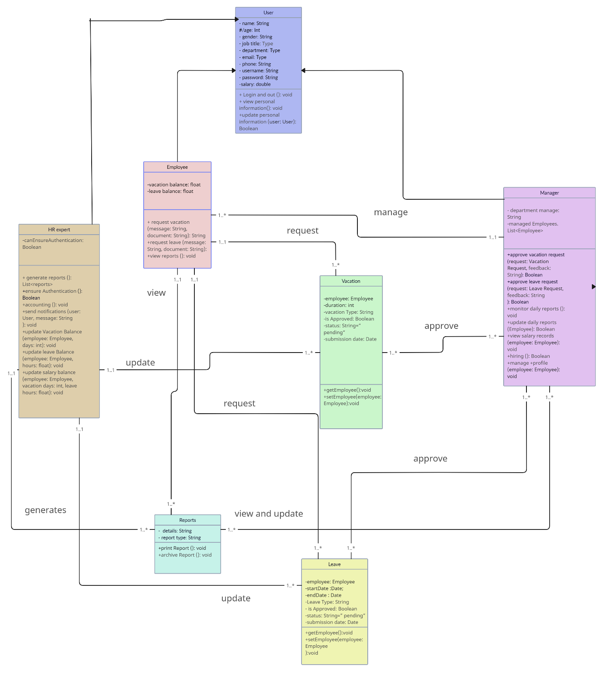

Figure : HR System Class-Diagram

# Use-case Specification Documents

## Employee Initiates Leave Request Use-case (Christina Saba 1201255)

### **Basic Description**

This use-case allows the employee to initiate a leave request for various reasons including sick or personal leaves. This includes providing supporting reasons for the request in addition to optionally submitting attachments and documents.

The actors in this use case are the Employee who initiates the leave request, manager who approves or denies, and HR expert who is responsible for transactions calculations.

### **Flow of Events**

#### Basic Flow – Initiate Leave Request

1. The employee logs into the system using their biometric prints or username and password displayed on the UI.
2. The employee selects the “Initiate Leave Request” option from the employee dashboard.
3. A leave request form is displayed, showing related fields to be filled including leave type, start date, end date, comment section for reasons and excuses, and an optional upload attachment button for additional documents.
4. The employee enters the required information specifying each field.
5. The system validates the entered data to ensure a proper structure, if all valid, then the system accepts the request.
6. When all clear, the employee submits the leave request to be directed to the manager.
7. The manager processes the leave request details, reviews the employee’s report pattern, and decides to approve or reject the request.
8. The employee is notified of the decision made by the manager, if approved, the manager directs the accounting process to the HR expert to perform the transaction calculations, then the employee is granted the leave, else if request rejected, the employee is notified and given a secure communication with the manager for clarification, at which the use case is completed.

#### Alternative Flows

##### Update Leave Request when still Pending

1. If the employee wants to edit the previously submitted request, they select the “Edit Leave Request” option.
2. A list of submitted pending leave requests are viewed by the system.
3. The employee selects the demanded one among them to update.
4. The system displays the form of that request.
5. The employee is allowed to edit the viewed fields such as leave type, dates, or comments.
6. When the changes are complete, the employee selects “save the changes”.
7. The system ensures the entered data are valid and adequate, then updates the request and redirects the request to the manager for approval. Then the use case ends.

##### Cancel Leave Request

* + - 1. Pending Request

1. If the employee wishes to cancel a previously submitted pending request, they select the “Cancel Leave Request” option.
2. A list of submitted leave requests are viewed by the system.
3. The employee selects the demanded one among them to withdraw.
4. The system alerts the employee to confirm their cancellation process.
5. The employee confirms the cancellation.
6. The system archives the leave request, cancels the manager’s participation, and changes the status of the leave request at which the use case ends.
   * + 1. Approved Request
       2. Steps 1-5 in 2.2.2.1 are repeated.
       3. The employee is notified to wait for the manager’s new decision of the cancellation.
       4. The manager views the newly sent cancellation request, evaluate the detailed excuses, and makes the decision.
       5. If cancellation approved, the manager notifies the HR expert of the changes to edit the financial transactions and redo the deduction from the employee’s balance then notifies the employee of the approval of cancellation and the employee can resume the working hours as is. If cancellation refused, the employee is notified of the rejection and the manager opens a secure conversation to discuss the decision. This is when the use case ends.

##### Emergency Leave Request

1. The employee selects the “Emergency Leave Request” option, indicating the case of severe emergency which is inevitable (such as severe illness or injury, legal matters such as court appearances, family critical illness or deaths).
2. The system displays a new leave request form with minimal required information such as a text box for type of emergency and a brief explanation of the case.
3. The employee enters the vital details.
4. The system then validates the entered data and accelerates the approval process.
5. The system immediately forwards the emergency leave request to the manager for a fast review and approval.
6. The employee awaits a quick response from the manager of approval, that’s when the use case completes.

##### Leave Request Extension after approval

1. In case the employee requires to extend the previously submitted leave request which has been approved by the manager, they select "Request Leave Extension" to modify the dates.
2. The system displays the active leave request of the employee.
3. The employee is prompted to enter the new end time for the request to be extended.
4. The employee selects “submit” option.
5. The system validates the data entered and updates the extension details.
6. The employee is notified that the newly extended leave request is “Pending” until the manager’s approval.
7. The system notifies the manager of the changes, and the request status remains “Pending” until the manager’s approval or rejection.
8. The employee is notified of the manager’s decision, if rejected, the manager opens a discussion section for the reasons, if approved, the manager alerts the HR expert to make the required balance adjustment, then the employee is notified of the approval when the use case ends.

##### Employee’s manager is absent, the request is directed to HR expert

1. In case the manager is absent or unavailable at the time the request has been sent; the system automatically directs the leave request to the HR expert to make the decision.
2. The HR expert reviews the request’s submitted details and analyzes the employee’s report pattern records.
3. The HR takes the decision and notifies the employee of the HR decision, if rejected, the employee can discuss the result with the HR expert, if accepted the HR does the required balance calculations and alerts employee of the approval. That when the use case ends.

### **Special Requirements**

The system shall allow the employee to conveniently initiate a Leave Request by providing an accessible and responsive automated notification upon successful submission of the leave request within 5 seconds, sending a confirmation message and details of the applied request.

The system ensures secure communication protecting the notifications and feedback between the employee and the manager. The approval workflow is customized upon the policies and laws to facilitate the process.

The system shall sync the approved leave request of the employee with the personal calendar to support the integration to monitor and access their historically saved leave periods.

The system shall offer flexible reports for the manager and HR expert to study the pending leave request, analyze their leave patterns and balances, and generate and update relevant reports. This maintains an adaptable trace of the records related the leave requests including the submissions, approvals, rejections, and tracking of their balance accounts.

### **Entry Conditions**

* The employee must be logged into the system with a stable internet connection to initiate a leave request.

### **Exit Conditions**

* The system saves and records of the leave request and their attached details.
* The employee receives an automated confirmation of the successful request submission process.
* An automated notification is sent to the employee’s manager to check the new leave request for approval. if approved later, the employee is notified, and their timeline schedule is updated shown in their calendars.
* The employee can frequently check their submitted leave request information and check the status in the system before receiving response.
* Any comments or feedback provided by manager are saved and recorded for future references.

# INITIATE LEAVE REQUEST - UML-Activity Diagram

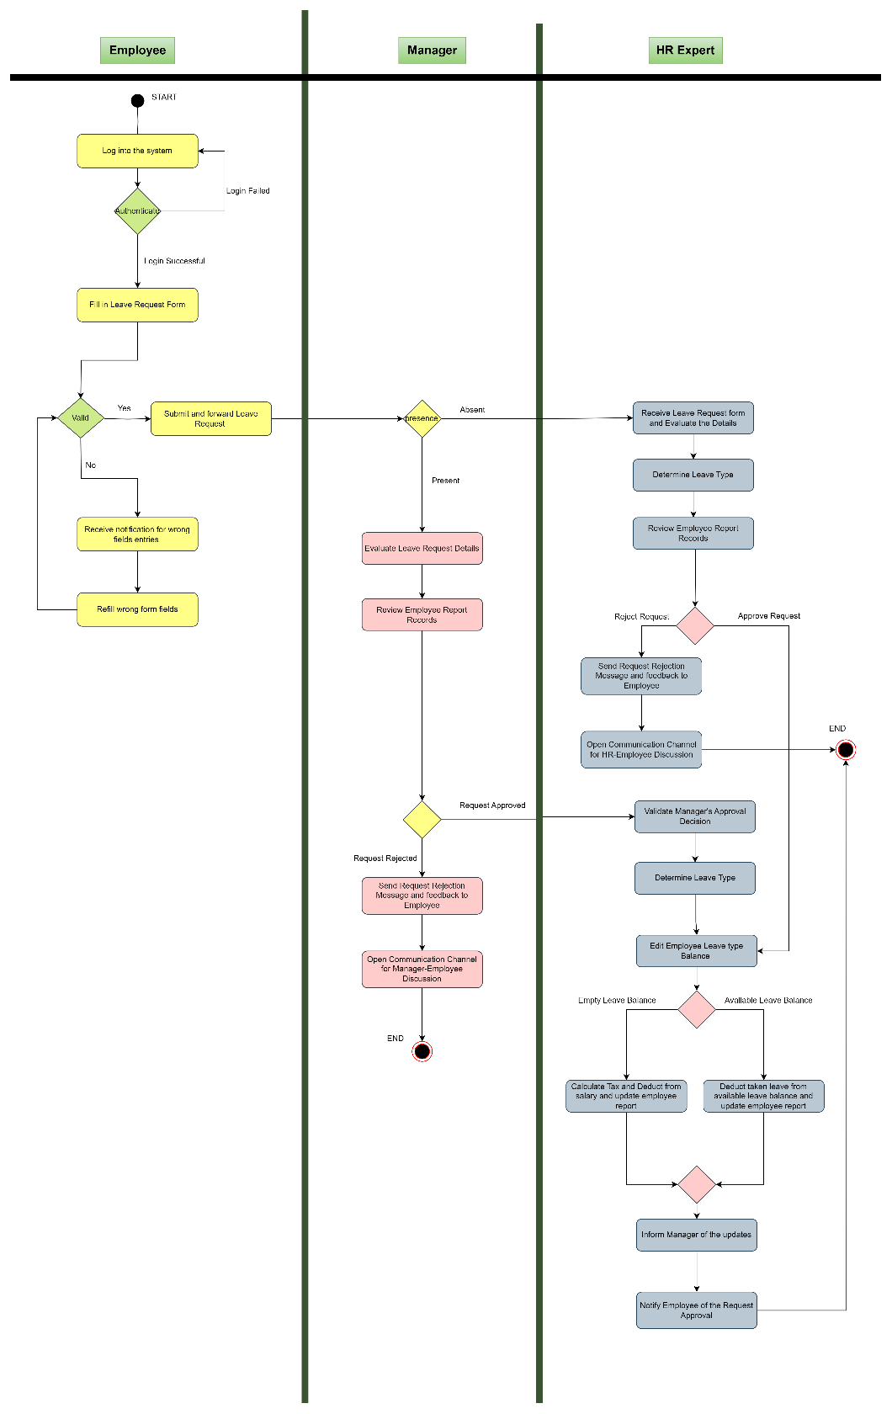

## Manager Approve Requests (Pierre Backleh 1201296)

### Brief Description

The system shall give HR managers an effective and user-friendly interface to review and approve employee requests for leaves and vacations. This feature is necessary to guarantee accurate recording of employee absences and to simplify the approval procedure.

### Flow of events

The HR Manager logs in and chooses "Approve Requests" from the User Interface.

#### Basic Flow – view requests

1. The user requests approval from the controller so that the management can review it.

2. Request details are retrieved from the database by the Controller Request.

3. The request details are displayed on the manager's interface via the Controller Request.

4. The HR Manager chooses whether to accept or deny the request for a leave of absence.

5. The Controller Request receives the status (Approved/Rejected).

6. Upon the HR Manager's approval, the Controller Request modifies the leave/vacation balance in the database.

7. Notification service is initiated to let the user know about the final decision of the manager.

#### 2.2 Alternative Flows

##### 2.2.1 HR Manager Requests Modification

1. The HR Manager finds a problem with the request. As the HR Manager goes over the request specifics manager notices a problem, like inconsistent dates or missing information.

2. The required changes that the HR Manager has requested are included in the modification information that the User Interface submits to the Controller Request.

3. Controller Request conducts the modification, changing the request data in the Database as per HR Manager's instructions.

4. The HR Manager checks the updated request information to make sure it still complies with the standards once the modification is made.

5. The HR Manager makes the final determination about whether to approve a leave or vacation request if they are satisfied with the updates.

6. Continue with the basic flow from Step 6.

##### 2.2.2 HR Manager either requests additional details or rejects the request.

1. The HR Manager finds issues, such missing information or a need for clarification, while going over the request's specifics.

2. Selects to ask for more details instead of giving a totally approval or rejection.

3. Sends out a request via the User Interface for further information, stating what is needed.

4. A request for further information is sent to Controller Request via User Interface.

5. The employee receives a mail message from Controller Request regarding the HR Manager's request for more information.

6. The employee logs into the system to supply the further information that the HR Manager has asked after getting the message.

7. The employee's extra details are processed by Controller Request, which then modifies the request's database information.

8. The HR Manager evaluates the modified request after obtaining the new information before reaching a decision.

9. Continue with the basic flow from Step 5.

##### 2.2.3 AI-Supported Approval Process

1. For an objective evaluation of the request, the HR Manager chooses to request the aid of an artificial intelligence (AI) system.

2. Using the User Interface, the HR Manager turns on the AI support option.

3. The AI system produces a recommendation (approved or rejection) based on the analysis.

4. The HR Manager considers the AI advice before deciding whether to approve the request or not.

5. Continue with the basic flow from Step 5.

### 3. Special Requirements for the "Approve Requests" Use Case:

The system should Use role-based access control to restrict access and authorization activities to HR Managers who have been given permission.

The system must use encryption techniques to protect sensitive data during transmission and storage, guaranteeing the integrity and confidentiality of information related to leave and vacation requests.

The system shall be performance-optimized to guarantee that requests for approval are handled promptly and efficiently.

The Notification Service should support HR Managers in customizing their notification choices. It should be possible for users to select the preferred notification mechanism such as email or SMS.

### 4. Entry Conditions for the "Approve Requests" Use Case:

#### 4.1 Login

The HR Manager has to have successfully logged into the HR Management System before starting the "Approve Requests" use case. The system makes sure that only authorized users (HR Managers) with the proper role may access and handle leave/vacation request approvals.

#### 4.2 Access Rights

To examine and approve leave/vacation requests, the HR Manager must possess the required access rights and authorizations. Enforcing access control measures helps to ensure that the person logging in is, in fact, an HR Manager with the authority to provide approval.

### 4.3 Active Requests Exist

Requests for leaves of absence that need the HR Manager's permission must be current in the system. There can only be pending employee requests for the "Approve Requests" use case to be relevant. This use case might not need to be completed by the HR Manager if there are no pending requests until they are submitted.

### 5. Exit Conditions for the "Approve Requests" Use Case:

#### 5.1 Updated Request Status:

The system modifies the status of a leave or vacation request based on the HR Manager's approval or rejection. The exit condition makes ensuring that the request's status is appropriately represented in the database of the system.

# Manager Approve Request - UML-Activity Diagram

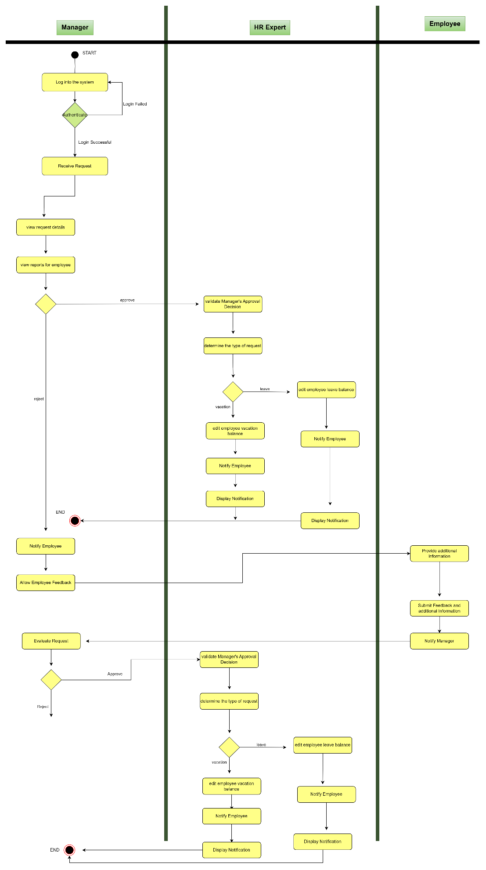

## Update Balance use case (Samuel Tannous 1201123)

### **Basic Description**

The update balance use case allows the HR expert to update the records which must be updated in response to an employee's leave or vacation such as historical absence, leave info, remaining balance, and any other financial transactions.

### **Flow of Events**

#### Basic Flow – update balance

1.The process begins with the employee securely logging into the HR system.

2 After logging in, the employee initiates a leave or vacation request, providing details through the HR system, specifying type, start/end dates, and additional details.

3. Manager receives the request, reviews the details, and decides to approve or deny the request.

4. The manager receives the request, reviews the details, and decides to approve or deny it in response to the employee's current leave or vacation balance to ensure availability.

5. HR expert manages financial transactions, reduce leave or vacation balance or the employee salary following company policies, and maintains records of the transaction, and the updated financial and leave/vacation records.

6. HR expert updates the employee's reports, including historical absence, leave info, and remaining balance.

7. the system notifies the manager of the successful update and any relevant financial adjustments.

8. Employees can access updated leave/vacation balance and related information through their personal account.

#### Alternative Flows

##### cancelation of any approved leave or vacation

1. The employee initiates a request to cancel an approved vacation or leave through the HR system, specifying reasons for cancellation.

2 The manager receives the cancellation request, reviews the reasons provided, and decides whether to approve or deny the cancellation.

3 The HR expert adjusts the leave or vacation balance based on the canceled days, and updates the employee's reports, including the historical absence, leave info, and remaining balance.

1. If there are financial changes due to the cancellation, the system processes any necessary adjustments.
2. The HR expert sends a notification to the employee informing them of the cancellation status and any related balance adjustments and send a notification to the manager confirming the cancellation and any related updates.
3. Employees can access their modified leave/vacation balance and related details through their personal accounts.

##### 2.2.2 The HR expert consults with manager in request balance.

##### 1 The employee initiates a request for a balance adjustment through the HR system, providing details and reasons for the adjustment.

1. The HR expert, upon receiving the balance adjustment request, reviews the details and initiates a consultation process with the manager.
2. The HR expert collaborates with the manager to discuss the balance adjustment, providing HR ideas.
3. Guided by the HR expert's recommendations, the HR system verifies the current leave or vacation balance of the employee.
4. Based on the consultation, the manager decides regarding the balance adjustment.
5. The system sends a notification to the employee, communicating the decision regarding the balance adjustment and providing reasons.

##### 2.2.3 automated decision support in urgent balance adjustment.

1 The HR expert employs automated decision support tools to analyze the balance adjustment request.

2 The system presents the automated recommendation to the manager for review.

3 The manager may choose to approve the recommendation or provide additional ideas for manual consideration.

4 If the manager approves the automated recommendation, or after a specified time, the system automatically confirms the decision and proceeds to the next steps.

5 the system sends an automated notification to the employee, communicating the decision, reasons for the adjustment, and any relevant details.

### **3 Special Requirements**

Ensure that the HRMS supports cloud-based storage for secure and scalable data storage. This facilitates data accessibility, analysis, and ensures data backup and recovery, implement an automated calculation system that accurately computes leave or vacation balances based on predefined company policies and finally the system should respond to balance update requests within two seconds to ensure a smooth user experience.

### **Entry Conditions**

Users must complete the secure login at the beginning.

### **exit Conditions**

1 The employee's records, including leave and vacation balances, are updated based on the approved balance adjustment.

2 at the end of the process the employee, HR expert, and approvers, receive notifications about the successful balance update. The notification includes details of the adjustment made.

# Update Balance – UML – Activity Diagram

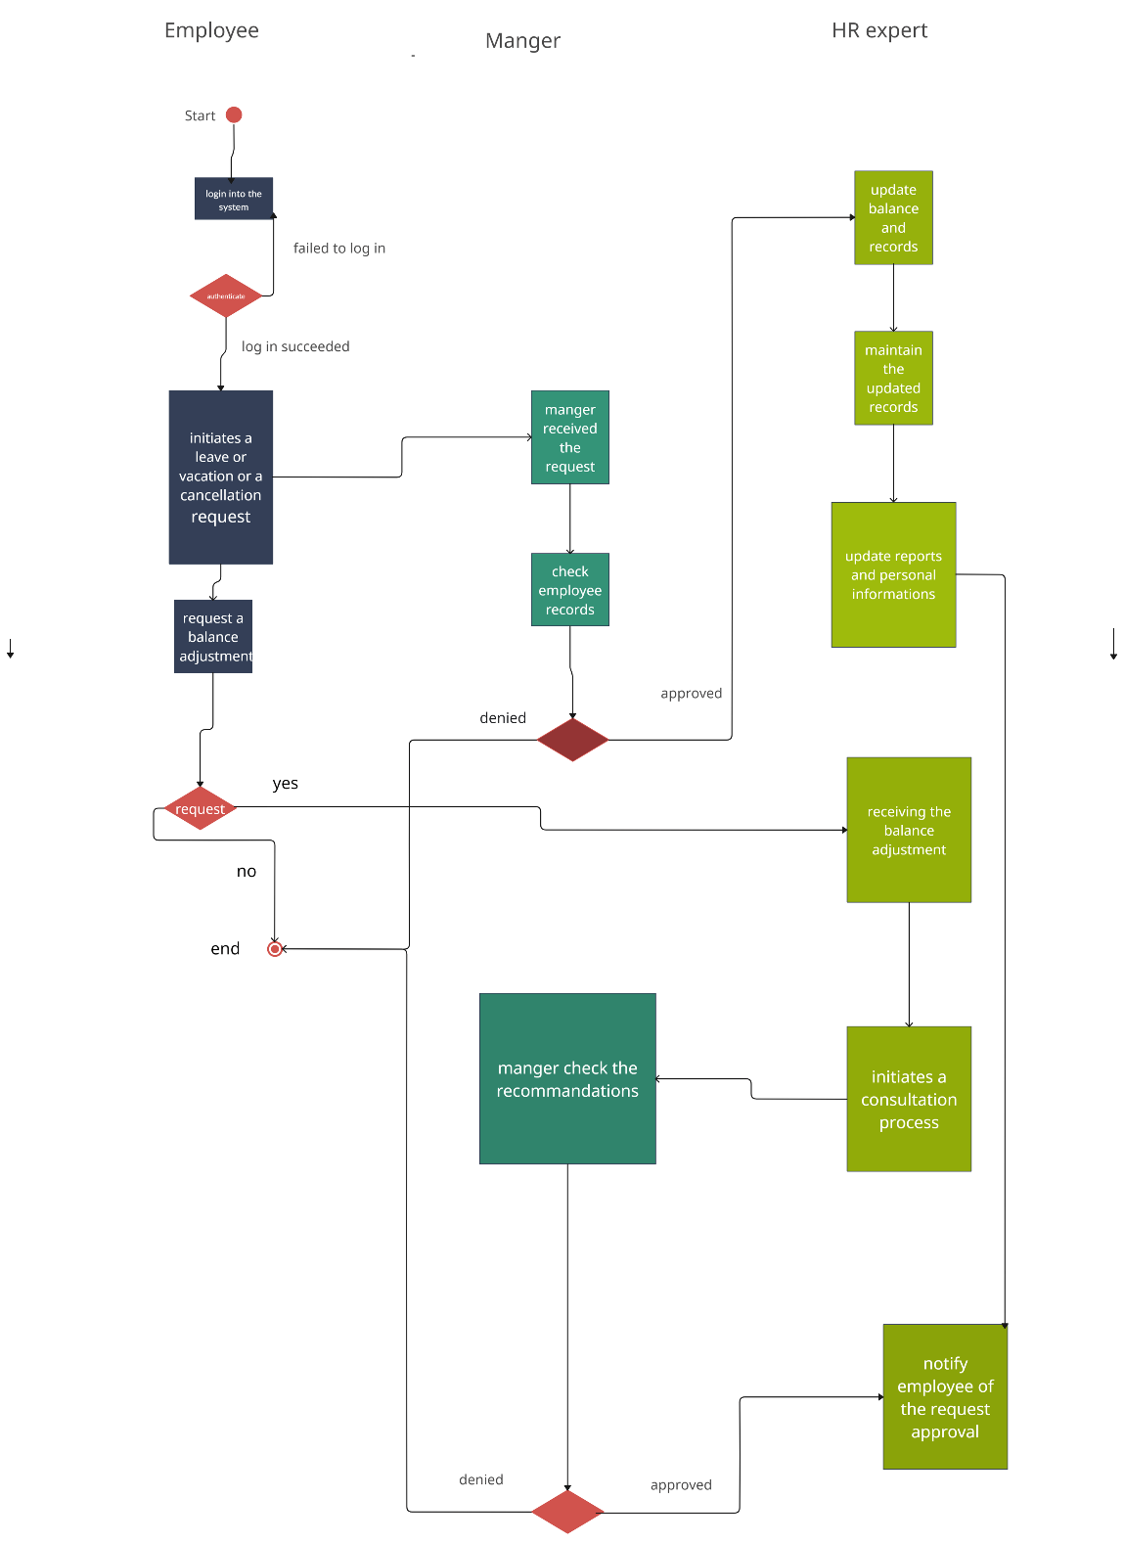

## Employee Requests Vacation (Hussain Radwan - 1200475)

### Brief Description

This use case describes the journey an employee takes to request vacation time, from logging into the system to receiving the final decision. It's a digital conversation between the employee and the company, mediated by the system, with a focus on clarity and mutual understanding. The actors involved are:

**Employee:** Initiates the request.

**Manager:** Reviews and approves or denies the request.

**HR Expert:** Optionally involved in processing and validation.

### Flow of Events

#### 2.1 Basic Flow – Request Vacation

##### 2.1.1 Employee Login:

1. **Employee Login:** An employee starts this process by entering their credentials. Success here is like unlocking the door to their vacation possibilities.
2. **Form Submission:** They then navigate to a form specifically designed to capture their dream vacation details, filling it out with care.
3. **System Check:** Like a helpful assistant, the system reviews the request for completeness. If something's amiss, it gently nudges the employee to make corrections, ensuring everything's in order before moving on.
4. **Manager's Review:** The request lands on the manager's virtual desk, awaiting their attention. It's here that consideration for the team's needs and the employee's well-being are weighed with a thoughtful eye.
5. **Approval or Denial:** The manager's decision is relayed back through the system, either greenlighting the vacation or providing constructive feedback if the request can't be accommodated.

#### 2.2 Alternative Flows

##### 2.2.1 Invalid Request Handling

1. System-Assisted Corrections When an employee submits a form with errors, the system provides specific, easy-to-understand guidance, prompting the employee to make the necessary corrections.
2. Decision to Amend or Withdraw: The employee can then choose to correct the information based on the system's feedback or withdraw their request if they decide against resubmitting.

##### 2.2.2 Managerial Review with a Personal Touch

1. Comprehensive Review: The manager takes the time to review each request in detail, understanding the personal nature of vacation time.
2. Personalized Feedback: If a vacation request cannot be accommodated, the manager provides personalized feedback and, when possible, alternative solutions.

##### 2.2.3 HR's Considerate Validation

1. Compliance with Compassion: The HR Expert ensures compliance with leave policies while considering the employee's individual needs and circumstances.
2. Special Requests Handled with Care: Requests that require special attention, such as extended leave or personal circumstances, are handled with extra care to ensure the employee feels supported.

##### 2.2.4 System Outages and User Experience

1. Empathetic Communication during Outages: If the system is temporarily down, the employee is informed not just about the outage but also reassured that their data is safe.
2. Seamless Continuation Post-Outage: Employees are provided with a clear path to seamlessly continue their request once the system is back up, minimizing frustration and valuing their time.

##### 2.2.5 Coordinating Multiple Requests

1. Equitable Queue Management: The system manages a fair and transparent queue for vacation requests, especially during high-demand periods.
2. Conflict Management with Care: Managers use provided tools to navigate overlapping requests, ensuring that employees feel their requests are handled justly.

### Special Requirements

System performance must ensure a response time of less than 5 seconds for each transaction.

The system must handle concurrent requests without loss of data or performance degradation.

Notifications must include actionable feedback for the Employee to follow up on their request.

### Entry Conditions

The Employee must have an active account within the system.

The Employee must have a positive vacation balance.

### Exit Conditions

The vacation request is either approved or denied, with the Employee's vacation balance updated accordingly.

The Employee has been notified of the outcome of the request.

# Vacation Request - UML-Activity Diagram

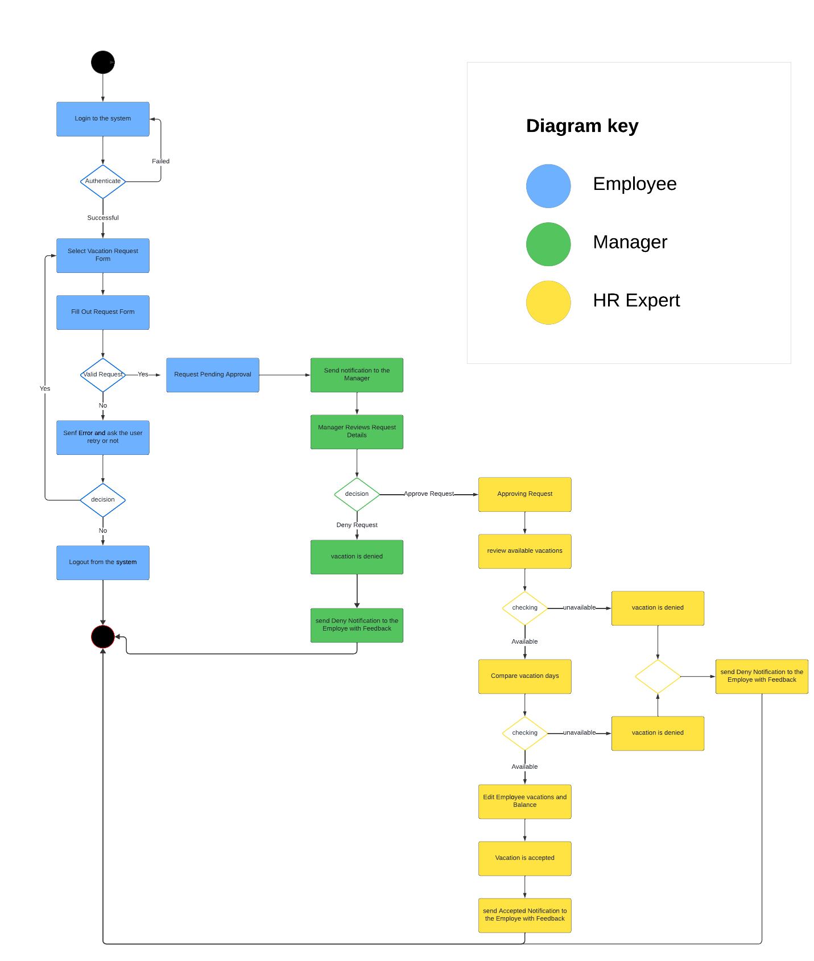

# Design Goals

They are designed based on the achievement of non-functional requirements which are specified below:

1. Security: implementing an architecture with layered structure encapsulating the data and functionality by limiting access to authorized components only. It is achieved by the presence of the authentication process such as login and the usage of encrypting between the interfaces of components protecting any sensitive data.
2. Availability: which specializes in replacing and updating components without stopping the system by utilizing redundant components. The database is responsible for storing and managing the data by deploying database clustering solutions to distribute data and workload across multiple nodes, ensuring high availability as well as regular data back-up to control any issues in case of data loss. Server implements load balancing methods.
3. Performance: localizing critical operations within a small number of components and deploying them on the same computer rather than distributing them across the network. The critical operation such as frequent data access and intensive computation, so localize them within specific components to minimize workload overhead in addition to using parallel processing techniques. Furthermore, implementing caching mechanisms is applied to store frequently accessed data in memory and allocate resources to accommodate growing workloads and improve performance.

These non-functional requirements and many more including safety and maintainability are used in the planning and designing of Component and Deployment Diagrams.

# Component Diagram

The UML component diagram describes the physical wiring of multiple components in a system, visually representing the dependencies between various them. In our case, there are multiple components including:

1. User-Interface Component: provides user-friendly interfaces and dashboards of employee, manager, and HR expert and their interactions with the system. It provides the interactive elements for the related tasks to be performed. It includes:

* Manager: This role likely has the ability to oversee and manage employee information or tasks.
* Employee: This represents the individual workers who may use the system to carry out tasks like applying for leave or checking their work schedules.
* HR Expert: This could be someone in the Human Resources department who uses the system for more specialized tasks, such as consulting on complex HR issues.

1. Server-Interface Component: acts as a bridge between the user-interface side and server-side which facilitates the communication and data exchange securely by providing APIs from user’s side to interact with the functionalities found in the database. It validates the user’s credentials during login process and supports performance evaluation analysis process.
2. Database Component: backbone of the system which controls and enhances the data accesses ensuring the data integrity, consistency, and reliability. It supports transaction management by managing concurrent access to shared data and preventing any data inconsistencies.
3. Storage Component: either physical storage or cloud-based one, stores the data ensuring its availability and scalability, it enables scalable and cost-effective access to files. In addition to implementing data encryption mechanisms to protect sensitive data stored in it in addition to built-in backup features.
4. Leave Management Component: handles all aspects in relation to leave requests. It encompasses the leave tracking, submission, approval, denial, and management. It ensures the efficient utilization of leaves and balances of employees. Employees can submit a leave request through their interface, and it can route the request to a specific manager for approval.
5. Vacation Management Component: manages all tasks related to vacation requests including submission, tracking, approval. It ensures the efficient utilization of vacations and balances of employees. Employees can submit a vacation request through their interface, and it can route the request to a specific manager for approval.
6. Report Management Component: controls the creation, storage, retrieval, and distribution of reports within the system. It offers pre-defined report templates such as attendance, leave, performance, and statistical reports. It enhances the transparency and accountability through data visualization by enabling the scheduling of automated report generation and distribution at regular intervals which enhance the performance improvements and optimization.
7. Balance Management Component: responsible for tracking various user’s balances and allowances, such as vacation and leave days. It records the changes based on the user’s actions such as leave or vacation request and attendance records, it maintains the deduction of vacation of leave hours or salary fee in addition to alerting the users of their personal changes accordingly.

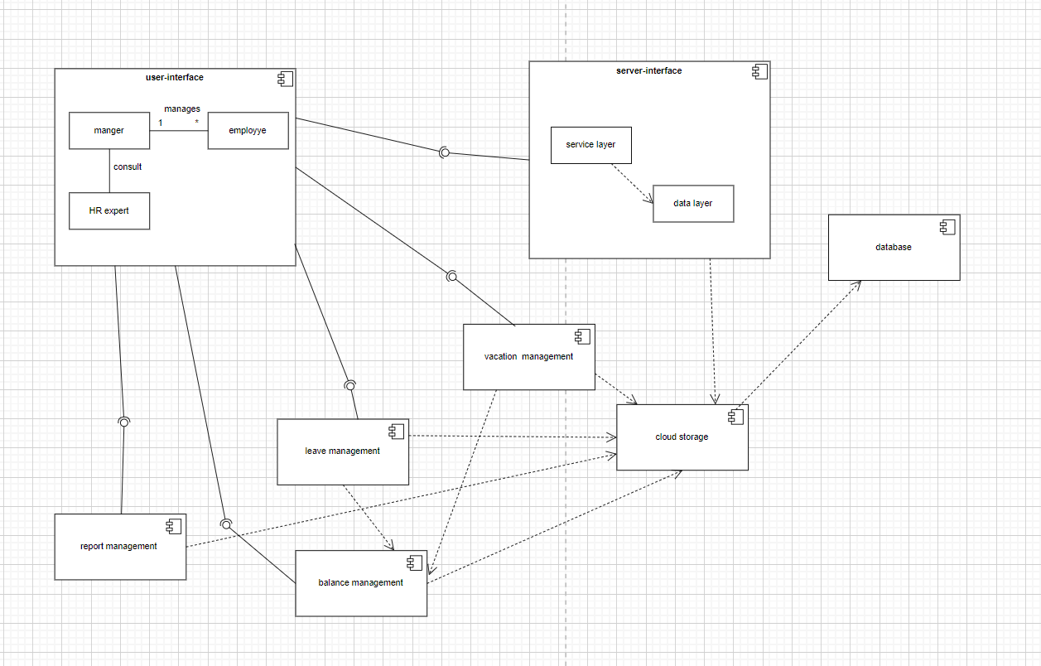the Component diagram described previously is shown in the figure below:

Figure : Component Diagram

# Deployment Diagram

The deployment diagram below, utilizes the Client-Server Architecture style which implements the security using the HTTPS protocol to ensure secure data transfer between client and server. It ensures the secure communication between the web browser and the HR system application. In addition to the data sync which is the synchronization process between the cloud storage and database.

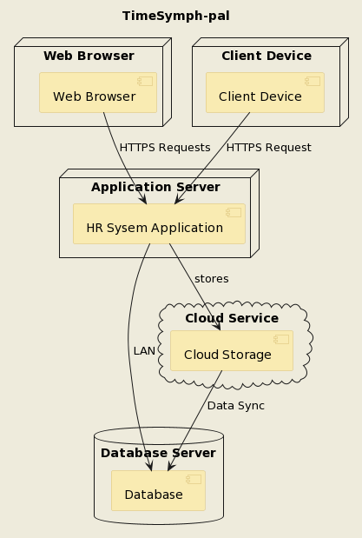

Figure : Deployment Diagram