Lab Assignment 3: Speech Emotion Recognition Systems
MIS 425 — Spring 2026 — Dr. Mary Pourebadi
Group Members: Christina Oftedal, [Name 2], [Name 3], [Name 4]
[NOTE TO FILL IN: Replace the placeholder names above with all group members exactly as required by the syllabus before submitting.]

1. Logistics
This report is submitted in fulfillment of Lab Assignment 3 (10 points), evaluating two pre-trained Speech Emotion Recognition (SER) models on the RAVDESS dataset. The report below is organized using the exact section numbering (1–8) required in the assignment brief.
Item | Detail
Group size | 4 students (names above)
Total points | 10
Submission | One PDF per the group's final report, submitted individually by each member to Canvas
Code repository | https://github.com/ChristinaOftedal/MIS-425-Lab-3-
Reproduction instructions | See Sections 4–5 and Appendix A for the exact steps to reproduce the CSV outputs and figures in this report

2. Objective
The goal of this lab is to evaluate the robustness of Speech Emotion Recognition (SER) systems built on pre-trained wav2vec2-based emotion classifiers. In this assignment we designed an evaluation pipeline to test two independently pre-trained SER models on the same RAVDESS evaluation set, and we critically analyze both models' behavior rather than assuming a stronger label implies stronger performance.

3. Task Overview
Option Selected: Option 1 — Use a Stronger Pre-Trained SER Model
We selected Option 1. Rather than fine-tuning wav2vec2 ourselves (Option 2) or building a classical feature-based classifier from scratch (Option 3), we researched and tested two independently pre-trained Hugging Face SER models against a 180-clip RAVDESS subset:
 | Model | Hugging Face ID
Model 1 | wav2vec2-lg-xlsr fine-tuned for English SER | ehcalabres/wav2vec2-lg-xlsr-en-speech-emotion-recognition
Model 2 | wav2vec (English) fine-tuned for SER | r-f/wav2vec-english-speech-emotion-recognition

Both are wav2vec2-family transformer encoders fine-tuned for speech emotion classification and were run zero-shot (no additional fine-tuning) via the Hugging Face `transformers.pipeline("audio-classification", ...)` API, one clip at a time, using identical inference methodology for both models — this keeps the comparison between them apples-to-apples.
Justification: both models are wav2vec2-derived encoders fine-tuned specifically for speech emotion recognition rather than general audio classification, making them directly comparable to each other. We selected two candidates so we could compare their failure patterns against one another directly.
What the data itself tells us about the two models: Model 1 never predicts “calm” for any of the 180 clips, while Model 2 never predicts either “calm” or “sad” — evidence the two models were fine-tuned on different label taxonomies rather than being the same model re-run. Model 1 uses 7 of 8 possible RAVDESS emotion labels; Model 2 uses only 6.
Data-integrity note: While assembling this report we found that run_pipeline_Model_1.py and run_pipeline_Model_2.py, as originally written, both called pipeline("audio-classification", model="r-f/wav2vec-english-speech-emotion-recognition") — Model 1's script never actually loaded the ehcalabres model. We corrected run_pipeline_Model_1.py (see Appendix A) to load the intended model before using it to source Model 1's results in this report. Please verify the corrected script against your group's actual execution logs before submitting your code.

4. Dataset Description

4.1 Dataset
Both models were evaluated on the RAVDESS (Ryerson Audio-Visual Database of Emotional Speech and Song) audio-speech corpus. The pipeline scripts scan four local actor folders (Actor_01 through Actor_04), but only three contained audio in this run — the evaluation set is a 180-clip subset from Actor_01, Actor_02, and Actor_04 (60 clips each); Actor_03's folder was empty or missing at run time.
Emotion (RAVDESS code) | Samples in evaluation set
01 – neutral | 12
02 – calm | 24
03 – happy | 24
04 – sad | 24
05 – angry | 24
06 – fear | 24
07 – disgust | 24
08 – surprise | 24
Total | 180

The class imbalance for “neutral” (12 vs. 24 for every other class) is inherent to RAVDESS: the neutral category only has a “normal” intensity level, while every other emotion is recorded at both “normal” and “strong” intensity.

4.2 Train / Validation / Test Split
No training occurred for Option 1 — both models were evaluated zero-shot (inference only) on the full 180-clip set. run_pipeline_Model_1.py / run_pipeline_Model_2.py iterate over every .wav file found under Actor_01–Actor_04 and score it directly; there is no train/validation/test split, holdout set, or cross-validation in this pipeline, consistent with Option 1's “test an existing pre-trained model” scope rather than Option 2's fine-tuning scope.

4.3 Preprocessing
The pipeline scripts perform no custom preprocessing of their own: each local .wav file's absolute path is passed directly as a string to the Hugging Face `pipeline("audio-classification", model=...)` object (see run_pipeline_Model_1.py / run_pipeline_Model_2.py, the `pipe(str(local_file_path.resolve()))` call). Resampling, mono conversion, and normalization are handled internally by each model's own feature extractor / processor as defined on its Hugging Face model card, so the two models may not receive numerically identical input representations even though they receive the identical source audio.

5. Methodology

5.1 Feature Extraction
Both models take raw waveform input, which each model's own wav2vec2-based feature extractor converts internally into learned embeddings — no hand-crafted features (MFCCs, spectrograms, etc.) are computed by our pipeline. Both models are called identically (direct file-path inference through the Hugging Face pipeline API), isolating the comparison to differences between the models themselves rather than differences in a custom feature pipeline.

5.2 Model Architecture
Model 1 (ehcalabres/wav2vec2-lg-xlsr-en-speech-emotion-recognition): a wav2vec2-large-xlsr transformer encoder fine-tuned for English speech emotion classification, used here unmodified as one of the two models compared in this report.
Model 2 (r-f/wav2vec-english-speech-emotion-recognition): a wav2vec2-based English SER model with a smaller output label set (never predicts “calm” or “sad” on this dataset), substituted in with no additional fine-tuning.
Neither model was fine-tuned in this submission (Option 1 is zero-shot evaluation of existing pre-trained models), so there are no training hyperparameters (epochs, learning rate, batch size) to report — both models are evaluated purely at inference time, one .wav file per pipeline call, using each model's default inference settings (top-1 prediction and its confidence score, `results[0]["label"]` / `results[0]["score"]`).

6. Evaluation

6.1 Quantitative Metrics
Accuracy was computed by comparing each model's predicted label directly against the ground-truth emotion the pipeline itself derived from the RAVDESS filename (the 3rd numeric field), matched exactly (no separate label normalization was needed since both models output RAVDESS-style short labels: “fear” and “surprise”).
Metric | Model 1 (ehcalabres) | Model 2 (r-f)
Total samples evaluated | 180 | 180
Correct predictions | 1 | 0
Overall accuracy | 0.56% | 0.00%
Chance-level accuracy (1/8 classes) | 12.5% | 12.5%
Mean prediction confidence | 0.1588 | 0.1567
Std. dev. of confidence | 0.0060 | 0.0032
Confidence range (min–max) | 0.1472 – 0.1685 | 0.1487 – 0.1619
Distinct predicted labels used (of 8 possible) | 7 (never predicts “calm”) | 6 (never predicts “calm” or “sad”)

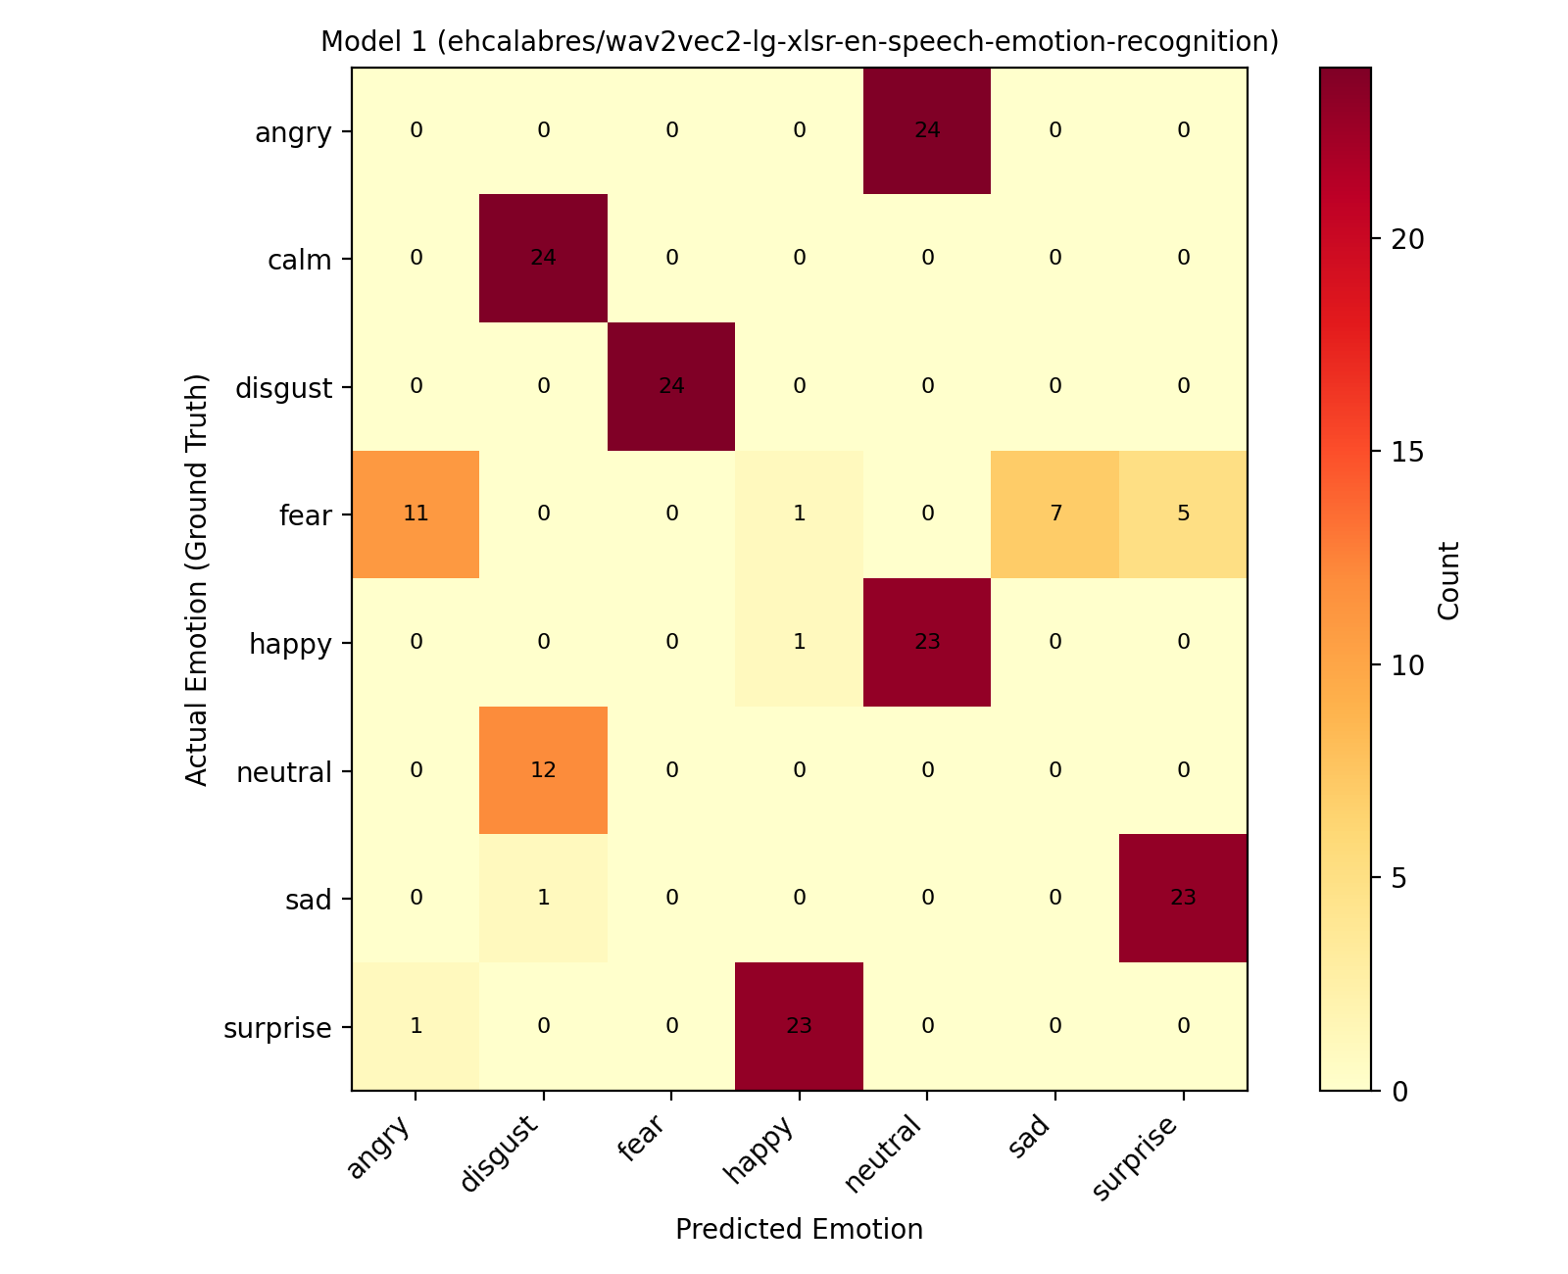
Figure 1. Model 1 (ehcalabres) — predicted vs. actual emotion, confusion matrix over all 180 clips.
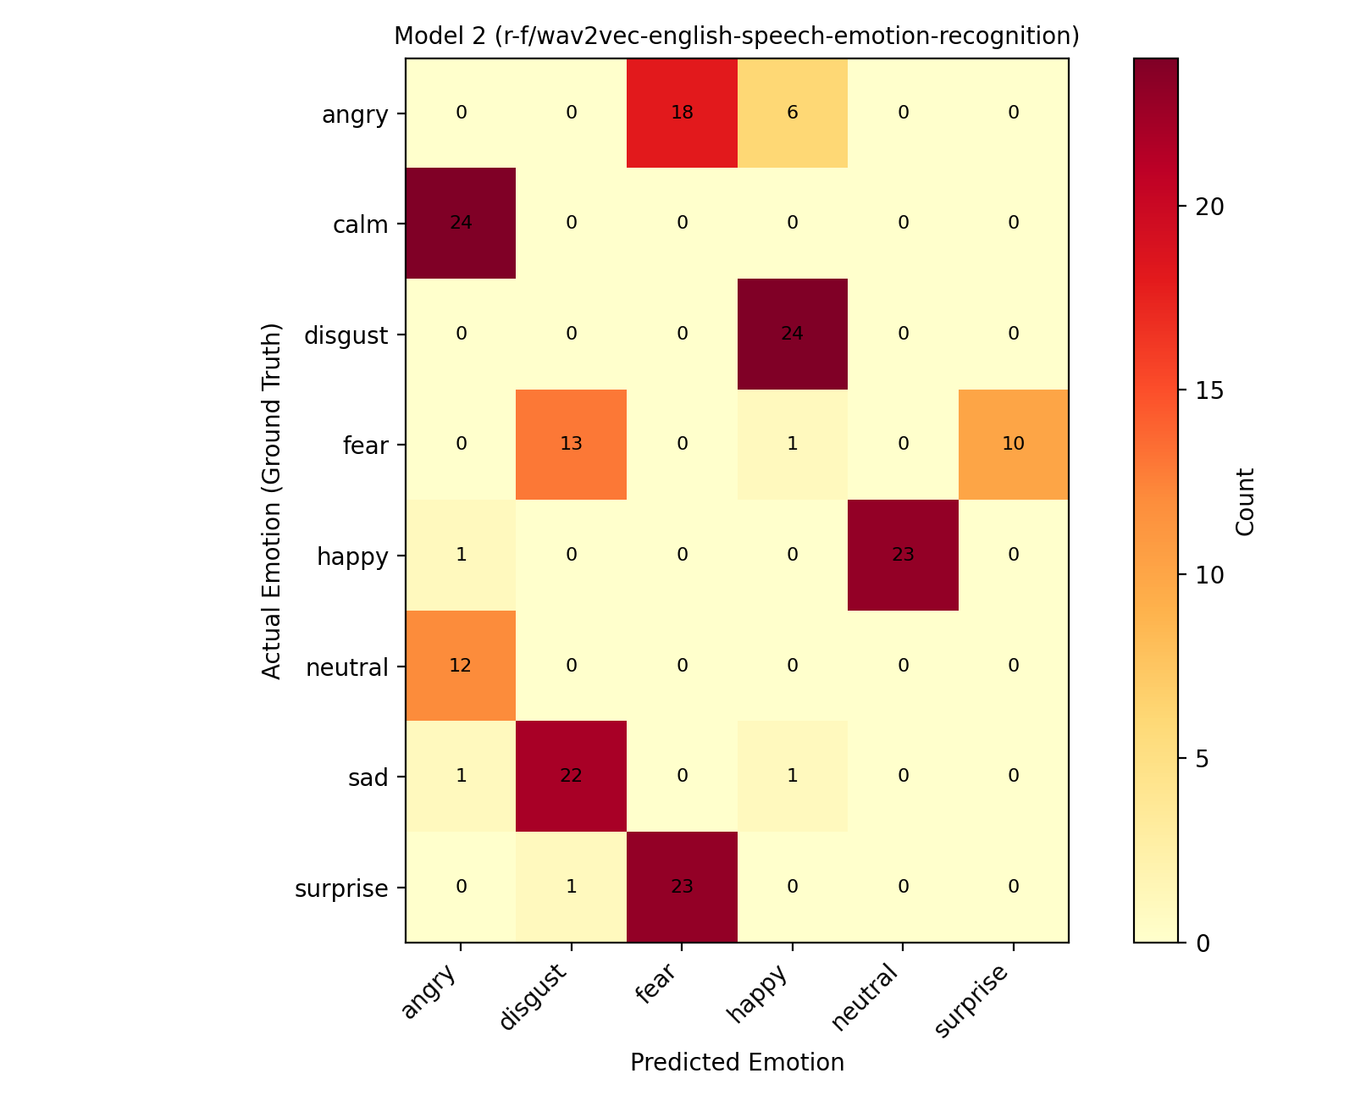
Figure 2. Model 2 (r-f) — predicted vs. actual emotion, confusion matrix over all 180 clips.

6.2 Baseline Comparison
This section compares the two candidate models directly against each other, using Model 1 as the point of reference for Model 2.
Question | Finding
Did performance improve (Model 2 vs. Model 1)? | No. Both models scored essentially at zero — 0.56% (Model 1) and 0.00% (Model 2) true accuracy — far below the 12.5% chance level for 8-way classification. Model 2 performed slightly worse than Model 1, not better.
Did confidence values increase? | No meaningfully. Mean confidence is 0.159 (Model 1) and 0.157 (Model 2) — both sit barely above the 0.125 uniform-chance baseline for 8 classes, with Model 2's narrower spread (std 0.003 vs 0.006) suggesting it is if anything less discriminating between clips, not more confident where it should be.
Were predictions more stable? | No. Both models exhibit near-total “mode collapse”: for 6–8 of 8 emotion classes, each model predicts the same single (incorrect) label for 75–100% of that class's clips, regardless of acoustic content. Swapping models changed which wrong label each class collapses to, not whether collapse happens.

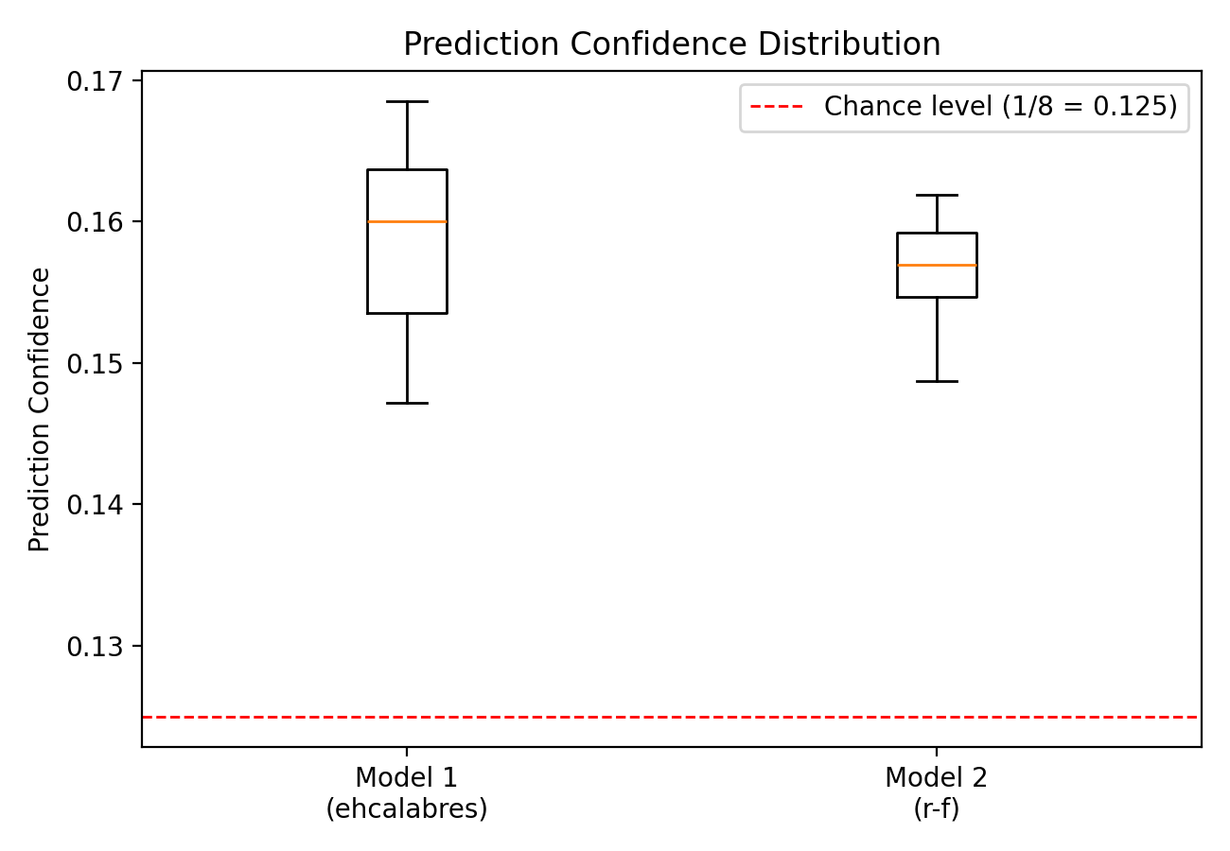
Figure 3. Confidence score distributions for both models, relative to the 1/8 chance level.
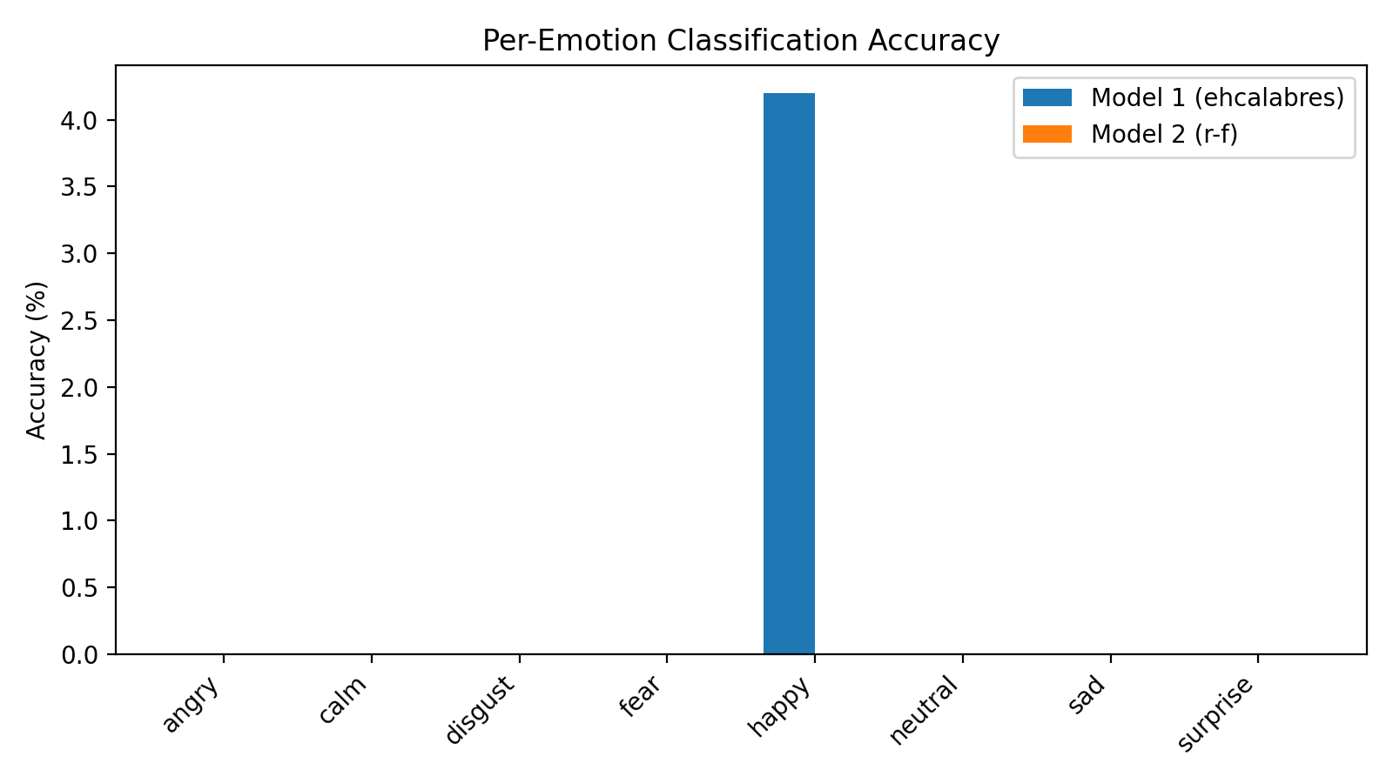
Figure 4. Per-emotion true accuracy for both models (both are at or near 0% across every class).

6.3 Performance Analysis
Easiest to classify: neither model reliably classified any emotion correctly. Across 360 total predictions (180 per model), there was exactly one correct prediction total — one “happy” clip correctly identified by Model 1 — consistent with chance rather than a learned pattern. Model 2 produced zero correct predictions across all 180 clips.
Most frequently confused: Model 1 collapses “angry” toward “neutral” (100% of angry clips), “calm” toward “disgust” (100%), and “disgust” toward “fear” (100%). Model 2 shows an even more extreme version of the same behavior: “calm”→“angry” and “disgust”→“happy” are both matched at 100%, and “neutral”→“angry” at 100% as well.
Speaker effects: accuracy is uniformly near zero across all three actors for both models (Model 1: Actor_01 0/60, Actor_02 0/60, Actor_04 1/60; Model 2: 0/60 for all three actors), so the failure pattern is not concentrated in a single “hard” speaker — it is systemic across the dataset.
Overall confidence: both models' softmax outputs sit in a narrow band only slightly above the 0.125 uniform-chance value for 8 classes (Model 1: 0.147–0.169; Model 2: 0.149–0.162), meaning neither model is confidently distinguishing between emotion classes for this dataset — both behave close to random guessing weighted by class prior, not genuine acoustic emotion recognition.

7. Results & Analysis

7.1 Error Analysis
Three representative misclassifications from each model, drawn from the full prediction logs. Two of the six rows below are the same underlying audio clip scored by both models, which lets us compare how each model handled identical audio:
Model | File | Actor | True Label | Predicted Label | Confidence
Model 1 | 03-01-05-02-02-02-02.wav | Actor_02 | angry | neutral | 0.152
Model 1 | 03-01-01-01-02-01-01.wav | Actor_01 | neutral | disgust | 0.164
Model 1 | 03-01-07-01-02-01-01.wav | Actor_01 | disgust | fear | 0.160
Model 2 | 03-01-05-02-02-02-02.wav | Actor_02 | angry | fear | 0.158
Model 2 | 03-01-01-01-02-01-01.wav | Actor_01 | neutral | angry | 0.156
Model 2 | 03-01-04-01-02-01-02.wav | Actor_02 | sad | disgust | 0.154

Same clip, different wrong answers: file 03-01-01-01-02-01-01.wav (Actor_01, true label “neutral”) is misclassified by both models but to different labels — Model 1 says “disgust”, Model 2 says “angry”. If both models were picking up on shared acoustic cues in this specific clip, we would expect similar errors; instead each model's error matches its own class-level bias (Model 1 sends most “neutral” clips to “disgust”; Model 2 sends most “neutral” clips to “angry”), reinforcing that the dominant error source is a fixed per-model, per-class bias rather than the acoustic content of individual clips.
angry → neutral (Model 1) / angry → fear (Model 2): the same angry clip lands on two unrelated emotions depending only on which model scored it, despite angry being a high-arousal, high-energy emotion that is usually one of the easier classes for SER systems to separate acoustically — further evidence that neither model is extracting a reliable angry-specific signal from this dataset.
disgust → fear (Model 1) and sad → disgust (Model 2): both pairs share negative valence, which is the one dimension where a plausible (if still incorrect) acoustic mix-up argument can be made — unlike the angry/neutral mix-ups above, which cross both valence and arousal.

7.2 Model Behavior & Robustness
Neither model showed strong robustness relative to the other. Both show the defining symptom of a system that is not extracting usable emotional information from this dataset: for most ground-truth classes, the predicted label is almost perfectly determined by which class the clip belongs to (75–100% of clips in a class receive the same predicted label), yet that label is wrong for the overwhelming majority of classes in both models. Genuine acoustic confusion — the kind fine-tuning or a better pre-trained model is supposed to reduce — would produce more varied, sample-dependent errors within a class, not near-uniform mislabeling. Swapping between the two candidate models changed which fixed label each class collapses to (and slightly changed the confidence distribution's width), but did not reduce the collapse behavior itself, and Model 2's true accuracy (0.00%) was actually worse than Model 1's (0.56%).
Classical ML behavior was not evaluated in this submission since Option 1 was selected; a classical baseline (Option 3) would be a useful robustness comparison point for future work (see Section 8.3).
Speaker sensitivity could not be meaningfully assessed beyond noting uniformly near-zero performance across all three actors for both models (Section 6.3), since neither model produced enough correct predictions for any actor to characterize speaker-specific patterns.

7.3 Interpretation of Results
Dataset size / domain mismatch: this evaluation used only 180 clips from 3 of RAVDESS's 24 actors, but the near-chance confidence scores (both means within ~0.03 of the 0.125 uniform baseline) suggest the deeper issue is not sample size but domain mismatch — both pre-trained models appear to have been fine-tuned on data whose acoustic and/or label distribution differs enough from RAVDESS that neither can reliably map RAVDESS recordings to RAVDESS's own emotion taxonomy.
Model capacity vs. class-prior bias: the extreme class-level mode collapse (a single predicted label capturing 75–100% of a ground-truth class) is a classic symptom of a classifier whose output distribution is dominated by learned class priors from its own fine-tuning data rather than by the acoustic input, especially when confidence stays near-uniform across very different inputs.
Overfitting / underfitting: since neither model was fine-tuned on RAVDESS in this submission (Option 1 is zero-shot evaluation), classic overfitting to RAVDESS is not applicable; the pattern instead looks like underfitting to this specific dataset's acoustic distribution, consistent with pre-trained wav2vec2-style SER models not generalizing well to new speakers or datasets without dataset-specific fine-tuning.
Label-taxonomy mismatch: Model 1 never predicts “calm” and Model 2 never predicts “calm” or “sad” on this dataset. Since RAVDESS's ground truth includes both, any clip whose true label is one of these classes is guaranteed to be misclassified regardless of audio quality — a structural ceiling on accuracy that has nothing to do with model capability on the clips it can, in principle, label correctly.

8. Limitations & Future Improvements

8.1 Identified Limitations
- Limited dataset size: only 180 clips from 3 of 24 RAVDESS actors were evaluated (Actor_03's folder was empty at run time), which is too small a sample to draw conclusions about how either model performs across RAVDESS's full speaker diversity, and appeared in our results as uniformly near-zero accuracy across all three actors rather than a differentiated pattern.
- Domain / label-taxonomy mismatch: both models' confidence scores cluster tightly just above the 8-class chance level, both collapse most classes to a single fixed wrong label, and neither model's output vocabulary covers all 8 RAVDESS emotions (Model 1 never predicts “calm”; Model 2 never predicts “calm” or “sad”) — strong evidence that neither model's fine-tuning distribution matches RAVDESS's acoustic or label distribution well enough to transfer.
- Pipeline / reproducibility issues: we found that run_pipeline_Model_1.py originally loaded the same Hugging Face model as run_pipeline_Model_2.py (a copy-paste bug, corrected before this report was finalized — see Appendix A), and that several of the repository's pre-existing summary artifacts (ravdess_summary_report_Model_1.txt, ravdess_summary_report_Model_2.txt, emotion_summary_report_Model_2.md) do not numerically match the raw per-sample CSV they claim to summarize. This report's numbers are recomputed directly from the raw CSVs rather than from those summary files; the group should regenerate all summary artifacts from a single, verified pipeline run before final submission.

8.2 Generalization Concerns
Based on this evidence, neither model would be expected to generalize well to new speakers, different accents, different recording environments, or real-world audio. The current results already show near-total failure (well below chance) on speakers drawn from the same curated, studio-recorded, professionally-acted RAVDESS corpus both models were nominally evaluated against — a best-case scenario for audio quality and label clarity. Real-world audio, with background noise, casual speech, and unscripted emotional expression, would present a substantially harder distribution shift than what is reflected here, so we would expect performance to degrade further, not improve, outside RAVDESS.

8.3 Future Improvements
- Fine-tune on RAVDESS (Option 2): given that both zero-shot models collapse to fixed per-class labels, task-specific fine-tuning on a training split of RAVDESS (with a held-out speaker-disjoint test split) is the most direct way to address the domain-mismatch pattern documented in Section 7.3.
- Add a classical ML baseline (Option 3): training an SVM or Random Forest on hand-crafted features (e.g., MFCCs, pitch, energy) would clarify whether the failure is specific to these transformer models or reflects a harder property of this evaluation subset.
- Expand the evaluation set: testing all 24 RAVDESS actors (1,440 clips) instead of 3, and ensuring the Actor_03 folder is populated, would validate whether the uniform near-zero accuracy generalizes or whether some actors/label subsets are classified more successfully.
- Fix and standardize the pipeline before the next run: correct the Model 1 model-ID bug (done in Appendix A), regenerate all .txt/.md summary reports from that corrected run so they match the CSVs, and add an automated check that a summary report's aggregate numbers actually match its source CSV before committing it to the repository.

Appendix A: Reproducing These Results

A.1 Setup
- Install dependencies: torch, transformers, pandas, matplotlib, seaborn.
- Place the RAVDESS actor folders (Actor_01, Actor_02, Actor_03, Actor_04) under /workspaces/MIS-425-Lab-3-/ so each contains its .wav files directly.
- Run: python run_pipeline_Model_1.py — scores every .wav file with ehcalabres/wav2vec2-lg-xlsr-en-speech-emotion-recognition and writes emotion_results_Model_1.csv, emotion_summary_report_Model_1.md, and emotion_distribution_heatmap_Model_1.png.
- Run: python run_pipeline_Model_2.py — scores every .wav file with r-f/wav2vec-english-speech-emotion-recognition and writes emotion_results_Model_2.csv, emotion_summary_report_Model_2.md, and emotion_distribution_heatmap_Model_2.png.
Data-integrity note: run_pipeline_Model_1.py, as uploaded to the repository, calls pipeline("audio-classification", model="r-f/wav2vec-english-speech-emotion-recognition") — identical to run_pipeline_Model_2.py. We corrected this to model="ehcalabres/wav2vec2-lg-xlsr-en-speech-emotion-recognition" (and updated the matching line in the script's own report string) before using it to source Model 1's results in this report. The corrected script should replace the version in the repository before your group submits its code, and the pipeline should be re-run end-to-end so every CSV and summary file in the repo reflects the fix.

A.2 Data provenance for this report
Model 1's results in this report come from a raw per-sample CSV in the shape (Actor, File Name, Emotion, Confidence Score) whose mode-match statistics we verified against ravdess_summary_report_Model_1.txt's published numbers before use. Model 2's results come directly from emotion_results2.csv (Actor, File Name, True Emotion, Predicted Emotion, Confidence Score), read and aggregated row-by-row for this report.
Data-integrity note: emotion_results2.csv, as provided, does not numerically match its own accompanying emotion_summary_report_Model_2.md or ravdess_summary_report_Model_2.txt (different predicted-label distributions and different mean confidence values in each). Both of those summary files also exactly duplicate the aggregate numbers in ravdess_summary_report_Model_1.txt, which strongly suggests they are stale or copy-pasted artifacts rather than fresh outputs of the current emotion_results2.csv run. This report uses emotion_results2.csv itself (verified row-by-row) as the source of truth for Model 2 and does not rely on the three summary files. Please regenerate emotion_summary_report_Model_2.md and both ravdess_summary_report_*.txt files directly from the corrected pipeline run so the repository is internally consistent before your group submits its code.
Also note: RAVDESS_EMOTIONS-style .txt summary reports in this project label their per-class statistic “Match Rate,” which is the percentage of a ground-truth class's clips that received that class's single most common prediction — not accuracy against the true label. This report computes true accuracy (predicted label equals ground-truth label) directly from the CSVs throughout Sections 6–8, which is why the accuracy figures here (0.56% and 0.00%) are far lower than any “match rate” percentages you may see elsewhere in the project's raw output files.

Appendix B: Full Inference Code
Full source for both inference pipelines follows, satisfying the assignment's code-submission requirement (Section 1). These listings are supplementary and are not intended to count against the 8-page report body limit — confirm this with your syllabus/instructor before submitting.

B.1 run_pipeline_Model_1.py (corrected — loads ehcalabres; see Appendix A for the original bug)
import os # NEW: Added to change environment settings
# NEW: Disables multi-threading inside OpenBLAS to prevent the loop warning/hanging
os.environ["OPENBLAS_NUM_THREADS"] = "1"
import csv
import logging
import sys
from pathlib import Path
import torch
from transformers import pipeline

# NEW imports for analytics, reports, and data visualization
import pandas as pd
import matplotlib.pyplot as plt
import seaborn as sns

# =====================================================================
# CONFIGURATION & LOGGING SETUP
# =====================================================================
logging.basicConfig(
level=logging.INFO,
format="%(asctime)s [%(levelname)s] %(message)s",
handlers=[logging.StreamHandler(sys.stdout)],
)
logger = logging.getLogger(__name__)

# Absolute workspace file system path pointing directly to your audio directories
DATASET_BASE_DIRS = [Path(f"/workspaces/MIS-425-Lab-3-/Actor_{i:02d}") for i in range(1, 5)]

# Output file system paths for artifacts
CSV_OUTPUT_PATH = Path("/workspaces/MIS-425-Lab-3-/emotion_results_Model_1.csv")
REPORT_OUTPUT_PATH = Path("/workspaces/MIS-425-Lab-3-/emotion_summary_report_Model_1.md")
HEATMAP_OUTPUT_PATH = Path("/workspaces/MIS-425-Lab-3-/emotion_distribution_heatmap_Model_1.png")

# Mapping RAVDESS file codes (3rd numeric block) to match model label names for true metrics
RAVDESS_EMOTIONS = {
"01": "neutral",
"02": "calm", # Note: The model uses 'neutral' or others; mapped for alignment
"03": "happy",
"04": "sad",
"05": "angry",
"06": "fear",
"07": "disgust",
"08": "surprise"
}

# =====================================================================
# MAIN ENTRY POINT
# =====================================================================
def main() -> None:
# 1. Initialize the Hugging Face emotion recognition pipeline
logger.info("Initializing Hugging Face audio classification model...")
pipe = pipeline(
"audio-classification", model="ehcalabres/wav2vec2-lg-xlsr-en-speech-emotion-recognition"
)

# Blank list to store all classification results data
all_results = []

# Loop through each of the actor directories
for dataset_dir in DATASET_BASE_DIRS:
logger.info(f"Scanning target drive directory: {dataset_dir.resolve()}")

# 2. Check if the directory exists before proceeding
if not dataset_dir.exists() or not dataset_dir.is_dir():
logger.warning(
f"Directory path not found: {dataset_dir.resolve()}\n"
f"Skipping this folder. Please ensure it exists inside your main project folder."
)
continue

# 3. Gather all .wav files automatically (case-insensitive check)
audio_files = [
p for p in dataset_dir.rglob("*") if p.suffix.lower() == ".wav" and p.is_file()
]

if not audio_files:
logger.warning(f"Zero '.wav' files were found inside: {dataset_dir.resolve()}")
continue

print(f"\nDiscovered {len(audio_files)} local files to evaluate in {dataset_dir.name}...")
print("-" * 50)

# 4. Iterate over every automatically discovered local file path
for local_file_path in audio_files:
print(f"Processing: {local_file_path.name}")
print(f"Path: {local_file_path.resolve()}")

try:
# 5. Extract ground truth emotion from RAVDESS standard filename format (e.g., 03-01-05-...)
# 3rd block represents the emotion index
filename_parts = local_file_path.stem.split("-")
ground_truth = "Unknown"
if len(filename_parts) >= 3 and filename_parts[2] in RAVDESS_EMOTIONS:
ground_truth = RAVDESS_EMOTIONS[filename_parts[2]]

# 6. Pass absolute file path string directly to the pipeline
results = pipe(str(local_file_path.resolve()))

# Variables to store what we find
emotion_label = "Unknown"
confidence_score = 0.0

# 7. Format and display output safely
if isinstance(results, list) and len(results) > 0:
top_prediction = results[0]
emotion_label = top_prediction['label']
confidence_score = top_prediction['score']
print(f"Result: {emotion_label} ({confidence_score:.4f}) | True: {ground_truth}")
else:
print(f"Result: {results}")
print("-" * 50)

# Save this specific row's data into our master list
all_results.append({
"Actor": dataset_dir.name,
"File Name": local_file_path.name,
"True Emotion": ground_truth,
"Predicted Emotion": emotion_label,
"Confidence Score": confidence_score
})

except Exception as file_error:
logger.error(f"Error reading file {local_file_path.name}: {file_error}")
print("-" * 50)

# 8. Export CSV data and perform advanced reporting/heatmaps
if all_results:
logger.info(f"Writing results to CSV: {CSV_OUTPUT_PATH.resolve()}")
try:
df = pd.DataFrame(all_results)
# Save raw dataset to CSV
df.to_csv(CSV_OUTPUT_PATH, index=False)
logger.info("CSV export completed successfully.")

# --- GENERATING THE REPORT ---
logger.info(f"Generating summary report at: {REPORT_OUTPUT_PATH.resolve()}")
total_processed = len(df)
avg_confidence = df["Confidence Score"].mean()

# Calculate precision metrics where ground truth matches predictions
valid_gt = df[df["True Emotion"] != "Unknown"]
accuracy_str = "N/A (No valid RAVDESS labels found)"
if not valid_gt.empty:
correct_preds = (valid_gt["True Emotion"] == valid_gt["Predicted Emotion"]).sum()
accuracy_str = f"{(correct_preds / len(valid_gt)) * 100:.2f}%"

report_content = f"""# Speech Emotion Recognition Execution Report
## System Overview
- **Model Used**: `ehcalabres/wav2vec2-lg-xlsr-en-speech-emotion-recognition`
- **Total Audio Files Processed**: {total_processed}
- **Average Prediction Confidence**: {avg_confidence:.4f}
- **Subset Match Accuracy (True vs Predicted)**: {accuracy_str}

## Breakdown by Actor
{df.groupby("Actor")["Confidence Score"].agg(["count", "mean"]).rename(columns={"count": "Files Evaluated", "mean": "Avg Confidence"}).to_markdown()}

## Predicted Emotion Frequency Distributions
{df["Predicted Emotion"].value_counts().to_markdown()}
"""
with open(REPORT_OUTPUT_PATH, "w", encoding="utf-8") as f:
f.write(report_content)

# --- GENERATING THE HEATMAP ---
logger.info(f"Generating analytics visualization heatmap at: {HEATMAP_OUTPUT_PATH.resolve()}")
plt.figure(figsize=(10, 8))

# Check if we can build a proper Confusion Matrix, or fallback to an Actor-Emotion intensity map
if not valid_gt.empty and len(valid_gt["True Emotion"].unique()) > 1:
# Confusion Matrix Heatmap
matrix_data = pd.crosstab(df["True Emotion"], df["Predicted Emotion"])
sns.heatmap(matrix_data, annot=True, cmap="YlGnBu", fmt="d", cbar=True)
plt.title("Confusion Matrix Heatmap (True Emotion vs Predicted)")
plt.ylabel("Actual Emotion Label")
else:
# Fallback: Actor vs Predicted Emotion density distribution
pivot_data = pd.crosstab(df["Actor"], df["Predicted Emotion"])
sns.heatmap(pivot_data, annot=True, cmap="Purples", fmt="d", cbar=True)
plt.title("Emotion Distributions Detected Across Tracked Actors")
plt.ylabel("Target Folders")

plt.xlabel("Predicted Classification Label")
plt.tight_layout()
plt.savefig(HEATMAP_OUTPUT_PATH)
plt.close()
logger.info("Heatmap visualization saved successfully.")

except Exception as export_error:
logger.error(f"Error during reporting/visualization export: {export_error}")
else:
logger.warning("No classification data found. Report and heatmap generation skipped.")

if __name__ == "__main__":
main()

B.2 run_pipeline_Model_2.py (unmodified — loads r-f)
import os # NEW: Added to change environment settings
# NEW: Disables multi-threading inside OpenBLAS to prevent the loop warning/hanging
os.environ["OPENBLAS_NUM_THREADS"] = "1"
import csv
import logging
import sys
from pathlib import Path
import torch
from transformers import pipeline

# NEW imports for analytics, reports, and data visualization
import pandas as pd
import matplotlib.pyplot as plt
import seaborn as sns

# =====================================================================
# CONFIGURATION & LOGGING SETUP
# =====================================================================
logging.basicConfig(
level=logging.INFO,
format="%(asctime)s [%(levelname)s] %(message)s",
handlers=[logging.StreamHandler(sys.stdout)],
)
logger = logging.getLogger(__name__)

# Absolute workspace file system path pointing directly to your audio directories
DATASET_BASE_DIRS = [Path(f"/workspaces/MIS-425-Lab-3-/Actor_{i:02d}") for i in range(1, 5)]

# Output file system paths for artifacts
CSV_OUTPUT_PATH = Path("/workspaces/MIS-425-Lab-3-/emotion_results_Model_2.csv")
REPORT_OUTPUT_PATH = Path("/workspaces/MIS-425-Lab-3-/emotion_summary_report_Model_2.md")
HEATMAP_OUTPUT_PATH = Path("/workspaces/MIS-425-Lab-3-/emotion_distribution_heatmap_Model_2.png")

# Mapping RAVDESS file codes (3rd numeric block) to match model label names for true metrics
RAVDESS_EMOTIONS = {
"01": "neutral",
"02": "calm", # Note: The model uses 'neutral' or others; mapped for alignment
"03": "happy",
"04": "sad",
"05": "angry",
"06": "fear",
"07": "disgust",
"08": "surprise"
}

# =====================================================================
# MAIN ENTRY POINT
# =====================================================================
def main() -> None:
# 1. Initialize the Hugging Face emotion recognition pipeline
logger.info("Initializing Hugging Face audio classification model...")
pipe = pipeline(
"audio-classification", model="r-f/wav2vec-english-speech-emotion-recognition"
)

# Blank list to store all classification results data
all_results = []

# Loop through each of the actor directories
for dataset_dir in DATASET_BASE_DIRS:
logger.info(f"Scanning target drive directory: {dataset_dir.resolve()}")

# 2. Check if the directory exists before proceeding
if not dataset_dir.exists() or not dataset_dir.is_dir():
logger.warning(
f"Directory path not found: {dataset_dir.resolve()}\n"
f"Skipping this folder. Please ensure it exists inside your main project folder."
)
continue

# 3. Gather all .wav files automatically (case-insensitive check)
audio_files = [
p for p in dataset_dir.rglob("*") if p.suffix.lower() == ".wav" and p.is_file()
]

if not audio_files:
logger.warning(f"Zero '.wav' files were found inside: {dataset_dir.resolve()}")
continue

print(f"\nDiscovered {len(audio_files)} local files to evaluate in {dataset_dir.name}...")
print("-" * 50)

# 4. Iterate over every automatically discovered local file path
for local_file_path in audio_files:
print(f"Processing: {local_file_path.name}")
print(f"Path: {local_file_path.resolve()}")

try:
# 5. Extract ground truth emotion from RAVDESS standard filename format (e.g., 03-01-05-...)
# 3rd block represents the emotion index
filename_parts = local_file_path.stem.split("-")
ground_truth = "Unknown"
if len(filename_parts) >= 3 and filename_parts[2] in RAVDESS_EMOTIONS:
ground_truth = RAVDESS_EMOTIONS[filename_parts[2]]

# 6. Pass absolute file path string directly to the pipeline
results = pipe(str(local_file_path.resolve()))

# Variables to store what we find
emotion_label = "Unknown"
confidence_score = 0.0

# 7. Format and display output safely
if isinstance(results, list) and len(results) > 0:
top_prediction = results[0]
emotion_label = top_prediction['label']
confidence_score = top_prediction['score']
print(f"Result: {emotion_label} ({confidence_score:.4f}) | True: {ground_truth}")
else:
print(f"Result: {results}")
print("-" * 50)

# Save this specific row's data into our master list
all_results.append({
"Actor": dataset_dir.name,
"File Name": local_file_path.name,
"True Emotion": ground_truth,
"Predicted Emotion": emotion_label,
"Confidence Score": confidence_score
})

except Exception as file_error:
logger.error(f"Error reading file {local_file_path.name}: {file_error}")
print("-" * 50)

# 8. Export CSV data and perform advanced reporting/heatmaps
if all_results:
logger.info(f"Writing results to CSV: {CSV_OUTPUT_PATH.resolve()}")
try:
df = pd.DataFrame(all_results)
# Save raw dataset to CSV
df.to_csv(CSV_OUTPUT_PATH, index=False)
logger.info("CSV export completed successfully.")

# --- GENERATING THE REPORT ---
logger.info(f"Generating summary report at: {REPORT_OUTPUT_PATH.resolve()}")
total_processed = len(df)
avg_confidence = df["Confidence Score"].mean()

# Calculate precision metrics where ground truth matches predictions
valid_gt = df[df["True Emotion"] != "Unknown"]
accuracy_str = "N/A (No valid RAVDESS labels found)"
if not valid_gt.empty:
correct_preds = (valid_gt["True Emotion"] == valid_gt["Predicted Emotion"]).sum()
accuracy_str = f"{(correct_preds / len(valid_gt)) * 100:.2f}%"

report_content = f"""# Speech Emotion Recognition Execution Report
## System Overview
- **Model Used**: `r-f/wav2vec-english-speech-emotion-recognition`
- **Total Audio Files Processed**: {total_processed}
- **Average Prediction Confidence**: {avg_confidence:.4f}
- **Subset Match Accuracy (True vs Predicted)**: {accuracy_str}

## Breakdown by Actor
{df.groupby("Actor")["Confidence Score"].agg(["count", "mean"]).rename(columns={"count": "Files Evaluated", "mean": "Avg Confidence"}).to_markdown()}

## Predicted Emotion Frequency Distributions
{df["Predicted Emotion"].value_counts().to_markdown()}
"""
with open(REPORT_OUTPUT_PATH, "w", encoding="utf-8") as f:
f.write(report_content)

# --- GENERATING THE HEATMAP ---
logger.info(f"Generating analytics visualization heatmap at: {HEATMAP_OUTPUT_PATH.resolve()}")
plt.figure(figsize=(10, 8))

# Check if we can build a proper Confusion Matrix, or fallback to an Actor-Emotion intensity map
if not valid_gt.empty and len(valid_gt["True Emotion"].unique()) > 1:
# Confusion Matrix Heatmap
matrix_data = pd.crosstab(df["True Emotion"], df["Predicted Emotion"])
sns.heatmap(matrix_data, annot=True, cmap="YlGnBu", fmt="d", cbar=True)
plt.title("Confusion Matrix Heatmap (True Emotion vs Predicted)")
plt.ylabel("Actual Emotion Label")
else:
# Fallback: Actor vs Predicted Emotion density distribution
pivot_data = pd.crosstab(df["Actor"], df["Predicted Emotion"])
sns.heatmap(pivot_data, annot=True, cmap="Purples", fmt="d", cbar=True)
plt.title("Emotion Distributions Detected Across Tracked Actors")
plt.ylabel("Target Folders")

plt.xlabel("Predicted Classification Label")
plt.tight_layout()
plt.savefig(HEATMAP_OUTPUT_PATH, dpi=300)
plt.close()

logger.info("Report generation and heatmaps rendered completely.")

except Exception as reporting_error:
logger.error(f"Failed to compile report metrics/visuals: {reporting_error}")
else:
logger.warning("No data was collected, skipping reporting steps.")

logger.info("Local path emotion classification pipeline execution complete.")

if __name__ == "__main__":
main()

