Relational Databases with MySQL Week 6 Coding Assignment

**Points possible:** 70

|  |  |  |
| --- | --- | --- |
| **Category** | **Criteria** | **% of Grade** |
| **Functionality** | Does the code work? | 25 |
| **Organization** | Is the code clean and organized? Proper use of white space, syntax, and consistency are utilized. Names and comments are concise and clear. | 25 |
| **Creativity** | Student solved the problems presented in the assignment using creativity and out of the box thinking. | 25 |
| **Completeness** | All requirements of the assignment are complete. | 25 |

**Instructions:** In Eclipse, or an IDE of your choice, write the code that accomplishes the objectives listed below. Ensure that the code compiles and runs as directed. Take screenshots of the code and of the running program (make sure to get screenshots of all required functionality) and paste them in this document where instructed below. Create a new repository on GitHub for this week’s assignments and push this document, with your Java project code, to the repository. Lastly, in the Learning Management System, click the “Add Submission” button and paste the URL to your GitHub repository.

**Coding Steps:**

This week you will be working together as a **team** to create a full CRUD application.

Your console CRUD application will need to use a database to store all the application data.

As a team, decide what you want your project to do. Get instructor approval early in the week before beginning development.

You need to have at least 3 entities.

Users should be able to interact via the console (i.e. Scanner(System.in)))

Use git to collaborate.

Everyone will be graded on their individual contributions.

**Screenshots of Code:**

Recipe.java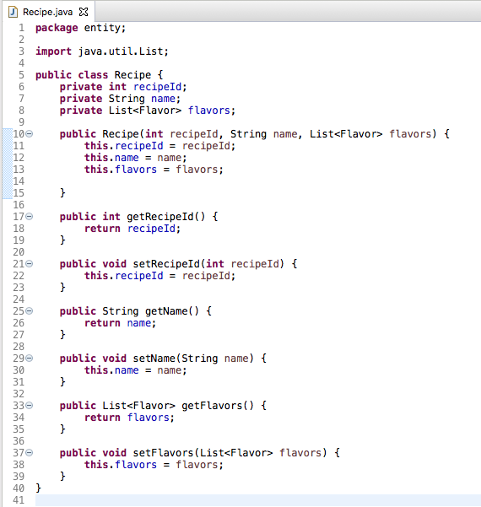

Flavor.java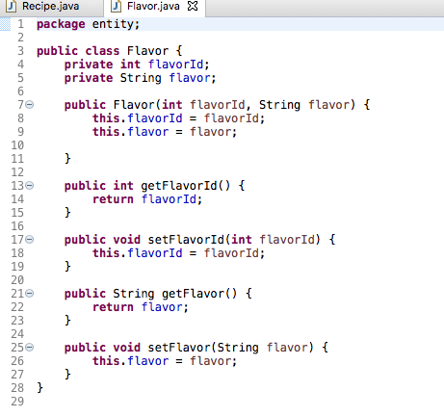

Flavor_recipe.java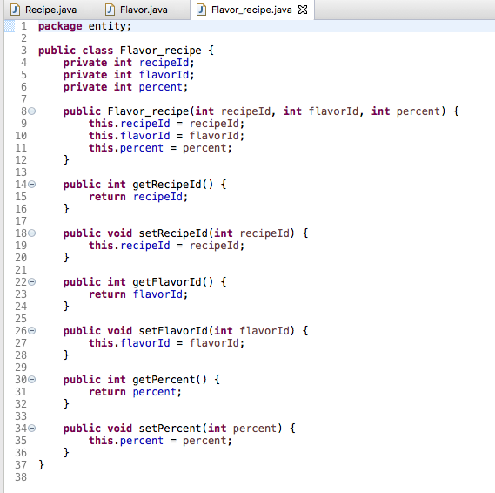

RecipeDao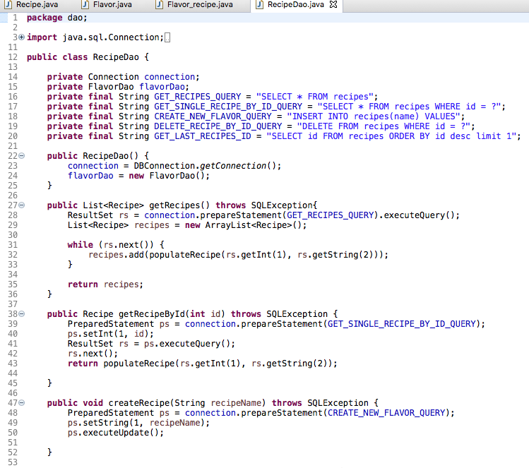

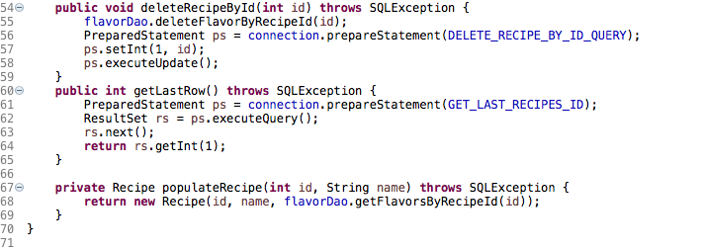

FlavorDao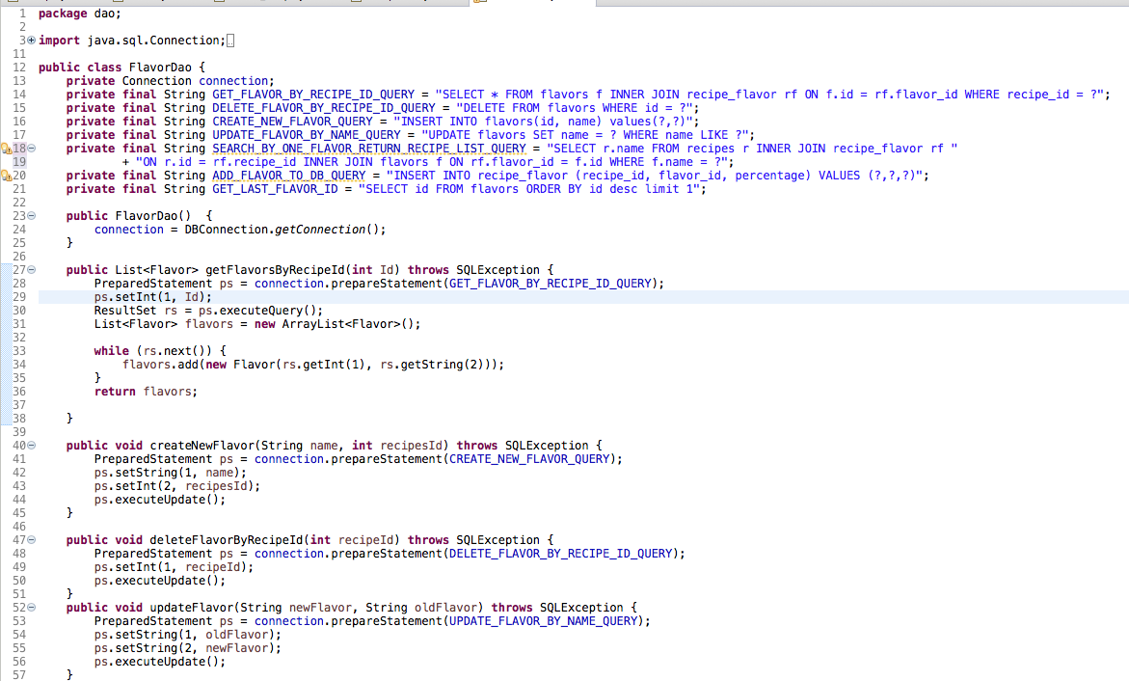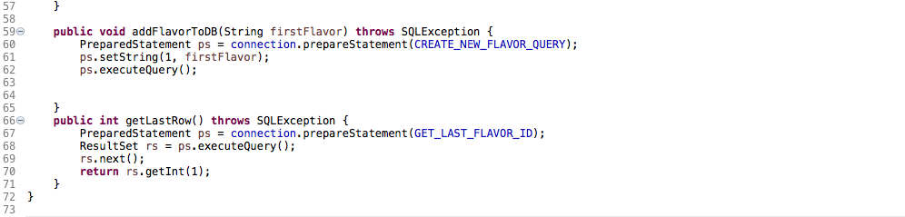

Flavor_recipeDao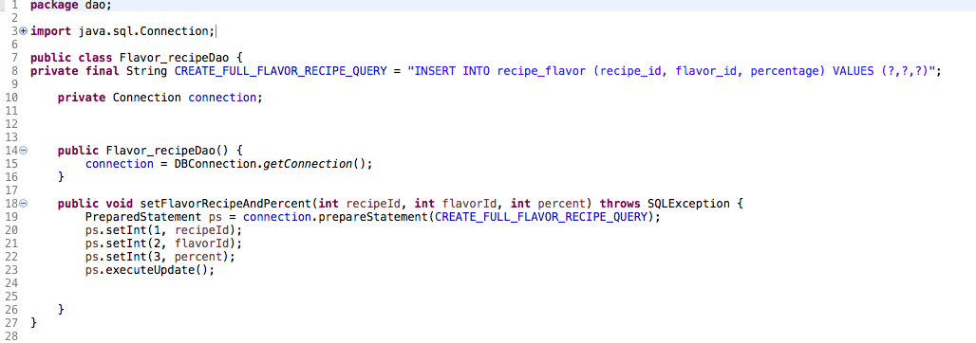

DBConnection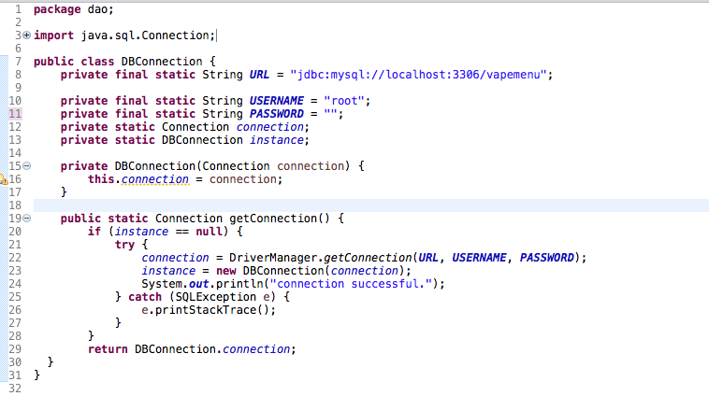

Menu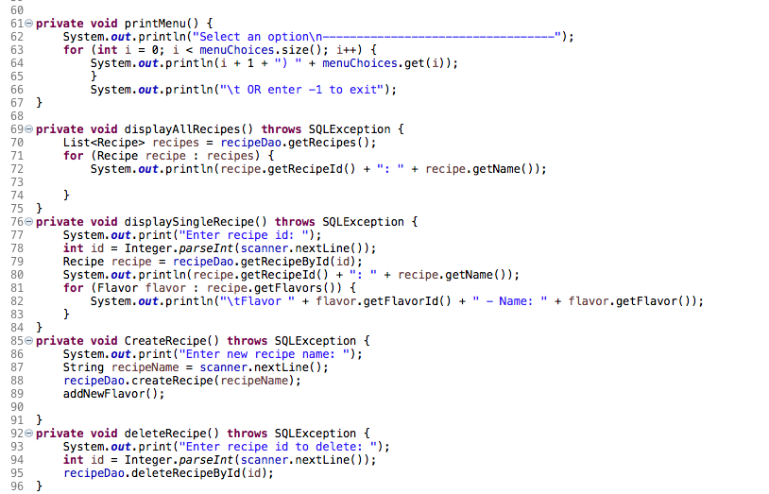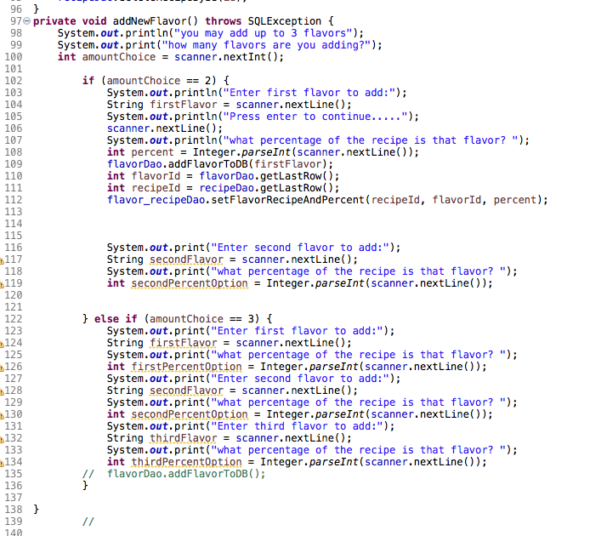

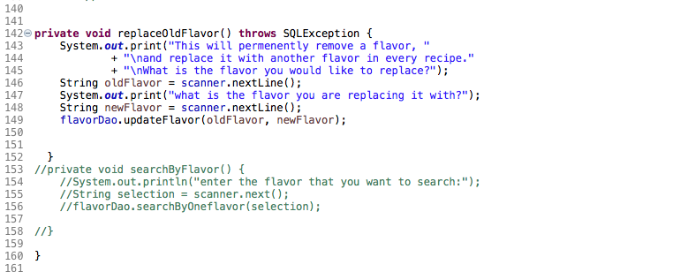

Application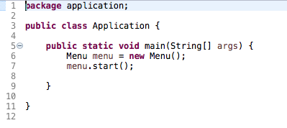

**Screenshots of Running Application:**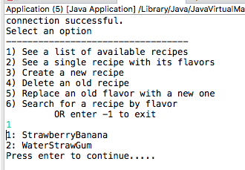

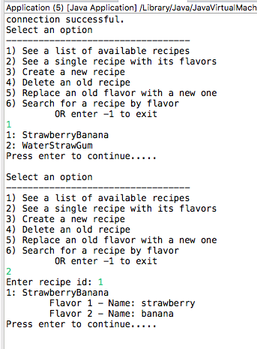

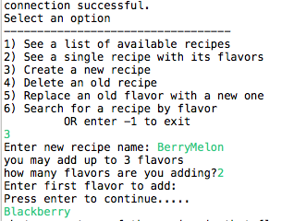

**URL to GitHub Repository:**

https://github.com/Christinalytle/week6SQLGroupProject.git