**快递物流系统**

**体系结构设计模型**

学 院：南京大学软件学院

成 员：潘凌伟 申彬 谭昕玥 杨雁飞

完成日期：2015年10月26日

目录

1、软件体系结构逻辑设计方案 3

2、开发包设计 4

2.1、快递物流系统最终开发包设计（表一） 7

3、开发包图 8

3.1、快递物流系统客户端开发包图（图一） 8

3.2、快递物流系统服务器端开发包图（图二） 8

3.3、快递物流系统层之间调用的接口（表二） 9

3.4、快递物流系统用户管理用例层之间调用的接口 10

3.5、快递物流系统用户界面跳转 11

3.6、快递物流系统业务逻辑层的分解 11

# 1、软件体系结构逻辑设计方案

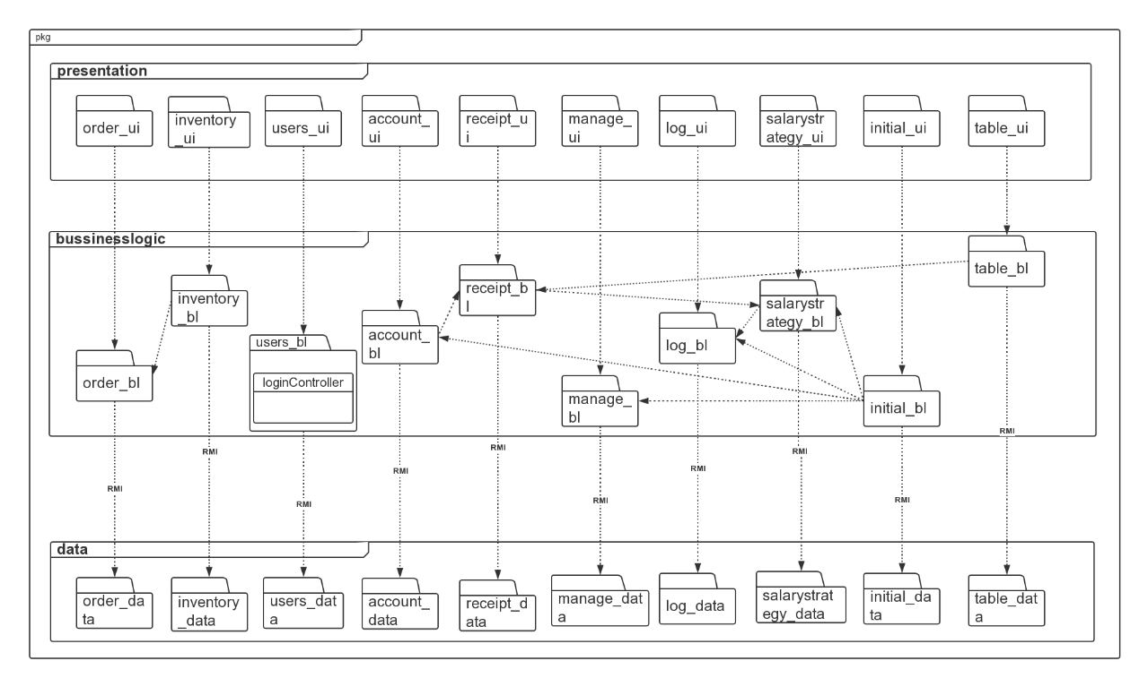

# 2、开发包设计

|  |  |
| --- | --- |
| 开发（物理）包 | 依赖的其他开发包 |
| main_ui | query_ui,login_ui,courier_ui,businessclerk_ui,centerclerk_ui,inventoryController_ui,finacialstaff_ui,generalManager_ui,administrator_ui,VO |
| login_ui | login_blservice,界面类库包,VO |
| query_ui | expressorder_blservice,界面类库包,VO |
| courier_ui | order_blservice,界面类库包,VO |
| businessclerk_ui | order_blservice,manage_blservice,界面类库包,VO |
| centerclerk_ui | order_blservice,界面类库包,VO |
| inventoryController_ui | inventory_blservice,界面类库包,VO |
| finacialstaff_ui | account_blservice,table_blservice,initial_blservice,界面类库包,VO |
| generalManager_ui | manage_blservice,log_blservice,table_blservice,界面类库包,VO |
| administrator_ui | user_blservice,界面类库包,VO |
| expressorder_  blservice |  |
| expressorder_bl | expressorder_data_service,PO |
| login_blservice |  |
| login_bl | user_data_service,PO |
| order_blservice |  |
| order_bl | expressorder_bl,order_data_service,PO |
| receipt_blservice |  |
| receipt_bl | receipt_data_service,PO |
| account_blservice |  |
| account_bl | account_data_service,PO |
| manage_blservice |  |
| manage_bl | manage_data_service,strategy_data_service,PO |
| transmanage_blservice |  |
| transmanage_bl | transmanage_data_service |
| log_blservice |  |
| log_bl | log_data_service,PO |
| strategy_blservice |  |
| strategy_bl | strategy_data_service,PO |
| table_blservice |  |
| table_bl | receipt_data_service,PO |
| approve_blservice |  |
| approve_bl | expressorder_data_service,receipt_data_service,order_data_service,strategy_data_service |
| initial_blservice |  |
| initial_bl | strategy_bl,manage_bl,log_bl,strategy_data_servidce,PO |
| user_blservice |  |
| user_bl | user_data_service,PO |
| expressorde_data_  service | JAVA RMI,PO |
| expressorde_data | databaseutility,PO |
| user_data_service | JAVA RMI,PO |
| user_data | databaseutility,PO |
| receipt_data_  service | JAVA RMI,PO |
| receipt_data | databaseutility,PO |
| account_data_  service | JAVA RMI,PO |
| account_data | databaseutility,PO |
| inventory_data_  service | JAVA RMI,PO |
| inventory_data | databaseutility,PO |
| manage_data_  service | JAVA RMI,PO |
| manage_data | databaseutility,PO |
| transmanage_data_service | JAVA RMI,PO |
| transmanage_data | databaseutility,PO |
| log_data_service | JAVA RMI,PO |
| log_data | databaseutility,PO |
| strategy_data_  service | JAVA RMI,PO |
| strategy_data | databaseutility,PO |
| initial_data_service | JAVA RMI,PO |
| initial_data | databaseutility,PO |
| VO |  |
| PO |  |
| excel_bl |  |
| databaseutility | java.JDBC |
| 界面类库包 |  |
| JAVA RMI | java.swing,java.awt,java.2D,java.3D |

## 2.1、快递物流系统最终开发包设计（表一）

# 3、开发包图

## 3.1、快递物流系统客户端开发包图（图一）

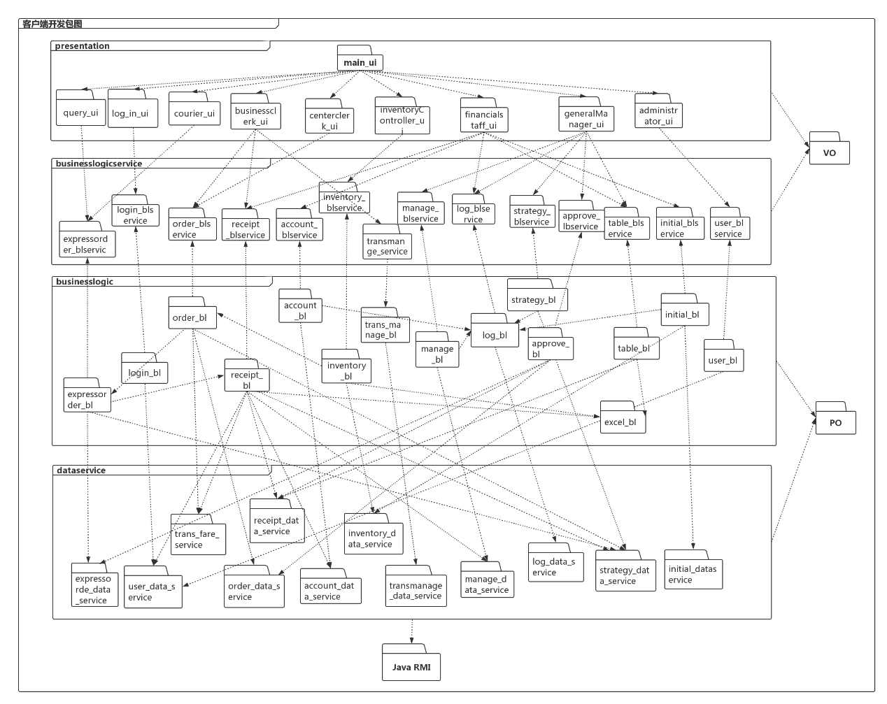

## 3.2、快递物流系统服务器端开发包图（图二）

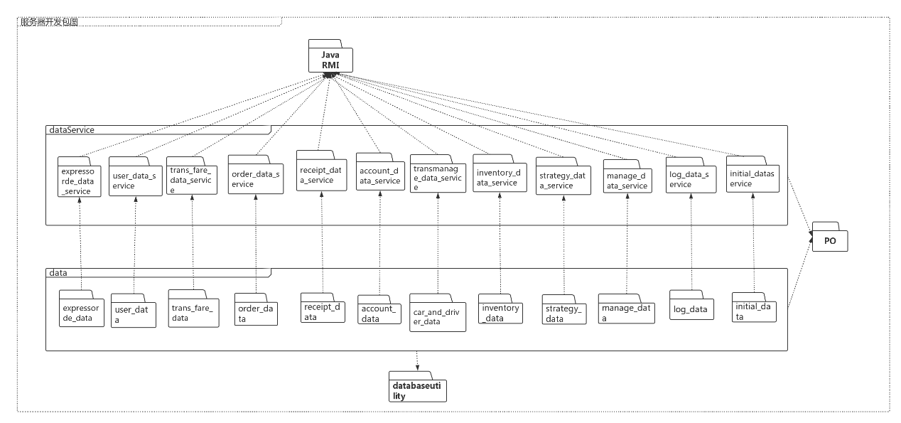

## 3.3、快递物流系统层之间调用的接口（表二）

|  |  |  |
| --- | --- | --- |
| 接口 | 服务调用方 | 服务提供方 |
| expressorder_blservice  login_blservice  order_blservice  receipt_blservice  account_blservice  inventory_blservice  transmanage_blservice  manage_blservice  strategy_blservice  table_blservice  initial_blservice  approvel_blservice  user_blservice | 客户端展示层 | 客户端业务逻辑层 |
| expressorder_data_service  user_data_service  order_data_service  receipt_data_service  account_data_service  inventory_data_service  transmanage_data_service  manage_data_service  log_data_service  strategy_data_service  initial_data_service | 客户端业务逻辑层 | 服务器端数据层 |

## 3.4、快递物流系统用户管理用例层之间调用的接口

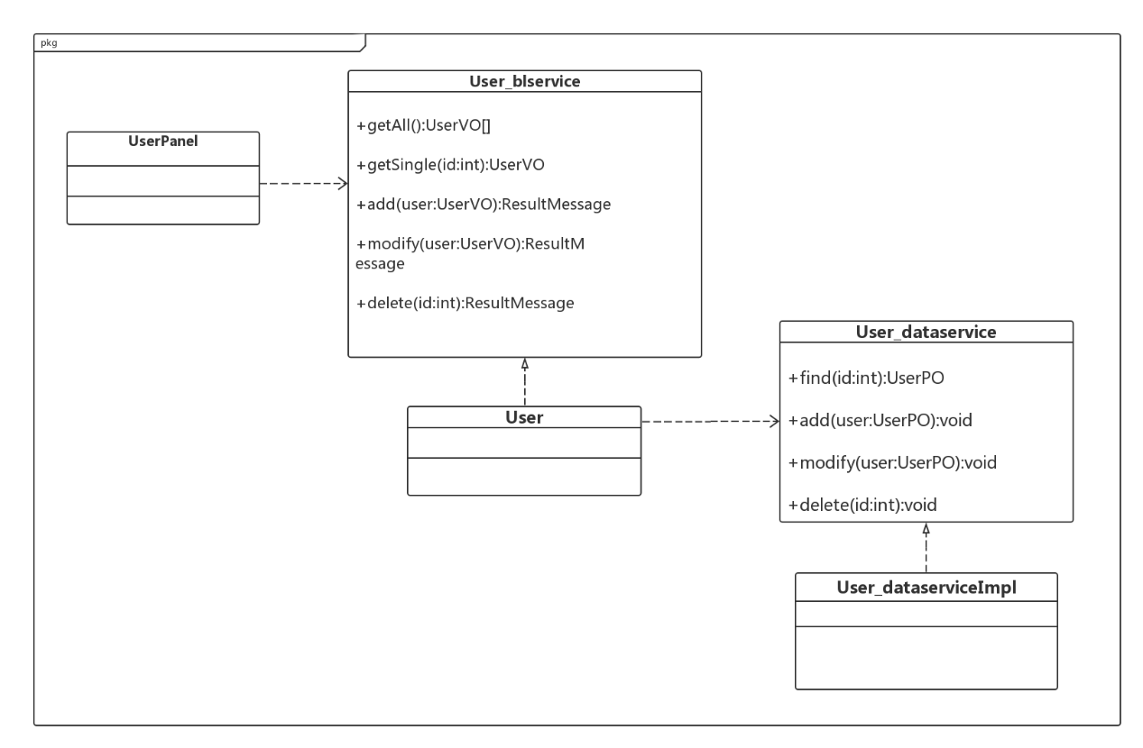

## 3.5、快递物流系统用户界面跳转

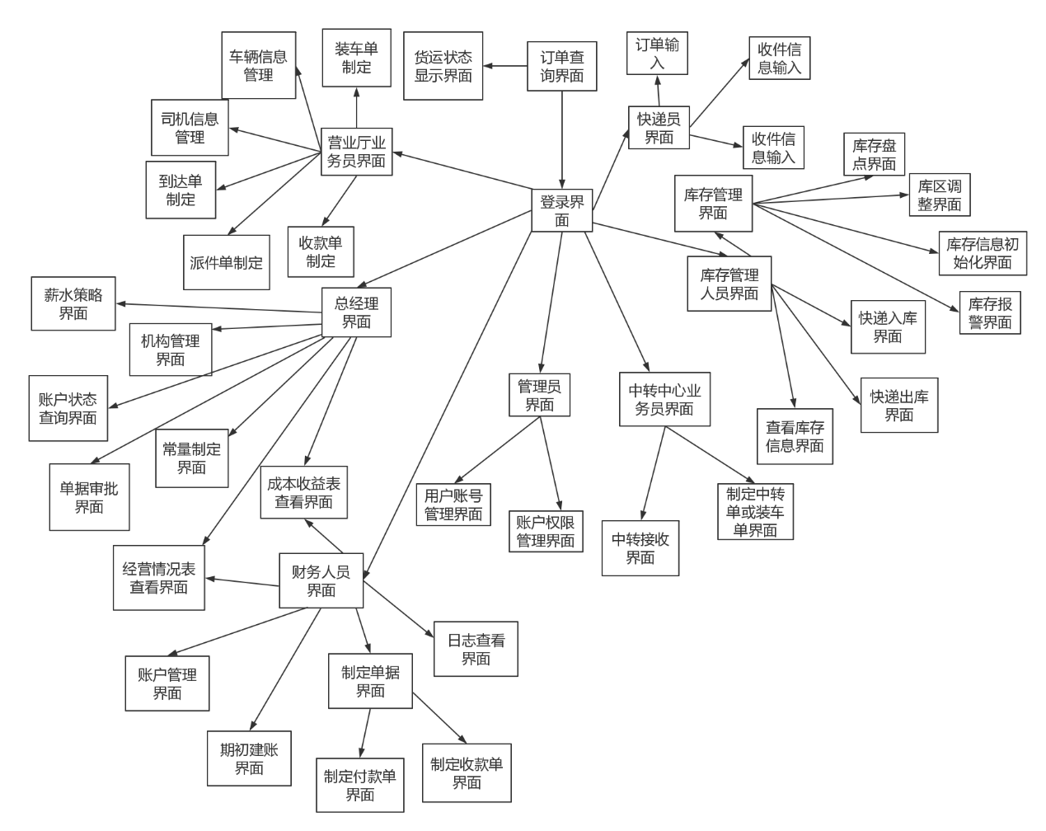

## 3.6、快递物流系统业务逻辑层的分解

