ClosetIQ
User Manual

Your Style. Smarter Every Day.

Version 1.0
October 2026

Contents
1. Getting Started — Creating Your Account
2. Signing In
3. The Dashboard — Your Wardrobe at a Glance
4. Managing Your Wardrobe
4.1 Viewing Your Wardrobe
4.2 Adding a New Item
4.3 Filtering by Category
4.4 Removing an Item
5. Today's Look — The Outfit Generator
5.1 Generating an Outfit
5.2 Changing the Weather
5.3 Filtering by Occasion
5.4 Regenerating Your Outfit
6. Signing Out

1. Getting Started — Creating Your Account
To use ClosetIQ, you first need to create an account. Open your browser and go to the ClosetIQ login page.
Step 1: Click the "Create Account" tab at the top of the login card.
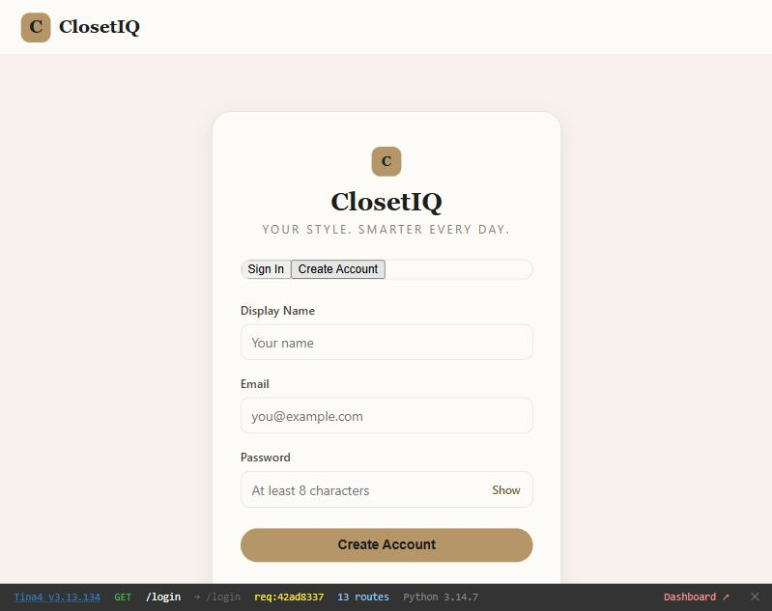

Step 2: Fill in your details:
- Display Name — the name shown in the navigation bar
- Email — your login email address
- Password — at least 8 characters
Step 3: Click the "Create Account" button. You will be signed in automatically and redirected to your dashboard.
Tip: Click the "Show" button next to the password field to see what you are typing.

2. Signing In
If you already have an account, sign in from the login page.
Step 1: Make sure the "Sign In" tab is active (it is the default).
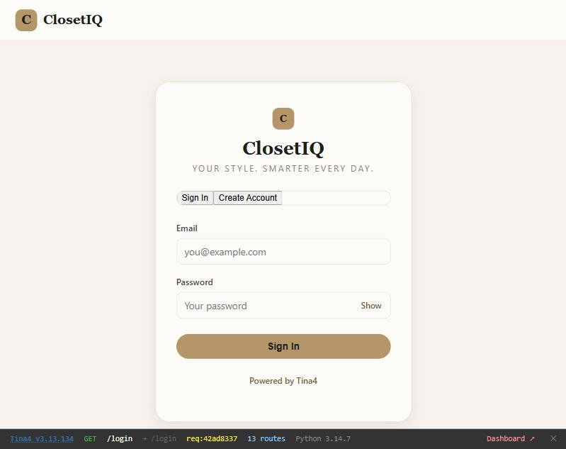

Step 2: Enter your email address and password.
Step 3: Click the "Sign In" button. You will be redirected to your dashboard.
Tip: If you enter the wrong credentials, an error message will appear. Check your email and password and try again.

3. The Dashboard — Your Wardrobe at a Glance
After signing in, you arrive at the Dashboard. This is your home screen, showing a summary of everything in your digital wardrobe.
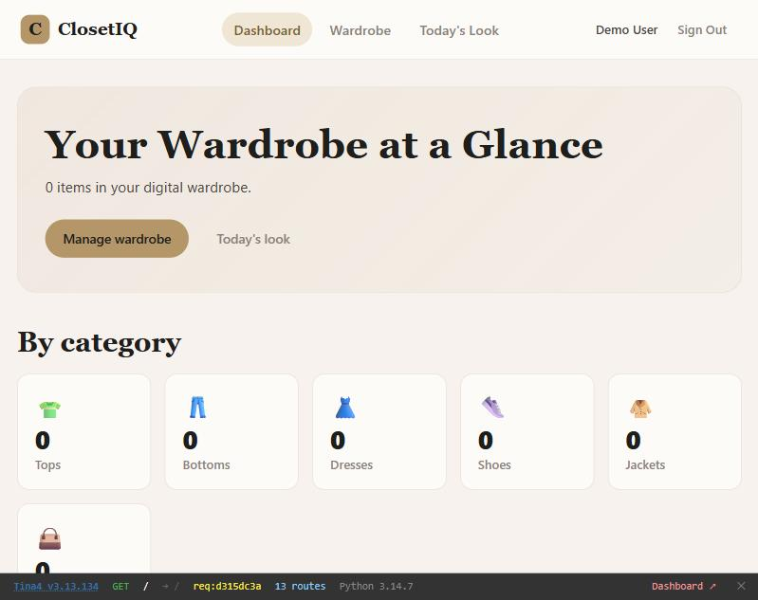

The dashboard shows:
- Total item count — how many pieces are in your wardrobe
- Category cards — quick counts for Tops, Bottoms, Dresses, Shoes, Jackets, and Accessories — click any card to jump to that category in your wardrobe
- Quick links — "Manage wardrobe" takes you to your full wardrobe; "Today's look" opens the outfit generator

The navigation bar at the top gives you quick access to:
- Dashboard
- Wardrobe
- Today's Look
- Sign Out

4. Managing Your Wardrobe

4.1 Viewing Your Wardrobe
Click "Wardrobe" in the navigation bar to see all your items. If your wardrobe is empty, you will see a message inviting you to add your first item.
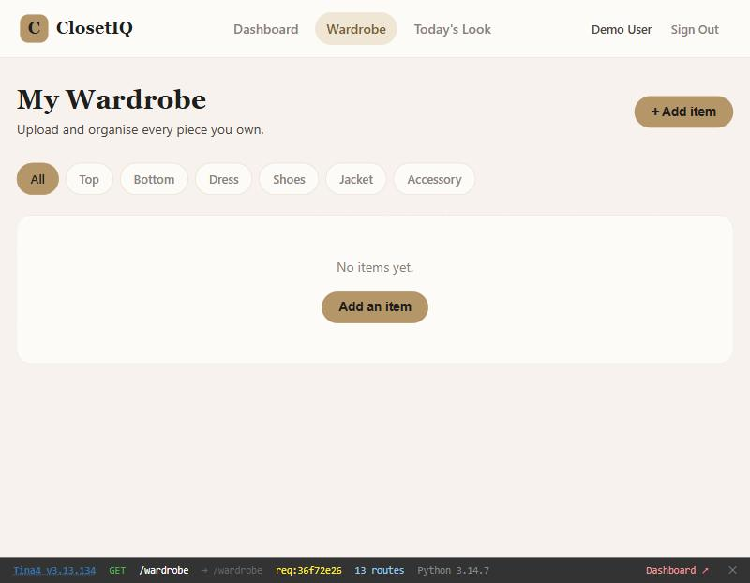

Each item card shows the item name, its category badge, a colour swatch, style tags, and how many times it has been worn.

4.2 Adding a New Item
Step 1: Click the "+ Add item" button in the top-right corner of the wardrobe page.
The add item form will slide open:
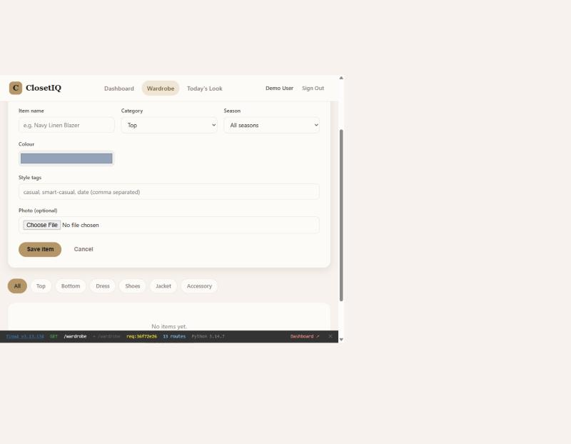

Step 2: Fill in the item details:
- Item name — e.g. "Navy Linen Blazer"
- Category — choose from Top, Bottom, Dress, Shoes, Jacket, or Accessory
- Season — choose All seasons, Summer, or Winter
- Colour — pick a colour using the colour picker
- Style tags — enter comma-separated tags like "casual, smart-casual, date"
- Photo — (optional) upload a photo of the item
Step 3: Click "Save item". The page will reload and your new item will appear in the wardrobe.
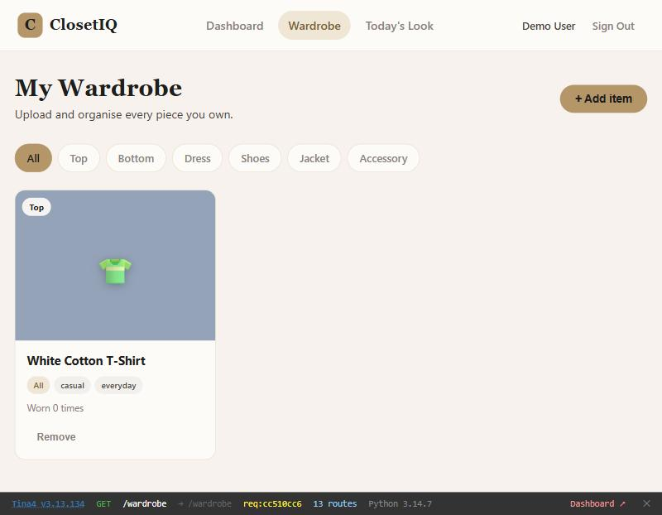

4.3 Filtering by Category
Use the filter chips at the top of the wardrobe page to show only items in a specific category. Click "All" to show everything again.
Available filters: All, Top, Bottom, Dress, Shoes, Jacket, Accessory.
Tip: You can also reach a filtered view by clicking a category card on the Dashboard.

4.4 Removing an Item
Step 1: Click the "Remove" link at the bottom of the item card you want to delete.
Step 2: A confirmation dialog will appear asking if you are sure.
Step 3: Click "OK" to confirm. The item will be permanently removed and the page will refresh.
Tip: Removing an item cannot be undone. Make sure you want to delete it before confirming.

5. Today's Look — The Outfit Generator
Click "Today's Look" in the navigation bar to open the outfit generator. ClosetIQ will pick a complete outfit from your wardrobe — a top, bottom, shoes, and an accessory.

5.1 Generating an Outfit
When you first open the page, ClosetIQ generates an outfit based on the current weather setting (Mild by default).
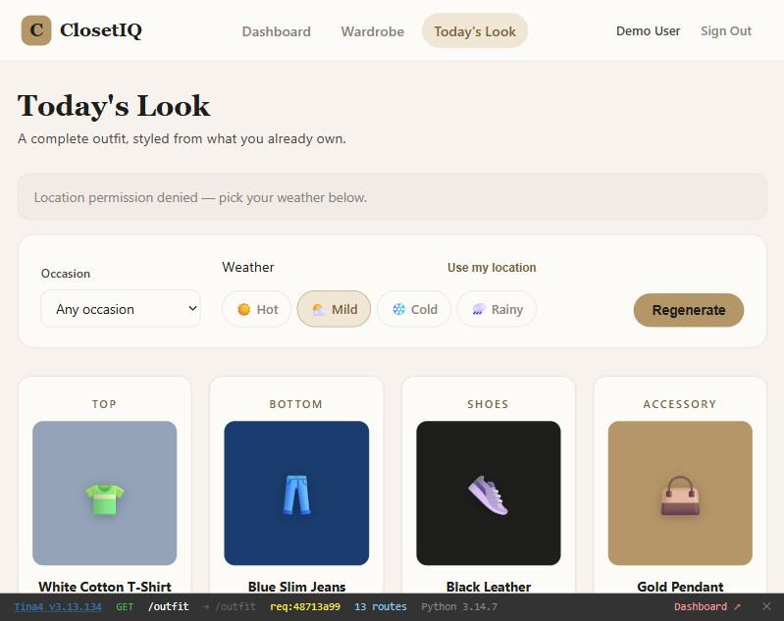

Each slot in the outfit shows the item name and a visual representation. The outfit is random — every time you visit the page or click Regenerate, you get a different combination.

5.2 Changing the Weather
Use the weather radio buttons to match your outfit to the weather:
- Hot — lightweight, summer-friendly items
- Mild — all-season items (the default)
- Cold — adds a JACKET slot and picks winter items
- Rainy — weather-appropriate pieces

Selecting "Cold" adds an extra JACKET slot to your outfit, so you get five pieces instead of four:
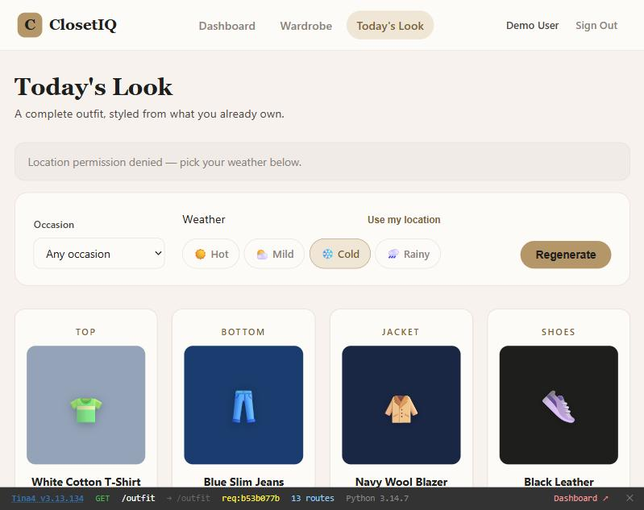

Tip: ClosetIQ can also detect your local weather automatically. Click "Use my location" to let it choose the best setting for you.

5.3 Filtering by Occasion
Use the Occasion dropdown to filter for a specific dress code:
- Any occasion (default — no filter)
- Casual
- Formal
- Smart-casual
- Date
- Work
The outfit generator will only use items whose style tags match the selected occasion.

5.4 Regenerating Your Outfit
Step 1: Click the "Regenerate" button to get a fresh outfit with the same weather and occasion settings.
Each click picks different items at random from your wardrobe, so you can keep regenerating until you find a look you love.

6. Signing Out
Step 1: Click "Sign Out" in the top-right corner of the navigation bar.
You will be redirected back to the login page. Your wardrobe data is saved and will be there when you sign in again.

ClosetIQ — Your Style. Smarter Every Day.

Powered by Tina4 — tina4.com

