STUDENT MANAGEMENT

Project Description
A Student Management System (SMS) is a management information system for education establishments to manage student data, designed to help schools for management, viewing student data, managing seats, quota, board, semester, faculty, category and for examination, block allocation, subject management, scheduling exam, result and related issues are made simple and easy. There are custom search capabilities to aid in finding student information and working on student records. This can make the system easier to navigate and to use maximizing the effectiveness of time and other resources. SMS allows the keeping of personnel data in a form that can be easily accessed and analyzed in a consistent way.
Student management system has become important factors in modern education field. This system should help the institutional to streamline the administrative task and provide real-time access to the data. Building this system in web based interface will further help the ease of accessibility through any web browsers.

The main objective of this project is to develop a Student Management System (SMS) for all schools in the Philippines. Following is the details of the project objective to archive:
• To study and understand the Struts 2 Framework and its Model-View-Controller (MVC) architecture.
• To study and analyze the requirement specifications of the Student Management System

• To produce the SRS of the Student Management System
• To produce the SDD of the Student Management System
• To develop the prototype of Student Management System using Struts architecture.

The project scopes define the description of the work that required in delivering the student management system. Following are the scopes of work during the course of this project:
• Study and understand the requirement of this project.
• Construct Software Requirement and Specification (SRS) document of the SMS.
• Construct Software Design Document (SDD) of the SMS.
• Build prototype of the SMS using Struts 2 Framework.

Project Coverage
In Students Management System, it includes here the students, teachers or professors and the admin. In students, they must sign up first the information needed for their identity for registration. After the signing up, all the data that the students filling up, the admin will be the one to save so that if the students wants to login, they can already use the system. On the other side, for the teachers and professors, it is the same as what the students do. Fill up all the forms for registration and after that the admin will be the one to save.
When the students wants to login, he/she must fill up its username ant the password for signing in. For the teachers, it is the same on what the students do.

Schedule of Work (Gantt chart)
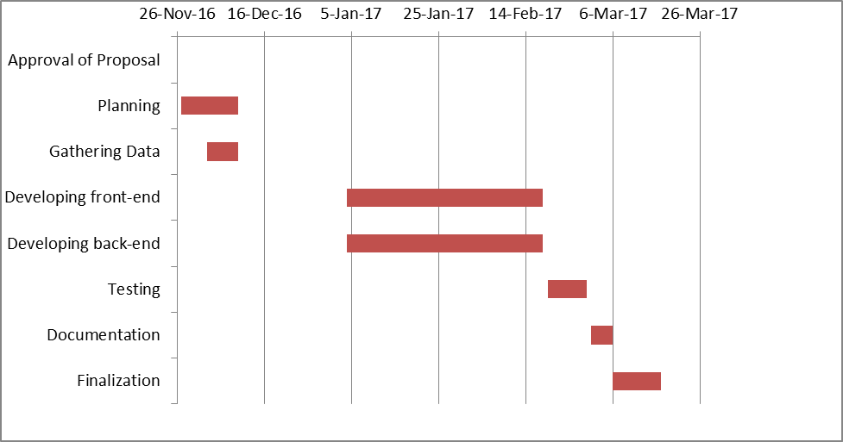
Breakdown of Functions
- Admin
- Teachers
- Students
- Register
- Login
- Profiling
- Submit/Request

