Python/Selenium Documentation

# Python Setup:

## **Step 1:**

First verify that python wasn’t already installed by typing the following into the command prompt:

python --version

If it is installed it will return the version installed, otherwise you will see something similar to Figure 1 below.

### Figure 1 – Initial Python Check

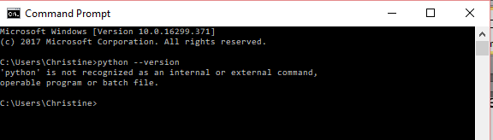

## Step 2:

If python is not already installed you will need to install it by going to the following link and downloading the version of python you would like to use. <https://www.python.org/downloads/>

* To determine if your computer is 32/64 bit, go to your start menu 🡪 Control Panel 🡪 System 🡪 Then you should be able to view it under System: System Type.
* For 32 bit: click on “Download Python 3.6.5” on the home page of the python site.
* For 64 bit: Once on the site, go to Downloads, then Windows. Select “Latest Python 3 Release”. Then scroll to the bottom and select the executable installer for your operating system (Windows, Mac, etc.) and download it.
* IMPORTANT: Before you hit install, make sure you select the checkbox to add the python path. This will automatically add the correct path to your Environment Variables.
* Now you can install it.

Python Installation Tutorial:

<https://www.youtube.com/watch?v=S8oYT5am8j4>

## **Step 3:**

Open a NEW command prompt and use the same line from Step 1 to verify that python was installed correctly. Figure 2 shows an example of what your command prompt should return.

### Figure 2 – Python Version Check

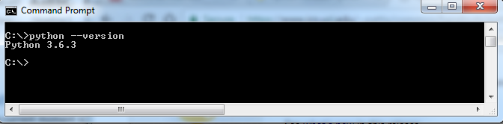

# Selenium Setup:

## Step 1:

Now that python is installed we can start setting up selenium. To do this we need to make sure pip is installed and working. This should have been installed with python, but to verify it type the following command:

pip –version

This should show and output of the version of pip installed on your computer as shown in the figure 3 below:

### Figure 3 – Pip Version Check

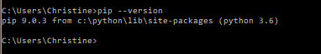

Now we can start with selenium…

## Step 2:

Use pip to install selenium by typing the following command into the command prompt:

pip install -U selenium

This will automatically run an installation in the command prompt and look similar to the image in Figure 4 below:

### Figure 4 – Selenium Installation

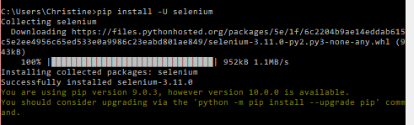

## Step 3:

Download the correct drivers needed for the browsers you plan to work with from the following link: <https://www.seleniumhq.org/download/>

* Once the driver is downloaded you follow the following tutorial that shows you how to set up each driver: ADD LINK HERE

## **Step 4:**

Write your Selenium Script with a .py extension

## Step 5:

Run it in the command line using >python nameoffile.py

**CONGRATULATIONS!!!**

**YOU HAVE SET UP PYTHON AND SELENIUM ON YOUR COMPUTER!!**

# Selenium Links If Needed:

Python/Selenium Installation Tutorial - <https://www.youtube.com/watch?v=FFDDN1C1MEQ&t=24s>

Selenium Installation: <https://pypi.python.org/pypi/selenium>

Setting Environment Variables: <https://www.youtube.com/watch?v=0vsswJooDe0>