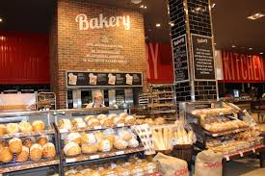

Final Project Stream One
Austrian Bakery Website
Christine Wilde | Full Stack Software Developer | 04.10.2017

Introduction – Frontend Website
The goal of the stream one project is to build a frontend responsive Website. For my project I have chosen to design an Austrian bakery that offers a range of Austrian sweet and savory delicacies. My client is my work colleague Barbara Widholm whose dream it is to one day open an Austrian bakery shop near her home in London. Barbara is therefore my contact who has provided guidance how her Business should look like on the Web and the products it should offer. The below bullet points list the items that are in scope for this Website and the target audience.

Website scope & target audience

Target customers and users:

Scope:
- Menu bar for navigation (About Us, Bakery Products, Order Online, Delivery Availability)
- Audio and Images: Image gallery with Austrian music feature
- Responsive bakery product order form
- Delivery availability look-up feature
- Footer (T&C, Social Media, Location: Contact & Address)

Technical inclusions
The list below highlights the technical tools used to accomplish the bakery Website from the initial prototype versions to the completed Website product.

Balsamiq
- Website prototypes

GitHub, GitBash, GitHub Pages
  - Hosting the software project files and version control
  - Creating repositories and branches for project files
  - Submitting final project

(Semantic) HTML5
- Website HTML structure – DOM

CSS
  - General and advanced Website display (external style sheet)
  - Media queries to accommodate different screen sizes (external style sheet)

JavaScript
- Responsive form, queries and navigation

Navigation bar
- Bootstrap

The Prototype

Testing results & summary

The complete product – Austrian Bakery

