- Error: addEventListener ‘DOMContentLoaded’ required
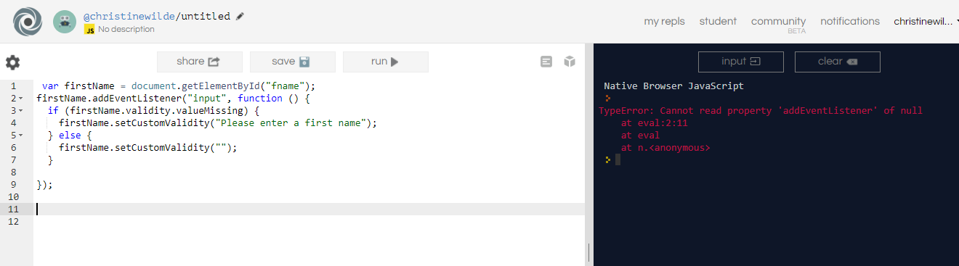
Solution

