**Step-by-step documentation of the VOSviewer-Network visualization**

1. Download VOSviewer: <https://www.vosviewer.com/>
2. Download and unzip the txt-input files (input_publication_metadata.zip) from OSF:
   * *01_naturalness_webofscience2024_55.txt* - metadata of 55 publications on voice naturalness, exported from Web of Science in July 2024‎ by clicking on “Export” -> “Plain text file”.
   * *02_naturalness_manual2024_17.txt* – metadata of 17 publications on voice naturalness which were not available on Web of Science, added manually
   * *03_voice_theory_webofscience2024_9.txt* – metadata of 9 voice theory papers, exported in July 2024 from Web of Science
   * *04_voice_theory_manually2024_1.txt* – metadata of one voice theory paper, added manually
3. Open VOSviewer -> click on “Create” -> “Create a map based on bibliographic data” -> “Read data from bibliographic database file” -> select all four textfiles

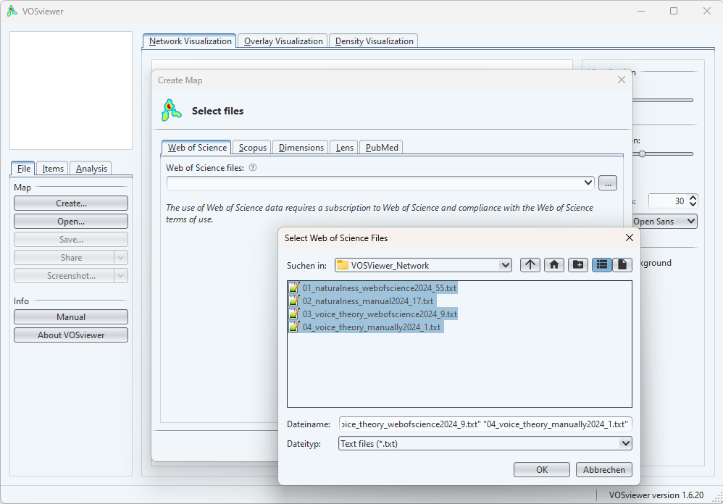

1. For type of analysis, select “Citation”; for unit of analysis, select “Documents”

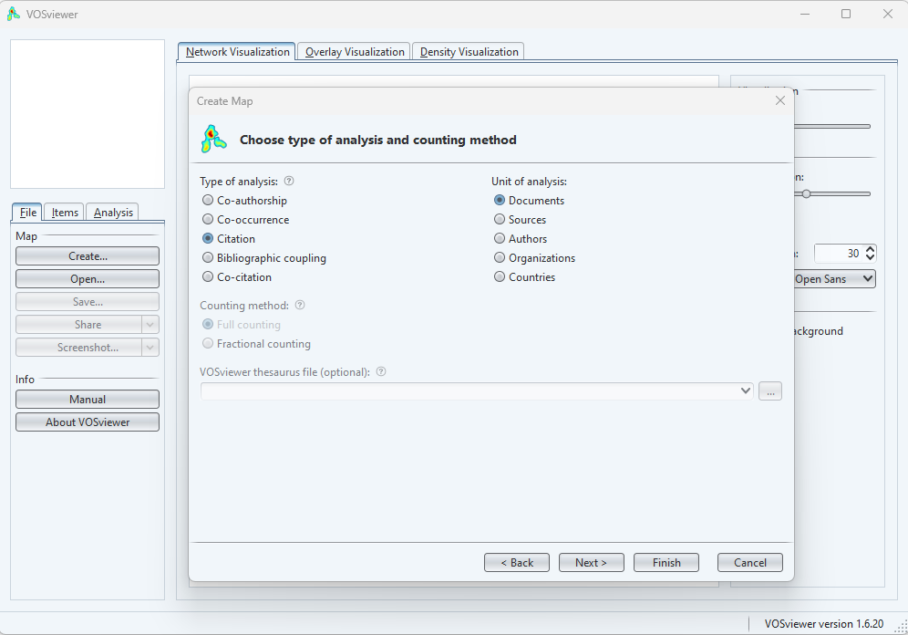

1. Minimum number of citations of a document: 0; number of documents to be selected: 82
2. Verify selected documents and then click on “Finish” 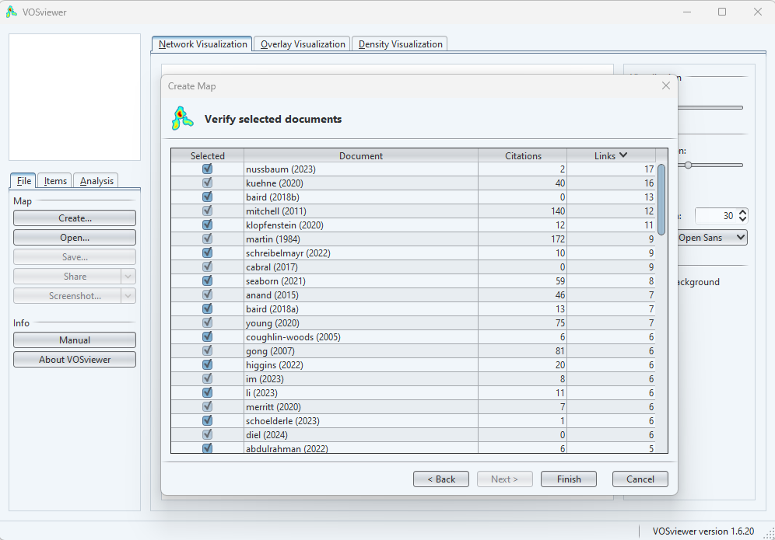
3. Note that 10 out of the 82 publications have no links at all to the other publications. They are omitted by clicking “yes”

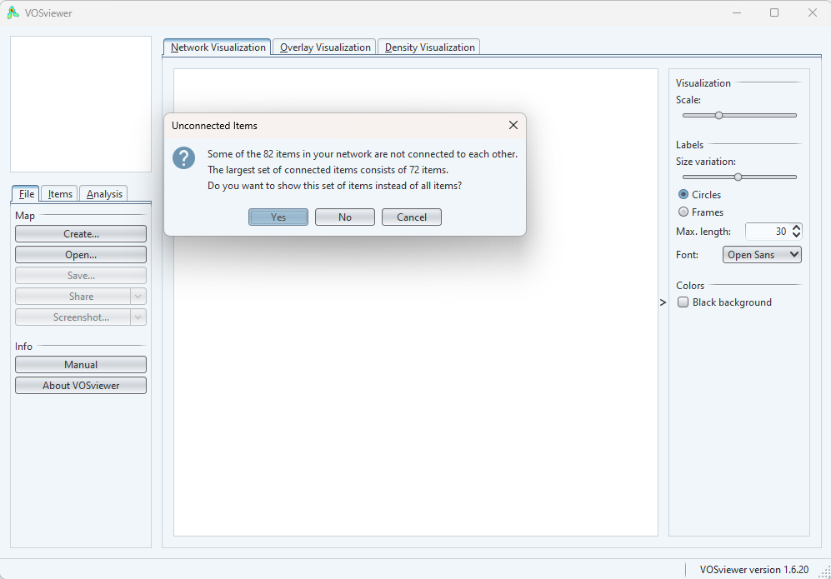

1. Get a first view on the raw network:

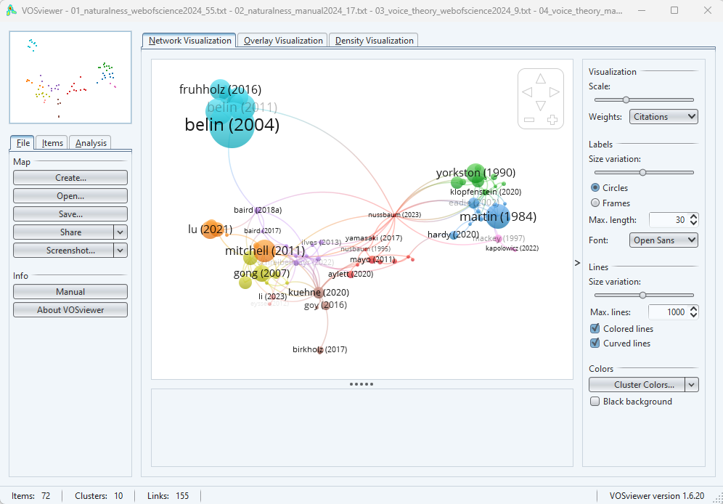

1. Go to “Analysis” and click on “Rotate” twice.
2. Set “Min. cluster size” to 8 and click “update clustering”
3. One the right side of the menu, set the visualization to the following settings:

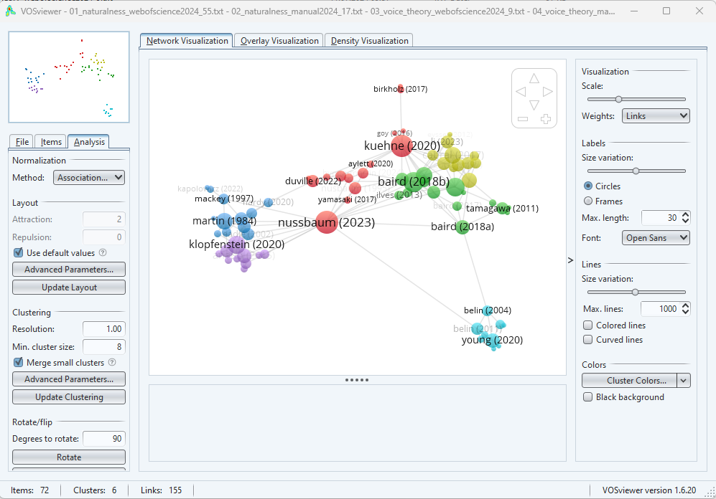

1. Adjust cluster colors as follows:

|  |  |  |  |  |
| --- | --- | --- | --- | --- |
| **Number** | **Post-hoc label** | **R** | **G** | **B** |
| Cluster 1 | Synthetic Voices | 50 | 140 | 220 |
| Cluster 2 | Synthetic Voices | 50 | 100 | 220 |
| Cluster 3 | Voice Pathology | 210 | 40 | 120 |
| Cluster 4 | Synthetic Voices | 50 | 60 | 220 |
| Cluster 5 | Voice Pathology | 210 | 40 | 40 |
| Cluster 6 | Voice Theory | 30 | 130 | 50 |

1. This is how the network should look now:

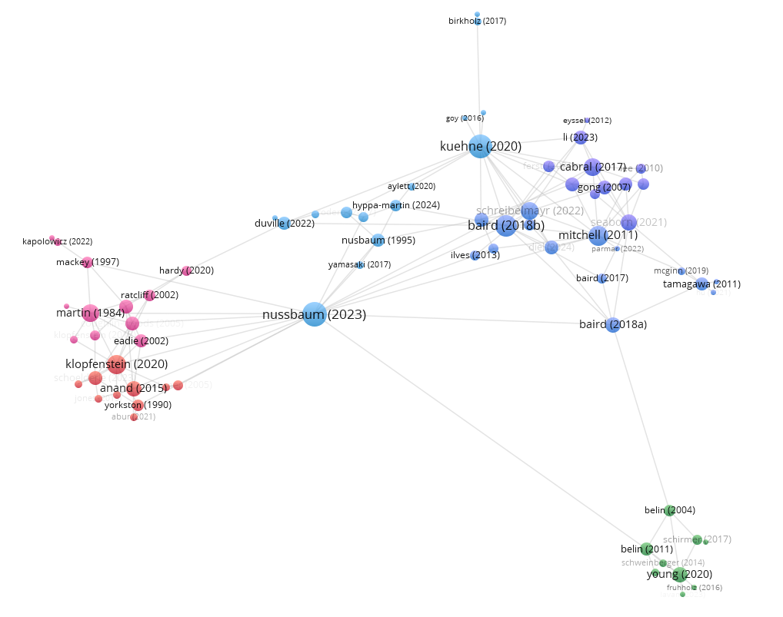

1. To save the network, go to File -> Save… -> Save both the map and the network file:

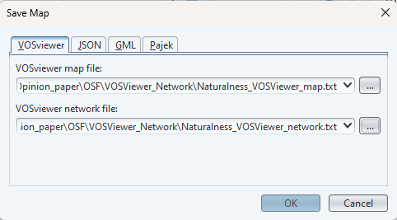

1. To load the data later, go to “open” and open both files. Note that some of the settings in the visualization get lost upon re-opening.
2. To export an image, click on “Screenshot” (Options: Scaling 400%, none of the other options)