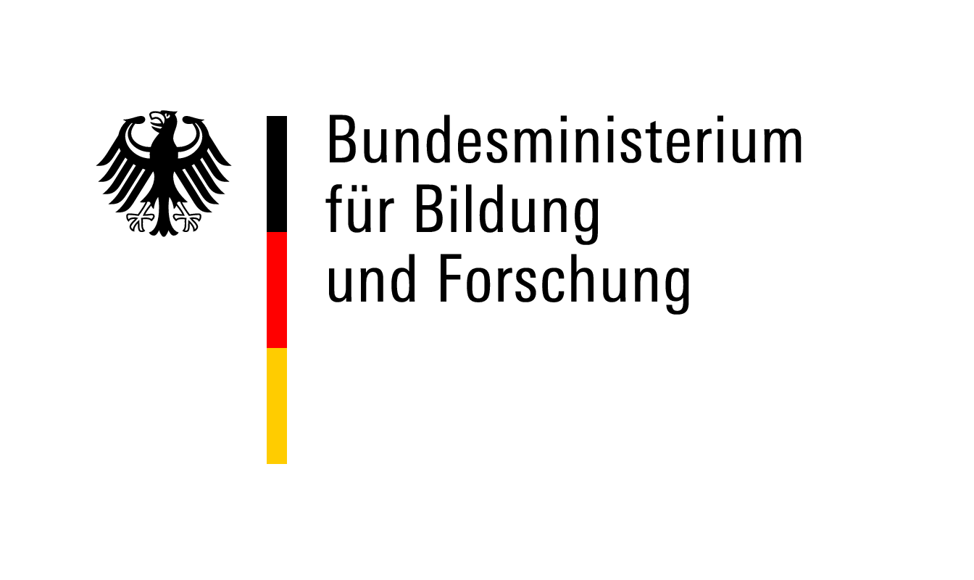

**Checklist – Application Documents**

**Postdoctoral Researchers International Mobility Experience (PRIME)**

**Documents to be uploaded to the DAAD Portal (make sure to reduce file sizes):**

Application form

CV

Career plan / motivation letter

Short summary of the research project (including **working title** and **keywords**)

Detailed research proposal

Time schedule

Binding declaration German host university (form 1)

Invitation letter German host (form 2)

Invitation letter foreign host

Degree certificates

Master (or equivalent**) with transcripts of records** (marksheets)

PhD with transcripts of records (if available)

If PhD not yet completed, statement from PhD supervisor on expected time of completion

Publication list

List of the most important publications (min.1, max. 3) with reasons for their selection

Short summary of the doctoral thesis

Ethics issues checklist (form 3)

Language certificates (if applicable)

Reference letter requested (will be sent by post)

Do not upload documents we don’t need (e.g., certificates for reviews, conferences, sports awards). You can list these activities on your CV.

I have taken note of the call for applications and the programme FAQs. I am aware that only complete applications will be processed. Applications that are incomplete or non-compliant with the programme regulations will not enter the review process.

Place/Date Signature of Applicant