Vocal Emotion Perception: A Comparison of Singers and Instrumentalists, Amateurs and Professionals

Christine Nussbaum1,2, Jessica Dethloff1,2, Annett Schirmer3,2, and Stefan R. Schweinberger1,2,4

**Supplemental Tables and Figures**

1Department for General Psychology and Cognitive Neuroscience, Friedrich Schiller University Jena, Germany

2Voice Research Unit, Friedrich Schiller University, Jena, Germany

3Institute of Psychology, University of Innsbruck, Austria

4Swiss Center for Affective Sciences, University of Geneva, Switzerland

# Supplemental Sample Information

**Table S1**

*List of reported instruments by amateurs (singers and instrumentalists)*

|  |  |  |  |  |
| --- | --- | --- | --- | --- |
| **Singers** | **Instrumentalists** | | | |
| Gesang *(singing)* / Chor *(choir)* | | 35 | Violine *(violin)* | 10 |
| + Klavier *(piano)* | | 3 | Posaune (*trombone*) | 6 |
| + Violine (*violin*) | | 2 | Cello (*cello*) | 5 |
| + Gitarre *(guitar)* | | 2 | Klarinette (*clarinet*) | 4 |
| + Bass (*bass*) | | 1 | Trompete (*trumpet*) | 4 |
| + Klavier *(piano)* and Cello *(cello)* | | 1 | Waldhorn (*horn*) | 2 |
| + Trompete (*trumpet*) | | 1 | Bratsche (*Viola*) | 2 |
|  | |  | Schlagzeug (*drums*) | 2 |
|  | |  | Bariton (*bariton*) | 1 |
|  | |  | Bass (*bass*) | 1 |
|  | |  | Fagott (bassoon) | 1 |
|  | |  | Gitarre *(guitar)* | 1 |
|  | |  | Klavier *(piano)* | 1 |
|  | |  | Querflöte (*flute*) | 1 |
|  | |  | Tuba (*tuba*) | 1 |
|  | |  | Saxophon (saxophone) | 1 |

**Table S2**

*Socioeconomic background of amateurs (singers and instrumentalists)*

|  |  |  |  |  |  |  |  |  |
| --- | --- | --- | --- | --- | --- | --- | --- | --- |
| **Income (in €)** |  |  | **Education** |  |  | **Degree** |  |  |
|  | **S** | **I** |  | **S** | **I** |  | **S** | **I** |
| <1750 | 5 | 4 | keine *(none)* | 0 | 0 | keine *(none)* | 0 | 1 |
| 1750-2500 | 6 | 7 | Schüler *(pupil)* | 0 | 1 | Schüler *(pupil)* | 0 | 0 |
| 2500-3500 | 11 | 10 | Hauptschule  *(secondary school)* | 0 | 0 | In Ausbildung  *(under training)* | 15 | 17 |
| 3500-5000 | 17 | 9 | Mittelschule  *(secondary school)* | 0 | 0 | Lehre  *(traineeship)* | 0 | 3 |
| >5000 | 6 | 13 | Fachschule  *(technical college)* | 1 | 1 | Fachschule  *(technical college)* | 1 | 0 |
|  |  |  | Abitur  *(A-levels)* | 44 | 41 | Meister  *(master craftsmen)* | 0 | 0 |
|  |  |  |  |  |  | Bachelor  *(Bachelor)* | 10 | 4 |
|  |  |  |  |  |  | Fachhochschulabschluss *(polytechnic degree)* | 1 | 2 |
|  |  |  |  |  |  | Master/Diplom *(Master/Diploma)* | 14 | 10 |
|  |  |  |  |  |  | Promotion *(PhD)* | 4 | 6 |
|  |  |  |  |  |  |  |  |  |
| χ2 = 5.23, df = 4, p = 0.264 | | | χ2 = 1.06, df = 2, p = 0.588 | | | χ2 = 9.06, df = 7, p = 0.249 | | |

*Note. This table presents the number of individuals belonging to different income, education, and degree categories. We tested group differences between musician (M) and non-musicians (C) using a Chi-square test and show the results in the last line of this table. Please note that the response options “Education” (i.e. the type of school) and “Degree” (i.e. the highest professional qualification) were tailored to the German educational system and are therefore difficult to translate Further, please note that “Fachschule” and “Abitur” are similar as they both enable a person to pursue a university degree (with a few more constrains for a “Fachschule” degree). We therefore consider the trend observed for the “Education” factor merely as an artefact of the response format. M = Musicians, C = Controls/Non-Musicians*

# Supplemental Stimulus Information

**Table S3**

*Summary of the acoustic characteristics of female voice morphs separately for each Emotion and Morph Type*

|  |  |  |  |  |  |  |
| --- | --- | --- | --- | --- | --- | --- |
|  | **MType** | **F0 Mean** | **F0 SD** | **F0 Glide** | **FormDisp** | **HNR** |
| *Happiness* |  |  |  |  |  |  |
|  | Full | 348 | 98 | -112 | 993 | 19 |
|  | F0 | 348 | 98 | -112 | 1096 | 20 |
|  | Timbre | 247 | 25 | -37 | 981 | 19 |
| *Pleasure* |  |  |  |  |  |  |
|  | Full | 185 | 21 | -32 | 1131 | 19 |
|  | F0 | 185 | 21 | -32 | 1094 | 19 |
|  | Timbre | 247 | 25 | -37 | 1122 | 20 |
| *Fear* |  |  |  |  |  |  |
|  | Full | 288 | 30 | 28 | 1112 | 21 |
|  | F0 | 288 | 30 | 28 | 1093 | 21 |
|  | Timbre | 247 | 25 | -37 | 1120 | 21 |
| *Sadness* |  |  |  |  |  |  |
|  | Full | 219 | 19 | -39 | 1090 | 22 |
|  | F0 | 219 | 19 | -39 | 1097 | 21 |
|  | Timbre | 247 | 25 | -37 | 1085 | 22 |
| *Average* |  |  |  |  |  |  |
|  | Full | 247 | 25 | -39 | 1094 | 22 |

*Note. All acoustical parameters were adapted from (McAleer et al. 2014) and extracted using Praat software (Boersma 2018) and the F0 contour information from the TANDEM-STRAIGHT object in Matlab (MATLAB 2020). F0 Glide = F0End – F0Start; Formant Dispersion (FormDisp) = ratio between consecutive formant means (from F1 to F4, maximum formant frequency set to 5.5 kHz, window length 0.025 s); HNR (harmonics-to-noise ratio) was extracted with the cross-correlation method (mean value; time step = 0.01 s; min pitch = 75 Hz; silence threshold = 0.1, periods per window = 1.0).*

**Table S4**

*Summary of the acoustic characteristics of male voice morphs separately for each Emotion and Morph Type*

|  |  |  |  |  |  |  |
| --- | --- | --- | --- | --- | --- | --- |
|  | **MType** | **F0 Mean** | **F0 SD** | **F0 Glide** | **FormDisp** | **HNR** |
| *Happiness* |  |  |  |  |  |  |
|  | Full | 259 | 89 | -74 | 999 | 17 |
|  | F0 | 259 | 89 | -74 | 1037 | 17 |
|  | Timbre | 158 | 21 | -43 | 985 | 15 |
| *Pleasure* |  |  |  |  |  |  |
|  | Full | 121 | 18 | -32 | 1064 | 14 |
|  | F0 | 121 | 18 | -32 | 1046 | 15 |
|  | Timbre | 158 | 21 | -43 | 1058 | 14 |
| *Fear* |  |  |  |  |  |  |
|  | Full | 191 | 23 | -19 | 1077 | 17 |
|  | F0 | 191 | 23 | -19 | 1046 | 17 |
|  | Timbre | 158 | 21 | -43 | 1074 | 17 |
| *Sadness* |  |  |  |  |  |  |
|  | Full | 122 | 14 | -47 | 1040 | 16 |
|  | F0 | 122 | 14 | -47 | 1049 | 16 |
|  | Timbre | 158 | 21 | -43 | 1033 | 16 |
| *Average* |  |  |  |  |  |  |
|  | Full | 158 | 21 | -43 | 1047 | 17 |

*Note. All acoustical parameters were adapted from (McAleer et al. 2014) and extracted using Praat software (Boersma 2018) and the F0 contour information from the TANDEM-STRAIGHT object in Matlab (MATLAB 2020). F0 Glide = F0End – F0Start; Formant Dispersion (FormDisp) = ratio between consecutive formant means (from F1 to F4, maximum formant frequency set to 5.5 kHz, window length 0.025 s); HNR (harmonics-to-noise ratio) was extracted with the cross-correlation method (mean value; time step = 0.01 s; min pitch = 75 Hz; silence threshold = 0.1, periods per window = 1.0).*

# Supplemental Design Information

**Table S5**

*Summary of response key mappings to emotions.*

|  |  |  |  |  |
| --- | --- | --- | --- | --- |
|  | **„d“** | **„f“** | **„j“** | **„k“** |
| CB 1 | happiness | pleasure | sadness | fear |
| CB 2 | sadness | fear | happiness | pleasure |
| CB 3 | pleasure | happiness | fear | sadness |
| CB 4 | fear | sadness | pleasure | happiness |

*Note. Participants were instructed explicitly to press the keys „d“ and „f“ with their left index- and middle-finger and the keys „j“ and „k“ with their right index- and middle-finger. CB = counterbalancing condition.*

**Table S6**

*Participant assignment to the different response key mappings.*

|  |  |  |
| --- | --- | --- |
|  | **Singers** | **Instrumentalists** |
| CB 1 | 11 | 10 |
| CB 2 | 10 | 12 |
| CB 3 | 16 | 8 |
| CB 4 | 8 | 13 |

*Note. Participants were randomly assigned to key mappings. CB = counterbalancing condition.*

# Supplemental Results

**Table S7 – Bayesian Repeated Measures ANOVA (Singers vs. Instrumentalists)**

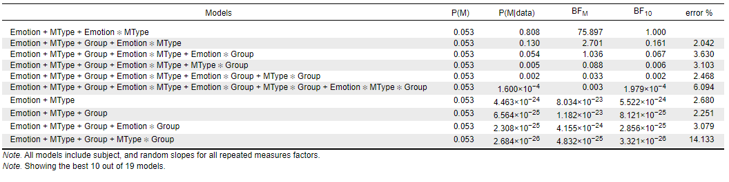

*Note. For interpretation of the output, refer to van den Bergh et al. (2020)*

**Table S8 – Bayesian Repeated Measures ANOVA (Professionals vs. Amateurs vs. Non-Musicians)**

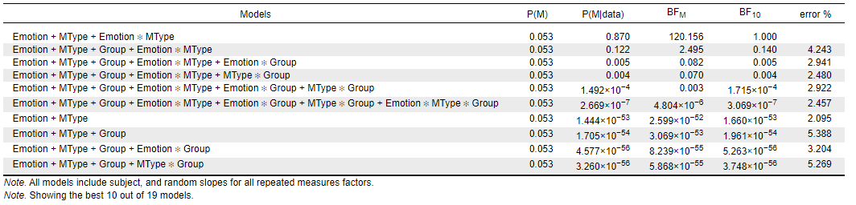

*Note. For interpretation of the output, refer to van den Bergh et al. (2020)*

**Figure S1**

*Confusion data for each Emotion for the three Morph Types* *– Singers and Instrumentalists*

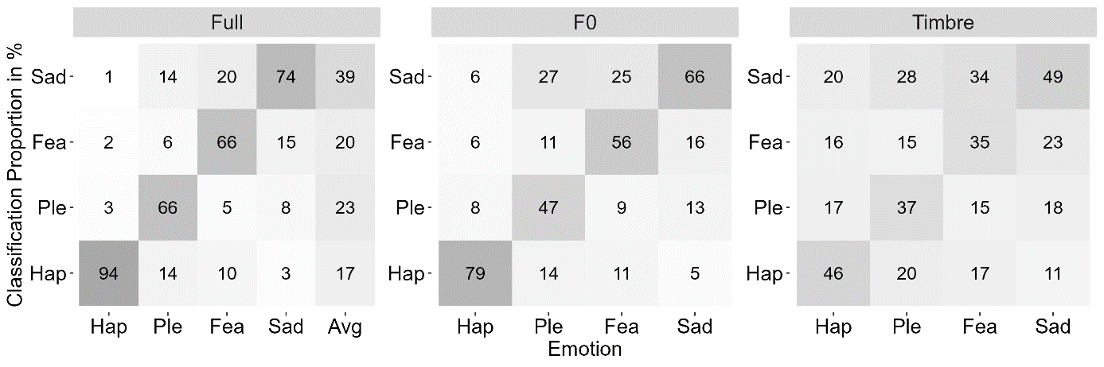

*Note. Numbers represent the proportion of classification responses per Emotion and Morph Type, averaged across musicians. Hap = happiness, Ple = pleasure, Fea = fear, Sad = sadness, Avg = average.*

**Figure S2**

*Confusion data for each Emotion for the three Morph Types – Singers only*

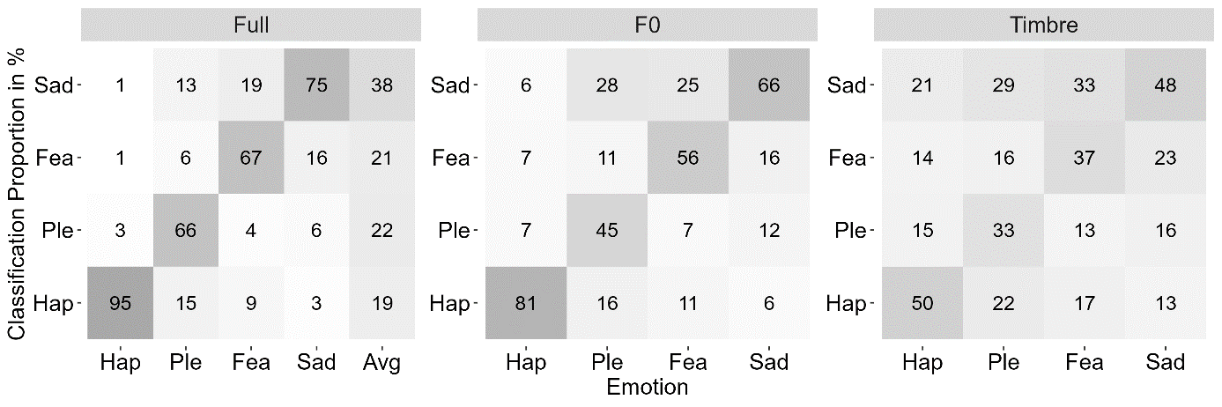

*Note. Numbers represent the proportion of classification responses per Emotion and Morph Type, averaged across non-musicians. Hap = happiness, Ple = pleasure, Fea = fear, Sad = sadness, Avg = average.*

**Figure S3**

*Confusion data for each Emotion for the three Morph Types – Instrumentalists only*

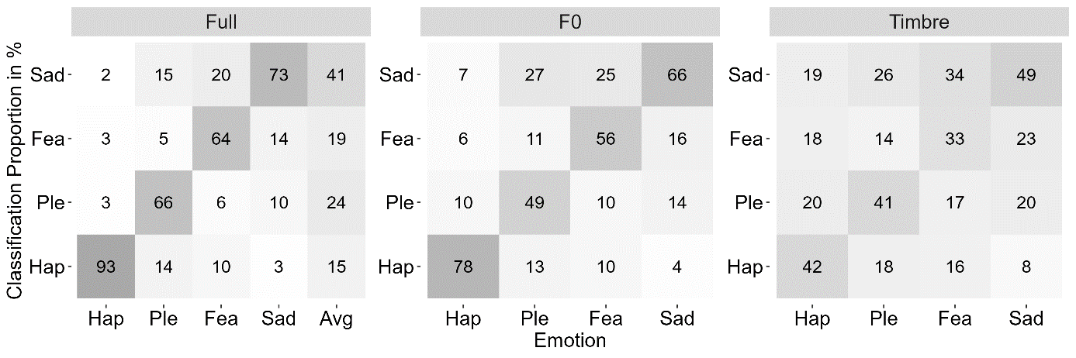

*Note. Numbers represent the proportion of classification responses per Emotion and Morph Type, averaged across non-musicians. Hap = happiness, Ple = pleasure, Fea = fear, Sad = sadness, Avg = average.*

**Figure S4**

*Correlation between Emotion Classification Performance and Music Perception Abilities (PROMS)*

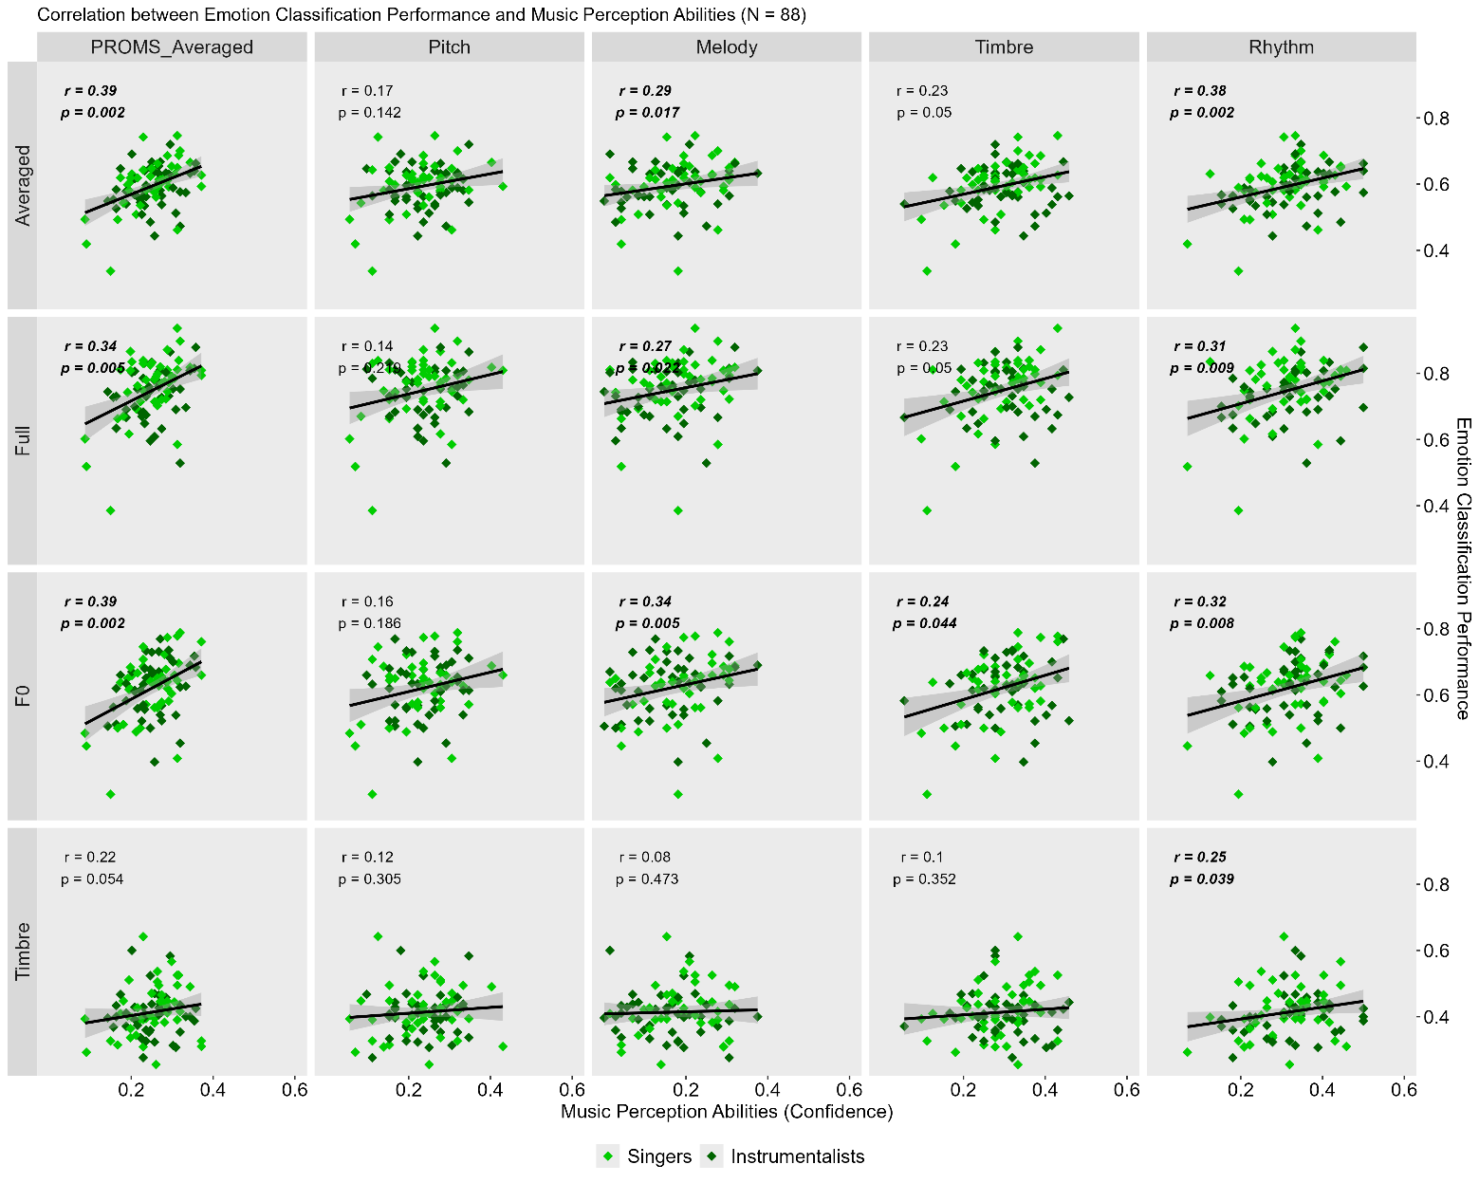

*Note. Correlations are not controlled for formal musical education. The x-axis shows the different subtests of the PROMS (Pitch, Melody, Timbre, and Rhythm) as well as the averaged performance across all subtests (PROMS_Averaged). The y-axis shows the vocal emotion classification performance separately for each Morph Type (Full, F0 and Timbre) and averaged across Morph Types (Averaged). Correlations are not controlled for formal musical education. p-values were adjusted for multiple comparisons using the Benjamini-Hochberg correction (Benjamini und Hochberg 1995)*

**Figure S5**

*Correlation between Emotion Classification Performance and self-rated Music Skills (GOLD-MSI)*

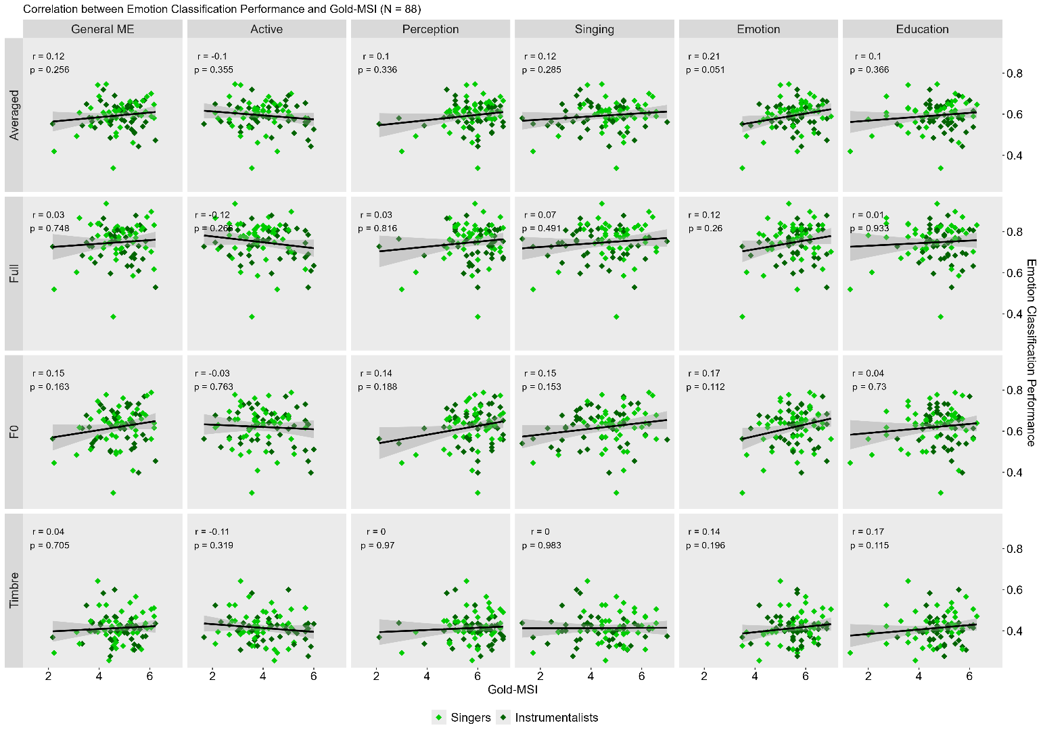

*Note. The x-axis shows the different subscores of the Gold-MSI (Active, Perception, Singing, Emotion, and Education) as well as the General Music Education score (General ME). The y-axis shows the vocal emotion classification performance separately for each Morph Type (Full, F0 and Timbre) and averaged across Morph Types (Averaged). Correlations are not controlled for formal musical education. p-values were adjusted for multiple comparisons using the Benjamini-Hochberg correction (Benjamini und Hochberg 1995)*

**Table S9 – PROMS and VER, correlations**

|  |  |  |  |  |  |
| --- | --- | --- | --- | --- | --- |
|  | PROMSAvg | Pitch | Melody | Timbre | Rhythm |
| VERAvg | **.39 (.002)** | .17 (.142) | **.29 (.017)** | .23 (.054) | **.38 (.002)** |
| Full-Morphs | **.34 (.005)** | .14 (.219) | **.27 (.022)** | **.23 (.049)** | **.31 (.009)** |
| F0-Morphs | **.39 (.002)** | .16 (.186) | **.34 (.005)** | **.24 (.044)** | **.32 (.008)** |
| Timbre-Morphs | .22 (.054) | .12 (.305) | .08 (.473) | .10 (.352) | **.25 (.039)** |

*Note. VER = Vocal Emotion Recognition performance. p-values of Tables S7 – S10 were adjusted for multiple comparisons using the Benjamini-Hochberg correction (Benjamini und Hochberg 1995)*

**Table S10 – PROMS and VER, controlled for musical education**

|  |  |  |  |  |  |
| --- | --- | --- | --- | --- | --- |
|  | PROMSAvg | Pitch | Melody | Timbre | Rhythm |
| VERAvg | **.38 (.003)** | .15 (.204) | **.27 (.023)** | .22 (.066) | **.36 (.003)** |
| Full-Morphs | **.35 (.005)** | .14 (.212) | **.28 (.023)** | .23 (.058) | **.32 (.008)** |
| F0-Morphs | **.39 (.003)** | .15 (.204) | **.34 (.006)** | .24 (.053) | **.32 (.008)** |
| Timbre-Morphs | .18 (.124) | .08 (.503) | .05 (.673) | .08 (.499) | .22 (.062) |

*Note. VER = Vocal Emotion Recognition performance.*

**Table S11 – MSI and VER, correlation*s***

|  |  |  |  |  |  |  |
| --- | --- | --- | --- | --- | --- | --- |
|  | General Sophistication | Active  Engagement | Musical Training | Emotions | Singing Abilities | Perceptual Abilities |
| VERAvg | .12 (.256) | -.1 (.355) | .10 (.366) | .21 (.051) | .12 (.285) | .10 (.336) |
| Full-Morphs | .03 (.748) | -.12 (.266) | .01 (.933) | .12 (.260) | .07 (.491) | .03 (.816) |
| F0-Morphs | .15 (.163) | -.03 (.763) | .04 (.730) | .17 (.112) | .15 (.153) | .14 (.188) |
| Timbre-Morphs | .04 (.705) | -.11 (.319) | .17 (.115) | .12 (.196) | .00 (.983) | .00 (.970) |

*Note. VER = Vocal Emotion Recognition performance.*

**Table S12 – MSI and VER, controlled for musical training**

|  |  |  |  |  |  |
| --- | --- | --- | --- | --- | --- |
|  | General Sophistication | Active  Engagement | Emotions | Singing Abilities | Perceptual Abilities |
| VERAvg | .08 (.627) | -.16 (.509) | .19 (.509) | .09 (.627) | .07 (.627) |
| Full-Morphs | .04 (.769) | -.14 (.509) | .13 (.533) | .07 (.627) | .02 (.829) |
| F0-Morphs | .16 (.509) | -.06 (.711) | .17 (.509) | .15 (.509) | .14 (.509) |
| Timbre-Morphs | -.09 (.628) | -.21 (.509) | .08 (.627) | -.05 (.731) | -.07 (.627) |

*Note. VER = Vocal Emotion Recognition performance.*

**Table S13**

*Post-hoc tests on the AQ for professionals vs. non-musicians*

|  |  |  |  |  |  |  |  |  |
| --- | --- | --- | --- | --- | --- | --- | --- | --- |
|  | | **Pro-fessionals** | **Non-musicians** |  |  |  |  |  |
|  | | *M (SD)* | *M (SD)* | *t* | *dfa* | *p* | *Cohens d* |  |
| *AQ* | |  |  |  |  |  |  |  |
| Total | 15.7 (4.98) | | 17.58 (6.41) | -1.44 | 69.83 | .154 | -0.34 [-0.82, 0-13] |  |
| Attention to Detail | | **5.43 (2.04)** | **4.32 (2.01)** | 2.42 | 75.87 | .018 | 0.56 [0.09, 1.01] | * |
| Social | | **10.28 (4.70)** | **13.26 (6.51)** | -2.32 | 67.08 | .024 | -0.57 [-1.05, -0.08] | * |
| Social Skills | | **1.48 (1.68)** | **2.61 (2.63)** | -2.25 | 62.40 | .028 | -0.57 [-1.07, -0.06] | * |
| Communication | | 1.85 (1.61) | 2.39 (1.73) | -1.44 | 74.83 | .155 | -0.33 [-0.79, 0.13] |  |
| Imagination | | 2.18 (1.52) | 2.87 (1.95) | -1.75 | 69.92 | .085 | -0.42 [-0.89, 0.06] |  |
| Attention Switching | | 4.78 (1.91) | 5.39 (1.92) | -1.43 | 75.75 | .158 | -0.33 [-0.78, 0.13] |  |

*a Note that original degrees of freedom were 76 but were corrected due to unequal variance.*

**Table S14**

*Post-hoc tests on the AQ for professionals vs. amateurs*

|  |  |  |  |  |  |  |  |
| --- | --- | --- | --- | --- | --- | --- | --- |
|  | **Pro-fessionals** | **Amateurs** |  |  |  |  |  |
|  | *M (SD)* | *M (SD)* | *t* | *dfa* | *p* | *Cohens d* |  |
| *AQ* |  |  |  |  |  |  |  |
| Total | **15.7 (4.98)** | **18.73 (7.40)** | -2.72 | 107.7 | .008 | -0.52 [-0.91, -0.14] | ** |
| Attention to Detail | 5.43 (2.04) | 5.51 (2.42) | -0.21 | 88.61 | .835 | -0.04 [-0.46, 0.37] |  |
| Social | **10.28 (4.70)** | **13.22 (6.49)** | -2.90 | 101.8 | .005 | -0.57 [-0.97, -0.18] | ** |
| Social Skills | **1.48 (1.68)** | **2.74 (2.49)** | -3.36 | 107.8 | .001 | -0.65 [-1.03, -0.26] | ** |
| Communication | 1.85 (1.61) | 2.49 (2.12) | -1.88 | 97.42 | .063 | -0.38 [-0.78, 0.02] |  |
| Imagination | 2.18 (1.52) | 2.66 (1.8) | -1.57 | 89.18 | .120 | -0.33 [-0.75, 0.09] |  |
| Attention Switching | 4.78 (1.91) | 5.33 (2.06) | -1.48 | 80.83 | .142 | -0.33 [-0.77, 0.11] |  |

*a Note that original degrees of freedom were 126 but were corrected due to unequal variance.*

**Table S15**

*Post-hoc tests on the AQ for amateurs vs. non-musicians*

|  |  |  |  |  |  |  |  |
| --- | --- | --- | --- | --- | --- | --- | --- |
|  | **Amateurs** | **Non-musicians** |  |  |  |  |  |
|  | *M (SD)* | *M (SD)* | *t* | *dfa* | *p* | *Cohens d* |  |
| *AQ* |  |  |  |  |  |  |  |
| Total | 18.73 (7.40) | 17.58 (6.41) | -0.88 | 80.44 | .382 | -0.2 [-0.63, 0.24] |  |
| Attention to Detail | **5.51 (2.42)** | **4.32 (2.01)** | -2.87 | 83.53 | .005 | -0.63 [-1.07, -0.19] | ** |
| Social | 13.22 (6.49) | 13.26 (6.51) | 0.04 | 70.10 | .970 | 0.01 [-0.46, 0.48] |  |
| Social Skills | 2.74 (2.49) | 2.61 (2.63) | -0.27 | 67.11 | .791 | -0.06 [-0.54, 0.41] |  |
| Communication | 2.49 (2.12) | 2.39 (1.73) | -0.26 | 85.06 | .795 | -0.33 [-0.75, 0.09] |  |
| Imagination | 2.66 (1.8) | 2.87 (1.95) | 0.57 | 65.93 | .574 | 0.14 [-0.34, 0.62] |  |
| Attention Switching | 5.33 (2.06) | 5.39 (1.92) | 0.17 | 74.89 | .865 | 0.04 [-0.41, 0.49] |  |

*a Note that original degrees of freedom were 124 but were corrected due to unequal variance.*

**Table S16**

*Post-hoc tests on the Gold-MSI for professionals vs. non-musicians*

|  |  |  |  |  |  |  |  |
| --- | --- | --- | --- | --- | --- | --- | --- |
|  | **Pro-fessionals** | **Non-musicians** |  |  |  |  |  |
|  | *M (SD)* | *M (SD)* | *t* | *dfa* | *P* | *Cohens d* |  |
| *Gold-MSI* |  |  |  |  |  |  |  |
| General ME | **5.68 (0.50)** | **2.74 (1.07)** | 15.45 | 51.63 | <.001 | 4.30 [3.30, 5.28] | *** |
| Active Engagement | **4.94 (0.81)** | **2.95 (1.19)** | 8.55 | 64.53 | <.001 | 2.13 [1.51, 2.73] | *** |
| Formal Education | **5.95 (0.56)** | **1.71 (0.68)** | 30.10 | 71.67 | <.001 | 7.11 [5.85, 8.36] | *** |
| Emotion | **5.88 (0.73)** | **4.95 (1.32)** | 3.79 | 56.87 | <.001 | 1.00 [0.45, 1.55] | *** |
| Singing | **5.34 (0.83)** | **2.84 (1.26)** | 10.3 | 63.49 | <.001 | 2.59 [1.91, 3.25] | *** |
| Perception | **6.31 (0.51)** | **4.22 (1.49)** | 8.19 | 45.10 | <.001 | 2.44 [1.66, 3.20] | *** |

*a Note that original degrees of freedom were 76 but were corrected due to unequal variance.*

**Table S17**

*Post-hoc tests on the Gold-MSI for professionals vs. amateurs*

|  |  |  |  |  |  |  |  |
| --- | --- | --- | --- | --- | --- | --- | --- |
|  | **Pro-fessionals** | **Amateurs** |  |  |  |  |  |
|  | *M (SD)* | *M (SD)* | *t* | *dfa* | *P* | *Cohens d* |  |
| *Gold-MSI* |  |  |  |  |  |  |  |
| General ME | **5.68 (0.50)** | **4.76 (0.82)** | 7.80 | 116.1 | <.001 | 1.45 [1.04, 1.85] | *** |
| Active Engagement | **4.94 (0.81)** | **4.02 (1.00)** | 5.54 | 91.98 | <.001 | 1.16 [0.71, 1.59] | *** |
| Formal Education | **5.95 (0.56)** | **4.66 (0.96)** | 9.54 | 118.5 | <.001 | 1.75 [1.33, 2.17] | *** |
| Emotion | **5.88 (0.73)** | **5.55 (0.78)** | 2.29 | 80.76 | .025 | 0.51 [0.06, 0.95] | * |
| Singing | **5.34 (0.83)** | **4.59 (1.19)** | 4.08 | 105 | <.001 | 0.80 [0.40, 1.19] | *** |
| Perception | **6.31 (0.51)** | **5.75 (0.92)** | 4.42 | 121.3 | <.001 | 0.80 [0.43, 1.17] | *** |

*a Note that original degrees of freedom were 126 but were corrected due to unequal variance.*

**Table S18**

*Post-hoc tests on the Gold-MSI for amateurs vs. non-musicians*

|  |  |  |  |  |  |  |  |
| --- | --- | --- | --- | --- | --- | --- | --- |
|  | **Amateurs** | **Non-musicians** |  |  |  |  |  |
|  | *M (SD)* | *M (SD)* | *t* | *dfa* | *p* | *Cohens d* |  |
| *Gold-MSI* |  |  |  |  |  |  |  |
| General ME | **4.76 (0.82)** | **2.74 (1.07)** | -10.41 | 56.77 | <.001 | -2.76 [-3.48, -2.03] | *** |
| Active Engagement | **4.02 (1.00)** | **2.95 (1.19)** | -4.81 | 60.26 | <.001 | -1.24 [-1.79, -0.68] | *** |
| Formal Education | **4.66 (0.96)** | **1.71 (0.68)** | -19.67 | 97.53 | <.001 | -3.98 [-4.66, -3.29] | *** |
| Emotion | **5.55 (0.78)** | **4.95 (1.32)** | -2.59 | 48.55 | .013 | -0.74 [-1.32, -0.16] | * |
| Singing | **4.59 (1.19)** | **2.84 (1.26)** | -7.30 | 66.78 | <.001 | -1.79 [-2.35, -1.21] | *** |
| Perception | **5.75 (0.92)** | **4.22 (1.49)** | -5.85 | 49.64 | <.001 | -1.66 [-2.30, -1.01] | *** |

*a Note that original degrees of freedom were 124 but were corrected due to unequal variance.*

**Table S19**

*PROMS post-hoc tests for professionals vs. non-musicians*

|  |  |  |  |  |  |  |  |
| --- | --- | --- | --- | --- | --- | --- | --- |
|  | **Pro-fessionals** | **Non-musicians** |  |  |  |  |  |
|  | *M (SD)* | *M (SD)* | *t* | *dfa* | *P* | *Cohens d* |  |
| *PROMS* |  |  |  |  |  |  |  |
| Pitch | **0.27 (0.06)** | **0.18 (0.06)** | 6.25 | 75.77 | <.001 | 1.43 [0.93, 1.94] | *** |
| Melody | **0.23 (0.08)** | **0.07 (0.08)** | 9.42 | 75.95 | <.001 | 2.16 [1.59, 2.72] | *** |
| Timbre | **0.32 (0.08)** | **0.26 (0.09)** | 2.99 | 73.64 | .004 | 0.70 [0.22, 1.16] | ** |
| Rhythm | **0.33 (0.08)** | **0.27 (0.08)** | 3.52 | 75.96 | <.001 | 0.81 [0.34, 1.27] | *** |

*a Note that original degrees of freedom were 76 but were corrected due to unequal variance.*

**Table S20**

*PROMS post-hoc tests for professionals vs. amateurs*

|  |  |  |  |  |  |  |  |
| --- | --- | --- | --- | --- | --- | --- | --- |
|  | **Pro-fessionals** | **Amateurs** |  |  |  |  |  |
|  | *M (SD)* | *M (SD)* | *t* | *dfa* | *p* | *Cohens d* |  |
| *PROMS* |  |  |  |  |  |  |  |
| Pitch | **0.27 (0.06)** | **0.24 (0.07)** | 2.57 | 87.32 | .012 | 0.55 [0.12, 0.98] | * |
| Melody | **0.23 (0.08)** | **0.16 (0.10)** | 4.42 | 95.24 | <.001 | 0.91 [0.48, 1.33] | *** |
| Timbre | 0.32 (0.08) | 0.29 (0.08) | 1.72 | 74.69 | .090 | 0.40 [-0.06, 0.85] |  |
| Rhythm | 0.33 (0.08) | 0.32 (0.09) | 0.80 | 84.27 | .425 | 0.17 [-0.25, 0.60] |  |

*a Note that original degrees of freedom were 126 but were corrected due to unequal variance.*

**Table S21**

*PROMS post-hoc tests for amateurs vs. non-musicians*

|  |  |  |  |  |  |  |  |
| --- | --- | --- | --- | --- | --- | --- | --- |
|  | **Amateurs** | **Non-musicians** |  |  |  |  |  |
|  | *M (SD)* | *M (SD)* | *t* | *dfa* | *p* | *Cohens d* |  |
| *PROMS* |  |  |  |  |  |  |  |
| Pitch | **0.24 (0.07)** | **0.18 (0.06)** | -4.39 | 81.21 | <.001 | -0.97 [-1.43, -0.51] | *** |
| Melody | **0.16 (0.10)** | **0.07 (0.08)** | -5.65 | 91.34 | <.001 | -1.18 [-1.62, -0.74] | *** |
| Timbre | 0.29 (0.08) | 0.26 (0.09) | -1.88 | 62.25 | .064 | -0.48 [-0.98, 0.03] |  |
| Rhythm | **0.32 (0.09)** | **0.27 (0.08)** | -3.16 | 80.84 | .002 | -0.70 [-1.15, -0.25] | *** |

*a Note that original degrees of freedom were 124 but were corrected due to unequal variance.*

Literaturverzeichnis

Benjamini, Yoav; Hochberg, Yosef (1995): Controlling the False Discovery Rate: A Practical and Powerful Approach to Multiple Testing. In: *Journal of the Royal Statistical Society: Series B (Methodological)* 57 (1), S. 289–300. DOI: 10.1111/j.2517-6161.1995.tb02031.x.

Boersma, Paul (2018): Praat: doing phonetics by computer [Computer program]. Version 6.0.46, retrieved January 2020 from http://www.praat.org/. In: *http://www. praat. org*.

MATLAB (2020): version 9.8.0 (R2020a). Natick, Massachusetts: The MathWorks Inc.

McAleer, Phil; Todorov, Alexander; Belin, Pascal (2014): How do you say ‘Hello’? Personality impressions from brief novel voices. In: *PLoS One* 9 (3), e90779. DOI: 10.1371/journal.pone.0090779.

van den Bergh, Don; van Doorn, Johnny; Marsman, Maarten; Draws, Tim; van Kesteren, Erik-Jan; Derks, Koen et al. (2020): A Tutorial on Conducting and Interpreting a Bayesian ANOVA in JASP. In: *L’Année psychologique* Vol. 120 (1), S. 73–96. DOI: 10.3917/anpsy1.201.0073.