Is vocal emotional processing fine-tuned to speaker gender, identity and phonetic content? - Evidence from simultaneous opposite adaptation
Christine Nussbaum^{1,2}

¹Department for General Psychology and Cognitive Neuroscience, Friedrich Schiller University Jena, Germany
²Voice Research Unit, Friedrich Schiller University, Jena, Germany

Correspondence should be addressed to Christine Nussbaum, Department for General Psychology and Cognitive Neuroscience, Friedrich Schiller University Jena, Am Steiger 3/ Haus 1, 07743 Jena, Germany. Tel: +49 (0) 3641 945934, E-Mail: christine.nussbaum@uni-jena.de. Preprocessed data, analysis scripts and supplemental materials can be found in the associated OSF repository (https://osf.io/4ejb9)
WordCount ~ 8000 (without Figures, Tables and References, Acknowledgements etc.)

Abstract
The perception of vocal emotions requires efficient and flexible processing of auditory input. A hallmark of this flexibility is perceptual adaptation, which enables listeners to tune into the current auditory context (e.g., angry voices), thus sensitizing the system to sudden changes (e.g., a shift to fear). However, how vocal emotion adaptation is modulated by either stable speaker characteristics such as gender and identity, or dynamic cues such as phonetic content is insufficiently understood. This gap was addressed in three experiments using a paradigm inducing simultaneous opposite aftereffects: during adaptation, emotions were systematically tied to a voice feature to test if adaptation aftereffects could be induced in opposite directions along a fear-anger continuum. For example, after adaptation to angry-male and fearful-female voices, male targets should be more often perceived as fearful and female ones more often as angry. Based on theoretical considerations, such simultaneous opposite aftereffects were predicted for speaker gender (Experiment1) and identity (Experiment 2), but not for phonetic pseudoword content (Experiment 3). Indeed, the hypothesized pattern was observed for speaker gender and pseudoword. Evidence for speaker identity was not fully conclusive but offered promising hints that listeners may exhibit nuanced adaptation to different speakers as well. Together, these findings show that vocal emotion adaptation is partially fine-tuned to stable speaker characteristics, whereas this does not seem to be case for dynamic phonetic content. This provides important empirical support for recent calls that a comprehensive understanding of vocal emotional processing requires a closer look at the speakers expressing them.

Keywords: adaptation, vocal emotions, speaker gender, identity, simultaneous opposite aftereffects

Highlights
- Listeners flexibly tune into auditory context, known as “perceptual adaptation”.
- Here, I tested if vocal emotion adaptation is fine-tuned to speaker and speech.
- Emotion adaptation was modulated by gender and identity, but not phonetic content.
- Thus, when hearing vocal emotions, we also incorporate infos about the speakers.

Introduction

Human voices – a rich and complex signal
While we speak, our voices transport a wealth of information (Belin et al., 2011; Lavan & McGettigan, 2023). These can be grouped into linguistic, extralinguistic and paralinguistic cues (Schweinberger et al., 2014). Linguistic cues express the phonetic and semantic content of the uttered message, i.e. the spoken (pseudo-)words. Extralinguistic cues refer to stable speaker characteristics that do not change over the course of a conversation, such as gender, age, identity, and even perceived personality traits such as trustworthiness and dominance (Lavan et al., 2024). Paralinguistic cues, in contrast, are non-verbal vocal features that are conveyed together with the spoken word and are constantly modulated during an utterance. Importantly, they are not only a mere byproduct of the spoken utterances, but a carrier of rich and complex meaning (Schirmer et al., 2025).
Emotions arguably reflect highly important types of paralinguistic cues (Scherer, 1986, 2018). Since effective emotional communication is crucial to everyday social interaction, it is not surprising that listeners seem to pick them up in a seemingly effortless and automatic manner (Bachorowski & Owren, 2003; Lima et al., 2019). But although seemingly effortless on the surface, vocal emotional processing actually reflects a complex challenge for our perceptual system (Schirmer & Kotz, 2006). Emotions may rapidly change over the course of a conversation, and their specific expression can vary substantially between speakers and contexts (Scherer et al., 2016), requiring constant real-time monitoring and very efficient processing of the auditory input (Paulmann & Kotz, 2018). How is this degree of efficiency achieved? Although not yet understood exhaustively, a part of the answer lies in a fundamental feature of our perceptual system: flexibility. The processing of emotions is not a static readout of the acoustic signal but tunes into contexts and speakers (Bestelmeyer & Evans, 2026). There is ample evidence showing that listeners rely on different acoustic cues to infer emotions, depending on which are currently most informative (Laukka et al., 2016; Nussbaum, Schirmer, & Schweinberger, 2022, 2024; Thompson & Balkwill, 2006). As a result, while speakers express emotions in very different ways, listeners are equally efficient in recognizing them (Spackman et al., 2009). Thus, listeners are able to decode similar emotions from very different acoustic input. But that is not all: listeners also infer different emotions from the very same acoustic input, depending on the context in which they are presented. This is evidenced by the phenomenon of perceptual adaptation.

Adaptation – a hallmark of perceptual flexibility
Perceptual adaptation can be understood as a calibration process to the current perceptual configuration of the environment, which manifests in a perceptual bias to opposite features of a stimulus after repeated exposure. The auditory adaptation for vocal emotions was first demonstrated by Bestelmeyer, Rouger, et al. (2010): After repeated exposure to angry voices (the adaptors), a subsequently presented ambiguous voice (the target) at an intermediate position within an anger-fear continuum was more often perceived as fearful. Conversely, after repeated exposure to fearful adaptors, the very same ambiguous target voice was more often perceived as angry. This perceptual shift is called a contrastive aftereffect. Such a dynamic perceptual system is very beneficial, because it allows a “float” of the sensitivity range (Webster et al., 2005), which in turn facilitates prompt adjustments in behavioral responses. Adaptation plays a critical role for efficient stimulus processing and constitutes a general mechanism of the human perceptual system, with ample evidence in the visual and the auditory domain beyond emotions, e.g. for gender, age, identity, facial eye gaze, and facial ethnicity (Bestelmeyer, Jones, et al., 2010; Fox & Barton, 2007; Hubbard & Assmann, 2013; Jenkins et al., 2006; Leopold et al., 2001; Schweinberger et al., 2008; Schweinberger et al., 2010; Skuk et al., 2015; Webster et al., 2004; Webster & MacLeod, 2011; Webster & Maclin, 1999; Zäske et al., 2009). On a neural level, adaptation has been linked to a decreased response of dedicated neuron populations upon prolonged exposure, which then fire more vigorously when the stimulus features change (Grill-Spector et al., 2006). This seems to occur on all levels of the auditory (and visual) pathway (for reviews, see Pérez-González & Malmierca, 2014; Willmore & King, 2023).

Is vocal emotion adaptation fine-tuned to speaker gender, identity and the spoken word?
Adaptation paradigms allow us to explore mechanisms of perceptual flexibility, potentially leading to a more fine-grained understanding of how efficient emotional processing is achieved in everyday interactions. Voices are processed as a holistic signal (Schweinberger et al., 2014): we simultaneously decode linguistic, extralinguistic and paralinguistic cues. While traditional theoretical models emphasized that these types of cues are analyzed in distinct pathways (Belin et al., 2011), there is now a consensus that there is some degree of interdependent processing (Lavan & McGettigan, 2023). In that case, how are linguistic and extralinguistic cues incorporated in emotional adaptation? Are these cues just treated as “noise” that need to be averaged out, or do they provide valuable information to fine-tune the emotional adaptation process? This is the key question of the present paper.
Extralinguistic cues are stable speaker characteristics, and they likely shape the decoding of vocal emotions, just like stable facial identity shapes the decoding of facial emotions (Atkinson et al., 2005; Schweinberger et al., 1999; Xu & Armony, 2024). In that vein, vocal emotional perception is always somewhat “personal”, because it is nuanced by characteristics of speakers (Pinheiro, 2025). The presumably strongest evidence for this notion comes from an interaction of emotion perception and speaker gender: male voices are more often perceived as angry whereas female voices more often associated with fear or happiness (Brody, 2010; Korb et al., 2023), potentially based on stereotypical beliefs shared by listeners. Importantly, speaker gender has also been found to affect emotion adaptation, which was massively reduced when adaptors and targets were of different speaker genders (Nussbaum, von Eiff, et al., 2022). However, while this paradigm provides evidence that speaker gender interferes with emotion adaptation, it does not address the question above, whether it fine-tunes the process, in a sense that it may lead to more efficient tracking of relevant emotional changes. This can be achieved with a paradigm inducing simultaneous opposite aftereffects, first shown by Bestelmeyer, Jones, et al. (2010) for male and female faces: after participants adapted to angry-female faces and fearful-male faces (and vice versa) simultaneously, they showed gender-specific aftereffects, i.e. female target faces were more often classified as fearful and male target faces more often classified as angry (and vice versa). Thus, the visual system differently recalibrated to male and female faces – at the same time! This shows that facial gender information was incorporated to fine-tune the emotional adaptation process, because otherwise, the adaptors would have cancelled each other out. However, to the best of my knowledge, this has (1) never been tested for the auditory domain. Further, it has not been explored for (2) other extralinguistic cues such as identity – which is also stable over the course of a conversation - or (3) linguistic cues – which continuously change during speaking. This is addressed in the present experiments.

Rationale and aim of the present studies
The aim of this paper was to understand the flexibility of vocal emotional processing by studying the interplay between vocal emotions as paralinguistic cues with both linguistic and extralinguistic cues in the context of perceptual adaptation. In three experiments, I tested whether simultaneous opposite aftereffects could be induced for speaker gender, identity and phonetic content, i.e. the pseudoword. All experiments employed identical stimulus material – the only difference was the systematic coupling of adaptor emotions with linguistic and extralinguistic cues. To parallel the design of the face study by Bestelmeyer, Jones, et al. (2010), fearful and angry voices were used, which have been shown to produce large and reliable adaptation aftereffects in voices before (Bestelmeyer, Rouger, et al., 2010; Nussbaum, von Eiff, et al., 2022).
In Experiment 1, adaptor emotions were tied to speaker gender. In essence, this is a replication of the visual paradigm reported by Bestelmeyer, Jones, et al. (2010), but in the auditory domain. Accordingly, I hypothesized to find simultaneous opposite aftereffects for speaker gender.
In Experiment 2, adaptor emotions were tied to speaker identity, and I hypothesized to find simultaneous opposite aftereffects as well. This hypothesis was based on considerations of processing efficiency in everyday interactions: Let us assume a situation where one speaker is angry and the other is fearful, e.g. while watching a sports match where both individuals root for different parties. If there is a sudden change in emotional states (i.e. because one sports team scored an important goal), an adequate reaction may not only depend on the nature of that change but also on the individuals who experience and express it. Thus, a speaker-specific calibration to uttered emotions could turn out to be beneficial, evidenced by a simultaneous opposite aftereffect for speaker identity.
Finally, in Experiment 3, adaptor emotions were tied to the phonetic content (pseudoword). Note that pseudowords do not carry sematic meaning, to avoid influence from the emotional content of a word (Liebenthal et al., 2016). Importantly, I expected to find no simultaneous opposite aftereffect here, because linguistic information changes constantly and rapidly in a conversation over the course of an emotional utterance. Therefore, on the notion of efficient processing, it would be more beneficial if linguistic cues were averaged out during emotional adaptation.
In summary, I predicted simultaneous opposite aftereffects for extralinguistic cues, as they do not change within a conversation, but not for dynamic linguistic information. Experiment 1 and its hypotheses were directly adapted from Bestelmeyer, Jones, et al. (2010) for the auditory domain. As Experiment 2 and 3 are extensions of the original paradigm, their hypotheses were preregistered (10.17605/OSF.IO/3H9WN ).

Experiment 1: Speaker gender

Hypothesis
For Experiment 1, I expected to find simultaneous opposite aftereffects for male and female speakers, indicated by an AdaptationCondition x Speaker Gender interaction: In AdaptationCondition 1, all female adaptors were always angry, and all male adaptors were always fearful. In that case, female target voices should be more often classified as fearful and male target voices more often as angry. Vice versa, in AdaptationCondition 2, male adaptors are always angry, and female adaptors are always fearful. In that case, male target voices should be more often classified as fearful and female target voices more often as angry.

Method

Participants
An a-priori power analysis with the R-package “Superpower” (Lakens & Caldwell, 2019) for a 2 x 2 within-subject interaction with a medium effect size f = .167, a desired power of .80 and an alpha level of .05 revealed a required sample size of N = 38. The effect size was calculated based on the predicted response patterns, which were in turn based on the data reported by Bestelmeyer, Jones, et al. (2010). All participants had to be native German speakers, aged between 18 and 50, and without hearing impairments. They were recruited from the local university and received course credit as compensation.
Data was collected online via Psytoolkit version 3.3.2 (Stoet, 2010, 2017) between June and July 2021. Participants had to use a computer with a physical keyboard and headphones. The web browser Safari was excluded for technical reasons. 56 people accessed the study via hyperlink, 40 of which contributed complete data. One participant had to be excluded, because they had >5% trials of omission in the baseline task. Two participants reported having occasional tinnitus but did not feel impaired by it and were thus kept in the sample. Another two were unsure if all sounds were played correctly. However, as data quality was deemed acceptable after careful inspection, they were kept in the sample as well. Therefore, the final sample consisted of N = 39 participants (25 female, 14 male, aged 19 to 39 years [M = 22.89, SD = 3.6]).
All data were collected pseudonymized. All experimental procedures conformed to the ethical guidelines by the American Psychological Association (APA) and their methodologies were approved by the local ethics committee of the Friedrich Schiller University Jena (Reg.-Nr. FSV 24/048).

Stimuli
This study used morphed voices ranging on a continuum from fearful to angry. The input material for voice morphing was selected from a database of vocal actor portrayals (Frühholz et al., 2015) and comprised of four pseudowords (/molen/, /namil/, /loman/, /belam/), spoken by four speakers (two male, two female) in a fearful and an angry emotional prosody. After the necessary preprocessing (i.e. cutting small artifacts like smacks and clicks from the recordings, as well as manual mapping of time- and frequency anchors in each stimulus), the morphing software TANDEM-STRAIGHT (Kawahara et al., 2008; Kawahara & Skuk, 2018) was used to create pairwise morphing trajectories between fearful and angry expressions of the same speaker and pseudoword (see Figure 1A). The endpoints (0% = fully fearful and 100 % = fully angry) were used as adaptors, resulting in 4 (speakers) x 4 (pseudowords) x 2 (emotions) = 32 adaptor stimuli. As target stimuli, morphed voices were created in 7 target morph levels (tML), encompassing equidistant 10% steps from 20 (% anger) to 80. In total, all combinations of 4 (speakers) x 4 (pseudowords) x 7 (tML) resulted in 112 target stimuli. Using Praat software (Boersma, 2018), all morphed stimuli were root-mean-square normalized to 70 dB SPL (duration M= 807 ms, Min = 540 ms, Max = 1009 ms, SD = 97 ms). A summary of the acoustic properties of the resulting stimuli can be found in Supplemental Tables S1-S3 on OSF, together with some sound examples. For a more detailed description of the voice morphing procedure, please refer to Kawahara and Skuk (2018) and Nussbaum, von Eiff, et al. (2022). Note that these stimuli are identical to a subset of the ones used in Nussbaum, von Eiff, et al. (2022).
Figure 1
Illustration of stimuli and experimental design
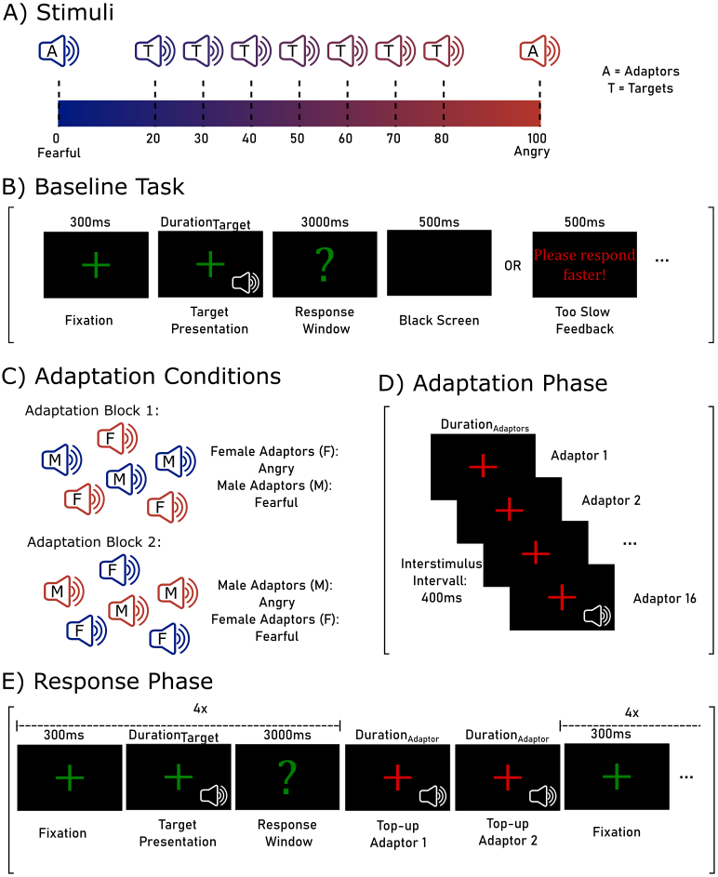
Note. A) Illustration of a morphing continuum between fearful and angry voices. The endpoints (0% and 100%) were used as adaptors. The intermediate morphs (20-80% in 10%-steps) served as targets. B) Illustration of a trial in the baseline task. C) Depiction of the two adaptation conditions: in the first block, all female adaptors were angry, and all male adaptors were fearful; in the second block vice versa. Order of blocks was counterbalanced between participants. D) Illustration of the adaptation phase. E) Illustration of the response phase, with two top-up adaptors every four trials. The adaptation and the response phase both belong to the adaptation task.

Design and Procedure
At the beginning of the study, participants gave their informed consent and entered their demographic information. Then, the browser switched into full screen and the experiment started, which consisted of a baseline and two adaptation tasks.
Baseline. In the baseline task (Figure 1B), all targets were presented once without prior adaptation and participants classified them as either angry or fearful. This later served as a reference condition. Each trial started with a green fixation cross for 300ms. Then, the voice stimulus was played while the fixation cross remained on screen. After stimulus offset, a green question mark signaled the beginning of the response window and participants entered their response by pressing the key “F” for fearful and “J” for angry. If no response was entered withing 3000ms after voice offset, it was logged as omission and the final trial slide (500ms) comprised a feedback screen prompting for faster response. Otherwise, a black screen was shown instead. Then the next trial started. After five practice trials, all 112 targets were presented once in randomized order, in two blocks of 56 trials each with a self-paced break in the middle.
Adaptation. After completing the baseline task, participants completed two adaptation blocks. In one adaptation block, participants adapted to angry-female and fearful-male voices. In the other one, the combination was reversed: angry-male and fearful-female (Figure 1C). Otherwise, both blocks were identical, and it was counterbalanced between participants which one came first. Each block consisted of an adaptation phase and a response phase. During the adaptation phase (Figure 1D), 16 adaptor stimuli (4 speakers × 4 pseudowords) were presented in random order with a red fixation cross on the computer screen and an interstimulus interval of 400 ms. Participants were instructed to listen attentively. Note that exactly half of the adaptor stimuli were fearful and the other half was angry but always tied to a speaker gender: either all female voices sounded angry, and all male voices sounded fearful or vice versa. After the adaptation phase, the response phase started, which was signaled by a message in green font for 3000 ms. The response phase was almost identical to the baseline task (Figure 1E): all targets were presented once and participants classified them as fearful or angry by pressing the corresponding keys. However, every fourth trial, a red fixation cross appeared again, and two top-up adaptors were played. They were picked randomly, but one top-up adaptor was fearful, and the other one was angry, thus one was male and one was female (their specific combination depending on the adaptation block). Their order was randomized as well. The top-up adaptors were included to refresh the adaptation impression during the response phase. This procedure has been shown to elicit substantial perceptual aftereffects, while keeping experimental duration within reasonable limits (Nussbaum, von Eiff, et al., 2022). In each adaptation block, participants classified all 112 targets, again split into 56 trials with a break in between. As there were two adaptation blocks, participants performed 224 trials in total. Before, participants practiced this task with 6 stimuli in the adaptation phase and 12 trials in the response phase.
After the experiment, participants indicated whether all sounds were played correctly, and whether they understood all instructions. Furthermore, they answered a few exploratory questions about their self-rated voice perception abilities, their commitment to the experimental task and potential strategies. Overall duration of the study was about 30 minutes.

Data analysis
Data were analyzed using R version 4.5.0 (R Core Team, 2025). Errors of omission (<1% in the baseline and <0.5% in the adaptation condition) were removed from the data and participants with more than 5% of such omissions were excluded from data analysis. In the first step, the response in each trial (i.e. the classification as angry = 1 or fearful = 0) was modeled using a multilevel logistic regression using the glmer-command of the lme4 package (Bates et al., 2009), with a binominal distribution, a logit-link function and Laplace approximation. Predictor variables were target morph level (tML, 20-80%, z-standardized for model estimation), speaker gender (SpGender, female, male), and adaptation condition (AdaptCond1: female-angry and male-fearful; AdaptCond2: male-angry and female-fearful). Random effects were estimated for each speaker identity (SpID) and participant. Goodness-of-fit evaluation was based on the Akaike information criterion (AIC) and visual inspection of the data. Differences in the AIC between models were tested for significance using χ²-tests. This resulted in the following model:
Response_{angry/fearful} ~ tML * SpGender * AdaptCond + (1 | SpID) + (1 | Participant)
P-values of main and interaction effects were calculated with the mixed-command from the afex-package (Singmann et al., 2015) using a likelihood ratio test. Note that the data from the Baseline block were not included in this first analysis, because they were not relevant for the main hypothesis.
In a second step, the analyses specifically zoomed into the interaction of SpGender and AdaptCond. To this end, data were averaged across target morph levels and pseudowords, resulting in a proportion of angry responses in each SpGender x AdaptCond combination per participant. Baseline data were averaged for each SpGender as well. AdaptConditions were then compared for male and female voices separately, using paired t-tests. Finally, both AdaptConditions were compared to the Baseline conditions, again separately for each SpGender. Data visualization was done with ggplot2 (Wickham, 2006).

Transparency and Openness
The rationale for sample size estimation, all data exclusions, and all manipulations have been specified. Preprocessed data, analysis scripts and supplemental materials can be found in the associated OSF repository.

Results
A summary of model parameters and estimates of the multilevel logistic regression can be found in Table 1. The main effect of tML indicates that the proportion of angry responses increased with an increased percentage of acoustic “angriness” in the voice, validating the morphing procedure. The interaction of tML x SpGender indicated that the slope of this increase was slightly steeper for male than for female voices. Importantly, there was the predicted interaction of SpGender x AdaptCond (Figure 2A).
Table 1
Summary of Multilevel Logistic Regression for the classification of stimuli as angry or fearful
Model Exp 1
Response ~ | tML * SpGender * AdaptCond + (1 | SpID) + (1 | Participant)
Predictor | Chi2 | p |  | Fixed effects | Estimate | SE | z | p
Morph Level (tML) | 4130 | <0.001 |  | (Intercept) | -0.79 | 0.406 | -1.95 | 0.051
Speaker Gender (SpGender) | 0.03 | 0.856 |  | tML | 1.81 | 0.074 | 24.45 | <0.001
AdaptCond | 0.38 | 0.536 |  | SpGender: male | 0.68 | 0.555 | 1.22 | 0.221
tML x SpGender | 9.02 | 0.003 |  | AdaptCond: 2* | 0.62 | 0.084 | 7.34 | <0.001
tML x AdaptCond | 1.72 | 0.190 |  | tML x SpGender: male | 0.32 | 0.109 | 2.96 | 0.003
SpGender x AdaptCond | 93.59 | <0.001 |  | tML x AdaptCond: 2 | <0.01 | 0.102 | -0.04 | 0.972
tML x SpGender x AdaptCond | 1.59 | 0.207 |  | SpGender: male x AdaptCond: 2 | -1.16 | 0.121 | -9.59 | <0.001
 |  |  |  | tML x SpGender: male x AdaptCond: 2 | -0.19 | 0.148 | -1.26 | 0.207
Model information |  |  |  | Random effects | Var | SD
AIC/BIC | 7433 | 7504 |  | Participant - Intercept | 0.42 | 0.65
N observations | 8703 |  |  | Speaker Identity (SpID) - Intercept | 0.30 | 0.55
N participants | 39
N speaker identity | 4
Note. The target morph level (tML) was z-standardized for model estimation. *AdaptCond1: female-angry and male-fearful; AdaptCond2: male-angry and female-fearful.

Planned t-tests confirmed that female voices were perceived less often as angry (and thus more fearful) in the AdaptCond1 (adaptation to female-angry and male-fearful), M = 0.39 ± 0.02 SEM, than AdaptCond2 (adaptation to male-angry and female-fearful), M = 0.47 ± 0.02 SEM, |t(38)| = 6.65, p < .001, d = 1.08 [0.67, 1.47]. For male voices, it was the other way around. They were perceived more often as angry in AdaptCond1, M = 0.49 ± 0.02 SEM, than AdaptCond2, M = 0.41 ± 0.02 SEM, |t(38)| = 4.92, p < .001, d = .80 [0.43, 1.16], (Figure 2B).
Finally, both AdaptConditions were compared to the Baseline condition with no prior adaptation. For female voices, there was no significant difference between the Baseline, M = 0.40 ± 0.02 SEM, and AdaptCond1, |t(38)| = 1.08, p = .288, d = 0.17 [-0.15, 0.49]. However, there was a big difference to AdaptCond 2, |t(38)| = 5.78, p < .001, d = 0.94 [0.55, 1.31]. For male voices, both AdaptConditions differed significant from the Baseline condition, M = 0.45 ± 0.02 SEM, |ts(38)| ≥ 2.55, ps ≤ .015, ds ≥ 0.41 [0.08, 0.74]. Note that across all conditions, there was a general bias towards fearful classifications.
Figure 2
Proportion of angry responses separately for Speaker Gender and Adaptation Condition
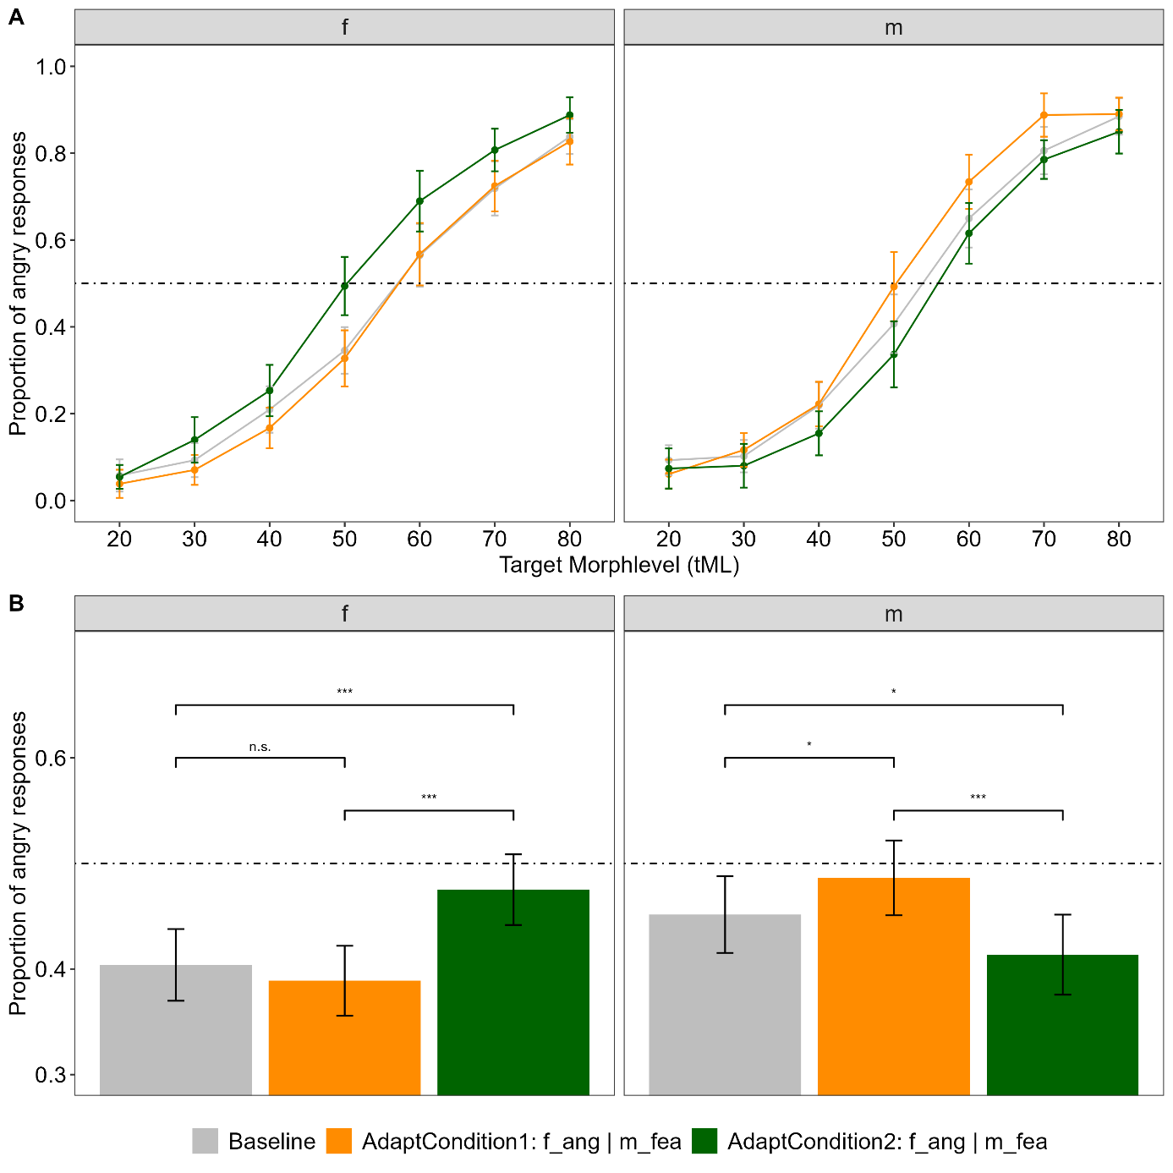Note. A) Proportion of angry responses for each morph level separately. B) averaged across morph level. The dotted line depicts 0.5, thus an equal proportion of classifications as angry and fearful, also referred to as the point of subjective equality. f = female, m = male

Interim Summary
In line with the hypothesis, Experiment 1 revealed simultaneous opposite aftereffects for speaker gender. For both male and female voices, there were classic contrastive aftereffects: after adaptation to angry voices, targets voices were more likely perceived as fearful; and after adaption to fearful voices, targets voices were more likely perceived as angry. However, the distinguished feature here is that this adaptation happened in opposite directions for male and female voices at the same time. This shows that the calibration to vocal emotions is modulated by speaker gender.

Experiment 2: Speaker identity

Hypothesis
For Experiment 2, I expected to find simultaneous opposite aftereffects for different speaker identities, indicated by an AdaptationCondition x Identity interaction:
In AdaptationCondition 1, adaptors of Identity A were always angry, and adaptors of Identity B were always fearful. In that case, target voices of Identity A should be more often classified as fearful and target voices of Identity B more often as angry. Vice versa, in AdaptationCondition 2, adaptors of Identity B were always angry, and adaptors of Identity A were always fearful. In that case, target voices of Identity B should be more often classified as fearful and target voices of Identity A more often as angry. Identities A and B were always of the same speaker gender per block, and I expected to find this interaction for both male and female speakers. This experiment and its hypothesis were preregistered (10.17605/OSF.IO/3H9WN ).

Method

Participants
Data were collected online via Psytoolkit version 3.4.6 (Stoet, 2010, 2017) in July 2024, with the same technical requirements and the same target sample size as for Experiment 1. N = 75 people accessed the study via hyperlink, of which N = 45 contributed complete data. Three participants had to be excluded (N = 1 for pressing only one key during the whole experiment, N = 1 due to 5% trials of omission in the baseline task, N = 1 due to problems with the sound playback). Two participants reported having occasional tinnitus but did not feel impaired by it and were thus kept in the sample. Therefore, the final sample consisted of 42 participants (34 female, 6 male, 2 diverse, aged 18 to 31 years [M = 22.04, SD = 2.94]). Again, all data were collected pseudonymized and the experiment was approved by the local ethics committee.

Stimuli
Stimuli were identical to Experiment 1.

Design and Procedure
The design was very similar to Experiment 1. Again, participants started by giving consent and entering their demographic information. Then, they completed the listening experiment in full screen mode. Afterwards, they answered the same follow-up questions as in Experiment 1. Overall duration of the study was about 30 minutes as well.
This time, the experiment consisted of two baseline and four adaptation tasks, because they were blocked for speaker gender. Thus, in the Baseline, participants completed one block of 56 trials with female targets only and one block of 56 trials with male ones only, with a break in between. In all other respects, the baseline task was identical to Experiment 1.
Afterwards, participants completed the Adaptation in four blocks, two for each speaker gender. In each block, adaptor emotions were tied to speaker identity: In the first female block, participants adapted to angy-IdentityF1 and fearful-IdentityF2. In the other one, the combination was reversed: angry-IdentityF2 and fearful-IdentityF1 (Figure 3A). Likewise, for the male blocks: in one, the combination was angy-IdentityM3 and fearful-IdentityM4. In the other, angy-IdentityM4 and fearful-IdentityM3. The trial procedure was very similar to Experiment 1: Each block consisted of an adaptation phase and a response phase.
During the adaptation phase, 16 adaptor stimuli (4 speakers x 2 identities x 2 repetitions) were presented in random order with a red fixation cross on the computer screen, but this time with a longer interstimulus interval of 600 ms. Again, exactly half of the adaptor stimuli were fearful, and the other half was angry but always tied to a certain speaker’s identity. After the adaptation phase, the response phase started, which was signaled by a message in green font for 3000 ms. The response phase was almost identical to the one in Experiment 1: all targets were presented once and participants classified them as fearful or angry by pressing the corresponding keys. Again, every fourth trial, a red fixation cross appeared, and two top-up adaptors were played, with similar constraints as in Experiment 1: They were picked randomly, but one top-up adaptor was fearful, and the other one was angry, thus coming from two different speaker identities (their specific combination depending on the adaptation block). In each adaptation block, participants classified all 56 targets of each speaker gender. After each adaptation block, participants could take a self-paced break. As there were four adaptation blocks, participants performed 224 trials in total.
Participants were randomly assigned to one of four counterbalancing conditions. They either started with the male or the female adaptation blocks and completed the prior baseline task in this order as well. Within speaker gender, it was further counterbalanced which adaptation condition came first.
Figure 3
Adaptation Conditions of Experiment 2 and 3
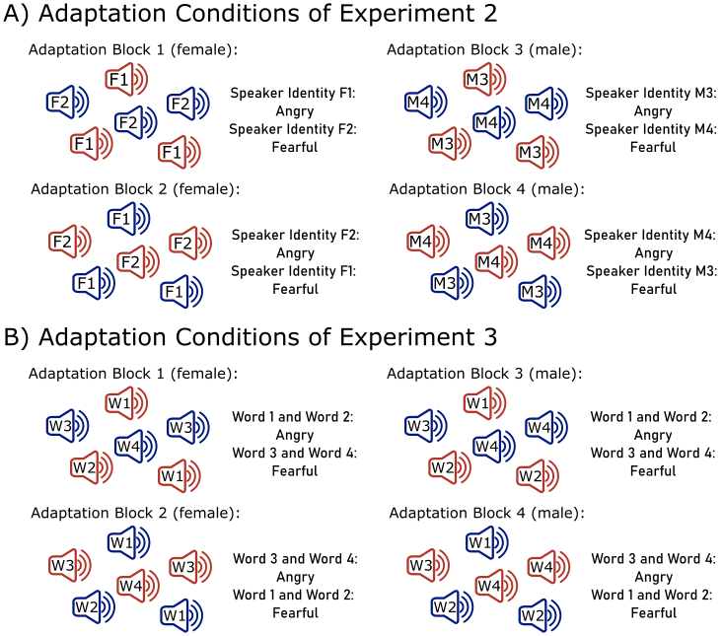
Note. A) Experiment 2: Depiction of the two adaptation conditions, separately for speaker gender. In Block 1, participants adapted to angry-IdentityF1 and fearful-IdentityF2. In Block 2, they adapted angry-IdentityF2 and fearful-IdentityF1. In Block 3, they adapted to angy-IdentityM3 and fearful-IdentityM4. In Block 4, they adapted to angy-IdentityM4 and fearful-IdentityM3. B) Experiment 3: Depiction of the two adaptation conditions, separately for speaker gender. In Block 1, participants adapted to angry-Pseudowords 1 and 2 and fearful-Pseudowords 3 and 4. In Block 2, they adapted angry- Pseudowords 3 and 4 and fearful- Pseudowords 1 and 2. Block 3 was parallel to Block 1 and Block 4 parallel to Block 2, just with male instead of female stimuli.

Data analysis
Software and R-packages for data analyses were identical to Experiment 1. Errors of omission (<5%) were excluded from the data. Data were analyzed for male and female blocks separately, using the same two-step approach as in Experiment 1:
First, responses in each trial were modeled with a multilevel logistic regression. For the female blocks, predictor variables were the target morph level (tML, 20-80%, z-standardized for model estimation), the speaker identity (F1 and F2), and the adaptation condition (AdaptCond1: angy-F1 and fearful-F2; AdaptCond2: angry-F2 and fearful-F1). Random effects were estimated for each participant, resulting in the following model:
Response_{angry/fearful} ~ tML * SpID_{females} * AdaptCond_{1/2} + (1 | Participant)
For the male blocks, predictor variables were the target morph level, the speaker identity (M3 and M4), and the adaptation condition (AdaptCond3: angy-M3 and fearful-M4; AdaptCond4: angry-M4 and fearful-M3), with random effects for each participant:
Response_{angry/fearful} ~ tML * SpID_{males} * AdaptCond_{3/4} + (1 | Participant)
Again, data from the Baseline block were not included in this first analysis. Please note that this analysis pipeline deviates from the preregistered plan, which intended the estimation of cumulative gaussian functions (Nussbaum, von Eiff, et al., 2022), which had to be discarded due to bad model fit.
In the second step, data were averaged again across target morph levels and pseudowords, to zoom into the interaction of SpID and AdaptCond, separately for speaker gender. Baseline data were included here as well. AdaptConditions were then compared between F1 vs F2 and M3 vs M4, using paired t-tests. Finally, all AdaptConditions were compared to the Baseline conditions, again separately for each SpGender. All further methodological specifications were identical to Experiment 1.

Transparency and Openness
The rationale for sample size estimation, all data exclusions and all manipulations have been specified. Preprocessed data, analysis scripts and supplemental materials can be found in the associated OSF repository.

Results
A summary of model parameters and estimates of the multilevel logistic regression can be found in Table 2. For female voices, there was a main effect of tML indicating that the proportion of angry responses increased with an increased percentage of acoustic “angriness” in the voice. The interaction of tML x SpID indicated that the slope of this increase was slightly steeper for Speaker Identity F1 compared to F2. The main effect of SpID further suggested that F1 was overall more often classified as angry, compared to F2. Importantly, the predicted interaction of SpID x AdaptCond (Figure 4A) was significant.
For male voices, there were large main effects of tML, SpID and AdaptCond. Speaker Identity M4 was perceived as angry much more often than M3. The interaction of tML x SpID further indicated a steeper slope for M4 compared to M3. The main effect of AdaptCond indicated that in AdaptCond 3 (angy-M3 and fearful-M4), all targets were classified more often as angry, compared to AdaptCond 4 (angry-M4 and fearful-M3), irrespective of SpID. Importantly, the predicted interaction of SpID x AdaptCond (Figure 4B) was not significant.

Table 2
Summary of Multilevel Logistic Regressions for Experiment 2
Model Exp 2 - Female Voices
Response ~ | tML * SpID * AdaptCond + (1 | Participant)
Predictor | Chi2 | p |  | Fixed effects | Estimate | SE | z | p
Morph Level (tML) | 1785.96 | <0.001 |  | (Intercept) | -0.17 | 0.12 | -1.34 | 0.181
Speaker Identity (SpID) | 44.00 | <0.001 |  | tML | 1.74 | 0.10 | 18.26 | <0.001
AdaptCond | 7.16 | 0.007 |  | SpID: F2 | -0.30 | 0.10 | -2.89 | 0.004
tML x SpID | 34.14 | <0.001 |  | AdaptCond: 2* | 0.00 | 0.11 | 0.01 | 0.994
tML x AdaptCond | 5.95 | 0.015 |  | tML x SpID: F2 | -0.48 | 0.12 | -3.85 | <0.001
SpID x AdaptCond | 7.21 | 0.007 |  | tML x AdaptCond: 2 | 0.28 | 0.14 | 2.00 | 0.046
tML x SpID x AdaptCond | 0.40 | 0.528 |  | SpID: F2 x AdaptCond: 2 | -0.41 | 0.15 | -2.68 | 0.007
 |  |  |  | tML x SpID: F2 x AdaptCond: 2 | -0.12 | 0.18 | -0.63 | 0.528
Model information |  |  |  | Random effects | Var | SD
AIC/BIC | 4460 | 4518 |  | Participant - Intercept | 0.41 | 0.64
N observations | 4677
N participants | 42
Model Exp 2 - Male Voices
Response ~ | tML * SpID * AdaptCond + (1 | Participant)
Predictor | Chi2 | p |  | Fixed effects | Estimate | SE | z | p
Morph Level (tML) | 1860.19 | <0.001 |  | (Intercept) | -1.38 | 0.15 | -8.94 | <0.001
Speaker Identity (SpID) | 441.93 | <0.001 |  | tML | 1.50 | 0.10 | 15.47 | <0.001
AdaptCond | 34.59 | <0.001 |  | SpID: M4 | 1.88 | 0.13 | 14.66 | <0.001
tML x SpID | 57.57 | <0.001 |  | AdaptCond: 4* | -0.47 | 0.14 | -3.46 | <0.001
tML x AdaptCond | 2.61 | 0.106 |  | tML x SpID: M4 | 0.92 | 0.16 | 5.87 | <0.001
SpID x AdaptCond | 0.48 | 0.490 |  | tML x AdaptCond: 4 | -0.08 | 0.14 | -0.53 | 0.593
tML x SpID x AdaptCond | 0.85 | 0.357 |  | SpID: M4 x AdaptCond: 4 | -0.13 | 0.18 | -0.69 | 0.489
 |  |  |  | tML x SpID: M4 x AdaptCond: 4 | -0.20 | 0.22 | -0.92 | 0.358
Model information |  |  |  | Random effects | Var | SD
AIC/BIC | 3816 | 3874 |  | Participant - Intercept | 0.65 | 0.81
N observations | 4682
N participants | 42
Note. The response is the classification of stimuli as angry or fearful. The target morph level (tML) was z-standardized for model estimation. * AdaptCond1: angy-F1 and fearful-F2; AdaptCond2: angry-F2 and fearful-F1; AdaptCond3: angy-M3 and fearful-M4; AdaptCond4: angry-M4 and fearful-M3.

Planned post-hoc t-tests revealed differential effects on the two female speaker identities (Figure 4C): The perception of F1 target voices was not affected by the adaptation conditions, which also did not differ from the Baseline (all |ts(41)| ≤ 0.66, p ≥ .511, d ≤ 0.10 [-0.20, 0.41], M_{AdaptCond1} = 0.48 ± 0.02 SEM, M_{AdaptCond2} = 0.48 ± 0.02 SEM, M_{Baseline} = 0.49 ± 0.02 SEM). For F2 however, the adaptation conditions modulated the response in the expected direction: In AdaptCond1 (angy-F1 and fearful-F2), M = 0.42 ± 0.02 SEM, F2 targets were more often classified as angry, compared to AdaptCond2 (angry-F2 and fearful-F1), M = 0.36 ± 0.02 SEM, |t(41)| = 3.80, p < .001, d = 0.59 [0.26, 0.92], as well as compared to the Baseline, M = 0.37 ± 0.02 SEM, |t(41)| = 2.58, p = .013, d = 0.40 [0.08, 0.72]. AdaptCond2 and Baseline did not differ, |t(41)| = 0.49, p = .626, d = 0.08 [-0.23, 0.38].
For male voices, planned post-hoc t-tests confirmed the main effect of AdaptCondion for both speaker identities again (Figure 4D): Both M3 and M4 were more often classified as angry in AdaptCond3 (angy-M3 and fearful-M4) compared to AdaptCond4 (angry-M4 and fearful-M3), |ts(41)| ≥ 3.81, p ≤ .001, ds ≥ 0.60 [0.26, 0.92]. Further, AdaptCond 3 did not differ from the Baseline for both speakers, |ts(41)| ≤ 0.83, p ≥ .413, d ≤ 0.13 [-0.18, 0.44], but AdaptCond4 did, |ts(41)| ≥ 2.90, p ≤ .006, ds ≥ 0.45 [0.13, 0.77]. Mean values for M3 were M_{AdaptCond3} = 0.29 ± 0.02 SEM, M_{AdaptCond4} = 0.22 ± 0.02 SEM, M_{Baseline} = 0.28 ± 0.02 SEM, and for M4 they were M_{AdaptCond3} = 0.56 ± 0.02 SEM, M_{AdaptCond4} = 0.49 ± 0.02 SEM, M_{Baseline} = 0.56 ± 0.02 SEM.
Figure 4
Proportion of angry responses separately for Speaker Identity and Adaptation Condition
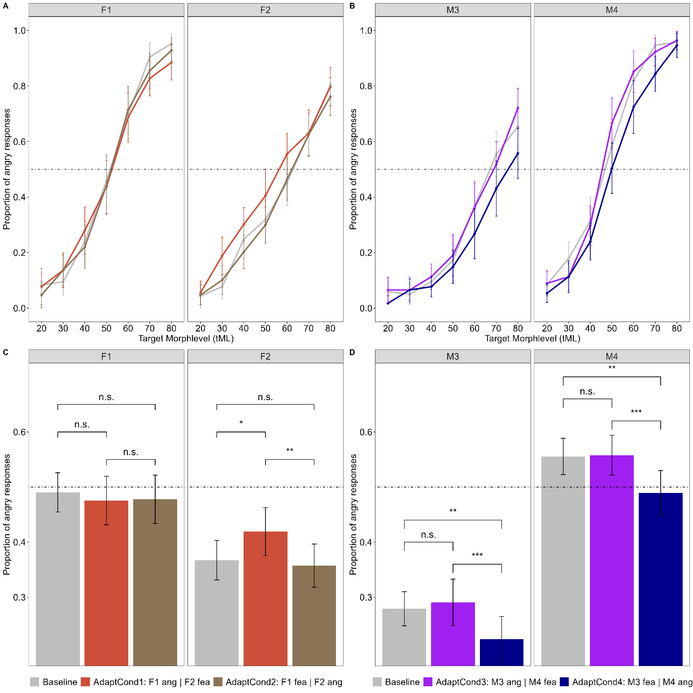
Note. Proportion of angry responses for each morph level separately for A) female speaker identities F1 and F2 and B) male speaker identities M3 and M4. C) Responses averaged across morph level for female identities, and D) for male identities. The dotted line depicts 0.5, thus an equal proportion of classifications as angry and fearful, also referred to as the point of subjective equality.

Interim Summary
In summary, there was no evidence for contrastive aftereffects for male speaker identities, and only partly for female speaker identities. Thus, evidence for the hypothesis of Experiment 2 is inconclusive. Note that there was a pronounced confound between emotionality and speaker identity in male voices: across the whole morphing continuum, M3 was perceived far more often as fearful and M4 more often as angry. This could have biased the adaptation conditions. The amount of fearful and angry information should have been balanced, but with speakers being so different in how effectivly they convey both emotions, AdaptCond4 was probably overall an angry emotion adaptation, explaining the main effect depicted in Figure 4D. A similar mechanism may have been at play for female voices as well, but to a lesser degree, which is why a speaker-specific modulation was still visible for F2. Thus, problematic stimulus properties could offer a preliminary explanation for this conflicting pattern of results.

Experiment 3: Spoken Pseudoword

Hypothesis
For Experiment 3, I expected to find no simultaneous opposite aftereffects for different pseudowords, thus no AdaptationCondition x Pseudoword interaction. In other words, target voices of all pseudowords (1,2,3,4) should have a similar likelihood of being classified as either angry or fearful in the two adaptation conditions (AdaptCond1: angry-pseudowords 1 and 2 and fearful-pseudowords 3 and 4, AdaptCond2: angry-pseudowords 3 and 4 and fearful-pseudowords 1 and 2), because adaptation impressions should cancel each other out across pseudowords. This was hypothesized for male and female voices. This experiment and its hypothesis were preregistered (10.17605/OSF.IO/3H9WN ).

Method

Participants
Data were collected online via Psytoolkit version 3.4.6 (Stoet, 2010, 2017) in July 2024, with the same technical requirements and the same target sample size as for Experiment 1 and 2. 99 people accessed the study via hyperlink, of which 48 contributed complete data. Six participants had to be excluded (N = 3 due to 5% trials of omission in the baseline task, N = 3 due to problems with the sound playback). Therefore, the final sample consisted of N = 42 participants (34 female, 7 male, 1 diverse, aged 18 to 46 years [M = 25.76, SD = 5.47]). Again, all data were collected pseudonymized and the experiment was approved by the local ethics committee.

Stimuli
Stimuli were identical to Experiments 1 and 2.

Design and Procedure
The design was very similar to Experiment 2 and differed only in the adaptation tasks. The baseline task was identical. Again, participants completed the Adaptation in four blocks, two for each speaker gender. In each block, adaptor emotions were tied to the pseudoword: In the first female block, participants adapted to angry-pseudowords 1 and 2 and fearful-pseudowords 3 and 4. In the other one, the combination was reversed: angry-pseudowords 3 and 4 and fearful-pseudowords 1 and 2 (Figure 3B). Likewise, for the two male blocks. In all other aspects, the trial procedure was identical to Experiment 2. Following the same logic, the top-up adaptors during the response phase now were two different pseudowords, one angry and one fearful, matching the respective adaptation conditions.

Data analysis
Software and R-packages for the first part of the data analyses were similar to Experiment 2. Errors of omission (<5%) were excluded from the data. Then, responses in each trial were modeled with a multilevel logistic regression.
Predictor variables were the target morph level (tML, 20-80%, z-standardized for model estimation), the pseudoword (PW1: /belam/, PW2: /molen/, PW3: /namil/ and PW 4: /loman/), and the adaptation condition (AdaptCond1: PW 01/02-angry and PW 03/04-fearful; AdaptCond2: PW 03/04-angry and PW 01/02-fearful). Random effects were estimated for each speaker identity (SpID) and participant. Thus, the following model was estimated:
Response_{angry/fearful} ~ tML * Pseudoword * AdaptCond + (1 | SpID) + (1 | Participant)
As preregistered, this classical frequentist approach was complemented with a Bayesian analysis, which – in contrast to null hypothesis significance testing - allows a quantification of evidence for null findings (Rosenfeld & Olson, 2021). The Bayes factor (BF10) is reported as an indicator for the likelihood of the null and alternative hypothesis given the observed data. BF₁₀ > 1 indicates larger evidence for the alternative hypothesis, BF₁₀ < 1 indicates larger evidence for the null hypothesis. For example, a BF₁₀ = 3 means that the alternative hypothesis is three times more likely than the null hypothesis, whereas the reciprocal BF₁₀ = .33 means that the null hypothesis is three times more likely than the alternative. Following the guidelines by Jarosz and Wiley (2014), values of BF₁₀ = 1-3 (1-.33) are considered as anecdotal, BF₁₀ = 3-10 (.33-.10) as moderate, BF₁₀ = 10-30 (.10-.03) as strong, BF₁₀ = 30-100 (.03-.01) as very strong and BF₁₀ > 100 (< .01) as decisive evidence for the alternative hypothesis and the reciprocal values in parentheses as respective evidence for the null hypothesis. Bayesian analysis was conducted with the “brms”-package in R (Bürkner, 2017; Carpenter et al., 2017). The default_prior-command was used to identify appropriate default priors for each model. The Bayes Factor was estimated by comparing two models with and without the interaction PW x AdaptCond. All further specifications can be found in the analysis scripts on OSF.
Finally, to keep the analysis pipeline parallel to Exp 1 and 2, I zoomed into the AdaptConditions, by averaging across tML and SpGender, and comparing them via paired t-tests to the Baseline Condition.

Results
A summary of model parameters and estimates of the multilevel logistic regression can be found in Table 3. Again, the main effect of tML indicates that the proportion of angry responses increased with an increased percentage of acoustic “angriness” in the voice. The main effect of PW indicated that some pseudowords were more often classified as angry, especially PW1 (see Figure 5). Similarly, the main effect of AdaptCond indicated that in AdaptCond1 (angry-PW1|2 and fearful-PW3|4), all targets were more often classified as angry compared to AdaptCond2 (angry-PW3|4 and fearful-PW1|2). Crucially, and in line with the null hypothesis, there was no interaction of PW x AdaptCond (p = .866). The Bayes factor BF₁₀ = 0.07 also indicated strong evidence for the null hypothesis. Thus, the mean classification of the pseudowords was not differentially affected by the different Adaptation Conditions. Please note that the three-way interaction suggests that the slope of the function differed slightly as a function of SpGender, PW and AdaptCond. Exploratory analysis for male and female speakers separately yielded essentially the same patterns (details on OSF, Supplemental Table S5).

Table 3
Summary of Multilevel Logistic Regression for Experiment 3
Model Exp 3
Response ~ | tML * Pseudoword * AdaptCond + (1|SpID) + (1 | Participant)
Predictor | Chi2 | p |  | Fixed effects | Estimate | SE | z | p
Morph Level (tML) | 4111.7 | <.001 |  | (Intercept) | 0.32 | 0.3 | 1.01 | 0.311
Pseudoword (PW) | 452.31 | <.001 |  | tML | 1.65 | 0.1 | 18.15 | <0.001
AdaptCond | 6.52 | 0.011 |  | PW: PW2* | -1.64 | 0.1 | -13.75 | <0.001
tML x PW | 40.61 | <.001 |  | PW: PW3 | -1.05 | 0.1 | -9.03 | <0.001
tML x AdaptCond | 0.73 | 0.375 |  | PW: PW4 | -0.41 | 0.1 | -3.55 | <0.001
AdaptCond x PW | 0.73 | 0.866 |  | AdaptCond: 2** | -0.23 | 0.1 | -2.13 | 0.033
tML x PW x AdaptCond | 9.54 | 0.023 |  | tML x PW: W3 | 0.41 | 0.1 | 2.92 | 0.0035
 |  |  |  | tML x PW: W4 | 0.68 | 0.1 | 4.63 | <0.001
 |  |  |  | tML x PW: W4 x AdaptCond: 2 | -0.57 | 0.2 | -2.84 | 0.0046
Model information |  |  |  | Random effects | Var | SD
AIC/BIC | 7933 | 8061 |  | Participant - Intercept | 0.42 | 0.65
N observations | 9371 |  |  | Speaker Identity (SpID) - Intercept | 0.34 | 0.58
N participants | 42
N Speaker Identity | 4

Note. The response is the classification of stimuli as angry or fearful. The target morph level (tML) was z-standardized for model estimation. This table shows only a subset of effects for readability. The complete information can be found on OSF, Supplemental Table S4. *PW1: /belam/, PW2: /molen/, PW3: /namil/ and PW 4: /loman/. ** AdaptCond1 angry-PW1|2 and fearful-PW3|4; AdaptCond2: angry-PW3|4 and fearful-PW1|2.

The planned post-hoc comparison revealed that in AdaptCond1 (angry-PW1|2 and fearful-PW3|4), all targets were more often classified as angry compared to AdaptCond2 (angry-PW3|4 and fearful-PW1|2), |t(41)| = 2.20, p = .034, d = 0.34 [0.03, 0.66], M_{AdaptCond1} = 0.44 ± 0.02 SEM, M_{AdaptCond2} = 0.41 ± 0.01 SEM, as already implied by the main effect above. Further, AdaptCond1 significantly differed from the Baseline, |t(41)| = 2.21, p = .033, d = 0.34 [0.03, 0.66], M_{Baseline} = 0.41 ± 0.01 SEM, whereas AdaptCond2 did not, |t(41)| = 0.68, p = .500, d = 0.11 [-0.20, 0.41]. To keep data visualization parallel to the previous Experiments, responses were plotted separately for each combination of Pseudoword x AdaptCond, although they did not interact (Figure 5B).

Figure 5
Proportion of angry responses separately for Pseudoword and Adaptation Condition
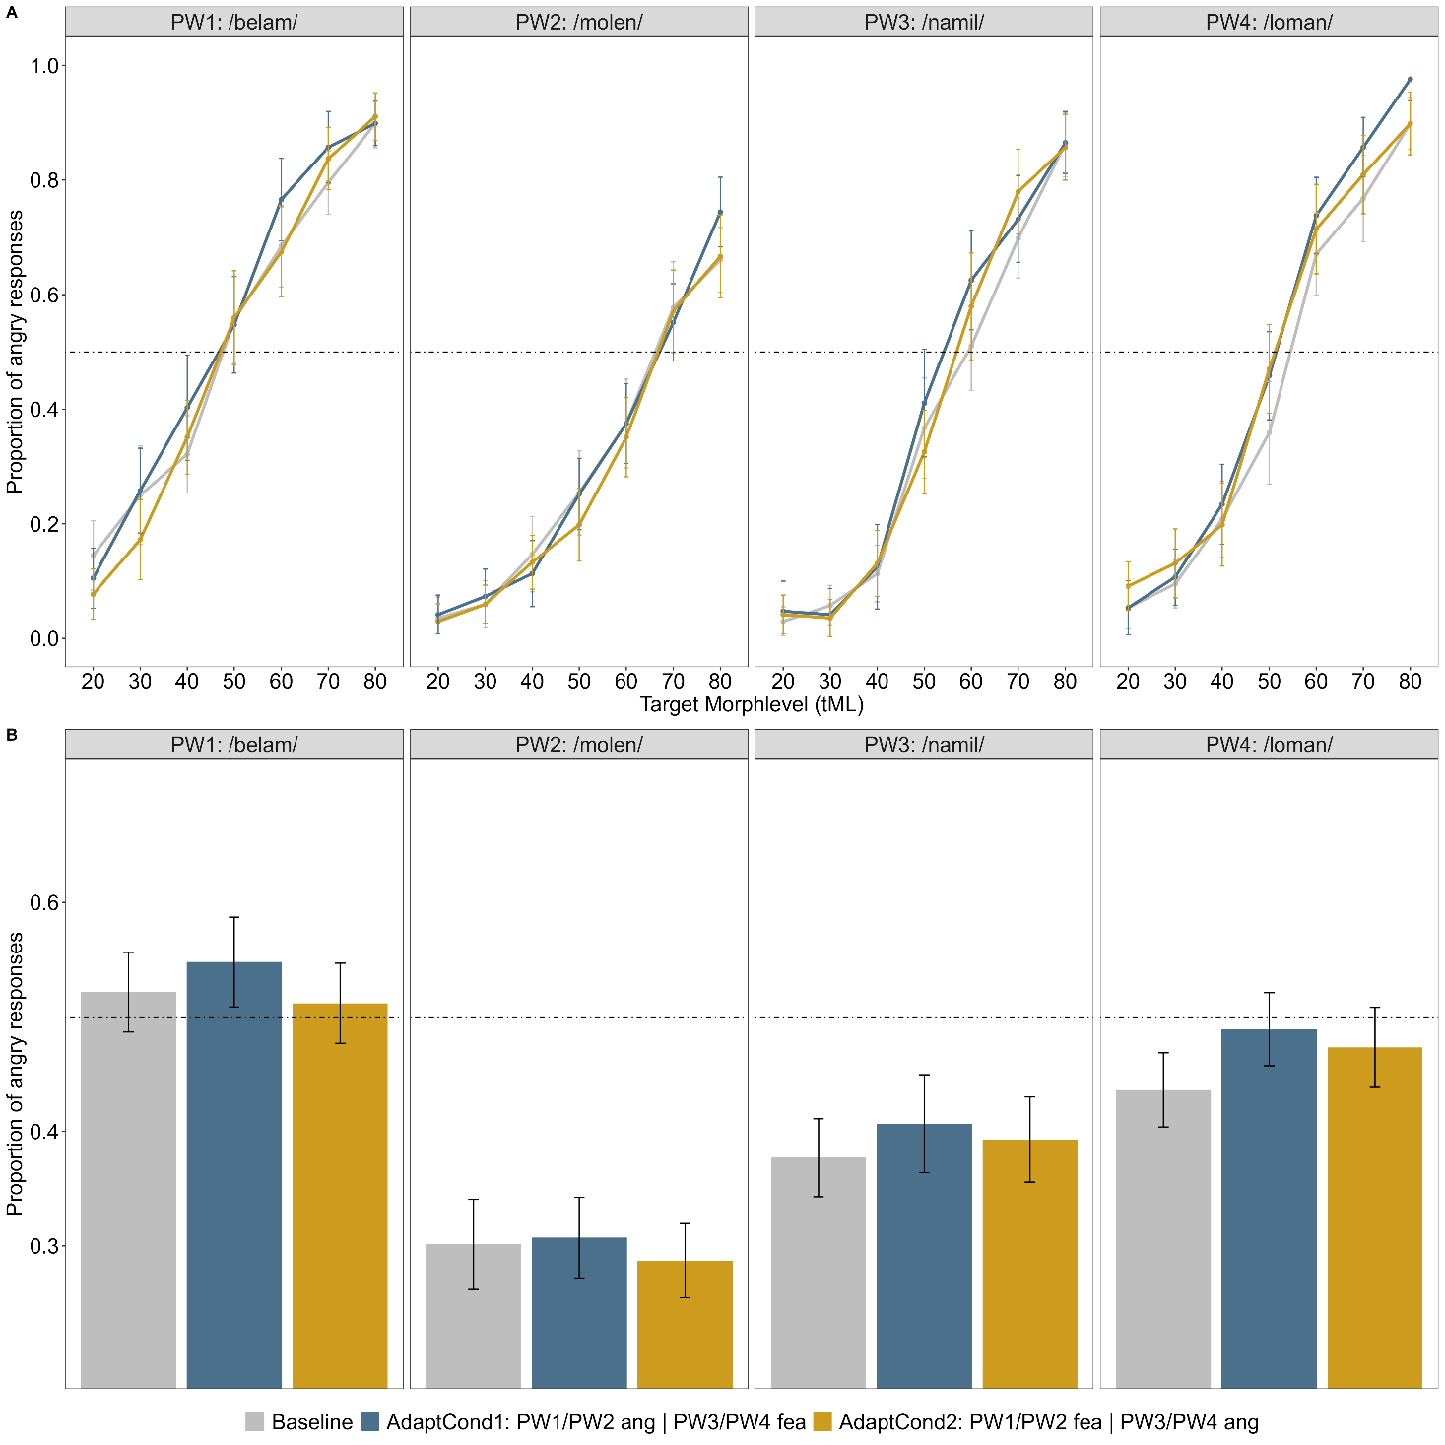
Note. A) Proportion of angry responses for each morph level separately. B) Averaged across morph level. The dotted line depicts 0.5, thus an equal proportion of classifications as angry and fearful, also referred to as the point of subjective equality.

Interim Summary
In line with the hypothesis of Experiment 3, there was evidence against simultaneous opposite aftereffects for pseudowords. Note, however, that there was a confound again between pseudoword and emotionality, especially when comparing PW1 and PW2, similar to the pattern for male speakers in Experiment 2 (cf. Figure 5B). As a result, emotionality in the adaptation condition could have been unbalanced again (i.e. AdaptCond2 being a weak angry adaptation condition overall), which explains the main effect of the AdaptationCondition. Crucially, however, none of the effects were specific to the pseudowords, indicating that there was no differential modulation by linguistic/phonetic features.

General Discussion
The aim of the present work was to investigate how linguistic and extralinguistic cues modulate vocal emotional adaptation, by means of simultaneous opposite aftereffects, which were predicted for stable speaker cues such as gender and identity, but not for pseudoword. Both the results for speaker gender and pseudoword were in line with these hypotheses. For speaker identity, evidence was inconclusive. In what follows, these patterns are discussed in more detail.

Stable speaker cues: effects of gender and identity
The results of Experiment 1 revealed a clear pattern for speaker gender: simultaneous adaptation to different emotions in male and female speakers led to aftereffects in opposite directions. This shows that the calibration to the current emotional context is not solely based on global auditory stimulation but fine-tuned to different groups of speakers. While this pattern is a replication of the study by Bestelmeyer, Jones, et al. (2010) on faces, it has not been shown for voices before. Previous research already provided evidence for gender-specific emotional biases (Brody, 2010). The present findings go beyond that, as they do not only reveal a universal bias, but a context-specific modulation. Thus, they provide strong evidence for perceptual flexibility in vocal emotional processing.
For speaker identity, the picture is much more difficult. In male speaker identities, simultaneous opposite aftereffects could not be observed and although the predicted interaction was found in females, specific modulations could only be found for one of the two identities. Why was the pattern so clear for speaker gender, but so conflicting for speaker identity? Although speculative at this point, both theoretical and methodological considerations offer potential explanations.
From a theoretical perspective, it is worth considering the voice space framework, which postulates that voices are stored in a multidimensional voice space and represented by their deviation from each other and/or a central midpoint (Andics et al., 2010; Latinus et al., 2013). Importantly, it has been argued that there are two distinct voice spaces for male and female speakers (Latinus et al., 2013), which are hence processed in relation to different reference frames, in two partially distinct neural networks (Junger et al., 2013; Park et al., 2025; Weston et al., 2015). This suggests that there is a build-in neural architecture for a separate tracking of male and female voices, which in turn could facilitate a gender-specific calibration to vocal emotions. This fits with the observation that cross-gender emotion adaptation aftereffects are largely reduced compared to a same-gender condition (Nussbaum, von Eiff, et al., 2022). In contrast, speaker identities of the same gender share one reference frame, potentially employing similar neural circuits, which could in turn hinder a separate recalibration to emotions. Note, however, that this does not necessarily imply that effects for speaker identity have to be completely absent. They could simply be much smaller, and harder to detect, which would fit with the present data for female speakers.
From a methodological perspective, one aspect deserves particular consideration: for simultaneous opposite aftereffects to occur, there must be no classification ambiguity about the voice cues under study. For speaker gender, that is usually no problem, as listeners can infer it easily within less than 200ms after voice onset (Lavan et al., 2024), even in unfamiliar voices. For speaker identity, this is much harder: perception of unfamiliar identities is based on very few encounters only, and easily disturbed by the interindividual variability introduced by pseudowords and emotions (Lavan, Burston, & Garrido, 2019; Xu & Armony, 2021). As a result, fearful and angry utterances by the same speaker could have been interpreted as different speaker identities, providing a straightforward explanation for the absence of simultaneous opposite aftereffects. One way to address this in the future would be by using speakers which are familiar to the listeners. Recognition and discrimination of familiar speakers is easier, as their representation incorporates intraindividual variability (Lavan, Knight, & McGettigan, 2019; Maguinness et al., 2018), including idiosyncratic styles of emotional expression (Xu & Armony, 2024). In light of these considerations, the present data only serve as a starting point for future research unraveling the speaker-specific fine-tuning to vocal emotions (Pinheiro, 2025).

Dynamic voice cues: effects of the (pseudo-)word
As predicted, there were no simultaneous opposite aftereffects for different pseudowords. Note that this does not mean a mere absence of a difference in the data, but instead Bayesian inference revealed strong evidence for a null effect. Thus, during vocal emotion adaptation, dynamic linguistic information seems to be averaged out. This does not imply that spoken words do not carry emotional meaning. In fact, there is ample evidence that semantic affective information interacts with the processing of emotional prosody (for a review, see Liebenthal et al., 2016). And even pseudowords, which do not carry semantic meaning, show differential patterns, depending on their phonetic composition, as some phonemes are particularly well-suited to express high arousal and anger (Lev-Ari & McKay, 2023). In English and German languages, that seems to be the case for plosives (Aryani et al., 2018), which fits well with the present data: the only pseudoword containing a plosive (PW1: /belam/) was perceived more often as angry than the other three. Thus, the current results do not suggest that linguistic/phonetic features are emotionally uninformative. However, they suggest that for a perceptual recalibration to the current emotional context, this linguistic information is averaged out.

Limitations, constraints on generality and outlook
There are a number of limitations in the present studies that may serve as valuable starting points for follow-up research, beyond the above-mentioned replication with familiar speakers. First, all studies were powered based on the study by Bestelmeyer, Jones, et al. (2010), which targeted speaker gender in faces. Therefore Experiment 2 may have been underpowered to detect effects of speaker identity, which could be much smaller for reasons discussed above. Further, as mentioned earlier, there were some confounds between emotionality and speaker identities on the one hand, and to a lesser degree pseudowords on the other hand. One male speaker and one pseudoword were perceived as angry much more often than the other ones. Note that these confounds mainly manifest in main effects of speaker identity/pseudoword and the adaptation conditions of Experiment 2 and 3. Therefore, they do not necessarily impede simultaneous opposite adaptation, which would be reflected in the additional interaction of these factors, but could have reduced its statistical power, rendering it non-detectable. Further, while the utterances already have substantial phonetic variability compared to earlier works on emotional adaptation (Bestelmeyer et al., 2014; Bestelmeyer, Rouger, et al., 2010), there is still room for improvement, as some phoneme classes such as fricatives and certain vowels are completely missing. Finally, it should be acknowledged that the current study builds on a binary conceptualization of voice gender, while there is now a growing body of more inclusive research on diverse gender identities (Rosi & McGettigan, 2025). Yet, even with a large body of literature targeting vocal expression of gender diversity, very little is known about its interplay with emotion perception and expression (Menezes et al., 2024). Future research may therefore explore how we fine-tune to voices that do not fall into clear binary categories.

Summary and Conclusion
In three different experiments, it was explored whether vocal emotional processing is fine-tuned to linguistic and extralinguistic cues, using a paradigm inducing simultaneous opposite adaptation aftereffects. Experiment 1 provided clear evidence for gender-specific adaptation aftereffects. For speaker identity, Experiment 2 resulted in inconclusive patterns. Finally, Experiment 3 revealed the predicted evidence for a null effect of pseudoword, suggesting that linguistic information is averaged out during emotional adaptation. Together, these findings shed new light on our remarkable ability to fine-tune into the auditory context for efficient emotional processing. This supports current calls that a deepened understanding of vocal emotional processing needs to consider the speakers behind the utterance. Future research could follow up on this notion by exploring the role of speaker familiarity.

Conflict of Interest and Funding
The author declares no conflict of interest. This research did not receive any specific grant from funding agencies in the public, commercial, or not-for-profit sectors.

Credit Author Statement
All parts of this research project were conducted by CN.

Acknowledgements
The data were collected by Dorothea Berges, Laura Würfel and Johanna Andres for Experiments 1-3, respectively, in partial fulfilment of a bachelor’s degree. Sascha Frühholz provided the original voice recordings that served as a basis for creating the stimulus material for these experiments. Finally, I am grateful to Manuel Pöhlmann and Stefan R. Schweinberger for helpful suggestions on an earlier version of this manuscript, and Jessica Dethloff for doublechecking the analyses.

References
Andics, A., McQueen, J. M., Petersson, K. M., Gál, V., Rudas, G., & Vidnyánszky, Z. (2010). Neural mechanisms for voice recognition. Neuroimage, 52(4), 1528–1540. https://doi.org/10.1016/j.neuroimage.2010.05.048
Aryani, A., Conrad, M., Schmidtke, D., & Jacobs, A. (2018). Why 'piss' is ruder than 'pee'? The role of sound in affective meaning making. PLoS One, 13(6), e0198430. https://doi.org/10.1371/journal.pone.0198430
Atkinson, A. P., Tipples, J., Burt, D. M., & Young, A. W. (2005). Asymmetric interference between sex and emotion in face perception. Perception & Psychophysics, 67(7), 1199–1213. https://doi.org/10.3758/BF03193553
Bachorowski, J. A., & Owren, M. J. (2003). Sounds of emotion: Production and perception of affect-related vocal acoustics. Annals of the New York Academy of Sciences, 1000, 244–265. https://doi.org/10.1196/annals.1280.012
Bates, D., Maechler, M., Bolker, B., Walker, S., Christensen, R. H. B., Singmann, H., Dai, B., Scheipl, F., Grothendieck, G., Green, P., & others (2009). Package ‘lme4’. URL Http://lme4. R-Forge. R-Project. Org.
Belin, P., Bestelmeyer, P. E. G., Latinus, M., & Watson, R. (2011). Understanding voice perception. British Journal of Psychology, 102(4), 711–725. https://doi.org/10.1111/j.2044-8295.2011.02041.x
Bestelmeyer, P. E. G., & Evans, D. (2026). Context effects on the processing hierarchy of vocal expressions. Cerebral Cortex, 36(1). https://doi.org/10.1093/cercor/bhaf343
Bestelmeyer, P. E. G., Jones, B. C., DeBruine, L. M., Little, A. C., & Welling, L. L. M. (2010). Face aftereffects suggest interdependent processing of expression and sex and of expression and race. Visual Cognition, 18(2), 255–274. https://doi.org/10.1080/13506280802708024
Bestelmeyer, P. E. G., Maurage, P., Rouger, J., Latinus, M., & Belin, P. (2014). Adaptation to vocal expressions reveals multistep perception of auditory emotion. J Neurosci, 34(24), 8098–8105. https://doi.org/10.1523/JNEUROSCI.4820-13.2014
Bestelmeyer, P. E. G., Rouger, J., DeBruine, L. M., & Belin, P. (2010). Auditory adaptation in vocal affect perception. Cognition, 117(2), 217–223. https://doi.org/10.1016/j.cognition.2010.08.008
Boersma, P. (2018). Praat: Doing phonetics by computer [Computer program]: Version 6.0.46, retrieved January 2020 from http://www.praat.org/. Http://www. Praat. Org.
Brody, L. R. (2010). The socialization of gender differences in emotional expression: Display rules, infant temperament, and differentiation. In A. H. Fischer (Ed.), Gender and Emotion (pp. 24–47). Cambridge University Press. https://doi.org/10.1017/CBO9780511628191.003
Bürkner, P.‑C. (2017). brms : An R Package for Bayesian Multilevel Models Using Stan. Journal of Statistical Software, 80(1). https://doi.org/10.18637/jss.v080.i01
Carpenter, B., Gelman, A., Hoffman, M. D., Lee, D., Goodrich, B., Betancourt, M., Brubaker, M. A., Guo, J., Li, P., & Riddell, A. (2017). Stan: A Probabilistic Programming Language. Journal of Statistical Software, 76. https://doi.org/10.18637/jss.v076.i01
Fox, C. J., & Barton, J. J. S. (2007). What is adapted in face adaptation? The neural representations of expression in the human visual system. Brain Research, 1127(1), 80–89. https://doi.org/10.1016/j.brainres.2006.09.104
Frühholz, S., Klaas, H. S., Patel, S., & Grandjean, D. (2015). Talking in Fury: The Cortico-Subcortical Network Underlying Angry Vocalizations. Cerebral Cortex, 25(9), 2752–2762. https://doi.org/10.1093/cercor/bhu074
Grill-Spector, K., Henson, R., & Martin, A. (2006). Repetition and the brain: neural models of stimulus-specific effects. Trends Cogn Sci, 10(1), 14–23. https://doi.org/10.1016/j.tics.2005.11.006
Hubbard, D. J., & Assmann, P. F. (2013). Perceptual adaptation to gender and expressive properties in speech: the role of fundamental frequency. J Acoust Soc Am, 133(4), 2367–2376. https://doi.org/10.1121/1.4792145
Jarosz, A. F., & Wiley, J. (2014). What Are the Odds? A Practical Guide to Computing and Reporting Bayes Factors. The Journal of Problem Solving, 7(1). https://doi.org/10.7771/1932-6246.1167
Jenkins, R., Beaver, J. D., & Calder, A. J. (2006). I thought you were looking at me: Direction-specific aftereffects in gaze perception. Psychological Science, 17(6), 506–513. https://doi.org/10.1111/j.1467-9280.2006.01736.x
Junger, J., Pauly, K., Bröhr, S., Birkholz, P., Neuschaefer-Rube, C., Kohler, C., Schneider, F., Derntl, B., & Habel, U. (2013). Sex matters: Neural correlates of voice gender perception. Neuroimage, 79, 275–287. https://doi.org/10.1016/j.neuroimage.2013.04.105
Kawahara, H., Morise, M., Takahashi, T., Nisimura, R., Irino, T., & Banno, H. (2008). TANDEM-STRAIGHT: A temporally stable power spectral representation for periodic signals and applications to interference-free spectrum, F0, and aperiodicity estimation. IEEE International Conference on Acoustics, Speech and Signal Processing.
Kawahara, H., & Skuk, V. G. (2018). Voice Morphing. In S. Frühholz, P. Belin, S. Frühholz, P. Belin, & K. R. Scherer (Eds.), The Oxford Handbook of Voice Perception (pp. 684–706). Oxford University Press. https://doi.org/10.1093/oxfordhb/9780198743187.013.31
Korb, S., Mikus, N., Massaccesi, C., Grey, J., Duggirala, S. X., Kotz, S. A., & Mehu, M. (2023). Emosex: Emotion prevails over sex in implicit judgments of faces and voices. Emotion, 23(2), 569–588. https://doi.org/10.1037/emo0001089
Lakens, D., & Caldwell, A. R. (2019). Simulation-Based Power-Analysis for Factorial ANOVA Designs. https://doi.org/10.31234/osf.io/baxsf
Latinus, M., McAleer, P., Bestelmeyer, P. E. G., & Belin, P. (2013). Norm-based coding of voice identity in human auditory cortex. Current Biology, 23(12), 1075–1080. https://doi.org/10.1016/j.cub.2013.04.055
Laukka, P., Elfenbein, H. A., Thingujam, N. S., Rockstuhl, T., Iraki, F. K., Chui, W., & Althoff, J. (2016). The expression and recognition of emotions in the voice across five nations: A lens model analysis based on acoustic features. Journal of Personality and Social Psychology, 111(5), 686–705. https://doi.org/10.1037/pspi0000066
Lavan, N., Burston, L. F. K., & Garrido, L. (2019). How many voices did you hear? Natural variability disrupts identity perception from unfamiliar voices. British Journal of Psychology (London, England : 1953), 110(3), 576–593. https://doi.org/10.1111/bjop.12348.
Lavan, N., Knight, S., & McGettigan, C. (2019). Listeners form average-based representations of individual voice identities. Nature Communications, 10(1), 2404. https://doi.org/10.1038/s41467-019-10295-w
Lavan, N., & McGettigan, C. (2023). A model for person perception from familiar and unfamiliar voices. Communications Psychology, 1(1), 1–11. https://doi.org/10.1038/s44271-023-00001-4
Lavan, N., Rinke, P., & Scharinger, M. (2024). The time course of person perception from voices in the brain. Proceedings of the National Academy of Sciences, 121(26), e2318361121. https://doi.org/10.1073/pnas.2318361121
Leopold, D. A., O'Toole, A. J., Vetter, T., & Blanz, V. (2001). Prototype-referenced shape encoding revealed by high-level aftereffects. Nature Neuroscience, 4(1), 89–94. https://doi.org/10.1038/82947
Lev-Ari, S., & McKay, R. (2023). The sound of swearing: Are there universal patterns in profanity? Psychonomic Bulletin & Review, 30(3), 1103–1114. https://doi.org/10.3758/s13423-022-02202-0
Liebenthal, E., Silbersweig, D. A., & Stern, E. (2016). The Language, Tone and Prosody of Emotions: Neural Substrates and Dynamics of Spoken-Word Emotion Perception. Frontiers in Neuroscience, 10, 506. https://doi.org/10.3389/fnins.2016.00506
Lima, C. F., Anikin, A., Monteiro, A. C., Scott, S. K., & Castro, S. L. (2019). Automaticity in the recognition of nonverbal emotional vocalizations. Emotion, 19(2), 219–233. https://doi.org/10.1037/emo0000429
Maguinness, C., Roswandowitz, C., & Kriegstein, K. von (2018). Understanding the mechanisms of familiar voice-identity recognition in the human brain. Neuropsychologia, 116(Pt B), 179–193. https://doi.org/10.1016/j.neuropsychologia.2018.03.039
Menezes, D. P., Lira, Z. S. de, Araújo, A. N. B. de, Almeida, A. A. F. de, Gomes, A. d. O. C., Moraes, B. T., & Lucena, J. A. (2024). Prosodic Differences in the Voices of Transgender and Cisgender Women: Self-Perception of Voice - An Auditory and Acoustic Analysis. Journal of Voice, 38(4), 844–857. https://doi.org/10.1016/j.jvoice.2021.12.020
Nussbaum, C., Schirmer, A., & Schweinberger, S. R. (2022). Contributions of fundamental frequency and timbre to vocal emotion perception and their electrophysiological correlates. Social Cognitive and Affective Neuroscience, 17(12), 1145–1154. https://doi.org/10.1093/scan/nsac033
Nussbaum, C., Schirmer, A., & Schweinberger, S. R. (2024). Musicality - Tuned to the melody of vocal emotions. British Journal of Psychology, 115(2), 206–225. https://doi.org/10.1111/bjop.12684
Nussbaum, C., von Eiff, C. I., Skuk, V. G., & Schweinberger, S. R. (2022). Vocal emotion adaptation aftereffects within and across speaker genders: Roles of timbre and fundamental frequency. Cognition, 219, 104967. https://doi.org/10.1016/j.cognition.2021.104967
Park, E., Kasuya, M., & Homae, F. (2025). Neural responses to male and female voices: An event-related potential study on listener and speaker differences. Neuroscience Research, 219, 104942. https://doi.org/10.1016/j.neures.2025.104942
Paulmann, S., & Kotz, S. A. (2018). The Electrophysiology and Time Course of Processing Vocal Emotion Expressions. In S. Frühholz, P. Belin, S. Frühholz, P. Belin, & K. R. Scherer (Eds.), The Oxford Handbook of Voice Perception (pp. 458–472). Oxford University Press. https://doi.org/10.1093/oxfordhb/9780198743187.013.20
Pérez-González, D., & Malmierca, M. S. (2014). Adaptation in the auditory system: An overview. Frontiers in Integrative Neuroscience, 8, 19. https://doi.org/10.3389/fnint.2014.00019
Pinheiro, A. P. (2025). Behind a Voice There is a Speaker: Why Vocal Emotion Research Needs to Become 'Personal'. Affective Science, 6(3), 562–574. https://doi.org/10.1007/s42761-025-00317-w
R Core Team. (2025). R: A Language and Environment for Statistical Computing. https://www.R-project.org/
Rosenfeld, J. P., & Olson, J. M. (2021). Bayesian Data Analysis: A Fresh Approach to Power Issues and Null Hypothesis Interpretation. Applied Psychophysiology and Biofeedback, 46(2), 135–140. https://doi.org/10.1007/s10484-020-09502-y
Rosi, V., & McGettigan, C. (2025). Voice gender diversity: Expression, perception and acoustics. Royal Society Open Science, 12(10), 251193. https://doi.org/10.1098/rsos.251193
Scherer, K. R. (1986). Vocal affect expression: a review and a model for future research. Psychological Bulletin, 99(2), 143–165. https://doi.org/10.1037/0033-2909.99.2.143
Scherer, K. R. (2018). Acoustic Patterning of Emotion Vocalizations. In S. Frühholz, P. Belin, S. Frühholz, P. Belin, & K. R. Scherer (Eds.), The Oxford Handbook of Voice Perception (pp. 60–92). Oxford University Press. https://doi.org/10.1093/oxfordhb/9780198743187.013.4
Scherer, K. R., Banse, R., & Wallbott, H. G. (2016). Emotion Inferences from Vocal Expression Correlate Across Languages and Cultures. Journal of Cross-Cultural Psychology, 32(1), 76–92. https://doi.org/10.1177/0022022101032001009
Schirmer, A., Croy, I., Liebal, K., & Schweinberger, S. R. (2025). Non-verbal effecting - Animal research sheds light on human emotion communication. Biological Reviews of the Cambridge Philosophical Society, 100(1), 245–257. https://doi.org/10.1111/brv.13140
Schirmer, A., & Kotz, S. A. (2006). Beyond the right hemisphere: brain mechanisms mediating vocal emotional processing. Trends Cogn Sci, 10(1), 24–30. https://doi.org/10.1016/j.tics.2005.11.009
Schweinberger, S. R., Burton, A. M., & Kelly, S. W. (1999). Asymmetric dependencies in perceiving identity and emotion: Experiments with morphed faces. Perception & Psychophysics, 61(6), 1102–1115. https://doi.org/10.3758/BF03207617
Schweinberger, S. R., Casper, C., Hauthal, N., Kaufmann, J. M., Kawahara, H., Kloth, N., Robertson, D. M., Simpson, A. P., & Zäske, R. (2008). Auditory adaptation in voice perception. Curr Biol, 18(9), 684–688. https://doi.org/10.1016/j.cub.2008.04.015
Schweinberger, S. R., Kawahara, H., Simpson, A. P., Skuk, V. G., & Zäske, R. (2014). Speaker perception. Wiley Interdiscip Rev Cogn Sci, 5(1), 15–25. https://doi.org/10.1002/wcs.1261
Schweinberger, S. R., Zäske, R., Walther, C., Golle, J., Kovács, G., & Wiese, H. (2010). Young without plastic surgery: Perceptual adaptation to the age of female and male faces // Young without plastic surgery: Perceptual adaptation to the age of female and male faces. Vision Research, 50(23), 2570–2576. https://doi.org/10.1016/j.visres.2010.08.017
Singmann, H., Bolker, B., Westfall, J., Aust, F., Ben-Shachar, M. S., Højsgaard, S., & others (2015). Package ‘afex’. URL Http://afex. Singmann. Science/, Https://github. Com/singmann/afex.
Skuk, V. G., Dammann, L. M., & Schweinberger, S. R. (2015). Role of timbre and fundamental frequency in voice gender adaptation. J Acoust Soc Am, 138(2), 1180–1193. https://doi.org/10.1121/1.4927696
Spackman, M. P., Brown, B. L., & Otto, S. (2009). Do emotions have distinct vocal profiles? A study of idiographic patterns of expression. Cognition and Emotion, 23(8), 1565–1588. https://doi.org/10.1080/02699930802536268
Stoet, G. (2010). PsyToolkit: A software package for programming psychological experiments using Linux. Behavior Research Methods, 42(4), 1096–1104. https://doi.org/10.3758/BRM.42.4.1096
Stoet, G. (2017). PsyToolkit: A novel web-based method for running online questionnaires and reaction-time experiments. Teaching of Psychology, 44(1), 24–31. https://doi.org/10.1177/0098628316677643
Thompson, W. F., & Balkwill, L.‑L. (2006). Decoding speech prosody in five languages. Semiotica, 2006(158). https://doi.org/10.1515/SEM.2006.017
Webster, M. A., Kaping, D., Mizokami, Y., & Duhamel, P. (2004). Adaptation to natural facial categories. Nature, 428(6982), 557.
Webster, M. A., & MacLeod, D. I. A. (2011). Visual adaptation and face perception. Philosophical Transactions of the Royal Society of London. Series B, Biological Sciences, 366(1571), 1702–1725. https://doi.org/10.1098/rstb.2010.0360
Webster, M. A., & Maclin, O. H. (1999). Figural aftereffects in the perception of faces. Psychonomic Bulletin & Review, 6(4), 647–653.
Webster, M. A., Werner, J. S., & Field, D. J. (2005). Adaptation and the phenomenology of perception. Fitting the Mind to the World: Adaptation and Aftereffects in High Level Vision, 241–277.
Weston, P. S. J., Hunter, M. D., Sokhi, D. S., Wilkinson, I. D., & Woodruff, P. W. R. (2015). Discrimination of voice gender in the human auditory cortex. Neuroimage, 105, 208–214. https://doi.org/10.1016/j.neuroimage.2014.10.056
Wickham, H. (2006). An introduction to ggplot: An implementation of the grammar of graphics in R. Statistics, 1–8.
Willmore, B. D. B., & King, A. J. (2023). Adaptation in auditory processing. Physiological Reviews, 103(2), 1025–1058. https://doi.org/10.1152/physrev.00011.2022
Xu, H., & Armony, J. L. (2021). Influence of emotional prosody, content, and repetition on memory recognition of speaker identity. Q J Exp Psychol (Hove), 74(7), 1185–1201. https://doi.org/10.1177/1747021821998557
Xu, H., & Armony, J. L. (2024). Arousal level and exemplar variability of emotional face and voice encoding influence expression-independent identity recognition. Motivation and Emotion, 48(3), 464–483. https://doi.org/10.1007/s11031-024-10066-1
Zäske, R., Schweinberger, S. R., Kaufmann, J. M., & Kawahara, H. (2009). In the ear of the beholder: neural correlates of adaptation to voice gender. Eur J Neurosci, 30(3), 527–534. https://doi.org/10.1111/j.1460-9568.2009.06839.x

