Simultaneous opposite aftereffects in vocal emotion adaption: effects of speaker sex, identity and word

Christine Nussbaum^{1,2}

¹Department for General Psychology and Cognitive Neuroscience, Friedrich Schiller University Jena, Germany
²Voice Research Unit, Friedrich Schiller University, Jena, Germany

Correspondence should be addressed to Christine Nussbaum, Department for General Psychology and Cognitive Neuroscience, Friedrich Schiller University Jena, Am Steiger 3/ Haus 1, 07743 Jena, Germany. Tel: +49 (0) 3641 945934, E-Mail: christine.nussbaum@uni-jena.de. Preprocessed data, analysis scripts and supplemental materials can be found in the associated OSF repository (ToDo).

Abstract
ToDo

Keywords: adaptation, vocal emotions, speaker sex, identity, simultaneous opposite aftereffects

Public significance statement
- ToDo
- ToDo

Introduction

Human voices – a rich and complex signal
While we speak, our voices transport a wealth of information. These can be grouped into linguistic, extralinguistic and paralinguistic cues (Schweinberger et al. 2014). Linguistic cues express the semantic content of the uttered message, i.e. the spoken words. Extralinguistic cues refer to speaker characteristics such as sex, age, identity, and even perceived personality traits such as trustworthiness and dominance (Lavan). These cues are commonly assumed as rather stable and therefore do not change over the course of a conversation. Paralinguistic cues, in contrast, are non-verbal vocal features that are conveyed together with the spoken word and are constantly modulated during an utterance. They are also referred to as “voice prosody” and they are not only mere byproduct of the spoken utterances, but a carrier of rich and complex meaning.
The arguably most important type of paralinguistic cues are vocal emotions. With our voices, we can express a remarkable range of emotions and since effective emotional communication is crucial to everyday social interaction, it is not surprising that listeners seem to pick them up in a seemingly effortless and automatic manner (Quelle). But although it appears “effortless” on the surface, vocal emotional processing is actually a very complex task for our perceptual system. As paralinguistic cues, emotions may rapidly change over the course of a conversation, and their specific expression varies substantially between speakers and contexts (Quelle). Therefore, adequate perception of and reaction to vocal emotions requires constant real-time monitoring and very efficient processing of the auditory input (Quelle). How is this degree of efficiency achieved? Although this is not understood exhaustively, a part of the answer lies in a fundamental feature of our perceptual system: flexibility. The processing of emotions is not static but tunes into contexts and speakers. There is ample evidence showing that listeners rely on different acoustic cues to infer emotions, depending on which are currently most informative (Quelle, Laukka et al., 2016; Thompson & Balkwill, 2006; Thompson et al., 2010). As a result, while speakers express emotions in very different ways, listeners are equally efficient in recognizing them (Quelle). Thus, listeners are able to decode similar emotions from very different acoustic input. But that is not all: listeners can also infer different emotions from the very same acoustic input, depending on the context in which they are presented. This is evidenced in a phenomenon called perceptual adaptation.
Adaptation – a hallmark of perceptual flexibility
Perceptual adaptation can be understood as a calibration process to the current perceptual configuration of the environment, which manifests in a perceptual bias to opposite features of a stimulus after repeated exposure. For vocal emotions, it was first shown by Bestelmeyer et al: After repeated exposure to angry voices (the adaptors), a subsequently presented ambiguous voice (the target) at an intermediate position within an anger-fear continuum was more often perceived as fearful. Conversely, after repeated exposure to fearful adaptors, the very same ambiguous target voice was more often perceived as angry. This perceptual shift is called a contrastive aftereffect. Such a dynamic perceptual system is very beneficial, because it allows a “float” of the sensitivity range and can therefore maximize its information differentiation capacity (Webster et al., 2005). In other words, by calibrating to the current stimulation (i.e. angry voices), we become more sensitive to sudden changes (i.e. a shift to fear), which in turn facilitates prompt adjustments in behavioral responses. Adaptation plays a critical role for efficient stimulus processing and constitutes a general mechanism of the human perceptual system. Hence, there is ample evidence for adaptation in both the visual and the auditory domain beyond emotions, e.g. for sex, age, identity, facial eye gaze, facial ethnicity (ToDo).
On a neural level, adaptation has been linked to a decreased response of dedicated neuron populations upon prolonged exposure, which then fire more vigorously when the stimulus features change (Quelle). This seems to occur on all levels of the auditory (and visual) pathway, from sub-cortical processing (Quelle), via the primary sensory cortices (Quelle), up to higher-level and potentially supramodal representation (Quelle). For emotions specifically, adaptation is assumed to take place at several stages of processing, a XXX (Nussbaum 2022) because it is not tied to specific stimulus configurations (Bestelmeyer 2010) and can be induced cross-modally (Quellen). Importantly, a reduction of the emotional adaptation effect in faces has been observed in individuals with severe depression (Jiang 2022) and ASD, suggestion that an alteration of adaptative mechanisms could be linked to socio-emotional functioning. However, in individuals with autism, such an alteration was not found (Bestelmeyer 2018). ToDo: abrunden – visual and auditory domain are linked, not all it the same.
Is vocal emotional adaptation fine-tuned to speakers and words?
In the context of vocal emotions, adaptation paradigms allow us to explore the mechanisms of perceptual flexibility in more detail, potentially revealing more fine-grained understanding how efficient emotional processing is achieved in everyday interactions. Voices are processed as a holistic signal: we simultaneously decode linguistic, extralinguistic and paralinguistic cues. While traditional theoretical models emphasized that these types of cues are analyzed in distinct pathways (Quelle), there is now a consensus that there is some degree of interdependent processing (Quelle). In that case, how are linguistic and extralinguistic cues incorporated in emotional adaptation? Are these cues just treated as “noise” that needs to be cancelled out, or do they provide valuable information to fine-tune the emotion adaptation process? This is the key question of the present paper.
Extralinguistic cues are stable speaker characteristics that do not change over the course of a conversation and there is ample evidence that they shape the decoding of vocal emotions (Quelle). In that vein, vocal emotional perception is always somewhat “personal” (Pinheiro 2025). The presumably strongest evidence for this notion comes from an interaction of emotion and speaker sex: XXW (Quellen). Importantly, speaker sex has also been found to affect emotion adaptation: Nussbaum. However, this paradigm provides evidence that speaker sex interferes with emotion adaptation, but it does not answer the question above, whether it fine-tunes the process, in a sense that it may lead to more efficient tracking of relevant emotional changes. This can be done with a paradigm inducing simultaneous opposite aftereffects (Rhodes 2004) and Bestelmeyer 2010 were the first to show that it is possible to induced them in male and female faces during emotion adaptation: participants adapted to angry-female faces and fearful-male faces (and vice versa) simulateously and then showed sex-specific aftereffects, i.e. female target faces were more often classified as fearful and male target faces more often classified as angry (and vice versa). This shows that the visual system differently recalibrated to male and female faces – at the same time. This shows that facial sex was incorporated to fine-tune the emotional adaptation process, because otherwise, the adaptors would have cancelled each other out. However, to the best of my knowledge, this has never been tested for the auditory domain. Further, it has not been explored for other extralinguistic cues such as identity – which are also stable over the course of a conversation - or compared to linguistic cues – which constantly change during speaking. This is therefore the aim of the present studies.

Rationale and aim of the present studies
The aim of this paper is to understand the flexibility of vocal emotional processing in more depths by studying its interplay with linguistic and extralinguistic cues in the context of a well-established paradigm: perceptual adaptation.

Hypothesis motivated from very practical considerations of everyday perceptual efficacy.

Experiment 1: Speaker sex

Hypothesis
For Experiment 1, I expected to find simultaneous opposite aftereffects for male and female speakers, indicated by an AdaptationCondition x Speaker Sex interaction:
In AdaptationCondition 1, all female adaptors were always angry, and all male adaptors were always fearful. In that case, female target voices are more often classified as fearful and male target voices more often as angry. Vice versa, in AdaptationCondition 2, male adaptors are always angry, and female adaptors are always fearful. In that case, male target voices are more often classified as fearful and female target voices more often as angry.

Method

Participants
An a-priori power analysis with the R-package “Superpower” (Lakens & Caldwell, 2019) for a 2 x 2 within-subject interaction with a medium effect size f = .167, a desired power of .80 and an alpha level of .05 revealed a required sample size of ~38. All participants had to be native German speakers, aged between 18 and 40, and without hearing impairments. They were recruited from the local university and received course credit as compensation.
Data was collected online via Psytoolkit version 3.3.2 (Stoet, 2010, 2017) between June and July 2021. Participants had to use a computer with a physical keyboard and headphones. The browser Safari was excluded for technical reasons. 56 people accessed the study via hyperlink, of which 40 contributed complete data. One participant had to be excluded, because they had >5% trials of omission in the baseline task. Two participants reported having occasional tinnitus but did not feel impaired by it and were thus kept in the sample. Another two were unsure if all sounds were played correctly, but data quality seemed fine after careful inspection, and they were kept in the sample as well. Therefore, the final sample consisted of 39 participants (25 female, 14 male, aged 19 to 39 years [M = 22.89, SD = 3.6]).
All data was collected pseudonymized. All experiments were in line with the ethical guidelines by the American Psychological Association (APA) and their methodology approved by the local ethics committee of the Friedrich Schiller University Jena (Reg.-Nr. FSV 19/045).

Stimuli
This study used morphed voices ranging on a continuum from fearful to angry. The input material for voice morphing was selected from a database of vocal actor portrayals (Frühholz et al., 2015) and comprised of four pseudowords (/molen/, /namil/, /loman/, /belam/), spoken by 4 speakers (2 male, 2 female) in a fearful and angry emotion. After the necessary preprocessing (i.e. cutting small artifacts like smacks and clicks from the recordings, as well as manual mapping of time- and frequency anchors in each stimulus), the morphing software TANDEM-STRAIGHT (Kawahara et al., 2008; Kawahara & Skuk, 2018) was used to create pairwise morphing trajectories between fearful and angry expressions of the same speaker and pseudoword (see Figure 1A). The endpoints (0% = fully fearful and 100 % fully angry) were used as adaptors, resulting in 4 (speakers) x 4 (pseudowords) x 2 (emotions) = 32 adaptor stimuli. As target stimuli, morphed voices were created in 7 target morph levels (tML), encompassing equidistant 10% steps from 20/80 (fear/anger, in%) to 80/20. In total, all combinations of 4 (speakers) x 4 (pseudowords) x 7 (tML) resulted in 112 target stimuli. Using Praat software (Boersma, 2018), all morphed stimuli were root-mean-square normalized to 70 dB SPL (duration M= XXX ms, Min = XXX ms, Max = XXX ms, SD = XXX ms). A summary of the acoustic properties of the resulting stimuli can be found in XXX. Stimulus examples can be found on XXX. For a more detailed description of the voice morphing procedure, please refer to Kawahara and Skuk (2018) and Nussbaum et al. (2022). Note that these stimuli are identical to a subset of the ones used in Nussbaum et al. (2022).

Figure 1
Illustration of stimuli and experimental design
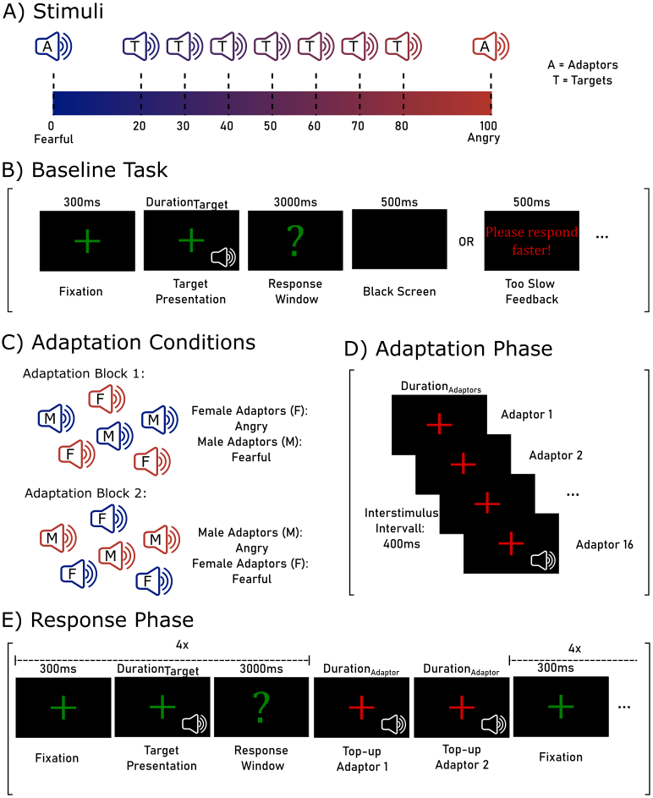
Note. A) Illustration of a morphing continuum between fearful and angry voices. The endpoints (0% and 100%) were used as adaptors. The intermediate morphs (20-80% in 10%-steps) served as targets. B) Illustration of a trial in the baseline task. C) Depiction of the two adaptation conditions: in the first block, all female adaptors were angry, and all male adaptors were fearful; in the second block vice versa. Order of blocks was counterbalances between participants. D) Illustration of the adaptation phase. E) Illustration of the response phase, with two top-up adaptors every four trials. The adaptation and the response phase both belong to the adaptation task.

Design and Procedure
At the beginning of the study, participants gave their informed consent and entered their demographic information, such as age, gender, mother tongue, profession, and potential hearing impairments. Then, the browser switched into full screen to avoid distractions from other apps and the experiment started, which consisted of a baseline and two adaptation tasks.
Baseline. In the baseline task (Figure 1B), the targets were presented once without prior adaptation and participants classified them as either angry or fearful. Each trial started with a green fixation cross for 300ms. Then, the voice stimulus was played while the fixation cross remained on screen. After stimulus offset, a green question mark signaled the beginning of the response window and participants entered their response by pressing the key “F” for fearful and “J” for angry. If no response was entered withing 3000ms after voice offset, it was logged as omission and the final trial slide trial slide (500ms) comprised a feedback screen prompting for faster response (German: “Bitte reagieren Sie schneller”). Otherwise, a black screen was shown instead. Then the next trial started. All 112 targets were presented once in randomized order, in two blocks of 56 trials with a self-paced break in the middle. To acquaint participants with the experimental procedure, they first performed 5 practice trials.
Adaptation. After completing the baseline task, participants completed two adaptation blocks. In one adaptation block, participants adapted to angry-female and fearful-male voices. In the other one, the combination was reversed: angry-male and fearful-female (Figure 1E). Otherwise, both blocks were identical, and it was counterbalanced between participants which one came first. Each block consisted of an adaptation phase and a response phase. During the adaptation phase (Figure 1C), 16 adaptor stimuli (4 speakers × 4 pseudowords) were presented in random order with a red fixation cross on the computer screen and an interstimulus interval of 400 ms. Participants were instructed to listen attentively. Note that exactly half of the adaptor stimuli were fearful and the other half was angry but always tied to a speaker sex: either all female voices sounded angry, and all male voices sounded fearful or vice versa. After the adaptation phase, the response phase started, which was signaled by a message (“Now it starts”, German: “Jetzt geht es los!”) in green font for 3000 ms. The response phase was almost identical to the baseline task (Figure 1D): all targets were presented once and participants classified them as fearful or angry by pressing the corresponding keys. However, every fourth trial, a red fixation cross appeared again, and two top-up adaptors were played. They were picked randomly, but one top-up adaptor was fearful, and the other one was angry, thus one was male and one was female (their specific combination depending on the adaptation block). Their order was randomized as well. The top-up adaptors were included to refresh the adaptation impression during the response phase. This procedure has been shown to elicit substantial perceptual aftereffects, while keeping experimental duration within reasonable limits (Nussbaum et al., 2022). In each adaptation block, participants classified all 112 targets, again split into 56 trials with a break in between. As there were two adaptation blocks, participants performed 224 trials in total. Before, participants practiced this task with 6 stimuli in the adaptation phase and 12 trials in the response phase.
After the experiment, participants indicated whether all sounds were played correctly, and whether they understood all instructions. Furthermore, they answered a few exploratory questions about their self-rated voice perception abilities, their commitment to the experimental task and potential strategies. Overall duration of the study was about 30 minutes.

Data analysis
Data were analyzed using R version 4.5.0 (R Core Team, 2025). Errors of omission (<1% in the baseline and <0.5% in the adaptation) were excluded from the data and participants with more than 5% of such omissions were excluded from data analysis (see above). In the first step, the response in each trial (i.e. the classification as angry = 1 or fearful = 0) was modeled using a multilevel logistic regression using the glmer-command of the lme4 package (Bates et al., 2009), with a binominal distribution, a logit-link function and Laplace approximation. Predictor variables were the target morph level (tML, 20-80%, z-standardized for model estimation), the speaker sex (SpSex, female, male), and the adaptation condition (AdaptCond1: female-angry and male-fearful; AdaptCond2: male-angry and female-fearful). Random effects were estimated for each speaker identity (SpID) and participant. Goodness-of-fit evaluation was based on the Akaike information criterion (AIC) and visual inspection of the data. Differences in the AIC between models were tested for significance using χ²-tests. Thus, we estimated the following model:
Response_{angry/fearful} ~ tML * SpSex * AdaptCond + (1 | SpID) + (1 | Participant)
P-values of main and interaction effects were calculated with the mixed-command from the afex-package (Singmann et al., 2015) using a likelihood ratio test. Note that the data from the Baseline block were not included in this first analysis
In a second step, we specifically zoomed into the interaction of SpSex and AdaptCond. To this end, data were averaged across target morph levels and pseudowords, resulting in the proportion of angry responses in each SpSex x AdaptCond combination per participant. Baseline data was averaged for each SpSex as well. AdaptConditions were then compared for male and female voices separately, using paired t-tests. Finally, both AdaptConditions were compared to the Baseline conditions, again separately for each SpSex.
Data visualization was done with ggplot2 (Wickham, 2006).

Transparency and Openness
The rationale for sample size estimation, all data exclusions and all manipulations have been specified. Preprocessed data, analysis scripts and supplemental materials can be found in the associated OSF repository (XXX).

Results
A summary of model parameters and estimates of the multilevel logistic regression can be found in Table 1. The main effect of tML indicates that the proportion of angry responses increased with an increased percentage of “angriness” in the voice, validating the morphing procedure. The interaction of tML x SpSex indicated that the slope of this increase was slightly steeper for male than for female voices. Importantly, there was the predicted interaction of SpSex x AdaptCond (Figure 2A).
Table 1
Summary of Multilevel Logistic Regression for the classification of stimuli as angry or fearful
Model Exp 1
Response ~ | tML * SpSex * AdaptCond + (1 | SpID) + (1 | Participant)
Predictor | Chi2 | p |  | Fixed effects | Estimate | SE | z | p
Morph Level (tML) | 4130 | <0.001 |  | (Intercept) | -0.79 | 0.406 | -1.95 | 0.051
Speaker Sex (SpSex) | 0.03 | 0.856 |  | tML | 1.81 | 0.074 | 24.45 | <0.001
AdaptCond | 0.38 | 0.536 |  | SpSex: male | 0.68 | 0.555 | 1.22 | 0.221
tML x SpSex | 9.02 | 0.003 |  | AdaptCond: 2* | 0.62 | 0.084 | 7.34 | <0.001
tML x AdaptCond | 1.72 | 0.190 |  | tML x SpSex: male | 0.32 | 0.109 | 2.96 | 0.003
SpSex x AdaptCond | 93.59 | <0.001 |  | tML x AdaptCond: 2 | 0.00 | 0.102 | -0.04 | 0.972
tML x SpSex x AdaptCond | 1.59 | 0.207 |  | SpSex: male x AdaptCond: 2 | -1.16 | 0.121 | -9.59 | <0.001
 |  |  |  | tML x SpSex: male x AdaptCond: 2 | -0.19 | 0.148 | -1.26 | 0.207
Model information |  |  |  | Random effects | Var | SD
AIC/BIC | 7433 | 7504 |  | Participant - Intercept | 0.42 | 0.65
N observations | 8703 |  |  | Speaker Identity (SpID) - Intercept | 0.30 | 0.55
N participants | 39
N speaker identity | 4
Note. The target morph level (tML) was z-standardized for model estimation. *AdaptCond1: female-angry and male-fearful; AdaptCond2: male-angry and female-fearful.

Planned t-tests confirmed that female voices were perceived less often as angry (and thus more fearful) in the AdaptCond1 (adaptation to female-angry and male-fearful), M = 0.39 ± 0.02 SEM, than AdaptCond2 (adaptation to male-angry and female-fearful), M = 0.47 ± 0.02 SEM, |t(38)| = 6.65, p < .001, d = 1.08 [0.67, 1.47]. For male voices, it was the other way around. They were perceived more often as angry in AdaptCond1, M = 0.49 ± 0.02 SEM, than AdaptCond2, M = 0.41 ± 0.02 SEM, |t(38)| = 4.92, p < .001, d = .80 [0.43, 1.16]. Thus, for both male and female voices, there were classic contrastive aftereffects: after adaptation to angry voices, targets voices were more likely perceived as fearful; and after adaption to fearful voices, targets voices were more likely perceived as fearful. However, the distinguished feature here is that this adaptation happens in opposite directions for male and female voices at the same time (Figure 2B). In AdaptCond1, perception of female target voices is biased towards fear and perception for male target voices is biased towards anger. In AdaptCond2, it is the other way around.
Finally, both AdaptConditions were compared to the Baseline condition with no prior adaptation. For female voices, there was no significant difference between the Baseline, M = 0.40 ± 0.02 SEM, and AdaptCond1, |t(38)| = 1.08, p = .288, d = 0.17 [-0.15, 0.49]. However, there was a big difference to AdaptCond 2, |t(38)| = 5.78, p < .001, d = 0.94 [0.55, 1.31]. For male voices, both AdaptConditions differed significant from the Baseline condition, M = 0.45 ± 0.02 SEM, |ts(38)| ≥ 2.55, ps ≤ .015, ds ≥ 0.41 [0.08, 0.74].

Figure 2
Proportion of angry responses separately for Speaker Sex and Adaptation Condition
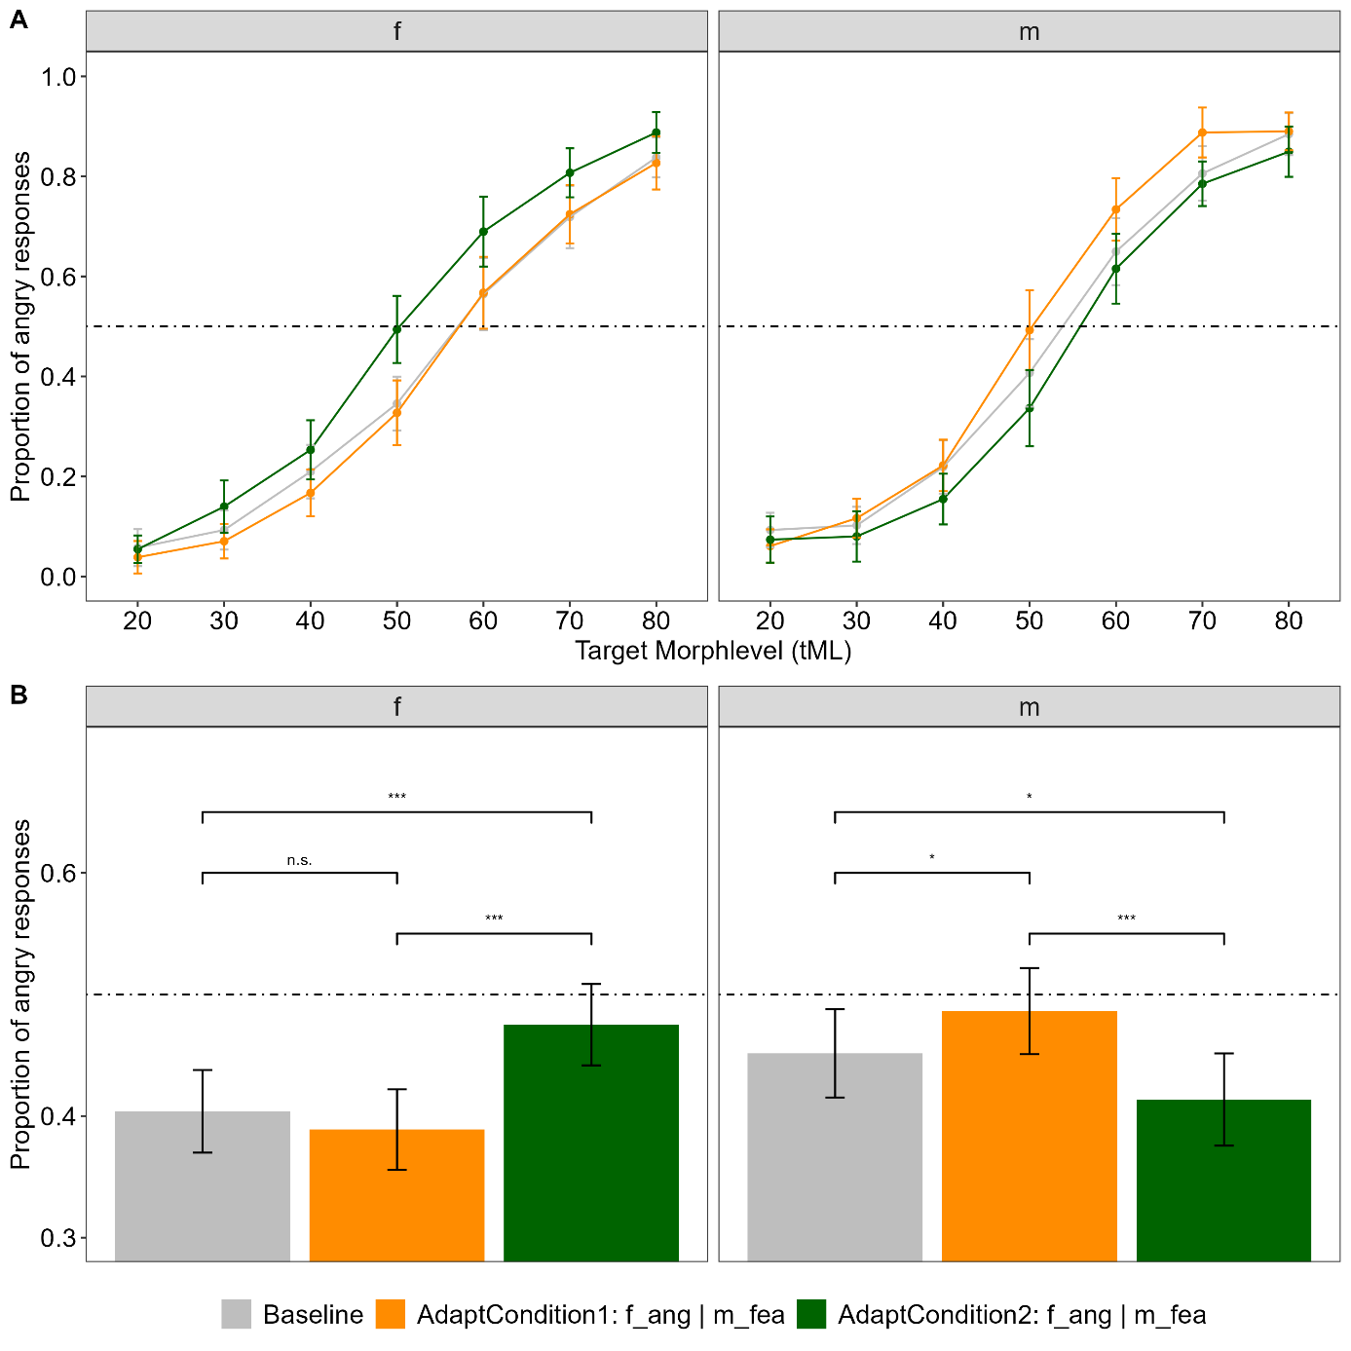Note. A) Proportion of angry responses for each morph level separately. B) averaged across morph level. The dotted line depicts 0.5, thus an equal proportion of classifications as angry and fearful, also referred to as the point of subjective equality. f = female, m = male

Interim Discussion
ToDo
Note that across all conditions, there was a general bias towards fearful classifications.

Experiment 2: Speaker identity

Hypothesis
For Experiment 2, I expected to find simultaneous opposite aftereffects for different speaker identities, indicated by an AdaptationCondition x Identity interaction:
In AdaptationCondition 1, adaptors of Identity A are always angry, and adaptors of Identity B are always fearful. In that case, target voices of Identity A are more often classified as fearful and target voices of Identity B more often as angry. Vice versa, in AdaptationCondition 2, adaptors of Identity B are always angry, and adaptors of Identity A are always fearful. In that case, target voices of Identity B are more often classified as fearful and target voices of Identity A more often as angry.
Identities A and B were always of the same speaker sex per Block, and I expected to find this interaction for both male and female speakers.
This experiment and its hypothesis were preregistered (10.17605/OSF.IO/3H9WN ).

Method

Participants
Data was collected online via Psytoolkit version 3.4.6 (Stoet, 2010, 2017) in July 2024, with the same technical requirements and the same target sample size as for Experiment 1. 75 people accessed the study via hyperlink, of which 45 contributed complete data. Three participants had to be excluded (N = 1 for pressing only one key during the whole experiment, N = 1 due to 5% trials of omission in the baseline task, N = 1 due to problems with the sound playback). Two participants reported having occasional tinnitus but did not feel impaired by it and were thus kept in the sample. Therefore, the final sample consisted of 42 participants (34 female, 6 male, 2 diverse, aged 18 to 31 years [M = 22.04, SD = 2.94]). Again, all data was collected pseudonymized and approved by the local ethics committee.

Stimuli
Stimuli were identical to Experiment 1.

Design and Procedure
The design was very similar to Experiment 1 and differed only in the adaptation tasks. Again, participants started by giving consent and entering their demographic information. Then completed the listening experiment in full screen mode. Afterwards, they answered the same follow-up questions as in Experiment 1. Overall duration of the study was about 30 minutes as well.
This time, the experiment consisted of two baseline and four adaptation tasks, because they were blocked for speaker sex. Thus, in the Baseline, participants completed one block of 56 trials with female targets only and one block of 56 trials with male ones only, with a break in between. In all other respects, the baseline task was identical to Experiment 1.
Afterwards, participants completed the Adaptation in four blocks, two for each speaker sex. In each block, adaptor emotions were tied to the speaker identity: In the first female block, participants adapted to angy-IdentityF1 and fearful-IdentityF2. In the other one, the combination was reversed: angry-IdentityF2 and fearful-IdentityF1 (Figure 3A). Likewise, for the male blocks: in one, the combination was angy-IdentityM3 and fearful-IdentityM4. In the other, angy-IdentityM4 and fearful-IdentityM3. The trial procedure was very similar to Experiment 1: Each block consisted of an adaptation phase and a response phase.
During the adaptation phase, 16 adaptor stimuli (4 speakers × 2 identities x 2 repetitions) were presented in random order with a red fixation cross on the computer screen, but this time with a longer interstimulus interval of 600 ms. Again, exactly half of the adaptor stimuli were fearful and the other half was angry but always tied to a certain speaker’s identity. After the adaptation phase, the response phase started, which was signaled by a message (“Now it starts”, German: “Jetzt geht es los!”) in green font for 3000 ms. The response phase was almost identical to the one in Experiment 1: all targets were presented once and participants classified them as fearful or angry by pressing the corresponding keys. Again, every fourth trial, a red fixation cross appeared again, and two top-up adaptors were played, with similar constraints as in Experiment 1: They were picked randomly, but one top-up adaptor was fearful, and the other one was angry, thus coming from two different speaker identities (their specific combination depending on the adaptation block). In each adaptation block, participants classified all 56 targets of each speaker sex. After each adaptation block, participants could take a self-paced break. As there were four adaptation blocks, participants performed 224 trials in total.
Participants were randomly assigned to one of four counterbalancing conditions. They either started with the male or the female adaptation blocks and also completed the prior baseline task in this order. Within speaker sex, it was further counterbalanced which adaptation condition came first

Figure 3
Adaptation Conditions of Experiment 2 and 3
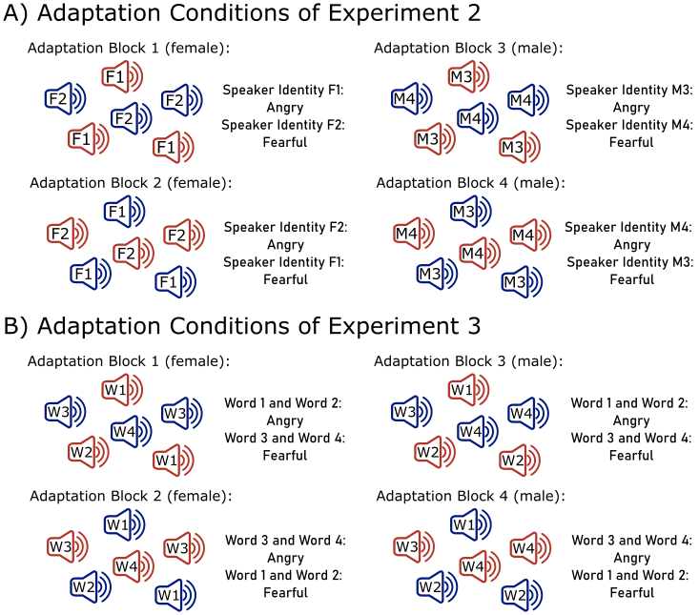
Note. A) Experiment 2: Depiction of the two adaptation conditions, separately for speaker sex. In Block 1, participants adapted to angry-IdentityF1 and fearful-IdentityF2. In Block 2, they adapted angry-IdentityF2 and fearful-IdentityF1. In Block 3, they adapted to angy-IdentityM3 and fearful-IdentityM4. In Block 4, they adapted to angy-IdentityM4 and fearful-IdentityM3. B) Experiment 3: Depiction of the two adaptation conditions, separately for speaker sex. In Block 1, participants adapted to angry-Words 1 and 2 and fearful-Words 3 and 4. In Block 2, they adapted angry- Words 3 and 4 and fearful- Words 1 and 2. Block 3 was parallel to Block 1 and Block 4 parallel to Block 2, just with male instead of female stimuli.

Data analysis
Software and R-packages for data analyses were identical to Experiment 1. Errors of omission (<3%) were excluded from the data. Data was analyzed for male and female blocks separately, using the same two-step approach as in Experiment 1:
First, responses in each trial were modeled with a multilevel logistic regression. For the female blocks, predictor variables were the target morph level (tML, 20-80%, z-standardized for model estimation), the speaker identity (F1 and F2), and the adaptation condition (AdaptCond1: angy-F1 and fearful-F2; AdaptCond2: angry-F2 and fearful-F1). Random effects were estimated for each participant, resulting in the following model:
Response_{angry/fearful} ~ tML * SpID_{females} * AdaptCond_{1/2} + (1 | Participant)

For the male blocks, predictor variables were the target morph level, the speaker identity (M3 and M4), and the adaptation condition (AdaptCond3: angy-M3 and fearful-M4; AdaptCond4: angry-M4 and fearful-M3), with random effects for each participant:
Response_{angry/fearful} ~ tML * SpID_{males} * AdaptCond_{3/4} + (1 | Participant)

Again, data from the Baseline block were not included in this first analysis. Please note that this analyses pipeline deviates from our preregistered plan, which intended the estimation of cumulative gaussian functions (cf. Nussbaum et al., 2022), but had to be discarded due to bad model fit.
In the second step, data were averaged again across target morph levels and pseudowords, to zoom into the interaction of SpID and AdaptCond, separately for speaker sex. Baseline data was included here as well. AdaptConditions were then compared between F1 vs F2 and M3 vs M4, using paired t-tests. Finally, all AdaptConditions were compared to the Baseline conditions, again separately for each SpSex. All further methodological specifications were identical to Experiment 1.

Transparency and Openness
The rationale for sample size estimation, all data exclusions and all manipulations have been specified. Preprocessed data, analysis scripts and supplemental materials can be found in the associated OSF repository (XXX).

Results
A summary of model parameters and estimates of the multilevel logistic regression can be found in Table 2. For female voices, there was a main effect of tML indicates that the proportion of angry responses increased with an increased percentage of “angriness” in the voice. The interaction of tML x SpID indicated that the slope of this increase was slightly steeper Speaker Identity F1 compared to F2. The main effect of SpID further suggested that F1 was overall more often classified as angry, compared to F2. Importantly, there was the predicted interaction of SpSex x AdaptCond (Figure 4A).
For male voices, there were large main effects of tML, SpID and AdaptCond. Speaker Identity M4 was perceived much more often as angry than M3. The interaction of tML x SpID further indicated a steeper slope for M4 compared to M3. The main effect of AdaptCond indicated that in AdaptCond 3 (angy-M3 and fearful-M4), all targets were classified more often as angry, compared to AdaptCond 4 (angry-M4 and fearful-M3), irrespective of SpID. Importantly, the predicted interaction of SpSex x AdaptCond (Figure 4B) was not significant.

Table 2
Summary of Multilevel Logistic Regressions for Experiment 2
Model Exp 2 - Female Voices
Response ~ | tML * SpID * AdaptCond + (1 | Participant)
Predictor | Chi2 | p |  | Fixed effects | Estimate | SE | z | p
Morph Level (tML) | 1778.33 | <0.001 |  | (Intercept) | -0.19 | 0.12 | -1.51 | 0.131
Speaker Identity (SpID) | 42.09 | <0.001 |  | tML | 1.72 | 0.09 | 18.26 | <0.001
AdaptCond | 6.94 | 0.008 |  | SpID: F2 | -0.30 | 0.10 | -2.88 | 0.004
tML x SpID | 31.69 | <0.001 |  | AdaptCond: 2* | -0.01 | 0.11 | -0.06 | 0.953
tML x AdaptCond | 5.82 | 0.016 |  | tML x SpID: F2 | -0.46 | 0.12 | -3.73 | <0.001
SpID x AdaptCond | 6.49 | 0.011 |  | tML x AdaptCond: 2 | 0.27 | 0.14 | 1.96 | 0.049
tML x SpID x AdaptCond | 0.35 | 0.552 |  | SpID: F2 x AdaptCond: 2 | -0.39 | 0.15 | -2.55 | 0.011
 |  |  |  | tML x SpID: F2 x AdaptCond: 2 | -0.11 | 0.18 | -0.60 | 0.552
Model information |  |  |  | Random effects | Var | SD
AIC/BIC | 4503 | 4561 |  | Participant - Intercept | 0.40 | 0.63
N observations | 4704
N participants | 42
Model Exp 2 - Male Voices
Response ~ | tML * SpID * AdaptCond + (1 | Participant)
Predictor | Chi2 | p |  | Fixed effects | Estimate | SE | z | p
Morph Level (tML) | 1846.07 | <0.001 |  | (Intercept) | -1.38 | 0.15 | -9.03 | <0.001
Speaker Identity (SpID) | 433.77 | <0.001 |  | tML | 1.49 | 0.10 | 15.48 | <0.001
AdaptCond | 36.31 | <0.001 |  | SpID: M4 | 1.87 | 0.13 | 14.62 | <0.001
tML x SpID | 54.60 | <0.001 |  | AdaptCond: 4* | -0.47 | 0.14 | -3.46 | <0.001
tML x AdaptCond | 2.88 | 0.090 |  | tML x SpID: M4 | 0.89 | 0.16 | 5.76 | <0.001
SpID x AdaptCond | 0.66 | 0.415 |  | tML x AdaptCond: 4 | -0.08 | 0.14 | -0.56 | 0.573
tML x SpID x AdaptCond | 0.93 | 0.336 |  | SpID: M4 x AdaptCond: 4 | -0.15 | 0.18 | -0.82 | 0.414
 |  |  |  | tML x SpID: M4 x AdaptCond: 4 | -0.21 | 0.21 | -0.96 | 0.337
Model information |  |  |  | Random effects | Var | SD
AIC/BIC | 3855 | 3913 |  | Participant - Intercept | 0.63 | 0.80
N observations | 4704
N participants | 42
Note. The response is the classification of stimuli as angry or fearful. The target morph level (tML) was z-standardized for model estimation. * AdaptCond1: angy-F1 and fearful-F2; AdaptCond2: angry-F2 and fearful-F1; AdaptCond3: angy-M3 and fearful-M4; AdaptCond4: angry-M4 and fearful-M3.

Planned post-hoc t-tests revealed differential effects on the two female speaker identities (Figure 4C): The perception of F1 target voices was not affected by the adaptation conditions, which also did not differ from the Baseline (all |ts(41)| ≤ 0.81, p ≥ .440, d ≤ 0.12 [-0.19, 0.43], M_{AdaptCond1} = 0.47 ± 0.02 SEM, M_{AdaptCond2} = 0.47 ± 0.02 SEM, M_{Baseline} = 0.49 ± 0.02 SEM). For F2 however, the adaptation conditions modulated the response in the expected direction: In AdaptCond1 (angy-F1 and fearful-F2), M = 0.42 ± 0.02 SEM, F2 targets were more often classified as angry, compared to AdaptCond2 (angry-F2 and fearful-F1), M = 0.35 ± 0.02 SEM, |t(41)| = 5.58, p < .001, d = 0.56 [0.23, 0.89], as well as compared to the Baseline, M = 0.36 ± 0.02 SEM, |t(41)| = 2.44, p = .019, d = 0.38 [0.06, 0.70]. AdaptCond2 and Baseline did not differ, |t(41)| = 0.52, p = .606, d = 0.08 [-0.23, 0.39].
For male voices, planned post-hoc t-tests confirmed the main effect of AdaptCondion for both speaker identities again (Figure 4D): Both M3 and M4 were more often classified as angry in AdaptCond3 (angy-M3 and fearful-M4) compared to AdaptCond4 (angry-M4 and fearful-M3), |ts(41)| ≥ 3.80, p ≤ .001, ds ≥ 0.59 [0.26, 0.92]. Further, AdaptCond 3 did not differ from the Baseline for both speakers, |ts(41)| ≤ 0.75, p ≥ .456, d ≤ 0.12 [-0.19, 0.42], but AdaptCond4 did, |ts(41)| ≥ 2.94, p ≤ .005, ds ≥ 0.46 [0.13, 0.78]. Mean values for M3 were M_{AdaptCond3} = 0.29 ± 0.02 SEM, M_{AdaptCond4} = 0.22 ± 0.02 SEM, M_{Baseline} = 0.28 ± 0.02 SEM, and for M4 they were M_{AdaptCond3} = 0.56 ± 0.02 SEM, M_{AdaptCond4} = 0.48 ± 0.02 SEM, M_{Baseline} = 0.56 ± 0.02 SEM.
In summary, there was no evidence for contrastive aftereffects for male speaker identities, and only partly for female speaker identities.

Figure 4
Proportion of angry responses separately for Speaker Identity and Adaptation Condition
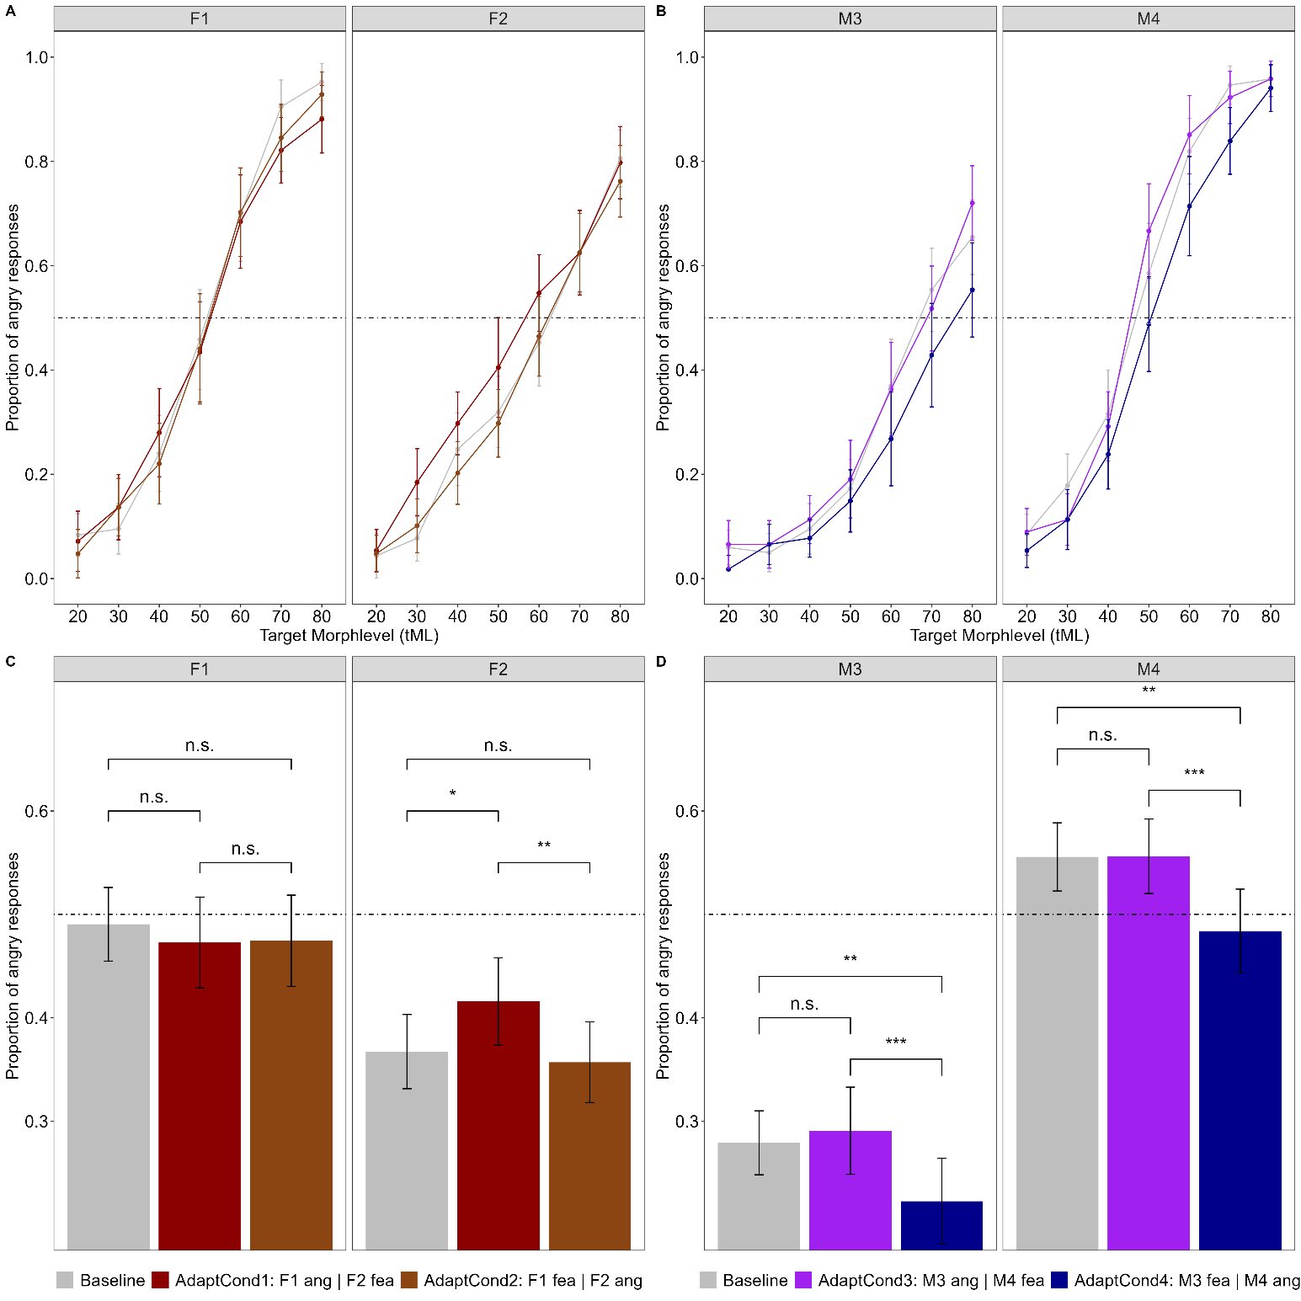
Note. Proportion of angry responses for each morph level separately for A) female speaker identities F1 and F2 and B) male speaker identities M3 and M4. C) Responses averaged across morph level for female identities, and D) for male identities. The dotted line depicts 0.5, thus an equal proportion of classifications as angry and fearful, also referred to as the point of subjective equality.

Interim Discussion
ToDo

Experiment 3: Spoken Pseudoword

Hypothesis
For Experiment 3 (Pseudoword), I expected find NO simultaneous opposite aftereffects for different pseudowords, thus NO AdaptationCondition x Pseudoword interaction. In other words, target voices of all pseudowords (1,2,3,4) have a similar likelihood of being classified as either angry or fearful in the two adaptation conditions (AdaptCond1: angry-Words 1 and 2 and fearful-Words 3 and 4, AdaptCond2: angry - Words 3 and 4 and fearful- Words 1 and 2), because adaptation impressions cancel each other out across pseudowords. This will be found for both male and female voices.
This experiment and its hypothesis were preregistered (10.17605/OSF.IO/3H9WN ).

Method

Participants
Data was collected online via Psytoolkit version 3.4.6 (Stoet, 2010, 2017) in July 2024, with the same technical requirements and the same target sample size as for Experiment 1 and 2. 99 people accessed the study via hyperlink, of which 48 contributed complete data. Six participants had to be excluded (N = 3 due to 5% trials of omission in the baseline task, N = 3 due to problems with the sound playback). Therefore, the final sample consisted of 42 participants (34 female, 7 male, 1 diverse, aged 18 to 46 years [M = 25.76, SD = 5.47]). Again, all data was collected pseudonymized and approved by the local ethics committee.

Stimuli
Stimuli were identical to Experiment 1 and 2.

Design and Procedure
The design was very similar to Experiment 2 and differed only in the adaptation tasks. The baseline task was identical. Again, participants completed the Adaptation in four blocks, two for each speaker sex. In each block, adaptor emotions were tied to the pseudoword: In the first female block, participants adapted to angry-Words 1 and 2 and fearful-Words 3 and 4. In the other one, the combination was reversed: angry- Words 3 and 4 and fearful- Words 1 and 2 (Figure 3B). Likewise, for the two male blocks. In all other aspects, the trial procedure was identical to Experiment 2. Following the same logic, the top-up adaptors during the response phase now depicted two different pseudowords, one angry and one fearful, matching the respective adaptation conditions.

Data analysis
Software and R-packages for the first part of the data analyses were similar to Experiment 2. Errors of omission (<3%) were excluded from the data. Then, responses in each trial were modeled with a multilevel logistic regression.
Predictor variables were the target morph level (tML, 20-80%, z-standardized for model estimation), the pseudoword (PW1: /belam/, PW2: /molen/, PW3: /namil/ and PW 4: /loman/), and the adaptation condition (AdaptCond1: Word 01/02-angry and Word03/04-fearful; AdaptCond2: Word03/04-angry and Word 01/02-fearful). Random effects were estimated for each speaker identity (SpID) and participant. Thus, the following model was estimated:
Response_{angry/fearful} ~ tML * Pseudoword * AdaptCond + (1 | SpID) + (1 | Participant)

This classical frequentist approach was complemented with a Bayesian analysis, which – in contrast to null hypothesis significance testing - allows a quantification of evidence for null findings (Rosenfeld & Olson, 2021). The Bayes factor (BF10) is reported as an indicator for the likelihood of the null and alternative hypothesis given the observed data. BF10 > 1 indicates larger evidence for the alternative hypothesis, BF10 < 1 indicate larger evidence for the null hypothesis. For example, a BF10 = 3 means that the alternative hypothesis is three times more likely than the null hypothesis, whereas the reciprocal BF10 = .33 means that the null hypothesis is three times more likely than the alternative. Following the guidelines by Jarosz and Wiley (2014), values of BF10 = 1-3 (.1-.33) are considered as anecdotal, BF10 = 3-10 (.33-.10) as moderate, BF10 = 10-30 (.10-.03) as strong, BF10 = 30-100 (.03-.01) as very strong and BF10 > 100 (< .01) as decisive evidence for the alternative hypothesis and the reciprocal values in parentheses as respective evidence for the null hypothesis. Bayesian analysis was conducted with the “brms”-package in R (Bürkner, 2017; Carpenter et al., 2017). The default_prior-command was used to identify appropriate default priors for each model. The Bayes Factor was estimated by comparing two model with and without the PW x AdaptCond. All further specifications can be found in analyses scripts can be found on OSF.
Finally, to keep the analysis pipeline parallel to Exp 1 and 2, we zoomed into the main AdaptConditions, by averaging across tMl and SpSex, and comparing them via paired t-tests to the Baseline Condition.

Results
A summary of model parameters and estimates of the multilevel logistic regression can be found in Table 3. Again, the main effect of tML indicates that the proportion of angry responses increased with an increased percentage of “angriness” in the voice. The main effect of PW indicated that some pseudowords were more often classified as angry, especially PW1 (see Figure 5). Similarly, the main effect of AdaptCond indicated that in AdaptCond1 (angry-PW1|2 and fearful-PW3|4), all targets were more often classified as angry compared to AdaptCond2 (angry-PW3|4 and fearful-PW1|2). Crucially, and in line with the null hypothesis, there was NO interaction of PW x AdaptCond (p = .914). The Bayes factor BF10 = 0.08 also indicated strong evidence for the null hypothesis. Thus, the mean classification of the pseudowords was not differently affected by the different Adaptation Conditions. Please note that the three-way interaction suggests that the slope of the function differed slighty as as a function of SpSex, PW and AdaptCond. An exploratory analysis for male and female speakers separately yielded essentially the same patterns (details on OSF).

Table 3
Summary of Multilevel Logistic Regression for Experiment 3
Model Exp 3
Response ~ | tML * Pseudoword * AdaptCond + (1|SpID) + (1 | Participant)
Predictor | Chi2 | p |  | Fixed effects | Estimate | SE | z | p
Morph Level (tML) | 4111.7 | <.001 |  | (Intercept) | 0.32 | 0.3 | 1.01 | 0.311
Pseudoword (PW) | 452.31 | <.001 |  | tML | 1.65 | 0.1 | 18.15 | <0.001
AdaptCond | 6.52 | 0.011 |  | PW: PW2* | -1.64 | 0.1 | -13.75 | <0.001
tML x PW | 40.61 | <.001 |  | PW: PW3 | -1.05 | 0.1 | -9.03 | <0.001
tML x AdaptCon | 0.73 | 0.375 |  | PW: PW4 | -0.41 | 0.1 | -3.55 | <0.001
AdaptCond x PW | 0.73 | 0.866 |  | AdaptCond: 2** | -0.23 | 0.1 | -2.13 | 0.033
tML x PW x AdaptCond | 9.54 | 0.023 |  | tML x PW: W3 | 0.41 | 0.1 | 2.92 | 0.0035
 |  |  |  | tML x PW: W4 | 0.68 | 0.1 | 4.63 | <0.001
 |  |  |  | tML x PW: W4 x AdaptCond: 2 | -0.57 | 0.2 | -2.84 | 0.0046
Model information |  |  |  | Random effects | Var | SD
AIC/BIC | 7933 | 8061 |  | Participant - Intercept | 0.42 | 0.65
N observations | 9371 |  |  | Speaker Identity (SpID) - Intercept | 0.34 | 0.58
N participants | 42
N Speaker Identity | 4

Note. The response is the classification of stimuli as angry or fearful. The target morph level (tML) was z-standardized for model estimation. This table shows only a subset of effects for readability. The complete information can be found on ToDo. *PW1: /belam/, PW2: /molen/, PW3: /namil/ and PW 4: /loman/. ** AdaptCond1 angry-PW1|2 and fearful-PW3|4; AdaptCond2: angry-PW3|4 and fearful-PW1|2.

The planed post-hoc comparison revealed that in in AdaptCond1 (angry-PW1|2 and fearful-PW3|4), all targets were more often classified as angry compared to AdaptCond2 (angry-PW3|4 and fearful-PW1|2), |t(41)| = 2.20, p = .034, d = 0.34 [0.03, 0.66], M_{AdaptCond1} = 0.43 ± 0.02 SEM, M_{AdaptCond2} = 0.41 ± 0.01 SEM, as already implied by the main effect above. Further, AdaptCond1 significantly different from the Baseline, |t(41)| = 2.21, p = .033, d = 0.34 [0.03, 0.66], M_{Baseline} = 0.49 ± 0.02 SEM, whereas AdaptCond2 did not, |t(41)| = 0.68, p = .500, d = 0.11 [-0.20, 0.41]. To keep data visualization parallel to the previous Experiments, we plotted the responses separately for each combination Pseudoword x AdaptCond, although they did not interact.

Figure 5
Proportion of angry responses separately for Pseudoword and Adaptation Condition
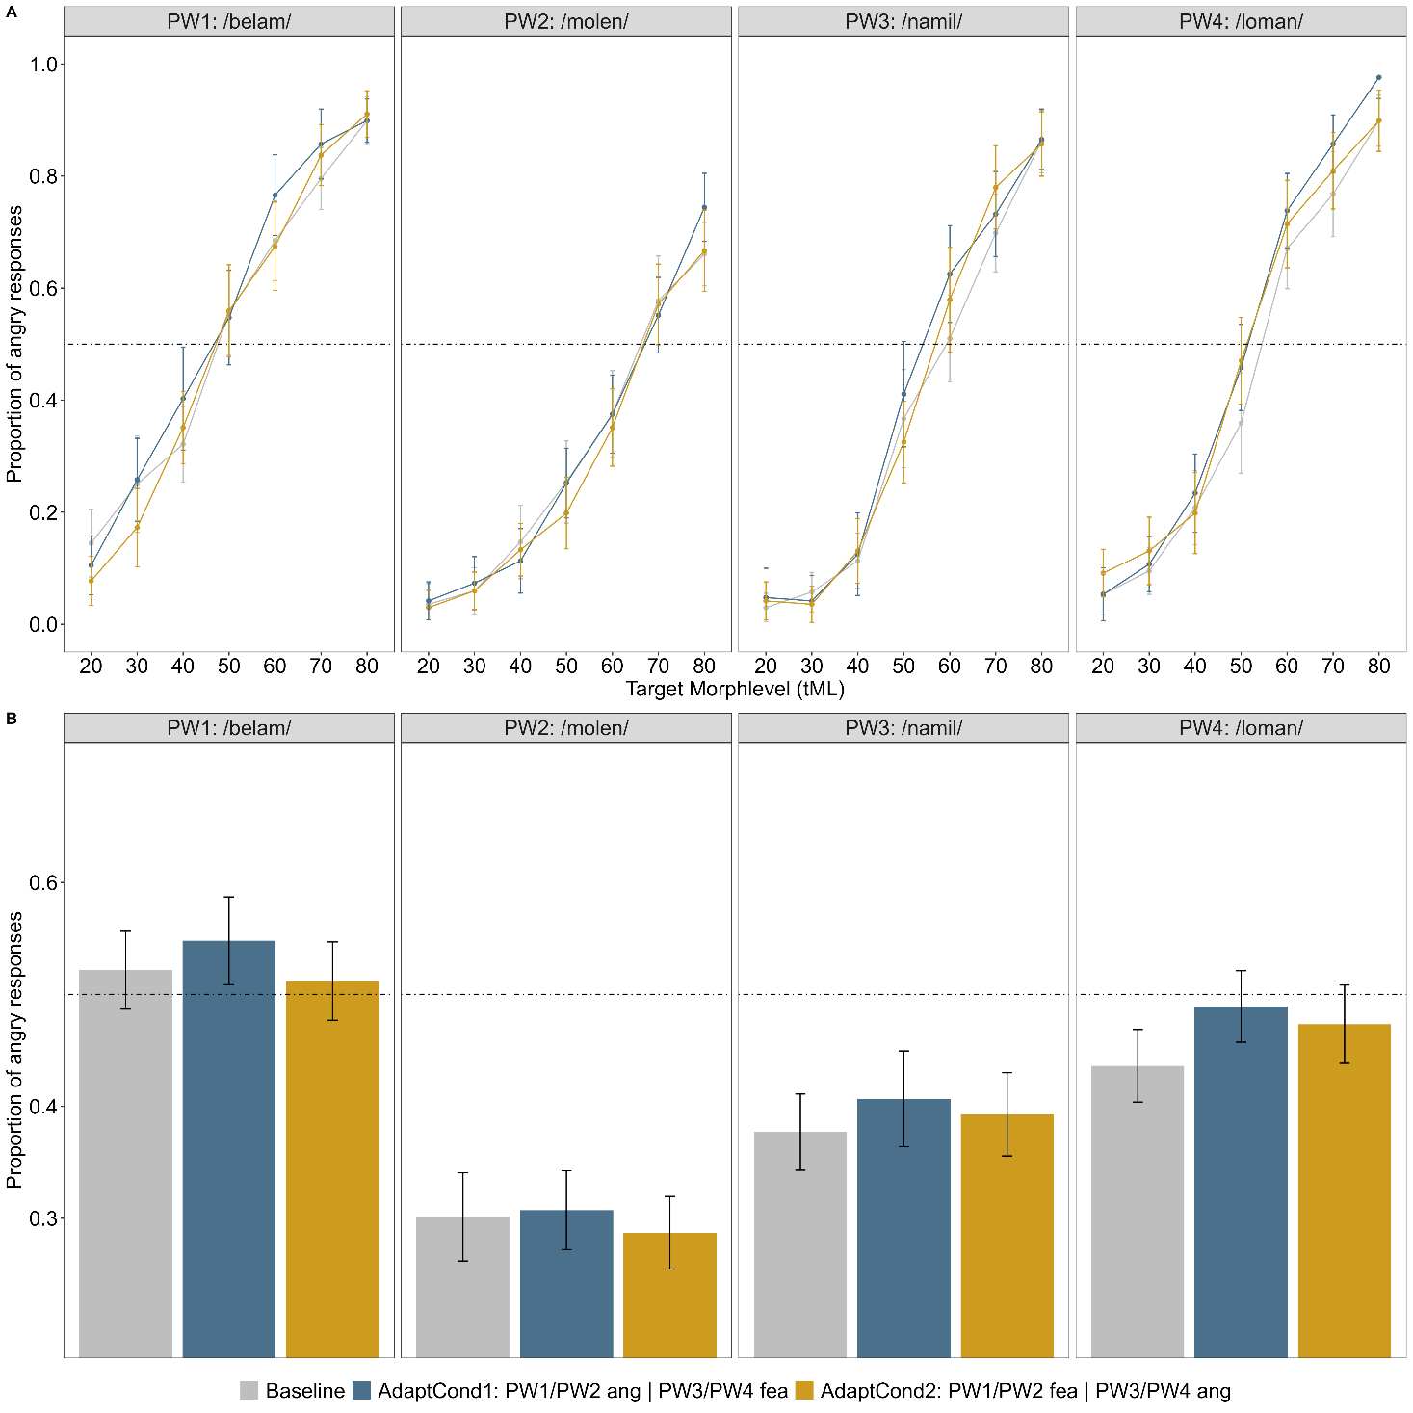
Note. A) Proportion of angry responses for each morph level separately. B) Averaged across morph level. The dotted line depicts 0.5, thus an equal proportion of classifications as angry and fearful, also referred to as the point of subjective equality.

Interim Discussion
ToDo

General Discussion

Summary and Conclusion

Acknowledgements
Sascha Frühholz -> Stimuli
Students

Conflict of Interest and Funding

Credit Author Statement

References
Bates, D., Maechler, M., Bolker, B., Walker, S., Christensen, R. H. B., Singmann, H., Dai, B., Scheipl, F., Grothendieck, G., Green, P., & others (2009). Package ‘lme4’. URL Http://lme4. R-Forge. R-Project. Org.
Boersma, P. (2018). Praat: Doing phonetics by computer [Computer program]: Version 6.0.46, retrieved January 2020 from http://www.praat.org/. Http://www. Praat. Org.
Bürkner, P.‑C. (2017). brms : An R Package for Bayesian Multilevel Models Using Stan. Journal of Statistical Software, 80(1). https://doi.org/10.18637/jss.v080.i01
Carpenter, B., Gelman, A., Hoffman, M. D., Lee, D., Goodrich, B., Betancourt, M., Brubaker, M. A., Guo, J., Li, P., & Riddell, A. (2017). Stan: A Probabilistic Programming Language. Journal of Statistical Software, 76. https://doi.org/10.18637/jss.v076.i01
Frühholz, S., Klaas, H. S., Patel, S., & Grandjean, D. (2015). Talking in Fury: The Cortico-Subcortical Network Underlying Angry Vocalizations. Cerebral Cortex, 25(9), 2752–2762. https://doi.org/10.1093/cercor/bhu074
Jarosz, A. F., & Wiley, J. (2014). What Are the Odds? A Practical Guide to Computing and Reporting Bayes Factors. The Journal of Problem Solving, 7(1). https://doi.org/10.7771/1932-6246.1167
Kawahara, H., Morise, M., Takahashi, T., Nisimura, R., Irino, T., & Banno, H. (2008). TANDEM-STRAIGHT: A temporally stable power spectral representation for periodic signals and applications to interference-free spectrum, F0, and aperiodicity estimation. IEEE International Conference on Acoustics, Speech and Signal Processing.
Kawahara, H., & Skuk, V. G. (2018). Voice Morphing. In S. Frühholz, P. Belin, & K. R. Scherer (Eds.), The Oxford Handbook of Voice Perception (pp. 684–706). Oxford University Press. https://doi.org/10.1093/oxfordhb/9780198743187.013.31
Lakens, D., & Caldwell, A. R. (2019). Simulation-Based Power-Analysis for Factorial ANOVA Designs. https://doi.org/10.31234/osf.io/baxsf
Nussbaum, C., von Eiff, C. I., Skuk, V. G., & Schweinberger, S. R. (2022). Vocal emotion adaptation aftereffects within and across speaker genders: Roles of timbre and fundamental frequency. Cognition, 219, 104967. https://doi.org/10.1016/j.cognition.2021.104967
R Core Team. (2025). R: A Language and Environment for Statistical Computing. https://www.R-project.org/
Rosenfeld, J. P., & Olson, J. M. (2021). Bayesian Data Analysis: A Fresh Approach to Power Issues and Null Hypothesis Interpretation. Applied Psychophysiology and Biofeedback, 46(2), 135–140. https://doi.org/10.1007/s10484-020-09502-y
Singmann, H., Bolker, B., Westfall, J., Aust, F., Ben-Shachar, M. S., Højsgaard, S., & others (2015). Package ‘afex’. URL Http://afex. Singmann. Science/, Https://github. Com/singmann/afex.
Stoet, G. (2010). PsyToolkit: A software package for programming psychological experiments using Linux. Behavior Research Methods, 42(4), 1096–1104. https://doi.org/10.3758/BRM.42.4.1096
Stoet, G. (2017). PsyToolkit: A novel web-based method for running online questionnaires and reaction-time experiments. Teaching of Psychology, 44(1), 24–31. https://doi.org/10.1177/0098628316677643
Wickham, H. (2006). An introduction to ggplot: An implementation of the grammar of graphics in R. Statistics, 1–8.

