# METHODOLOGY

This chapter discusses in detail the various methods used in designing the system after considering a wide range of solutions. Section 3.1 considers the communication methods employed while Section 3.2 describes the system in general. Section 3.3 looks at the various components used and their interactions with themselves and the external environment.

## 3.1 SYSTEM COMMUNICATION

This project considers various design considerations including, cost effectiveness, power consumption and accuracy. As transmission plays a vital role in ensuring the efficient operation of the system it is essential to consider technologies that helps achieve the goal of the system while considering factors such as cost, power consumption among others. Wireless transmission is employed due to the fact that it doesn’t necessitate any physical connection between the two communicating points or nodes. Comparing the different types of wireless technologies including, the popular IEEE 802.11 WIFI standard, IEEE 802.15 Bluetooth standard, IEEE 802.16 WiMAX standard, the ZigBee wireless communication was chosen. Zigbee was developed by IEEE with the IEEE 802.15.4 standard. This standard derived its name from the manner bees zig and zag while moving from flower to flower to obtain pollen grains while transmitting information to other bees. It is a relatively new technology employed in this field of toll collection due to the fact that it focuses on homogenizing and aiding interoperability of different products. It also places emphasis on applications that require low battery power. It also provides a short- range cost effective networking capability of 10 – 100 meters taking into consideration the power being given out as well as environmental conditions. As topologies, it employs the mesh, star and tree network incorporating data security features. Like WIFI, it also has a Media Access Control Address (MAC Address) which identifies each Zigbee Module. Zigbee is used in this project for the above described reasons however significant reason is that unlike other IEEE 802.15 standards that provides high bandwidth, it addresses the unique need of sensors that do not need to use high bandwidth. This is to say, it suited for application that require low data transfers. As these sensors are often low power devices, Zigbee can in cooperate a wide range of sensors which operate on low power.

## SYSTEM ARCHITECTURE

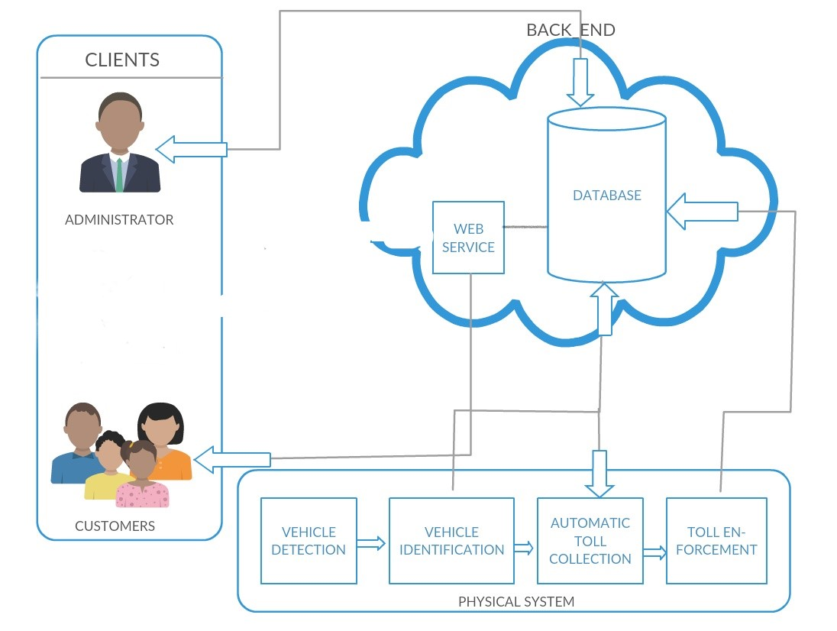

Figure No. shows a visual overview of the ETC system. The system comprises of two users namely; the administrator and customers. The administrator is responsible for regulating the entire system transaction. The physical systems begin the whole process. When the customer enters the toll region with his vehicle, the system immediately is activated. The vehicle is then classified by picking up the MAC address of the Zigbee connected to the vehicle. This information is then sent to the database hosted on cloud with the help of a web service. A web service is a piece of code that is made available over a network and written in the standard Extensible Markup Language (XML). The car is identified and correctly classified. A toll charge is calculated and the amount duly deducted from the users account.

## DESIGN AND IMPLEMENTATION

This project includes a hardware set up in cooperated with software to allow the hardware perform a set of tasks, as well as a software application to interact with the clients effectively.

## COMPONENT LIST

A description of the Components that were employed in the implementation and build of the system is listed and detailed in their operation.

The Arduino Board

The Arduino board is a microcontroller board that with has memory for storing instructions, GPIO analog and digital pins for connecting input and output devices as well as a microprocessor whose components include a control unit, an Arithmetic Logic Unit and a data path for performing the processing of data. The Arduino is open source implying it may be accessed freely, modified and redistributed. Due to the fact that it is open source, it has a large community which makes using the board relatively easier as compared to using other boards. The devices connected to the Arduino board through the I/O pins can be manipulated in some way by uploading a set of written instructions. This board is used due to the following reasons;

* It is relatively cheap compared to other micro controller boards.
* It is open source with software that can be extended from other libraries.
* It can run on different operating systems including Linux while other boards are mostly limited to Windows.
* It provides a simple programming environment which is not too complicated for first time users.

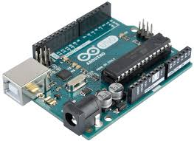

Load Cell Sensor

Load cells are simply, transducers that have the ability to translate pressure (mechanical force) into electrical signals. This can be achieved in different ways as evident in the way they have been set up. The first way is the hydraulic load cell which makes use of a conventional piston with an arrangement of cylinders to indicate a change in pressure when the piston and the diaphragm moves to produce a change in the pressure. Another way is the pneumatic load cells which engages air pressure to one end of a diaphragm so it escapes through the nozzle positioned at the bottom of the load cell with a pressure gauge inside the cell. The last way is strain gauge load cell, a mechanical element which senses the force caused by the deformation of the strain gauge on the element.

The set up used in the project consists of four resistors arranged in parallel and connected to an amplifier to amplify the electrical signal generated. These resistors have been positioned under a speed ramp few meters before the toll station. This electrical signal will further trigger the microcontroller to activate the entire system.

This device is used due to the fact that it is insensitive to temperature variations as well as being explosion proof.

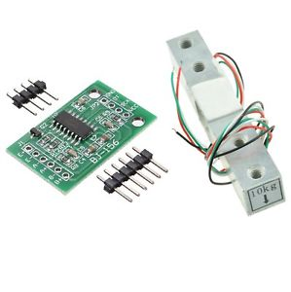

GSM Module

GSM(Global system for mobile Communication) is a protocol developed by the European Telecommunications standards for second-generation digital cellular networks used by mobile devices.

It is open and is used in transmitting mobile voice and data service. The specific module used in the project development is the **SIM900 GSM Module which operates in the frequency range of** 900MHz.

It is used in in sending receipts to user after a successful transaction at the toll gate and also to prompt users when they have insufficient balance in their account

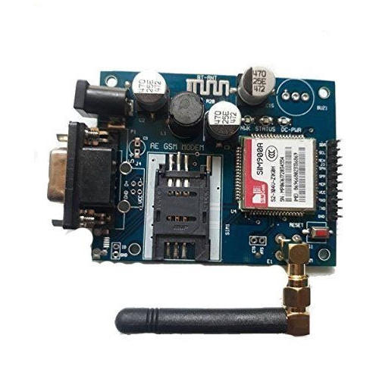

Xbee Shield

The Xbee shield is used in the implementation to allow the Arduino board communicate wirelessly using the Zigbee wireless communication. It can communicate up 100 meters within a line of sight. For the purpose of this project it is configured in the command mode.

It supports a number of nodes which is necessary as we are assigning a module each for every registered vehicle. Simpler and less expensive than other Wireless Personal Area Networks such as the IEEE 802.11 WIFI standard. Serves a slave when connected to user vehicle.

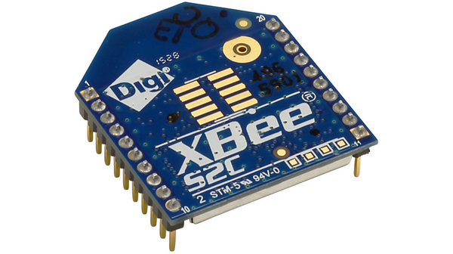

Servo Motor

It operates on the principle of servomechanism (a principle that uses electromagnetism to convert electricity into accurate motion by employing negative feedback mechanism). The main components include, a DC motor, a potentiometer, and an Integrated Circuit (IC). The potentiometer enables controlled motion by transmitting the existing location of the shaft. The DC motor is responsible for the movement of the shaft while the IC interprets the signal from the potentiometer and your microcontroller. To control this motor a mechanism known as pulse width modulation is employed to control the angular position of the shaft of the servo.

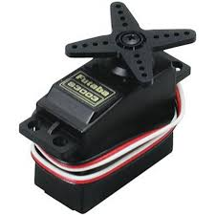

## OPERATIONAL BLOCKS

This section describes the interconnections of all the various electronic circuit as

listed and their operations. Different diagrams are used to explain the project in detail.

High-Level Block

The high level block diagram presents a view of the system where the relevant components or parts are represented as chunks and linked depending on their relationships using lines with arrows. The High-Level Block Diagram presents an abstracted view of the operations of

the individual components. The purpose of this block is to present in a visual

way the most meaningful interconnection on the components

The load sensor block is connected as an input to the microcontroller. The data obtained the microcontroller is processed in some way and data is sent to the xbee module, the GSM module and the servo motor as outputs.

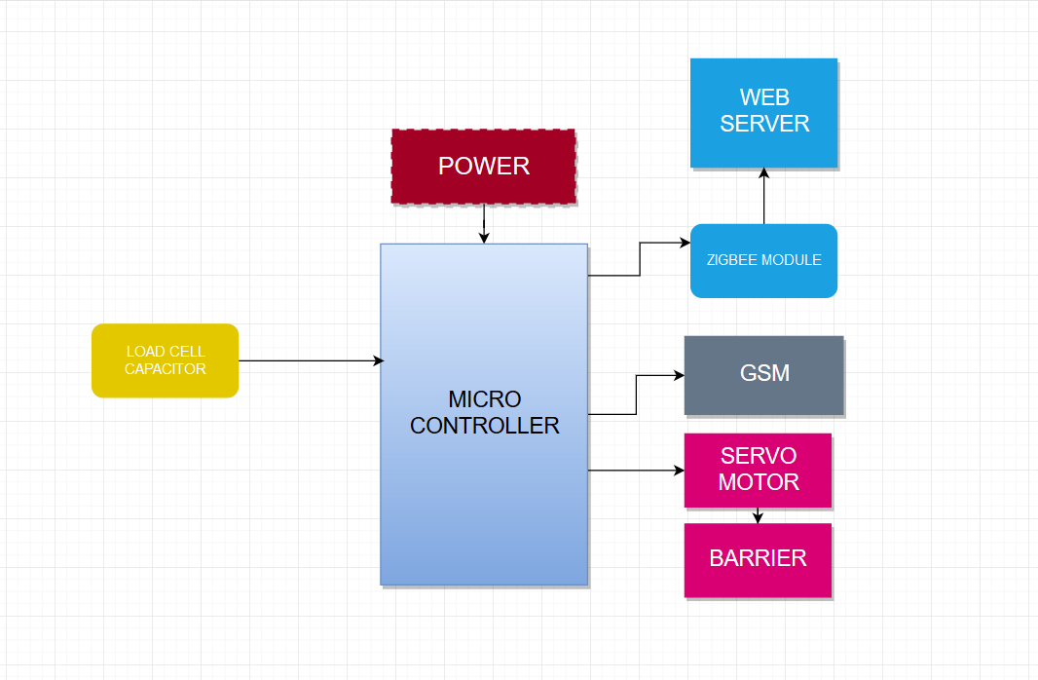

Functional Block

The Functional Block Diagram presents a lower level of abstraction compared to the High-Level Block. This block represents speciﬁc interaction of the subcomponents of all the interconnected circuits.

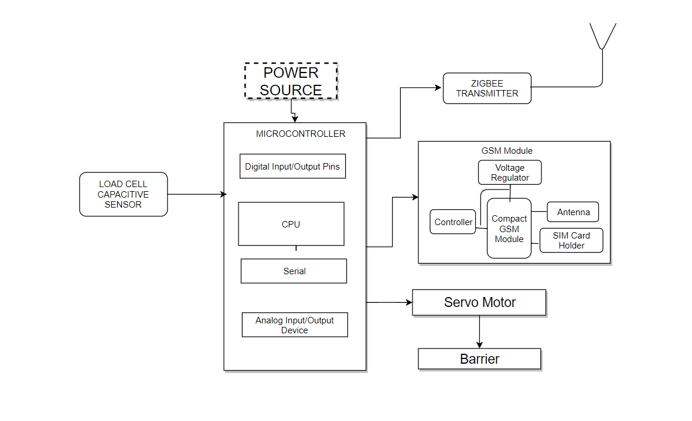

## SYSTEM DESIGN

This section describes the process of control between the interacting components

of the system. It also presents the ﬂow of data processing between the system

user and the system.

Flow Chart For the System

The Flow Chart gives a view of process pgrogression of the system in its

operation. Here, we see some measures that have been put in place to limit redundancy in the systems operation such as powering oﬀ the system upon unsuccessful

initialization after a speciﬁed number of times..

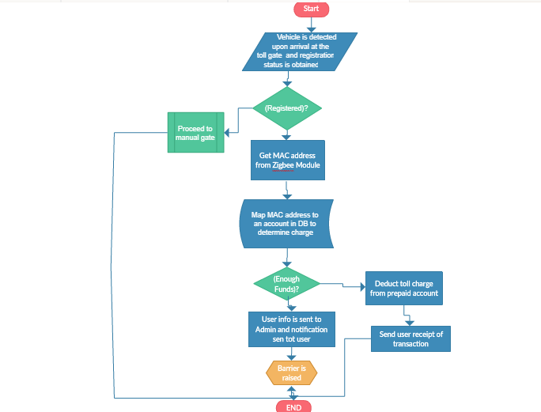

Use Case Diagrams

The Use Case Diagram gives the interaction of an actor which in this

case is the system user with the system. The user is able to access the serrives of

the system in a predeﬁned order that is suitable to their needs at any particular

session

ETC Administrator

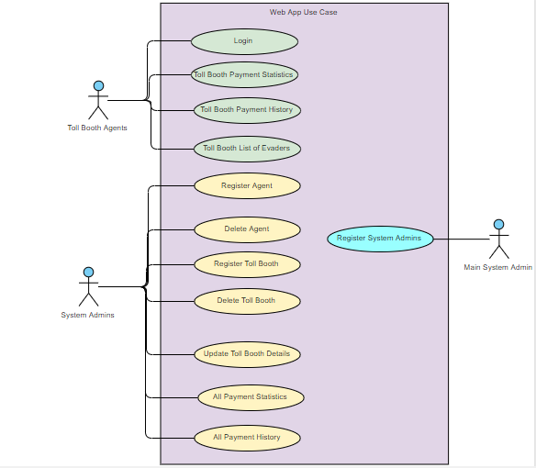

ETC Customer

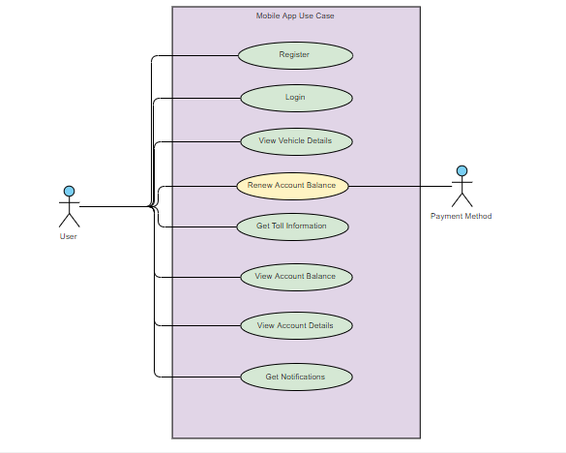

## SYSTEM SOFTWARE

This comprises the high-level application software that runs on the system and

also the low-level code that controls and coordinate the workings of the embedded

circuitry of the components.