

KWAME NKRMAH UNIVERSITY OF SCIENCE AND TECHNOLOGY, KUMASI

COLLEGE OF ENGINEERING

FACULTY OF COMPUTER AND BIOMEDICAL ENGINEERING

DEPARTMENT OF COMPUTER ENGINEERING



PROJECT REPORT:

ELECTRONIC TOLL COLLECTION SYSTEM

BY:

ABEKA TABITHA AMA  
ACQUAYE CHRISTABEL

PROJECT SUPERVISOR:

Dr. Bright Yeboah-Akowuah

# DECLARATION

This report is being submitted as part of the requirements necessary for the acquisition of a Bachelor of Science Degree in Computer Engineering from the College of Engineering, KNUST. We, the undersigned hereby declare that this project entitled **“Electronic Toll Collection System”** unless stated otherwise is the result of our research under the supervision of our capable supervisors, Dipl. Ing. Benjamin Kommey and Mr. Selasi Agbemenu.

Name: Abeka Tabitha Ama Signature: ……………………………...

Index Number: 4125415 Date: ………………………………………

Name: Acquaye Christabel Signature: ……………………………...

Index Number: 4125415 Date: ………………………………………

We hereby declare that we have read through this project report entitled **“Electronic Toll Collection System”** and found that it complies with the protocols laid down for the partial fulfillment for the award of Bachelor of Science Degree in Computer Engineering.

Supervisor’s Name: Dr. Bright Yeboah-Akowuah

Signature: ……………………………...

Date: ……………………………………...

## ACKNOWLEDGEMENT

Our profound gratitude first goes to the Almighty God. Secondly, we would like to extend our sincere appreciation to the Head of Department, Dr. Emmanuel Akowuah and the entire staff and management of this esteemed faculty.

We would also like to appreciate our supervisor, Dr. Bright Yeboah-Akowuah and Dipl. Ing. Benjamin Kommey. These professionals gave us very in-time valuable instructions during the design and development of the project.

## ABSTRACT

A toll booth is essentially an interface from one place to another where drivers have to stop and pay some toll to access the road. These tolls are collected by personals known as toll booth attendants who reside in booths or small accommodations set up for the collection of tolls. The monies collected serves as the primary source of income that provides officials the means to design and construct new roads, maintain and repair already existing roads.

Over the years in Ghana, human beings have collected tolls manually. However, this method has proven to be unaccountable since tolls collected did not match the number of cars that passed. As a result, the country did not receive the total revenue estimated from tolls. The advent of new technologies that are being used in other countries to facilitate the collection of tolls has increased accountability whilst adding further benefits such as increased throughput of road usage, decreased emissions and cost effectiveness.

This report has its contents within the limit of chapters with each concisely exploring their various topics ranging from the history of toll booth systems, and the various strides taken by different countries such as India, Japan and other technology inclined countries.

Table of Contents

DECLARATION 2

ACKNOWLEDGEMENT 3

ABSTRACT 4

ABREVIATIONS AND ACRONYMS 7

1. INTRODUCTION 8

1.1 BACKGROUND OF STUDY AND PROBLEM DEFINITION 8

1.2 HISTORY OF ELECTRONIC TOLL COLLECTION 9

1.3 OBJECTIVE 10

1.4 SPECIFIC OBJECTIVES 10

1.5 PROJECT SCOPE 11

1.7 PROJECT SIGNIFICANCE 11

1.7 ORGANIZATION OF PROJECT REPORT 11

2. LITERATURE REVIEW 11

2.1 MANUAL TOLL COLLECTION SYSTEM 12

2.2 AUTOMATIC TOLL COLLECTION SYSTEM 12

2.2.1 ODOMETER BASED TECHNIQUE 13

2.2.2 GLOBAL POSITIONING SYSTEM TECNIQUE 13

2.2.3 AUTOMATED CASH MACHINE 15

2.2.4 DEDICATED SHORT-RANGE COMMUNICATION TECHNIQUE 15

2.2.5 NUMBER PLATE RECOGNITION USING OPTICAL CHARACTER RECOGNITION 17

2.2.6 MOBILE PHONE TOLLING SYSTEM 17

2.2.7 RADIO FREQUENCY IDENTIFICATION TECHNIQUE 18

2.3 REVIEW OF VARIOUS PAPERS ON ELECTRONIC TOLL COLLECTION 18

2.3.1 Automated Toll Collection System Using RFID paper by Pranoti Salunke, Poonam Malle, Kirti Datir, and Jayshree Dukale 19

2.3.2 AUTOMATIC TOLL E-TICKETING SYSTEM FOR TRANSPORTATION SYSTEMS by Sana Said Al-Ghawi, Dr. S. Asif Hussain, Muna Abdullah Al Rahbi and S. Zahid Hussain 19

2.3.3 Automatic Toll Gate System Using Advanced RFID and GSM Technology by S. Nandhini and P. Premkumar 20

2.3.4 Design and Implementation of Low-Cost Electronic Toll Collection System in India by Subhankar Chattoraj, Saptarshi Bhowmik, Karan Vishwakarma and Parami Roy 20

2.3.5 Electronic Toll Collection Based on Vehicle-Positioning System Techniques by Wei-Hsun Lee, Shian-Shyong Tseng, Ching-Hung Wang and Bor- Shenn Jeng. 21

2.3.6 Electronic Toll Collection Using Barcode Reader by Devika Mhatre, Rohan Kamble, Sayali Pimple and Prof. Amruta Sankhe 21

2.3.7 Secured Electronic toll collection using RFID and mobile application by Prof. Ramkrishna Vadali, Amey Shinde, Pratik Ghuse, Shashikant More and Dinesh Tope. 22

2.4 SOME COUNTRIES WITH MAJOR BREAKTHROUGHS IN ELECTRONIC TOLL COLLECTION 22

2.4.2 ELECTRONIC TOLL COLLECTION IN THE UNITED STATES OF AMERICA 22

2.4.1 ELECTRONIC TOLL COLLECTION IN GERMANY 23

2.4.3 ELECTRONIC TOLL COLLECTION IN ENGLAND 23

2.4.4 ELECTRONIC TOLL IN SOUTH AFRICA 24

3 METHODOLOGY 25

3.1 SYSTEM COMMUNICATION 25

3.2 SYSTEM ARCHITECTURE 26

3.3 DESIGN AND IMPLEMENTATION 26

3.3.1 COMPONENT LIST 27

3.3.2 SYSTEM DESIGN 31

3.4.1 USER INTERFACE 39

REFERENCES 44

APPENDIX 48

QUESTIONNAIRE 49

List of Figures

Figure 2‑1: How GPS is used in Electronic Toll Collection [19] 16

Figure 2‑2: Image of an ATM machine used in tolling [23] 17

Figure 2‑3: Pictorial Representation of how DSRC is used in ETC [26] 18

Figure 3‑1: System Architecture of the ETC system 28

Figure 3‑2: Diagram of a NODE MCU ESP 8266 Module 30

Figure 3‑3: Diagram of RC-522 13.56 MHz RFID Reader 30

Figure 3‑4: Diagram of a Futaba Servo motor 31

Figure 3‑5: Diagram of a lithium polymer 32

Figure 3‑6: Diagram of Light Emitting Diodes (LEDs) 32

Figure 3‑7: Block Diagram for the system(hardware) 32

Figure 3‑8: Flowchart Diagram of the entire system 34

Figure 3‑9: Flowchart diagram for hardware 35

Figure 3‑10: Fritzing Diagram of the hardware setup 35

Figure 3‑11: Schematic Diagram of the hardware setup 36

Figure 3‑12: Use Case Diagram for ETC Administrators 38

Figure 3‑13: Use Case Diagram for ETC End Users 39

Figure 3‑14: Introductory screens to mobile application 42

Figure 3‑15: Side Navigation showing different routes 43

Figure 3‑16: User Profile Screen 44

List of Tables

Table 3‑1: Table showing estimated budget for purchase of hardware components for prototype 35

# ABREVIATIONS AND ACRONYMS

|  |  |
| --- | --- |
| ABREVIATIONS | ACRONYMS |
| ATM | Automated Teller Machine |
| DC | Direct Current |
| DSRC | Dedicated Short Range Communication |
| DVLA | Drivers Vehicle and Licensing Authority |
| e-Toll | Electronic Toll |
| ETC | Electronic Toll Collection |
| GPIO | General Purpose Input and Output |
| GSM | General System for Mobile Communication |
| GPS | Global Positioning System |
| GPIO | General Purpose I |
| IC | Integrated Circuit |
| JPEG | Joint Photographic Experts Group |
| MAC | Media Access Control |
| OBU | On Board Unit |
| OCR | Optical Character Recognition |
| PWM | Pulse Width Modulation |
| RFID | Radio Frequency Identification |
| XML | Extensible Markup Language |

# INTRODUCTION

## 1.1 BACKGROUND OF STUDY AND PROBLEM DEFINITION

The collection of tolls employs different methods considering the country one decides to write about. Countries including Japan, South Korea, Taiwan, and China, have already switched to using the electronic means of toll collection varying from the very popular RFID Technology, OCR Technology among others. [1] While this is the main method of toll collection, countries like Japan run the old system of toll collection which employs human effort in conjunction with the new and improved versions currently being used for road users who are yet to be registered. [2]

Toll booths were introduced to serve as a means of raising money to facilitate the construction and maintenance of roads in Ghana. This idea of toll collection and tax collection serving as one of the sources of Government and maintenance of Roads was proposed by Jones A.K and Hoare R.R in the year 1986. [3] The collection of these tolls is done by toll personnel who sit in booths at the toll gates. Upon arriving at the gate, the drivers pay their tolls which is dependent on the class of vehicles being driven. Receipts are issued after completion of payments.

This system has a major flaw being that there is no effective way to ensure that the tolls collected correspond with the number of cars that use the gate at a particular time. As such there is a possibility of some of the monies going unaccounted for. Currently in Ghana, there are quite a number of toll booths available with at least one in a region, however the Accra Tema toll booth is the only booth which have been made computerized in some way.

Looking at the different types of vehicles that are used in Ghana, a classification can be made to put them into three different classes. An interview was conducted and it was discovered that for Saloon cars and other private cars, the toll charge is 50 pesewas per gate, however that of 4x4 private cars and other vehicles within this range are charged GH₵1.0. This same charge is given to the commercial vehicles popularly referred as ‘Trotro’. For buses, the charge given is GH₵1.5, while Tippers and other big articulator trucks pay an amount of GH₵2.0. Trailers are charged GH₵2.5. [4]

Considering the Accra Tema motorway which has twelve toll booths with toll attendants, some assumptions can be made to estimate the number of tolls collected daily. Assuming 20000 vehicles use the motorway in a day, and assuming every vehicle is charged at least GH₵1.0 per trip, a revenue value of GH₵20,000 can be recorded in a day, GH₵140,000 a week and GH₵560,000 in a month. Deducting the cost of labor and other factors reduces the estimated amount hence the need for a system that properly accounts for these tolls collected as well as offering a cheaper alternative.

## 1.2 HISTORY OF ELECTRONIC TOLL COLLECTION

The inception of toll booths can be dated back to at least 2700 years due to the fact that travelers at the time traveling via the Susa-Babylon highway had to pay some money as instructed by the Ashurbanipal the governing body during the 7Th century BC. Additionally, Aristotle and Pliny make reference to tolls collected in the Arabic and other parts of Asia around this time. [5]

Along the way in Europe specifically England around the 14th century, a story is told of how tolls were collected to maintain some of the heavily patronized roads. [6] This went on till 1959, when William Vickery, a Nobel Economics Prize winner came out with a proposal for a system of electronic tolling for the Washington Metropolitan Area. Until this, tolls were collected by toll personnel manually. His proposal described how each vehicle was to be equipped with a transponder whose signal would be picked up as the vehicle passed through an intersection and later relayed to the command center where the central computer will calculate the vehicles charge according to the intersection in question and the time of the day. This was later tested in the 1960s and 70s. Transponders were fixed at the undersides or windshields of the vehicles while the signal readers were fixed under the surface of the highway. [7]

In modern toll systems, this configuration was changed and the transponder was fixed under the windshield with the readers now fixed in overhead gantries. In 1986, Bergen a city in Norway introduced the very first Electronic Toll Collection System and they worked hand in hand with the old system. Another city in Norway by name Trondheim also introduced the world’s first use of unaided full-speed electronic tolling where vehicles had tolls being collected without the vehicles coming to a halt. This system was developed in 1991. Till date Norway has 25 toll roads which has the Electronic Toll Collection System incorporated. [8]

Portugal in the 1995, became the first country to apply a single universal system to all tolls in the country. [8]The Unites States is also another country who have implemented the ETC in most of their states though the optional manual system is still operational. [9] [10] [11] This is not to say these are the only countries that use the Electronic Method of toll collection. As stated early on, countries in the Asian continent including Japan, South Korea, Taiwan and China also use the new and improved system as well. [1]

South Africa is the county in the African Continent that cannot be left out when mentioning countries who have had breakthroughs in achieving the Electronic Toll Collection System. Their e-toll system has been employed by the Sanral, a South Africa’s Road Agencies on selected toll roads in accordance to the Sanral Act of 1998. [12]

## 1.3 OBJECTIVE

The main objective of this project is to design a system that accounts for tolls collected at toll gates.

## 1.4 SPECIFIC OBJECTIVES

The specific objectives of this project are;

* Create a sensor network to help to identify and classify vehicles.
* Create a central database and web server to store and retrieve information about transactions.
* Create a web platform for administrators to manage the entire Electronic Toll Collection System.
* Create a mobile client for vehicle owners to facilitate transactions.

## 1.5 PROJECT SCOPE

The project focuses on adding additional features to the current computerized toll system at the Accra Tema toll booth, as this is the only toll booth that have seen some upgrade since toll booth were introduced in Ghana with an automated barrier which stops vehicles in order for toll attendants to collect tolls and issue receipts after which the barrier is lifted.

## 1.7 PROJECT SIGNIFICANCE

This project on its completion seeks to present the benefits of reducing the overall cost involved in toll collection, increase the quality of service provided to vehicle owners at toll gate, reduce the rate of pollution at toll gates and additionally reduce fuel consumption during waiting periods at toll gates.

## 1.7 ORGANIZATION OF PROJECT REPORT

This document entails a progressive report on the design of an Electronic Toll Collection System and has been broken down into some chapters.

Chapter one is the introductory chapter. It presents a brief description of the evolution of toll collection and its benefits, the necessity of improving toll booth collection and the aims and objectives of this project.

Chapter two contains the literature review of this project. This entails the critical analysis of previous related research and projects undertaken by other people. The pros and cons of the various designs are carefully analyzed.

Chapter three consists of a look at the design considerations. This contains a list of the various proposed designs and the best after careful considerations. This also looks a detailed description of the various components and how they all come together to work.

The next chapter highlights the testing and subsequent evaluation of the test results of the operations of the system level designs in the previous chapter.

The ETC project is concluded with recommendations for future modifications which will further improve the project.

All technical reports diagram from the simulations from EAGLE are included in the Appendix section including images of questionnaires and other necessary diagrams. References used in the development of this project report.

# LITERATURE REVIEW

Efforts have been made over the years by different engineers from all walks of life to facilitate the collection of tolls. While some of these solutions have made significant impacts in toll collection, there still exist some flaws. This section describes the efforts put in into four main sections. **Section 2.1** of this section discusses the manual attempts that have been implemented in solving the problem. **Section 2.2** discusses the Automated Technologies which have been implemented in solving the problem. This section is further divided in sub sections and discusses the specific technologies in details. The drawbacks of the different approaches are also touched on. **Section 2.3** reviews different papers written in the past years on the subject while **Section 2.4** discusses the automation of toll collection in different countries.

## 2.1 MANUAL TOLL COLLECTION SYSTEM

As mentioned early on, the manual system was the earliest approach that was conceived and was entirely regulated by human attendants who sat in toll plazas awaiting the arrival of vehicles. Upon arrival, the attendant will collect tolls based on the specific protocol that have been put in place. For most countries however, protocols like the type of vehicle is the parameter used in determining how much tolls will be collected. The toll booth attendant will issue a receipt and change if necessary. The vehicle will then proceed from there. The system ensured the governing body received the tolls needed to construct and maintain the roads. [13]

**FLAWS OF THE MANUAL TOLL COLLECTION SYSTEM**

* Longer operational time.
* High operational cost of the entire system in the long run.
* During periods of high traffic, long queues may occur.
* High emissions of carbon monoxide which may be toxic to the human body when encountered continuously over a period of time.
* Monies collected may not be properly accounted for. [13]

## 2.2 AUTOMATIC TOLL COLLECTION SYSTEM

Automation can be briefly described as the manner by which a process or procedure is achieved using the least human assistance. Automation covers various applications including, manufacturing, health and many other areas. [14] It is employed in the collection of tolls with the help of electrical and electronic devices, as controlling electrical signals is arguable easier than other forms of control. As such, the term automatic tolling system and electronic tolling system can be used interchangeable. Automation over the years have been achieved using different communication protocols ranging from the Dedicated Short-Range Communication, Radio Frequency Identification, and Satellite Communication among others. Some of these technologies offer free flowing traffic, while others require the vehicles to come to a halt for the transaction to be completed. The following write up sheds light on the various breakthroughs made using different technologies and some flaws they may have. [13]

### 2.2.1 ODOMETER BASED TECHNIQUE

[15] The odometer is simply an instrument found in vehicles that measures the mileage of the vehicle it is located in. Here the onboard mileage counting unit in the vehicles is what is used to measure the miles travelled by a vehicle. Using this data, tolls are calculated at a fixed charge corresponding to the distance travelled by the vehicle. It is important to note that this approach of toll collection do not retain any cloistered information about the vehicle or its owner. It only measures the kilometers/miles travelled by the vehicle.

A GPS receiver is also included in this system so as to monitor when the vehicle moves in and out of the set geographical area so as to prevent vehicle owner from being charged out of state.

The system charges a vehicle owner by assessing the distance the vehicle has been covered in the stipulated time. Depending on the results given by the odometer and considering other factors including the time of the day a trip is taken, the place of travel and the vehicles’ emissions, vehicle weight and so on, a charge can be issued. The system offers the vehicle owner a choice of charging methods; prepaid and postpaid. [16]

The Oregon Department of Transportation (ODOT) is among the few bodies that have adopted this technique as a means to raise revenue to substitute the Oregon’s gas tax. Known as OReGO, the implementation is based on a voluntary basis offering a plug-in device to collect revenue at a fixed rate of 1.5 cents per mile. It also offers some flexibility, in that taxpayers have the option of using a device with no GPS that tallies charges for all miles driven or a GPS equipped device that tallies only miles within the state. An account manager responsible for billing the vehicle owner uses this measured mileage. [16]

**FLAWS OF THE ODOMETER BASED TECHNIQUE**

The flaw using this technique is fraud due to the fact that vehicle owners may mount defeat devices in their vehicles which may not be able to effectively calculate the distance covered by the vehicle resulting in their tolls being undercharged.

### 2.2.2 GLOBAL POSITIONING SYSTEM TECNIQUE

Before the breakthroughs made using this technique is mentioned it is important to know first what the Global Positioning System is. [17] It is just a system for placing a mobile object including an automobile in a global geometrical region. It encompasses a GPS receiver which responsible for receiving the radio waves from a couple of satellites and outputting either a 2-D position or 3-D positional measurement mode indicating the current position of the object in question.

[18] Using this system, the vehicle owner will register himself at the payment service center after which the OBU is installed. He either gets a prepaid or post package. When his vehicle moves into a charging zone, the OBU gets the current position of the vehicle from the GPS and automatically calculates the vehicles charge and sends the fee charge to the Control Center through the GSM. Depending on the package he chose during the registration, his toll will be collected. These techniques offer certain advantages including the fact that the user will be charged according to his usage of the road as opposed to the fixed system where he is charged a fixed bill.

Additionally, by calculating the traveling distance the vehicle traveling multi-path identification problem will be completely resolved. In the DSRC-based ETC, that will be a problem.

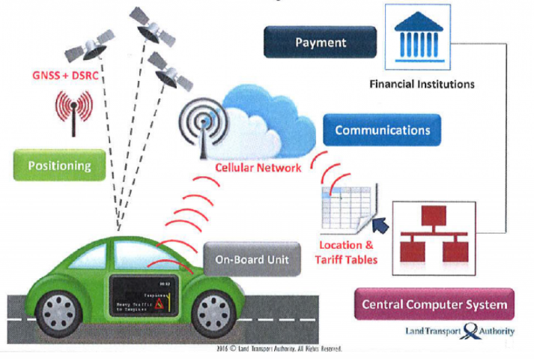

Figure ‑: How GPS is used in Electronic Toll Collection [19]

**[20] FLAWS OF THE GLOBAL POSITIONING SYSTEM TECNIQUE**

* High cost of OBU at a cost of up to $350 per OBU.
* Difficulty in the matching process between the debt and application information as such the system needs to do more post processing jobs in order to reduce the incidence of mismatch failure.
* GPS is new and upcoming technology as it is still in its development stages worldwide.
* Interference in situations where signal is lost.
* User’s reluctance in having their movements tracked.

### 2.2.3 AUTOMATED CASH MACHINE

[21] An Automatic Teller Machine abbreviated as ATM is in simple terms a data terminal that allows its users withdraw or deposit some money. It has two input devices including the card reader or keypad and four output devices. It connects to a database communicating through a host processor. When the driver of the vehicles gets to the machine, a barrier which is only raised after transactions have been completed prevents the vehicles from further movement.

[22] **Aegean Motorway** has implemented a similar system which allows the driver insert coins or bank notes in indicated slots. The machine returns a receipt and change if any. An indicator light changes to green and the barrier opens to allow the driver pass through.

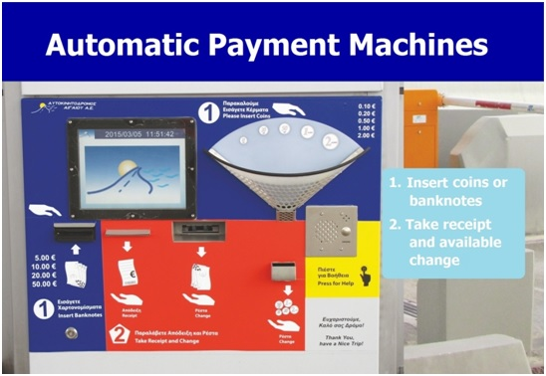

Figure ‑: Image of an ATM machine used in tolling [23]

**FLAWS OF THE AUTOMATIC CASH MACHINE**

* High cost in construction and maintenance
* Requires vehicles to come to a halt for driver to pay.

### 2.2.4 DEDICATED SHORT-RANGE COMMUNICATION TECHNIQUE

[24] Dedicated short-range communication (DSRC) is a communication standard that enables vehicles in an intelligent transportation setting to communicate with other vehicles or similar technologies or infrastructure. It works at a 5.9 GHz band of the Radio Frequency Spectrum thus making it effective over short to medium distances. Due to its low latency, high reliability and security, Engineers explored its applications in toll collection.

[25] Autostrade Tech based in Rome, Italy developed a technology using this standard to collect tolls with the aid of a device called a Transpass using the microwave DSRC at a frequency of 5.8GHz between the device in the vehicle and the established infrastructure equipped with the reader. This Transpass acting as a semi-passive transponder implying it has an independent power supply. It is activated and only transmits when queried by the reader allowing it to offering dynamic toll collection. At a Tele pass gate, the incoming or departing openings has a device in charge of automatically managing passages, in addition to maintaining the dialogue with the on-board terminal and the connection with the central system to charge a vehicle owner for his usage according to the logical steps described in the following image.

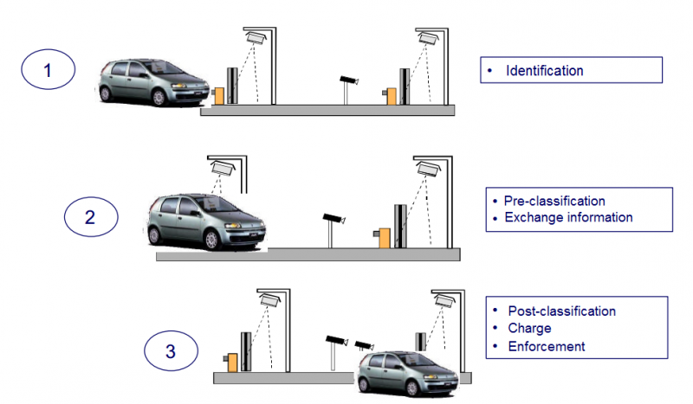

Figure ‑: Pictorial Representation of how DSRC is used in ETC [26]

**[27] FLAWS OF THE DSRC**

* It requires certain road-side infrastructure along the road which is costly most of the time.
* Also, maintaining the toll structure and making changes to the toll network presents high charges.
* Roads which have many intersections in their set up may also be expensive.
* Creating a centralized system for this system of tolling may be tough.

### 2.2.5 NUMBER PLATE RECOGNITION USING OPTICAL CHARACTER RECOGNITION

[28] The Optical Character Recognition (OCR) is a mechanism that converts images of handwritten, typed, or printed text, scanned documents, scene photos including sign board texts or simple a photo of a document. Number plate recognition has been used in tracking vehicles over the years to reduce vehicle theft and improve border control. Sensors have been installed here to detect the vehicle presence when it enters the toll charge region.

[29] A digital camera is employed and fixed at an angle parallel to the horizon. The camera captures an image of the number plate of the vehicle. The image is sent to a control station. This system makes use of an Artificial Intelligent Agent that has been trained with pre-captured images of number plates in JPEG format and preprocessed by changing colored images to greyscale level. The new colored JPEG image captured will therefore have to be converted to grey scale image. As a precaution, dilation is performed to remove unwanted noise. This is just a process for filling empty spaces and maximizing the brightness on the captured image in addition to sharpening the edges of the image and connecting any broken lines.

Further processing is performed and license of the vehicle is determined. Program goes through a database to determine the owner of the vehicle so charged toll is collected automatically. This system ensures that vehicles have free flowing traffic at a particular highway.

[30] The Texas Department of Transportation has employed this system after considering other alternatives.

**[31] FLAWS OF THE OCR**

• Blurry images, particularly motion blur, most likely at higher vehicle speeds.

• Poor lighting and low contrast due to overexposure, reflection, shadows, or plate

background color or style.

• An object obscuring (part of) the plate, quite often a tow bar, or dirt on the plate.

• A different font, as in out-of-state plates and vanity plates.

* Poor image resolution, usually because the plate is out of focus.

### 2.2.6 MOBILE PHONE TOLLING SYSTEM

Smart phones in recent times have become a very necessary technology that most people cannot do without in a day. With this knowledge, another stride was made in this regard to automate toll collection and ensure the whole process was convenient. In countries like Florida where this system is employed offers toll operators the ability to reinstall the toll equipment used at the booths at minimal cost. A sticker is given to the vehicle owner who attaches it to his smart phone. This works in conjunction with a mobile application that needs to be downloaded by the user. At the toll booth, the vehicles location is obtained through the phones GPS which communicates the specific station the vehicle is and through the software necessary deductions are made from his account.

**[27] FLAWS OF THE MOBILE PHONE TOLLING SYSTEM**

* In setting up the system, a detailed and elaborate plan is required.
* A mobile phone is required which poses limitations to users who do not have this.
* Users phone should have a strong battery which may not always be the case.
* Security issues may arise in terms of protecting the user’s data.

### 2.2.7 RADIO FREQUENCY IDENTIFICATION TECHNIQUE

[32] Radio Frequency Identification abbreviated as RFID was conceived during the 1970s. It was later developed in the 1990s. Unlike other technologies such as barcode, it doesn’t require a line of sight with its reader.

The major components required in implementing the tolling includes the RFID tag encoded with some digital data, an RFID reader and an antenna for wave propagation. On arrival at the toll station, the RFID tag attached to the vehicle is read. The specific vehicle information is obtained and from that the vehicle is identified and charge deducted from users account.

**[33] FLAWS OF THE RADIO FREQUENCY INDENTIFICATION TECHNIQUE**

#### RFID systems can be easily disrupted.

* RFID tag collision.
* RFID reader collision or interference.

## 2.3 REVIEW OF VARIOUS PAPERS ON ELECTRONIC TOLL COLLECTION

### 2.3.1 Automated Toll Collection System Using RFID paper by Pranoti Salunke, Poonam Malle, Kirti Datir, and Jayshree Dukale

This paper published Jan – Feb 2013 as part of the Volume 9, Issue 2 of the IOSR Journal of Computer Engineering (IOSR-JCE) proposes the use of an Automated Toll Collection System (ATCS) for collecting tax automatically. The identification of a vehicle would be done using radio frequency. Vehicles would have an RFID tag issued by the traffic governing agency which will store all basic information as well as the amount the driver has paid in advance for the toll collection. An RFID reader placed at the toll plaza to identify RFID tags on vehicles passing through the toll plaza thus collecting toll by deducting the required amount from the prepaid account of the driver. The driver’s account is then updated. Should there be insufficient amount in the account, an alarm sounds alerting the authority of the situation and the vehicle is prevented from moving.

**Flaws of the proposed system:**

* In the case of insufficient balance in the user’s account, sounding an alarm to alert the authority on non-payment of toll would result in the slowing down of traffic since vehicles/users behind the stopped car must wait for it to move before they can do same. This results in the delay of the system.
* The system does not provide a means of alerting the users of low balance before arriving at the toll plaza.
* There was no mention of administrators of the system. Agencies in charge of toll collection have no means tracking payments. No history of payments given to the administrators.
* Receiver at toll plaza is always turned on even when no vehicle is at the plaza resulting in power losses.

### 2.3.2 AUTOMATIC TOLL E-TICKETING SYSTEM FOR TRANSPORTATION SYSTEMS by Sana Said Al-Ghawi, Dr. S. Asif Hussain, Muna Abdullah Al Rahbi and S. Zahid Hussain

This system proposes the implementation of a low cost and efficient technique through RFID Technology**.** Tolls are collected as the vehicles move through the plaza. It is assumed that all vehicles are equipped with a prepaid account, which is maintained by the owner of the vehicle. Tolls are automatically deducted from the account when passing through the toll plaza. Vehicles owners receive SMS notifying them on payments.

**Flaws of the proposed system:**

* The proposed system obliges the uses to have a dedicated prepaid account.
* External source of light can interfere with the workings of the infrared proximity sensor. This would affect the effective detection of vehicles arriving at the toll plaza.

### 2.3.3 Automatic Toll Gate System Using Advanced RFID and GSM Technology by S. Nandhini and P. Premkumar

This system employs the use of RFID and GSM in the collection of tolls. Capacitive sensors are used to detect the size of the vehicle. IR sensors are used to detect the presence of a vehicle at the toll plaza. To control the opening and closing of toll gate as a vehicle enters or exits the Toll Tax Unit Gate models are used. Information on the vehicle is stored in the microcontroller using the tag number. The tag is read by the RFID reader and based on the tag number the appropriate toll amount is deducted. Information on the transaction is sent to the phone of the owner using a GSM modem.

**Flaws of the proposed system:**

* The use of IR technology makes the system susceptible to failure.
* The use of capacitive sensors to determine vehicle size may result in the classification of a small but heavily packed vehicle as the same as a bigger but lighter car. The two cars would then be required to pay the same toll.
* Owners of vehicles would have to bear the cost of acquiring the RFID tag.
* The implementation of the system would result in major changes in the architecture of exiting toll roads.

### 2.3.4 Design and Implementation of Low-Cost Electronic Toll Collection System in India by Subhankar Chattoraj, Saptarshi Bhowmik, Karan Vishwakarma and Parami Roy

The system proposed in this paper employs the use of an RFID based smart card. Strain gauge load cells are used to determine the type of vehicle on the base that different vehicles such as cars, trucks and trailer trucks do not have similar weight. A smart card reader, interfaced with the Arduino microcontroller, is used to debit the account of the vehicle owner. To ensure enforcement, an optical character recognition system is implemented as the primary surveillance system.

**Flaws of the proposed system:**

* The OCR may not function properly during poor weather conditions such as on rainy days, hazy days and snowy days.
* The number of images stored becomes too large since a picture of every car that passes through the toll plaza is taken.
* The use of OCR may infringe on the privacy of vehicle users.
* This system faces the issue of possible misclassification of vehicle types due to the use of only load cells for the classification

### 2.3.5 Electronic Toll Collection Based on Vehicle-Positioning System Techniques by Wei-Hsun Lee, Shian-Shyong Tseng, Ching-Hung Wang and Bor- Shenn Jeng.

This system employs the use of an OBC, Global Positioning System, an enforcement system and a backend system to ensure the collection of tolls. The mechanism operates based on the interaction between the OBC and backend through GPRS.

**Flaws of the proposed system:**

* VPS is a new coming technology; it is currently on the development and field trial stage worldwide as such there is no business operation instance in the world.
* It is more difficult in the matching process between the debit and enforcement information, so the VFS system needs more post-processing jobs in order to reduce the mismatch failure.
* The personal privacy problem is still there, just the same as DSRC-based ETC.
* Implementation of this method clothed to be way lengthier
* Implementation of the system is way pricey than expected.

### 2.3.6 Electronic Toll Collection Using Barcode Reader by Devika Mhatre, Rohan Kamble, Sayali Pimple and Prof. Amruta Sankhe

This paper proposes the use of barcode reader technology in implementing electronic tolling system in India. The system involves the mounting of barcode tags on the number plates of vehicles or on the front side of the vehicle. A barcode reader at the tollgate reads information on the tag concerning the type of vehicle and toll to be paid.

**Flaws of the proposed system:**

* System may not function well during bad weather conditions.

### 2.3.7 Secured Electronic toll collection using RFID and mobile application by Prof. Ramkrishna Vadali, Amey Shinde, Pratik Ghuse, Shashikant More and Dinesh Tope.

The RFID tag will be deployed by the toll authority by embedding unique identification number (UIN) and customer’s details into the tag. The deployed active RFID tag will be attached to the windshield of the vehicle. Whenever the vehicle passes through the tollbooth, tag data will be read by RFID reader & same will be sent to the server for verification. Server will check tag details & depending upon the type of the vehicle, the toll amount will be deducted from the user’s account. The notification about the toll amount deduction will be sent to the customer via SMS and email as well. The developed android application will be used to recharge the customer’s account.

**Flaws of the proposed system:**

* Low frequency results in lower maximum data rate, although it is fast enough to allow multiple transmissions to increase reliability.
* Passive RFID tags are relatively less adept than active RFID tags, while active RFID tags are costlier.
* Speed of vehicle can bottleneck the system.
* If at a particular tollbooth user loses his network coverage, may get SMS notification late.

## 2.4 SOME COUNTRIES WITH MAJOR BREAKTHROUGHS IN ELECTRONIC TOLL COLLECTION

### 2.4.2 ELECTRONIC TOLL COLLECTION IN THE UNITED STATES OF AMERICA

The inception of Electronic Toll Collection in North America dates back 12 years ago with Texas the first state where ETC was implemented. Since its inception, the market for collecting tolls using electronic means has increased to the extent that North America heads the league of countries using ETC. This is due to the fact that out of the estimated 8800 lanes using ETC all around the world, North America accounts for over 4500 of the estimated lanes representing 51% of the worldwide market.

The EZ Tag is an alternative method of toll collection the USA. It employs the system of open tolling implying that the drivers do not have to stop their vehicles at toll gates just to make payments. It was developed in the late 2003s. by the Houston County Road Toll Authority based in Houston Texas. The system employs radio wave transmission in communication. This system recognizes two important components, that is the RFID reader installed at the toll station and the transponder attached to the vehicle of the registered driver. It is important to note that the transponder has been encoded with information about the vehicle and the driver. Lanes at toll stations have been equipped with sensors that identifies the vehicle at the lane. The RFID reader reads the information off the tag attached to the vehicle and uses WIFI to transmit the information to a server hosted online. This server matches the information read by the RFID reader to a user account and makes necessary deductions to the user account.

Though this system proved to be an effective method of toll collection, the administrative fees issued to customers who missed a toll payment or forgot to renew information on their credit were quite erroneous hence they were sued.

### 2.4.1 ELECTRONIC TOLL COLLECTION IN GERMANY

Toll Collection in Germany can be discussed without making mention of Toll Collect a company responsible for tolling for trucks on highways. Their system of tolling also provides an open system where trucks do not have to wait or stop at toll stations. Development of the system began in September 2002 however it was officially opened in January 1, 2015. This system uses on Board Units (OBUs) embedded in the vehicle for calculating the miles travelled by the vehicles as well GPS for tracking the location of the vehicle so that the miles travelled are calculated only when the vehicle is within state. Additionally, the system uses infrared technology for communicating with the stationary control station on the toll road. At the toll gate, the toll charge is determined by using sensors which estimate the vehicle emission of the truck as well as the number of axles the truck has. Payment of this system can be done in three different ways. The first payment requires the driver to pre-book a particular route he will be using within a period so that based on the information collected a charge is deducted from his prepaid account. The vehicle driver can also decide to pay at terminals such as fuel stations or he can pay at the toll gate. Though this system offers a simple and easy way to pay tolls, it was realized that the On-Board Unit installed into the vehicle cost up to $350 which was on the high side.

### 2.4.3 ELECTRONIC TOLL COLLECTION IN ENGLAND

The Dart Charge Electronic toll collection was developed across the Dartford Crossing by the UK Government and introduced on the 30TH of November 2014.It provides an open system of tolling where vehicles do not necessarily have to wait or stop. This system employs the optical recognition system, that is to say the system has been set up to automatically use the number plate of the vehicle. The OCR is the mechanism that will convert the images captured by the overhead cameras set at the toll gates into a form that can be used by the computer. The image is sent to a control station where with the use of an Artificial Intelligent model trained with precaptured models the actual plate information is obtained. The associated information with the particular vehicle number is obtained. It is important to note that to use the service you first need to set up a DartCharge account. If you live in Thurrock or Dartford you can apply for a local resident account. Payment is done in four ways. The first way is paying with cash at a Pay zone store or set up account to pay by your post code. Additionally, the vehicle user can also pay in advance or top-up his account by post or alternatively, pay or set up a mobile phone account. Charges can be paid online or using the phone system of advance payment or midnight after crossing.

### 2.4.4 ELECTRONIC TOLL IN SOUTH AFRICA

In South Africa toll collection was started on selected roads by the South Africa Roads Agency Sanral in 2014. Two methods of electronic toll collection are used here; Boom down ETC and the Open Road Tolling in the Gauteng Province in December 2013. The Boom down method of tolling is used in lanes marked with the e-Tag sign overhead the toll station. This system requires the vehicle to slow down so that with the help of overhead equipment the details of the e- Tag is read and an amount deducted from the users toll account after which the boom lifts with a light turning green communicating the driver can go. The multilane free flowing ETC system operates with no physical toll booth set up. Rather with the help of sensors and cameras mounted on overhead gantries the license plate is obtained and amount taken from the users account. For corroboration each vehicle is snapped from above for length classification, with supplementary photos of the front and rear number plates. This system is used on highways as the vehicle does not need to stop.

### 

# METHODOLOGY

This chapter discusses in detail the various methods used in designing the system after considering a wide range of solutions. It is important to note that the system being implemented may not necessarily be an upgrade from the systems discussed in Chapter 2 but rather a local solution to toll collection in Ghana. **Section 3.1** considers the communication methods employed while **Section 3.2** describes the system in general. Section 3.3 looks at the various components used and their interactions with themselves and the external environment.

## 3.1 SYSTEM COMMUNICATION

This project considers various design considerations including, cost effectiveness, power consumption and accuracy. As transmission plays a vital role in ensuring the efficient operation of the system it is essential to consider technologies that helps achieve the goal of the system while considering factors such as cost, power consumption among others. Wireless transmission is employed due to the fact that it doesn’t necessitate any physical connection between the two communicating points or nodes. Comparing the different types of wireless technologies including, the popular IEEE 802.11 WIFI standard, IEEE 802.15 Bluetooth standard, IEEE 802.16 WiMAX standard, the ZigBee wireless communication was chosen. [34] Zigbee was developed by IEEE with the IEEE 802.15.4 standard. This standard derived its name from the manner bees zig and zag while moving from flower to flower to obtain pollen grains while transmitting information to other bees. It is a relatively new technology employed in this field of toll collection due to the fact that it focuses on homogenizing and aiding interoperability of different products. It also places emphasis on applications that require low battery power. It also provides a short- range cost effective networking capability of 10 – 100 meters taking into consideration the power being given out as well as environmental conditions. As topologies, it employs the mesh, star and tree network incorporating data security features. Zigbee is used in this project for the above described reasons however significant reason is that unlike other IEEE 802.15 standards that provides high bandwidth, it addresses the unique need of sensors that do not need to use high bandwidth. This is to say, it suited for application that require low data transfers. As these sensors are often low power devices, Zigbee can in cooperate a wide range of sensors which operate on low power.

## SYSTEM ARCHITECTURE

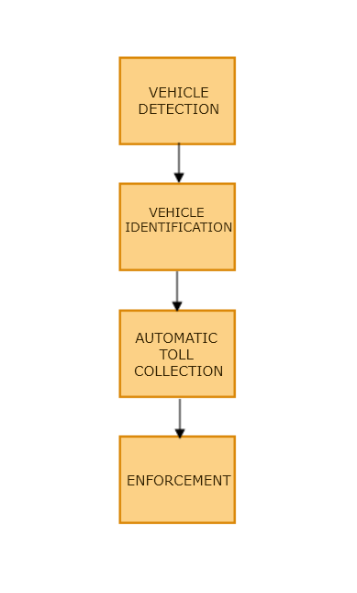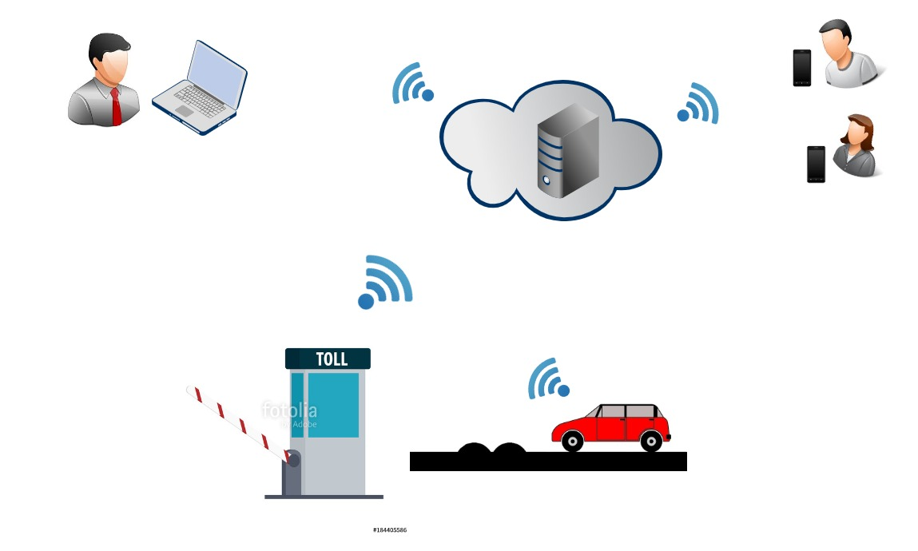

Figure ‑: System Architecture of the ETC system

Figure 3-1 shows a visual overview of the ETC system. The system comprises of two users namely; the administrator and customers. The administrator is responsible for monitoring the entire system transaction. The physical systems begin the whole process. When the customer enters the toll region with his vehicle, the system immediately is activated. The information encoded onto the tag is read by the RFID reader installed at the booth. Using this way, information is then sent to the database hosted on cloud with the help of a web service. A web service is a piece of code that is made available over a network and written in the standard Extensible Markup Language (XML). The car is identified and correctly classified. A toll charge is calculated and the amount duly deducted from the users account.

## DESIGN AND IMPLEMENTATION

The electronic toll collection project considers various design considerations including, cost effectiveness, power consumption and accuracy. This report seeks to highlight the hardware design considerations used in the development of the project including clearly stating the components to be used both in the prototype and actual hardware design stage, power considerations, method of transmission chosen and so on.

This project includes a hardware set up in cooperated with software to allow the hardware perform a set of tasks, as well as a software application to interact with the clients effectively.

### 3.3.1 COMPONENT LIST

This section highlights the components selected and the reasons why they were selected despite the facts that different hardware components could have been used. For the prototyping stage the components considered includes;

List of sensors and modules considered for the proposed design

* ESP8266 Node MCU
* RC-522 13.56 MHz RFID Reader
* 5kg Servo motor
* Green and Red LEDs

**ESP 8266 NODE MCU**

The ESP 8266 Node MCU is a development board which is USB TTL where Serial cables are a range of USB to serial converter cables which provide connectivity between USB and serial UART interfaces. It has 10 GPIO where every GPIO can be pulse width modulated.

NodeMCU has ESP-12 based serial WIFI integrated on board to provide GPIO, PWM, ADC, I2C and 1-WIRE resources at your fingertips, built-in USB-TTL serial with super reliable industrial strength CH340 for superior stability on all supported platforms. It is used in this project because;

* It is a cheaper option.
* It offers a more compatible development with C in Arduino, JavaScript in Samrt.js, python in Micro python and so on.
* It offers enhanced functionality with a chip clock rate acceleration, a new Analog to Digital Converter (ADC)
* It also has a wide range of learning resources.
* It has an active community where different developers can share ideas on how to go about some developmental issues.

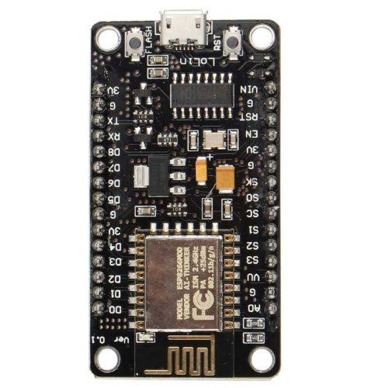

Figure ‑: Diagram of a NODE MCU ESP 8266 Module

**RC-522 13.56 MHz RFID Reader**

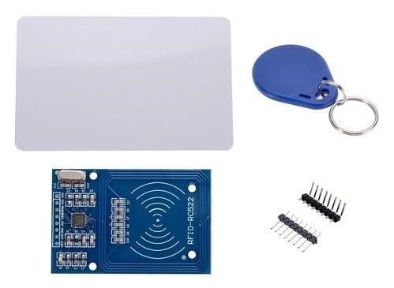

Figure ‑: Diagram of RC-522 13.56 MHz RFID Reader

This low cost MFRC522 based RFID Reader Module is easy to use and can be used in a wide range of applications.

The MFRC522 is a highly integrated reader/writer IC for contactless communication at 13.56 MHz It is used in the design and development of the project because;

* It has an operating frequency: 13.56MHz which is preferred in the presentation of the prototype version of the project
* It requires a voltage of 3v which can easily be supplied by the ESP 8266 which also requires a voltage of about 3v
* It also has a current specification of 3-26mA which can easily by provided by the stipulated voltage.
* It has a read range of about 3cm which for the presentation is considered appropriate. However, for the actual implementation a wider range will be considered.
* It also has maximum data transfer Rate of 10Mbit / s which is enough to transmit the data encoded.

**FUTUBA SERVO MOTOR**

The futuba works on the principle of servomechanism (a principle that uses electromagnetism to convert electricity into accurate motion by employing negative feedback mechanism). [43] The main components include, a DC motor, a potentiometer, and an Integrated Circuit (IC). The potentiometer enables controlled motion by transmitting the existing location of the shaft. The DC motor is responsible for the movement of the shaft while the IC interprets the signal from the potentiometer and your microcontroller. To control this motor a mechanism known as pulse width modulation is employed to control the angular position of the shaft of the servo.

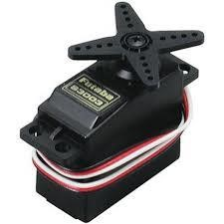

Figure ‑: Diagram of a Futaba Servo motor

**LITHIUM POLYMER**

A rechargeable Lithium Polymer (LiPo) battery with a nominal voltage 3.7V will be used as the main power supply.

* A Constant Voltage/Constant Current (CV/CC) charge IC is used for charging the battery.
* Protection circuit is used to safeguard against over discharging and short circuit.

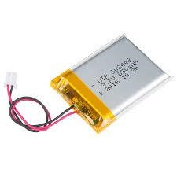

Figure ‑: Diagram of a lithium polymer

**GREEN AND RED LEDs**

LEDs are used in most projects for illumination and indication purposes. As such for this project it is used for indicating the status of the transaction. When the transaction is successful, the green LED turns on while the red LED is turned off. However, when the transaction is unsuccessful, the Red LED turns on.

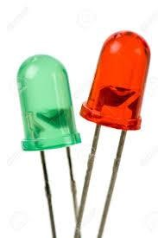

Figure ‑: Diagram of Light Emitting Diodes (LEDs)

### 3.3.2 HARDWARE BLOCK DIAGRAM

The diagram below shows a block diagram of the ETC hardware which puts out clearly the various subsystems which coordinate to produce the required result

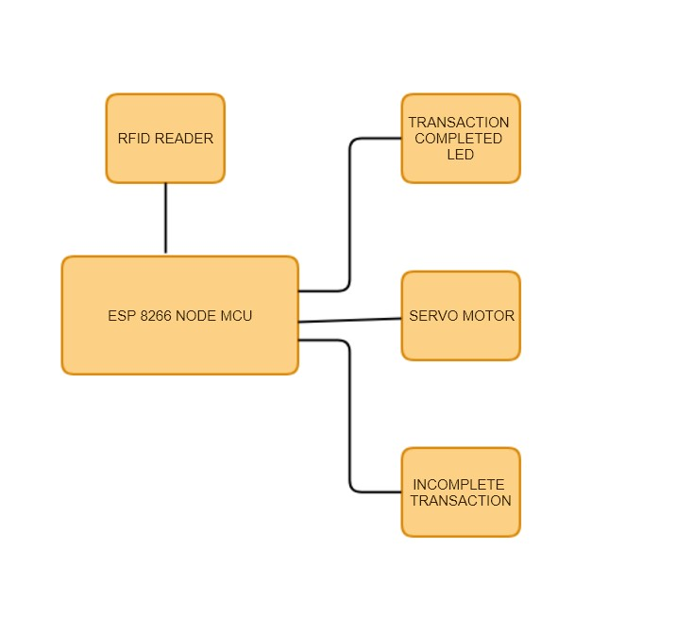

Figure ‑: Block Diagram for the system(hardware)

### 3.3.2 SYSTEM DESIGN

This section describes the process of control between the interacting components

of the system. It also presents the ﬂow of data processing between the system

user and the system.

**Flow Chart for the System**

The Flow Chart gives a view of process progression of the system in its operation. The system starts when the user reaches the toll booth. This is detected using the load cell arranged in the speed ramp before the toll station. This is done so the system can estimate the number of cars that use a particular gate within a specified period. As done in other developed countries the system provides an option for vehicles who haven’t yet registered under the system. As such when the user who hasn’t been registered gets to the toll station, he gets the opportunity to pay through a manual gate. For registered users the weight of the vehicles is recorded. When the vehicle gets to the toll station progression is hindered by the barrier placed at the station. On completion of the payment barrier is lifted to allow user access the road. The RFID reader transmits radio waves to the transponder of the vehicle which in turn responds with the encoded data identifying the vehicle. The system checks the balance of the account the encoded data mapped to, to determine if user has sufficient funds. If the balance is enough the charge is deducted and a receipt sent to user. If funds are insufficient, the user’s details will be sent to the Administrator who can found the Evaders List to a higher authority to handle users who evade paying their tolls. Such an authority is Driver Vehicle and Licensing Authority (DVLA) where Drivers go to renew their license and register other stuff in relation to their vehicles. A reminder is sent to the user however to prompt him of the fact that he doesn’t have enough balance in his account.

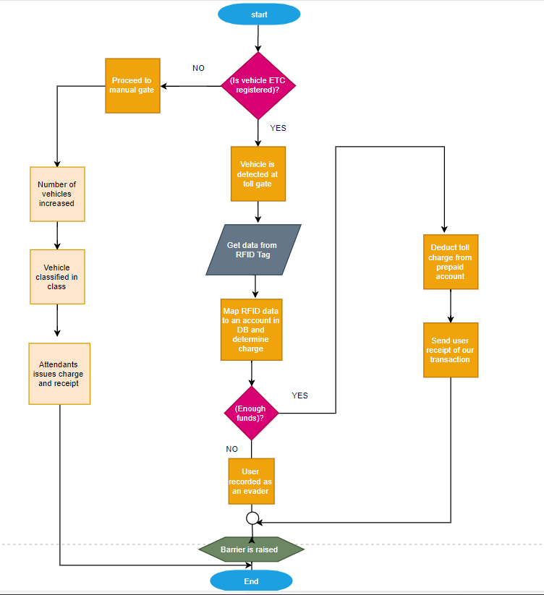

Figure ‑: Flowchart Diagram of the entire system

##### 3.3.2.1 HARDWARE SYSTEM DESIGN CONSIDERATIONS

Flow Chart for the Hardware Simulation

This flowchart for the hardware setup starts with the load sensor detecting the presence of a vehicle and closing the barrier by setting the servo motor rotation in the anti-clockwise direction. On reaching the overhead scaffold, the RFID tag is activated and the data encoded on the tag is read by the RFID reader. The encoded data is transmitted via WIFI to an online database. The system then checks to ensure that the data is successfully mapped to an account in database after which deductions are made to the appropriate account. If the transactions is recorded as successful, the green LED lights up to indicate successful transaction to the user after which the barrier is opened by setting the servo motor rotation in the clockwise direction.

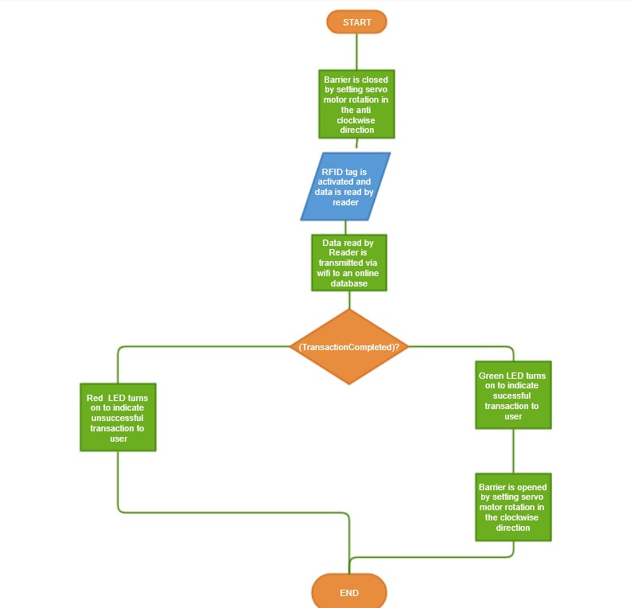

#### Figure 13 Flowchart Diagram of the hardware setup

Figure ‑: Flowchart diagram for hardware

Fritzing Diagram for the Hardware Setup

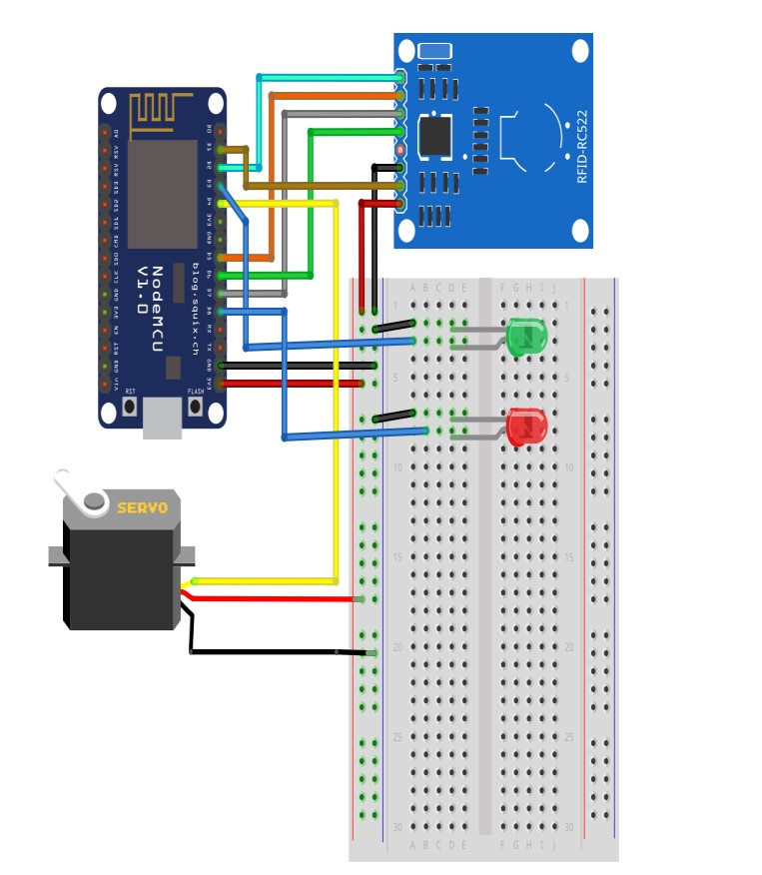A fritzing diagram is one which shows or presents a physical connection between some electronic components during prototyping. This fritzing diagram shows the pin connection of the RFID reader, the servo and the LEDs to the NODE MCU board.

Figure ‑: Fritzing Diagram of the hardware setup

Schematic Diagram for the Hardware Simulation

A schematic diagram shows a representation of elements used in a particular system using graphical symbols instead of the images of the actual components. This schematic shows the symbols of the four main components used in this project simulation and how they are connected on a much lower level.

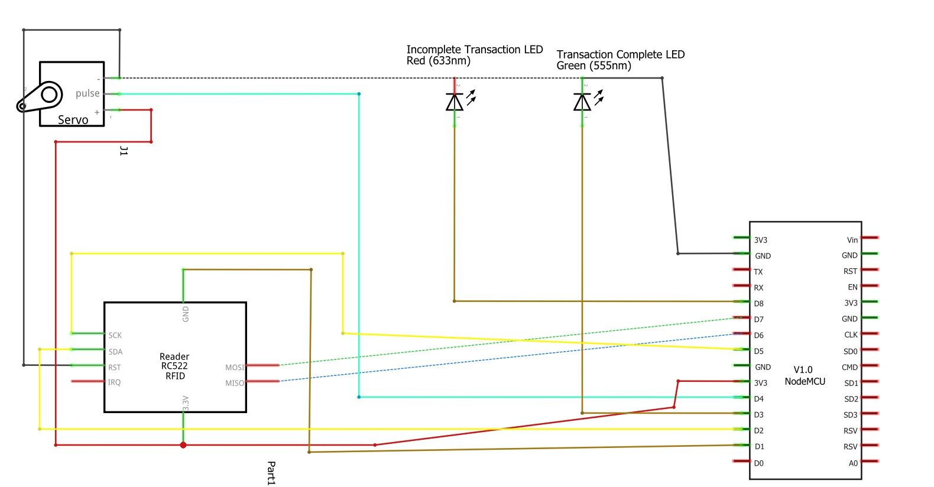

Figure ‑: Schematic Diagram of the hardware setup

Projected Budget for the Project

|  |  |  |  |
| --- | --- | --- | --- |
| Hardware Components | Projected Cost For  1 Component | Quantity  Required | Total  Estimate |
| ESP 8266 Node MCU | ₵27.00 | 1 | ₵27.00 |
| Green and Red LEDs | ₵0.50 | 2 | ₵1.00 |
| Load Sensor | ₵6.11 | 1 | ₵6.11 |
| RC-522 13.56 MHz RFID Reader | ₵45.00 | 2 | ₵90.00 |
| Futaba S3003 Servo | ₵50.00 | 1 | ₵50.00 |

**Total**₵174.11

Table ‑: Table showing estimated budget for purchase of hardware components for prototype

##### 3.3.2.2 SOFTWARE SYSTEM DESIGN CONSIDERATIONS

Based on the insights of the qualitative research on user’s needs within this field, the team has developed the concept of paying tolls using electronic means. This system should allow the drivers access to certain information about the different toll subscriptions to allow the driver make a well-informed decision as to which subscription he should go for to pay his tolls.

In this section, we describe the software design considerations and requirements for a yet unnamed application further referred to as the eToll app, its scope and any other relevant information associated in the development of this application.

Product Perspective

eToll is meant to operate on two independent platforms including a mobile application which runs on the Android OS and an iOS platform and a Web Application hosted on a browser for the administrators to monitor all tolling activities.

Product Functionality

The application provides services not only for the toll collection agencies but also the drivers utilizing the application. These services include;

1) Platform for drivers to scout different toll subscriptions available to them so they can make a choice based on their preference ranging from their choice of pricing and expiry dates posted by agencies selling toll subscriptions.

2)Platform for interaction between toll collection agencies and drivers so any issues can be addressed.

3)Feature that allows drivers view their history of tolls paid in the past and their location on the map.

Users and Characteristics

The users for this application have been grouped under two main categories: Toll Agencies and users who in this case are the drivers who use these toll gates. The following writeup describes these users

**Toll Agencies:** This category of users are the ones who will be in charge of managing the whole toll collection process. This is to say they will be responsible for first providing the tags to be used in this system. The tags encrypted with a unique code that identifies a particular vehicle will be associated with an account that can be managed from the mobile application by the registered driver. These toll agencies will also be in charge of posting various toll subscriptions on the mobile application so that registered drivers can purchase toll credits that can be automatically deducted from their accounts as and when they use a toll gate. They are also in charge of ensuring that estimated toll amounts for a particular period correlates with the actual calculated amount at the end of the period. They will also be available to assist with any issues that may pop up from the end user side.

The use case diagrams give a summarized version of how the toll agencies will actively interact with the system.

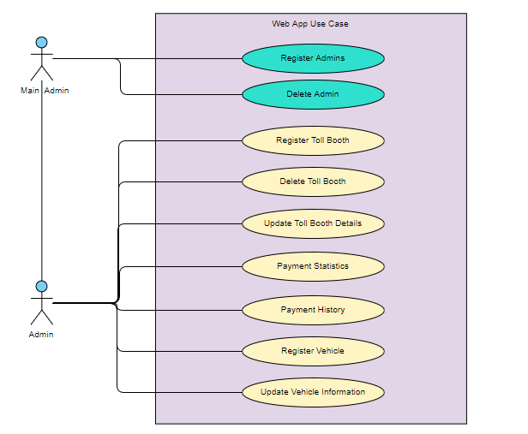

Figure ‑: Use Case Diagram for ETC Administrators

**Drivers (Registered customers) :** These users also benefit from this application, in that they have access to any information they will require about a particular toll subscription posted by an agency. They can even go as far as interacting directly with a representative to ask about issues that may not be clear in the information posted. They then proceed to booking a toll subscription based on information they have gathered. They also get the opportunity of obtaining an e-receipt which provides information about each transaction they make as they use the toll booth. Additionally, they can view past toll information and also view their toll credit balance. They will also be able to receive notifications when a toll transaction is successful.

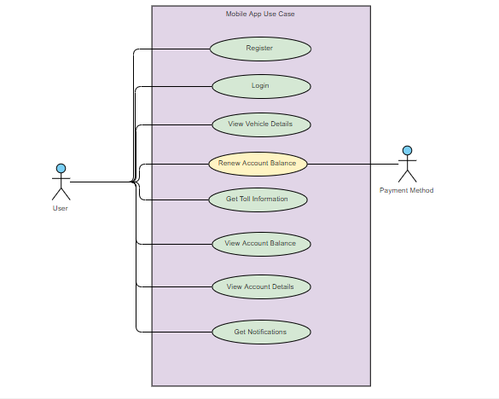

Figure ‑: Use Case Diagram for ETC End Users

Operating Environment

The clients of this transport management system require a device running Ice Cream Sandwich 4.0 – Kit Kat 4.4 or later for an Android OS and an iPhone with the iOS version of 5. 0 upwards. Additionally, a device with a working Internet connection with any browser can also be considered.

Assumptions and Dependencies

In this application, we will depend on the PostgreSQL for our database management. In addition, we will use Flask to handle all other backend operations specially the RESTFUL APIs.

It is also important to note that, user documentation for eToll would be minimal. A FAQ document available on the app would be sufficient to answer any questions users may have through support via email.

## USER INTERFACE

As stated early on, the software that runs for this project can be categorized into two components comprising of a high-level application software and the low-level software that regulates the workings of the embedded components connected to the microcontroller.

The high-level software for the implementation is designed for two different platforms; a web application for the administrator and a mobile app for the user. Using Adobe XD, the interfaces for the project was designed to be implemented later.

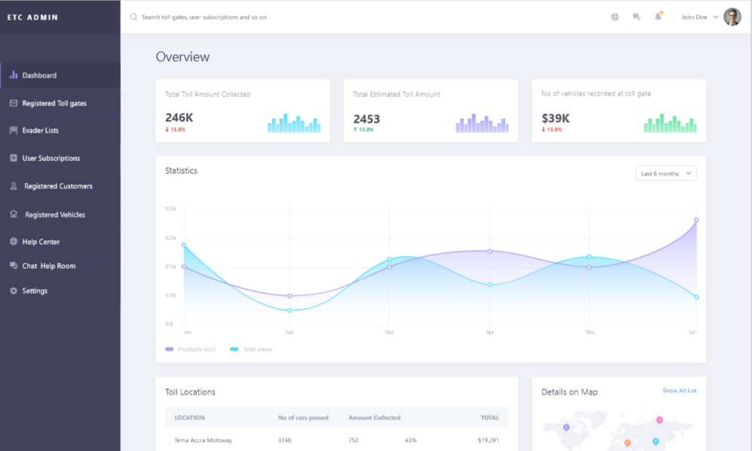

#### Figure 15 Graphical Interface of ETC Administrator Dashboard

The User Interface for the administrator is designed with nine tabs which is reveled after authentication has been passed. The Dashboard provides a general overview of the system including the total amount of tolls collected within a day, month or year depending on the option selected by the user compared to the total estimated toll amount and the vehicles recorded at the toll gate. The registered toll gates tab presents information on all toll gates that have been registered under the ETC system. For the purpose of the project, the Accra-Tema motorway is the only registered toll booth. The Evader List shows all the users who passed with insufficient balance to pay their tolls. Users who redeem their tolls by design of the system will have their names removed from this list. The user subscriptions tab shows the administrator all the toll plans he has presented to the users and the number of the people who have activated that particular offer. The registered customers tab gives the administrator information about all the customers who have registered with the system including information about the vehicles they have registered among others. The registered vehicles tab gives information about all the vehicles registered with the system. The help center tab presents a forum where administrators can address issues posted by customers.

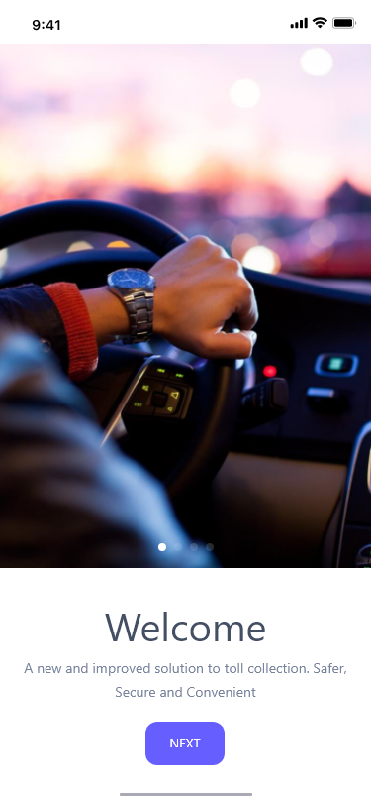 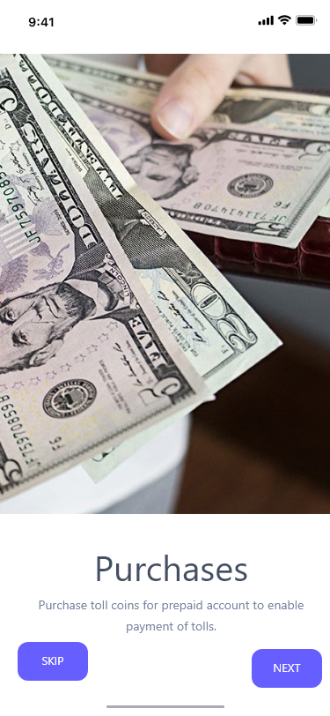

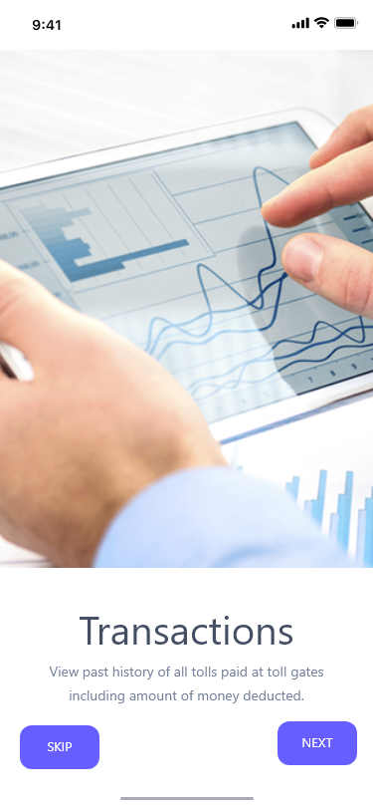 

Figure ‑: Introductory screens to mobile application

The above screens basically give the new user some information about the application he /she will be using so they wouldn’t be completely overwhelmed with the environments. As the app basically provides three main function including the purchases, transactions and support feature it is essential to highlight this when the registered driver first uses the application. The purchase slider communicates that the user can make purchase of toll credit using any payment platform he considers necessary. The transaction slider communicates that the user can view information concerning his payments made in the past. Lastly the support section highlights the fact that the various toll agencies will be available to assist the users in whatever way they can in relation to using the system. The app starts with these screens after which a sign up and sign in screen will be provided so as to first allow users log in or for new users sign up to use the system. After the details entered by the user has passed the authentication, the user is directed to the home page which contains two menu icons to allow the user access notifications and also to open the side navigation menu.

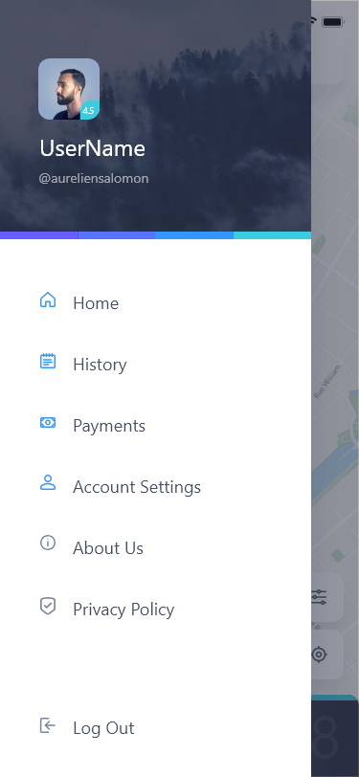

Figure ‑: Side Navigation showing different routes

This side navigation provides menu options like the history section, where the user can view his past transactions if any to allow him/her monitor his/her transactions. Information such as the location of the toll gate is provided in the form of a map, in addition the name of the toll gate as known to the system is provided. The amount paid is also presented as well as the date and time the transaction took place.

The second menu option dubbed ‘payments’ presents the user with an interface where he can view his remaining toll balance for a particular subscription he has made. This is to help him monitor his toll credits so that he can make new subscriptions as when he feels it is necessary. Additionally, the payment option screen will also present the user with different subscriptions that has been posted by the various toll agencies so that based on the price and duration presented he can make a decision as to which subscription to choose. Selecting a particular subscription redirects the user to another page where he will select the payment option he prefers and make payments for the toll credit.

The next menu option ‘Account Settings’ will provide the user with the interface displayed below.



Figure ‑: User Profile Screen

This menu options allows has menu icons which directs the user to

1. Invite a friend to use the system or application.

2. Interact with a representative from the toll agencies to assist him as and when he has issues.

3. Notifications menu where he can click to be directed to a page where he can view all notifications sent to him. Notifications may come in different forms in that he may receive notifications when he makes a purchase or when a transaction has been made.

4. General settings allow the user to make changes to the physical appearance of the app so that he can make changes to the size of the text among other functionalities that will make him have a more custom environment space to work with.

The remaining menu options provide information about the terms, conditions that must be heeded in addition to the privacy policy of eToll.

##### 3.3.2.2 EMBEDDED SYSTEM CONSIDERATIONS

It is important to note that though we have software running the application program that is the system the user directly interacts with; we also have the embedded system software which controls the hardware components. The source code that controls the operations on the ETC Board was written using the Embedded C language. It was written in Arduino IDE. The source code contains logic that facilitates the harvesting of signals generated as a result of the sensor detecting the presence of an vehicle at the toll gate.

# TESTING AND EVALUATION

4.1 Test A mini-seating area was set up and the system was set up. The test was carried out for three hours interspersed with random occupying, “permanent” and “temporary” vacation; allocation, de-allocation, singular and mass hibernation, fault tagging and “repairing” of seats. Several arbitrary log in and log out instances by various administrators; and registering of new administrators also took place. Thus all aspects of the system was tested.

4.2 Evaluation From the theoretical and experimental results, we have estimated that this loading mode capacitive sensing technique can clearly distinguish between an occupied and available seat. The relationship between available and occupied is approximately a double ratio one in favour of the latter. After the three hours of testing, the voltage of the battery was measured and recorded as 2.99V. It was estimated that a battery could last a year when used to power device and thus the device is power efficient. Base station – display interaction was a hundred percent proficient, however the base station and seat unit communication experienced four percent packet failure. This was attributed to factors such as interference from other networks, interference from other wireless-technology-based networks such as Bluetooth, ZigBee and UWB. This could also be alluded to radio range issues.

Testing

The tests carried out included both white-box testing where the individual com

ponents were tested to ensure they oﬀered performance close to simulated results.

Reﬁnements were made to the embedded hardware code to calibrate the hardware

that did not meet performance targets until optimum performance was achieved.

Black-box testing ensued after all the hardware component were integrated into

the main system and all interactions between the system hardware and software

were ascertained to be working as expected.

The Medi-COMPANION mobile application was compiled to run on the

Android platform. The software was installed on a compatible handset and all

the features of the app tested to ensure it works as expected. Features like Find

Nearest Centre which utilize the Google Maps API allowed users to ﬁnd Medi

STATION centres and directions. Other features of the mobile app allow users

to book appointments and also be notiﬁed when those appointments were due.

4.2 Results

Results of system usage were collected from prototype hardware from the success

ful completion of this project. The prototype hardware was built with attention

to its functionality and not aesthetics hence the lack of proper packaging.

After successful implementation and testing, the proposed systems were

run through a number or real-world scenarios where users were selected to in

teract with the system in order to verify that it worked as expected. The Medi

STATION was deployed where results from its usage showed that the system was able to meet its design expectations.

Data gathered from actual usage of the Medi-STATION health system

shows a drastic improvement in the time users spent at health facilities to screen

their health parameters. Users of the system faced a number of challenges which

included being unfamiliar with the system as with any new technological machin

ery. Also users who were not able to read the instruction for using the system

could not follow through the screenings to completion. Fig. 4 shows some of the

user interfaces of the Medi-COMPANION application.

Traditional Health Facility Medi-STATION

Average time spent at OPD/min

60 25

Estimate patients per doctor per day/ persons

8 19

Table 4.1: Average waiting and patient turnaround times

From Table 4.1, it can be seen that the number of patients that are

treated at hospitals withMedi-STATION are more than double of those patients

that are treated using conventional techniques involving nurses. The increase in

treated case positively aﬀect the economy of the country as much of the productive

time of the workforce will not be spent at the hospital. There is also motivation

to go for regular check-ups since the estimated time spent in doing these screening

tasks have been reduced by more than double the original time. This helps to

maintain an active workforce in order to sustain nation building.

# CONCLUSIONS AND RECOMMENDATIONS

We have proposed and tested a system for dynamically monitoring seat occupancy in auditoriums, halls and the like. The ATOMS system can handle this task efficiently, accurately and cost effectively. Wireless communication adapted into this system to replace the massive cabling make easy seat occupancy monitoring neat and easy to achieve. The designed system is highly practical and adaptable for installation in any auditorium setting. The system is very portable to cater for already built seats. The system also enables hall establishments operate independent of ushers.

5.2 Recommendations 1. Base stations should be diversified. Portable devices such as mobile phones, and tablets should be considered. 2. The CC3200 microchip allows for checking of power supply level. Future versions of the system should be able to remotely inform the administrator of devices with low battery sources. 3. The base station- ATOMS device communication should be made impregnable to interference from other networks or other wireless technologies. 4. The system could be prospectively applied as a ticketing concierge.

5.1 Conclusion

The Medi-STATION and Medi-COMPANION solutions after initial testing and

deployment demonstrated signs of oﬀering tremendous beneﬁts to our society,

especially in this part of the world where very limited resources (human and non

human) have contributed to the rise in NCD mortality. The proposed systems will

reduce the dependency on our limited health personnel and facilities since people

will be able to acquire reliable information concerning their general health from

these automated screening stations. Users will be able to access these screening

services at any time of the day and also at their own convenience and this will

allow people to pay close attention to their general health at any point in time.

The results (digital or print format) from these screenings can also serve

to inform health-personnel on whether users require further diagnosis. Also, with

the information gathered from the usage of these systems, policy makers and

stakeholders in the health sector will be able to make informed decisions that

will that will directly inﬂuence and improve the delivery of healthcare to our

communities and thereby reducing the rate of NCD mortality.

Usage of the Medi-COMPANION mobile application used in conjunction

with the Medi-STATION will not only help reduce in oﬀering a complete solution

for an integrated health system but tt will also keep users informed on the new

and improved ways of healthy living any point in time.

5.2 Recommendation

Based on some observations througout the design, development and deployment

of this project, a number of recommendations have been outlined pertaining to

the speciﬁc requirements of both the Medi-STATION and Medi-COMPANION

systems.

The Medi-STATION being a medical station is expected to guarantee

a level of accurary in the services is provides more importantly pertaining to

user health parameter screenings. The accuray of screening observed from the

complete system were of acceptable levels for a prototype device but not for

production systems. The culprit in this case was determined to be the quality

of components used to develop the system. The rocommendation is this case is

then to aquire quality components for further development of the system. The

second recommendation is the opportunity of expand the scope of this project to

increase the amount of automated services that can be provided by the system,

this will further help to drive home the objective of reducing dependence on our

limited health facilities.

After the completion of the Medi-COMPANION project, a number of

recommendations that will further improve the project include

• A web application should be provided to the healthcare facilities to make interaction between clients and the facilities easier.

• The mobile application can come with a daily challenge for users. This could be exercises or healthy foods they should eat on that particular day.

• The mobile application should be able to use sensors on mobile devices to take medical readings. This will help reduce dependency on the medical

station for medical readings.

4.1 Conclusion

This project was birthed out after seeing the hurt people go through at toll station; the time

spent on queuing, the money spent on fuel and even the harm it causes to the environment

due to combustion. All these were stated in our problem statement and we tackled them by

providing an efficient, convenient and fast way of taking tolls and even provided an extra

help in tracking vehicles especially those who do not pay tolls using a camera.

ATC (Automated Toll Collection) solved the stated problem using proper coordination

between its 3 (three) sub-components:

• RFID tag

We successfully bundled the owners information onto the RFID tag.

• Docking Station or Detection Station

The docking station consists of the microprocessor board (raspberry pi) interfaced with an

RFID reader, Wi-Fi module and a camera. The camera forms an integral part of the system it,

the camera is placed at the docking station to take pictures of all the passing vehicle in order

that vehicles who use the road without paying tolls can be easily tracked, although it is an

added feature or not part of the main project idea. The transmission of the users information

too was successful.

• Web Management Portal The Web Management Portal is a web application built for administrators to be able to access

data obtained from road users and the toll that were taken using the RFID Reader. A secure

portal was built using modern web development technologies.

25

All in all the project met the objectives that were set out for:

1. Providing a system that will reduce the cost in printing receipts, time and energy spent queuing at toll booth and even the environmental hazard it seems to pose. 2. Providing a platform to view records of road user taken at the docking station.

4.2 Recommendations

We did our best to make sure that the project met the objectives that were set out for it but

while we worked on it we got to understand there were some improvements that could made

on this work, some of which is:

• CMOS camera to capture fast moving cars or vehicles. • A faster processor which will increase the OCR performance. • The web portal for the administrator should be improved to show daily, weekly and other statistics of the accumulated tolls. • Detection scheme to alert the administrator if a docking station is down. • To push the whole idea to be implemented nation-wide by the Ghana roads and transport sector or DVLA.

# REFERENCES

|  |  |
| --- | --- |
| [1] | "List_of_electronic_toll_collection_systems," [Online]. Available: https://en.wikipedia.org/wiki/List_of_electronic_toll_collection_systems. |
| [2] | Mitsubishi Heavy Industries, LTD, "Introduction to Electronic Tolling Collection system in Japan," 2014. |
| [3] | S. Nandhini and P. Premkumar, *Automatic Toll Gate System Using Advanced RFID and GSM Technology.* |
| [4] | M. Martey, Interviewee, [Interview]. 16 November 2018. |
| [5] | H. Gilliet, "Toll roads-the French experience," Transrouts International, Saint-Quentin-en-Yvelines, 1990. |
| [6] | W. J. Bernstein, "The Birth of Plenty: How the Prosperity of the Modern World was Created," pp. 245-6, 2010. |
| [7] | F. Kelly, "Road Pricing: Addressing congestion, pollution and the financing of Britain's road," *Ingenia,* no. 39, p. 36–42, 2006. |
| [8] | "Advances in Databases and Information Systems," in *13th East- European Conference*, Riga, Latvia, September 7-10, 2009. |
| [9] | ["Welcome to the Maine Turnpike's E-ZPass Program"](http://www.ezpassmaineturnpike.com/). *www.ezpassmaineturnpike.com* |
| [10] | ["Home - Illinois Tollway"](http://www.illinoistollway.com/). *www.illinoistollway.com* |
| [11] | [*"Archived copy"*](https://web.archive.org/web/20121011043551/https:/www.myncquickpass.com/en/home/index.shtml). Archived from [*the original*](https://www.myncquickpass.com/en/home/index.shtml) on 2012-10-11*. Retrieved 2012-03-05* |
| [12] | Background to e-toll" (http://www.sanral.co.za/e-toll/index.php?gort_xml+template~~menu /main~~L1_2065~~ENG~~~~~~). sanral.co.za. Sanral. Retrieved 22 August 2014 |
|  |  |

|  |  |  |
| --- | --- | --- |
| [13] |  | J. Opiola, "Toll Collection Systems," Washington D.C, 2006. |
| [14] |  | *Groover, Mikell (2014). Fundamentals of Modern Manufacturing: Materials, Processes, and Systems* |
| [15] |  | [*"Oxford English Dictionary (online):''odograph''"*](http://www.oed.com/view/Entry/256927?redirectedFrom=odograph). Oed.com*. Retrieved 2011-11-12* |
| [16] |  | D. K. Persad, D. C. Michael and W. S. Hussain, "Toll Collection Technology and Best Practices," *Vehicle/License Plate Identification for Toll Collection Application,* pp. 14-15, AUGUST 2006; REVISED JANUARY 2007 . |
| [17] |  | Patents.google.com. (2019). *US5210540A - Global positioning system - Google Patents*. [online] Available at: https://patents.google.com/patent/US5210540A/en [Accessed 2 Jan. 2019]. |
| [18] |  | W. Lee, S. Tseng and C. Wang, "Design and implementation of electronic toll collection system based on vehicle positioning system techniques", *Computer Communications*, vol. 31, no. 12, pp. 2925-2933, 2008. Available: 10.1016/j.comcom.2008.05.014. |
| [19] |  | "General", *General2511.rssing.com*, 2019. [Online]. Available: http://general2511.rssing.com/chan-16879389/all_p252.html. [Accessed: 02- Jan- 2019]. |
| [20] |  | W.-H. Lee, S.-S. Tseng, B.-S. Jeng and C.-H. Wang, "Electronic Toll Collection Based on Vehicle-Positioning System Techniques," *Networking, Sensing & Control,* pp. 643 - 648, 23 March 2004. |
| [21] |  | H. Garden, P. Finance and B. ATMs, "How ATMs Work", *HowStuffWorks*, 2019. [Online]. Available: https://money.howstuffworks.com/personal-finance/banking/atm2.htm. [Accessed: 02- Jan- 2019]. |
| [22] |  | 2019. [Online]. Available: https://www.aegeanmotorway.gr/en/ypiresies/mhxanimata-automatis-plirwmis. [Accessed: 02- Jan- 2019]. |
| [23] |  | 2019. [Online]. Available: https://www.aegeanmotorway.gr/en/ypiresies/mhxanimata-automatis-plirwmis. [Accessed: 02- Jan- 2019]. |
| [24] |  | "What is dedicated short-range communication (DSRC)? - Definition from WhatIs.com", *WhatIs.com*, 2019. [Online]. Available: https://whatis.techtarget.com/definition/dedicated-short-range-communication-DSRC. [Accessed: 02- Jan- 2019]. |
| [25] |  | "Autostrade//Tech - Autostrade//Tech", *Autostradetech.it*, 2019. [Online]. Available: http://www.autostradetech.it/en/index.html. [Accessed: 02- Jan- 2019]. |
| [26] |  | F. Camnasio, "Verso un telepass unico per le autostrade europee - Strade & Autostrade Online", *Strade & Autostrade Online*, 2019. [Online]. Available: https://www.stradeeautostrade.it/traffico-smart-mobility/verso-un-telepass-unico-per-le-autostrade-europee/. [Accessed: 02- Jan- 2019]. |
| [27] |  | J. d. l. H. Molina, J. G. Sánchez and J. M. V. Magro, "Electronic Toll Collection Systems and their Interoperability," *The State of Art.* |
| [28] |  | "What is OCR and OCR Technology", *Abbyy.com*, 2019. [Online]. Available: https://www.abbyy.com/en-eu/finereader/what-is-ocr/. [Accessed: 02- Jan- 2019]. |
| [29] |  | "https://www.ijltet.org/journal/151728819812%202051.pdf", *International Journal of Latest Trends in Engineering and Technology*, vol. 9, no. 3, 2018. Available: 10.21172/1.93.12. |
| [30] |  | T. Texas), "Toll Operations Toll Collection Software RFI", *Txdot.gov*, 2019. [Online]. Available: https://www.txdot.gov/inside-txdot/division/toll-operations/back-office-software-rfi.html. [Accessed: 02- Jan- 2019]. |
| [31] |  | S. U. Karez Abdulwahhab Hamad and A. U. Mehmet Kaya, "A detailed Analysis of Optical Character Recognition Technology," vol. 4, no. Special Issue, pp. 244-249, 3 September 2016. |
| [32] |  | 2019, A. Defense, T. 2019 and H. 179, "What is RFID and How Does RFID Work? - AB&R®", *AB&R*, 2019. [Online]. Available: https://www.abr.com/what-is-rfid-how-does-rfid-work/. [Accessed: 02- Jan- 2019]. |
| [33] |  | "Problems with RFID" www.technovelgy.com |
|  |  |  |

|  |  |
| --- | --- |
| [34] | "- Document", *Ieeexplore.ieee.org*, 2019. [Online]. Available: https://ieeexplore.ieee.org/document/4127535Published in: Proceedings ELMAR 2006 Date of Conference: 7-10 June 2006 Date Added to IEEE Xplore: 12 March 2007 Print ISBN: 953-7044-03-3 Print ISSN: 1334-2630 INSPEC Accession Number: 9309611 DOI: 10.1109/ELMAR.2006.329562 Publisher: IEEE Conference Location: Zadar, Croatia. [Accessed: 03- Jan- 2019]. |
| [35] | "Arduino - Introduction", *Arduino.cc*, 2019. [Online]. Available: https://www.arduino.cc/en/guide/introduction. [Accessed: 03- Jan- 2019]. |
| [36] | http://www.hobbytronics.co.uk/arduino-uno-r3 |
| [37] | DeGlandon, Kathy. "Selectring the Best Hydraulic Pressure Sensor". Drilling Instruments. Drilling Instruments. Retrieved 28 December 2016. |
| [38] | https://www.ebay.co.uk/itm/10KG-Scale-Load-Cell-Weight-Weighing-Sensor-HX711-Weighing-Sensors-AD-Module-CF-/272331534665 |
| [39] | https://www.elprocus.com/gsm-architecture-features-working/ |
| [40] | https://randomnerdtutorials.com/sim900-gsm-gprs-shield-arduino/ |
| [41] | "Arduino - ArduinoXbeeShield", *Arduino.cc*, 2019. [Online]. Available: https://www.arduino.cc/en/Main/ArduinoXbeeShield. [Accessed: 03- Jan- 2019]. |
| [41] | https://xbee.cl/category/aprende/tutoriales/ |
| [42] | *Baldor.com*, 2019. [Online]. Available: http://www.baldor.com/pdf/manuals/1205-394.pdf. [Accessed: 03- Jan- 2019]. |
| [43] | "Save 20-50% on Servo Motors and Drives | Anaheim Automation", *Anaheimautomation.com*, 2019. [Online]. Available: https://www.anaheimautomation.com/manuals/forms/servo-motor-guide.php. [Accessed: 03- Jan- 2019]. |
| [44] | http://www.etechpk.net/shop/motors-2/servo-motor/servo-futaba-s3003-360degree/ |
| [45] | "Block diagram", *En.wikipedia.org*, 2019. [Online]. Available: https://en.wikipedia.org/wiki/Block_diagram. [Accessed: 03- Jan- 2019]. |

# APPENDIX

### QUESTIONNAIRE

