All About Suicide Burns

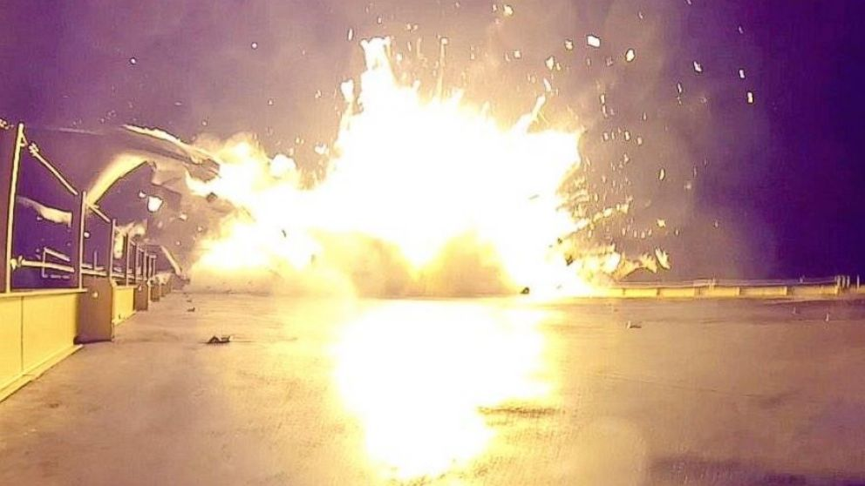

Unsuccessful Attempt at a Suicide Burn Landing by SpaceX

# Introduction

Landing rockets is difficult, as evinced by the recent failures and celebrated successes of SpaceX in landing an orbital first stage. It is also a necessary part of a cost-effective re-usable rocket system. The primary role of the first stage of an orbital rocket is to give as much speed and altitude as possible to the second stage, so that it can achieve orbit. The first stage is therefore traveling extremely fast after releasing the second stage, so fast that experiments with parachute recovery have all ended in failure. SpaceX and Blue Origin have recently tried a new approach: they use the rocket engines already on board the second stage to slow the rocket down for a soft landing.

If one is trying to land a rocket, one must first apply thrust to cancel out any horizontal velocity with respect to the surface one is landing on. Then, one needs to orient the rocket with its engine facing downwards, in the same position that it launched in, except moving the opposite direction. Finally, one must fire the engines in order to slow down the rocket, so that it comes to a stop just as its landing legs begin to touch the ground.

One strategy for landing rockets is to wait as long as possible to fire the engines, firing them at the last possible moment and at full thrust. This method, known as a “suicide burn” uses the least fuel, although it is difficult to control for errors, since there is a very small margin for error. To execute a sucide burn, the rocket only needs to know at what altitude to fire the engine so that it will come to a stop. It can be necessary since it is difficult to design rocket engines which can throttle to less than half of their maximum thrust, and therefore many rockets (such as SpaceX’s Falcon 9) are unable to hover, because they can’t apply a *small* enough force. In this case, a suicide burn is the only option.

I will discuss techniques for planning suicide burns for two scenarios. In both scenarios, the gravity is assumed to be of constant strength. This is a valid approximation when close to the surface of a planet. Since our rockets typically fire below 10km altitude for earth landings, we can safely use this approximation, which greatly simplifies calculations because the gravitational acceleration is now constant. In the first scenario, the rocket applies a set force to itself with the engine, and its mass is fixed (i.e., no propellant is consumed). This approximation is valid for slow landings, or landings which do not consume an appreciable fraction of the mass of the entire rocket in fuel. The second scenario takes into account the use of the fuel, and is therefore valid for faster landings. I will discuss the differences between the predictions of the two models. For each model, I will discuss how to determine the altitude at which to begin the deceleration burn.

# Model 1: Negligible Fuel Consumption

This model will start by determining the motion of the rocket both while the rockets are on and off. I will next determine how much distance a rocket will need to stop, if it is moving at a given velocity $v_{0}$. Finally, I will use the freely-falling motion model to predict at what altitude to begin the burn.

## Determining Accelerations

This model assumes that for the duration of the burn, the rocket’s mass has an approximately constant value, $m$. When the rockets are not firing, the acceleration is entirely due to gravity, and is $−g$. When the rockets are firing with force $F$, they exert an acceleration of magnitude $F/m−g$.

## Determining Stopping Distance

If the rocket is moving with speed $v_{0}$ at the moment it fires its engines, then its distance and velocity from the point of initial firing will be:

$$\begin{matrix}d(t) & =v_{0}t+1/2at^{2} \\ v(t) & =v_{0}+at\end{matrix}$$

When $v(t)=0$, the rocket has stopped. Therefore, the rocket stops at time:

$$\begin{matrix}t_{stop} & =\frac{−v_{0}}{a}\end{matrix}$$

At that time, its distance from the point of initial firing is:

$$\begin{matrix}d(t_{stop}) & =v_{0}\left(\frac{−v_{0}}{a}\right)+\frac{1}{2}a{\left(\frac{−v_{0}}{a}\right)}^{2} \\ d(t_{stop}) & =\frac{−v_{0}^{2}}{2a}\end{matrix}$$

Thus, if the rocket is moving at a speed $v_{0}$, it will take a distance $\frac{v_{0}^{2}}{2a}$ to stop.

## Determining Firing Altitude

When falling, the pilot should ignite the rocket when their altitude is equal to the stopping distance. In this subsection we will determine what altitude this will be, given the altitude and vertical velocity of the rocket.

Solving for the $t$ such that $d(t)=x(t)$, we find:

# Model with Fuel Consumption

In the previous model, we assumed that the rocket’s mass is essentially constant for the duration of the burn. If a rocket is attempting to land at high velocities, it will need to burn a significant fraction of its mass in propellant.

## Fuel Consumption

The rocket’s mass is assumed to be $m_{0}$ before the burn begins. The rocket’s engine, when operating at thrust $f$, will consume fuel at a constant rate $b$. Therefore, the mass of the rocket is given by:

$$\begin{matrix}m(t) & =m_{0}−bt\end{matrix}$$

as long as $t$ is small enough so that the rocket does not use up all its fuel.

## Forces on the Rocket

When the engine is not firing, the only force acting upon the rocket is gravity. This force causes a downwards acceleration of magnitude $g$.

When the engine is firing, gravity and thrust are acting upon the rocket and together cause an acceleration of $f/m(t)−g$ at time $t$.

## Velocity of the Rocket Under Power

Suppose the rocket is at an altitude $x_{0}$ and traveling with speed $v_{0}$, with none of its fuel consumed. At time $t=0$, it ignites its engines. Then, the velocity evolves according to the following differential equation:

$$\begin{matrix}\frac{dv}{dt}(t) & =\frac{f}{m(t)}−g\end{matrix}$$

This has the following solution which satisfies the boundary conditions:

$$\begin{matrix}v(t) & =v_{0}−gt+\frac{f}{b}log\left(\frac{m_{0}}{m_{0}−bt}\right)\end{matrix}$$

## Stopping Time

To determine the time until the rocket comes to a stop, we need to solve the equation $v(t)=0$ for $t$. This is difficult to express analytically, however, numerical methods exist to find the solution. The velocity as a function of time can be expanded to the second order about the origin, and this will provide an accurate initial guess for a numerical method such as newton’s method.

At the origin, the acceleration is $\frac{f}{m_{0}}−g$, and the jerk is:

$$\begin{aligned}
j(t) & = \frac {f b} {(m_0 - b t)^2} \nonumber \\
j(0) & = \frac {f b} {m_0^2}\end{aligned}$$

Therefore, the velocity as a function of time is approximately:

$$\begin{matrix}v(t) & ≈v_{0}+\left(\frac{f}{m_{0}}−g\right)t+\frac{fb}{2m_{0}^{2}}t^{2}\end{matrix}$$

and in this approximate expression, $t_{stop}$ is given by the solution to the equation:

$$\begin{matrix}0 & ≈v_{0}+\left(\frac{f}{m_{0}}−g\right)t+\frac{fb}{2m_{0}^{2}}t^{2}\end{matrix}$$

Solving this equation, we obtain the following approximate expression for $t_{stop}$:

$$\begin{matrix}t_{stop} & ≈\frac{\sqrt{a(0)^{2}+2j(0)(v_{f}−v_{0})}−a(0)}{j(0)}\end{matrix}$$

This guess can be improved by iterative procedures such as newton’s method. Note that if there is a propellent mass $m_{p}$ onboard, $bt_{stop}$ must be less than or equal to $m_{p}$. If it is not, then the rocket will not be able to stop itself.

## Stopping Distance

In order to know the distance the rocket takes to decelerate to a stop, one needs to determine the rocket’s position of a function of time. Fortunately, this is only as difficult as integrating the expression for the velocity. The result is shown below:

$$\begin{matrix}x(t) & =x_{0}+v_{0}t−\frac{1}{2}gt^{2}+\frac{f}{b}\left[−\left(m_{0}−bt\right)log\left(\frac{m_{0}}{m_{0}−bt}\right)−bt\right]\end{matrix}$$

Therefore, the distance required to stop, if moving at speed $v_{0}$, is, if $v(t_{stop})=0$:

$$\begin{matrix}d_{stop} & =v_{0}t_{stop}−\frac{1}{2}gt_{stop}^{2}+\frac{f}{b}\left[−(m_{0}−bt_{stop})log\left(\frac{m_{0}}{m_{0}−bt_{stop}}\right)−bt_{stop}\right]\end{matrix}$$

## Burn Altitude

We can finally solve the original problem from here: given a rocket’s initial position and velocity, find at what time and altitude it needs to burn at. The burn will start at a time $t_{fire}$ from the initial time $t=0$. At $t_{fire}$:

$$\begin{matrix}x(t_{fire}) & =d_{stop}(v(t_{stop}))\end{matrix}$$

We must determine $t_{fire}$.