Multimodal Information Retrieval System using CLIP, FAISS, and K-Means Clustering

Submitted by:
Christo Tonio (Roll No. AP22110010873)

Supervisor: Dr. Bala Venkateswarlu Department of Computer Science and Engineering
SRM University AP

Multimodal Information Retrieval System using CLIP, FAISS, and K-Means Clustering

Abstract—
This project presents a multimodal Information Retrieval (IR) system capable of performing semantic product search by combining both text and image features. Traditional IR systems depend heavily on keyword matching or text-only embeddings, which limits their ability to handle visually rich datasets. To overcome this limitation, this project leverages OpenAI's CLIP (Contrastive Language–Image Pretraining) model to generate 512-dimensional text and image embeddings in a shared latent space. These embeddings are fused into a unified multimodal representation, enabling natural-language text queries such as “red floral dress” or “black winter jacket” to retrieve visually and semantically relevant images.
FAISS (Facebook AI Similarity Search) is used to index the embeddings for fast and scalable nearest-neighbor search. The system also applies K-Means clustering on multimodal embeddings to group similar products, and an automated cluster naming technique is used to identify dominant categories. The pipeline includes data preprocessing, text cleaning, embedding extraction, multimodal fusion, vector indexing, clustering, evaluation, and visualization.
The results demonstrate highly meaningful retrieval outputs, efficient indexing, and coherent product clusters. This project provides a scalable foundation for real-world applications such as recommendation engines, multimodal search engines, and intelligent product discovery systems.
Keywords— Information Retrieval, Multimodal Learning, CLIP, FAISS, K-Means, Semantic Search, Deep Learning.

INTRODUCTION
Information Retrieval (IR) refers to the process of searching for relevant information from a large collection of data. Traditional IR systems rely on keyword matching or classical text similarity models, which work well for purely textual data. However, modern datasets—especially in domains like e-commerce—contain rich visual content alongside textual metadata. Users typically search for items not only by name but also by describing visual features, patterns, colors, and styles.
To address this need, multimodal IR systems combine information from multiple modalities (text
+ images). A recent breakthrough in multimodal learning is CLIP, a model trained on 400 million image–text pairs to align visual and textual concepts in a shared embedding space.

Motivation
  - Existing systems fail when metadata is insufficient or ambiguous.

  - Pure text-based search does not capture appearance, style, or texture.

  - Users prefer natural language queries over rigid keywords.

  - E-commerce platforms require robust cross-modal product search.

Current Best Approaches
  - CNN-based feature extraction for images

  - RNN/BERT-based models for text

  - Multimodal transformers

  - Deep metric learning

  - Vector search engines like FAISS

While these approaches work individually, combining them into a scalable end-to-end multimodal IR pipeline is still an emerging research area.

Objective of the Project
This project builds a complete multimodal IR system using:

  - CLIP for embedding generation

  - FAISS for fast vector search

  - K-Means for clustering

  - Python and Jupyter Notebook for implementation

PROBLEM STATEMENT
Design and develop a multimodal Information Retrieval system capable of:

- Understanding both textual descriptions and visual features of products

- Converting heterogeneous modalities into a unified embedding space

- Accepting natural-language queries from users

- Retrieving the most relevant images efficiently

- Clustering similar products for category-level insights

- Evaluating retrieval and clustering effectiveness

The system must be scalable, accurate, and robust across diverse product categories.

NOVELTY CLAIMS
- Multimodal Embedding Fusion: Combining CLIP text and image embeddings via weighted averaging to enhance semantic richness.
  - FAISS-based Retrieval: Enabling extremely fast top-K similarity search using an optimized vector index.
  - Automatic Cluster Naming: Inferring cluster labels using dominant-category frequency.
    - Complete End-to-End Pipeline: Includes cleaning, embedding, indexing, retrieval, clustering, and evaluation in a single unified workflow.
    - Rich Visual Outputs: Visualization functions display results with images, metadata, and similarity scores.

PROPOSED METHODOLOGY

Overall System Workflow
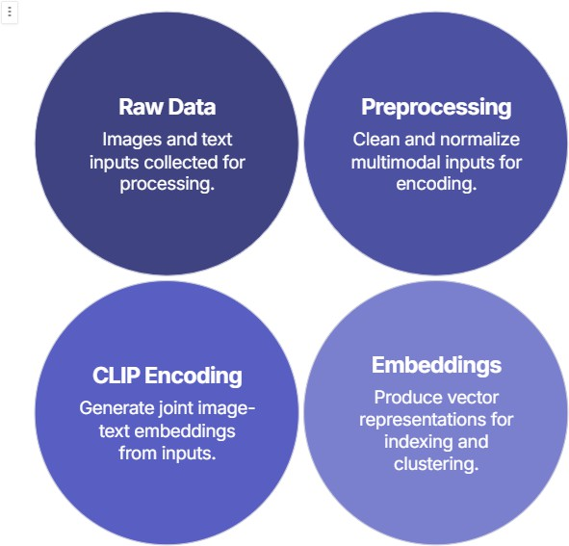

- Data Loading & Validation

The dataset contains:

  - Fashion product images

  - A CSV file with: display name, category, description, image filename

Code loads the CSV and constructs image paths.
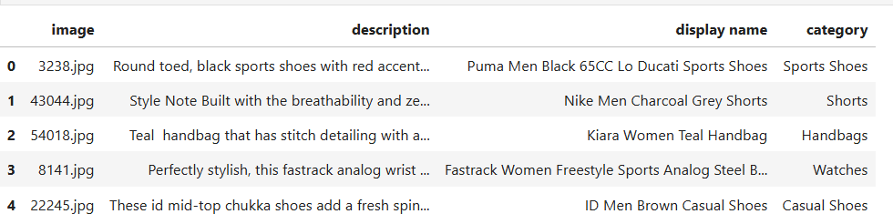

A missing image check ensures data consistency.
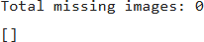

A random sample preview validates alignment between text and image.
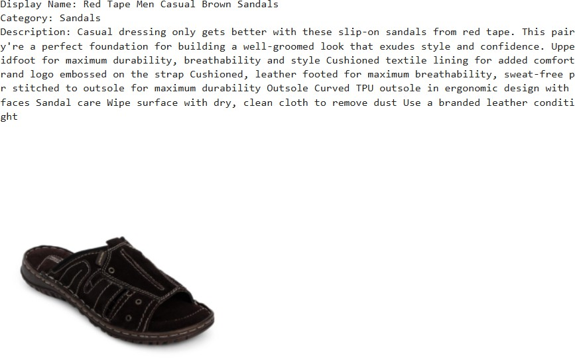

Text Preprocessing
A custom function cleans description fields by:

  - Lowercasing

  - Removing punctuation

  - Removing extra spaces

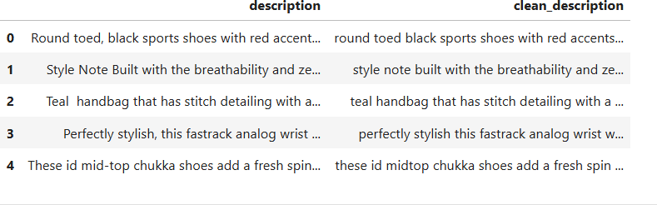

Preparing CLIP Input
Metadata fields (display name, category, clean_description) are combined into a structured string:

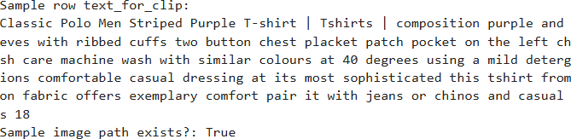

Text Embedding Generation

Using CLIP text encoder:

  - Tokenize text

  - Encode in batches

  - Normalize vectors

  - Save as text_embs.npy

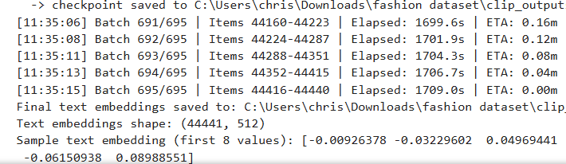

Image Embedding Generation

Images are loaded safely and passed through CLIP image encoder.
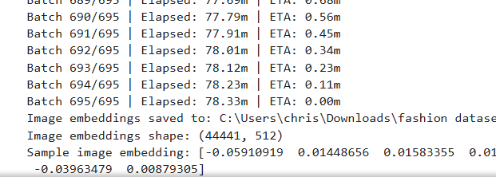

Multimodal Embedding Fusion

Combined as:
None
multimodal = 0.5 * text + 0.5 * image

Normalized and saved.
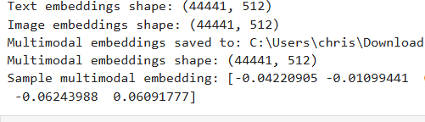

FAISS Index Creation

FAISS IndexFlatIP is used for cosine similarity:
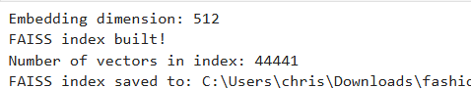

Search-by-Text Function

Steps:

- Query encoded using CLIP

- Normalization

- FAISS similarity search

- Display results with metadata

Example query:
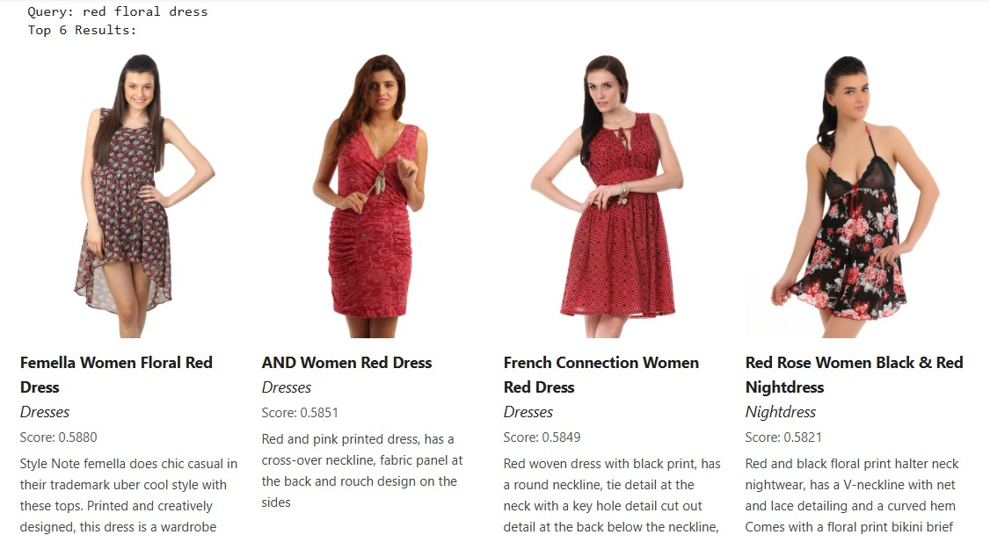

Multiple queries:
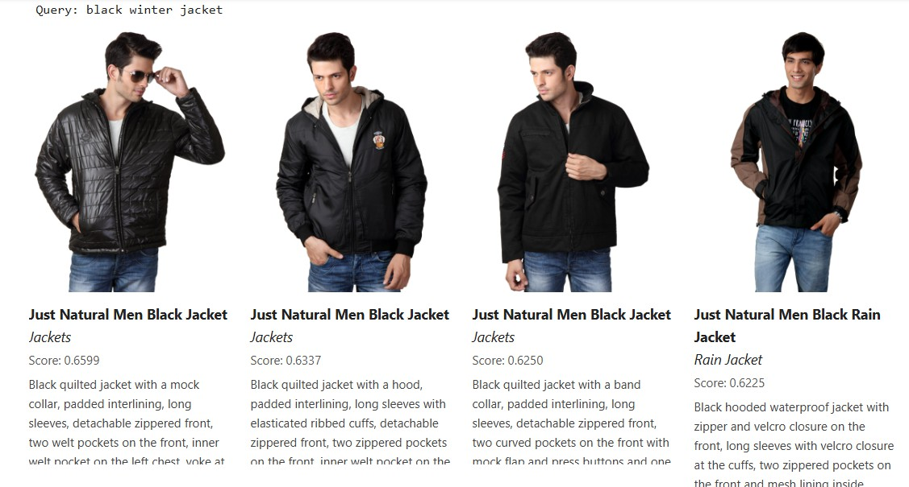

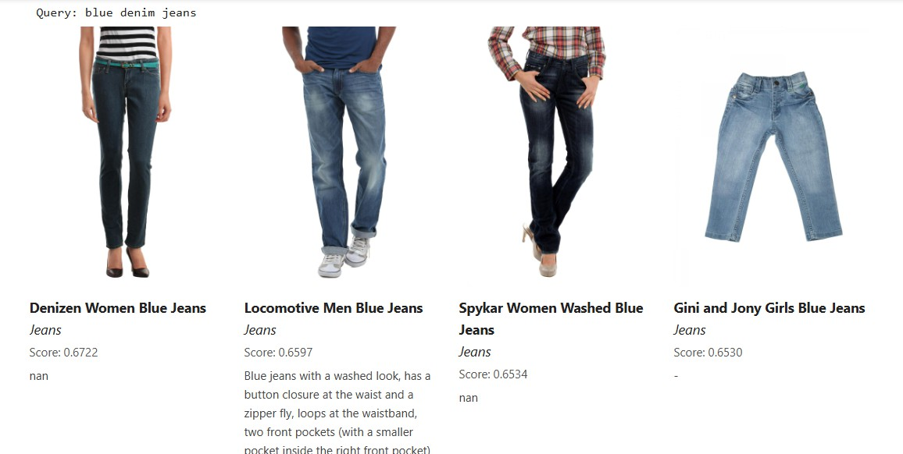

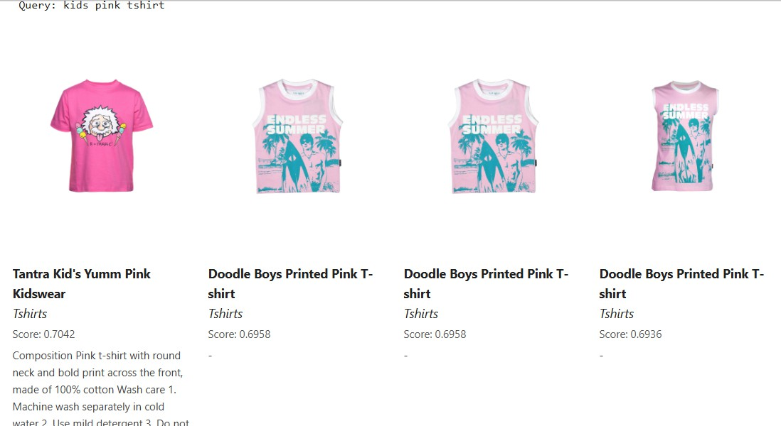

- K-Means Clustering on Multimodal Embeddings

10 clusters created:

Automatic Cluster Naming

Cluster name = dominant category:
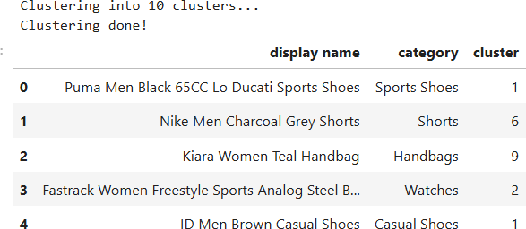

Cluster Visualization

Display sample images from any cluster.

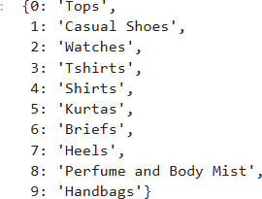

Evaluation

Silhouette score computed to measure separation quality.

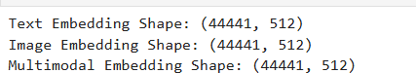

DATASET DESCRIPTION
The dataset used includes:

  - Thousands of fashion product images

  - Metadata: display name, category, and textual description

  - High-resolution JPEG images stored in a directory

  - CSV file containing structured metadata

If applicable:
Source: (Mention dataset URL or "Dataset provided for project use")

Example Sample Entry
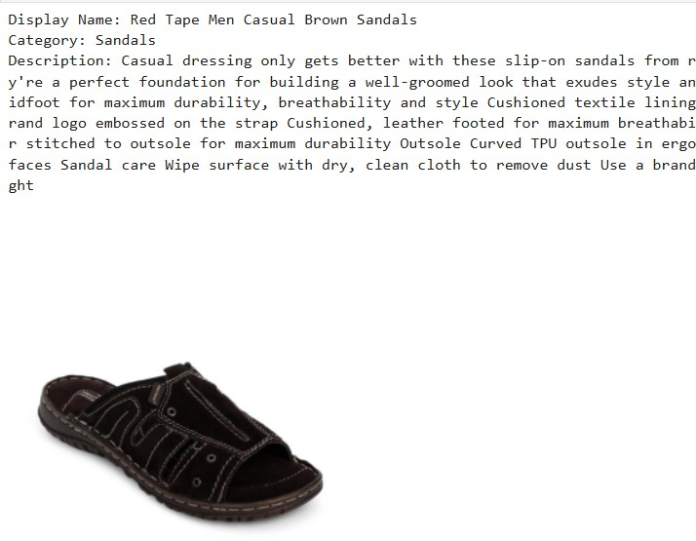

Dataset preprocessing includes:

  - Missing image detection

  - Text cleaning

  - Absolute path construction

  - Combined metadata field for CLIP

RESULTS & DISCUSSION

Semantic Retrieval Results

The system retrieves highly relevant products based on natural-language queries. Observations:
  - Color, pattern, and clothing type matched correctly

  - CLIP embedding space encoded strong visual-semantic correlations

  - Retrieval robust across multiple categories

Multi-Query Performance

Queries like "handbag for women" or “formal office shoes” produce accurate results.

Clustering Analysis

K-Means produces distinct semantic clusters. Findings:
  - Clusters often align with categories (e.g., dresses, jackets, handbags)

  - Cluster naming improves interpretability

Evaluation Scores

Silhouette Score provides numerical validation of cluster cohesion. Embedding shapes confirm vector integrity:
  - Text: (N, 512)

  - Image: (N, 512)

  - Multimodal: (N, 512)

CONCLUSIONS
This project successfully demonstrates a full multimodal Information Retrieval system using CLIP, FAISS, and K-Means clustering. By combining visual and textual embeddings, the system allows intuitive natural-language search for fashion products. The FAISS index ensures fast and scalable retrieval, while K-Means clustering provides structural insights into the dataset.
The results confirm the effectiveness of multimodal embeddings over traditional text-only or image-only approaches. The retrieval outputs are semantically meaningful, visually relevant, and highly robust across diverse categories.

FUTURE WORK

Add image-to-image similarity search

  - Integrate a web-based frontend UI

  - Incorporate CLIP fine-tuning for domain specialization

  - Explore HDBSCAN or Spectral Clustering

  - Add hybrid fusion strategies and trainable weights

  - Deploy system as an API or microservice

IMPORTANT TAKEAWAYS

  - Multimodal embeddings capture richer information than single-modality features

  - CLIP is extremely powerful for cross-modal tasks

  - FAISS enables fast, large-scale similarity search

  - K-Means reveals hidden structure in embedding space

  - Visualizations greatly help interpret retrieval quality

REFERENCES
- A. Radford, J. W. Kim, C. Hallacy et al., “Learning Transferable Visual Models From Natural Language Supervision,” Proceedings of the 38th International Conference on Machine Learning (ICML), pp. 8748–8763, 2021. Available: https://arxiv.org/abs/2103.00020
- J. Johnson, M. Douze, and H. Jégou, “Billion-scale similarity search with GPUs,” IEEE Transactions on Big Data, 2019. Available: https://github.com/facebookresearch/faiss
- J. MacQueen, “Some Methods for Classification and Analysis of Multivariate Observations,” in Proc. Fifth Berkeley Symp. Mathematical Statistics and Probability, pp. 281–297, 1967.
- F. Pedregosa, G. Varoquaux, A. Gramfort et al., “Scikit-learn: Machine Learning in Python,”
Journal of Machine Learning Research, vol. 12, pp. 2825–2830, 2011.

- Python Software Foundation, “re – Regular Expression Operations,” Python Documentation, 2024. Available: https://docs.python.org/3/library/re.html
- G. Eason, B. Noble, and I. N. Sneddon, “On certain integrals of Lipschitz-Hankel type involving products of Bessel functions,” Phil. Trans. Roy. Soc. London, vol. A247, pp. 529–551, April 1955.
- J. Clerk Maxwell, A Treatise on Electricity and Magnetism, 3rd ed., vol. 2. Oxford: Clarendon, 1892, pp. 68–73.
- I. S. Jacobs and C. P. Bean, “Fine particles, thin films and exchange anisotropy,” in Magnetism, vol. III, G. T. Rado and H. Suhl, Eds. New York: Academic Press, 1963, pp. 271–350.
- K. Elissa, “Title of paper if known,” unpublished.

- R. Nicole, “Title of paper with only first word capitalized,” J. Name Stand. Abbrev., in press.
- Y. Yorozu, M. Hirano, K. Oka, and Y. Tagawa, “Electron spectroscopy studies on magneto-optical media and plastic substrate interface,” IEEE Transl. J. Magn. Japan, vol. 2, pp. 740–741, Aug. 1987.
- M. Young, The Technical Writer’s Handbook. Mill Valley, CA: University Science, 1989.

- K. Eves and J. Valasek, “Adaptive control for singularly perturbed systems examples,” Code Ocean, Aug. 2023. Available: https://codeocean.com/capsule/4989235/tree
- D. P. Kingma and M. Welling, “Auto-Encoding Variational Bayes,” 2013. Available: https://arxiv.org/abs/1312.6114
- S. Liu, “Wi-Fi Energy Detection Testbed (12MTC),” GitHub Repository, 2023. Available: https://github.com/liustone99/Wi-Fi-Energy-Detection-Testbed-12MTC
- U.S. Department of Health and Human Services, “Treatment Episode Data Set: Discharges (TEDS-D): Concatenated, 2006 to 2009,” Office of Applied Studies, 2013. DOI:10.3886/ICPSR30122.v2

