**Day 1:**

Created Storage account in azure and a web container. Hosted a static web using blob service

Static Web - > Enabled

Web container - > Uploading of the Web file

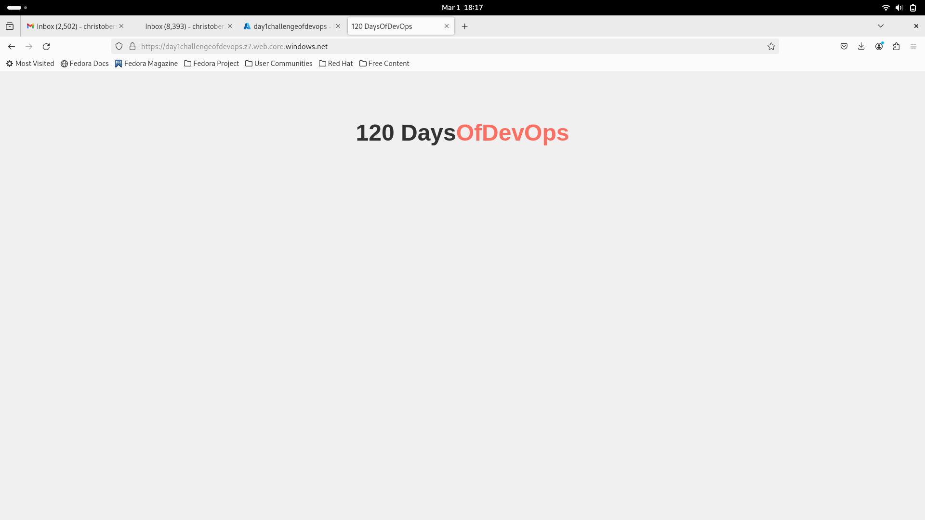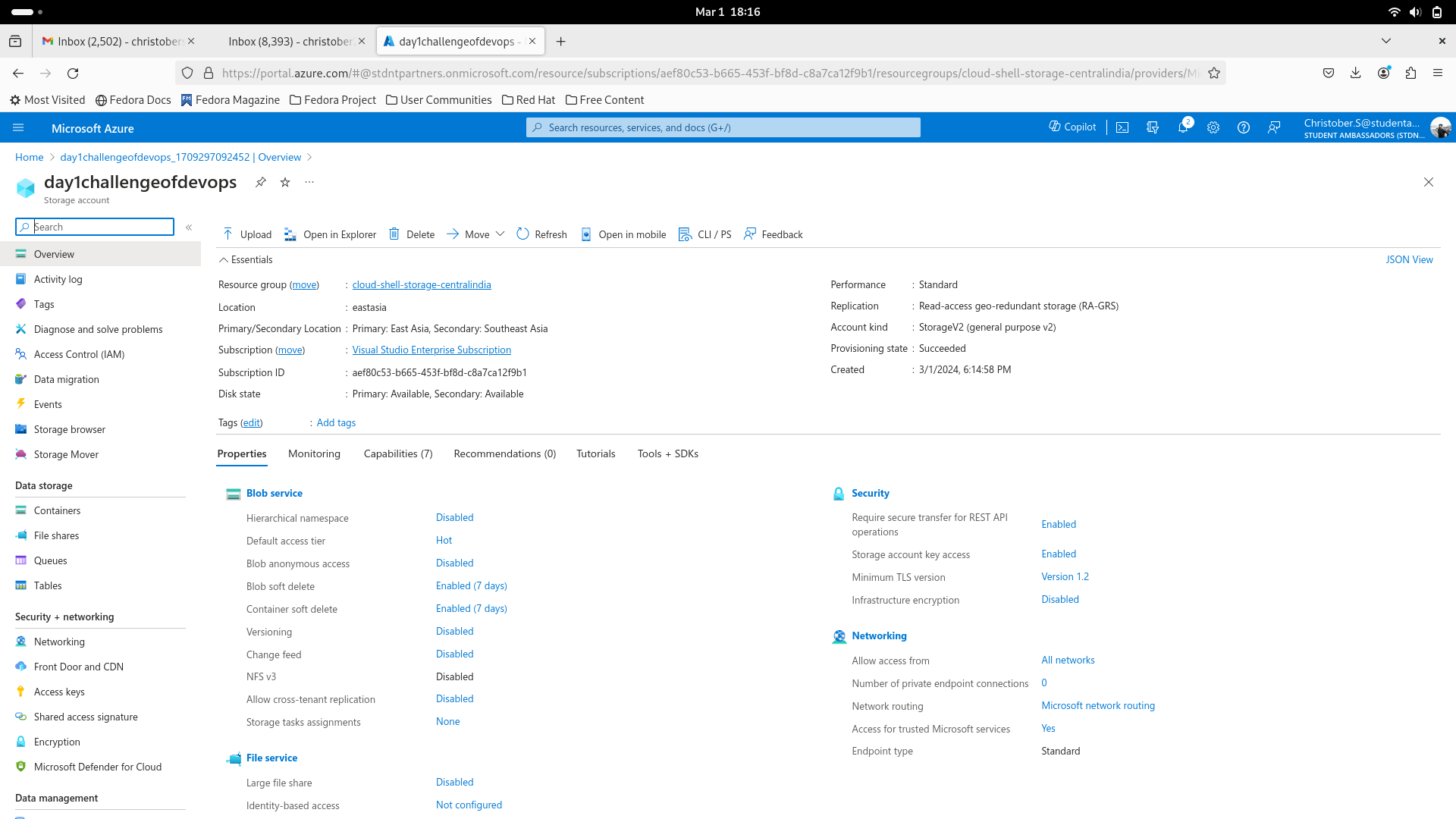

Jenkins setup in the Docker Container

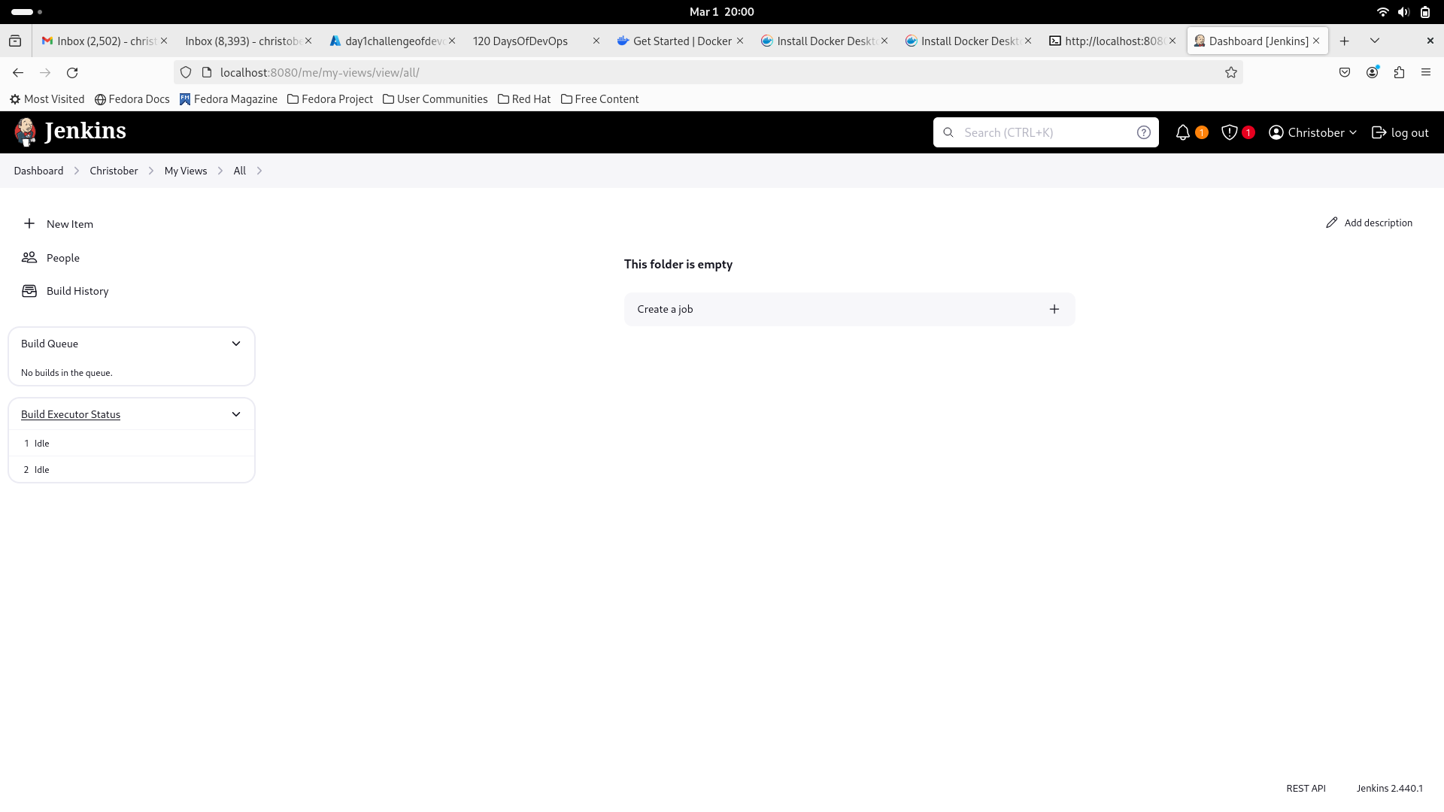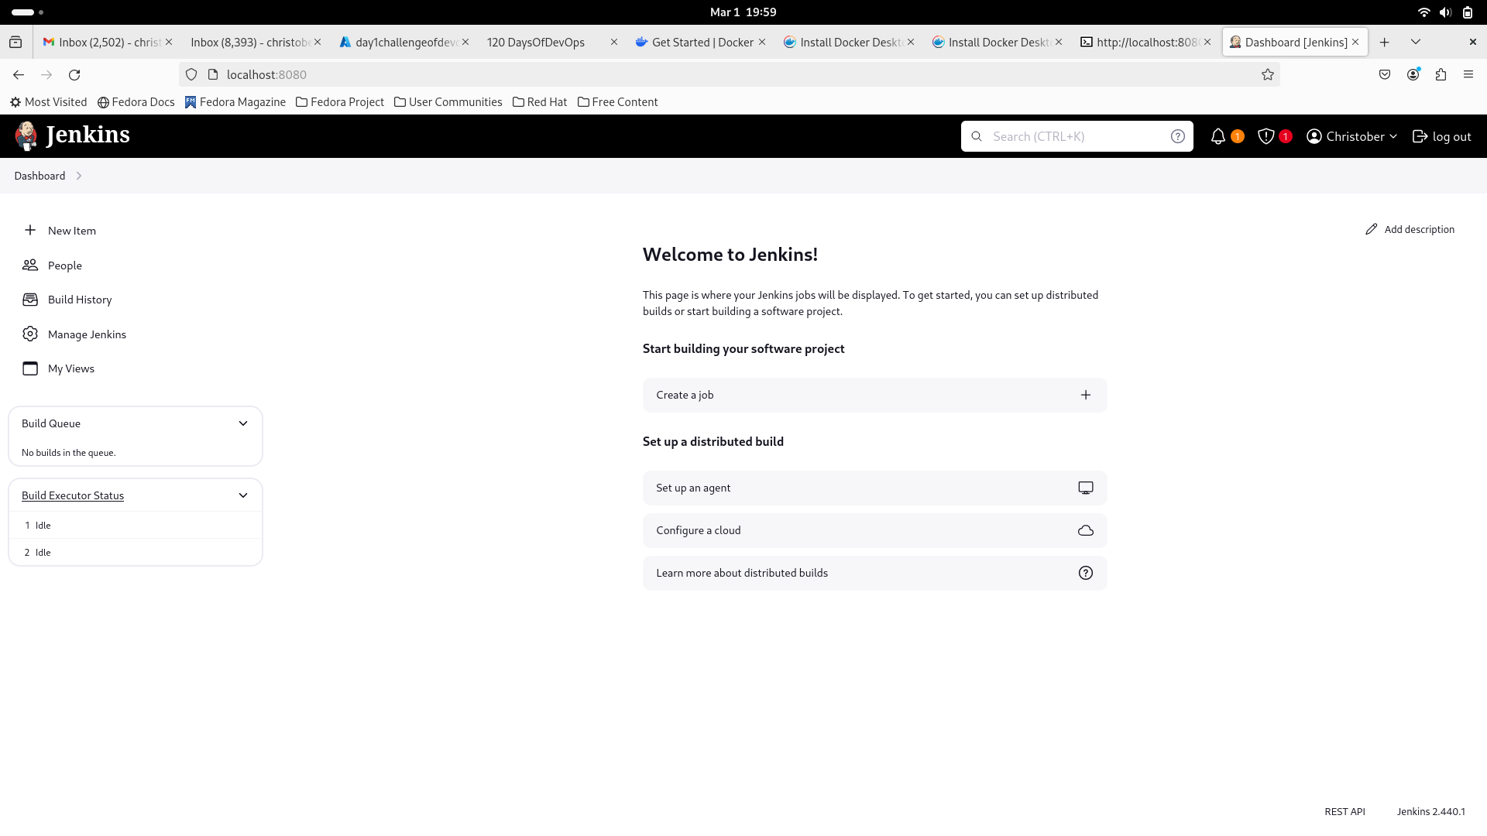

Cmd:

docker run -p 8080:8080 -p 5000:5000 -d -v jenkins_home:/var/jenkins_home jenkins/jenkins:lts