**DevOps (DevSecOps)**

Source -> Building APP -> Tools -> Deploy to server -> Managing after deployment

CI CD

Created EC2 instance on AWS

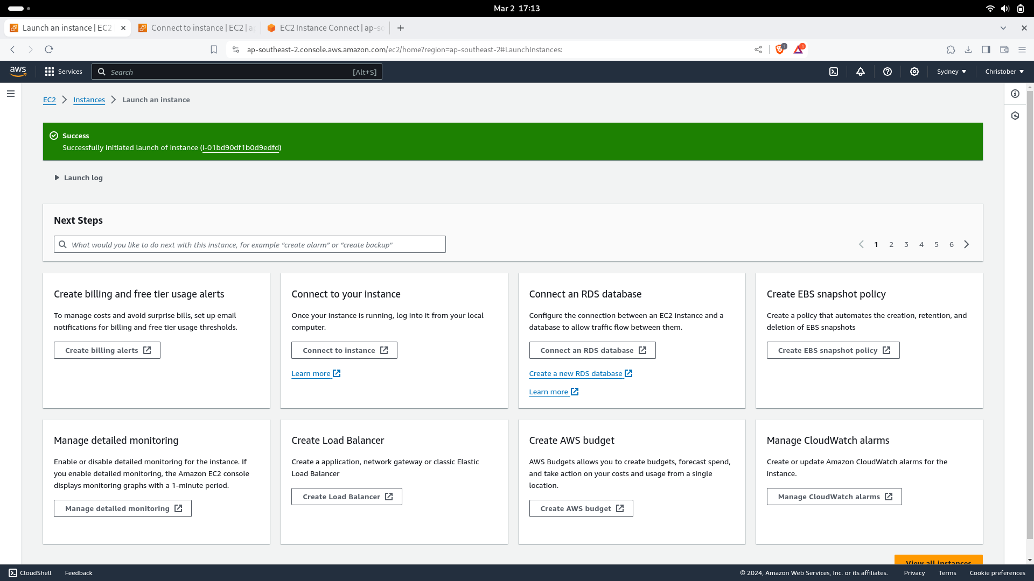

CMD:

sudo wget -O /usr/share/keyrings/jenkins-keyring.asc \

https://pkg.jenkins.io/debian-stable/jenkins.io-2023.key

echo deb [signed-by=/usr/share/keyrings/jenkins-keyring.asc] \

https://pkg.jenkins.io/debian-stable binary/ | sudo tee \

/etc/apt/sources.list.d/jenkins.list > /dev/null

sudo apt-get update

sudo apt-get install jenkins

This command is used to install jenkins on our ubuntu machine

sudo systemctl enable jenkins

sudo systemctl start jenkins

sudo systemctl status jenkins

Important Things to be noted:

Allows HTTPS, HTTP while creating an EC2 Instance

We have to create new rule with custom TCP port: 8080

Sudo cat /var/-> To see the password for setUp jenkins

Jenkins:

We can create new job by clicking the option of “create new job”

Manage Jenkins- Is the core part of Jenkins which is like a setting of jenkins

Configure System -> It is used to configure server’s in the Jenkins

Configure Tools -> It is used to configure Tools in the Jenkins

Plugins -> It is a place where we will download new tools from jenkins. Here we’ll Download what are the plugin are needed for us