Department of Regulatory Agencies
State Plumbing Board

PLUMBING RULES AND REGULATIONS
3 CCR 720-1
[Editor’s Notes follow the text of the rules at the end of this CCR Document.]

1.1 STATEMENT OF BASIS AND PURPOSE
A. The following Rules and Regulations of the Colorado State Plumbing Board (“Board”) are necessary for general clarification, efficient management, expeditious procedures, and safeguarding of the general public, in compliance with Title 12, Article 155 of the Colorado Revised Statutes. These Rules and Regulations shall be known, and may be cited, as “the Rules” and/or “these Rules.”
B. The Board adopts the following Rules pursuant to the authority granted to the Colorado State Plumbing Board (“Board”) by sections 12-155-105(1)(e) and 12-155-106(1) and (5), C.R.S., and hereby repeals all previous rules with the same number.
C. These Rules shall be binding on every person and legal entity authorized to practice, offer to practice, or perform plumbing or plumbing contracting as well as jurisdictions granted authority to perform permitting and inspections and their inspectors in Colorado. All licensees, registrants and plumbing inspectors under Title 12, Article 155 of the Colorado Revised Statutes are charged with having knowledge of the existence of these Rules and shall be deemed to be familiar with their provisions and to understand the Rules. In these Rules, the word “licensee” shall mean any person holding a master plumber license, journeyworker plumber license, or residential plumber license. In these Rules, the word “registrant” shall mean any person registered as a plumbing apprentice and any person or legal entity registered with the Board as a plumbing contractor.
D. These Rules are severable. If one rule or portion of a rule is found to be invalid, all other rules or portions of rules that can be enforced without the invalid rules shall be enforced and shall remain valid.

1.2 STANDARDS
A. Colorado Plumbing Code
The Board hereby adopts and incorporates by reference, with certain additions, revisions, and deletions, the following chapters, sections, and appendices of the International Plumbing Code (“IPC”) and International Residential Code (“IRC”).
These Rules, together with the following incorporated provisions, shall be known as the Colorado Plumbing Code. The Colorado Plumbing Code sets forth the minimum standards governing the inspection, installation, alteration, and repair of the plumbing fixtures, appliances, and systems throughout Colorado. The Colorado Plumbing Code does not include any later amendments to or editions of the IPC or IRC provisions listed below.
1. Chapter 1, Sections 101.2, 102, 105, 106.1, 106.3, 106.4, 106.5, 106.5.5, 106.6.1, 107, 108.1, 110.3 Chapters 2-13, 15; and Appendices B, C, D, and E of the IPC, 2024 edition promulgated by the International Code Council 1st printing (June 2023).
2. Chapter 1, Section R101, R102; Chapter 2; Chapter 3, Section R313.1 exceptions 1 and 2, Section R326; Chapters 25-32, of the IRC, 2024 edition, promulgated by the International Code Council, 1st printing (May 2024).
B. Colorado Fuel Gas Code
The Board hereby adopts and incorporates by reference, with certain additions, revisions, and deletions, the following chapters, sections, and appendices of the International Fuel Gas Code (“IFGC”) and the IRC. These Rules, together with the following incorporated provisions, shall be known as the Colorado Fuel Gas Code. The Colorado Fuel Gas Code sets forth the minimum standards governing the inspection, installation, alteration, and repair of fuel gas piping and systems throughout Colorado. The Colorado Fuel Gas Code does not include any later amendments to or editions of the IFGC and IRC provisions listed below.
1. Chapter 1 Section 101, 102, 105, 107, Chapters 2-8 save and except Sections 412 and 413, Appendices A-C of the IFGC, 2024 edition, promulgated by the International Code Council, 1st printing (October 2023).
2. Chapter 1, Section R101, R102; Chapter 2; Chapter 24, Sections G2411-G2422, and G2401.1-Table G2428.3(4) and G2448 of the IRC, 2024 edition, promulgated by the International Code Council, 1st printing (May 2024).
C. Public Copies
Copies of the provisions of the IPC, IFGC, and IRC, adopted and incorporated into the Colorado Plumbing Code and the Colorado Fuel Gas Code, are available for public inspection during regular business hours at the Board office at the Department of Regulatory Agencies Welcome Center, 1560 Broadway, Civic Center Plaza, Denver, Colorado, 80202, and at any state publications depository library. For further information regarding how this material can be obtained or examined, contact the Program Director for the Board (“Program Director”) at 1560 Broadway, Suite 1350, Denver, Colorado, 80202, (303) 894-2309. Copies of the IPC, IFGC, and IRC may be obtained from the International Code Council, 500 New Jersey Avenue, NW, 6th Floor, Washington, DC 20001. A list of ICC regional offices is available at http://www.iccsafe.org/AboutICC/Pages/ContactICC.aspx.
D. General Interpretations
The following shall apply to the Colorado Plumbing Code and Colorado Fuel Gas Code.
1. Code Official. Whenever the Colorado Plumbing Code and the Colorado Fuel Gas Code refer to “the code official,” it shall mean the Board or its designee, if any.
2. Reasonable Time. As used in the Rules, the term “reasonable time” shall mean thirty calendar days.
3. Amendments to the Colorado Codes. Any city, town, county or city and county which adopts more stringent standards than the Colorado Codes shall furnish a copy thereof to the Board.
4. Abbreviations
ANSI – American National Standards Institute
ASME – American Society of Mechanical Engineers
ASSE – American Society of Sanitary Engineers
ASTM – American Society for Testing and Materials
C.F.R. – Code of Federal Requirements
C.R.S. – Colorado Revised Statutes
ICC – International Code Council
NFPA – National Fire Protection Association
USC FCCC&HR – University of Southern California, Foundation for Cross-Connection Control and Hydraulic Research
5. Alternate Materials and Methods Review
a. Criteria. The Board shall consider requests for approval of alternate materials or methods under the procedures and limitations of Section 105 of the Colorado Plumbing Code and Colorado Fuel Gas Code.
b. Procedures
(1) Petitions for Approval. Any interested person may petition the Board to amend the Colorado Plumbing or Fuel Gas Code so as to approve the use of an alternate material or method, pursuant to Section 105 of the IPC. Such petition shall conform to the requirements in subsection (2)(b). Incomplete petitions will not be processed.
(2) Petition Contents. Each petition filed under this Rule shall comply with the following requirements:
(a) Where to Submit. Petitions shall be submitted in duplicate to the Program Director.
(b) Petition Document. Petitions shall begin with a short concise document labeled as the “petition,” and which includes the following information:
(i) Identification of the petitioner and the petitioner's interest in the alternate materials or methods approval. This identification shall designate one person as the Board's contact for the petition, and list telephone, fax, e-mail, and mailing addresses for that person.
(ii) A full description of the types of uses for which the petitioner would like approval. This list should be sufficiently detailed to allow the Board to consider specific types of applications or uses for the alternate material and/or method.
(iii) A complete identification of the applicable standards from the Referenced Standards identified in the Colorado Plumbing Code or Colorado Fuel Gas Code that the petitioner proposes to be the acceptance criteria for the alternate material or method.
(iv) If the petition is for approval of an alternate material, one sample of the material. The sample will be returned to the petitioner after completion of the review process.
(v) Copy of approval language of each code the petitioner cites.
(c) Submission of National Standards. Each petition shall be accompanied by a set of the applicable standards from the Referenced Standards identified in the Colorado Plumbing Code, Colorado Fuel Gas Code or other standards listed by the petitioner in Rule 1.2(D)(5)(b)(2)(iii). If the listed standard incorporates other standards into its criteria, copies of the incorporated standards shall be submitted as well.
(d) Results of Independent Third Party Compliance Testing. Each petition shall be supported with complete copies of test reports with protocols issued within the previous eighteen months prior to the date of submission by a laboratory or other testing facility that is recognized as a nationally recognized testing laboratory, pursuant to 29 C.F.R. section 1910.7, or by an ANSI accredited third-party certifier.
(e) Compliance with Section 104. Each petition shall be supported by detailed written discussion as to why the proposed alternate material or method meets the following requirements from Section 104 of the IPC and IFGC:
(i) That the proposed design of the proposed alternate material is satisfactory and complies with the intent of the Colorado Plumbing Code or Colorado Fuel Gas Code.
(ii) That the proposed material is appropriate for the proposed intended use at least the equivalent of that prescribed in the Colorado Plumbing Code or Colorado Fuel Gas Code with respect to quality, strength, effectiveness, durability and safety. This description requires that the petitioner directly compare the quality, strength, effectiveness, durability and safety data on the applicable conventional systems with the tested and documented performance characteristics of the proposed alternate material and/or method.
(iii) When an alternate installation method is proposed, the petitioner shall describe how the proposed method of installation conforms to the most recently adopted edition of the Colorado Plumbing Code or Colorado Fuel Gas Code.
c. Reconsideration of Board Action
Any petitioner whose petition has not been fully granted by the Board may apply for reconsideration of the Board’s decision within thirty days of the mailing of the Board's notice of denial, publication of notice of termination, or publication of the Board Rule that partially granted the petition. A request for reconsideration shall be in writing and shall explain why reconsideration is warranted. Action on any request for reconsideration is within the sole discretion of the Board.
6. Fee Establishment. Licensing, permit, and reinspection fees shall be established pursuant to section 12-20-105, C.R.S., and shall be categorized appropriately, such as original license, registration, endorsement, renewal, reinstatement fees, permit fees, and reinspection fees.
7. Information Only Sections. Installations detailed in the Colorado Plumbing Code that are typically not installed by plumbers (i.e., shower wall composition from Sections 421.4.1, IPC and P2710.1, IRC; Shower floors from Sections 421.5, IPC and P2709.2, P2709.3, IRC) are not subject to licensing, permitting or inspection but are informational only.
8. Definitions
a. Certified Cross-Connection Control Technician means a person who possesses a valid Backflow Prevention Assembly Tester certification from one of the following approved organizations: American Society of Sanitary Engineering (ASSE), the American Backflow Prevention Association (ABPA), or other agency recognized by the Board.
9. Clarification of “Domestic appliances” referenced in section 12-155-118(6)(a)(I), C.R.S. and “faucets” as shown in section 12-155-118(6)(a)(II), C.R.S.
Water heaters used to supply domestic hot water to a residential or commercial potable water system are not equipped with backflow preventers. Therefore, they do not fall under the exemption in section 12-155-118(6)(a)(l), C.R.S.
Shower valves and tub and shower valves referenced in 2021 IPC sections 412.3 to 412.8 and 2021 IRC section P2708.4 shall not be considered “faucets”. Therefore, they do not fall under the exemption in section 12-155-118-(6)(a)(II) CRS.
10. Clarification of back flow prevention device installation requirements.
A plumbing license is not required for persons engaged in the business of inspecting, testing, and repairing backflow prevention devices. Section 12-155-118(4), C.R.S., requires persons engaged in the installation and removal of such devices that are within the definition of plumbing to be a registered and licensed plumbing contractor.
E. Revisions and Exceptions to the Incorporated Codes
1. Revisions and Exceptions to the Colorado Plumbing Code
a. IPC Section 102.8 Referenced codes and standards
Delete in its entirety and replace with:
[A] 102.8 Referenced codes and standards. The codes and standards referenced in this code shall be those that are listed in Chapter 15 and such codes and standards adopted or recognized by the Plumbing Board shall be considered as part of the requirements of this code to the prescribed extent of each such reference.
b. IPC Section 105.5 Permit issuance
Add exception reading:
Exception: Where emergency plumbing is performed, the required permit may be obtained the following business day after the work has been started (i.e., broken water lines, broken drain lines, water heater replacements).
c. IPC Section 202 Definitions
Add new definitions to read:
Direct Supervision. Direct supervision means that the supervising licensed master plumber, journeyworker plumber, or residential plumber is physically present at the same physical addresses listed on the permits and where the apprentice is working or no more than five minutes distance from the apprentice within the same construction or job site.
d. IPC Section 202 Definitions
Add new definitions to read:
Trap drain. That portion of horizontal piping between the weir of a trap and the point where it intersects with the vent serving that same trap (trap arm).
e. IPC Section 202 Definitions
Delete the definition and replace with:
Fixture Drain. That portion of a plumbing drainage system that connects the trap drain to any other drain pipe receiving the discharge from one or more plumbing fixtures.
f. IPC Section 202 Definitions
Delete the definition and replace with:
Graywater. Wastewater that, before being treated or combined with other wastewater, is collected from fixtures within residential, commercial, or industrial buildings or institutional facilities for the purpose of being put to beneficial uses. Sources of graywater are limited to discharges from bathroom and laundry room sinks, bathtubs, showers, and laundry machines. Graywater does not include the wastewater from toilets, urinals, kitchen sinks, dishwashers, or non-laundry utility sinks.
g. IPC Section 202 Definitions
Delete the definition and replace with:
Reclaimed Water. Domestic wastewater that has received secondary treatment by a domestic wastewater treatment works (centralized system or a localized system) and such additional treatment as to enable the wastewater to meet the standards for approved uses.
h. IPC Section 305.1 Protection against contact.
Delete section in it's entirety and replace with:
IPC Section 305.1 Protection against contact. Piping except for, cast iron, ductile iron, and galvanized steel shall not be placed in direct contact with steel framing members. Piping shall not be placed in direct contact with concrete or cinder walls and floors, other masonry, and corrosive soil. Where sheathing is used to prevent direct contact, the sheathing shall have a thickness of not less than .025 inch (.64 mm). Where sheathing protects piping that penetrates concrete or masonry walls or floors, the sheathing shall be installed in a manner that allows movement of the piping within the sheathing.
i. IPC Section 306.2.4 Tracer wire
Delete in its entirety.
j. IPC Section 308 Interval of support
308.5 Interval of support
Add new sentence at the end of the section to read:
Hanger support rods shall be sized in accordance with table 308.5.1
k. Add new Table 308.5.1 Hanger Rod Size

Table 308.5.1 Hanger Rod Size
Pipe and Tube Size | Rod Size
½” – 4” | 3/8”
5” – 8” | ½”
10” – 12” | 5/8”

l. IPC Section 308.7.1 Location
Delete in its entirety and replace with:
308.7.1 Location. For pipe sizes greater than four inches (102 mm), restraints shall be provided for drain pipes utilizing mechanical joints at all changes in direction and at all changes in diameter greater than two pipe sizes. Braces, blocks, rodding and other suitable methods as specified by the coupling manufacturer shall be utilized.
m. IPC Section 312.1 Required tests
Delete the words “for piping systems other than plastic” and “After the plumbing fixtures have been set and their traps filled with water, the entire drainage system shall be submitted to final tests. The code official shall require the removal of any cleanouts if necessary to ascertain whether the pressure has reached all parts of the system.”
n. IPC Section 312.3 Drainage and vent air test
Delete the words “Plastic piping shall not be tested using air.”
o. IPC Section 312.5 Drainage and vent final test
Delete in its entirety.
p. IPC Section 312.6 Water supply system test
Delete the words “for piping systems other than plastic.”
q. IPC Section 312.10 Shower liner test
Delete in its entirety.
r. IPC Section 312.11.2 Testing
Delete the verbiage entirely and replace it with:
312.10.2 Testing. Reduced pressure principle, double check, pressure vacuum breaker, reduced pressure detector fire protection, double check detector fire protection, and spill-resistant vacuum breaker backflow preventer assemblies and hose connection backflow preventers shall be tested at the time of installation, immediately after repairs or relocation and at least annually by a certified cross connection control technician, in accordance with the applicable testing procedures associated with each specific certifying agency. When applicable the testing procedure shall be performed for the identified backflow prevention assembly in its entirety in accordance with one of the following applicable standards: ASSE 5013, ASSE 5015, ASSE 5020, ASSE 5047, ASSE 5048, ASSE 5052, ASSE 5056, CSA B64.10, CSA B64.10.1 or the testing procedures provided in the 10th Edition Manual of Cross-Connection Control from the University of Southern California’s Foundation for Cross-Connection Control and Hydraulic Research.
The testing procedures from the 10th Edition Manual of Cross-Connection Control from the University of Southern California’s Foundation for Cross-Connection Control and Hydraulic Research is incorporated by reference, and may be examined at the Colorado Plumbing Board’s office at 1560 Broadway, Suite 1350, Denver, Colorado 80202, during normal business hours, Monday through Friday, except days designated as state holidays. Certified copies of the 10th Edition Manual of Cross-Connection Control shall be provided at cost, upon request. The Board or the Board’s staff will provide information regarding how the 10th Edition Manual of Cross-Connection Control may be examined for free at the state public depository library. The 10th Edition Manual of Cross-Connection Control is also available from the agency, organization or association originally issuing the code, standard, guideline, or rule at: USC Foundation Office, Research Annex 219, Los Angeles, CA 90089-7700 or (https://fccchr.usc.edu/). This rule does not include any later amendments or editions of the code, standard, guideline, or rule.
s. IPC Section 403.1 Minimum number of fixtures
Add a new sentence to the end of the section to read as follows:
Lavatory to water closet or urinal ratios in accordance with Table 403.1 shall be maintained in all restrooms.
t. IPC Section 403.3 Employee and public toilet facilities, effective January 1, 2024
Add a new paragraph to the end of the section to read as follows:
All state departments (excluding K-12 schools), state agencies, state institutions of higher education, counties, cities, or municipality buildings that are newly constructed or are being remodeled shall provide an ADA-compliant single-user or an ADA-compliant multi-user non-gendered restrooms as required by section 9-5.7-103, C.R.S.
u. IPC Section 405.3.2 Public Lavatories
Add a new exception reading:
Exception: Lavatories located outside toilet facilities located within a classroom serving students from that classroom only. These toilet facilities and lavatories shall not count toward the total fixture count required by Table 403.1.
v. IPC Section 405.3.6 Service sink location
Add new section:
Service sinks, including mop sinks, shall not be permitted to be installed in toilet facilities, bathing rooms, or areas intended for the preparation of food.
w. IPC Section 410.4 Substitution.
Change first sentence to read:
Where restaurants (or spaces classified as an A2 occupancy) provide drinking water in a container free of charge, drinking fountains shall not be required in (these restaurants and A2 occupancies).
x. IPC Section 419.5
Add new sentence to the end of the section to read:
Lavatories in patient rooms of health care facilities shall be considered public for the purposes of this section.
y. IPC Section 421.7 Shower head location
Add new section to read:
421.7 Shower head location. Showerheads shall be located on the sidewall of shower compartments or be arranged so the shower head does not discharge directly at the entrance to the compartment and the bather can adjust the valve prior to stepping into the shower spray.
Exception: Showers of the roll in type installed in accordance with 2017 ANSI A117.1 or ICC A117.1.
z. IPC Section 421.8 Shower valve location
Add new section to read:
421.8 Shower valve location. A shower or tub/shower control valve shall be installed only where the spout and/or shower head discharges into an approved tub or shower compartment.
Exception: Emergency Showers.
aa. IPC Section 425.3 Water closet seats
Add new exception to read:
Exception: Water closets installed in public restrooms for the purpose of complying with accessible fixtures as required by Section 404 fitted with the “AXS-Wingman Universal Design Water Closet Seat” having a closed front are allowed.
bb. IPC Section 504.6.1 Collection of Relief Valve Discharge
Add new section 504.6.1 to read:
504.6.1. Collection of Relief Valve Discharge. A means shall be provided to capture the discharge from a relief valve and convey it to the sanitary drainage system or exterior of the structure either by gravity or a pumped discharge.
Exceptions:
(1) Replacements for existing water heaters.
(2) Where a water sensing device wired to a normally closed solenoid valve installed in the water supply piping to the heater is placed within the water heater drain pan.
cc. IPC Section 504.6.1.1 Pumped discharge of relief valve collection
Add new Section 504.6.1 to read as follows:
504.6.1.1 Pumped discharge of relief valve collection. Pumps used to discharge the clear water collection of relief valves shall have an operating temperature equal to or exceeding that of the relief valve discharge temperature and shall have a gpm rating equal to or greater than the discharge of the relief valve.
dd. IPC Section 504.7 Required pan.
Add new exception to read:
Replacements for water heaters that did not have a pan previously installed due to code in effect at the time of the original installation.
ee. IPC Section 604.3 Water distribution design criteria
Add new exception to read:
Exception: Interior domestic water distribution pipe sizing using IAPMO’s Water Demand Calculator shall be approved as an alternative method for calculations in residential and multifamily installations. This does not include water distribution calculations for fire prevention systems.
ff. IPC Section 605.15.2 Solvent cementing
Delete the exception in its entirety.
gg. IPC Section 608.3.1 Special equipment, water supply protection
Add additional wording to read:
The water supply for hospital fixtures and dental chairs shall be protected against backflow with a reduced pressure principle backflow prevention assembly, an atmospheric or spill resistant vacuum breaker assembly, or an air gap. Vacuum breakers for bedpan washer hoses shall not be located less than 5 feet (1524 mm) above the floor. Vacuum breakers for hose connections in health care or laboratory areas shall be not less than 6 feet (1829 mm) above the floor.
hh. IPC Section 608.9.1 Signage required
Delete the section in its entirety and replace with:
(1) Plumbing fixtures flushed with nonpotable water shall be identified with signage that reads as follows:
“Nonpotable water is used to flush this fixture. CAUTION: NONPOTABLE WATER – DO NOT DRINK.”
In addition to the required wordage, the pictograph shown in figure 608.8.1 shall appear on the required signage.
(2) A permanent warning sign must also be visible at all fixtures from which graywater is collected. The sign must state that:
“WATER FROM THIS FIXTURE IS REUSED. CHEMICALS, EXCRETA, PETROLEUM OILS AND HAZARDOUS MATERIALS MUST NOT BE DISPOSED DOWN THIS DRAIN.”
(3) For both types of fixtures indicated in subsections 1.2(E)(1)(ee)(1) and (2) above, the words shall be legibly and indelibly printed on a tag or sign constructed of corrosion-resistant waterproof material or shall be indelibly printed on the fixture. The letters of the words shall be not less than 0.5 inch (12.7 mm) in height and in colors in contrast to the background on which they are applied.
ii. IPC Section 608.9.2 Distribution pipe labeling and marking
Delete the section verbiage and replace with:
Nonpotable distribution piping shall be purple in color or the piping shall be installed with a purple identification tape or wrap the entire length of the piping and shall be embossed, or integrally stamped or marked, with the words: “CAUTION: NONPOTABLE WATER – DO NOT DRINK”.
jj. IPC Section 608-17 Connections to the Potable Water Systems
Add new subsection 608.17.2.1 to read:
Section 608.17.2.1 essentially nontoxic fluid conditioning chemical.
When the conditioning chemical introduced is an essentially nontoxic transfer fluid the potable supplier to the boiler shall, at a minimum, be equipped with a backflow preventer with an intermediate atmospheric vent complying with ASSE 1012 or CSA B64.3.
kk. IPC Section 608 Protection of potable water system
Add new subsection 608.17.11 to read:
Section 608.17.11 Connection to graywater system or reclaimed water system
The potable water system connection to a graywater system must be protected against backflow by an air gap or reduced pressure principle backflow prevention assembly.
ll. IPC Section 701.2 Connection to sewer required
Add exception 2:
Exception 2: Floor drains or trench drains installed in utility buildings and residential garages may be daylighted or discharged to an approved alternative disposal system when written approval has been provided from the jurisdiction having authority through CDPHE or sewer purveyor.
mm. IPC Section 705.10.2 Solvent cementing
Delete the exception in its entirety.
nn. IPC Section 706.3. Installation of fittings
Add sentence to end of IPC Section 706.3:
fixture crosses will not be required to meet the exception of IPC Section706.3
oo. IPC Table 706.3 Fittings for change of direction
Delete footnotes a and b from the table.
pp. IPC Section 708.1.3 Building drain and building sewer junction.
Add new sentence at the end of the section to read:
When the cleanout is installed at the junction of the building drain and building sewer, it shall be an approved two way fitting with a single riser not to exceed 4 feet in depth or a two riser cleanout using back to back combination fittings or equal of schedule 40 material. Cleanouts shall be installed and tested at underground or rough-in in accordance with Section 312.2.
qq. IPC Section 802.1.8 Domestic dishwashing machines
Add a new section to read:
Domestic dishwashing machines may be connected to a separately trapped stand pipe provided with an air break (with drain hose secured to the underside of the counter top) or air gap as shown in the illustration below. Refer to 2024 IPC 409.4 for additional waste connections.
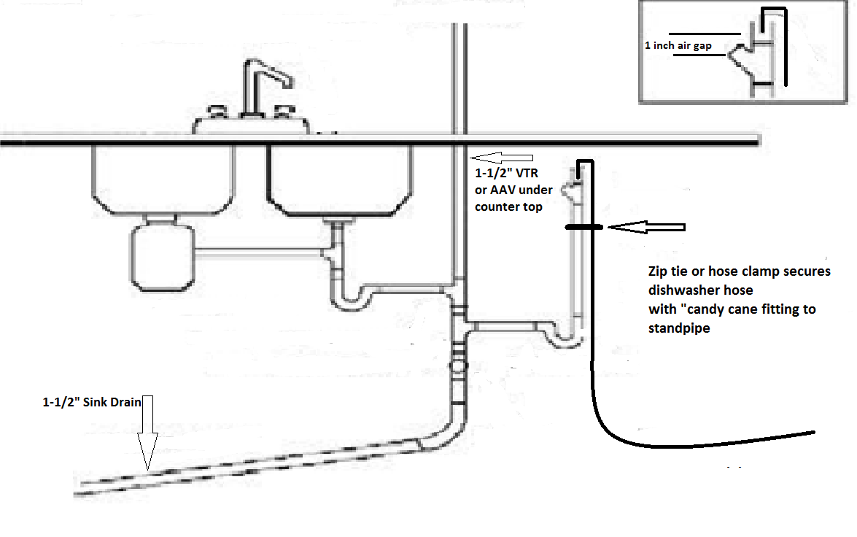
2” sink drain

rr. IPC Section 802.3 Installation
Delete the last sentence
ss. IPC Section 802.4 Waste receptors.
Add new exception to read:
Exception: Where equipment is installed in a crawl space, a waste receptor shall be allowed with an approved backwater valve installed.
tt. IPC Section 903.1.1 Roof extension unprotected
Insert 6 inches into the section so that it reads: “All open vent pipes that extend through a roof shall be terminated at least 6 inches above the roof.
uu. IPC Section 903.1.3 Protected vent terminal
Change wording to read 4 inches instead of 2 inches.
Section 903.1.3 Where an open vent pipe terminates above a sloped roof and is covered by either a roof-mounted panel (such as a solar collector or photovoltaic panel mounted over the vent opening) or a roof element (such as an architectural feature or a decorative shroud), the vent pipe shall terminate not less than 4 inches (102 mm) above the roof surface.
vv. IPC Section 903.2 Frost Closure
Delete in its entirety.
ww. IPC Section 912.1 Horizontal wet vent permitted
Add a new exception to read:
Exception: Fixtures other than those considered to be bathroom group fixtures, of equivalent drainage fixture units, may be included in the wet vented section provided the total number of drainage fixture units does not exceed the total number included in two bathroom groups and the fixtures not considered bathroom fixtures are valued at one drainage fixture unit or less.
xx. IPC Section 915.1 Type of fixtures
Add a new sentence to read:
Floor sinks shall be considered “sinks” for the purposes of this section.
yy. IPC Section 1002.1 Fixture traps
Add new exception 5 to read:
Exception: 5. Trench and floor drains connected to a sand oil interceptor need not be individually trapped provided the drain piping from the trench or floor drains is turned down after entering the interceptor so the discharge point is a minimum of 4 inches below the standing water level of the interceptor.
zz. IPC Section 1003.1 Where required
Add the following Exception:
Exception: Where special regulations exist by the local waste water and/or sanitation district into which the grease trap or interceptor effluent is transported and/or treated. These regulations may supersede this requirement.
aaa. IPC.1003.3.2 Food waste disposers restriction.
Add exception to read:
When using a gravity interceptor equal to or greater than 500 gallon capacity.
bbb. IPC Section 1101.3 Prohibited drainage
Add a new sentence to the end of the section reading:
Storm water from roof drains shall not discharge over public walkways except when an approved grated trough or trench drain sized to accept the calculated discharge is installed in the walkway. The discharge shall be diverted vertically from a height not greater than 12 inches to the grate.
Exception: Secondary drains.
ccc. IPC Section 1301.2.2 Filtration Required Exception
Modify section 1301.2.2 Exemption reading:
Nonpotable water utilized for water closet and urinal ﬂushing application shall be ﬁltered by a 100-micron or ﬁne ﬁlter.
Exception: Reclaimed water sources shall not be required to comply with these requirements. Graywater treatment systems installed in accordance with Section 1302.6.1 do not need to meet additional ﬁltration requirements.
ddd. IPC Section 1301 General
Add new section 1301.3.1 reading:
1301.3.1. Distribution pipe labeling and marking
Nonpotable distribution piping shall comply with Section 608.8.2 as amended in Rule 1.2(E)(1)(u).
eee. IPC Section 1301.3.2 Signage required graywater treatment works.
Add section new section 1301.3.2 reading:
For each room that contains graywater treatment works components, a sign that says “CAUTION GRAYWATER TREATMENT WORKS, DO NOT DRINK, DO NOT CONNECT TO THE POTABLE DRINKING WATER SYSTEM. NOTICE: CONTACT BUILDING MANAGEMENT BEFORE PERFORMING
ANY WORK ON THIS WATER SYSTEM" must be posted on any door providing entrance to the room.
fff. IPC Section 1301 General
Add new figure 1301.4
1301.4 Typical Graywater Collection System
(This figure is typical only, not a schematic)
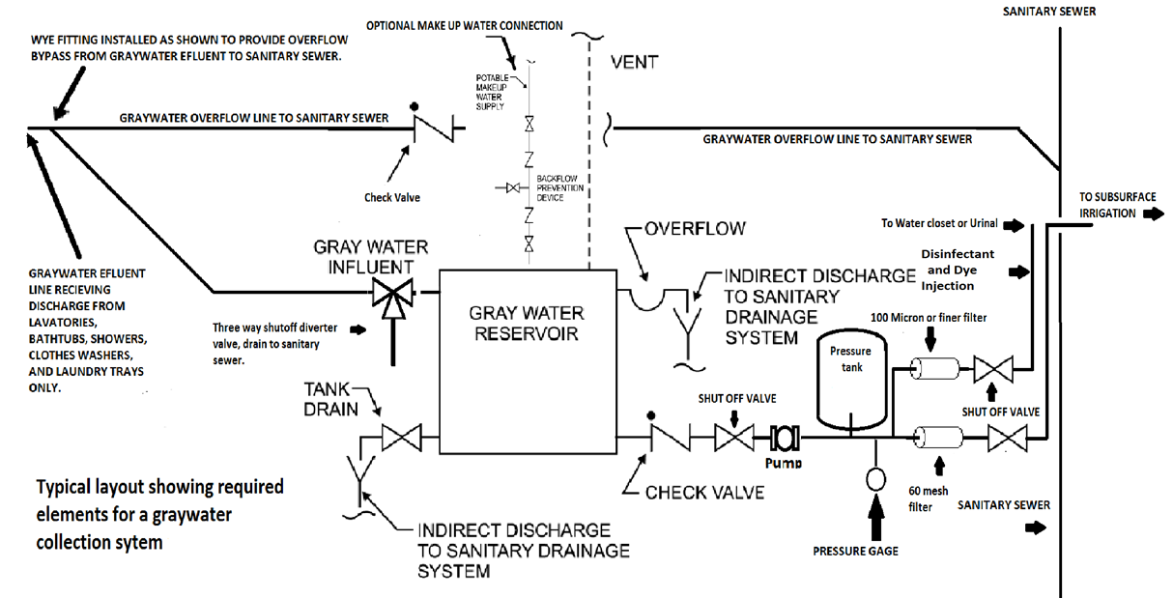

ggg. IPC Section 1301 General
Add new ﬁgure 1301.5
1301.5 Typical graywater system for toilet and urinal ﬂushing
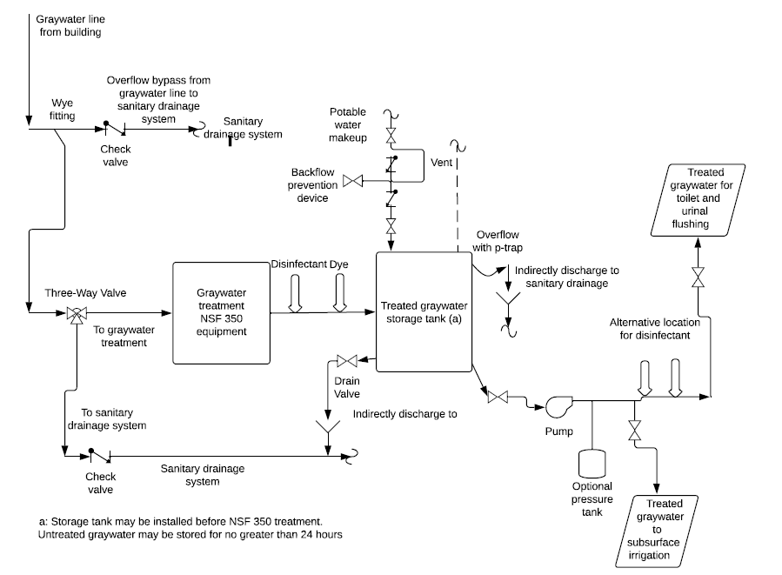

hhh. IPC Section 1301 General
Add new ﬁgure 1301.6
1301.6 Typical graywater system for disbursed subsurface irrigation system
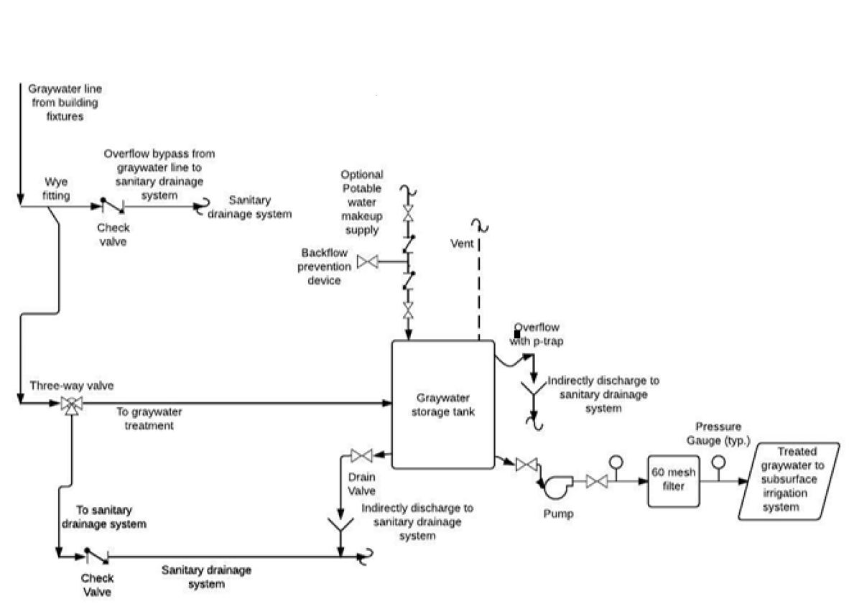

iii. IPC Section 1301 General
Add new ﬁgure 1301.7
1301.7 Typical graywater system for mulch basin subsurface irrigation
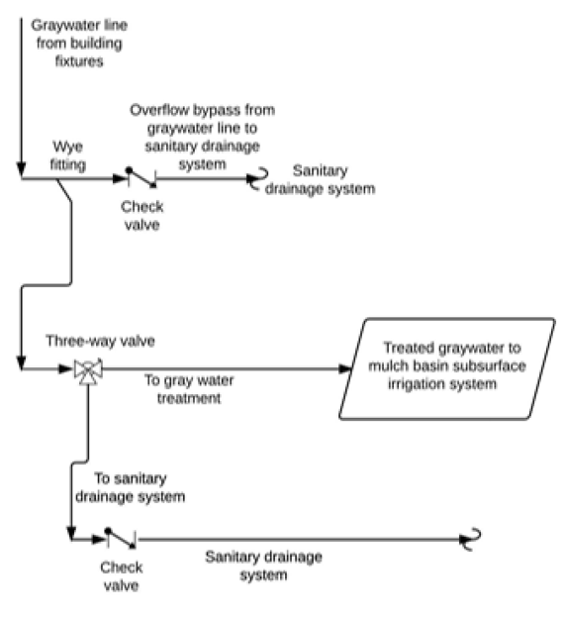
jjj. IPC Section 1301.9.2 Materials Exception Add section
1301.9.2 Exemption reading:
Exemption. Tanks are not required if the graywater use is comprised of only subsurface irrigation and ﬂows into a mulch basin system, where the mulch basin volume is three times the anticipated average daily ﬂow.
kkk. IPC Section 1301.9.5 Overflow
Delete the section verbiage and replace with:
The storage tank shall be equipped with an overflow pipe having a diameter not less than that shown in Table 606.5.4. The overflow pipe shall be protected from insects or vermin. The overflow drain shall not be equipped with a shutoff valve and shall discharge into the sanitary sewer either directly, or indirectly with a trap in the drain line to keep odors from escaping the tank. A cleanout shall be provided on each overflow pipe in accordance with Section 708.
lll. IPC Section 1301.9.8 Draining of tanks
Delete the text “shall discharge as required for overflow pipes and”. Replace it with: shall discharge into the sanitary sewer either directly, or indirectly with a trap in the drain line to keep odors from escaping the tank
mmm. IPC Section 1301.11 Trenching Requirements
Delete in its entirety.
nnn. IPC Section 1301.12 Outdoor Outlet Access
Delete in its entirety.
ooo. IPC Section 1302.1 General
Add a sentence to the end of the section saying:
All plumbing systems utilizing nonpotable water reuse systems shall have a reduced pressure backflow preventer device installed at the water service entrance immediately downstream of the building water service shut off valve.
ppp. IPC Section 1302.5 Filtration
Add a new sentence to the end of the section saying:
1302.5 Filtration: Graywater used for dispersed subsurface irrigation system requires a cartridge filter. The cartridge filter must be a minimum of sixty mesh located between the storage tank and the irrigation system.
Exemption. Filtration is not required for mulch basin subsurface irrigation systems.
qqq. IPC Section 1302.6.1 Graywater used for fixture flushing
Add a new sentence to the end of the section reading:
Graywater used for toilet and urinal flushing shall be dyed with blue or green food grade vegetable dye and be visibly distinct from potable water.
rrr. IPC Section 1302.7.3 Overflow
Add a new Section 1302.7.3 that reads:
1302.7.3 Overflow. Storage tank for on-site nonpotable systems must include an overflow line without a shut off valve. The overflow line shall be connected to the sanitary sewer indirectly. The overflow line must be the same or larger diameter line than the tank influent line. The overflow line connected indirectly must be trapped to prevent the escape of gas vapors from the tank
sss. IPC Section 1302.7.4 Venting
Add a new Section 1302.7.4 that reads:
1302.7.4 Venting. Storage tank for on-site nonpotable systems must be vented. Indoor tanks must be vented to the atmosphere outside the building or connected to the plumbing vent system.
ttt. IPC Section 1302.7.5 Tank Drains
Add a new Section 1302.7.5 that reads:
1302.7.5 Tank Drains. Storage tank for on-site nonpotable systems must include a valved drain. The drain shall be indirectly connected to the sanitary sewer. The tank drainline must be the same or larger diameter line than the tank influent line.
uuu. IPC Section 1302.8.1 Bypass Valve
Change the section heading and section verbiage to read:
Section 1302.8.1 System Bypass
Delete the section verbiage and replace with:
One three-way diverter valve listed and labeled to NSF 50 or other approved device shall be installed on collection piping upstream of any graywater treatment equipment, as applicable, to divert untreated on-site reuse sources to the sanitary sewer to allow servicing and inspection of the system. Bypass valves shall be installed downstream of fixture traps and vent connections. Bypass valves shall be marked to indicate the direction of flow, connection graywater treatment works, storage tank and graywater subsurface irrigation systems. Bypass valves shall be installed in accessible locations. Two shutoff valves shall not be installed to serve as a bypass valve. In addition to the bypass valve a series of drainage fittings shall be installed in the collection piping upstream of the bypass valve in a configuration that will allow the graywater from the plumbing fixtures to automatically flow directly into the sanitary sewer system in the event the filter or other parts of the collection system become clogged to the point of not allowing the effluent free flow through the system. The overflow line connected to the sanitary sewer shall be equipped with a backwater valve.
vvv. IPC Section 1303 Nonpotable rainwater collection and distribution systems
Delete in its entirety.
www. IPC Chapter 14 Subsurface graywater soil absorption systems
Delete in its entirety.
2. Revisions and Exceptions to the International Residential Code Part VII incorporated as the Colorado Plumbing Code
a. IRC Section 105.1 Required
Add exception reading:
Exception: Where emergency plumbing is performed, the required permit may be obtained the following business day after the work has been started (i.e., broken water lines, broken drain lines, water heater replacements).
b. IRC Section R202 Definitions
Add new definition to read as follows:
Multipurpose Residential Fire Sprinkler System. A Multipurpose Residential Fire Sprinkler System includes the domestic water distribution piping and the fire sprinkler piping which shall be a part of and connect to the cold water distribution piping at any point.
c. IRC Section R202 Definitions
Add new definitions to read:
Direct Supervision. Direct supervision means that the supervising licensed master plumber, journeyworker plumber, or residential plumber is physically present at the same physical addresses listed on the permits and where the apprentice is working or no more than five minutes distance from the apprentice within the same construction or job sites.
d. IRC Section R202 Definitions
Add new definition to read as follows:
Trap drain. That portion of horizontal piping between the weir of a trap and the point where it intersects with its vent.
e. IRC Section R202 Definitions
Delete the definition and replace with:
Fixture drain. That portion of a plumbing drainage system that connects the trap drain to any other drain pipe receiving the discharge from one or more plumbing fixtures.
f. IRC Section R202 Definitions
Add new definition to read as follows:
Manufactured Housing and Tiny Home Hookup-Sewer. The point of connection from the completed building drain to the building sewer, the building underground system, or on-site plumbing systems not part of the manufactured home or tiny home.
g. IRC Section R202 Definitions
Add new definition to read as follows:
Manufactured Housing and Tiny Home Hookup-Water. The point of connection from the completed manufactured home or tiny home water supply system to the site-installed potable water riser.
h. IRC Section 202 Definitions
Delete the definition and replace with:
Reclaimed Water. Domestic wastewater that has received secondary treatment by a domestic wastewater treatment works (centralized system or a localized system) and such additional treatment as to enable the wastewater to meet the standards for approved uses.
i. IRC Section P2503.5.1 Rough Plumbing
Delete the words “for piping systems other than plastic”.
j. IRC Section P2503.6 Shower liner test
Delete in its entirety.
k. IRC Section P2503.7 Water supply system testing
Delete the words “for piping systems other than plastic”
l. IRC Section P2603.3 Protection against corrosion.
Delete section in its entirety and replace with:
IRC P2603.3 Protection against corrosion. Piping except for, for cast iron, ductile iron, and galvanized steel shall not be placed in direct contact with steel framing members. Piping shall not be placed in direct contact with concrete or cinder walls and floors, other masonry, and corrosive soil. Where sheathing is used to prevent direct contact, the sheathing shall have a thickness of not less than .025 inch (.64 mm). Where sheathing protects piping that penetrates concrete or masonry walls or floors, the sheathing shall be installed in a manner that allows movement of the piping within the sheathing.
m. IRC Section P2605.2 Thermal expansion tanks.
Add new section P2605.2 to read:
P2605.2 Thermal expansion tanks. A thermal expansion tank shall be supported in accordance with the manufacturer’s instructions. Thermal expansion tanks shall not be supported by the piping that connects to such tanks.
n. IRC Section P2705.1 General
Add new exception to read:
Exception for remodels only: Lavatory clearance from its center to any sidewall or partition may be reduced to a minimum of twelve inches.
o. IRC P2706.1 General (waste receptors)
Add new exception to read:
Exception: Where equipment is installed in a crawl space, a waste receptor shall be allowed with an approved backwater valve installed.
p. IRC Section P2708.6 Shower head location
Add new section P2708.5 to read:
P2708.5 Shower head location. Shower heads shall be so located on the sidewall of shower compartments or be arranged so the shower head does not discharge directly at the entrance to the compartment and the bather can adjust the valve prior to stepping into the shower spray.
q. IRC Section P2717.3 Dishwasher drain
Add new section to read:
IRC Section P2717.3 Dishwasher drain. Dishwashers may drain into a standpipe complying with Section P2706.2 as shown in the following illustration. The standpipe shall be provided with an air break (with drain hose secured to the underside of the counter top) or air gap as shown in the illustration below.

2” sink drain

r. IRC Section P2801.5 Required pan.
Add new exception to read:
Exception: Replacements for water heaters that did not have a pan previously installed due to code in effect at the time of the original installation.
s. IRC Section P2804.6.2 Collection of Relief Valve Discharge
Add new section P2803.6.2 to read:
P2803.6.2 Collection of Relief Valve Discharge. A means shall be provided to capture the discharge from a relief valve and convey it to the sanitary drainage system or exterior of the structure either by gravity or a pumped discharge.
Exceptions:
(1) Replacements for existing water heaters.
(2) Where a water sensing device wired to a normally closed solenoid valve installed in the water supply piping to the heater, is placed within the water heater drain pan.
t. IRC Section P2803.6.2.1 Pumped discharge of relief valve collection
Add new Section P2804.6.2.1 to read:
P2803.6.2.1 Pumped discharge of relief valve collection. Pumps used to discharge the clear water collection of relief valves shall have an operating temperature equal to or exceeding that of the relief valve discharge temperature and shall have a gpm rating equal to or greater than the discharge of the relief valve.
u. IRC Section P2901.1 Potable water required
Delete the last sentence of the section.
v. IRC Section P2901.1.2.1 Signage required
Delete the section in its entirety and replace with:
Plumbing fixtures flushed with nonpotable water shall be identified with signage that reads as follows:
“Nonpotable water is used to flush this fixture. CAUTION: NONPOTABLE WATER – DO NOT DRINK.”
In addition to the required wordage, the pictograph shown in figure P2901.2.1 shall appear on the required signage.
w. IRC New Section P2901.1.2.3
Add new Section P2901.1.2.3 to read:
Graywater used for toilet and urinal flushing shall be dyed with blue or green food grade vegetable dye and be visibly distinct from potable water.
x. IRC Section P2901.2.2 Distribution pipe labeling and marking
Delete the section verbiage and replace with:
Nonpotable distribution piping shall be purple in color or the piping shall be installed with a purple identification tape or wrap the entire length of the piping and shall be embossed, or integrally stamped or marked, with the words: “CAUTION: NONPOTABLE WATER – DO NOT DRINK”.
y. IRC Section P2902.5 Protection of potable water connections
Add new subsection P2902.5.1.1 to read:
Section P2902.5.1.1 Essentially nontoxic fluid conditioning chemical.
When the conditioning chemical introduced is an essentially nontoxic transfer fluid the potable supplier to the boiler shall, at a minimum, be equipped with a backflow preventer with an intermediate atmospheric vent complying with ASSE 1012 or CSA B64.3.
z. IRC New Section P2902.5.6 Protection of potable water system
Add new subsection P2902.5.6 to read:
Section P2902.5.6 Connection to graywater system or reclaimed water system
The potable water system connection to a graywater system or reclaimed water system must be protected against backflow by an air gap or reduced pressure principle backflow prevention assembly.
aa. IRC Section P2903.10.1 Service valve.
Delete the words "with provision for drainage such as a bleed orfice or installation of a separate drain valve"
bb. IRC Section P2904 General
Delete in its entirety and replace with:
P2904.1 General. Where installed, residential fire sprinkler systems, or portions thereof, shall be in accordance with NFPA 13D or Section P2904, which shall be considered equivalent to NFPA 13D. Section P2904 shall apply to multipurpose wet-pipe sprinkler systems that do not include the use of antifreeze. A multipurpose fire sprinkler system shall supply domestic water to both fire sprinklers and plumbing fixtures. A backflow preventer shall not be required to separate the sprinkler system from the water distribution system.
cc. IRC Section P2910 Nonpotable Water Systems
Add new Figure P2910.4 Typical Graywater Collection system.
(This figure is typical only, not a schematic)

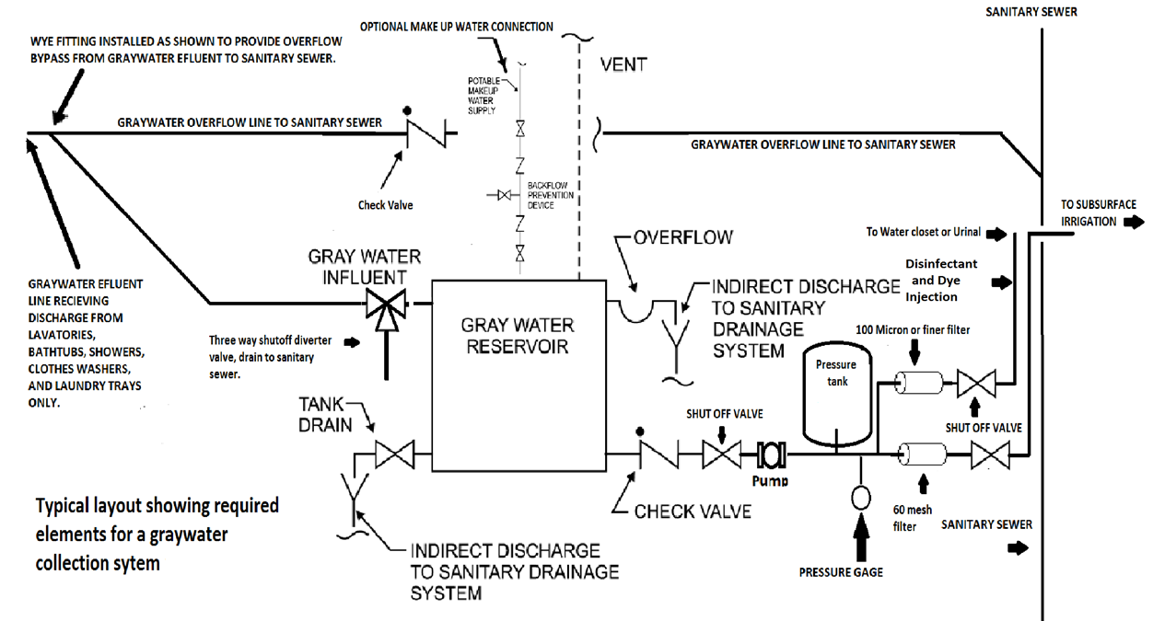
dd. IPC Section 2910.1 Scope
Add a sentence to the end of the section saying:
All plumbing systems utilizing nonpotable water reuse systems shall have a reduced pressure backflow preventer device installed at the water service entrance immediately downstream of the building water service shut off valve.
ee. IRC Section P2910.2.2 Filtration Required Exception
Modify section Exemption to read:
P2910.2.2 Filtration Required. Nonpotable water utilized for water closet and urinal ﬂushing application shall be ﬁltered by a 100-micron or ﬁne ﬁlter.
Exception: Reclaimed water sources shall not be required to comply with these requirements. Graywater treatment systems installed in accordance with Section P2911.6.1 do not need to meet additional ﬁltration requirements.
ff. IRC Section P2910 Graywater recycling systems
Add new ﬁgure Section 2910.5

gg. IRC Section P2910 Graywater recycling systems
Add New Figure Section 2910.6
2910.6 Typical graywater system for disbursed subsurface irrigation system

hh. IRC Section P2910 General
Add new ﬁgure Section 2910.7
2910.7 Typical graywater system for mulch basin subsurface irrigation

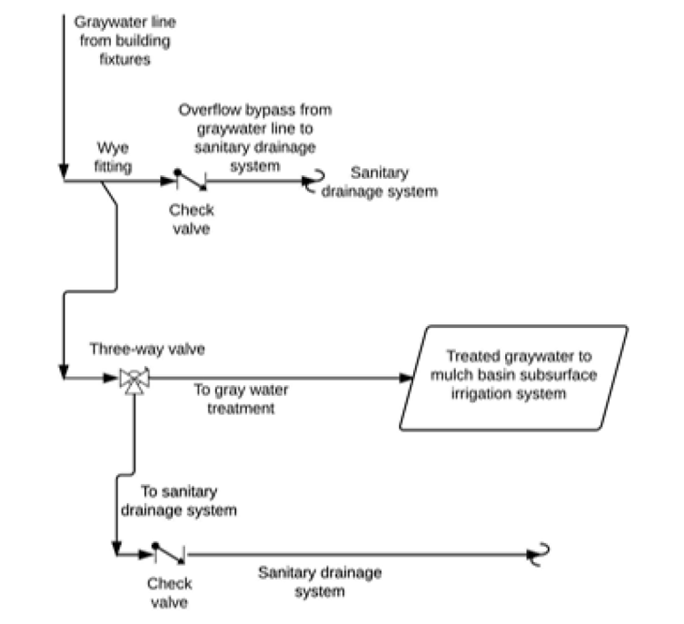
ii. IRC Section 2910.9.3 Materials
Add section Exemption to read:
Exemption. Tanks are not required if the graywater use is comprised of only subsurface irrigation and flows into a mulch basin system, where the mulch basin volume is three times the anticipated average daily flow.
jj. IRC Section 2911.5 Filtration
Delete the section in its entirety and replace with:
P2911.5 Filtration. Graywater used for dispersed subsurface irrigation system requires a cartridge filter. The cartridge filter must be a minimum of sixty mesh located between the storage tank and the irrigation system. If a pump is being used to pressurize the graywater distribution system the filter must be located after the pump. Filters shall be accessible for inspection and maintenance. Filters shall utilize a pressure gauge or other approved method to provide indication when a filter requires servicing or replacement. Filters shall be installed with shutoff valves immediately upstream and downstream to allow for isolation during maintenance.
Exemption. Filtration is not required for mulch basin subsurface irrigation systems.
kk. IRC Section P2911.7.6 Overflow
Add a new Section P2911.7.6 that reads:
P2911.7.6 Overflow. Storage tank for on-site nonpotable systems must include an overflow line without a shut off valve. The overflow line shall be connected to the sanitary sewer indirectly. The overflow line must be the same or larger diameter line than the tank influent line. The overflow line connected indirectly must be trapped to prevent the escape of gas vapors from the tank.
ll. IRC Section P2911.7.4 Venting
Add a new Section P2911.7.4 that reads:
P2911.7.4 Venting. Storage tank for on-site nonpotable systems must be vented to the atmosphere or connected to the plumbing system vent piping.
mm. IRC Section P2911.7.5 Draining of tanks
Add a new Section P2911.7.5 that reads:
P2911.7.5 Draining of tanks. Storage tank for on-site nonpotable systems must include a valved drain. The drain line shall be connected to the sanitary sewer either directly or indirectly. The tank drain line must be the same or larger diameter line than the tank influent line.
nn. IRC Section P2911.8.1 Bypass valve
Section P2911.8.1 System Bypass
Delete the section verbiage and replace with:
One three-way diverter valve listed and labeled to NSF 50 or other approved device shall be installed on collection piping upstream of any graywater treatment equipment, as applicable, to divert untreated on-site reuse sources to the sanitary sewer to allow servicing and inspection of the system. Bypass valves shall be installed downstream of fixture traps and vent connections. Bypass valves shall be marked to indicate the direction of flow, connection to graywater treatment works, storage tank and graywater subsurface irrigation system.. Bypass valves shall be installed in accessible locations. Two shutoff valves shall not be installed to serve as a bypass valve. In addition to the bypass valve a series of drainage fittings shall be installed in the collection piping upstream of the bypass valve in a configuration that will allow the graywater from the plumbing fixtures to automatically flow directly into the sanitary sewer system in the event the filter or other parts of the collection system become clogged to the point of not allowing the effluent free flow through the system. The overflow line connected to the sanitary sewer shall be equipped with a backwater valve.
oo. IRC Section 3001.1 Scope
Add exception 1:
Exception 1: Floor drains or trench drains may be allowed to be daylighted or discharged to an approved alternative disposal system when written approval has been provided from the jurisdiction having authority.
pp. IRC Section P3003.9.2 Solvent cementing
Delete wording, “or other approved primer” and delete exception in its entirety.
qq. IRC Table P3005.1 Fittings for changes in direction
Delete footnotes “a” and “b” from table P3005.1 and adding wording to section P3005.1.1 stating: Fixture crosses will not be required to meet the exception of this section.
rr. IRC Section P3005.2.3 Building drain and building sewer junction.
Add new sentence at the end of the section to read:
When the cleanout is installed at the junction of the building drain and building sewer, It shall be an approved two way fitting with a single riser not to exceed 4 feet in depth or a two riser cleanout using back to back combination fittings of schedule 40 material. Cleanouts shall be installed and tested at underground or rough-in in accordance with Section P2503.5.
ss. IRC Section P3008.1 Where required (backwater valves)
Delete section in its entirety and replace with:
Backwater valves shall be installed where waste receptors are located in a crawl space for the purpose of receiving condensate discharge from equipment located in that crawl space. Refer to new exception for 1.2(E)(1)(pp).
tt. IRC Section P3009 Graywater soil absorption systems
Delete in its entirety.
uu. IRC Section P3103.1.3 Roof extension covered
Change wording to read 4 inches instead of 2 inches.
Section P3103.1.3 Where an open vent pipe terminates above a sloped roof and is covered by either a roof-mounted panel (such as a solar collector or photovoltaic panel mounted over the vent opening) or a roof element (such as an architectural feature or a decorative shroud), the vent pipe shall terminate not less than 4 inches (102 mm) above the roof surface.
vv. IRC Section P3103.2 Frost closure
Delete in its entirety.
ww. IRC Section P3108.1 Horizontal wet vent permitted
Add a new exception to read:
Exception: Fixtures other than those considered to be bathroom group fixtures, of equivalent drainage fixture units, may be included in the wet vented section provided the total number of drainage fixture units does not exceed the total number included in two bathroom groups and the fixtures not considered bathroom fixtures are valued at one drainage fixture unit or less.
3. Revisions and exceptions to the International Fuel Gas Code incorporated as the Colorado Fuel Gas Code
a. IFGC Section 101.1 Title
Delete in its entirety.
b. IFGC Section 101.2.3 Piping Systems
Delete the words “and maintenance” from the end of the last sentences.
c. IFGC Section 101.2.5 Systems, appliances and equipment outside the scope.
Delete 13 from the list.
d. IFGC Section 303.3. Prohibited locations
Replace the words “toilet rooms” with “toilet facilities” in the section.
e. IFGC Section 403.9.6 Welded joints
Add new section 403.9.6 to read:
403.9.6 Welded Joints. Welded joints shall be performed by a person holding a valid certificate of competency based on the requirements of the ANSI/ASME Boiler and Pressure Vessel Code, Section IX, Brazing and Welding Qualifications. Welded joints shall comply with ASTM 139.
f. IFGC Section 404.14.1 Conduit with one end terminating outdoors
Delete in its entirety.
g. IFGC Section 406.1 Inspection, Testing, and Purging
Add a new sentence to the end of the section reading:
Inspection and pressure testing shall apply to all temporary installations connected to a primary or temporary fuel gas source, natural or LP gas, for the purpose of supplying temporary heat.
h. IFGC Section 409.5.3 Located at manifold
Delete in its entirety.
i. IFGC 409.6 Shutoff valve for laboratories
Add new subsection 409.6.1 to read
409.6.1 Electric Solenoid Valve. A remotely located electric solenoid emergency shutoff valve may be used for compliance to Section 409.6, when all the following requirements are met.
(1) The emergency control shutoff “panic button” shall be readily accessible, located within the laboratory space served, adjacent to all egress doors from the space and shall be identified by approved signage stating “Gas Shutoff”.
(2) The gas solenoid valve shall be a “normally closed” type valve with a manual reset.
j. IFGC Section 411.1 Connecting appliances
Add additional line (10).
10. Gas turrets for use in school or laboratory science rooms can be considered an appliance and may be allowed to be connected by an approved appliance connector in accordance with ANSI Z21.24 that is installed downstream of a shutoff valve as approved in Section 409.
k. IFGC Section 503.4.1 Plastic Piping,
Add new sentence to the end of the section saying:
Where installed as an exhaust vent for a gas fired water heater, the new plastic pipe shall be tested with 5 psi air pressure or 10 ft. head water column at the time of inspection prior to being connected to the water heater.
Engineered UL-1738 vent systems do not require the pressure test as long as they are properly installed per the manufacturer's instructions.
4. Revisions and exceptions to the International Residential Code Chapter 24 Fuel Gas incorporated as the Colorado Fuel Gas Code
a. IRC Section G2414.9.6 Welded joints
Add new section G2414.10.5 Welded joints to read:
Welded joints. Welded joints shall be performed by a person holding a valid certificate of competency based on the requirements of the ANSI/ASME Boiler and Pressure Vessel Code, Section IX, Brazing and Welding Qualifications. Welded joints shall comply with ASTM 139.
b. IRC 2415.14.1 Conduit with one end terminating outdoors
Delete in its entirety.
c. IRC Section G2420.5.3 (Shutoffs) Located at manifolds
Delete in its entirety.
d. IRC G2427.4.1 Plastic Piping,
Add new sentence to the end of the section saying:
Where installed as an exhaust vent for a gas fired water heater, the new plastic pipe shall be tested with 5 psi maximum air pressure or 10 ft. head water column at the time of inspection prior to being connected to the water heater.
Engineered UL-1738 vent systems do not require the pressure test as long as they are properly installed per the manufacturer's instructions.

1.3 APPRENTICES REGISTRATION AND RECORDKEEPING
A. Registration
1. The Board may require the supervising plumbing contractor of a plumbing apprentice to provide information verifying the apprentice’s record of employment and practical experience, including but not limited to a written attestation from the responsible master plumber verifying that the apprentice has been performing plumbing work during any period the apprentice was not registered. Supervising plumbing contractor of apprentices shall cooperate with any request from the Board pursuant to this Rule and furnish such information or assistance as the Board may request.
2. An individual that holds an active residential plumber’s license and is working on a commercial job site must be registered as an apprentice.
3. An employer who fails to timely register an apprentice within 30 days or less of employment as required by section 12-155-108(2)(a), C.R.S., and this Rule shall be subject to disciplinary action pursuant to sections 12-155-113(1) and 12-20-404, C.R.S.
4. An employer who fails to inactivate an apprentice from their company’s registration within 30 days of termination of employment shall be subject to the same disciplinary action as Board Rule 1.3(A)(3) above.
B. Recordkeeping. Plumbing contractors shall maintain employment records or work reports for their individuals under their supervision in order to provide experience verification. Such records or reports shall accurately document the number of hours and months the individual performed plumbing work as defined by section 12-155-103, C.R.S., and should specifically reflect:.
1. Exact dates of employment
2. Number of hours and months of residential plumbing experience; and,
3. Number of hours and months of commercial or industrial plumbing experience
C. Plumbing Contractors shall provide an experience verification form prepared and furnished by the Board within 30 days of their termination or resignation, and upon request indicated in Board Rule 1.3(B).
D. Exemption for Apprentice Required to Exam. Apprentices seeking exemption to the requirements of section 12-155-124(4), C.R.S., must meet the following criteria established in accordance with section 12-155-124(4)(a)(II), C.R.S., which requires circumstances that justify the exemption.
1. An apprentice deployed to serve in the United States Military in accordance with military orders may be granted exemption to the examination requirements of section 12-155-124(4), C.R.S.
a. Apprentice must meet the examination attempt requirements within the statute.
b. A request, including supporting evidence and documentation for Board consideration, must be submitted at least 15 days prior to deployment.
(1) Acceptable evidence of deployment include but may not be limited to the following documentation that must clearly state the date and length of deployment, and be issued by the United States Military.
(a) Copy of Deployment Orders;
(b) Report or letter from a senior officer; and/or
(c) Other military evidence of deployment.
(2) Special consideration of timely submission may be given with evidence of short notice deployment.
2. Exemption will be applied:
a. When calculating the years of apprentice registration that requires an examination per the statute;
b. For the actual time the apprentice is deployed and actively registered as an apprentice with the Board; and
c. So that times of deployment that may disadvantage the apprentice may not be counted.
E. Direct Supervision. Direct Supervision of apprentices is defined within Board Rules, sections 1.2(E)(1)(c) and (2)(c).

1.4 APPLICATIONS AND LICENSING
A. Applications for License or Registrations.
1. Submission. All applications for licensure or registrations shall be submitted to the Division of Professions and Occupations. Candidates must pass the required examination(s) before submitting an application to the Board with the required experience and education.
2. Incomplete Application. An application for a license by examination or endorsement or a registration submitted without all required fees and documentation will be considered incomplete. Incomplete applications will be retained for one year from the date originally received, after which applicants shall begin the process again including payment of the application fee.
3. Documentation for Plumbing License. Applicants shall provide documented written evidence of all in state and out of state experience on experience verification forms prepared and furnished by the Board which shall include all of the following:
a. Exact dates of employment.
b. Breakdown of plumbing work performed in:
(1) Commercial, residential and industrial; and,
(2) Increments of hours and months.
c. Signature of the master plumber for, or a signatory authority of, the plumbing contractor, or employer.
d. If training and experiences were obtained all or in part from an accredited high school vocational technical training course, community college, or trade school program, a transcript from the accredited high school vocational technical training course, community college or trade school verifying completion of the program shall be submitted with the application. The program length shall be a minimum of two years. Such education may replace actual field experience under a licensed master as follows: one hour of classroom training equals one hour of on the job training up to a maximum of one year, with 2000 hours equaling one year.
e. If training and experiences were obtained all or in part from military training in plumbing work, detail and submit such for evaluation with the application. Such experience may replace actual field experience under a licensed master as follows: one month for every six months' training or experience up to a maximum of one year.
f. The hours of practical experience required to qualify for licensure are:
(1) Residential Plumber 3,400
(2) Journeyworker Plumber 6,800
(3) Master Plumber 8,500
g. Applicants cannot verify their own experience.
4. Documentation for Water Conditioning Installer, Principal, or Contractor. Any applicant for registration shall furnish evidence upon request as to his or her training and experience to qualify for registration.
a. Water Conditioning Installer.
(1) Any applicant for a water conditioning installer registration shall possess the following qualifications and experience:
(a) Knowledge of water quality, water quality issues, and problems common to water sources.
(b) Knowledge of the analysis and treatment of water for impurities, water softening, drinking water options, reverse osmosis and water filtration.
(c) Knowledge of common water treatment system operations, including water softening, reverse osmosis, and water filtration.
(d) Knowledge of hydraulics fundamentals including plumbing distribution system operations, pressure loss and cross connections, effects on public safety, flow rates, and code requirements for safe drainage.
(e) Knowledge of recommended practices, including legal and ethical considerations in the water treatment industry.
(f) Knowledge of disinfection methods, including standard disinfectants and methods, water contamination problems, UV and chemical disinfection systems, disinfection of private water sources, and final barrier water treatment.
(g) Knowledge of water analysis fundamentals including selection of tests for analysis, reading and interpreting water analyses, and conducting and interpreting water tests.
(h) Experience with water conditioning installation.
(i) Knowledge of general installation principles including POE and POU water treatment systems, including related safety considerations.
(2) Any applicant for a water conditioning installer registration shall possess and maintain an active Certified Installer (CI) certification from the Water Quality Association or an equivalent certification as approved by the Plumbing Board.
b. Water Conditioning Principal.
(1) Any applicant for a water conditioning principal registration shall possess the following qualifications and experience:
(a) All items listed in the previous subsection 1.4(A)(5)(a)(1) of these Rules.
(b) Knowledge of common water problems including: nitrates, bacterial contamination, iron/manganese/hydrogen sulfide, and arsenic.
(c) Ability to design water treatment systems to address regional water issues such as Endocrine Disruptors and Pharmaceuticals, Radium/Barium/Radioactive Decay, and Tannins.
(d) Knowledge of methods to calculate pressure loss in distribution systems.
(2) Principal. Any applicant for a water conditioning principal registration shall possess and maintain an active Certified Installer (CI) certification and an active Certified Water Specialist (CWS) or Master Water Specialist (MWS) certification from the Water Quality Association or an equivalent certification or certifications as approved by the Plumbing Board.
c. Water Conditioning Contractor. Any applicant for a water conditioning contractor must be or employ full time a water conditioning principal.
d. Water Conditioning Contractor's Loss of Water Conditioning Principal. A water conditioning contractor that, for any reason, loses the services of the water conditioning principal will be allowed twenty days in which to hire another water conditioning principal. If another water conditioning principal has not been hired during that period, the water conditioning contractor registration will be placed into a “Need WC Principal Hire-Cannot Practice” status until such time as a principal has been hired, and the appropriate fee paid.
B. Licenses and Registration Issuance.
1. Issuance. Residential, journeyworker or master plumber licenses will be issued upon successful passing of the respective examination and meeting the qualifications within Title 12 of Article 155, C.R.S. Water conditioning registrations shall be issued upon application approval based on proper documentation as outlined in 1.4(A)(4) of these Rules.
a. By endorsement. Licensees from another state may be eligible for licensure by endorsement providing that the applicant meets the requirements of section 12-155-116, C.R.S., and all of the following conditions:
(1) Completion of a state or federally approved or registered apprenticeship program, or completion of the required years and type of experience for the comparable license.
(2) Successful completion of a comparable state plumbing examination based on the current or previous edition of the plumbing code adopted by the Board.
(3) Currently holds an active license by the endorsing state.
C. Disapproval
1. Reconsideration. An applicant requesting reconsideration of a Board action concerning a disapproval of an application or license by endorsement or requesting a personal interview before the Board, shall submit the request in writing, accompanied by additional information or documentation. This request shall be submitted within forty-five days of the date on which the Board made the decision. The Board may not consider requests filed thereafter.
D. [Repealed eff.06/14/2020]
E. Renewal and Reinstatement (Effective July 1, 2020)
1. Renewal.
a. A licensee or registrant shall have a sixty-day grace period after the expiration of the license or registration to renew such license or registration without having to submit a reinstatement application. During this grace period a delinquency fee will be charged for late renewals.
b. A licensee or registrant who does not renew his or her license or registration shall be ineligible to practice until such license or registration is reinstated. If the licensee or registrant practices with an expired license or registration, the Board may impose disciplinary actions.
2. Reinstatement. An expired license or registration may be reinstated by submitting a reinstatement application, paying the current reinstatement fee, and meet the appropriate requirements below.
a. Expired for More Than Sixty Days But Less Than Two Years. If the license or registration has expired for more than sixty days but less than two years, the applicant must provide evidence of completion of continuing education complaint with requirements of Board Rule 1.4(E)(3), since applicant’s most recent licensing event (original; license, renewal, or reinstatement) preceding the application for reinstatement, of eight hours of continuing education, complaint with requirements of Board Rule 1.4(E)(3).
b. Expired for More Than Two Years. If the license has been expired for more than two years, pursuant to section 12-155-112(2)(b)(II), C.R.S. the applicant must demonstrate competency to practice by any of the following:
(1) Satisfactorily passing the State plumbing examination;
(2) Provide a verification of an active, substantially equivalent license in good standing from another state and proof of active practice in that state for the year immediately prior to the date of the reinstatement application;
(3) Holding an active Colorado plumbing license that is more advanced that the license to be reinstated; or
(4) By other means that may be approved by the Board.
c. In the case of Water Conditioning Installers and Water Conditioning Principals, registrants shall re-affirm that their certifications per board Rule 1.4(A)(5) are current and active.
3. Continuing Education Requirements
a. Statutory Basis. Pursuant to section 12-155-112(3)(b) C.R.S, the Board shall adopt rules establishing continuing education requirements and standards that a licensee shall demonstrate in order to renew or reinstate a license. Such requirements and standards must include course work related to the code, including core competencies as determined by the Board.
b. Basis of Requirements. As established by the Colorado General Assembly, the regulatory authority of the Board is to establish continuing education standards to renew, reinstate, or reactivate a license and the documentation necessary to demonstrate compliance.
c. Definitions
(1) Core Competencies: Core Competencies are technical and professional subjects, related to the practice of plumbing work, which the Board deems necessary to safeguard the public.
(2) Inactive Status: A licensee is not required to comply with continuing education requirements to renew a license in inactive status. An individual whose license is in inactive status is prohibited by law from practicing as a licensed plumber.
(3) Code: Code for the safe installation of plumbing installation, plumbing materials, conservation, medical gas, sanitary drainage systems, and solar plumbing.
(4) Attesting Providers List: A publicly available list containing continuing education providers that have attested their courses and instructors meet all the requirements of Board Rule 1.4(E)(3)(d) and 1.4(E)(3)(e). Credit may be earned by a licensee by completing a course from a provider on this list. However, licensee are responsible for ensuring that the providers they choose meet the continuing education requirements in Board Rule 1.4(E)(3).
d. Requirements
(1) After the first renewal or reinstatement, in order to renew or reinstate a plumbing license, an applicant must provide evidence of completion of eight (8) hours of continuing education, as defined in section 1.4(E)(3) herein, for each year since the applicant’s most recent licensing event (i.e., original license, renewal, or reinstatement). The continuing education hours must be selected from among the Core Competencies below in any combination, except that, within every twenty-four month period, a minimum of four (4) continuing education hours must be related to codes as defined in Board Rule 1.2 and a maximum of two (2) hours can be related to safety training:
(a) Cross connection and backflow prevention
(b) Fixtures, Faucets and Fixture Fittings
(c) Indirect/Special Waste
(d) Industry Product Training
(e) Non-potable Water Systems
(f) Plumbing Administration
(g) Residential Fire Sprinkler Systems
(h) Sanitary Drainage
(i) Special Piping (Medical Gas)
(j) Storm Drainage
(k) System piping and components
(l) Traps, Interceptors and Separators
(m) Vents - DVM
(n) Water Heaters
(o) Water Supply and Distribution
(p) Safety related to the plumbing industry.
(2) Colorado Plumbing Code. In addition to the requirements of 1.4(E)(3)(d)(1), licensees must make attestation upon renewal that they have read the current Colorado Plumbing Code in Board Rule 1.2.
(3) Continuing education credits will only apply to each twelve month period after the later of the last date of renewal or reinstatement
(4) Licensees shall cooperate with the Board to determine compliance with continuing education requirements.
Pursuant to section 12-155-112(2)(c), C.R.S. continuing education requirements within section 12-155-112(3)(a), C.R.S. and Rule 1.4(E)(3) do not apply to water conditioning installers or water conditioning principles,
e. Attesting Providers. Continuing education providers must be listed with the Board and attest that their courses and instructors meet the continuing education requirements of Board Rule sections 1.4 (E)(3)(d)(1) through (4), The list of Attesting Providers with expire on December 31st of the final year of the current code cycle.
(1) The Board has sole discretion to accept providers that have attested.
(2) Providers. Providers may attest that they meet the CE requirements if their courses and instructors meet all the requirements of Board Rule 1.4(E)(3)(e)(4).
(a) As proof of course completion, the Board will accept a certificate of completion from the course provider.
(b) Certificates of completion shall not be issued to attendees unless the course is successfully completed. Certificates of completion shall include all of the following elements:
(i) Name of attendee;
(ii) Attendee’s Colorado plumber’s license number;
(iii) Date of course;
(iv) Provider name and approval number;
(v) Course title;
(vi) Instructor name; and
(vii) Number hours of continuing education credit earned.
(3) Courses. Criteria for courses from Attesting Providers shall include the following:
(a) Each course shall cover a minimum of one core competency, as listed in Board Rule 1.4(E)(3)(d)(1). Course credit will apply to only one core competency per course.
(b) All online courses or webinars shall be interactive. Each course must have capabilities in place to ensure active participation and demonstrate comprehension a minimum of once per hour, and fast-forward must be disabled.
(4) Instructors. Courses must be taught by instructors with the following qualifications:
(a) Instructors must be sponsored by the Attesting Provider.
(b) Instructor’s background and experience must meet at least one of the following criteria.
(i) Hold a minimum of a Colorado master plumber’s license or journeyworker plumber’s license (or equivalent) plus a minimum of five years of journeyworker plumber field experience;
(ii) Community college or vo-tech instructor as approved by the Board;
(iii) Plumbing continuing education instructor from other areas as approved by the Board; or,
(iv) Instructor shall provide documentation of background and experience as requested by the Board.
(5) Once attesting they meet the qualifications as an Attesting Provider, providers will be placed on an Attesting Provider list.
(6) The Board has sole discretion to accept or reject any continuing education credit earned by a licensee from a provider that is, or is not, on the list.
(7) The Board has discretion to remove providers from the list.
(8) It is the responsibility of the licensee to ensure the continuing education obtained meets the requirements of this section 1.4(3)(E).
f. Recordkeeping
(1) The licensee shall track and document completed continuing education in a process approved by the Board.
(2) The licensee shall retain documentation for a minimum of six years.
g. Audits
(1) The Board may conduct audits of continuing education for verification of compliance with these requirements at any time. The Board may, at its discretion, disallow any continuing education course completed by a licensee that was offered by a provider on the Attesting Provider list.
(2) A licensee shall provide all documentation requested for audit within thirty days of the request.
h. Multiple Licenses. A licensee holding multiple licenses issued by the Board shall complete continuing education requirements for the most advanced license held. Completion of continuing education requirements for the most advanced license shall satisfy the requirements for all lesser licenses.
4. Inactive License Status and Reactivation
a. Inactive License. Pursuant to section 12-20-203, C.R.S., any licensee may apply to the Board to transfer his or her license to inactive status. Such application shall be in the form and manner designated by the Board. The holder of an inactive license shall not be required to comply with continuing education requirements for renewal so long the license remains inactive.
(1) Each holder of an inactive license shall renew once every three years with the Board in the same manner as active license holders and pay a fee pursuant to section 12-155-105(1)(d), C.R.S.
(2) During such time as a license remains in an inactive status, the licensee shall not perform any acts restricted to active licensed plumbers. Such practice may be grounds for revocation.
b. Reactivation of Inactive License. An inactive license may be reactivated by submitting the proper application, paying the current reactivation fee, and meeting the appropriate requirements below.
(1) Inactive for Less Than Three Years. To reactivate a license that has been inactive for less than three years, the applicant must provide evidence of completion, within the three years immediately preceding the application for reinstatement, of twenty-four hours of continuing education, as defined in Board Rule 1.4(e)(3)
(2) Inactive for More Than Three Years. Pursuant to section 12-155-112(2)(a), C.R.S., a licensee whose license has been inactive for more than three years must demonstrate competency to practice by any of the following:
(a) Satisfactorily pass the state plumbing examination.
(b) Provide a verification of an active, substantially equivalent license in good standing from another state and proof of active practice in that state for the year immediately prior to the date of the reinstatement application;
(c) Holding an active Colorado plumbing license that is more advanced that the license to be reactivated; or
(d) By other means that may be approved by the Board.
(3) Practicing with an Inactive License. Practicing plumbing work with a license in inactive status shall constitute practice without an active license and, therefore, may be grounds for injunctive or disciplinary action, up to and including revocation.
5. Registered Plumbing and Water Conditioning Contractors with expired permits shall not have their contractor registrations renewed until such time as all expired permits are cleared or as otherwise allowed by the Board.
F. Pumping Equipment License
License required. Any individual licensed as a residential plumber, journeyworker plumber, or master plumber under Title 12, Article 155 of the Colorado Revised Statutes who intends to install, alter, or repair “pumping equipment”, as defined by section 37-91-102(13), C.R.S., shall first apply for and obtain licensure with the Water Well Construction and Pump Installation Contractors Board prior to commencing any such activity. Failure to comply with the licensure requirements set forth herein shall be, if proven, a violation of sections 12-155-113(1)(b) and 12- 20-404, C.R.S.
(“Pumping equipment” means any pump or related equipment used or intended for use in withdrawing or obtaining groundwater, including, but not limited to, well seals, pitless adapters, and other safeguards to protect the groundwater from contamination and any waterlines up to and including the pressure tank and any coupling appurtenant thereto.)
G. Requirement to Carry Documentation. Any licensed water conditioning registrant working as a plumber, apprentice, or registered individual shall be required to carry on his or her person the appropriate license, temporary work permit, or registration.
H. Residential Plumber on Commercial Job. Residential Plumbers must maintain an apprentice registration when working on commercial jobs and be supervised accordingly.
I. Plumbing Contractor's Loss of Responsible Master. A plumbing contractor that, for any reason, loses the services of the responsible master plumber will be allowed twenty days in which to hire another master plumber. If another master plumber has not been hired during that period, the plumbing contractor registration will be placed into a “Need Master Hire-Cannot Practice” status until such time as a master has been hired, and the appropriate fee paid.
J. Termination or Separation of Apprentice. Plumbing contractors shall notify the Board within thirty days after the termination or separation of a plumbing apprentice.
K. Apprentice Information File. It shall be the responsibility of the apprentice to file and keep current contact information with the Board. Notification by any manner approved by the Board is acceptable but the online registration system is preferred.
L. Notice of Change of Address
1. A licensee or registrant shall inform the Board in a clear, explicit, and unambiguous written statement or through the Board’s secure online system (as available) of any name, address, telephone, or email change within thirty days of the change. The Board will not change the licensee or registrant information without explicit notification from the licensee or registrant. Notification by any manner approved by the Board is acceptable.
a. The Division of Professions and Occupations maintains one contact address for each licensee or registrant, regardless of the number of licenses or registrations the licensee or registrant may hold.
b. All communications will be sent to the address on record for each licensee or registrant. Address change requests to route specific communications (i.e., confidential communications) to a separate address are not accepted.
2. The Board requires one of the following forms of documentation to change the name or correct the social security number or individual taxpayer identification number of a licensee or registrant:
a. Marriage license;
b. Divorce decree;
c. Court order;
d. Documentation from the Internal Revenue Service verifying the licensee’s valid individual taxpayer identification number; or
e. A driver’s license or social security card with a second form of identification may be acceptable at the discretion of the Division of Professions and Occupations.
M. Advertising. Registered plumbing contractors or water conditioning contractors shall not advertise in any manner by any name, including DBA’s, other than the registered company name on record with the Department of Regulatory Agencies.
N. Requirements for Displaying Registration and License
1. On and after July 1, 2025, plumbing contractors are required to display their plumbing contractor registration number and the license number of their master plumber on their vehicles, billing materials, bid sheets, and website pursuant to section 12-155-125, C.R.S. The purpose of these rules is to ensure transparency and accountability among plumbing contractors by requiring the display of relevant registration and license information wherever public interaction occurs. Compliance with the requirements includes:
a. Company Vehicles
(1) All company owned vehicles, or any vehicle used for the company’s business purposes for any length of time must display the plumbing contractor’s registration number and the company’s master plumber’s license number issued by the Board.
(2) The registration and license numbers must be prominently displayed in at least two locations on the vehicle.
(3) The registration and license numbers must be readable, and the lettering and numbering must be least two inches in height.
b. Bid Sheets
(1) All bid forms must include the registration and license numbers.
(2) For bid forms that are provided to the public by a general contractor, the plumbing contractor must ensure the registration and license numbers are:
(a) Entered onto the general contractor’s bid form; or,
(b) Within a coversheet the plumbing contractor submits to the general contractor to be provided to the public.
(3) The registration and license numbers should appear on the cover page or at the top of the first page.
c. Billing Materials
(1) Plumbing contractor invoices, receipts, and other billing documents must include the registration and license numbers.
(2) The registration and license numbers should be placed near the contractor's contact information.
d. Websites
(1) The registration and license numbers must be displayed prominently on the homepage of the company website.
(2) The registration and license numbers should also appear on the “Contact Us” and “About Us” pages to ensure visibility.
(3) Any plumbing contractor advertising on any website, including social media, shall also display the required registration and license numbers.
e. Plumbing contractors must ensure all required displays are updated in the event of changes to the company’s plumbing contractor number or master plumber’s license number within 90 days.

1.5 EXAMINATIONS
A. Identification. The applicant shall present positive photo identification in order to be admitted to the examination area.
B. Proprietary Information. The content and answers to examinations for licensure or renewal administered by the Board are proprietary property. Licensees and registrants shall not disclose, or offer to disclose any portion of the examinations to others. Licensees and registrants may be subject to disciplinary action by the Board should they disclose, or offer to disclose, sell or otherwise distribute the content and/or answers for any examinations administered by the Board.
C. Results. Examination results will be provided in writing to each examinee. Results will not be given in any other manner. Consistent with widely accepted testing practices, applicants who pass the examination will be given their results in a pass/fail format.
D. Review. Examinations shall not be subject to review by applicants.
E. The Board designates the Division as its authorized agent in order to manage the administration of examination(s).

1.6 PERMITS AND INSPECTIONS
A. Permits
1. Permit Required. A permit and inspections shall be required for all plumbing, fuel gas piping work, water conditioning equipment installation or manufactured home hookup as described in the Title 12, Article 155, C.R.S. and/or the Colorado Plumbing Code or Colorado Fuel Gas Code, either through the Board or the Local Authority Having Jurisdiction.
2. Issuance. Plumbing, fuel gas piping, water conditioning equipment or manufactured home hookup permits shall be issued in the name of the qualified applicant or registered contractor performing the work prior to the commencement of any work being undertaken.
a. Qualified applicant. A qualified applicant able to purchase a permit for inspection of a manufactured home hook up shall be a “registered installer” of manufactured homes as defined by Part 33 of Article 32 of Title 24, C.R.S.
3. Fraudulent Information. Any permit issued as a result of fraudulent or incorrect information supplied on the application shall be cancelled.
4. Double Fee. Any work commencing prior to the purchase of a permit is subject to twice the prescribed permit fee.
5. Stop Work Order
a. Notice to owner. Upon notice from the plumbing inspector that work on any building or structure is being installed contrary to the provisions of this code or in an unsafe and dangerous manner, such work shall be immediately stopped. The stop work order shall be in writing and shall be given to the owner of the property involved, or to the owner’s agent or to the person doing the work, or posted at the job site and shall state the conditions under which work will be permitted to resume.
b. Unlawful continuance. Any person who shall continue any work in or about the structure after having been served with a stop work order, except such work as that person is directed to perform to remove a violation or unsafe condition, shall be subject to penalties as prescribed by this article.
6. Moved Buildings. Moved buildings with a pre-existing plumbing and/or fuel gas system
a. New potable water supply and sanitary system may be connected upon written verification to the Board from a plumbing contractor that the existing system presents no hazard to life, health, or property. A permit and inspection are required to witness proper connections are made.
b. Prior to connecting an existing gas piping system to a new gas supply, a permit must be obtained, a pressure test performed, and an inspection must be approved.
c. Any new plumbing or gas piping system installed in a moved building shall require a permit and inspections according to the codes and amendments enforced at the time the permit is obtained.
7. Temporary Buildings. Temporary buildings used by the public shall incorporate sanitary facilities and potable water in accordance with the Colorado Plumbing Code. Permits and inspections are required.
B. Inspections
1. How Conducted. Inspections shall be conducted according to Section 107 (IPC, IFGC) and Section P2503 (IRC) as adopted into the Colorado Plumbing Code or Colorado Fuel Gas Code.
2. Requirements for inspections. Persons requesting inspections shall provide:
a. Access to the inspection area during the reasonable working hours (i.e., Monday through Friday, 8:00 a.m. to 5:00 p.m.).
b. Ladders for access to inspection areas such as roofs and/or deep crawl spaces.
c. An approved set of design plans for commercial and school jobs shall be located at the job site.
3. Inspection Categories. Prior to requesting an inspection, the installation to be inspected shall be complete and under test by the following categories:
a. Plumbing
(1) Underground plumbing (all drain, waste, vent, and water piping below grade).
(2) Rough in plumbing (all drain, waste, vent, and water piping, valves above grade).
(3) Final plumbing (all plumbing fixtures installed with hot and cold running water).
b. Gas piping
(1) Rough gas piping (all piping shall be installed and under the prescribed air test).
(2) Underground installation (any underground piping after the point of delivery by the purveyor).
(3) Final gas piping inspection (all gas appliance shutoff outlets shall be installed, capped or plugged, unless connected to a properly vented gas burning appliance).
4. Incomplete Installations. Installations that are incomplete when the inspector arrives may be subject to a re-inspection fee.
Exception: Large projects may have partial inspections in designated areas as needed to keep projects within a time schedule. All portions of the installation must be completed within the designated area of inspection.
5. Reinspection Fees. A reinspection fee may be assessed at the discretion of the inspector for reasons including, but not limited to, the following:
a. The job is not ready for an inspection and an extra trip is required for the inspector (a job with multiple code violations may be considered “not ready” by the inspector).
b. Corrections have not been made to all code violations cited from previous inspection.
c. No access to the job site for reasons including but not limited to; locked gate or door, snow not plowed, no escort into an occupied structure, etc. (inspectors may not enter an occupied residence without an escort at least eighteen years of age or older).
d. Hazardous construction site as determined by the inspector or OSHA guidelines (may include loose dogs, etc.)
e. Address not posted so as to be visible from the street or road.
f. Improper directions to jobsite given on permit or inspection requests.
6. Reinspection. A reinspection shall not be performed until the reinspection fee has been paid.
7. Requests. An inspection request will only be accepted from the permit owner or their agent.
8. Provide services. A utility purveyor shall not provide service to any structure required to have gas inspections required by section 12-155-120(1), C.R.S., without proof of approval. Approval shall be indicated by the presence of a “Blue Tag” affixed to the gas piping system at the point of utility connection. Approval may also be granted verbally or in writing by the inspector or his/her supervisor.

1.7 ENFORCEMENT
A. Knowledge of Violation. Licensees and registrants having knowledge of, or involvement in, any alleged violation of Title 12, Article 155, C.R.S., or Board Rules, shall cooperate with any investigation initiated by the Board and furnish such information or assistance as may be requested.
B. Reporting Felony Convictions
1. A licensee or registrant, as defined in sections 12-155-103(3), (4), (9), (10), and (13), C.R.S., including but not limited to registered plumbing apprentices, registered plumbing contractors, or licensed plumbers (residential, journeyworker, and master) shall inform the Board, in a manner set forth in this Rule, within forty- five days of the conviction of the licensee or registrant of a felony under the laws of any state or of the United States.
2. The conviction of the licensee or registrant of a felony under the laws of any state or of the United States is grounds for discipline pursuant to section 12-155-113(1)(f), C.R.S.
3. For purposes of this Rule, a “conviction” includes:
a. A guilty verdict;
b. A plea of guilty accepted by the court; or
c. A plea of nolo contendere (no contest) accepted by the court.
4. The notice to the Board shall include the following information:
a. The court;
b. The jurisdiction;
c. The case name;
d. The case number; and
e. A description of the matter or a copy of the indictment or charges.
5. The licensee or registrant shall inform the Board of the following information within forty-five days of each such occurrence:
a. The imposition of sentence for a felony conviction; and
b. The completion of all terms of a sentence for a felony conviction.
6. The licensee or registrant notifying the Board may submit a written statement with any notice under this Rule to be included in the registrant or licensee records.
7. This Rule shall apply to any conviction or plea as described in Rule 1.7(B)(3).
C. Citations
1. Forms. The citation form will be completed by the state plumbing inspector or by the Board. Citations shall be served by certified mail, in person by a State plumbing inspector, or by waiver of personal service. Personal service provided by the plumbing inspector shall be verified by affidavit. The Program Director will approve the completed and served citation. The Board maintains the discretion to dismiss the citation at any time.
2. Response. The citation form shall direct the recipient to respond in one of the following ways within ten working days after service of the citation:
a. Pay the fine;
b. Submit a written request to negotiate a stipulated settlement agreement with the Program Director; or
c. Submit a written request for a formal administrative hearing.
3. Fines. If one of the following actions is not taken by the citation recipient within ten working days following service of the citation, recipient will be deemed to have failed to comply with the citation:
a. Full payment of the fine;
b. Written request for negotiation of a stipulated settlement agreement; or
c. Written request for a formal administrative hearing. Reasonable attorney fees and costs may be assessed by the Board when taking formal action to collect fines. A citation offense that is more than four years old will not be considered by the Board when determining disciplinary action.
4. Negotiations. All requests and explanation for negotiation of a stipulated settlement agreement shall be submitted to the Program Director or designee in writing and may include information in mitigation of the violation. Inspectors shall not negotiate settlements or accept payments of fines resulting from citations. The date the request for negotiation of a stipulated settlement agreement is received by the Program Director constitutes the submittal date. After reviewing the requested settlement information, the Program Director has the option to authorize any of the following actions:
a. Reduce the fine;
b. Arrange a payment schedule for the fine;
c. Permit a personal appearance before the Board;
d. Refer the matter to the Board.
5. Termination of negotiations. Negotiations may terminate for reasons including but not limited to:
a. The recipient admits to committing the violation;
b. The recipient does not conduct settlement negotiations timely and in writing;
c. The recipient does not present reasonable mitigating or extenuating information in writing;
d. The Program Director determines the settlement negotiations are not being conducted in good faith or are being conducted for the purpose of delay;
e. It appears unlikely the parties will reach a negotiated resolution;
f. The recipient has prior violations that need to be brought to the Board's attention prior to attempting settlement negotiations.
6. Stipulation Agreement. A stipulated settlement agreement shall be signed and dated by the Program Director and the citation recipient. The stipulated settlement agreement shall be approved by the Board to become final and shall contain an admission of the violation(s), unless good cause exists, in the Program Director's discretion, to omit one or more admissions. A stipulated settlement agreement shall be considered a violation for the purpose of determining the fine amount of subsequent violations.
7. Formal Hearing. A written request from the citation recipient to proceed to a formal hearing may be submitted at any time during settlement negotiations. If the negotiations are subsequently deemed futile, the citation recipient shall be notified that payment of the fine or request for a formal administrative hearing shall be submitted within ten calendar days. Written settlement information may be used against the licensee, registrant, or applicant respondent at the hearing when unsuccessful settlement negotiations proceed to a formal administrative hearing.
8. Attorney General Assistance. The Board or Program Director may request that the Attorney General assist with settlement negotiations when the citation recipient retains an attorney for assistance during the stipulated settlement negotiations.
9. Hearings. Hearings shall be conducted by an administrative law judge at the Office of Administrative Courts. The citation recipient may be represented at the hearing by counsel of his or her choosing. Hearings shall be conducted in accordance with the Administrative Procedure Act, Title 24, Article 4, C.R.S.
a. Board action. At the formal administrative hearing, the Board may pursue the maximum fine allowed by statute. At the formal administrative hearing, the Board may also pursue any other disciplinary sanctions such as revocation, suspension, or probation.
D. The following is the current fine schedule adopted by the Board pursuant to section 12-155-123(2), C.R.S.

Violation | Statutory/Rule  Provision | 1st | 2nd | 3rd
Engaging in the business, trade, or calling of a residential plumber without a license | 12-155-108(1)  12-155-113(1)(a)  12-155-113(1)(o) | $150 | $375 | Up to $2,000 per day
Engaging in the business, trade or calling of a journeyworker plumber without a license | 12-155-108(1)  12-155-113(1)(a)  12-155-113(1)(o) | $225 | $600 | Up to $2,000 per day
Engaging in the business, trade or calling of a master plumber without a license | 12-155-108(1)  12-155-113(1)(a)  12-155-113(1)(o) | $300 | $600 | Up to $2,000 per day
Engaging in the business, trade, or calling of a registered water conditioning installer without being registered by the Board | 12-155-108(1)  12-155-113(1)(a)  12-155-113(1)(o) | $150 | $375 | Up to $2,000 per day
Engaging in the business, trade or calling of a registered water conditioning principal without being registered by the Board | 12-155-108(1)  12-155-113(1)(a)  12-155-113(1)(o) | $225 | $600 | Up to $2,000 per day
Engaging in the business, trade or calling of a registered water conditioning contractor without being registered by the Board | 12-155-108(1)  12-155-113(1)(a)  12-155-113(1)(o) | $300 | $600 | Up to $2,000 per day
Failure of a plumbing contractor to register an apprentice | 12-155-108(2)(b)  12-155-113(1)(a) | $225 | $600 | Up to $2,000 per day
Failure of an apprentice to work under the supervision of a licensed plumber | 12-155-124(1)  12-155-113(1)(a) | $50 | $200 | Up to $2,000 per day
Employment of unlicensed personnel to perform plumbing work | 12-155-113(1)(k) | $300 | $600 | Up to $2,000 per day
Operating as a plumbing contractor without obtaining registration from the Board | 12-155-108(3)  12-155-113(1)(a) | $750 | $1,500 | Up to $2,000  per day
Failure of a licensee to supervise a plumbing apprentice | 12-155-113(1)(i)  12-155-124 | $375 | $600 | Up to $2,000  per day
Supervision by a residential, journeyworker, or master plumber of more than three apprentice plumbers at the same jobsite | 12-155-124(1)  12-155-113(1)(a) | $375 | $600 | Up to $2,000  per day
Failure to obtain a permit and/or failure to obtain an inspection | 12-155-120(1)  12-155-113(1)(a) | $375 | $900 | Up to $2,000  per day
Applying for a plumbing permit if not qualified applicant | 12-155-113(1)(r) | $375 | $900 | Up to $2,000 per day
Failure of a licensed or registered individual working as a plumber to carry on his or her person the appropriate license, temporary work permit, or registration | 12-155-113(1)(b)  Rule 1.4(G) | $150 | $375 | Up to $2,000  per day
Failure of a plumbing contractor to display their plumbing contractor and/or the plumbing contractor’s master plumber license number per statute and rule requirements. | 12-155-125  12-155-113(1)(a)  12-155-113(1)(s) | $225 | $600 | Up to $2,000 per day
Failure to remove a cause for disapproval of any plumbing installation within a reasonable time | 12-155-113(1)(c) | $450 | $900 | Up to $2,000  per day
Advertising by a licensee or registrant which is false or misleading | 12-155-113(1)(g) | $375 | $750 | Up to $2,000  per day
Deception, misrepresentation or fraud in obtaining or attempting to obtain a license | 12-155-113(1)(h) | $1,000 | $2,000 | Up to $2,000  per day
Violating other state law in connection with a construction project (i.e., construction, safety, labor, health, worker’s compensation insurance, or tax law) | 12-155-108(3)  12-155-113(1)(q) | $375 | $750 | Up to $2,000  per day
Other violations of Article 155 of Title 12, C.R.S. or any Board Rule | 12-155-113(1) | Up to  $1,000 | Up to  $2,000 | Up to $2,000  per day
E. Compliance. Payment of a fine assessed from a citation does not relieve the receiver of the citation from correcting the situation, installation, statute or code violation noted in the citation.

1.8 DECLARATORY ORDERS
A. Board Petition. Any person may petition the Board for a declaratory order to terminate controversies or to remove uncertainties as to the applicability to the petitioner of any statutory provision or of any Rule or order of the Board.
B. Board Ruling. The Board will determine, at its discretion and without notice to the petitioner, whether to rule upon any such petition. If the Board determines that it will not rule upon such a petition, the Board shall promptly notify the petitioner of its action and state the reasons for such action.
C. Determination to Rule. In determining whether to rule upon a petition filed pursuant to this Rule, the Board will consider the following matters, among others:
1. Whether a ruling on the petition will terminate a controversy or remove uncertainties as to the applicability to petitioner of any statutory provision or rule or order of the Board.
2. Whether the petition involves any subject, question or issue which is the subject of a formal or informal matter or investigation currently pending before the Board or a court involving one or more of the petitioners.
3. Whether the petition involves any subject, question or issue which is the subject of a formal or informal matter of investigation currently pending before the Board or a court but not involving any petitioner.
4. Whether the petition seeks a ruling on a moot or hypothetical question or will result in an advisory ruling or opinion.
5. Whether the petitioner has some other adequate legal remedy, other than an action for declaratory relief pursuant to Rule 57, Colo. R. Civ. P., which will terminate the controversy or remove any uncertainty as to the applicability to the petitioner of the statute, rule or order in question.
D. Petition Requirements. Any petition filed pursuant to this Rule shall set forth the following:
1. The name, e-mail address, and physical address of the petitioner and whether the petitioner is licensed pursuant to the organic act;
2. The statute, rule or order to which the petition relates;
3. A concise statement of all of the facts necessary to show the nature of the controversy or uncertainty and the manner in which the statute, rule or order in question applies or potentially applies to the petitioner.
E. Procedure. If the Board determines that it will rule on the petition, the following procedures shall apply:
1. The Board may rule upon the petition based solely upon the facts presented in the petition. In such a case:
a. Any ruling of the Board will apply only to the extent of the facts presented in the petition and any amendment to the petition.
b. The Board may order the petitioner to file a written brief, memorandum or statement of position.
c. The Board may set the petition, upon due notice to petitioner, for a non- evidentiary hearing.
d. The Board may dispose of the petition on the sole basis of the matters set forth in the petition.
e. The Board may request the petitioner to submit additional facts, in writing. In such event, such additional facts will be considered as an amendment to the petition.
f. The Board may take administrative notice of facts, pursuant to the Administrative Procedure Act, section 24-4-105(8), C.R.S., and may utilize its experience, technical competence and specialized knowledge in the disposition. If the Board rules upon the petition without a hearing, it shall promptly notify the petitioner of its decision.
2. The Board may, at its discretion, set the petition for hearing upon due notice to petitioner, for the purpose of obtaining additional facts or information or to determine the truth of any facts set forth in the petition or to hear oral argument on the petition. The notice to the petitioner setting such hearing shall set forth, to the extent known, the factual or other matters into which the Board intends to inquire. For the purpose of such a hearing, to the extent necessary, the petitioner shall have the burden of proving all of the facts stated in the petition, all of the facts necessary to show the nature of the controversy or uncertainty and the manner in which the statute, rule or order in question applies or potentially applies to the petitioner and any other facts the petitioner desires the Board to consider.
F. Parties. The parties to any proceeding pursuant to this Rule shall be the Board and the petitioner. Any other person may seek leave of the Board to intervene in such a proceeding, and leave to intervene will be granted at the sole discretion of the Board. A petition to intervene shall set forth the same matters as required by section (D) of this Rule. Any reference to a “petitioner” in this Rule also refers to any person who has been granted leave to intervene by the Board.
G. Order. Any declaratory order or other order disposing of a petition pursuant to this Rule shall constitute agency action subject to judicial review pursuant to section 24-4-106, C.R.S.

1.9 STATE PLUMBING INSPECTORS
A. Applicant. All applicants for the position of state plumbing inspector must possess a current journeyworker or master plumber license issued by the State of Colorado.
B. Plumbing License. Plumbing inspectors must maintain a current Colorado journeyworker or master plumbing license.

Editor’s Notes
History
Entire rule eff. 01/01/2008.
Entire rule eff. 04/01/2010.
Rules 2.3.A, 2.4.1-2.4.2, 6.4 eff. 09/01/2011.
Entire rule eff. 03/15/2014.
Rules 2.3, 3.1 eff. 12/15/2014.
Entire rule eff. 02/14/2016.
Rules 2.5.1.27, 4.1, 4.2, 4.5.4, 4.5.5, 4.6-4.13, 6.1, 7.4 eff. 04/01/2016.
Rules 1.2 A-C, 1.2 D.4, 1.2 D.7-10, 1.2 E, 1.3, 1.4 A, 1.4 E, 1.6 B.8 eff. 06/14/2020. Rule 1.4.D repealed eff. 06/14/2020.
Rule 1.3 C eff. 08/30/2021.
Rule 1.4 L.2 eff. 12/15/2021.
Rule 1.10 emer. rule eff. 10/26/2022.
Rule 1.10 eff. 12/15/2022.
Rules 1.2, 1.3 A,B, 1.4 A,B,E,L, 1.5 E, 1.7 D eff. 04/14/2023.
Rule 1.2 E.1 eff. 12/15/2023. Rule 1.10 repealed eff. 12/15/2023.
Rules 1.1 C, 1.2 E.1.c, 1.2 E.2.c, 1.3 D, 1.4 A.3.e-f, 1.4 B.1, 1.4 E.2, 1.4 E.3.e(4)(b)(i), 1.4 E.4.a(1), 1.4 E.4.b(2)(c)(i), 1.4 F, 1.4 N, 1.7 B.1, 1.7 D, 1.9 eff. 04/30/2025.
Rules 1.2.D.10,.1.2.E.3.l, 1.3.B-E, 1.4.A.3, 1.4.E.2-4 eff. 02/14/2026.
Rules 1.2 eff. 08/14/2026.

Annotations
Rules 1.10 B. and 1.10 C. (adopted 10/26/2022) were not extended by Senate Bill 23-102 and therefore expired 05/15/2023.

