

8 CCR 1507-83

Civil Defense Qualified Volunteer Program

Statement of Basis, Statutory Authority, and Purpose
The Colorado General Assembly enacted statutory provisions regarding the protections and benefits for volunteers providing emergency services for civil defense. Pursuant to Section 24-33.5-818, C.R.S., the Division shall establish by rule the various classes of civil defense workers and the scope of the duties of each class and shall adopt rules prescribing the manner in which civil defense workers of each class are to be registered in order to facilitate the paying of workers’ compensation benefits to eligible, qualified volunteer civil defense workers pursuant to the provisions in Part 8 of Title 24, Article 33.5, C.R.S. The Office of Emergency Management (the Office) within the Division of Homeland Security and Emergency Management shall create a process to determine if a volunteer qualifies for these protections and benefits, to establish a qualified volunteer organization list, and to verify the volunteer’s provision of volunteer services during the qualifying event(s).
The purpose of these rules is to establish a Qualified Volunteer Organization List by the Office in the Colorado Department of Public Safety (the Department) for providing volunteer services during a disaster or an organized training exercise, drill, or class for emergency management response. Pursuant to Section 24-33.5-827 (1)(a), C.R.S., the Office shall create a process for a county sheriff, local government, local emergency planning committee, or state agency to nominate a volunteer organization to be included on the qualified volunteer organization list.
Pursuant to Section 24-33.5-827 (1)(b), C.R.S., the Office shall create a process to verify that a qualified volunteer provided volunteer services during a disaster or an organized training exercise, drill, or class, and a method to allow the volunteer to provide proof of such service to their employer pursuant to Section 24-33.5-824 (2), C.R.S.
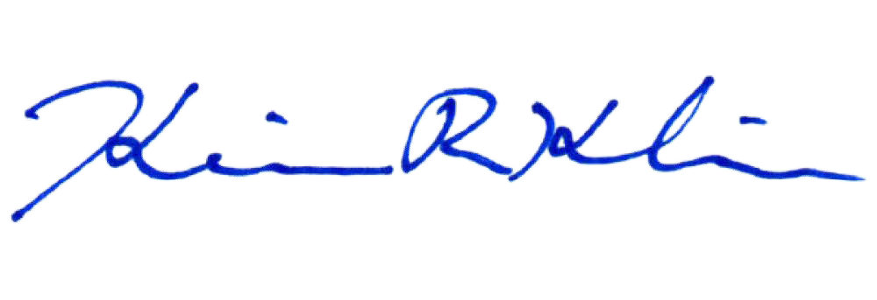
These rules are promulgated under the authority of Sections 24-33.5-801 et seq, C.R.S. and are intended to be consistent with the requirements of the State Administrative Procedure Act, Sections 24-4-101 et seq., C.R.S. (the “APA”).

Kevin Klein, Division Director
Division of Homeland Security & Emergency Management
July 10, 2026
Date of Adoption

Department of Public Safety

Division of Homeland Security & Emergency Management

8 CCR 1507-83

Civil Defense Qualified Volunteer Program

[Editor’s Notes follow the text of the rules at the end of this document.]

Authority
This regulation is adopted pursuant to the authority in Sections 24-33.5-801 et seq., C.R.S., and is intended to be consistent with the requirements of the State Administrative Procedure Act, Section 24-4-101 et seq., C.R.S. (the “APA”).

Scope and Purpose
The Division shall establish by rules various classes of civil defense workers and the scope of the duties of each class and shall also adopt rules prescribing the manner in which civil defense workers of each class are to be registered. All such rules shall be designed to facilitate the paying of workers’ compensation pursuant to Section 24-33.5-818, C.R.S.
These rules shall govern the implementation of the Qualified Volunteer Organization List (List) pursuant to Sections 24-33.5-823 and 24-33.5-827, C.R.S. The Office shall create a process for a county sheriff, local government, local emergency planning committee, or state agency to nominate a volunteer organization to be included on the List pursuant to Section 24-33.5-823, C.R.S. The Office shall create a process to verify that a qualified volunteer provided volunteer services during a disaster or an organized training exercise, drill, or class, and a method to allow the volunteer to provide proof of such service to his or her employer pursuant to Section 24-33.5-824 (2), C.R.S.

Applicability
The provisions of these rules shall be applicable to all entities seeking listing as a Qualified Volunteer Organization as provided by law and to individual volunteers seeking verification of volunteer service for the purpose of qualifying for those benefits enumerated by Section 24-33.5, part 8, C.R.S.

Definitions
The definitions provided in Section 24-33.5-802, C.R.S., apply to these rules. The following definitions also apply:
“Division” means the Division of Homeland Security and Emergency Management within the Colorado Department of Public Safety and created in Section 24-33.5-1603, C.R.S.
“Memorandum of Understanding (MOU)” means a written agreement between a county sheriff, a local government, a local emergency planning committee, or a state agency and a volunteer organization that may include the provisions set forth in Section 24-33.5-822, C.R.S.
“Nominating Entity” means a state agency, county sheriff, local government, or local emergency planning committee that submits a Volunteer Organization for listing on the Qualified Volunteer Organization List and that intends to call that Volunteer Organization to service and directly manage and supervise the work of the Volunteer Organization.
“Office” means the Office of Emergency Management within the Division and created in Section 24-33.5-705 (1)(a), C.R.S.
“Organization” means an entity with members, to include paid or unpaid workers, who may wish to volunteer in a disaster and who do not fall under the employment or direct management of a state agency, county sheriff, local government, or local emergency planning committee. For the purposes of these rules, an organization is independent and distinct from government agencies, has separate and identifiable funding sources, and has an identified executive or leader who is authorized to enter into an MOU with the nominating entity. Such an organization has formal training processes and holds regular trainings or meetings with documented agendas and minutes.
“Qualified Volunteer Organization List (the List)” means a list of organizations that have been nominated to and accepted by the Office, for which volunteers may request verification of volunteer service.
“Volunteer” means a volunteer allowed to receive the benefits and protections specified in Part 8 pursuant to Article 10 of Title 24, C.R.S. if the volunteer is determined to be a qualified volunteer pursuant to Section 24-33.4-824, C.R.S.

Program Requirements

5.1 Nomination for Inclusion on Qualified Volunteer Organization List
5.1.1 The Office will maintain a web page on the Division’s public website where nominations of a volunteer organization may be submitted to the Office.
    - A county sheriff, principal executive of local government, chair of a local emergency planning committee, or principal executive of a state agency may nominate a volunteer organization for inclusion on the Qualified Volunteer List (the List) by identifying the organization and furnishing a copy of the MOU executed pursuant to Section 24-33.5-822, C.R.S., using the mechanism provided on the web page furnished by the Office (for example, an online form).
    - Upon receipt of the nomination and the MOU, the Office will review materials to ensure that the parties, process, and MOU meet the requirements identified in the applicable Colorado Revised Statutes and these rules, specifically that:
5.1.3.1 The nominating individual is a county sheriff, principal executive of a local government, chair of a local emergency planning committee, or principal executive of a state agency.
5.1.3.2 There is a valid MOU in place executed within the previous twelve (12) months between the nominating entity and the volunteer organization to assist the county sheriff, local government, local emergency planning committee, or state agency in providing services as required. The nominating individual must be a signatory, and the independent executive or leader of the volunteer organization must also be a signatory.
5.1.3.3 If the MOU includes provisions for expiration and the date of expiration is less than two (2) years from the date of listing, the date of expiration will be noted as the date upon which the Office will remove the volunteer organization from the List, notwithstanding any other rules regarding removal.
5.1.3.4 If national or statewide training and certification standards exist for a certain organization or certain type of volunteer, the existing standards shall be used in the MOU.
5.1.3.5 The nominated volunteer group meets the definition of a volunteer group outlined in these rules and in the applicable Colorado Revised Statutes.
5.1.4 The Office will then issue a letter to the nominating entity, signed by the Director of the Office, verifying listing on the List for a period of two (2) years from the date of signature.
5.1.5 All organizations included on the List will be enumerated on the Office’s web page dedicated for that purpose, and a copy of the List can be requested by contacting the Office of Emergency Management at the Division, 9195 E. Mineral Ave., Suite 200, Centennial, CO 80112.
5.1.6 In the event that an MOU includes provisions for cancellation or termination, and such a provision is triggered, or the MOU expires pursuant to a condition included in the MOU, the nominating entity must notify the Office, and the Volunteer Organization will be removed from the List. Absent notification of the Office, the Volunteer Organization will be considered removed from the List at such time as it expires or is terminated.

5.2 Renewal of Qualified Volunteer Organization Listing
5.2.1 Approximately eighteen (18) months after the issuance of a letter confirming inclusion on the List, the Office will make reasonable attempts to issue a notification of pending expiration by electronic or postal mail. The notification will be sent to the nominating individual or entity and may also be sent to the Volunteer Organization. This notification of pending expiration shall be considered a courtesy notification, and failure to send or receive the notification will not impact the removal of a volunteer organization for two (2) years following initial inclusion on the List.
5.2.2 Two (2) years after the issuance of a letter confirming inclusion on the List, the Office will remove the Volunteer Organization from the List and will issue a notification of such action by electronic or postal mail unless the nominating entity or individual has submitted a new nomination (renewal).
5.2.3 A new nomination (renewal) shall follow the same process for an initial nomination and shall include submission of the most current MOU between the nominating entity and the volunteer organization.
5.2.4 The purpose of removal from the List and the requirement of renewal are to ensure that current elected officials or principal executives of nominating entities are aware of and in concurrence with their entity’s sponsorship of a volunteer organization and to ensure that parties to a MOU are the current leaders of both the nominating entity and the volunteer organization.

5.3 Verification of Volunteer Service
5.3.1 The Office will publish on the Division’s public website a method by which qualified volunteers can request verification that they provided volunteer services during a disaster or an organized training exercise, drill, or class, and a method to allow the volunteer to provide proof of such service to their employer pursuant to Section 24-33.5-827, C.R.S. Such requests must be made by either the individual volunteer or a representative of the nominating entity, and verification will be provided to whichever entity or individual the requestor directs.
5.3.2 In an effort to confirm provision of volunteer service, the Office may request records including, but not limited to, volunteer shift schedules, time records, and/or written confirmation of volunteer service by the nominating entity. Documentation, such as a resource order, may be required to confirm volunteer service.

5.3.3 If the Office is able to verify volunteer service, and that the nature of service was consistent with descriptions and requirements provided in statute, the Office will issue a letter verifying the dates, times, and nature of volunteer service and note that the individual was operating as a Qualified Volunteer under the provisions of Sections 24-33.5-801 et seq., C.R.S.

5.4 Classes of Civil Defense Workers
5.4.1 One class of Civil Defense Worker is established as “Civil Defense and Disaster Volunteers”. All volunteers who are members of a Qualified Volunteer Organization as listed in 5.1 shall be a Civil Defense and Disaster Volunteer. Additional classes of Civil Defense Workers are reserved and may be defined at a later date.

