

STATEMENT OF BASIS, STATUTORY AUTHORITY, AND PURPOSE

Pursuant to Section 24-33.5-1620(3)(a), C.R.S. the Department of Public Safety adopted rules in 8 CCR 1507-48 Preventing Identity-Based Violence Grant Program for the administration of the grant program established in Section 24-33.5-1620(2)(a), C.R.S. This grant program provides grants to eligible entities or programs that focus on building strong communities and preventing acts of violence that threaten human life or critical infrastructure, venues, or key resources, in which actors or groups intentionally target a discernible population of individuals, such as a population determined by its members’ ethnicity, national origin, religion, or sexual orientation or identity, in a manner that poses a threat to homeland security,
referred to in this statute as “identity-based violence.” The Office of Prevention and Security (also known as Colorado Information Analysis Center) in the Division of Homeland Security and Emergency Management of the Colorado Department of Public Safety administers this grant program.

The purpose of these proposed amended rules is several-fold. First, the proposed rule changes amend 8 CCR 1507-48 to better align with statute and with the procedures to administer the grant program established by the Division pursuant to the provision set forth in Section 24-33.5-1620, C.R.S.

Second, after the mandatory review of 8 CCR 1507-48 in accordance with Section 24-4-103.3(I), C.R.S of the Administrative Procedure Act, the Office determined that the rule should be amended to give more flexibility to grant applicants. Rule 5.3(B) is updated to remove the prohibition of extensions to the period of performance to align with the program goals and grant priorities determined by the Division and the Department.

Third, grant eligibility and grant award selection criteria provisions were expanded for greater clarity in Rule 5.4 and to better align with statute.

Finally, the amended rules correct grammar and formatting errors and update the definitions and Division contact information.

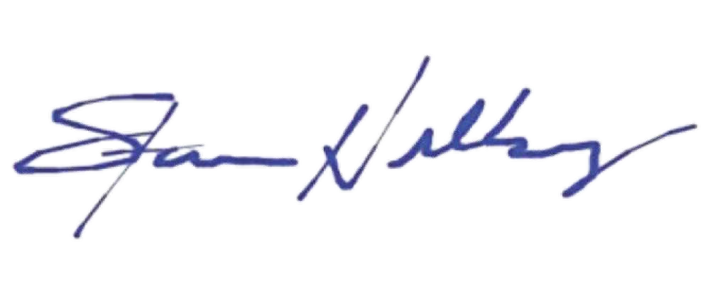
Stan Hilkey
Executive Director Colorado Department of Public Safety

07/08/2026

Date of Adoption

DEPARTMENT OF PUBLIC SAFETY
Division of Homeland Security and Emergency Management
COLORADO PREVENTING IDENTITY-BASED VIOLENCE GRANT PROGRAM
8 CCR 1507-48

Authority
This regulation is adopted pursuant to the authority in Section 24-33.5-1620, C.R.S. and is intended to be consistent with the requirements of the State Administrative Procedure Act, Section 24-4-101 et seq., C.R.S. (the “APA”).

Scope and Purpose
This regulation shall govern the implementation of the Colorado Preventing Identity-Based Violence Grant Program, which includes the time frames for applying for these grants, the form of the grant program application, and the time frames for distributing grant funds.

Applicability
The provisions of these rules shall be applicable to all eligible applicants and recipients of grant funds as provided by law.

Definitions
The definitions provided in Section 24-33.5-1620, C.R.S. apply to these rules. The following additional definitions also apply:
“Grant program” means the Colorado Preventing Identity-based Violence Grant Program as set forth in Section 24-33.5-1620, C.R.S.
“Office” means the Office of Prevention and Security (Colorado Information Analysis Center) created in Section 24-33.5-1606, C.R.S., within the Colorado Division of Homeland Security and Emergency Management.
“Recipient” means an eligible applicant receiving an award.
“Prevention project(s)” means projects proposed and outlined within the application related to
preventing identity-based violence.

“Award” means a financial assistance grant that provides support to accomplish a public
purpose given by the state to an eligible recipient.
“Period of Performance” means the period of time during which the recipient is required to
complete the grant activities and to receive and expend approved funds.
“Project Implementation and Measurement Plan” means a written form or other document determined by the Office to outline the steps necessary to achieve grant objectives and required measurements for the grant objectives.
“Quarterly Progress Report” means a written form or other document determined by the Office to indicate and report the operational and financial activity of the recipient during the time period specified.
“Summary Report” means a written form or other document determined by the Office to indicate and report the final operational and financial activity of the recipient during the time period specified.

Program Requirements

5.1 Eligibility
- Applicants must be from a county, municipality, or city and county, and any agency thereof; an American Indian Tribe; a law enforcement agency; a district attorney’s office; an educational entity; and a nonprofit organization that is exempt from taxation under Section 501 (c)(3) of the federal “Internal Revenue Code of 1986”, as amended, which may be a community-based nonprofit organization that has experience working with those affected by identity-based violence.
  - Eligible applicants that are not a community-based nonprofit organization that have experience working with those affected by identity-based violence must partner with a community-based nonprofit organization with that experience to carry out the project funded by the grant program.
- Eligible applicants must submit an application developed by the Office in conformance with the application and the terms of the program guidance described below.
- Eligible applicants must indicate in the application that the grant funds will be used to further at least one of the following preventing identity-based violence-related goals:
  - Building awareness for the prevention and intervention of identity-based violence within Colorado communities;

  - Strengthening local collaboration and capabilities for prevention and intervention of identity-based violence; and/or
  - Building sustainable support for the prevention and intervention of identity-based violence.
- Eligible applicants must demonstrate they have sufficient authority and capacity to implement the prevention project outlined in their application, including the capability to engage the participants that the eligible applicants propose to include in their projects.
- Proposed prevention projects shall not infringe on individual privacy, civil rights, and civil liberties. Prevention projects shall describe any potential impacts to privacy, civil rights, and civil liberties and ways in which the eligible applicants will prevent or mitigate those impacts and administer their prevention projects in a nondiscriminatory manner.
- Eligible applicants who are a law enforcement agency shall comply with the requirements set forth in 28 CFR Part 23 with regard to the collection, maintenance, and use of intelligence information learned by the agency through a project funded with an award from this grant program, regardless of whether the agency is a direct recipient or is acting in partnership with a recipient.
- The grant agreement between the State and the recipient(s) of the grant program will specify additional requirements, including but not limited to: performance measures, reporting requirements, and monitoring of the recipient’s activities and expenditures.
  - The Office shall annually evaluate environmental factors that lead to identity-based violence and challenges to reducing identity-based violence. The Office may establish annual priorities for the program that address the identified factors and challenges.

5.2 Award Details
- Period of Performance: 12 months
- Funding Instrument: Discretionary Grant

5.3 Time Frames for Application
- Time Frames
The Office shall publish the annual grant application guidance on the grant program website each year after the annual evaluation as required by Section 24-33.5-1620(3)(b), C.R.S. is completed.
The deadline for submission of applications is July 30th.

The deadline for awarding grant funds to applicants will be no later than October 30th.
- Restrictions
  - Applications that are not submitted by the stated Application Submission Deadline will not be reviewed or considered for funding;
  - All applications must include the required elements for all applications, as well as specific requirements of the projects they are proposing, including but not limited to performance measures for each project type. Failure to provide a complete application or significant deviation from the requirements can cause an application to be ineligible or not reviewed or considered for funding;
  - Applications that describe programs, projects, or activities that do not appropriately protect privacy, civil rights, or civil liberties will be deemed ineligible for funding;
  - Recipient(s) that are not a law enforcement agency shall not collect or maintain intelligence information about the political, religious, or social views, associations, or activities of any individual or group, association, corporation, business partnership, or other organization;
  - Applications that only consist of research are not eligible under this grant program. Research is an allowable expense; however, eligible applicants must propose to implement one or more prevention capabilities during the Period of Performance and must demonstrate how any proposed research will support that implementation;
  - Equipment costs are not allowed under this program. Equipment is defined as tangible personal property (including information technology systems) having a useful life of more than one year and a per-unit acquisition cost which equals or exceeds the lesser of the capitalization level for financial statement purposes. Additionally, this grant program does not allow costs for supplies or equipment related to emergency communications, tactical response, or related costs;
  - Pre-Award Costs are NOT allowed under this grant program (costs incurred or work completed prior to the award date);
  - A Cost Share or Cost Match is not required;
  - Up to 5% of the award may be used for management and administration of the grant funds; and

  - Recipient(s) shall not use any part of an award as matching funds for other grants or cooperative agreements, or for lobbying efforts, litigation costs, or intervention in regulatory or adjudicatory proceedings.

Grant Application and Award Selection Criteria
5.4.1. To be eligible for funding, grant applications will:
      - Describe the project that will be funded with a grant award including the proposed project’s goals and how these goals relate to the Preventing Identity-Based Violence Grant Program goals as established in Section 24-33.5-1620(2)(b)(I), C.R.S. and in the application announcement;
      - Demonstrated that the applicant has sufficient authority and capacity to implement the project outlined in the applicant’s grant proposal, including the capacity to engage the participants that the applicant proposes to include in the project;
      - Describe any potential impacts of the project on individuals’ privacy, civil rights, and civil liberties and explain how the applicant will prevent or mitigate those impacts and administer the applicant’s projects in a nondiscriminatory manner;
      - Include needs assessment, financial and programmatic sustainability, key personnel and partnerships, budget request, and implementation and measurement plan;
      - Describe the community-based nonprofit organization that the applicant has partnered with, if the applicant is not a community-based nonprofit organization, and how the funds will be allocated between the applicant and its partner nonprofit organization; and
      - Include other relevant information as required by the grant opportunity announcement.
5.4.2. Grant recipients will be selected based on the information provided through the application process in accordance with the program priorities as set forth in Section 24-33.5-1620(2)(b)(I), C.R.S. and with the annual grant program priorities as set forth in the annual grant opportunity announcement.
5.4.3. There are no set award amounts for the grant program. Awards are subject to available funding. Partial awards may be offered where applications include unallowable funding requests, budget inaccuracies, or when available funding cannot meet the full funding requested.
5.4.4. In making award selections, priority will be given to fully funding the applications that are deemed to be most impactful and sustainable within the available award funding. A committee composed of grant program staff will review applications and prioritize applications based on the criteria set forth in Rule 5.4.1 and in the grant opportunity announcement.

Application Submissions
Eligible applicants must submit their acceptable signed application via email or other delivery methods as listed and allowed in the grant application and accompanying guidance.

5.6 Grant Guidance
The Office is responsible for the implementation of this grant program and will develop and publish a grant application and guidance. Grant guidance will include the following reporting requirements:
- A Project Implementation and Measurement Plan;
- Quarterly Progress Reports;
- A final Summary Report; and
- Any other documents required by the application, terms and conditions of the award, or other guidance provided by the Office.
The amount of each award will be determined by the quality and completeness of the application in accordance with the criteria outlined in these rules, as well as the proposed use of funding as it relates to the goals and priorities outlined in the application.

