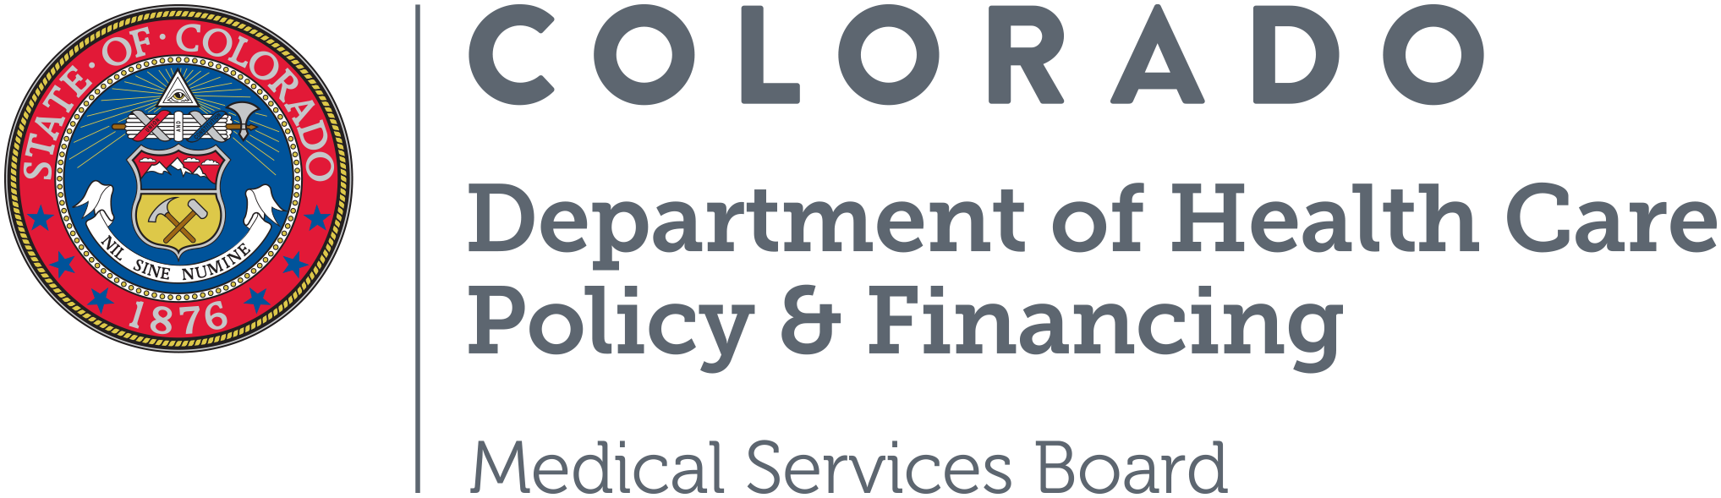

July 2026 Emergency Justification for Medical Assistance rules adopted at the July 10, 2026 Emergency Medical Services Board Meeting

Document A, MSB 26-04-26-A, Revision to the Medical Assistance Colorado Dental Care Program For Low-Income Seniors, Procedure Rate Decrease on Schedule A for Fiscal Year 2026-27

Emergency rule-making is imperatively necessary. Due to the current state budget emergency, the Senior Dental Program had a reduction of $500,000 in FY2025-26 and a $2 million reduction in FY2026-27. The current reduction left many aging adults on waiting lists, some who were in the middle of treatment plans. This means we may have had some participants waiting to have restorations (fillings or crowns) that were not completed and instead received the worst-case scenario of full extractions completed, and while waiting for the healing process, the reduction left the senior with no dentures because the grantee had no additional funds available. Due to this, we are submitting this rule change as an emergency rule change to be effective July 10, 2026 to ensure that participating seniors are able to obtain medically necessary dental care. Emergency rulemaking is imperatively necessary for the preservation of public health safety, and welfare.

Document B, MSB 26-01-29-A, Revision to the Medical Assistance Act Rule concerning Non-Emergent Medical Transportation Rideshare Authorization, Section 8.014

Emergency rule-making is imperatively necessary. The proposed emergency rule-making is imperatively necessary to comply with House Bill 26-1328, which requires authorizing Transportation Network Companies to provide NEMT services when no NEMT provider is available to serve the member in their county or service area at the time the trip is requested, or if the NEMT provider originally assigned to complete a trip is unable to fulfill the assignment and no other NEMT provider is available to complete the trip within the time frame necessary to ensure the member arrives at their appointment. Authorizing TNC to provide NEMT services in such circumstances is imperatively necessary to preserve public health, safety, and welfare because it ensures members arrive at their medical appointments on time. This strengthens access to care and improves system reliability, particularly in rural and frontier areas where transportation options are limited. Emergency rulemaking is imperatively necessary for the preservation of public health safety, and welfare.

