

To: Members of the State Board of Health

From: Stephen Holloway, MPH Director, Primary Care Office
Through: Alicia Haywood
Prevention Services Deputy Division Director

Date: July 15, 2026

Subject: Request for a Rulemaking Hearing concerning 6 CCR 1015-6 State-Designated Health Professional Shortage Area Designation

The Primary Care Office (PCO) in the Prevention Services Division of the Colorado Department of Public Health and Environment (CDPHE) requests amendments to Rule 6 CCR 1015-6 as outlined in this briefing. These proposed rule amendments seek to add a methodology for identifying State-Designated Health Professional Shortage Areas (HPSA) specific to those insured by Colorado Medical Assistance Program (Medicaid). This rulemaking is authorized by Section 25-1.5-404 (1)(a) C.R.S.

Promulgation of amended rules is requested because the PCO aims to better elucidate access to care needs specifically for Coloradans enrolled in Medicaid, which will support implementation of Colorado Health Service Corps (Section 25-1.5-501, et seq.) and related health systems planning for underserved communities. This rulemaking request is part of a planned expansion of the methodologies that intends to further describe the health professional workforce with respect to Medicaid-enrolled populations and Medicaid participating clinicians.

Colorado faces significant disparities in health access, due in part to uneven access to care and interventions. Factors like economic instability, education, insurance coverage, race, ethnicity, chronic stress, language barriers, health conditions, and the cost of care all play a role in creating these disparities, with rural and frontier areas experiencing additional challenges associated with geographic isolation.

As described in prior rulemaking regarding 6 CCR 1015-6 State-Designated Health Professional Shortage Area Designation, federal HPSA assessment methodologies are inadequate for describing specific clinician shortages across all currently supported health disciplines (primary care, perinatal health, oral health, and behavioral health).

In the case of primary care, federal models do not account for the contributions of
non-physician primary care clinicians, nor do they consider the variable primary care needs of populations by age and sex or reliably stratify relative need among designated shortage areas.

Similarly, within behavioral health, federal models do not consider the unique systems and professions required to deliver comprehensive care for behavioral health and substance use disorders (SUD). Federal rules measure only board-certified psychiatrists when evaluating workforce capacity, rather than the full range of behavioral health professionals engaged in behavioral health care. Furthermore, these methodologies assume a constant rate of need for care within a population, regardless of age, sex, or other demographic factors that correlate with mental illness and SUD risk.

Federal designations for oral health shortages are similarly limited. Despite improvements in dental insurance coverage among Coloradans over the past ten years, self-reported oral health status has remained constant, with 16.7% of Coloradans reporting fair or poor oral health.¹ Similarly, oral health among kindergartners and third graders has deteriorated as evidenced by the 2004 Basic Screening Survey, finding that nearly two-thirds of third graders in Colorado experiencing tooth decay.² This suggests that persistent barriers to care, including geography and income, contribute to conditions that increase the burden of oral disease.

Regarding perinatal health, federal shortage designations, referred to as Maternity Care Target Areas (MCTAs) are dependent upon primary care designations rather than being assessed independently. Despite involving a specialized workforce of health professionals such as midwives and obstetricians, MCTA designations are restricted to areas already designated as a primary care HPSA. Comprehensive, community-level data is needed to understand the geographic distribution of perinatal health shortages. Furthermore, with 36% of all births and 45% of rural births covered by Medicaid shortage designation methodologies specific to this population are critical to understanding local needs. ³

The value of Medicaid-specific shortage designation models, in addition to comprehensive all-payer models, is increasingly important given the evolving federal policy landscape.
Recent federal changes introduce new administrative requirements for Medicaid eligibility and restrict state financing strategies for funding Medicaid programs. In combination with constrained state budgets that impact Medicaid funding, relying solely on all-payer methodologies risks obscuring the specific access barriers experienced by individuals covered by Medicaid. Implementing Medicaid-specific shortage models provides a strategic opportunity

¹ Colorado Health Institute. (2026, February). Colorado's oral health coverage paradox. https://deltadentalcofoundation.org/wp-content/uploads/2026/03/DDCOF-CHAS-Brief-2026.pdf (accessed April 30, 2026).
² Colorado Basic Screening Survey (2024) https://coloradooralhealth.org/initiatives/surveillance/colorado-basic-screening-survey-dashboard/ Accessed April 30, 2026),
³ KFF. (2023). Births Financed by Medicaid by Metropolitan Status. https://www.kff.org/medicaid/state-indicator/births-financed-by-medicaid/?currentTimeframe=0&sort Model=%7B%22colId%22:%22Location%22,%22sort%22:%22asc%22%7D#notes (accessed April 30, 2026).

to more accurately map where coverage shifts intersect with clinician capacity. This targeted approach will enable the state to direct public interventions more efficiently and optimize the use of limited public resources.

STATEMENT OF BASIS AND PURPOSE AND SPECIFIC STATUTORY AUTHORITY
for Amendments to
6 CCR 1015-6 State-Designated Health Professional Shortage Area Designation

Basis and Purpose
The Primary Care Office (PCO) in the Prevention Services Division (PSD) administers the Colorado Health Service Corps (CHSC). The CHSC promotes improved access to primary, perinatal, oral, and behavioral health care in underserved Colorado communities through practice incentives for certain clinicians. This goal is achieved by reducing educational loan debt for health professionals in exchange for a period of contracted service in a designated Health Professional Shortage Area (HPSA).
CHSC clinicians are typically obligated to three years of service in a practice that accepts Medicaid, Medicare, Child Health Plan Plus (CHP+), and uninsured patients on a sliding fee scale. The practice must also be in an HPSA, as determined by an assessment conducted by the PCO in accordance with federal methodologies.
Existing methodologies for health workforce analysis are established in federal regulations. The amendments requested in this brief propose enhancing state methodologies to better assess need among the Medicaid-enrolled population and associated workforce capacity at the community level.
Legislative Background
Authority for state HPSA designation was established in 2018 with the passage of Senate Bill 18-024. This legislation expanded the scope of the CHSC to include clinicians and facilities that provide treatment for substance use disorders (SUD) and increased appropriations to the program for SUD clinicians.
Although this legislation emphasized behavioral health workforce needs, statutory changes related to state HPSA designation were intentionally drafted to permit primary care and oral health assessment. Program authority was further expanded under House Bill 24-1262, titled “Maternal Health Midwives,” which directs the PCO to develop a health professional shortage area methodology for mapping perinatal health service capacity and gaps.
The authority for the PCO to administer state shortage designation rules is critical because current federal designation methods do not adequately inform the eligibility and prioritization of CHSC contracts in areas with the greatest workforce needs. Furthermore, changes in federal health policy, health insurance coverage, and state budget constraints heighten the

need for precise and objective measures of relative need to guide public health access investments.
Request for Promulgation of Amended Rules
The PCO requests promulgation of amended rules that add a new methodology for State-Designated HPSAs specific to the Medicaid clinical workforce across all currently
supported disciplines (primary care, perinatal health, oral health, and behavioral health). The shortage designation analysis and process, as described in the proposed amended rule that follows, will produce detailed quantitative information on local shortages of clinicians who provide health care services to Medicaid-enrolled persons.
If the amended rule for Medicaid HPSAs is adopted, more than $3,000,000 in state, federal, and private funds will be distributed annually in the form of educational loan repayment to clinicians who provide health care services in state-designated Medicaid HPSAs. Additional state resources may also be allocated based on the findings of the geospatial analysis described in this proposed rule in the PCO and other state agencies.
Description of the Medicaid Model Methodology
Population
The population analyzed includes all civilian, non-institutionalized Colorado residents enrolled in Medicaid.⁴ Baseline population estimates at the census block group level are derived from the U.S. Census American Community Survey (ACS) 5-year estimates. ⁵
Institutionalized populations and military group quarters are excluded from the analysis because health services for these groups are provided within closed health care delivery systems. It is assumed that interaction between health care supply and demand for group quarters populations and non–group quarters populations within the same service area is minimal.
Estimating Demand for Care Among Medicaid-Enrolled Persons
Annualized demand for health services varies by age, sex, and health discipline. Table 1 reports data sources used for each discipline to identify the population in need of services and estimate demand according to age and sex. Component data sources are regularly updated as new data become available.

⁴ Where individuals live and sleep most of the time. The resident population excludes people whose usual residence is outside of the United States, such as the military and federal civilian personnel living overseas, as well as private U.S. citizens living overseas.
⁵ Census block groups are created by the US Census Bureau and are stable statistical divisions of census tracts that generally contain between 600 and 3,000 residents.

Table 1. Data Sources Used for Population and Demand estimation for Health Disciplines

Clinical Discipline | Subject Population | Population Modifier Data Source | Demand Modifier Data Source or Encounter Constant*
Primary Care | Total population | N/A | Average number of primary care visits per year by age and sex (Medical Expenditure Panel Survey, Agency for Healthcare Research and Quality, U.S. Department of Health and Human Services)
Perinatal Health | Pregnant and infant population | Birth records and pregnancies (CDPHE Vital Statistics Program) | 12 visits per pregnancy for maternal ages 20-34; 15 visits for all other maternal ages
Behavioral Health | Population experiencing substance use disorder or any mental illness | Prevalence of substance use disorder or any mental illness in the past year (National Survey on Drug Use and Health, U.S. Substance Abuse and Mental Health Services Administration) | 8 visits per year
Oral Health | Total population | N/A | 2 visits per year
*Constants used to estimate the annual number of visits desired per year (or per pregnancy/ birth) are based on a review of the literature and stakeholder engagement.
A multi-step procedure is used to modify the baseline census block group population to isolate the population of interest (civilian, non-institutionalized Medicaid enrollees) while aligning with the age and sex strata established by the source data used to estimate demand each health discipline:
- Isolating the Civilian, Non-Institutionalized (CNI) Population: The percentage of the population living in institutionalized or military group quarters by sex and age is calculated by applying 2020 decennial census data (derived from ACS Table P18 group quarters counts and ACS Table P12 total counts). These percentages are applied to the total ACS population estimates by sex and age (ACS Table B01001) to establish the CNI population for each block group. For perinatal health models, Vital Statistics data is used in place of ACS data to capture the pregnant and infant population.
- Isolating the Medicaid-Enrolled Population: The percentage of the population enrolled in Medicaid is determined using ACS estimates for health insurance coverage by age (ACS Table B27010). This percentage is applied to the CNI population estimates from Step 1 to generate current estimates of Medicaid-enrolled CNI residents for desired sex and age strata.

- Correcting for ACS Undercounts: Because the ACS is known to significantly undercount Medicaid enrollees,⁶ a county-specific adjustment factor to correct the Medicaid-enrolled population estimates is applied. To illustrate the magnitude of this undercount statewide as of 2024, the ACS estimated 845,880 enrolled members (at time of survey), whereas administrative data from the Colorado Department of Health Care Policy and Financing (HCPF) reported a monthly average of 1,207,822 enrollees for Fiscal Year 2024-25.⁷ To correct for this at the local level, HCPF administrative counts were compared to ACS estimates within each county to generate a
county-specific multiplier. This inflation factor was then applied to all census block groups within the respective county to derive the final, adjusted population estimates by sex and age.
Annual demand (encounters with a clinician) for health services is determined by multiplying these Medicaid-enrolled population estimates by the prevalence of the health condition, if applicable (e.g., behavioral health), and the number of visits expected for the population within each health discipline, sex, and age subset.
Estimating Supply of Medicaid Visits
A table of clinicians who are licensed in Colorado and have a minimum of 48 Medicaid claims in Colorado for a calendar year (four per month, on average) is generated out of a custom extract provided by the Colorado All Payer Claims Database (APCD).⁸ The table includes the number of claims in the calendar year and identifying information relating to the claim rendering location.
Claims data are separated into discrete health disciplines based on ICD-10 codes,⁹ and an aggregate treatment encounter supply is created for each health care facility. This is performed by summing the total estimated encounters by clinician for all Medicaid clinicians affiliated with that practice address in the Colorado Health Systems Directory.
Estimating the Spatial Relationship of Supply and Demand for Medicaid Care
The relationship between the demand for and supply of Medicaid encounters is evaluated at the service area level. A service area is defined as a discrete geographic area where a preponderance of the civilian, non-institutionalized population within the area could reasonably expect to access health care services, when the service area is adequately resourced. All clinicians within the service area are presumed to be generally accessible and

⁶ Boudreaux, M., Noon, J. M., Fried, B., & Pascale, J. (2019). Medicaid expansion and the Medicaid undercount in the American Community Survey. Health services research, 54(6), 1263–1272. https://doi.org/10.1111/1475-6773.13213
⁷ Colorado Department of Health Care Policy and Financing [FJ1.1] Fiscal Year 2024-25
⁸ Administered by the Center for Improving Value in Health Care, the APCD is a comprehensive, statewide data system that aggregates medical, pharmacy, and dental claims from public and private insurers to support analysis of health care utilization, cost, and access across Colorado.
⁹ The ICD-10 is a standardized system for coding and classifying diseases, health conditions, and related clinical information, enabling consistent reporting, billing, and analysis across health care systems.

similarly proximate to all residents of the service area. Service locations outside of the service area are assumed to be generally inaccessible by distance for the purposes of this analysis.
To estimate the availability of health care services for each block group, the Variable
Two-step Floating Catchment Area (V2SFCA) method is applied independently and separately for each health discipline.¹⁰ The V2SFCA method was selected because spatial accessibility to health care is not generally bound by census or political subdivisions. It is presumed that patients routinely cross civil boundaries to obtain health care services of all types.
A summary of the V2SFCA implementation is shown in Figure 1. To execute the V2SFCA analysis, the mean population center of each block group is used to represent its travel centroid.¹¹ This method is then applied in two steps using ArcGIS Pro® (Version 3.5.1 © 2025 Esri) within R, each augmented using a distance decay weight:
Step 1: Calculating the Supply-to-Demand Ratio. For each health care facility location with Medicaid claims, a catchment area is generated based on travel time using a road network dataset. To account for varying population densities, the V2SFCA dynamically adjusts the catchment area size. Applying an established base population threshold, a
20-minute catchment area is evaluated first. If the population threshold is not met within 20 minutes, the catchment expands to 40, and then up to 60 minutes, as required. Once the final catchment boundary polygon is defined for a facility,¹² an initial ratio is calculated by dividing the facility’s Medicaid encounter supply by the total predicted Medicaid encounter demand across all block groups with their centroid within that catchment. A distance decay function weight is applied to this ratio to account for decreased accessibility across larger catchments.
In the example shown in Figure 2, the estimated encounter demand from block groups 1, 2, 3, 4, and 7 would be summed to estimate total encounter demand in the health care facility’s 20-minute catchment area. The encounter supply at that facility would then be divided by this total demand to produce the supply-to-demand ratio for that facility. This is repeated for all health facilities. As shown in Figure 3 and expected under the V2SFCA model, nearby health facilities tend to create overlapping or “floating” catchment areas. In these two hypothetical examples block groups 2, 4, and 7 are included in both hypothetical catchment areas.
Step 2: Summing Supply-to-Demand Ratios for the Population. For each census block group, a catchment area is generated based on travel time using a road network dataset.

¹⁰ Luo, W., & Whippo, T. (2012). Variable catchment sizes for the two-step floating catchment area (2SFCA) method. Health & place, 18(4), 789–795. https://doi.org/10.1016/j.healthplace.2012.04.002
¹¹ A travel centroid is the geometric center of a group of points within a geographic shape (e.g., Census
block group) where the center point generally falls within the shape.
¹² The boundry polygon is a closed, irregular geometric shape on a map surface that defines equivalent road travel distances from a central point within the shape.

To account for the varying density of health care facilities, the V2SFCA dynamically adjusts this catchment size. Using a minimum encounter accessibility threshold, a
20-minute catchment area is evaluated first. If the encounter accessibility threshold is not met within 20 minutes, the catchment expands to 40, and then up to 60 minutes, as required. Once the final catchment boundary polygon is defined for a block group, the distance-weighted supply-to-demand ratios for all accessible providers are then summed to produce the final spatial accessibility score for the block group. A distance decay function weight is applied to this cumulative ratio to account for decreased accessibility across larger catchments.

Figure 1. Implementation of the V2SFCA Model

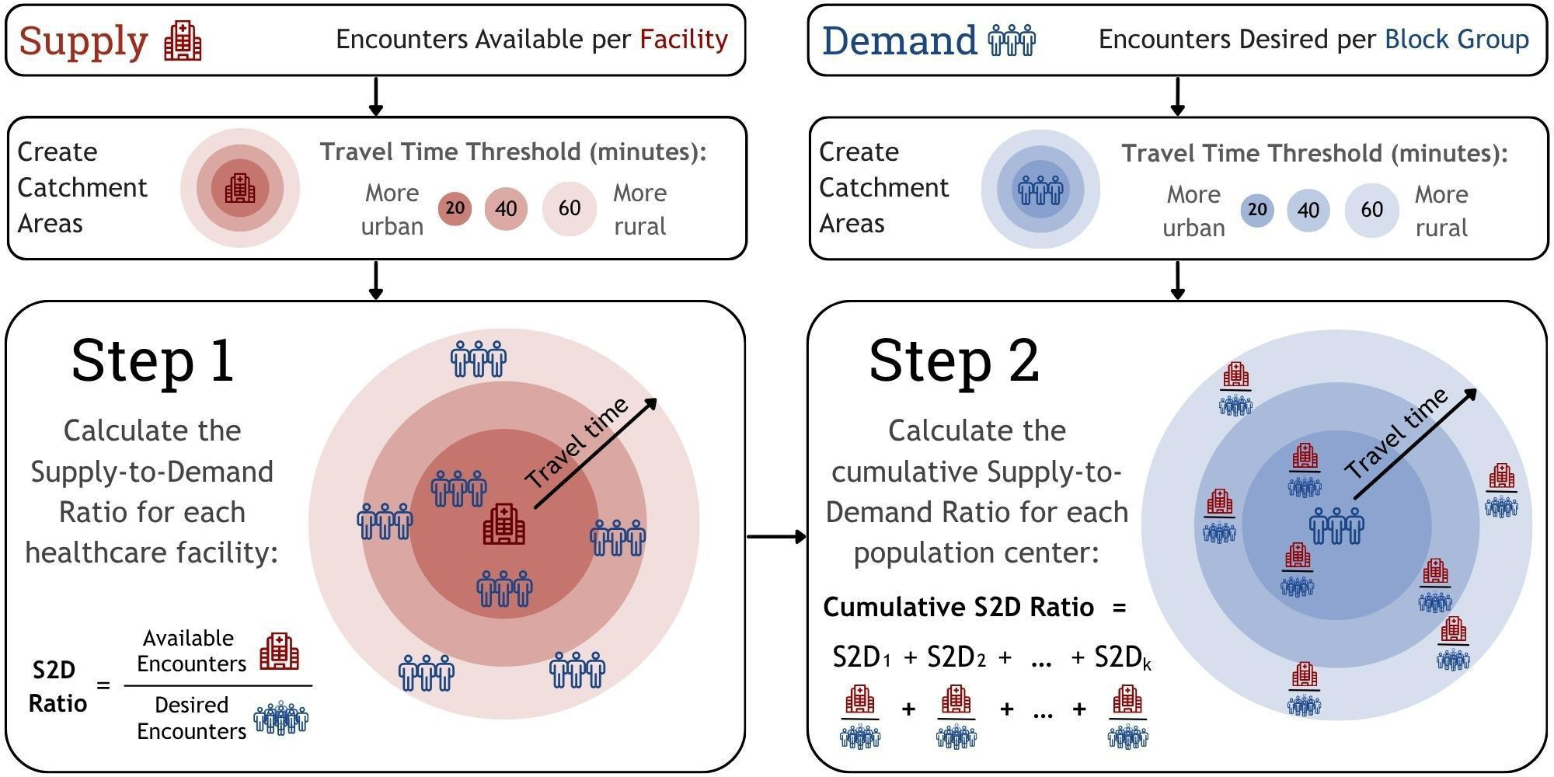

SBP 7

Figure 2. Hypothetical Block Group Catchment Area Map with Travel Polygon
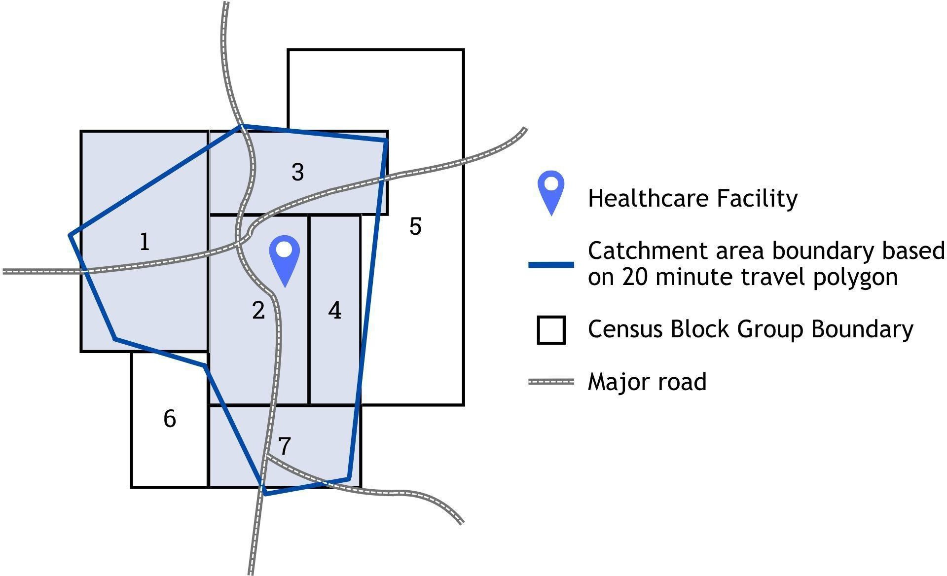

Figure 3. Hypothetical Block Group Catchment Area Map with Travel Polygon
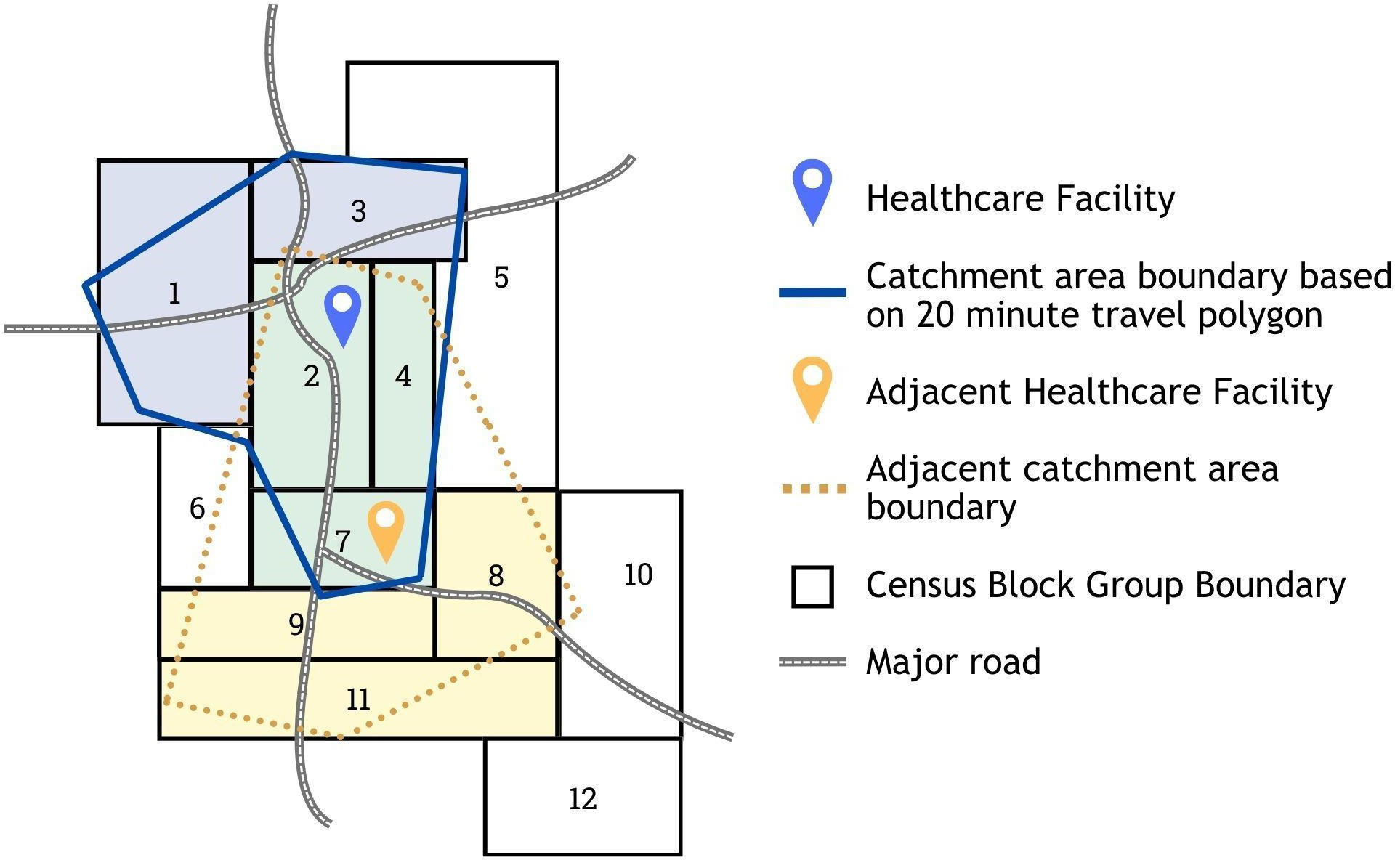

Stratifying Relative Shortage
The supply-to-demand ratio is calculated for all 4,058 census block group catchment areas in Colorado. These ratios are then binned into ten deciles. Catchment areas where the demand exceeds the supply of Medicaid encounters (ratio less than 1.0) are deemed to be a HPSA for that health discipline regarding Medicaid clinicians.
Limitations
- This analysis relies on 2020 Census data which, according to the U.S. Census Bureau’s 2020 Post-Enumeration Survey Estimation report, increased miscounts for some demographic groups and households for 14 states. Colorado was not included as a state in the over/under count for households; therefore, the potential impact of the lower quality 2020 Census data on this designation methodology in Colorado was likely negligible.
- Population estimates at the census block group level tend to have a higher error rate compared to larger census geographies like census tracts or metropolitan statistical areas. While utilizing block groups enhances discrete area analysis, it may also introduce additional error. However, the overlapping nature of the floating catchment area analysis is likely to mitigate the impact of individual block group population error rates.
Application to Colorado Health Service Corps Program

Shortage designation determines which geographic areas of the state experience a shortage of health care professional capacity relative to the needs of the population. Independent of this proposed rule, the CHSC also assesses individual clinical locations to determine their eligibility for participation in the CHSC program. Criteria used to determine eligibility include that the practice accepts all patients regardless of ability to pay, has an established nondiscrimination policy, accepts Medicaid, Medicare, and the Child Health Plan+, and offers a range of primary, oral, and/or behavioral health care services.

Individual clinician participants in the CHSC must apply to the program to participate. Clinicians are selected for personal attributes that indicate a higher likelihood of long-term retention in practice in the shortage area once the service obligation to the state is concluded. Attributes of “retainability” include training specific to rural or underserved practice, personal commitment to the needs of the underserved, personal experience of being underserved, graduation from a Colorado based education program, and ability to deliver clinical services in a language other than English.

Specific Statutory Authority
Statutes that require or authorize rulemaking: 6 CCR 1015-6 State-Designated Health Professional Shortage Area Designation

Is this rulemaking due to a change in state statute?
Yes, the bill number is . Rules are authorized required.
X No
Does this rulemaking include proposed rule language that incorporate materials by reference?
Yes URL
X No
Does this rulemaking include proposed rule language to create or modify fines or fees?
Yes
X No
Does the proposed rule language create (or increase) a state mandate on local government?
X No

- The proposed rule does not require a local government to perform or increase a specific activity for which the local government will not be reimbursed;
- The proposed rule requires a local government to perform or increase a specific activity because the local government has opted to perform an activity, or;
- The proposed rule reduces or eliminates a state mandate on local government.

Yes.

This rule includes a new state mandate or increases the level of service required to comply with an existing state mandate, and local government will not be reimbursed for the costs associated with the new mandate or increase in service. The state mandate is categorized as:
Necessitated by federal law, state law, or a court order
Caused by the State’s participation in an optional federal program
Imposed by the sole discretion of a Department
Other:
(i.e. requested by local governments and consensus was achieved)

Has an elected official or other representatives of local governments disagreed with this categorization of the mandate? Yes No. If “yes,” please explain why there is disagreement in the categorization.

Please elaborate as to why a rule that contains a state mandate on local government is necessary.

REGULATORY ANALYSIS
for amendments to
6 CCR 1015-6 State-Designated Health Professional Shortage Area Designation

- A description of the classes of persons affected by the proposed rule, including the classes that will bear the costs and the classes that will benefit from the proposed rule.

Group of persons/entities Affected by the Proposed Rule | Size of the Group | Relationship to the Proposed Rule  Select category: C/CLG/S/B
Primary Care Office | 5 staff are assigned to various aspects of designation analysis | C
Health Care Facilities that employ Medicaid clinicians | 530 health care clinic sites | B
Colorado residents | Estimated to exceed 1,207,822 persons in Colorado | B
Health Equity Organizations | Estimated 80 organizations | S

While all are stakeholders, groups of persons/entities connect to the rule and the problem being solved by the rule in different ways. To better understand those different relationships, please use this relationship categorization key:
C = individuals/entities that implement or apply the rule.
CLG = local governments that must implement the rule in order to remain in compliance with the law.
S = individuals/entities that do not implement or apply the rule but are interested in others applying the rule.
B = the individuals that are ultimately served, including the customers of our customers. These individuals may benefit, be harmed by or be at-risk because of the standard communicated in the rule or the manner in which the rule is implemented.

More than one category may be appropriate for some stakeholders.
This rule is not expected to harm any individual or group, and no individual person or private sector entity will directly bear the costs of implementation and maintenance. The costs associated with implementing this rule will be funded by existing state appropriations from the General Fund, revenue from retail marijuana taxes, and Master Tobacco Settlement Agreement.
Other classes of or persons affected by this proposed rule amendment include:

Primary Care Office: Implementation of this rule. Relationship: C
Size: 5 staff are assigned to various aspects of designation analysis.

Clinic Employers: Safety-net clinic entities that employ Medicaid clinicians may benefit from this rule through reduced provider recruitment and retention costs, as clinicians receive incentives to practice in State-Designated Health Professional Shortage Areas (sHPSAs) where these entities are located. Approximately 530 health care sites could potentially receive direct or indirect benefits from the shortage designation process.
Relationship: B

Size: 530 health care clinic sites

Colorado residents: Because the need for health care services is universal, nearly all residents of communities with insufficient Medicaid clinician capacity may benefit from this shortage designation analysis.
Relationship: B

Size: Estimated to exceed 1,207,822 persons in Colorado.

Health Equity Orgs: Organizations that promote improved access to health services for medically underserved communities and people may benefit from the assessment of need and the promotion of improved access for underserved people. Other state agencies and local governments may also benefit if Colorado is better able to address health care access needs. Approximately 80 organizations, advocacy groups and other governmental entities may benefit from this rule in this way.
Relationship: S

Size: Approximately 80 public and nongovernmental entities

- To the extent practicable, a description of the probable quantitative and qualitative impact of the proposed rule, economic or otherwise, upon affected classes of persons.
Organizations employing Medicaid clinicians in sHPSAs may experience reduced costs associated with recruiting and retaining clinical providers. While the precise impact is uncertain, it may be substantial when considered across all eligible safety-net clinic sites in Colorado. This proposed rule is not expected to have any adverse effects on these organizations.

Individuals who require health care and live far from service sites may benefit from the recruitment of clinicians to underserved areas closer to their residences. This effect may reduce travel time and distance, decrease absences from work or school, and lower transportation-related costs. These benefits are expected to be greatest for individuals who are least well served as the result of financial barriers to care.

No impacts to local governments are anticipated because of promulgating these rules.

Economic outcomes

Please describe any anticipated financial costs or benefits to these individuals/ entities.

Stakeholder Class | Anticipated Costs and Benefits
Clinic Employers (B) | Recruiting health care professionals to underserved communities in Colorado can be costly (some positions in difficult to recruit to areas of Colorado may require more than $120,000 to place). Many clinicians in the Colorado Health Service Corps (CHSC) note in exit surveys that education loan repayment significantly influenced their choice of practice location.  Employers currently in the CHSC program emphasize that loan repayment plays a crucial role in their recruitment and retention strategies.  A second order effect of state administered practice incentives may lower overall employer retention costs. This is true even for those clinicians who do not ultimately receive a CHSC award but were motivated to apply for qualified employment for the prospect of educational loan repayment.

Clinic Employers (B) | If employer recruitment costs are reduced by a conservative $10,000 per CHSC applicant for health care clinician types eligible for CHSC, the aggregate annual employer savings could exceed $1,000,000. These savings are estimated according to the following:  - Employers recruit health care professionals in advance of the clinicians’ CHSC application.  - Recruitment and retention cost savings accrue to employers when clinicians choose to work at eligible practice sites for the prospect of receiving a loan repayment benefit, regardless of whether individual clinicians receive a CHSC award.  - The CHSC program typically receives three applications for each available award.  - If 100 CHSC health care clinician applications are received in year one and safety-net employers experience a modest $10,000 per applicant reduction in recruitment costs per applicant, then aggregate recruitment cost savings per year experienced by all safety-net employers will be approximately $1,000,000 (100 x 10,000).
Colorado Residents (B) | Health systems capacity development in underserved communities brings about positive secondary economic benefits. For instance, the addition of clinicians in a specific health service area creates multiple non-clinical jobs. Communities also profit when economic activity linked to or incidental to (retail purchasing and service activities) health care spending takes place within the vicinity, rather than in adjacent areas where access to care might be displaced to because health care is more readily available.

Non-economic outcomes
Summarize the anticipated favorable and non-favorable non-economic outcomes (short-term and long-term), and, if known, the likelihood of the outcomes for each affected class of persons by the relationship category.
Favorable non-economic outcomes: For publicly insured individuals, participation in treatment may increase, leading to greater demand for publicly financed care. However, these initial increases in utilization are expected to be offset over time by reductions in avoidable and preventable health care costs.

The CHSC and this rule may also improve resource allocation and focus policy attention among organizations working to expand access to care for medically underserved populations. This includes nongovernmental organizations that advocate for underserved communities, as well as support for other state agencies and local governments.

Unfavorable non-economic outcomes: None are anticipated.

- The probable costs to the agency and to any other agency of the implementation and enforcement of the proposed rule and any anticipated effect on state revenues.
  - Anticipated CDPHE personal services, operating costs or other expenditures:
None

Anticipated CDPHE Revenues:
None

  - Anticipated personal services, operating costs or other expenditures by another state agency:
None
Anticipated Revenues for another state agency:
None

- A comparison of the probable costs and benefits of the proposed rule to the probable costs and benefits of inaction.

Along with the costs and benefits discussed above, the proposed rules:

X Comply with a statutory mandate to promulgate rules.
Comply with federal or state statutory mandates, federal or state regulations, and department funding obligations.
Maintain alignment with other states or national standards.
Implement a Regulatory Efficiency Review (rule review) result
X Improve public and environmental health practice.
X Implement stakeholder feedback.
Advance the following CDPHE Strategic Plan priorities (select all that apply):

Improve outcomes in public health and environmental protection for all people of Colorado.
Realize a human-first, progress-forward culture!
Accomplish bold and Wildly Important Goals (WIGs) with an annual focus on a few key issues.
X Continuously pursue operational excellence in support of our programs.
Strengthen Colorado’s governmental public health system and promote effective public health practice.
Advance CDPHE Division-level strategic priorities.

The costs and benefits of the proposed rule would not be incurred if inaction was chosen. Costs and benefits of inaction not previously discussed include:
None

- A determination of whether there are less costly methods or less intrusive methods for achieving the purpose of the proposed rule.
Rulemaking is proposed when it is the least costly method, or the only statutorily authorized method, for achieving the purpose of the statute. The revisions proposed in this rulemaking were developed in conjunction with stakeholders. Implementation costs will be covered by existing state appropriations to the PCO for administering state health professional shortage area designations and related practice incentives. These proposed rules are designed to provide maximum benefit at minimal cost while ensuring compliance with statutory requirements.

- Alternative Rules or Alternatives to Rulemaking Considered and Why Rejected.
This existing rule provides the appropriate regulatory framework for implementing health workforce needs assessment; therefore, no preferable alternatives to rulemaking have been identified to fulfill this purpose. This determination was reached with full participation and input from an extensive stakeholder engagement process, as described in the Stakeholder Engagement section. No alternative viewpoints or dissenting opinions regarding the promulgation of these rule amendments were expressed during the engagement period.
- To the extent practicable, a quantification of the data used in the analysis; the analysis must take into account both short-term and long-term consequences.
Proposed amended rules will apply a “modified two-step floating catchment area” method first proposed by Luo and Wang in 2003 (Measures of Spatial Accessibility to Health Care in a GIS Environment: Synthesis and a Case Study in the Chicago Region. Environment and Planning B: Planning and Design, 30, 865-884.)

Instruments that were applied in the test analysis included:

- ArcGIS Pro®, Version 3.5.1 © 2025 Esri
- R, Version 4.5.3. R Core Team (2026)
- Python, Version 3.11.11. Python Software Foundation (2024)
- Microsoft® Excel, Version 16.0.5443.1000. © 2016 Microsoft

These instruments may be replaced with similar tools in implementation of the final rule and future shortage assessments.

Data sources that inform test determinations of state-designated Health Professional Shortage Areas may include:

- Clinician Locations, State of Colorado, March 2024, Colorado Health Systems Directory, Version 3.0. Primary Care Office, Colorado Department of Public Health and Environment
- Discipline- and clinician-specific Medicaid claims summarized into discrete patient encounters in Colorado for a calendar year, Colorado All Payer Claims Database

- U.S. Census Bureau; American Community Survey, 2019-2023 5-year estimates, Tables B01001 and B27010
- U.S. Census Bureau; 2020 Census Demographic and Housing Characteristics File (DHC), Tables P12 and P18

These sources may be replaced by better quality analogous data sets as they become available in implementation of the final rule and future shortage assessments.

STAKEHOLDER ENGAGEMENT
for amendments to
6 CCR 1015-6 State-Designated Health Professional Shortage Area Designation
State law requires agencies to establish a representative group of participants when considering to adopt or modify new and existing rules. This is commonly referred to as a stakeholder group.

Early Stakeholder Engagement:
The following individuals and/or entities were invited to provide input and included in the development of these proposed rule amendments:

Organization | Representative Name and Title (if known)
American Academy of Pediatrics, Colorado Chapter | Ellen Brilliant, Executive Director
Axis Health Systems | Jennifer Bearden, Human Resources Manager; Sarada Leavenworth, Senior Director, Strategy &  Development
Behavioral Health Administration | Mary McMahon, Manager CAC Clinical Training
Cavity Free at Three Master Trainers | Karen Wells, Renee Hall, Valerie Haustein, Heather Schnorr, Brittany Williams, Denise Ogden, Carol Rykiel, Kristine Gatdula, Rita Orhdorf, Nick Miner, Maria Mattias, Christine  Finn
CDPHE Health Access Branch (HAB) | Steve Holloway, Branch Director; Tamara Davis, PCO & CHSD Manager, Holly Mask, HPSA Analyst; Ashleigh Kirk, OHU Program Manager; Jenni Lansing, RDH, State Dental Director
Chaffee County Public Health | Andrea Carlstrom, Director; Julie Nutter, RDH, Oral Health Program Director
Children’s Hospital of Colorado | David Keller, MD, Vice Chair of Clinical Strategy and Transformation
Colorado Area Health Education Center (COAHEC) | Josina Romero O’Connell, MD, Director
Colorado Association of Family Medicine Residencies | Lynne Jones, Executive Director
Colorado Behavioral Health Care Council | Frank Cornelia, Deputy Executive Director
Colorado Coalition for the Homeless | Andrew Grimm, Vice President of Integrated Health Operations
Colorado Community Health Network | Suzanne Smith, Director of the Health Center

Operations Division; Jessica Sanchez, Joy Green, Holly Kingsbury, Quality Initiatives Division Director; Alexis Miller,
Quality Initiatives Specialist
Colorado Community Managed Care Network (CCMCN) | Jennifer Ammerman, Performance Program Manager
Colorado Consumer Health Initiative (CCHI) | Mannat Singh, Executive Director
Colorado Dental Association (CDA) | Molly Pereira, Executive Director and CEO; Leah Schulz, DDS, President
Colorado Dental Hygienists’ Association (CODHA) | Alyssa Aberle, RDH, Executive Director; Courtney Justice, RDH, President
Colorado Department of Health Care Policy & Financing (HCPF) | Ivy Beville, RDH, Medicaid Dental Specialist; Yvonne Castillo, Dental Plan Contract Manager; Sandra Wetenkamp, Health Network Accountability Specialist, Cost Control & Quality Improvement
Colorado Department of Public Health and Environment,  Maternal and Child Health | Alex Murphy; Angela Goodger, Pediatric Care Coordination Systems Consultant
Colorado Department of Regulatory Agencies | Tara Smith
Colorado Health Institute (CHI) | Sarah Schmitt, President and CEO; Karam Ahmad, Director; Lindsey Whittington, Data and Analysis Manager
Colorado Health Network/Howard Dental | Jeffrey De Guzman, DDS, Dentist; Symone Webley, DDS, Dentist
Colorado Hospital Association | Essey Yirdaw
Colorado Medical Society | Chet Seward, Senior Director, Division of Health Care Policy
Colorado Mountain College | Laura Jacob, RDH, Program Director, Dental Hygiene and Adjunct Faculty
Colorado Perinatal Care Quality Collaborative | Katie Breen; Kylie Hibshman
Colorado Rural Health Center (CRHC) | Sara Leahy, Director of Member Services; Michelle Mills, CEO; Emery Shekiro, Population Health Epidemiologist; Kelly Erb, Policy Manager
Colorado School of Public Health | Kelly Bogaert
Community College of Denver (CCD) | Paige McEvoy, RDH

Community Health Services, Inc. | Logan Hood, Executive Director; Lisa Westhoff, RDH, MSDH, Regional Oral Health Specialist
Contexture | Kelly Joines, Chief Strategy Officer; Kristine Abeyta
Delta Dental of Colorado Foundation (DDCOF) | DJ Close, Executive Director; Mara Holiday, Senior Program Officer, Early Childhood and Prevention; Carla Castillo, Senior Program Officer
Dental Aid | Jose Mena, DDS, Dental Director
Denver Health | Patty Braun, MD, MPH, Pediatrician; Aaron Ortiz, Manager of Provider Recruitment
Early Milestones | Tanya Weinberg, Portfolio Director: Health and Well-Being
East Morgan County Hospital | Linda Thorpe, Chief Executive Officer
Family and Kids Dental, PC | Rodrell Brown, DDS, Dentist
Garfield County Public Health | Carrie Godes, Dental Program Manager
Great Dental | Jessica Jensen, RDH, Dental Hygienist
Health Child Care Colorado (HCCC) | Taran Schneider, Executive Director
Health District of Northern Larimer County | Justyna Aspiazu, DDS, Dentist
Healthier Colorado | Christina Walker, Senior Director of Policy
Heart of the Rockies Medical Center | Lori Rucker, Clinics Nurse Manager
Kiowa County Hospital District | Charlene Korrell, Chief Executive Officer
Lakeside Kids Dentistry | Shaheen Moezzi, DDS, Dentist
Lincoln Health | Linda Messer
Marillac Clinic | Kristy Schmidt, Chief Development Officer
Mental Health Colorado | Vincent Atchity, President and CEO
Mount San Rafael Hospital and Clinic | David Rollins, Chief Financial Officer; Kathleen Topping, Director of Patient Financial Services; Tammy  Rogers, Human Resources Director
Northeast Colorado Health Department | Talya Honstead, Health Promotion and Prevention Manager; Michelle Huell, Regional Oral Health Specialist; Desiree  Moore, Development Coordinator

Office of eHealth Innovation | John Kennedy
Open and Affordable Dental (Loveland) | Simone Leonard, DDS, Dentist
Pagosa Springs Medical Center | Krista Starr, Manager, Medical Staff Office & Credentialing
Pediatric Dental Group of Colorado | Ann Hoang, DMD, Dentist
Project Worthmore | Carolyn Anello, Clinical Program Director
Pueblo Community College (PCC) | Linda Blasi, RDH, MS, Dental Hygiene Program Director
Pueblo Community Health Center | Donald Moore, Chief Executive Officer; Rejeanna Livengood
River Valley Family Health Center | Debby Harrison-Zarki, Chief Executive Officer; Karen Hotsenpiller, Chief Operating Officer
Saint Joseph Family Medicine Residency | Meghan Harper
Salud Family Health Center | Jennifer Morse, Vice President of Development; Jonathan Muther, Vice President of Behavioral Health;  John Santistevan, Chief Executive Officer
San Juan Basin Public Health | Tiffani Roberts, Clinic Manager and ROHS program manager;  Courtney Justice, Regional Oral Health Specialist
School Based Health Center Clinicians | Haidith Ramirez-Leon, Sarah Jones, Merry Hummell, Ashley Coram, Enas Al Sharea, Megan Jackson, Amber Clark, Danielle Ford, Sonya Chavez, Libby Goode-Grasmick, Kristy Schmidt, Diana Flinn
School Based Health Centers (SBHC) | Michelle Shultz, Program Manager; Kristina Green, Project Manager; Liz Atwood, SBIRT Project Coordinator; Angela Oh,  Program Coordinator
Sterling Regional Medical Center | Amanda Amen, Clinic Manager
Stride Community Health Center | Athena Baca-Chieza
Substance Abuse Mental Health Services Administration  (Region 8) | Charles Smith, Ph.D., Regional Administrator, Region VIII
Sunrise Community Health Center | Mark Wallace, MD, MPH

Telluride Medical Center | John Gardener, Chief Executive Officer
Tepeyac Community Health Center | Olga Webber, Chief Operating Officer
The Partners in Integrated Care (PIC) Place | Rahul Salunke, DDS, Dentist
The Steadman Group | J.K. Costello, MD, Senior Consultant
UCHealth Center for Midwifery | Jessica Anderson
University of Colorado Denver | Trishia Vasquez, BS/DDS Program Manager; Christopher Neuman
University of Colorado School of Dental Medicine | Bruce Dye, DDS, MPH, Professor, DDCOF Chair in Oral Health Equity; Tamara Tobey, DDS, Associate Professor; Deidre Callanan, RDH, DC, MPH, Assistant Professor, Director of Continuing Education
University of Colorado, College of Nursing | Amy Barton, PhD, RN
University of Colorado, Department of Psychiatry | Sarah Nagle-Yang, MD
University of Colorado, Fort Morgan Family Medicine  Residency Rural Training Track | Dan Burke, MD
University of Colorado, School of Medicine | Melanie Deherrera, Manager, Rural  Track/Undergraduate Medical Education; Liza Creel; Mark Deutchman; Jennifer Halfacre
University of Denver, Graduate School of Social  Work | Michael Talamantes, MSW, Clinical Professor
Valley-Wide Health Systems | Jania Arnoldi, Chief Executive Officer
Various stakeholder presentations via Zoom | 200 participants cumulatively from across sectors and government
Wellbeing Trust | Benjamin Miller, PsyD., Chief Strategy Officer
The health care stakeholder engagement process involved a series of official feedback meetings with a diverse group of stakeholders. This included meetings specifically designed to engage groups and obtain their input.
Additionally, open sessions were offered and advertised through partner networks and following other meetings. Engagement included individuals from state agencies, non-profit organizations, safety net clinics, hospitals, and member organizations.
Stakeholder Group Notification

The stakeholder group was provided notice of the rulemaking hearing and provided a copy of the proposed rules or the internet location where the rules may be viewed. Notice was provided prior to the date the notice of rulemaking was published in the Colorado Register (typically, the 10th of the month following the Request for Rulemaking).

X Not applicable. This is a Request for Rulemaking Packet. Notification will occur if the Board of Health sets this matter for rulemaking.
Yes.
Summarize major factual and policy issues encountered and the stakeholder feedback received. If there is a lack of consensus regarding the proposed rule, please also identify the Department’s efforts to address stakeholder feedback or why the Department was unable to accommodate the request.
No major factual or policy issues were encountered during the preparation of this rulemaking packet. No local government mandate or impact is anticipated.

Please identify the determinants of health or other health equity and environmental justice considerations, values or outcomes related to this rulemaking.
The proposed changes document the process the Board is currently utilizing to ensure effective rulemaking hearings and robust public participation.

Overall, after considering the benefits, risks and costs, the proposed rule: Select all that apply.
X Improves behavioral health and mental health; or, reduces substance abuse or suicide risk.
X Reduces or eliminates health care costs, improves access to health care or the system of care; stabilizes individual participation; or, improves the quality of care for unserved or underserved populations.
Improves housing, land use, neighborhoods, local infrastructure, community services, built environment, safe physical spaces or transportation.
Reduces occupational hazards; improves an individual’s ability to secure or maintain employment; or, increases stability in an employer’s workforce.
Improves access to food and healthy food options.
Reduces exposure to toxins, pollutants, contaminants or hazardous substances; or ensures the safe application of radioactive material or chemicals.
Improves access to public and environmental health information; improves the readability of the rule; or, increases the shared understanding of roles and responsibilities, or what occurs under a rule.
X Supports community partnerships; community planning efforts; community needs for data to inform decisions; community needs to evaluate the effectiveness of its efforts and outcomes.
Increases a child’s ability to participate in early education and educational opportunities through prevention efforts that increase protective factors and decrease risk factors, or stabilizes individual participation in the opportunity.
Considers the value of different lived experiences and the increased opportunity to be effective when services are culturally responsive.
Monitors, diagnoses and investigates health problems, and health or environmental hazards in the community.
Ensures a competent public and environmental health workforce or health care workforce

Supplemental Information for amendments to
6 CCR 1015-6 State-Designated Health Professional Shortage Area Designation
Figure S1. Test Model Results: State-Designated Medicaid Health Professional Shortage Areas for Primary Care
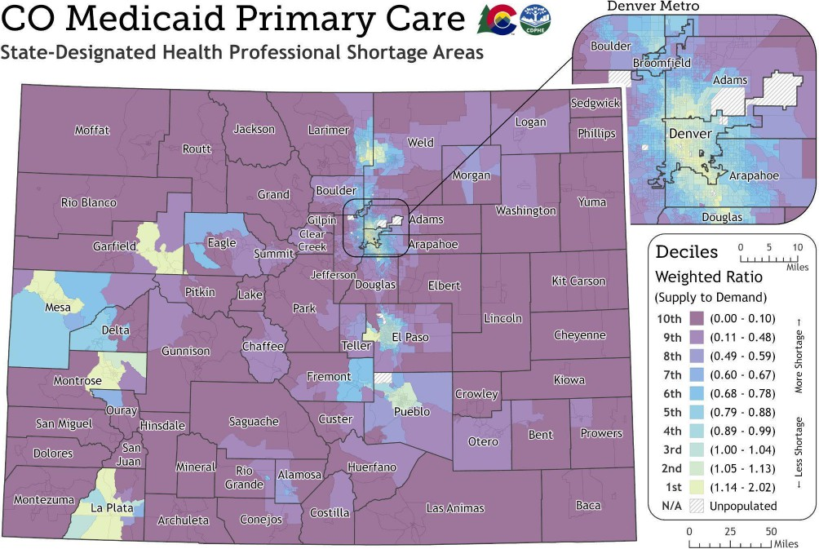

Figure S1 represents test results of the methodology proposed in the amended rule as applied to primary care. Additional and more contemporary data collection may modify these results in implementation of the amended rule, if adopted.

SI 1

Proposed Rule Amendment Revision Notes

Line 19: Technical revision to align title heading format with comparable sections.
Lines 66–70: Subsection inserted describing the Medicaid based methodology for shortage area determination.
Lines 128–141: Term definitions added to support implementation of the proposed Medicaid designation amendments.
Lines 143–198: Definitions re-numbered to accommodate the addition of new terms referenced in the proposed amendments.
Lines 200–210: Definitions removed that are no longer applicable to the rule, as amended. Line 224: Internal section reference updated to reflect re-numbered definitions.
Lines 232–233: Clarifying language added to specify applicability to dental care.
Line 242: Technical revision to align title heading format with comparable sections.
Lines 249–255: Language added establishing the procedure for determining perinatal health demand, necessary for application of the proposed Medicaid designation methodology.
Lines 267–300: New section added describing the methodology for designation of Medicaid Health Professional Shortage Areas.
Line 301: Section re-numbered to reflect insertion of new Medicaid methodology.
Lines 312-313: Additional specification of required data sources for Medicaid-based determinations.
Line 315: Section re-numbered to reflect insertion of new sections. Line 317: Updated schedule for designation review.

SI 2

DEPARTMENT OF PUBLIC HEALTH AND ENVIRONMENT
Prevention Services Division
STATE-DESIGNATED HEALTH PROFESSIONAL SHORTAGE AREA DESIGNATION 6 CCR 1015-6

Adopted by the Board of Health on ; effective .
  - Purpose
This rule establishes quantitative methods for determining which areas of Colorado have a shortage of health care providers and thus, should receive a state designation as a health professional shortage area.
The methodology for behavioral health care services designation is based upon:

- The estimated demand for behavioral health care services encounters within a population defined by a discrete geographic area;

- The estimated supply of behavioral health care services encounters for the population within a discrete geographic area;
- The determination of whether supply meets demand within a discrete geographic area; and

- The designation of geographic areas as behavioral health care services health professional shortage areas where the resultant supply falls short of estimated demand for minimally adequate substance use disorder treatment.

The methodology for primary care designation is based upon:

- The estimated demand for primary care service encounters within a population defined by a discrete geographic area;

- The estimated supply of primary care service encounters for the population within a discrete geographic area;

- The determination of whether supply meets demand within a discrete geographic area; and

- The designation of geographic areas as primary care health professional shortage areas where the resultant supply falls short of estimated demand for primary care services.

The methodology for dental care designation is based upon:

- The estimated demand for dental care services encounters within a population defined by a discrete geographic area;

- The estimated supply of dental care service encounters for the population within a discrete geographic area;

- The determination of whether supply meets demand within a discrete geographic area; and

- The designation of geographic areas as dental health professional shortage areas where the resultant supply falls short of the estimated demand for dental services.

The methodology for perinatal care designation is based upon:

- The estimated demand for perinatal care services encounters within a population defined by a discrete geographic area;

- The estimated supply of perinatal care service encounters for the population within a discrete geographic area;

- The determination of whether supply meets demand within a discrete geographic area; and

- The designation of geographic areas as perinatal health professional shortage areas where the resultant supply falls short of the estimated demand for perinatal care services.

  - Authority

This regulation is adopted pursuant to the authority in Section 25-1.5-404(1)(a), Colorado Revised Statutes.

  - Definitions

- “Behavioral Health Care Provider,” pursuant to Section 25-1.5-502(1.3), C.R.S., means the following providers who provide behavioral health care services within their scope of practice:

  - a licensed addiction counselor (LAC),

  - a certified addiction counselor (CAC),

  - a licensed professional counselor (LPC),

  - a licensed clinical social worker (LCSW),

  - a licensed marriage and family therapist (LMFT),

  - a licensed psychologist (Ph.D. or Psy.D.),

  - a licensed physician assistant (PA) with specific training in substance use disorder,

  - an advanced practice nurse (APN) with specific training in substance use disorder, pain management, or psychiatric nursing, or

  - a physician with specific board certification or training in addiction medicine, pain management, or psychiatry.

- “Behavioral Health Care Services,” pursuant to Section 25-1.5-502(1.5), C.R.S., means services for the prevention, diagnosis, and treatment of, and the recovery from, mental health and substance use disorders.

- “Capacity” means the typical volume of health service encounters a health care professional can produce within the scope of his or her practice and scheduled clinical hours.

- “Catchment Area” means a discrete geographic area where a preponderance of the civilian noninstitutionalized population within the service area could reasonably expect to access behavioral health services within the service area without excessive travel, when it is adequately resourced.
- “Census Block Group” means a statistical division of a census tract defined by the U.S. Census Bureau.
- “Civilian Noninstitutionalized Population” are all people who live and sleep most of the time within the boundaries of a geographic area but are not housed in a group quarter such as a correctional institution, juvenile facility, military installation, or dormitory.
- “Colorado Health Systems Directory” means the clinician data system administered by the Colorado Department of Public Health and Environment’s Primary Care Office (section 25-1.5-403, C.R.S.) which provides a comprehensive database of all licensed clinicians and health care sites in Colorado.
- “Encounter” means an instance of direct provider to patient interaction with the primary purpose of diagnosing, evaluating or treating a patient’s health care concern.

93) “Minimally Adequate Treatment” means the minimum necessary health care service visits for diagnosis, treatment or recovery needed to address a specific or general medical or behavioral health care service need.
104) “Oral Health Provider,” means the following health care professionals as defined in Section 25-1.5-502(5), C.R.S., who provide primary oral health care services within their scope of practice:
- a Doctor of Dental Surgery (DDS) or Doctor of Medicine in Dentistry (DMD) who is practicing in general dentistry and/or pediatric dentistry; or
- a licensed dental hygienist (RDH).
115) “Oral Care Services” means a type of primary oral health services that involves comprehensive first contact and continuing care services for the prevention, diagnosis, and treatment of common oral diseases to maintain the health of the mouth, teeth, and orofacial structures.
126) “Perinatal Care Provider” means a clinician who provides prenatal, intrapartum, and postpartum care within their scope of practice:

- a physician (MD or DO) with specific board certifications or training in obstetrics, gynecology, maternal-fetal medicine, or neonatal-perinatal medicine;

- a physician (MD or DO) with specific board certifications or training in family medicine and who routinely provides prenatal, intrapartum, and postpartum care;

- an advanced practice nurse (APN) with a focus or specialty in women’s health or nurse midwifery whose clinical practice includes the provision prenatal, intrapartum, and postpartum care;

- an advanced practice nurse certified nurse midwife (CNM);

- a midwife pursuant to section 12-255-111.5, C.R.S.

137) “Prevalence” means the proportion of a population who has behavioral health care needs at some point within the previous year.

148) “Primary Care Provider” means the following health care professionals as defined in Section 25-1.5-502(5), C.R.S., who provide primary care services within their scope of practice:

- an advanced practice nurse (APN) with a focus or specialty in primary care, women’s health, or nurse midwifery;

- a physician (MD or DO) with specific board certification or training in family medicine, general internal medicine, or general pediatrics; or

- a physician assistant (PA) with a practice focus on primary care services.

1519) “Primary Care Services,” means a type of primary health services, as defined in Section 25-1.5-502(10), C.R.S., that involves comprehensive first contact and continuing care services for the prevention, diagnosis, and treatment of any undiagnosed sign, symptom or health concern not limited by problem origin or diagnosis.

160) “Polygon” means a closed, irregular geometric shape on a map surface that defines equivalent road travel distances from a central point within the shape.

171) “Population Centroid” means the geometric center of a group of population points within a geographic shape (e.g., census block group).

182) "State-Designated Health Professional Shortage Area,” pursuant to Section 25-1.5-402(11) and Section 25-1.5-502(13), C.R.S., means an area of the state designated by the Primary Care Office in accordance with state-specific methodologies established by the State Board by rule pursuant to Section 25-1.5-404 (1)(a), C.R.S., as experiencing a shortage of health care professionals or behavioral health care providers.

193) “State Designated Substance Use Disorder Health Professional Shortage Area” means a State-Designated Health Professional Shortage Area experiencing a shortage of behavioral health care providers providing behavioral health care services for substance use disorder.

204) “Substance Use Disorder” means mild, moderate, or severe recurrent use of drugs and/or alcohol that causes clinically and functionally significant impairment of individuals. Impairment may include health concerns, disability, risky behavior, social impairment, and failure to perform significant responsibilities at work, school, or with family. The diagnosis may be applied to the abuse of one or more of ten separate classes of drugs including alcohol, caffeine, cannabis, hallucinogens, inhalants, opioids, sedatives, stimulants, tobacco, and other substances. The dependent use of tobacco and caffeine are not a primary focus of this rule.

****

  - Dental Health Professional Shortage Area Determination Method

- Catchment areas are created for analysis of dental health provider capacity by determining standard road travel distances from the population centroid of each census block group in Colorado using a variable two-step floating catchment area method.
- The population of each catchment area is the civilian noninstitutionalized population according to the most recent available data from U.S. Census Bureau at the time of analysis.
- The estimated demand for dental care services within each catchment area is determined by multiplying the civilian noninstitutionalized population in the catchment area (section 1.5(2)) by two visits per year.
- The estimated dental services supply in each catchment area is determined by surveying dentists with a practice address within the catchment area. The list of dentists is derived from the most recent available data reported in the Colorado Health Systems Directory administered by the Colorado Department of Public Health and Environment’s Primary Care Office. Each dentist is assigned a dental primary care service 12 month productivity rate. The sum of encounter productivity for all practicing primary care providers in the catchment area is the total estimated primary care services supply in the catchment area.
- Designation of a census block group as a State Designated Dental Health Professional Shortage Area occurs when the supply of dental care service encounters falls below the per capita demand for primary care demand within the catchment area.
- Current designation status of each region of the state will be posted at least annually on or about July 1 on a publicly accessible website.
  - Perinatal Health Professional Shortage Area Determination

- Catchment areas are created for analysis of perinatal care provider capacity by determining standard road travel distances from the population centroid of each census block group in Colorado using a variable two-step floating catchment area method.

- The population of each catchment area is the pregnant population according to records of live births as reported by Colorado Department of Public Health and Environment’s Vital Records, averaged across the most recent five years on the date of analysis.

- The estimated perinatal care services supply in each catchment area is determined by surveying perinatal care providers with a common practice address. The list of perinatal care providers is derived from the most recent available data reported in the Colorado Health Systems Directory administered by the Colorado Department of Public Health and Environment’s Primary Care Office. Each perinatal care provider is assigned a perinatal care service 12 month productivity rate. The sum of encounter productivity for all practicing perinatal care providers with a common practice address is the total estimated perinatal care services supply in the practice address.

- Designation of a census block group as a State Designated Perinatal Care Health Professional Shortage Area occurs when the supply of perinatal health service encounters falls below the per capita demand for perinatal care demand within the census block group’s catchment area.

  - Data Sources
- If current data from the sources cited above are unavailable, the department may rely upon comparable data sources.
- To the extent available, reliable and practicable, the department will rely upon data collected within one year prior to analysis.
- Health care providers practice characteristics data may be derived from direct survey methods, claims analysis, peer reviewed and validated workforce research tools, and statistical methods.

  - Review
Shortage designation status will be reviewed in 2025 and at least every three years thereafter. More frequent review may be performed where data is available and analytical resources are available.

Designation status of each area will remain effective for 36 months from the date of publication or when replaced by a more recent analysis.

