BEFORE THE LIMITED GAMING CONTROL COMMISSION STATE OF COLORADO

RESOLUTION CONCERNING ADOPTION OF EMERGENCY AMENDMENTS TO DIVISION OF GAMING, SPORTS BETTING RULES 7.6, 7.7, and 7.11, 1 C.C.R. 207-2

WHEREAS, on April 13, 2026, the Colorado General Assembly passed Senate Bill (SB) 26-131, Sports Betting Protections and, in connection therewith, making an appropriation;

WHEREAS, on June 2, 2026, Governor Jared S. Polis signed SB 26-131; WHEREAS, SB 26-131 takes effect at 12:01 a.m. on August 12, 2026;
WHEREAS, section 4 of SB 26-131 in part prohibits internet sports betting operators from accepting deposits using a credit card, either directly or indirectly, including through an account funded by a credit card, in connection with the acceptance of a sports bet;

WHEREAS, a temporary or emergency rule may be adopted under section 24-4-103(6)(a), C.R.S., if an agency finds that immediate adoption of a rule is imperatively necessary and that compliance with the requirements of section 24-4-103, C.R.S., would be contrary to the public interest;

WHEREAS, the immediate adoption of the emergency amendments to Rules
7.6 Sport betting system requirements, 7.7 Sports betting kiosks, and 7.11 Sports betting accounts, 1 C.C.R. 207-2, which amend the rules that currently explicitly permit credit cards to prohibit deposits using a credit card, either directly or indirectly, in connection with the acceptance of a sports bet, are imperatively necessary to comply with newly enacted law so the rules conform to the provisions of SB 26-131, and compliance with the procedural requirements of section 24-4-103, C.R.S., would be contrary to public interest because the new law will be effective August 12, 2026;
WHEREAS, the proposed emergency rule amendment is necessary for the Division of Gaming to carry out the purposes of SB 26-131 and the modifications therein by the effective date, and immediate adoption of the emergency amendments to Rules 7.6, 7.7, and 7.11 will remove unlawful rules and allow

licensees to understand and comply with the statutory changes to section 44-30-1511, C.R.S.; and,

WHEREAS, a permanent change could be achieved no sooner than September 2026, given the process for notice and promulgation of the rules pursuant to the provisions of section 24-4-103, C.R.S., after Governor Jared S. Polis signed SB 26-131 on June 2, 2026.

NOW, THEREFORE, IT IS HEREBY RESOLVED by the Colorado Limited Gaming Control Commission, based on the facts recited above, as follows:

The immediate adoption of the emergency rule amendments for Division of Gaming, Sports Betting Rules 7.6, 7.7, and 7.11, 1 C.C.R. 207-2, effective immediately, is imperatively necessary to implement the changes in SB 26-131 by removing conflicting and unlawful rules, and the delay resulting from strict compliance with the requirements of section 24-4-103, C.R.S., would be contrary to the public interest.

These emergency rule amendments for Division of Gaming, Sports Betting Rules 7.6, 7.7, and 7.11 will remain in effect up to one hundred and twenty days from the date of the adoption of these emergency rules, per section 24-4-103(6)(a), C.R.S., unless superseded and repealed through permanent rulemaking prior to the expiration of that period of time.

RESOLVED AND ENTERED this16 day of July, 2026.

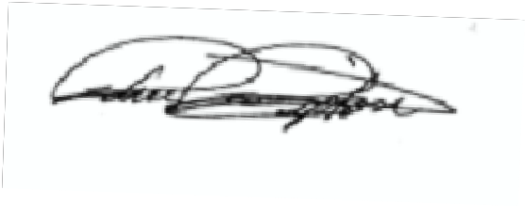
COLORADO LIMITED GAMING CONTROL COMMISSION

By: John Tipton, Chair

