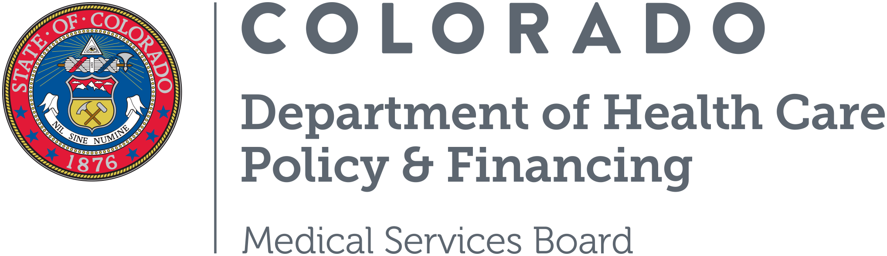

June 2026 Emergency Justification for Medical Assistance rules adopted at the June 12, 2026 Emergency Medical Services Board Meeting

Document A, MSB 26-05-28-A, Revision to the Medical Assistance Act Rule Concerning Updates to the General and Citizenship Eligibility Requirements, Section 8.100.3.G.1.viii

Emergency rule-making is imperatively necessary. An emergency rule change for Medical Assistance must be enacted, and a CBMS project initiated, to implement the necessary adjustments required to comply with House Bill (HB) 26-1411. The law was passed with enrollment cap changes on June 3, 2026, and requires that the cap be implemented on July 1, 2026 for the 2026-2027 fiscal year. Emergency rulemaking is imperatively necessary for the preservation of public health safety, and welfare.

Document B, MSB 26-05-05-B, Revision to the Medical Assistance Act Rule concerning Caregiver Limits sections 8.520; 8.7400; 8.7500

Emergency rule-making is imperatively necessary. This rule implements the caregiver limit policy that was approved through the Long Bill (signed by Governor Polis on May 8, 2026). The policy, as reviewed in detail with the Joint Budget Committee and approved through HB 26-1410, requires that the initial weekly caregiver limit begins July 1, 2026. This requires the Department to have regulations in place for the caregiver limits, the exception process, the emergency situation criteria, and enforceability requirements. Running this through the emergency rulemaking process allows the Department, provider agencies, case management agencies, and members enough time to finalize policies and procedures to comply with the policy. Emergency rulemaking is imperatively necessary for the preservation of public health safety, and welfare.

Document C, MSB 26-05-05-A, Revision to the Medical Assistance Act concerning Legally Responsible Persons Homemaker Hours section 8.7500

Emergency rule-making is imperatively necessary. The Department received approval from CMS and the General Assembly for the policy and associated savings assumptions related to the reduction in LRP Homemaker hours. While the Medical Services Board approved the policy through emergency rulemaking authority, the Board did not adopt the rule permanently during final rulemaking. However, because the State budget already incorporates the savings associated with this policy change, the Department must move forward with emergency rulemaking to remain compliant with the appropriated budget and fiscal assumptions enacted through the Long Bill. Emergency rulemaking is imperatively necessary for the preservation of public health safety, and welfare.

