

Statement of Emergency Justification and Adoption

1 CCR 201-18, Emergency Rule 39-28.8-301

Colorado Department of Revenue

Pursuant to sections 24-4-103(6), 39-21-112(1), 39-21-113, 39-26-102, 39-26-103, 39-
26-105, 39-26-116, 39-26-118(2), 39-28.8-101, 39-28.8-301, 39-28.8-302, 39-28.8-303,
39-28.8-304, 39-28.8-308, 44-10-103, 44-10-202(1)(a), 44-10-502(9.5), 44-10-503, and
44-10-602(13.5), C.R.S., I, Heidi Humphreys, Executive Director of the Department of Revenue, hereby adopt Emergency Rule 39-28.8-301.
Section 24-4-103(6), C.R.S., authorizes the Executive Director to adopt temporary or emergency rules if the Executive Director finds that the immediate adoption of the rules are imperatively necessary to comply with a state or federal law or for the preservation of public health, safety, or welfare, and that compliance with the requirements of section 24-4-103, C.R.S., regarding promulgation of permanent rules, would be contrary to the public interest.
I find that the immediate adoption of this rule is imperatively necessary to comply with state or federal law, specifically to ensure the timely creation of average market rate categories for the final test period of 2026 on September 1 to facilitate rulemaking after the test period but before the July 1, 2027, rulemaking deadline in House Bill 26-1077. As a result, I find that compliance with the requirements of section 24-4-103, C.R.S., would be contrary to the public interest under these circumstances because the permanent rules being adopted at the same time as this temporary rule will not take effect prior to September 1, 2026.

Statutory Authority
The statutory authorities for this rule are sections 24-4-103(6), 39-21-112(1), 39-21-113, 39-26-102, 39-26-103, 39-26-105, 39-26-116, 39-26-118(2), 39-28.8-101, 39-28.8-301,
39-28.8-302, 39-28.8-303, 39-28.8-304, 39-28.8-308, 44-10-103, 44-10-202(1)(a), 44-10-
502(9.5), 44-10-503, and 44-10-602(13.5), C.R.S.

Purpose
The purpose of this rule is to provide guidance regarding the imposition and calculation of the retail marijuana excise tax; establish rules governing the calculation of the average market rate for purposes of the retail marijuana excise tax; and establish procedures governing the collection, administration, and enforcement of the retail marijuana excise tax.

Statement of Emergency Justification and Adoption Page 2

Adoption
For the reasons set forth above, I hereby adopt Emergency Rule 39-28.8-301, which is attached to this Statement. This emergency rule shall be effective on the date of this adoption and shall apply prospectively. This emergency rule shall be in force and effect for a period of one hundred and twenty days from the date of this notice, unless sooner terminated or replaced by permanent rules adopted in accordance with section 24-4-103, C.R.S.

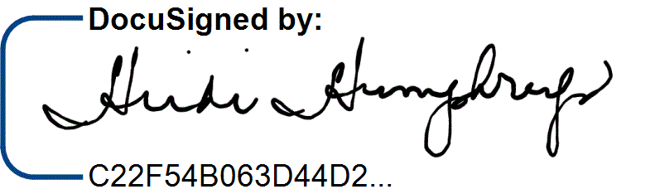
8/4/2026

Heidi Humphreys Date
Executive Director
Colorado Department of Revenue

