DEPARTMENT OF NATURAL RESOURCES
Division of Water Resources
RULES AND REGULATIONS APPLYING EXCLUSIVELY TO THE WITHDRAWAL OF GROUND WATER FROM THE DAWSON, DENVER, ARAPAHOE AND LARAMIE-FOX HILLS AQUIFERS IN THE DENVER BASIN
2 CCR 402-6
[Editor’s Notes follow the text of the rules at the end of this CCR Document.]
_________________________________________________________________________

Rule 1. Title:
The title of these rules and regulations is “The Rules and Regulations Applying Exclusively to the Withdrawal of Ground Water from the Dawson, Denver, Arapahoe and Laramie-Fox Hills Aquifers in the Denver Basin.” The short title for these rules and regulations is “The Denver Basin Rules” and they may be referred to herein collectively as the “rules” or individually as a “rule.”

Rule 2. Authority:
These rules are promulgated pursuant to the authority granted the State Engineer in Sections 37-90-137(9)(a), 37-90-137(9)(b), and 37-80-102(1)(g), C.R.S.

Rule 3. Scope and Purpose:
A. These rules apply to the evaluation and processing of well permit applications acted upon after the effective date of these rules for the withdrawal of ground water from the Dawson, Denver, Arapahoe and Laramie-Fox Hills Aquifers, as defined below, pursuant to Section 37-90-137(4), C.R.S.
B. The purpose of these rules is to permit the withdrawal of ground water from the Dawson, Denver, Arapahoe and Laramie-Fox Hills Aquifers without materially affecting vested water rights.
C. These rules apply exclusively to the evaluation and processing of well permit applications for the withdrawal of ground water from the Dawson, Denver, Arapahoe and Laramie-Fox Hills Aquifers. In addition, other rules and regulations of the State Engineer may also apply to the withdrawal of ground water from the Dawson, Denver, Arapahoe and Laramie-Fox Hills Aquifers.
D. As to any application for a well permit to withdraw ground water from the Dawson, Denver, Arapahoe or Laramie-Fox Hills Aquifer which is the subject of an existing water court decree, in the event of a conflict between terms and conditions specified in the decree and terms and conditions that would be required by these rules, the water court decree shall control.

Rule 4. Definitions:
A. The following definitions are applicable to these Denver Basin Rules:
1. The “Dawson Aquifer” means both the Lower Dawson Aquifer and the Upper Dawson Aquifer.
2. The “Upper Dawson Aquifer” means that aquifer above the base of the aquifer as shown in Denver Basin Atlas No. 1, Plate 3, Figure 1D, and that aquifer above the base of the aquifer as shown in Plate 1, Figure 1A south of the boundary of the Lower Dawson Aquifer.
3. The “Lower Dawson Aquifer” means that aquifer between the base of the aquifer as shown in Denver Basin Atlas No. 1, Plate 1, Figure 1A north of the boundary of the Lower Dawson Aquifer and the top of the aquifer as shown in Plate 2, Figure 1B and including the area of the outcrop/subcrop as shown in Plate 2, Figure 1C.
4. The “Denver Aquifer” means that aquifer between the base of the aquifer as shown in Denver Basin Atlas No. 2, Plate 1, Figure 2B and the top of the aquifer as shown in Plate 1, Figure 2A and including the area of the outcrop/subcrop as shown in Plate 2, Figure 2C.
5. The “Arapahoe Aquifer” means both the Lower Arapahoe Aquifer and the Upper Arapahoe Aquifer.
6. The “Upper Arapahoe Aquifer” means that aquifer between the base of the aquifer as shown in Denver Basin Atlas No. 3, Plate 3, Figure 3C and south and east of the boundary of the Lower Arapahoe Aquifer as shown in Plate 3, Figure 3C and the top of the aquifer as shown in Plate 1, Figure 3A and including the area of the outcrop/subcrop as shown in Plate 4, Figure 3E.
7. The “Lower Arapahoe Aquifer” means that aquifer between the base of the aquifer as shown in Denver Basin Atlas No. 3, Plate 2, Figure 3B north and west of the boundary of the Lower Arapahoe Aquifer and the top of the aquifer as shown in Plate 3, Figure 3D and including the area of the outcrop/subcrop as shown in Plate 5, Figure 3F.
8. The “Laramie-Fox Hills Aquifer” means that aquifer between the base of the aquifer as shown in Denver Basin Atlas No. 4, Plate 2, Figure 4B and the top of the aquifer as shown in Plate 1, Figure 4A and including the area of the outcrop/subcrop as shown in Plate 3, Figure 4C.
9. “Denver Basin Aquifers” means the Upper Dawson, Lower Dawson, Denver, Upper Arapahoe, Lower Arapahoe and Laramie-Fox Hills Aquifers as defined in these rules.
10. “Denver Basin” means that geographic area overlying the base of the Laramie-Fox Hills Aquifer as shown in Denver Basin Atlas No. 4, Plate 2, Figure 4B.
B. Any term used in these Denver Basin Rules that is defined in Sections 37-90-103 or 37-92-103, C.R.S. is used with the meaning given therein.
C. Any term used in these Denver Basin Rules that is not defined herein that is defined in other Rules and Regulations of the State Engineer is used with the meaning given therein.

Rule 5. Location of Nontributary Ground Water in the Denver Basin:
A. The location of nontributary ground water in the Upper Dawson Aquifer is shown in Denver Basin Atlas No. 1, Plate 4, Figure 1G.
B. The location of nontributary ground water in the Lower Dawson Aquifer is shown in Denver Basin Atlas No. 1, Plate 4, Figure 1F.
C. The location of nontributary ground water in the Denver Aquifer is shown in Denver Basin Atlas No. 2, Plate 2, Figure 2D.
D. The location of nontributary ground water in the Upper Arapahoe Aquifer is shown in Denver Basin Atlas No. 3, Plate 6, Figure 3H.
E. The location of nontributary ground water in the Lower Arapahoe Aquifer is shown in Denver Basin Atlas No. 3, Plate 5, Figure 3G.
F. The location of nontributary ground water in the Laramie-Fox Hills Aquifer is shown in Denver Basin Atlas No. 4, Plate 4, Figure 4D.

Rule 6. Determination Of Specific Yield For Wells In The Denver Basin:
A. In determining the allowed average annual amount of withdrawal from a well in one of the Denver Basin Aquifers, the State Engineer shall apply the following specific yield values, unless the applicant or permittee submits site specific data acceptable to the State Engineer that support a different value pursuant to paragraph B below:
 | Aquifer |  | Specific Yield
1. | Upper Dawson | - | 20.0%
2. | Lower Dawson | - | 20.0%
3. | Denver | - | 17.0%
4. | Upper Arapahoe | - | 17.0%
5. | Lower Arapahoe | - | 17.0%
6. | Laramie-Fox Hills | - | 15.0%
B. If a specific yield test or tests meeting the requirements of the Statewide Nontributary Ground Water Rules are done at the location of a permitted well or wells, the value derived therefrom shall be used as the specific yield for determining the allowed average annual amount of withdrawal from the well or wells. If the requirements of a specific yield test are not set forth in the Statewide Nontributary Ground Water Rules or those rules are not in effect, the State Engineer shall consider site specific data for specific yield presented by an applicant or permittee and vary the specific yield value for determining the allowed average annual amount of withdrawal from a well if such data rebut the presumptive value set forth in Rule 6.A. Such use of site specific data shall not be deemed to be a modification of these rules. In determining whether an applicant or permittee has rebutted a presumptive specific yield value set forth in paragraph A above, nothing in this rule shall preclude the State Engineer from considering any other site specific data available to him.

Rule 7. Determination of Number of Feet of Saturated Aquifer Materials in the Denver Basin Aquifers:
The thicknesses of sandstones and siltstones in the Denver Basin Aquifers are shown on the following figures:
*(Thickness from Plate 4, Figure 3E) - (Thickness from Plate 5 Figure 3F) = Thickness of Upper Arapahoe Aquifer
A. | Upper Dawson | Denver Basin Atlas No. 1, Plate 3, Figure 1E
B. | Lower Dawson | Denver Basin Atlas No. 1, Plate 2, Figure 1C
C. | Denver | Denver Basin Atlas No. 2, Plate 2, Figure 2C
D. | Upper Arapahoe | Denver Basin Atlas No. 3, Plate 4, Figure 3E minus Plate 5, Figure 3F*
E. | Lower Arapahoe | Denver Basin Atlas No. 3, Plate 5, Figure 3F
F. | Laramie-Fox Hills | Denver Basin Atlas No. 4, Plate 3, Figure 4C
I.E., to find the thickness of the Upper Arapahoe Aquifer subtract the thickness value shown in Plate 5, Figure 3F from the thickness value in Plate 4, Figure 3E. Where there is no overlap between figures, Figure 3F is “O”.
The thicknesses on the figures shall be considered to be the presumptive thickness of saturated aquifer material as long as the aquifer is confined, under artesian pressure. The applicant may be required by the State Engineer to demonstrate that the aquifer is still confined or, if the aquifer is unconfined, to provide data on the exact location of the water table. Upon evaluating the location of the water table, the State Engineer shall determine the thickness of saturated aquifer materials.

Rule 8. Limit on Consumption:
In order to assure that no water rights are materially affected by withdrawals of nontributary ground water from the Denver Basin Aquifers, no more than 98% of the water withdrawn annually from a well withdrawing such nontributary ground water shall be consumed. The applicant must demonstrate to the reasonable satisfaction of the State Engineer prior to the issuance of the permit that not more than 98% of the water withdrawn will be consumed. The State Engineer may reasonably require a permittee to demonstrate periodically that no more than 98% of the water being withdrawn from the well is being consumed.

Rule 9. Modification of Elevation of the Top or Bottom of Aquifer and the Number of Feet of Saturated Aquifer Materials:
The following aquifer characteristics established by these rules (in addition to the specific yield values set forth in Rule 6) are deemed presumptive: the elevation of the top or bottom of any of the Denver Basin Aquifers at a specific location; and the number of feet of saturated aquifer materials in any of the Denver Basin Aquifers at a specific location. If an applicant or permittee submits site specific data satisfactory to the State Engineer which support the use of a different value for one or more of the above aquifer characteristics, then, for the purpose of determining the allowed average annual amount of withdrawal from the well and the interval from which the well may withdraw water, the State Engineer shall modify the aquifer characteristic or characteristics accordingly. Such site specific data may include, but are not limited to, geophysical logs. Such use of site specific data shall not be deemed to be a modification of these rules. In determining whether an applicant or permittee has rebutted one or more of the above presumptive aquifer characteristics, nothing in this rule shall preclude the State Engineer from considering any other site specific data available to him.

Rule 10. Replacement of Existing Wells Completed Into Two Adjacent Aquifers:
If a permit is sought to replace an existing well that withdraws ground water from two adjacent Denver Basin Aquifers, pursuant to a valid water court decree or well permit, the applicant or permittee shall, upon proper application, be granted a permit for a replacement well to withdraw ground water from the same producing interval as the original well. Provided, however, that the replacement well shall be constructed within 200 feet of the original well. This rule shall not apply to the issuance of permits for new wells, additional wells, alternate point of diversion wells, or supplemental wells.

Rule 11. Incorporation by Reference:
All figures referred to in these rules and the Statement of Basis and Purpose for the Adoption of the Denver Basin Rules are incorporated by reference as part of these rules.

Rule 12. Severability:
If any portion of these Denver Basin Rules is found to be invalid, the remaining portion of the rules shall remain in force and unaffected.

Rule 13. Revision:
The State Engineer may revise these rules in accordance with Section 24-4-103 C.R.S. Such revisions may be a result of new data and/or the submittal of a petition by an interested person pursuant to Section 24-4-103(7) C.R.S. and 2 C.C.R. 402-5 1.1.3.B.2).

Rule 14. Effective Date:
These rules shall become effective on January 1, 1986.
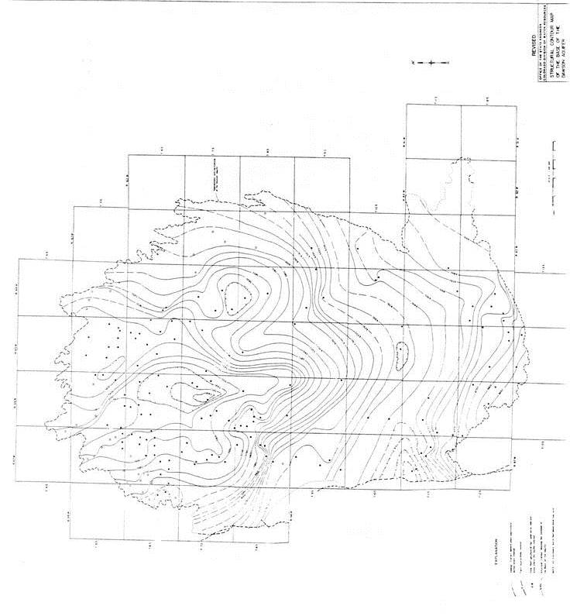
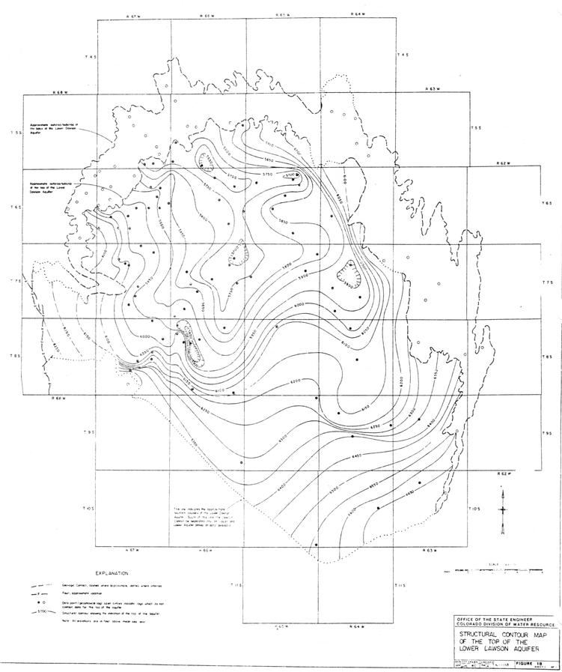
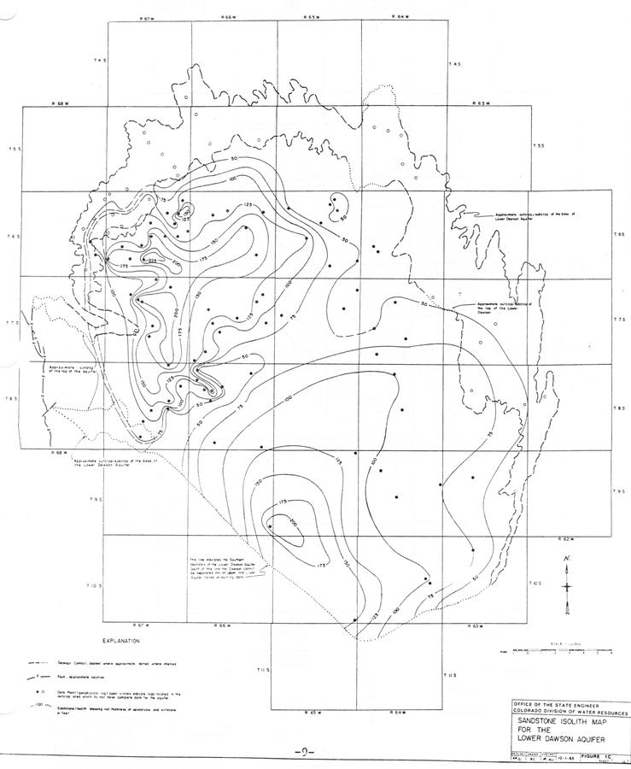
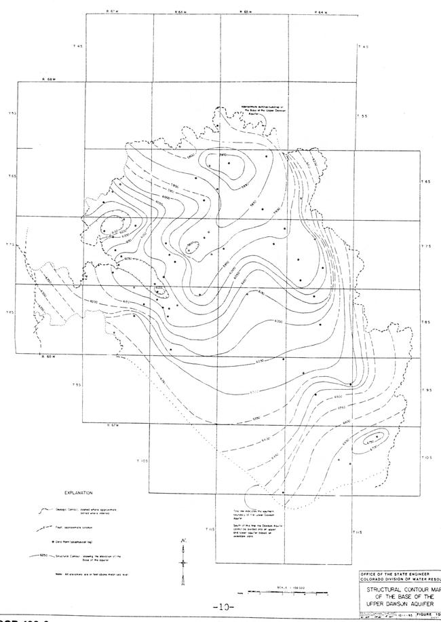
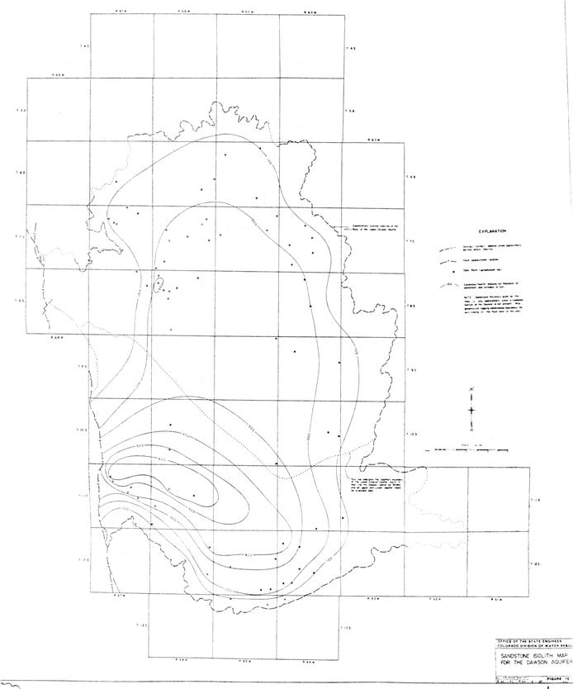
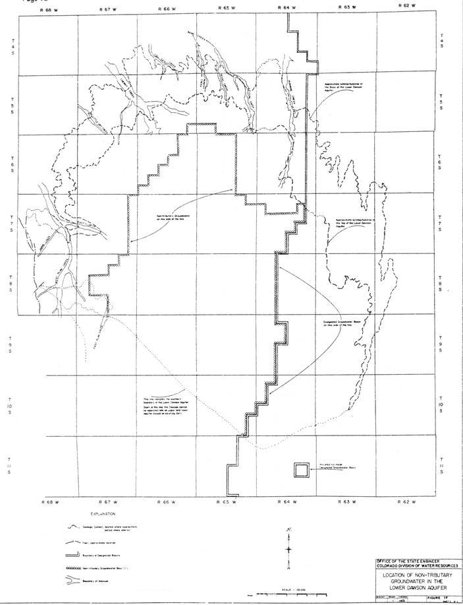
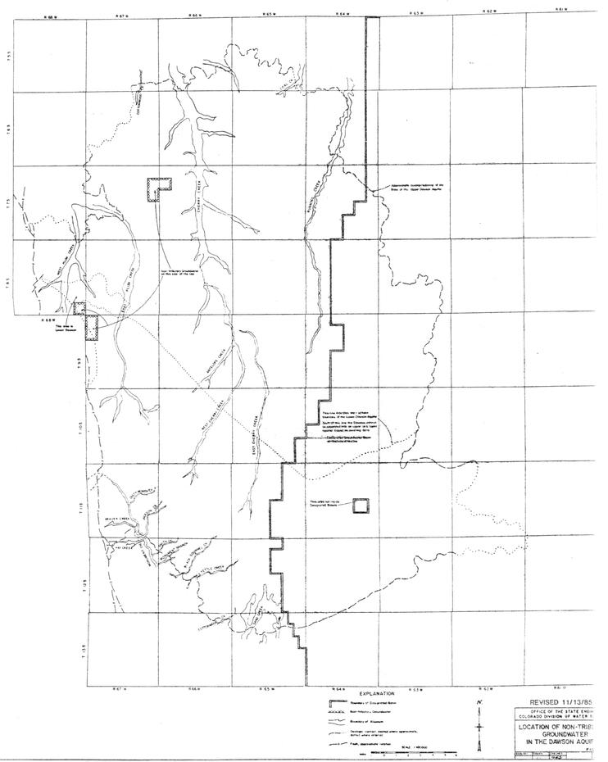
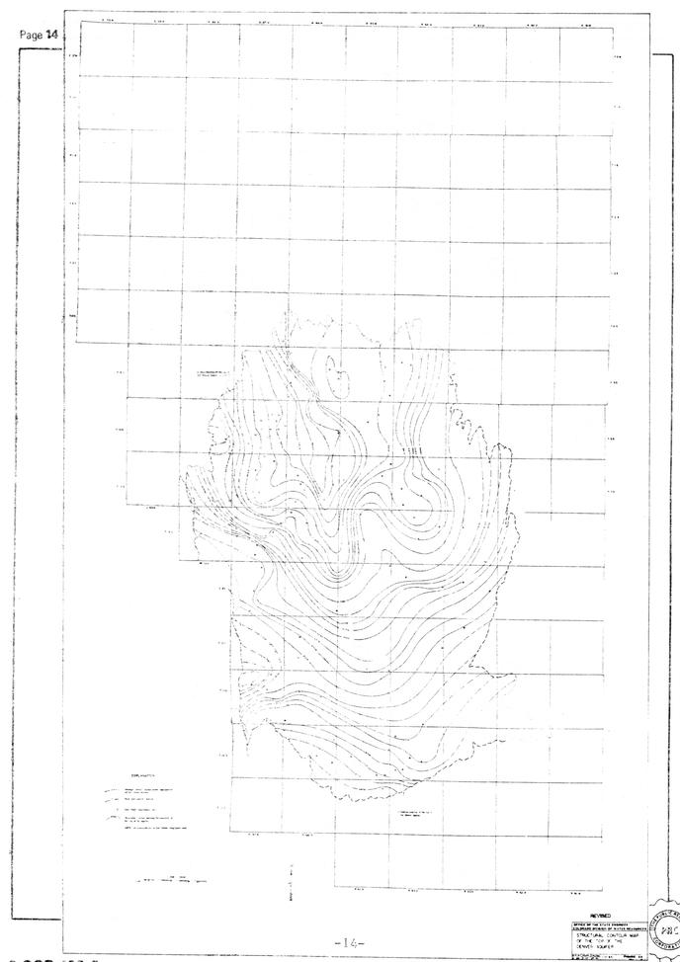
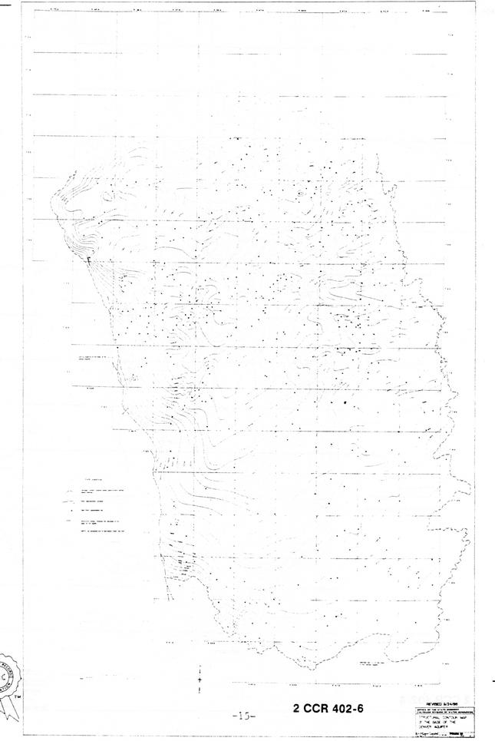
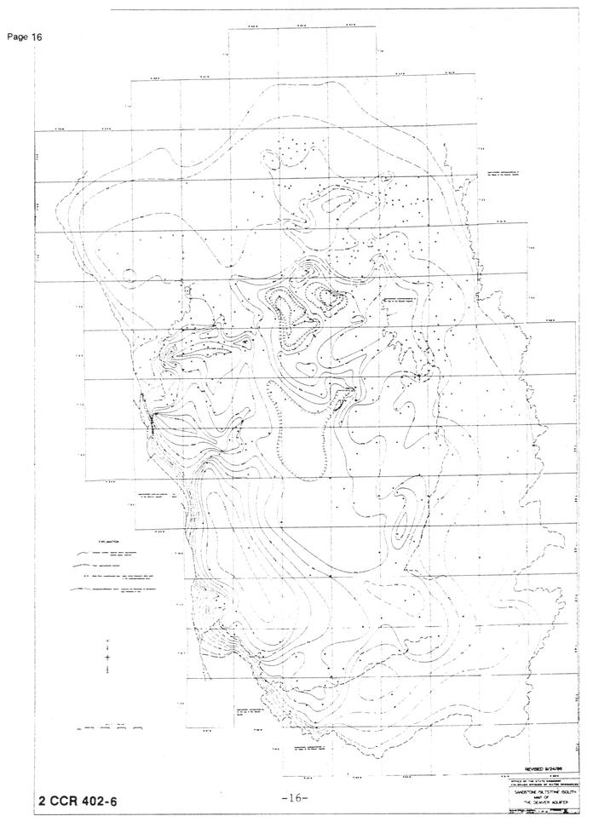
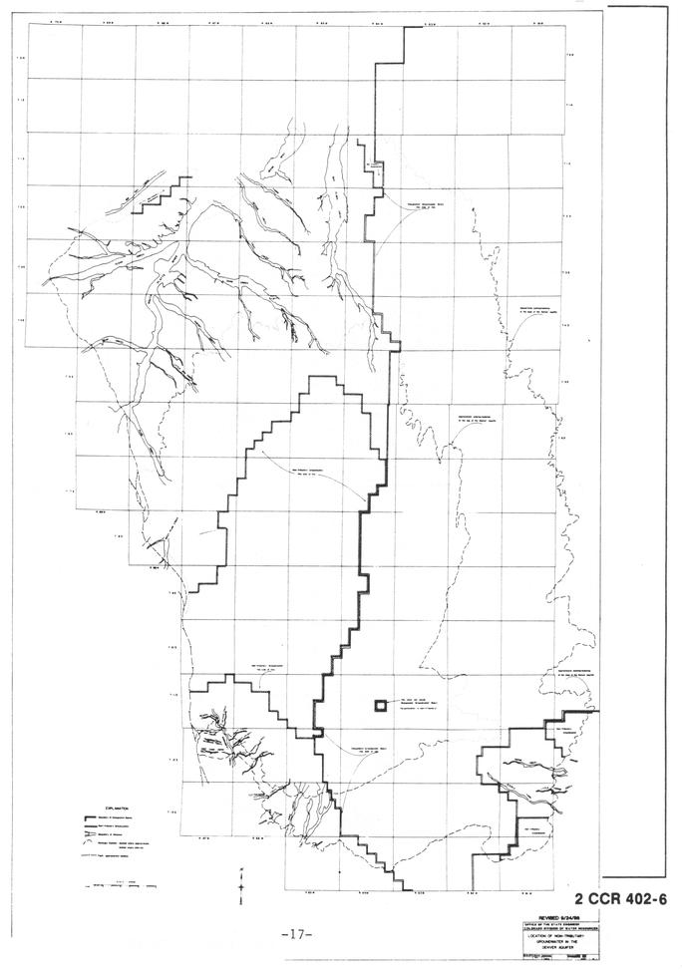
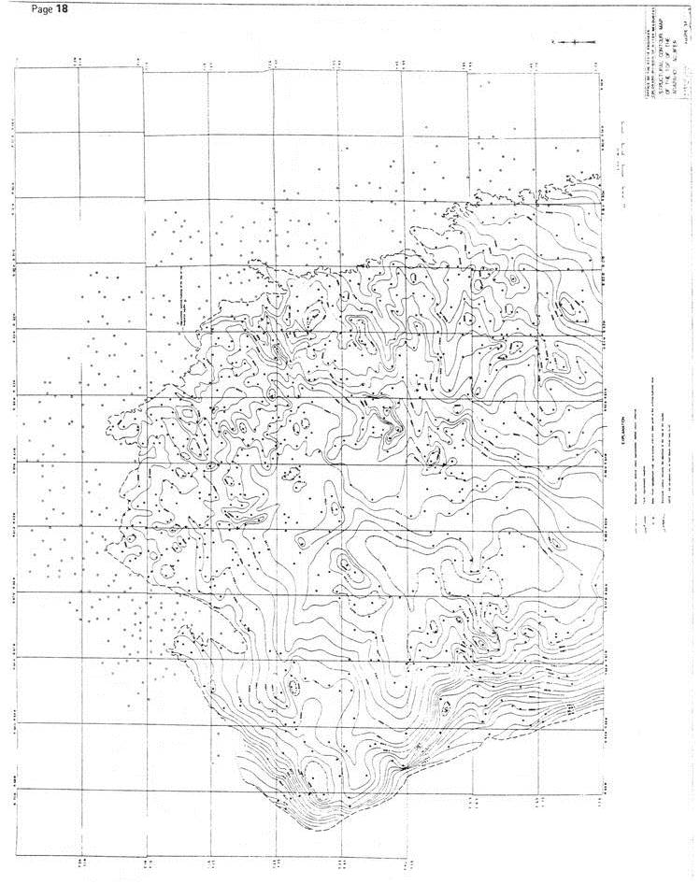
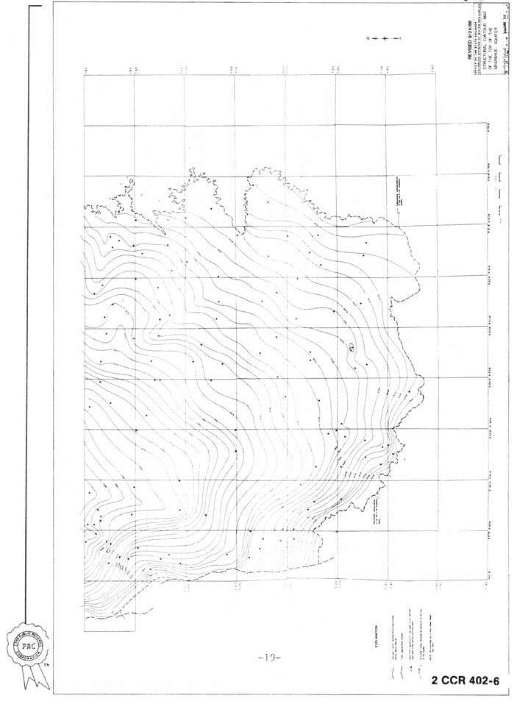
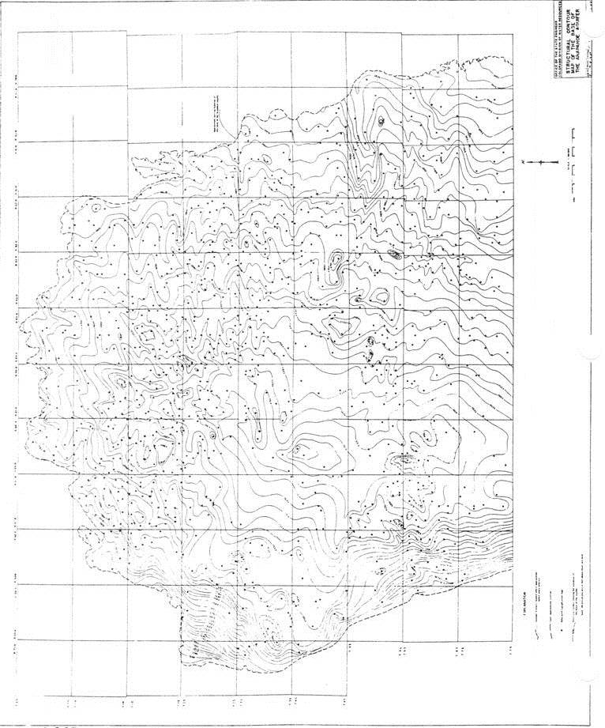
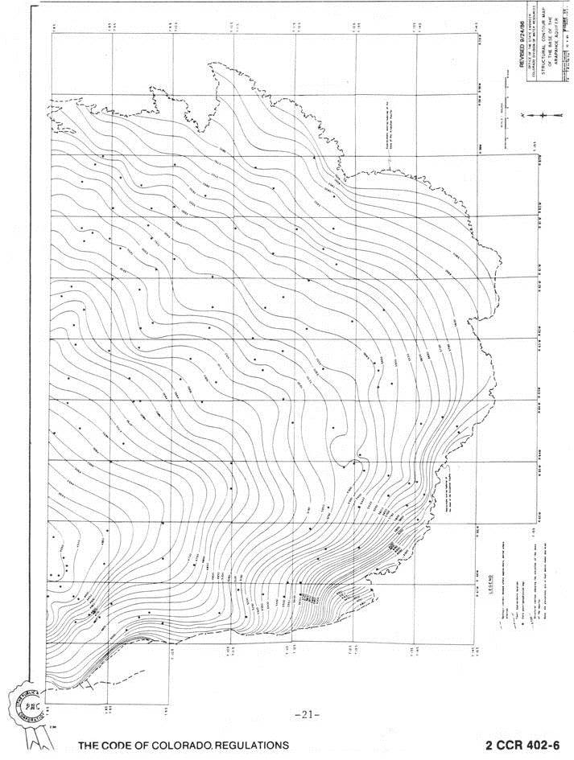
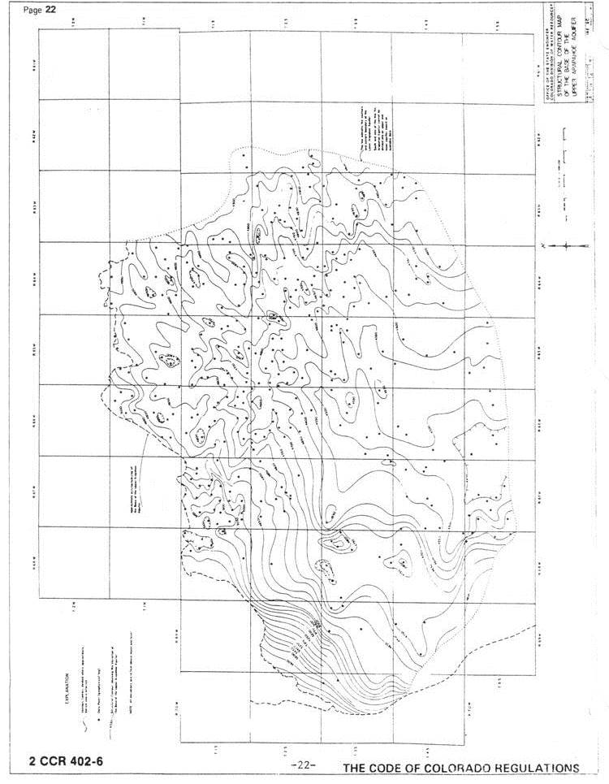
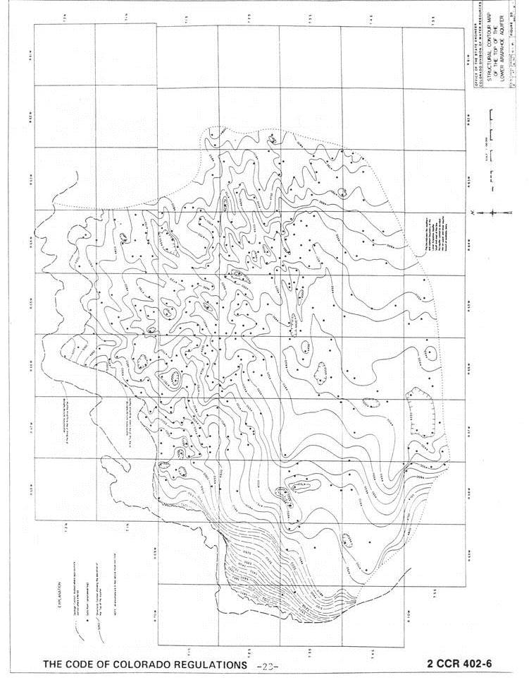
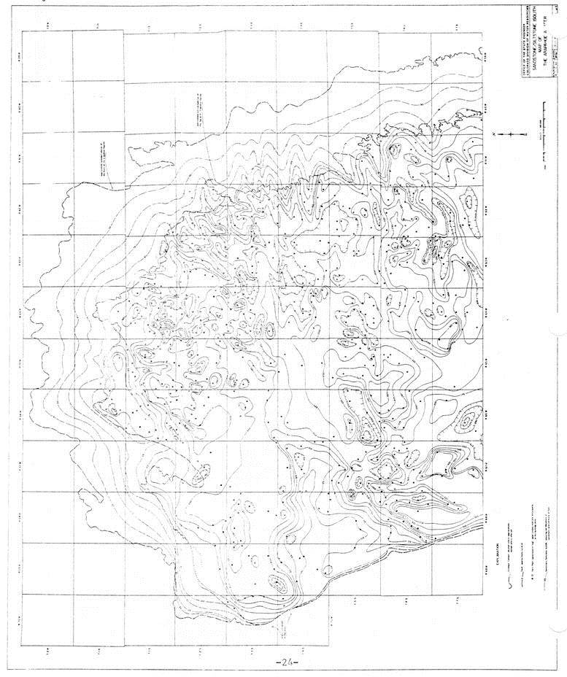
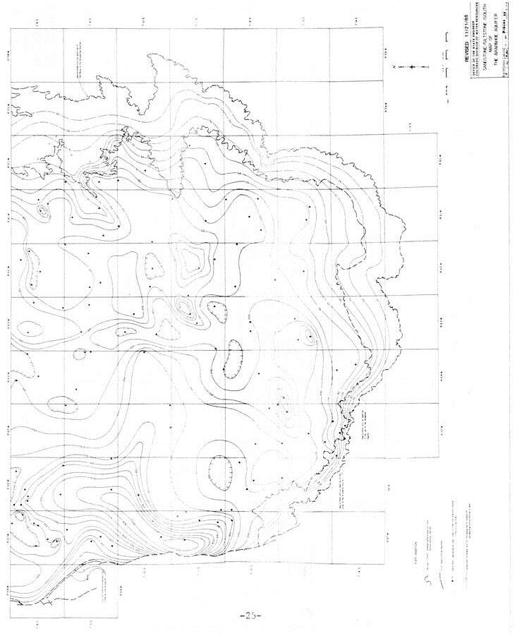
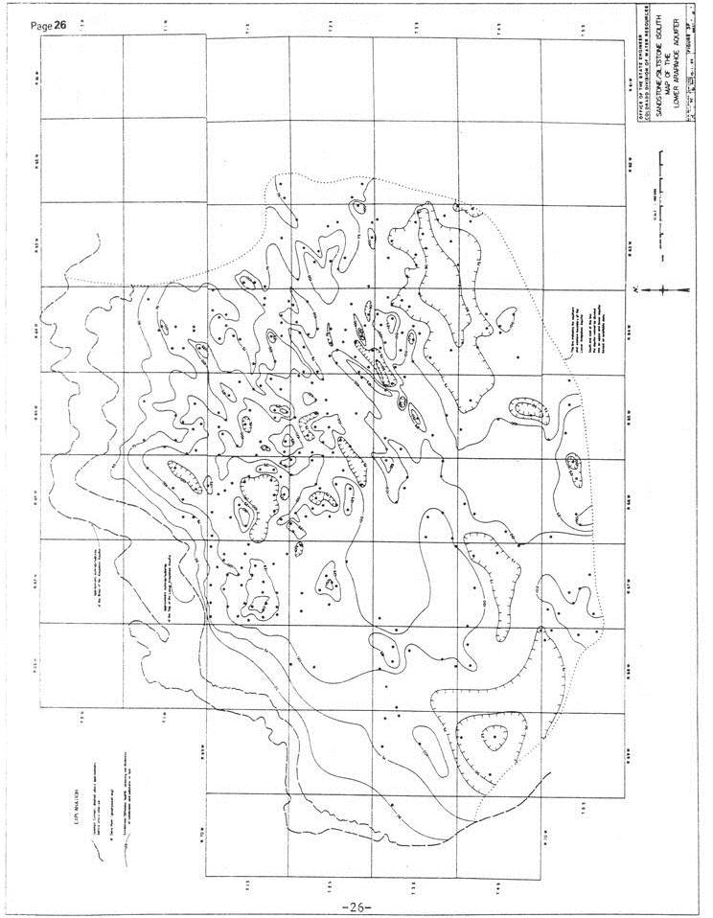
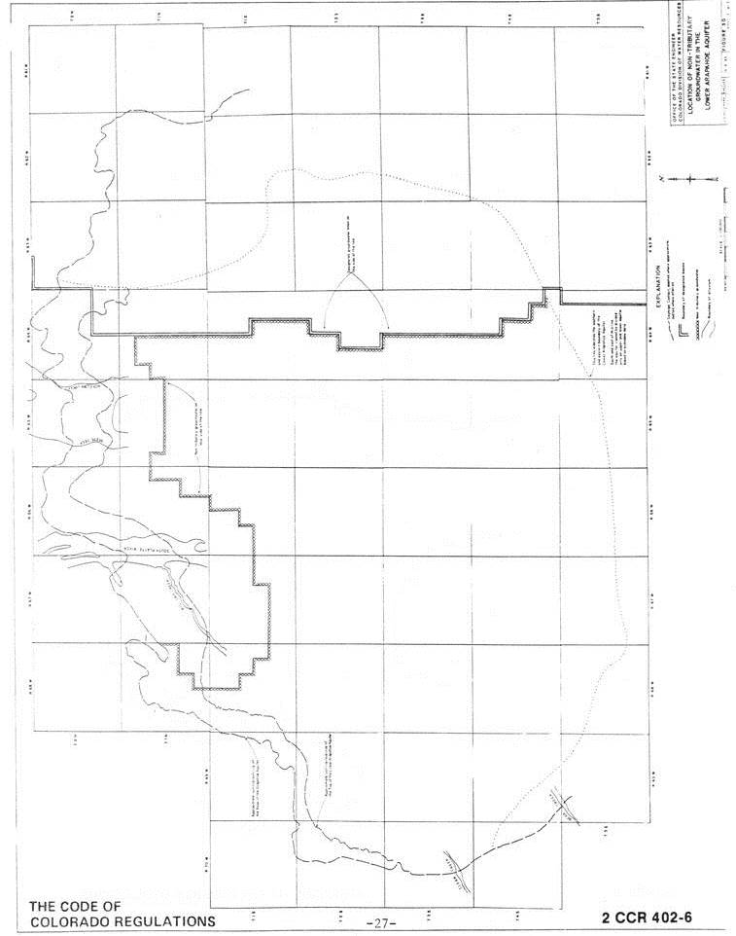
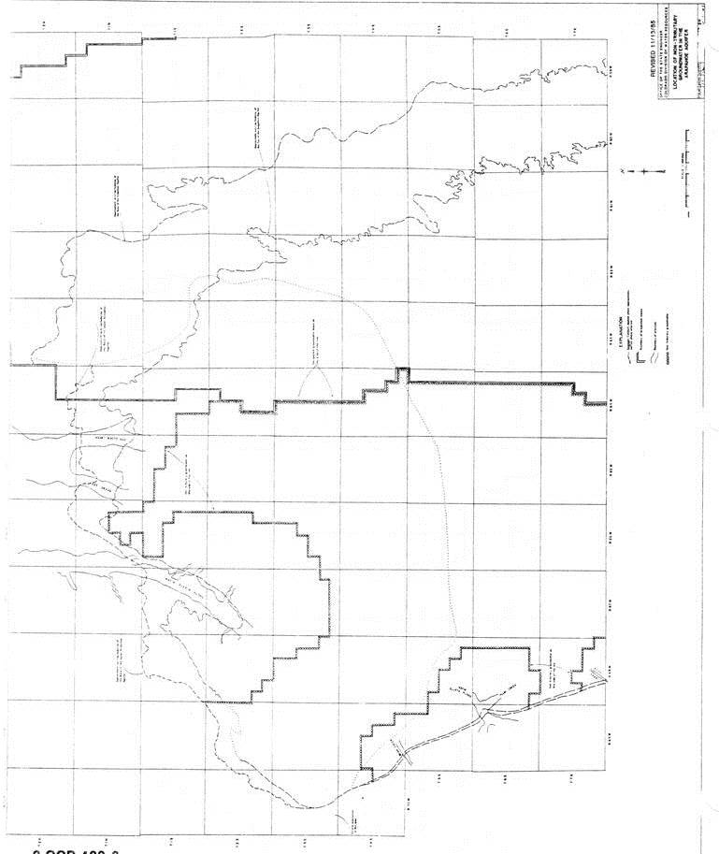
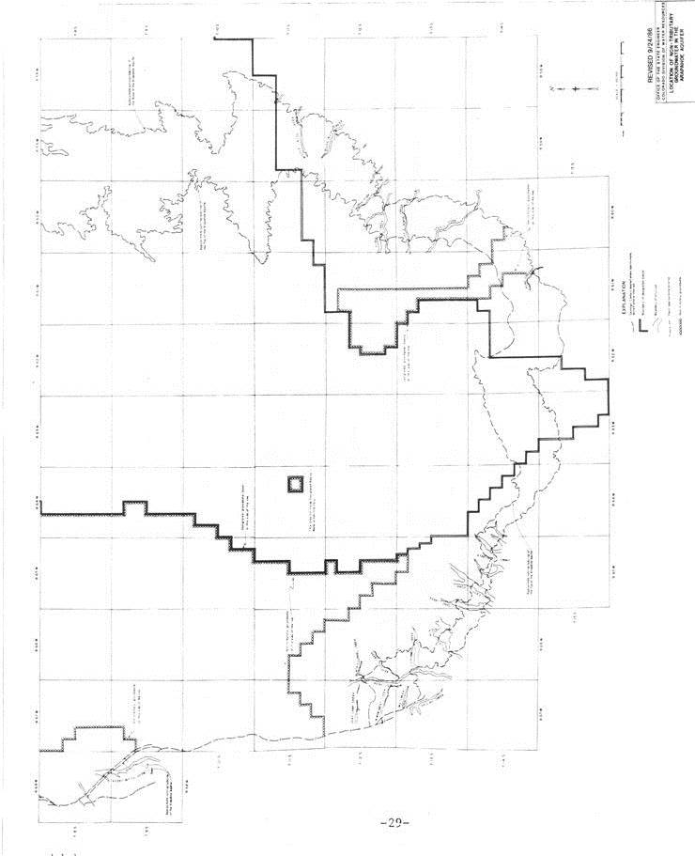
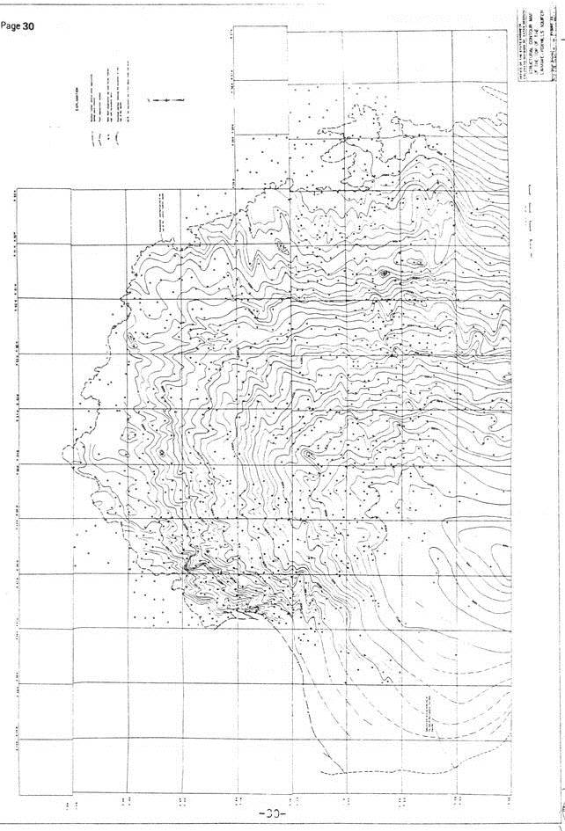
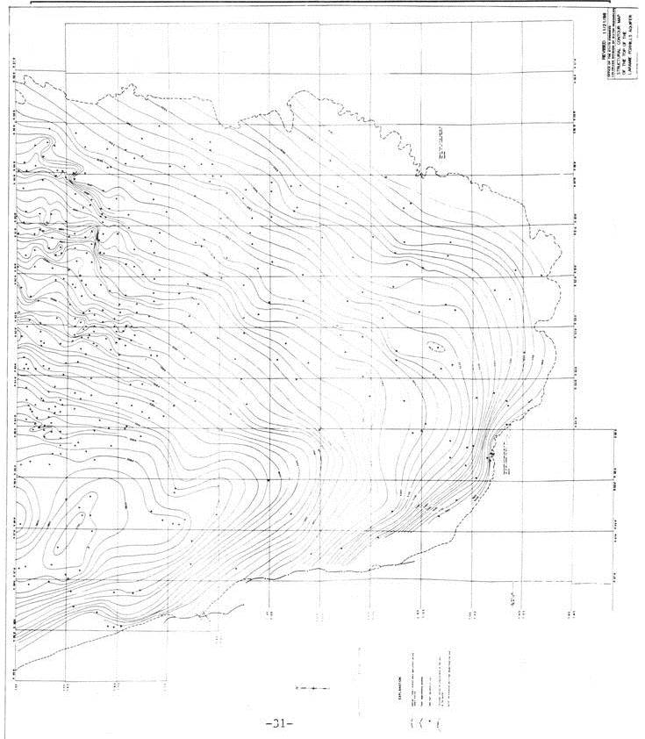
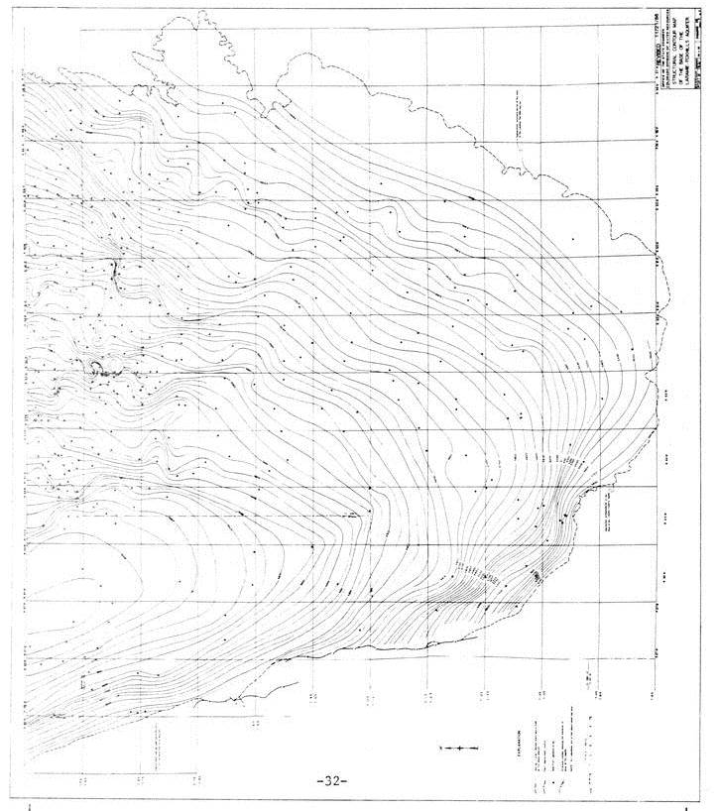
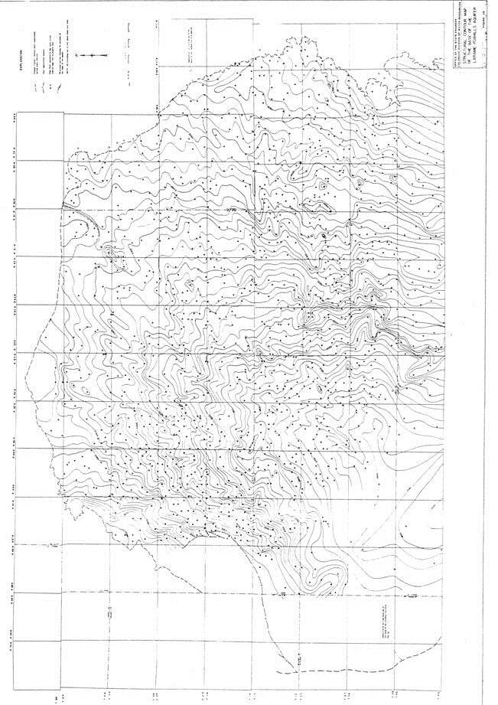
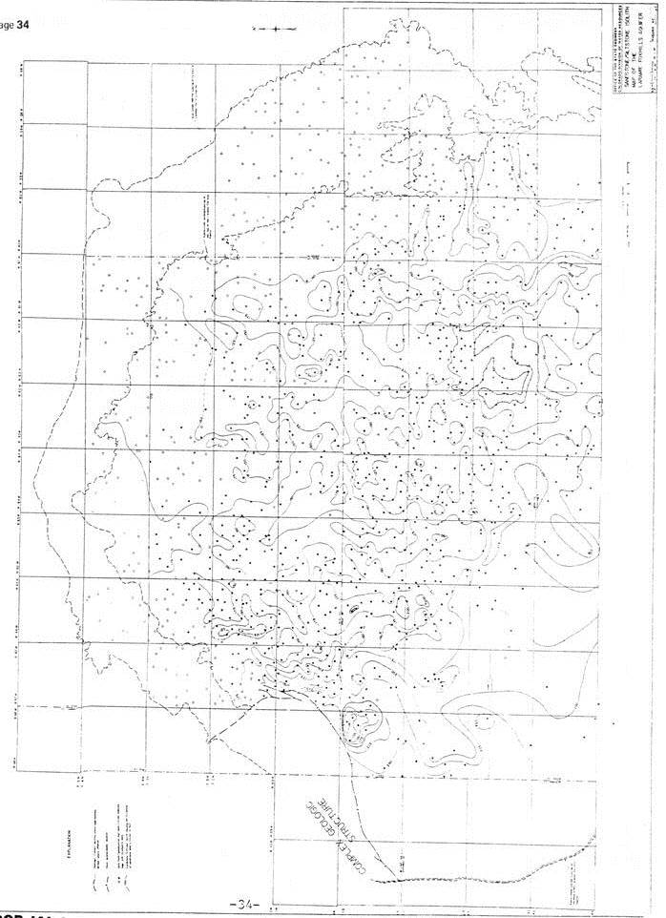
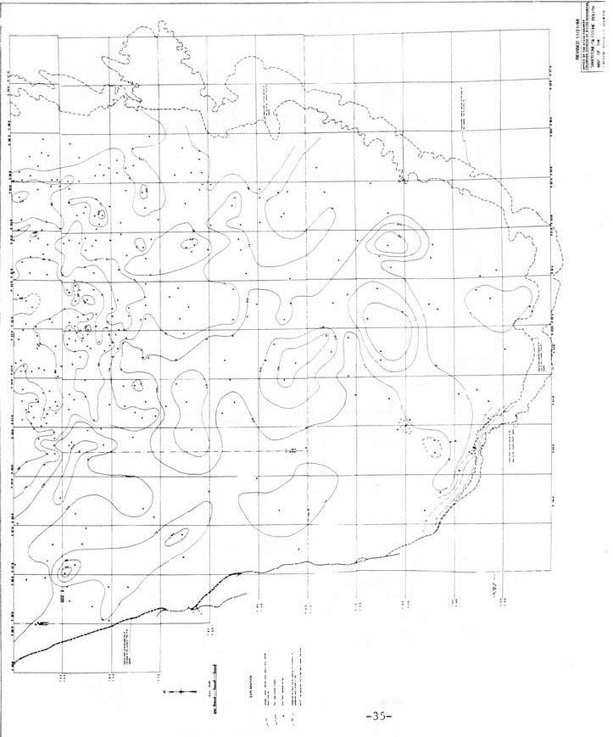
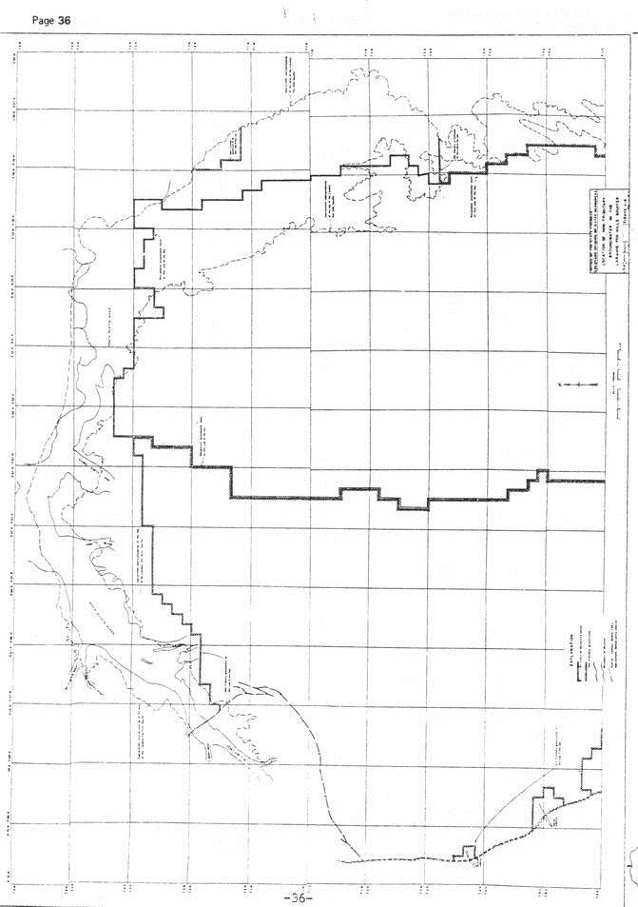
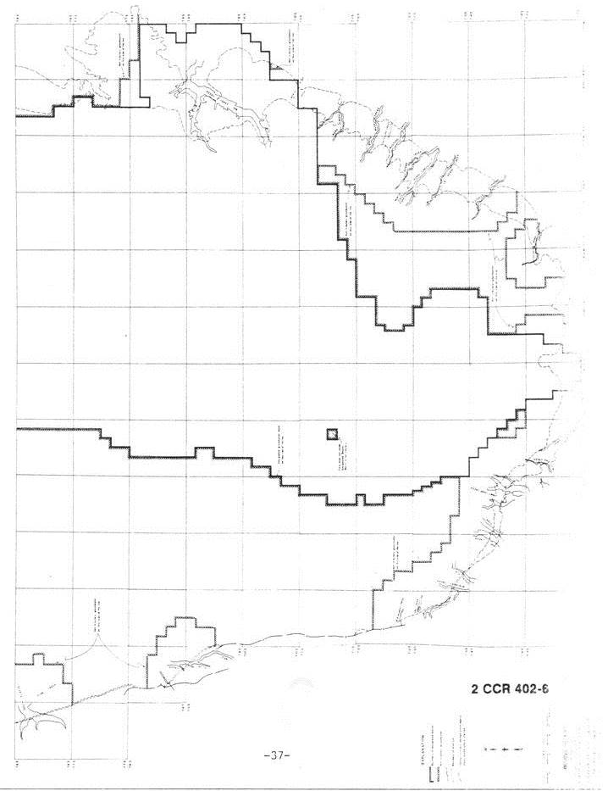
_________________________________________________________________________

Editor’s Notes
History

