DEPARTMENT OF NATURAL RESOURCES
Division of Water Resources
RULES AND REGULATIONS GOVERNING THE MEASUREMENT OF GROUND WATER DIVERSIONS AFFECTING THE REPUBLICAN RIVER COMPACT, WITHIN WATER DIVISION NO. 1
2 CCR 402-16
[Editor’s Notes follow the text of the rules at the end of this CCR Document.]
_________________________________________________________________________

16.1 Authority
These Rules and Regulations are adopted pursuant to the authority in sections 37-80-102(1)(g) and 37-80-104, C.R.S. and are intended to be consistent with the requirements of the State Administrative Procedure Act, section 24-4-101 et seq., C.R.S.

16.2 Scope and Purpose
A. These Rules are applicable to all Wells Affecting the Republican River Compact within the area as illustrated in Appendix A and described in Appendix B, except;
1. Decreed or permitted “exempt” Wells constructed pursuant to section 37-92-602, C.R.S., or as may be amended in the future.
2. Permitted small capacity wells constructed pursuant to (a) through (f) of section 37-90-105, C.R.S., or as may be amended in the future.
3. Wells Affecting the Republican River Compact and located within the East Cheyenne Groundwater Management District are excluded from these Rules. Those wells are subject to the East Cheyenne Groundwater Management District Rule 5.A.
B. The purpose of these Rules is to obtain information needed for administration and compliance of the Republican River Compact.

16.3 Applicability
The provisions of this section shall be applicable to all Wells Affecting the Republican River Compact within the area as illustrated in Appendix A and described in Appendix B, unless otherwise specifically exempted by these Rules.

16.4 Definitions
A. As used in these Rules:
1. “Affecting the Republican River Compact” means the diversion of ground water from a Well (a) included in calculations of the Republican River Compact ground water model and (b) within the area as illustrated by the map in Appendix A and described by the metes and bounds in Appendix B.

2. “Calibration Factor” is a ratio representing the flow as measured by a test meter compared to the flow as measured by an installed TFM. A calibration factor must be verified and submitted to the Division Engineer by a Qualified Well Tester in accordance with these Rules.
3. “Complex System” means any system where the total dynamic head at the pump will vary due to multiple discharge locations in a pipeline, or where the method of delivery will vary between open discharge, gated pipe, or sprinkler system during a single irrigation season, or where multiple Wells discharge into a common pipeline.
4. “Compound System” means a system where the power meter records electrical usage from any electrical device other than the pumping systems from a single well and its attached sprinklers.
5. “Division Engineer” means the Division Engineer, or designated personnel for the Colorado Division of Water Resources, Water Division No. 1.
6. “Inactive Well” means any Well that is not in use and is disconnected from a power source or the pump or motor has been removed.
7. “Interim Water Measurement Program” means a temporary method of measuring the flow of water diverted by a Well that has been approved by the Division Engineer for use as a backup measurement method in case the primary Method of Measurement fails.
8. “Notification”, “Notice”, or “Notify” to the Division Engineer means submission to the Division Engineer by mail, facsimile, or email of a written message , or, where specifically required by these Rules, of a completed form or other format prescribed by the State Engineer.
9. “Person” means an individual, a partnership, an association, a corporation, a municipality, the State of Colorado, the United States, or any other legal entity, public or private.
10. “Power Conversion Coefficient” or “PCC” means the amount of electrical energy expressed as kilowatt hours (KWH) consumed in pumping one acre-foot of ground water from a Well.
11. “PCC Test” means the process prescribed by the State Engineer requiring a Qualified Well Tester to determine in the field, and submit in a format prescribed by the State Engineer, the PCC to the Division Engineer.
12. “Qualified Well Tester” means a person who is currently certified by the State Engineer as qualified to determine the accuracy of a TFM and perform a PCC test on a Well.
13. “Republican River Compact” means the agreement between Colorado, Kansas, and Nebraska with respect to the waters of the Republican River Basin,C.R.S.§37-67-101 et seq.; Final Settlement Stipulation, Kansas v. Nebraska and Colorado, No. 126 Original (Dec. 15, 2002).
14. “Rules” means the Rules and Regulations Governing the Measurement of Ground Water Diversions Affecting the Republican River Compact within Water Division No. 1. The short title for these Rules is “Republican River Measurement Rules,” and they may be referred to herein collectively as the “Rules” or individually as a “Rule.”
15. “Totalizing Flow Meter” or “TFM” means a meter associated with a Well that is designed and manufactured for the purpose of measuring the flow of water, has a totalizing feature in acre-foot measurements, and meets the requirements of Rule 16.5.
16. “Verification”, “Verified”, or “Measurement Method Verification” means the test performed by a Qualified Well Tester to verify the accuracy of a Well’s method of measurement.
17. “Well Distribution System” means the pumping and piping systems through which the Well water is pumped.
18. “Well” means any structure or device used for the purpose or with the effect of obtaining ground water for beneficial use from an aquifer except those exempted under Rule 16.2A.
19. “Well User” means any Person diverting ground water.
B. Any other term used in these Rules that is defined in sections 37-80-102, 37-80-104, 37-90-103, 37-90-107, 37-90-137 or 37-92-103, C.R.S., (as may be amended) shall have the same meaning given therein.
C. Any term used in these Rules not defined herein that is defined in other Rules and Regulations of the State Engineer applicable to Water Division No. 1 shall have the same meaning given therein.

16.5 Measurement Methods and Requirements
All Wells within the scope of these Rules shall either: (1) be equipped with a verified TFM that meets the requirements of Rule 16.5.A.; (2) be equipped with a verified Alternative Method of Measurement that meets the requirements of Rule 16.5.B; or (3) be declared Inactive in accordance with Rule 16.8. All measurement devices must be tamper-resistant.
A. Totalizing Flow Meter (TFM) Method
1. Any meter that is designed and manufactured for the purpose of measuring the flow of water, and that has a totalizing feature in acre-feet, shall be considered to be acceptable for purposes of these Rules. A TFM installed prior to the Rules 2009 effective date, that reads in gallons and contains sufficient recording digits to assure that “rollover” to zero does not occur within two years, will be acceptable. The State Engineer may adopt written standards and specifications for the installation, calibration, testing, repair, and maintenance of meters. When a TFM is used, it shall be the Well User’s responsibility to keep the meter in accurate operating condition. An installed TFM shall be deemed to be in accurate operating condition when the flow measured by the meter is within plus or minus 5% of an independent field measurement made using calibrated test equipment. The Division Engineer may order any meter that fails to meet this standard to be recalibrated or replaced.

2. TFM shall be: properly verified in the field to be in accurate operating condition by a Qualified Well Tester and contain sufficient recording digits to assure that “rollover” to zero does not occur within two years; and shall be maintained by the Well User so as to provide a continuous, accurate record of withdrawals. TFM’s are required to be re-verified in the field to be in accurate operating condition by a Qualified Well Tester every four years from the date of the most recent approved Measurement Method Verification. A TFM must be re-verified if there are any damages, repairs, or alterations to the meter itself, OR if there are any modifications or alterations to the Well Distribution System that would affect the TFM’s accuracy. Adjustments or modifications to the Well-Distribution System’s pressure or rate of flow, that do not affect the TFM’s accuracy, will be allowed without the requirement of a TFM re-verification test.
3. Should a meter fail to meet the accuracy standard of Rule 16.5.A.1 the Well User may seek a variance, from the Division Engineer, to use a Calibration Factor computed by a Qualified Well Tester using standards provided by the State Engineer.
4. TFM shall be installed and maintained according to manufacturer's specifications and recommendations.
5. A TFM shall be installed at the well before any point of discharge and at a point that is prior to any discharge pipe that is laid underground.
B. Alternative Method of Measurement
The Division Engineer may approve a variance, in accordance with Rule 16.11, to the installation of a TFM if it can be demonstrated by a Qualified Well Tester that the proposed Alternative Method of Measurement would produce results accurate to within plus or minus 5% of the actual volume pumped over a calendar year.
1. Power Conversion Coefficient (“PCC”) Method of Measurement
a. For Wells that operate under stable water table conditions the following minimum standards and specifications for PCC testing apply:
(1) PCC Tests shall be performed utilizing rating procedures approved by the State Engineer and conducted by a Qualified Well Tester.
(2) For verification of stable water table conditions, PCC Tests shall include the operating pressure and one of the following: the pumping water level or the rate of flow.
(3) Verification of stable water table conditions require that the operating pressure and one of the following have not changed by more than 10% during the PCC Test: (a) the pumping water level or (b) the rate of flow.
b. A PCC computed from an acceptable PCC Test shall be valid for the following periods and shall be used to calculate total well diversions as follows:
(1) PCC Tests performed between June 15 and October 15 of the same calendar year, shall be valid for a period of 2 years from the date of the PCC Test.

i. PCC computed from the PCC Test performed between June 15 and October 15 of the same calendar year shall be used to compute the amount of water diverted from the date of the PCC Test forward up to the date of any subsequent PCC Test.
(2) PCC Tests performed between October 16 of any year and the following June 14 shall be valid until the following August 14. An additional PCC Test shall be performed during the period June 15 through August 14 following that PCC Test. Should a subsequent PCC Test not be performed by the following August 14, no water shall be withdrawn from the Well after August 14 until an acceptable PCC Test is approved by the Division Engineer.
i. The PCC computed from the PCC Test performed before June 15 shall be used to compute the amount of water pumped from the date of the PCC Test forward up to the date of the subsequent PCC Test.
ii. A subsequent PCC Test is required to be performed during the period June 15 through August 14 and that PCC shall be used to compute the amount of water pumped from the date of the PCC Test forward until any subsequent PCC Test.
c. A PCC Test shall be required more frequently than described above, and prior to any diversions from the Well, if any of the following occur:
(1) A new or re-worked pump and/or motor are installed on the Well.
(2) The Well is re-worked to change the yield of the Well.
(3) The system that the pump discharges into is modified in such a manner as to change the PCC, the discharge of the pump, or the operating pressure.
(4) Any other alteration to the system which changes the discharge of the pump, the operating pressure, or PCC.
(5) Additional PCC Tests may also be required if the State Engineer conducts or reviews PCC Tests and determines an error was made, or if any changes to the Well Distribution System or ground water levels will make the use of the PCC, based upon the current PCC Test, inaccurate by 5% or more.
d. Use of a PCC may not be appropriate where varying terrain results in inaccurate calculations due to the differences in elevations to which the water must be pumped unless the system has working pressure regulators installed.
e. If the difference between the current approved PCC and the results of the next subsequent PCC is greater than 10%, the new PCC shall be considered invalid and a PCC will not be considered a valid Alternative Method of Measurement for the Well from the date of the new PCC Test forward, unless the Well User submits and obtains approval by the Division Engineer of a variance to allow the PCC.

C. Interim Water Measurement Program
Should any approved measurement device or method cease to operate accurately or fail Verification at any time, or if changes are made to the Well or the Well’s Distribution System that would result in a change to the current PCC, the Well User shall immediately Notify the Division Engineer and establish an Interim Water Measurement Program until the meter is replaced or repaired or a new PCC test is performed and approved. If the TFM is not replaced or repaired and Verified to be in accurate operating condition or a new PCC is not performed within 14 calendar days of the Notification to the Division Engineer, the Well shall not be operated until the TFM is replaced or repaired, or a new PCC is approved or until the Division Engineer grants a variance.
D. Measurement Method Verification Testing
The Well User shall provide Measurement Method Verification to the Division Engineer in a format prescribed by the State Engineer within 30 calendar days of the Verification. Measurement Method Verifications must be performed no later than the expiration date of the current Verification.
E. Complex or Compound Systems
If the Well(s) are part of a Complex System or Compound System, or if the pump is not powered by electricity, or the Well produces from a confined aquifer, the Well User must utilize a TFM (Rule 16.5.A.).
F. Testing Equipment Calibration
All flow measuring equipment utilized in verification of accuracy and working condition of TFMs or to obtain a PCC in the field must be calibrated every two years to be accurate within plus or minus 2%, unless a variance is granted by the Division Engineer. Calibration and certification of accuracy of such testing equipment must be accomplished by a facility qualified and equipped to certify a test meter as accurate in accordance to this Rule using National Institute of Standards and Technology (NIST) traceable standards.
G. All Wells newly incorporated into the Scope of the Rules as a result of these amendments, shall be required to comply with these Rules in their entirety no later than April 1, 2016.

16.6 Notice of Compliance
A. TFM’s
Well Users with Wells within the scope of these Rules with a TFM shall provide Notice to the Division Engineer, on a form or format prescribed by the State Engineer that includes: (1) the name and address of the owner of the Well(s); (2) the name and address of the user of the Well(s) (if different than the owner); (3) the Well permit number(s); (4) the decree or case number(s) (if applicable); (5) the legal description and UTM coordinates of the location of the Well(s); (6) a legal description and map or drawing of land irrigated (if applicable); (7) the type or method of irrigation (if applicable); (8) the meter manufacturer, the meter model number and the meter size; (9) the meter serial number(s); (10) the volumetric units (gallons or acre-feet); (11) the name of power utility company and power company account number (if applicable); (12) the kilowatt hour meter reading on the date of installation (if applicable); (13) the beginning TFM reading; (14) and the date of installation of the TFM. The Well Owner must immediately Notify the Division Engineer of any change of method of Well measurement. Such Notice shall be provided in a format as prescribed by the State Engineer within 30 days of such change.
B. PCC Method of Measurements
All Well Users of Wells within the scope of these Rules with a PCC shall provide Notice to the Division Engineer, on a form or format prescribed by the State Engineer, such information as specified in the terms and conditions of the approved variance, which may include: (1) the name and address of the owner of the Well(s); (2) the name and address of the user of the Well(s) (if different than the owner); (3) the Well permit number(s); (4) the decree or case number(s) (if applicable); (5) the legal description and UTM coordinates of the location of the Well(s); (6) a legal description and map or drawing of land irrigated (if applicable); (7) the type or method of irrigation (if applicable); (8) the power company name, and account number; (9) the power meter serial number, number of digits, multiplier, and other power meter factors; (10) description of all equipment served by power meter (house, sprinkler, well, etc); (11) description of all types of discharges, and if irrigation, all Well Distribution System detail; (12) the kilowatt hour meter reading on the date of installation (if applicable); (13) the beginning power meter reading; (14) and the date of installation of the power meter. The Well Owner must immediately Notify the Division Engineer of any change of method of Well measurement. Such Notice shall be provided in a format as prescribed by the State Engineer within 30 days of such change.

16.7 Data Submission
A. Annual Reporting
All Well Users of Wells within the scope of these Rules shall report in a format prescribed by the State Engineer, the annual amounts of water diverted from Wells for the period of November 1 to October 31 and, for irrigation Wells, the method of irrigation (flood, center-pivot, etc.), to the Division Engineer no later than December 1st. Amounts pumped shall be reported more frequently if required by the State Engineer.
B. Forms and Notification
Data as required by these Rules shall be submitted to the Division Engineer in a format prescribed by the State Engineer. Such format shall also include consent to release power data to the Division Engineer. If the power account number, measurement method, or any other change associated with a Well’s Measurement Method changes for any reason, the Well User must immediately Notify the Division Engineer of the changes, and submit all required reporting in accordance with these Rules.

16.8 Inactive Well
An owner of an Inactive Well must, upon Inactivation, provide Notification to the Division Engineer in a format prescribed by the State Engineer. Once an Inactive Well Notification is filed with the Division Engineer no further filings are required under these Rules unless the Well User wishes to change the Well from Inactive status to active status. When a Well User intends to change an Inactive Well to active status, Notification to the Division Engineer is required prior to activation. A Well listed as Inactive under this Rule 16.8 shall not be used until such Notification is given and the Well is in compliance with these Rules.

16.9 Water not to be Withdrawn
No water shall be withdrawn from any Well that is not in compliance with these Rules except to verify the Measurement Method.

16.10 Noncompliance
Failure to comply with any of these Rules may subject the Well User to court proceedings and the state's costs, including reasonable attorney’s fees, associated with enforcement of these Rules. Prior to filing any court action, the Division Engineer shall notify the Well User of the violation in writing by Certified Mail and shall advise the Well User of the date by which the violation must be corrected to avoid court proceedings, which date shall be at least ten calendar days following the date of receipt of the notice by the Well User or personal service of the notice on the Well User.

16.11 Variance
When the strict application of any provisions of these Rules would cause unusual hardship, the Division Engineer may grant a variance. Any request for a variance shall be made to the Division Engineer, in a format prescribed by the State Engineer, and shall state the basis, with supporting documentation, for the requested variance. If the Division Engineer finds the request justifiable, the Division Engineer may issue a written order granting the variance and setting forth the terms and conditions on which the variance is granted. Variance requests are granted at the sole discretion of the Division Engineer.

16.12 Effect of Rules on Other Wells
Nothing in these Rules shall be construed to preclude the State Engineer from requiring metering of withdrawals, periodic reporting of such withdrawals, and cessation of excessive withdrawals from wells not covered by these Rules.

16.13 Effect of Rules on Prior Rules of the State Engineer
These Rules shall supersede Republican River Basin Measurement Rules adopted in 2009.

16.14 Severability
If any portion of these Rules is found to be invalid, the remaining portion of the Rules shall remain in force and in effect.

16.15 Revisions
These Rules may be revised in accordance with section 24-4-103, C.R.S. and 2 CCR 402-5.

16.16 Statement of Basis and Purpose Incorporated by Reference
The Statement of Basis and Purpose for these Rules is incorporated herein as part of these Rules.

16.17 Effective Date
These Rules, as adopted by the State Engineer, shall become effective on November 15, 2015 and shall remain in effect until amended as provided by law.
IT IS FURTHER ORDERED that any persons wishing to protest these Rules may do so in the manner provided in sections 24-4-101 et seq., C.R.S., (the State Administrative Procedure Act).
Submitted on this 16th day of September, 2015
/s/Dick Wolfe
Dick Wolfe, P.E.
State Engineer

APPENDIX A
Graphical Representation of boundary and area encompassed by the
Republican River Compact Measurement Rules Boundary (2015)
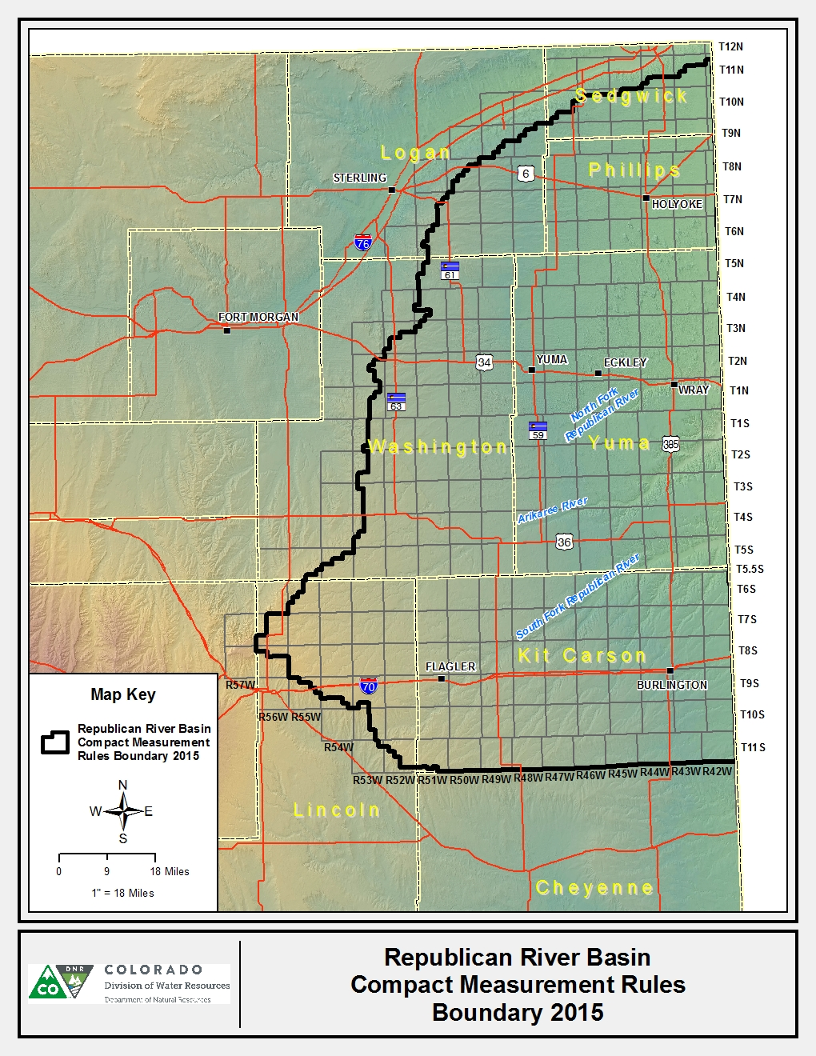

APPENDIX B
The Public Land Survey System description of the boundary and area encompassed by the
Republican River Compact Measurement Rules Boundary (2015)
All the following are west of the 6th P.M.
T 11 N R 42 W Sections 7, 8, 17 thru 20, 29 thru 32
T 11 N R 43 W Sections 13 thru 16, 20 thru 36
T 11 N R 44 W Sections 25 thru 29, 31 thru 36
T 10 N R 42 thru 44 W All Sections
T 10 N R 45 W Sections 1 thru 4, 7 thru 36
T 10 N R 46 W Sections 8 thru 36
T 10 N R 47 W Sections 13, 24 thru 28, 32 thru 36
T 9 N R 42 thru 47 W All Sections
T 9 N R 48 W Sections 1, 2, 9 thru 17, 19 thru 36
T 9 N R 49 W Sections 23 thru 27, 33 thru 36
T 8 N R 42 thru 49 W All Sections
T 8 N R 50 W Sections 11 thru 15, 21 thru 29, 31 thru 36
T 7 N R 42 thru 50 W All Sections
T 7 N R 51 W Sections 12 thru 14, 23 thru 26, 35, 36
T 6 N R 42 thru 50 W All Sections
T 6 N R 51 W Sections 1 thru 3, 9 thru 16, 20 thru 28, 33 thru 36
T 5 N R 42 thru 50 W All Sections
T 5 N R 51 W Sections 1 thru 4, 8 thru 17, 19 thru 36
T 4 N R 42 thru 50 W All Sections
T 4 N R 51 W Sections 1 thru 5, 8 thru 17, 19 thru 27, 33 thru 36
T 3 N R 42 thru 50 W All Sections
T 3 N R 51 W Sections 1 thru 5, 7 thru 36
T 3 N R 52 W Sections 13 thru 15, 20 thru 29, 31 thru 36
T 2 N R 42 thru 52 W All Sections
T 2 N R 53 W Sections 11 thru 15, 23 thru 26, 36
T 1 N R 42 thru 52 W All Sections
T 1 N R 53 W Sections 1, 11 thru 15, 22 thru 27, 34 thru 36
T 1 S R 42 thru 52 W All Sections
T 1 S R 53 W Sections 1 thru 3, 10 thru 15, 22 thru 27, 33 thru 36
T 2 S R 42 thru 52 W All Sections
T 2 S R 53 W Sections 1 thru 3, 10 thru 15, 22 thru 29, 32 thru 36
T 3 S R 42 thru 52 W All Sections
T 3 S R 53 W Sections 1 thru 5, 9 thru 16, 21 thru 28, 33 thru 36

T 4 S R 42 thru 52 W All Sections
T 4 S R 53 W Sections 1 thru 4, 9 thru 16, 20 thru 36
T 5 S R 42 thru 53 W All Sections
T 5 S R 54 W Sections 11 thru 16, 19 thru 36
T 5 S R 55 W Sections 25, 34 thru 36
T 5.5 S R 42 thru 50 W All Sections
T 6 S R 42 thru 54 W All Sections
T 6 S R 55 W Sections 1 thru 3, 10 thru 16, 20 thru 36
T 7 S R 42 thru 55 W All Sections
T 7 S R 56 W Sections 1 thru 4, 9 thru 16, 21 thru 36
T 8 S R 42 thru 55 W All Sections
T 8 S R 56 W Sections 1 thru 6, 9 thru 12
T 9 S R 42 thru 52 W All Sections
T 9 S R 53 W Sections 1 thru 31, 34 thru 36
T 9 S R 54 W Sections 1 thru 26, 36
T 9 S R 55 W Sections 1 thru 4, 11 thru 13
T 10 S R 42 thru 52 W All Sections
T 10 S R 53 W Sections 1 thru 3, 10 thru 15, 22 thru 26, 35, 36
T 11 S R 41 thru 50 W All Sections
T 11 S R 51 W Sections 1 thru 30, N1/2 33, 35, 36
T 11 S R 52 W Sections 1 thru 6, 8 thru 16, 22 thru 27
T 11 S R 53 W Section 1
_________________________________________________________________________

Editor’s Notes
History
Entire rule eff. 12/01/2008.
Entire rule eff. 11/15/2015.

