DEPARTMENT OF REGULATORY AGENCIES
Division of Insurance
CONCERNING TITLE INSURANCE
3 CCR 702-8
[Editor’s Notes follow the text of the rules at the end of this CCR Document.]
_________________________________________________________________________

Regulation 8-1-1 TITLE INSURANCE RATES & FEES
Section 1 Authority
Section 2 Scope and Purpose
Section 3 Applicability
Section 4 Definitions
Section 5 Rules Regarding Rate and Fee Filing Requirements
Section 6 Rules Regarding Rates and Fees
Section 7 Severability
Section 8 Enforcement
Section 9 Effective Date
Section 10 History
Appendix A Title Insurance Closing and Settlement Fee Justification Form
Appendix B Title Insurance Closing and Settlement Fee Filing Agency Fee Sheet for Consumers
Appendix C Title Insurance Rate Justification Form - Side by Side - New Rates
Appendix D Title Insurance Rate Justification Form - Side by Side – Amended or Withdrawn
Appendix E Title Insurance Closing Settlement Fee Justification Form – Side by Side – New Fees
Appendix F Title Insurance Closing Settlement Fee Justification Form – Side by Side – Amended or Withdrawn
Appendix G Title Insurance Rate Justification
Appendix H Rate Cover Letter
Appendix I Fee Cover Letter

Section 1 Authority
This regulation is promulgated and adopted by the Commissioner of Insurance under the authority of §§ 10-1-108(7), 10-1-109, 10-3-1110, 10-4-403, 10-4-404, 10-11-118 C.R.S.

Section 2 Scope and Purpose
The purpose of this regulation is to ensure that title insurance rates and fees are not excessive, inadequate or unfairly discriminatory. This regulation contains filing requirements for both title insurance companies and title insurance agents. This regulation ensures that consumers receive the benefits of competition in the area of title insurance and ensures consumer protection.

Section 3 Applicability
This regulation governs title entities and does not extend the regulatory authority of the Colorado Division of Insurance (“Division”) to any person other than title entities or persons transacting the business of title insurance.

Section 4 Definitions
A. “Business of title insurance” shall have the same meaning as set forth in § 10-11-102(3), C.R.S.
B. “Division” means, for the purposes of this regulation, the Colorado Division of Insurance.
C. “Fee” means, for purposes of this regulation only, the amount other than the rate (see subsection F below) charged by a title entity for services performed pursuant to the business of title insurance as defined in § 10-11-102, C.R.S.
D. “Justification” means, for the purposes of this regulation, information that establishes the rate or fee is not excessive, inadequate, or unfairly discriminatory pursuant to §10-4-403, C.R.S. This information must qualify, quantify, and demonstrate the facts and figures to support, defend, and substantiate a proposed rate or fee.
E. “Person” has the same meaning as found at §10-2-103(8), C.R.S.
F. “Rate” means, for purposes of this regulation, expenses as defined in § 10-4-402(1.5), C.R.S., together with the pure premium rate as defined in § 10-4-402(2.4), C.R.S., and includes production expenses, profit, and commissions, in accordance with § 10-4-403, C.R.S.
G. “Title insurance agency” shall have the same meaning as found at § 10-11-102(8.5), C.R.S.
H. “Title insurance agent” shall have the same meaning as found at § 10-11-102(9), C.R.S.
I. "Title insurance company” shall have the same meaning as found at § 10-11-102(10), C.R.S.
J. “Title insurance entity” shall have the same meaning as found at § 10-11-102(11), C.R.S.

Section 5 Rules Regarding Rate and Fee Filing Requirements
A. Each title insurance entity must submit a complying filing electronically, in a format prescribed by the Commissioner, with an effective date that is at least thirty (30) days after the date the Division receives the filing electronically.
1. A title insurance company’s filing must include justification for any new or amended rate or fee being placed on file that a consumer may be charged.
2. A title insurance entity’s filing must include justification for any new or amended fee being placed on file that a consumer may be charged.
3. Each rate or fee filing must include information outlined in Sections 5.C.3 and 5.D.3. Failure to provide the information in Sections 5.C.3 and 5.D.3 will render the filing incomplete. Incomplete filings are deficient. Deficient filings that are not rectified will be rejected on or before the 30th day after receipt by the Division.
4. A rate or fee filing that does not include an effective date at least 30 days after the date the Division receives the filing will be considered deficient. The title insurance company can rectify the deficiency to include an effective date that is more than 30 days after the filing date. However, a failure to rectify this deficiency will result in the rejection of the rate or fee.

5. Any deficiency will be identified and communicated through the System for Electronic Rate and Form Filings (SERFF) database to the title insurance entity on or before the 15th day after receipt. Filings that do not include the required information to rectify the identified deficiency will be rejected on or before the 30th day after receipt by the Division.
B. Title insurance agencies or title insurance agents that use multiple title insurance companies as underwriters must place on file and justify their own fees and may not have the fees placed on file by the underwriter on their behalf.
C. General Rate Filing Requirements
1. Each title insurance company must submit all rate filings electronically in SERFF.
2. Each filing must be received by the Division at least thirty (30) days prior to the effective date of the new or amended rates.
3. Each filing must include justification for the new or amended rate being submitted. Justification must include data to support the rate. Justification includes, but is not limited to:
a. Expense provisions – data must clearly describe the amount of the fixed and/or variable expense provision and how this provision is to be accounted for in the final rate. This includes an itemization of actual or average expenses associated with each rate. Examples of some expenses include but are not limited to: amounts retained by or commissions paid to agents; claims; taxes; personnel; office space; office equipment; supplies; other overhead; and vendor services, etc.;
b. Expected losses and loss ratios; or a rationale as to why such losses or loss ratios are not applicable. If expected losses and loss ratios are not provided in the initial filing, such data must be provided consistent with Section 5.C.4. for amended rates or Section 5.C.5 for new rates;
c. Rate history listing the effective date and percentage amount of any rate changes made in the past three (3) years for the rate(s) being changed. If the last rate change was more than three (3) years ago, then the effective date, SERFF filing number, and percentage of change are required;
d. Methodologies and material assumptions in developing the rate; or a rationale as to why such methodologies or material assumptions are not applicable. If methodologies or material assumption data are not provided in the initial filing, such data must be provided consistent with Section 5.C.4. for amended rates or Section 5.C.5 for new rates;
e. The amount and description of all profit and contingencies built into the rate; or a rationale as to why such profit and contingencies are not applicable. If profit and contingencies data are not provided in the initial filing, such data must be provided consistent with Section 5.C.4. for amended rates or Section 5.C.5 for new rates;
f. A description of the rate and any and all services must be provided in the rate manual. For example, when submitting a “bundled rate”, include a line item for each service included in the bundle;
g. If a comparative analysis is used as a portion of the rate justification, the insurer must include in the analysis the names of other insurers used in the analysis, and must demonstrate how the rates being compared are comparable in services and expenses; and
h. Any other determining factor used to develop the final rate.
i. If any of the above referenced justification information (a-h) is not provided, then the Rate Cover Letter found in Appendix H will be required at the time of filing.
4. Each amended rate filing shall contain a side-by-side comparison of the rating manual indicating the changes made in the current filing, the rate(s) prior to the change, and the new or amended rate(s). The comparison should include three columns: the first containing the current rates; the second containing the proposed rate; and the third containing percentage increase or decrease of each proposed change. If the proposed rates are not replacing existing rates, then the filing must specifically state that the rates proposed are new rates. The format in which the new rates shall be filed with the Division can be found in Appendix C of this regulation. The format in which the amended or withdrawn rates shall be filed with the Division can be found in Appendix D of this regulation.
5. The introduction of a new rate shall contain credible company experience to support the reasonableness of the rate. Any new rate that does not include specific Colorado data will require the title insurance company to submit a new filing no later than one year to include Colorado historical information in the justification for the new rate. If proper Colorado historical information is not available, a filing must be made annually from the effective date of the rate to include any new Colorado historical information justifying the new rate until credible experience has been established.
6. If one or more of the justification items are not provided in the proposed filing, the title insurance company must explain and support with specificity the rationale for not including the listed piece(s) of information in the filing. The Division will determine whether the proposed rationale for omission is valid. If the Division concludes that the omission is invalid, the title insurance entity will submit the required justification within fifteen (15) calendar days from the date of the objection letter.
7. The “Title Insurance Rate Justification Form”, which is found in Appendix G. of this regulation, is required to be filed with the Division and includes insurance rates a consumer may be charged during a real estate transaction.
8. A redline copy and final copy of the rating manual with the proposed new or amended rates.
D. General Fee Filling Requirements
1. Each title insurance entity must submit all fee filings electronically in SERFF if the title insurance entity charges fees.
2. Each filing must be received by the Division at least thirty (30) days prior to the effective date of the new or amended fee.
3. Each filing must include justification for the new or amended fee being submitted. Justification must include data to support the fee. Justification includes, but is not limited to:
a. An itemization of any expenses associated to the new or amended fee. Expenses may include, but are not limited to: the actual or average expense of the fee, personnel, operations, leases/rent, equipment, business insurance, vendor services, office supplies, miscellaneous costs, and any pass-through expense;
b. The amount and description of all profit and contingencies built into the fee. If profit and contingency is zero for a particular fee, zero must be included in the filing;
c. The “Title Insurance Closing and Settlement Fee Filing Agency Fee Sheet for Consumers” which is found in Appendix B of this regulation, is required to be filed with the Division and includes a general description of what is included in the services provided for the new or amended fee. For example, when submitting a “bundled fee”, include all of the services and fees that are included in the bundle;
d. If a comparative analysis is used as a portion of the fee justification, the analysis must include the names of other title insurance entity(ies) used in the analysis and must demonstrate how the fees being compared are comparable in services and expenses;
e. Fee history listing the effective date and percentage amount of any fee changes made in the past three (3) years for the fees being changed. If the last fee change was more than three (3) years ago, then the effective date, SERFF number or filing number, and percentage of change are required; and
f. Any other determining factor used to develop the final fee.
g. If any of the above referenced justification information (a-f) is not provided, then the Fee Cover Letter found in Appendix I will be required at the time of the filing.
4. Each amended fee filing shall contain a side-by-side comparison of the fee schedule indicating the changes made in the current filing, the fee(s) prior to the change, and the new or amended fee(s). The comparison should include three columns: the first containing the current fee; the second containing the proposed fee; and the third containing percentage increase or decrease of each proposed change. If the proposed fees are not replacing existing fees, then the filing must specifically state that the fees proposed are new fees. The format in which the new fees shall be filed with the Division can be found in Appendix E of this regulation. The format in which the amended or withdrawn fees shall be filed with the Division can be found in Appendix F of this regulation.
5. The introduction of a new fee shall contain credible experience to support the reasonableness of the fee. Any new fee that does not include specific Colorado data will require the title insurance entity to submit a new filing no later than one year to include Colorado historical information in the justification for the new fee. If proper Colorado historical information is not available, a filing must be made annually from the effective date to include any new Colorado historical information justifying the new fee until credible experience has been established.

6. If one or more of the justification items are not provided in the proposed filing, the title insurance entity must explain and support with specificity the rationale for not including the listed piece(s) of information in the filing. The Division will determine whether the proposed rationale for omission is valid. If the Division concludes that the omission is invalid, the title insurance entity will submit the required justification within fifteen (15) calendar days from the date of the objection letter.
7. The “Title Insurance Closing and Settlement Fee Justification Form” which is found in Appendix A of this regulation, is required to be filed with the Division, and includes commonly used fees a consumer may be charged during a real estate transaction. Each title insurance agent and title insurance company, if the title insurance company charges fees, must place on file his or her fees and any justification used by the title insurance agent.
8. A final copy of the fee sheet with the proposed new or amended fee.

Section 6 Rules Regarding Rates and Fees
A. Every title insurance entity shall make readily available for review by the public its schedule of effective rates and fees for all issued title insurance policies and closing and settlement charges, including endorsements, guarantees and other forms of title insurance coverage. Either the schedule or a notice explaining the schedule’s availability shall be displayed in a public place in the title insurance entity’s offices. Copies of such schedules shall be furnished to the public upon request. The title insurance entity may impose a charge for copies of schedules, but such charges shall not exceed the actual cost per page of reproducing the schedules, and copies shall be provided within three (3) business days of receipt of a written request.
B. All rate cards and schedules of effective rates and fees shall denote, in a clear and conspicuous manner, the title insurance company and/or agent that has filed the title insurance rates and fees shown and the effective date of these rates and fees.
C. If justified, title insurance entities may place on file different rates and fees for title insurance policies and/or closing and settlement services in different counties, and shall include the effective date of the rates and fees in the schedule.
D. A title insurance company may not use different rates for different title insurance entities for the same risk in the same county.
E. Rates and fees shall not apply to title insurance commitments and/or policies or closing and settlement services ordered prior to the effective date of such rate or fee.
F. No title insurance entity shall quote any rate or fee to any person which is more or less than what is currently available to others for the same type of title insurance policy or service for the same amount of insurance, insuring title to property in the same county, same risk and involving the same factors, and as set forth in its current schedule of rates and fees.
G. No title insurance entity may charge a rate or fee unless it is on file with the Division and in effect at the time that the title insurance commitment and/or policy or closing and settlement service is ordered.
H. Title insurance companies may charge additional rates when unusual conditions are encountered, special or unusual risks are insured against, and for special services rendered in connection with the issuance of a title insurance policy and/or closing and settlement services. If additional rates are charged, the title insurance companies shall, in their rate schedules, disclose the terms and conditions for imposing said additional rates.
I. Any title insurance commitment charge must have a reasonable relation to the cost of production of the title insurance commitment and cannot be less than the minimum rate or fee for the type of policy to be issued, as set forth in the insurer's current schedule of rates and fees.
J. Any fee charged for a vesting deed, instrument of public record, an insured closing letter, closing protection letter, or for additional information related thereto, must be the same for all persons and not charged on an unfairly discriminatory basis and must be filed with the Division.
K. Every title insurance entity shall file with the Division a “Title Insurance Closing and Settlement Fee Filing Agency Fee Sheet for Consumers” form, which is found in Appendix B of this regulation, with each fee filing if the title insurance entity charges fees. The sheet will be posted to the Division’s website for consumer use.
L. Prohibited Practices
The Division has determined that certain rating practices lead to excessive, inadequate or unfairly discriminatory rates and are unfair methods of competition and/or unfair or deceptive acts or practices in the business of insurance. Therefore, in accordance with § 10-3-1110(1), C.R.S., it is considered an unfairly discriminatory practice for a company to include, in any component of a rate, any amount intended to recover losses or expenses incurred in another state or jurisdiction due to any referendum, law or regulation which requires a general reduction in rates. This subsection shall not prohibit the use of national, regional or other industry data as a necessary and actuarially supportable supplement to Colorado data that is not fully credible.

Section 7 Mandatory Obligations and Prohibited Fees
A. General.
1. Agreements between the title insurance companies and title insurance agents/title insurance agencies must include a commission schedule which lists the title insurance agent’s and title insurance agency’s compensation for soliciting and acquiring title insurance business.
2. Title insurance companies subsequently include these commissions and/or other acquisition expenses in their comprehensive rate filings and must justify these expenses.
3. If title insurance agents or title insurance agencies charge a separate fee for the title insurance product in addition to those included as commissions in the title insurance companies’ rate filings, the premiums could be considered excessive.
B. Title insurance agents, title insurance agencies, and title insurance companies are prohibited from charging separate fees in addition to those contemplated in the rate filing and included in their commissions for the solicitation and procurement of insurance products or for servicing existing insurance policies. These services may include, but are not limited to:
1. Quoting premiums;
2. Issuing or signing policies;
3. Examinations and searches of title and mailing policies;
4. Correspondence and other bookkeeping and clerical work; and
5. Issuing certificates of insurance and endorsements, except those endorsements placed on file with the Division.
C. Insurance producers are also prohibited from charging fees for purchasing new computer equipment, adding new sales facilities, or other overhead expenses associated with the solicitation or procurement of insurance products or the servicing of existing insurance policies.
D. The prohibitions in this Section 7 shall not apply to insurance wholesale intermediaries.
E. This Section does not prohibit title insurance entities from charging fees for the closing and settlement of a real estate transaction.
F. Title insurance companies may file a properly justified rate with the Division that allows for an increased rate for transactions that require additional search or resources. Title insurance agents and title insurance agencies must charge the rate the title insurance company has on file, if any. Title insurance agents and title insurance agencies are prohibited from charging a fee for extraordinary circumstances.

Section 8 Severability
If any provision of this regulation or the application of it to any person or circumstance is for any reason held to be invalid, the remainder of this regulation shall not be affected.

Section 9 Enforcement
Noncompliance with this regulation may result in the imposition of any of the sanctions made available in the Colorado statutes pertaining to the business of insurance, or other laws, which include the imposition of civil penalties, issuance of cease and desist orders, and/or suspensions or revocation of license, subject to the requirements of due process.

Section 10 Effective Date
This regulation shall become effective on August 15, 2020.

Section 11 History
New regulation effective August 15, 2020.

Appendix A Title Insurance Closing and Settlement Fee Justification Form
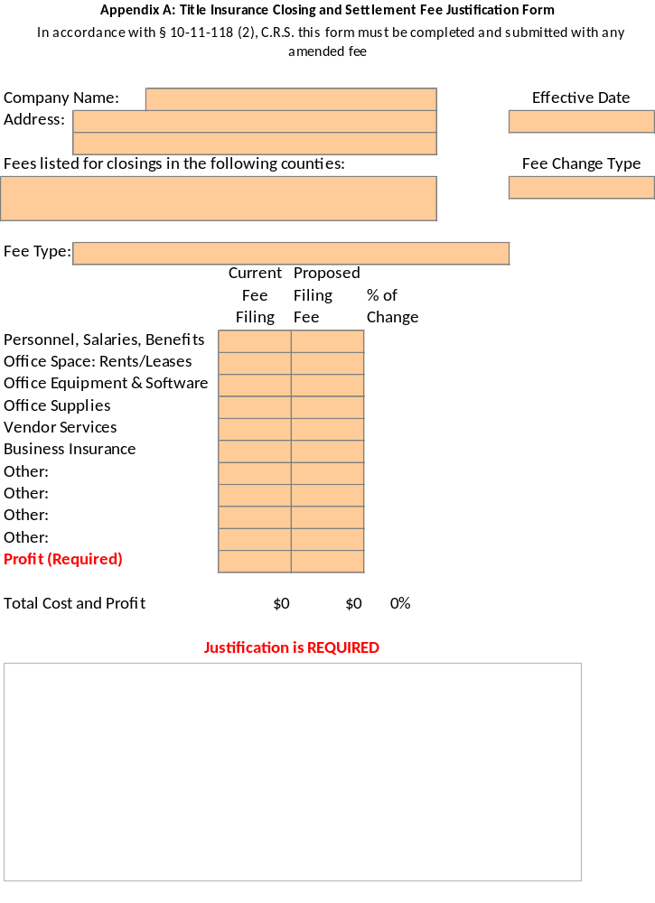

Appendix B Title Insurance Closing and Settlement Fee Filing Agency Fee Sheet for Consumers
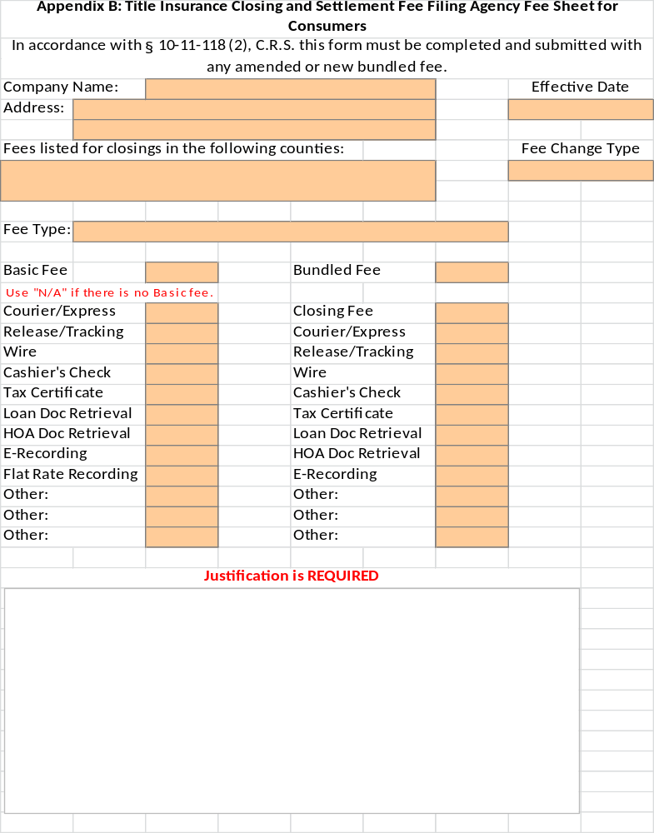

Appendix C Title Insurance Rate Justification Form - Side by Side - New Rates
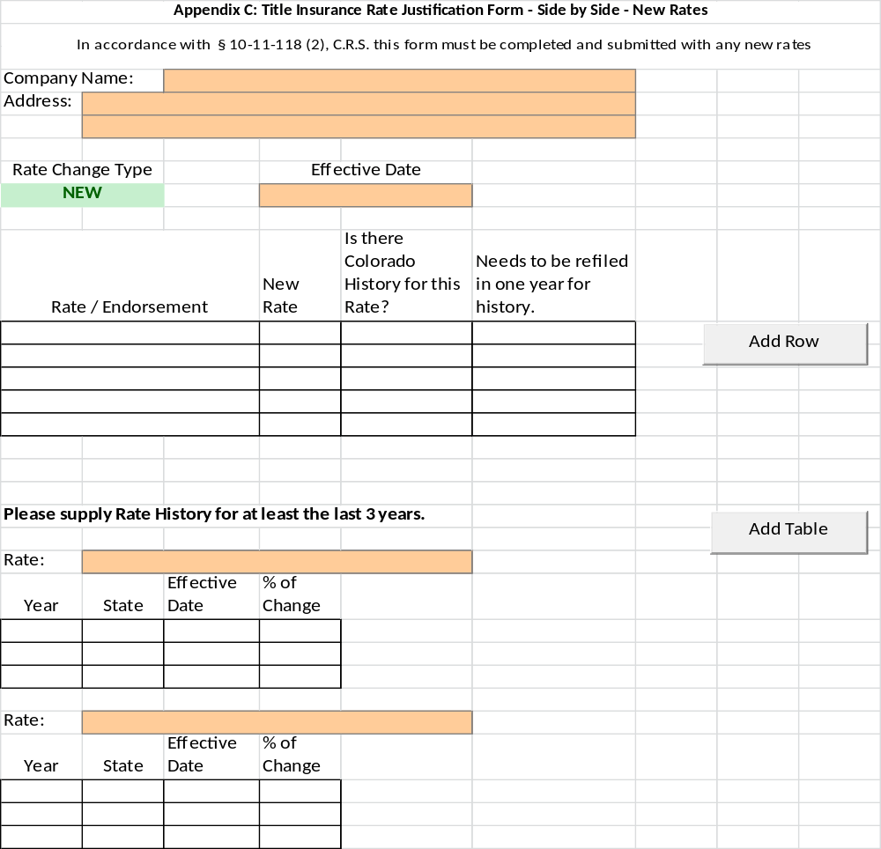

Appendix D Title Insurance Rate Justification Form - Side by Side – Amended or Withdrawn
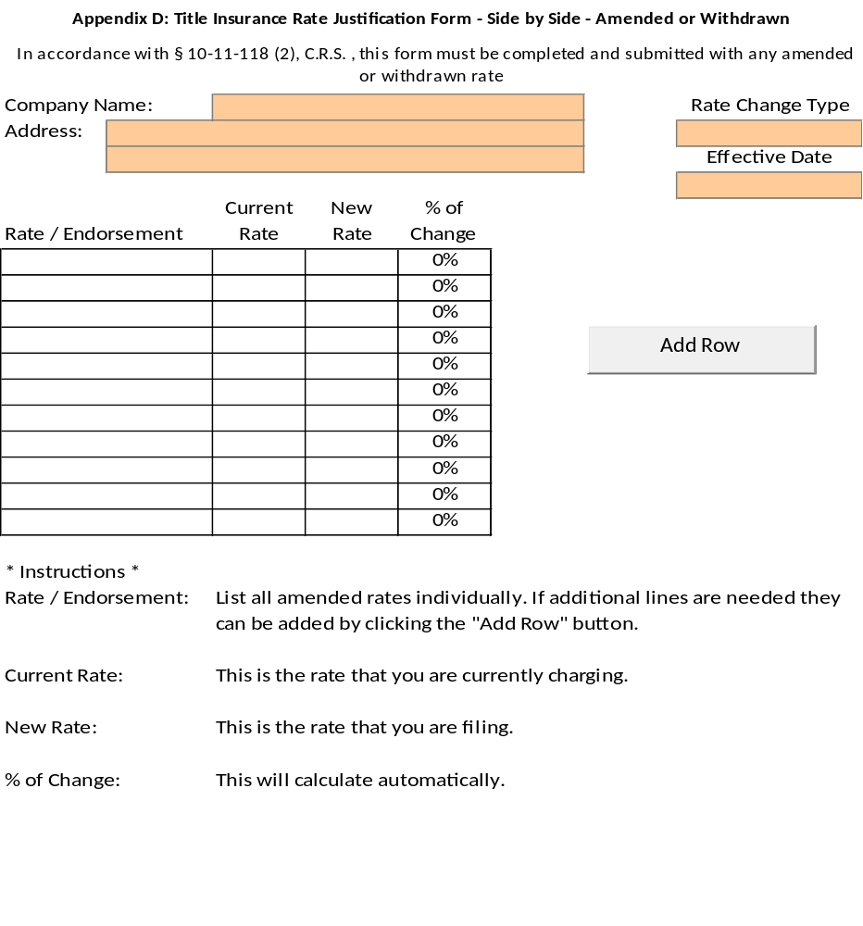

Appendix E Title Insurance Closing Settlement Fee Justification Form – Side by Side – New Fees
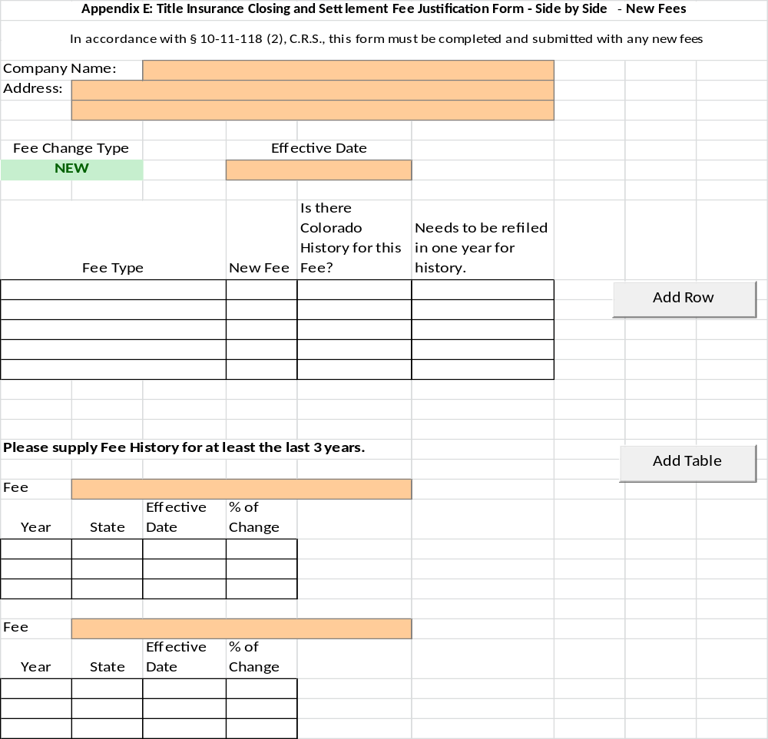

Appendix F Title Insurance Closing Settlement Fee Justification Form – Side by Side – Amended or Withdrawn
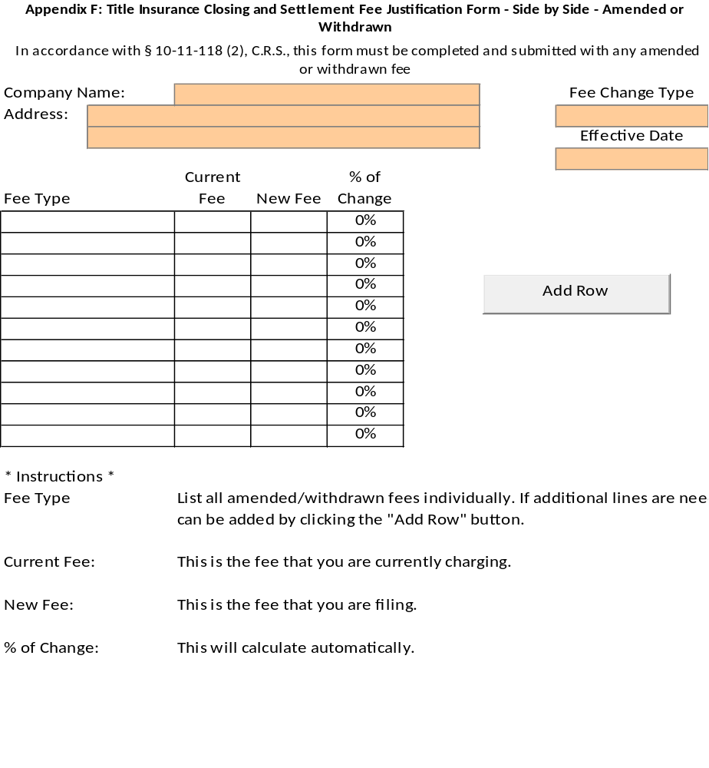

Appendix G Title Insurance Rate Summary Justification Form
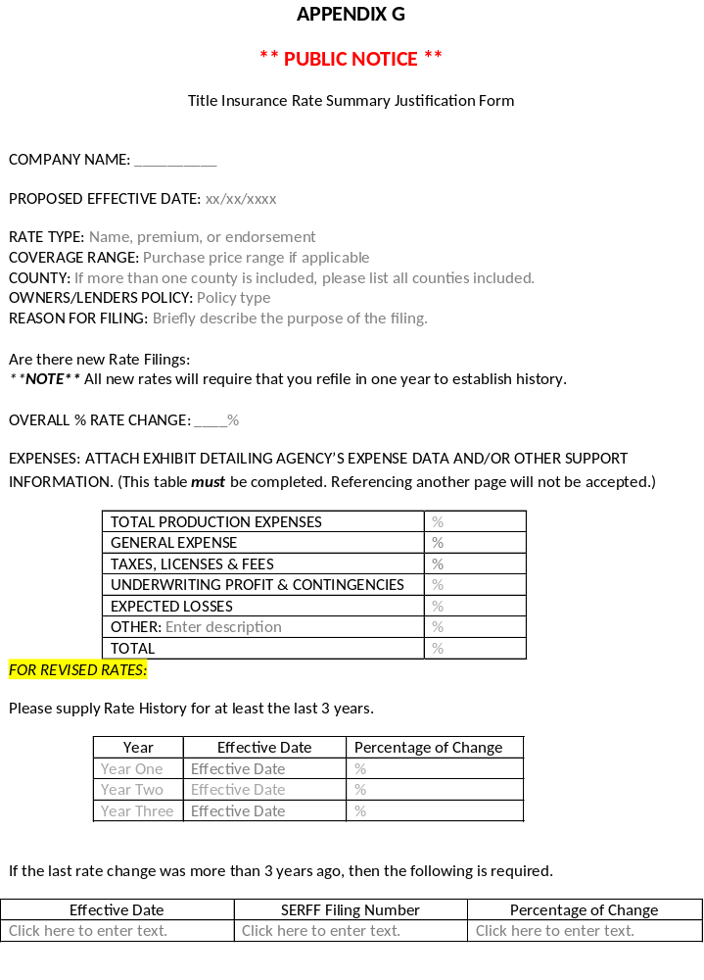

Appendix H Rate Cover Letter
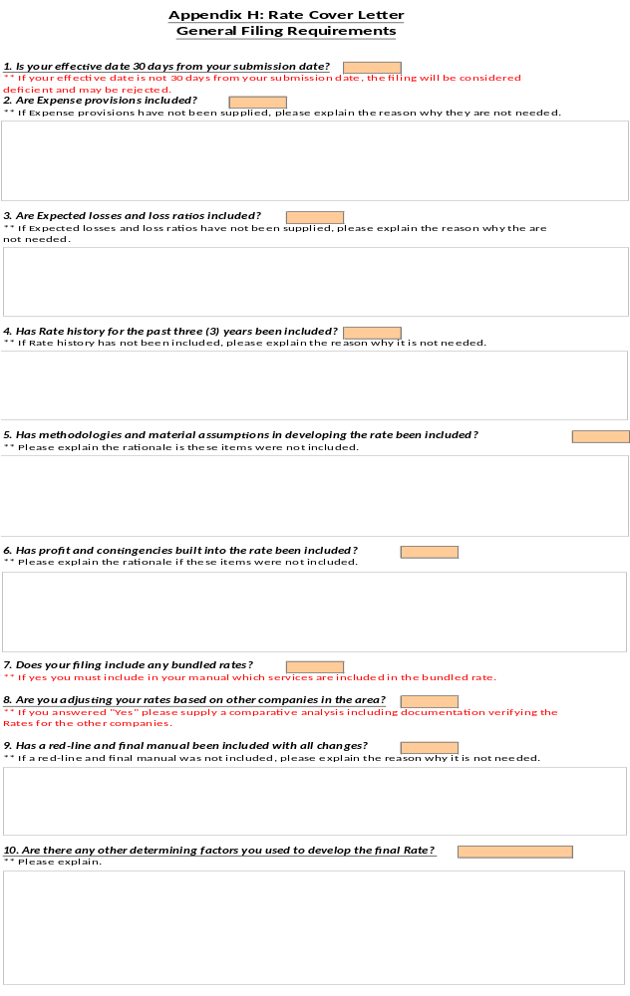

Appendix I Fee Cover Letter
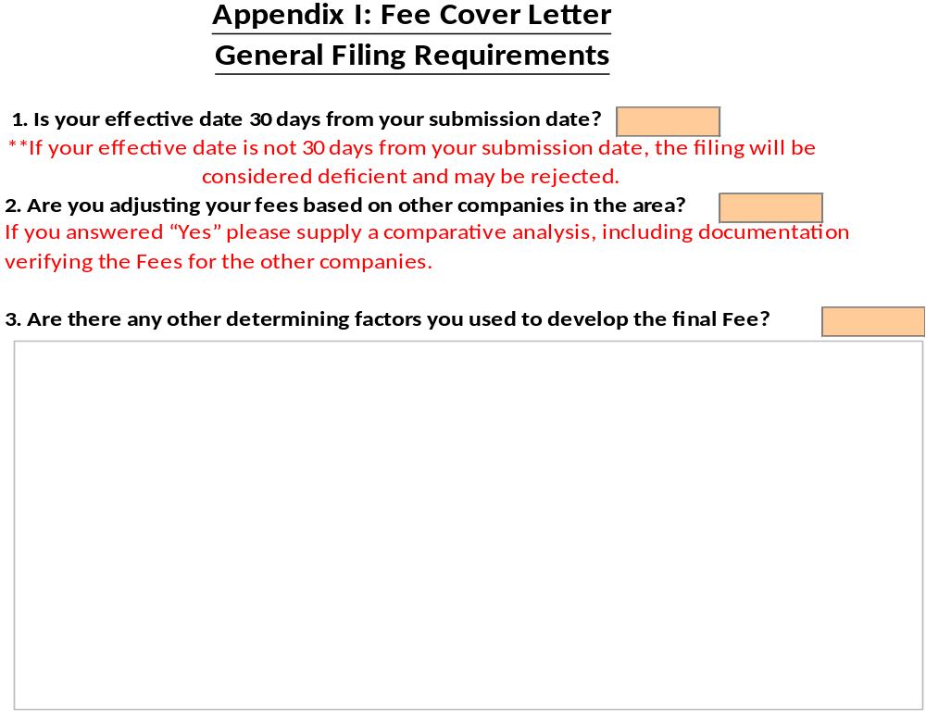

Regulation 8-1-2 TITLE INSURANCE CONSUMER PROTECTION
Section 1 Authority
Section 2 Scope and Purpose
Section 3 Applicability
Section 4 Definitions
Section 5 Rules Regarding Consumer Protection
Section 6 Severability
Section 7 Enforcement
Section 8 Effective Date
Section 9 History
Appendix A Good Funds Agreement

Section 1 Authority
This regulation is promulgated and adopted by the Commissioner of Insurance under the authority of §§ 10-1-108(7), 10-1-109, 10-3-131, and 10-3-1110, C.R.S.

Section 2 Scope and Purpose
The purpose of this regulation is to ensure that consumers receive the benefits of competition in the area of title insurance and to ensure consumer protection.

Section 3 Applicability
This regulation governs title entities and does not extend the regulatory authority of the Colorado Division of Insurance (“Division”) to any person other than title entities or persons transacting the business of title insurance. This regulation only applies to residential transactions.

Section 4 Definitions
A. “Application for title insurance” means, for the purposes of this regulation, receipt by a licensed title entity of an order for a title insurance commitment or other title insurance products that contain information about all parties and details concerning a title insurance transaction.
B. “Available for immediate withdrawal as a matter of right” has the same meaning as found at § 38-35-125(1)(a), C.R.S.
C. “Business of title insurance” has the same meaning as found at § 10-11-102(3), C.R.S.
D. “Closing agent” means, for the purposes of this regulation, any and all persons employed or contracted to perform closing and settlement services on behalf of a title entity.
E. “Closing instructions” or “written instructions” mean, for the purposes of this regulation, a document, signed by one (1) or more parties to a title insurance transaction, which purports to direct a title entity in the completion of settlement services.
F. “Commitment” or “title commitment” mean, for the purposes of this regulation, a report furnished in connection with an application for title insurance, which is a statement of the requirements, terms, and conditions upon which the title insurance company is willing to insure an interest in a subject property.
G. “Division” means, for the purposes of this regulation, the Colorado Division of Insurance.
H. “Error rate” means, for the purposes of this regulation, the percentage of applicable files reviewed during a market conduct action that contained one (1) or more exceptions or violations of the applicable statute or regulation.
I. “Financial institution” has the same meaning as found at § 38-35-125, C.R.S.
J. “Generic exceptions” means, for the purposes of this regulation, broad exceptions on a commitment or policy of title insurance that do not refer to a specific document or recording information and are not standard or preprinted exceptions or a specific exception.
K. “Person” has the same meaning as found at § 10-2-103(8), C.R.S.
L. “Rate”, for the purposes of this regulation, means expenses as defined in § 10-4-402(1.5), C.R.S., together with the pure premium rate as defined in § 10-4-402(2.4), C.R.S. and includes production expenses and commissions in accordance with § 10-4-403, C.R.S.
M. “Settlement producer” has the same meaning as found at § 10-11-102(6.5), C.R.S., and does not include insurance producers as defined in § 10-2-103(6), C.R.S.
N. “Settlement services” has the same meaning as found at § 10-11-102(6.7), C.R.S.
O. “Specific exception” means, for the purposes of this regulation, exceptions that are known impairments for the subject property but the impairment does not appear in a reasonable examination of the property records for the property being insured.
P. “Standard or preprinted exceptions” means, for the purposes of this regulation, those exceptions on title commitments and policies dealing with parties in possession, survey matters, mechanic’s liens, unpatented mining claims, patented or unpatented mineral reservations, water rights, mineral rights, mineral leases, mineral grants, taxes, and rights or encumbrances.
Q. “Systemic error” means, for the purposes of this regulation, an exception or violation that is not determined using an error rate because it is inherent in the system or process of the title entity.
R. “TBD commitment” means, for the purposes of this regulation, a report, in the form of a commitment, furnished prior to receipt of an application for title insurance, in which the buyer, sales amount, and loan amount, among other possible details, are not yet known.
S. “Title entity” means, for the purposes of this regulation, title insurance agents, title insurance agencies and title insurance companies, unless otherwise stated in the regulation.
T. “Title insurance agency” means, for the purposes of this regulation, a corporation, partnership, association, or foreign or domestic entity as defined in § 7-90-102, C.R.S., or other legal entity that transacts the business of title insurance.
U. “Title insurance agent” has the same meaning as found at § 10-11-102(9), C.R.S.
V. “Title insurance company” has the same meaning as found at § 10-11-102(10), C.R.S.

Section 5 Rules Regarding Consumer Protections
A. In order to comply with the requirements of § 10-11-106, C.R.S., no title entity shall issue a commitment for title insurance without first performing, or causing to be performed, a reasonable examination of the property records for the property to be insured. An examination shall be considered reasonable if it conforms to written standards and practices as determined by the title insurance company that is insuring the transaction. Nothing contained herein shall permit a title insurance company to create written standards and practices that do not comply with sound underwriting principles. Nothing contained herein shall prohibit title insurance companies from developing separate examination standards for different types of transactions or geographical areas.
B. Every title entity shall ensure that the title commitment, as may be amended or modified, fully discloses to all recipients the terms upon which title to the property will be insured, the extent of coverage proposed, all proposed title exceptions, and, in a clear and conspicuous manner, shall show whether the title commitment does or does not commit to insure over or delete those exceptions to the title specified therein, consistent with § 10-11-106, C.R.S.
C. Every title entity shall ensure that the title commitment, as may be amended or modified, fully discloses the record vested owner as shown by the applicable county real estate records as of the effective date shown on the commitment. If a circumstance exists which requires a person other than the vested owner to be shown, the title entity shall disclose, in a clear and conspicuous manner, the reason(s) for the deviation from the available county real estate records.
D. Every title entity shall ensure that, except for standard, or preprinted exceptions, or as set forth in Subsection E below, all proposed title exceptions on a title commitment for the issuance of an owner’s policy of title insurance make reference to the recording information of the document to be excepted from coverage.
E. For owner’s policies of title insurance, if a title entity has conducted a reasonable examination of title and was unable to find recorded information for a known impairment, the title entity may make use of a specific exception if the title entity uses other identifiable information, including, but not limited to marks on a document, names of parties, and case numbers, that clearly identify and makes readily available to the consumer the instrument or information referenced in the specific exception. Nothing in this subsection may be construed to allow a title entity to avoid the requirement of conducting a reasonable examination of title.
F. Whenever a title entity provides the closing and settlement service that is in conjunction with the issuance of an owner’s policy of title insurance, it shall update the title commitment from the date of issuance to be as reasonably close to the time of closing as permitted by the real estate records. Such update shall include all impairments of record at the time of closing or as close thereto as permitted by the real estate records. The title insurance company shall be responsible to the proposed insured(s) subject to the terms and conditions of the title commitment, other than the effective date of the title commitment, for all undisclosed matters that appear of record prior to the time of closing.
G. As soon as reasonably practical prior to closing, every title entity shall notify in writing every prospective insured under an owner’s title commitment the circumstances under which the title insurance company is responsible for all matters which appear of record prior to the time of recording (commonly referred to as “Gap Coverage”). This notice shall be clear and conspicuous, reasonably understandable, and designed to call attention to its nature and significance.

H. Every title insurance company shall be responsible to the proposed insured(s) subject to the terms and conditions of the title commitment, other than the effective date of the title commitment, for all matters which appear of record prior to the time of recording whenever the title insurance company, or its agent, conducts the closing and settlement service that is in conjunction with its issuance of an owner’s policy of title insurance and is responsible for the recording and filing of legal documents resulting from the transaction which was closed.
I. If a title entity undertakes to insure any person or entity against the possible adverse effect of any recorded lien, recorded encumbrance or other recorded interest, in accordance with § 10-11-106, C.R.S., and any other applicable law, it shall:
1. Delete such recorded lien, recorded encumbrance or other recorded interest from the schedule of exceptions in its title commitment and have on hand funds, securities, a bonded obligation, or letter of credit payable to the order of said title entity, adequate to discharge such lien, encumbrance or other interest in the event said lien, encumbrance or other interest is perfected to the detriment or possible detriment of the person or entity insured, or any successor in interest to such person or entity;
2. Insure over and reflect such recorded lien, recorded encumbrance or other recorded interest in the schedule of exceptions in its title commitment, and receive an appropriate indemnity from the responsible party; or
3. Insure over the defect in accordance with the title entity’s sound underwriting practices and guidelines; and
4. Not raise as a defense to any claim based on, or arising out of, the deletion or insurance over such defect or exception that the insured assumed, agreed to, or had knowledge of the said defect or exception.
J. All title entities shall comply with the “good funds law” contained in § 38-35-125, C.R.S. In particular, no title entity that provides closing and settlement services for any real estate transaction shall disburse funds as a part of such services until the funds to be disbursed have been received and are either: available for immediate withdrawal as a matter of right from the financial institution in which the funds have been deposited; or available for immediate withdrawal as a consequence of the agreement of the financial institution in which the funds are to be deposited or the financial institution upon which the funds are drawn. Any such agreement shall be made with or for the benefit of the person or entity providing closing and settlement services for a real estate transaction.
1. Notwithstanding the provisions of this Section 5.J., the entity providing closing and settlement services may advance funds, not to exceed five hundred dollars, on behalf of interested parties for the transaction to pay incidental fees for such items as tax certificates and recording costs or to cover minor changes in the closing adjustments.
2. A title entity may satisfy the requirements of this Section 5.J. by use of the Good Funds Agreement appended as Appendix A, without substantial amendment or modification. This is the only agreement approved by the Division for such purpose.
3. Nothing in this Section 5.J. shall be deemed to prohibit the recording of documents before such funds are available provided all necessary parties to the transaction consent in writing thereto.
4. The requirements of Section 5.J. above may be waived by the seller in the real estate transaction if:
a. It is specified as part of written closing instructions in advance of closing that the seller waives the requirements set forth in Section 5.J. above and that the person or entity conducting the closing, unless such person or entity is the seller, is not to handle the receipt and disbursement of funds as part of the closing; and
b. Any holder of a lien encumbering the property up to the time of closing agrees, in writing, to such waiver and further agrees, in writing, to release such lien immediately upon receipt of a check from the closing drawn in the amount of the outstanding indebtedness secured by such lien. Such an agreement shall obligate the lien holder to release such lien regardless of whether the payoff check received has been or will be honored.
5. Any seller who so requests as part of written closing instructions in advance of closing, shall be entitled to receive the proceeds of closing in a cashier’s check or in funds electronically transferred to an account specified by the seller.
K. No title entity shall provide closing and settlement services without receiving written instructions from all necessary parties. All amendments to existing written instructions must be in writing.
L. Every title entity shall be responsible for properly conducting each closing or settlement service and recording such documents as it is directed in writing to record in conjunction therewith, for each transaction for which such title entity charges and collects a fee.
1. All documents must be submitted for recording within seven (7) calendar days of:
a. Receipt of the document to be recorded; or
b. The disbursement date of the transaction.
2. In the event incorrect or incomplete documents are received, the title entity shall have seven (7) calendar days, from receipt of the corrected or complete documents, to submit the documents for recording.
3. A title entity shall be deemed in compliance if they submit the recording to a third party electronic recording vendor or the county recorder’s office.
M. Every title entity shall notify in writing, at the time of delivery of the title commitment, every prospective insured in an owner's title commitment for a single family residence (including a condominium or townhouse unit) of that title entity's general requirements for the deletion of an exception or exclusion to coverage relating to unfiled mechanic’s or materialman’s liens, except when said coverage or insurance is extended to the insured under the terms of the policy. This notice shall be clear and conspicuous, reasonably understandable, and designed to call attention to its nature and significance. Notwithstanding the foregoing, nothing contained in this Section 5.M. shall be deemed to impose any requirement upon any title insurance company to provide mechanic’s or materialman’s lien coverage.
N. Every title entity shall issue and deliver to the insured, the title insurance policy within ninety (90) calendar days of:
1. The effective date of the owner’s title insurance policy if the title entity is providing closing and settlement services for the transaction; or
2. The satisfaction of the terms, conditions and requirements of the title commitment if the title entity is not providing closing and settlement services for the transaction.
3. The title entity is not responsible for compliance with this subsection if the title entity has not received payment for the title insurance premium.
O. A title insurance company shall notify the Division in writing within thirty (30) calendar days, if at any point a title insurance company becomes aware that a title insurance agent or title insurance agency fails to issue and deliver to the insured the title policy, in compliance with Section 5.N. above.
P. Every title entity is responsible for:
1. Ensuring that rates charged to insureds for the title entity’s products by the following persons are the same as the rates that the title entity has filed with the Division:
a. The title entity’s employees; and
b. Title insurance agents with whom the title entity has an employment relationship, a contract, or an agency agreement.
2. Pursuant to § 10-3-131, C.R.S., when the following persons are acting on the title entity’s behalf, any unfair business practice, when the title entity knew or should have known about the unfair business practice:
a. The title entity’s employees; and
b. Title insurance agents with whom the title entity has an employment relationship, a contract, or an agency agreement.
3. In all other areas, exercising reasonable efforts to ensure that the acts of its employees and other authorized agents, including closing agents and title insurance agencies, which are performed within the scope of the person’s employment, contract, agency agreement, or closing protection letter, comply with all laws and regulations concerning the business of title insurance.
a. For the purposes of market conduct actions involving a title insurance company conducted pursuant to Part 3 of Article 1 of Title 10 C.R.S., with the exception of systemic errors, the Division will consider an error rate that exceeds 7% for claims and an error rate that exceeds 10% for other issues, by employees and agents of the title insurance company performed within the scope of the person’s employment, contract, agency agreement, or closing protection letter, to be a reportable exception that the title insurance company failed to conduct reasonable efforts to ensure its employees and agents complied with the laws and/or regulations at issue in the market conduct action.
b. For the purposes of market conduct actions involving a title insurance agent or agencies conducted pursuant to Part 3 of Article 1 of Title 10, C.R.S., with the exception of systemic errors, the Division will consider an error rate that exceeds 7% for claims and an error rate that exceeds 10% for other issues to be a reportable exception.
Q. Every title entity shall maintain adequate documentation and records sufficient to show its compliance with this regulation and Title 10 of the Colorado Revised Statutes for a period of not less than seven (7) years, except as otherwise permitted by law.

Section 6 Severability
If any provision of this regulation or the application of it to any person or circumstance is for any reason held to be invalid, the remainder of this regulation shall not be affected.

Section 7 Enforcement
Noncompliance with this regulation may result in the imposition of any of the sanctions made available in the Colorado statutes pertaining to the business of insurance, or other laws, which include the imposition of civil penalties, issuance of cease and desist orders, and/or suspensions or revocation of license, subject to the requirements of due process.

Section 8 Effective Date
This regulation shall become effective on September 14, 2022.

Section 9 History
New regulation effective October 1, 2015.
Amended regulation effective September 14, 2022.

Appendix A GOOD FUNDS AGREEMENT
THIS GOOD FUNDS AGREEMENT (“Agreement”) is entered into as of this ____ day of
__________________________, by and among ___________________________ (“Mortgage Lender”),
______________________ (“Closing Agent”),__________________ (“Bank”) and
________________________________________ (“Warehouse Lender”).
RECITALS
A. Colorado Revised Statutes Section 38-35-125 (the “Statute”) establishes certain requirements for the collection and availability of funds which must be satisfied to enable a provider of closing and settlement services for real estate transactions to disburse such funds;
B. The Mortgage Lender is presently engaged in the making of one or more loans (“Loan or Loans”) to individuals or entities (“Borrowers”) or purchasing Loans made by other lenders. The Loans to which this Agreement pertains shall in every case be evidenced by a promissory note (“Note”) executed by the pertinent Borrower and secured by a priority mortgage or deed of trust (“Mortgage”) on real property improved by a 1-4 family residence.
C. The Bank is a “financial institution”, as defined in the Statute.
D. The Bank/Warehouse Lender has extended a credit facility to the Mortgage Lender, pursuant to which the Bank/Warehouse Lender has agreed, upon certain terms and conditions, to advance funds (an “Advance”) to the Mortgage Lender for the purpose of enabling the Mortgage Lender to make Loans. Each Advance by the Bank/Warehouse Lender shall be secured by the Note and Mortgage executed in connection with the Loan for which the Advance is made. The term “Bank/Warehouse Lender” shall mean (i) the Bank if no separate warehouse lender is a party or (ii) the Warehouse Lender if, the warehouse lender is not the Bank.
E. In order to comply with the Statute, the parties wish to agree upon an arrangement whereby the Closing Agent may, immediately upon the closing of Loans, disburse funds delivered to it in connection with such closings.
F. The Bank may issue Reservation Numbers (as defined below) for Loans to be funded by the Mortgage Lender’s check drawn upon the Bank or its affiliated bank,________________________________ account # _________________________ (“Good Funds Account”) and the Bank is willing to agree with the Lender and the Closing Agent that it will fund checks drawn upon the Good Funds Account (“Good Funds Check”) for the funding of Loans and the Closing Agent may disburse the funds immediately upon the closing of Loans, upon the terms set forth in this Agreement.
NOW, THEREFORE, for good and valuable consideration, the receipt and sufficiency of which is hereby acknowledged, the parties agree as follows:
1. Incorporation of Recitals. The Recitals set forth above are hereby incorporated and made a part of this Agreement.

2. Responsibilities of Mortgage Lender. The Mortgage Lender shall, prior to the closing of a Loan, prepare and deliver to the Closing Agent all necessary Loan documents including, without limitation, a loan settlement statement. Alternatively, if the Closing Agent or any third party prepares the Loan documents, the Mortgage Lender shall review and approve the Loan documents.
3. Responsibilities of the Closing Agent. The Closing Agent shall be responsible to do the following, at or prior to the closing of each Loan:
(a) During the Bank’s normal business hours, on or before the day of disbursement of funds, the Closing Agent shall obtain from the Bank or its designee by telephone as specified on the signature page, a reservation number which has been issued by the Bank for the Good Funds Check (the “Reservation Number”).
(b) The Closing Agent shall verify that the amount of the check delivered to it by the Mortgage Lender and drawn on the Bank does not exceed the face amount of the Loan less all discount points charged in connection with the Loan, as set forth on the settlement statement.
(c) The Closing Agent shall make disbursements in accordance with the settlement statement and do all other things and obtain all other documents that it deems necessary in order to comply with the Mortgage Lender’s closing instructions that are applicable to the Loan and issue a mortgagee’s policy of title insurance in favor of the Mortgage Lender, insuring that the Mortgage is a ____________________ lien on real property improved by a 1-4 family residence as described therein. The duties of the Closing Agent hereunder shall not include the preparation of legal documents. The Closing Agent shall in each case forward the original Mortgage to the proper governmental authority for recording. The Note and all other Loan documents shall be delivered to the Mortgage Lender within two (2) business days after disbursement of funds, unless the Closing Agent is requested and agrees to forward the Loan package to the Bank/Warehouse Lender or its designee as specified on the signature page. For the purposes of perfecting the Bank’s/Warehouse Lender’s security interest therein pursuant to § 4-9-313(c), C.R.S., the Closing Agent shall be the bailee of the Bank/Warehouse Lender and agrees to hold possession of the Note and all other Loan documents for the benefit of the Bank/Warehouse Lender until the Closing Agent delivers the Loan documents to the Mortgage Lender or the Bank/Warehouse Lender.
(d) In the event Loan proceeds are not disbursed within two (2) business days after issuance of a Reservation Number, the Closing Agent shall so notify the Mortgage Lender and return the check to the Mortgage Lender.
4. Bank’s Agreement to Honor Checks. The Bank shall have no obligation under this Agreement or otherwise to issue a Reservation Number for any check drawn on the Good Funds Account. However, if (1) the Bank does issue a Reservation Number, (2) the Bank has given a Reservation Number to the Closing Agent, and (3) the Closing Agent closes a Loan and disburses funds, then issuance of the Reservation Number shall constitute the warranty by, and unconditional agreement between the Bank and the Closing Agent that:
(a) The Bank shall honor and pay the Good Funds Check upon presentment without reference to amounts on deposit in any account;
(b) Issuance of the Reservation Number constitutes an acceptance or certification of the Good Funds Check by the Bank, pursuant to § 4-3-409, C.R.S.;
(c) The Good Funds Check shall be deemed, with respect to the ability of the Bank to stop payment, to be the equivalent of a cashier’s check issued by the Bank;
(d) Funds represented by the Good Funds Check are not subject to offset by the Bank; and
(e) The Bank shall not honor any stop-payment order or direction from the Mortgage Lender with respect to the Good Funds Check.
Mortgage Lender agrees to pay, and indemnify Closing Agent for, all losses sustained as a result of a dishonor of a Good Funds Check that the Bank is obligated to honor as set out in this paragraph 4. Notwithstanding any other provision of this Agreement, nothing in this Agreement is intended to alter the normal check collection and clearance time periods for a Good Funds Check.
5. Insured Closing Letter. For the duration of this Agreement, the Closing Agent shall obtain and cause to remain in effect insured closing letters from the Title Insurance Company in form and content acceptable to the Bank/Warehouse Lender (the “Insured Closing Letters”). The Insured Closing Letters shall be addressed to the Bank/Warehouse Lender and to the Mortgage Lender and shall not be cancelable except with ten (10) days prior written notice to the Bank/Warehouse Lender and the Mortgage Lender. A copy of the Insured Closing Letter shall be delivered by the Mortgage Lender to the Bank/Warehouse Lender prior to any request for confirmation pursuant to paragraph 3 (a) hereof.
6. Termination. This Agreement shall apply to all Loans of the Mortgage Lender which are now or hereafter closed by the Closing Agent for which a Reservation Number is requested and given, prior to termination of this Agreement. This Agreement may be terminated by any party hereto, immediately upon the giving of written notice to all other parties. The rights and obligations of the parties with respect to all Good Funds Checks for which a Reservation Number has been issued by the Bank prior to termination of this Agreement shall survive any such termination.
7. Notices. All notices which are required or may be given in connection with this Agreement shall be effective upon the earlier of receipt or three (3) days after the same are sent by certified mail, return receipt requested, with postage prepaid, to the addresses contained on the signature page.
8. Miscellaneous:
(a) This Agreement shall be governed by and construed in accordance with the laws of the State of Colorado.
(b) Nothing in this Agreement shall be deemed to supersede or modify the rights and obligations of the Mortgage Lender and the Bank/Warehouse Lender vis-à-vis each other under any loan agreement or other documents that may currently be in place with respect to the Bank’s/Warehouse Lender’s credit facility with the Mortgage Lender (“Other Agreement or Documents”), and the Bank/Warehouse Lender shall be entitled to exercise all rights and remedies granted in any such Other Agreements or Documents, as specified therein except that the Bank’s agreement to honor a Good Funds Check under paragraph 4 shall not be altered or impaired by such Other Agreement or Documents.

(c) This Agreement may not be assigned by the Closing Agent or Mortgage Lender without the prior written consent of the Bank and the Warehouse Lender, if any. This Agreement shall be binding upon and inure to the benefit of the successors and assigns of the Bank and the Warehouse Lender, if any, and upon any permitted successors and assigns of the Closing Agent or the Mortgage Lender.
(d) This Agreement may be amended or modified only by a written instrument executed by the parties hereto and only as permitted by Division of Insurance Regulation 3-5-1.
(e) No right or interest under this Agreement shall be waived except by written instrument executed by the party against whom such waiver is sought. Any waiver of any particular default or failure to perform hereunder or of any provision hereof shall not constitute a waiver of any other default or failure to perform hereunder or of the same default arising again in the future.
(f) In the event of any litigation or arbitration hereunder, the prevailing party shall be entitled to recover its attorneys fees and costs in addition to the award granted by the court or arbitrator.
(g) The rights and remedies of each party under this Agreement shall be cumulative, both as to other rights or remedies under this Agreement and as to rights and remedies otherwise provided or available under other agreements or at law, by statute or in equity. The exercise or partial exercise of any such right or remedy shall not preclude the exercise of any other right or remedy
(h) No Closing Agent, Mortgage Lender, or Bank/Warehouse Lender shall be required to enter into this Agreement.

IN WITNESS WHEREOF, the parties have entered into this Good Funds Agreement as of the date first above written.

Bank: | Closing Agent:
By | By
Name: | Name:
Title: | Title:
Address: | Address:
Telephone No.: | Telephone No.:
FAX No.: | FAX No.:
E-mail: | E-mail:
Attention: | Attention:
WAREHOUSE LENDER:_______________ MORTGAGE LENDER:_________________
Bank: | Closing Agent:
By | By
Name: | Name:
Title: | Title:
Address: | Address:
Telephone No.: | Telephone No.:
FAX No.: | FAX No.:
E-mail: | E-mail:
Attention: | Attention:
FOR RESERVATION NUMBERS pursuant to paragraph 3(a) contact:
Name: _____________________________________________________________________
Address: ______________________________________________________________________
Address: _____________________________________________________________________
Telephone No.: _________________________________________________________________
E-mail: _______________________________________________________________________
Bank Authorization: ____________________________________________________________
Name & Title
FOR LOAN DOCUMENT DELIVERY pursuant to paragraph 3(c) deliver to:
Name: _____________________________________________________________________
Address: ______________________________________________________________________
Address: _____________________________________________________________________
Telephone No.: _________________________________________________________________
E-mail: _______________________________________________________________________
Bank Authorization: ____________________________________________________________
Name & Title

Regulation 8-1-3 TITLE INSURANCE STANDARDS OF CONDUCT
Section 1 Authority
Section 2 Scope and Purpose
Section 3 Applicability
Section 4 Definitions
Section 5 Rules Regarding Standards of Conduct for Title Insurance Entities
Section 6 Severability
Section 7 Enforcement
Section 8 Effective Date
Section 9 History
Appendix A Title Closing Protection Letters

Section 1 Authority
This regulation is promulgated and adopted by the Commissioner of Insurance under the authority of §§ 10-1-108(7), 10-1-109, 10-2-104, 10-3-1110, 10-11-116, 10-11-119, and 10-11-124(2) C.R.S.

Section 2 Scope and Purpose
The purpose of this regulation is to ensure that consumers receive the benefits of competition in the area of title insurance and to ensure consumer protection. The regulation also proscribes unlawful inducements, deceptive trade practices, and discriminatory acts, all of which are detrimental to the consumer and, in the aggregate, may threaten the solvency of title insurance companies and title insurance agents.

Section 3 Applicability
This regulation governs title entities and does not extend the regulatory authority of the Colorado Division of Insurance (“Division”) to any person other than title entities or persons transacting the business of title insurance. This regulation does not create any type of safe harbor from the enforcement of any federal statutes and regulations applicable to title entities.

Section 4 Definitions
A. “Affiliate” means a person who directly, or indirectly through one or more intermediaries:
1. controls a title entity;
2. is controlled by a title entity; or
3. is under common control with a title entity.
B. “Affiliated business arrangements” shall have the same meaning as set forth in § 10-11-102(1), C.R.S. Affiliated business arrangements are distinct from controlled business arrangements, which are defined by § 10-2-401(4), C.R.S.
C. “Application for title insurance” shall mean receipt by a licensed title entity of an order for a title insurance commitment or other title insurance product that contains information about all parties and details concerning a title insurance transaction.
D. “Business of title insurance” shall have the same meaning as set forth in § 10-11-102(3), C.R.S.
E. “Commitment” or “title commitment” shall mean a report furnished in connection with an application for title insurance, which is a statement of the requirements, terms, and conditions upon which the title insurance company is willing to insure an interest in a subject property.
F. “Core title services” shall have the same meaning as set forth in the United States Department of Housing and Urban Development (HUD) RESPA Statement of Policy 1996-4.
G. “Division” means the Colorado Division of Insurance.
H. “Fair Market Value” means, for the purpose of this regulation, a price that represents the value of a product or service being provided, which must include cost and profit.
I. “Fee” means, for purposes of this regulation only, the price other than the Rates (see subparagraph L below) assessed to a consumer by a title entity in rendering services pursuant to the business of title insurance as defined in § 10-11-102, C.R.S.
J. “Ownership and encumbrance report” (“O&E”) means information identifying the last recorded owner, legal description and recorded unreleased deeds of trust, or mortgages of a particular parcel of real property available from public records.
K. “Person” has the same meaning as that in § 10-2-103(8), C.R.S.
L. “Rate”, for purposes of this regulation, means expenses as defined in § 10-4-402(1.5), C.R.S., together with the pure premium rate as defined in § 10 4 402(2.4), C.R.S., and includes production expenses and commissions, in accordance with § 10-4-403, C.R.S.
M. “Remuneration” means, for the purposes of this regulation, any type of payment or compensation.
N. “Services actually rendered” for the purposes of this regulation includes, but is not limited to, a reasonable examination of title, including instruments of record, and a determination of insurability of such title in accordance with sound underwriting practices. “Services actually rendered” does not include the mere referral of title insurance business.
O. “Settlement producer” shall have the same meaning as set forth in § 10-11-102(6.5), C.R.S., and does not include insurance producers as defined in § 10-2-103(6), C.R.S.
P. “Settlement services” shall have the same meaning as in § 10-11-102(6.7), C.R.S.
Q. “TBD commitment” shall mean a report, in the form of a commitment, furnished prior to receipt of an application for title insurance, in which the buyer, sales amount, and loan amount, among other possible details, are not yet known.
R. “Title insurance agency” means, for the purpose of this regulation, a corporation, partnership, association, or foreign or domestic entity as defined in § 7-90-102, C.R.S., or other legal entity that transacts the business of insurance.
S. “Title insurance agent” shall have the same meaning as in § 10-11-102(9), C.R.S.
T. “Title insurance company” shall have the same meaning as in § 10-11-102(10), C.R.S.
U. “Title entity” shall mean title insurance agents, title insurance agencies and title insurance companies, unless otherwise stated in the regulation.

V. “Trip”, means, for the purposes of this regulation, a journey or getaway that includes any one or more of the following:
1. Air travel;
2. Travel outside the state of Colorado;
3. Any overnight lodging or accommodation.

Section 5 Rules Regarding Standards of Conduct for Title Insurance Entities
A. A title entity shall not give remuneration to any person, either directly or indirectly, pursuant to any agreement or understanding, oral or otherwise, for the referral of the business of title insurance, other than remuneration that is a part of a compliant and authorized affiliated business agreement or for services actually rendered.
B. An agreement or understanding for the referral of the business of title insurance need not be written or verbalized but may be established by a practice, pattern, or course of conduct. When any type of remuneration is given repeatedly and is connected in any way with the volume or value of the business referred, the giving of the remuneration is evidence that it is made pursuant to an agreement or understanding for the referral of the business of title insurance.
C. The following activities are permissible standards of conduct:
1. Providing discounts that are properly filed and justified in the title entity’s rate or fee filing.
2. Furnishing a TBD commitment for a charge that bears a reasonable relation to the cost of production of the TBD commitment or crediting a charge paid for a TBD commitment to the final premiums or fees paid upon the consummation of the transaction contemplated by such TBD commitment, when such charge has been properly filed and justified.
3. Paying, furnishing, or providing a proportional share of the actual cost for a thing of value being provided. The title entity must comply with Section 5.C.12. if the title entity is providing promotional materials and Section 5.C.13. if the title entity is providing office space or accommodation.
4. Crediting a charge paid for an ownership and encumbrance report to the final premiums or fees paid upon the consummation of the transaction contemplated by such ownership and encumbrance report.
5. Accumulating, crediting or deferring the charge for a title policy or a closing or settlement service, to the extent that a properly filed and justified rate or fee is in place for the accumulated, credited, or deferred charge.
6. Paying for or furnishing a business form to a settlement producer which is a form regularly used in the conduct of the title entity's business and which form is furnished solely for the convenience of the title entity and does not constitute a monetary benefit to a settlement producer.
7. Advancing or paying into escrow, or offering to advance or pay into escrow, title entity funds as provided in Division Regulation 8-1-2 Section 5.J.1.

8. Providing a single copy of the last recorded vesting deed for a parcel of real property to a settlement producer without charge if:
a. The document is provided as presented by the public records and nothing of material value is added to the information contained in it; and
b. The document provided contains no advertising or promotional material on behalf of the settlement producer.
Nothing in this regulation prohibits title entities from imposing a reasonable fee for any of the above information, or for additional information, provided the fee is the same for all persons and assessed on a non-discriminatory basis.
9. Providing to a settlement producer a copy of an instrument of public record in connection with the issuance of a commitment or TBD commitment, including but not limited to a deed, deed of trust, mortgage, judgment, lien, contract, map, plat, declaration of covenants, conditions, and restrictions, or any other document purporting to affect a parcel of real property without charge if:
a. The document is provided in concert with the issuance of a commitment for title insurance;
b. The document is provided as presented by the public records and nothing of material value is added to the information contained in it; and
c. The document provided contains no advertising or promotional material on behalf of the settlement producer.
Nothing in this regulation prohibits title entities from imposing a reasonable fee for any of the above information, or for additional information, provided the fee is the same for all persons and assessed on a non-discriminatory basis.
10. Providing a quote for title insurance premiums and settlement service fees for a specific real estate transaction. Such a quote need not comply with the reasonable search and examination standards required by § 10-11-106, C.R.S., or Regulation 8-1-2, provided said quote is not binding in the event a reasonable search and examination of the property records reveals a circumstance in which the quoted rate or fee must be amended.
11. Issuing a closing protection letter that satisfies the following standards:
a. Any closing protection letter issued substantially conforms to an American Land Title Association (“ALTA”) promulgated form, which may include amending such form to be applicable to a seller;
b. All fees that are charged for a closing protection letter are not in any way included in the rate charged for the title insurance product;
c. All fees that are charged for the closing protection letter are disclosed to the consumer paying the fee;
d. All fees that are charged for a closing protection letter have been properly filed and justified in accordance with Regulation 8-1-1 by the title insurance company providing title insurance for the subject transaction;
e. All fees that are charged for a closing protection letter are remitted to the title insurance company providing title insurance for the subject transaction; and
f. The title insurance company includes a notice to the consumer on the commitment disclosure statement of the availability of the issuance of a closing protection letter.
12. Normal promotional and educational activities that:
a. Are not conditioned on the referral of the business of title insurance;
b. Do not involve the defraying of expenses that otherwise would be incurred by persons in a position to refer settlement services or business incident thereto;
c. Comply with paragraphs 5.C.15 through 19.; and
d. Do not violate paragraph 5.D.20. of this regulation.
13. Utilizing office space or other accommodations within a settlement producer’s office or business space, provided that rent is paid in accordance with Section 5.C.3., if:
a. Written notice has been provided to the consumer disclosing that an office or accommodations sharing arrangement exists and that the consumer has the right to shop for and use another title entity and/or settlement producer;
b. The title entity’s space is clearly and conspicuously identified separately from the settlement producer’s space;
c. The title entity’s space can be readily locked and secured independently from the settlement producer’s space;
d. The title entity’s space is directly and easily accessible to the public without entering the settlement producer’s primary workspace, such as where the title entity’s entrance leads to or from a common area or the exterior of the premises; and
e. The title entity does not directly or indirectly pay for or subsidize the settlement producer’s expenses as proscribed by § 10-11-108, C.R.S.
14. Charitable donations that meet the following requirements:
a. The donation must be made directly to the charitable organization; and
b. The donation must not be made on behalf of a settlement producer.
15. Expenditures for business meals as a method to promote a title entities business, only when at least one title insurance producer attends the business meal for every four settlement producers that attend the business meal.
16. A title entity may provide or sponsor educational courses under the following conditions:
a. The topic of the education course is title insurance, escrow, closing and settlement services, other courses related to such topics, or real estate and mortgage classes;
b. The education course be at least one hour in duration; and
c. If the topic of the education course is residential real estate or mortgage classes, escrow, closing and settlement services, the title entity conducting or sponsoring the course must provide Appendix A of this regulation, titled “Title Insurance Closing Protection Letters (CPLs),” to all individuals taking the course.
17. Attending or participating in local sporting events as a method to promote any title entities’ business, only when at least one title insurance producer attends, or participates in, the sporting event for every four settlement producers that attend, or participate in, the sporting event.
18. A title entity may attend and participate in trade association activities and events under the following conditions:
a. Any marketing and promotional items and gifts promoting a title entity must be available to the public;
b. Any advertising purchased by the title entity in a trade association publication is purchased at fair market value; and
c. The title entities attendance or participation in the trade association activities and events must not violate paragraph 5.D.20. of this regulation.
19. Expenditures for coffee, donuts, bagels, or other similar refreshments, for a settlement producer, as a method to promote the title entities’ business, only when at least one title insurance producer is present to promote the title entities’ business.
D. The following is a partial, but not all-inclusive, list of acts and practices which the Division considers per se unlawful inducements proscribed by § 10-11-108, C.R.S.:
1. Except as otherwise permitted in Regulation 8-1-2 Section 5.J.1., the disbursement of closing and settlement services funds before all necessary conditions of the transaction have been met.
2. Furnishing a title commitment without charge or at a reduced charge, in the absence of a bona fide sale, purchase or loan transaction. The charge for a commitment must have a reasonable relation to the cost of production of the commitment.
3 Furnishing a TBD commitment without a charge that bears a reasonable relation to the cost of production of the TBD commitment. Any such charge must be properly filed and justified in accordance with Regulation 8-1-1. While such charge for the production of a TBD commitment must be made at the time the TBD commitment is provided, nothing in this provision shall prohibit a company from crediting a charge paid for a TBD commitment to the final premiums or fees paid upon the consummation of the transaction contemplated by such TBD commitment.
4. Paying for, furnishing, providing, subsidizing, waiving or offering to pay, furnish, provide, subsidize or waive, to or for any settlement producer or associate, all or any portion of the following:
a. The cancellation fee for a title commitment or other fee before or after a settlement producer cancels an order with another title entity; and
b. Salary, compensation or services, except for services actually rendered, including but not limited to:
(1) All or any part of the time or productive effort of any employee or affiliate of the title entity (e.g., office manager, escrow officer, secretary, clerk, messenger) to any settlement producer at less than the fair market value of the services;
(2) Compensation of a settlement producer or associate of a settlement producer;
(3) The salary or any part of the salary of a relative of any settlement producer which payment is in excess of the reasonable value of the work actually performed by such relative on behalf of the title entity; and
(4) Services by any settlement producer, which services are required to be performed by such settlement producer in his or her professional capacity, and for which the settlement producer would not normally charge the title entity.
5. Except for services actually rendered, paying a settlement producer or associate to make an inspection or appraisal of property.
6. Any transaction in which any person receives, or is to receive, securities of the title entity or its affiliates at prices below the normal market price, or bonds or debentures which guarantee a higher than normal interest rate, when such transaction is directly or indirectly related to the number of closing and settlement services or title orders coming to the title entity through the efforts of such person.
7. Charging less than the scheduled rate or fee for a specified title or closing and settlement service, or for a policy of title insurance.
8. Waiving, or offering to waive, all or any part of the title entity's established rate or fee for services which are not the subject of rates or fees filed with the Commissioner or are required to be maintained on the entity's schedules of rates and fees.
9. Furnishing information, including but not limited to, farm packages and ownership and encumbrance reports, or similar packages containing information about one or more parcels of real property, without both making a charge that is commensurate with the fair market value of the work performed and the material furnished, and making a good faith effort to collect payment in the amount of such charge. While such charge for the production of an ownership and encumbrance report must be made at the time the report is provided, nothing in this provision prohibits a company from crediting a charge paid for an ownership and encumbrance report to the final premiums or fees paid upon the consummation of the transaction contemplated by such ownership and encumbrance report.
10. Subsidizing the production of ownership and encumbrance reports, farm packages, information kits, or similar packages containing information about one or more parcels of real property, whether through sponsorship, advertising, or any other direct or indirect method of payment to a company or organization that is able to produce such materials but is not subject to the rules and regulations of the division.

11. Designing, producing, printing, distributing or causing to be designed, produced, printed, or distributed, on behalf of any settlement producer, postcards, flyers, home information books, business cards, or any other product used to market to prospective clients without both making a charge that is commensurate with the fair market value of the work performed and the material furnished, and making a good faith effort to collect payment in the amount of such charge.
12. Accumulating, crediting or deferring the charge for a title policy or closing and settlement services in order to qualify the charge for said policy and a later transaction for a lower rate or fee, except to the extent that a properly filed and justified rate or fee is in place for a deferred rate.
13. Making or guaranteeing or offering to make or guarantee, directly or indirectly, any loan to any settlement producer, regardless of the terms of the note or guarantee.
14. Guaranteeing, or offering to guarantee, the performance or services of any settlement producer.
15. Providing, or offering to provide, either directly or indirectly, a “compensating balance” or deposit in a lending institution either for the express or implied purpose of influencing the extension of credit by such lending institution to any settlement producer, or for the express or implied purpose of influencing the placement or channeling of title insurance business by such lending institution.
16. Paying for, or offering to pay for, the fees or charges of an outside professional (e.g., an attorney, engineer, appraiser, or surveyor) whose services are required by any settlement producer or consumer to structure or complete a particular transaction.
17. In addition to those services in Section 5.D.11., providing, or offering to provide, non-title insurance services (e.g. computerized bookkeeping, forms management, computer programming, REO or foreclosure services, or any similar non-title insurance benefit) to any settlement producer at less than the fair market value of the services.
18. Advancing or paying into escrow, or offering to advance or pay into escrow, any of the title entity funds or “closing short”, except as provided in Regulation 8-1-2.
19. Charging less than the actual cost of the closing and settlement service of the title entity.
20. Contributing fees, prizes, gifts, or other things of value to a settlement producer including, but not limited to:
a. Co-sponsoring, subsidizing, or paying for meetings, except for meetings on the title company’s premises and educational courses as allowed by section 5.C.16. of this regulation;
b. Co-sponsoring, subsidizing, or paying for any type of incentive, retreat, transportation, or vacation;
c. Co-sponsoring, subsidizing, or paying for the attendance of a settlement producer at a trade association event or meeting;
d. Co-sponsoring, subsidizing, or paying for open house celebrations, or open houses at homes or properties for sale;
e. Co-sponsoring, subsidizing, or paying for settlement producers’ recreational activities including, but not limited to:
(1) All types of trips; and
(2) All types of parties including cocktail parties, barbeques and holiday parties;
f. Co-sponsoring, subsidizing, paying, or contributing fees, prizes, gifts or other things of value to or for a settlement producer in a manner designed to evade the provisions of this paragraph 5.D.20.
21. A marketing arrangement commonly referred to as Marketing Services Agreement (MSA), between a title entity and settlement producer.
E. Affiliated Business Arrangements:
1. Section 10-11-124 (1)(a), C.R.S. permits an affiliated business arrangement where the person referring the business to the affiliated business arrangement receives payment only in the form of a return on an investment and where it does not violate the provisions of § 10-11-108 (1), C.R.S. Affiliated business arrangements which are tied to the referral of title insurance business are a per se unlawful inducement proscribed by § 10-11-108(1), C.R.S., and constitute a violation of § 10-11-124 (1) (a), C.R.S. The Division will make determinations as to compliance with these sections on a case-by-case basis. Prohibited arrangements include, but are not limited to the following:
a. Arrangements in which the amount of the return on the ownership interest is directly or indirectly conditioned on the number of or premium volume of referrals made, such as where owners or stockholders receive dividends or bonuses based on the number of referrals generated or achievement of certain referral plans or goals;
b. Arrangements in which the ownership interests themselves are conditioned on the referrals, such as where the stock certificates are distributed based on the number of or premium volume of the referrals made in the past or to be made in the future;
c. Arrangements in which owners or stockholders receive anything of value that is directly tied to the referral of business;
d. Arrangements in which employees, agents, or associates of the owners or stockholders receive incentives, inducements, or other things of value directly tied to the referral of business;
e. Arrangements in which the cost of the ownership opportunity is not equivalent for all investors;
f. Arrangements in which no formal business plan is developed and/or the formation of such arrangement is designed to obscure kickbacks in the form of dividends or other considerations and not for a bona fide business reason.

2. “Sham” affiliated business arrangements are prohibited.
a. In considering whether or not a title entity is a legitimate affiliated business arrangement or a “sham” affiliated business arrangement the factors the Division will consider include but are not limited to the following:
(1) Whether the title entity is structured and operated in a manner that evidences a good faith effort to conform to applicable title insurance laws.
(2) Whether the title entity maintains a separate and distinct, verifiable physical location. In the event the title entity shares office space with a settlement producer, the Division shall consider the factors set forth in Paragraph C.13.a. through e. of this Section, inclusive, in determining compliance with this provision. In the event the title entity shares office space with another title entity the Division shall consider the following factors:
(a) Whether the title entity's space is clearly and conspicuously identified separately from another title entity's space;
(b) Whether the title entity's space can be readily locked and secured independently from another title entity's space; and
(c) Whether the title entity's space is directly and easily accessible to the public without entering another title entity's primary workspace, such as where the title entity's entrance leads to or from a common area or the exterior of the premises.
(3) Whether the title entity was established with at least the minimum capitalization required pursuant to § 10-11-116 (2), C.R.S. and maintains such minimum capitalization at all times.
(4) Whether the title entity shares employees with another title entity, settlement producer or other affiliated entity. In determining whether or not an individual is an employee of the title entity, the Division may consider the following factors:
(a) Whether the title entity issues, or causes to be issued, an annual Internal Revenue Service Form W-2 to the employee;
(b) Whether the employee is subject to the title entity's supervision and control;
(c) Whether the employee devotes fixed periods of time exclusively to the business of the title entity or whether the employee is compensated on a fluctuating per-hour basis or per-transaction basis;
(d) Whether the employee is physically located in the office of the title entity.

(5) Whether the title entity performs core title services, by and through its employee(s). In accordance with the HUD Statement of Policy 1996-4 the title entity shall not collect premiums for services not actually performed.
(6) What, if any, title or settlement services the title entity has contracted to other sources.
In addition to the above factors the Division will consider the guidelines set forth in the HUD Statement of Policy 1996-2, Sham Controlled Business Arrangements (commonly referred to as the “HUD 10-Step Sham Test”), which Statement is incorporated herein by reference. The Division may also consider any other relevant facts and circumstances relating to the above factors and to those elements set forth in the 10-Step Sham Test.
3. An affiliated business arrangement shall comply with the disclosure requirements set forth in § 10-11-124 (1) (b), C.R.S. Such disclosure shall be in accordance with the “Real Estate Settlement Procedures Act”, 12 U.S.C. sec 2601, et seq. The title entity shall maintain documentation of such disclosure in its title and/or escrow file for no less than a period of seven (7) years.

Section 6 Severability
If any provision of this regulation or the application of it to any person or circumstance is for any reason held to be invalid, the remainder of this regulation shall not be affected.

Section 7 Enforcement
Noncompliance with this regulation may result in the imposition of any of the sanctions made available in the Colorado statutes pertaining to the business of insurance, or other laws, which include the imposition of civil penalties, issuance of cease and desist orders, and/or suspensions or revocation of license, subject to the requirements of due process.

Section 8 Effective Date
With the exception of Section 5.C.11., this regulation shall become effective on August 15, 2016. Section 5.C.11. shall become effective on January 1, 2017.

Section 9 History
New regulation effective August 15, 2016.

Appendix A TITLE INSURANCE CLOSING PROTECTION LETTERS (CPLs)
The purpose of this appendix is to provide information regarding the issuance and protections of Closing Protection Letters (“CPLs”).
Colorado Insurance Regulation 8-1-3 states, in part, that title insurance companies may issue CPLs and, in addition, that title entities may conduct or sponsor certain types of educational courses, if the standards of Regulation 8-1-3 are met. In the event a title entity is sponsoring or conducting a course related to real estate or mortgage issues, the title entity must provide this appendix to the individuals taking the course.
CPLs contractually obligate a title insurer to indemnify certain parties to a real estate transaction for certain improper actions related to the business of title insurance. CPLs can be issued to lenders, buyers and sellers. Key protections may include:
• Loss due to fraud, theft, dishonesty, misappropriation of funds, or the mishandling of documents, and
• Loss due to failure to comply with the closing instructions of the lender as provided for by the terms of the CPL.
For more information regarding CPLs, please contact your local title agent or title insurance company.

Regulation 8-1-4 TITLE INSURANCE – FIDUCIARY DUTIES
Section 1 Authority
Section 2 Scope and Purpose
Section 3 Applicability
Section 4 Definitions
Section 5 Rules Regarding Fiduciary Duties
Section 6 Reporting Requirements for the Prevention of Defalcations
Section 7 Safe Harbor
Section 8 Severability
Section 9 Enforcement
Section 10 Effective Date
Section 11 History

Section 1 Authority
This regulation is promulgated, and adopted by the Commissioner, pursuant to the authority of §§ 10-1-108(7), 10-1-109, 10-2-104, 10-2-704, 10-2-801, 10-3-131, 10-3-1110, and 10-11-127(2),C.R.S.

Section 2 Scope and Purpose
The purposes of this regulation are to set forth the fiduciary duties of title entities and to create reporting requirements to assist the Division of Insurance (Division) with identifying and mitigating certain risk factors which may have an immediate and direct impact on the solvency of title insurance entities.
Numerous defalcations have occurred in Colorado resulting in losses to Colorado consumers and insurers. As a result, the Commissioner finds that the provisions of this regulation are necessary in order to protect the title insurance industry, its policyholders and members of the general public that may not directly be title insurance policyholders.

Section 3 Applicability
This regulation governs title entities and any other persons transacting the business of title insurance.

Section 4 Definitions
A. "Affiliate” means a person who directly, or indirectly through one or more intermediaries:
1. controls a title entity;
2. is controlled by a title entity; or
3. is under common control with a title entity.
B. “Closing and settlement services” shall have the same meaning as § 10-11-102(3.5), C.R.S.
C. “Person” has the same meaning as that in § 10-2-103(8), C.R.S.
D. “Reconcile” means, for the purpose of this regulation, the accounting process of comparing transactions and activity in order to balance accounts and resolve any discrepancies in an amount that exceeds five hundred dollars ($500.00).
E. “Sweep account” means, for the purposes of this regulation, a banking arrangement in which a bank account balance is automatically transferred to and from another account.
F. “Title insurance agency” shall mean a corporation, partnership, association, or foreign or domestic entity as defined in § 7-90-102, C.R.S., or other legal entity that transacts the business of title insurance.
G. “Title insurance agent” shall have the same meaning as in § 10-11-102(9), C.R.S.
H. "Title insurance company” shall have the same meaning as in § 10-11-102(10), C.R.S.
I. "Title entity" shall mean title insurance agents, title insurance agencies and title insurance companies, unless otherwise stated in the regulation.

Section 5 Rules Regarding Fiduciary Duties
A. All title entities, their authorized agents, and affiliates in possession of funds received and belonging to others shall maintain the funds in a fiduciary capacity in a separate fiduciary fund account or accounts supported by books and records sufficient to identify such funds. Any such fiduciary fund account shall be identified as “fiduciary fund account”, “trust account” or “escrow account”, or identified similarly.
B. Funds that must be maintained as fiduciary funds include, but are not limited to, underwriter portions of title insurance premiums, earnest money deposits, loan proceeds, seller proceeds, homeowner association dues, and any other funds received as part of a title entity conducting closing and settlement services.
C. All fiduciary funds shall be maintained in an account separate from other monies and assets of the title entity. Commingling of other monies and assets of the title entity with fiduciary funds is prohibited. Notwithstanding the foregoing, nothing herein shall prohibit the advancement of funds authorized pursuant to § 38-35-125(2), C.R.S.
D. All fiduciary funds shall be deposited within three business days of receipt with a state or federal bank, or a savings and loan association whose depositors are insured by an instrumentality of the United States Government, unless otherwise directed in writing by all necessary parties to the transaction.
E. Except as otherwise consented to in writing by the parties to a transaction establishing the need for fiduciary funds, a title entity or its authorized agent shall not use such fiduciary funds for any purpose other than the purpose or purposes set forth in the written agreement for which the fiduciary funds were deposited with the title entity.
F. Unless otherwise consented to in writing by all necessary parties, fiduciary funds, other than earnest money, held by a title entity shall either be disbursed for the purpose that the funds were collected or returned to the party that deposited the funds with the title entity within 120 days of the closing of the transaction.
G. Unless prior written authorization has been received by all necessary parties, fiduciary funds shall not be deposited by a title entity into a treasury management account or any other type of investment account.
H. Fiduciary funds may only be deposited into a sweep account by a title entity if the funds are segregated and held in a fiduciary capacity in the account the funds are swept into.

I. A title entity shall not earn interest on fiduciary funds unless disclosure is made to any parties to a transaction, for who said funds are being held, that interest is or has been earned. Said disclosure must offer the opportunity to receive payment of any interest earned on such funds beyond any administrative fees as may be on file with the Division. Said disclosure must be clear and conspicuous, and may be made at any time up to and including closing.
J. Until a title entity receives written instructions pertaining to the holding of fiduciary funds, in a form agreeable to the title entity, it shall comply with the following:
1. The title entity shall deposit funds into an escrow, trust, or other fiduciary account and hold them in a fiduciary capacity.
2. The title entity shall use any funds designated as “earnest money” for the consummation of the transaction as evidenced by the contract to buy and sell real estate applicable to said transaction. Except, if the transaction does not close, the title entity shall:
a. Release the earnest money funds as directed by written instructions signed by both the buyer and seller; or
b. If acceptable written instructions are not received, uncontested funds shall be held by the title entity for 120 days from the scheduled date of closing, after which the title entity shall return said funds to the depositing party.
3. Nothing herein shall be read as relieving the responsibilities, if any, of any title entity in complying with the Colorado unclaimed property act, § 38-13-101, et seq., C.R.S.
4. Every title insurance agent or title insurance agency shall reconcile all fiduciary accounts, or similarly identified accounts, at least every forty-five (45) days.
K. In the event of any controversy regarding the funds held by the title entity (not withstanding any termination of the contract), the title entity shall not be required to take any action unless and until such controversy is resolved. At its option and discretion, the title entity may:
1. Await any proceeding; or
2. Deliver written notice to the buyer and seller that unless the title entity receives a copy of a summons and complaint or claim (between buyer and seller), containing the case number of the lawsuit or lawsuits, within 120 days of the title entity’s written notice delivered to the parties, title entity shall return the funds to the depositing party.

Section 6 Reporting Requirements for the Prevention of Defalcations
A. A title insurance company shall notify the Division within thirty (30) days if:
1. At any point a title insurance company becomes aware that a title insurance agent or title insurance agency fails to remit premium to the insurer, on the later of, forty-five (45) days after the contractual due date, or if there is no contractual due date, ninety (90) days after receipt;
2. At any point a title insurance company becomes aware that a title insurance agent or title insurance agency fails to reconcile the title insurance agent’s or title insurance agency’s fiduciary bank accounts, or similarly identified accounts, at least every forty-five (45) days;
3. At any point a title insurance company becomes aware that a title insurance agent or title insurance agency has an account shortage or file shortage of more than $10,000 in a title insurance agent’s or title insurance agency’s fiduciary account;
4. The title insurance company enters into any repayment agreement with a title insurance agent or a title insurance agency; or
5. The title insurance company becomes aware of any commingling of other monies or assets with fiduciary funds held by the title insurance agent or title insurance agency.
B A title insurance company shall provide the Division with a comprehensive list of all title insurance agencies that are authorized in the state of Colorado to issue title insurance products of the title insurance company.
C. A title insurance company shall notify the Division in writing within thirty (30) days if the title insurance company:
1. Authorizes a new title insurance agent or title insurance agency to issue its title insurance products;
2. Suspends the authority of a title insurance agent or title insurance agency to issue its title insurance products; or
3. Cancels the authority of a title insurance agent or title insurance agency to issue its title insurance products.

Section 7 Safe Harbor
If a title insurance company properly complies with the requirements of Section 6 of this regulation, the Division shall not take any regulatory action against the title insurance company for a shortage in a title insurance agent’s or title insurance agency’s fiduciary account, with the exception of any necessary regulatory actions to order that restitution be paid by the title insurance company.

Section 8 Severability
If any provision of this regulation or the application of it to any person or circumstance is for any reason held to be invalid, the remainder of this regulation shall not be affected.

Section 9 Enforcement
Noncompliance with this regulation may result in the imposition of any of the sanctions made available in the Colorado statutes pertaining to the business of insurance, or other laws, which include the imposition of civil penalties, issuance of cease and desist orders, and/or suspensions or revocation of license, subject to the requirements of due process.

Section 10 Effective Date
This regulation is effective July 15, 2018.

Section 11 History
Regulation promulgated on March 15, 2017.
Amended regulation effective July 15, 2018.

Regulation 8-1-5 TITLE INSURANCE AGENT LICENSING
Section 1 Authority
Section 2 Scope and Purpose
Section 3 Applicability
Section 4 Definitions
Section 5 Rules Regarding Agent Licensing
Section 6 Severability
Section 7 Enforcement
Section 8 Effective Date
Section 9 History

Section 1 Authority
This regulation is promulgated and adopted by the Commissioner of Insurance under the authority of §§ 10-1-108(7), 10-1-109, 10-2-104, 10-2-406, 10-11-116, and 10-11-119, C.R.S.

Section 2 Scope and Purpose
The purpose of this regulation is to set forth the title insurance agent licensing requirements.

Section 3 Applicability
This regulation governs title entities and does not extend the regulatory authority of the Colorado Division of Insurance (“Division”) to any person other than title entities or persons transacting the business of title insurance.

Section 4 Definitions
A. “Affiliated business arrangements” shall have the same meaning as found at § 10-11-102 (1), C.R.S. Affiliated business arrangements are distinct from controlled business arrangements, which are defined by § 10-2-401(4), C.R.S.
B. “Title insurance agent” shall have the same meaning as found at § 10-11-102(9), C.R.S.

Section 5 Rules Regarding Agent Licensing
A. To demonstrate compliance with § 10-11-116(2), C.R.S., the title agent or agency seeking licensure shall submit a notarized letter from an certified public accountant verifying that upon a limited review of the title entity’s books and records performed for this purpose, the accountant reasonably believes the title agent or agency has a net worth at least equal to the minimum amount set forth in § 10-11-116(2), C.R.S., or the title agent or agency possesses actual paid-in cash capital of at least the amount set forth in § 10-11-116 (2), C.R.S.
B. Every title agent and agency shall disclose every affiliated business arrangement in a form acceptable to the Commissioner. Such disclosure shall be completed with every new or renewal license application and within thirty (30) days of any changes of the disclosed information.

Section 6 Severability
If any provision of this regulation or the application of it to any person or circumstance is for any reason held to be invalid, the remainder of this regulation shall not be affected.

Section 7 Enforcement
Noncompliance with this regulation may result in the imposition of any of the sanctions made available in the Colorado statutes pertaining to the business of insurance, or other laws, which include the imposition of civil penalties, issuance of cease and desist orders, and/or suspensions or revocation of license, subject to the requirements of due process.

Section 8 Effective Date
This regulation is effective March 15, 2017.

Section 9 History
New regulation effective March 15, 2017.
_________________________________________________________________________

Editor’s Notes
History
Entire rule eff. 10/01/2015.
Regulation 8-1-3 eff. 08/15/2016.
Regulations 8-1-4, 8-1-5 eff. 03/15/2017.
Regulation 8-1-4 eff. 07/15/2018.
Regulation 8-1-1 eff. 08/15/2019.
Regulation 8-1-2 eff. 09/14/2022.

