DEPARTMENT OF NATURAL RESOURCES
Division of Water Resources

Board of Examiners of Water Well Construction and Pump Installation Contractors

RULES AND REGULATIONS FOR WATER WELL CONSTRUCTION, PUMP INSTALLATION, CISTERN INSTALLATION, AND MONITORING AND OBSERVATION HOLE/WELL CONSTRUCTION
2 CCR 402-2
[Editor’s Notes follow the text of the rules at the end of this CCR Document.]
______________________________________________________________________

Rule 1 Title
1.1 The title of these rules and regulations is “Rules and Regulations for Water Well Construction, Pump Installation, Cistern Installation and Monitoring and Observation Hole/Well Construction.” The short title for these rules and regulations is “Construction Rules” and they may be referred to herein collectively as the “Rules” or individually as a “Rule.”

Rule 2 Authority
2.1 These Rules are promulgated pursuant to the authority granted the State Board of Examiners of Water Well Construction and Pump Installation Contractors (the “Board” or “Board of Examiners”) in sections 37-91-104(1)(b), (c), (j) & (k); 37-91-106(3) & (4); 37-91-109(1) & (2); and 37-91- 110(1) & (2), C.R.S.

Rule 3 Scope of Rules
Basis and Purpose: The statutory authority for this Rule is found in sections 37-91-101(1); 37-91-102; 37- 91-104(1)(c), (j), & (k); 37-91-106(3) & (4); and 37-91-110(2), C.R.S. The purpose of this Rule is to identify the activities and individuals to which these Rules apply.
3.1 These Rules apply to the construction and repair of water wells, test holes, dewatering wells, monitoring and observation holes and wells; well plugging, sealing, and abandonment; and pump and cistern installation and repair, as those terms are defined by these Rules and section 37-91- 102, C.R.S.

3.2 These Rules do not apply to excavations made for the purpose of obtaining or prospecting for minerals or to those wells subject to the jurisdiction of the Oil and Gas Conservation Commission as provided in Article 60 of Title 34, C.R.S., or to those wells subject to the jurisdiction of the Mined Land Reclamation Board as provided in Article 32 of Title 34, C.R.S. (Minerals), and Article 33 of Title 34, C.R.S. (Coal). See section 37-91-102(16)(b)(I), C.R.S.
3.3 These Rules apply to licensed well construction and pump installation contractors, private drillers, private pump installers, authorized individuals, any persons who undertake any activity described in Rule 3.1 or otherwise described by these Rules, and any persons excluded from the licensing requirements as described in section 37-91-106, C.R.S. See sections 37-91-102, 37-91-104(j) & (k), and 37-91-106, C.R.S
3.4 Reference Materials - Information on examining or acquiring reference materials referred to in these rules, including American Society for Testing and Materials (ASTM) Designation: F480-14(2022) Standard Specification for Thermoplastic Well Casing Pipe and Couplings Made in Standard Dimension Ratios (SDR), SCH 40 and SCH 80; Department of Agriculture, Colorado Chemigation Act, Article 11 of Title 35, C.R.S.; National Fire Protection Association standard number 70, hereafter known as the NFPA 70 National Electrical Code, 2023 Edition; Examining Board of Plumbers Rules and Regulations, 3 CCR 720-1 (April 2025); and National Ground Water Association ANSI/NGWA-01-14 Water Well Construction Standard (May 2014), Code of Federal Regulations, Title 40 Protection of the Environment Subpart H (2010); NSF/ANSI 60-2024: Drinking Water Chemicals Health Effects. Rules Governing New Withdrawals of Ground Water in Water Division 3 Affecting the Rate or Direction of Movement of Water in the Confined Aquifer System (Confined Aquifer New Use Rules for Division 3) may be obtained from the Division of Water Resources, 1313 Sherman Street, Denver Colorado, 80203. Any Rule that incorporates any of these reference materials does not include later amendments to or editions of the incorporated material. See § 24-4-103(12.5), C.R.S.
3.5 These Rules shall not be construed to establish or alter the jurisdiction of either the State of Colorado or the Southern Ute Indian Tribe over the construction and repair of water wells, test holes, dewatering wells, monitoring and observation holes and wells; well plugging, sealing, and abandonment; and pump and cistern installation and repair within the boundaries of the Southern Ute Indian Reservation as recognized in Pub. L. No. 98-290, S 3, 98 Stat. 201 (1984)

Rule 4 Purpose of Rules
Basis and Purpose: The statutory authority for this Rule is found in sections 37-91-104(1)(c), (j), & (k); 37- 91-106(3) & (4); and 37-91-110(2), C.R.S. The purpose of this Rule is to identify the broad purposes for the Rules.
4.1 To enable the Board to carry out the provisions of Article 91 of Title 37, C.R.S.
4.2 To safeguard the public health of the people of the State of Colorado and to protect the groundwater resources of the State of Colorado.
4.3 To set minimum standards for the construction, repair, plugging, sealing, and abandonment of all wells, test holes, monitoring and observation holes and wells, and dewatering wells.
4.4 To allow certain types of monitoring and observation holes, monitoring and observation wells, temporary dewatering wells, and test holes to be constructed, utilized, plugged, sealed, and abandoned by persons other than a licensed well construction contractor.
4.5 To set minimum standards for the installation and repair of pumping equipment and cisterns.
4.6 To set minimum standards for the reporting, testing, sampling, measuring, and disinfection of all wells and associated water well supply systems, to the extent such standards are required for the proper construction and repair of water wells.

Rule 5 Definitions
Basis and Purpose: The statutory authority for this Rule is found in sections 37-91-101(1); 37-91-102; 37- 91-104(1)(c), (j), & (k); 37-91-106(3) & (4); and 37-91-110(2), C.R.S. The purpose of this Rule is to identify the terms used throughout the Rules.
5.1 Statutory Definitions - Certain terms used in these Rules have the identical meaning as provided in section 37-91-102, C.R.S., as quoted and cited in Rule 5.2.
5.2 Specific Definitions - Unless expressly stated otherwise, the following terms when used in these Rules have the meaning indicated in this Rule. Terms used in the singular include the plural.
5.2.1 “Administrative Denver Basin” means the geographic area including the Denver Basin Aquifers as defined in 2 CCR 402-6, 1985 and on Figure 1). For the purposes of these Rules, the Boulder Complex Area is not within the “Administrative Denver Basin.”
5.2.2 “Annular space,” or “annulus” means the space surrounding a cylindrical object within a cylinder, such as the space between the outermost drill pipe or casing and the borehole wall. It also means the space between the outside of an inner string of casing and the inside of an outer string of overlapping casing. For example, a borehole with a 10-inch diameter, and a 7-inch outer-diameter casing, will have a 1½-inch annular space. See Figure 2, below.
5.2.3 “Aquifer” means a hydrogeologic unit or interval of consolidated and/or unconsolidated geologic material that is capable of storing and transmitting water. “Aquifer” includes both the saturated and unsaturated interval but does not include the confining unit that separates aquifers.
5.2.3.1 “Administratively-defined aquifer” means a hydrogeologic unit that has been defined in rules promulgated by the State Engineer, identified in a well permit, identified in a decree, or included in a list of aquifers approved by the Board.
5.2.3.2 “Type 1 aquifer” means an aquifer that is overlain by a confining unit of relatively impermeable geologic material. A Type 1 Aquifer may also be known as a confined aquifer, but the water level could potentially be lower than the top of the aquifer.
5.2.3.3 “Type 2 aquifer” means an aquifer consisting of consolidated geologic material or crystalline rock that is not overlain by a confining unit. A Type 2 Aquifer may also be known as an unconfined bedrock aquifer. Type 2 aquifers can be identified on geologic maps as outcropping or subcropping below unconsolidated units at the well location.
5.2.3.4 “Type 3 aquifer” means an aquifer that consists of unconsolidated geologic material including alluvial, colluvial or other unconsolidated materials. Type 3 aquifers may contain localized impermeable layers that do not act as hydraulic boundaries between distinct aquifers. A common example of a Type 3 aquifer is an alluvial aquifer.
5.2.3.5 “Laramie-Fox Hills aquifer” means that aquifer found below the shales of the Laramie Formation and above the Pierre Shale, including the basal sandstone units of the Laramie Formation and the siltstones and sandstones of the Fox Hills Sandstone. The Laramie-Fox Hills aquifer exists both inside and outside the Administrative Denver Basin boundary (Rule 5.2.1).
5.2.3.6 “Unconfined San Luis Valley aquifer” means the aquifer underlying portions of Water Division No. 3 consisting in part of unconsolidated clays, silts, sands, gravels, and cobbles. The Unconfined San Luis Valley aquifer, an administratively-defined aquifer, is found above the Blue Clay (confining layer) and is also identified as Layer 1 in the RGDSS Groundwater Model, https://cdss.colorado.gov/rgdss-modeling-data. The Unconfined San Luis Valley aquifer shall be considered as a Type 3 aquifer for the purposes of well construction and abandonment.
5.2.3.7 “Confined San Luis Valley aquifer” means the formations, groups of formations, or parts of formations underlying portions of Water Division 3 consisting in part of unconsolidated clays, silts, sands, gravels, and interbedded volcanic rock. The Confined San Luis Valley aquifer, an administratively-defined aquifer, is found below the Blue Clay (confining layer) and is also identified as Layer 2, 3, 4, and 5 in the RGDSS Groundwater Model, https://cdss.colorado.gov/rgdss-modeling-data.
5.2.3.8 “High Plains aquifer” means the Ogallala and White River aquifers. The High Plains aquifer is a Type 2 aquifer. Within the Northern High Plains Designated Basin (see Figure 3) the alluvium and the High Plains aquifers are an administratively-defined aquifer and a single hydrogeologic unit. Therefore, within the Northern High Plains Designated Basin, wells completed in the alluvium and the High Plains aquifers shall be considered as a Type 2 aquifer for the purposes of well construction and abandonment. Wells completed solely within the alluvium within the Northern High Plains Designated Basin shall be considered as constructed within a Type 3 aquifer for the purposes of well construction and abandonment.
5.2.3.9 “Southern High Plains aquifer” is an administratively-defined aquifer and includes the Alluvial, Ogallala, Dakota, Cheyenne, and Dockum aquifers within the Southern High Plains Designated Basin. See Figure 3. The Southern High Plains Aquifer is a Type 2 aquifer within the Southern High Plains Designated Basin. Wells completed solely within the alluvium within the Southern High Plains Designated Basin shall be considered as constructed within a Type 3 aquifer for the purposes of well construction and abandonment.
5.2.4 “Authorized individual” means a professional engineer registered in Colorado, a professional geologist as defined in section 23-41-208(b), C.R.S., or a person directly employed by or under the supervision of a registered professional engineer or professional geologist. Alternatively, an individual may be designated an Authorized Individual by the Board upon presentation and approval of qualifications. “Professional geologist” is defined in section 23-41-208(b), C.R.S. as “a person engaged in the practice of geology who is a graduate of an institution of higher education which is accredited by a regional or national accrediting agency, with a minimum of thirty semester (forty-five quarter) hours of undergraduate or graduate work in a field of geology and whose post baccalaureate training has been in the field of geology with a specific record of an additional five years of geological experience to include no more than two years of graduate work.”
Figure 1 Administrative Denver Basin
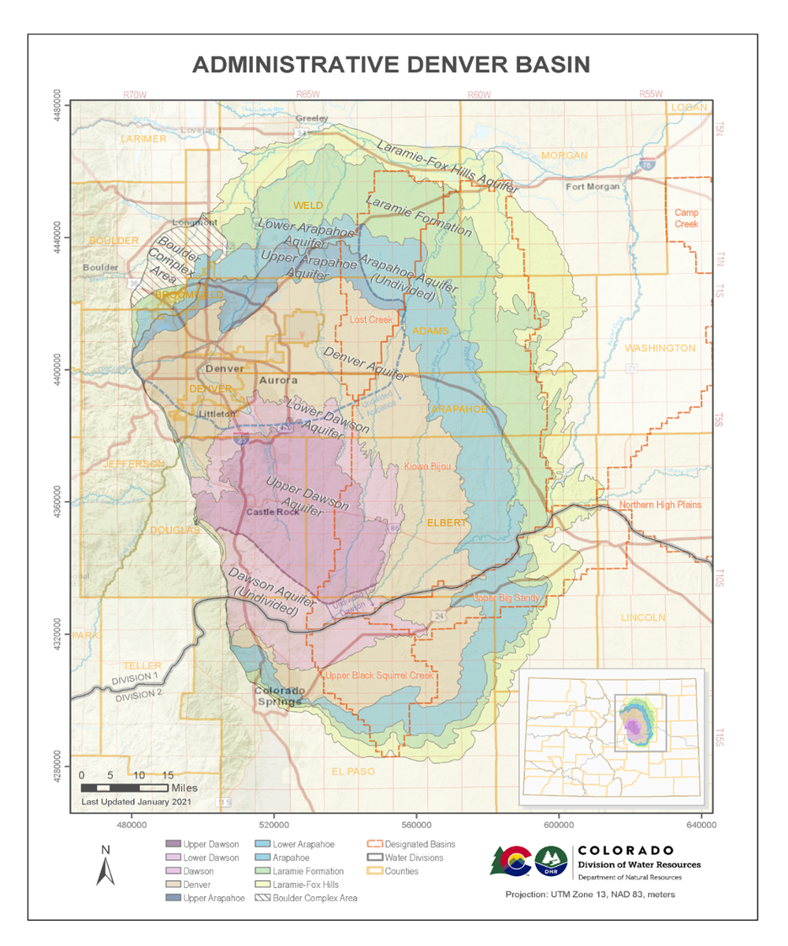
Figure 1. Administrative Denver Basin and Denver Basin Aquifer Extents. Note Boulder Complex Area is in the Administrative Denver Basin but are not considered Denver Basin Aquifers.

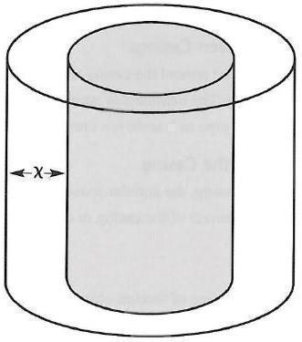
Figure 2. Annular Space” is the distance marked “x”
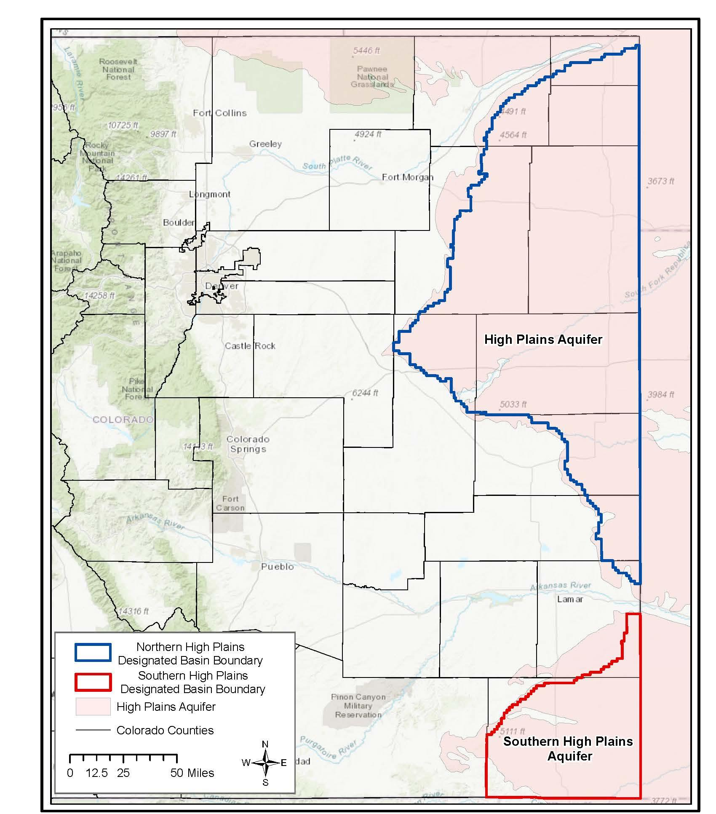
Figure 3. Boundaries of the High Plains Aquifer, the Northern High Plains Designated Basin, and the Southern High Plains Designated Basin
5.2.5 “Bedrock” means consolidated crystalline or sedimentary rock.
5.2.6 “Board” means the state Board of Examiners of Water Well Construction and Pump Installation Contractors created by section 37-91-103. § 37-91-102(3), C.R.S.
5.2.7 “Borehole” means a cylindrical excavation that is augered, drilled, bored, cored, washed, fractured, driven, dug, jetted, or otherwise constructed to access the subsurface for the purpose of constructing a hole or well under the jurisdiction of these Rules.
5.2.8 “Casing” means the pipe installed to prevent collapse of and provide access to the borehole. The term includes both nonperforated (“solid”) pipe, perforated pipe, liner, and screen.
5.2.8.1 “Temporary Surface Casing” is the outermost, temporary string of casing used to hold back zones of shallow, unconsolidated, or unstable materials from the borehole to facilitate drilling and placement of other strings of casing. Temporary surface casing may be PVC or steel and is differentiated from Surface Casing and Production Casing in that it is not considered a permanent part of the well construction, must be removed prior to completing grouting in any required grouted intervals and thus is not documented on the well construction report.
5.2.8.2 “Surface Casing” is one or more strings of nonperforated, steel casing typically set to isolate or protect the borehole and other subsequent strings of casing from shallow, unconsolidated, or unstable materials, though surface casing may extend to significant depths. Surface casing can be placed in a drilled borehole or driven into place.
5.2.8.3 “Production Casing” is a string of casing that is typically set through the production zone. The production casing may extend to the ground surface and could be the only casing string if no surface casing is used, or could be a liner that extends up and into the surface casing but not necessarily to the ground surface. Production casing can be nonperforated, perforated, PVC or steel casing depending on its position within the well and the Aquifer type.
5.2.9 “Centralizer” means a device attached to the outside of casing for the purpose of centering it within a borehole or outer casing.
5.2.10 “Cistern” means an enclosed, unpressurized reservoir or tank for storing water as part of a water well supply system.
5.2.11 “Completion of pump installation” means that the production equipment has been installed in a well, all necessary equipment has been connected, the well has been disinfected, the production equipment has been tested, and the well is ready to be placed into service.
5.2.12 “Completion of well construction” means that the well has been cased, developed, tested for yield, cleaned, disinfected, and is ready for the installation of the production equipment.

5.2.13 “Confining unit” means a geologic formation, group of formations, or part of a formation that separates or inhibits the flow of groundwater into, out of, or between distinct or administratively-defined aquifers because it is impermeable or distinctly less permeable than adjacent hydrogeologic units. Some confining units may contain geologic materials or intervals capable of yielding small amounts of water to wells.
5.2.14 “Construction of wells” means “any act undertaken at the well site for the establishment or modification of a well, including, without limitation, the location of the well and the excavation or fracturing thereof but not including surveying or other acts preparatory thereto, site preparation and modification or site modification, or the installation of pumping equipment.” § 37-91-102(4), C.R.S.
5.2.15 “Contaminant” means any chemical or organic material, live organisms, radioactive material or heated or cooled water that will adversely affect the quality of water.
5.2.16 “Contamination” means the introduction of contaminants.
5.2.17 “Contractor” means any person authorized to perform an activity regulated by the Board under these Rules.
5.2.18 “Development” means the act of repairing damage to the formation resulting from the drilling process and enhancing the permeability of the materials surrounding the intake portion of the well.
5.2.19 “Dewatering system” means a permanent well, drain, sump or other excavation constructed for the purpose of keeping the water table below a desired level or elevation where the water produced is not put to beneficial use.
A dewatering system is not the same as a “dewatering well” defined by section 37-91-102(4.5), C.R.S.
5.2.20 “Dewatering well” “includes any excavation that is drilled, cored, bored, washed, fractured, driven, dug, jetted, or otherwise constructed when the intended use of such excavation is for temporary dewatering purposes for construction only.” § 37-91-102(4.5), C.R.S.
5.2.21 “Directly employed” means “engaged in employment where the employer is responsible for and directly controls the performance of the employee, and, where applicable, the employee is covered by workers’ compensation and unemployment compensation. ‘Directly employed’ does not refer to independent contractors or subcontractors.” § 37-91-102(4.7), C.R.S.

5.2.22 “Dry Hole” means a borehole that does not produce enough water for the permitted use(s). Dry hole reports must be submitted in lieu of well construction reports in order to continue to attempt to drill a successful well under the original permit.
Dry holes constructed under a valid well permit are not Test Holes as defined in Rule 5.2.57.
5.2.23 “Filter pack”, also referred to as “gravel pack”, means selected granular materials placed in the annular space between the borehole wall and casing to reduce the amount of solid material entering the perforated casing or screen.
5.2.24 “Gallery Well or Infiltration Galleries” means a shallow depth groundwater collection device comprising solid and perforated pipes, rings, boxes, or casing. These systems are not constructed using conventional drilling methods, are typically excavated, and may only be constructed after a variance has been issued in accordance with Rule 10.4.13. A gallery well or infiltration gallery does not include a spring box or other spring collection structure as defined by Rule 5.2.64.2.
5.2.25 “Groundwater” or “ground water” means “any water not visible on the surface of the ground under natural conditions.” § 37-91-102(7), C.R.S. In these Rules, the term “groundwater” has the same meaning as defined at section 37-91-102(7), C.R.S.
5.2.26 “Grout” means any material, approved by the Board, that is used to form a permanent impermeable seal in the annulus between the casing and the borehole wall or between two strings of casing, or that is used in plugging, sealing, and abandoning a borehole or well. See Rule 10.5.1.
5.2.27 “Grouting” means the process by which grout is placed in the borehole or casing.
5.2.28 “Hydraulic fracturing of a water well” means the treatment of a water well by the application of fluid or other substance or fluid additive under pressure that is expressly designed to initiate or propagate fractures in the permitted production interval to enhance the flow or production of water in that interval.
5.2.29 “Installation of pumping equipment” means “the selection, placement, and preparation for operation of pumping equipment, including all construction involved in entering the well and establishing well seals and safeguards to protect groundwater from contamination.” § 37-91-102(8), C.R.S.
5.2.30 “Laramie-Fox Hills aquifer” is defined above in Rule 5.2.3.5
5.2.31 “License” means “the document issued by the Board to qualified persons making application therefor, pursuant to section 37-91-105, authorizing such persons to engage in one or more methods of well construction or pump installation or any combination of such methods.” § 37-91-102(10), C.R.S.
5.2.32 “Lithologic log” means a written geologic description of the type, color, and character of the soil and rock materials penetrated by the drilling procedure or activity.
5.2.33 “Monitoring and observation hole” means a temporary well constructed for the purpose of repeated observations of groundwater, repeated measurements of groundwater, any sampling of groundwater, or any remediation of groundwater.
Temporary wells completed for environmental groundwater investigations are monitoring and observation holes. A monitoring and observation hole may only be constructed upon a notice of intent. See Rules 6.3 & 14.2.1. A monitoring and observation hole must be plugged, sealed, and abandoned in less than eighteen (18) months from the date it was constructed unless a permit for a monitoring and observation well has been obtained from the State Engineer. See Rule 14.2.1.
A monitoring and observation hole is not a test hole (see Rule 5.2.57 for definition of “test hole”).
5.2.34 “Monitoring and observation well” “includes any excavation that is drilled, cored, bored, washed, fractured, driven, dug, jetted, or otherwise constructed when the intended use of such excavation is for locating such well, pumping equipment or aquifer testing, monitoring groundwater, or collection of water quality samples.” § 37-91-102(10.5),C.R.S.
A monitoring and observation well must be permitted by the State Engineer. See § 37-90-105(1)(d), C.R.S.; § 37-92-602(1)(f), C.R.S.; and Rule 14.2.2.
5.2.35 “Nested well” means the installation of two or more casings in a single borehole or excavation for completion of more than one interval.
5.2.36 “Notice of intent” refers to the forms of the State Engineer titled “Notice of Intent to Construct a Monitoring Hole(s),” and “Notice of Intent to Construct Dewatering Wells,” which requires no less than three days notice, including one business day, for construction of certain types of structures. See Rule 6.3.
5.2.37 “Person” means “an individual, a partnership, a corporation, a municipality, the state, the United States, or any other legal entity, public or private.” § 37-91-102(11.5), C.R.S.
5.2.38 “Piezometer hole” means a small-diameter monitoring and observation hole or well that is constructed for the sole purpose of monitoring or measuring water pressure or water level elevation.
5.2.39 “Pitless adapter” means a device that is designed to attach to well casing in order to permit water service pipes to pass through the wall of a well casing but prevent entrance of contaminants into the well or water supply.
5.2.40 “Pitless unit” means a commercially-manufactured assembly, or other unit approved by the Board, designed to be attached to the well casing with an integral mechanical seal below ground level, that will permit water service pipes to be connected to the well but will prevent the entry of contaminants into the well or the water supply.
5.2.41 “Plugged, sealed, and abandoned well” means a well that has been filled and grouted to (1) prevent the entry of contaminants from the surface into the well, (2) prevent the movement of fluids between aquifers through the borehole, (3) maintain natural protection against pollution of water-bearing formations, and (4) exclude known sources of contamination, as required by section 37-91-110(1)(a)(III), C.R.S.
5.2.42 “Positive displacement” means a procedure whereby a material such as grout is first introduced at the bottom of an interval and is pumped or placed upward through the interval, displacing fluids within the interval.
5.2.43 “Private driller” means “any individual, corporation, partnership, association, political subdivision, or public agency, that uses equipment owned by it to dig, drill, redrill, case, recase, deepen, or excavate a well entirely for its own use upon property owned by it.” § 37-91-102(12), C.R.S. Private driller refers to a well owner or their direct employee(s) who use the owner’s equipment (not rented, leased, or hired) to construct or repair a well located on land they own (not rent or lease).
5.2.44 “Private driller assessment” means an online, open-book assessment meant to aid the private driller in understanding their responsibilities pursuant to § 37-91-110, C.R.S., and to assist them in complying with all applicable well construction standards and the rules of the Board.
5.2.45 “Private pump installer” means “any individual, corporation, partnership, association, political subdivision, or public agency that uses equipment owned by it to install pumping equipment on a well entirely for its own use on property owned by it.” § 37-91-102(12.5), C.R.S. Private pump installer refers to a well owner or their direct employee(s) who use the owner’s equipment (not rented, leased or hired) to install pumping equipment in a well on land they own (not rent or lease).

5.2.46 “Private pump installer assessment” means an online, open-book assessment meant to aid the private driller in understanding their responsibilities pursuant to § 37-91-110, C.R.S., and to assist them in complying with all applicable pump installation standards and the rules of the Board.
5.2.47 “Production zone” means that portion of the permitted or administratively-defined aquifer that consists of permeable geologic material.
5.2.48 “Pumping equipment” means “any pump or related equipment used or intended for use in withdrawing or obtaining groundwater, including, but not limited to, well seals, pitless adapters, and other safeguards to protect the groundwater from contamination and any waterlines up to and including the pressure tank and any coupling appurtenant thereto.” § 37-91-102(13), C.R.S.
5.2.48.1 “Pumping equipment” also includes cisterns or other water storage tanks connected to a water well supply system between the wellhead and the pressure tank or downstream of the wellhead if no pressure tank is utilized.
5.2.49 “Pump installation contractor” means “any person licensed to install, remove, modify, or repair pumping equipment for compensation.” § 37-91-102(14), C.R.S.
5.2.50 “PVC casing” means polyvinyl chloride casing as specified in ASTM Standard F480-14 (2022), Thermoplastic Well Casing Pipe and Couplings Made in Standard Dimension Ratios (SDR), SCH 40 and SCH 80 that is clearly marked by the manufacturer as “well casing”.
5.2.51 “Recovery well” means a well which is constructed specifically for aquifer remediation, or for the removal of contaminants from an aquifer.
5.2.52 “Repair” means “any change, replacement, or other alteration of any well or pumping equipment which requires a breaking or opening of the well seal or any waterlines up to and including the pressure tank and any coupling appurtenant thereto.” § 37-91-102(15), C.R.S.
5.2.53 “Replacement well” means “a new well which replaces an existing well and which shall be limited to the yield of the original well and shall take the date of priority of the original well, which shall be abandoned upon completion of the new well.” § 37-90-103(13), C.R.S. All replacement wells must be properly permitted by the State Engineer.
5.2.54 “Static water level” means the water level in a well when there is less than one (1) foot difference between two (2) consecutive water level measurements taken at least sixty (60) minutes apart.
5.2.55 “Supervision” means “personal and continuous on-the-site direction by a licensed well construction contractor or licensed pump installation contractor, unless the licensed contractor has applied for and received from the board an exemption from continuous on-the-site direction for a specific task.” § 37-91-102(15.5), C.R.S.
5.2.56 “Surface Water” means any and all surface waters which are contained in or flow in or through this State, but does not include waters in sewage systems, waters in treatment works of disposal systems, waters in potable water distribution systems, and all water withdrawn for use until use and treatment have been completed (5 CCR 1002-61).
5.2.57 “Test hole” “includes any excavation that is drilled, cored, bored, washed, fractured, driven, dug, jetted, or otherwise constructed when the intended use of such excavation is for geotechnical, geophysical, or geologic investigation or soil- or rock-sampling.” § 37- 91-102(15.7), C.R.S. Test holes must be properly plugged, sealed, and abandoned upon the completion of the geotechnical, geophysical, or geologic investigation or soil- or rock- sampling. Any test hole that penetrates through a confining unit must be constructed by a licensed contractor pursuant to a Notice of Intent filed with the State Engineer. See Rules 6.3 and 14.6.
A “dry hole” or borehole not completed for its intended use as a production water well constructed pursuant to an issued well permit is not a Test hole. See Rule 5.2.22.
Inclinometers and soil vapor extraction wells, or air sparge structures that do not encounter the water table are considered test holes with the exception that any borehole constructed or used for environmental groundwater investigations, repeated groundwater observations, repeated groundwater measurements, or any groundwater samplings, is a monitoring and observation hole or well (5.2.33 or 5.2.34), not a test hole, and may only be constructed under a notice of intent or well permit. See Rules 6.3 & 14.2.1.
5.2.58 “Type 1 aquifer” is defined above at Rule 5.2.3.2.
5.2.59 “Type 2 aquifer” is defined above at Rule 5.2.3.3.
5.2.60 “Type 3 aquifer” is defined above at Rule 5.2.3.4.
5.2.61 “Valid permit” means a well permit issued by the State Engineer that has not been canceled or revoked and for which (1) when issued in accordance with section 37-92-602, C.R.S. (exempt wells) the completion of well construction is accomplished prior to the permit expiration date; or, (2) for all other wells (non-exempt wells), the completion of well construction or pump installation is accomplished on or before the permit expiration date. The State Engineer has the exclusive administrative authority to determine whether or not a well permit is valid.
5.2.62 “Water well supply system” includes all components of a groundwater well, pump, drop pipe, pitless adapters or units, other pumping equipment, storage tanks or cisterns, and piping and connections between the well and its point of discharge from the pressure tank, if such a tank is installed.
5.2.63 “Watertight” means a condition that does not allow the entrance, passage, or flow of water under normal operating conditions.
5.2.64 “Well” as used in these Rules, “means any test hole or other excavation that is drilled, cored, bored, washed, fractured, driven, dug, jetted, or otherwise constructed for the purpose of location, monitoring, dewatering, observation, diversion, artificial recharge, or acquisition of groundwater for beneficial use or for conducting pumping equipment or aquifer tests.” § 37-91-102(16)(a), C.R.S.
5.2.64.1 “Well”, as used in these Rules, does not include: “an excavation made for the purpose of obtaining or prospecting for minerals or those wells subject to the jurisdiction of the Energy and Carbon Management Commission, as provided in article 60 of title 34, C.R.S. or article 90.5 of title 37, C.R.S., or those wells subject to the jurisdiction of the office of mined land reclamation, as provided in article 32-34 of title 34, C.R.S.” § 37-91- 102(16)(b)(I), C.R.S.
5.2.64.2 “Well”, as used in these Rules, “does not include a naturally flowing spring or springs where the natural spring discharge is captured or concentrated by installation of a near-surface structure or device less than ten feet in depth located at or within fifty feet of the spring or springs’ natural discharge point and the water is conveyed directly by gravity flow or into a separate sump or storage, if the owner obtains a water right for such structure or device as a spring pursuant to article 92 of this title.” § 37-91-102(16)(b)(II), C.R.S.

5.2.64.3 “Well”, as used in these Rules, does not include wells constructed specifically for cathodic protection, a technique to prevent corrosion of a metal surface by making that surface the cathode of an electrochemical cell (7 CCR 1101-14).
5.2.64.4 “Well”, as used in these Rules, does not include recharge basins, or infiltration basins that are constructed in such a manner that the intent of their design is to remain above the groundwater level.
5.2.64.5 “Well” as used in these Rules, does not include injection wells used to emplace a carbon dioxide or wells used for geologic sequestration of carbon dioxide as allowed by 40 CFR 146 Subpart H - Criteria and Standards Applicable to Class VI Wells (2010).
5.2.64.6 “Well” as used in these Rules does not include wells associated with Deep Geothermal Operations. Deep geothermal operations means any exploration for or production of allocated geothermal resources or geothermal resources that are deeper than two thousand five hundred feet below the surface. Deep geothermal operations do not include any exploration or production activities associated with the groundwater in the Denver Basin Aquifers. Deep Geothermal Operations Wells are regulated by the Energy and Carbon Management Commission (§37-90.5-103. C.R.S., 2023).
5.2.65 “Well construction contractor” means “any person licensed pursuant to this article and responsible for the construction, test-pumping, or development of wells, either by contract or for hire or for any consideration whatsoever.” § 37-91-102(17), C.R.S.
5.2.66 “Well owner” means any person or his or her agent who holds the title or other property rights in or to a well.
5.2.67 “Well seal” means “an approved arrangement or device used to cover a well or to establish and maintain a junction between the casing or curbing of a well and the piping or equipment installed therein, the purpose or function of which is to prevent contaminated water or other material from entering the well at the upper terminal.” § 37- 91-102(18), C.R.S.
5.2.68 “Well vault” means an underground structure or pit in which the well casing terminates below ground surface.
5.2.69 “Well yield estimate” means a procedure designed to accurately estimate stabilized well production rate. Acceptable procedures include, but are not limited to, air-lifting or bailing.
5.2.70 “Well yield test” means a procedure conducted to determine a stabilized drawdown and production rate of a well, also known as a pumping test or aquifer test.
5.3 Other Definitions All other words used herein must be given their usual, customary, and accepted meaning. Terms not defined in Rule 5.2 that are defined in other rules promulgated by the State Engineer must use the meaning given therein. All words of a technical nature specific to the water well construction industry must be given the meaning generally accepted in that industry.

Rule 6 General Rules
Basis and Purpose: The statutory authority for this Rule is found in sections 37-91-101(1); 37-91-102; 37- 91-104(1)(c), (j), & (k); 37-91-106(3); and 37-91-110(2), C.R.S. The purpose of this Rule is to implement general statutory provisions that apply to well construction and the installation of pumping equipment.
6.1 The process for obtaining and maintaining a license for the construction of wells or the installation of pumping equipment or cisterns, or any special licenses issued pursuant to the Board’s authority in section 37-91-105(2.5), C.R.S., is codified in the Board’s Rules and Regulations for Administration of Licensing, Financial Responsibility, Continuing Education and Remedial Action, 2 CCR 402-14.
6.1.1 Private drillers must complete the private driller assessment prior to constructing or repairing a well on their property.
6.1.2 Private pump installers must complete the private pump installer assessment prior to installing or repairing pumping equipment in wells on their property.
6.2 Compliance with Well Permits
6.2.1 No well may be constructed, repaired, replaced, or modified, unless the well is associated with a valid well permit issued by the State Engineer. (See sections 37-90-105(3)(a)(I)(C), 37-90-107, 37-90-108, 37-90-137, 37-90-138(3), 37-92-602(3)(a), and 38-30-102(3) C.R.S.).
6.2.1.1 A valid well permit is required for:
a. any change, replacement, or other alteration of any well or pumping equipment which requires a breaking or opening of the well seal, or
b. any change, replacement, or other alteration of any waterlines up to and including the pressure tank and any coupling appurtenant thereto.
6.2.1.2 For those wells that are permitted, the State Engineer requires that a new well permit be obtained prior to:
a. changing the production and/or grout interval of an existing well,
b. installing certain dewatering systems as specified by the State Engineer,
c. installing pumping equipment that will allow a sustained production rate in excess of the permitted production rate.
6.2.1.3 The extraction of casing or pumping equipment for the purpose of repair or replacement does not require a new permit if the interval of perforated casing is not altered and the production rate does not exceed the rate specified on the existing valid well permit.
6.2.2 As further defined in Rules 6.2.2.1 and 6.2.2.2, it is the responsibility of the private driller, private pump installer, and all persons licensed to construct or repair wells, or to install, repair, modify, or replace pumping equipment, to determine that a valid permit issued by the State Engineer exists prior to and during all such work.
6.2.2.1 A copy of the well permit must be available and posted at the well site at all times when a contractor is working on a new well or when performing any work that requires a new well permit as specified in Rule 6.2.1.2. All such work must comply with the conditions of approval of the valid well permit, including any applicable condition that the well construction and/or pump installation contractor provide advance notification to the State Engineer prior to well construction, the initial installation of the pump, or installation of a cistern connected to a water well supply system. All work must be completed prior to the expiration of the permit.
6.2.2.2 When performing repairs on an existing well or pumping equipment in accordance with Rule 6.2.2, the private driller, private pump installer, or licensed contractor must make a reasonable effort to comply with the requirements of Rule 6.2.2. If the private driller, private pump installer, or licensed contractor is unable to verify that a valid well permit exists within thirty (30) days of performing the work;
a. The individual must notify the State Engineer of the well on a form prescribed by the State Engineer.
b. If the work performed on the well requires the filing of a well construction report, pump installation report or other report, the individual need not additionally notify the State Engineer pursuant to Rule 6.2.2.2.a.

6.2.3 Where a well has been constructed in accordance with a well permit issued by the State Engineer that authorized construction of the well at any location within a specified tract of land, the well construction contractor must submit the Well Construction and Yield Estimate Report, including the as-built well location by UTM coordinates (NAD83) or latitude/longitude WGS84 (decimal degrees), within sixty (60) days of completion of the well or seven (7) days after the permit expires whichever is sooner.
6.3 Prior Notice of Dewatering Well, Monitoring and Observation Hole, and Test Hole
In accordance with the requirements of the State Engineer, the Division of Water Resources must be provided with a Notice of Intent (see Rule 5.2.36) no less than three (3) days, including at least one standard business day, prior to the construction of the following:
a. any dewatering well;
b. any monitoring and observation hole; or
c. any test hole that will penetrate through a confining unit between two distinct or administratively defined aquifers.
6.3.1 The State Engineer requires notice to be submitted through the Notice of Intent eForm available on the Division of Water Resources’ website, https://dwr.state.co.us/eforms
6.3.2 Any test hole or monitoring and observation hole that penetrates through a confining unit between two distinct or administratively defined aquifers may only be constructed by a licensed contractor. See Table 1 for a summary of notice, license, and permit requirements.
6.3.3 The authorized individual (see Rules 5.2.4 and 9.1) or the licensed well construction contractor is responsible for providing the necessary notice required for the construction of dewatering wells, test holes, and monitoring and observation holes.
6.3.4 The construction of any test hole penetrating through a confining unit, dewatering well, or monitoring and observation hole for which a Notice of Intent form was provided to the State Engineer pursuant to Rule 6.3 must be completed within ninety (90) days of the notice date.
6.3.5 Construction of a monitoring and observation hole must be completed within 72 hours after drilling the borehole (see Rule 14.2.1.1).

6.4 Emergency Authorization - Pursuant to the procedures of the State Engineer, the State Engineer or their designee may approve the construction of dewatering wells or monitoring and observation holes with less than the required notice upon the State Engineer’s determination that such approval is warranted based on certain conditions, such as public safety, practical difficulties, or unusual hardship.
6.5 Requests for Well Site Information - Upon request by the State Engineer or their staff, all water well construction and pump installation contractors, authorized individuals, private drillers, and private pump installers must identify the permit number or other authorization and the location of any wells, test holes, cisterns connected to a water well supply system, or monitoring and observation holes or wells which that person expects to work on within a specified five (5) day period.
6.6 Compliance with Regulations - All well construction and pump and cistern installation must comply with the minimum standards in these Rules. There may be federal, tribal, state, county, municipal or local government laws, regulations, or codes that are more stringent than these Rules, or contain standards not covered by these Rules then the work must comply with those laws, regulations, codes, or standards. The licensed well construction or pump installation contractor, authorized individual, private driller, or private pump installer is responsible for determining if such laws, regulations, codes, or other requirements exist and apply to the work being performed.
6.7 Products Containing Toxic Materials - Products, such as solder and fluxes that contain any more than 0.20% lead, and materials, such as pipes, fittings, fixtures or pipe joint compounds, that are not considered “lead free” (per 40 CFR 143.12(a) of the Safe Drinking Water Act) are prohibited from being used in the construction, repair, rehabilitation, hydraulic fracturing of a water well, or abandonment of wells and holes. Known toxic materials must not be used in well construction.
6.8 Disposal of Fluids Resulting from Well Construction, Development and Disinfection - Fluids resulting from well construction, development or disinfection must not be discharged into the surface waters of the state without first obtaining a permit pursuant to the Colorado Discharge Permit System (CDPS) administered by the Colorado Department of Public Health and Environment.
6.8.1 Fluid disposal by land application must not flow into surface waters and must not impact aquatic life or groundwater.
6.8.2 Fluid wastes may be disposed of by other proper means such as off-site transport for treatment and final disposal, evaporation ponds, or pumping to a sanitary sewer system with permission from the appropriate authorities.
6.9 Water Used for Well Construction and Stimulation - All water used during the construction, development, and stimulation, including hydraulic fracturing, of a well must be obtained from an approved public supply.
6.9.1 If water is not readily available from such a public supply, the water may be obtained from a groundwater source or from a flowing surface water supply under the following conditions:
a. water obtained from a groundwater source must be disinfected with a minimum chlorine concentration of twenty-five (25) mg/l (milligrams per liter);
b. in remote mountainous areas, where adequate public or groundwater sources are not readily available, water may be obtained from flowing surface waters, provided that such waters are located upstream from any sewer plant, feedlot, chemical storage area or other known sources of contamination. These surface waters must be disinfected by adding chlorine for a minimum concentration of one-hundred (100) mg/l (Fifty (50) mg/l when polymer or bentonite is used), with a contact time of one (1) hour and a residual concentration of ten (10) mg/l; or
c. for reverse rotary construction, only when public or groundwater sources cannot provide sufficient volumes of drilling water, water may be obtained from flowing surface water supplies provided that such water is disinfected to a minimum chlorine concentration of twenty-five (25) mg/l or the well is disinfected in accordance with the provisions of Rule 6.9.1 (also see Rule 15.7).
6.9.2 Upon completion, all wells must be disinfected in accordance with Rule 15.
6.9.3 The use of water from wetland areas, lakes, ponds, or known contaminated groundwater sources is prohibited.
6.10 Fluids and Additives– The use of fluids and additives must comply with all manufacturers’ safety guidelines and directions, as well as federal, state, and local laws, rules, regulations, and codes. The individual using the materials is responsible for ensuring that the materials are used properly. Requests to add fluids, additives, or chemicals must be submitted to the Board in writing with supporting information and be approved prior to use.
6.10.1 Drilling Fluids and Additives: All drilling fluids and drilling fluid additives must be appropriate for the purposes for which the well or hole will be constructed and must be specifically approved for use by the Board. A list of specifically approved drilling fluids and drilling fluid additives is available on the Board’s website.
6.10.2 Grout Additives: All grout additives must be appropriate for the purposes for which the well or hole will be constructed and must be specifically approved for use by the Board. A list of specifically approved grout additives is available on the Board’s website.
6.10.3 Well Development and Rehabilitation Chemicals: All well development and rehabilitation chemicals must be appropriate for the purposes for which the well or hole will be constructed or rehabilitated, and must be specifically approved for use by the Board. A list of specifically approved well development and rehabilitation chemicals is available on the Board’s website.
TABLE 1: SUMMARY OF LICENSING AND CONSTRUCTION AUTHORIZATION REQUIREMENTS
STRUCTURE WHO MAY CONSTRUCT REQUIRED AUTHORIZATION
Type of Well or Borehole | Licensed | Authorized Individual | Special License |  | Approved Well Permit | Approved Notice of Intent
BOREHOLE DOES NOT PENETRATE THROUGH A CONFINING UNIT*
Water well | X |  |  |  | X
Gallery/infiltration well | X |  | X |  | X
Monit./observ. well,  recovery well, & certain dewatering system | X | X | X |  | X
Monit./observ. holes &  dewatering wells | X | X | X |  |  | X
Test holes | X | X | X
BOREHOLE DOES PENETRATE THROUGH A CONFINING UNIT*
Water well | X |  |  |  | X
Monit./observ. well,  recovery well & certain dewatering system | X |  | X |  | X
Monit./observ. hole and  dewatering well | X |  | X |  |  | X
Test holes | X |  | X |  |  | X
*As defined in Rule 5.2.13

Notes:

1) This table summarizes minimum licensing requirements. A licensed contractor is authorized to construct all of the types of wells or holes indicated above. Special licenses may be obtained for certain types of specialized work or well construction, as allowed in Rule 6.5 of the Board’s Rules and Regulations for Administration of Licensing, Financial Responsibility, Continuing Education and Remedial Action, 2 CCR 402-14. Persons who obtain a special license and authorized individuals are restricted to the type of work for which they are licensed or qualified.
2) Monitoring and observation holes constructed pursuant to notice as provided in Rule 6.3, or under a special license issued by the Board, may not be converted into water wells (see Rule 14). Monitoring and observation holes must be plugged and sealed within eighteen (18) months after being constructed (see Rule 16.5). The requirement to permit a monitoring and observation well also applies to any borehole that will remain in use for more than eighteen (18) months (e.g., long-term piezometers).
3) The requirements for test holes only apply to geotechnical boreholes that are not used for repeated groundwater measurements, repeated groundwater observations, and any samplings of groundwater (see Rules 5.2.57 & 14.6).

Rule 7 Licensing
For rules and regulations concerning the Board’s licensing procedures, see Rules and Regulations for Administration of Licensing, Financial Responsibility, Continuing Education and Remedial Action (BOE Rules) 2 CCR 402-14.

Rule 8 Financial Responsibility
For rules and regulations concerning the Board’s bonding and financial responsibility requirements, see Rules and Regulations for Administration of Licensing, Financial Responsibility, Continuing Education and Remedial Action (BOE Rules) 2 CCR 402-14.

Rule 9 Wells and Holes Which May Be Constructed by Persons Other Than Licensed Well Construction Contractors
Basis and Purpose: The statutory authority for this rule is found in sections 37-91-101(1); 37-91-104(1)(c), (j), & (k); 37-91-106(3); and 37-91-110(2), C.R.S. The Purpose of this Rule is to identify the basic types of activities that may be completed by persons that are not licensed for water well construction or pump installation, as well as notification and reporting requirements. Additionally, this Rule identifies certain structures that do not have minimum construction standards.
9.1 This Rule 9 applies to those wells and holes which may be constructed by persons that are not licensed for water well construction (or are not employed by or directly supervised by a licensed water well contractor). Table 1 summarizes the license requirements for construction of certain types of wells and holes. Unless otherwise specified, responsibility for ensuring compliance with the provisions of this Rule 9 is placed upon:
a. the authorized individual (see Rule 5.2.4)
b. the contractor holding a special license, and/or
c. the private driller (see section 37-91-102(12), C.R.S.) if an authorized individual or contractor holding a special license is not contracted for the work.
9.2 Excavations Authorized by this Rule The following types of excavations that do not penetrate through a confining unit between aquifers recognized by the State Engineer may be designed, constructed, used, and plugged, sealed and abandoned by authorized individuals (see Table 1 for a summary of who is authorized to construct each type of well):
a. dewatering wells,
b. monitoring and observation holes and wells,
c. piezometer holes,
d. recovery wells,
e. some dewatering systems (see exclusion in Rule 9.3.2),
f. pond and lake wells, and
g. test holes.
9.2.1 Required Notice - Test holes that penetrate a confining unit between two distinct aquifers, monitoring and observation holes and wells, and dewatering wells must be constructed pursuant to the Notice of Intent requirements stated in Rule 6.3.
9.2.2 Reporting Requirements - A Well Construction and Test Report must be submitted in accordance with the provisions of Rule 17 for each monitoring and observation hole constructed. A well construction report is not required for the construction of a dewatering well unless the well is permitted as a dewatering system.

9.3 Construction Standards The excavations authorized under this Rule 9 must be constructed in accordance with the applicable Rules specified for such structure. Where construction standards for an excavation authorized by this Rule 9 are not specified in these Rules, the construction of the excavation must comply with the standards and Rules applicable to water wells (Rule 10), unless a variance from those Rules is obtained pursuant to Rule 18.
9.3.1 Monitoring and observation holes and wells, and test holes that do not penetrate through a confining unit between two distinct aquifers must be constructed in accordance with the provisions of Rule 14.
9.3.1.1 Fully-grouted vibrating wire piezometers are exempt from Rule 14, unless they penetrate through a confining unit, due to the fully grouted nature of their construction and given the piezometers are essentially plugged and abandoned as part of the process of construction.
9.3.2 Dewatering wells and dewatering systems that do not penetrate through a confining unit must be constructed in accordance with all applicable municipal, county, state, and federal regulations and standards. No other minimum construction standards apply for such wells or holes, except that the well or hole must be constructed to prevent contamination of surface or groundwater. Such wells must be abandoned pursuant to the provisions of Rule 16.5.1.
9.3.2.1 All portions of a dewatering system (excluding interior sumps) that are constructed in a vertical borehole and do not penetrate through a confining unit must meet the construction requirements of Rule 14.
9.3.2.2 Dewatering systems (excluding drains and sumps) constructed as wells must be constructed in accordance with the construction and grouting requirements of Rule 10 if the well or borehole penetrates through a confining unit.
9.3.3 Pond or lake wells (including gravel pit wells) permitted pursuant to sections 37-90-107 or 37-90-137, C.R.S. are exempt from the provisions of these minimum construction and location standards, except that the owner must ensure that the pond or lake well is constructed in such a manner as to prevent contaminants from entering the pond or lake well. A report documenting construction of a pond or lake well must be submitted upon completion of the well, as required by Rule 17.1.7.

9.4 If during construction of an excavation authorized by this Rule 9, the borehole penetrates through a confining unit into a lower aquifer, the hole must be plugged back through the confining unit with at least twenty (20) feet of cement or cement-bentonite grout or through the entire confining unit, whichever is greater, or the hole must be plugged, sealed and abandoned pursuant to Rule 16 within twenty-four (24) hours.
9.5 Plugging, Sealing and Abandonment - Excavations authorized by this Rule 9 shall be plugged, sealed and abandoned according to the provisions of Rule 16.
9.6 Conversion to Water Wells Prohibited - A monitoring and observation hole, dewatering well, test hole, or other excavation constructed pursuant to a Notice of Intent form provided to the State Engineer, as provided in Rule 6.3 and this Rule 9, may not be converted to a production water well for beneficial use. A monitoring and observation hole or dewatering well constructed in accordance with proper notice may only be converted to a monitoring and observation well, recovery well for purposes of aquifer remediation, or dewatering system for dewatering of the aquifer, if such conversion is approved and permitted by the State Engineer. Test holes must be properly plugged, sealed, and abandoned upon the completion of the geotechnical, geophysical, or geologic investigation or soil- or rock sampling.

Rule 10 Minimum Construction Standards for Water Wells
Basis and Purpose: The statutory authority for this rule is found in sections 37-91-101(1); 37-91-102; 37- 91-104(1)(c), (j), & (k); 37-91-106(3); 37-91-109(1); and 37-91-110(2), C.R.S. The purpose of this Rule is to identify the minimum construction standards for water wells or other excavations constructed in different types of aquifers in Colorado, in order to ensure that such construction prevents harm to the public health, will not impair water quality or cause contamination of shared groundwater resources, and will ensure the safety of groundwater resources for Colorado’s existing and future populations.
10.1 General - To assist in the orderly development of the groundwater resources of Colorado, to insure the protection of the public health, and to prevent degradation of the groundwater resource, all wells constructed to withdraw or inject water must be constructed, maintained, or repaired in such a manner that will:
a. maintain existing natural protection against contamination of aquifers;
b. prevent the entry of contaminants through the borehole;
c. limit groundwater production to one aquifer unless otherwise permitted by the State Engineer;
and
d. prevent the intermingling of groundwater from different sources through the borehole.
10.1.1 The contractor is responsible for constructing the well using standards that are more stringent than the minimum specified in these Rules, if necessary to ensure the adequate integrity of the well and protection of the aquifer. If conditions on the well permit specify standards that exceed the minimum standards of these Rules, the well construction contractor must comply with the conditions specified on the well permit.
10.1.2 Prior to starting construction, all persons authorized to construct wells must investigate and become familiar with the geology of potential aquifers, confining units, anticipated water quality problems, and known contaminated water-bearing zones that may be encountered in the area of the proposed drilling activity, and where necessary, must advise the well owner of the potential for poor water quality or contamination and plan for the resolution of such issues prior to beginning construction.
10.1.3 All wells and boreholes, when unattended, must be securely sealed, capped, or covered. It is the responsibility of the well construction contractor and pump installation contractor to ensure the well is securely covered while unattended during well construction and pump installation and securely sealed or capped upon completion of the well. Thereafter, it is the responsibility of the well owner to ensure that the well is securely sealed or capped.
10.1.3.1 A secure cover is intended as a temporary arrangement of materials or a device that must perform the function of preventing deleterious entry of objects, animals, or contaminants into the borehole or well while unattended and prior to completion of the well.
10.1.3.2 A secure well seal or well cap shall consist of a sanitary cap or seal as commonly defined within the industry and must be properly sized for the casing. The sanitary well seal or well cap must be capable of preventing entry of contaminants, insects and animals into the well. A sanitary well cap or seal must be constructed of metal and may utilize gaskets or seals suitable for use in potable water systems.
10.1.3.3 Wellheads that support equipment or devices such as turbines and diverters must also be arranged to promote sanitary conditions in the well and to prevent entry of contaminants, insects or animals into the well. Devices used to securely seal or cap the wellhead must be constructed of metal and may utilize gaskets or seals suitable for use in potable water systems.
10.1.3.4 Requirements for venting are presented in Rule 11.5.2.
10.1.4 When hazardous contaminants are known or suspected to be encountered during well construction, the contractor is responsible for ensuring that his or her personnel are adequately trained, and that proper safety equipment is provided to handle and contain those substances.
10.1.5 Nested wells completed in different aquifers or production zones must be grouted to prevent intermingling of groundwater and require a written variance.
10.1.6 Any hydraulic fracturing or stimulation of a well must be restricted to the permitted production interval and must not compromise the integrity of an adjoining confining unit or aquifer. (See Rule 6.2.1 and 10.4.5.3) Within 60 days of the completion of the fracturing or stimulation process, the driller or authorized individual must provide reports or other data concerning the hydraulic fracturing of the water well. Such information may include, but is not limited to, the interval within which hydraulic fracturing was performed, pressures used, duration, formation fractured, medium used to perform fracturing, additives used in the fracturing medium, production rate prior to fracturing and production rate after fracturing.
10.2 Well Location - When selecting a well location, consideration must be given to topography, drainage, sources of contaminants, underground utility locations, and other onsite conditions in order to promote sanitary conditions and prevent contamination of the well and aquifer. The ground surface in the vicinity of the well should be sloped to prevent the concentration of, and discourage the infiltration of, surface water at or near the wellhead.
10.2.1 When locating wells, well construction contractors and private drillers must comply with the regulations of federal, state, county, municipal, or local governments, in determining the required distance from sources of contaminants, when those regulations are more stringent than the minimum standards of these Rules.
10.2.2 Wells must not be located closer than one-hundred (100) feet horizontally to the nearest existing source of contaminants or fifty (50) feet horizontally from a septic tank, exterior sewer line or other above or below ground vessels containing contaminants (but excluding properly-maintained vessels for permitted chemigation products; properly-maintained vessels mounted on vehicles; and properly-maintained vessels mounted or carried on equipment used in the construction or development of wells or installation of pumping equipment), at the time of well construction. A request for variance (as provided for in Rule 18) must be submitted and written approval from the Board must be obtained prior to the construction of a well that cannot meet this spacing requirement. The variance request must be prepared by a water well construction contractor or authorized individual, must be based on hydrogeologic information, and must comply with the minimum requirements shown in Figure 4a or 4b (whichever is applicable) to the greatest extent possible.
10.2.3 In the event a well is constructed as a replacement for an existing well that is located less than one hundred (100) feet horizontally from a source of existing contaminants, the replacement well must not be located closer to the source of contaminants. The distance between the perimeter of that source and the base of the grout seal must not be less than 100 feet, as shown in Figure 4a (or not less than 50 feet as shown in Figure 4b), unless a variance request prepared in accordance with the provisions of Rule 10.2.2, is granted.
Figure 4a Minimum Distance from a Source of Contamination
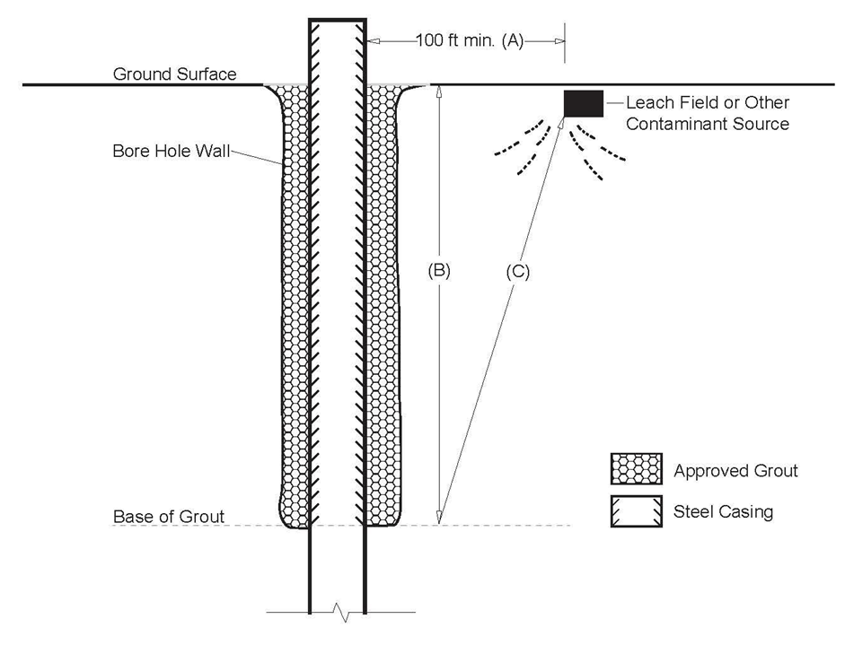

Figure 4a. Schematic of the minimum distance (A) to a well from a leach field or other source of contaminants (Rule 10.2.2). Exceptions to Rule 10.2.2 may be granted through a variance request; if distance A is less than 100 ft., distance C must equal 100 feet or more.
Grout depth calculation:

Figure 4b Minimum Distance from a Vessel Containing Contaminants
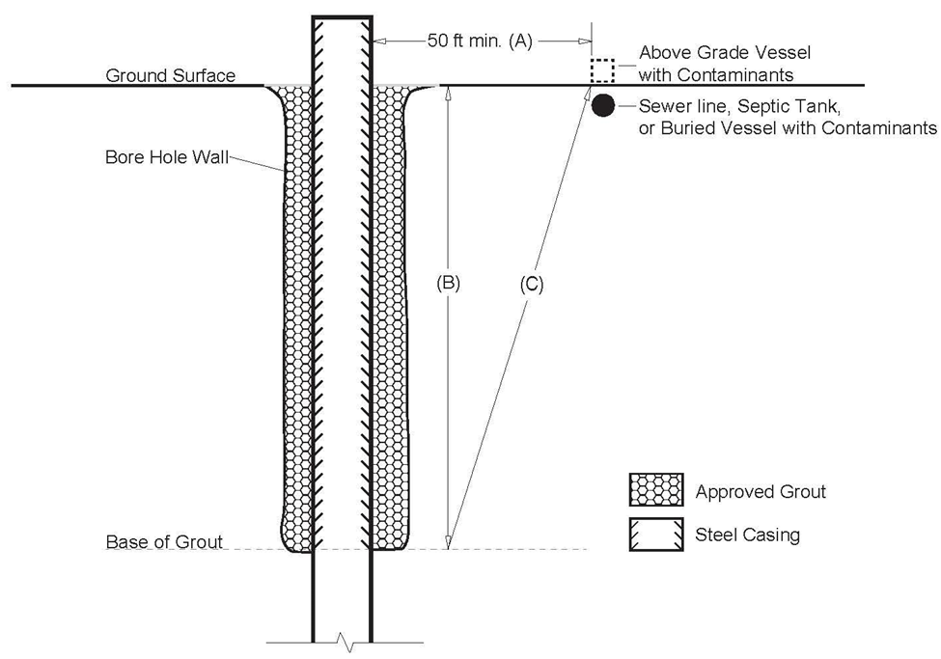

Figure 4b. Schematic of the minimum distance (A) to a well from a sewer line, septic tank, or other above or below ground vessel containing contaminants (Rule 10.2.2). Exceptions to Rule 10.2.2 may be granted through a variance request; if distance A is less than 50 ft., distance C must equal 50 feet or more.
Grout depth calculation:
10.3 Well Casing Well casing must consist of materials that will ensure adequate protection against failure for the intended use of the well.
10.3.1 All casing must be new or unused pipe, except that casing recovered when a well is modified or replaced may be reused in the new well if it will ensure satisfactory well performance. PVC casing must not be exposed above the ground surface. All surface casing must be steel pipe. All casing must be undamaged, free of pits and corrosion, and free of contamination. Used oilfield pipe must not be installed in any well. Corrugated metal casing must not be used in well construction.
10.3.2 Temporary surface casing must be removed from the borehole prior to, during, or immediately after grouting in order to allow grout to be placed at the annular seal between the outermost casing and the borehole.
10.3.3 The well casing inside diameter (ID) or pitless adapter must be sufficient to accept a pump capable of producing the desired production rate. The following minimum ID (nominal) requirements apply to the specified type of well casing:
a. Steel well casing: 4.5 inch ID
b. PVC well casing: 4.0 inch ID
10.3.4 All casing wall thickness must be adequate to prevent collapse/damage due to hydraulic pressures and other internal/external pressures. The following minimum wall thicknesses apply to the specified type of well casings:
a. Steel well casing: 0.188 inches;
b. PVC well casing: not less than that allowed by ASTM F480-14(2022) Table 2 for the respective casing size and type (example: 4 inch nominal pipe size Schedule 40, wall thickness = 0.237 inch minimum); no casing having a strength less than that of equivalent inside diameter Schedule 40 PVC pipe may be used in the well; all casing must be selected to have an appropriate strength for the intended use; and
c. Precast concrete rings: 3.00 inches.
10.3.5 Casing Perforation – Casing perforation methods or designs must not result in inclusions or debris inside of the well casing. Any inclusions or debris must be removed after perforation. Oxygen-acetylene torch-cut perforations on well casing are prohibited on well casings less than 5 inches ID.

10.4 Construction Procedures The excavation of the borehole, selection and installation of the casing, grouting, development and disinfection of a new well, and repair or deepening of an existing well, must protect the health and safety of the public utilizing workmanship and materials that match the intended use of the well.
10.4.1 Centralizers –
10.4.1.1 Centralizers must be installed in all required grouted intervals of the surface casing and production casing of a well. The distance between centralizers must not exceed fifty (50) feet for intervals that will be grouted for more than fifty (50) feet.
10.4.1.2 If the grouted interval of the casing is less than fifty (50) feet, centralizers must be installed within 5 feet of the bottom of the grouted interval.
10.4.1.3 Centralizer materials attached to the casing and left in the borehole must be metal or plastic.
10.4.1.4 Pre-manufactured centralizers must be properly sized for the intended use, be intended for use in water wells, and must be used in accordance with the manufacturer’s guidelines and recommendations.
10.4.1.5 Contractor-fabricated centralizers must be durable enough to survive the placement of the casing in the borehole and must be rigid and wide enough that they will provide the intended centralization for the casing.
10.4.1.6 Centralizer devices must extend in a sufficient number of planes and directions around the circumference of the casing, to properly centralize the casing.
10.4.1.7 Centralizer devices must be properly sized to maintain the minimum required annular space in grouted intervals between the casing and the borehole or between strings of casing.
10.4.1.8 Centralization of the casing at the ground surface may be accomplished with appurtenances of the drilling equipment or other mechanical means. The shallowest centralizer shall be no deeper than 50 feet
10.4.1.9 Production casing must be hung in tension during the placement of grout material.

10.4.2 Wells with Surface Casing - Wells that will be constructed with a surface casing string must have watertight steel casing and joints installed from a minimum of one (1) foot above to a minimum of nineteen (19) feet below ground level. The annular space between the borehole wall and surface casing string must, at a minimum, be grouted in accordance with the requirements of Rule 10.5.
10.4.2.1 Driven Surface Casing for wells- Unless the method of well construction allows the grouting of an open annulus between the casing and the borehole meeting the minimum depths, intervals and sizes required by Rule 10.4.4 through 10.4.9, the annular space between surface casing that is driven and the production casing string must be grouted in accordance with the following requirements: (See Figure 5.)
a. For Type 3 aquifers (unconsolidated aquifers) with driven surface casing, the grout interval must extend from at least ten (10) feet below to at least ten (10) feet above the base of the surface casing.
b. For all other aquifers with driven surface casing, the grout interval must extend from at least twenty (20) feet below to at least ten (10) feet above the base of the driven surface casing. If the combination of driven surface casing and the minimum grouted interval of this Rule does not completely isolate Type 3 aquifer materials from underlying bedrock materials or would result in a well completion that does not comply with the requirements of Rule 10.1, additional grouting beyond the minimum required depth may be necessary to comply with the requirements for the particular type of aquifer.
c. Driven surface casing must not penetrate through a confining layer. The base of driven surface casing must not penetrate more than twenty (20) feet below the transition from one aquifer to another, or from an aquifer to a confining unit.
10.4.3 Wells without Surface Casing - All wells that will be constructed without surface casing must have watertight steel casing and joints installed from a minimum of one (1) foot above to a minimum of nineteen (19) feet below ground level. The annular space between the borehole wall and production casing string must be grouted in accordance with grouting requirements for the particular type of aquifer in which the well is constructed and the requirements of Rule 10.5.2.1.

FIGURE 5 WELLS WITH DRIVEN CASING THAT ARE NOT GROUTED WITH AN OPEN ANNULUS OUTSIDE THE CASING
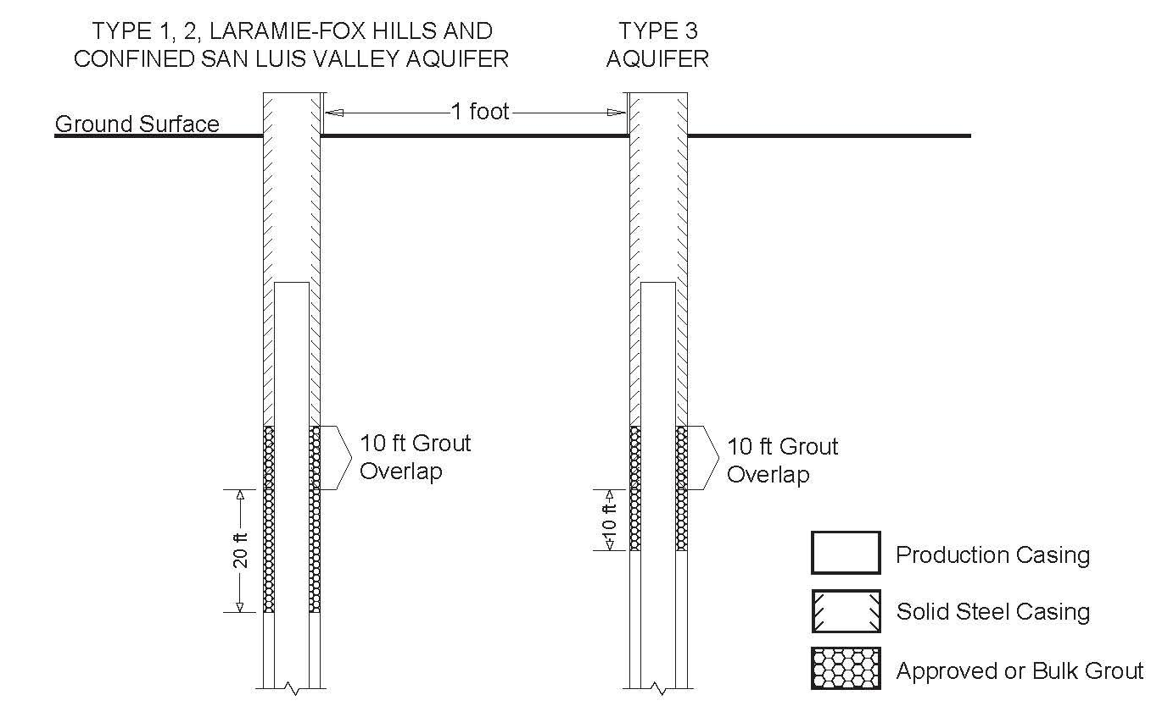
Figure 5. Schematic diagram for grout placement in wells with driven steel casing. In each aquifer type, the minimum continuous grout interval must extend a minimum of 10 feet into the annulus between the driven casing and the production casing.
10.4.4 Annular Space Requirements for All Grouted Intervals - The borehole must be constructed to provide sufficient annular space for the placement of grout. Minimum annular space requirements apply only to intervals that must be grouted to meet the requirements of the Construction Rules.
10.4.4.1 The borehole diameter must not be less than two (2) inches larger than the outside diameter of the casing (minimum one (1) inch of annular space, as defined in Rule 5.2.2) except for those intervals described in Rules 10.4.4.3 through 10.4.4.6 where a larger annulus is required.
10.4.4.2 When grouting between two casing strings, the inside diameter of the outer casing must not be less than two (2) inches larger than the outside diameter of the inner casing (minimum one (1) inches of annular space as defined in Rule 5.2.2) except for those intervals described in Rule 10.4.4.3 through 10.4.4.6 where a larger annulus is required.
10.4.4.3 If grout is placed via positive displacement through a tremie between the casing and borehole wall or between casing strings in intervals of Type 1 aquifer and Laramie Fox Hills aquifer wells required by Rules 10.4.5.2.a through 10.4.5.2.d., and 10.4.8.2, but excluding the upper thirty-nine (39) feet of the well:
a. the borehole diameter in the required grouted interval must not be less than three (3) inches larger than the outside diameter of the casing (minimum one and a half (1.5) inches of annular space), and/or
b. the inside diameter of the outer casing must not be less than three (3) inches larger than the outside diameter of the inner casing (minimum one and a half (1.5) inches of annular space).
10.4.4.4 If approved grout is poured from the surface and the casing is not vibrated, the borehole diameter must not be less than four (4) inches larger than the outside diameter of the casing (annular space of at least two (2) inches). See Rule 10.5.3.4 for limits on the maximum depth approved grout may be poured.
10.4.4.5 If bulk grout is poured from the surface, the borehole diameter must not be less than twelve (12) inches larger than the outside diameter of the casing (at least six (6) inch annular space). See Rule 10.5.3.5 for limits on the maximum depth bulk grout may be poured.
10.4.4.6 Granular bentonite grout (pellets, granules or chips) used in the intervals allowed by Rule 10.4.5.2.e must be placed through a tremie pipe and prior to hydration. The outside diameter of the tremie pipe must not exceed the annular space between the casing and the borehole and/or between the two casing strings the tremie is placed between. The tremie pipe must be rigid and the inside diameter of the tremie must be a minimum of four (4) times the diameter of the pellet, granule or chip of granular bentonite. The minimum annular space for tremie placed granular bentonite must not be smaller than that required by Rule 10.4.4.3 for other tremie placed grouts.
10.4.5 Wells Completed in Type 1 Aquifers (Confined Aquifers) - Excluding Wells Completed in the Laramie-Fox Hills Aquifer (see Rule 10.4.8) or Wells Completed in the Confined San Luis Valley Aquifer (see Rule 10.4.9)
10.4.5.1 Casing Requirements – (Figure 6)

a. Wells completed in a Type 1 aquifer (confined aquifer—see Rule 5.2.3.2), where the borehole penetrates through one (1) or more confining unit(s) and are constructed without surface casing must have watertight solid production casing with watertight joints installed from the base of the confining unit directly above the permitted aquifer or production zone, to the top of the well.
b. Wells that are completed in a Type 1 aquifer with surface casing that does not extend at least to the top of the production zone must have solid casing with watertight joints installed from the base of the confining unit directly above the permitted aquifer or production zone, to at least ten (10) feet above the base of the surface casing.
c. Wells that are constructed with surface casing that extends to the top of the production zone or deeper must have solid production casing with watertight joints installed from the base of the confining unit directly above the permitted aquifer or production zone.
d. In no instance may the base of solid casing be less than thirty-nine (39) feet below the ground surface. Casing intervals must also comply with Rules 10.4.2 and 10.4.3.
10.4.5.2 Grouting Requirements (Figure 6)
a. The annular space between the borehole wall and each casing string must be grouted with approved grout or bulk grout (Table 2) using approved placement methods. Grout must be placed in the interval from the base of the confining unit overlying the permitted aquifer or production zone up to the depth required by Rule 10.5.2.1. Grouting of the annulus outside separate casing strings can be performed independently if a grout overlap described in 10.4.5.2.b is utilized.
b. Where the base of the surface casing does not extend to the top of the production zone, approved or bulk grout must also be placed in the annulus between strings of surface casing and/or between the surface and production casing up to a level at least ten (10) feet above the base of the surface casing. Grout placed between the casing strings must be placed as part of the continuous placement of the grout required for the annulus outside the inner casing string.
c. In no case may there be less than thirty (30) feet of continuous approved or bulk grout beginning at least thirty-nine (39) feet below the ground surface.
d. If the surface casing is driven, and the construction methodology is such that grout cannot be adequately placed with proper annular space and centralization outside the surface casing to satisfy the intervals of solid casing and grout required by Rule 10.4.5.1, 10.4.5.2.a through 10.4.5.2.c the driven surface casing must be grouted to meet the requirements of Rule 10.4.2.1. The driven casing must not penetrate through a confining layer and the base of grout must extend from the top of the permitted production zone up to the depth required by Rule 10.4.2.1 or the top of the confining layer, whichever is higher.
e. Granular bentonite may be used instead of approved grout or bulk grout in the portion of the grouted interval required in this Rule, from the base of the confining unit overlying the permitted aquifer or production zone and ending at a point not less than thirty-nine (39) feet below the ground surface. Only approved or bulk grout is allowed in the upper thirty-nine (39) feet below the ground surface. Granular bentonite must be placed in accordance with Rule 10.4.4.6 and 10.5.3. The grout material must be designed to withstand the maximum potential hydrostatic pressure encountered in the annulus.
10.4.5.3 Hydraulic Fracturing of a Water Well in Type 1 Aquifers – Any hydraulic fracturing or stimulation of the producing interval of a water well drilled into a Type 1 Aquifer must not compromise the integrity of a confining layer. Before initiating any hydraulic fracturing operations in a water well drilled into a Type 1 Aquifer, the driller and/or consultant (Authorized Individual) must provide detailed plans for such operations to be reviewed by Board Staff at the State Engineer’s Office, and may only initiate such operations upon (1) advance written approval of the Board, and (2) at least 24 hours advance notification of the initiation of such operations to the Chief Well Inspector by telephone or email. Upon request of the State Engineer, the driller or authorized individual must provide reports or other data concerning the hydraulic fracturing of the water well.

FIGURE 6 TYPE 1 AQUIFER WELLS PENETRATING ONE OR MORE CONFINING UNITS
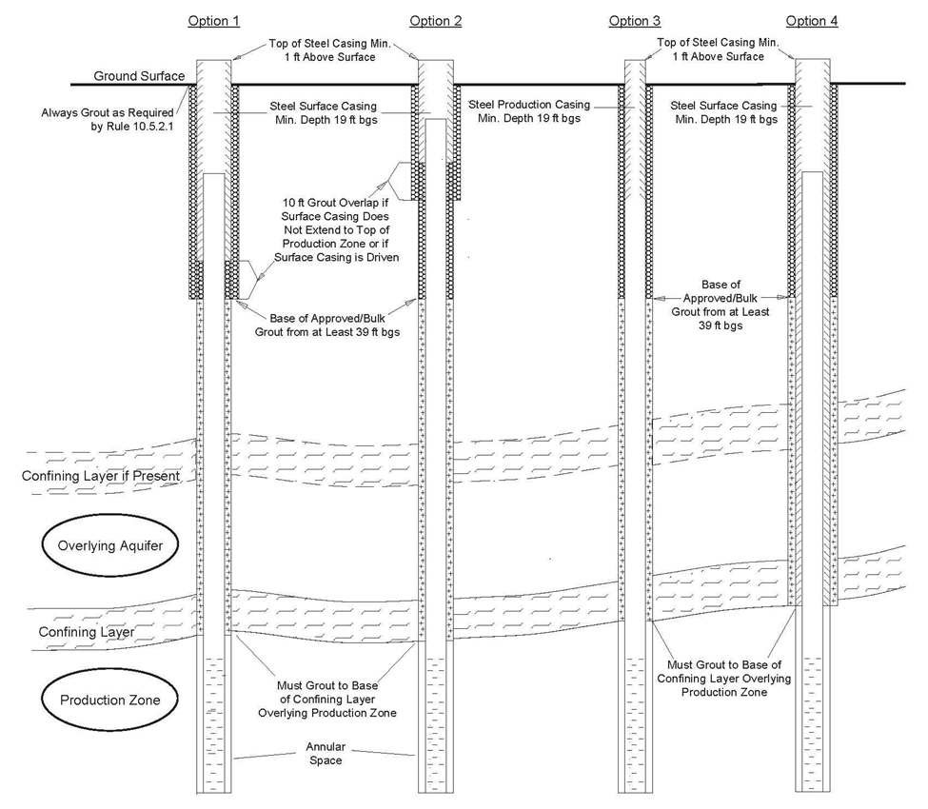

Figure 6.Schematic diagram for wells that penetrate through one or more confining units and are constructed into a Type 1 (confined) aquifer.
10.4.6 Wells Completed in Type 2 Aquifers (Unconfined Bedrock Aquifers or Bedrock Aquifers Not Overlain by a Confining Unit):
10.4.6.1 Casing Requirements – (Figure 7a and 7b)

a. Wells completed in a Type 2 aquifer (unconfined bedrock aquifer—see Rule 5.2.3.3) that are constructed without surface casing must have solid casing with watertight joints installed from the top of the permitted production zone to the top of the well.
b. Wells completed in a Type 2 aquifer that are constructed with surface casing must have solid casing with watertight joints installed from the top of the permitted production zone to at least ten (10) feet above the base of the surface casing.
c. In no instance may the base of solid casing be less than thirty-nine (39) feet below ground level. Casing intervals must also comply with Rules 10.4.2 and 10.4.3.
10.4.6.2 Grouting Requirements for Wells Constructed into Type 2 Aquifers - (Figure 7b)
a. Wells completed in a Type 2 aquifer must have at least thirty (30) feet of continuous approved grout or bulk grout and the base of the grout must begin at least thirty-nine (39) feet below the ground surface.
b. If no surface casing is installed, grout must be placed in the annular space between the production casing and the borehole wall from a depth of at least thirty-nine (39) feet up to the depth required by Rule 10.5.2.1.
c. If surface casing is installed to a depth less than thirty-nine (39) feet below the surface and the annulus between the base of the surface casing and borehole is grouted to the depth required by Rule 10.5.2.1, the annulus between the borehole wall and the production casing string must be grouted from a depth of at least thirty-nine (39) feet below the surface back to a level that is at least ten (10) feet above the base of the surface casing.
d. If surface casing is installed, to at least thirty-nine (39) feet below the surface, and penetrates into the Type 2 aquifer, the annulus between the surface casing and the production casing string need not be grouted if the annular space between the borehole wall and the surface casing is grouted from a depth of at least thirty-nine (39) feet and up to the depth required by Rule 10.5.2.1.

e. If the surface casing is driven and the construction methodology is such that grout cannot be adequately placed with proper annular space and centralization outside the surface casing to satisfy the intervals of solid casing and grout required by Rules 10.4.6.1, 10.4.6.2.a through 10.4.6.2.d, grout must be placed to meet the requirements of Rule 10.4.2.1.
10.4.6.3 Grouting Requirements for Type 2 Aquifer Overlain by a Type 3 Aquifer (Alluvial/Colluvial) - Wells completed in a Type 2 aquifer that penetrate through a Type 3 aquifer must be grouted in accordance with Rule 10.4.6.2 and must isolate the Type 3 aquifer interval from the Type 2 aquifer interval using a combination of solid casing and grout. If the minimum grouted intervals described in Rule 10.4.6.2 will not extend to or below the base of the Type 3 Aquifer, additional continuous grout must also be placed in the annulus from the base of the Type 3 aquifer up to the grout intervals required by Rules 10.4.6.2. See Figure 7b.
FIGURE 7a TYPE 2 AQUIFER WELLS COMPLETED IN TYPE 2 (UNCONFINED BEDROCK) AQUIFER NOT OVERLAIN BY TYPE 3 AQUIFER
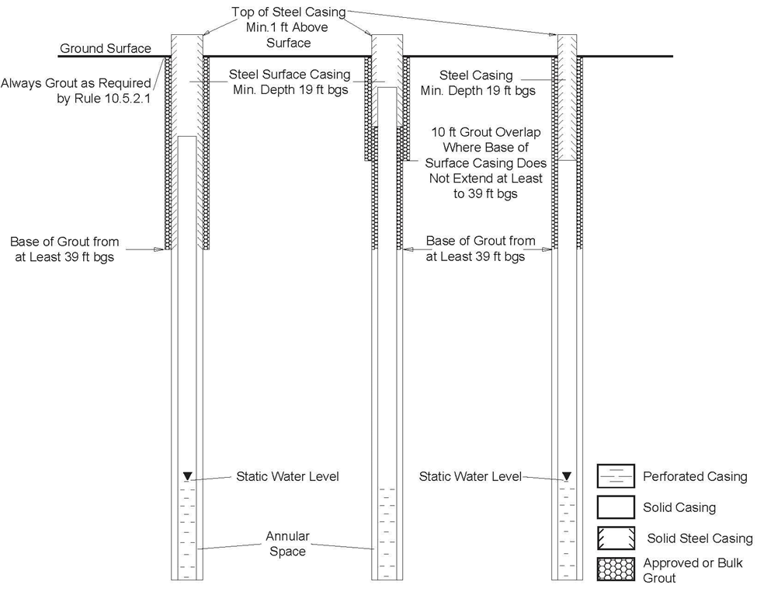
Figure 7a. Schematic diagram for wells constructed into Type 2 (unconfined bedrock) aquifers, not overlain by a Type 3 (unconsolidated) aquifer.
FIGURE 7b TYPE 2 AQUIFER WELLS COMPLETED IN TYPE 2 AQUIFER (UNCONFINED BEDROCK) AQUIFERS OVERLAIN BY TYPE 3 AQUIFER
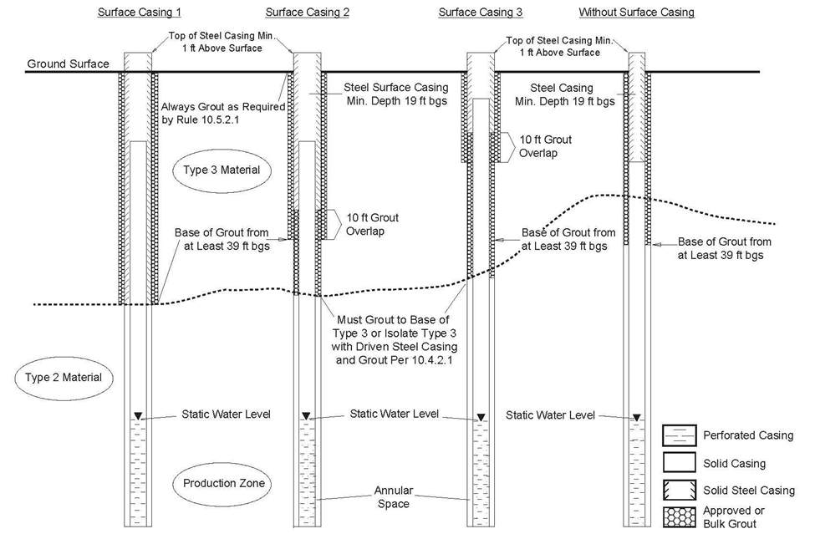
Figure 7b. Schematic diagram for wells constructed into Type 2 (unconfined bedrock) aquifers, overlain by a Type 3 (unconsolidated) aquifer.
10.4.7 Wells Completed in Type 3 Aquifers (Unconsolidated Material)
10.4.7.1 Casing Requirements - All wells completed in a Type 3 Aquifer (unconsolidated aquifer--see Rule 5.2.3.4) with or without surface casing must have solid steel casing with watertight joints installed from a depth of at least nineteen (19) feet to the top of the well and in accordance with Rules 10.4.2 and 10.4.3. See Figure 8.
10.4.7.2 Grouting Requirements – (Figure 8)
a. If surface casing is installed, the annulus between the borehole wall and the surface casing must be grouted from a depth of at least nineteen (19) feet up to the depth required by Rule 10.5.2.1. At least ten (10) feet of continuous grout is required.
b. If surface casing is not installed, the annulus between the borehole wall and the production casing string must be grouted from a depth of at least nineteen (19) feet up to the depth required by Rule 10.5.2.1. At least ten (10) feet of continuous grout is required.
c. If the surface casing is driven, and the construction methodology is such that grout cannot be adequately placed with proper annular space and centralization outside the surface casing to satisfy the intervals of solid casing and grout required by Rules 10.4.7.2.a and 10.4.7.2.b, grout must be placed to meet the requirements of Rule 10.4.2.1.
FIGURE 8 TYPE 3 AQUIFER
WELLS COMPLETED IN UNCONSOLIDATED ALLUVIAL/COLLUVIAL MATERIALS
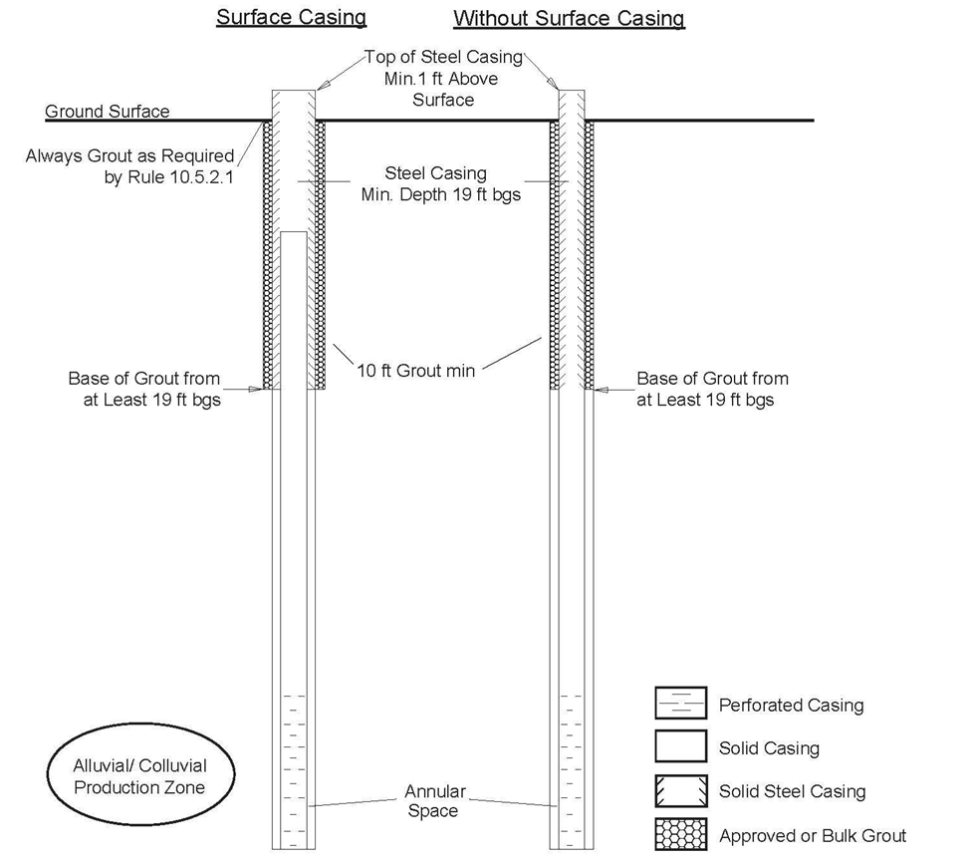
Figure 8. Schematic diagram for wells constructed into Type 3 (unconsolidated) aquifers.
10.4.8 Wells Constructed into Laramie-Fox Hills Aquifer (Inside and Outside the Administrative Denver Basin):
10.4.8.1 Casing Requirements -
a. Wells completed in the Laramie-Fox Hills aquifer that are constructed without surface casing must have solid steel casing with watertight joints installed from the top of the permitted production zone to the top of the well.
b. Wells completed in the Laramie-Fox Hills aquifer that are constructed with surface casing that does not extend to the top of the permitted production zone must have solid steel casing with watertight joints installed from the top of the permitted production zone to at least ten (10) feet above the base of the watertight solid surface casing (see Figure 9). In wells where surface casing extends to the top of the production zone and the annulus between the borehole and the surface casing is grouted per Rule 10.4.8.2, the production casing need not be steel.
c. In no situation may there be less than thirty-nine (39) feet of solid steel casing below the ground surface.
10.4.8.2 Grouting Requirements –
a. For wells completed in the Laramie-Fox Hills aquifer, the annular space between the borehole wall and the casing string(s) must be grouted with an approved grout or bulk grout (Table 2) from the top of the permitted production zone up to the depth required by Rule 10.5.2.1. The contractor completing the well construction shall identify and grout coal layers that may be present above the Laramie-Fox Hills aquifer. Grouting of the annulus outside separate casing strings can be performed independently if a grout overlap described in 10.4.8.2.b is utilized.
b. Where the base of the surface casing does not extend to the top of the production zone, approved grout or bulk grout must also be placed in the annulus between strings of surface casing and/or between the surface and production casing up to a level at least ten (10) feet above the base of the surface casing. Grout placed between the casing strings must be placed as part of the continuous placement of the grout required for the annulus outside the inner casing string.
c. In no case may there be less than thirty (30) feet of continuous grout beginning at least thirty-nine (39) feet below the ground surface.
d. If the surface casing is driven, and the construction methodology is such that grout cannot be adequately placed with proper annular space and centralization outside the surface casing to satisfy the intervals of solid casing and grout required by Rules 10.4.8.2.a through 10.4.8.2.c, the driven surface casing must be grouted to meet the requirements of Rule 10.4.2.1 (see Figure 5). The driven casing must not penetrate through a confining layer and the base of grout must extend from the top of the permitted production zone up to the depth required by Rule 10.4.2.1 or the top of the confining layer, whichever is higher.
FIGURE 9 LARAMIE-FOX HILLS AQUIFER
WELLS COMPLETED IN LARAMIE-FOX HILLS AQUIFERS
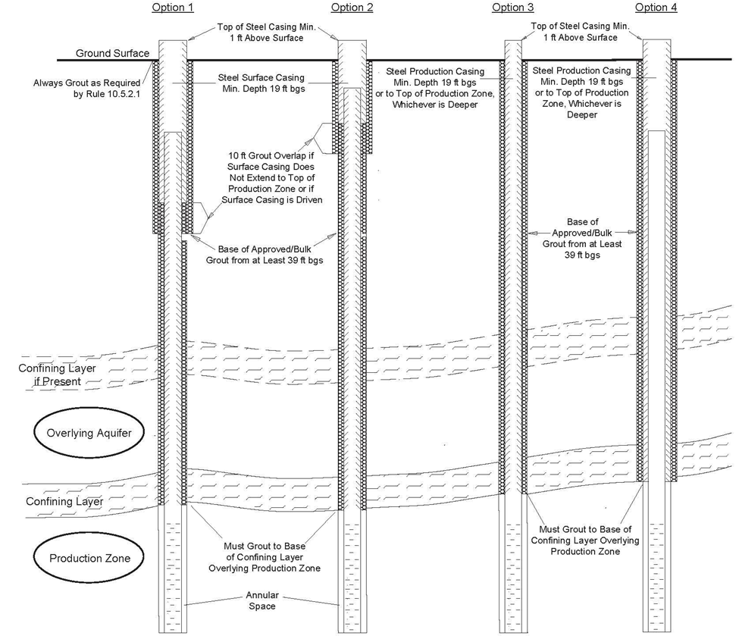
Figure 9. Schematic diagram for wells constructed into Laramie-Fox Hills aquifers inside and outside the Denver Basin.

10.4.9 Requirements for Wells Completed in the Confined San Luis Valley Aquifer - Wells completed in the Confined San Luis Valley Aquifer must fully isolate the Unconfined San Luis Valley Aquifer interval from the Confined San Luis Valley Aquifer interval. (See Figure 10)
10.4.9.1 Casing Requirements -
a. Wells constructed without surface casing must have solid casing with watertight joints installed from at least 10 feet below the top of the confining clay series of the Confined San Luis Valley aquifer to the top of the well. In no case may the base of the solid casing be less than the depth required by permit condition.
b. Wells constructed with surface casing must have solid casing with watertight joints installed from at least 10 feet below the top of the confining clay series of the Confined San Luis Valley aquifer to at least ten (10) feet above the base of the surface casing. In no case may the base of the solid casing be less than the depth required by permit condition.
c. In no instance may the solid casing extend less than thirty-nine (39) feet below ground level. Casing must also comply with Rules 10.4.2 and 10.4.3.
10.4.9.2 Grouting Requirements –
a. The annular space between the borehole wall and the casing string(s) must be grouted with an approved grout or bulk grout (Table 2) from a depth at least 10 feet below the top of the confining clay series of the Confined San Luis aquifer up to the depth required by Rule 10.5.2.1, and must have at least thirty (30) feet of continuous grout beginning at least thirty-nine (39) feet below the ground surface. In no case may the base of grout be less than the depth required by permit condition and the depth necessary to control hydrostatic pressures between aquifers.
b. If surface casing is used and does not extend at least 10 feet below the top of the confining clay series, approved grout or bulk grout meeting the requirements of Table 2 must also be placed in the annulus between the production casing and the surface casing up to at least ten (10) feet above the base of the surface casing. The grouted interval must be extended as necessary to withstand the maximum potential hydrostatic pressure differential between the aquifers.
c. If the surface casing is driven, and the construction methodology is such that grout cannot be adequately placed with proper annular space and centralization outside the surface casing to satisfy the intervals of solid casing and grout required by Rules 10.4.9, 10.4.9.1, and 10.4.9.2, the driven surface casing must be grouted to meet the requirements of Rule 10.4.2.1 (see Figure 5). The driven casing must not penetrate through the confining unit and the base of grout must extend from a depth at least 10 feet below the top of the permitted interval or confining clay series of the Confined San Luis aquifer up to the depth required by Rule 10.4.2.1 or the top of the permitted interval or confining clay series, whichever is higher.
FIGURE 10 CONFINED SAN LUIS VALLEY AQUIFER
WELLS COMPLETED IN THE CONFINED SAN LUIS VALLEY MATERIALS
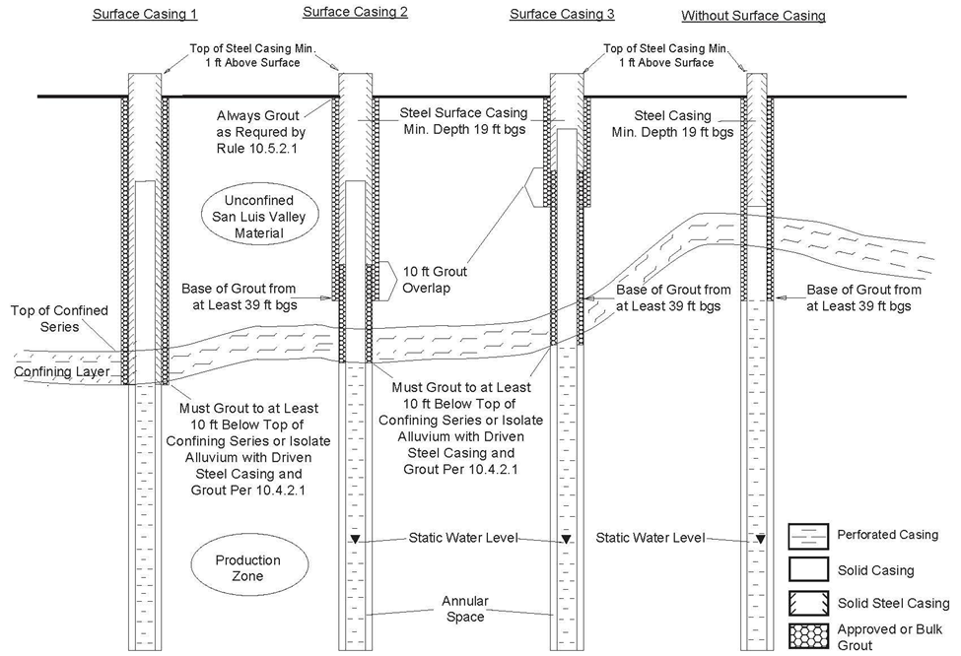
Figure 10. Schematic diagram for wells constructed into the Confined San Luis Valley aquifer
10.4.10 Surface Completion - In the event the outermost casing is cut off and does not extend more than one (1) foot above ground surface, the annulus between the outer casing and the casing that extends above the surface must have a watertight mechanical seal (e.g., a welded seal) or be sealed with a minimum of ten (10) feet of cement grout up to the depth required by Rule 10.5.2.1. If additional filter pack materials are to be added after the well has been completed, those materials must be inserted through the use of a filler tube, as required by Rule 10.4.12.
10.4.11 Filter Pack - If a filter pack is installed in a well, the interval of the filter pack materials must be limited to the permitted production zone and must not extend to the ground surface, except as provided in Rule 10.4.12. If additional filter pack materials are to be added after the well has been completed, those materials must be inserted through the use of a filler tube.
10.4.11.1 Filler Tube - The portion of the filler tube above the production zone must be grouted in place up to the depth required by Rule 10.5.2.1. Filler tube exposed above the ground surface must be composed of or covered by steel pipe. The top of the filler tube must be covered by a metal water-tight sanitary seal or cap.
10.4.12 Filter Packs in Type 3 Aquifers with Grouted Surface Casing and Mechanical Seal: If a well in a Type 3 aquifer (unconsolidated) and Unconfined San Luis Aquifers have surface casing properly grouted in accordance with Rule 10.4.7, and the annular space between the surface casing and production casing is sealed with a watertight mechanical seal (e.g., a welded seal), then filter pack may be installed from the permitted production zone up to the mechanical seal. Under these circumstances, the filter pack may only be installed through a filler tube welded in place with a water-tight sanitary seal. The filler tube and seal must consist of steel pipe.
10.4.13 Gallery Wells or Infiltration Galleries - Prior to the construction of infiltration galleries or gallery type wells, a well construction variance to this Rule 10 must be obtained from the Board of Examiners. The variance request must include written plans detailing the location and size of the proposed excavation, sizes and types of materials to be installed, types and placement method of grout and/or backfill materials to be used, and other information pertinent to the construction. If the Board finds the proposed gallery acceptable, it will approve the well construction variance in writing and impose any conditions necessary to reduce the risk to public health by contamination of the aquifer. Acceptable examples of gallery type wells are shown in Figure 7.
10.4.13.1 Mastic and other waterproofing agents between components of the well must be suitable for use in potable-water systems.
10.4.13.2 Each gallery well or infiltration gallery must include a low-permeability seal over the entire extent of the excavation in the interval above the filter material and within 1-foot of the ground surface if no pitless adapter is used. The seal must be comprised of either:
a. a minimum 1-foot thick layer of clean, imported or native clay,
b. a minimum 3-inch thick layer of granular bentonite, or
c. a minimum 1-foot thick layer of onsite soils blended with bentonite at a rate in accordance with the bentonite manufacturer’s recommendations for a low permeability layer/membrane.
10.4.13.3 Casing or concrete ring wall thicknesses shall meet the minimum requirements of Rule 10.3.4. Other plastic casing not meeting ASTM F480-14 must be rated for use at the depths and backfill conditions proposed, and as recommended by the manufacturer.
10.4.13.4 Corrugated, galvanized culvert pipe must not be used in gallery well or infiltration gallery construction.
10.4.13.5 Plastic or PVC casing must not be exposed at the ground surface. Above grade PVC or plastic casing must be protected by metal or concrete casing or a protective structure composed of similar materials.
10.4.14 Directional Drilling - All wells must be constructed vertically and in accordance with Rule 10.4.15, unless directional drilling has been specifically approved by the State Engineer in a well permit and a variance to this Rule 10 has been approved by the Board.
10.4.15 Plumbness and Alignment - All wells must be constructed so that the horizontal deviation of the borehole from its surface location is a practical minimum at all times. An unintentional deviation of the borehole due to adverse drilling conditions will not be considered directional drilling. The casing must be sufficiently plumb and straight to facilitate the successful installation of grout. The casing must be sufficiently plumb and straight so that it will not interfere with the installation, operation or removal of the pump.
10.4.16 Well Sumps and Ratholes Extending Below the Permitted Aquifer or Production Zone -
10.4.16.1 Well sumps and ratholes must not penetrate through a confining unit.
10.4.16.2 The total depth must not exceed the depth of the permitted aquifer for wells completed in Denver Basin Aquifers.
10.4.16.3 To allow for a sump and/or rathole, the total drilled depth below the permitted aquifer or production zone must not exceed 20 feet for wells completed in aquifers that are not a Denver Basin Aquifer.
10.4.16.4 In the event a sump or rathole penetrates through a confining unit below the permitted aquifer or production zone, the confining layer and underlying aquifer must be grouted through the intervals required by Rule 16.2.
10.4.16.5 In the event a sump or rathole encounters sandstone/siltstone/crystalline bedrock/Confined San Luis Valley unit or any unit that may allow the intermingling of groundwater from different sources in the interval below the base of the permitted aquifer or production zone the sump/rathole must be plugged using approved grout or granular bentonite to fully isolate the aquifer materials from the permitted aquifer or production zone.
FIGURE 11.a GALLERY WELLS OR INFILTRATION GALLERIES
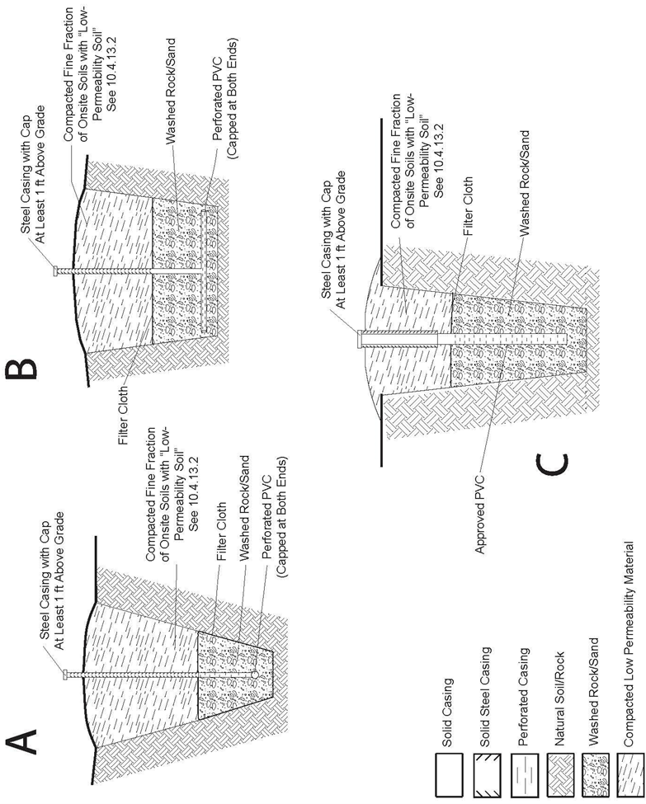

Figure 11.a Schematic diagram of various gallery-type well designs

FIGURE 11.b GALLERY WELLS OR INFILTRATION GALLERIES
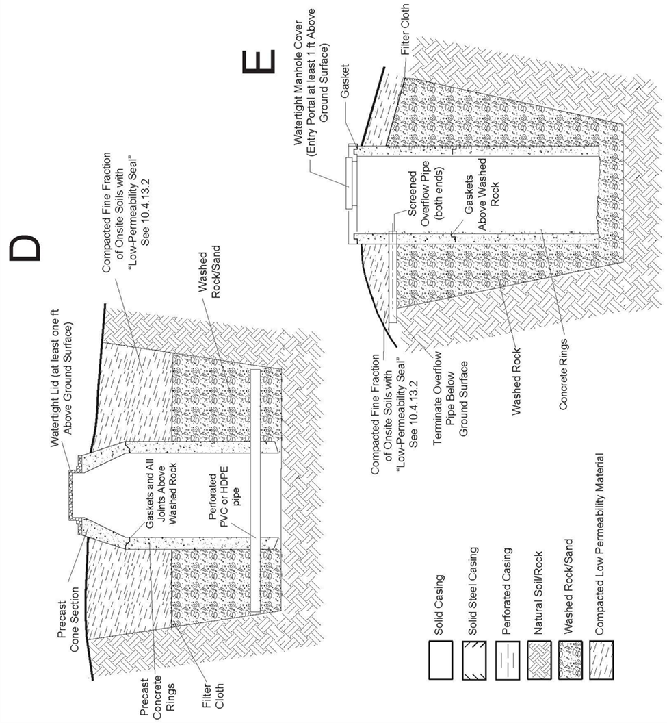
Figure 11.b (continued). Schematic diagram of various gallery-type well designs
FIGURE 11.c GALLERY WELLS OR INFILTRATION GALLERIES
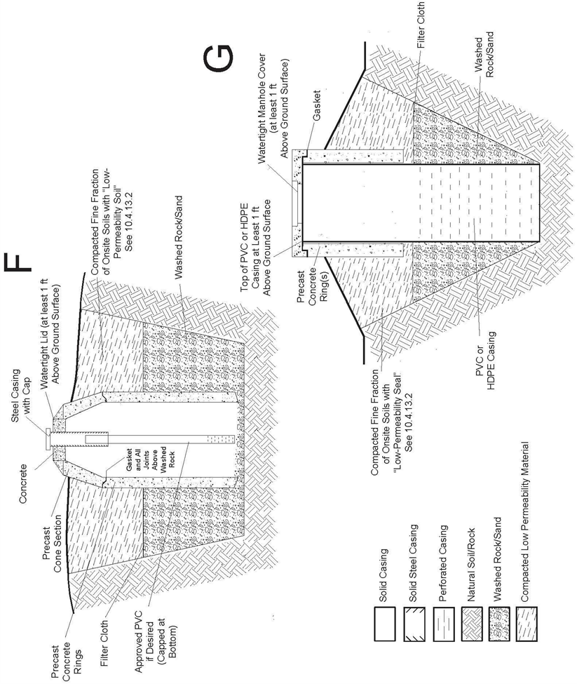
Figure 11.c Schematic diagram of various gallery-type well designs
10.5 Grout and Grout Placement - All wells must be grouted to prevent contaminants from entering the borehole, to separate groundwater in different aquifers, and to seal off water bearing zones known or suspected to contain contaminants. To achieve these objectives, the selection, mixing, and placement of all grout is the responsibility of the person authorized to construct the well. All grout seals must be installed before completion of the well and the installation of the production equipment.
10.5.1 Only the grout materials that meet the requirements set forth in Table 2 may be used. Grout must be uniformly mixed prior to placement in the well. The grout mixture constituents’ weight, volume, density and/or the percent by weight of each constituent used in the grout mixture must be reported on the well construction report.
10.5.2 The following minimum grout intervals apply to all wells intended for the withdrawal of groundwater or for the artificial recharge of water into an aquifer.
10.5.2.1 At or near the ground surface, the annulus between the borehole and the outermost casing must be sealed with at least the minimum amount of continuous cement grout required for the particular type of aquifer in which the well is constructed (see Rule 10.4), and considering whether a pitless adapter or unit will be installed. The top of the grout seal must not exceed the depths below ground level as set forth below:
a. Not more than three (3) feet below ground level if no pitless connection is installed on the casing. The annular space above the top of the grout must be backfilled with fill materials not more permeable than the surrounding ground that are adequately compacted.
b. Not more than three (3) feet below any pitless adapter or pitless unit to be installed. The annular space above the pitless connection must be backfilled with fill materials not more permeable than the surrounding ground that are adequately compacted.
10.5.2.2 All known zones containing contaminants must be sealed off by successfully placing grout throughout the interval from twenty (20) feet below to twenty (20) feet above those zones.
TABLE 2: GROUT MATERIALS
Approved Grouts
A. Neat Cement: a slurry of cement and water with no more than six (6) gallons of water per 94-pound sack (Portland cement ASTM C150 or Portland Limestone Cement Type IL, ASTM C595).
Fly ash may be blended with Portland cements (ASTM C150) or Portland Limestone cement (ASTM C595) for grouting wells. Fly ash may be blended with cement up to a ratio of 44% fly ash by weight of Portland cement, and up to a ratio of 40% fly ash by weight of Portland Limestone cement. The water-cement ratio for grout slurries blended with fly ash must not exceed 5 gallons of water per 86-pound sack of blended cement.
B. Cement-Bentonite: a slurry of cement (ASTM C150 or ASTM C595), bentonite and water. The amount of bentonite added must not exceed 8% bentonite per dry weight of cement. The volume of additional water used in preparing these slurries is limited to three quarters (0.75) of a gallon per 94-pound sack of cement for each 1% of bentonite added.
C. Cement, Fly-Ash, Bentonite: a slurry of cement (ASTM C150 or ASTM C595), fly ash, bentonite, and water. The amount of bentonite must not exceed the ratio to be considered high solids grout and the mixture must adhere to manufacturer’s recommendations.
D. Non-shrinking Cementitious Grouts of differing composition may be reviewed and approved by the Board.
Prior to the use of other grout materials or other combination of the above approved grout materials, a written request must be submitted to and written approval obtained from the Board.

Bulk Grouts - restricted use (see Rule 10.5.3.5)
A. Cement-Sand: a slurry of cement, sand and water. The amount of sand added must not exceed 140 pounds for each 94-pound sack of cement. Not more than six (6) gallons of water per 94-pound sack of cement may be used in the preparation of these slurries. These slurries should be used where extra strength or bulk is required.

B. Concrete: a slurry of cement, sand and gravel aggregate. The amount of aggregate added must not exceed 400 pounds for each 94-pound sack of cement. Not more than seven (7) gallons of water per 94-pound sack of cement may be used in the preparation of these slurries. These slurries should be used where extra strength and bulk is required and the annular space allows the placement of the slurry.

Bentonite - restricted use pursuant to Rule 10.4.5.2.e or 10.5.3.6. The Board may approve the following types of bentonite products.
Only bentonite products that are intended for use in water wells may be used. Mixing of bentonite grouts must strictly adhere to the manufacturer's recommendations and must achieve a slurry of not less than 20% solids by volume and a density of not less than 9.4 pounds per gallon.
A. Bentonite Slurry: a slurry of bentonite clay (powder, chips, granules or pellets) and water. Mixing of bentonite grouts must strictly adhere to the manufacturer's recommendations and must achieve a slurry of not less than 20% solids by volume and a density of not less than 9.4 pounds per gallon. The density must be measured using a “mud balance” and reported on the well construction and test report.
B. Granular Bentonite: Except as allowed in Rule 10.4.5.2.e, solid granular bentonite (pellets, granules and chips) may only be used as grout material in saturated zones and must be placed directly into the appropriate interval.
Fill Materials: Fill material, such as clean native clay, clean drill cuttings, or other inert rock material may be used to fill the annular space in any interval where grout is not required by these Rules. These materials are not grouts and must not be placed where grout is required. Fill materials placed in the annulus near the land surface must be less permeable than the surrounding soil and must be adequately compacted to prevent settling.
10.5.3 The method of grout placement must achieve a permanent watertight seal for the required interval(s). Grout must be selected and placed to withstand the maximum potential hydrostatic pressure differential between aquifers.
10.5.3.1 Approved or bulk grout and bentonite slurries placed by positive displacement must be placed through well casing or through a tremie pipe. Grouting of each interval must be installed from the bottom up in one continuous operation unless placed in accordance with Rules 10.5.3.4 or 10.5.3.5, however it is recognized that in certain wells that take more grout than expected, it may be necessary to install grout in more than one continuous operation. The outside diameter of the tremie pipe must not exceed the annular space between the casing and the borehole, or between strings of casing. The contractor is responsible to ensure that the tremie pipe used to install the grout is sized adequately to install grout at the necessary interval.
a. The tremie pipe may be sacrificed in the annulus provided that the tremie pipe remains full of grout.
10.5.3.2 Positive displacement grouting must be performed through an opening, shoe or grout port in the casing or through a tremie pipe where the bottom of the tremie at the start of grouting is near the bottom of the interval to be grouted.
a. The opening or grout port through the casing is a penetration of the casing and therefore must be located below the required grout interval.
b. The bottom of or other openings in the tremie pipe must be continuously submerged within the grout during placement of the grout.
10.5.3.3 One or more grout baskets, packers, shale traps or other devices intended to support the base of the grout must be placed at or below the base of the minimum required grouted interval to facilitate grout placement. Additional grout baskets, packers (not associated with pressure grouting), shale traps or devices for the support of grout placed above the base of the required grouted interval, that are not associated with the base of another required grouted interval, may be installed no shallower than 10 feet above the base of the cement placement.
10.5.3.4 Where grout is poured from the surface, only approved grouts as described in Table 2 may be used except as provided in Rule 10.5.4.5. Grout may only be poured into a dry annulus where the placement depth does not exceed forty (40) feet below ground surface.
10.5.3.5 Bulk grouts (cement-sand or concrete grout mixtures) as described in Table 2, may only be poured into a dry annulus where the placement depth does not exceed forty (40) feet.
10.5.3.6 Bentonite grout may be used in required grout intervals only pursuant to Rule 10.4.5.2.e or a variance from the Board. Bentonite grout’s use must be consistent with the requirements of Rule 10.5, Table 2 and 10.4.4.6. Bentonite must not be used to seal the casing of a well within thirty-nine (39) feet below ground surface. A fully-hydrated bentonite slurry must not be used as a grout where a difference in hydrostatic head exists across the grout interval or if the interval will not remain saturated.
10.5.4 It is the responsibility of the person authorized to construct the well to allow the grout to set before resuming construction or performing any development, cleaning or stimulation of the well. The minimum setting time is six (6) hours for cement grout with accelerators and twenty-four (24) hours for cement grout without accelerators.
10.6 Well Development And Cleaning - All wells must be initially cleaned and developed by the person authorized to construct the well in order to promote production efficiency and establish proper conditions in the well for installation of the permanent pumping equipment. At a minimum, well cleaning must include removal of drill cuttings, drilling fluids, and any foreign materials introduced into the borehole as a result of the borehole drilling and well completion processes. The person authorized to construct the well shall also develop the well using procedures designed to maximize well yield and promote well efficiency to the extent practical given site-specific conditions at the well site, type of drill rig used, and physical characteristics of the aquifer. Well development procedures may include: over-pumping, backwashing, bailing, mechanical surging, jetting, and air lifting. The person authorized to construct the well shall log and report the methodology used, duration, and evaluation criteria per Rule 17.1.1. At the minimum, three casing volumes of water must be evacuated from the completed well during development.
10.7 Disinfection Prior to leaving the well site, the person authorized to construct the well must disinfect the well according to the provisions of Rule 15.
10.8 Static Water Level Measurement The static water level in all newly-constructed or modified wells must be measured by the method described in Rule 5.2.54 by the well construction or pump installation contractor, private driller, private pump installer, or authorized individual, within seven (7) days after the well has been cleaned and developed and the well yield estimate performed (see Rule 12.2). Static water level measurements must be reported on the well construction and/or pump installation report.

10.9 Flowing Wells - Flowing wells, and wells that can be reasonably assumed to develop flowing conditions, must be constructed to prevent leakage around the casing or adjacent to the well. Upon completion of grouting, flowing wells must be equipped with a device to completely control the flow from the well, or the well must be plugged, sealed, and abandoned in accordance with Rule 16. It is the responsibility of the well construction contractor or private driller to install such control equipment at the time of well construction. Thereafter, it is the responsibility of the well owner to ensure the control equipment is maintained and operational.

Rule 11 Minimum Pump Installation and Cistern Installation Standards
Basis and Purpose: The statutory authority for this Rule is found in sections 37-91-101(1), 37-91- 104(1)(c), 37-91-109(1) & (2), 37-91-110(2), C.R.S. The purpose of this Rule is to establish the minimum standards for installing pumping equipment and cisterns that are connected to water well supply systems in order ensure that such installation prevents harm to the public health, will not impair water quality or cause contamination of shared groundwater resources, and will ensure the safety of groundwater resources for Colorado’s existing and future populations.
11.1 General Rules- All permanent pump installations and cistern installations in or connected to a new or existing water well supply system must be completed by a licensed pump installation contractor or a private pump installer (see sections 37-91-102(12.5) and 37-91-109(2), C.R.S.). Pumping equipment may be installed in wells constructed and used solely for purposes of aquifer remediation (recovery well) or temporary dewatering (dewatering well) by authorized individuals or anyone directly employed by or under the supervision of an authorized individual. It is the responsibility of the person installing the pumping equipment to ensure that a valid well permit authorizing such installation exists in accordance with the requirements of Rule 6.2.2.1 and 6.2.2.2.
11.1.1 Licensed water well construction contractors who are not licensed as pump installation contractors may not install pumping equipment in a well, except for temporary pumps used only for well development and testing.
11.1.2 Licensed pump installation contractors may not remove casing or install casing except for:
a. removal, alteration, or repair of casing to install a pitless adapter or pitless unit,
b. the upward extension of existing casing from the pitless adapter or pitless unit, or
c. the installation or replacement of casing in a well constructed through a single aquifer where such installation or replacement does not require the placement of grout in the annulus to meet the standards of these Rules.
11.1.3 Licensed pump installation contractors may not install grout in the annular space of a well or between well casing as required by Rule 10. This prohibition does not apply to grout installation associated with the installation of a pitless adapter, or grout installed in a well to abandon the well pursuant to Rule 16.
11.1.4 Pumping systems may not be designed to exceed the permitted pumping rate at the point of delivery when operating under normal design conditions.
11.1.5 Pump installation contractors and private pump installers must submit a pump installation report every time a pump is installed in a well or for any change in the pump depth setting. The report must describe the pump, date of installation, its depth setting, static water level, and the results from the production equipment test required by Rule 12.
11.2 Installation Standards - Pumps, cisterns, pitless units and adapters, and related equipment that will be installed as part of, or connected to, a water well supply system must be installed in such a manner that the well, pump, cistern, and surrounding area will be kept in a sanitary condition, and will provide adequate protection against contamination from any surface or subsurface source.
11.2.1 Pump installation contractors may not cut off or penetrate well casing below ground level except to install a pitless adapter or a pitless unit. Pitless adapters must be installed on steel casing that extends to a minimum of one (1) foot above the finished ground level and must be watertight. Pitless units must have steel extensions to a minimum of one (1) foot above the finished ground level. All connections to the pitless adapters or pitless units must be made with threaded, flanged, welded or mechanical joints. Mechanical joints must be rodded across the connection and secured to the body of the well casing or pitless assembly. In the event it is necessary to cut off the outermost casing below ground level in order to install a pitless unit on the inner casing, the contractor must comply with the requirements of Rule 10.5.2.1.
11.2.2 A pump installation contractor may only install a pitless adapter or pitless unit if, after such installation, the minimum continuous grout interval required by Rule 10.4 and Rule 10.5 is maintained.
11.2.3 Flowing wells must be equipped so that the discharge can be controlled or stopped at all times. It is the responsibility of the pump installation contractor or private pump installer to install such equipment. Thereafter, it is the responsibility of the well owner to ensure the equipment is maintained and operational.
11.2.4 Pump installation contractors may not cut off or penetrate cisterns below ground level except to install watertight devices for water line or electrical connections.

11.3 Cistern Installation and Location - When selecting a cistern location, consideration must be given to topography, drainage, sources of contaminants, and other onsite conditions in order to promote sanitary conditions and prevent contamination of the well and aquifer.
11.3.1 A cistern installed below ground level must be constructed and placed in such a manner to withstand saturated soil pressures when empty.
11.3.2 Any cistern installed below ground level must be watertight and be equipped with a human-sized access portal that extends to at least one foot above the ground surface. The backfill material must be sloped away from the access portal.
11.3.3 A cistern installed below ground level must be buried to an adequate depth to prevent freezing.
11.3.4 A cistern installed below ground level must be properly bedded and backfilled in accordance with the manufacturer’s recommendation.
11.3.5 All penetrations of a cistern must be watertight and the access portal must prevent the entry of contaminants, insects and animals.
11.3.6 A cistern placed in a building must be placed in an area that is adequate to support the anticipated loads of the cistern, full of water, all pumping equipment, and controls.
11.3.7 A cistern must be placed in an area accessible to service.
11.3.8 When an existing cistern is connected to a water well supply system, the installation or connection must be performed by a licensed pump installation contractor. See § 37-91- 109(2), C.R.S. The cistern that is connected to the water well supply system must meet all of the requirements of Rules 11.3 and 11.4 and any relevant local regulation.
11.3.9 Mastic, sealants and other waterproofing agents between components of the cistern must be suitable for use in potable-water systems.
11.4 Location Variance - A cistern installed below ground level must not be located closer than one hundred (100) feet horizontally to the nearest existing source of contaminants or fifty (50) feet horizontally from a septic tank, sewer line or other above or below ground vessels containing contaminants (but excluding properly-maintained vessels for permitted chemigation products; properly-maintained vessels mounted on vehicles; and properly-maintained vessels mounted or carried on equipment used in the construction or development of wells or installation of pumping equipment), at the time of well construction. A request for variance must be submitted and written approval from the Board must be obtained prior to the construction of a cistern that cannot meet this spacing requirement. The variance request must be prepared in accordance with Rule 18.2 by a pump installation construction contractor or authorized individual and must be based on hydrogeologic information.
11.5 Seals and Vents -
11.5.1 Well Seals - All pumping equipment must be installed with an effective metal well seal at the top of the casing that will prevent the entry of contaminants into the well. The pumping equipment must be designed to allow for its installation and removal through an approved well seal and to prevent unprotected openings from connecting with the interior of the pump or well. Only metal well seals are approved well seals within section 37-91-102(18), C.R.S; additional requirements for well seals and caps are presented in Rule 10.1.3.
11.5.2 Well and cistern vents - When needed or used, well or cistern vents must be connected with watertight joints and permit air to freely enter and exit the well with changing water levels in the casing. Vents may be an integral part of the well or cistern seal or be attached to the seal and terminate a minimum of one (1) foot above the finished ground level, be turned down, and be screened to prevent entry of insects and rodents. Vents must be constructed to vent all gasses to the atmosphere outside of a building and to prevent gas accumulation that could produce a health or explosion hazard. Well vent materials must be metal.
11.6 Well Vaults - New well vault installations are not permitted unless the Board approves a specific variance request. If a variance is granted by the Board, provisions must be made to prevent contaminants from entering the well and for gravity drainage of the vault through a floor drain or by an automatic sump pump.
11.6.1 Existing Well Vaults The vault must be structurally sound to support anticipated surface loads and the top must be watertight, including any manhole covers. The well casing must extend at least one (1) foot above the floor of the vault and must have a well seal to prevent contaminants from entering the well. Provisions must be made for gravity drainage of the vault through a floor drain or by an automatic sump pump. All drain openings must be screened to prevent the entry of rodents and insects.
11.6.2 Well construction or pump installation contractors encountering unacceptable well vaults must make every effort to bring the well vault into compliance with these Rules. If it is not possible to correct the problems, the contractor must notify the Board of Examiners. The well owner is responsible for the costs associated with bringing an unacceptable well vault to compliance with these rules.
11.7 Water Level Measurement Devices - A water level sounding tube must be installed on all wells whenever the permit issued by the State Engineer requires installation of water level measuring equipment. The water level sounding tube must have a minimum inside diameter of 3/4 (.75) inch. It must extend from the well head to the top of the pump discharge equipment and must be securely attached to the column or drop pipe so that it hangs straight. All tubes must be equipped with a removable cap or plug to prevent entry of foreign material. The bottom of the tube must be constructed to allow the free entry and exit of water and to prevent the measuring device from passing out of the bottom of the tube.
11.8 Compliance with Applicable Law All persons authorized to install pumps and cisterns must comply with applicable federal, state, county, municipal and local laws, regulations, and codes.
11.8.1 Electrical Connection of Pumping Equipment Only licensed pump installation contractors, private pump installers, or licensed electrical contractors, using appropriately licensed or supervised personnel, may install electrical materials and connections between the well head junction box and the pump service disconnect box (see Figure 12). The materials, fittings, and control assemblies used for this installation must meet the standards of the NFPA 70: National Electric Code (2023) and are subject to permitting and inspection by the Colorado State Electrical Board. Electric power to the pump service disconnect box must be installed by either a licensed electrical contractor or the property owner.
FIGURE 12 REQUIREMENTS FOR WELL WIRING
Electrical permit required prior to installation
Use approved electrical fittings, materials, and control assemblies per the requirements of the National Electrical Code (2023).
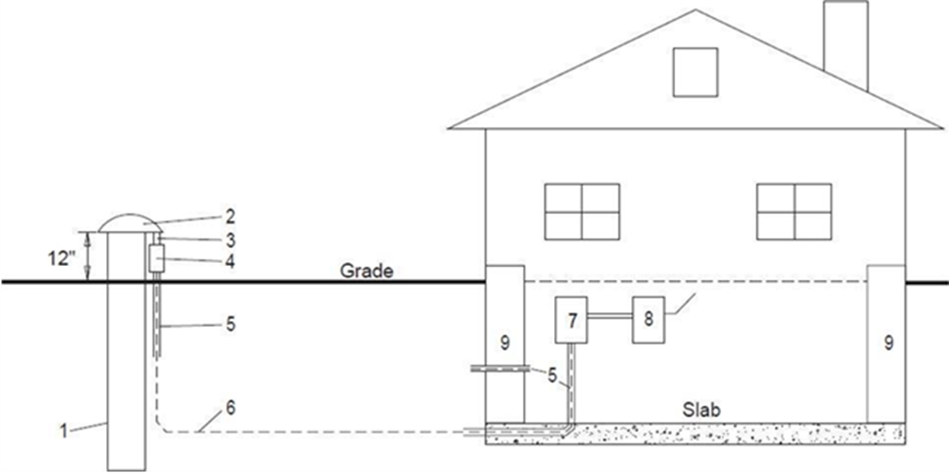
1. Well casing
2. Well head
3. Metal nipple
4. Approved weatherproof junction box. The electrical junction between the electrical conductor from the supply and the pump wire must be made in the weatherproof junction box located at the well seal.
5. Approved electrical conduit
6. Conductors approved for direct burial. Size of conductors to be determined by size of pump motor and distance. Well casing shall be bonded to the pump circuit equipment grounding conductor in junction box on well casing
7. Controller – licensed electrical contractor or licensed well contractor
8. Disconnect – installed by licensed electrical contractor or licensed well contractor
9. Foundation – all wiring through or under foundation, or under concrete floor, to be installed in approved electrical conduit
Note: Electrical conduit must extend 18 inches below finished grade from well junction box
11.8.2 Plumbing Connection of the Pumping Equipment Only persons authorized to install pumps may install piping and connection between the well and the point of discharge from the pressure tank, if such a tank is installed. All materials and fittings used to connect the well to the pressure tank must meet the standards of the Rules and Regulations of the Colorado State Plumbing Board, 3 CCR 720-1 (4/30/2025).
11.9 Pressure Relief Valve All water well supply systems capable of producing pressures greater than seventy-five (75) pounds per square inch must be equipped with a pressure relief valve sized to discharge the production rate of the pumping system.
11.10 Backflow Prevention Pump installations and cistern installations must have check valves, backflow prevention devices or suitable air gap cross-connection controls, as necessary to prevent damage to the pumping equipment and contamination of the aquifer.
11.10.1 Pump installations and cisterns supplying irrigation water where fertilizers, insecticides, herbicides, or other chemicals are injected into the water must be equipped to prevent well or aquifer contamination. Vessels containing fertilizers, insecticides, herbicides or other chemicals that are connected to the irrigation water distribution system are exempted from the requirements of Rule 10.2.2 and 10.2.3. The installation must comply with Section 35-11-107, C.R.S. and the Rules and Regulations Pertaining to the Administration and Enforcement of the Colorado Chemigation Act, 8 CCR 1203-8, promulgated by the Department of Agriculture pursuant to the Colorado Chemigation Act, Article 11 of Title 35, C.R.S.
11.11 Disinfection After installing a pump or cistern, and prior to placing the well in service, the person authorized to install pumping equipment must disinfect according to the provisions of Rule 15.

Rule 12 Well Testing
Basis and Purpose: The statutory authority for this Rule is found in sections 37-91-106(4), and 37-91- 110(1)(b) & (2), C.R.S. The purpose of this Rule is to establish minimum standards for the testing of water wells.
12.1 General - The provisions of this Rule establish minimum standards for the testing of water wells. Every well constructed for the purpose of producing groundwater must undergo:
12.1.1 A well yield estimate to determine a stabilized yield for the well (a well yield test may be performed instead of a well yield estimate); and
12.1.2 A production equipment test to determine the production capacity of the equipment as actually installed in the well.
12.2 Well Yield Estimate - The yield of a well must be tested and estimated as a stabilized production rate where the withdrawal rate does not change by more than 10% during the last hour of the test. A well yield estimate may be established by procedures such as air-lifting or bailing. Well yield estimates may be performed at rates that exceed the permitted pumping rates.
If the yield is estimated via test pumping, report final pumping water level, the test duration in hours and the mean pumping rate in gallons per minute.
12.3 Responsibility for Well Yield Estimate - Well construction contractors are responsible for performing the well yield estimate and submitting the data to the State Engineer on the Well Construction and Yield Estimate Report form.
12.4 Production Equipment Test - The permanent production equipment installed in wells must be tested to ensure it is functioning as designed. The test must demonstrate the production capacity of the equipment as actually installed in the well. The production equipment test must not be conducted at rates that exceed the permitted pumping rates
12.5 Responsibility for Production Equipment Test - Pump installation contractors are responsible for testing the production equipment installed in a well upon completion of their work. The pump installation contractor is also responsible for ensuring that the production from the well complies with the conditions of the well permit. Production equipment test data must be submitted to the State Engineer on the Pump Installation and Production Equipment Test Report.
12.6 Well Yield Test - A well yield test (also known as a pumping test or aquifer test) may be performed instead of, or in addition to, a well yield estimate. If a well yield test is performed, the test must be performed with equipment that is capable of determining both drawdown and pumping/production rate. Well yield tests may be performed at rates that exceed the permitted pumping rates. If a well yield test is performed, well yield test data must be submitted to the State Engineer on the Well Yield Test Report form.

Rule 13 Sampling, Measuring, and Test Pumping
Basis and Purpose: The statutory authority for this Rule is found in section 37-91-106(4), C.R.S. The purpose of this Rule is to provide minimum standards for sampling, measuring, or test pumping groundwater to ensure that shared groundwater resources are protected from contamination.
13.1 Well Owner's Knowledge Sampling, measuring, and test pumping must be conducted with the well owner's knowledge.
13.2 Measuring Devices All measuring and sampling devices and equipment must be cleaned, decontaminated and disinfected in accordance with Rule 15.6 prior to being inserted into any well.
13.3 Removal of Well Seal Only a licensed well construction contractor, licensed pump installation contractor, authorized individual, or the well owner may remove a well seal. Whenever the seal is removed from a well and the equipment being used in the well is not disinfected pursuant to Rule 15.6, the well must be disinfected according to Rule 15.3. The person removing the well seal is responsible for disinfecting the well and reinstallation of the seal.
13.4 Measuring, Sampling and Test Pumping Registered professional engineers, professional geologists or hydrologists, or anyone directly employed by or under the supervision of a registered professional engineer, professional geologist or hydrologist may measure, sample or test pump holes or wells for scientific, engineering, or regulatory purposes. Such activities must be limited to measuring water levels, collecting water samples, and the installation of pumps dedicated solely to scientific, engineering, or regulatory purposes, provided all work complies with the standards in these Rules.
13.5 Lost Equipment It is the responsibility of the person doing the testing, sampling, or measuring to inform the well owner in writing of any equipment malfunction, equipment loss in the well, or difficulties encountered.

Rule 14 Minimum Construction Standards for Monitoring and Observation Wells, Monitoring and Observation Holes, Dewatering Wells, and Test Holes
Basis and Purpose: The statutory authority for this Rule is found in sections 37-91-101(1); 37-91- 104(1)(c), (j) & (k); 37-91-106(4). The purpose of this Rule is to establish minimum construction standards for certain types of holes and wells that may be constructed by authorized individuals who are not specifically licensed by the Board.
14.1 General - Monitoring and observation wells and monitoring and observation holes are primarily used for observing groundwater levels and flow conditions, obtaining samples for determining groundwater quality, and for evaluating hydraulic properties of water-bearing strata. Dewatering wells are primarily used for temporary dewatering for construction only. Test holes are primarily used for conducting geotechnical or geological investigations. See section 37-91-102(10.5) and (15.7), C.R.S., and Rule 5.2 for definitions and authorized uses for each type of structure.
14.1.1 If the holes do not penetrate through a confining unit, monitoring and observation holes or wells, dewatering wells and test holes may be constructed by an authorized individual (see Rule 5.2.4 and Rule 9), a licensed well construction contractor, or a private driller (see section 37-91-102(12), C.R.S). Rules 6, 7, 9, 14 and 17 for licensing, notification, and reporting requirements (summarized in Table 1).
14.1.2 Monitoring and observation holes or wells, dewatering wells and test holes that penetrate through a confining unit between two distinct aquifers may not be constructed by an authorized individual. All holes or wells that penetrate through a confining unit between two distinct aquifers must be drilled by a licensed water well construction contractor and must comply with the standards of Rule 10.
14.1.3 Prior to starting construction, all persons authorized to construct monitoring and observation holes or wells, or test holes constructed within 200 feet of the footprint of a dam are required to contact the Division of Water Resources Dam Safety Branch and obtain an approved Subsurface Investigation Plan prior to performing the work. All requirements of these Rules must be followed.
14.1.4 Notice and reporting requirements for compliance with this Rule 14 are stated in Rule 9.2. The person authorized to construct and to plug, seal, and abandon monitoring and observation holes, dewatering wells and test holes must ensure that the proper notice has been provided to the State Engineer pursuant to Rule 6.3, keep accurate records of work performed, and submit the required reports to the State Engineer (see Rule 17).
14.1.5 Prior to starting construction, all persons authorized to construct monitoring and observation holes or wells, dewatering wells or test holes must investigate and become familiar with the geology and hydrogeology of the area, potential aquifers, confining units, anticipated water quality problems, and known contaminated water-bearing zones which may be encountered in the area of the proposed drilling activity.
14.1.6 When hazardous contaminants are known or suspected to be encountered during construction, the authorized individual, licensed contractor, or private driller is responsible for ensuring that all personnel on site are adequately trained, and that proper safety equipment is provided to handle and contain those substances.
14.1.7 Drill cuttings and wastewater from monitoring and observation wells/holes, dewatering wells or test holes in areas of known or suspected contamination must be managed in accordance with all applicable federal, state, and local regulations or laws.
14.1.8 All wells/holes and boreholes, when unattended, must be securely sealed, capped, or covered to ensure protection of the groundwater resource. During construction, it is the responsibility of the person constructing the hole or well to ensure the borehole is securely covered when unattended. Upon completion of construction, the hole or well must be securely sealed or capped by the person responsible for construction. Thereafter, it is the responsibility of the hole or well owner to ensure that the hole or well remains securely sealed or capped.
14.1.8.1 A secure cover is intended as a temporary arrangement of materials or a device that must perform the function of preventing deleterious entry of objects, animals or contaminants into the borehole or well while unattended and prior to completion of the well.
14.1.9 Holes, wells and boreholes constructed in accordance with Rule 14 under a monitoring hole or dewatering well notice of intent, a monitoring well permit (with no intention to be converted to a water well) or test hole do not need to be constructed vertically.
14.1.10 Authorized individuals and well construction or pump installation contractors who encounter a monitoring and observation hole or well that appears not to meet the standards of these Rules, or a damaged monitoring and observation hole or well, or an open and unattended hole or well, must notify the Board of Examiners in writing of the location of such holes or wells.
14.2 Monitoring and Observation Holes - Monitoring and observation holes constructed pursuant to notice as provided in Rule 6.3 and in accordance with the standards of this Rule 14 may only be used for those purposes described in section 37-91-102(10.5) and may not be converted to production wells for beneficial use. A monitoring and observation well must be permitted by the State Engineer, and may be used for the purposes described in Rule 5.2.34 and section 37-91-102(10.5), C.R.S. A monitoring and observation hole may only be converted to a monitoring and observation well, recovery well for remediation of the aquifer, or a dewatering system for dewatering the aquifer, if such conversion is approved and permitted by the State Engineer.
14.2.1 Monitoring and Observation Hole - Prior to the start of construction of any monitoring and observation hole (see Rule 5.2.33 for definition), the State Engineer must be notified pursuant to Rule 6.3. The authorized individual, owner of the monitoring and observation hole, or the owner's technical representative (i.e. consultant) is responsible for providing the required notice. The monitoring and observation hole must be constructed within ninety (90) days of giving such notice.
14.2.1.1 Construction of a monitoring and observation hole must be completed or abandoned within 3 days after drilling the borehole, unless the contractor or authorized individual has obtained approval from the Board of Examiners for an extension of time to complete the construction.
14.2.1.2 A monitoring and observation hole that will exist for more than eighteen (18) months must be permitted by the State Engineer as a monitoring and observation well.
14.2.1.3 The individual who submitted the notice of intent for the monitoring and observation hole must notify the owner, in writing, that a permit from the State Engineer must be obtained for the monitoring and observation hole or that the hole must be properly plugged and abandoned within eighteen (18) months of the date the monitoring and observation hole is constructed. Evidence of the written notification must be submitted to the State, if requested.
14.2.2 Monitoring and Observation Well - All monitoring and observation wells must be permitted by the State Engineer. The well owner or the well owner’s authorized agent is responsible for obtaining the Monitoring/Observation Well Permit, and may obtain the Monitoring/Observation Well Permit from the State Engineer prior to the construction of a monitoring and observation well, if the owner expects or knows that the structure will exist for more than eighteen (18) months or expects that the structure will be converted to a production well.
14.2.2.1 A monitoring and observation well constructed after obtaining the proper monitoring well permit from the State Engineer may only be converted to a production well if a permit to use groundwater has been obtained from the State Engineer and if the well was constructed by a licensed well construction contractor in accordance with the well construction standards of Rule 10.
14.2.2.2 A monitoring and observation well that was originally constructed under a notice of intent as a monitoring and observation hole may not be converted to a production well.
14.2.2.3 All monitoring and observation wells must be plugged, sealed, and abandoned upon completion of the intended purposes of the well.
14.2.3 A copy of the applicable notice or permit obtained from the State Engineer must be available at the construction site at all times during construction of a monitoring and observation hole or well. Monitoring and observation wells or holes may not be constructed without proper notice, a permit, or emergency approval from the State Engineer.
14.2.4 Location - Monitoring and observation holes or wells must be located to allow access for maintenance, modification, repair, and plugging, sealing and abandonment. When selecting the location, the contractor or authorized individual must consider the topography, drainage and other on-site conditions in order to promote groundwater protection and public safety.

14.2.5 Damaged Holes or Wells - The owner of the monitoring and observation hole or well is responsible for the repair, replacement or plugging, sealing and abandonment of any damaged monitoring and observation hole or well. Repair, or plugging, sealing and abandonment of damaged monitoring and observation holes or wells must be performed within sixty (60) days of the owner becoming aware of the damage.
14.2.6 The responsible individual (see Rule 9.1) must submit all work reports within sixty (60) days after completion of construction of the monitoring and observation well or hole in accordance with Rule 17.
14.3 Monitoring and Observation Hole/Well Construction Standards - Monitoring and observation holes or wells must be constructed to maintain existing natural protection against contamination of aquifers; prevent the entry of contaminants from the surface through the borehole; and prevent the intermingling of groundwater from different aquifers through the borehole. The construction of monitoring and observation holes or wells must meet the minimum standards presented in Rule 14.3 and must be consistent with the examples of acceptable construction shown on Figure 13, unless the monitoring and observation well will be converted to a production well in which case refer to Rule 14.2.2 and the minimum construction standards presented in Rule 10.
14.3.1 Casing - Casing materials must meet the casing requirements presented in Rule 10.3 except for the minimum diameter requirements presented in Rule 10.3.3.
14.3.2 Casing Cap - The top of a monitoring and observation hole or well must be fitted with a cap, plug, or “sanitary seal” to prevent water, insects, animals, or contaminants from entering the hole or well. Openings or passages for water level measurement, venting, pump power cables, discharge tubing, and other access must prevent entry of water, insects, animals, or contaminants.
14.3.3 Monitoring or Observed Interval - Monitoring and observation holes or wells must restrict the screened, open or filter packed interval to a single aquifer except as allowed by Rule 14.3.5.4.
14.3.3.1 Authorized Individuals may construct nested monitoring and observation holes or wells within one aquifer type.
14.3.3.2 Nested monitoring and observation holes or wells constructed in more than one aquifer may only be constructed by a licensed water well construction contractor or specially licensed contractor, must restrict each of the monitored intervals to a single aquifer, and must construct the hole or well in accordance with the requirements of Rule 10.
14.3.4 Filter Pack Interval- Filter pack should be limited to the interval being monitored, measured or sampled and should be limited to a single aquifer.
14.3.5 Annular Seal - An approved grout, bulk grout or bentonite grout material meeting the requirements of Rule 10.5.1, Table 2. Grout must be uniformly mixed prior to placement in the hole/well. The grout mixture constituents’ weight, volume, density and/or the percent by weight of each constituent used in the grout mixture must be reported on the well construction report.
14.3.5.1 Annular Space Requirements - The annulus in which the approved grout or bentonite grout is placed must not be less than one (1) inch (the borehole must not be less than two (2) inches larger than the outside diameter of the casing). The annulus for bulk grout must meet the requirements of Rule 10.4.4.5 if poured or Rules 10.4.4.1 and 10.4.4.2 if placed via positive displacement.
14.3.5.2 Placement of Grout - The placement of grout must meet the requirements of Rule 10.5.3 with the exception that granular bentonite may be placed without the use of a tremie.
14.3.5.3 Surface Seal – Annular seal materials must be placed beginning at the top of the filter pack, or the top of the interval being monitored/observed if no filter pack is used. The base of the seal must start no shallower than two feet (2) feet below the ground surface and must extend up to the ground surface. The seal must consist of an approved grout, bulk grout and/or bentonite grout meeting the requirements of Table 2. At a minimum, the upper one (1) foot of annular seal must consist of a cement-based grout such as an approved grout or bulk grout.
14.3.5.4 Deep Seal – Annular seal materials must be placed to completely fill any portions of the borehole and annular space outside of the casing necessary to isolate the monitored/observed interval to one aquifer or geologic unit.
14.3.6 Wellhead Completion - The top of the well casing must terminate at least one (1) foot above ground surface, except where site conditions, such as vehicular traffic, will not allow. PVC casing must not be exposed above ground surface. Protective steel surface casing or well vaults are acceptable wellhead completion designs and information about the protective casing or vault must be included on the construction report.
14.3.6.1 Locking Cover - The top of a monitoring and observation hole or well must be protected by a metal locking cover or equivalent level of protection to prevent unauthorized access. The lock must be incorporated into the above ground protective steel casing lid, or into the well cap/plug at the top of the casing if located inside a vault.
14.3.6.2 Protective Steel Casing - When the top of PVC casing extends above the ground surface the casing must be enclosed by a structurally sound steel casing or equivalent structure to protect the casing.
14.3.6.3 Vaults - The top of the casing may be below ground surface if justified by traffic or other critical considerations. A structurally-sound watertight vault or equivalent structure must be installed to house the top of the casing.
a. The floor of the vault must consist of an annular seal material, must not be more than four (4) feet below ground surface, and the top of the casing must extend above the floor of the vault.
b. The vault cover or lid must be watertight but must allow the venting of gasses if necessary. The cover or lid must be fitted with a means to secure it to the rest of the vault.
c. The lid must be clearly and permanently marked “MONITORING WELL”. The vault and its lid must be strong enough to support vehicular traffic where such traffic might occur.
14.3.6.4 Placement of Protective Steel Casing and Vaults - The base of the protective steel casing or vault must contact the annular seal in a manner to form a watertight and structurally-sound connection. Filter pack materials must not be exposed inside the protective steel casing or vault. Placement of the protective steel casing and vault must not cause the failure of the well casing or annular seal.
a. Where cement-based annular seal materials are used, the protective steel casing or vault must be set into or contact the annular seal material before it sets. If a bentonite-based material is used for the annular seal, the protective steel casing or vault must be set into the bentonite before the bentonite is fully hydrated.

b. Cement-based annular seal material (approved grout or bulk grout meeting the requirements of Rule 10.5.1, Table 2) must be used in at least the upper one (1) foot between the outer wall of the protective steel casing or vault and the excavation into which it is placed. The minimum depth of annular seal placed below the ground surface must meet the requirements of Rule 14.3.5.
c. The top of the vault must be set at or above grade so drainage is away from the vault. The ground surface around the vault or protective casing must promote drainage away from the well.
14.3.7 Protection from Vehicles and Livestock - Protective steel posts, or the equivalent, must be installed around a monitoring and observation hole or well casing where it terminates above ground surface in areas of vehicular traffic. The posts must be highly visible and must protect the hole or well from vehicular impact. At locations where livestock have access to the hole or well site, monitoring and observation holes and wells must be enclosed by fencing or structure adequate to prevent livestock from contacting and damaging the hole or well.
14.4 Installation of Pumping Equipment - Aquifer testing and/or test pumping of any monitoring and observation hole or well must not exceed a cumulative total of two hundred (200) hours unless prior written approval for additional testing is obtained from the State Engineer. The well owner or their agent are responsible for obtaining appropriate permits and complying with all rules and regulations pertaining to the discharge of all fluids produced during the testing.
14.4.1 Test pumping equipment may be installed in a monitoring and observation hole or well by an authorized individual, well construction or pump installation contractor, or well owner. The person installing the equipment must notify the State Engineer within three (3) days of when pumping equipment is installed in a monitoring and observation hole or well if such equipment is to remain in the hole/well for a period exceeding 72 hours.
14.4.2 The installation of test pumping equipment in a monitoring and observation hole or well must comply with the applicable provisions of Rule 13 and Rule 15.
14.4.3 Water level data and/or water sample analyses obtained from a monitoring and observation hole or well must be submitted to the State Engineer upon request.
14.4.4 Monitoring and observation holes and wells, dewatering wells, and recovery wells are exempt from the disinfection standards of Rule 15 if disinfection conflicts with the purpose of the well.
14.5 Dewatering Wells – Dewatering wells may be converted to another type of well as allowed by Rule 9.6 and 14.5.1, if they are constructed in vertical boreholes, and if they comply with the requirements of Rule 14 for the particular type of well they are to be converted to.
14.5.1 Dewatering wells constructed in vertical boreholes pursuant to notice as provided in Rule 6.3 and in accordance with the standards of this Rule 14 may only be used for those purposes described in Section 37-91-102(4.5) and may not be converted to production wells for beneficial use. A dewatering well may only be converted to a monitoring and observation well, recovery well for remediation of the aquifer, or a dewatering system for dewatering the aquifer, if such conversion is approved and permitted by the State Engineer.
14.6 Test Holes - Test holes are defined at section 37-91-102(15.7), C.R.S., in Rule 5.2.57, and Table 1 and are administered in accordance with the requirements of the State Engineer.
14.6.1 Test holes that penetrate through a confining unit between two distinct aquifers:
14.6.1.1 Require a notice of intent be submitted to the State Engineer prior to construction.
14.6.1.2 Require a lithologic log and construction report be submitted to the State Engineer.
14.6.2 Test holes that do not penetrate through a confining unit:
14.6.2.1 Do not require a notice of intent be submitted to the State Engineer prior to construction.
14.6.2.2 Do not require a lithologic log and construction report be submitted to the State Engineer.
14.6.3 When unattended, test holes must be securely sealed, capped, or covered. A secure cover is intended as a temporary arrangement of materials or a device that must perform the function of preventing deleterious entry of objects, insects, animals or contaminants into the test hole well while unattended and prior to abandonment.
14.6.4 Test holes must be plugged, sealed, and abandoned upon completion of the intended purposes of the test hole.
FIGURE 13.a MONITORING AND OBSERVATION HOLES/WELLS
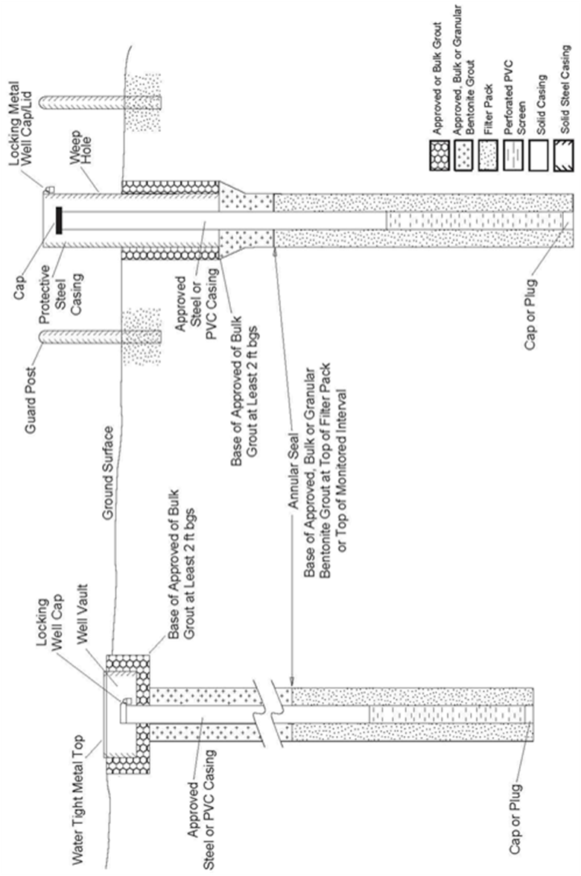

Figure 13.a. Schematic diagrams of typical monitoring and observation hole/well designs.
FIGURE 13.b (CONTINUED) MONITORING AND OBSERVATION HOLES/WELLS
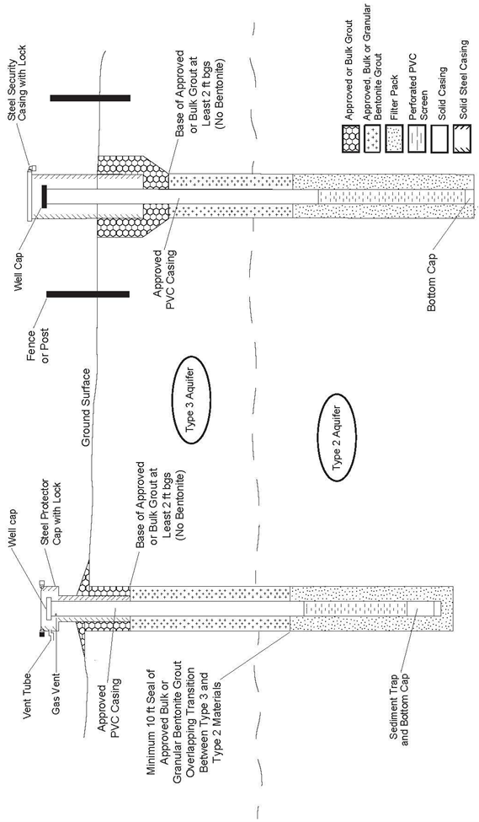
Figure 13.b (continued) Schematic diagram of typical monitoring and observation hole/well designs

Rule 15 Minimum Disinfection Standards
Basis and Purpose: The statutory authority for this Rule is found in sections 37-91-101(1); 37-91- 104(1)(c); 37-91-106(3); and 37-91-110(1)(b) & (2), C.R.S. The purpose of this Rule is to require completed groundwater excavations be properly decontaminated for the use for which they were constructed.
15.1 General Rule - All materials installed in wells or cistern must be thoroughly and carefully cleaned and disinfected to ensure that all harmful or disease-carrying or causing organisms are eliminated. All areas of the well or cistern, including the full casing length and filter pack, must come in contact with the disinfecting solution as provided for in this Rule. Gravel pit or pond/lake wells are exempt from this disinfection requirement. Monitoring and observation holes and wells, dewatering wells, and recovery wells where the use of a disinfectant may interfere with the purpose of the hole or well, are exempt from this Rule.
15.2 Disinfection Solution
15.2.1 Disinfection of wells must be accomplished with chlorine solution or chlorine compounds in solution.
15.2.2 Compressed or pelletized chlorine tablets must not be introduced directly into the well or cistern. Such tablets may be used if mixed into a liquid solution prior to placement into the well or cistern. After initial well disinfection, chlorine tablets may be used as part of regular disinfection or maintenance of the well.
15.2.3 Prior to the use of other disinfectants, a written request must be submitted and written approval obtained from the Board.
15.2.4 Sufficient disinfectant must be used to produce a minimum concentration of one hundred (100) mg/l (milligrams per liter or parts per million) chlorine when disinfecting as required in Rule 15. (see Table 3).
15.2.5 Dry disinfectants used in the preparation of solutions must not be outdated, must be full strength, and must be prepared to the required concentration in accordance with the manufacturer's directions for mixing.
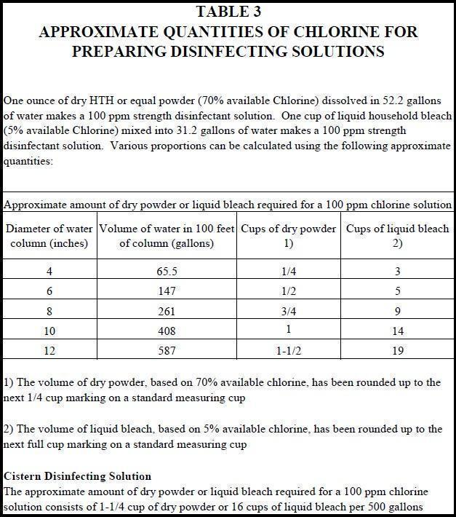
15.3 Placement All wells and cisterns must be disinfected after completion of well construction, cistern installation, and after installation of production equipment. After completion of construction of the well, agitation of the solution is best accomplished through use of a pump and recirculation. If no pump is available, a bailer or plunger must be used. After installation of the pumping equipment, the disinfectant solution must be thoroughly circulated through the entire well and installed water well supply system. When a new pump or well water supply system is connected to, or a replacement pump is installed in, an existing municipal or commercial water distribution system that has been disinfected in the past, the disinfection solution must be distributed up to the point of isolation between the new/replacement pump and the rest of the system.
15.4 Contact Time The disinfection solution must be in contact with the well, cistern, pump and distribution system for sufficient time to eliminate any harmful bacteria.
15.4.1 Decontamination of newly-installed wells and cisterns constructed using water from a public supply source must be accomplished by adding and mixing enough disinfectant to reach a concentration of at least one hundred (100) milligrams per liter. The disinfectant must be left in the well for a minimum ten (10) hours and must not be intentionally disturbed after that time until the pump is installed.
15.4.2 Upon completion, all wells drilled, developed, or stimulated without using water obtained from a public supply source must be flushed, cleaned, and disinfected with a minimum chlorine concentration of five-hundred (500) mg/l. This disinfectant must remain in the well for a minimum of twelve (12) hours.
15.4.3 Following the installation of new pumps in new or existing wells or cisterns, the reinstallation of a pump back into a well or cistern, or the transfer of an existing pump from an original well or cistern into a replacement well or cistern, the well, cistern, pump, and the distribution system must be disinfected. After placement, mixing, and circulation, the disinfectant solution having a concentration of at least one hundred (100) milligrams per liter must remain undisturbed in the well and distribution system for as long as possible, but not less than three (3) hours, after which time, the residual chlorine concentration must be at least twenty five (25) milligrams per liter.
15.5 Flushing of Disinfectant After disinfection by the pump installer in accordance with Rule 15.3 and prior to the use of water, the remaining disinfectant solution must be thoroughly flushed from the well and water supply system and disposed of properly. The disinfectant solution must not be discharged into the surface waters of the State (see Rule 6.8).
15.6 Test Equipment Disinfection All equipment inserted into wells for sampling, measuring, and test-pumping must be disinfected prior to being used in a well unless the entire well will be disinfected after completion of the testing operations. Disinfection of the test equipment must consist of contact with a solution having a minimum concentration of three hundred (300) milligrams per liter total chlorine for a period of not less than fifteen (15) minutes.
15.7 Tanks and Vessels for Hauling and Storing Water for Drilling - Tanks used for hauling water to the drilling site and any vessel used to store water for drilling purposes must be constructed of a material approved for use with potable water and must be regularly decontaminated. Tanks or vessels used for hauling and/or storage of hydrocarbons, waste materials, chemicals, or other contaminants may not be used for hauling or storing water for drilling purposes.

Rule 16 Standards for Plugging, Sealing, and Abandoning Wells and Boreholes
Basis and Purpose: The statutory authority for this Rule is found in sections 37-91-101(1); 37-91- 104(1)(c), (j), & (k); 37-91-106(3); 37-91-109(1); and 37-91-110(2), C.R.S. The purpose of this Rule is to identify the minimum standards for the proper abandonment of water wells and other excavations constructed into the ground that, if not adequately sealed and abandoned, present a risk to the health and safety of Colorado’s shared groundwater resources.
16.1 General - The plugging, sealing, and abandonment of all wells, monitoring and observation wells, monitoring and observation holes and test holes that are no longer intended for use, and the plugging, sealing, and abandonment of collapsed or unusable boreholes, and other incomplete wells or excavations is necessary to prevent contamination of groundwater and the migration of water through the borehole. It is the ultimate responsibility of the well owner to have an existing well properly plugged, sealed, and abandoned. The well construction contractor or authorized individual is responsible for notifying the well owner in writing of these plugging requirements. Proof of this written notification must be provided to the State Engineer, if requested.
16.1.1 Pumping equipment must be removed from the well prior to plugging, sealing and abandonment of the borehole.
16.1.2 In the event a borehole(s) is not completed for the intended purpose, the contractor will notify the well owner, in writing, of the well owner’s responsibility for the proper abandonment of the borehole(s) according to Rule 16.1. Proof of this written notification must be provided to the State Engineer, if requested. If the well owner does not agree to allow the contractor to abandon the borehole(s), the contractor must notify the Board of Examiners, in writing, of the existence of the borehole(s) and the contractor's effort to notify the well owner of the well owner’s abandonment responsibilities under Rule 16.1
16.1.3 Persons Authorized to Plug, Seal, and Abandon Wells:
16.1.3.1 Licensed water well construction contractors are authorized to plug, seal, and abandon all types of wells or holes.
16.1.3.2 Licensed pump installation contractors may plug, seal and abandon only those wells that do not require the removal of casing that penetrates more than one aquifer or the ripping or perforating of casing opposite confining units.
16.1.3.3 Authorized individuals may plug, seal, and abandon only those monitoring and observation wells and holes, dewatering wells, piezometer holes, and test holes that do not penetrate through a confining unit.
16.1.3.4 Private Drillers/Private Pump Installers (Well owners) may plug, seal, and abandon only those wells they own that do not require the removal (with the exception of cutting the top of the casing off below the ground surface per Rule 16.1.4), ripping, or perforating of casing in accordance with this Rule 16. Private Drillers/Private Pump Installers (Well owners) abandoning their own wells must consult with a licensed water well construction contractor or Board staff prior to abandoning their well.
16.1.4 Materials used for backfilling must be clean, inert, and free from contaminants. The well casing may be cut off below land surface so that it will not interfere with the anticipated use of the land. If the casing is cut off below land surface, the uppermost five (5) feet of the remaining casing must be filled with grout or a watertight cover must be permanently attached to the remaining casing and the excavation filled with materials that are not more permeable than the surrounding soils and adequately compacted to prevent settling.
16.1.5 Grout materials and method of placement of grout for the abandonment of wells, boreholes, or dry holes must be in accordance with Rule 10.5
16.2 Abandonment of Wells, Boreholes, or Dry Hole in Type 1 Aquifers (confined aquifers), Laramie-Fox Hills Aquifer - Wells or Dry Holes which penetrated through one or more confining units must be plugged and sealed by placing approved grout in the well or borehole within each confining unit interval.
16.2.1 If well construction records do not show that the casing opposite each confining unit was grouted when originally constructed prior to December 15, 1972 or grouted at each confining layer in accordance with the Rules in place at the time of construction, the casing must be either completely removed from the hole, or perforated or ripped throughout the entire confining unit interval(s) that was not originally grouted. Approved grout must be placed in a manner that will fill the well casing, annulus and/or borehole throughout the entire confining unit interval(s). If the confining unit intervals are less than 60 feet, the grout interval must be no less than 60 feet in length and must be designed to withstand the maximum potential hydrostatic pressure differential between the aquifers. The well casing or borehole, except for the grout plug intervals, must be completely filled to the land surface with clean native clays, approved grout, or high-solid bentonite grout. A watertight cover must be permanently welded or attached to the top of the casing.
16.2.2 If well construction records show that the casing opposite each confining unit was grouted when originally constructed prior to December 15, 1972 or grouted in accordance with the Rules in place at the time of construction, a plug of approved grout must be placed beginning at the base of each confining unit interval. Plugs must be no less than sixty (60) feet in length and must be designed to withstand the maximum potential hydrostatic pressure differential between the aquifers. The well casing, except for the grout plug intervals, must be completely filled to the land surface with clean native clays, approved grout, or high-solid bentonite grout. A watertight cover must be permanently welded or attached to the top of the casing.

16.3 Abandonment of Wells or Boreholes in Type 2 (unconfined bedrock aquifers), Type 3 Aquifers (unconsolidated aquifers) and Unconfined San Luis Valley aquifer - Wells completed into, or Dry Holes terminated in, unconfined bedrock aquifers and unconsolidated aquifers must be plugged, sealed, and abandoned by filling the well to the static water level with clean sand, clean gravel, approved grout or coated (to delay hydration) granular bentonite. Between the static water level and the ground surface, the borehole must be filled with clean native clays, approved grout, drill cuttings, or granular bentonite grout to the ground surface. The uppermost five (5) feet of casing must be filled with approved grout or a permanent watertight cover must be installed at the top of the casing. If casing is removed, the hole must be filled as described above to within five (5) feet of the ground surface. The top five (5) feet of the hole must be filled with materials that are not more permeable than the surrounding soils that are adequately compacted to prevent settling.
16.4 Abandonment of Wells or Boreholes in the Confined San Luis Valley Aquifer - Wells, boreholes or dry holes which penetrate into the Confined San Luis Valley Aquifer must be plugged and sealed by placing approved grout in a manner that will fill the well casing and/or borehole throughout the entire interval beginning 10 feet below the top of the Confined San Luis Valley aquifer and extending up to the top of the well. The base of the grouted interval must extend deeper below the top of the Confined San Luis Valley aquifer if necessary to withstand the maximum potential hydrostatic pressure differential between the aquifers. If well construction records do not show that the casing opposite the Unconfined San Luis Valley Aquifer was appropriately grouted to isolate the Confined San Luis Valley aquifer when originally constructed, the casing must be either completely removed from the hole, or perforated or ripped beginning at least 10 feet below the top of the Confined San Luis Valley aquifer up to the ground surface or up to the originally grouted interval documented on the construction records, prior to grouting. The well casing or borehole, except for the grout plug intervals, must be completely filled with clean native clays, approved grout, or high-solid bentonite grout. A watertight cover must be permanently welded or attached to the top of the casing.
16.5 Abandonment of Other Structures:
16.5.1 Abandonment of Dewatering Wells, Monitoring and Observation Holes, and Piezometer Holes - Dewatering wells, monitoring and observation holes, and piezometer holes must be plugged, sealed, and abandoned pursuant to Rules 16.2, 16.3 or 16.4, as appropriate per the Aquifer Type completed in.
16.5.2 Abandonment of Test Holes. – Air sparge structures, test holes, inclinometers, or soil vapor extraction wells that do not penetrate a confining unit must be plugged, sealed, and abandoned pursuant to the requirements of Rule 16.3 or by removing any casing or equipment from the hole and backfilling the hole with drill cuttings, clean native clays, approved grout, or granular bentonite grout to the ground surface, and adequately compact the material to prevent settling. Air sparge structures, test holes, inclinometers, or soil vapor extraction wells that penetrate through a confining unit must be abandoned per Rule 16.2.
16.5.3 Abandonment of Fully Grouted Vibrating Wire Piezometers - If the vibrating wire equipment and the full length of the borehole was fully grouted with a low-permeability cement-based grout at the time of construction, no further abandonment is required by these Rules.
16.5.4 Cistern - Cisterns must either be disconnected from the water well supply system, or the cistern must be abandoned by one of the following methods: by removing the cistern and backfilling the hole with materials that are not more permeable than the surrounding soils that are adequately compacted to prevent settling; by filling the cistern with clean native clays, approved grout, or natural soils that are not more permeable than the surrounding soils and permanently affixing a watertight cover on the portal.
16.6 A well for which a replacement well has been permitted and constructed must be plugged, sealed, and abandoned within sixty (60) days after the completion of the replacement well, unless otherwise stated on the original well permit or if the original well is re-permitted by the State Engineer.

Rule 17 Reporting Requirements
Basis and Purpose: The statutory authority for this Rule is found in section 37-91-110(2), C.R.S. The purpose of this Rule is to require the submittal of reports concerning the construction of certain excavations as necessary for documenting the location of such excavations, gathering information about hydrogeological conditions of Colorado, and for ensuring compliance with permits and water rights requirements.
17.1 Work Reports - Reports must be submitted to the State Engineer on prescribed forms that describe where, when, and how all wells and certain holes have been constructed, the pumping equipment has been installed in water wells, a cistern connected to a water well supply system has been installed and a description of how boreholes, wells, dry holes, and incomplete wells are plugged, sealed, and abandoned.

17.1.1 Well Construction and Yield Estimate Report - Well construction contractors, authorized individuals, or private drillers must report where, how, and when a test hole penetrating a confining unit between two distinct aquifers, a well, or a monitoring and observation hole/well was drilled. The report must also describe the specifics of each well or hole construction and include a lithologic log of the geology, and a geophysical log if required by the permit or otherwise obtained from the borehole. The report must also contain detailed information from the well yield estimate in accordance with Rule 12, the method and duration of well development and what criteria was used to evaluate the completion of development, the type and quantity of disinfectant used, and the method of disinfection used that was suitable to treat the entire well.
17.1.2 Dry Hole Construction Report - A Dry Hole Construction Report must be submitted for each borehole that was not completed as a well due to insufficient water for the permitted use(s). The report must describe the specifics of each borehole, a lithologic log of the geology and a description of any partial well construction. A Dry Hole Construction Report is intended to provide information for the borehole and hole construction of the attempted well and will not prevent additional attempts to construct a well under the same valid permit.
17.1.3 Pump Installation Report - Pump installation contractors and private pump installers must submit a pump installation report every time a new pump is installed in a well or for any change in the pump depth setting. The report must describe the: pump; date of installation; the pump intake depth setting; static water level; the results from the production equipment test required by Rule 12; and the type and quantity of disinfectant used according to the provisions of Rule 15.
17.1.4 Well Yield Test Report – Well construction contractors, pump installation contractors, authorized individuals, and private drillers/pump installers must submit a well yield test report if a well yield test (pumping or aquifer test) is performed in accordance with Rule 12.6
17.1.5 Well Abandonment Report - A Well Abandonment Report must be submitted for each test hole or dewatering well penetrating a confining unit between two distinct aquifers, well, incomplete well/dry hole, monitoring and observation hole or well, or dewatering system that has been plugged, sealed, and abandoned. The report must identify the abandoned well or hole by location and permit number, monitoring hole number, or other official identification of location. The report must contain a detailed description of how the well or hole was plugged, including types and amounts of materials used, and the placement method and intervals of those materials. A Well Abandonment Report must be submitted to the State Engineer upon the cessation.
17.1.6 Dry Hole Abandonment Report - The report must contain a detailed description of how the dry hole was abandoned, if abandonment was performed. A Dry Hole Abandonment Report is intended to provide information for the abandonment of the attempted well and will not prevent additional attempts to construct a well under the same valid permit.
17.1.7 Gravel Pit, Pond, or Lake Well Construction Report: After initiating the construction of gravel pit, pond, or lake well permitted pursuant to sections 37-90-107(6), -137(2), or -137(11), C.R.S., and in lieu of a well construction report form prescribed by the State Engineer, the owner shall submit site plan and cross-section drawings showing the extent of the intended excavation, the maximum depth of the pit or pond, the initial static water level, and the date of initial groundwater exposure to the atmosphere.
17.1.8 Cistern Installation Report – Pump installation contractors or private pump installers must submit documentation that a cistern connected to a new or existing water well supply system was installed and disinfected.
17.1.9 Post-Construction Well Inspection Report – When a Well Construction and Yield Estimate Report has not been submitted for a well constructed on or after May 8, 1972, the owner must provide a Post-Construction Well Inspection Report. The Post- Construction Well Inspection Report must be signed by a licensed contractor or authorized individual.
17.1.10 Well Vault Installation Report - When a variance has been approved to install a well vault, the licensed contractor or private driller or private pump installer must submit a Well Vault Installation Report. The report must contain as-built data and comprehensive photographic documentation of newly installed well vaults. Photos must show 360° around the wellhead and the base of the vault including the floor drain or sump pump location. If the vault includes a floor drain, a photo must document the surface outfall of the drain.
17.2 Format of Reports Work reports must be submitted on forms provided by the State Engineer or on computer-generated forms that have been previously approved by the State Engineer. Incorporation of as-built drawings is encouraged, but must be on sheets no larger than 8½ x 11 inches. All data requested on the form must be reported accurately.
17.3 Timely Submittal Complete work reports must be submitted to the State Engineer within sixty (60) days after completion of the well construction, pump installation, or other work required to be reported or within seven (7) days after the expiration of the permit or other authorization, whichever is sooner.

17.4 Certification Work reports must be signed and certified as to accuracy and truthfulness of the information on the report by the well construction or pump installation contractors or authorized individuals responsible for the work performed by them or under their direction or supervision, or by the private driller or private pump installer if the work was performed by them. Such reports are deemed to be completed, signed and certified under oath.
17.5 Unsanitary or Non-Compliant Conditions A licensed contractor who repairs an existing well or pump must report to the Board of Examiners any unsanitary or noncompliant conditions that he or she is unable to correct.
17.6 Copy of Report to Owner Well construction and pump installation contractors must provide a copy of all work reports to the well owner in accordance with Rule 17.3.
17.7 Water Quality Reports If water quality analyses for newly constructed wells are obtained by or are available to the well or pump installation contractor, a copy of that analysis must be provided to the State Engineer upon request by the State Engineer. The well location, date of analysis, and the permit number or other identifying authorization must be shown on the report.
17.8. Data Confidentiality In the event that the information provided contains trade secrets, privileged information, or confidential commercial, financial, geological, or geophysical data, and upon written request by the well owner, the information will be kept confidential pursuant to section 24- 72-204(3)(a)(IV), C.R.S.

Rule 18 Variances
Basis and Purpose: The statutory authority for this rule is found in sections 37-91-101(1); 37-91-104(1)(c), (j), (k) & (2); 37-91-106(3); 37-91-109(1); and 37-91-110(2), C.R.S. The purpose of this Rule is to allow the Board to approve alternate methods of construction or abandonment of an excavation over which it has jurisdiction, in the event that the individual requesting such alternative to the minimum standards can adequately demonstrate that the variance will protect the health and safety of the public and prevent contamination to Colorado’s groundwater.
18.1 General When the strict application of any provision of these Rules presents practical difficulties or unusual hardship, the Board may grant a variance for a specific instance or method of construction and may impose any conditions deemed necessary to protect the groundwater and aquifers from contamination.
18.2 Written Request Required - Any request for a variance must be submitted to the Board of Examiners in writing and must be signed by the well owner or his or her agent. Such request must specify:
a. the nature and reason for seeking the variance,
b. the proposed construction details (diagram of proposed structure), and
c. special precautions that will be taken to protect the well from contamination.
18.2.1 A written request for a variance from the Rules must be submitted to the Board and approval of the variance obtained prior to construction of the well. During the construction of a well, if circumstances or conditions at the well site require variance from these Rules, the contractor may request a variance from the Board of Examiners by telephone, AskDWR, or email and must obtain approval for the variance prior to completing construction of the well.
18.2.2 Pursuant to section 37-91-104(2), C.R.S., the Board may delegate to Staff of the State Engineer the authority to review and approve or deny certain requests for variances from these Rules. Where Staff acts on behalf of the Board under this Rule pursuant to the Board’s delegation of authority, the individual requesting the variance may appeal the Staff’s decision to the Board at the next regularly-scheduled Board meeting.
18.3 Written Decision - The Board will respond in writing to each variance request, and must include reasons for its decision. The Board may impose terms and conditions to protect public health and safety or prevent aquifer contamination.
18.4 Appeal - The Board’s written decision on the request for variance is final agency action. The individual who requested the variance may request the Board’s reconsideration of the Board’s written decision at the next regularly scheduled Board meeting following issuance of the written decision. Any appeal of the Board’s written decision must be pursuant to the State Administrative Procedures Act, Article 4 of title 24, C.R.S.

Rule 19 Emergencies
Basis and Purpose: The statutory authority for this rule is found in sections 37-91-101(1); 37-91-102; 37- 91-104(1)(c), (j), & (k); 37-91-106(3); 37-91-109(1); and 37-91-110(2), C.R.S. The purpose of this Rule is to ensure that, even in the case of an emergency, excavations under the Board’s jurisdiction must still be constructed upon approval of the State Engineer.
In accordance with the procedures of the State Engineer, in the event of an emergency, construction of replacement wells, monitoring and observation holes, temporary dewatering wells, or recovery wells may begin only after approval has been granted by the State Engineer. The well construction contractor or authorized individual that has received approval from the State Engineer must comply with all conditions of such approval.

Rule 20 Petitions for Declaratory Orders
Basis and Purpose: The statutory authority for this rule is found in section 24-4-105(11). The purpose of this Rule is to comply with the requirement of section 24-4-105(11) and provide the Board’s procedures for entertaining, in its discretion, any petitions for declaratory orders to terminate controversies or to remove uncertainties as to the applicability to the petitioners of any statutory provision or of any rule or order of the agency.
20.1 General – pursuant to section 24-4-105(11), C.R.S., this rule provides procedures for the Board’s entertaining of petitions for declaratory orders to terminate controversies or to remove uncertainties as to the applicability to the petitioner of any statutory provision or of any rule or order of the agency. The order disposing of the petition constitutes agency action subject to judicial review. The Board retains the right to determine, in its sound discretion, whether to entertain any such petition submitted pursuant to this Rule. See § 24-4-105(11), C.R.S.
20.2 Petition for Statement of Position – Any person may petition the Staff for a statement of position concerning the applicability to the petitioner of any provision of these Construction Rules, or any regulation of the Board. The Staff shall respond with a written statement of position within 30 days of receiving a proper petition.
20.3 Petition for Declaratory Order – Any person who has properly petitioned the Staff for a statement of position, and who is dissatisfied with the statement of position, or who has not received a response within 30 days of the petition, may petition the Board for a declaratory order pursuant to section 24-4-105(11), C.R.S. Such petition must be submitted to the Chief Well Inspector or a member of his or her staff within 30 days of the date of the Staff’s written statement of position. A petition for declaratory order must include the following:
a. The name and address of the petitioner.
b. Whether the petitioner holds an active license issued by the Board.
c. Whether the petitioner is involved in any pending administrative hearings with the Board.
d. The language of the statute, rule, or order of the Board to which the petition relates.
e. A concise statement of all facts necessary to show the nature of the controversy or the uncertainty as to the applicability of the statute, rule, or order of the Board to which the petition relates.
f. A concise statement of the legal authorities, if any, and other reasons or authorities upon which the petitioner relies.
g. A concise statement of the declaratory order sought by the petitioner.
20.4 Board’s Exercise of its Discretion to Entertain a Petition – The Board will determine, in its discretion and with no prior notice to the petitioner, whether to entertain any petition. If the Board decides it will not entertain a petition, it shall promptly notify the petitioner in writing of its decision and the reasons for that decision. Any of the following grounds are sufficient reason to refuse to entertain a petition:
a. The petitioner failed to properly petition the Staff for a statement of position, or if a statement of position was issued, the petition for declaratory order was filed with the Board more than 30 days after the Staff issued its statement of position.
b. A ruling on the petition will neither terminate the controversy nor remove uncertainties concerning the applicability to petitioner of the statute, rule, or order in question.
c. The petition involves a subject, question, or issue that is currently involved in a pending hearing before the Board or the State Engineer’s Office, or that is involved in an on-going investigation conducted by the Board, or that is involved in a written complaint previously filed in any state court or with the State Engineer’s Office.
d. The petition seeks an order on a moot or hypothetical question.
e. The petitioner has some other adequate legal remedy, other than an action for declaratory relief pursuant to C.R.C.P. 57, that will terminate the controversy or remove any uncertainty concerning applicability of the statute, rule, or order.
20.5 If Board Entertains a Petition – If the Board determines that it will entertain the petition for declaratory order, it must notify the petitioner within 30 days of making such determination, and the following procedures will apply:
a. The Board may expedite the hearing, so long as the interests of the petitioner will not be substantially prejudiced thereby, by ruling on the basis of the facts and legal authority presented in the petition, or by requesting the petitioner or the Staff to submit additional evidence and legal argument in writing.
b. In the event the Board determines that an evidentiary hearing or legal argument is necessary to a ruling on the petition, a hearing must be conducted in accordance with the state Administrative Procedures Act. The petitioner will be identified as Respondent.

c. The parties to any proceeding pursuant to this rule shall be the petitioner/Respondent and the Staff. Any other interested person may seek leave of the Board to intervene in the proceeding and such leave may be granted if the Board determined that such intervention will make unnecessary a separate petition for declaratory order by the interested person.
d. The declaratory order shall constitute a Final Agency Action subject to judicial review pursuant to section 24-4-106, C.R.S.
20.6 Records of Petitions and Declaratory Orders – Files of all petitions, requests, statements of position, and declaratory order will be maintained by the Board. Such files will be available for public inspection, except for any material required by law to be kept confidential. The Board will post a copy of all statements of position and declaratory orders constituting Final Agency Action on the Board’s web site.

Rule 21 Severability
If any portion of these Rules is found to be invalid, the remaining portion of the Rules shall remain in force and unaffected.

Rule 22 Revisions
The Board may revise these Rules in accordance with section 24-4-103, C.R.S.

Rule 23 Effective Date
These revised Rules shall become effective January 1, 2026.

Rule 24 Statement of Basis and Purpose
The Statement of Basis and Purpose for these Rules is incorporated herein by this reference.

Editor's Notes
History
Entire rule eff. 01/01/2005.
Entire rule eff. 09/01/2016.
Rule 6.3 eff. 07/01/2018.
Entire rule eff. 01/01/2026

STATEMENT OF BASIS AND PURPOSE
RULES AND REGULATIONS FOR WATER WELL CONSTRUCTION, PUMP INSTALLATION, CISTERN INSTALLATION, AND MONITORING AND OBSERVATION HOLE/WELL CONSTRUCTION
2 CCR 402-2
______________________________________________________________________

RULE 1 TITLE
These Rules have been referenced by different titles over the years. Generally, the Rules apply to those structures over which the Board has jurisdiction, which are referenced in the title of the Rules.

RULE 2 AUTHORITY
The authority of the Board of Examiners of Water Well Construction and Pump Installation Contractors (“Board”) to promulgate these Rules arises from the general assembly’s creation of the Board to ensure protection of the groundwater resources of the State of Colorado and public health and safety. See § 37-91-101, C.R.S. This Rule cites the specific statutory authority of the Board to promulgate minimum standards for certain activities and for the construction of certain types of structures, and to revise such regulations in accordance with the Board’s statutory authority and the State Administrative Procedure Act of article 4 of title 24, C.R.S.

RULE 3 SCOPE OF RULES
The statutory authority for this Rule is found in sections 37-91-101(1); 37-91-102; 37-91-104(1)(c), (j), & (k); 37-91-106(3) & (4); and 37-91-110(2), C.R.S. The purpose of this Rule is to identify the activities and individuals to which these Rules apply.
Rule 3.4 identifies all materials incorporated by reference in these Rules as authorized by section 24-4-103(12.5), C.R.S, and explains how copies of such materials may be obtained.
Rule 3.5 clarifies the jurisdiction of these Rules are limited to the State of Colorado and not necessarily the Southern Ute Indian Reservation.

RULE 4 PURPOSE OF RULES
The statutory authority for this rule is found in sections 37-91-104(1)(c), (j), & (k); 37-91-106(3) & (4); and 37-91-110(2), C.R.S. The purpose of this Rule is to identify the broad purposes for the Rules as a whole. These Rules specify minimum standards for construction materials and methods. As required by Rule 10.1.1, when mandated by geologic, hydrogeologic, or well construction conditions, a licensed contractor must apply or use higher standards, higher grade construction materials, and more thorough site-specific construction and installation methods to comply with the purpose of these Rules.
Rule 4.6 was added to the Rules under the authority of section 37-91-106(4).

RULE 5 DEFINITIONS
The statutory authority for this Rule is found in sections 37-91-101(1); 37-91-102; 37-91-104(1)(c), (j), & (k); 37-91-106(3) & (4); and 37-91-110(2), C.R.S. The purpose of this Rule is to identify the terms used throughout the Rules.
Section 37-91-102, C.R.S. defines nineteen terms used in these Rules and provides verbatim the statutory language of all terms defined by the General Assembly. This Rule also defines additional terms to ensure that their meanings and usage are clearly understood.
The definitions of the different aquifer “types” in Rule 5.2 include two particular aquifers (Laramie-Fox Hills and Confined San Luis Valley) and three other specific administratively-defined aquifers (Unconfined San Luis Valley, High Plains, and Southern High Plains). In order to properly regulate construction of wells drilled into different geological formations in Colorado, it is necessary to classify and define distinct aquifer types according to their hydrogeological characteristics. Although Colorado has distinct, named aquifers, these aquifers may be found with localized or regional geologic features. For example, certain Denver basin aquifers may be a Type 1 or Type 2 aquifer, depending on the specific subsurface position of the aquifer. Therefore, these Rules designate five types of aquifers, and specific construction standards for each type, in order to ensure that a well constructed in a particular location will be constructed to protect the groundwater resources of the State of Colorado based on the characteristics of the aquifer at that location.
Rule 5.2.1 describes the geographic area which includes the Denver Basin Aquifers (referenced in Figure 1)
Rule 5.2.2 clarifies annular space also includes the space between the inner and outer casing strings when those casings overlap.
Rule 5.2.3: Aquifer Type numbers were changed from Roman to Arabic for clarity. The Rules provide different construction requirements for three general classifications of aquifers (Types 1-3) and two particular aquifers (Laramie-Fox Hills and Confined San Luis Valley). Three other aquifers (Unconfined San Luis Valley, High Plains and Southern High Plains) are defined within the Rules for clarity, but the construction requirements for Unconfined San Luis Valley, High Plains and Southern High Plains follow the Rules for other defined aquifer types or are prescribed by permit condition.
Rule 5.2.3.1 defines those hydrogeologic units described in State Engineer rule, well permit, decree, or an annually-updated list of aquifers approved by the Board.
Rule 5.2.3.2: Type 1 aquifer refers to an aquifer overlain by a confining geologic layer, regardless of whether the aquifer is confined based on hydrostatic pressure. In some cases, Type 1 aquifers may become ‘unconfined’ based on changing water levels, thereby affecting the hydrostatic pressure of the aquifer.
Rule 5.2.3.3: Type 2 aquifers, while not overlain by a confining layer, may or may not underlie a Type 3 (unconsolidated aquifer).
Rule 5.2.3.4: Type 3 wells are those drilled into unconsolidated materials and identifies that impermeable layers that do not act as hydraulic boundaries may exist within these deposits, and not as a confining unit as defined in these Rules.
Rule 5.2.3.5 defines the Laramie-Fox Hills aquifer as a separate aquifer type, because of unique issues of poor water quality found in this aquifer and adjacent geologic units. There is an increasing reliance by homeowners and communities on this aquifer in areas without other viable water supplies. These Rules identify specific minimum construction standards for wells drilled into the Laramie-Fox Hills aquifer. The Laramie-Fox Hills aquifer is also administratively defined in the Denver Basin Rules, 2 CCR 402-6 (1985) See Rule 10.4.8
Rule 5.2.3.6 is the administratively-defined Unconfined San Luis Valley aquifer above the Blue Clay (confining layer) and identified as Layer 1 in the RGDSS Groundwater Model. It is a Type 3 aquifer for the purposes of well construction and abandonment (previous BOE Policy 2003-3).
Rule 5.2.3.7 is the administratively-defined Confined San Luis Valley aquifer, as defined in the Rules Governing New Withdrawals of Ground Water in Water Division 3 Affecting the Rate or Direction of Movement of Water in the Confined Aquifer System (Confined Aquifer New Use Rules for Division 3), and is identified as Layers 2, 3, 4, and 5 in the RGDSS Groundwater Model. See Rule 10.4.9
Rule 5.2.3.8 describes the administratively-defined Northern High Plains aquifer, as described in Rule 5.2.2 of the Rules and Regulations for the Management and Control of Designated Ground Water (Designated Basin Rules, 2 CCR 410-1). It further clarifies the distinction that within the Northern High Plains Designated Basin the alluvium is also included with the High Plains aquifer and they are therefore considered a single hydrogeologic unit, considered a Type 2 aquifer (previous BOE Policy 2021-2).
Rule 5.2.3.9 describes the administratively-defined Southern High Plains aquifer, as described in Rule 5.2.3 of the Rules and Regulations for the Management and Control of Designated Ground Water (Designated Basin Rules, 2 CCR 410-1), and clarifies it is a Type 2 aquifer (previous BOE Policy 2017-3).
Rule 5.2.4, the definition of “Authorized individual,” was modified in order to allow for an individual not registered as a professional geologist or professional engineer to request designation by the Board as an Authorized Individual based on unique qualifications and experience, and on a case-by-case basis.
Rule 5.2.8 added three sub-definitions of casing to describe the difference between temporary surface casing, surface casing, and production casing, as typically described in well construction. Temporary surface casing (Rule 5.2.8.1) is used on a short-term, non-permanent basis to hold back shallow unstable materials to allow the placement of permanent casing and construction of the well. Surface casing (Rule 5.2.8.2) is nonperforated, steel casing permanently installed in the well. Production casing (Rule 5.2.8.3) is installed through the production zone and may either extend up into surface casing or be driven as the only casing string.
In Rule 5.2.10, the definition of “Cistern” was modified in order to distinguish cisterns used for domestic water supply from an “artificial reservoir” such as livestock storage tanks or other device not intended for public or domestic use.
Rule 5.2.13: this definition was changed from confining layer to confining unit to better describe the performance of the overall zone acting to impede groundwater flow. Confining layers are administratively defined for the Denver Basin and for Designated Ground Water Basins. Confining layers between aquifers outside of these administratively-defined areas are those as mapped in geologic literature.
The definition of Contracting was removed from these Rules because it was not used and better belongs in the Administration Rules (BOE Rules, 2 CCR 402-14).
Rule 5.2.28: a definition for “hydraulic fracturing of a water well” was added to the Rules in 2016 because of the increasing use of hydraulic fracturing techniques to stimulate water production for certain wells. Such techniques, if performed in certain hydrogeologic settings, may present a risk to the integrity of confining layers that bound aquifers. See Rule 10.1.6.
In Rule 5.2.33, monitoring and observation holes are distinguished from test holes as those boreholes constructed for the purpose of observing, measuring, or sampling groundwater. Because monitoring and observation holes will be used for monitoring and observing groundwater (and thus will be open holes, presenting a risk of groundwater contamination if not constructed and abandoned properly), they must be registered with the State Engineer and constructed only by an authorized individual. This includes environmental boreholes constructed for repeated observations of groundwater. These are distinguished from “test holes” as defined in Rule 5.2.57. Monitoring and observation holes include holes constructed as air sparge wells that encounter the water table and piezometers.
Monitoring and observation holes/wells include fully-grouted vibrating wire piezometers, but such piezometers are exempted from the requirements to provide notice and the construction standards of Rule 14 if they do not penetrate a confining layer because of the minimal risk for the migration of groundwater given the borehole and instrumentation is fully-grouted at the time of the completion of construction and is not an “open hole” piezometer. Inclinometers and soil vapor extraction wells, and air sparge structures that do not intersection the groundwater and are constructed with an intent/purpose other than to observe, measure, or sample groundwater and are therefore considered test holes.
5.2.54: The definition of “static water level” is meant to limit the potential for reporting a water level on the construction report that has not yet reached equilibrium. The static water level is an important data point for pump installers and scientists researching aquifer conditions and this definition will hopefully result in better reporting.
Rule 5.2.57: The definition of “test hole” was expanded to distinguish such holes, used exclusively for geotechnical, geophysical, or geologic investigation, or soil/rock sampling, from monitoring and observation holes used for observations of groundwater. Holes drilled with the intent of investigating or measuring groundwater are not test holes. Test holes include inclinometers and soil vapor extraction holes.
Rules 5.2.64.3 through 5.2.64.6 were included to distinguish certain specific structures that are not “wells” because they are under the jurisdiction of other entities and agencies (carbon dioxide injection wells and deep geothermal operations) or are part of other construction (recharge and infiltration basins). Though previously included in the 1988 through 1996 versions of the well construction Rules cathodic protection wells are not under the jurisdiction of the Board of Examiners.
Rules 5.2.69 and 5.2.70 define and distinguish between a “well yield estimate” and a “well yield test,” which are two types of procedures designed to estimate or test the stabilized production rate of a well. See Rules 10.8 and 12.

RULE 6 GENERAL RULES
The statutory authority for this Rule is found in sections 37-91-101(1); 37-91-102; 37-91-104(1)(c), (j), & (k); 37-91-106(3); and 37-91-110(2), C.R.S.
Rule 6 implements general statutory provisions that apply to well construction and the installation of pumping equipment. Rule 6 also advises contractors of certain State Engineer’s notice and permitting requirements.
Rule 6.1 explains that the licensing process and those functions associated with obtaining and maintaining a license, previously explained in the Construction Rules, are now found in the BOE Rules, 2 CCR 402-14.
Rule 6.2 clarifies well permit requirements by identifying the types of work for which the State Engineer requires the issuance of a new well permit and specifying that a contractor must determine that a valid well permit exists prior to and during all phases of well construction and installation of pumping equipment. For enforcement purposes, this Rule also requires a copy of the well permit to be available at the well site at all times such work is being performed.
Rule 6.2.2.1 requires all contractors or their direct employees to possess, make available, and post at the well site a copy of the well permit for the well on which work is being performed. This rule also requires compliance with all conditions of approval of well permits, including advance notification of well construction or pump installation. If the applicable well permit includes such a condition, details for compliance with the advance notification requirement will be included in the well permit.
Rule 6.2.2.2 allows a contractor who is unable to verify that a well permit exists or is required for the work being requested on a well or the pumping equipment, to notify the State Engineer of certain work performed and to provide information about repairs to the well, or to pumping equipment involving the replacement of a pump or change in depth, on forms prescribed by the State Engineer. While this Rule recognizes the practical difficulties that a contractor may encounter when performing emergency repairs on an existing well, it does not relieve a contractor of the responsibility for complying with statutory requirements and Rule 6.2.2.
Rule 6.2.3 addresses situations where the State Engineer has issued a well permit authorizing construction of a well at any point within a specified tract of land and provides that the well construction contractor must identify within 60 days of completion the location of the constructed well pursuant to the conditions of the well permit.
Rule 6.3 sets forth the notice requirements of the State Engineer for the construction of dewatering wells and monitoring and observation holes, and for the construction of test holes that will penetrate through a confining layer between aquifers. Rule 6.3.3 clarify who is responsible for providing such notice, and Rule 6.3.4 establishes time periods for completing construction of structures for which notice was given under this Rule.
Table 1 lists the general types of wells and holes, identifies who may construct such wells and holes, identifies when a permit or notice is required prior to construction, and indicates what types of excavations can be constructed and plugged and sealed by a person with a special license. This table was revised to clarify license, permit, and notice requirements.
Rule 6.4 sets forth the conditions under which the State Engineer has deemed that approval of the construction of dewatering wells or monitoring and observation holes with less than the required notice may be obtained.
Rule 6.5 requires all licensed contractors, private drillers, private pump installers and authorized individuals, upon request by the State Engineer or his staff, to identify any well, test hole or monitoring and observation hole/well that they intend to construct or work on within a specified five-day period. This Rule was modified to change the time period from three days to five days in order to allow the Chief Well Inspector to request advance notice of anticipated activities over a longer time period. Such notifications will assist the State Engineer in enforcement and monitoring efforts.
Rule 6.6 establishes that the construction standards of these Rules are minimum standards that contractors must comply with for all hole/well construction, pump installation, and cistern installation. If more stringent or comprehensive standards that apply to the work being performed are set forth in federal, state, county, local or municipal laws, regulations or codes, the contractor must comply with such standards. It is the contractor’s responsibility to know if such more stringent or comprehensive standards exist and to comply with such standards. Under no circumstances will the minimum standards of the Rules serve to insulate a contractor or other individual from complying with the valid and existing requirements of a local, state, or federal jurisdiction.
Rule 6.7 prohibits the use of products and materials which may be health hazards and is patterned after and complies with similar standards established for drinking water regulations. Pipe thread compounds are used on drilling equipment and may commonly be applied generously to ensure an excess amount remains on tools after tightening. Therefore, where such compounds contain hazardous or toxic substances, excess amounts could be left in the well after drilling, which causes a serious risk to public health. The purpose of this rule is to prevent use of materials or products that may pose a risk to public health and safety and to the groundwater resources of Colorado. The concentration of lead allowed in products such as solder and fluxes and requirements for “lead free” materials in Rule was updated in 2025 to conform to the requirements of 40 CFR 143.12(a) of the Safe Drinking Water Act.
Rule 6.8 addresses the disposal of fluids generated during well construction, development or disinfection. The improper disposal of such fluids into the surface or ground waters of the state may contaminate those waters and is therefore prohibited unless authorized by the appropriate agency. The purpose of this Rule is to alert well construction contractors and pump installation contractors so that they can avoid these potential hazards and obtain proper authorization if necessary. The discharge of water to the ground surface as addressed in Policy 2020-3 was left as a policy so that the Board and the Water Quality Control Division (WQCD) of the Colorado Department of Public Health and Environment (CDPHE) may revisit concurrence on the proper methods to handle such discharges.
Rule 6.9. The water used in drilling fluids, developing and cleaning, or hydraulically fracturing or stimulating a well can potentially contaminate both the well and the aquifer. To minimize such hazards, Rule 6.9 requires contractors to obtain such water from an approved public supply and sets forth disinfection requirements for water obtained from a surface or ground water source when an approved public supply is not available. Contractors and authorized individuals must comply with local regulations, and the prior appropriation system, when obtaining water from flowing streams. Information on requirements for using water from rivers and streams can be obtained from the water commissioner or Office of the Division Engineer in the water district at issue.
Rule 6.10 Drilling fluid additives should be specifically approved by the Board. A list will be maintained on the Board’s website. The approval process for new additives will require that information about an additive be brought before the board for review at their regularly scheduled meeting.

RULE 7 LICENSING
Previous versions of these Rules included licensing and bonding requirements in Rule 7 and Rule 8. Those Rules are now found in the Rules and Regulations for Administration of Licensing, Financial Responsibility, Continuing Education, and Remedial Action (BOE Rules), 2 CCR 402-14. To avoid any confusion, and to maintain a consistent Rule numbering system for these Construction Rules, Rule 7 and Rule 8 have been left blank.

RULE 8 FINANCIAL RESPONSIBILITY
Previous versions of these Rules included licensing and bonding requirements in Rule 7 and Rule 8. Those Rules are now found in the Rules and Regulations for Administration of Licensing, Financial Responsibility, Continuing Education, and Remedial Action (BOE Rules), 2 CCR 402-14. To avoid any confusion, and to maintain a consistent Rule numbering system for these Construction Rules, Rule 7 and Rule 8 have been left blank.

RULE 9 WELLS AND HOLES WHICH MAY BE CONSTRUCTED BY PERSONS OTHER THAN LICENSED WELL CONSTRUCTION CONTRACTORS
The statutory authority for this rule is found in sections 37-91-101(1); 37-91-104(1)(c), (j), & (k); 37-91-106(3); and 37-91-110(2), C.R.S. The Purpose of this Rule is to identify the basic types of activities that may be completed by persons that are not licensed for water well construction or pump installation, as well as notification and reporting requirements. Additionally, this Rule identifies certain structures that do not have minimum construction standards.
Thousands of test holes are drilled each year in Colorado to investigate the subsurface geology and to obtain data needed to design buildings, bridges, highways, dams and other structures. The majority of these holes are constructed by soil engineering firms, consultant engineers or geologists with their own equipment, or by specialized firms providing equipment and operators for hire. Generally, these individuals and/or firms do not have experience with water well construction, and thus are unable to qualify to take the examination for a well construction contractor's license.
Large numbers of monitoring and observation holes/wells are constructed every year to monitor fluctuations of the water table and to collect aquifer data or water quality samples. Many of these are located around or within known or suspected locations of contaminated groundwater. Some are required to be located at solid or hazardous waste disposal sites, and wells are now required to monitor for potential contamination from underground storage tanks. Many of these are being constructed by other than licensed contractors, because quite often, licensed water well contractors do not have the specialized equipment necessary to construct test holes and/or monitoring and observation holes/wells.
Rule 9.1 identifies the individual responsibility for compliance with the provisions of the Rules for those holes or wells that can be constructed by persons not licensed for water well construction. Rule 9.1 was reworded to clarify the meaning of the rule. Three specific type of individuals are authorized to construct the structures identified in Rule 9, and those individuals are identified in Rule 9.1.
After consideration of the many different types of excavations which are constructed, the Board determined that the excavations listed in Rule 9.2 could be constructed and otherwise worked on by persons other than a licensed contractor, provided that the excavation does not penetrate through a confining layer between two adjacent aquifers. Where such excavations may penetrate through a confining layer between aquifers, adequate experience, equipment, knowledge, and training is necessary to ensure protection to the aquifers and prevent contamination or interconnection.
Therefore, any excavation that penetrates a confining layer must be constructed by an individual licensed for water well construction, unless a person with requisite knowledge, skill, and training requests and receives a special license issued by the Board under the procedures identified in the BOE Rules, 2 CCR 402-14. The Board recognizes that certain individuals possess the ability to properly construct and abandon wells so as to prevent cross-contamination, who are not licensed contractors or do not have the water well construction experience needed to take the examination for a license. The Board’s intention is to issue a special license to persons meeting the requirements of Section 37-91-105, C.R.S. and the requirements of the BOE Rules, 2 CCR 402-14, who can demonstrate that they know how to properly construct monitoring or observation holes/wells or test holes through a confining layer between adjacent aquifers. This provision should allow geological, geotechnical, and engineering consulting firms to continue their current normal business after obtaining the special license.
Rule 9.2. identifies common types of excavations that may be constructed by an authorized individual. A “horizontal drain” is a type of dewatering system, so it was eliminated in this list to avoid redundancy. Should there be any question as to whether a person is qualified or allowed to construct a particular type of excavation, it is the responsibility of that person to contact the Board of Examiners for a determination as to whether the person is authorized to construct the structure.
Rules 9.2.1 and 9.2.2 set forth the State Engineer’s required notice prior to construction of dewatering wells and monitoring holes and the requirements for filing construction reports for such structures.
Rule 9.3 identifies the specific construction Rules that apply to the construction and the plugging, sealing and abandoning of excavations included in Rule 9.
Rules 9.3.2 and 9.3.3 were added to the Rules. Rule 9.3.2 concerns dewatering wells and dewatering systems that do not penetrate a confining layer and are not constructed in a vertical borehole in order to address confusion concerning the relevant construction standards applicable to such excavations. Dewatering wells and systems are commonly constructed as part of home or commercial construction to eliminate or minimize the presence of shallow groundwater for proper construction, on a temporary or permanent basis. Individuals constructing such excavations must ensure that such excavations prevent contamination of nearby surface water or groundwater, and must comply with any relevant local, state, or federal requirements. Abandonment of such excavations, however, must be performed in accordance with Rule 16.5.1 in order to ensure that such excavations will prevent the rapid infiltration to groundwater of any surface contamination in the future.
Rule 9.3.3 concerns pond or lake “wells,” which will intercept and use groundwater for beneficial use and therefore require well permits from the State Engineer. However, such excavations, to the extent that they do not penetrate a confining layer between aquifers, present minimal risk to groundwater. Therefore, this rule provides no minimum universal construction standards for ponds or lakes permitted as wells by the State Engineer. However, construction of such excavations must ensure that contaminants are prevented from entering the pond or lake.
Rule 9.4 details the requirements for plugging accidental penetrations through a confining layer, in order to prevent the interconnection or cross-contamination of water from different aquifers.
Rule 9.6 prohibits the conversion to a production water well of any excavation constructed pursuant to a notice of intent as provided in Rules 6.3 and in accord with the requirements of Rule 9. This provision stems from the Board’s concern that unlicensed contractors have neither the knowledge, skill, or equipment needed to properly construct excavations that will be eventually converted into water supply wells. The adoption of Rule 9.6 also ensures consistency with Rule 6.1 and Section 37-90-138(3), C.R.S., (which require a permit be obtained from the State Engineer prior to constructing a new well or performing work on an existing well under the authority of the State Engineer) while allowing for the construction of test holes and monitoring and observation holes without engaging the permit process prior to their construction.

RULE 10 MINIMUM CONSTRUCTION STANDARDS FOR WATER WELLS
The statutory authority for this rule is found in sections 37-91-101(1); 37-91-102; 37-91-104(1)(c), (j), & (k); 37-91-106(3); 37-91-109(1); and 37-91-110(2), C.R.S. The purpose of this Rule is to identify the minimum construction standards for water wells or other excavations constructed in different types of aquifers in Colorado, in order to ensure that such construction prevents harm to the public health, will not impair water quality or cause contamination of shared groundwater resources, and will ensure the safety of groundwater resources for Colorado’s existing and future populations.
In general, Rule 10 establishes minimum construction standards for production water wells, injection wells and all other wells, in order to provide for the reasonable life of a well, to produce an adequate supply of groundwater when such water is available, to prevent the intermingling of water between aquifers, and to prevent contamination of the aquifer and the groundwater. These minimum standards do not relieve a contractor from employing more stringent practices or standards in response to specific geologic, hydrologic or construction situations. These construction standards apply to all wells as that term is defined in Section 37-91-102(16), C.R.S., except for those wells that are described in Rule 9.
Rule 10.1 summarizes common industry practices and objectives necessary to prevent injury to humans and livestock and to protect a well from the entry of contaminants.
Rule 10.1.1, requires a licensed contractor to apply or use higher standards, higher grade of materials and/or more thorough and protective, site-specific construction and installation methods to comply with the purpose of these Rules when mandated by geologic, hydrologic or particular construction conditions.
Rules 10.1.2 through 10.1.4 establish the responsibility of the contractor to be informed of potential hazards prior to well construction and set forth requirements that are intended to safeguard humans, animals, and groundwater during the well construction process. Rule 10.1.2 was amended to ensure the contractor is familiar with the geology of all aquifers AND confining layers he/she will encounter and require the contractor to advise well owners of the potential for encountering known poor water quality or contamination.
Rule 10.1.3 clarifies what constitutes a secure cover, seal or cap. Practices of covering boreholes or casing with buckets while not onsite, or the top of casing with tape are not secure.
Rule 10.1.5 requires that nested wells be grouted to prevent intermingling of water from different aquifers in the borehole and thereby prevent the cross-contamination of groundwater from different aquifers.
A rule that previously concerned “gravel pit wells,” was removed from the Rules. A related rule, concerning construction standards for pond or lakes permitted as wells, was added at Rule 9.3.3. The Board does not have jurisdiction over excavations made for the purpose of obtaining or prospecting for minerals, including sand and gravel, even where such excavations are later permitted by the State Engineer as “wells”. See 37-91-102(16)(b)(I).
Rule 10.1.6 addresses hydraulic fracturing of water wells. This rule ensures the fracturing and ensures a more complete well record process does not damage the confining layer between two aquifers.
Rule 10.2 addresses well locations. In selecting well sites, it is important to consider topography, surface drainage, floodplain, and proximity to leach fields, feedlots and corrals, surface water courses, septic tanks, and sewer lines as potential sources for contamination. It is necessary for the contractor to comply with local (city, county, etc.) spacing requirements for distances from potential sources of contamination that may exceed the distances stated in this Rule. Compliance with the Board’s Rules in no way insulates or exempts a contractor from complying with more strict requirements of local jurisdictions. In choosing a well site, consideration must also be given to the accessibility of the location for the construction equipment and for any future repairs to and plugging of the well. The current rules are promulgated to maximize the distance between the well and contaminant sources, but within the practical limits of lot size.
In the event a well must be constructed less than 100 feet horizontally from a potential source of contaminants, or less than 50 feet from a septic tank, sewer line, or other vessel containing contaminants, this Rule establishes a procedure for a greater minimum grouting depth near the surface to provide additional protection from contamination. Figures 4a and 4b are included in Rule 10.2 to illustrate the construction requirements for wells less than 100 feet from a contaminant source or 50 feet from a vessel. The Rule explains procedure and requirements for obtaining a variance from the minimum spacing and/or grouting requirements when those standards present practical difficulties or unusual hardship. The minimum grouting depth requirements of Rule 10.2.3 are based on ensuring protection to the groundwater from sources of contamination nearby for replacement wells.
Rule 10.3 describes well casing criteria. The diameter, wall thickness, and materials of the well casing affect the life of the well and the size of the pump equipment that may be installed. In selecting casing materials, a contractor must consider the type of formations penetrated by the borehole, depth of well, corrosive conditions known or anticipated, and purpose for which the well is constructed. Only steel casing may be used where well casing will be exposed at the surface and/or where substantial weight will be attached to the well casing.
Rule 10.3.1 describes the condition of well casing to be used. Oil field pipe, including gas-line pipe, may be contaminated with residual hydrocarbons and is not suitable for water wells, its use is prohibited. This Rule eliminated the use of used surface casing. Only new casing should be installed in wells because used casing may be corroded or contaminated, even though it may not immediately appear so.
Rule 10.3.2 describes how contractors may use temporary surface casing that is other than steel but that the temporary casing must be removed from the borehole prior to the completion of grouting to allow adequate grout placement between the borehole wall and the outside of the permanent casing.
Rule 10.3.3 addresses minimum well casing diameter requirements. To be more definitive in describing casing diameters, these Rules refer to inside diameter (ID) instead of outside diameters (OD). Minimum steel well casing diameter was increased to 4.5 inches ID to reduce the number of pumps becoming stuck in a well due to biofouling or corrosion. Steel casing with an ID of at least 4.5 inches is available for use by contractors, according to contractors and suppliers. Pumps can commonly become stuck in older steel-cased wells that have an ID of less than 4.5 inches, due to corrosion or other issues. Stuck pumps prevent proper abandonment of wells and may lead to a risk of groundwater contamination. Corrosion is not a concern with PVC casing, and wells constructed using 4-inch ID PVC casing have been shown to be acceptable for wells constructed in certain locations. PVC casing may not be exposed above the ground surface, as required in Rule 10.3.1.
Rule 10.3.4 presents well casing thickness requirements. Adequate casing wall thickness is required to prevent collapse due to hydrostatic pressures. This rule was adjusted in 2025 to allow other schedules (SCH 80, 120) and types (SDR) of PVC casing conforming with ASTM F480 to be used in well construction provided that the strength of the casing is not less than an equivalent diameter Sch 40 casing. This will allow the continued use of Sch 40 PVC casing commonly used by contractor but also allow the selection of higher strength PVC casing to better ensure protection to groundwater resources and provide a longer-lasting well for Colorado well users.
Rule 10.3.5 was added to the Rules to prohibit certain casing perforation methods or designs that leave debris on the inside of the well casing, such as “torch-cut slots.” Debris or protrusions in the inside of the well casing has caused difficulties with removing pumps for service or replacement. Stuck pumps, which may lead to well abandonment procedures that include leaving the pump in place, present a danger to the quality of groundwater resources. Oxygen-acetylene torches are prohibited on well casings less than 5 inches in diameter because they often result in debris left inside the casing. Plasma torches are allowed in all cases because the cuts do not leave debris inside the well casing.
Rule 10.4 outlines required construction procedures for wells. The size of the borehole and casing, and the amount, type and placement method of the grout are construction components important in achieving an effective seal to prevent the entry and/or migration of contaminants into and through the borehole and to confine groundwater production to the specified aquifer or authorized producing interval. This Rule requires that certain minimum depths of steel casing be used at ground surface to protect against breakage and to provide resistance to degradation by sunlight.
Rule 10.4.1 requires centralizers to be installed in all grouted intervals of the production casing in order to maintain the natural seal between aquifers. Casing lengths typically run over 40 feet long, so the minimum distance between centralizers should be no more than 50 feet to allow the well constructor to determine where the centralizers should properly be located on the casing. For grouted intervals that span less than 50 feet, the interval must be centralized at the top and bottom of the grouted interval. Unless centralizers are properly installed to center the production casing in a borehole, grout may not adequately flow around the casing or set at a minimum thickness in order to properly seal the well between aquifers, thereby presenting a risk of aquifer cross-contamination. Further, properly-grouted surface casing is the most important protection against surface contamination. Therefore, this rule was amended in 2016 to require centralizers be installed within five feet of the base of the surface casing, to ensure that the annular space outside of the surface casing is grouted uniformly and the casing is centered in the borehole.
Centralizers can only perform their intended function if they survive placement and can maintain the separation between the well casing and the borehole wall or other casing strings. This Rule was further amended in 2025 to clarify the type of materials the centralizers may be constructed of and that the devices must be suitable for the intended purpose. Contractor fabricated centralizer devices must be fabricated of materials that will not be deleterious to or reactive with the casing materials that would accelerate casing corrosion. Centralization of the casing in a single plane within the borehole is not recognized as sufficient centralization to achieve the intent of this Rule; centralization in multiple planes around the circumference of the casing are necessary for proper centralization.
Rule 10.4.2 identifies minimum requirements for wells constructed using surface casing, to ensure that surface contamination will be prevented from migrating into groundwater.
10.4.2.1 clarifies that in certain circumstances where the surface casing is driven below an interval where adequate open annulus exists to properly grout the well in accordance with other minimum requirements near the surface or in intervals required to isolate one aquifer from another, that grout overlapping the base of the driven surface casing surface casing is not required. Restrictions to the maximum distance driven surface casing can penetration from one aquifer to another or into a confining layer were added in 2025 to prevent excessive driven casing lengths that could allow unmitigated vertical movement of groundwater or contaminants from the surface or between aquifers through the possible annulus resulting from the difference in diameter between the driven casing and the drive shoe or bit while providing a adequate distance for a contractor to confirm the material change.
Rule 10.4.3 addresses minimum grout and casing requirements for wells constructed without surface casing.
Rule 10.4.4 discusses minimum annular space requirements for grouted intervals of wells. The size of the annular space is an important factor in obtaining an effective and permanent seal in a well. In general, a larger annular space, in conjunction with the use of casing centralizers, is much more likely to result in an effective seal in the borehole than a smaller annular space that allows the casing to be in contact with the borehole wall during grouting. Rule 10.4.4.3 was added in 2025 to differentiate annular space requirements for tremie placed grout in Type 1 (confined) aquifer and Laramie-Fox Hills wells from other placement methods and aquifer types. This rule increases the annular space to 1.5 inches for specific intervals of tremie placed grout, but does not increase the annular space from that defined in other Rules for poured grout or for grout pumped via positive displacement through the inside of the casing to the outside of the casing (“Halliburton method”). The purpose of this Rule is to provide a greater chance to accomplish the tremie grouting program in wells where confined aquifers exist that represent the highest risk to impact the administration of the groundwater resources if separation of groundwater from different sources is not maintained, and to acknowledge the increase in difficulty to successfully accomplish grouting at increasing depths using tremie placement methods especially when the measurement of annulus does not include couplings and where “practical minimums” for borehole plumbness and alignment as established elsewhere in the Rules are ambiguous and difficult to enforce. It is not the intent of the Rules to allow use of any tremie pipe with an outside diameter larger than the annulus in which it is inserted such that the well casing would not properly centralized due to the size of the tremie pipe.
Rule 10.4.4.4 describes an exception to Rule 10.4.4.1 and 10.4.4.2 where grout is poured from the surface and the casing is not vibrated. This method of placement requires a larger annular space.
Rule 10.4.4.5 was added in 2025 to differentiate annular space requirements for granular bentonite used in Type 1 (confined) aquifer wells to the be larger of either the annulus required for other tremie placed grouts defined in Rule 10.4.4.3 or the outside diameter of the tremie having an inside diameter at least 4 times larger than the size of the pellet, granule or chip of bentonite. The minimum interior diameter of the tremie is intended to reduce the potential for clogging/bridging of the tremie during grout placement.
Rule 10.4.5 establishes minimum standards for the intervals of grout and watertight casing in wells constructed into Type 1 (confined) aquifers. Continued and accelerated development of groundwater resources of deeper confined aquifers, and the likelihood that aquifers will increasingly be used for underground storage and recovery, require minimum construction standards that will ensure that wells are constructed to withdraw water from only the authorized zone of production and to prevent leakage to and from the surface and between aquifers through the borehole. Different ownership of waters in adjacent aquifers, the associated administration of separate water sources, and the potential for cross-contamination of adjacent aquifers through the borehole dictate that the construction of wells into and through Type 1 aquifers must be accomplished using appropriate materials installed according to specified procedures. Obtaining a permanent grout seal between aquifers is essential in preventing the unnecessary loss of hydrostatic pressure in a confined aquifer and is necessary for the administration of water rights from the confined aquifer. In addition to the larger annular space explained above, grouting materials and intervals are specified in this Rule to achieve the necessary separation of aquifers. Information that would allow drillers to accurately determine the depth of confining layers is not always available, therefore the best approach to protect groundwater resources is to grout from the top of the production zone back up to the depth required by Rule 10.4.5.2. In addition, grouting through overlying aquifers and confining layers protects the integrity of the casing from poor water quality and corrosion. Figure 6 is included in this Rule to illustrate the necessary elements of well construction in Type 1 aquifers.
In 2025 the Rules were simplified to remove differences between Type 1 aquifers that penetrate only one (1) confining layer and Type 1 aquifers that penetrate more than one (1) confining layer. A grout seal is required from the base of the lower-most confining layer up to the depth required by Rule 10.4.5.2. Greater flexibility has been provided in the Rules to allow contractors to choose a casing type other than steel casing for Type 1 wells where more than one (1) confining layer is penetrated and the option to consider using granular bentonite grout in specific intervals that had previously required a cement-based grout. Contractors and individuals constructing wells are responsible for selecting the proper casing materials and grout to maintain adequate material integrity for their construction methods to resist collapse or damage from the heat from hydration and weight of grout or other fluids.
Rule 10.4.5.3 prohibits compromising the integrity of a confining layer through hydraulic fracturing or artificial stimulation of Type 1 water wells. For the reasons stated above, wells drilled into Type 1 aquifers must protect against cross-contamination between different aquifers and the loss of hydrostatic pressure of a confined aquifer.
Rules 10.4.6, 10.4.6.1 and 10.4.6.2 establish minimum standards for the intervals of grout and watertight casing in wells constructed into Type 2 (unconfined bedrock) aquifers; such as the unconfined portion of a Denver Basin aquifer, the fractured granite common in mountain locations, and other water bearing formations that are neither under confined conditions nor consist of recently deposited unconsolidated alluvial and/or colluvial materials. These Rules designate two distinct Type 2 aquifers; those overlain by an alluvial/colluvial aquifer and those not overlain by an alluvial/colluvial aquifer. The required minimum depths of watertight casing and grout placement will afford reasonable protection from surface and near surface contamination of wells constructed into unconfined bedrock.
Rule 10.4.6.3 addresses the issue of intermingling of water between unconfined bedrock and overlying alluvial aquifers. Figures 7a and 7b are included in this Rule to illustrate the necessary elements of well construction in Type 2 aquifers.
Rule 10.4.7 establishes minimum standards for wells constructed into Type 3 aquifers (unconfined, unconsolidated material) such as recently deposited material located adjacent to river and stream channels or unconsolidated materials emplaced by gravity (slope wash). The vulnerability to contamination of wells constructed into Type 3 aquifers is well-recognized. The standards adopted in this Rule recognize that most wells constructed into Type 3 aquifers are shallow with a static water level near the land surface and that often, little natural protection from contamination is found between the land surface and the water table. The minimum depth of steel casing, solid casing, and grout interval reflect consideration of these factors. Contractors are encouraged to exceed these minimum standards in instances where the installation of additional grout is practical and may afford the well a greater degree of protection from contamination. Figure 8 is included in this Rule to illustrate the necessary elements of construction of wells completed into Type 3 aquifers.
Rule 10.4.8 sets out minimum construction standards for all wells that are constructed in the aquifer identified by the State Engineer’s office as the Laramie-Fox Hills aquifer. Because of the number of wells drilled in the aquifer, and the expected future wells that will be drilled, the Board has identified minimum standards to ensure that wells constructed in the Laramie-Fox Hills aquifer will be protected from known sources of poor groundwater quality. The Laramie-Fox Hills aquifer is a large aquifer that, in certain locations, was previously categorized as either Type 1 or Type 2. However, the aquifer has known zones of poor water quality, especially near the surface in some regions. Because of the need to ensure that Laramie-Fox Hills aquifer wells will protect the existing groundwater resource and will provide quality water to customers, Rule 10.4.8.2 requires contractors to grout all Laramie-Fox Hills aquifer wells from the top of the permitted production zone up to ten feet above the base of the surface casing, or to the depth required by Rule 10.5.2.1if no surface casing is installed.
Rule 10.4.8.2.c was added in 2025 to address the uncommon but potential situation where driven surface casing might be constructed through a portion of a confining layer, but more critically the Laramie Formation above the Laramie-Fox Hills aquifer. The Laramie is known to contain coal seams where low quality water, potentially aggressive to steel, is present. Isolation of the Laramie confining unit with a single layer of steel casing as the only protection is not allowed by these Rules. Rule 10.4.8.2.d describes how any confining layer encountered by driven casing must be sealed by steel casing and grout.
Rule 10.4.9 addresses the construction requirements for the Confined San Luis Valley aquifer, a new aquifer type identified in the 2025 Rules. Previously the construction requirements for the base of the required intervals for solid casing and grout were dictated by permit condition determined by DWR Division 3 engineers and correlated to the top of the confining series of the San Luis Valley aquifer. Such grouted intervals conflicted with the requirements for Type 1, confined aquifers. In acknowledgement that the administration of the Confined San Luis Valley aquifer is handled uniquely for this aquifer, these Rules were established to require solid casing and cement grout be used to isolate the entire interval of the unconfined portion of the San Luis Valley aquifer from the Confined San Luis Valley aquifer at the top of the confining series. The solid casing and grout must extend at least 10 feet below the top of the confining clay and not less than the base of the unconfined San Luis Valley identified by DWR Division 3 engineers on the well permits or the depth of solid casing and grout necessary to resist hydrostatic pressures between the aquifers.
Rule 10.4.10 describes an alternative construction method whereby the inner casing is extended above the land surface and the outer casing is cut off at the surface. Of primary concern in this Rule is the necessity of obtaining a watertight seal to prevent contaminants from entering or moving in the annulus between the casings.
Rule 10.4.11. Filter packs requiring the periodic replenishment of additional pack materials must be equipped so that the material can be inserted through an approved filler tube.
Rule 10.4.13 provides requirements for obtaining approval of plans for the construction of infiltration galleries and gallery-type wells. Figures 11.a through 11.c illustrate some of the essential elements of construction of gallery-type wells and provide some acceptable examples of their construction. Due to the high potential for contamination of these types of wells, it is necessary that the construction plans be approved prior to construction so that conditions may be imposed, if necessary, to reduce the risk of such contamination.
Rule 10.4.13 was clarified to describe certain minimum requirements that had generally be enforced for gallery well construction materials. By including these minimum standards in Rules the Board hopes to reduce confusion of individuals who request variances for gallery type wells and to promote the use of long lasting materials, suitable for use in potable water systems and to promote aspects of gallery well construction that separate surface water from groundwater.
Rules 10.4.14 and 15 express the necessity of maintaining a vertical (or near vertical) borehole. A vertical borehole allows casing to be more easily installed and centered within the hole for proper grouting. Vertical wells also minimize wear on casing and pumping equipment due to gravity induced contact of the components within the borehole. Although the State Engineer may allow directional drilling, the minimum well construction standards in these Rules were developed for conventional drilling and construction methods. It is necessary that the Board specifically review and approve well construction procedures that include directional drilling methods that do not comply with the minimum standards of these Rules. Where a contractor, or private driller, desires to construct a well using directional drilling techniques, the contractor must first obtain a permit from the State Engineer for the specific well construction sought, before requesting a variance from the Board under the procedures of Rule 18.
Rule 10.4.16 addresses the practice of the construction of sumps or ratholes below the base of an aquifer into a confining unit below the permitted aquifer to allow for the accumulation of sediment, to facilitate the placement of perforated casing through the entire permitted aquifer, or to provide some storage for water where the saturated aquifer interval is thin to promote pump function and cycling. Though previously common, the practice was not specifically addressed in the previous Rules; this Rule now clarifies a maximum depth for sumps and ratholes that do not encounter aquifer materials of another geologic unit below the permitted aquifer and that do not penetrate a confining layer. Should aquifer materials be encountered in the sump/rathole below the permitted aquifer or production zone be encountered in the sump/rathole interval must be filled to maintain separation between the permitted aquifer and the underlying aquifer materials that may have naturally existed and to prevent production from more than one aquifer.
Rule 10.5 addresses minimum grouting standards for wells. Grouting is the only means by which the annular space between the casing and the borehole wall can be artificially sealed with a permanent obstruction that prevents the downward flow or percolation of contaminants from the surface or known zones of subsurface contamination through the borehole into the well and aquifer. Grouting is also the only means by which a permanent seal can be placed between aquifers to ensure that the penetration of the confining layer or layers does not become a conduit for the exchange of groundwater in different aquifers and a potential avenue for cross-contamination of aquifers. Grouting between aquifers is also necessary to prevent the unnecessary loss of hydrostatic pressure in a confined aquifer and is essential for the administration of water rights and entitlements to withdraw water from a specific aquifer.
As explained above, the placement of grout is crucial to proper well construction in two primary categories, i.e., 1) near surface to prevent contamination from entering the well from the surface and 2) between aquifers to prevent intermingling of waters from different aquifers. Achieving an adequate grout seal depends on several factors which include the type of grout material used, the means of placement of the grout, the ability to place grout so that voids and intervals of contact between the well casing and borehole wall are eliminated or minimized, and the overall length of the grouted interval. Rule 10.5, in conjunction with Table 2, is intended to set standards for all water wells for the type of grout that may be used, to explain mixing and placement standards, and to establish standard depths below the land surface to the top of near surface grout seals. Standards for grout material, grout interval, and placement procedure for sealing between aquifers are set forth in Rule 10.5.
Table 2 outlines the standards for achieving an acceptable grout mixture of common grouts, depending on the material used and the placement method employed. The table also categorizes commonly used grout materials and identifies those areas in the Rules that address or may restrict the use of certain materials. Table 2 allows for the use of bentonite and alternative grouts in water wells upon written request and approval from the Board. As described in Table 2’s “Approved Grouts” section, a maximum of 6 gallons of water per 94-pound bag of cement is necessary to allow for adequate mixing of cement for neat cement and cement-sand grouts in accordance with guidelines published by the National Groundwater Association (NGWA), the American Water Works Association (AWWA) and Environmental Protection Agency (EPA).
Rule 10.5.2.1 sets standards for the depth to the top of the uppermost grouted interval in all wells. In some instances, pitless adapters or pitless units must not be installed if such installation would cause the destruction of a minimum continuous grout interval. Parts a and b of this Rule describe the depth to the top of the uppermost grout interval according to different construction methods (with or without a pitless adapter or pitless unit).
Rule 10.5.3 describes methods of placement for various grout mixtures and establishes standards for the maximum depth to which grout can be poured from the surface. A maximum depth and an adequate annular space are required to properly pour grout to ensure that it reaches the bottom of the interval and to prevent the alteration of the proportions and consistency of the grout mixture during placement. The method of grout placement is important in assuring that the borehole annulus is completely sealed as intended. Positive displacement of the grout mixture from the bottom of the interval upward is the best and recommended placement method. If necessary, grout can be placed in stages to prevent excessive grout loss into the formation. Also if necessary grout can be placed in stages to limit hydrostatic pressures generated during placement.
Rules 10.5.3.1 and 10.5.3.2 establishe the conditions for which the placement occurs via positive displacement.
Rule 10.5.3.3 describes restrictions to the placement of baskets, packers or shale traps above the base of the required grouted interval where the use of those devices will prevent observation of settlement of grout or the loss of grout that could make individual aware that additional grout is necessary to complete grouting to the minimum standards of the Rules. Opportunity remains to place additional baskets, packers or shale traps below the required grouted interval where they will not interfere with the ability to evaluate the success of the grout placement.
Rules 10.5.3.4 and 10.5.3.5 establish the conditions for which the placement grout poured from the surface is sanctioned. Due to the uncertainty in borehole geometry, pouring is restricted to forty feet below ground surface and only in a dry annulus. Cement-sand or concrete grout mixes can only be poured into a hole with a minimum annular space of 6 inches because of its high viscosity.
Rule 10.5.3.6, in conjunction with Table 2, sets forth the general limitations for the use of bentonite grouts in water wells and specifies the method of grout placement when the use of bentonite grout has been approved by the Board (see “Bentonite” in Table 2). Because of the numerous considerations involved in the appropriate use, mixing and placement of the various bentonite grout products available, the Board requires that a variance from grout requirements of Rule 10.5 be obtained to ensure that an adequate and permanent grout seal will be achieved. Bentonite grouts may achieve a good annular seal only where the interval remains hydrated. Also, the shear strength of bentonite grouts is insufficient to allow it to be used to separate aquifers where different hydrostatic pressures may exist.
Rule 10.5.4 specifies the required minimum setting time for cement grout prior to the resumption of well construction and/or cleaning and development. To determine the appropriate set times required for neat cement and cement with additives, contractors or private drillers should refer to the grout tables published by Halliburton Services. The Setting time for bentonite grout will be specified in the conditions of approval of the written variance granted for its use and will be in accordance with the manufacturer's recommendations.
Rule 10.6 describes minimum standards for well development and cleaning. Once constructed, and allowing adequate time for any grout that has been placed to set, the completed well must be cleaned of drilling fluids and cuttings and developed to ensure that the well is ready for installation of the pumping equipment. Proper well cleaning and development is necessary to ensure public health for the consumer of the water and to prevent contamination to aquifers. Cleaning and development is required by the well construction contractor, so that a constructed well is prepared for pump installation. Well development is a necessary step in the construction of a water well and is directly related to well design and aquifer characteristics. Well development should establish optimal hydraulic contact between the well and the geologic formation that supplies water, provide an acceptable level of sand and turbidity, and provide for an appropriate level of drawdown at the production pumping rate.
Rule 10.8 requires contractors to measure, and report, a completed well’s static water level. Such information is necessary to provide the well owner, pump installer, and the State Engineer's office with information on groundwater levels.
Rule 10.9 requires flowing wells to be equipped with a device that completely controls the flow from the well. Uncontrolled flowing wells waste water, create disposal problems and must be properly equipped to control and stop the flow prior to completing the well construction.

RULE 11 MINIMUM PUMP INSTALLATION AND CISTERN INSTALLATION STANDARDS
The purpose of this Rule is to establish the minimum standards for installing pumping equipment and cisterns that are connected to water well supply systems in order to ensure that such installation prevents harm to the public health, will not impair water quality or cause contamination of shared groundwater resources, and will ensure the safety of groundwater resources for Colorado’s existing and future populations.
To prevent the contamination of wells and to protect the aquifers and the public health, only individuals authorized by the Board may install pumping equipment and/or cisterns connected to water well supply systems. Standards for pump installations are necessary to assure that pumping equipment is installed to meet the intended purpose of the well and is compatible with the yield of the well. Fittings and connections must be selected and installed to allow water to discharge from the well while providing a watertight seal to prevent leakage of water or the entry of contaminants. Cistern installation standards are necessary to ensure that cistern installations connected to a water well supply system are accomplished in a manner that maintains sanitary conditions for the water supply and prevents backflow contamination to groundwater resources.
Rule 11.1 identifies the limited conditions under which an authorized individual may install pumping equipment, authorizes well construction contractors to install temporary pumps solely for well development and testing. The Rule reflects the statutory requirement that only a licensed pump installation contractor (or private pump installer) can install a cistern or other water storage tank between the wellhead and pressure tank. See § 37-91-109(2), C.R.S. This Rule also emphasizes a pump installation contractor’s responsibility for ensuring that a valid well permit authorizing pump installation exists and cross-references Rules 6.2.2.1 and 6.2.2.2, which address how to fulfill this responsibility. Rule 11.1.2 identifies the limited conditions under which a pump installation contractor may remove and install casing or liners. Rule 11.1.3 prohibits licensed pump installers from installing grout in the annular space of a well, or between well casing; grout installation in a water well at depth is a task for which a water well construction license is required. However, a pump installation contractor may install grout as necessary to install a pitless adapter (assuming the required minimum continuous grout interval is maintained) and to abandon a well pursuant to Rule 16.
Rule 11.2 establishes pump installation and cistern installation standards intended to prevent the entry of foreign matter and contaminants into all wells, regardless of whether water withdrawn from a well is used for human consumption. Rules 11.2.1 and 11.2.2. address the installation of pitless adapters or pitless units and of well seals. Where installation of such devices will require some grout removal, any such alteration of grout must still maintain the minimum continuous grout interval required by Rule 10.4 and Rule 10.5. Rule 11.2.4 provides for the penetration of cisterns to install water lines and electrical wires.
Rule 11.3 identifies considerations for locating a cistern to promote sanitary installations that protect the water in the well and aquifer from contamination. Rules 11.3.1 through 11.3.4 address the standards for installing a cistern below ground level. The standards are adopted to prevent rupture or structural failure of the cistern and to prevent contamination from entering the cistern. Rule 11.3.5 addresses the need for all penetrations above and below ground to be watertight to maintain sanitary conditions but does not disallow the use of vents. Rule 11.3.6 addresses the placement of cisterns above interior grade within a building and the need for the supporting structure to carry anticipated loads. Rule 11.3.7 identifies the need for cistern placement at a location that is accessible for maintenance and repair. Rule 11.3.8 identifies persons qualified to connect existing cisterns to water well supply systems. Only persons qualified to install pumps may connect existing cisterns to water well supply systems because of the risk of contamination to the water supply and aquifer from improperly connected systems. Rule 11.3.9 clarifies that materials used to make the cistern watertight must be intended for use in potable-water systems as intended by the manufacturer.
Rule 11.4 restricts the location of a cistern to at least 100 feet from a leach field and at least 50 feet from a septic tank or other above or below ground vessel containing contaminants. As with the location of a well, the location of a cistern may be closer than the specified distances only if prior approval of a variance is obtained from the Board. Rule 11.4 also provides the procedure for obtaining a variance to the distance requirements.
Rule 11.5 specifies that a sealed cover or cap is required for all wells and cisterns. After recent experience with forest fires in areas of Colorado where wells were equipped with PVC caps, this rule was clarified to require metal well seals and well caps to protect groundwater from serious contamination caused by fires and subsequent failing of plastic or PVC well caps and well seals. The intent of the Rule is that no well is left open or is equipped with a lid or cover that does not prevent the entry of organisms and fluids into the well.
Rule 11.5.2 addresses well or cistern vents, which, when needed, allow the water level in the well to move freely in response to the operation of the pump or changes in atmospheric pressure. It is the responsibility of the pump installation contractor to determine whether a vent is required.
Rule 11.6 establishes standards for well vaults to minimize the possibility of contamination of the well and aquifer from the presence of insects or animals and improper drainage in existing wells where the casing terminates below ground level. Rule 11.6.2 charges contractors who encounter unacceptable well vaults with the responsibility of either bringing such vaults into compliance with these Rules or with notifying the Board of Examiners of such well vaults. A contractor may install a new well vault only if specifically approved by the Board as part of a variance.
Rule 11.7 addresses the installation of water level sounding tubes intended to allow the measurement of the water level. Air lines easily tangle or become slack, leading to incorrect measurements and stuck pumps. Sounding tubes are more reliable and sturdy measurement devices. These devices minimize lost probes and damage to the pumping equipment and facilitate the use of these wells for scientific, engineering and regulatory studies as provided for in Section 37-91-106(4), C.R.S.
Rule 11.8 clarifies which aspects of the installation of electrical and plumbing connections between the well and the water system a licensed pump installation contractor may perform, and informs contractors that electrical and plumbing connections are governed by other rules and regulations and are subject to permitting and inspection by other regulatory agencies.
Rules 11.9 and 11.10 are intended to provide for the safe operation of pressurized water systems and to prevent damage to the pump and contamination of the aquifer from the backflow of water in the system. Rule 11.10.1 informs the contractor of other rules and regulations that govern the installation of pumping systems that supply irrigation water where chemicals are injected into the water.
Because materials used during the installation of a pumping system may accidentally introduce bacteria or other contaminants into the well, Rule 11.11 requires a contractor to disinfect the well and pumping system after installing the pump and prior to leaving the work site.

RULE 12 WELL TESTING
The statutory authority for this rule is found in sections 37-91-106(4), and 37-91-110(1)(b) & (2), C.R.S. The purpose of this rule is to establish minimum standards for the testing of water wells.
Every well must be tested to obtain an estimate of what the well will produce and to determine if the well produces sufficient water to serve the purpose for which it was constructed. Well yield estimates can be conducted using a variety of procedures of variable accuracy. The well yield estimate approximates the amount of water the well will produce at the time of well construction and assists the well owner and pump installer in determining the size of pumping equipment to be installed. Well owners or contractors who desire or need a more reliable estimate of long-term well yield should arrange for a sustained pump test (well yield test) to be conducted on the well. After installation of the permanent pumping system, the equipment must be tested to ensure the proper operation of the equipment installed and to verify the production rate of the well under normal operating conditions. Rule 12 establishes what the tests should show and clarifies which contractor is responsible for performing and reporting well yield estimates and production equipment tests.

RULE 13 SAMPLING, MEASURING AND TEST PUMPING
The statutory authority for this rule is found in section 37-91-106(4), C.R.S. The purpose of this rule is to provide minimum standards for sampling, measuring, or test pumping groundwater to ensure that shared groundwater resources are protected from contamination.
Because inserting probes and sampling equipment potentially may contaminate wells, Rule 13 mandates that all equipment used for sampling, measuring and test-pumping must be disinfected prior to its use in wells. Rule 13 identifies who may remove a well seal, who may perform sampling, measuring or test-pumping, and the purposes to which sampling, measuring and test-pumping are limited, and requires that the well owner know that such activities will be performed. Rule 13 also requires a person conducting such activities to notify the well owner, in writing, of any problems encountered and directs the person who removed the well seal to ensure its proper reinstallation.

RULE 14 MINIMUM CONSTRUCTION STANDARDS FOR MONITORING AND OBSERVATION WELLS, MONITORING AND OBSERVATION HOLES, AND TEST HOLES
The statutory authority for this rule is found in sections 37-91-101(1); 37-91-104(1)(c), (j) & (k); 37-91-106(4). The purpose of this rule is to establish minimum construction standards for certain types of holes and wells that may be constructed by authorized individuals who are not specifically licensed by the Board. Such holes and wells must be constructed up to these minimum standards to ensure protection to shared groundwater resources, especially shallow groundwater and alluvial aquifers near the surface.
Rule 14.1 discusses general authorized uses of monitoring and observation holes/wells, dewatering wells, and test holes and provides information and reference regarding who may construct certain monitoring and observation holes/wells. The purpose for which such holes are constructed defines the type of hole or well and thus the minimum standards and authorization required. Rules 14.1.3 to 14.1.10 summarize industry practices necessary to prevent injury to humans and animals and to ensure that the construction and maintenance of such structures is consistent with their intended purpose.
Rule 14.2 explains the differences between a monitoring and observation “hole” and monitoring and observation “well”. Essentially, a monitoring and observations hole is a type of monitoring and observation well that is intended to be a temporary structure (in existence less than eighteen months) and is constructed pursuant to proper notice provided to the State Engineer, while a monitoring and observation well is a more permanent structure that has been granted a permit by the State Engineer. Although often constructed for similar purposes, the duration of each type of structure’s intended use differs. Because monitoring and observation wells will be in place for more than 18 months, it must meet certain construction standards, and be registered accordingly with the State Engineer’s Office, in order to ensure that it will adequately prevent groundwater resources from contamination. Rule 14.2.1.3 identifies the person responsible for ensuring proper permitting or abandonment of a monitoring and observation hole.
Subsequent or alternative use of a monitoring hole also differs from that of a monitoring well. Current procedures of the State Engineer allow a monitoring and observation hole, that was constructed pursuant to the proper notice required by the State Engineer, to be converted only for use as a long-term monitoring and observation well or as a recovery well for remediation of the aquifer. However, a monitoring and observation well that was constructed subsequent to obtaining a monitoring and observation well permit may be re-permitted for other uses, including the withdrawal of water to provide a water supply. Conversion of a monitoring and observation well that was constructed pursuant to a monitoring and observation well permit to a production well may occur only if the structure has been constructed by a licensed well construction contractor in accordance with the minimum construction standards for water wells adopted in these Rules and upon obtaining the appropriate well permit to withdraw and use groundwater from the State Engineer. This requirement ensures that the well will be constructed by individuals with requisite knowledge of well construction standards necessary to protect groundwater and to ensure an adequately-functioning well for the ultimate users of such water supply.
Whether the construction of a monitoring and observation hole or well is for short term testing and monitoring or for long term use, consideration must be given to the location of the structure for maintenance, repair, and ultimately the plugging, sealing, and abandonment of the structure. The Rule also specifies that construction reporting requirements are the same for these structures as they are for water wells.
Rule 14.3 sets forth the minimum construction standards for monitoring and observation holes and wells and provides some examples of acceptable design and construction (see Figures 13.a and 13.b) and provide clarification to minimum standards for annular space, acceptable grout materials, method of placement for grout materials, required intervals to be sealed and approved casing materials whereas previous “general” examples in the 2016 version of the Rules left the standards open for significant interpretation. The standards contained in Rule 14.3 afford the greatest possible flexibility for methods of construction while maintaining the safeguards necessary to protect the potable water supply and to prevent the structures from becoming a hazard to public health. The intent of the monitoring and observation hole and well construction standards are to limit the interval being monitored to a single aquifer interval or single geologic unit unless provisions for nested holes/wells are provided. This is accomplished in accordance with the requirements of Rule 14.3.5 requiring an annular seal material in the interval above the filter pack or interval that is intended to be monitored but where the base of the surface for “shallow” seal starts no shallower than 2 feet below the ground surface. Rule 14.3.5 also addresses how to isolate an unconsolidated aquifer from underlying consolidated bedrock materials to preserve any natural protection that might exist between the two. Rule 14.3.6 prohibits the use of PVC casing for completing above-ground wellheads due to the potential for groundwater contamination from PVC failures, especially in areas with forest fire risks. Rule 14.3.6.3 and 14.3.6.4 addresses requirements for the placement of annular seal material at the surface and adjacent to protective steel casing and vaults.
Rule 14.4 explains the conditions and limitations of placing pumping equipment in a monitoring and observation hole or well and explains the current requirements of the State Engineer with regard to withdrawing water from a monitoring and observation hole or well.
Rule 14.5 addresses the construction standards for dewatering wells in vertical boreholes. Temporary construction dewatering wells that are in excavated pits or trenches that are not vertical boreholes are not included in the scope of Rule 14.5. Temporary dewatering wells constructed in vertical boreholes require measures to isolate groundwater from surface water or different sources of groundwater similar to monitoring and observation holes/wells with the exception that the shallow seal need not consist of cement grout to facilitate removal of the dewatering well casing upon completion, if desired.
Rule 14.6 provides an explanation of the current requirements of the State Engineer with regard to when notice for the construction of a test hole is required and establishes the duration that test holes may remain open. This Rule distinguishes between test holes that penetrate through a confining layer, and those that do not, because any drilling into or through confining layers presents a risk of aquifer cross-contamination, reduction of hydrostatic pressure, or other contamination to shared groundwater resources. As defined by the Colorado General Assembly, test holes are only those excavations intended for geotechnical, geophysical, or geologic investigation, such as soil or rock-sampling. If such a hole will be used for environmental observations of groundwater levels, it is a monitoring and observation hole. Test holes may not be used for repeated observation, measurement, or sampling of groundwater.

RULE 15 MINIMUM DISINFECTION STANDARDS
The statutory authority for this rule is found in sections 37-91-101(1); 37-91-104(1)(c); 37-91-106(3); and 37-91-110(1)(b) & (2), C.R.S. The purpose of this rule is to require completed groundwater excavations be properly decontaminated for the use for which they were constructed.
Materials and equipment used to construct, repair or modify wells, install production equipment, install cisterns and for sampling, measuring and test-pumping of wells frequently becomes contaminated. To protect the groundwater and aquifers from contamination, each well, cistern and any equipment subsequently used in the well or cistern must be disinfected.
This Rule provides minimum standards for the mixing and strength of the disinfectant solution and contact times to assure the proper disinfection of the well, materials and equipment.
Chlorine compounds in solution ensure thorough disinfection while compressed or pelletized chlorine tablets introduced directly into the well can be ineffective for the initial disinfection of a well if they do not completely dissolve.
However, as provided in Rule 15.2.2, chlorine tablets are appropriate for use as part of regular disinfection or well maintenance, and are commonly used for this purpose.
Disinfection contact times are commensurate with ANSI/NGWA-01-14 Section 9 standards.
Table 3 is intended to assist in the preparation of the minimum strengths of disinfectant solutions. Concentrations are specified in units of mg/l (milligrams per liter), which are approximately equivalent to ppm (parts per million) for the values used in these Rules.
Rule 15.3 was modified to allow existing commercial or municipal water well supply systems that maintain disinfection of the overall system to limit the portion of the water well system requiring disinfection following work on the well or pumping equipment that trigger the requirements for disinfection per these Rules. Rule 15.3 clarifies the requirement to circulate disinfectant solution through the well and water well supply system may be limited to the well and water supply system up to a point of isolation within the existing system. The mechanism or arrangement of equipment used to establish that point of isolation must allow the disinfection solution to contact and circulate through the system up to at least that point of isolation.
15.4.3 was modified in 2025 to clarify that disinfection of the well and water supply distribution system was necessary not only after the installation of new pumps in wells or cisterns, but also after existing pumps are pulled and reinstalled in the same well or cistern, or after moving a pump from one well or cistern to another. This change acknowledges that contaminants could contact the pumping equipment during repairs as well as during new installation of equipment and provides requirements for disinfection of the water supply system following repairs and new installation.
Rule 15.7 recognizes that the water used in the drilling process potentially may introduce contaminants into a well and restricts the types of containers in which such water can be transported for drilling purposes. Monitoring and observation wells, where the use of a disinfectant will interfere with the purpose of the well, are exempt from Rule 15.

RULE 16 STANDARDS FOR PLUGGING, SEALING, AND ABANDONING WELLS AND BOREHOLES
The statutory authority for this rule is found in sections 37-91-101(1); 37-91-104(1)(c), (j), & (k); 37-91-106(3); 37-91-109(1); and 37-91-110(2), C.R.S. The purpose of this Rule is to identify the minimum standards for the proper abandonment of water wells and other excavations constructed into the ground that, if not adequately sealed and abandoned, present a risk to the health and safety of Colorado’s shared groundwater resources.
Wells that are not being used or that are incapable of being used are safety hazards to people and livestock and present potential avenues for contamination of aquifers and groundwater. Rule 16 addresses procedures to assure that unused wells are properly plugged, sealed, and abandoned by persons having the necessary equipment and training. Whenever the surface area of a well site will be reclaimed, the plugged wells should be cut off sufficiently deep to allow normal activity to proceed on the land surface.
Wells that were constructed through more than one aquifer (Type 1 aquifers and Laramie Fox Hills aquifers) must be plugged, sealed, and abandoned by a licensed well construction contractor to ensure that the necessary watertight plug is properly placed at the first confining layer on top of each aquifer. If grout was placed at a confining layer and in accordance with the Rules in place at the time of construction, a minimum cement grout plug no less than 60 feet in length must be placed and should overlap the grouted interval placed outside the casing. Where evidence of grout outside the casing across the confining layer does not exist, to assure that no hydraulic connection between aquifers exists through the borehole, the casing opposite confining layers must be either grouted in the borehole casing annulus and inside the casing, or the casing must be removed, ripped or be perforated so that when grout is placed it may fill the entire borehole across from the confining layer (or a minimum 60-foot interval if the confining layer is less than 60 feet) or fill the casing and any remaining annulus outside the casing through the same intervals. The intervals between grout plugs must be filled with clean materials. Well owners who abandon their own well must consult with a licensed water well construction contractor or Board staff prior to abandoning their well because understanding the hydrogeology of the aquifer(s) is important in applying proper techniques for well abandonment and protection of the groundwater resources of the State of Colorado.
The Confined San Luis Aquifer is also “confined” but it has historically been administered by isolating the unconfined San Luis Aquifer from the confined portion of the aquifer by grouting to a specific depth as required by permit condition. That depth does not represent the base of the confining layer as it would for other “confined aquifers”
Individuals licensed to install pumping equipment have the requisite knowledge and ability to properly plug, seal, and abandon wells that do not require removal of casing that penetrates a confining layer.
Rule 16.5 was modified to define a means to plug and abandon all types of holes, wells and structures addressed by the Rules. If modifies the methods from those allowed in prior Rules, and now requires that any hole, well or other structure under the jurisdiction of the Board that penetrates a confining layer be abandoned per the requirements of Rule 16.2 save for those wells constructed into the Confined San Luis Valley that have their own requirements for abandonment as presented in Rule 16.4. Such a change is necessary to maintain natural protections against movement of water from one aquifer to another when a hole or well penetrates a confining layer. The Rule was further clarified that abandonment of monitoring and observation holes and wells must consider what aquifer type the hole/well were constructed into to determine the proper method for abandonment.
Rule 16.5.4 was included to address how a cistern should be abandoned. If the cistern will be disconnected from the water well supply system and continue to be used, such a change in use is acceptable provided it meets the standards of other governing State or Local agencies having authority over such a structure. If the cistern will no longer be used, abandonment of the structure is required to protect the groundwater resources and public health by removing pathways form the surface to the subsurface where contamination could migrate by the methods described in the Rule. Any waterlines between the cistern and the well or other portions of the water supply system should be removed or properly sealed to prevent contamination through such waterlines.

RULE 17 REPORTING REQUIREMENTS
The statutory authority for this rule is found in section 37-91-110(2), C.R.S. The purpose of this Rule is to require the submittal of reports concerning the construction of certain excavations as necessary for documenting the location of such excavations, gathering information about hydrogeological conditions of Colorado, and for ensuring compliance with permits and water rights requirements.
Work reports are essential in documenting where wells, test holes, and monitoring and observation holes and wells are constructed, the lithology of geologic formations and aquifers encountered, details of methods and materials used in constructing the well, test hole, or monitoring and observation hole or well, the measurement of the estimated yield of the well, and reporting the type of pumping equipment installed and the tested production of the equipment.
Rule 17.1.1 describes the driller’s requirement to complete a well construction and yield estimate report. This form will more accurately represent the drilling contractor’s estimate of well yield and ensure construction specifications meet the minimum standards.
Rule 17.1.2 describes the driller’s requirements to complete a dry hole construction report. Work reports for dry holes that will not be completed as water wells are another important source of lithology for use by DWR and by contractors, and is an important record for the owner should the construction contractor not be allowed to abandon the hole at the time of construction.
Rule 17.1.3 requires a pump installation report every time a new pump is installed or the depth setting is changed. These reports become part of the structure’s permanent record for future reference should repair, replacement, or plugging of the well become necessary and to ensure the moved or replaced pumps are in compliance with the original permit. The reports are also necessary for administrative purposes mandated by the provisions of Articles 90 and 91 of Title 37, C.R.S., and to verify compliance with these Rules. A contractor’s submittal of a completed work report initiates the period of liability for the contractor for the subject well construction and/or pump installation and is instrumental in preventing the expiration of a well permit. The data submitted on work reports provides the well owner with documentation for water rights proceedings and real estate transactions and enables the Board to monitor and ensure public health and safety.
17.1.4 Well Yield Test Report is the form where pumping test or aquifer test data are reported. The form will include instructions for the submission of pressure transducer data in spreadsheet form. This report must be submitted if the well yield test is performed during the process of well construction.
Rule 17.1.5 addresses Well Abandonment Reports. When any well, monitoring and observation hole/well, dewatering well, or a test hole penetrating a confining layer is taken out of service, it is important to identify and document the equipment removed from the structure, the amounts and types of materials used to plug the structure, and the placement method and intervals of all plugs installed in the structure. This information is necessary to verify the status of a structure and compliance with the provisions of these Rules and regulatory requirements.
Rule 17.1.6 requires individuals responsible for the abandonment of a dry hole must submit a dry hole abandonment report to verify the status of the hole.
Rule 17.1.8 Cistern Installation Report. Cisterns filled from a water well are required to be installed by a licensed pump installation contractor. An installation report has not been required so with the implementation of the reporting requirement we now have a means to track cistern installations, the installer and inspection of the installation if needed.
Rule 17.1.9 Post-Construction Well Inspection Report. Form GWS-68 used to verify the construction of an existing well for permitting purposes must be completed or verified by a licensed water well construction contractor. This will help identify if any wells that are contamination sources and need repaired or abandoned and if it meets the description of a well.
To provide a minimum of necessary data and a uniform presentation of the required information, Rule 17.2 provides that the reports must be submitted on a form provided by or approved by the State Engineer. Rue 17.3 establishes criteria for the timely submittal and certification as to the truthfulness of the reports. Rule 17.4 underscores the importance of accurate reports by establishing that such reports are deemed to be completed, signed and certified under oath.
Rule 17.5 Prior to regulation of well construction, numerous wells were constructed or pumping equipment installed without regard to protecting the well from damage and preventing the entry of contaminants. Persons authorized to repair wells and pumping equipment need to correct any such unsanitary conditions encountered. If unable to bring the well into compliance with the standards of these Rules, the person doing the work should provide the information to the Board, or include on the work report any non-compliant conditions not corrected. Such notice will inform the well owner of the non-compliant conditions and will provide the Board and, if necessary, other regulatory agencies with an opportunity to order remedial actions necessary to protect the groundwater supplies of the State.
Rule 17.7 Previously, no records were collected and maintained for the many bacteriological, organic and inorganic chemical analyses performed on newly constructed wells. Knowledge and recording of such water quality data are necessary to locate and identify potable and contaminated groundwater. This information is necessary for the proper design and construction of new wells so that contaminated groundwater can be identified, avoided, and/or contained to protect the public health. Submission to the State Engineer of available water quality data for newly constructed wells becomes part of a data base for statewide ground water quality information.

RULE 18 VARIANCES
The statutory authority for this rule is found in sections 37-91-101(1); 37-91-104(1)(c), (j), (k) & (2); 37-91-106(3); 37-91-109(1); and 37-91-110(2), C.R.S. The purpose of this Rule is to allow the Board to approve alternate methods of construction or abandonment of an excavation over which it has jurisdiction, in the event that the individual requesting such alternative to the minimum standards can adequately demonstrate that the variance will protect the health and safety of the public and prevent contamination to Colorado’s groundwater.
These Rules establish the minimum standards for common well construction and plugging, sealing, and abandoning methods, equipment and materials used, types of pump installation, cistern installation, and the submission of work reports. However, given the diversity of conditions encountered in the state, Rule 18 recognizes the occasional need for different standards and use of alternative materials, equipment or techniques, provided that such proposals meet the statutory requirements for protecting the groundwater and the aquifers from contamination.
Rule 18.2.1 provides that, to be able to deviate from the minimum standards, a request must be submitted in writing and approved prior to performing such work. Recognizing that conditions or circumstances may arise during well construction that necessitate varying from the minimum standards, this Rule also authorizes variance requests by telephone or fax under such conditions or circumstances, provided that approval of the variance is obtained prior to completing such well construction.
Rule 18.2.2 allows the Board to delegate the authority to issue certain categorical variance requests pursuant to specific direction. Such delegation is explicitly authorized and contemplated by section 37-91-104(2), C.R.S.
Rule 18.4 clarifies the finality of the Board’s decision on a variance request and the right to appeal such decision under the Colorado State Administrative Procedures Act.

RULE 19 EMERGENCIES
The statutory authority for this rule is found in sections 37-91-101(1); 37-91-102; 37-91-104(1)(c), (j), & (k); 37-91-106(3); 37-91-109(1); and 37-91-110(2), C.R.S. The purpose of this Rule is to ensure that, even in the case of an emergency, excavations under the Board’s jurisdiction must still be constructed upon approval of the State Engineer. Because contamination to groundwater from improper construction practices may cause permanent or costly damage to Colorado’s groundwater resources, emergency circumstances do not negate the requirement to receive necessary approvals and comply with any conditions imposed.
In certain instances, health considerations or sudden well failures may require the construction of a well prior to being able to obtain the required permit. This Rule sets forth the State Engineer’s requirement for obtaining approval to proceed in such situations.

RULE 20 PETITIONS FOR DECLARATORY ORDERS
The statutory authority for this rule is found in section 24-4-105(11). The purpose of this Rule is to comply with the requirement of section 24-4-105(11) and provide the Board’s procedures for entertaining, in its discretion, any petitions for declaratory orders to terminate controversies or to remove uncertainties as to the applicability to the petitioners of any statutory provision or of any rule or order of the agency.

RULE 21 SEVERABILITY
The statutory authority for this rule is found in sections 37-91-104(1)(c), (j), & (k); and 37-91-110(2), C.R.S. The purpose of this Rule is to clarify that each rule is independent of the others, so that if any one Rule is found to be invalid, the remainder will remain in effect.

RULE 22 REVISIONS
The statutory authority for this rule is found in sections 37-91-104(1)(c), (j), & (k); and 37-91-110(2), C.R.S.
As new technologies, construction methods and equipment become available, it may become necessary for the Board to revise the minimum standards of these Rules. This Rule recognizes the ability of the Board to make any required changes, subject to the requirements of the State Administrative Procedure Act.

RULE 23 EFFECTIVE DATE

RULE 24 STATEMENT OF BASIS AND PURPOSE
______________________________________________________________________

Editor’s Notes
History
Entire rule eff. 01/01/2005.
Entire rule eff. 09/01/2016.
Rule 6.3 eff. 07/01/2018.
Entire rule eff. 01/01/2026.

