DEPARTMENT OF NATURAL RESOURCES
Division of Water Resources
RULES AND REGULATIONS FOR THE DETERMINATION OF THE NONTRIBUTARY NATURE OF GROUND WATER PRODUCED THROUGH WELLS IN CONJUNCTION WITH THE MINING OF MINERALS
2 CCR 402-17
[Editor’s Notes follow the text of the rules at the end of this CCR Document.]
_________________________________________________________________________
“PRODUCED NONTRIBUTARY GROUND WATER RULES”

17.1 Title
The title of these rules and regulations is “Rules and Regulations for the Determination of the Nontributary Nature of Ground Water Produced through Wells in Conjunction with the Mining of Minerals." The short title of these rules and regulations is “Produced Nontributary Ground Water Rules” and in this document the rules and regulations may be referred to as “Rules.”

17.2 Authority
These Rules are promulgated pursuant to the authority granted the State Engineer in House Bill 09-1303, Section 3, as codified at section 37-90-137(7)(c), C.R.S.; and section 37-80-102(1)(g), C.R.S.

17.3 Scope and Purpose of Rules
A. The purpose of these Rules is to assist the State Engineer with administration in the case of dewatering of geologic formations by withdrawing nontributary ground water to facilitate or permit the mining of minerals.
B. These Rules establish procedures pursuant to which an operator may petition the State Engineer for a determination that water that is being or that may be withdrawn from geologic formations to facilitate or permit the mining of minerals is nontributary, as defined at section 37-90-103(10.5), C.R.S. These Rules further identify certain areas, locations and formations within the State of Colorado where the State Engineer shall regard ground water removed from geologic formations to facilitate or permit mining of minerals to be nontributary.
C. These Rules provide for the use of engineering and scientific methodologies, including the use and results of ground water modeling or other ground water characteristics, such as water chemistry, hydrogeology, or other scientifically based approaches, that an applicant may rely upon in support of a petition for a nontributary determination.
D. These Rules apply only to ground water removed from geologic formations to facilitate or permit mining of minerals. Consistent with section 37-90-137(7)(c), C.R.S., the State Engineer is adopting these Rules to assist with his administration of ground water withdrawn to facilitate or permit the mining of minerals. Consistent with the intent of House Bill 09-1303, such administration includes the State Engineer using nontributary determinations made pursuant to these Rules for purposes of issuing water well permits pursuant to section 37-90-137(7), C.R.S., and to obviate the need for administration of wells subject to permitting consideration, as allowed by sections 37-90-137(7) and 37-92-305(11), C.R.S.. The State Engineer shall not use these Rules for permitting of wells pursuant to section 37-90-137(4), C.R.S.
E. These Rules do not apply to any aquifer or portion thereof that contains designated ground water and is located within the boundaries of a designated ground water basin.
F. These Rules and regulations shall not be construed to establish the jurisdiction of either the State of Colorado or the Southern Ute Indian Tribe over nontributary ground water within the boundaries of the Southern Ute Indian Reservation as recognized in Pub. L. No. 98-290, § 3, 98 Stat. 201 (1984).

17.4 Definitions
A. Statutory Definitions. The terms listed below have the identical meaning as in the referenced statutes:
1. “Ground water,” also referred to as “underground water,” is defined in section 37-90-103(10.5), C.R.S. and section 37-91-102(7), C.R.S.
2. “Nontributary ground water” is defined in section 37 90-103(10.5) C.R.S.
B. Specific Definitions. Unless expressly stated otherwise or the context otherwise requires:
1. “Field” means a region with an abundance of oil and/or gas wells extracting petroleum hydrocarbons from below ground.
2. “Formation” or “geologic formation” means a certain number of rock strata that have a comparable lithology, facies or other similar properties.
3. “Oil and gas well” means any boring or well into the earth's surface designed to find and produce petroleum oil and/or gas hydrocarbons.
4. “Operator” means any person or entity engaged in the mining of minerals, including any person or entity conducting exploration, production and/or maintenance of oil and gas well(s) or field(s), and excluding geothermal energy developers.
5. “Produced water” means ground water removed during the dewatering of one or more geologic formations to facilitate or permit mining of minerals.
C. Other Definitions. All other words used herein shall be given their usual, customary, and accepted meanings. All words of a technical nature specific to the well drilling industry shall be given the meaning that is generally accepted in that industry. All words of a technical or legal nature specific to the State of Colorado water rights administration shall be given the meaning that is generally accepted within that field.

17.5 Process for Obtaining a Determination of Nontributary Ground Water
Any person may seek to amend these Rules, through applicable rulemaking procedures, to identify areas within the State of Colorado where the State Engineer shall regard Produced Water to be nontributary, or to amend, based on factual information not presented at the time of adoption, the Rules to exclude areas previously determined to be nontributary pursuant to these Rules or any amendment thereof. An amendment excluding areas previously determined to be nontributary will not invalidate any existing permits issued pursuant to these Rules or otherwise cause the State Engineer to change his administration of wells in existence prior to such amendment. As an alternative to requesting a rulemaking proceeding, an Operator may obtain a determination regarding the nontributary nature of Produced Water through an adjudicatory proceeding before the State Engineer. Any such request for a nontributary determination must be submitted pursuant to the procedures set forth in this Rule 17.5.
These Rules do not preclude any Operator from obtaining a determination regarding the nontributary nature of Produced Water, for the purpose of section 37-90-137(7), C.R.S., through an appropriate proceeding before the Water Court.
A. Submittal of Petition for a Determination of Nontributary Ground Water
An Operator or group of Operators seeking a nontributary determination for Produced Water withdrawn from an existing well or group of wells, or for a well or wells to be constructed in one or more geologic formations within a geographically delineated area (“Applicant” ) shall file a petition in the form of a letter and accompanying professional report to the State Engineer. The petition shall at a minimum contain the following information:
1. Information indicating whether the ground water will be withdrawn to facilitate or permit the mining of minerals, or withdrawn for purposes other than the mining of minerals.
2. Information indicating whether the Applicant is seeking a nontributary determination for a single well, group of wells, or for all wells, whether such wells have been constructed or are proposed to be constructed in one or more geologic formations within a geographically delineated area.
3. Information sufficient to demonstrate, through analytic or numeric modeling, that the depletions that result from pumping at the location of the well, wells, or at any well constructed, or proposed to be constructed in one or more geologic formations within a geographically delineated area, meet the nontributary standard. In lieu of ground water modeling, the Applicant may provide geologic, hydrologic, and other information sufficient to demonstrate that each subject geologic formation at the well location or within the geographically delineated area is hydraulically disconnected from all surface streams such that there will be no depletions to any surface stream as a result of pumping.
B. Notice and Comment
1. Concurrent with submission of the petition to the State Engineer, the Applicant shall file notice of the petition. The notice shall be sent to all parties on the Produced Nontributary Ground Water Notification List for the water division in which the subject ground water is located and the primary newspapers in circulation in the affected watersheds.
2. The State Engineer shall establish a Produced Nontributary Ground Water Notification List for each water division within the State of Colorado for the purposes of ensuring that water users within each water division receive adequate notice of proceedings held pursuant to these Rules. In order to establish such notification list, the State Engineer shall, immediately upon effect of these Rules, and in January of each year thereafter, cause to have published in the water court resume for each water division an invitation to be included on such notification list for the applicable water division. Persons on the Produced Nontributary Ground Water Notification List shall be provided notice required pursuant to these Rules by either first-class mail, or, if a person so elects, by electronic mail.
3. The State Engineer shall allow 30 days for any person to respond to the petition. A person may respond to the petition by submitting written comments or by requesting that the matter be referred for hearing on the petition. The person must state the basis for such a request in sufficient detail to allow the State Engineer to determine whether a hearing is appropriate prior to an Initial Determination. The Applicant or the staff of the State Engineer may also refer the matter for hearing on the petition. If the State Engineer determines a hearing is appropriate, he shall schedule a hearing pursuant to the procedures described below. The State Engineer may submit the matter to a designated Hearing Officer at his discretion.
C. Initial Determination
1. If no person requests a hearing, the staff of the State Engineer shall evaluate the petition and any written comments, and produce an Initial Determination with respect to whether water withdrawn from an existing well or wells proposed to be constructed in one or more geologic formations within a geographically delineated area is nontributary. The Initial Determination may find that water from only certain wells or certain locations is nontributary.
2. The staff of the State Engineer shall provide a copy of its Initial Determination to the Applicant, any person who submitted written comments, and any person who requested a copy of the Initial Determination. If no person objects to the Initial Determination within 30 days, the staff of the State Engineer will submit its initial determination to the State Engineer for review and certification as a Final Decision, as described below.
D. Hearing
1. If any person objects to the Initial Determination, or if the State Engineer has determined a hearing is appropriate before an Initial Determination, the matter will be set for an adjudicatory hearing before the State Engineer. The person objecting must state in detail the basis for such an objection to the Initial Determination.
2. The hearing shall be conducted pursuant to the Division of Water Resources Procedural Regulations, 2 CCR 402-5, and applicable provisions of the State Administrative Procedure Act. The Applicant shall provide notice of the hearing to any person who responded to the petition.
3. For purposes of the hearing, the Applicant shall be considered the party requesting the hearing and the proponent of the order, and shall have the initial burden of proof. Any person who responded to the petition may participate as a party to the hearing. The staff of the State Engineer may participate as a party.
4. The State Engineer may consider the Initial Determination of the staff of the State Engineer as evidence; however, the hearing will be de novo, based upon the evidence presented at the hearing.
E. Final Decision
If no hearing is held, the Initial Determination shall become the Final Decision of the State Engineer (“Final Decision”) with respect to the Applicant’s petition. If there has been a hearing on the petition, the decision of the State Engineer shall become the Final Decision of the State Engineer pursuant to procedures set forth in the Division of Water Resources Procedural Regulations, 2 CCR 402-5, and applicable provisions of the State Administrative Procedure Act.
F. Effect of Final Decision
1. The State Engineer shall rely upon the Final Decision to evaluate well permit applications submitted pursuant to section 37-90-137(7), C.R.S., where an operator is withdrawing nontributary ground water to facilitate the mining of minerals, and where the nontributary ground water being removed will be beneficially used.
2. The State Engineer shall rely upon the Final Decision to authorize the withdrawal of nontributary ground water to facilitate the mining of minerals without requiring a well permit, pursuant to section 37-90-137(7), C.R.S., where the nontributary ground water being removed will not be beneficially used.
3. Where a Final Decision is applicable to all wells to be constructed within a geographically delineated area, the State Engineer shall rely upon the Final Decision to evaluate all wells constructed within that area for the purposes set forth in the preceding paragraphs.

17.6 Engineering and Scientific Methodologies and Standards
A. An Applicant shall comply with the engineering and scientific methodologies and standards described in Rule 17.6 of these Rules when submitting a petition for determination of nontributary groundwater made pursuant to Rule 17.5 of these Rules.
B. Conceptual Model
For any petition for determination of nontributary groundwater submitted pursuant to Rule 17.5 of these Rules, an Applicant shall include a conceptual model of the geologic and hydrogeologic characteristics of the relevant area, formation or basin under consideration. The conceptual model shall adequately represent the known geologic and hydrogeologic characteristics of the ground water system. At a minimum, the conceptual model shall define the hydrostratigraphic units along with any known characteristics and boundary conditions. The conceptual model will determine whether numerical or analytical modeling, or alternative methodologies are appropriate for evaluating the petition for a determination of nontributary ground water. For numerical modeling, the conceptual model shall establish the preliminary water budget of the system, which should include sources of water, flow directions, and discharge or exit points.
C. Ground Water Modeling
1. An Applicant may use mathematical ground water modeling simulating the ground water system through equations that describe the heads or flows with representative boundary conditions to demonstrate that the withdrawal of produced ground water that is, or is presumed to be, in hydraulic connection with the surface water system is nontributary, as defined at section 37-90-103(10.5), C.R.S.
2. Any ground water model used to demonstrate that the withdrawal of produced ground water that is, or is presumed to be, in hydraulic connection with the surface water system is nontributary shall comply with the protocol for development and use of a mathematical ground water model as generally agreed upon by technical experts in the water resources discipline. Many analytical and numerical models are available that may be found acceptable for use in the evaluation of an Application. However, the Applicant must demonstrate the model’s suitability and applicability to determining that the ground water is nontributary. The Applicant should contact the State Engineer’s Office regarding the use of models since certain models will have more or less credibility with ground water modeling experts.
3. For situations in which the hydrologic system is under confined or semi-confined conditions, model calculations shall utilize a storativity (storage coefficient). A specific yield value may be used in the calculations where water table (unconfined) conditions exist.
4. All data files used in a numerical or analytical ground water model shall be provided in an electronic format deemed acceptable to the State Engineer’s Office. All data files shall include the model input files as well as any supporting data used in the development of the model input files. Any GIS shape files used in the development of the model shall also accompany submittal of the model.
5. Documentation to explain the context and methodology of all ground water modeling shall accompany the Professional Report as described in Rule 17.6.E. It is incumbent upon the Applicant to demonstrate to the satisfaction of the State Engineer’s Office that the model code and input data are suitable and applicable for determining that the produced ground water is nontributary. Proprietary information and data need not be disclosed by an Applicant beyond that which is deemed necessary by the State Engineer’s Office to evaluate the model and verify model input parameters.
6. Any party objecting to a petition for an adjudicatory proceeding or objecting to an Initial Determination, as specified in Rule 17.5, may obtain all supporting information relied upon by an Applicant in developing any ground water modeling, or alternative methodologies. The Applicant’s obligation to disclose such information arises upon request of any party and, to the extent that the Applicant deems and the State Engineer finds any such information sensitive, confidential, or proprietary, the parties and State Engineer shall agree to hold such information confidential and protect it from public dissemination under appropriate terms and conditions.
D. Alternative Methodology
1. Geologic conditions at a site may effectively isolate the mineral-bearing production zones from the surface water system. An alternative method may be utilized to demonstrate that ground water produced in conjunction with the mining of minerals from the potential and existing production zones is nontributary. Alternative methodologies are intended to demonstrate that the production zones are disconnected from the surface water system by a lithologic discontinuity or structural separation between the production zone and its outcrop equivalent.
2. The criteria for demonstrating isolation of an existing or potential production zone from the surface water system may include both direct and indirect physical evidence such as that obtained from drilling, borehole geophysical logging, surface seismic and geophysical surveys, drill stem and pump tests, geochemical analyses and surface and subsurface mapping.
Geologic and geophysical maps and cross sections shall be based on actual evidence obtained from drilling, geophysical and/or seismic surveys or other verifiable geotechnical investigations. Location, seismic and geophysical survey data, including GIS data, shall be submitted in a paper and/or electronic format deemed acceptable by the State Engineer’s Office.
3. Published professional reports, investigations, or technical papers may be provided as a source of factual evidence in support of a petition.
4. Petrophysics, hydrogeologic data and water chemistry may be used to support the conclusions of a petition. Samples of water and gas, or other media to be subjected to chemical or isotopic analysis, shall be collected, handled and analyzed to ensure that the results are consistent with the intended use of the data. A detailed description of the sample collection procedures and analytical methods shall be submitted to the State Engineer’s Office upon request. Laboratory data shall be submitted in a format deemed acceptable by the State Engineer’s Office.
5. Copies of supporting evidence shall be provided to the State Engineer’s Office upon request. Such evidence may include, but is not limited to, geophysical logs and surveys, pump and drill stem test data, lithologic descriptions or other physical or hydrologic analyses and water quality/chemistry analyses on which the Applicant has relied to support a petition. Proprietary information and data need not be disclosed by an applicant beyond that which is deemed necessary by the State Engineer’s Office to evaluate the petition and demonstrate that the data on which the Applicant’s conclusions are based is valid.
6. Any party objecting to a petition for an adjudicatory proceeding or objecting to an Initial Determination, as specified in Rule 17.5, may obtain all supporting information relied upon by an Applicant in developing any ground water modeling, or alternative methodologies. The Applicant’s obligation to disclose such information arises upon request of any party and, to the extent that the Applicant deems and the State Engineer finds any such information sensitive, confidential, or proprietary, the parties and State Engineer shall agree to hold such information confidential and protect it from public dissemination under appropriate terms and conditions.
E. Professional Report
1. The supporting data for a petition shall be assembled in a professional report and shall include appendices of the data and calculations used to demonstrate that the ground water is not connected to the surface water system or that the ground water otherwise meets the statutory definition of nontributary ground water as set forth at section 37-90-103(10.5), C.R.S.
2. A detailed map of the proposed nontributary area shall accompany the report and shall be overlain on a standard U.S.G.S. topographic map with scale 1:24000 inches when such area can be shown within the boundary of 7 mile by 14 mile map area. For larger areas, a topographic base map with a scale of 1:50000, 1:100000 or 1:250000 inches may be utilized; using the largest scale possible that will enclose the entire area of the nontributary ground water determination, wells, and locations of data points, surveys, and other features related to the petition.
3. Standard Data Format – For consistency in reporting, the following parameters shall be used as the standard format and units for reporting the stated types of data:
Where: L = length (feet); t = time (day).
a. Hydraulic conductivity (K) shall be reported in units of L/t (ft/day).
b. Transmissivity [T] shall be reported in units of L²/t (ft²/day).
c. Water production rate [Q] shall be reported in units of L³/t (ft³/day).
d. Specific storage (Ss) shall be reported in units of L-¹(1/ft).
e. Water volume shall be reported in units of L³ (ft³).
f. Specific yield, storativity or storage coefficient shall be reported as a ratio.
g. Thicknesses (aquifer, formation, etc.) shall be reported in units of L (feet).
h. Distances shall be reported in units of L (feet).
4. The Applicant shall submit two paper copies of the report and appendices and one electronic copy, including GIS shape files, in a format deemed acceptable by the State Engineer’s Office.
5. A petition for multiple production zones may be submitted with a single report utilizing data from a source or sources that include the same geographic/geologic area.

17.7 Specific Locations of Nontributary Ground Water in Colorado
Ground water in the State of Colorado is legally presumed to be “tributary,” or hydraulically connected to surface water in such a fashion so as to require administration within the prior appropriation system in conjunction with surface rights, unless it is demonstrated to be nontributary ground water in accordance with the law. See Simpson v. Bijou Irrigation Co., 69 P.3d 50, 57 n.7 (Colo. 2003). For purposes of administration under section 37-90-137(7), C.R.S. absent a determination made pursuant to Rule 17.5 of these Rules, or other Rulemaking, the State Engineer shall regard all Produced Water within the State of Colorado to be tributary, with the exception of the ground water described in Rule 17.7.A through D.
A. The Denver Basin
The State Engineer shall regard the bedrock aquifers of the Denver Basin (the Dawson, Denver, Arapahoe, and Laramie-Fox Hills) to be nontributary only where shown to be nontributary by the Denver Basin Rules, 2 CCR 402-6. Pursuant to section 37-90-103(10.7), C.R.S., the State Engineer shall regard all remaining ground water in the bedrock aquifers of the Denver Basin subject to the Denver Basin Rules to be not nontributary.
B. Water Rights Found to be Nontributary by a Valid Court Decree
The State Engineer shall regard all water rights that are decreed nontributary by a court to be nontributary only to the extent provided by the court decree and only insofar as such water is used in a manner wholly consistent with the terms and conditions of such decree.
C. Existing Ground Water Well Permits
House Bill 09-1303, Section 3, codified at section 37-90-137(7)(c), C.R.S. provides “[a]ny rules promulgated pursuant to this subsection (7) shall not conflict with existing laws and shall not affect the validity of ground water well permits existing prior to the adoption of such rules.” Therefore, the State Engineer shall regard as nontributary all ground water permitted for withdrawal as nontributary ground water pursuant to well permits issued by the State Engineer prior to the adoption of these Rules.
D. For the purpose of meeting the objectives in the scope and purpose of these Rules, Rule 17.7.D. identifies geographically delineated areas under which the ground water in only certain formations is nontributary for the limited purposes of these Rules. Small-scale maps showing the extents of the delineated areas and identifying the geologic formations are included as a reference in an appendix to these Rules. Larger-scale maps are available on the Division of Water Resources’ website along with an electronic version of these Rules. The small-scale and large-scale maps show identical areas and each are incorporated as part of the Rules. The delineated areas may be viewed through Division of Water Resources’ public data viewing tools as they are developed and the data files describing the areas are also available for downloading from the Division of Water Resources’ website.
1. Ground water in the Piceance Basin, Mesaverde Formation, Cameo and South Canyon Coal Groups within the boundaries shown on the small-scale Map A-1 in Appendix A, which boundaries are more clearly shown on the large-scale map labeled Map 1, available on the Division of Water Resources’ website.
2. Ground water in the Northern San Juan Basin, Fruitland Formation within the boundaries shown on the small-scale Map A-2 in Appendix A, which boundaries are more clearly shown on the large-scale map labeled Map 2, available on the Division of Water Resources’ website.
3. Ground water in the Piceance Basin, Neslen Formation within the boundaries shown on the small-scale Map A-3 in Appendix A, which boundaries are more clearly shown on the large-scale map labeled Map 3, available on the Division of Water Resources’ website.
4. Ground water in the Paradox Basin, Paradox Formation within the boundaries shown on the small-scale Map A-4 in Appendix A, which boundaries are more clearly shown on the large-scale map labeled Map 4, available on the Division of Water Resources’ website.
5. Ground water in the following formations in the Sand Wash Basin:
a. Wasatch Formation (Hiawatha Formation) within the boundaries shown on the small-scale Map A-5a in Appendix A, which boundaries are more clearly shown on the large-scale map labeled Map 5a, available on the Division of Water Resources’ website.
b. Nugget Sandstone, Dakota Sandstone, Mowry Shale, Frontier Formation, Baxter Shale, Mesaverde Group, Lewis Shale, Lance Formation, and Fort Union Formation, within the boundaries shown on the small-scale Map A-5b in Appendix A, which boundaries are more clearly shown on the large-scale map labeled Map 5b, available on the Division of Water Resources’ website. For the Frontier Formation Mowry Shale and Dakota Sandstone, the delineated nontributary area excludes the upthrown fault block lying above the Uinta-Sparks fault system.
6. Ground water in the following formations in the Piceance Basin:
a. Ground water in the Weber Formation within the boundaries shown on the small-scale Map A-6a in Appendix A, which boundaries are more clearly shown on the large-scale map labeled Map 6a, available on the Division of Water Resources’ website.
b. Ground water in the Morrison and the Sundance/Entrada Formation within the boundaries shown on the small-scale Map A-6b in Appendix A, which boundaries are more clearly shown on the large-scale map labeled Map 6b, available on the Division of Water Resources’ website.
7. Ground water in the following formations in the Piceance Basin:
a. Ground water in the Undifferentiated Wasatch Formation within the boundaries shown on the small-scale Map A-7a in Appendix A, which boundaries are more clearly shown on the large-scale map labeled Map 7a, available on the Division of Water Resources’ website.
b. Ground water in the Middle and Lower Wasatch Formation within the boundaries shown on the small-scale Map A-7b in Appendix A, which boundaries are more clearly shown on the large-scale map labeled Map 7b, available on the Division of Water Resources’ website.
c. Ground water in the Iles Formation within the boundaries shown on the small-scale Map A-7c in Appendix A, which boundaries are more clearly shown on the large-scale map labeled Map 7c, available on the Division of Water Resources’ website.
d. Ground water in the Williams Fork Formation within the boundaries shown on the small-scale Map A-7d in Appendix A, which boundaries are more clearly shown on the large-scale map labeled Map 7d, available on the Division of Water Resources’ website. These boundaries are also representative of the Undifferentiated Mesaverde Group for the purpose of these Rules.
8. Ground water in the following formations in the Piceance Basin:
a. Ground water in the Mancos Formation within the boundaries shown on the small-scale Map A-8a in Appendix A, which boundaries are more clearly shown on the large-scale map labeled Map 8a, available on the Division of Water Resources’ website.
b. Ground water in the Dakota Formation within the boundaries shown on the small-scale Map A-8b in Appendix A, which boundaries are more clearly shown on the large-scale map labeled Map 8b, available on the Division of Water Resources’ website.
c. Ground water in the Morrison Formation within the boundaries shown on the small-scale Map A-8c in Appendix A, which boundaries are more clearly shown on the large-scale map labeled Map 8c, available on the Division of Water Resources’ website.
9. Ground water in the following formations in the Northern San Juan Basin:
a. Ground water in the Pictured Cliffs Sandstone Formation within the boundaries shown on the small-scale Map A-9a in Appendix A, which boundaries are more clearly shown on the large-scale map labeled Map 9a, available on the Division of Water Resources’ website.
b. Ground water in the Cliff House Sandstone Formation within the boundaries shown on the small-scale Map A-9b in Appendix A, which boundaries are more clearly shown on the large-scale map labeled Map 9b, available on the Division of Water Resources’ website.
c. Ground water in the Menefee Formation within the boundaries shown on the small-scale Map A-9c in Appendix A, which boundaries are more clearly shown on the large-scale map labeled Map 9c, available on the Division of Water Resources’ website.
d. Ground water in the Point Lookout Sandstone within the boundaries shown on the small-scale Map A-9d in Appendix A, which boundaries are more clearly shown on the large-scale map labeled Map 9d, available on the Division of Water Resources’ website.
e. Ground water in the Dakota Formation within the boundaries shown on the small-scale Map A-9e in Appendix A, which boundaries are more clearly shown on the large-scale map labeled Map 9e, available on the Division of Water Resources’ website.
10. Ground water in the following formations in the Denver-Julesburg Basin, provided such ground water is not in an upthrown fault block:
a. Ground water in the Pierre Shale Formation, Parkman Sandstone Member; also known as the Larimer, Richard, and Rocky Ridge Members; within the boundaries shown on the small-scale Map A-10a in Appendix A, which boundaries are more clearly shown on the large-scale map labeled Map 10a, available on the Division of Water Resources’ website.
b. Ground water in the Pierre Shale Formation, Sussex Sandstone Member, also known as the Terry Member, within the boundaries shown on the small-scale Map A-10b in Appendix A, which boundaries are more clearly shown on the large-scale map labeled Map 10b, available on the Division of Water Resources’ website.
c. Ground water in the Pierre Shale Formation, Shannon Sandstone Member; also known as the Hygiene Member, within the boundaries shown on the small-scale Map A-10c in Appendix A, which boundaries are more clearly shown on the large-scale map labeled Map 10c, available on the Division of Water Resources’ website.
d. Ground water in the Lower Pierre Shale Formation within the boundaries shown on the small-scale Map A-10d in Appendix A, which boundaries are more clearly shown on the large-scale map labeled Map 10d, available on the Division of Water Resources’ website.
e. Ground water in the Niobrara Formation within the boundaries shown on the small-scale Map A-10e in Appendix A, which boundaries are more clearly shown on the large-scale map labeled Map 10e, available on the Division of Water Resources’ website.
f. Ground water in the Carlile Formation within the boundaries shown on the small-scale Map A-10f in Appendix A, which boundaries are more clearly shown on the large-scale map labeled Map 10f, available on the Division of Water Resources’ website.
g. Ground water in the Greenhorn Formation within the boundaries shown on the small-scale Map A-10g in Appendix A, which boundaries are more clearly shown on the large-scale map labeled Map 10g, available on the Division of Water Resources’ website.
h. Ground water in the Graneros Formation within the boundaries shown on the small-scale Map A-10h in Appendix A, which boundaries are more clearly shown on the attached large-scale map labeled Map 10h, available on the Division of Water Resources’ website.
i. Ground water in the Dakota Group within the boundaries shown on the small-scale Map A-10i in Appendix A, which boundaries are more clearly shown on the large-scale map labeled Map 10i, available on the Division of Water Resources’ website.
j. Ground water in the Lyons Formation within the boundaries shown on the small-scale Map A-10j in Appendix A, which boundaries are more clearly shown on the large-scale map labeled Map 10j, available on the Division of Water Resources’ website.

17.8 Severability
If any portion of these Rules is found to be invalid, the remaining portion of the Rules shall remain in force and in effect.

17.9 Revisions
These Rules may be revised in accordance with section 24-4-103, C.R.S.

17.10 Other laws, rules, and decrees
These Rules shall be interpreted so as to not conflict with existing laws, rules, or decrees.

17.11 Effective Date
These Rules shall become effective 20 days after publication and shall remain in effect until amended or revoked as provided by law.

17.12 Statement of Basis and Purpose
The Statement of Basis and Purpose for these Rules is incorporated herein as part of the Rules.
STATEMENT OF BASIS, PURPOSE, AND SPECIFIC STATUTORY AUTHORITY
Department of Natural Resources
Office of the State Engineer
Produced Nontributary Ground Water Rules 2 CCR 402-17
This statement pertains to the adoption by the State Engineer of rules and regulations to assist his administration of wells that dewater geologic formations by withdrawing nontributary ground water to facilitate or permit the mining of minerals.

Background
Pursuant to the Colorado Ground Water Management Act, § § 37-90-101 through -143, C.R.S. (the “Ground Water Act”), the State Engineer must require all water users to obtain permits for any “well,” defined as “any structure or device used for the purpose or with the effect of obtaining ground water for beneficial use from an aquifer.” C.R.S. § 37-90-137(1); C.R.S. § 37-90-103(21)(a). Pursuant to the Water Right Determination and Administration Act of 1969, § § 37-92-101 through -602, C.R.S. (the “Water Rights Act”), the State Engineer must protect existing water rights against injury by curtailing out-of-priority diversions of ground water that cause material injury to vested water rights. C.R.S. § 37-92-502. Simpson v. Bijou, 69 P.3d 50, 67 (Colo. 2003).
Absent a showing to the contrary, ground water in Colorado is presumed to be “tributary,”or hydraulically connected to surface water so as to require administration within the prior appropriation system. Simpson v. Bijou Irrigation Co. , 69 P.3d 50, 57 n.7 (Colo. 2003). Pursuant to the Water Rights Act, the State Engineer must protect existing water rights against injury by curtailing injurious out-of-priority diversions of tributary ground water that are not replaced under an approved augmentation plan or substitute water supply plan or otherwise authorized under law. C.R.S. § 37-92-502. Simpson v. Bijou, 69 P.3d 50, 67 (Colo. 2003).
Ground water may instead be “nontributary,” defined as “that ground water, located outside the boundaries of any designated ground water basins in existence on January 1, 1985, the withdrawal of which will not, within one hundred years, deplete the flow of a natural stream, including a natural stream as defined at C.R.S. § § 37-82-101 (2) and 37-92-102 (1) (b) at an annual rate greater than one-tenth of one percent of the annual rate of withdrawal.” C.R.S. § 37-90-103(10.5). Under Colorado law, ground water that has been determined to be nontributary is not administered within the prior appropriation system. See C.R.S. § 37-92-305(11). Therefore, a party seeking to operate a well to withdraw nontributary ground water is not required to obtain an augmentation plan or substitute water supply plan. In addition, pursuant to C.R.S. § 37-90-137(7), a party who withdraws nontributary ground water in order to facilitate the mining of minerals is not required to obtain a water well permit, unless the ground water being removed will be beneficially used.
Historically, the State Engineer has not administered ground water withdrawn in the course of oil and gas operations (“produced water”) within the prior appropriation system. The State Engineer had concluded that administration of produced water was under the exclusive jurisdiction of the Colorado Oil and Gas Conservation Commission (“COGCC”). Based on that conclusion, the State Engineer did not require oil and gas wells to obtain Ground Water Act well permits, or require oil and gas wells that withdraw tributary ground water to obtain substitute water supply plans or augmentation plans. Although these rules are not limited to oil and gas operations, they have been the primary focus of these rules.
The State Engineer’s position was challenged by a group of water rights users in Vance v. Wolfe, 205 P.3d 1165, 1173 (Colo. 2009). In Vance , the Supreme Court specifically found that the extraction of ground water in the course of coalbed methane (“CBM” ) operations was a beneficial use of water, and that operators of CBM wells must obtain well permits under the Ground Water Act. Id. In addition, the Court in Vance more generally held that “while the production of oil and gas is subject to extensive regulation by COGCC, it is also subject to the [Water Rights Act] and the Ground Water Act.” Id. As a result, pursuant to Vance, the State Engineer must consider the need to permit, as well as determine whether augmentation or substitute water supply plans are required, for the more than 35,000 existing oil and gas wells.
In reaction to the Vance decision, the General Assembly passed House Bill 09-1303, as codified at C.R.S. § § 37-90-137, 37-90-138(2), and 37-92-308(11). House Bill 1303 had three primary purposes. First, House Bill 1303 established a reasonable period of delay, until April 1, 2010, before oil and gas wells would be required to obtain Ground Water Act well permits, if needed. C.R.S. § 37-90-138(2). Second, House Bill 1303 provided an additional transition period, until December 31, 2012, within which time period operators of CBM wells that withdraw tributary ground water could obtain approval of substitute water supply plans without having to file applications for plans for augmentation in water court. C.R.S. § 37-92-308(11). Third, House Bill 1303 authorizes the State Engineer to adopt rules to assist in the administration of C.R.S. § 37-90-137(7). The record shows that the legislature intended that the rulemaking be used specifically to assist the State Engineer in efficiently and expeditiously identifying those oil and gas wells that withdraw nontributary ground water.

Description of Proposed Rules
The State Engineer is adopting Produced Nontributary Ground Water Rules pursuant to the rulemaking authority granted to the State Engineer. The rules establish an adjudicatory procedure pursuant to which the State Engineer may make individual nontributary determinations for purposes of the State Engineer’s administration of produced water. Before Vance , requests for determinations of nontributary ground water required case-by-case analysis. However, the State Engineer had not established a formal procedure for the review of such nontributary determinations, other than in the context of challenges to the well permitting process. In addition, the State Engineer had not established a procedure for submission or review of requests for nontributary ground water determinations where well permits may not have been required; specifically, in the context of requests for withdrawal of nontributary produced water. These adjudicatory procedures provide interested parties with notice of such determinations and an opportunity for a hearing.
In addition, the rules delineate certain areas or formations of the State as nontributary for purposes of the State Engineer’s administration of produced water. Currently, there are no rules or statutes designating areas within the State where ground water is nontributary (with the exception of the Denver Basin Rules, which delineate areas of nontributary ground water in specific bedrock aquifers that rarely are used for the mining of minerals). The most efficient means by which the State Engineer can fulfill his statutory administration and potential permitting for the over 35,000 existing oil and gas wells and new wells that withdraw produced ground water is through rulemaking that designates produced water withdrawn from a certain geologic formation, within a certain geographic area, as nontributary.

Basis for Rulemaking
The State Engineer finds adoption of these rules necessary for the following reasons.
First, adoption of such rules is necessary in light of the Colorado Supreme Court’s decision in Vance v. Wolfe , 205 P.3d 1165, 1173 (Colo. 2009). In holding that CBM operations place ground water to beneficial use, the Vance decision clarified that the State Engineer must permit CBM wells if they produce ground water. In addition, the State Engineer must evaluate all existing oil and gas wells for potential injury to vested water rights, and potentially require substitute water supply plans and eventually court approved augmentation plans for those oil and gas wells that withdraw tributary ground water. In order to most effectively comply with the Vance decision, the State Engineer must adopt rules delineating those areas of the State wherein he may regard ground water withdrawn to facilitate or permit the mining of minerals to be nontributary or in the alternative, conduct an adjudicatory process for such determinations after the rules are adopted.
Second, adoption of such rules provides the State Engineer, water users, and other interested parties with an adjudicatory process pursuant to which an operator withdrawing ground water to facilitate or permit the mining of minerals may obtain a nontributary determination. As noted, the State Engineer has historically processed requests for nontributary determinations in the context of well permitting applications. The State Engineer has not documented a formal procedure for review of requests of nontributary determinations where such a request is made outside of the context of a well permit application or where a well permit may not be required; for example, a request for a nontributary determination in the context of C.R.S. § 37-90-137(7). The State Engineer believes that adopting a formal procedure for processing requests for nontributary ground water determinations in the context of C.R.S. § 37-90-137(7) will clarify the process for submission and for obtaining adjudicatory review of such determinations.

Authority for Rulemaking
The State Engineer adopts the Produced Nontributary Groundwater Rules pursuant to House Bill 09-1303, Section 3, codified at § 37-90-137(7)(c), C.R.S., which provides that “the State Engineer may, pursuant to the “State Administrative Procedure Act” , adopt rules to assist with the administration of this subsection (7).” These rules are adopted pursuant to the State Administrative Procedure Act, § § 24-4-103 et seq. , C.R.S.

Scope of Rulemaking
Section 37-90-137(7)(c), C.R.S. authorizes the State Engineer to adopt rules to assist with the administration of this subsection (7). Section 37-90-137(7) concerns the administration of wells that withdraw ground water to facilitate or permit the mining of minerals.
Therefore, these rules apply only to ground water withdrawn from geologic formations to facilitate or permit the mining of minerals. Consistent with C.R.S. § 37-90-137(7)(c), the State Engineer is adopting these Rules to assist with his administration of ground water withdrawn to facilitate or permit the mining of minerals. Consistent with the intent of House Bill 09-1303, such administration includes the State Engineer using nontributary determinations made pursuant to these rules for purposes of issuing water well permits pursuant to C.R.S. § 37-90-137(7), and to obviate the need for administration of wells subject to permitting consideration as allowed by C.R.S. § § 37-90-137(7) and 37-92-305(11). The State Engineer shall not use these rules for permitting of wells pursuant to C.R.S. § 37-90-137(4).
The State Engineer recognizes that administration of water removed in the course of geothermal energy development raises complex issues that were not the subject of this rulemaking proceeding. The State Engineer did not address such issues in developing these rules. Therefore, whether or not water withdrawn in the course of geothermal energy development is considered to be water withdrawn to facilitate or permit the mining of minerals, these rules shall not apply to water removed in the course of geothermal energy development.
These rules focus on distinguishing tributary and nontributary ground water. There is a third legal category of ground water known as designated ground water. Exclusive authority over designated ground water is vested in the Colorado Ground Water Commission. The State Engineer has included a provision clarifying that these rules do not apply to any aquifer or portion thereof that contains designated ground water and is located within the boundaries of a designated ground water basin, thus recognizing the jurisdiction of the Colorado Ground Water Commission over designated ground water.
These rules were developed in order to make hydrogeologic determinations for the purposes of the State Engineer’s ground water administration, not for purposes of making political or jurisdictional determinations or decisions. Therefore, although the rules delineating nontributary and tributary areas extend into the Southern Ute Indian Reservation, the rules shall not be construed to establish the jurisdiction of either the State of Colorado or the Southern Ute Indian Tribe over nontributary groundwater within the boundaries of the Reservation as recognized in Pub. L. No. 98-290, § 3, 98 Stat. 201 (1984).

Discussion of Specific Concerns Raised in the Rulemaking Proceedings
During the course of the rulemaking proceedings, issues and concerns with certain aspects of this proceeding were raised by parties in various motions and prehearing or responsive statements, and by nonparties through comments submitted to the State Engineer. The State Engineer’s responses to the relevant issues and concerns are as follows.
Adoption of Basin-Specific Rules. Certain parties questioned whether the State Engineer has authority to adopt through these rulemaking proceedings rules that designate certain areas of the state to be nontributary. These parties acknowledged that the House Bill 09-1303 granted the State Engineer authority to adopt rules to assist the State Engineer in making nontributary determinations for his permitting and administrative decisions related to wells that withdraw ground water to facilitate or permit the mining of minerals. However, these parties argued that this authority extended only to establishing adjudicatory procedures for making such nontributary determinations, and not to establishing rules that make such determinations.
The State Engineer has considered these arguments but disagrees. The General Assembly has previously granted the State Engineer authority to identify areas of the State as nontributary through his rulemaking authority. See C.R.S. § 37-90-137(9). The legislative history for House Bill 09-1303 demonstrates that the General Assembly granted the State Engineer similar authority in House Bill 09-1303. The legislative history for House Bill 09-1303 clearly establishes the General Assembly intended that, in order to comply with the administration deadlines set forth in House Bill 09-1303, the State Engineer rely upon the authority granted pursuant to House Bill 09-1303 to adopt rules delineating areas of the State as tributary or nontributary for the purposes of his administration of C.R.S. § 37-90-137(7). Testimony by various persons before House and Senate Committees indicated that the intent of the Bill was to provide a means by which the State Engineer could identify nontributary wells, thus enabling the State Engineer to more effectively and properly permit and administer oil and gas wells by the deadlines established under House Bill 09-1303. Therefore, the State Engineer finds that he has authority to adopt through these rulemaking proceedings rules that determine ground water in certain areas of the State to be nontributary.
Due Process. Certain parties argued that these rulemaking proceedings did not provide the parties with due process. The State Engineer disagrees with this assertion.
The essence of due process is basic fairness in procedure. Jafay v. Bd. of County Comm’rs of Boulder County, 848 P.2d 892, 899 (Colo. 1993). The procedural protections that the Colorado and federal due process clauses require are not fixed, but are contingent upon the demands of the particular situation. Id. (citing People v. Kibel , 701 P.2d 37, 43 (Colo.1985)). Whether particular procedures satisfy due process standards depends upon the circumstances of the particular case. Jafay , 848 P.2d at 899; see also Anderson v. Colorado State Dep't of Personnel , 756 P.2d 969, 976-77 (Colo. 1988).
Here, the Colorado General Assembly in House Bill 09-1303 specifically identified the process that should be provided with respect to the circumstances presented by this rulemaking proceeding. Specifically, the General Assembly directed the State Engineer to comply with the requirements of the Colorado Administrative Procedure Act. In addition, the General Assembly directed the State Engineer to provide parties the opportunity to cross-examine witnesses.
The State Engineer complied with the requirements imposed by the Colorado General Assembly. All parties were provided notice and opportunity to be heard, as provided for in statute. The State Engineer provided formal notice of the rulemaking proceedings consistent with the Colorado Administrative Procedure Act. All parties were provided the opportunity to present evidence and cross-examine witnesses. The State Engineer complied with the timelines set forth in the Colorado Administrative Procedure Act.
The State Engineer recognizes that the procedures provided by this rulemaking proceeding differ than those that might have been provided in a formal judicial setting. However, the State Engineer does not find there was a need or requirement to impose formal judicial-type procedures upon these rulemaking proceedings in order to ensure fairness to the parties. Courts have rejected this argument, noting that the demands and objectives of a governmental agency proceeding differ from that of a judicial proceeding. See, e.g. Mathews v. Eldridge , 424 U.S. 319, 348 (1975) (noting that the judicial model is neither a required, nor necessarily the most effective method of decision making in all circumstances). Rather than strictly imposing judicial requirements upon agency proceedings, Courts have required agencies provide process that is reasonable when weighed against the individual interest at stake, the governmental interest in retaining challenged procedures, and the degree to which proposed alternative procedures will lessen risk of erroneous deprivation of individual property. Matthews v. Eldridge , 424 U.S. at 334-35; see also Watso v. Colorado Dept. of Social Services , 841 P.2d 299, 307-08 (Colo. 1992). The State Engineer believes the process provided complied with this requirement.
First, the process provided was reasonable. As noted, the State Engineer provided all process required by the General Assembly in House Bill 09-1303. In addition, although not specifically required by House Bill 09-1303 or the Colorado Administrative Procedure Act, the State Engineer in this matter implemented additional procedural safeguards in the interest of ensuring due process. The State Engineer provided all parties the opportunity for informal discovery by establishing processes for the exchange of information regarding and demonstration of the technical models considered as part of these proceedings. Testimony throughout this proceeding affirmed the usefulness of these informal discovery processes. In addition, the proceedings were bifurcated and continued in order to provide the parties with additional time to gather evidence, prepare for the proceedings, present evidence, and question and cross examine witnesses.
The proceedings followed with respect to the adoption of these rules provided the parties substantially more procedural protection than the General Assembly has required, or the State Engineer has historically provided with respect to nontributary decisions. The State Engineer’s nontributary determinations have historically been made in the context of the State Engineer’s permitting decisions, without notice or hearing, and based solely on State Engineer review of information submitted by the permitting parties. See, e.g. C.R.S. § 37-90-137(2) (requiring notice and hearing only where there are well owners within six hundred feet of the proposed well). These proceedings, by comparison, provided parties not only with ample opportunity to be heard, but with many of the procedural protections, such as the opportunity to cross-examine witnesses, that are typically available only in judicial-type forums.
The State Engineer also provided extensive process prior to the formal initiation of this rulemaking proceeding. The State Engineer provided public notice through publication on the State Engineer’s Substitute Water Supply Notification List of the State Engineer’s intent to initiate these rulemaking proceedings well prior to the formal initiation of the proceedings. In order to solicit input into the rulemaking process, the State Engineer noticed and held several public meetings regarding the proposed rulemaking prior to the initiation of these rulemaking proceeding. The State Engineer formed a Produced Nontributary Ground Water Advisory Group, including legal and technical subcommittees, which included representatives from many of the parties to this rulemaking proceeding.
The State Engineer notes that there were other opportunities for parties to become aware of and involved in the issues relevant to these proceedings. The CBM produced water issue has been a topic of active investigation and discussion for many years. The State Engineer’s Office has previously briefed the General Assembly regarding this issue. There have been active legal and technical discussions regarding this issue. Numerous studies of the issue have been conducted. The issue was the subject of a Water Court proceeding and a Supreme Court appeal. Parties involved in this proceeding participated in the drafting of House Bill 09-1303. There was extensive testimony throughout these proceedings regarding the Technical Advisory Group established to provide peer review of the model developed for purposes of evaluating CBM well operations in the San Juan Basin – Fruitland Formation. With respect to the Alternate Proposed Rules proposed by the CBM operators, some of the technical information has been available well before the initiation of this rulemaking. This information was requested and provided to party representatives through Colorado Open Record Act requests made on March 21, 2008, August 14, 2008, and June 14, 2009.
The State Engineer acknowledges that notwithstanding all of the facts in the preceding paragraph, this rulemaking presented a challenging schedule for all parties. The State Engineer also acknowledges, however, that the ambitious schedule was set by the General Assembly for the purpose of solving a problem without imposing unnecessary regulation. The State Engineer believes that the parties to the rulemaking have responded such that the outcome of the rulemaking would not have been significantly different given more time.
Second, the process provided was sufficient to protect the individual property interests at stake. Although the State Engineer agrees that tributary water rights are significant property interests, the State Engineer believes these proceedings as conduced present minimal risk of a significant deprivation of these rights. The State Engineer applied a conservative “clear and convincing” standard in deciding whether to delineate an area or formation within the State as nontributary. Conservative assumptions were made in the models used to delineate nontributary areas. In addition, the CBM wells that result in the majority of the produced water at issue in these proceedings operate for only a limited period of time. Accordingly, to the extent that there may be errors in these assumptions, the State Engineer is convinced any such errors would be outweighed by the other conservative assumptions and attributes of the models.
The limited purpose of these proceedings also weighs against the likelihood of a significant deprivation of a property right. Consistent with C.R.S. § 37-90-137(7)(c), the State Engineer is adopting these Rules to assist with his administration of ground water withdrawn to facilitate or permit mining of minerals. Consistent with the intent of House Bill 09-1303, such administration includes the State Engineer using nontributary determinations made pursuant to these rules for purposes of issuing water well permits pursuant to C.R.S. § 37-90-137(7), and to obviate the need for administration of wells subject to permitting consideration as allowed by C.R.S. § § 37-90-137(7) and 37-92-305(11). The State Engineer shall not use these rules for permitting of wells pursuant to C.R.S. § 37-90-137(4).
Indeed, to this point, there have been no specific allegations of deprivation, only general allegations that the proceedings present a risk of deprivation. Other factors provide additional protection against such deprivation. Because the rules result in many CBM wells being found to be tributary, operators of such wells will be required to obtain approval of substitute water supply plans and eventually augmentation plans. Such plans provide protection against deprivation of water rights. Should any such deprivations be revealed, the deprivations may be adequately addressed through these plans, proposed modifications to the rules or other appropriate agency or water court proceedings. See, e.g. Sundheim v. Board of County Commissioners of Douglas County , 904 P.2d 1337, 1346 (Colo. App. 1995) (no due process violation where state affords reasonable remedies to rectify errors).
Third, it is not clear that any proposed procedural modification would prove useful in preventing any deprivation. The State Engineer authorized informal discovery that included model demonstrations and the opportunities for the parties to request and provide additional technical information. The State Engineer provided parties additional time to review corrections made to the models. With respect to the Alternate Proposed Rules proposed by non-CBM operators, the hearing date has been delayed until January 11, 2010, thus providing the objecting parties additional time to review the technical information.
Fourth, there is substantial governmental interest in proceeding with the rulemaking pursuant to the procedures established under House Bill 09-1303. The State Engineer is statutorily obligated to evaluate the need to administer over 35,000 wells by April 1, 2010. This rulemaking proceeding was based upon a schedule that was necessary for the State Engineer to effectively fulfill this statutory obligation. The legislative history for House Bill 09-1303 indicates that the General Assembly specifically contemplated that the State Engineer would rely upon this rulemaking to designate nontributary areas prior to April 1, 2010. Absent the challenged procedures that allow for timely implementation of the rules, the State Engineer may be forced to curtail thousands of wells with severe economic consequences, contrary to the General Assembly’s intent in granting the State Engineer rulemaking authority in House Bill 09-1303.
In summary, the State Engineer has complied with the clear direction provided by the General Assembly. The State Engineer has conducted these proceedings in a fashion that provides all parties ample opportunity to be heard, and that minimizes the risk of a deprivation of rights. Therefore, based upon a review of the circumstances relevant to this rulemaking proceeding, it is the State Engineer’s conclusion that these proceedings provided the parties with due process.
Limiting Basin-Specific Rules to Existing Wells. Certain parties questioned whether the State Engineer has authority through these rules to adopt basin-specific rules that apply to areas where there currently are not existing oil and gas wells. These parties argued that the State Engineer’s authority is limited to adopting rules for administration of existing wells. However, nothing in the plain language of or legislative history for House Bill 09-1303 indicates that the General Assembly intended to so limit the State Engineer’s authority. Indeed, House Bill 09-1303 more broadly grants the State Engineer authority to promulgate rules to assist with his administration of C.R.S. § 37-90-137. The State Engineer therefore concludes that he has authority to adopt basin-specific rules that apply to areas that he reasonably determines to be areas of likely future oil and gas development.
Standard of Review. Certain parties requested that the State Engineer include within these rules a statement indicating the effect that aWater Court should grant to State Engineer determinations made pursuant to the rules. With respect to judicial challenges to the rules themselves, the State Engineer agrees with the position expressed by all of the parties that, pursuant to C.R.S. § 37-90-137(7)(c), the proper standard for Water Court review of the rules themselves is that set forth in the Colorado Administrative Procedures Act. With respect to the effect upon Water Court proceedings of the State Engineer’s determinations made pursuant to the rules, the State Engineer believes that such effect is a matter for determination by the Water Court. The State Engineer does not presume the authority to dictate through these rules their effect upon a water court proceeding.
Extension of Notice Period for Adjudicatory Proceedings. Certain parties requested that the State Engineer extend from 30 to 60 days the time period for allowed for persons to respond to a petition for a determination of nontributary ground water. The State Engineer declines this request. In other comparable circumstances, including, for example, submission of comments on the State Engineer’s review of an application for a substitute water supply plan pursuant to C.R.S. § § 37-92-308(4) and -308(5), and submission of comments on a ground water well permit application pursuant to C.R.S. § 37-90-137(2)(b)(II)(E), the General Assembly has specifically provided for a 30 day comment period. Accordingly, the State Engineer believes that 30 days is a reasonable time period for responding to a petition for a determination of nontributary ground water.
Dedication of State Engineer Staff. Certain parties requested that the State Engineer include in the rules a provision stating that the State Engineer would be required to dedicate staff to evaluation of any submittal of a petition seeking a nontributary determination through an adjudicatory or rulemaking proceeding prior to committing staff to curtailing any wells that are the subject to such a petition. The State Engineer does not believe it appropriate to include such a provision in these rules. Decisions about appropriate allocation of staff shall be made on a case-by-case basis, based upon the circumstances presented.
Evidentiary Standard for Adoption of Basin-Specific Rules. As part of this rulemaking proceeding, the State Engineer considered whether to adopt alternate rules that identify areas and formations within specific basins of the State as nontributary for purposes of the State Engineer’s administration of wells pursuant to C.R.S. § 37-90-137(7). The parties disagreed with respect to the evidentiary standard the State Engineer should apply in considering whether to indentify an area within the State as nontributary. In a recent case indirectly addressing this issue, the Supreme Court indicated that the standard of review is “clear and convincing.” Colorado Ground Water Comm’n v. North Kiowa-Bijou Groundwater Management Dist., 77 P.3d 62, 70 (Colo. 2003). Several parties have argued that the Court’s statements in North-Kiowa are dicta, and that the correct standard is “clear and satisfactory,” as applied in Safranek v. Town of Limon , 123 Colo. 330, 334, 228 P.2d 975, 977 (Colo. 1951).
The State Engineer has applied a “clear and convincing” evidentiary standard. To whatever extent applicable, the North Kiowa-Bijou decision does indicate that the “clear and convincing” evidentiary standard is the correct standard for determining whether water is nontributary. Applying a “clear and convincing” standard thus creates the most regulatory certainty in the event of challenges to State Engineer nontributary determinations. In addition, applying a “clear and convincing” standard minimizes the risk of any deprivation of property rights.

Discussion of Specific Concerns Regarding Basin-Specific Rules
As part of this rulemaking proceeding, several parties proposed alternate rules that identify portions of formations within specific basins of the State as nontributary for purposes of the State Engineer’s administration of wells pursuant to C.R.S. § 37-90-137(7). The State Engineer is adopting the following basin-specific rules. The bases for the State Engineer’s adoption of these rules, and responses to some of these issues and concerns raised by various parties regarding the rules, are set forth below.
For purposes of the State Engineer's permitting and administration pursuant to C.R.S. § 37-90-137(7), these rules identify ground water located within certain delineated areas and contained within certain geological groups, formations, or members as nontributary only as specifically identified within these rules.
Rule for Piceance Basin – Mesaverde Formation. The State Engineer finds there is clear and convincing evidence supporting his adoption of a rule identifying water withdrawn from the Cameo and South Canyon Coal Groups of the Mesaverde Formation by wells located within a delineated area of the geologic formation known as the Piceance Basin, in the Muddy Creek Drainage north of Paonia Reservoir in Delta and Gunnison Counties, Colorado to be nontributary for purposes of his administration and permitting of wells pursuant to C.R.S. § 37-90-137(7).
The State Engineer’s finding is based primarily upon testimony and evidence provided regarding an analysis performed by Gary Witt, P.G. using the Glover-Balmer method for purposes of determining the timing of depletions to stream flow resulting from withdrawal of ground water from the Cameo and South Canyon Coal Groups. The State Engineer finds there is clear and convincing evidence that this analysis identifies nontributary areas in manner that is consistent with C.R.S. § 37-90-103(10.5) and, therefore, provides a useful tool for the State Engineer’s administration and permitting of ground water wells pursuant to C.R.S. § 37-90-137(7) within this delineated area.
First, the State Engineer finds that the Glover method is an appropriate method for determining the timing of depletions to stream flow for purposes of C.R.S. § § 37-90-103(10.5) and 37-90-137(7). Although less sophisticated than numerical flow models such as the U.S.G.S. MODFLOW modeling code (“MODFLOW” ), the Glover method is nonetheless a well-established method for analyzing ground water flow, with an extensive history of use in Colorado for determining impacts of ground water pumping upon stream flow. This history has demonstrated the Glover method to be generally a “conservative” method for determining whether water removed in the course of ground water pumping is nontributary, in that the method is generally regarded as overestimating the impact of such pumping on such surface streams. Dave McElhaney, P.G., Chief of the Hydrogeological Services Branch for the Office of the State Engineer, testified that in his experience he had never observed water determined to be nontributary through the Glover method to later be found tributary through use of a MODFLOW model.
Second, the State Engineer finds the inputs to the Glover-Balmer method to be appropriate in the case of Mr. Witt’s analysis of the Cameo and South Canyon Coal Groups. The basic values needed to operate the Glover-Balmer method are transmissivity, storativity, and a distance from the pumping well to the nearest potential point at which depletions could occur. The State Engineer finds the storativity values relied upon by Mr. Witt are reasonable. The transmissivity values relied upon by Mr. Witt were on the lower end of the range of values for coal deposits as commonly presented in the literature. However, the values were within the acceptable range. In addition, the values provided were supported by research of coal fractures and permeability in nearby coal mines conducted by other investigators. The State Engineer finds this independent, site-specific data to be convincing evidence that values used were correct and that these values are further supported by supplemental evidence provided by Mr. Witt regarding the dry condition of adjacent coal mines.
Certain parties commented with respect to whether Mr. Witt considered all appropriate potential points of depletion. Specifically, these parties questioned whether Mr. Witt should have included depletions to ephemeral streams located within the study area as a point of depletion to a “natural stream” for purposes of the definition of nontributary water at C.R.S. § 37-90-103(10.5). The State Engineer believes it is unclear at this time whether and when modeling to an intermittent or ephemeral stream is appropriate. As noted by Mr. McElhaney, for bedrock aquifer applications, it has been the general practice of the State Engineer’s Office to model depletions to the nearest perennial stream and its saturated alluvium, rather than to intermittent or ephemeral streams, in order to avoid classifying as natural streams channels where stream flow is often only associated with extreme or prolonged precipitation events and the alluvial saturation is unknown, or where the condition of the channel or alluvium otherwise does not justify modeling depletions to that location. However, the State Engineer has in certain circumstances modeled stream depletions to ephemeral or intermittent streams with saturated alluvium. In this case, the State Engineer does not need to reach a decision on this issue with respect to the rule for the Piceance Basin – Mesaverde formation, because the evidence was clear, and all parties agreed, that in this instance modeling to any additional intermittent or ephemeral streams would not have altered the location of the line demarcating the tributary and nontributary areas.
In summary, the inputs to the analysis are appropriate and based upon site specific data. All inputs to the data are within the expected range. No aspects of the analysis are indicative of errors that would cause meaningful error in the proposed line derived from the model demarking the division between tributary and nontributary ground water. The State Engineer finds the Glover analysis performed by Mr. Witt to provide clear and convincing evidence in support of the State Engineer’s adoption of a rule identifying water withdrawn from the Cameo and South Canyon Coal Groups of the Mesaverde Formation by wells located within a delineated area of the Piceance Basin in Delta and Gunnison Counties, Colorado to be nontributary for purposes of his administration and permitting of wells pursuant to C.R.S. § 37-90-137(7).
Rule for Northern San Juan Basin – Fruitland Formation. The State Engineer finds there is clear and convincing evidence supporting his adoption of a rule identifying water withdrawn from the Fruitland Formation by wells located within delineated areas within the geologic formation known as the Northern San Juan Basin (“NSJB” ) in southwestern Colorado to be nontributary for purposes of his administration and permitting of wells pursuant to C.R.S. § 37-90-137(7). The Northern San Juan Basin is defined as that portion of the San Juan structural basin located within Colorado.
The State Engineer’s finding is based primarily upon the testimony and evidence regarding the development, operation and calibration of a numerical ground water model of the Northern San Juan Basin (the “NSJB Model”) utilizing MODFLOW. The State Engineer thus finds that there is clear and convincing evidence that the NJSB Model is capable of conservatively demarcating areas within the Fruitland Formation in the NSJB as nontributary in manner that is consistent with C.R.S. § 37-90-103(10.5) and, therefore, provides a useful tool for the State Engineer’s administration and permitting of ground water wells pursuant to C.R.S. § 37-90-137(7).
First, the State Engineer finds there is clear and convincing evidence that the detailed conceptual model of ground water flow in the Fruitland Formation within the San Juan Basin more than adequately represents the geologic and hydrogeologic characteristics of the pertinent formations for purposes of developing a ground water flow model meeting the objective of this rulemaking. The NSJB has been the subject of numerous studies by independent parties over an extended period of time. As a result, there is an extensive site specific robust geologic and hydrogeologic data for the NSJB. These robust data include permeability, basin geology, formation thickness and location, recharge amounts and location, location of outcrops, climatology, surface water hydrology, and ground water/surface water interaction. The testimony and evidence provided by the witnesses throughout this proceeding demonstrated that there was appropriate reliance upon these datain development of the NSJB conceptual model. Where there was doubt with respect to a certain data, the conceptual model generally relied on conservative data. Dr. James McCord, Ph.D, P.E., an expert representing parties generally opposed to adoption of the NSJB conceptual and numerical models, did concede that many aspects of the NSJB models are well founded on site specific data.
Certain parties expressed concern that the recharge amount for the Fruitland Formation, which was estimated based upon a chloride mass balance method, may be inaccurate because of the possible contribution of chloride from the formation itself. However, the recharge estimate is consistent with independent recharge estimates by Kernoddle (1996). Certain parties also note that the Kirtland Shale Formation thins out in the eastern portion of the NSJB, and questioned whether the formation should be considered a confining layer for that portion of the model. However, the evidence demonstrated that even to the east the Kirtland Shale Formation remains at a thickness which is much more than sufficient to act as a confining layer. Finally, certain parties questioned whether certain “dikes” formed by vertical to near-vertical intrusive igneous features in the eastern portion of the NSJB might act as pathways for hydraulic communication between the Fruitland Formations and overlying surface water features such as streams and springs. However, the State Engineer finds this concern to be unsupported based on rebuttal testimony.
Second, the State Engineer finds there is clear and convincing evidence that the NSJB Model more than adequately integrates the conceptual model and data underlying that model into a numerical model utilizing MODFLOW. MODFLOW is a well-established tool for modeling ground water flow. All of the parties to this proceeding conceded that an appropriately-developed MODFLOW model is a useful tool for the State Engineer’s administration and permitting of wells pursuant to C.R.S. § 37-90-137(7).
Here there was substantial evidence that the NSJB Model was properly developed. The testimony of Adam Bedard, P.E. provided a thorough description of how the NSJB conceptual model was translated into a numerical model. The numerical model appropriately reflects the geologic and hydrogeologic data developed for the NSJB conceptual model. The staff of the State Engineer questioned whether the NSJB Model should have relied upon a general head or drain boundary to define the boundary of the model. The State Engineer finds the testimony of Mr. Bedard to provide a convincing justification for the use of a drain boundary. The staff of the State Engineer also raised other questions regarding implementation of the NSJB Model, including how the river length was calculated, and how the model sums and lumps the net coal and carbonaceous shale intervals into individual model layers. The testimony of Mr. Bedard adequately responded to these concerns. The staff of the State Engineer testified that their concerns with respect to these issues had been adequately addressed. Certain parties also questioned the appropriateness of the vertical conductivity values used in the NSJB Model. There was no evidence, however, that this concern of anisotropy bias caused any inaccuracy in calibrating the model. Also, the model conservatively assumed continuous layers with a constant horizontal permeabilities, which is an idealized representation of the lenticular and discontinuous nature of this stratigraphy. Indeed, the evidence indicated that the model likely over estimated the horizontal permeability of the coal layers (the predominant flow path), thus conservatively reducing the area found nontributary by the model despite the anisotropy ratios used in the NSJB Model.
Third, the State Engineer finds the calibration results for the NSJB Model provide additional clear and convincing evidence that the NSJB Model accurately delineates areas within the Fruitland Formation in the Northern San Juan Basin as nontributary. Mr. Bedard noted that calibration of the NSJB Model was able to rely upon a large dataset, including transient heads. The availability of these data resulted in a model with very good calibration results. Dr. McCord agreed that one of the strengths of the NSJB Model was the robust calibration approach employed to refine model parameters to improve the fit to observational data. Dr. McCord found it especially notable that this calibration approach included a transient calibration.
Certain parties objected to the manner in which calibration of the NSJB Model addressed certain issues. Specifically, certain parties noted that the recharge value for the model was decreased from 160 acre-feet per year to approximately 130 acre-feet per year as part of the model calibration process. The State Engineer finds that Mr. Bedard and James Thomson, P. G., provided persuasive explanations for adjusting the recharge value as part of the calibration process. The State Engineer, therefore, finds the final recharge value used in the model to be reasonable. Certain parties also objected to the manner in which the NSJB Model was calibrated to springs. The State Engineer finds, based upon the testimony of Mr. Bedard and Mr. Thomson, that the model was appropriately calibrated to springs.
Fourth, the State Engineer finds that there is clear and convincing evidence that the NSJB Model was appropriately adjusted based upon corrections to the storativity values for cells located at the outcrop. The State Engineer finds that these corrections were necessary to correctly model unconfined conditions at the outcrop.
Fifth, the State Engineer finds the peer review of the NSJB Model, in the form of the participation of experienced engineers and hydrogeologists in a Technical Advisory Group, to be additional clear and convincing evidence that the NSJB Model is capable of accurately delineating areas within the Fruitland Formation in the NSJB. In particular, the State Engineer finds convincing the testimony of Phillippe Martin, P.G., C.P.G., a hydrogeologist with many years of experience working directly with ground water models, Colorado water issues and Colorado water law. The State Engineer finds the participation of these individuals is additional evidence that the NSJB Model was developed in a conservative manner using accepted and supported values and methodologies. Participation by these individuals also addressed any concerns raised regarding the experience of Mr. Bedard with respect to Colorado water law issues as it may relate to developing the conceptual and numerical models.
In summary, the State Engineer finds the NSJB Model to be well-conceived and consistent with the known geologic/hydrogeologic framework of the Northern San Juan Basin. The inputs to the NSJB Model are based upon particularly complete and robust data. All data were within the expected range. The NSJB Model was thoroughly calibrated and had undergone appropriate peer review. No aspects of the conceptual and numerical models are indicative of errors that would cause significant error in the proposed line derived from the NSJB Model demarcating the division between tributary and nontributary ground water. The State Engineer thus finds there to be clear and convincing evidence supporting his adoption of a rule identifying water withdrawn from the Fruitland Formation by wells located within areas delineated through use of the NSJB Model to be nontributary for purposes of his administration and permitting of wells pursuant to C.R.S. § 37-90-137(7).
Rules for Piceance Basin – Neslen Formation. The State Engineer finds there is clear and convincing evidence supporting his adoption of a rule identifying water withdrawn from the Neslen Formation within a delineated area of the geologic formation known as the Piceance Basin in Garfield and Rio Blanco Counties, Colorado to be nontributary for purposes of his administration and permitting of wells pursuant to C.R.S. § 37-90-137(7).
The State Engineer’s finding is based primarily upon testimonial evidence regarding an analysis performed by Phillippe Martin, P.G., C.P.G., and Jacob Bauer of Martin and Wood Water Consultants using the Glover-Balmer method for purposes of determining the timing of depletions to stream flow resulting from withdrawal of ground water from the Neslen Formation within this delineated area. The State Engineer finds that this testimony, as well as the additional evidence in the record, provides clear and convincing evidence that the rules identify nontributary areas in a manner that is consistent with C.R.S. § 37-90-103(10.5), and, therefore, provides a useful tool for the State Engineer’s administration and permitting of ground water wells pursuant to C.R.S. § 37-90-137(7) within the delineated area.
First, for reasons stated in the discussion of the Rule for the Piceance Basin – Mesaverde Formation, the State Engineer finds the Glover-Balmer method is an appropriate method for determining the timing of depletions to stream flow for purposes of C.R.S. § § 37-90-103(10.5) and 37-90-137(7).
Second, the State Engineer finds the inputs to the Glover-Balmer method to be appropriate. The State Engineer finds the storativity values relied upon by Messrs. Bauer and Martin are reasonable. The permeability values relied upon by Messrs. Bauer and Martin were based upon site-specific data based upon injection fall-off tests. These values are generally consistent with, and indeed slightly higher, and thus more conservative than the values commonly presented in the literature. The State Engineer finds use of this independent, site-specific data within a conservative Glover-Balmer analysis convincing evidence that the rule identifies nontributary areas in a manner consistent with C.R.S. § 37-90-103(10.5).
Certain parties commented with respect to whether the proposed rule utilized appropriate values for the distance from the pumping well to the nearest potential point at which depletions could occur. These parties questioned whether the rules should consider all intermittent and ephemeral streams, as well as all perennial streams, as points of depletion to a “natural stream” for purposes of the definition of nontributary water at C.R.S. § 37-90-103(10.5). Specifically, these parties questioned whether Messrs. Martin and Bauer should have modeled depletions to West Douglas Creek and West Salt Creek, two intermittent or ephemeral streams that cross the outcrop of the Neslen Formation within the study area, as points of depletion to a “natural stream.” The State Engineer believes it is unnecessary to determine whether modeling to these intermittent or ephemeral streams is appropriate, because the final version of the rule considers the section of West Salt Creek that crosses the Neslen Formation outcrop to be a point of depletion to a natural stream. In addition, Mr. Martin and Mr. Hal Macartney provided clear and convincing evidence that geologic faulting has created a hydraulic disconnect between much of the Neslen Formation and the Neslen Formation in the vicinity of where West Douglas Creek crosses the Neslen Outcrop. The final version of the rule has been adjusted to reflect this hydraulic disconnect. Accordingly, the evidence is convincing that, in the final version of the rule, all areas that could be hydraulically connected to West Douglas Creek have been removed from the delineated nontributary area.
In summary, the inputs to the analysis are appropriate and based upon site specific data. All inputs to the model are within the expected range. No aspects of the analysis are indicative of errors that would cause meaningful error in the proposed line derived from the model delineating the division between tributary and nontributary ground water. The State Engineer finds the Glover-Balmer analysis performed by Messrs. Bauer and Martin to provide clear and convincing evidence in support of the State Engineer’s adoption of rule identifying water withdrawn from the Neslen Formation within a delineated area of the Piceance Basin in Garfield and Rio Blanco, Colorado to be nontributary for purposes of his administration and permitting of wells pursuant to C.R.S. § 37-90-137(7).
Rules for Paradox Basin – Paradox Formation. The State Engineer finds there is clear and convincing evidence supporting his adoption of rules identifying water withdrawn from the Hovenweep Shale, Gothic Shale, and Desert Creek Members of the Paradox Formation within a delineated area of the geologic formation known as the Paradox Basin in Mesa, Montrose, San Miguel, Dolores, and Montezuma Counties, Colorado to be nontributary for purposes of his administration and permitting of wells pursuant to C.R.S. § 37-90-137(7).
The State Engineer’s finding is based upon testimonial evidence regarding an analysis performed by Gary Witt, P.G. using the Glover-Balmer method for purposes of determining the timing of depletions to stream flow resulting from withdrawal of ground water from the Hovenweep Shale, Gothic Shale, and Desert Creek Members of the Paradox Formation within the delineated area. The State Engineer finds that this testimony, as well as the additional evidence in the record, provides clear and convincing evidence that the rules identify nontributary areas in manner that is consistent with C.R.S. § 37-90-103(10.5), and, therefore, provides a useful tool for the State Engineer’s administration and permitting of ground water wells pursuant to C.R.S. § 37-90-137(7) within the delineated area.
First, for reasons previously stated, the State Engineer finds the Glover-Balmer method is an appropriate method for determining the timing of depletions to stream flow for purposes of C.R.S. § § 37-90-103(10.5) and 37-90-137(7).
Second, the State Engineer finds the inputs to the Glover-Balmer model to be appropriate. The State Engineer finds the storativity values relied upon by Mr. Witt are reasonable. Although the permeability values relied upon by Mr. Witt for the shales were low, these values were based upon site-specific data from 5 wells completed in the subject shale formations as analyzed by an independent laboratory. The State Engineer finds these independent, site-specific data to be convincing evidence that values used were appropriate. In addition, the State Engineer notes that shales of this type are usually considered hydraulic seals.
Certain parties commented with respect to whether the proposed rules utilized appropriate values for the distance from the pumping well to the nearest potential point at which depletions could occur. Specifically, these parties questioned whether the rules should consider all intermittent and ephemeral streams, as well as all perennial streams, as points of depletion to a “natural stream” for purposes of the definition of nontributary water at C.R.S. § 37-90-103(10.5). The State Engineer does not need to reach this issue with respect to these rules. In his analysis, Mr. Witt relied upon a Glover-Balmer model to calculate an offset from the boundaries of the proposed designated nontributary area. Pursuant to this analysis, the proposed area is demonstrated nontributary if there are no potential points of depletions to a natural stream within the calculated offset area. In this instance, there were no perennial, intermittent, or ephemeral streams located within the offset area. Accordingly, the analysis convincingly demonstrated the proposed area to be nontributary regardless of whether intermittent and ephemeral streams are considered points of depletion to a “natural stream.”
The State Engineer’s finding is also based upon testimonial evidence from Duane Zavadil, M.S., Laura Mauro, E.I.T., and Mr. Witt demonstrating that the delineated area is geologically disconnected from the surface water system by a lithologic discontinuity or structural separation. The State Engineer finds that the lack of known Desert Creek Member outcrops in Colorado, as well as water chemistry data showing produced water from the Desert Creek Member to have a total dissolved solids concentration more than 7 times greater than sea water, provides clear and convincing geologic evidence that groundwater within the hydrocarbon reservoir rocks of the Desert Creek Member of the Paradox Formation are disconnected from Colorado’s surface water system. The State Engineer similarly finds that the extremely low permeability of the Hovenweep Shale and Gothic Shale Members, the fact that these Members naturally contain little, if any, free water, and the greater than 4-mile separation from age equivalent rocks outside the delineated area provide clear and convincing geologic evidence that ground water within these formations is nontributary.
In summary, the inputs to the Glover-Balmer and geologic analyses are appropriate and based upon site specific data. All inputs to the analyses are within the expected range. No aspects of the analyses are indicative of errors that would cause meaningful error in the proposed lines derived from the model delineating the division between tributary and nontributary ground water. Accordingly, the State Engineer finds the geologic and Glover-Balmer analyses provide clear and convincing evidence in support of the State Engineer’s adoption of rules identifying water withdrawn from the Hovenweep Shale, Gothic Shale, and Desert Creek Members of the Paradox Formation within the delineated area of the Paradox Basin to be nontributary for purposes of his administration and permitting of wells pursuant to C.R.S. § 37-90-137(7).
Rules for Sand Wash Basin. The State Engineer finds there is clear and convincing evidence supporting his adoption of rules identifying water withdrawn from the Fort Union Formation, Lance Formation, Lewis Shale, Mesaverde Group, Baxter Shale, Frontier Formation, Mowry Shale, Dakota Sandstone, Nugget Sandstone and the Hiawatha Member of the main body of the Wasatch Formation, within a delineated area of the Sand Wash Basin in Moffat County, Colorado to be nontributary for purposes of his administration and permitting of wells pursuant to C.R.S. § 37-90-137(7).
The State Engineer’s finding is based upon testimonial evidence regarding an analysis performed by Phillippe Martin, P.G., C.P.G., using the Glover-Balmer method for purposes of determining the timing of depletions to stream flow resulting from withdrawal of ground water from the delineated area. The State Engineer finds that this testimony, as well as the additional evidence in the record, provides clear and convincing evidence that the rules identify nontributary areas in manner that is consistent with C.R.S. § 37-90-103(10.5), and, therefore, provides a useful tool for the State Engineer’s administration and permitting of ground water wells pursuant to C.R.S. § 37-90-137(7) within the delineated area.
First, for reasons previously stated, the State Engineer finds the Glover-Balmer method is an appropriate method for determining the timing of depletions to stream flow for purposes of C.R.S. § § 37-90-103(10.5) and 37-90-137(7).
Second, the State Engineer finds the inputs to the Glover-Balmer model to be appropriate. The State Engineer finds the storativity and permeability values relied upon by Mr. Martin are reasonable. The permeability values relied upon by Mr. Martin were based upon site-specific data and fall within the ranges typically found in deeper bedrock formations of this type. The State Engineer finds the use of independent, site-specific data confirmed by reference to the literature to be convincing evidence that values used were appropriate.
Certain parties commented with respect to whether the proposed rules utilized appropriate values for the distance from the pumping well to the nearest potential point at which depletions could occur. These parties questioned whether the rules should generally consider all intermittent and ephemeral streams, as well as all perennial streams, as points of depletion to a “natural stream” for purposes of the definition of nontributary water at C.R.S. § 37-90-103(10.5). The State Engineer does not need to reach this issue with respect to these rules. In his analysis, Mr. Martin relied upon a Glover-Balmer model to calculate an offset from the boundaries of the proposed designated nontributary area. Pursuant to this analysis, the proposed area is demonstrated nontributary if there are no potential points of depletions to a natural stream within the calculated offset area. In this instance, there were no perennial, intermittent, or ephemeral streams located within the offset area. Accordingly, the analysis convincingly demonstrated the proposed area to be nontributary regardless of whether intermittent and ephemeral streams are considered points of depletion to a “natural stream.”
These parties also specifically questioned whether Vermillion Creek should be considered a point of depletion for ground water withdrawals. These parties noted that Vermillion Creek crosses an outcrop area for the Frontier Formation, Mowry Shale, and Dakota Sandstone approximately six miles south of the delineated area. However, there was clear and convincing evidence presented that this outcrop area lies south of the Uinta-Sparks fault system that separates the producing formations for the Frontier Formation, Mowry Shale, and Dakota Sandstone within the delineated area from the mapped outcrops for these formations. Further, there was clear and convincing evidence presented that Vermillion Creek need not be considered a point of depletion provided the rule specifically limited the delineated nontributary area to the producing formations for the Frontier Formation, Mowry Shale, and Dakota Sandstone located in the downthrown fault block lying beneath the Uinta-Sparks fault system, and excluded from the delineated nontributary area the noted outcrops for these formations located in the upthrown fault block lying above the Uinta-Sparks fault system. The State Engineer has so limited the final rule.
The State Engineer’s finding is also based upon testimonial evidence from Mr. Martin and Brent Greenhalgh, M.S. demonstrating that the delineated area is disconnected from the surface water system by a lithologic discontinuity or structural separation. Specifically, the State Engineer finds that the depth of the formations at issue, minimal and declining water production from wells drilled into these formations, and geologic structural, stratigraphic and lithofacies change data provides clear and convincing evidence that these formations are disconnected from Colorado’s surface water system.
In summary, the inputs to the Glover-Balmer and geologic analyses are appropriate and based upon site specific data. All inputs to the model are within the expected range. No aspects of the analyses are indicative of errors that would cause meaningful error in the proposed lines derived from the model delineating the division between tributary and nontributary ground water. Accordingly, the State Engineer finds the geologic and Glover-Balmer analyses provide clear and convincing evidence in support of the State Engineer’s adoption of rules identifying water withdrawn from the Fort Union Formation, Lance Formation, Lewis Shale, Mesaverde Group, Baxter Shale, Frontier Formation, Mowry Shale, Dakota Sandstone, Nugget Sandstone and the Hiawatha Member of the main body of the Wasatch Formation, within the delineated area of the Sand Wash Basin to be nontributary for purposes of his administration and permitting of wells pursuant to C.R.S. § 37-90-137(7).
Rules for Rangely, Wilson Creek, and Hiawatha and West Hiawatha Fields. The State Engineer finds there is clear and convincing evidence supporting his adoption of rules identifying water withdrawn from the Weber Formation at Rangely Oil Field and the Morrison and Sundance/Entrada Formations at Wilson Creek Oil Field within the Piceance Basin in Rio Blanco County, Colorado, and the Wasatch Formation within Hiawatha and West Hiawatha Gas Fields within the Sand Wash Basin in Moffat County, Colorado, to be nontributary for purposes of his administration and permitting of wells pursuant to C.R.S. § 37-90-137(7).
The State Engineer’s finding is based upon testimonial evidence regarding an analysis performed by James Thomson, P.G., using the Glover-Balmer method for purposes of determining the timing of depletions to stream flow resulting from withdrawal of ground water from the delineated area. The State Engineer finds that this testimony, as well as the additional evidence in the record, provides clear and convincing evidence that the rules identify nontributary areas in manner that is consistent with C.R.S. § 37-90-103(10.5), and, therefore, provides a useful tool for the State Engineer’s administration and permitting of ground water wells pursuant to C.R.S. § 37-90-137(7) within the delineated area.
First, for reasons previously stated, the State Engineer finds the Glover-Balmer method is an appropriate method for determining the timing of depletions to stream flow for purposes of C.R.S. § § 37-90-103(10.5) and 37-90-137(7).
Second, the State Engineer finds the inputs to the Glover-Balmer model to be appropriate. The State Engineer finds the storativity and permeability values relied upon by Mr. Thompson are reasonable. The permeability values relied upon by Mr. Thompson were based upon appropriate site-specific or published data. The State Engineer finds the use of site-specific data to be convincing evidence that values used were appropriate.
Certain parties initially questioned whether the proposed rules utilized appropriate values for the distance from the pumping well to the nearest potential point at which depletions could occur. These parties questioned whether the rules should generally consider all intermittent and ephemeral streams, as well as all perennial streams, as points of depletion to a “natural stream” for purposes of the definition of nontributary water at C.R.S. § 37-90-103(10.5). The State Engineer does not need to reach this issue with respect to these rules, because the model assumed the entire outcrop area for each of the formations at issue to be points of depletion, regardless as to whether the outcrop areas were crossed by ephemeral, intermittent, or perennial streams. Accordingly, the analysis convincingly demonstrated the proposed area to be nontributary regardless of whether intermittent and ephemeral streams are considered points of depletion to a “natural stream.”
Questions were also raised whether in performing the Glover-Balmer analysis, Mr. Thompson should have simulated a no-flow boundary to account for certain faults in the vicinity of the fields. However, the evidence was clear and convincing that because of the location of the faults no modifications to the Glover-Balmer analysis were necessary.
The State Engineer finds that the testimony provided by Mr. Thompson regarding the minimal water production from wells drilled into the formations at issue within the fields, the high salinity of the water produced, and the fall in water pressure and lack of any aquifer infill resulting from the removal of ground water, provides additional evidence that these formations are disconnected from Colorado’s surface water system.
In summary, the inputs to the Glover-Balmer analysis are appropriate and based upon site specific data. All inputs to the model are within the expected range. No aspects of the analysis are indicative of errors that would cause meaningful error in the proposed lines derived from the model delineating the division between tributary and nontributary ground water. The State Engineer finds the analysis provide clear and convincing evidence in support of the State Engineer’s adoption of rules identifying water withdrawn from the Weber Formation within the Rangely Oil Field and the Morrison and Sundance/Entrada Formations within the Wilson Creek Oil Field within the Piceance Basin in Rio Blanco County, Colorado, and the Wasatch Formation within the Hiawatha and West Hiawatha Gas Fields within the Sand Wash Basin in Moffat County, Colorado, to be nontributary for purposes of his administration and permitting of wells pursuant to C.R.S. § 37-90-137(7).
Rules for Piceance Basin – Shallow Formations. The State Engineer finds there is clear and convincing evidence supporting his adoption of rules identifying water withdrawn from the undifferentiated Wasatch Formation, middle and lower Wasatch Formation, Iles Formation of the Mesaverde Group, Williams Fork Formation of the Mesaverde Group, and undifferentiated Mesaverde Group, within certain delineated areas of the Piceance Basin in Rio Blanco, Garfield, Mesa, Delta, and Pitkin Counties, Colorado, to be nontributary for purposes of his administration and permitting of wells pursuant to C.R.S. § 37-90-137(7).
The State Engineer’s finding is based upon testimonial evidence provided regarding three separate analyses performed by Mark Levorsen, M.S., Gary Witt, P.G., and Adam Bedard, P.E. using the Glover-Balmer method for purposes of determining the timing of depletions to stream flow resulting from withdrawal of ground water from the Wasatch Formation and Williams Fork and Iles Formations of the Mesaverde Group within the Piceance Basin. The analyses performed by Messrs. Levorsen, Witt, and Bedard were performed separately, but produced similar results with respect to the nontributary nature of water withdrawn from these formations. The State Engineer finds that this testimony, as well as the additional evidence in the record, provides clear and convincing evidence that the rules identify nontributary areas in manner that is consistent with C.R.S. § 37-90-103(10.5). The State Engineer therefore finds it appropriate to adopt a single rule based upon these analyses to assist in his administration and permitting pursuant of ground water wells pursuant to C.R.S. § 37-90-137(7).
First, for reasons previously stated, the State Engineer finds the Glover-Balmer method is an appropriate method for determining the timing of depletions to stream flow for purposes of C.R.S. § § 37-90-103(10.5) and 37-90-137(7).
Second, the State Engineer finds the inputs to the Glover-Balmer models relied upon by Messrs. Levorsen, Witt, and Bedard to be appropriate. The State Engineer finds the storativity and permeability values relied upon in the analyses to be reasonable. In the case of Mr. Levorsen’s analysis, the storativity and permeability values were based upon an extensive review of a detailed site-specific data obtained from core samples from numerous wells completed in the subject formations. Utilizing a Klinkenberg adjustment, water permeabilities were derived from the data obtained from these core samples. A representative reservoir intrinsic permeability was calculated for each formation using a geometric mean of all Klinkenberg permeabilities. Less than one percent of the data was excluded in this analysis. Messrs. Witt and Bedard similarly computed permeability values based upon extensive analyses of site specific data. The State Engineer finds there to be clear and convincing evidence that these detailed analyses of extensive site-specific data resulted in the use of appropriate values.
Certain parties challenged the use by Messrs. Levorsen, Witt, and Bedard of a single permeability value for each formation derived as a geometric mean of the numerous permeability measurements. The State Engineer finds the evidence to be clear and convincing that the use of such a single value was appropriate. Although permeability within a formation may vary to some extent, ground water traveling through the formation will travel through areas of both relatively higher and lower permeability. Accordingly, to the extent that the permeability numbers may vary within a formation, the effective permeability of the formation is accurately reflected through use of a geometric mean of the measured values. Moreover, because of the discontinuous nature of the formations, the evidence is clear and convincing that the measured permeability values in fact significantly overestimate the actual formation permeability along any ground water flow path.
Certain parties also argued that the permeability values are likely to vary greatly between the deeper portions of the formation and the portions of the formation located at or near the formation outcrops. The State Engineer finds there to be clear and convincing evidence that this concern does not cast doubt upon the accuracy of the analyses. The State Engineer found particularly convincing the testimony of Lesley Evans, P.G., which demonstrated that it is unlikely there would be any significant variance between the permeability values for the deeper and shallow portions of the formations at issue. Moreover, as demonstrated by the testimony of Mr. Levorsen, any concern that the permeability values might vary greatly near the outcrop area were largely addressed by an adjustment made to the final versions of the rule, offsetting the nontributary line by a constant distance from the outcrop areas. Finally, any change in the permeability values near the offset would likely be more than offset by a corresponding change in storativity values, as the ground water located at outcrop would likely be under unconfined rather than confined conditions.
Certain parties commented with respect to whether the proposed rules utilized appropriate values for the distance from the pumping well to the nearest potential point at which depletions could occur. Specifically, these parties questioned whether the rules should consider all intermittent and ephemeral streams, as well as all perennial streams, as points of depletion to a “natural stream” for purposes of the definition of nontributary water at C.R.S. § 37-90-103(10.5). The State Engineer does not need to reach this issue with respect to these rules, because as a result of an adjustment to the proposed rule, the entire outcrop area for each of the formations at issue were considered points of depletion, regardless as to whether the outcrop areas were crossed by ephemeral, intermittent, or perennial streams. Accordingly, the analysis convincingly demonstrated the proposed areas to be nontributary regardless of whether intermittent and ephemeral streams are considered points of depletion to a “natural stream.”
Separate rules were originally proposed by different rule proponents for slightly different but related delineated areas and formations within the Piceance Basin. The State Engineer finds that there is clear and convincing evidence that would support adoption of each of these rules. However, upon review, the State Engineer finds that these rules can be combined into four individual rules with different nontributary lines for four different formations or portions of formations. First, the rule includes a nontributary line for wells drilled into the undifferentiated Wasatch Formation, based upon the separate analyses performed by Mr. Witt and Mr. Bedard. Second, the rule includes a nontributary line for wells drilled into the middle and lower Wasatch Formation, based upon Mr. Levorsen’s analysis. Third, the rule includes a nontributary line for wells drilled into the Iles Formation of the Mesaverde Group, based upon Mr. Levorsen’s analysis. Fourth, the rule includes a nontributary line for wells drilled into the Williams Fork Formation of the Mesaverde Group, based upon Mr. Levorsen’s, Mr. Bedard’s, and Mr. Witt’s analyses. Because the Williams Fork and Iles Formations are the only formations within the Mesaverde Group, and because the nontributary area for the Williams Fork Formation is wholly contained within the nontributary area for the Iles Formation, the nontributary line for the Williams Fork Formation also defines the nontributary line for the undifferentiated Mesaverde Group.
In summary, the inputs to the analyses are appropriate and based upon site specific data. All inputs to the models are within the expected range. No aspects of the analyses are indicative of errors that would cause meaningful error in the proposed lines derived from the model delineating the division between tributary and nontributary ground water. The State Engineer finds the analyses provide clear and convincing evidence in support of the State Engineer’s adoption of rules identifying water withdrawn from the undifferentiated Wasatch Formation, middle and lower Wasatch Formation, Iles Formation of the Mesaverde Group, Williams Fork Formation of the Mesaverde Group, and undifferentiated Mesaverde Group, within delineated areas of the Piceance Basin, to be nontributary for purposes of his administration and permitting of wells pursuant to C.R.S. § 37-90-137(7).
Rules for Piceance Basin – Deep Formations. The State Engineer finds there is clear and convincing evidence supporting his adoption of rules identifying water withdrawn from the Mancos, Dakota, and Morrison Formations, within certain delineated areas of the Piceance Basin in Rio Blanco, Garfield, Mesa, Delta, and Pitkin Counties, Colorado, to be nontributary for purposes of his administration and permitting of wells pursuant to C.R.S. § 37-90-137(7).
The State Engineer’s finding is based upon testimonial evidence provided regarding analyses performed by Mark Palumbo, M.S. using the Glover-Balmer method for purposes of determining the timing of depletions to stream flow resulting from withdrawal of ground water from the subject formations. The State Engineer finds that this testimony, as well as the additional evidence in the record, provides clear and convincing evidence that the rules identify nontributary areas in manner that is consistent with C.R.S. § 37-90-103(10.5).
First, for reasons previously stated, the State Engineer finds the Glover-Balmer method is an appropriate method for determining the timing of depletions to stream flow for purposes of C.R.S. § § 37-90-103(10.5) and 37-90-137(7).
Second, the State Engineer finds the inputs to the Glover-Balmer model to be appropriate. The State Engineer finds the storativity values relied upon in the analyses to be reasonable. The permeability values were based upon a review of both the literature and of site-specific data obtained from wells completed in the subject formations. The State Engineer finds this site-specific data resulted in the use of appropriate values within their individual models.
Certain parties challenged the use of a single permeability value for each formation derived from the numerous data measurement points. The State Engineer finds the evidence to be clear and convincing that the use of such a single value was appropriate. Although permeability within a formation may vary to some extent, ground water traveling through the formation will travel through areas of both relatively higher and lower permeability. Accordingly, to the extent that the permeability numbers may vary within a formation, the effective permeability of the formation is accurately reflected through use of a geometric mean of the measured values. Moreover, because of the discontinuous nature of the formations, it is likely that the measured permeability values significantly overestimate the actual formation permeability along any ground water flow path.
Certain parties also argued that the permeability values may vary between the deeper portions of the formation and the portions of the formation located at or near the formation outcrops. The State Engineer finds that this concern does not cast doubt upon the accuracy of the analyses. The testimony demonstrated that the permeability numbers from the shallower and thus potentially more permeable portions of the formation were given greater weight in the analysis than the deeper and potentially less permeable areas. Moreover, any concern that the permeability values might vary greatly near the outcrop area were largely addressed by the fact that the proposed rule offsets the nontributary line by a constant distance from the outcrop areas.
Certain parties commented with respect to whether the proposed rules utilized appropriate values for the distance from the pumping well to the nearest potential point at which depletions could occur. Specifically, these parties questioned whether the rules should consider all intermittent and ephemeral streams, as well as all perennial streams, as points of depletion to a “natural stream” for purposes of the definition of nontributary water at C.R.S. § 37-90-103(10.5). The State Engineer does not need to reach this issue with respect to these rules, because as a result of an adjustment to the proposed rule, the entire outcrop area for each of the formations at issue were considered points of depletion, regardless as to whether the outcrop areas were crossed by ephemeral, intermittent, or perennial streams. Accordingly, the analysis convincingly demonstrated the proposed areas to be nontributary regardless of whether intermittent and ephemeral streams are considered points of depletion to a “natural stream.”
In summary, the inputs to the analysis are appropriate and based upon site specific data. All inputs to the model are within the expected range. No aspects of the analysis are indicative of errors that would cause meaningful error in the proposed lines derived from the model demarking the division between tributary and nontributary ground water. The State Engineer finds the geologic and Glover-Balmer analyses to provide clear and convincing evidence in support of the State Engineer’s adoption of rules identifying water withdrawn from the Mancos, Dakota, and Morrison Formations, within certain delineated areas of the Piceance Basin in Rio Blanco, Garfield, Mesa, Delta, and Pitkin Counties, Colorado, to be nontributary for purposes of his administration and permitting of wells pursuant to C.R.S. § 37-90-137(7).
Rule for Northern San Juan Basin – Pictured Cliff, Cliff House, Menefee, Point Lookout, and Dakota Formations. The State Engineer finds there is clear and convincing evidence supporting his adoption of rules identifying water withdrawn from the Pictured Cliff, Cliff House, Menefee, Point Lookout, and Dakota Formations within delineated areas within the geologic formation known as the Northern San Juan Basin in southwestern Colorado to be nontributary for purposes of his administration and permitting of wells pursuant to C.R.S. § 37-90-137(7).
The State Engineer’s finding is based primarily upon the testimony and evidence regarding the development, operation and calibration of five single layer finite difference numerical ground water models (the “NSJB finite difference models” ) for the Pictured Cliff, Cliff House, Menefee, Point Lookout, and Dakota Formations utilizing the U.S.G.S. MODFLOW modeling code. The State Engineer finds that there is clear and convincing evidence in the record that the NJSB finite difference models are capable of conservatively delineating nontributary areas within the subject formations in manner that is consistent with C.R.S. § 37-90-103(10.5) and that provides a useful tool for the State Engineer’s administration and permitting of ground water wells pursuant to C.R.S. § 37-90-137(7).
First, the State Engineer finds that the use of finite difference models to be an appropriate method for delineating nontributary areas in the Northern San Juan Basin. Models utilizing the U.S.G.S. MODFLOW modeling code are a well established tool for modeling ground water flow. All of the parties to this proceeding conceded that a appropriately developed MODFLOW numerical model is a useful tool for the State Engineer’s administration and permitting of ground water wells pursuant to C.R.S. § 37-90-137(7). Moreover, finite difference MODFLOW models are an accepted tool for Colorado water rights administration purposes, and were used to determine the location of nontributary areas for the Denver Basin aquifers. Finite difference models are able to address both confined and unconfined aquifer conditions. Because of confining layers, the model need not consider cross-formational flow; accordingly, the use of a single layer model is appropriate.
Second, the State Engineer finds that the numerical NSJB finite difference models more than adequately represent the geologic and hydrogeologic characteristics of the pertinent formations for purposes of developing a ground water flow model meeting the objective of this rulemaking. The undisputed testimony established that the conceptual model accurately reflects the geologic data available for the Northern San Juan Basin.
Third, the State Engineer finds there is clear and convincing evidence that the NSJB finite difference models more than adequately integrate the conceptual model and data underlying that model into numerical models utilizing the U.S.G.S. MODFLOW modeling code. The testimony of Jon Ford, P.G., provided a thorough description of how the NSJB conceptual model was translated into numerical models. The numerical models appropriately reflect the geologic and hydrogeologic data developed for the NSJB conceptual model. The State Engineer finds the inputs to the models to be appropriate. The storativity and permeability values were based upon a review of literature and upon site-specific data obtained from wells completed in the subject formations. The State Engineer finds this use of data supported by the literature and by site-specific measurements resulted in the use of appropriate values within the individual models.
Fourth, the State Engineer finds the peer review of the NSJB finite difference models to be additional evidence that the NSJB finite difference models are capable of accurately delineating nontributary areas within the Northern San Juan Basin. In particular, the State Engineer finds convincing the testimony of Phillippe Martin, P.G., C.P.G., a hydrogeologist with many years of personal experience with ground water models, Colorado water issues and Colorado water law. The State Engineer finds Mr. Martin’s testimony provides additional evidence that the NSJB Model was developed in a conservative manner using accepted and supported values and methodologies.
Fifth, the State Engineer finds the review of the NSJB conducted by Staff of the State Engineer to be evidence that the NSJB finite difference models are capable of accurately delineating nontributary areas within the Northern San Juan Basin. Staff for the State Engineer agreed that the conceptualization and modeling approach were appropriate, that standard modeling practices and procedures were followed, that the information used in the models was appropriate, and that the models could be used to determine the locations of nontributary boundaries.
Staff did have questions with respect to certain details regarding implementation of the models. Staff questioned whether the active area of the models covered the entire outcrop area. Based on this comment, the active areas of the models were revised. Staff agreed that, based upon these revisions, the active area of the models appropriately covered the outcrop areas. Staff for the State Engineer also questioned whether river cells were included for all river reaches. Based on this comment, the models were adjusted to add additional river cells. Staff questioned whether the model storage values for the outcrop areas appropriately reflect unconfined conditions. Appropriate adjustments were made to the storage values for outcrop areas.
Upon review of these revisions, Brian Ahrens, P.E., supervisor of the State Engineer’s Modeling Branch and an employee with over 30 years of experience with the State Engineer’s Office, including extensive experience with respect to review of nontributary determinations, agreed that the NSJB finite difference models could be used to delineate nontributary areas for the subject formations. Mr. Ahrens further supported adoption of rules finding the areas delineated by the NSJB finite difference models to be nontributary for purposes of the State Engineer’s administration and permitting of wells pursuant to C.R.S. § 37-90-137(7). No party disagreed with Mr. Ahrens careful and studied assessment.
In summary, the State Engineer finds the NSJB finite difference models to be well-conceived and consistent with the known geologic/hydrogeologic framework of the San Juan Basin. The inputs to the NSJB numerical models are supported by the literature and by site specific measurements. All inputs to the models are within the expected range. The models have undergone appropriate peer review. No aspects of the models are indicative of errors that would cause meaningful error in the proposed lines derived from the model demarking the division between tributary and nontributary ground water. The State Engineer thus finds there to be clear and convincing evidence supporting his adoption of rules identifying water withdrawn from the Pictured Cliff, Cliff House, Menefee, Point Lookout , and Dakota Formations within certain delineated areas within the Northern San Juan Basin to be nontributary for purposes of his administration and permitting of wells pursuant to C.R.S. § 37-90-137(7).
Rules for Denver-Julesburg Basin Formations. The State Engineer finds there is clear and convincing evidence supporting his adoption of rules identifying water withdrawn from the Parkman, Sussex, and Shannon Members of the Pierre Shale Formation, the Lower Pierre Shale Formation, the Niobrara Formation, the Carlile Formation, the Greenhorn Formation, the Graneros Formation, the Dakota Group, and the Lyons Formation (the “subject formations” ), within certain delineated areas of the geologic formation know as the Denver-Julesburg Basin in northeastern Colorado, to be nontributary for purposes of his administration and permitting of wells pursuant to C.R.S. § 37-90-137(7).
The State Engineer’s finding is based primarily upon testimonial evidence from Robert J. Weimer Ph.D., P.E., C.P.G., a highly credentialed geologist with extensive experience and demonstrated expertise with respect to the geologic structure of the Denver-Julesburg formation. The State Engineer’s finding is also based upon written testimony from David T. Snow, Ph.D., P.E., a credentialed and experienced hydrogeologist, and upon other evidence in the record. The State Engineer finds that the testimony of Drs. Weimer and Snow’s conclusively established that geologic faulting has created a substantial lithologic discontinuity or structural separation between the delineated nontributary area and the outcrop for the subject formations. This structural separation runs parallel to the outcrop for the subject formations from Colorado Springs to the Wyoming border, and is of sufficient magnitude to hydraulically disconnect the subject formations within the delineated nontributary area from the formation outcrop areas, thus severing any hydraulic connection between the nontributary areas and any surface stream.
Dr. Weimer’s testimony is based upon his academic achievements and expertise in studying geologic formations generally, and years of experience studying and performing field work specifically within the Denver-Julesburg Basin. Dr. Weimer’s testimony also is based upon his review and interpretation of the applicable literature and geologic studies of the basin, including a 1988 study by Kenneth Belitz and John D. Bredehoeft. In their 1988 study, Belitz and Bredehoeft recognized the existence of a faulting system commonly known as the “Golden Fault,” running from Colorado Springs to the general vicinity of the city of Boulder, and concluded that this faulting system created a hydraulic disconnect between the formation outcrop, located within the Front Range upthrown fault block, and the Denver-Julesburg Basin downthrown fault block. All of the evidence supported the existence of this hydraulic disconnect. Certain parties to this rulemaking who generally object to adoption of the proposed rule for the Denver-Julesburg Basin contended that the displacement of the Golden Fault is insufficient to create complete hydraulic disconnection between the subject formations and the formation outcrop areas. However, there was no evidence presented to support this assertion. Dr. Snow’s testimony, in particular, addresses how clay smearing along the faults at issue results in hydraulic disconnection between the fault blocks. Indeed, Chris Sanchez, P.G., and Scott Mefford, C.P.G., experts retained by the parties objecting to adoption of a rule for the Denver-Julesburg Basin, acknowledged the existence of the Golden Fault, and admitted that the Golden Fault creates a hydraulic disconnect between the formation outcrop area and delineated nontributary area for that part of the delineated nontributary area south of Boulder.
The objecting parties also asserted that the Golden Fault has generally been understood as ending in the vicinity of Boulder, and argued that there is no evidence that the hydraulic disconnect extends to the north beyond that point. However, Drs. Weimer and Snow testified that, in the vicinity of Boulder and running northwards to Wyoming, the faulting system changes in character from the more continuous Golden Fault to an intricate series of overlapping thrust and wrench faults. Drs. Weimer and Snow provided convincing testimony that, notwithstanding this change in the general character of the faulting system, as a result of the intertwined and overlapping nature and pattern of the faults, as well as the greater than two-mile magnitude of the overall throw, the faulting system continues to act as a hydraulic barrier to ground water flow between the subject formations within the designated nontributary area and the formation outcrop areas. This testimony was supported by Dr. Weimer’s extensive knowledge of and studies and field work within the Denver-Julesburg Basin. Dr. Weimer specifically referred to two west-east geologic cross-sections, including a west-east geologic cross section for a location north of Boulder, included in a 1997 publication by Dr. Weimer, and a cross-section located near the Colorado-Wyoming Border. Dr. Weimer testified that these cross-sections demonstrate that the faulting system continues north of Boulder to Wyoming, creating a hydraulic barrier between the outcrop and the delineated nontributary area running from Boulder to the Wyoming border.
The objecting parties assert that the cross-sections relied upon by Dr. Weimer in his analysis are evidence only of localized structure, rather than continuity of faulting, and thus did not provide evidence of any continuous north-south trending fault extending north of Boulder. The State Engineer finds Dr. Weimer’s testimony, based upon his years of study, observation, and field work, and supported by his demonstrated expertise with respect to the Denver-Julesburg Basin, to be more convincing than these assertions. The objecting parties relied also upon conclusions in the 1988 Belitz and Bredehoeft study to challenge Dr. Weimer’s conclusions that the faulting system established a hydraulic disconnect between the delineated nontributary area and the formation outcrop. In particular, Messrs. Sanchez and Mefford noted that Belitz and Bredehoeft recognized the existence of the Golden Fault, but concluded that the evidence did not establish that this faulting system continued north of Boulder. Mr. Mefford noted that the Belitz and Bredehoeft study relied upon modeling to conclude that north of Boulder there was recharge from the outcrop area to deeper formations within the Denver-Julesburg Basin. Drs. Weimer and Snow provided convincing testimony in response to this challenge. Dr. Snow demonstrated that Belitz and Bredehoeft model did not establish the necessity of assuming the existence of ongoing significant recharge into the Denver-Julesburg Basin. Moreover, Dr. Weimer testified that information obtained subsequent to the 1988 publication of the Belitz and Bredehoeft study, including Dr. Weimer’s own 1997 publication, conclusively demonstrates that a faulting system does continue north of Boulder. The State Engineer finds Dr. Weimer’s testimony to be the best evidence of the actual geologic structure of the Denver-Julesburg Basin.
The objecting parties also argued that there was no evidence demonstrating that the delineated nontributary areas lie east of the geologic faulting creating the hydraulic disconnect between the subject formations and the formation outcrop areas. However, Dr. Weimer testified that the proposed nontributary lines, which lie at a minimum a distance of 0.8 miles from the outcrop formations for the Lower Pierre Shale Formation (a highly impermeable shale formation), and are otherwise located at least 2.5 miles from the formation outcrop area, are at a more than sufficient distance from the formation outcrop areas to ensure that the delineated nontributary area in the Rules includes only formations located within the hydraulically disconnected Denver-Julesburg Basin downthrown fault block, and excludes any formations located within an upthrown fault block that may be hydraulically connected to the formation outcrop areas. In addition, the State Engineer has included in the final version of the Rules specific language providing that the rule applies only to groundwater withdrawn by wells drilled to formations within the Denver-Julesburg Basin downthrown fault block. The State Engineer will continue to presume as tributary that ground water withdrawn by wells drilled to formations within an upthrown fault block.
The objecting parties questioned whether the State Engineer may rely upon a geologic analysis in determining whether to consider certain areas nontributary for purposes of his administration and permitting of wells pursuant to C.R.S. § 37-90-137(7). The State Engineer concludes that he may rely upon a geologic analysis to make such determinations. Colorado statutes define nontributary ground water as ground water the withdrawal of which will not, within one hundred years of continuous withdrawal, deplete the flow of a natural stream at an annual rate greater than one-tenth of one percent of the annual rate of withdrawal. Evidence that there is no hydraulic connection between ground water located within a particular formation and the waters within any natural stream is relevant to the determination whether withdrawal of ground water will result in depletions to a natural stream in excess of the specified rate. Withdrawal of ground water that is not hydraulically connected to a natural stream cannot result in depletions to a natural stream.
In reaching his finding, the State Engineer considered as corroborating, but did not rely upon as determinative, testimonial evidence regarding Glover-Balmer analyses performed by Mark Levorsen for purposes of determining the timing of depletions to stream flow resulting from withdrawal of ground water from the subject formations. The State Engineer does not find it necessary to rely upon the Glover-Balmer method to determine the timing of depletions to stream flow, because of the convincing geologic evidence provided demonstrating the existence of a hydraulic disconnect within the subject formations between the outcrop areas and the delineated nontributary area. However, the State Engineer nonetheless finds that the Glover-Balmer analyses support the conclusion that the rule properly delineates areas where the State Engineer should consider ground water removed from the subject formation to be nontributary.
For reasons previously stated, the State Engineer finds the Glover-Balmer method is an appropriate method for determining the timing of depletions to stream flow for purposes of C.R.S. § § 37-90-103(10.5) and 37-90-137(7). The primary concern expressed regarding Mr. Levorsen’s use of the Glover-Balmer method related to the permeability values input into the model. The State Engineer generally does not find merit in these concerns. The permeability values were based upon an extensive review of a detailed site-specific data obtained from numerous wells completed in the subject formations. A representative reservoir intrinsic permeability was then determined for each formation by calculating a geometric mean of all measured permeabilities. The objecting parties noted that the measured permeability values for each formation varied, and challenged the use by Mr. Levorsen of a single permeability value for each formation derived as a geometric mean of the numerous permeability measurements. The State Engineer finds that the use of such a geometric mean value was appropriate. It is undisputed that permeability within any formation will vary; however, ground water traveling through the formation will travel through areas of both relatively higher and lower permeability. As testified to by Willem Schreuder, Ph.D., a recognized expert in the fields of applied mathematics and groundwater modeling, to the extent that permeability numbers vary within a formation over a logarithmically-normal pattern, the effective permeability of the formation is accurately reflected through use of a geometric mean of the measured values. Here, the evidence was undisputed that the permeability numbers varied over a logarithmically-normal pattern.
The objecting parties also noted that the permeability numbers were generally higher for wells outside of an oil and gas producing area known as the Greater Wattenberg Area, and argued that these higher permeability numbers were not adequately reflected in the permeability numbers input into the Glover-Balmer model. However, the evidence was that the ground water flow path (if such a flow path is assumed to exist) between the outcrop area and wells located to the east of the Greater Wattenberg Area would be through the lower permeability formations located within the Greater Wattenberg Area; thus, use of the lower permeability numbers was warranted. With respect to areas west of the Greater Wattenberg Area, Dr. Weimer’s testimony established that higher permeability numbers measured for such areas reflected the permeability of the outcrop areas located on an upthrown fault block, and not the permeability of the subject formations located within the Denver-Julesburg Basin downthrown fault block. These outcrop areas are specifically excluded from the delineated nontributary area.
The objecting parties also contended that in calculating a geometric mean permeability value, Mr. Levorsen improperly averaged data from wells with multiple permeability measurements, resulting in bias in the distribution of data points. The State Engineer finds this concern unwarranted. As the objecting parties admit, the permeability numbers within any formation may vary with vertical distribution, or depth, as well as with horizontal distribution. Thus, as testified by Mr. Levorsen, averaging all of the measured permeability values, regardless as to whether the measured permeability values are distributed vertically or horizontally within a formation, is a valid method for determining the overall effective permeability within that formation.
Finally, the objecting parties argued that the permeability values for certain of the formations, although site specific, were inappropriately derived from only a limited number of wells. The State Engineer notes that permeability values for other formations were derived from numerous wells, and that the permeability values for the formations with a relatively limited number of measurements generally were higher than the permeability values for the formations with a relatively higher number of measurements. Thus, the limited number of measurements for certain formations did not appear to result in bias resulting in a larger nontributary area for the formations having a lower number of data points. Moreover, all analyses must necessarily be based upon available data. Nonetheless, the State Engineer recognizes the limited number of data points for certain formations does raise concerns regarding the degree of accuracy of the Glover-Balmer analyses in this instance those formations. Because of these concerns, the State Engineer did not rely upon the Glover-Balmer method as determinative in establishing the validity of the nontributary line. The State Engineer finds that the testimony of Drs. Weimer and Snow conclusively established through a geologic analysis the lack of a hydraulic connection between the subject formations located within the Denver-Julesburg Basin downthrown fault block, and the subject formations located within an upthrown fault block that may be hydraulically connected to the formation outcrop areas. The Glover-Balmer analyses provide additional assurance that error would not be meaningful with respect to the State Engineer’s delineation of nontributary areas.
In summary, the State Engineer finds there is clear and convincing evidence of the lack of a hydraulic connection between the subject formations located within the delineated nontributary areas within the Denver-Julesburg Basin downthrown fault block, and the subject formations located in the formation outcrop areas to the west of the delineated nontributary lines. No aspects of the analysis are indicative of errors that would cause meaningful error in the proposed lines delineating the division between tributary and nontributary ground water. Accordingly, the State Engineer finds the analysis provides clear and convincing evidence supporting his adoption of rules identifying water withdrawn from the Parkman, Sussex, and Shannon Members of the Pierre Shale Formation, the Lower Pierre Shale Formation, the Niobrara Formation, the Carlile Formation, the Greenhorn Formation, the Graneros Formation, the Dakota Group, and the Lyons Formation from the Denver-Julesburg Basin downthrown fault block within the delineated areas to be nontributary for purposes of his administration and permitting of wells pursuant to C.R.S. § 37-90-137(7).

APPENDIX A

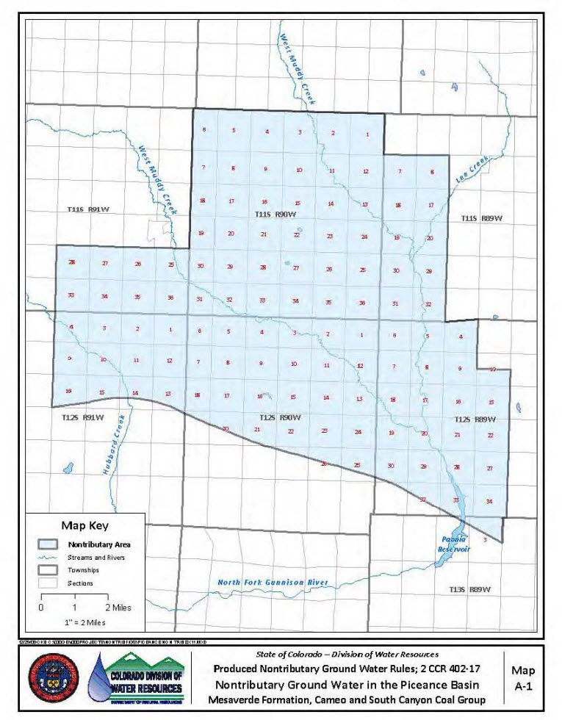

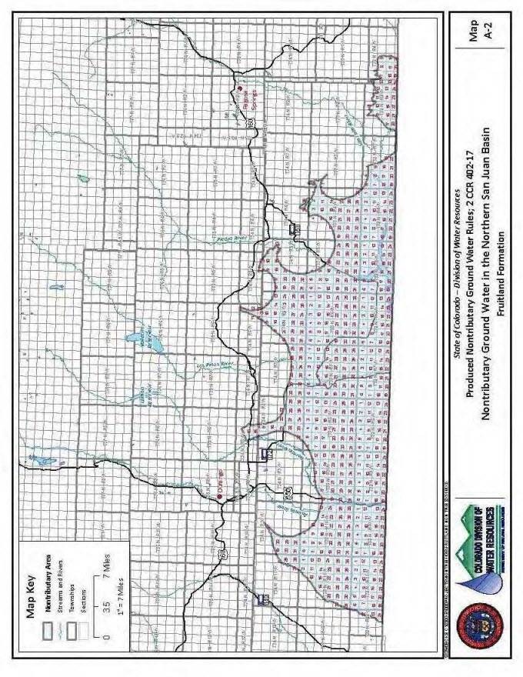

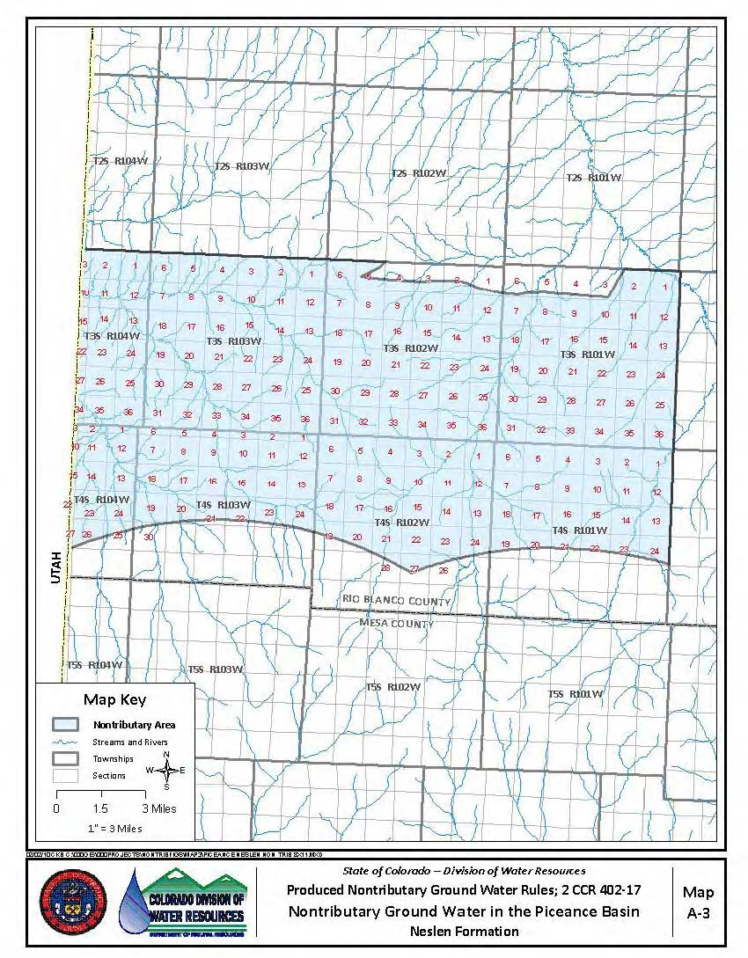

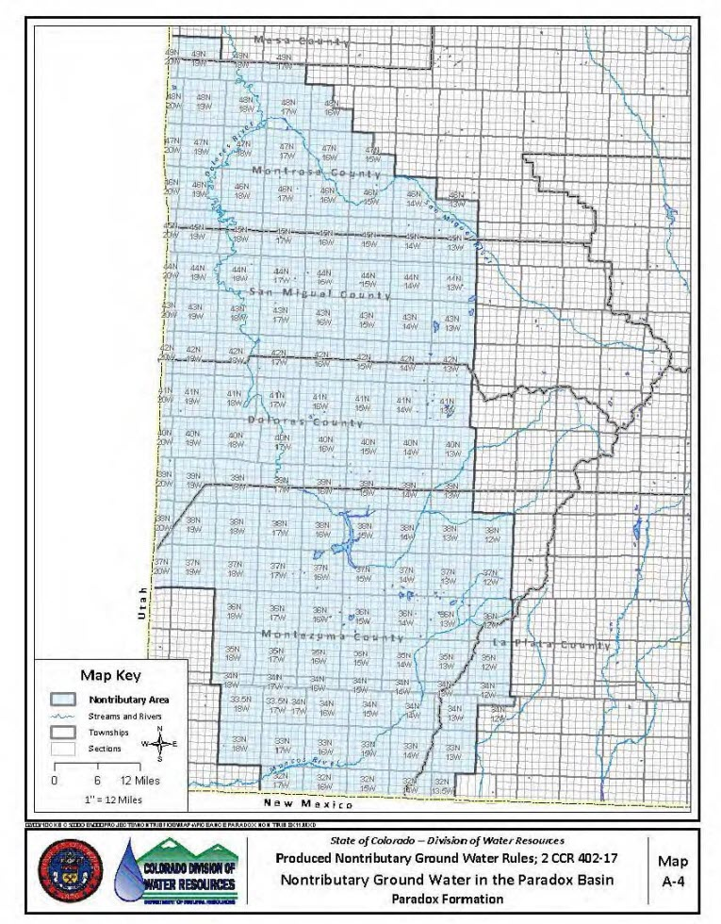

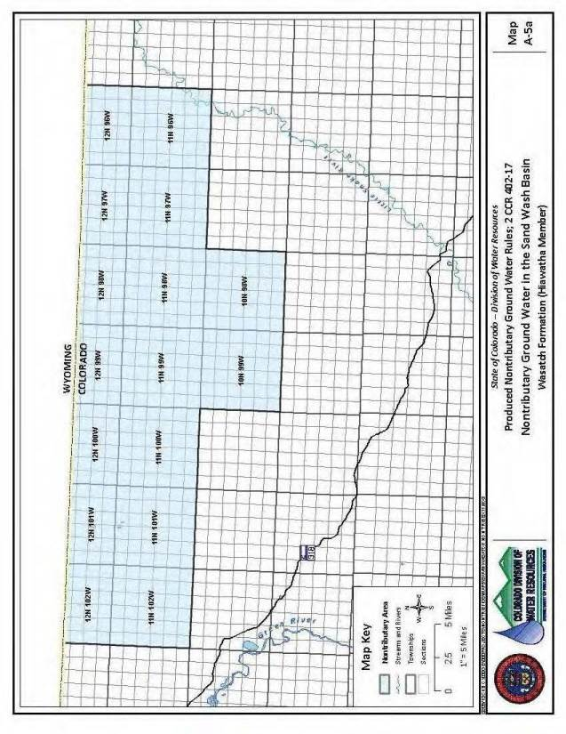

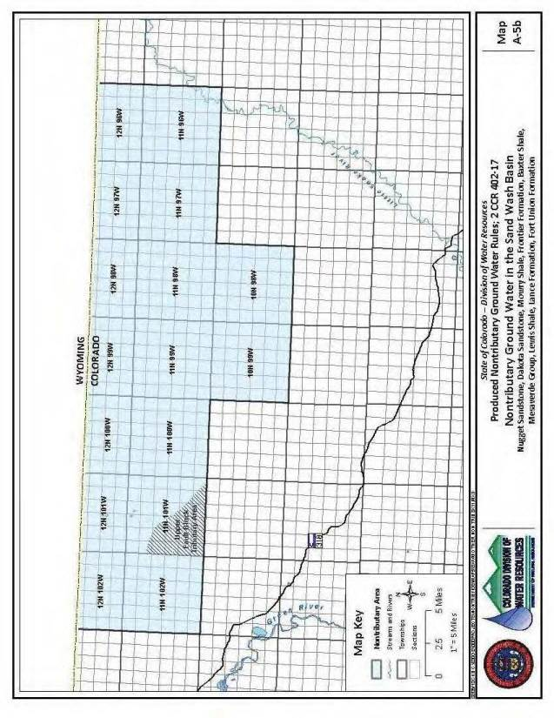

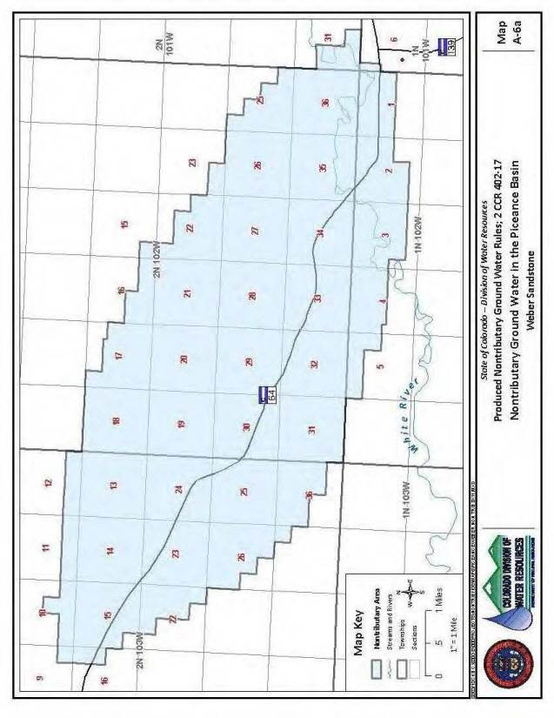

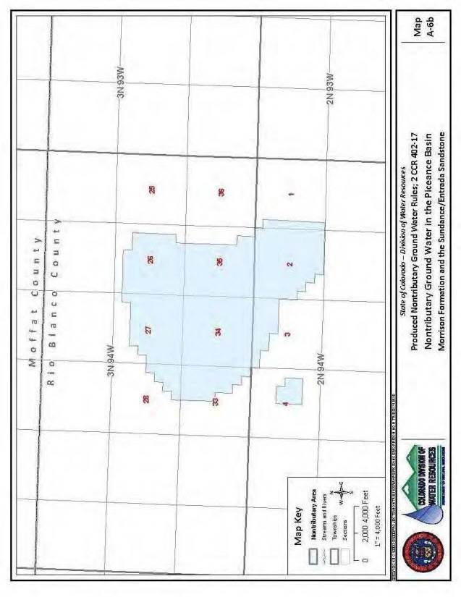

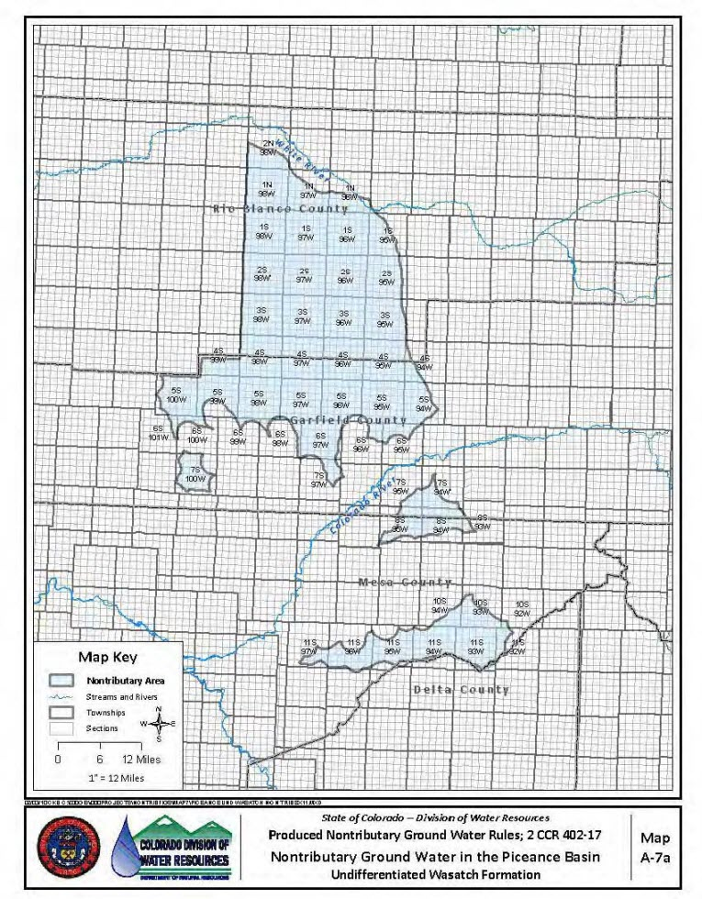

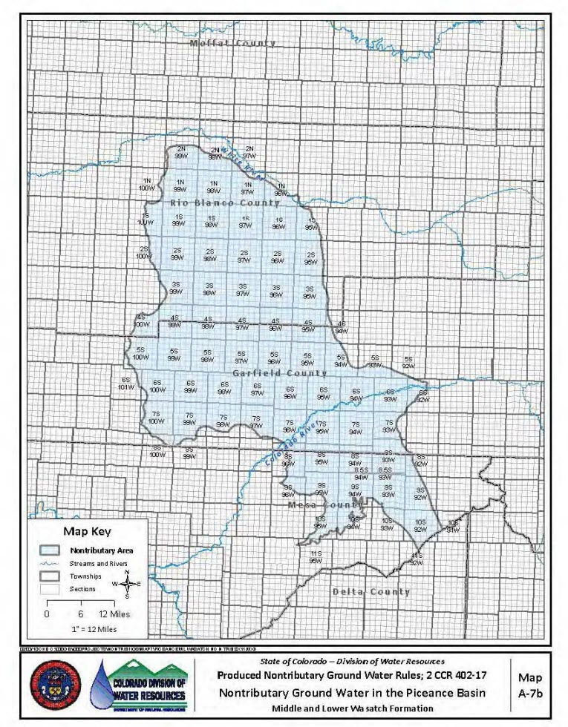

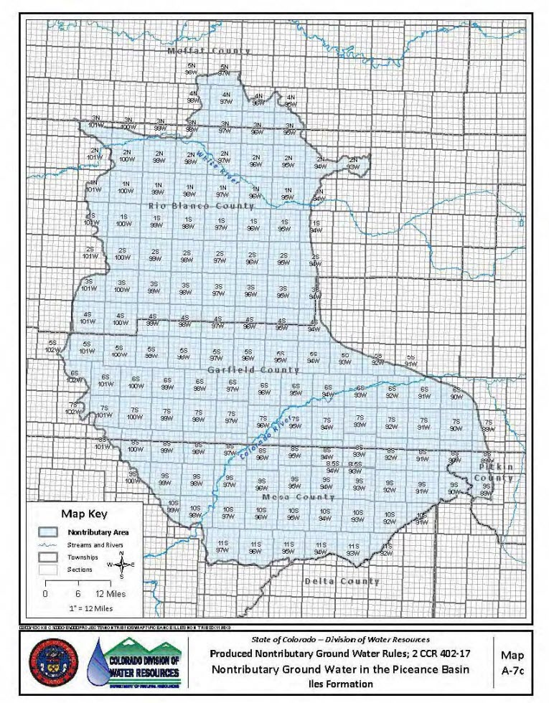

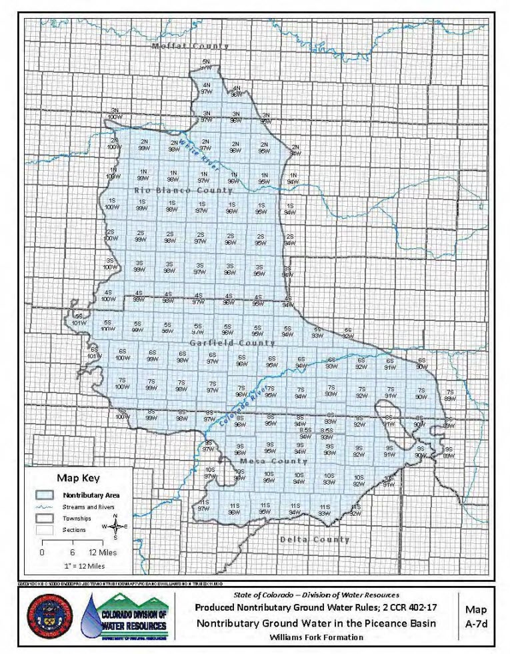

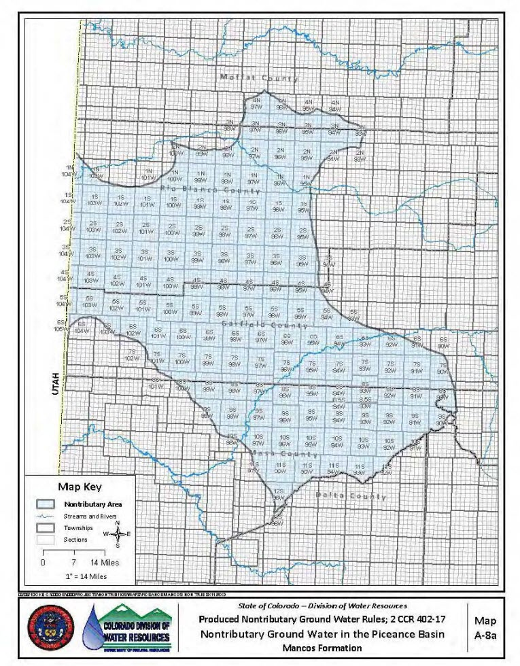

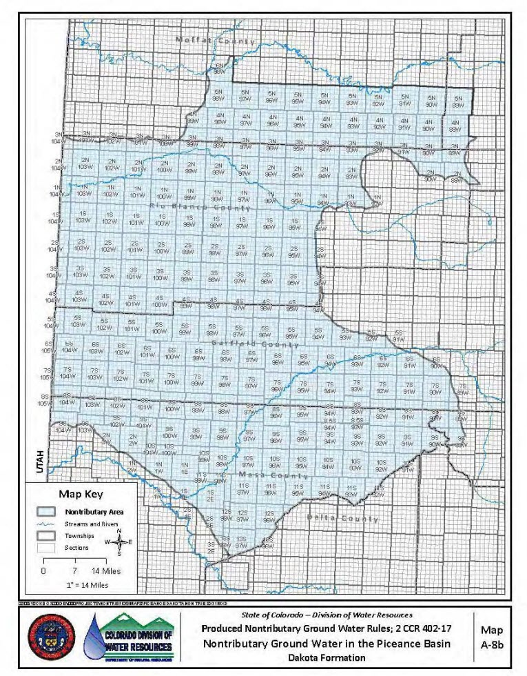

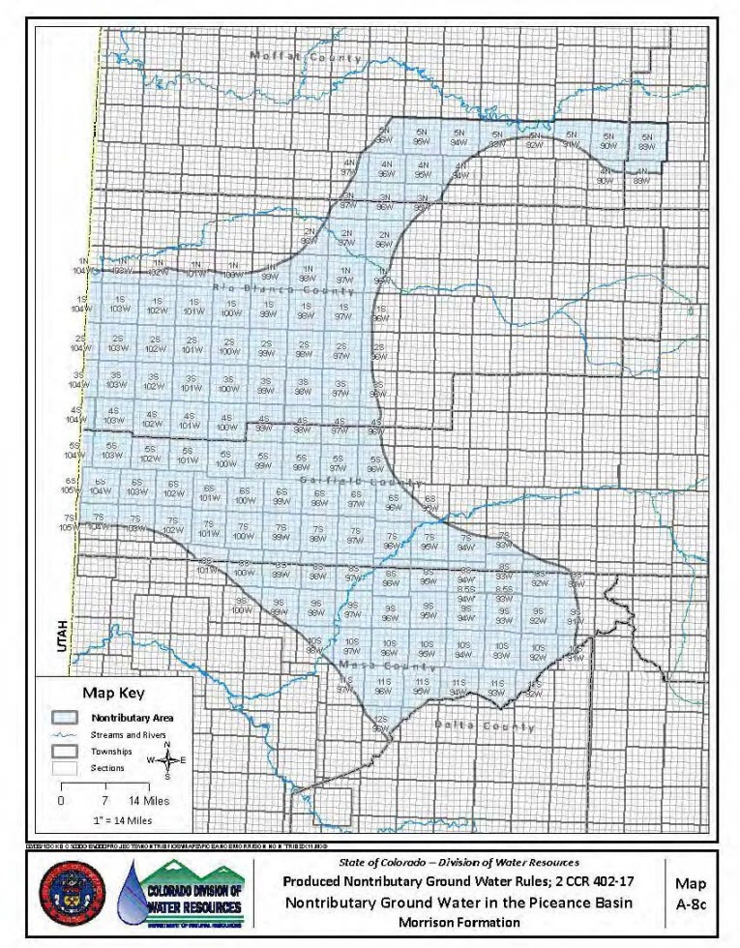

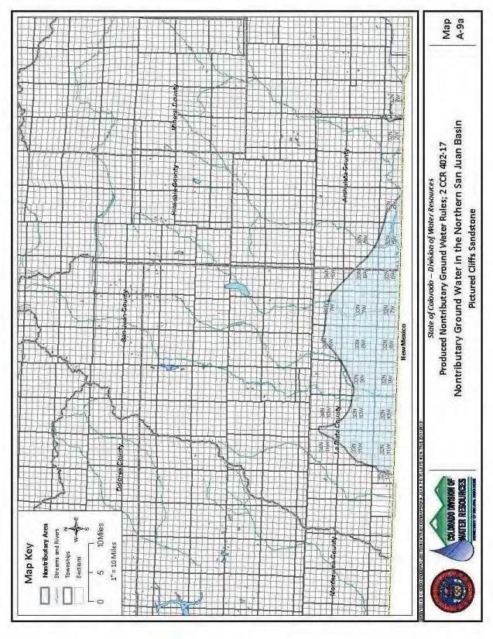

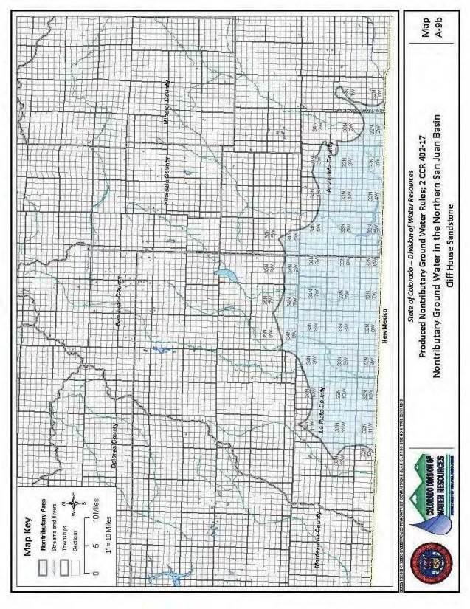

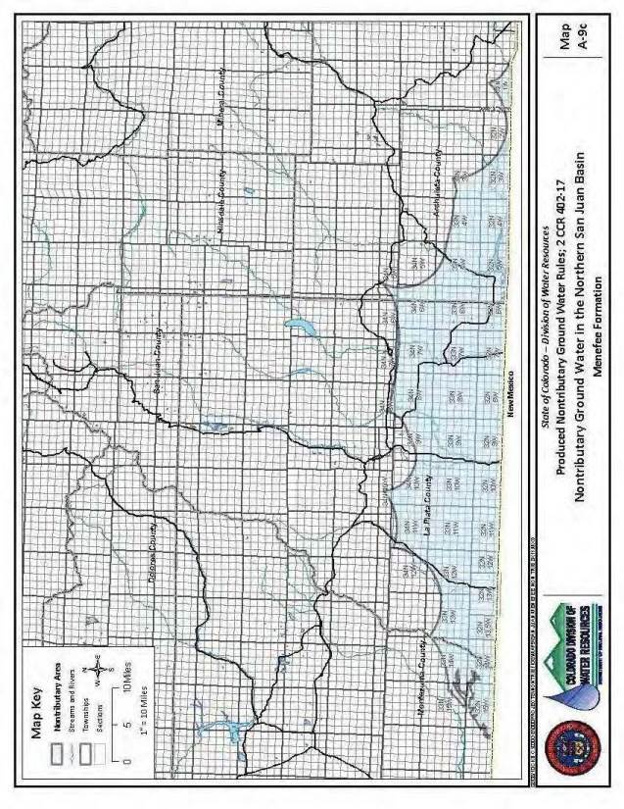

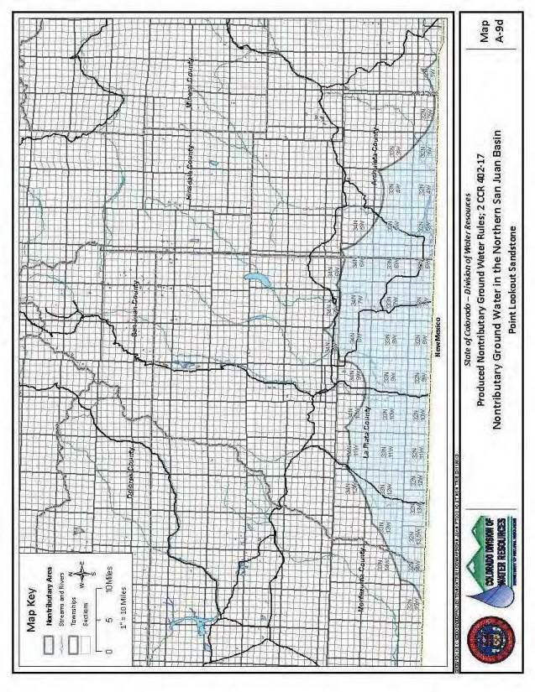

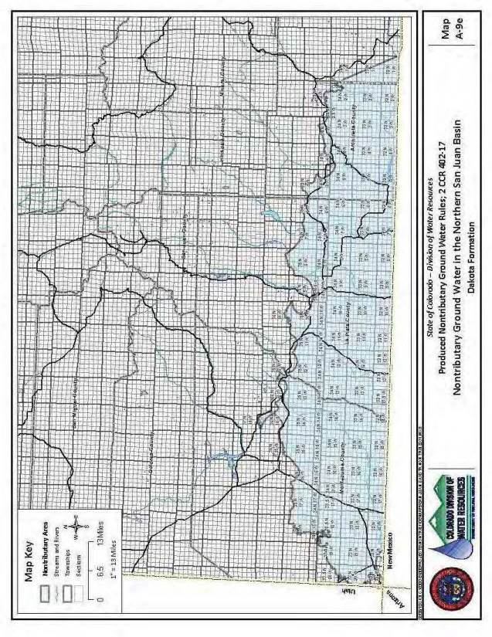

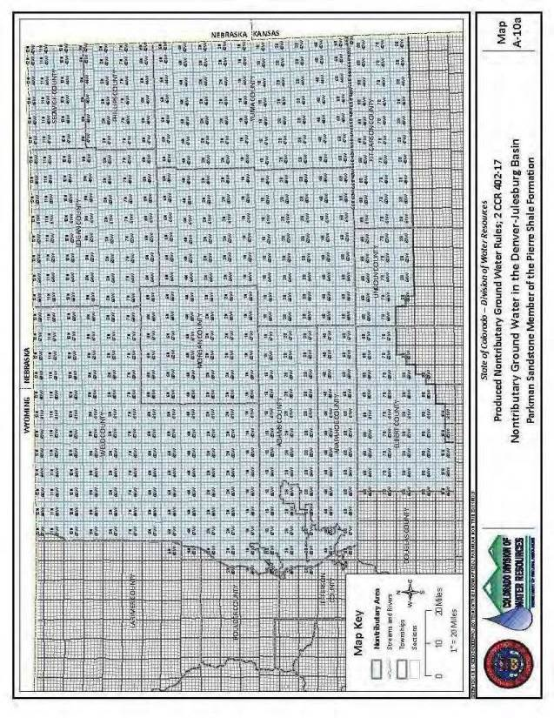

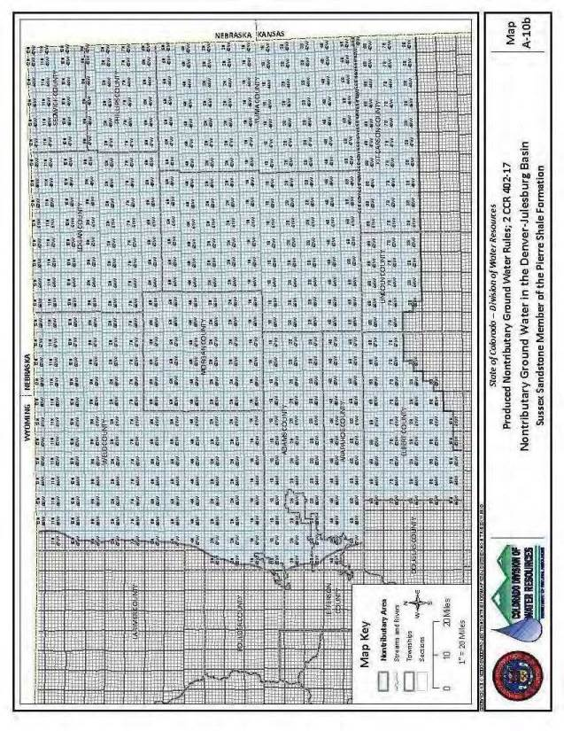

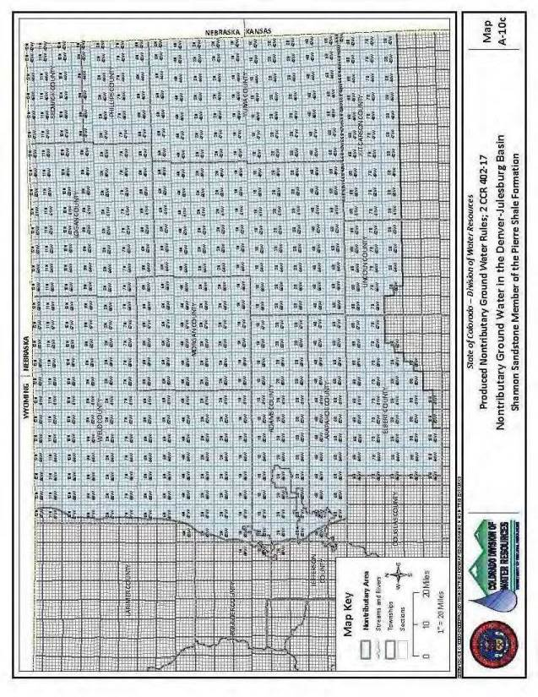

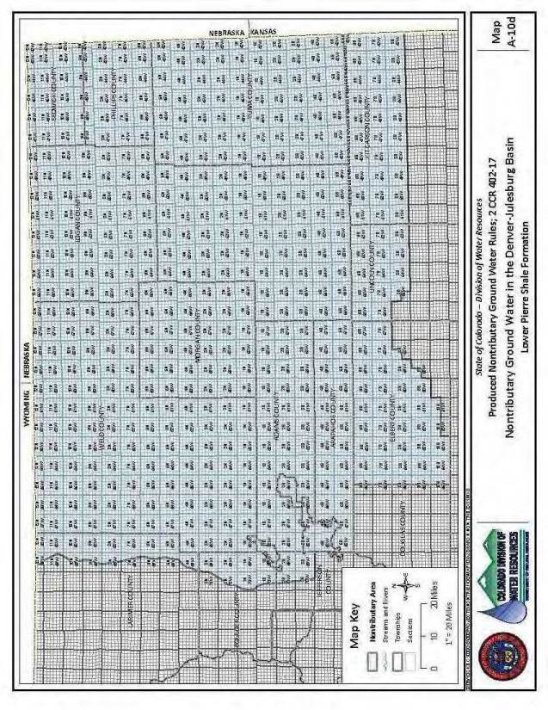

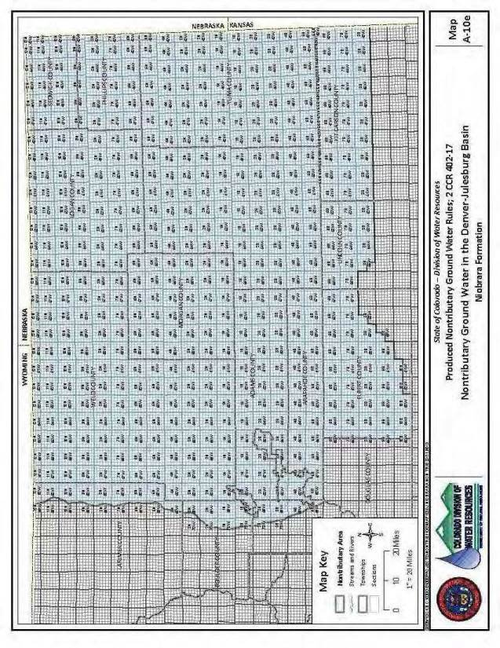

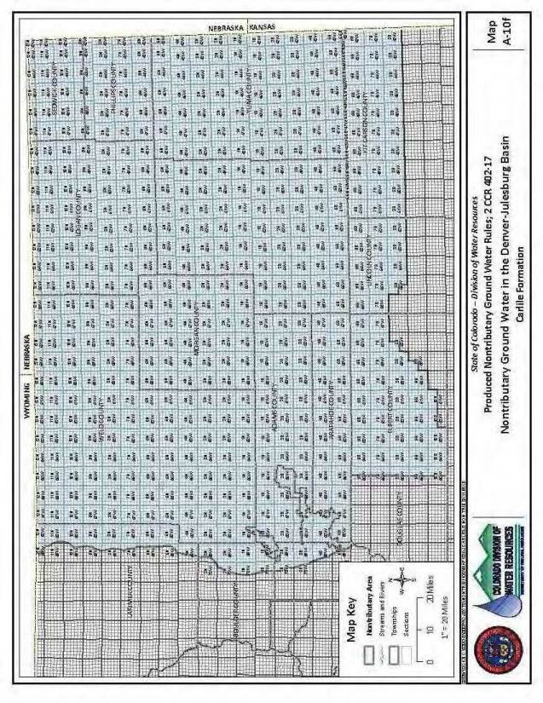

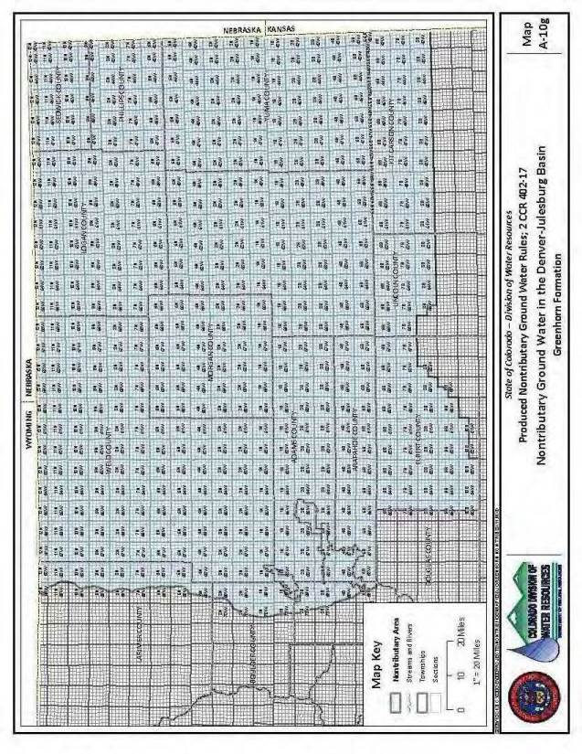

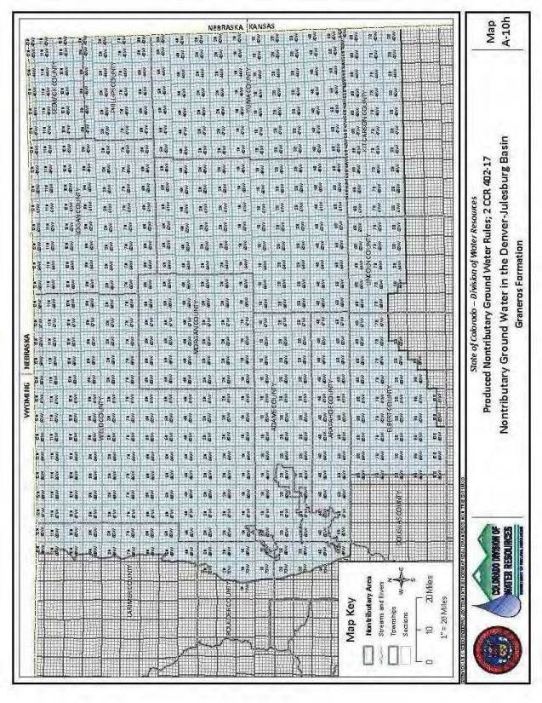

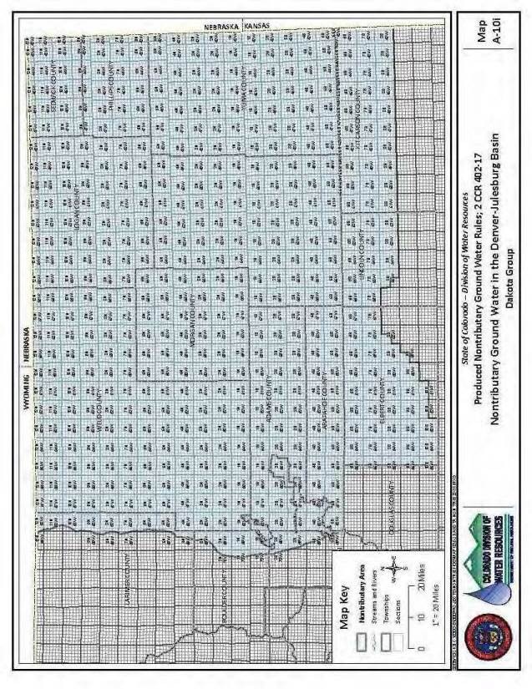

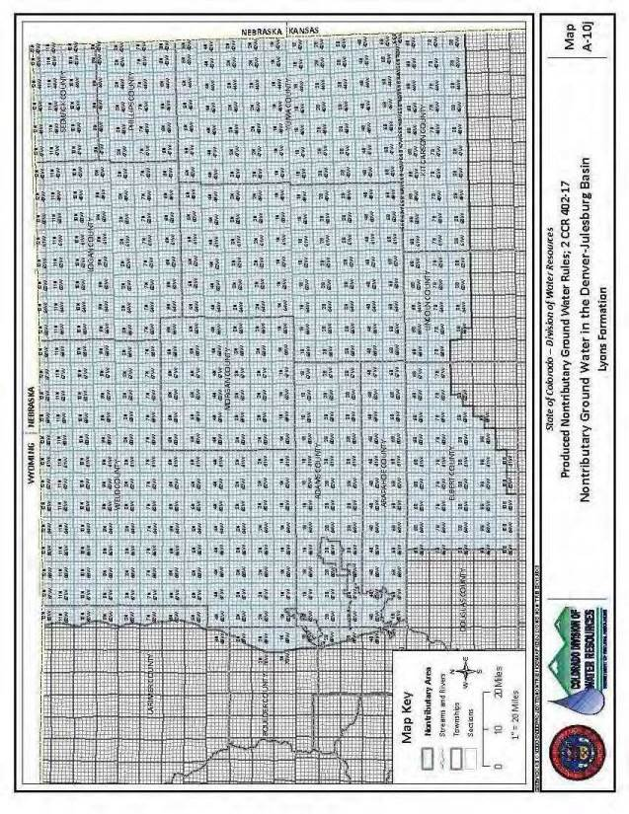
_________________________________________________________________________

Editor’s Notes
History
Entire rule eff. 01/30/2010.
Rule 17.7D, 17.12, Appendix A eff. 03/17/2010.

