DEPARTMENT OF EDUCATION
Division of Public School Capital Construction Assistance
PUBLIC SCHOOL FACILITY CONSTRUCTION GUIDELINES
1 CCR 303-1
[Editor’s Notes follow the text of the rules at the end of this CCR Document.]
_________________________________________________________________________

Article 1 - Purpose and Authority to Promulgate Rules
1.1. Purpose
1.1.1. Section 22-43.7-107(1)(a), C.R.S. states, The board shall establish public school facility construction guidelines for use by the board in assessing and prioritizing public school capital construction needs throughout the state as required by section 22-43.7-108, C.R.S. reviewing applications for financial assistance, and making recommendations to the state board regarding appropriate allocation of awards of financial assistance from the assistance fund only to applicants. The board shall establish the guidelines in rules promulgated in accordance with article 4 of title 24, C.R.S.
1.1.2. Section 22-43.7-107(1)(b), C.R.S. states, It is the intent of the general assembly that the Public School Facility Construction Guidelines established by the board be used only for the purposes specified in section 1.1.1 above.
1.1.3. The Public School Facility Construction Guidelines shall identify and describe the capital construction, renovation, and equipment needs in public school facilities and means of addressing those needs that will provide educational and safety benefits at a reasonable cost.
1.2. Statutory Authority
1.2.1. Section 22-43.7-106(2)(i)(I) C.R.S. states, the board may promulgate rules in accordance with article 4 of title 24, C.R.S. The board is directed to establish Public School Facility Construction Guidelines in rule pursuant to 22-43.7-107(1)(a), C.R.S.

Article 2 - Definitions
2.1. The definitions provided in 22-43.7-103, C.R.S., shall apply to these rules. The following additional definitions shall also apply:
“C.R.S.” means Colorado Revised Statutes.
“ES” means Elementary School.
“F.T.E.s” means Full Time Equivalent Students.
“Gross Square Feet (GSF)” means the total area of the building (inclusive of all levels as applicable) of a building within the outside faces of the exterior walls, including all vertical circulation and other shaft (HVAC) areas connecting one floor to another.
“Guidelines” means the Public School Facility Construction Guidelines.
“Historical significance” means having importance in the history, architecture, archaeology, or culture of this state or any political subdivision thereof or of the United States, as determined by the state historical society.
“HS” means High School.
“K12” means Kindergarten through 12th Grade School that is under all one facility / campus.
“MS” means Middle School.
“SF” means Square Foot.
“S.T.E.M.” means Science, Technology, Engineering, & Mathematics.

Article 3 - Codes, Documents and Standards incorporated by reference
3.1. The following materials are incorporated by reference within the Public School Facility Construction Guidelines:
3.1.1. ASHRAE 90.1-2013 Energy Standard for Buildings Except Low-Rise Residential Buildings.
3.1.2. ASHRAE Standard Benchmark Energy Utilization Index (October 2009).
3.1.3. ASHRAE Standard 189.1 - 2011 Standard for the Design of High-Performance Green Buildings.
3.1.4. ANSI/ASA S12.60-2010/ Part 1, Acoustical Performance Criteria, Design Requirements, and Guidelines for Schools, Part 1 Permanent Schools
3.1.5. International Code Council’s International Plumbing Code (2015) amended by Rules and Regulations of the Colorado State Plumbing Board 3 CCR 720-1, 2016-4-1
3.1.6. National Fire Protection Association (NFPA) 70: National Electrical Code (2014).
3.1.7. National Fire Protection Association (NFPA) 13: Standard for the Installation of Sprinkler Systems, 2013 Edition
3.1.8. National Fire Protection Association (NFPA) 72: National Fire Alarm and Signaling Code, 2013 Edition.
3.1.9. National Fire Protection Association (NFPA) 80: Standard for Fire Doors and Other Opening Protectives, 2016 Edition
3.1.10. ASHRAE Standard 62.1-2013 Ventilation for Acceptable Indoor Air Quality (2013).
3.1.11. Colorado Department of Public Health and Environment which references Air Quality, Hazardous Waste, Public and environmental health, Radiation Control, Solid Waste and Water Quality.
3.1.12. International Fire Code (IFC) – 2015 Edition, First Printing: May 2014 (Copyright 2014 by International Code Council, Inc. - Washington, D.C.), including Appendices B and C.
3.1.13. International Mechanical Code - 2015 Edition, First Printing: May 2014 (Copyright 2014 by International Code Council, Inc. - Washington, D.C.)
3.1.14. International Energy Conservation Code (IECC) - 2015 Edition, First Printing: May 2014 (Copyright 2014 by International Code Council, Inc. - Washington, D.C.)
3.1.15. International Existing Building Code – 2015 Edition, First Printing: May 2014 (Copyright 201 by International Code Council, Inc. - Washington, D.C.)
3.1.16. All projects shall be constructed and maintained in accordance with the codes and regulations as currently adopted by the Colorado Division of Fire Prevention & Control which incorporates current building, fire, existing building, mechanical, and energy conservation codes.
3.2. The Division shall maintain copies of the complete texts of the referenced incorporated materials, which are available for public inspection during regular business hours with copies available at a reasonable charge. Interested parties may inspect the referenced incorporated materials by contacting the Director of the Division of Public School Capital Construction Assistance, 1580 Logan Street, Suite 310, Denver, Colorado 80203.
3.3. This rule does not include later amendments or editions of the incorporated material.

Article 4 - These Guidelines are not mandatory standards to be imposed on school districts, charter schools, institute charter schools, the boards of cooperative services or the Colorado School for the Deaf and Blind. As required by statute, the Guidelines address:
4.1 Health and safety issues, including security needs and all applicable health, safety and environmental codes and standards as required by state and federal law. Public school facility accessibility.
4.1.1 Sound building structures. Each building should be constructed and maintained with sound structural foundation, floor, wall and roof systems.
4.1.1.1 - All building structures shall conform to all applicable codes adopted by the Colorado Division of Fire Prevention and Control in 8 CCR 1507-30.
4.1.2 Classroom Acoustics. To address issues of reverberation time and background noise in classrooms refer to ANSI/ASA S12.60-2010/ Part 1, American National Standard Acoustical Performance Criteria, Design Requirements, and Guidelines for Schools, Part 1: Permanent Schools.
4.1.3 Roofs. A weather-tight roof that drains water positively off the roof and discharges the water off and away from the building. All roofs shall be installed by a qualified contractor who is approved by the roofing manufacturer to install the specified roof system and shall receive the specified warranty upon completion of the roof. The National Roofing Contractors Association divides roofing into two generic classifications: low-slope roofing and steep-slope roofing. Low-slope roofing includes water impermeable, or weatherproof types of roof membranes installed on slopes of less than or equal to 3:12 (fourteen degrees). Steep slope roofing includes water-shedding types of roof coverings installed on slopes exceeding 3:12 (fourteen degrees).
4.1.3.1 - Low slope roofing systems:
4.1.3.1.1 - Built-up – minimum 4 ply, type IV fiberglass felt, asphalt BUR system. Gravel or cap sheet surfacing required.
4.1.3.1.2 - Ethylene Propylene Diene Monomer - minimum 60 mil EPDM membrane, with a ballasted or adhered system.
4.1.3.1.3 - Poly Vinyl Chloride - minimum 60 mil PVC membrane adhered or mechanically attached systems.
4.1.3.1.4 - Thermal Polyolefin - minimum 60 mil membrane adhered or mechanically attached systems.
4.1.3.1.5 - Polymer-modified bitumen sheet membrane - Styrene-Butadiene-Styrene (SBS) membranes only, to be used only as a component of a built-up system noted above.
4.1.3.2 - Steep slope roofing systems:
4.1.3.2.1 - Asphalt shingles - minimum 50 year spec asphalt shingles, UL Class A.
4.1.3.2.2 - Clay tile and concrete tile - minimum 50 year spec clay or concrete tile, UL Class A.
4.1.3.2.3 - Metal roof systems for steep-slope applications - minimum 24 gage prefinished steel, standing seam roof system with a minimum 1.5” seam height.
4.1.3.2.4 - Slate - ¼” minimum thickness, 50 year spec. UL Class A.
4.1.3.2.5 - Synthetic shingles - minimum 50 year spec, UL Class A.
4.1.4 Electrical Systems – Power Distribution and Utilization. Safe and secure electrical service and distribution systems shall be designed and installed to meet the National Electrical Code (NEC, NFPA 70); edition as enforced by the Colorado State Buildings Programs (SBP), unless otherwise more stringent based on local Authority Having Jurisdiction (AHJ), and ANSI/ASHRAE/IES Standard 90.1-2013 “Energy Standard for Buildings Except Low-Rise Residential Buildings”.
4.1.4.1 – Energy use intensity should not exceed the U.S. Department of Energy (DOE) building benchmarks, and shall conform to ASHRAE Standard Benchmark Energy Utilization Index (October 2009).
4.1.4.2 - Emergency lighting shall operate when normal lighting systems fail in locations and shall conform to all applicable codes adopted by the Colorado Division of Fire Prevention and Control in 8 CCR 1507-30.
4.1.5 Lighting Systems. Lighting systems shall be designed and installed to achieve appropriate lighting levels utilizing energy-efficient lighting fixtures and energy-saving automatic and manual control systems.
4.1.5.1 - Lighting systems shall be designed and installed to meet the National Electrical Code (NEC, NFPA 70) edition as enforced by the Colorado State Buildings Programs (SBP), unless otherwise more stringent based on local Authority Having Jurisdiction (AHJ).
4.1.5.2 – Illuminance levels shall meet the requirements for applicable spaces as recommended within in the Illuminating Engineering Society (IES) Handbook, and dictated by the Rules and Regulations Governing Schools in the State of Colorado 6 CCR 1010-6.
4.1.5.3 – Lighting power density shall not exceed the values indicated in ANSI/ASHRAE/IES Standard 90.1-2013.
4.1.5.4 - Lighting Control Systems shall be provided to comply with ANSI/ASHRAE/IES Standard 90.1-2013.
4.1.6 Mechanical Systems – Heating, Ventilation, and Air Conditioning (HVAC). Safe and energy efficient mechanical systems shall be designed and installed to provide proper ventilation, and maintain the building temperature and relative humidity, while achieving appropriate sound levels.
4.1.6.1 – Mechanical systems shall be designed and installed to meet the International Mechanical Code, International Fuel Gas Code, International Building Code, and other Codes as adopted by the Colorado Division of Fire Prevention and Control in 8 CCR 1507.
4.1.6.2 - Healthy building indoor air quality (IAQ) shall be provided through the use of the mechanical heating, ventilation and air conditioning (HVAC) systems, or by operable windows, and by reducing air infiltration and water penetration with a tight building envelope, in compliance with the enforced International Building Code and ASHRAE Standard 62. 1- 2013.
4.1.6.3 - Mechanical systems shall comply with: ASHRAE Standard 62.1-2013 Ventilation for Acceptable Indoor Air Quality, ASHRAE Standard 90.1-2013 Energy Standard for Buildings Except Low-Rise Residential Buildings, and ASHRAE Standard 189.1-2014 Standard for the Design of High-Performance Green Buildings.
4.1.6.4 Sound levels due to mechanical equipment shall comply with Occupational Safety & Health Administration Standard 1910.95 and ANSI/ASA Standard S12.60-2010 Part 1 for acoustical considerations within school facilities.
4.1.7 Plumbing Systems - Waste Water, Storm water, Domestic Water and Plumbing Supporting HVAC shall be in compliance with Division of Fire Prevention and Control in 8 CCR1507 and the Colorado Department of Health & Environment regulations.
4.1.8 Fire Protection Systems. Building fire detection, alarm and emergency notification systems in all school facilities shall be designed in accordance with State requirements. Exceptions where code required systems are not mandatory and the occupancy classification according to the International Building Code 2015 does not warrant a system. All fire management systems shall conform to all applicable codes adopted by the Colorado Division of Fire Prevention and Control in 8 CCR 1507-30 and the adopted Fire Code.
4.1.8.1 - Types of fire alarm notifications systems.
4.1.8.1.1 – Internal audible and visual alarms.
4.1.8.1.2 – External alarm monitoring and dispatch via internet / modem, telephone, radio, or cellular monitoring systems.
4.1.8.2 - Automatic Sprinkler Systems in Group E Occupancy a sprinkler system shall be provided as noted in the adopted Fire Code. Refer to the adopted Fire Code for exceptions.
4.1.8.2.1 All Group E fire areas greater than 12,000 square feet in area.
4.1.8.2.2 Throughout every portion of educational buildings below the lowest level of exit discharge serving that portion of the building.
4.1.8.3 - Types of Fire Protection Water Supplies.
4.1.8.3.1 - Fire hydrants.
4.1.8.3.2 - Static fire water storage tanks.
4.1.9 Means of egress. A continuous and unobstructed path of vertical and horizontal egress travel from any occupied portion of a building or structure to a public way. A means of egress consists of three separate and distinct parts: the exit access, the exit and the exit discharge. Reference 2015 International Building Code, Chapter 2, Definitions. A building code analysis shall be conducted to determine all code requirements.
4.1.10 Facilities with safely managed hazardous materials. Potential hazardous materials in building components, which are identified in the Asbestos Hazard Emergency Response Act (AHERA) report, may include: asbestos, radon, lead, lamps and devices containing mercury. Additional hazardous materials may include: science chemicals, cleaning chemicals, blood-borne pathogens, acid neutralization tank for science departments, and bulk fuel storage (UST/AST) management that may be stored by the occupant.
4.1.10.1 - Public schools shall comply with all AHERA criteria and develop, maintain, and update an asbestos management plan, to be kept on record at the school district. This should include a building survey of the exterior of the building, and identification of all friable, non-friable, and trace asbestos materials. Reference regulation Number 8, Control of Hazardous Air Pollutants, 5 CCR 1001-10.
4.1.10.2 - All new facilities and additions shall conduct radon testing following completion of construction within nineteen months after occupancy as required by Colorado Department of Public Health and Environment, 6 CCR 1010-6.
4.1.10.3 - Lead based paint. All schools shall conform to the regulations adopted by the Colorado Air Quality Control Commission governing the abatement of lead-based paint from target housing (constructed prior to 1978) and child-occupied facilities, reference C.R.S. 25-5-1101.
4.1.11 Security. The degree of resistance to, or protection from, harm. It applies to any vulnerable and valuable asset; such as a person, building or dwelling. Security provides “a form of protection where a separation is created between the assets and the threat.” These separations are generically called “controls,” and sometimes include changes to the asset or the threat. These separations and degrees of resistance can be achieved through several models and techniques.
4.1.11.1 - Video Management Systems (VMS).

4.1.11.1.1 - Cameras. Video cameras are typically used to implement a video management system. In new construction, these should be internet protocol (IP) cameras on Power over Ethernet (PoE) cabling infrastructure, with color CCD, day-night operation and supplemental IR illuminators and environmental accessories as required for application, Cameras should support motion activation, digital zoom and focus, and standard video compression. Fixed and pan-tilt-zoom (PTZ) cameras shall be considered to meet requirements. Consideration shall be given to cameras with integral audio microphones.
4.1.11.1.2 - Monitoring & Recording Systems. - A central video management system should be capable of monitoring live feeds from multiple cameras from a central location and remote locations, recording all video, searching and reviewing recorded video, and exporting video to portable digital media. A minimum of 30 days of storage of all videos at 15fps (frames per second) is required.
4.1.11.2 - Controlled Access.
4.1.11.2.1 - General Requirements
4.1.11.2.1.1 - The number of entryways into the building or onto the campus should be limited. New construction shall be designed to restrict normal entrance to only one or two locations, with no recessed doorways, provided that sufficient entryways are available for fire department access and shall conform to all applicable codes adopted by the Colorado Division of Fire Prevention and Control in 8 CCR 1507-30.
4.1.11.2.1.2 - All exterior doors shall be locking and equipped with panic bars to open readily from the egress side. Panic bars should utilize flush push bar hardware to prevent chaining doors shut.
4.1.11.2.1.2.1 - Unless a door is intended for ingress, exterior doors should not have handles and locks on the outside. In all cases exposed hardware should be minimized, provided that sufficient entryways are available for fire department access and shall conform to all applicable codes adopted by the Colorado Division of Fire Prevention and Control in 8 CCR 1507-30.
4.1.11.2.1.3 - Doors should be constructed of steel, aluminum alloy, or solid-core hardwood. If necessary, glass doors should be fully framed and equipped with burglar-resistant tempered glass. Translucent glass should be avoided in all cases.
4.1.11.2.1.4 - Exit doors with panic push-bars should be “Access Control Doors” per the codes adopted by the Colorado Division of Fire Prevention and Control in 8 CCR 1507-30, to prevent easy access by criminals and vandals, or in a lock-down / lock-out situation.

4.1.11.2.1.5 - Heavy-duty metal or solid-core wooden doors should be used at entrances in areas containing expensive items. These areas include classrooms, storerooms, and custodians’ rooms. Interior doorway doors should also be heavy-duty metal or solid-core wooden doors.
4.1.11.2.1.6 - Door hinges should have non-removable pins.
4.1.11.2.1.7 - Door frames should be constructed of pry-proof material.
4.1.11.2.1.8 - Armored strike plates shall be securely fastened to the door frame in direct alignment to receive the latch easily.
4.1.11.3 - Automated Locking Mechanisms.
4.1.11.3.1.1 Use of automated locking mechanisms (electronic access control) should be considered for exterior doors identified for entry and select interior doors associated with the main entry vestibule.
4.1.11.3.1.2 Acceptable automated electronic access control systems include RF-based proximity credential readers and biometric scanning devices. If the electronic access control systems are to be utilized the following shall apply:
4.1.11.3.1.2.1 - School personnel may be issued credentials for authenticating their identity in order to maintain efficient access to school facilities.
4.1.11.3.1.2.2 Students are not necessarily expected to carry electronic access control credentials. During normal arrival times, electronic locking systems may be disengaged via a timer while entries are monitored by school personnel.
4.1.11.3.1.2.3 All exterior doors shall utilize door position switches to notify staff of open doors and eliminate “door propping”.
4.1.11.3.1.2.4 Doors utilizing electronic access controls shall “fail secure” from the unsecure side. Free egress shall not be inhibited from the secure side in any scenario.
4.1.11.4 Manual Locking Devices
4.1.11.4.1 Use of a manual locking mechanism, such as traditional cylinder and key locks, should be provided for all interior doors requiring access control.
4.1.11.4.2 Manual and Electronic access control should not be used on the same door.

4.1.11.5 Emergency Lockdown
4.1.11.5.1 All exterior doors shall be able to be quickly and automatically secured from a position of safety (Administrative desk, Principal’s office, etc) without traveling to each individual exterior door.
4.1.11.5.2 Interior doors to occupied spaces shall be capable of quickly being secured from the inside by school personnel. Locking of doors may be done via manual deadbolt or automatic locking mechanism. Locking mechanism shall not interfere with automatic closing and latching functions required by the fire code and may have door sidelights, or door vision glass that allow line of sight into the corridors during emergencies, and shall conform to all applicable codes adopted by the Colorado Division of Fire Prevention and Control in 8 CCR 1507-30.
4.1.11.6 Intrusion Detection
4.1.11.6.1 A system shall be put in place to identify, alarm, and notify authorities in the case of unauthorized entry.
4.1.11.7 Alarm System
Passive infrared (PIR) sensors shall be located interior to all building entries to monitor human movement.
4.1.11.7.1.1 – An alarm keypad shall be located at selected building entries to arm and disarm the intrusion detection system.
4.1.11.7.1.2 – A manual alarm device shall be located in a position of safety (Administrative desk, Principal’s office, etc.) to force intrusion detection system into alarm status.
4.1.11.7.1.3 – The intrusion detection shall notify local authorities or monitoring company upon alarm status.
4.1.11.8 Security Integration
4.1.11.8.1 The Video Management System (VMS), Access Control System, and Intrusion Detection System may be components of an integrated security solution.
4.1.11.9 - Main Entry Physical Security
4.1.11.9.1 - Building vestibules. Where appropriate, buildings shall employ double entry door designs that provide a secured area for visitors to authenticate and gain clearance. Known as “man traps”, security vestibules solve several common security issues such as students opening doors for visitors, visitors bypassing check-in points, direct access to the interior from attackers, piggy-back entrances, and propped doors.

4.1.11.9.2 - Video based entrance intercom systems. Building designs shall allow for school personnel to be able to monitor incoming visitors from a safe location out of reach, or line of site from incoming visitors who have not yet been authenticated or cleared for entry. These entry points shall use remote video and access control technology to conduct multi-factor authentication of incoming visitors (e.g. visual verification and ID, PIN/password and ID, or biometric and other form of visual identification).
4.1.11.9.2.1 - Video based entrance systems shall use IP technology to allow access control to be conducted by school personnel from multiple locations, so that multiple personnel can provide coverage for screening incoming visitors.
4.1.11.9.3 - Line of sight. The front entrance should be designed to maximize the line of sight distance for school occupants to detect an intruder from each relevant perimeter (e.g. classroom to hallway, office or guard station to entryway, or entryway to exterior fence access, or exterior fence access to property perimeter).
4.1.11.10 - Event alerting and notification (EAN) system. An EAN system that utilizes an intercom / phone system with communication devices located in all classrooms and throughout the school to provide efficient inter-school communications, and communication with local fire, police, and medical agencies during emergency situations.
4.1.11.11 - Secure sites should include the following:
4.1.11.11.1 - Locations to avoid.
4.1.11.11.2 - Location of utilities.
4.1.11.11.3 - Roof access.
4.1.11.11.4 - Lighted walkways.
4.1.11.11.5 - Secured playgrounds.
4.1.11.11.6 - Bollards at main entrances and shop areas with overhead doors.
4.1.11.11.7 - Signage.
4.1.12 Health code standards. Schools, including labs, shops, vocational and other areas with hazardous substances shall conform to the Department Of Public Health and Environment, Division of Environmental Health and Sustainability, 6 CCR 1010-6 Rules and Regulations Governing Schools in the State of Colorado.
4.1.13 Food preparation equipment and maintenance. Food preparation and associated facilities equipped and maintained to provide sanitary facilities for the preparation, distribution, and storage of food as required by Department Of Public Health And Environment, Division of Environmental Health and Sustainability, 6 CCR 1010-6 Rules and Regulations Governing Schools in the State of Colorado.
4.1.14 Health care room. A separate health care room shall be provided and shall comply with the Department Of Public Health and Environment, Division of Environmental Health and Sustainability, 6 CR 1010-6 Rules and Regulations Governing Schools in the State of Colorado.
4.1.15 A site that safely separates pedestrian and vehicular traffic and is laid out with the following guidelines:
4.1.15.1 - Physical routes for basic modes (busses, cars, pedestrians, and bicycles) of traffic should be separated as much as possible from each other. If schools are located on busy streets and/or high traffic intersections, coordinate with the applicable municipality or county to provide for adequate signage, traffic lights, and crosswalk signals to assist school traffic in entering the regular traffic flow.
4.1.15.2 - When possible, provide a dedicated bus staging and unloading area located away from students, staff, and visitor parking.
4.1.15.3 - Provide an adequate driveway zone for stacking cars on site for parent drop-off/pick-up zones. Drop-off area design should not require backward movement by vehicles, and be one-way in a counterclockwise direction where students are loaded and unloaded directly to the curb/sidewalk. Students should not have to load or unload where they have to cross a vehicle path before entering the building. It is recommended all loading areas have “No Parking” signs posted.
4.1.15.4 - Provide well-maintained sidewalks and a designated safe path leading to the school entrance(s).
4.1.15.5 - Building service loading areas and docks should be independent from other traffic and pedestrian crosswalks. If possible, loading areas shall be located away from school pedestrian entries.
4.1.15.6 - Facilities should provide bicycle access and storage if appropriate.
4.1.15.7 - Fire lanes shall conform to all applicable codes adopted by the Colorado Division of Fire Prevention and Control in 8 CCR 1507-30 or the local fire department. Local fire department must adhere to the codes adopted by DFPC.
4.1.15.8 - Playgrounds shall comply with the ICC A117.1-2009 Accessible and Usable Buildings and Facilities and shall conform to all applicable codes adopted by the Colorado Division of Fire Prevention and Control in 8 CCR 1507-30.
4.1.16 Severe weather preparedness.
4.1.16.1 - Designated emergency shelters shall conform to all applicable codes adopted by the Colorado Division of Fire Prevention and Control in 8 CCR 1507-30 and ICC 500.
4.2 Technology, including but not limited to telecommunications and internet connectivity technology and hardware, devices or equipment necessary for individual student learning and classroom instruction, including access to electronic instructional materials, or necessary for professional use by a classroom teacher.
4.2.1 Educational facilities for individual student learning, classroom instruction, online instruction and associated technologies, connected to the Colorado institutions of higher education distant learning networks “Internet” and “Internet two.”
4.2.2 Educational facilities shall be supplied with standards-based wired and wireless network connectivity.
4.2.3 Security and associated filtering and intrusion control for internal voice, video and data networks shall be provided.
4.2.4 External internet service provider (ISP) connection and internal wide area network (WAN) connections meeting or exceeding recommended guidelines of the state education technology education directors association (SETDA) broadband imperative, and devices meeting or exceeding recommended specifications according to the most current version of technology guidelines for the partnership for assessment of readiness for college and careers (PARCC) assessments.
4.2.5 Provide school administrative offices with web-based activity access.
4.2.6 Building shall be constructed with long-term sustainable technology infrastructure. Facilities should be built with sufficient data cabling and/or conduit and power infrastructure to allow for maximum flexibility as technological systems are upgraded and replaced in the future. A plan for technology lifecycle review intervals should be put in place for review at 2-4 year intervals.
4.2.6.1 Applicable Standards. The design and installation of technology systems shall comply with:
4.2.6.1.1 ANSI/TIA/EIA-568-C
4.2.6.1.2 ANSI/TIA/EIA-569
4.2.6.1.3 ANSI/TIA/EIA-606-B
4.2.6.1.4 ANSI/TIA/EIA-607-B
4.2.6.1.5 ANSI/BICSI 001-2009, Information Transport Systems Design Standard for K-12 Educational Institutions.
4.2.7 Telecom Equipment Rooms
4.2.7.1 - Uninterruptible power supplies (UPS). Telecom Rooms (TRs) and Equipment Rooms (ERs) shall be provided with UPS equipment to provide continuous clean power to communications systems for a minimum of 90 minutes.
4.2.7.2 - Generators. A backup generator shall be considered for providing backup power to telecommunications systems of backup power is required beyond 9 minutes, or if the generator is already located for other purposes.
4.2.7.3 - Heating, Ventilation and Air Conditioning (HVAC). Mechanical equipment shall be used to accommodate heating loads within TRs and ERs. Ventilation-only systems may be used in spaces with limited equipment, active cooling systems should be considered for larger rooms. Maintained space temperatures shall target 65 degrees F. peak space temperatures shall not exceed 90 degrees F.
4.2.7.3.1 Direct evaporative cooling systems shall not be used, due to lack of control on humidity levels.
4.2.7.4 - Alarms shall be provided to notify assigned school personnel if environmental conditions approach or exceed bounds of operational conditions.
4.2.8 Connectivity standards.
4.2.8.1 - Wireless. Data cabling shall be planned to support appropriately spaced multiple-antenna wireless networking infrastructure allowing for wireless access points to support expected quantity of connected devices and required bandwidth. Support for 802.11b/g/n, 802.11ac, and/or newer protocols are recommended.
4.2.8.2 - Wired.
4.2.8.2.1 - Cabling. All new runs of copper data cable should be Category 6 cable or newer standards. Any data outlet should be supplied by two cables. Unshielded twisted pair (UTP) shall be used unless local conditions warrant otherwise.
4.2.8.2.2 - Telecom Rooms (TRs) and Equipment Rooms (ERs). TRs and ERs shall be connected by conduit and a combination of copper and fiber optic cable to allow for maximum data performance and upgradeability.
4.2.8.2.3 - TR to classroom. Classrooms should have a data outlet on the wall at the front and back of the room at a minimum for network/ internet access. Additional cabling may be warranted for security, audiovisual and special systems purposes.
4.2.8.2.4 - TR to office, and library or technology/media centers. Any areas designed for independent work or study should have a dedicated data outlet with two copper cable runs each.
4.2.8.2.5 - TR to common areas, auditorium, and cafeteria. Common areas should contain data outlets located as required to support program and curriculum requirements.
4.3 Building site requirements. Functionality of existing and planned public school facilities for core educational programs, particularly those educational programs for which the State Board has adopted state model content standards. Capacity of existing and planned public school facilities, taking into consideration potential expansion of services for the benefit of students such as full-day kindergarten and preschool- and school-based health services and programs.
4.3.1 Traditional education model, S.T.E.M. & Montessori / Expeditionary education models.
4.3.1.1 - Minimum occupancy requirements for schools:
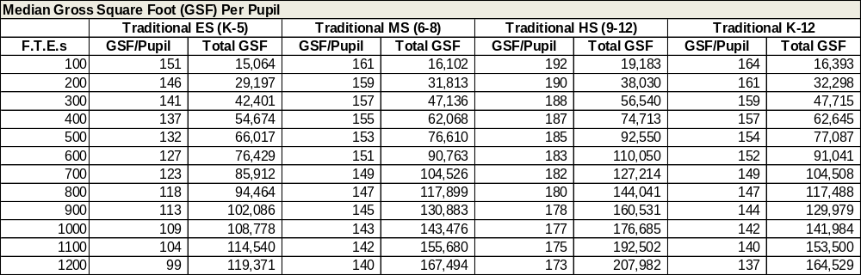
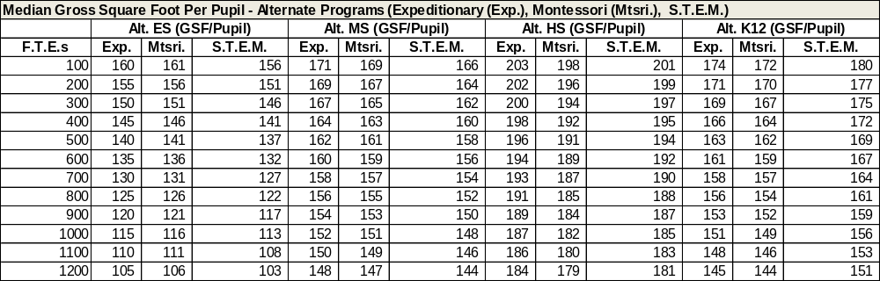
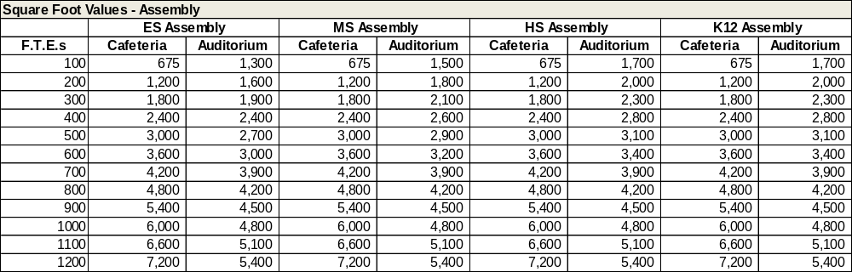
- Cafeteria Capacity assumes three (3) seatings without a secondary function overlay.
- Auditorium Capacity SF is sized for 1/3 of General enrollment and is inclusive of stage (size varies: 1,000 to 1,800); Basis is 9 SF per seat (1/3 FTES) plus stage at various sizes, stage includes a small amount of storage or similar support.
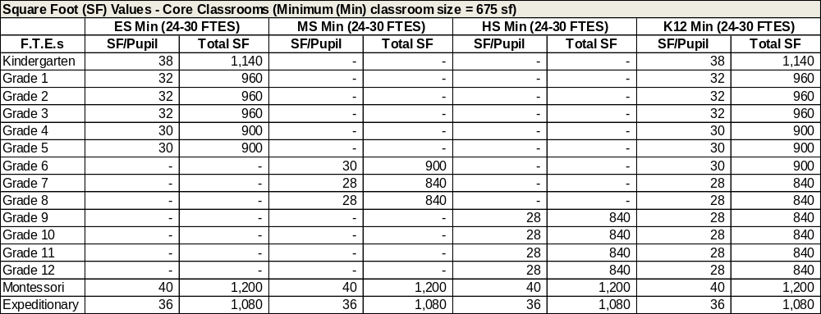
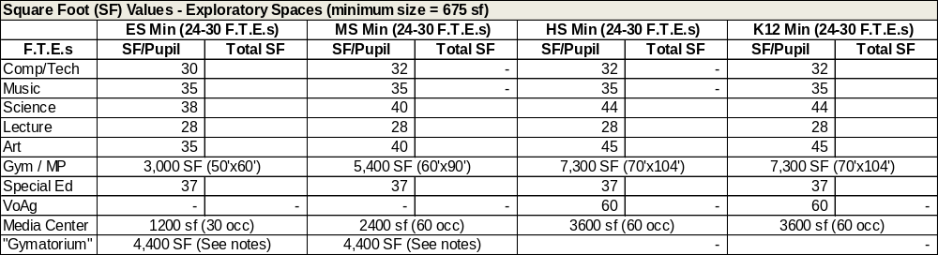
- ES Gymnasium basis is 50'X60' play area; Capacity Assumes (GE*.25)/7 periods (without fixed seats)
- MS Gymnasium basis is 60’X90’ play area; Capacity Assumes (GE*.5)/7 periods (without fixed seats)
- HS Gymnasium basis is 70’X104’ practice gym; Capacity Assumes (GE*.5)/7 periods (with limited fixed seats) Note: National Federation of State High School Association’s standards outline an “ideal” court for high school age as 84'x50' (and not greater than 94'x50')
- “Gymatorium” basis is 50'x60' play area and 1000 SF platform stage with 400 SF storage
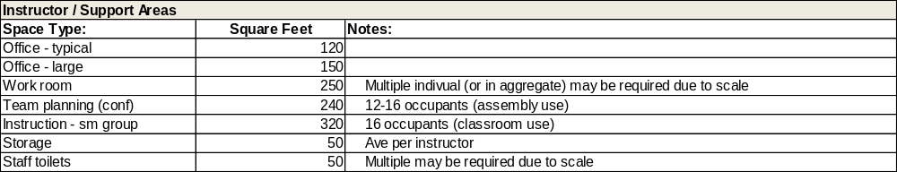
These facility area standards are copyrighted by Cuningham Group Architecture, Inc. and may not be reproduced or distributed without inclusion of “Copyright 2014 Cuningham Group Architecture, Inc.”. The data was derived from a multi-year national facility area standards study, supported in part by the Colorado League of Charter Schools.
4.3.2 Other rooms.
4.3.2.1 - Facilities with preschools shall comply with Rules Regulating Child Care Centers (Less Than 24-Hour Care) 12 CCR 2509-8 and shall comply with the Colorado Department of Public Health and Safety’s Regulations Governing Child Care, 6 CCR 1010-7.
4.3.2.2 - Special education classrooms. Special Education classrooms and facilities meeting or exceeding the accessibility and adaptive needs of the current and reasonably anticipated student population, in accordance with Section 504 and Title II of the Americans with Disabilities Act, the Exceptional Children’s Educational Act, and Individuals with Disabilities Education Act.
4.4 Building performance standards and guidelines for green building and energy efficiency.
Section 24-30-1305.5 C.R.S., requires all new facilities, additions, and renovation projects funded with 25% or more of state funds to conform with the High Performance Certification Program (HPCP) policy adopted by the Office of the State Architect (OSA) if:
• The new facility, addition, or renovation project contains 5,000 or more building square feet; and
• The project includes an HVAC system; and
• If increased initial cost resulting from HPCP can be recouped by decreased operational costs within 15 years, and
• In the case of a renovation project, the cost of the renovation exceeds 25% of the current value of the property.
4.4.1 High Performance Certification Programs.
4.4.1.1 The Department of Personnel and Administration, Office of the State Architect has determined the following three guidelines as meeting the High Performance Certification Program (HPCP) requirements per C.R.S.24-30-1305.5; the U.S. Green Building Council, Leadership in Energy and Environmental Design – New Construction (USGBC LEED™-NC) guideline with Gold as the targeted certification level; and the Green Building Initiative (GBI), Green Globes guideline with Three Globes the targeted certification level; and for the Colorado Department of Education, K-12 construction, the Collaborative for High Performance Schools (US-CHPS) is an optional guideline with Verified Leader as the targeted certification level.
4.4.1.2 – LEED, or Leadership in Energy and Environmental Design (for schools) is a globally recognized symbol of excellence in green building.
4.4.1.2.1 LEED is an internationally recognized certification system that measures a building using several metrics, including: energy savings, water efficiency, sustainable land use, improved air quality, and stewardship of natural resources.
4.4.1.2.2 Points are awarded on a 100-point scale, and credits are weighted to reflect their potential environmental impacts. Different levels of certification are granted based on the total number of earned points. The four progressive levels of certification from lowest to highest are: certified, silver, gold and platinum.
4.4.1.3 United States Collaborative for High Performance Schools (US-CHPS). US-CHPS reflects the three priority outcomes of the Core Criteria. These are, in order of importance.
4.4.1.3.1 Maximize the health and performance of students and staff.
4.4.1.3.2 Conserve energy, water and other resources in order to save precious operating dollars.
4.4.1.3.3 Minimize material waste, pollution and environmental degradation created by a school.
4.4.1.3.4 The CHPS National Technical Committee has weighted the available point totals for prerequisites and credits in seven categories to reflect these three priorities.
4.4.2 Renewable energy strategies.
4.4.2.1 - Solar Photovoltaic / Solar Thermal.
4.4.2.1.1 SB 20-124 Requires consultation with the incumbent electric utility regarding energy efficiency; beneficial electrification, as defined in section 40-3.2-106 (6)(a); and renewable distributed generation opportunities.
4.4.2.2 - Geothermal / Geo exchange.
4.4.2.3 - Wind.
4.4.2.4 - Passive Solar Design.
4.4.3 Energy management plan.
4.4.3.1 - Energy programs assist with creating a culture of energy efficiency within a school. Reference Energy Star Guidelines for Energy Management to help develop a plan.
4.4.4 Other energy efficient options.
4.4.4.1 - ENERGY STAR Labeled HVAC / mechanical systems.
4.4.4.2 - Windows, doors, and skylights (collectively known as fenestration).
4.4.4.3 - Building Envelope.
4.4.4.3.1 - The interface between the interior of the building and the outdoor environment, including the walls, roof, and foundation – serves as a thermal barrier and plays an important role in determining the amount of energy necessary to maintain a comfortable indoor environment relative to the outside environment.
4.4.4.3.2 - Roof. Roof design and materials can reduce the amount of air conditioning required in hot climates by increasing the amount of solar heat that is reflected, rather than absorbed, by the roof. For example, roofs that qualify for ENERGY STAR® are estimated to reduce the demand for peak cooling by 10 to 15 percent.
4.4.4.3.3 - Insulation is important throughout the building envelope.
4.4.4.4 - Lighting.
4.4.4.4.1 - Light emitting diodes (LEDs), compact fluorescents (CFLs) and fluorescent lighting should be considered over traditional incandescent lighting.
4.4.4.4.5 - Commissioning, retro commissioning and re-commissioning.
4.4.4.4.5.1 - Commissioning ensures that a new building operates initially as the owner intended and that building staff are prepared to operate and maintain its systems and equipment.
4.4.4.4.5.2 - Retro commissioning is the application of the commissioning process to existing buildings.
4.4.4.4.5.3 - Re-commissioning is another type of commissioning that occurs when a building that has already been commissioned, undergoes another commissioning process.
4.4.4.4.6 - Measurement and verification.
4.4.4.4.6.1 Measurement and verification (M&V) is the term given to the process for quantifying savings delivered by an Energy Conservation Measure (ECM), as well as the sub-sector of the energy industry involved with this practice. M & V demonstrates how much energy the ECM has avoided using, rather than the total cost saved.
4.4.4.4.7 - Landscaping
4.4.4.4.7.1 Irrigation: Consider water management which could include reducing storm-water run-off, preventing erosion and decreasing the effects of soil expansion.
4.4.4.4.7.2 Plant Materials: Consider Native materials, Xeriscaping.
4.4.4.4.7.3 Grass/ Sod Areas: Consider use of grass/ sod areas, consider water use, alternate options if planting sports fields.
4.4.4.4.8 – Permitting
4.4.4.4.8.1 Application for public school construction projects permits can be made at the DFPC website, www.colorado.gov/dfpc > Sections > Fire & Life Safety > Permits and Construction > School Construction.
4.4.4.4.8.2 If a local building department has entered into a memorandum of understanding (MOU) with DFPC, that local building department is considered a Prequalified Building Department (PBD). A School District may, at its discretion, choose to apply for permit through DFPC or the PBD that has jurisdiction of construction projects for the location of the school construction project. The list of PBD’s is available on the DFPC website, School Construction.
4.5 The historic significance of existing public school facilities and their potential to meet current programming needs by rehabilitating such facilities.
4.5.1 Buildings that are 50 years or older at the time of application may be subject to the State Register Act 24-80.1-101 to 108 in determining if the affected properties have historical significance.
4.5.1.1 - Historical significance means having importance in the history, architecture, archaeology, or culture of this state or any political subdivision thereof or of the United States, as determined by the state historical society.
4.5.2 When determining if a facility should be replaced, the cost to rehabilitate versus the cost to replace should be evaluated.
________________________________________________________________________

Editor's Notes
History
Entire rule emer. rule eff. 9/10/2008; expired 12/10/2008.
Entire rule eff. 01/30/2009.
Rules 3.10, 3.11, 4.3, 5, 6 eff. 11/30/2009.
Entire rule eff. 12/30/2011.
Rules 5.1.24.1-5.1.24.3 eff. 12/30/2012.
Entire rule eff. 01/30/2015.
Rules 3.1.4, 3.1.9-3.1.11 eff. 10/30/2015.
Articles 3, 4 eff. 11/30/2016.
Rules 3.1, 4.1.6.4, 4.1.16.1, 4.2, 4.4.2-4.4.6 eff. 03/30/2017.
Rule 4.2 eff. 12/30/2017.
Rule 4.4.2.1.1 eff. 02/14/2021.

