DEPARTMENT OF NATURAL RESOURCES
Ground Water Commission
RULES AND REGULATIONS FOR THE MANAGEMENT AND CONTROL OF DESIGNATED GROUND WATER
2 CCR 410-1
[Editor’s Notes follow the text of the rules at the end of this CCR Document.]
_________________________________________________________________________

RULE 1 TITLE
1.1 The title of these rules and regulations is “Rules and Regulations for the Management and Control of Designated Ground Water.” The short title is “Designated Basin Rules,” and may be referred to herein collectively as the “Rules” or individually as a “Rule.”

RULE 2 AUTHORITY
2.1 These Rules are promulgated pursuant to the authority of the Colorado Ground Water Commission in the “Colorado Ground Water Management Act,” Title 37, Article 90, Colorado Revised Statutes, primarily Sections 37-90-107, 108, 109 and 111, C.R.S.

RULE 3 SCOPE AND PURPOSE
3.1 The Rules establish the management criteria or allowable rate of depletion for designated ground water in each designated ground water basin. Such management criteria will be used as the basis for the review of applications to use designated ground water pursuant to section 37-90-107, C.R.S. The management criteria establish the basis to determine whether a proposed permit would result in unreasonable impairment to existing water rights.
3.2 The Rules for replacement wells will expedite the processing of replacement applications and establish limits to differentiate between a replacement well pursuant to section 37-90-111(1)(c), C.R.S., and a change of water right pursuant to section 37-90-111(1)(g), C.R.S.
3.3 The Rules establish equitable standards for the review of applications to change a right to use designated ground water pursuant to section 37-90-111(1)(g), C.R.S. These standards also set limitations necessary to prevent material injury.
3.4 The Rules establish reasonable guidelines for water measuring devices to be required as a condition of a permit or change application approval.
3.5 The Rules seek to improve communication and coordination between the Ground Water Commission and the Designated Ground Water Management Districts.
3.6 The Rules are intended to standardize policies and procedures of the Ground Water Commission, to make information as widely available as possible, and to ensure uniform and consistent action by the Commission.
3.7 The Rules are not intended to change any terms or conditions of any permits already issued or of any approvals already granted. However, the State Engineer or the Commission have the statutory authority to supervise and control the exercise and administration of all rights acquired to the use of designated ground water. §§ 37-90-110, 111(1)(a), C.R.S. (2018).
3.8 All plates, figures, various rules, findings, memoranda and reports referenced herein are available from the office of the Division of Water Resources, 1313 Sherman St., Room 821, Denver, CO 80203 and are available for public inspection during regular business hours; or on water.state.co.us. Certified copies of these materials shall be provided at cost upon request. These Rules do not contain any later amendments of the materials unless otherwise stated.

RULE 4 DEFINITIONS
4.1 The following terms are defined in section 37- 90-103, C.R.S., and these terms, whether capitalized or not, shall have identical meaning where used in these Rules:
Alternate Point of Diversion Well, Aquifer, Artesian Well, Board or Board of Directors, Designated Ground Water, Designated Ground Water Basin, Ground Water Commission or Commission, Ground Water Management District or District, Historical Water Level, Person, Replacement Well, Subdivision, Supplemental Well, Underground Water and Ground Water, Waste, and Well.
4.2 Specific Definitions Unless expressly stated otherwise the following terms when used in these Rules, whether capitalized or not, shall have the meaning indicated in this Rule.
4.2.1 “Additional Well” means a well permitted under Rule 5.3.9 or Rule 5.4.7 wherein an additional well, together with the previously permitted well(s) withdrawing ground water under provisions of Rule 5.3 or 5.4 may withdraw the allowed average annual amount of withdrawal of the previously permitted well(s).
4.2.2 “Allocation” means quantifying designated ground water for which the right to withdraw such designated ground water exists on the basis of overlying land ownership pursuant to section 37-90-107(7), C.R.S., 37-90-111(5), C.R.S., and Rule 5.3, and Rule 5.4.
4.2.3 “Allowed Maximum Annual Amount of Withdrawal” means the maximum amount of designated ground water in acre-feet that a permittee may withdraw from a well in a calendar year.
4.2.4 “Allowed Average Annual Amount of Withdrawal” means the average amount of designated ground water in acre-feet that a permittee may withdraw from a well in a calendar year.
4.2.5 “Applicant” means that person or entity who applies to the Ground Water Commission for a well permit or for a change in water right or for any other permitting action from the Commission pursuant to these Rules.
4.2.6 “Appropriation” means the application of a specified portion of designated ground water to a beneficial use pursuant to the procedures prescribed by law.
4.2.7 “Artificial Recharge” means the intentional introduction of water into any underground formation.
4.2.8 "Bedrock Aquifers" means Denver Basin bedrock aquifers as identified in Rule 4.2.19 and those other aquifers within the Designated Basins considered for appropriation under Rule 5.4.

4.2.9 “Beneficial Use” is the use of that amount of designated ground water that is reasonable and appropriate under reasonably efficient practices to accomplish without waste the purpose for which the appropriation is lawfully made and, without limiting the generality of the foregoing, includes the impoundment of water for firefighting or storage for any purpose for which an appropriation is lawfully made, including recreational, fishery, or wildlife purposes.
4.2.10 “Change of Water Right” means a change in acreage served, volume of appropriation, pumping rate, well location, place, time or type of use by any water right, either conditional or final, change of an allocation, or any combination of these changes including commingling of waters under such water rights.
4.2.11 “Commingling” means to irrigate common acreage with water from multiple wells.
4.2.12 “Commission Staff or Staff” means an employee or agent of the Colorado Division of Water Resources authorized by the State Engineer to act or assist in discharging the duties of the Commission.
4.2.13 “Conditional Water Right” means a right to perfect a water right under the provisions of the law with a certain priority upon the completion of the appropriation upon which such water right is to be based.
4.2.14 “Confining Layer” means all or part of a formation which impedes the flow of ground water from an adjacent aquifer.
4.2.15 “Confined Well” means a well completed in or producing from an aquifer or portion of an aquifer in which the static water level in the well rises due to hydrostatic pressure above where it was first encountered in the aquifer.
4.2.16 “Contiguous Parcel” means that portion of the overlying land that is in contact with itself so that no part is totally separated.
4.2.17 “Crop Consumptive Use” means the total amount of water taken up by vegetation for transpiration or building of plant tissue, plus the evaporation from the adjacent soil or from intercepted precipitation on the plant foliage.
4.2.18 “Cylinder of Appropriation” means a hypothetical cylinder centered around the location of an existing or proposed well which, for a specific aquifer, contains a volume of water equal to one hundred times the annual appropriation of an existing well or the allowed average annual amount of withdrawal of a proposed well. The radius of the cylinder of appropriation is computed from the following formula:
Radius of Cylinder (ft.) = the square root of:
43,560 (ft. sq./acres) x withdrawal (acre ft./yr.) x 100 (yr.)
Specific yield x Saturated Aquifer Materials (ft.) x 3.1416
where withdrawal means the annual appropriation or allowed average annual amount of withdrawal.
4.2.19 “Denver Basin Bedrock Aquifers” or “Denver Basin Aquifers” means the Upper Dawson, Lower Dawson, Denver, Upper Arapahoe, Lower Arapahoe and Laramie-Fox Hills aquifers as defined in the Denver Basin Rules, 2 CCR 402-6 (January 1, 1986) and as revised in Rule 5.3.1.1.
4.2.20 “Historical Withdrawal” means the average annual volumetric amount of designated ground water withdrawn by a well including any replacement well(s) during the life of the well permit. This amount shall be computed under the provisions of Rule 7.10. These terms differ from the term “the historical depletion of the aquifer” in the sense that the amount of historical depletion of the aquifer is equal to the amount of historical withdrawal from the aquifer minus the portion of the withdrawal which percolates back to the aquifer.
4.2.21 “Large Capacity Well” means any well which is permitted to put designated ground water to beneficial use provided the said permit is not for a small capacity well pursuant to section 37-90-105, C.R.S.
4.2.22 “Nontributary Ground Water” means that designated ground water, the withdrawal of which will not, within one hundred years of continuous withdrawal, deplete the flow of a natural stream, or deplete an alluvial aquifer, or deplete any aquifer listed in Rules 5.4.1.B, C, or D, at an annual rate greater than one tenth of one percent of the annual rate of withdrawal. The determination of whether designated ground water is nontributary shall be based on aquifer conditions existing at the time of permit application; except that, in recognition of the de minimis amount of water discharging from the Dawson, Denver, Arapahoe, and Laramie Fox Hills aquifers into surface streams due to artesian pressure, in determining whether designated ground water of the Dawson, Denver, Arapahoe, and Laramie Fox Hills aquifers is nontributary, it shall be assumed that the hydrostatic pressure level in each such aquifer has been lowered at least to the top of that aquifer throughout that aquifer.
4.2.23 “Not-nontributrary Ground Water” means designated ground water located within those portions of the Dawson, Denver, Arapahoe, and Laramie-Fox Hills aquifers within a designated basin, the withdrawal of which will, within one hundred years of continuous withdrawal, deplete the flow of a natural stream, or deplete an alluvial aquifer, at an annual rate greater than one-tenth of one percent of the annual rate of withdrawal.
4.2.24 “Overappropriated Aquifer” means an aquifer for which the net average annual depletion rate of designated ground water is considered to be in excess of the allowable net average annual depletion rate for that aquifer as set by the Commission.
4.2.25 “Overlying Land” means that land owned by the Applicant, or by another who has consented to the Applicant's withdrawal of designated ground water, which overlies the bedrock aquifers as described in Rule 5.3 and 5.4 of these Rules, and which the Applicant requests be considered in determining the allowed average annual amount of withdrawal sought in the application.
4.2.26 “Priority” means the date that a water right or a conditional water right will be entitled to use designated ground water in relation to other water rights and conditional water rights deriving their supply from a common source.
4.2.27 “Replacement Plan” means a detailed program to increase the supply of designated ground water available for beneficial use in a designated ground water basin or portion thereof for the purpose of preventing material injury to other water rights by the development of new or alternate means or points of diversion, by a pooling of water resources, by water exchange projects, by providing substitute supplies of water, by the development of new sources of water, or by any other appropriate means consistent with the rules adopted by the Commission. “Replacement Plan” does not include the salvage of designated ground water by the eradication of phreatophytes, nor does it include the use of precipitation water collected from land surfaces that have been made impermeable, thereby increasing the runoff, but not adding to the existing supply of designated ground water.
4.2.28 “Republican River Compact Compliance Wells” are wells acquired or constructed within Colorado for the sole purpose of offsetting stream depletions to the Republican River and its tributaries in order to comply with Colorado’s allocations under the Republican River Compact, including the Final Settlement Stipulation filed in Kansas v. Nebraska and Colorado, No. 126 Original.
4.2.29 “Saturated Aquifer Material(s)” means those aquifer materials containing sufficient water that can be drained by gravity and placed to beneficial use.
4.2.30 “Saturated Aquifer Thickness” means the thickness of an aquifer extending from the top of the water table to the bottom of the aquifer.
4.2.31 “Specific Yield” means the volume of designated ground water which can be drained by gravity from a volume of saturated aquifer material, divided by the volume of the saturated aquifer material. This ratio can be expressed as a percentage.
4.2.32 “Three Mile Circle” or “Circle” means a circle with a radius of three miles centered at the location of the well or proposed well used to appropriate designated ground water from the Ogallala Aquifer of the Northern High Plains Designated Ground Water Basin.
4.2.33 “Waiver of Claim of Injury” means a written affidavit given by a well owner to an Applicant waiving all claims of any injury to an existing water right as a result of the approval of Applicant's request by the Commission.
4.2.34 “Water Right” means a right to use in accordance with its priority a certain portion of the designated ground water by reasons of the appropriation of the same, or the right to use a certain portion of designated ground water by reason of an allocation.
4.2.35 “Well Field” means two or more wells, which are permitted to withdraw designated ground water from the same aquifer in any combination thereof up to the full permitted amount of the aggregate appropriations.
4.2.36 “Well Owner” means any person or his agent who holds the title or other rights of property in a well.
4.2.37 “Wire to Water Efficiency” or “Overall Pumping Plant Efficiency” means the ratio of the water energy output from the pump divided by the input energy to the power plant expressed as a percentage.
4.3 Other Definitions - All other words used herein shall be given their usual customary and accepted meaning. Terms that were not defined in this Rule which are defined in the statutes or other rules of the State Engineer shall use the meaning given therein. All words of a technical nature specific to the water well industry shall be given the meaning which is generally accepted in said industry.

RULE 5 APPROPRIATION AND ALLOCATION OF DESIGNATED GROUND WATER
5.1 Applicability
5.1.1 Section 37-90-107, C.R.S., provides for the Commission's review and approval of applications to use designated ground water. The availability of designated ground water for Appropriation or Allocation, prevention of unreasonable impairment to the rights of other appropriators, and prevention of unreasonable waste are criteria the Commission is to consider in determining whether to grant or deny an application.
5.1.2 The use of designated ground water requiring a permit pursuant to section 37 90 107, C.R.S., may include use for irrigation, municipal, commercial, industrial, mining, fishery, recreational and all other Beneficial Uses as occur through the use of a well.
5.1.3 The spacing limits, calculations of Appropriations and Allocations, and other limits set forth herein apply to Large Capacity Wells. Certain applications to be considered pursuant to prior court decree may not be subject to this rule but when a conditional decree previously granted by a court becomes absolute by reason of a well being drilled and water put to Beneficial Use, the well becomes fully subject to the Colorado Ground Water Management Act, Title 37, Article 90 and the Commission's rules and policies. For all applications to construct wells or use or deplete any water within the boundaries of a designated basin, the Commission shall first determine the extent to which the water that is the subject of the application is designated ground water and its jurisdiction over such water.
5.1.4 If an application to appropriate designated ground water under section 37-90-107(1), C.R.S., or to allocate designated ground water under section 37-90-107(7), C.R.S., 37-90-111(5), C.R.S., and Rule 5.3 or Rule 5.4 can be given favorable consideration such fact shall be published in accordance with sections 37-90-107(2) and 112, C.R.S.
5.1.5 Applications for well permits pursuant to section 37-90-105, C.R.S., may be granted by the State Engineer without regard to any provisions of these rules.
5.2 Appropriation from all aquifers except Bedrock Aquifers - This rule applies to all aquifers except Bedrock Aquifers. Aquifer boundaries defined here are deemed presumptive upon the Commission and Applicants, except that the Commission, after reviewing any site specific data, may revise an aquifer boundary.
5.2.1 No application for a permit to appropriate designated ground water from an aquifer under Rule 5.2 shall be granted within 1/2 mile of the permitted location of an existing Large Capacity Well producing from the same aquifer unless a Waiver of Claim of Injury is obtained from the owner of such a well or unless the Commission, after a hearing, finds that circumstances in a particular instance allow a permit to be issued without regard to the above limitation, or unless the proposed well will serve an individual residential site and the proposed pumping rate will not exceed fifty gallons per minute.
5.2.2 Northern High Plains Designated Ground Water Basin - Ogallala and White River Aquifers.
5.2.2.1 The areal extent of the Ogallala and White River Aquifers are considered to coincide with the areal extent of the Northern High Plains Designated Basin.
5.2.2.2 All new Appropriations from the Ogallala Aquifer (including the White River) shall be controlled by management criteria that limit the maximum allowable rate of depletion to 40% of the designated ground water in storage within the Saturated Aquifer Thickness (H, as described in Rule 5.2.2.3) over a 100 year period. No new Appropriation that exceeds this allowable rate of depletion, absent an approved Replacement Plan, shall be granted. The amount of designated ground water in storage shall be determined as of the date of acceptance of a complete application.
5.2.2.3 In the evaluation of new permit applications, the following Three Mile Circle formula shall be used in the determination of whether an application shall be granted or denied:
A = 640(D)(S.Y.) 3.1416 R² H + 640(f)(Pr) 3.1416 R²
(1.0 - Ir)t 12(1.0 - Ir)
where,
A | = | Annual Appropriation allowable within the circle being evaluated in acre-feet per year
D | = | Allowable depletion (expressed as a decimal)
S.Y. | = | Specific Yield (dimensionless)
R | = | Radius of circle (miles)
H | = | Average Saturated Aquifer Thickness within the circle (feet)
t | = | Time period during which depletion, D, occurs (years)
Pr | = | Precipitation recharge (inches/yr.)
f | = | Fraction of Pr that is available for Appropriation in the circle (dimensionless)
Ir | = | Fraction of A that returns to the aquifer as deep percolation, i.e., irrigation return (dimensionless)
The constants in the above equation are:
D = 0.4, S.Y. = 0.15, R = 3 miles, t = 100 years, f = 0.2 and Ir = 0.15
Use of these constants in the formula above gives:
A = 12.77H + 354.82Pr
Saturated Aquifer Thickness, H, shall be determined by an evaluation of contour maps developed from well completion reports of existing wells as well as other pertinent available water level data. Precipitation recharge, Pr, will be determined from Figure 1 (consisting of Figure 18 of the report “Distribution of Ground Water Recharge,” AER66 67 DLR9, Colorado State University, June 1967 by Donald L. Reddell).
5.2.2.4 When the Three Mile Circle includes the White River Formation, located in the shaded area as shown on Figure 2, the value for Specific Yield (S.Y.) in the above formula will be 0.25. The Saturated Aquifer Thickness, H, will be the average net sands thickness in the Three Mile Circle. The annual available Appropriation from within the Three Mile Circle can then be computed as:
A = 21.29H + 354.82Pr
5.2.2.5 The Appropriations to be included in the annual Appropriation allowable within the Three-Mile Circle that is the subject of Rule 5.2.2.3 shall include: the permitted annual Appropriation on all final and conditional permits; the annual requested Appropriations on all applications pending as of the date of acceptance of a complete application; and the amount requested on the application being evaluated.
5.2.2.6 When an application is received within 3 miles of the state line or the boundary of the Northern High Plains Designated Basin, the volume of water in storage, the amount of precipitation recharge and the existing Appropriations shall be calculated in such a way as to only include those amounts within the basin and within Colorado.

5.2.2.7 When an application is received within 3 miles of the administrative line shown in Figure 2, the amount of water in storage shall be determined by adding the amounts of water in storage under the parts of the Three Mile Circle in the net sand area (Rule 5.2.2.4) and the regular sand area (Rule 5.2.2.3).
5.2.2.8 The following sections in Kiowa and Prowers Counties are deemed overappropriated for the Ogallala Aquifer (including Alluvium) and no new Appropriations will be approved absent an approved Replacement Plan in accordance with Rule 5.6:
Township 21 South, Range 41 West: | Sections 5 through 8, 18;
Township 21 South, Range 42 West: | Sections 1 through 20
Township 21 South, Range 43 West: | Sections 1, 2, 11 through 13;
Township 20 South, Range 42 West: | Sections 7, 8, 17 through 21, and Sections 28 through 36;
Township 20 South, Range 43 West: | Sections 1, 2, 10 through 36;
Township 20 South, Range 44 West: | Sections 13, 24, 25, 36.
5.2.2.9 No new application for a permit to withdraw designated ground water from the Ogallala Aquifer (including Alluvial and White River Aquifers), absent an approved Replacement Plan, shall be granted where the new Appropriation either will exceed the allowable rate of depletion (40 percent in 100 years) or will cause any depletion in time, amount, or location to any stream within the Republican River Compact Administration (RRCA) Ground Water Model Domain, approved in the final settlement stipulation for the case Kansas v. Nebraska and Colorado, No. 126 Original. The stream depletion shall be determined by the RRCA Ground Water Model and will extend over a 100-year period.
5.2.2.10 Any approved Replacement Plan must be adequate to prevent material injury to all water rights (including designated ground water rights within any Three-Mile Circle in accordance with Rules 5.2.2.3 and 5.2.2.4) of other appropriators in accordance with Rule 5.6. The plan must also provide for the replacement of any depletions caused to streams within the RRCA Ground Water Model Domain.
5.2.3 Southern High Plains Designated Ground Water Basin - Alluvium, Cheyenne, Dakota, Dockum and Ogallala Aquifers
5.2.3.1 The areal extent of the Cheyenne, Dakota, and Ogallala aquifers are shown in Figures 3, 4, and 5 respectively of the report entitled “Ground Water Resources Study - Relating to Portions of Prowers, Baca and Las Animas Counties, Colorado” prepared for the Colorado Ground Water Commission by R. W. Beck and Associates, Denver, Colorado, 1967. The areal extent of Alluvium and Dockum aquifers shall be determined by the Commission based on site specific information and any applicable literature.
5.2.3.2 The aquifers identified above shall be administered as a single geo-hydraulic system.
5.2.3.3 New Large Capacity Well permits can be granted by the Commission to appropriate designated ground water from any of the aquifers identified above in Rule 5.2.3.1, or from the single geo-hydraulic system, if this Appropriation does not unreasonably impair any existing water rights.
5.2.3.4 For any existing Large Capacity Well that was constructed and put to Beneficial Use in compliance with all applicable statutory procedures, and is completed in one, or more than one, of the aquifers identified above in Rule 5.2.3.1, an additional Large Capacity Well permit can be granted by the Commission pursuant to section 37-90-107, C.R.S., for an increase in Appropriation, including an increase in irrigated acres. Any such additional well permit shall have an Appropriation date based on the date of application for the additional permit consistent with section 37-90-109, C.R.S., which shall be separate and distinct from the original Appropriation for the existing well.
5.2.4 Kiowa Bijou Designated Ground Water Basin - Alluvial Aquifer
5.2.4.1 The Alluvial Aquifer shall be defined as identified in Plate 2 of the report “Evaluation of Water Resources in Kiowa and Bijou Creek Basins, Colorado” prepared for the Colorado Water Conservation Board by Colorado State University, Fort Collins, Colorado, 1966, and also includes all unconsolidated material above bedrock within the basin outside the area identified in Plate 2 that is hydraulically connected to the alluvium as identified in Plate 2 as determined by the Commission.
5.2.4.2 The Alluvial Aquifer within the Kiowa Bijou Designated Ground Water Basin is determined to be overappropriated and, therefore, no new Large Capacity Well permits shall be granted in the Alluvial Aquifer unless a Replacement Plan is approved by the Commission in accordance with Rule 5.6.
5.2.5 Lost Creek Designated Ground Water Basin - Alluvial Aquifer
5.2.5.1 The Alluvial Aquifer shall be defined as the area identified in Plate 3 of the report entitled “Ground Water Resources of the Lost Creek Drainage Basin Weld, Adams and Arapahoe counties, Colorado,” prepared for the Colorado Ground Water Commission by Nelson, Haley, Patterson and Quirk, Inc., Greeley, Colorado, 1967, and also includes all unconsolidated material above bedrock within the basin outside the area identified in Plate 3 that is hydraulically connected to the alluvium as identified in Plate 3 as determined by the Commission.
5.2.5.2 The Alluvial Aquifer within the Lost Creek Designated Ground Water Basin is determined to be overappropriated and, therefore, no new Large Capacity Well permits shall be granted in the alluvial Aquifer unless a Replacement Plan is approved by the Commission in accordance with Rule 5.6.
5.2.6 Upper Black Squirrel Creek Designated Ground Water Basin - Alluvial Aquifer
5.2.6.1 The Alluvial Aquifer shall be defined as the area identified in Plate 3 of a report entitled “Ground Water Resources of the Upper Black Squirrel Creek Basin, El Paso County, Colorado,” prepared by the Colorado Division of Water Resources, Denver, Colorado, 1967, and also includes all unconsolidated material above bedrock within the basin outside the area identified in Plate 3 that is hydraulically connected to the alluvium as identified in Plate 3 as determined by the Commission.
5.2.6.2 The Alluvial Aquifer within the Upper Black Squirrel Creek Designated Basin is determined to be overappropriated and, therefore, no new Large Capacity Well permits shall be granted in the Alluvial Aquifer unless a Replacement Plan is approved by the Commission in accordance with Rule 5.6.
5.2.7 Upper Big Sandy Designated Groundwater Basin
5.2.7.1 The Alluvial Aquifer shall be defined as the area identified in Figure 3 “Interpolated Saturated Alluvial Extent” of the report entitled Upper Big Sandy Designated Groundwater Basin – Phase 2 Water Balance Report June 2009, by Martin and Wood Water Consultants, Inc., and also includes all unconsolidated material above bedrock within the basin outside the area identified in Figure 3 that is hydraulically connected to the Big Sandy Creek alluvium as determined by the Commission.
5.2.7.2 The Alluvial Aquifer within the Upper Big Sandy Designated Basin is determined to be overappropriated and, therefore, no new Large Capacity Well permits shall be granted in the Alluvial Aquifer unless a Replacement Plan is approved by the Commission in accordance with Rule 5.6.
5.2.8 Camp Creek Designated Ground Water Basin - All Aquifers
5.2.8.1 Camp Creek Designated Ground Water Basin consists of Alluvial, Dune Sand, Chadron and Ogallala aquifers. The aquifer boundaries within the basin are identified in Plates 2, 3 and 5 of the report entitled, “Ground Water Resources of Northwest Washington County, Colorado” prepared for Town of Akron by Nelson, Haley, Patterson, and Quirk, Inc., Greeley, Colorado, 1967.
5.2.8.2 A new Large Capacity Well permit can be granted by the Commission to appropriate water from any of the aquifers identified above in Rule 5.2.8.1 if this Appropriation does not unreasonably impair any existing water rights.
5.2.8.3 For any existing Large Capacity Well that was constructed and put to Beneficial Use in compliance with all applicable statutory procedures, and is completed in more than one of the aquifers identified above in Rule 5.2.8.1, an additional Large Capacity Well permit can be granted by the Commission pursuant to section 37-90-107, C.R.S., for an increase in Appropriation, including an increase in irrigated acres. Any such additional well permit shall have an Appropriation date based on the date of application for the additional permit consistent with section 37-90-109, C.R.S., which shall be separate and distinct from the original Appropriation for the existing well.
5.2.9 Upper Crow Creek Designated Ground Water Basin - Alluvial, Fan and White River Aquifers
5.2.9.1 The extent of each aquifer shall be defined as the area identified in Plate 1 of the report entitled, “Water Resources of Upper Crow Creek, Colorado” prepared for the Colorado Geological Survey by Robert Kirkham and John Rold, Denver, Colorado 1986. All but the southern tip of the study area is underlain by the White River Aquifer. The southern tip area is underlain by the Laramie formation.
5.2.9.2 The Alluvial Aquifer, Fan Aquifer and the White River Aquifer are determined to be overappropriated and, therefore, no new Large Capacity Well permits shall be granted in these aquifers unless a Replacement Plan is approved by the Commission in accordance with Rule 5.6.

5.2.9.3 In applying Paragraph 18 of the “Report, Findings of Fact, Conclusions of Law, and Initial Decision of the Hearing Officer – In the Matter of the Creation of a Designated Ground Water Basin On Upper Crow Creek In the State of Colorado”, dated January 20, 1987, Case No. 86-GW-12, which became the Order of the Colorado Ground Water Commission creating the Upper Crow Creek Designated Ground Water Basin effective February 20, 1987, the designated ground water to be pumped under any new Large Capacity Well permit shall be considered not tributary to the surface water source of any existing decreed vested surface water right and shall be considered to not injuriously affect any such decreed surface water right.
5.3 Allocation of designated ground water in Denver Basin Bedrock Aquifers
5.3.1 Denver Basin Aquifers
5.3.1.1 The Denver Basin Aquifers are located within the Kiowa Bijou, Lost Creek, Upper Big Sandy, and Upper Black Squirrel Creek Designated Ground Water Basins. The extent of each aquifer is defined in Rule 4(A) of the Denver Basin Rules, 2 CCR 402 6 (January 1, 1986), with the extent of the Laramie-Fox Hills aquifer revised as follows: within the Lost Creek Basin as shown on Figure 3 (consisting of Figure 6 of the January 25, 2013 Division of Water Resources Interoffice Memorandum reporting on Revisions To The Nontributary Boundary For The Laramie-Fox Hills Aquifer In The Lost Creek Designated Basin); within the Kiowa Bijou Basin as shown on Figure 7 (consisting of Figure 3 of the November 29, 2018 Division of Water Resources interoffice Memorandum “Revisions to the location of nontributary groundwater for the Laramie-Fox Hills (LFH) Aquifer in the Lost Creek, Kiowa-Bijou, Upper Big Sandy and Upper Black Squirrel Creek Designated Basins”); within the Upper Big Sandy Basin as shown on Figure 8 (consisting of Figure 4 of the November 29, 2018 Division of Water Resources interoffice Memorandum “Revisions to the location of nontributary groundwater for the Laramie-Fox Hills (LFH) Aquifer in the Lost Creek, Kiowa-Bijou, Upper Big Sandy and Upper Black Squirrel Creek Designated Basins”); and within the Upper Black Squirrel Creek Basin as shown on Figure 9 (consisting of Figure 5 of the November 29, 2018 Division of Water Resources interoffice Memorandum “Revisions to the location of nontributary groundwater for the Laramie-Fox Hills (LFH) Aquifer in the Lost Creek, Kiowa-Bijou, Upper Big Sandy and Upper Black Squirrel Creek Designated Basins”).
5.3.1.2 These aquifer definitions are deemed presumptive upon the Commission and Applicants except that the Commission, after reviewing any site specific data, may revise an aquifer boundary.
5.3.2 Allocation of Underlying Designated Ground Water
5.3.2.1 Pursuant to section 37-90-107(7), C.R.S., determinations of Allocations of designated ground water contained in Denver Basin Aquifers shall be on the basis of the ownership of the Overlying Land. Designated ground water that has not been separated from land owned by the Applicant or designated ground water to which Applicant has obtained sufficient written consent, as determined by the Commission, from the owner of the Overlying Land shall be available for Allocation. The availability of such designated ground water is limited by the provisions of these Rules to prevent unreasonable impairment to existing water rights.

5.3.2.2 Applicants applying for a determination of an Allocation of designated ground water contained in any of the Denver Basin Aquifers shall provide: (1) evidence of the Applicant’s ownership of the Overlying Land; or (2) written consent from the owner of the Overlying Land of the Applicant’s withdrawal of the underlying designated ground water; or (3) evidence of the consent of the owner of the Overlying Land pursuant to Rule 5.3.10. Any designated ground water identified as a water supply to be developed through individual wells in an approved subdivision water supply plan shall be deemed as being under the control of the individual lot owners absent a legal conveyance to the contrary or absent a resolution adopted pursuant to Rule 5.3.10. In addition, the Applicant shall provide evidence that the Applicant has given notice of the application by registered or certified mail, return receipt requested, no less than ten days prior to the making of the application, to every record owner of the Overlying Land and to every person who has a lien or mortgage upon, or deed of trust to, the Overlying Land recorded in the county in which the Overlying Land is located, unless the Applicant is a political subdivision of the state of Colorado, special district, municipality, or quasi-municipal district that obtained the right to the underlying water by deed, assignment, or other written evidence of express or implied consent where, at the time of application, the Overlying Land is within the water service area of such entity.
5.3.2.3 The amount of designated ground water in storage in the aquifer under the Overlying Land shall be computed based upon the following formula.
amount of water (acre-feet) =
land area (acres) x Saturated Aquifer Materials (ft) x Specific Yield dimensionless)
See Rule 5.3.4 for the thickness of Saturated Aquifer Materials and Rule 5.7 for Specific Yield values.
5.3.2.4 In computing the land area to be used in Rule 5.3.2.3, if the Cylinder of Appropriation of a well for which a right was created prior to November 19, 1973 as evidenced by a well registration or by a well permit and its Beneficial Use statement, overlap(s) the Overlying Land claimed in the application, the number of acres of Overlying Land to be used in determining the available designated ground water in storage shall be reduced by the number of acres of the Cylinder of Appropriation which overlaps the Overlying Land. An Applicant whose Water Rights are reduced by such cylinder(s) may, upon notice to all affected parties, challenge the Commission's determination of the size of such overlap by requesting an evidentiary hearing before the Commission.
A. In the event that a well completed prior to November 19, 1973 does not fully penetrate the aquifer, the radius of the Cylinder of Appropriation for that well shall be calculated assuming that it does fully penetrate that aquifer.

B. In the event that a well initiated prior to November 19, 1973 is constructed so as to produce designated ground water from more than one aquifer, Cylinders of Appropriation shall be calculated for each aquifer. The production of the well from each aquifer shall be allocated in proportion to the historical production of the well from each aquifer. The interval of each aquifer through which the well is completed shall be considered in the determination of the historical production from each aquifer. Where this perforation interval cannot be determined, the well shall be assumed to be producing from the entire interval of the aquifers involved.
C. The area of the Cylinder of Appropriation for a well(s) which has or can be issued a small capacity well permit pursuant to Section 37 90 105, C.R.S., shall be considered to be zero.
5.3.2.5 The amount of designated ground water in storage in the aquifer under the Overlying Land as computed by Rule 5.3.2.3 that is available for Allocation shall be reduced by the following amounts.
A. The amounts water permitted for withdrawal by existing small capacity wells withdrawing water from the aquifer beneath the Overlying Land that have been issued permits pursuant to section 37-90-105, C.R.S., prior to the issuance of the determination of the Allocation. The amount of water considered to be permitted for withdrawal by an existing small capacity well for purposes of determining the amount of ground water that is available for Allocation shall be computed as one-hundred (100) times the allowed annual withdrawals of the well, unless the well owner states that the existing well will no longer operate under the existing small capacity permit in which case the amount shall be computed as the allowed annual withdrawal of the well times the number of years the well has been in existence, or unless the well is subject to Rule 5.3.2.5.B and a different amount is needed to provide the required supply within the subdivision.
B. The amounts of water to be withdrawn from the aquifer beneath the Overlying Land by small capacity wells in subdivisions that are to be supplied by small capacity wells for which the State Engineer issued to a county an opinion of adequacy on the subdivision’s water supply pursuant to section 30-28-136(1)(h)(I), C.R.S.
5.3.2.6 The Allocation shall include all of the water under the Overlying Land which has not been previously allocated, or permitted for withdrawal as described in this Rule 5.3.2.
5.3.3 Allowable Rate of Withdrawal
5.3.3.1 Pursuant to section 37-90-107(7), C.R.S., permits issued for Allocations of designated ground water pursuant to subsection (7) shall allow withdrawals on the basis of an aquifer life of one hundred years.

5.3.3.2 The amount of water determined to be allocated in Rule 5.3.2 that is available for withdrawal by well permits issued pursuant to section 37-90-107(7), C.R.S. is the amount of water determined to be allocated in Rule 5.3.2 minus any amounts of the allocated water permitted to be withdrawn by small capacity wells issued permits pursuant to section 37-90-105, C.R.S., after the issuance of a determination of an Allocation. The amounts of allocated water considered to be permitted to be withdrawn by small capacity wells shall be computed as one-hundred (100) times the allowed annual withdrawals of those wells.
5.3.3.3 The Allowed Average Annual Amount of Withdrawal of water from any of these aquifers is determined by the formula:
Allowed Average Annual Amount of Withdrawal (acre-feet / year) =
amount of water determined to be allocated in Rule 5.3.2 as adjusted by Rule 5.3.3.2 (acre-feet) / 100 years
5.3.3.4 The Allowed Maximum Annual Amount of Withdrawal may exceed the Allowed Average Annual Amount of Withdrawal as long as the total volume of designated ground water withdrawn from the well or wells does not exceed the product of the number of years since the date or dates of issuance of the well permit or permits times the Allowed Average Annual Amount of Withdrawal. This provision is not applicable to a well whose water right was created prior to November 19, 1973. Existing wells operating under overlying land ownership based rights with permits that do not have this provision may avail themselves of this provision upon written approval of the Commission.
5.3.4 Determination of thickness of Saturated Aquifer Materials in the Denver Basin Aquifers
5.3.4.1 The thicknesses of sandstones and siltstones in the Denver Basin Aquifers are shown on the following figures prepared by the Colorado Division of Water Resources:
a. | Upper Dawson | Denver Basin Atlas No. 1, Plate 3, Figure 1E
b. | Lower Dawson | Denver Basin Atlas No. 1, Plate 2, Figure 1C
c. | Denver | Denver Basin Atlas No. 2, Plate 2, Figure 2C
d. | Upper Arapahoe | Denver Basin Atlas No. 3, Plate 4, Figure 3E minus Plate 5, Figure 3F*
e. | Lower Arapahoe | Denver Basin Atlas No. 3, Plate 5, Figure 3F
f. | Laramie-Fox Hills | Denver Basin Atlas No. 4, Plate 3, Figure 4C
* To find the thickness of the Upper Arapahoe Aquifer subtract the thickness value shown in Plate 5, Figure 3F from the thickness value shown in Plate 4, Figure 3E. Where there is no overlap between figures, Figure 3F value is zero.
5.3.4.2 The thicknesses on the above figures, subject to any revisions thereof by the Commission based upon any site specific data, shall be considered to be the thickness of Saturated Aquifer Material as long as the aquifer is confined, i.e., under artesian pressure. The Applicant may be required by the Commission to demonstrate that the aquifer is still confined or, if the aquifer is unconfined, to provide data on the site specific location of the water table. Upon evaluating the location of the water table, the Commission shall determine the thickness of Saturated Aquifer Materials.
5.3.5 Standards for requirements of geophysical logs and test holes in the Denver Basin aquifers shall be the same as set forth in Rules 9 and 10 of the Statewide Nontributary Ground Water Rules, 2 CCR 402 7 (March 3, 1986).
5.3.6 Replacement Water Requirements for the Denver Basin aquifers: The Commission recognizes that the pumping of designated ground water from the Dawson, Denver, Arapahoe and Laramie Fox Hills aquifers may cause depletions in the overlying alluvial aquifers which may affect vested water rights. Necessary terms and conditions shall be imposed on any new well permit to insure no unreasonable impairment to the rights of other appropriators.
5.3.6.1 The locations of Nontributary Ground Water for the Denver Basin Aquifers are shown in the figures referenced below. The Commission may accept site specific information if it finds that information is more precise.
A. The location of Nontributary Ground Water in the Upper Dawson Aquifer is shown in Denver Basin Atlas No. 1, Plate 4, Figure 1G as revised March 21, 1991.
B. The location of Nontributary Ground Water in the Lower Dawson Aquifer is shown in Denver Basin Atlas No. 1, Plate 4, Figure 1F as revised March 21, 1991.
C. The location of Nontributary Ground Water in the Denver Aquifer is shown in Denver Basin Atlas No. 2, Plate 2, Figure 2D as revised March 21, 1991, as revised within the Kiowa Bijou, Upper Big Sandy, and Upper Black Squirrel Creek Basins as shown on Figure 4 (consisting of Figure 1 of the October 15, 2018 Interoffice Memorandum “Revisions to the location of nontributary ground water for the Denver Aquifer in the Kiowa-Bijou, Upper Big Sandy and Upper Black squirrel creek Designated Basins”).
D. The location of Nontributrary Ground Water in the Upper Arapahoe Aquifer is shown in Denver Basin Atlas No. 3, Plate 6, Figure 3H as revised March 21, 1991, as revised within the Kiowa Bijou and Upper Big Sandy Designated Basins as shown on Figure 5 (consisting of Figure 1 of the October 15, 2018 Interoffice Memorandum “Revisions to the location of nontributary ground water for the Arapahoe Aquifer in the Kiowa-Bijou and Upper Big Sandy Designated Basins”).
E. The location of Nontributary Ground Water in the Lower Arapahoe Aquifer is shown in Denver Basin Atlas No. 3, Plate 5, Figure 3G as revised March 21, 1991.

F. The location of Nontributary Ground Water in the Laramie Fox Hills Aquifer is shown in Denver Basin Atlas No. 4, Plate 4, Figure 4D as revised March 21, 1991, and as revised as follows: within the Lost Creek Basin as shown on Figure 6 (consisting of Figure 7 of the January 25, 2013 Division of Water Resources Interoffice Memorandum “Revisions to the Nontributary Boundary for the Laramie-Fox Hills Aquifer in the Lost Creek Designated Basin”); within the Kiowa Bijou Basin as shown on Figure 7 (consisting of Figure 3 of the November 29, 2018 Division of Water Resources interoffice Memorandum “Revisions to the location of nontributary groundwater for the Laramie-Fox Hills (LFH) Aquifer in the Lost Creek, Kiowa-Bijou, Upper Big Sandy and Upper Black Squirrel Creek Designated Basins”); within the Upper Big Sandy Basin as shown on Figure 8 (consisting of Figure 4 of the November 29, 2018 Division of Water Resources interoffice Memorandum “Revisions to the location of nontributary groundwater for the Laramie-Fox Hills (LFH) Aquifer in the Lost Creek, Kiowa-Bijou, Upper Big Sandy and Upper Black Squirrel Creek Designated Basins”); and within the Upper Black Squirrel Creek Basin as shown on Figure 9 (consisting of Figure 5 of the November 29, 2018 Division of Water Resources interoffice Memorandum “Revisions to the location of nontributary groundwater for the Laramie-Fox Hills (LFH) Aquifer in the Lost Creek, Kiowa-Bijou, Upper Big Sandy and Upper Black Squirrel Creek Designated Basins”).
5.3.6.2 Replacement Water Required:
A. Terms and conditions for withdrawal of Nontributary Ground Water from the Dawson, Denver, Arapahoe and Laramie Fox Hills aquifers shall provide that no more than 98% of the water withdrawn annually is consumed.
B. Terms and conditions for withdrawal of Not-nontributary Ground Water from the Denver, Arapahoe, or Laramie Fox Hills aquifers originating from beneath Overlying Land located farther than 1 mile from the contact with the alluvium shall provide for the replacement to the alluvium of 4 percent of the water diverted. The delivery of replacement water to the alluvial aquifer in the vicinity of the point of withdrawal, as determined by the Commission, shall be presumed to result in no material injury to water rights of appropriators of alluvial water, but replacement at other locations may be approved by the Commission. The Well Owner is responsible for any required measurements of delivery of the replacement water. When applying for a well permit, and at any time thereafter upon request, the Applicant must identify the proposed, or actual, location of the delivery of the replacement water and how the required 4 percent of water diverted will be, or is being, delivered into to the alluvial aquifer. Credit for diffuse return flow shall be given only to the extent that the Well Owner has maintained control over such waters and can quantify such returns by reasonable engineering methods acceptable to the Commission.

C. Terms and conditions for withdrawal of Not-nontributary Ground Water from the Dawson Aquifer, or Not-nontributary Ground Water from the Denver, Arapahoe, or Laramie Fox Hills aquifers originating from beneath Overlying Land located closer than one mile from the contact with the alluvium,, shall provide for the depletion of alluvial water for the first 100 years due to all previous pumping, and if pumping continues beyond 100 years shall replace actual impact until pumping ceases, assuming water table conditions in the bedrock aquifer. The Applicant must obtain a Replacement Plan under Rule 5.6.
5.3.6.3 For wells which will withdraw water having more than one replacement requirement as identified in items A, B, and C of Rule 5.3.6.2, the replacement requirements shall be determined as follows.
A. In order to withdraw Nontributary Ground Water, or Not-nontributary Ground Water as described in Rule 5.3.6.2.B, from a well located in an area overlying Not-nontributary Ground Water as described in Rule 5.3.6.2.C, a Replacement Plan must be obtained under Rule 5.6 in the same manner as if the water withdrawn were Not-nontributary Ground Water described in Rule 5.3.6.2.C.
B. In order to withdraw Nontributary Ground Water from a well located in an area overlying Not-nontributary Ground Water as described in Rule 5.3.6.2.B, terms and conditions shall provide for the delivery to the alluvium of 4 percent of the water diverted from such well in the same manner as if the water withdrawn were Not-nontributary Ground Water described in Rule 5.3.6.2.B.
C. If Not-nontributary Ground Water as described in Rule 5.3.6.2.C is to be withdrawn from a well located in an area overlying Not-nontributary Ground Water as described in Rule 5.3.6.2.B or an area overlying Nontributrary Ground water, a Replacement Plan must be obtained under Rule 5.6 as described in Rule 5.3.6.2.C.
D. If Not-nontributary Ground Water as described in Rule 5.3.6.2.B is to be withdrawn from a well located in an area overlying Nontributary Ground Water, terms and conditions shall provide for the delivery to the alluvium of 4 percent of the designated ground water diverted from such well in the manner as described in Rule 5.3.6.2.B.
E. If the replacement water requirements stated in Rule 5.3.6.2 conflict with the requirements stated in Rule 5.3.6.3, the provisions of Rule 5.3.6.3 override those stated in Rule 5.3.6.2.
5.3.6.4 The measurement of annual withdrawals and the keeping of records is the responsibility of the Well Owner. The annual diversion from the period January 1 to December 31 of each year shall be the basis for computation of the replacement requirement.
5.3.6.5 The Well Owner shall be required to provide such self administration as determined necessary by the Commission to assure compliance with permit terms and conditions. Self administration may include metering, reporting or the retention of a neutral third party as reporting agent.
5.3.7 Well Location: All wells, including Additional Wells, withdrawing designated ground water from the Denver Basin Aquifers, must be located on the Overlying Land.
5.3.7.1 A permit shall not be issued for a Large Capacity Well under Rule 5.3 if this well is to be located within 600 feet of an existing Large Capacity Well in the same aquifer unless a Waiver of Claim of Injury is obtained from the owner of the existing well or unless the Commission, after a hearing, finds that circumstances in a particular instance warrant that a permit can be issued without regard to the above limitation, or unless the proposed well will serve an individual residential site and the proposed pumping rate will not exceed fifty gallons per minute.
5.3.7.2 If the Applicant has identified noncontiguous parcels of Overlying Land, the Applicant may withdraw the total Allowed Average Annual Amount of Withdrawal from one or more wells, provided that the well or wells are located so that the Cylinder or Cylinders of Appropriation for at least one of the wells overlap, at least in part, the noncontiguous parcels. In determining the Cylinder of Appropriation, the acreage from the noncontiguous parcels shall be included in the calculation.
5.3.8 Operation of a Well Field may be permitted where the entire Allocation for the several wells withdrawing designated ground water from the same aquifer may be withdrawn from any combination of wells within the Well Field. Such a plan may be approved at the time of original permitting or by subsequent request for a change pursuant to section 37 90 111(1)(g), C.R.S.
5.3.9 Additional Wells may be permitted so long as the effect is that the Allowed Average Annual Amount of Withdrawal from all wells involved will not exceed the permitted Allowed Average Annual Amount of Withdrawal as originally established pursuant to Rule 5.3.3.
5.3.10 It is recognized that economic considerations generally make it impractical for individual landowners to drill wells into the aquifers named in Rule 5.3 for individual water supplies where municipal or quasi municipal water service is available and that public interest justifies the use of such designated ground water by municipal or quasi municipal water suppliers under certain conditions. Therefore, wherever any existing municipal or quasi municipal water supplier is obligated either by law or by contract in effect prior to January 1, 1985, to be the principal provider of public water service to landowners within a certain municipal or quasi municipal boundary in existence on January 1, 1985, said water supplier may adopt an ordinance or resolution, after ten days notice pursuant to the provisions of Part 1 of Article 70 of Title 24, C.R.S, which incorporates designated ground water from the Dawson, Denver, Arapahoe, or Laramie Fox Hills aquifers underlying all or any specified portion of such municipality's or quasi municipality's boundary into its actual municipal service plan. Upon adoption of such ordinance or resolution, a detailed map of the land area as to which consent is deemed to have been given shall be filed with the Commission. Upon the effective date of such ordinance or resolution, the owners of land which overlies such designated ground water shall be deemed to have consented to the withdrawal by that water supplier of all such designated ground water, except that no such consent shall be deemed to be given with respect to any portion of the land if:
A. Water service to such portion of the land is not reasonably available from said water supplier and no plan has been established by that supplier allowing the landowner to obtain an alternative water supply;

B. Such ordinance or resolution was adopted prior to September 1, 1985, and, prior to January 1, 1985, such designated ground water was conveyed or reserved or consent to use such designated ground water was given or reserved in writing to anyone other than such water supplier and such conveyance, reservation, or consent has been properly recorded prior to August 31, 1985;
C. Such ordinance or resolution is adopted on or after September 1, 1985, and said designated ground water has been conveyed or reserved or consent to use such designated ground water has been given or reserved in writing to anyone other than such water supplier and such conveyance, reservation, or consent is properly recorded in the county where the Overlying Land is located before the effective date of that ordinance or resolution;
D. Consent to use such designated ground water has been given to anyone other than such water supplier by the lawful effect of an ordinance or resolution adopted prior to January 1, 1985;
E. Such designated ground water has been decreed or permitted to anyone other than such water supplier prior to the effective date of such ordinance or resolution; or
F. Such portion of the land is not being served by said water supplier as of the effective date of such ordinance or resolution and such designated ground water is the subject of an application for determination of a right to use designated ground water filed with the Commission prior to July 1, 1985.
5.3.11 The Commission recognizes that the State Engineer has the authority to issue small capacity well permits in accordance with section 37-90-105, C.R.S. and that small capacity well permits are not subject to the requirements of these rules or any terms and conditions of a Commission issued allocation of designated ground water.
5.4 Allocation from all Bedrock Aquifers Except the Denver Basin Bedrock Aquifers
5.4.1 This Rule shall apply to all aquifers in all the designated basins except those aquifers listed below:
A. Lost Creek, Kiowa Bijou, Upper Big Sandy and Upper Black Squirrel Creek Basins: Alluvium and Denver Basin Bedrock aquifers.
B. Northern High Plains and Camp Creek Basins: Alluvium, Ogallala, and White River aquifers.
C. Southern High Plains Basin: Alluvium, Ogallala, Dakota, Cheyenne and Dockum aquifers.
D. Upper Crow Creek: Alluvium, Fan, and White River aquifers.
5.4.2 Permits for Allocations of designated ground water contained in any of the aquifers subject to Rule 5.4 shall be analyzed on the basis of the ownership of the Overlying Land and shall allow withdrawals on the basis of an aquifer life of one hundred years. Designated ground water that has not been separated from land owned by the Applicant or designated ground water to which Applicant has obtained sufficient written consent, as determined by the Commission, from the owner of the Overlying Land shall be available for Allocation. The availability of such designated ground water is limited by the provisions of these rules to prevent unreasonable impairment to existing water rights.
5.4.2.1 Applicants applying for a permit for an Allocation of designated groundwater contained in any of the aquifers subject to Rule 5.4 shall provide: (1) evidence of the Applicant’s ownership of the Overlying Land; or (2) written consent from the owner of the Overlying Land of the Applicant’s withdrawal of the underlying designated ground water; or (3) evidence of the consent of the owner of the Overlying Land pursuant to Rule 5.4.13.
5.4.2.2 The Applicant shall provide evidence that that the Applicant has given notice of the application by registered or certified mail, return receipt requested, no less than ten days prior to the making of the application, to every record owner of the Overlying Land and to every person who has a lien or mortgage upon, or deed of trust to, the Overlying Land recorded in the county in which the Overlying Land is located, unless the Applicant is a political subdivision of the state of Colorado, special district, municipality, or quasi-municipal district that obtained the right to the underlying water by deed, assignment, or other written evidence of express or implied consent where, at the time of application, the Overlying Land is within the water service area of such entity.
5.4.3 The amount of designated ground water available in storage in a specified Bedrock Aquifer under a specified parcel of land shall be computed based upon the site specific hydrogeologic information available to the Commission, as determined by the formula:
Equation no. 1
amount of water (acre-feet) =
land area (acres) x Saturated Aquifer Materials (ft) x Specific Yield (dimensionless)
5.4.3.1 In computing the land area to be used in Equation no. 1, if the Cylinder of Appropriation of a well for which a right was created prior to May 1, 1992 as evidenced by a well registration or by a well permit, overlap(s) the Overlying Land claimed in the application, the number of acres of land area to be used in determining the available designated ground water in storage shall be the Overlying Land claimed in the application reduced by the number of acres of the Cylinder of Appropriation which overlaps the Overlying Land. An Applicant whose water rights are reduced by such cylinder(s) may, upon notice to all affected parties, challenge the Commission's determination of the size of such overlap by requesting an evidentiary hearing before the Commission.
A. In the event that a well completed prior to May 1, 1992 does not fully penetrate the aquifer, the radius of the Cylinder of Appropriation for that well shall be calculated assuming that it does fully penetrate that aquifer.
B. In the event that a well initiated prior to May 1, 1992 is constructed so as to produce designated ground water from more than one aquifer, and is not permitted for a single aquifer of production, Cylinders of Appropriation shall be calculated for each aquifer. The production of the well from each aquifer shall be allocated in proportion to the historical production of the well from each aquifer. The interval of each aquifer through which the well is completed shall be considered in the determination of the historical production from each aquifer. Where this perforation interval cannot be determined, the well shall be assumed to be producing from the entire interval of the aquifers involved.
C. The area of the Cylinder of Appropriation for an existing well(s) which has or can be issued a small-capacity well permit pursuant to section 37-90-105, C.R.S., shall be considered to be zero.
5.4.3.2 The amount of designated ground water in storage in the aquifer under the Overlying Land as computed by Rule 5.4.3 that is available for Allocation shall be reduced by the amounts of water permitted for withdrawal by existing small capacity wells withdrawing water from the aquifer beneath the Overlying Land that have been issued permits pursuant to section 37-90-105, C.R.S., prior to the issuance of the permit for the Allocation. The amount of water considered to be permitted for withdrawal by an existing small capacity well for purposes of determining the amount of ground water that is available for Allocation shall be computed as one-hundred (100) times the allowed annual withdrawals of the well, unless the well owner states that the existing well will no longer operate under the existing small capacity permit in which case the amount shall be computed as the allowed annual withdrawal of the well times the number of years the well has been in existence.
5.4.3.3 The Allocation shall include all of the water under the Overlying Land which has not been previously allocated, or permitted for withdrawal as described in this Rule 5.4.3.
5.4.4 The Allowed Average Annual Amount of Withdrawal of water is determined by the formula:
Equation no. 2
Allowed Average Annual Amount of Withdrawal (acre-feet / year) =
amount of water determined to be allocated in Rule 5.4.3 as adjusted by Rule 5.4.3.2 (acre-feet) / 100 years
5.4.5 The Allowed Maximum Annual Amount of Withdrawal may exceed the Allowed Average Annual Amount of Withdrawal as long as the total volume of water withdrawn from the well or wells does not exceed the product of (the number of years since the date of issuance of the first well permit or permits for the amount of underlying water) times (the Allowed Average Annual Amount of Withdrawal). This provision is not applicable to a well whose water right was created prior to May 1, 1992.
5.4.6 If the Applicant has identified noncontiguous parcels of Overlying Land, the Applicant may withdraw the total Allowed Average Annual Amount of Withdrawal from a well, provided that the well is located so that its Cylinder of Appropriation overlaps, at least in part, the noncontiguous parcels. In determining the Cylinder of Appropriation, the acreage from the noncontiguous parcels shall be included in the calculation.
5.4.7 Additional Wells may be permitted to withdraw the amount of water available in storage as determined in Rule 5.4.3 so long as the Allowed Average Annual Amount of Withdrawal as computed in Rule 5.4.4 and the Allowed Maximum Annual Amount of Withdrawal as identified in Rule 5.4.5 are not exceeded.
5.4.8 All wells must be located on the Overlying Land.

5.4.9 Prior to, or concurrent with, issuance of a permit for the withdrawal of any water that does not meet the definition of Nontributary Ground Water, a Replacement Plan must be obtained pursuant to Rule 5.6. The Replacement Plan must provide for the replacement of injurious depletions for the first 100 years due to all previous pumping, and if pumping continues beyond 100 years shall replace injurious depletions until pumping ceases.
5.4.10 Standards for requirements of geophysical logs and test holes in wells permitted pursuant to this Rule 5.4 shall be the same as set forth in Rules 9 and 10 of the Statewide Nontributary Ground Water Rules, 2 CCR 402 7 (March 3, 1986).
5.4.11 A permit shall not be issued for a Large Capacity Well under Rule 5.4 if this well is to be located within 600 feet of an existing Large Capacity Well in the same aquifer unless a Waiver of Claim of Injury is obtained from the owner of the existing well, or unless the Commission, after a hearing, finds that circumstances in a particular instance warrant that a permit can be issued without regard to the above limitation, or unless the proposed well will serve an individual residential site and the proposed pumping rate will not exceed fifty gallons per minute.
5.4.12 All wells must have a totalizing flow meter installed, or have an alternate method of measurement of withdrawals as approved by the Commission. The measurement of annual withdrawals and the keeping of permanent records of all withdrawals is the responsibility of the Well Owner.
5.4.13 It is recognized that economic considerations generally make it impractical for individual landowners to drill wells into the aquifers named in Rule 5.4 for individual water supplies where municipal or quasi municipal water service is available and that public interest justifies the use of such designated ground water by municipal or quasi municipal water suppliers under certain conditions. Therefore, wherever any existing municipal or quasi municipal water supplier is obligated either by law or by contract in effect prior to January 1, 1985, to be the principal provider of public water service to landowners within a certain municipal or quasi municipal boundary in existence on January 1, 1985, said water supplier may adopt an ordinance or resolution, after ten days notice pursuant to the provisions of Part 1 of Article 70 of Title 24, C.R.S, which incorporates designated ground water from the aquifers subject to Rule 5.4 underlying all or any specified portion of such municipality's or quasi municipality's boundary into its actual municipal service plan. Upon adoption of such ordinance or resolution, a detailed map of the land area as to which consent is deemed to have been given shall be filed with the Commission. Upon the effective date of such ordinance or resolution, the owners of land which overlies such designated ground water shall be deemed to have consented to the withdrawal by that water supplier of all such designated ground water, except that no such consent shall be deemed to be given with respect to any portion of the land if:
A. Water service to such portion of the land is not reasonably available from said water supplier and no plan has been established by that supplier allowing the landowner to obtain an alternative water supply;
B. Such ordinance or resolution was adopted prior to September 1, 1985 and, prior to January 1, 1985 such designated ground water was conveyed or reserved or consent to use such designated ground water was given or reserved in writing to anyone other than such water supplier and such conveyance, reservation, or consent has been properly recorded prior to the effective date of these rules;

C. Such ordinance or resolution is adopted on or after September 1, 1985, and said designated ground water has been conveyed or reserved or consent to use such designated ground water has been given or reserved in writing to anyone other than such water supplier and such conveyance, reservation, or consent is properly recorded in the county where the Overlying Land is located before the effective date of that ordinance or resolution;
D. Consent to use such designated ground water has been given to anyone other than such water supplier by the lawful effect of an ordinance or resolution adopted prior to January 1, 1985;
E. Such designated ground water has been decreed or permitted to anyone other than such water supplier prior to the effective date of such ordinance or resolution; or
F. Such portion of the land is not being served by said water supplier as of the effective date of such ordinance or resolution and such designated ground water is the subject of an application for a permit to use designated ground water filed with the Commission prior to July 1, 1985.
5.4.14 The Commission recognizes that the State Engineer has the authority to issue small capacity well permits in accordance with section 37-90-105, C.R.S., and that small capacity well permits are not subject to the requirements of these rules or any terms and conditions of a Commission issued permits for an allocation of designated ground water.
5.5 Water Quantity Requirements for Issuance of New Permits for Irrigation Use - For new permits issued under other than Rules 5.3 or 5.4, the amount of designated ground water to be appropriated for irrigation of agricultural lands shall be 2 1/2 acre-feet per irrigated acre for all aquifers in all designated basins except the Southern High Plains Basin where this amount shall be 3 1/2 acre-feet per acre. In reviewing permit applications, the amount of designated ground water available for Appropriation must be sufficient to irrigate the requested acreage at the prescribed rate unless an exception is granted by the Commission.
5.6 Replacement Plans – New appropriations of designated ground water from aquifers which are otherwise overappropriated or where such appropriations may result in an unreasonable impairment to existing water rights may be allowed pursuant to a detailed Replacement Plan. The source of water proposed to be delivered as replacement supply is referred to in this Rule as Replacement Source Water.
5.6.1 Requirements for approval of all Replacement Plans. The Applicant shall have the burden of proving the adequacy of the plan in all respects. If the Applicant meets its burden of proof, the Commission shall grant approval of a Replacement Plan to the Applicant which shall include any terms and conditions established by the Commission.
A. The plan must not cause any material injury to water rights of other appropriators.
B. The plan must not cause unreasonable impairment of water quality.
1. In making this determination, there shall be a rebuttable presumption of no unreasonable impairment of water quality if the Replacement Source Water complies with one of the criteria listed below.

a. If the Replacement Source Water is subject to a Colorado Department of Public Health, Water Quality Control Division permit authorizing discharges into the aquifer that is not subject to a compliance order or enforcement actions, and the Applicant demonstrates compliance with the Water Quality Control Division groundwater discharge permit, using the relevant points of compliance established in the permit; or
b. If the Replacement Source Water is from an onsite wastewater treatment system permitted by a local health agency, and the applicant demonstrates the source is in compliance with that permit; or
c. If the Replacement Source Water meets site specific standards contained in the Department of Public Health and Environment, Water Quality Control Commission’s Regulation No. 42 (5 CCR 1002-42, effective June 30, 2018), or if there are not site specific standards, meets standards set forth in the Department of Public Health and Environment, Water Quality Control Commission’s Regulation No. 41 (5 CCR 1002-41, effective December 30, 2018), including all of the standards in Tables 1-4, and, in both instances, the point of compliance is the point at which the water is recharged into the aquifer. The Commission may consult with the Department of Public Health and Environment Water Quality Control Division in determining whether the source meets the standards of the relevant regulation.
2. Other methods of proving Replacement Source Water will not cause unreasonable impairment of water quality may be proposed. The Commission may consult with the Department of Public Health and Environment Water Quality Control Division in determining whether the source will or will not cause unreasonable impairment of water quality.
3. During any hearing, once the Applicant presents evidence sufficient to make a prima facie showing of no unreasonable impairment of water quality, any party opposing the Replacement Plan bears the burden of providing evidence of unreasonable impairment to water quality. If Commission Staff or a party opposing the replacement plan provides contrary evidence of impairment, the burden shifts back to the Applicant to rebut that evidence and show an absence of unreasonable impairment of water quality by a preponderance of the evidence.
C. The proposed Replacement Plan, including the uses of the new withdrawals of designated ground water, must not be speculative under Colorado law. The Applicant must demonstrate the plan’s technical and financial feasibility and the Applicant’s ability to complete the project.
D. The Replacement Plan must be able to be operated and administered on an ongoing and reliable basis.
1. Replacement Source Water consisting of designated ground water must be diverted from its source and delivered into the aquifer for which the replacement water must be provided using a structure or method acceptable to the Commission. Delivery of the Replacement Source Water to an aquifer by way of claiming credit for not diverting a proposed source of water out of an aquifer is not allowed.
2. Pursuant to section 37-90-107.5, C.R.S., a Replacement Plan shall not be used as a vehicle for avoiding limitations on existing wells, including but not limited to restrictions on change of well locations. Therefore, before approving any Replacement Plan that includes existing wells, the Commission shall require independent compliance with all rules governing those existing wells in addition to compliance with any guidelines or rules governing replacement plans.
3. Flow or other measurement devices must be installed, operated, and maintained on all wells, replacement water delivery structures, and any other structure involved in the plan unless the Commission finds that such devices would be unnecessary or impractical.
4. Water quality sampling and monitoring shall be done of the Replacement Source Water at the point the Replacement Source Water is introduced into the aquifer, at any other point of compliance and at monitoring well(s) in the aquifer, as required by the Replacement Plan. The Commission may require a different location and frequency of water quality monitoring if the evidence indicates that a different location or frequency is more appropriate or feasible for the aquifer.
5. The Applicant must record, maintain and submit records of Replacement Plan operations on forms acceptable to the Commission on a schedule determined by the Commission but no less than on an annual basis, which shall also be made available to the ground water management district and parties to the original Replacement Plan proceedings on request without charge.
6. Replacement Plan approvals shall include appropriate terms and conditions for updating and/or recalibration of groundwater model(s) and a schedule for specified adjustments to the plan in accordance with the potential results of any such updated/recalibrated modeling. Plan approvals shall also include appropriate terms and conditions for ongoing water quality sampling and monitoring and monitoring of groundwater levels and a schedule for specified adjustments to the plan in accordance with the potential results of any ongoing sampling and monitoring.
E. A copy of the approved Replacement Plan must be recorded by the Applicant in the clerk and recorder’s records of the county in which structures that recharge and withdraw water involved in the plan are located so that a title examination of the land on which such structures are located reveals the existence of the plan.
F. Diversions must be limited to the extent necessary to ensure that the potential for material injury caused by the diversions will be prevented by Replacement Source Water physically and legally available for delivery to the aquifer in time, place and amount sufficient to prevent material injury to potentially affected water rights holders. Plan approvals may include terms and conditions to account for recharged water that is lost to vegetative consumption or evaporation.
G. Applicant must demonstrate that any Replacement Source Water identified for use in the Replacement Plan is legally available for use pursuant to the plan prior to actually being used as Replacement Source Water pursuant to the Replacement Plan.
1. For any Replacement Source Water decreed by a water court in a tributary system, the legality of the use of the water shall be determined by consideration of the water court decree consistent with the provisions of the Water Rights Determination and Administration Act of 1969 (“1969 Act”) and Colorado case law regarding decree interpretation.
2. Any determination concerning a 1969 Act source of water shall pertain only to the use of such right in the Replacement Plan.
3. The Commission may approve a Replacement Plan including proposed Replacement Source Water that is not legally available for use pursuant to the plan at the time the Replacement Plan is approved, if the Applicant: (1) has demonstrated it has a legal right to use the Replacement Source Water, as demonstrated by ownership or contract and that the replacement water will not be used by any other person; and (2) has demonstrated a reasonable probability of obtaining such approvals as are necessary to make the Replacement Source Water legally available for use in the Replacement Plan. An Applicant seeking approval of proposed Replacement Source Water shall have the burden of proving the time, place, amount and quality of the supplies anticipated in a manner sufficiently detailed to permit the Commission, the ground water management district, and other parties the ability to assess the actual use of the Replacement Source Water in the plan.
4. A Replacement Plan approving the future use of proposed Replacement Source Water not legally available at the time of the application shall include the following procedures requiring the Applicant to provide written notice to the Commission, the ground water management district, and all parties in the Replacement Plan proceedings when that Replacement Source Water has become legally available:
a. Applicant shall give at least sixty-three (63) days advance written Notice of Legal Availability of Replacement Source (“Notice”) to the Commission, the ground water management district, and the parties in the original Replacement Plan proceedings, prior to using such Replacement Source Water in the Replacement Plan, which shall identify: (1) the amount available for use pursuant to the Replacement Plan; (2) documentation as to how the Replacement Source Water became legally available, including copies of all decrees, permits, findings and orders and determinations issued by the Commission and Courts.

b. Any person may provide written comments on the Notice, which shall be submitted to the Commission and provided to the ground water management district and all parties to the original Replacement Plan proceedings within sixty-three (63) days after the date the Notice was submitted. Commission Staff shall consider any comments in determining: (1) whether the requirements of 5.6.1.G.4.a are met; and (2) any plan adjustments under the terms and conditions of 5.6.1.D.6 that are to be implemented for use of the Replacement Source Water in the Replacement Plan. Applicant may not use the Replacement Source Water until Commission Staff provides written confirmation the requirements of 5.6.1.G.4.a are met and setting forth any plan adjustments under 5.6.1.D.6 that are necessary for use of the Replacement Source Water in the Replacement Plan.
c. The Replacement Plan shall state that any Notice must be served no later than six (6) years after the date of approval of the Replacement Plan by the Commission or the Applicant’s right to use the source water shall expire. After the expiration, Applicant may only add the Replacement Source Water to the Replacement Plan by a new application to the Commission.
H. Once a Replacement Plan has been approved, any proposed Replacement Source Water not included in the Replacement Plan approval shall only be added to the Replacement Plan by a new application to the Commission. The Commission shall determine the terms and conditions under which the proposed Replacement Source Water shall be added to the Replacement Plan.
I. Replacement Source Water introduced into a designated aquifer is designated groundwater available to other appropriators in the basin.
J. Ground water management districts may have additional rules governing the operation of Commission approved Replacement Plans and may require compliance with such rules.
5.6.2 Applications for Replacement Plans must contain the following.
A. Name, mailing address, email address and telephone number of Applicant(s).
B. Name of designated basin in which plan will be located, and management district, if any, and aquifer in which the plan will operate.
C. Information regarding other water rights diverted from the structures involved in the plan.
D. Maps (either USGS topographic base map or other base map as appropriate) showing the locations of all structures involved in the Replacement Plan, including all recharge wells, recharge ponds, and other structures involved in recharging Replacement Source Water, all structures involved in delivering the Replacement Source Water to the project location, and all structures involved in delivering the new diversions to the end use.
E. A detailed description of the plan and its operation, including the following.
1. A general description of the Replacement Plan project location.
2. The purpose of the Replacement Plan.
3. The detailed description of the physical and legal sources of all proposed Replacement Source Water. Identify the amount of water available for replacement use from each source and provide copies of all decrees, permits, findings and orders and determinations issued by the Ground Water Commission and Courts.
4. The description of how the Replacement Source Water is delivered to the Replacement Plan project for recharge.
5. The method, location, timing, and amount of Replacement Source Water being recharged into the aquifer including without limitation identification of the structures that will recharge the Replacement Source Water, such as by recharge through a well or through a pond.
6. Based on Applicant’s proposed Replacement Plan operations, the maximum volume of water proposed to be introduced into the aquifer in any day, month and year, as applicable.
7. The detailed description of the method, location, timing and amount of proposed new diversions and depletions caused by the new appropriations of designated basin water, including without limitation identification of the structures that will divert, legal descriptions of their locations, and identification and copies of all decrees, permits, findings and orders and determinations issued by the Commission and Courts involving the structures.
8. The proposed use of the new diversions.
9. The proposed quantity and quality monitoring plan.
10. The approximate cost of the Replacement Plan project and the approximate date construction will begin and end.
F. Evidence that the plan will not injure other water rights.
G. Evidence that the plan does not cause unreasonable impairment of water quality. Such evidence shall include water quality for the Replacement Source Water and the water quality of the receiving aquifer unless 5.6.1.B.1.a applies.
H. Proposed terms and conditions required to prevent injury to other water rights, and prevent unreasonable impairment of water quality.
I. If required by Commission Staff, the Applicant shall submit a ground water model evidencing no material injury to vested rights or unreasonable impairment of water quality will result from operation of the plan.
J. A detailed description of the proposed use of the new appropriation of designated ground water which would result under the plan, including where the use will occur.
K. Name(s) and address(es) of owner(s) or reputed owner(s) of the land upon which structures that withdraw water and recharge replacement water involved in the plan are located. The Applicant must notify these owners that the Applicant is applying for this Replacement Plan, and provide proof to the Commission that the Applicant has done so, no later than 14 days after filing the application. Applicant may rely on the records maintained by the applicable County, including records available online, to determine the owner(s) or reputed owner(s), unless Applicant has actual knowledge or information of others not identified in said records.
L. If proposed Replacement Source Water is not legally available for use in the Replacement Plan at the time the application is submitted, the Applicant must identify any applications it has or is submitting or actions it has or is taking to make the source legally available.
M. Applicant must provide information demonstrating the Applicant’s right to use all proposed Replacement Source Water and that the Replacement Source Water will not be used by any other person.
N. A summary of the application for publication. If required by the Commission, the summary must be submitted in an electronic form that can be provided to the newspaper in which publication occurs.
5.6.3 Other than approval of a Replacement Plan the Commission does not permit or license the physical act of Artificial Recharge, and the Applicant is responsible for obtaining any and all necessary approvals for Artificial Recharge as may be required by federal, state, and local agencies. A well permit from the State Engineer is required for the construction of a well to be used solely for the purpose of Artificial Recharge.
5.6.4 Upon receipt of an application for a replacement plan, the staff shall review it to determine whether the application is complete under these rules, in order for the application to be published. If the plan is located within a ground water management district, a copy of the application shall be sent by the staff to the management district and the staff shall consider any comments or recommendations from the management district. If requested by the Applicant or any other party after publication of the application, Commission staff shall host a meeting including all interested parties to discuss the nature and scope of submitted and/or required modeling and to provide the Applicant feedback on its proposed modeling approach. If agreed to by all parties in the meeting, in order to encourage open discussion, communications in and related to the meeting shall be considered conduct or statements made in compromise negotiations within the ambit of C.R.E. 408, not discoverable, and not to be offered as evidence by any party in the course of the litigation. Staff may propose any additional terms and conditions or limitations which are necessary to prevent material injury and meet the requirements of these rules.
5.6.5 All rules and regulations referenced in this Rule 5.6 are available from the office of the Division of Water Resources, 1313 Sherman St., Room 821, Denver, CO 80203 and are available for public inspection during regular business hours. Certified copies of these materials shall be provided at cost upon request. This Rule does not contain any later amendments or editions of the materials.

5.7 Specific Yield Values Unless site specific information acceptable to the Commission is available, the Specific Yield for the various aquifers to be used in the evaluation of applications pursuant to these Rules is determined to be as follows. For all other aquifers, the Specific Yield will be determined from the best available information to the Commission
Aquifer | Specific Yield
Dawson (Upper and Lower) | 20%
Denver | 17%
Arapahoe (Upper and Lower) | 17%
Laramie Fox Hills | 15%
Lost Creek Alluvium | 17%
Kiowa Bijou Alluvium | 17%
Upper Black Squirrel Alluvium | 20%
Upper Big Sandy Alluvium | 20%
Upper Crow Creek - Fan Aquifer east of Crow Creek | 20%
Upper Crow Creek Alluvium | 20%
Northern High Plains - Ogallala Aquifer | 15%
Northern High Plains - Ogallala and  White River formations north of the  Administrative Line (on Figure2). | 25% for sand layers
Southern High Plains - Ogallala Aquifer | 15%
5.8 Aquifer storage and recovery plans (ASR Plan). An ASR Plan is a plan to artificially recharge water into, store water in, and recover water from a designated aquifer. The source of water that is so recharged, stored, and recovered is referred to in this Rule as ASR Source Water.
5.8.1 Requirements for Approval. The Applicant has the burden of proving the adequacy of the plan in all respects. If the Applicant meets its burden of proof, the Commission shall grant approval of an ASR Plan to the Applicant which shall include any terms and conditions established by the Commission.
A. The ASR Plan must not cause any material injury to water rights.
B. The ASR Plan must not cause unreasonable impairment of groundwater quality
1. In making this determination, there shall be a rebuttable presumption of no unreasonable impairment of water quality if the ASR Source Water is from a source described in 5.8.1.B.1.a and b below.
a. If the ASR Source Water is subject to a Colorado Department of Public Health, Water Quality Control Division permit authorizing discharges into the aquifer that is not subject to a compliance order or enforcement actions, and the Applicant demonstrates compliance with the Water Quality Control Division groundwater discharge permit, using the relevant points of compliance established in the permit; or

b. If the ASR Source Water meets site specific standards contained in the Department of Public Health and Environment, Water Quality Control Commission’s Regulation No. 42 (5 CCR 1002-42, effective June 30, 2018), or if there are not site specific standards, meets the standards set forth in the Department of Public Health and Environment, Water Quality Control Commission’s Regulation No. 41 (5 CCR 1002-41, effective December 30, 2018), including all of the standards in Tables 1-4, and, in both instances, the point of compliance is the point at which the water is recharged into the aquifer. The Commission may consult with the Department of Public Health and Environment Water Quality Control Division in determining whether the source meets the standards of the relevant regulation.
2. Other methods of proving ASR Source Water will not cause unreasonable impairment of water quality may be proposed. The Commission may consult with the Department of Public Health and Environment Water Quality Control Division in determining whether the source will or will not cause unreasonable impairment of water quality
3. During any hearing, once the Applicant present evidence sufficient to make a prima facie showing of no unreasonable impairment of water quality, any party opposing the ASR Plan bears the burden of providing evidence of unreasonable impairment to water quality. If Commission Staff or a party opposing the ASR Plan provides contrary evidence of impairment, the Applicant has the ultimate burden of showing an absence of unreasonable impairment of water quality by a preponderance of the evidence.
C. The proposed ASR Plan, including uses of the recovered ASR Source Water, must not be speculative under Colorado law. The Applicant must demonstrate the plan’s technical and financial feasibility and the Applicant’s ability to complete the project.
D. The ASR Plan must be able to be operated and administered on an ongoing and reliable basis.
1. The ASR Source Water must be diverted from its source and delivered into the aquifer using a structure or method acceptable to the Commission. Delivery of the ASR Source Water to an aquifer by way of claiming credit for not diverting a proposed source of water out of an aquifer is not allowed.
2. Flow or other measurement devices must be installed, operated, and maintained on all wells or other structures artificially recharging water into and recovering water from the aquifer, and any other structure involved in the plan, unless the Commission finds that such devices would be unnecessary or impractical.

3. Water quality sampling and monitoring shall be done of the ASR Source Water at the point the ASR Source Water is introduced into the aquifer, at any other point of compliance, and at monitoring well(s), as required by the ASR Plan. The Commission may require a different location and frequency of water quality monitoring if the evidence indicates that a different location or frequency is more appropriate or feasible for the aquifer.
4. The Applicant must record, maintain and submit records of ASR Plan operations on forms acceptable to the Commission on a schedule determined by the Commission but no less than on an annual basis, which shall also be made available to the ground water management district and parties to the original ASR Plan proceedings on request without charge.
5. If a ground water model is submitted or required, then plan approvals shall include appropriate terms and conditions for updating and/or recalibration of any groundwater model(s) and a schedule for specified adjustments to the plan in accordance with the potential results of any such updated/recalibrated modeling. Plan approvals shall also include appropriate terms and conditions for ongoing water quality sampling and monitoring and monitoring of groundwater levels and a schedule for specified adjustments to the plan in accordance with the potential results of any ongoing sampling and monitoring.
E. A copy of the approved ASR Plan must be recorded by the Applicant in the clerk and recorder’s records of the county in which any structure involved in the ASR Plan is located so that a title examination of the land on which such structure is located reveals the existence of the plan.
F. All ASR Source Water must be artificially recharged and stored in an aquifer. The aquifer must be capable of accommodating the water being recharged and stored without the water appearing within any surface or subsurface structure other than a well, and without contributing to evaporation or consumption by plants. Storage may be limited in order to maintain a minimum depth below the ground surface to avoid losses of stored water due to vegetative consumption, evaporation, or otherwise. Plan approvals may include terms and conditions for specified adjustments to the amounts of water that may be stored and limits on a minimum depth below the ground surface.
G. Except for plans proposed pursuant to Rule 5.8.2, the Applicant must demonstrate dominion and control over the ASR Source Water by showing the change in the water table and an ability to recover stored water within the ASR Boundary as described below. An Applicant is not required to own or have a legal right to use all of the land overlying the portions of the aquifer in which water will be stored. Water over which dominion and control is not maintained becomes designated ground water available to other appropriators within the basin. The following applies when determining whether or not dominion and control has been maintained.
1. The plan may contain methods or man-made structures to confine or restrict the water artificially recharged and stored in the aquifer from moving within the aquifer and/or mingling with the water previously existing in the aquifer.
2. Applicant has lost dominion and control over recharged and stored water that is pumped by wells other than the recovery wells identified in the plan.
3. An ASR Boundary concept that defines the area where water is recharged into, stored in and recovered from the aquifer.
a. The ASR Boundary shall be based upon the expected lateral extent of mounding resulting from proposed quantities and locations of recharge before any recovery of water.
b. Dominion and control has been lost on any water that flows across the ASR Boundary or is otherwise not available to the recovery wells. All recovery wells must be located within the ASR Boundary.
4. Consideration must be given to aquifer characteristics that result in the inability to recover amounts of water artificially recharged and stored in the aquifer.
H. Applicant must demonstrate that any ASR Source Water identified for use in the ASR Plan is legally available for recharge, storage, recovery and use pursuant to the plan prior to actually being recharged and stored in the aquifer under the ASR Plan.
1. For any ASR Source Water decreed by a water court in a tributary system, the legality of the use of the water shall be determined by consideration of the water court decree consistent with the provisions of the Water Rights Determination and Administration Act of 1969 (“1969 Act”) and Colorado case law regarding decree interpretation.
2. Any determination concerning a 1969 Act source of water shall pertain only to the use of such right in the ASR Plan.
3. The Commission may approve an ASR Plan including a potential source of ASR Source Water that is not legally available for recharge, storage, recovery and use pursuant to the plan if, at the time the ASR Plan is approved, the Applicant: (1) has demonstrated it has a legal right to use the ASR Source Water, as demonstrated by ownership or contract and that the ASR Source Water will not be used by any other person; (2) has demonstrated a reasonable probability of obtaining such approvals as are necessary to make the ASR Source Water legally available for use in the ASR Plan. An Applicant seeking approval of such a potential source of ASR Source Water shall have the burden of proving the time, place, amount and quality of the supplies anticipated in a manner sufficiently detailed to permit the Commission, the ground water management district, and other parties the ability to assess the actual use of the ASR Source Water in the plan.
4. An ASR Plan approving the future use of a potential source of ASR Source Water not legally available at the time of the application shall include the following procedures requiring the Applicant to provide written notice to the Commission, the ground water management district, and all parties in the ASR Plan proceedings when that ASR Source Water has become legally available:
a. Applicant shall give at least sixty-three (63) days advance written Notice of Legal Availability of ASR Source Water (“Notice”) to the Commission, the ground water management district, and the parties in the original ASR Plan proceedings, prior to recharging and storing such source in the aquifer, which shall identify: (1) the amount available for recharge, storage, recovery and use pursuant to the ASR plan; and (2) documentation as to how the ASR Source Water became legally available, including copies of all decrees, permits, findings and orders and determinations issued by the Commission and Courts.
b. Any person may provide written comments on the Notice, which shall be submitted to the Commission and provided to the ground water management district and all parties to the original ASR Plan proceedings within sixty-three (63) days after the date the Notice was submitted. Commission Staff shall consider any comments in determining: (1) whether the requirements of 5.8.1.H.4.a are met; and (2) any plan adjustments under the terms and conditions of 5.8.1.D.5 that are to be implemented for use of the ASR Source Water in the ASR plan. Applicant may not use the ASR Source Water until Commission Staff provides a written determination confirming the requirements of 5.8.1.H.4.a are met and setting forth any plan adjustments under 5.8.1.D.5 that are necessary for use of the ASR Source Water in the ASR Plan.
c. The ASR Plan shall state that any Notice must be served no later than six (6) years after the date of approval of the ASR Plan by the Commission or the Applicant’s right to use the ASR Source Water shall expire. After the expiration, Applicant may only add the ASR Source Water to the ASR Plan by a new application to the Commission.
I. Once an ASR Plan has been approved, any proposed ASR Source Water not included in the ASR Plan approval shall only be added to the ASR Plan by a new application to the Commission. The Commission shall determine the terms and conditions under which the proposed ASR Source Water shall be added to the ASR Plan.
J. While the ASR Plan may contain methods or man-made structures to confine or restrict the ASR Source Water within in the aquifer and/or prevent mingling with the water previously existing in the aquifer or other aquifers in the Designated Basin, such methods or structures are not required.
K. ASR Source Water that is recovered under the plan does not have to consist of the same molecules as the ASR Source Water that was initially recharged and stored.
L. ASR Source Water that is recharged, stored and recovered retains the same classification (e.g. designated ground water, waters of the state, nontributary groundwater, not-nontributary ground water) as the ASR Source Water had prior to being recharged and stored.

M. ASR Source Water that is recharged, stored and recovered remains subject to applicable provisions of the decrees and/or permits regarding types, manner and place of use under which it was originally diverted, the terms and conditions of the ASR Plan, and applicable Commission rules. Subsequent withdrawal of such water by Applicant’s recovery wells under an ASR Plan is not subject to the flow rate, volumetric limits and three-year modified banking provision of Rule 7.11 contained in the original well permit or decree.
N. Recharge or recovery wells used in an ASR Plan must have their producing zone completed in the single aquifer in which the water is intended to be stored. An ASR Plan must operate in only one aquifer.
O. ASR Plans shall include terms and conditions to prevent material injury to water rights or to prevent unreasonable impairment of the water quality.
P. Ground water management districts may have additional rules governing the operation of Commission approved ASR Plans and may require compliance with the District rules.
5.8.2 ASR Plans in aquifers for which appropriations are determined pursuant to Rule 5.3 or 5.4 have the following requirements for approval, in addition to those contained in 5.8.1.
A. Definitions
1. “Contiguous Extraction Area” means an area within an aquifer for which allocations are determined pursuant to Rule 5.3 or 5.4 from which the Applicant has the right to withdraw the naturally occurring water and from which the Applicant is proposing to recover ASR Source Water. The Applicant’s right to withdraw the naturally occurring water through overlying land ownership, consent of the landowner as described in Rules 5.3 or 5.4, or other means, must be continuous throughout the contiguous extraction area. The land area overlying the contiguous extraction area need not be a single legal tract of land.
2. “Remote Recovery Well” means the recovery of ASR Source Water from a well other than a well through which the volume of water to be recovered was injected or recharged.
B. No recovery well shall be located closer than one (1) mile to any point of contact between any natural stream including its alluvium and the outcrop/subcrop of the aquifer from which the ASR Source Water would be recovered.

C. Recovery from a Confined Aquifer.
1. Recovery of ASR Source Water from a confined aquifer within a designated basin shall be through the same well through which the water was recharged or shall be through a Remote Recovery Well located within the same Contiguous Extraction Area, but in no case shall the Remote Recovery Well be located more than five (5) miles from the farthest artificial recharge well within the same Contiguous Extraction Area. If, prior to or during recovery, the confined aquifer becomes an unconfined aquifer between any recharge well and the Remote Recovery Well, as determined by the Commission, recovery of the ASR Source Water by the Remote Recovery Well shall be subject to the provisions of Rule 5.8.2.D unless an exception is requested and granted by the Commission. The exception request shall include an analysis of continued operation of the Remote Recovery Well upon the change from a confined aquifer to an unconfined aquifer and the potential for material injury to all rights of record in the State Engineer’s office allowing the withdrawal of water from the same aquifer owned by other parties, which are located within one (1) mile of the Remote Recovery Well, or over a larger distance if requested by the Commission. The analysis shall consider the hydraulic gradient between the recharge wells and the Remote Recovery Well in the unconfined aquifer state. Requirements for submittal, publication and hearings of exception requests shall be the same as for variance requests as described in Rules 11.2.2 through 11.2.5. The Commission may also require the Applicant to provide specific notice of the exception request to the owners of those water rights identified in the above referenced analysis. If the exception request is granted, the Commission may require the exception request be repeated at a future specified date based on potential changes to unconfined aquifer conditions.
2. No Remote Recovery Well withdrawing ASR Source Water from a confined aquifer shall be located within the cylinder of appropriation, as calculated pursuant to Rule 4.2.15, for any existing or permitted well subject to Rule 5.3.3, owned by other than the Applicant, and authorized to withdraw water from the same aquifer, without the written permission of the owner of the well.
D. Recovery of ASR Source Water from an unconfined aquifer shall be through the same well through which the water was recharged, or shall be through a Remote Recovery Well located down hydraulic gradient from the recharge well and within the same Contiguous Recovery Parcel, but in no case shall the Remote Recovery Well be located more than one thousand (1,000) feet from the farthest recharge well.
E. The maximum amount of ASR Source Water that may be recovered from an aquifer through any one recovery well in any one calendar year shall not exceed five (5) times the maximum amount of water recharged into that aquifer in any one calendar year, and in no case shall the amount of water recovered exceed the total amount of water recharged into that aquifer less any amounts previously recovered.
F. ASR Source Water may be retained in the aquifer indefinitely by the person who has artificially recharged the water. Nothing in these rules shall limit the right of any person to withdraw naturally occurring ground water which has been “banked” pursuant to Rule 5.3.2.5.
5.8.3 Form of ASR Applications.
A. All applications for ASR Plans must contain the following:
1. Name, mailing address, email address and telephone number of Applicant(s).
2. Name of designated basin, ground water management district (if any), and aquifer in which the plan will operate.
3. Evidence that the plan will not injure other water rights.
4. A detailed description of the plan and its operation, including the following.
a. A general description of the ASR project location and ASR Boundary.
b. The purpose of the ASR Plan.
c. The description of the ASR Source Water (see Rule 5.8.3.A.8).
d. The description of how the ASR Source Water is delivered to the ASR project for recharge.
e. The method, location, timing, and amount of ASR Source Water being recharged into the aquifer including without limitation identification of the structures that will recharge the ASR Source Water, such as by recharge through a well or through a pond.
f. The maximum volume of water that would be stored in the aquifer at any one time.
g. Whether the Applicant proposes to use structures or methods to restrict or direct the underground flow of the water.
h. The method, location, timing, and amount of recovery of the ASR Source Water, including without limitation identification of the structures that will recover the stored water, legal descriptions of their locations, and identification and copies of all decrees, permits, findings and orders and determinations issued by the Commission and Courts involving the structures.
i. The proposed use of the ASR Source Water after it is recovered and where the use will occur if the use is not on the site of the ASR project.
j. The proposed plan to monitor both water quantity and water quality.
k. The approximate cost of the ASR project and the approximate date construction will begin and end.
l. An estimate of the amount of ASR Source Water that will be pumped by wells other than the recovery wells identified in the plan, and an explanation of how that estimate was made.
m. An estimate of the amount of ASR Source Water over which the Applicant will lose dominion and control, and an explanation of how that estimate was made.
n. Proposed terms and conditions required to prevent injury to other water rights.
5. If required by Commission Staff, the Applicant shall submit a ground water model evidencing: (a) that no material injury to vested rights or unreasonable impairment of water quality will result from operation of the plan, (b) maintenance of dominion and control over the water, (c) the timing and amount of recharged and stored water available to permitted wells other than the recovery wells identified in the plan.
6. Maps (either USGS topographic base map or other base map as appropriate) showing the following information:
a. A depiction of the project location and ASR Boundary, including a depiction of land owned by the Applicant within the boundaries.
b. The locations of all structures involved in the ASR Plan, including all recharge and recovery wells, recharge ponds and other structures involved in recharging and recovering the ASR Source Water, all structures involved in delivering the ASR Source Water to the project location, and all structures involved in delivering the recovered ASR Source Water to its end use.
7. The amount of storage space available in the aquifer within the ASR Boundary, how that amount was calculated, the amount of that available storage space the ASR Plan will utilize, the depth to water within the ASR Boundary prior to operation of the ASR Plan and the projected minimum depth to water during operation of the plan.
8. A detailed description of the physical and legal source of all proposed ASR Source Water, including without limitation identifying the amount of water available from each source, and providing copies of all decrees, permits, findings and orders and determinations issued by the Commission and Courts. If a proposed source of ASR Source Water is not legally available for storage, recovery, and subsequent use in the plan at the time the application is submitted, the Applicant must identify any applications it has or is submitting, or actions it has or is taking, to make the water legally available. Applicant must also provide information demonstrating the Applicant’s right to use all proposed ASR Source Water and that the ASR Source Water will not be used by any other person.
9. Evidence that the plan does not cause unreasonable impairment of ground water quality. Such evidence shall include water quality for the source water and the water quality of the receiving aquifer unless 5.8.1.B.1.a applies.
10. Name(s) and address(es) of owner(s) or reputed owner(s) of the land upon which structures that recharge and withdraw water involved in the plan are located. The Applicant must notify these owners that the Applicant is applying for the ASR Plan, and provide proof to the Commission that the Applicant has done so, no later than 14 days after filing the application. Applicant may rely on the records maintained by the applicable County, including records available online, to determine the owner(s) or reputed owner(s), unless Applicant has actual knowledge or information of others not identified in said records.
11 Information regarding other water rights diverted from the structures involved in the plan.
12. A summary of the application for publication. If required by the Commission, the summary must be submitted in an electronic form that can be provided to the newspaper in which publication occurs.
B. All ASR applications pursuant to Rule 5.8.2 must contain the following:
1. The items required by Rule 5.8.3.A.
2. A report summarizing the hydrological conditions in the aquifer, including, but not limited to, evidence as to whether the aquifer is confined or unconfined at the artificial recharge well(s) and any Remote Recovery Well(s) and any location between those wells, static water levels, and aquifer hydraulic gradient. The report must identify all large capacity wells of record in the State Engineer’s office allowing the withdrawal of ground water from the aquifer within one (1) mile of the proposed recovery site(s) that are subject to Rule 5.3.3, and identify the cylinder of appropriation of those wells as calculated pursuant to Rule 4.2.15.
5.8.4 A well used for recovery of ASR Source Water pursuant to an ASR Plan must be permitted for such use by the Commission. The Commission may permit wells for recovery that are not otherwise permitted for withdrawal of designated groundwater.
5.8.5 A well permit from the State Engineer is required for the construction of a well to be used solely for the purpose of Artificial Recharge or injection. Other than approval of an ASR Plan, the Commission does not permit or license the physical act of Artificial Recharge or storage. The Applicant is responsible for obtaining any and all necessary approvals to allow the physical act of Artificial Recharge or storage as may be required by federal, state, and local agencies.

5.8.6 Upon receipt of an application for an ASR Plan, the staff shall review it to determine whether the application is complete under these rules in order for the application to be published. If the plan is located within a ground water management district, a copy of the application shall be sent by the staff to the management district and the staff shall consider any comments or recommendations from the management district. If requested by the Applicant or any other party after publication of the ASR application, Commission staff shall host a meeting including all interested parties to discuss the nature and scope of submitted and/or required modeling and to provide the Applicant feedback on its proposed modeling approach. If agreed to by all parties in the meeting, in order to encourage open discussion, communications in and related to the meeting shall be considered conduct or statements made in compromise negotiations within the ambit of C.R.E. 408, not discoverable, and not to be offered as evidence by any party in the course of the litigation. Staff may propose any additional terms and conditions or limitations which are necessary to prevent material injury to water rights and meet the requirements of these rules.
5.8.7. All rules and regulations referenced in this Rule 5.8 are available from the office of the Division of Water Resources, 1313 Sherman St., Room 821, Denver, CO 80203 and are available for public inspection during regular business hours. Certified copies of these materials shall be provided at cost upon request. This Rule does not contain any later amendments or editions of the materials.
5.9 Well Completion - All wells must be completed in accordance with the Rules and Regulations of the Board of Examiners of Water Well Construction and Pump Installation Contractors for the State of Colorado, 2 CCR 402 2 (original effective date September 1, 2016 and as amended through July 1, 2018).
5.10 Deviation from Permitted Location for New Wells - The following distances are the allowable variation from the permitted site in each aquifer or basin. Wells completed farther than the specified distance from the permitted location shall be deemed to be in violation of permit conditions. If a Management District's Rules and Regulations specify a lesser distance for a new or replacement well, the lesser distance shall apply. For Bedrock Aquifer wells, well to well minimum spacing requirements of Rules 5.3.7.1 and 5.4.11 shall also apply.
 | Allowable Variation from the
Aquifer | Permitted Well Site
Bedrock Aquifers | 200 feet
All other aquifers | 300 feet
5.11 Storm Water Detention and Infiltration Facilities and Post-Wildland Fire Facilities
5.11.1 A “storm water detention and infiltration facility” means a facility that is operated solely for storm water management and:
A. Is owned or operated by a government entity or is subject to oversight by a governmental entity;
B. Continuously releases or infiltrates at least ninety-seven percent of all of the water from a rainfall event that is equal to or less than a five-year storm within seventy-two hours after the end of the rainfall event;

C. Continuously releases or infiltrates all of the water from a rainfall event greater than a five-year storm as quickly as practicable, but in all cases releases or infiltrates at least ninety-nine percent of all of the water from the rainfall event within one hundred twenty hours after the end of the rainfall event, and:
D. Operates passively and does not subject the storm water runoff to any active treatment process.
5.11.2 A “post-wildland fire facility” means a facility that is:
A. Not permanent, where a person who installed or operated a post-wildland fire facility ensures that the facility is removed or rendered inoperable after the emergency conditions create by the wildfire no longer exist;
B. Designed and operated solely for the mitigation of the impacts of wildland fire events; and
C. Designed and operated to minimize the quantity of water detained and the duration of the detention of water to the levels necessitated by public safety and welfare.
5.11.3 Water detained or released by a storm water detention and infiltration facility or post-wildland fire facility shall not be used for any purpose, including, without limitation, by substitution or exchange, by the entity that owns, operates, or has oversight over the facility or that entity’s assignees, and is available for use in Priority after release or infiltration.
A. An entity shall not release water detained by a storm water detention and infiltration facility or post-wildland fire facility for the subsequent diversion or storage by the entity that owns, operates, or has oversight over the facility or that entity’s assignees.
B. The operation of a storm water detention and infiltration facility or post-wildland fire facility is not the basis for a Water Right, credit, or other right to or for the use of water.
5.11.4 Storm water detention and infiltration facilities in existence on January 14, 2020, that are operated in compliance with Rules 5.11.1 and 5.11.3, and post-wildland fire facilities that are operated in compliance with Rules 5.11.2 and 5.11.3 do not cause material injury to vested Water Rights.
5.11.5 An entity that owns, operates, or has oversight for a storm water detention and infiltration facility constructed after January 14, 2020 shall, prior to operation of the facility: 1) publish notice of the location and approximate surface area at design volume of the facility and a statement confirming that the facility has been designed to comply with Rules 5.11.1 and 5.11.3,in a newspaper of general circulation in each of the counties in which the facility is located, once each week for two successive weeks, at the entity’s expense; and 2) provide notice of the location and approximate surface area at design volume of the facility and the data that demonstrates that the facility has been designed to comply with Rules 5.11.1 and 5.11.3, to all parties on the Designated Basins Publications Notification List maintained by the Division of Water Resources.
5.11.6 Operation of a storm water detention and infiltration facility constructed after January 14, 2020 in compliance with Rules 5.11.1 and 5.11.3 creates a rebuttable presumption that the facility does not cause material injury to vested Water Rights.
A. The holder of a vested Water Right may bring an action before the Commission to determine whether the operation of a storm water detention and infiltration facility constructed after January 14, 2020 has caused material injury to that Water Right.
B. The holder of a vested Water Right who brings an action under Rule 5.11.6.A may rebut the presumption established by Rule 5.11.6 with evidence sufficient to show that the operation of the storm water detention and infiltration facility has caused material injury to the Water Right by modifying the amount or timing of water that would have been available for diversion by the Water Right absent the operation of the facility under hydrologic conditions that existed as of the Water Right’s Priority date, excluding flows resulting from development of impervious surfaces within the drainage that created the need for the Storm Water Detention and Infiltration Facility.
5.11.7 No permit shall be required to be issued by the Commission for a storm water detention and infiltration facility that is operated in compliance with Rules 5.11.1 and 5.11.3, or a post-wildland fire facility that is operated in compliance with Rules 5.11.2 and 5.11.3. No Replacement Plan shall be required for a storm water detention and infiltration facility or a post-wildland fire facility unless the Commission determines that the facility causes material injury to vested water rights.
5.11.8 Nothing in this Rule 5.11 alters, amends, or affects any otherwise applicable requirement to obtain a state or local permit for a storm water detention and infiltration facility constructed on or after January 14, 2020.

RULE 6 REPLACEMENT WELL PERMITS
6.1 Applicability - For consideration as a replacement well under section 37 90 111(1)(c), C.R.S., the limitations in this Rule 6 shall apply. All replacement applications not within the limits of this rule shall be reviewed under Rule 7 as a Change of Water Right.
6.2 A replacement well shall be constructed within the following distance of the originally permitted well site except where a Management District's Rules and Regulations specify a lesser distance, in which case, the lesser distance shall apply:
Allowable Distance
from Originally
Aquifer | Permitted Well Site
Bedrock Aquifers | 200 feet
All other aquifers | 300 feet
6.3 A replacement well in a Bedrock Aquifer subjected to the 200 feet distance limitation of Rule 6.2 shall also satisfy the well to well minimum spacing requirements of Rule 5.3.7.1 and Rule 5.4.11, but a replacement well in any other aquifer subjected to the 300 feet distance limitation of Rule 6.2 shall not be required to satisfy the well to well minimum spacing requirement of Rule 5.2.1.
6.4 The originally permitted well site shall be the site as specified on the original well permit or a relocated site as approved by the Commission pursuant to section 37 90 111(1)(g), C.R.S. Where sectional coordinate distances are not available from any document in the permit file, the original site may be established by field location of the original well.
6.5 A replacement well permit will be limited so as to produce water from the same aquifer or aquifers as the original well.
6.6 A permit for the replacement of a well which was previously completed in one aquifer, but did not fully penetrate the water bearing materials in that aquifer, shall allow full penetration of that aquifer, except that for a Denver Basin Aquifer well, it shall not result in increasing its Cylinder(s) of Appropriation.
6.7 A replacement well permit shall be limited to the same terms and conditions as the original well permit.

RULE 7 CHANGE OF RIGHTS TO DESIGNATED GROUND WATER
7.1 Applicability and Exceptions
7.1.1 This rule applies to all Changes of Water Rights to designated ground water to be processed pursuant to Section 37 90 111(1)(g), C.R.S. A change can be approved only upon such terms and conditions as will not cause material injury to the vested rights of other appropriators. It shall be the Applicant's burden to demonstrate that the above criteria are met. Also, the Commission may require the Applicant to provide for any administration necessary to ensure compliance with the terms and conditions of any approval under Rule 7.
7.1.2 A change request may consist of but is not limited to the following:
A. Change of well location greater than the distance that was authorized for a replacement well as set forth in Rule 6.2;
B. Change of description of irrigated acreage without an increase in the number of acres irrigated;
C. An increase in the number of acres to be irrigated above the number of acres permitted;
D. A change to commingle two or more wells;
E. A change of type of use (with or without export from a designated basin);
F. A change of the volume of annual Appropriation;
G. An increase in the pumping rate in gpm.
H. A permit may be issued to change an existing well to a Republican River Compact Compliance Well as part of an application for Change of Water Right pursuant to these Rules, so long as the well would be in compliance with: (a) paragraph 3.B.1.k. of the Final Settlement Stipulation filed in Kansas v. Nebraska and Colorado, No. 126 Original; and (b) Rule 7.7 of these Rules.
7.1.3 For a right to use designated ground water on the basis of the ownership of the Overlying Land within the Denver Basin Aquifers pursuant to section 37-90-107(7)(a), C.R.S., and Rule 5.3, or other Bedrock Aquifers pursuant to Rule 5.4 (Allocation based rights), in determining whether a Change in Water Right results in material injury to the vested water rights of others, a Historical Withdrawal and depletion analysis is not required. Rather, the amount of designated ground water available to the changed right shall be based on the withdrawal allowed by the well permit or Determination of Water Right that quantified withdrawals available under the right.

7.2 Publication - Except as noted in this section, applications for Changes of Water Rights to designated ground water shall be published in accordance with section 37 90 112, C.R.S. The Staff shall act upon an application, or a resubmitted application, within sixty days of the receipt thereof. An incomplete application shall be returned to the Applicant with an explanation; this shall be deemed action by the Staff. An application that is found to be complete and requires a publication, shall be submitted to the appropriate newspaper for publication; which shall also be deemed action by the Staff. Publication does not require a favorable Staff finding and no such indication shall be made. The publication shall indicate (a) the name of the Applicant, (b) the well permit number, presently permitted annual volume, presently permitted pumping rate, presently permitted well location, and presently permitted irrigated land or other appropriate description of type of use for each well included within the application, and (c) a general statement describing the changes requested by the Applicant. The publication shall also indicate the deadline and location for filing any objections to the application.
7.2.1 Applications for a temporary change of use, to overcome an emergency situation as described in Rule 7.13.2, for a time period not to exceed ninety days, do not have to be published if Staff determines the change will not cause material injury to the vested rights of other appropriators.
7.3 Change of Well Location - In determining whether a proposed new well location will cause material injury to the vested rights of other appropriators, the following factors shall be considered for wells other than those wells covered by Rule 6 and Rule 7.3.6.
7.3.1 The Applicant shall be required to provide evidence of Historical Withdrawals and depletions of designated ground water from the well, in accordance with Rule 7.10. In addition to crop data, Applicant may be required to submit a wire to water pump efficiency test and power use data. Terms and conditions shall be imposed to prevent an increase over historical depletion to the aquifer.
7.3.2 The proposed new location may not be at a site where there is a Saturated Aquifer Thickness greater than, or a rate of water level decline less than, at the currently permitted location at the time when the application is filed, unless (1) the difference in Saturated Aquifer Thickness or rate of water level decline will not facilitate an increased use of water; or (2) restrictive terms and conditions can be imposed to ensure that the new location will not result in greater future water availability (e.g. future pumping limitation less than the established historical consumptive use); or (3) the change in location is accompanied by a change in use for compact compliance purposes. The determination of whether there is greater Saturated Aquifer Thickness or a lesser rate of water level decline shall be made solely on the basis of existing data that is available when an application if filed, and applicants shall not be required to obtain new data for the purpose of this analysis.
7.3.3 No proposed new location shall place a well closer to the permitted location of an existing well than the minimum distance required for new wells under Rule 5 unless specifically approved by the Commission, or unless the owner of the existing well gives a Waiver of Claim Injury in writing.
7.3.4 For the Northern High Plains Designated Ground Water Basin, a request to change the location of any well in excess of 300 feet from the currently permitted location shall be denied, unless there is water available for Appropriation at the proposed new location using the methodology described in Rule 5.2.2.
7.3.5 For all designated ground water basins other than the Northern High Plains Designated Ground Water Basin, a request to change the location of any well in excess of 1/2 mile from the currently permitted location shall be denied.
7.3.6 A change in the permitted location of a Water Right to the original historical site in the field of the well that originated the Water Right may be approved by the Commission without any other requirements of Rule 7.3 under the following conditions.
A. The historical site in the field is the site of a well that was constructed prior to being issued a well permit, with the well subsequently being recorded with the office of the State Engineer; or
B. The historical site in the field is the site of a well that was constructed subsequent to issuance of a well permit, and the aquifer was open for new Appropriation at the time the well permit was issued, and the original historical site in the field is either no closer to the permitted location of any well existing at the time the well permit was issued than the minimum distance required for new wells under Rule 5 or a Waiver of Claim of Injury is obtained from the owner of the well existing at the time the well permit was issued.
7.3.7 The well must have a totalizing flow meter, or have an alternate method of measurement of withdrawals as approved by the Commission.
7.3.8 The Allowed Maximum Annual Amount of Withdrawal from a well shall be administered by the three year modified banking provisions of Rule 7.11.
7.3.9 The Well Owner must have a contract with the local Ground Water Management District, Commission, or other person or entity acceptable to the Commission, to provide assistance with administration of the changed water right as may be required by the approval of the change.
7.4 Change of Description of Irrigated Acres (No Increase in Acreage). - An Applicant requesting a change of description of irrigated acres may elect to have the request approved under the criteria of either Rule 7.4.1 or Rule 7.4.2.
7.4.1 A change of description of irrigated acres may be approved if the change does not result in an increase over the historical average number of acres irrigated by the well. The historical average number of irrigated acres shall be based on ten or more most recent years. It is the burden of the Applicant to demonstrate the historical average number of acres irrigated, but the Commission may use all available information to establish the historical average number of acres irrigated.
7.4.1.1 No credit toward the historical average number of acres shall be given for historical irrigation of a number of acres which exceeds the number of permitted acres.
7.4.1.2 No credit toward the historical average number of acres shall be given for historical irrigation of acreage that is not within the permitted description of irrigated acreage, unless the description and number of historically irrigated acres (but not exceeding the number of permitted acres) are those under which the irrigation right was established by placement to Beneficial Use and have been continued to be irrigated since the irrigation right was established, and no change in actual irrigated acreage is occurring.
7.4.1.3 If in any given year or years the land permitted to be irrigated by a well was placed into a federal set aside or conservation reserve program resulting in limited or no irrigation, the historical average number of acres irrigated may be computed by excluding such year(s) from the average. Annual reporting to the Commission is not required to take advantage of the provisions of this sub-rule.
7.4.1.4 Irrigation occurring during the calendar year 2018 and during any successive calendar year may be excluded in computing historical average number of acres irrigated provided at least ten years of water use information is available to compute historical use and provided a written request to exclude water use for any given calendar year is received by the Commission by May 1 of that calendar year. This written request must be on a form prescribed by the Commission. To avoid having Applicants pick and choose water use years during this period to maximize the average historical number of irrigated acres, a request to exclude water use for any year once submitted cannot be withdrawn.
7.4.1.5 The annual amount of water allowed to be withdrawn for use after the change may not be more than the product of (the number of acres allowed to be irrigated by the change of description) times (the acre-feet per acre rates required for Appropriations for new wells by Rule 5.5).
7.4.2 A change of description of irrigated acres may be approved if the change does not result in an increase over the historical depletion of the aquifer by the well. The future average annual withdrawal from a well shall not exceed the average annual legal Historical Withdrawal by the well and may be less than this amount to ensure no increased depletion of the aquifer, i.e. to compensate for any reduction in return flows back to the aquifer.
7.4.2.1 It shall be the burden of the Applicant to demonstrate the Historical Withdrawal of water and the resulting depletion to the aquifer. The provisions of Rule 7.10 shall apply to determine the Historical Withdrawal and depletion by a well.
7.4.2.2 The well must have a totalizing flow meter installed, or have an alternate method of measurement of withdrawals as approved by the Commission.
7.4.2.3 The Allowed Maximum Annual Amount of Withdrawal from a well shall be administered by the three year modified banking provisions of Rule 7.11.
7.4.2.4 The Well Owner must have a contract with the local Ground Water Management District, Commission, or other person or entity acceptable to the Commission, to provide assistance with administration of the changed water right as may be required by the approval of the change.
7.4.3 Applications filed for a change of description of irrigated acres shall be deemed as an application for rotational acres to be evaluated under Rule 7.5 if the permit has already been granted a change of description of acres by the Commission twice within the last four years.
7.5 Increase in Permitted Irrigated Acreage (Including Rotation of Acres)
7.5.1 Application shall be on a form prescribed by the Commission. No application shall be considered complete without a statement from the Applicant agreeing to comply with metering and administrative requirements set forth in the application.
7.5.2 Implementing the practice of rotational acres shall be considered an increase in the permitted irrigated acreage and subject to the requirements of Rule 7.5.

7.5.3 An increase in acreage allowed to be irrigated shall not result in an increase over the amount of designated ground water historically depleted by the well from the aquifer. The future average annual Appropriation allowed from a well under this Rule shall not exceed the average legal Historical Withdrawal of water from the well and may be less than the Historical Withdrawal to ensure no increased depletion of the aquifer, i.e., to compensate for any reduction in return flows back to the aquifer. The burden of proof for the application shall rest with the Applicant. The provisions of Rule 7.10 shall apply to establish the Historical Withdrawal and depletion by a well.
7.5.4 The Allowed Maximum Annual Amount of Withdrawal from a well shall be administered by the three-year modified banking provisions of Rule 7.11.
7.5.5 Administrative Conditions - The following conditions are necessary in order to control and monitor designated ground water withdrawals when operating under an approval of expanded acres:
7.5.5.1 All wells approved for expanded acres shall have a flow meter installed and approved by the Commission or its authorized agent. Any alternate method or device for measurement instead of a flow meter must be approved by the Commission. A backup meter shall be kept on hand unless a specific backup water measurement program is approved by the Staff.
7.5.5.2 No person shall begin the irrigation of expanded acres until the Well Owner has signed a contract with the Management District or the Commission to pay the actual cost of administration, or until the Well Owner has contracted with a person or entity acceptable to the Commission to perform the same services as would otherwise be performed by the Commission, and the Commission determines, after consultation with the District, that the terms of the said contract provide for the required administration of the expanded acres.
7.5.6 As of September 30, 2022, the effective date that these Rules were re-amended as set forth in Rule 14 below, a change of water right that provides for an increase in permitted irrigated acreage may no longer be approved allowing an irrigation well to operate under the terms of the original permit as it existed prior to the change rather than the terms under which the increase in permitted irrigated acres was approved, as such approvals may have been allowed under previous versions of the Rules. Notwithstanding the foregoing, nothing in this Rule 7.5, as re-amended on September 30, 2022, shall alter, amend, or modify any approvals for an increase in permitted irrigated acreage that allowed a changed water right to operate under the terms of the original permit as it existed prior to the change, made pursuant to previous versions of the Rules.
7.5.6.1 Changes of water rights providing for an increase in permitted irrigated acreage, that were approved under versions of the Rules prior to the effective date these Rules as re-amended on September 30, 2022, that allow a water right to irrigate increased acres under terms as stated in the approval, and also allow the water right to irrigate the acres under the original permit with the annual appropriation described in the original permit, but do not clearly state that the ability to alternate between such operations may occur on a year-to-year basis, shall be understood to allow the water right to alternate between such operations on a year-to-year basis.

7.5.6.2 Changes of water rights providing for an increase in permitted irrigated acreage that (i) were approved under versions of the Rules in existence prior to the effective date these Rules were re-amended on September 30, 2022, (ii) allow a water right to irrigate increased acres under terms as stated in the approval, (iii) allow a water right to irrigate the acres under the original permit with the annual appropriation described in the original permit, and (iv) do not contain express conditions contrary to the following operations, shall be understood to allow the water right to operate under the original permit under the following conditions: (1) that year’s well pumping is limited to the maximum annual permitted Appropriation of its original permit; (2) said water is applied only to the land as appropriated under its original permit; (3) no water from the well is used elsewhere; (4) the well is not in violation of its permit and other approval conditions; (5) any past withdrawals in excess of the approved limitations have been remedied to the Commission's satisfaction; (6) if the change limited annual withdrawals on the basis of three-year modified banking under the increased permitted irrigated acres authorization, such operation will be cause for reinitiating the three-year modified banking program to the first year situation with no credit for real or claimed carryover; (7) and if the change limited annual withdrawals on the basis of a three year rolling average under the increased permitted irrigated acres authorization, such operation will be cause for reinitiating the three rolling average to the first year situation with no credit for real or claimed carryover.
7.6 Commingling
7.6.1 Commingling of water from two or more wells may be allowed by the Commission to achieve greater efficiency of water use, to encourage new irrigation methods, to facilitate water availability during temporary shutdown of a well, or for any other purpose that enhances the Beneficial Use of water without causing material injury to vested rights.
7.6.2 A commingling request may be approved only upon such terms and conditions as will prevent material injury to the vested rights of other appropriators.
7.6.3 The withdrawal from each individual well may not exceed its permitted annual acre-feet Appropriation and may not result in an increase over the historical depletion of the aquifer by the well. The future average annual withdrawal from a well under this rule shall not exceed the legal average annual Historical Withdrawals by the well and may be less than this amount to ensure no increased depletion of the aquifer when considering any reduction in return flows back to the aquifer. It shall be the burden of the Applicant to demonstrate the legal average annual Historical Withdrawal of designated ground water and the resulting depletion to the aquifer. The provisions of Rule 7.10 shall apply to determine the Historical Withdrawal and depletion by each individual well.
7.6.4 The future Allowed Maximum Annual Amount of Withdrawal from each well shall be administered by the three-year modified banking provisions of rule 7.11.
7.6.5 The commingled acreage must be made up of the acreages individually permitted to each individual well.
7.6.6 Commingling shall not be allowed where the intent or effect is to perfect the water right of a well by means of diversions through another well.
7.6.7 All wells approved for commingling shall have a totalizing flow meter, or an alternate method or other measuring device acceptable to the Commission, installed at their individual wellhead.
7.6.8 The owner of the wells must have a contract with the local Ground Water Management District, Commission, or other person or entity acceptable to the Commission, to provide assistance with administration of the changed water right as may be required by the Commission’s approval of the commingling request.
7.7 Change of Type of Use, or a Change in Place of Use Other than a Change of Description of Irrigated Acres under Rule 7.4 (With or Without Export from a Designated Basin)
7.7.1 A change of type of use, or a change in place of use other than a change of description of irrigated acres under Rule 7.4, including a change in type or place of use involving export out of a designated basin shall not result in an increase over the historical depletion of the aquifer by the well. The future average annual withdrawal from a well under this Rule shall not exceed the average annual legal Historical Withdrawal by the well and may be less than this amount to ensure no increased depletion of the aquifer, i.e. to compensate for any reduction in return flows back to the aquifer. Where a change in the season of use will result in an increased ability to withdraw water, conditions or limitations shall be imposed to prevent the changed season of use from resulting in an increase in the withdrawal of water over what would occur during the original season of use under present and future aquifer conditions at the original point of withdrawal.
7.7.2 It shall be the burden of the Applicant to demonstrate the Historical Withdrawal of water and the resulting depletion to the aquifer. The provisions of Rule 7.10 shall apply to determine the Historical Withdrawal and depletion by a well.
7.7.3 The permitted average annual withdrawal from a well shall be controlled by the three year modified banking provisions of Rule 7.11.
7.7.4 Change of Use Involving Export from a Ground Water Management District
7.7.4.1 In consideration of the authority granted to Management Districts pursuant to section 37-90-130(2)(f), C.R.S., if the requested change involves export of water out of the boundary of a Designated Ground Water Management District, the Commission shall request a written recommendation from the District and shall limit the approval of any export out of the District to an annual acre-feet amount not to exceed the amount approved for export by the District. A District may request that the Commission evaluate the matters described in Rules 7.7.1, 7.7.2, and 7.7.3 prior to the District conducting its formal review of the export request, and if so requested, the Commission Staff shall provide a preliminary evaluation to the District (which evaluation shall not constitute final action by the Commission on any portion of the change application), and then the Commission shall wait for the outcome of the District’s formal review of the export request before taking final action on the change application. After receiving the District’s final decision on the export request, the Commission shall take final action on the change application and shall limit any approval to an annual acre-feet amount not to exceed the amount approved for export by the District.
7.7.4.2 However, if the District requests deferral, or has a rule deferring its consideration of the export issue until after the Commission has approved the change application, the Commission shall take final action on the change application prior to District approval of an amount for export, in which case the Commission’s approval shall limit the future use to an amount not to exceed the legal historical depletion of the aquifer, and shall include a condition requiring subsequent District approval pursuant to section 37-90-130(2)(f), C.R.S., before any actual export may occur.
7.7.4.3 Any Commission approval under this Rule 7.7.4 shall also be limited by the provisions of Rule 7.7.1, 7.7.2 and 7.7.3.
7.7.5 Commission approval of a change of type or place of use initiates the Change of Water Right. Upon approval of a change in type or place of use, use of the right becomes subject to the right as changed, including any terms and conditions imposed by the approval. Upon approval of the change, the right may only be used for the same type of use or at the same place of use as before the change if the approval allows such use in a manner that prevents an increase over the historical depletion of the aquifer.
7.8 Change of Annual Volume of Appropriation - A change of permitted annual volume of Appropriation that does not exceed the current permitted amount, or the Historical Withdrawal and depletion to the aquifer as determined under Rule 7.10, may be allowed within the limits of other permit parameters and provided that no material injury occurs to the vested rights of other appropriators. For irrigation use the Appropriation shall not exceed the current allowable duty of water (acre-feet/acre), as determined under Rule 5.5.
7.9 Increase in Pumping Rate in GPM
7.9.1 An increase in pumping rate for a well may be allowed if such a change does not materially injure the permitted pumping capabilities of other wells and does not result in increased withdrawals from or depletion of the aquifer, as determined under Rule 7.10, on an annual basis. Where necessary, conditions or limitations shall be imposed to prevent any increase over the historical depletion of the aquifer.
7.10 Determining Historical Withdrawal and Depletion
7.10.1 It shall be the burden of the Applicant to determine the average annual Historical Withdrawal and depletion by a well. The evidence required to determine Historical Withdrawal and depletion may include irrigation system and pump efficiency tests, information on pump and irrigation method(s), flow meter readings and water consumption records where available, power and crop data, and such other data as is determined by the Staff to be necessary. Ten or more most recent consecutive years of records shall be submitted unless the Applicant can show good cause why the data cannot be supplied.
7.10.2 No credit toward historical use shall be given for designated ground water used on acreage which exceeds the number of permitted acres, or for any other water use not authorized by the permit.
7.10.3 The annual Historical Withdrawal of designated ground water computed for any given year shall not exceed the permitted annual Appropriation.
7.10.4(a) If in any given year or years the land permitted to be irrigated by a well was placed into a federal set aside or conservation reserve program resulting in limited or no irrigation, average historical use may be computed by excluding such year(s) from the average. Annual reporting to the Commission is not required to take advantage of the provisions of this subrule (a).

7.10.4(b) Water diversion during the calendar year 1997 and during any successive calendar year may be excluded in computing average annual historical use provided at least ten years of water use information is available to compute historical use and provided a written request to exclude water use for any given calendar year is received by the Commission by May 1 of that calendar year. This written request must be on a form prescribed by the Commission. To avoid having Applicants pick and choose water use years during this period to maximize the estimate of average annual historical use, a request to exclude water use for any year once submitted cannot be withdrawn.
7.10.5 Where the Historical Withdrawal cannot be established using power records or flow meter records, the average annual Historical Withdrawal shall be determined considering the following. The Commission shall make the final decision on the reasonableness of the following estimates.
(a) for an irrigation well, the allowable average annual Historical Withdrawal shall be limited to the historical average of net crop irrigation requirement divided by irrigation efficiency. The net crop irrigation requirement is equal to total potential Crop Consumptive Use (as determined by use of the Modified Blaney-Criddle method or other Crop Consumptive Use estimate method acceptable to the Commission) minus effective precipitation. This determination shall be made as an average of such use for consecutive years for the period of record defined under Rule 7.10.1. It shall be the burden of the Applicant to demonstrate the land was irrigated.
(b) For a well used for other than an irrigation use, the allowable average annual Historical Withdrawal shall be limited to the actual average historical use as determined from actual records or other data establishing the amount of actual historical use. This determination shall be made as an average of such use for consecutive years for the period of record defined under Rule 7.10.1.
7.10.6 Limitations necessary to prevent an increase over historical depletions to the aquifer shall include a reduction in allowable withdrawal where necessary to compensate for any decrease in return flows to the aquifer, resulting from a change in method of operation.
7.10.7 The Commission Staff will make available the values for potential Crop Consumptive Use, effective precipitation, and net irrigation requirement for major crops at key weather station locations in the vicinity of the designated ground water basins as computed by the Modified Blaney-Criddle method. The Staff will update this information as necessary.
7.10.8 If an application is for a change of that portion of a Water Right for which a previous Change of Water Right has been approved and for which the Historical Withdrawal and depletion was previously determined under Rule 7.10, the Commission shall not reconsider or re-quantify the Historical Withdrawal and depletion. However, the Commission may, without re-quantifying the Historical Withdrawal and depletion, impose such terms and conditions on the future use of that portion of the Water Right that is the subject of the changes as needed to limit the future withdrawal and depletion of that portion of the Water Right to the previously quantified Historical Withdrawal and depletion.

7.11 Three-Year Modified Banking
7.11.1 Only those wells for which a change in Water Right has determined Historical Withdrawal in accordance with Rule 7.10 can use the three-year modified banking provision. To initiate a banking reserve, an Applicant must have a written authorization from the Commission. In the first year, the Applicant will be allowed to withdraw an amount up to the specified amount determined to be the allowed average annual Historical Withdrawal. In successive years, the amount which can be withdrawn during the current year will be the allowed average annual Historical Withdrawal plus the amount of water in banking reserve for the well, not to exceed the originally permitted maximum annual Appropriation of that well.
7.11.2 The maximum number of acre-feet that can be placed in banking reserve shall not exceed an amount equal to three times the difference between the originally permitted maximum annual Appropriation of that well and the allowed average annual Historical Withdrawal for that well. The annual amount of water to be added to the banking reserve is the difference in the allowed average annual Historical Withdrawal minus the amount of water actually withdrawn by the well for that year. Likewise, the banking reserve shall be reduced by an amount equal to the quantity of banking reserve water pumped by the specific well for that year.
7.11.3 For any situation where actual pumping cannot be determined using flow meter records and/or power meter records, it shall be the Applicant's burden to demonstrate estimated pumping from the well: (a) for irrigation use, from the net crop irrigation requirement divided by irrigation efficiency (where the net crop irrigation requirement is equal to total potential Crop Consumptive Use (as determined by use of the Modified Blaney-Criddle method or other consumptive use estimate method acceptable to the Commission) minus effective precipitation), or (b) for any other use, from actual records or other data establishing the amount of actual use. The Commission shall make the final decision on the reasonableness of such pumping estimates. Failure of the Applicant to meet this requirement will be a cause for reinitiating the three-year modified banking program to the first year situation with no credit for real or claimed carryover. However, any deficit or over-pumping will be carried over the reinitiation of the banking program to prevent injury to other water rights.
7.11.4 The three-year modified banking program shall be adjusted to account for a change in the method of irrigation or any other factor which would affect the allowed historical depletion of the aquifer from the well.
7.11.5 The owners of wells for which a previous Change of Water Right has determined average annual Historical Withdrawal may apply to the Commission to avail themselves of the provisions of three-year modified banking. For these applications the banking reserve for the current calendar year shall be computed using the pumping that occurred in the prior three consecutive calendar years, so long as the well was operating under average annual Historical Withdrawal limits. If the well was operating under average annual Historical Withdrawal limits for less than the prior three consecutive calendar years, then the actual number of prior consecutive calendar years for which the well operated under the said limits shall be used to compute the banking reserve for the current calendar year.

7.12 Alternate Point of Diversion Wells and Supplemental Wells
7.12.1 To implement the purpose and intent of section 37-90-111(2), C.R.S., applications for alternate point of diversion well permits and supplemental well permits may not be approved in any aquifer or area of an aquifer that is declared to be overappropriated by the Commission in these Rules because the allowable net average annual depletion rate has already been exceeded such that any new alternate point of diversion well or supplemental well would deplete the aquifer in excess of the rate of depletion prescribed by the Commission.
7.12.2 In aquifers or areas of an aquifer where not prohibited by Rule 7.12.1, in determining whether a proposed alternate point of diversion well or supplemental well will cause material injury to the vested rights of other appropriators, the following factors shall be considered.
7.12.2.1 The Applicant shall be required to provide evidence of actual legal Historical Withdrawals and depletions of water from the original well in accordance with Rule 7.10. Terms and conditions shall be imposed to prevent an increase over legal Historical Withdrawals and depletions to the aquifer.
7.12.2.2 The alternate point of diversion well or supplemental well must produce from the same aquifer as the original well. If the original well produces from multiple aquifers, the alternate point of diversion well or supplemental well must produce from those same aquifers at the same relative proportions. To ensure the same proportions, the alternate point of diversion well or supplemental well should be completed in identical producing intervals and aquifers as the original well. Alternative well completion approaches may be considered that ensure the apportionment of production is the same.
7.12.2.3 An alternate point of diversion well or supplemental well may not be at a site where there is a Saturated Aquifer Thickness greater than, or a rate of water level decline less than, at the original well at the time when the application is filed, unless (1) the difference in Saturated Aquifer Thickness or rate of water level decline will not facilitate an increased use of water; or (2) restrictive terms and conditions can be imposed to ensure that the alternate point of diversion well or supplemental well will not result in greater future water availability (e.g. future pumping limitation less than the established historical consumptive use); or (3) the application for the alternate point of diversion well or supplemental well is accompanied by a change in use for compact compliance purposes. The determination of whether there is greater Saturated Aquifer Thickness or a lesser rate of water level decline shall be made solely on the basis of existing data that is available when an application if filed, and applicants shall not be required to obtain new data for the purpose of this analysis.
7.12.2.4 An alternate point of diversion well or supplemental well shall not be closer to an existing well producing from the same aquifer or aquifers than the minimum distance required for new wells under Rule 5 unless specifically approved by the Commission after a written request and hearing, or unless the owner of the existing well gives a Waiver of Claim of Injury.
7.12.2.5 For the Northern High Plains Designated Ground Water Basin, any request for an alternate point of diversion well or supplemental well in excess of 300 feet from the permitted location of the original well shall be denied unless there is water available for Appropriation at the proposed new location using the methodology described in Rule 5.2.2.
7.12.2.7 For all designated ground water basins other than the Northern High Plains Designated Ground Water Basin, any request for an alternate point of diversion well or supplemental well in excess of one-half (1/2) mile from the permitted location of the original well shall be denied.
7.12.3 Both the original well and the alternate point of diversion well or supplemental well must have a totalizing flow meters installed, or have an alternate method of measurement of withdrawals as approved by the Commission.
7.12.4 The cumulative Allowed Maximum Annual Amount of Withdrawal from both the original well and the alternate point of diversion well or supplemental well shall be administered by the three year modified banking provisions of Rule 7.11.
7.12.5 The well must owner have a contract with the local Ground Water Management District, Commission, or other person or entity acceptable to the Commission, to provide assistance with administration of the original well and the alternate point of diversion well or supplemental well as may be required by the approval of the alternate point of diversion well or supplemental well.
7.13 Temporary changes in use providing for emergency situations
7.13.1 An emergency situation is defined as a situation affecting (1) public health or safety, or (2) compliance with interstate compacts, where a water supply is needed more quickly than the time required to process a permanent change in use.
7.13.2 For emergency situations where a water supply is needed for a period of less than ninety days, a temporary change in use may be approved by Staff if the Staff determines that the change will not cause material injury to the vested rights of other appropriators. Upon the end of the emergency situation, the use of the right shall revert back to the use that was permitted prior to the temporary change.
7.13.3 For emergency situations where a water supply is needed for a period of more than ninety days, a request for a temporary change in use may be approved by Staff for a time period not to exceed one year, if the Staff determines that the change will not cause material injury to the vested rights of other appropriators and the following requirements have been met: (a) an application for a permanent Change of Water Right has been filed; (b) the publication of the permanent Change of Water Right application has been initiated; and (c) the publication describes both the temporary change of use and the permanent Change of Water Right requested by the Applicant. All objections to both the temporary change of use and permanent Change of Water Right will be heard and resolved using the normal hearing process for Change of Water Right applications. If the hearing officer (or the Commission) enters a decision which is different than the decision of the Staff regarding an emergency situation, the decision of the hearing officer (or the Commission) shall immediately supersede the decision of the Staff. Any request for an extension of a temporary approval beyond one year, if the emergency situation continues and the permanent Change of Water Right hearing process has not been completed, will be considered and acted upon by the Commission or its hearing officer and not by the Staff, without any republication unless required by the Commission or its hearing officer.

RULE 8 FLOW METER REQUIREMENTS
8.1 The Commission has the authority to require a totalizing flow meter or other measuring device for any well in a designated ground water basin. In the exercise of this authority the Commission shall consider these Rules and Management District rules and regulations. In cases where Management District rules and regulations require a meter, the Commission shall require a meter and notify the Applicant of the District's meter requirements as a condition of a new permit, replacement permit, or a Change of Water Right approval unless the District notifies the Commission that it waives the requirement. The Commission shall require meters in the following cases regardless of the Districts' metering requirements:
A. For wells which are relocated pursuant to Rule 7.3.
B. For all increases of acreage or implementation of rotational acres pursuant to Rule 7.5.
C. For any commingling of wells pursuant to Rule 7.6.
D. For any change of type of use approved pursuant to Rule 7.7.
E. For all Large Capacity Wells for municipal, commercial or industrial use.
F. For all Large Capacity Wells completed in Bedrock Aquifers.
G. For any well having a water right that has undergone a Historical Withdrawal and depletion analysis.
8.2 When a meter is required, it shall be the owner's responsibility to keep the meter in acceptable operating condition. The Commission may adopt standards and specifications for measuring devices and the installation, repair, and maintenance of measuring devices. As a minimum, meters shall be installed according to the manufacturer's recommendations and shall contain sufficient recording digits to assure that “roll over” to zero does not occur within three years. Meters shall be maintained by the Well Owner so as to provide a continuous, accurate record of withdrawals. If the meter is not operational, the well shall not be pumped unless a working meter is installed or unless a specific backup water measurement program approved by the Commission is put into effect.
8.3 The Commission may allow any alternate methods or devices for measurement instead of totalizing flow meters.
8.4 Well Owners are responsible to record the meter reading as required but no less than once each year and to retain these records and submit them to the Commission and the applicable Management District upon request.
8.5 Exceptions to these metering guidelines may be approved by the Commission on a case by case basis.

RULE 9 COORDINATION WITH GROUND WATER MANAGEMENT DISTRICTS
9.1 The Commission shall request written recommendation from the board of directors of any Ground Water Management District before issuing any orders or promulgating any regulations affecting that District and shall request written recommendations on any permit applications received from within the boundaries of that District.
9.2 The Commission shall contact each District for the purpose of developing a working agreement which sets criteria, timetables, and procedures for the referral requests set forth in section 37 90 111(3), C.R.S., and Rule 9.1.

RULE 10 SEVERABILITY
10.1 If any portion of these Rules is found to be invalid, the remaining portion of the Rules shall remain in force and unaffected.

RULE 11 VARIANCE
11.1 Applicability and Exceptions
11.1.1 When the strict application of any provisions of these Rules would cause unusual hardship, the Commission may grant a variance for a specific instance provided a written request for the variance is made to the Commission and the Commission finds the request justifiable in accordance with the provisions of this Rule.
11.1.2 This Rule is applicable to variance requests for all applications for new Appropriations, Allocations, and for change applications for Large Capacity Wells located in Designated Ground Water Basins that require Commission action pursuant to Rule 5 and Rule 7.
11.1.3 This Rule does not apply to variance requests made under Rules other than Rule 5 and Rule 7. However, if an application is filed for a replacement well pursuant to Rule 6 and the application includes a variance request to allow the well to be relocated to a place greater than the distance allowed for replacement wells as specified in Rule 6, said request shall be interpreted by the Staff as a request for a Change of Water Right and the Staff shall, consistent with Rule 6.1, evaluate such request pursuant to the provisions of Rule 7 and section 37-90-111 (1)(g), C.R.S.
11.2 Requirements for Variance Requests from Rules 5 and 7
11.2.1 Before consideration of any request for a variance from Rule 5 or Rule 7, the Staff must receive an application for a new Appropriation or an Allocation (Rule 5) or for a Change in Water Right (Rule 7). An Applicant seeking a variance pursuant to Rule 11 may submit the variance request at the time of application for either the new Appropriation or an Allocation or Change in Water Right. The Applicant may also submit a variance request after a new Appropriation or an Allocation or Change in Water Right application has been submitted, provided the Staff has not acted on the application. However, if the Staff has already acted on the application (i.e. denied the application), then the Applicant must file a new application and request for a variance.
11.2.2 The Executive Director of the Commission or his Staff shall have the authority to initially review all variance requests and determine whether they are complete and ready for Commission consideration. Such determinations shall be made within 60 days of the variance filing date. If not, the variance request will be returned to the Applicant with a written description of the deficiencies and the steps necessary to cure them. Once the variance request is deemed complete and ready for Commission consideration, it will be published. A copy of the variance request will be sent to the appropriate Ground Water Management District.
11.2.3 Publication of a variance request will follow the provisions of section 37-90-112, C.R.S.
11.2.4 Any hearing scheduled on the variance request will be held at the next Commission meeting, but no earlier than 14 days after the end of the statutory objection period.
11.2.5 The Applicant requesting the variance shall be required to pay for all publication costs associated with the variance. The Commission will not hear the request for variance unless, at least seven days prior to the time set for the hearing, the Applicant has paid all publication costs for the variance request.
11.3 Compliance - Failure to comply with any portion of this Rule may subject the Applicant to a denial of its variance request by the Commission.

RULE 12 VIOLATIONS AND ENFORCEMENT
12.1 No person shall divert designated groundwater if the diversion violates any applicable Rule.
12.2 Any person who diverts designated groundwater in violation of these Rules may be subject to a well enforcement proceeding under section 37-90-111.5, C.R.S., and may be subject to the issuance of an injunction by the district court in the county in which the water right or well is situated, the imposition of fines for each day any such violation continues, and the imposition of costs of the proceeding and reasonable attorney fees.
12.3 Any person who, when required to do so by these Rules, fails to submit data as to the amounts of designated groundwater pumped from a well, makes a false or fictitious report of the amounts of designated groundwater pumped from a well, falsifies any data as to amounts pumped from a well, makes a false or fictitious report of a power coefficient for a well, or falsifies any power coefficient test may be subject to a well enforcement proceeding under section 37-90-111.5, C.R.S., and may be subject to the issuance of an injunction by the district court in the county in which the water right or well is situated, the imposition of fines for each violation, and the imposition of costs of the proceeding and reasonable attorney fees.

RULE 13 REVISION
12.1 The Commission may revise any portion of these Rules in accordance with the applicable provisions of the Ground Water Management Act, Title 37, Article 90, C.R.S., and the Administrative Procedures Act, Title 24, Article 4, C.R.S. Such revisions may be the result of new data and/or any other need to upgrade these Rules in order to best serve the intended purpose of these Rules.

RULE 14 EFFECTIVE DATE
These Rules originally became effective on May 1, 1992, and were amended and re-amended on the following dates.
Amended: March 30, 1995
Re-amended: April 1, 1997
Re-amended: February 1, 2001
Re-amended: June 30, 2003
Re-amended: April 30, 2004
Re-amended: February 1, 2005
Re-amended: April 30, 2008
Re-amended: December 30, 2008
Re-amended: June 30, 2009
Re-amended: June 30, 2010
Re-amended: September 30, 2010
Re-amended: December 30,2010
Re-amended: April 14, 2017
Re-amended: May 15, 2018
Re-amended: April 14, 2019
Re-amended: January 14, 2020
Re-amended: September 30, 2022
Figure 1 (Reddell Figure 18; See Rule 5.2.2.3)
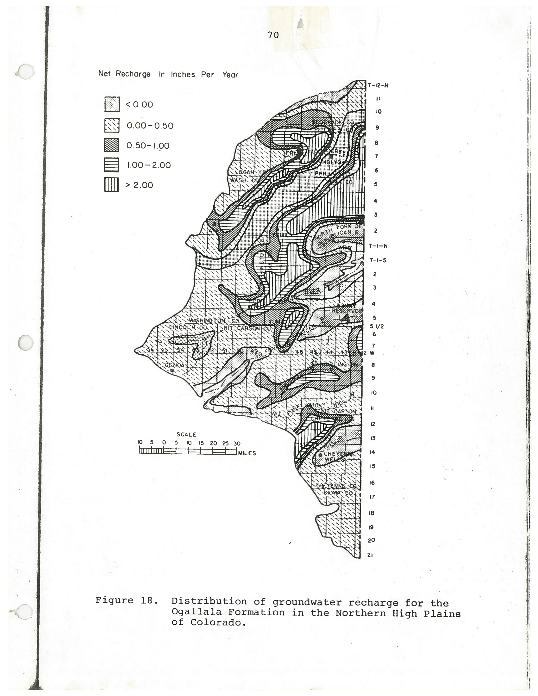
Figure 2 – (White River Formation area and regular sand vs. net sand areas;
See Rules 5.2.2.4 and 5.2.2.7)
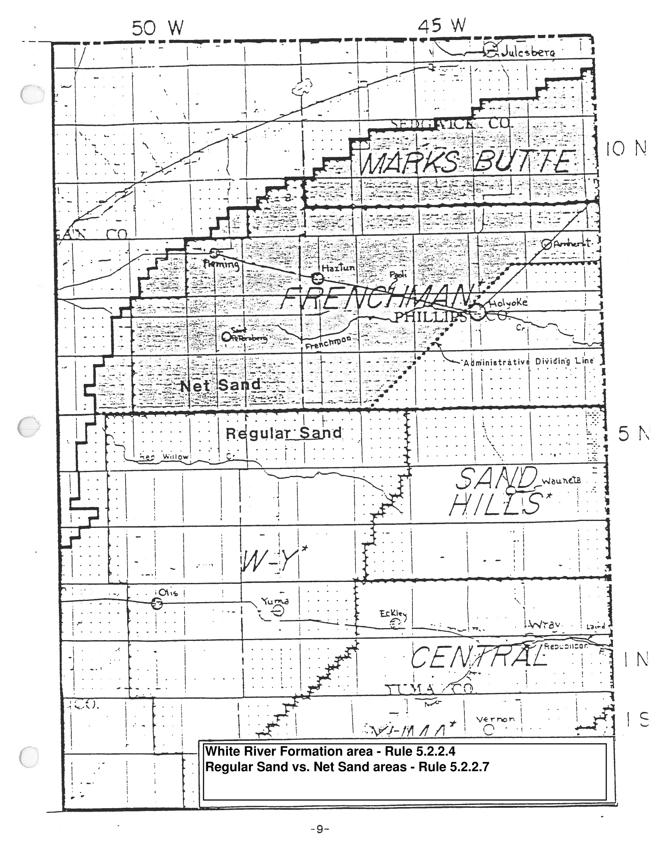

Figure 3 (Figure 6 of January 25, 2013 Division of Water Resources Interoffice Memorandum concerning revisions to the extent of the Laramie-Fox Hills aquifer; See Rule 5.3.1.1)
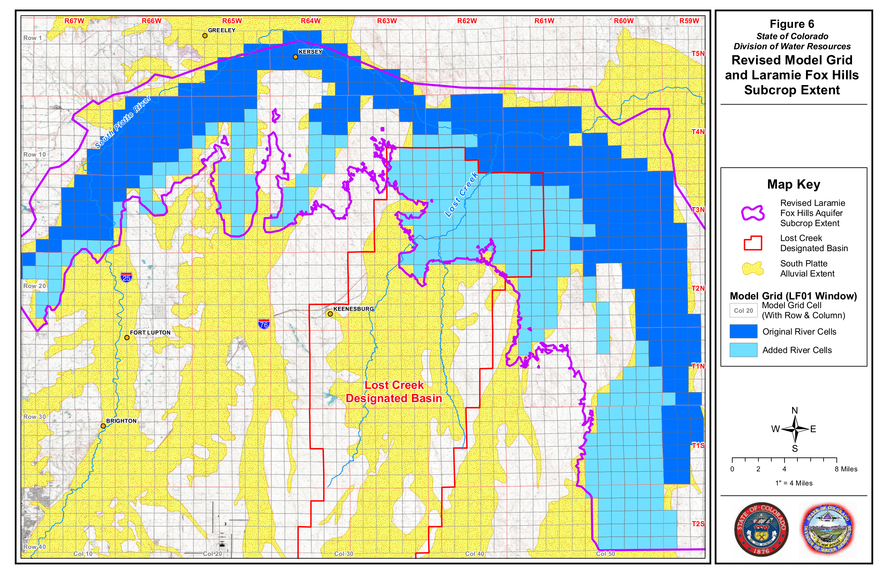
Figure 4 (Figure 1 of October 15, 2018 Division of Water Resources Interoffice Memorandum concerning revisions to location of nontributary ground water in the Denver Aquifer; See Rule 5.3.6.1.C)
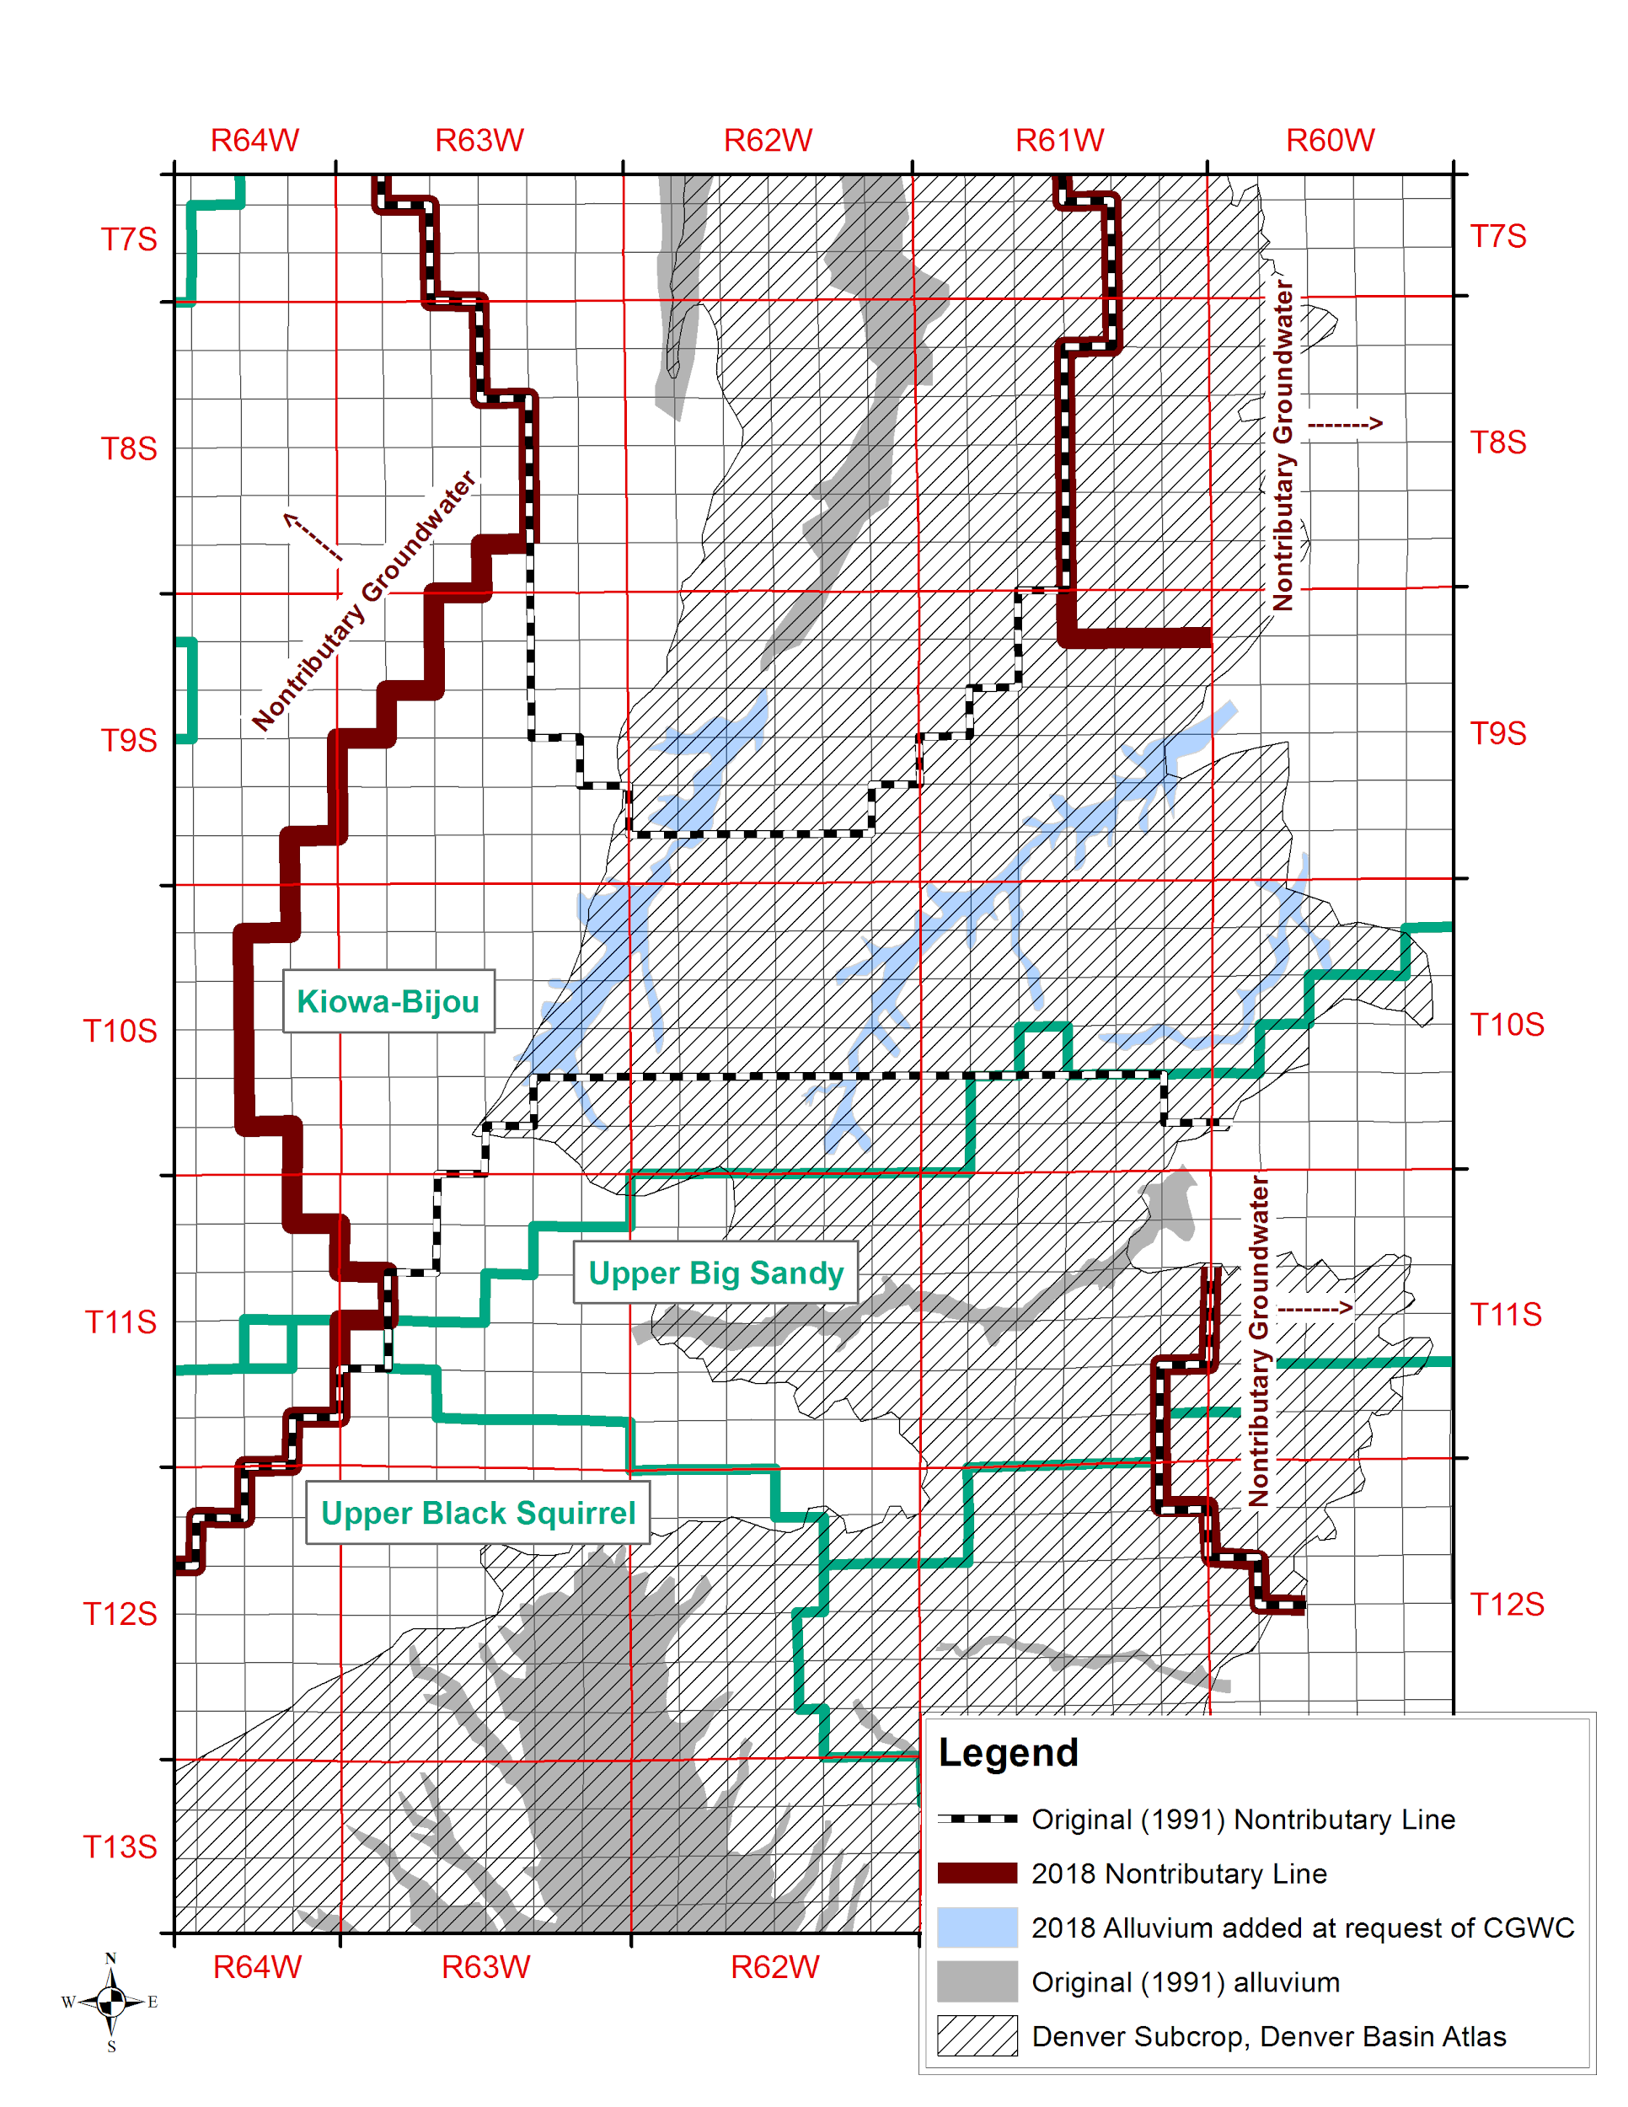
Figure 5 (Figure 1 of October 15, 2018 Division of Water Resources Interoffice Memorandum concerning revisions to location of nontributary ground water in the Arapahoe Aquifer; See Rule 5.3.6.1.D)
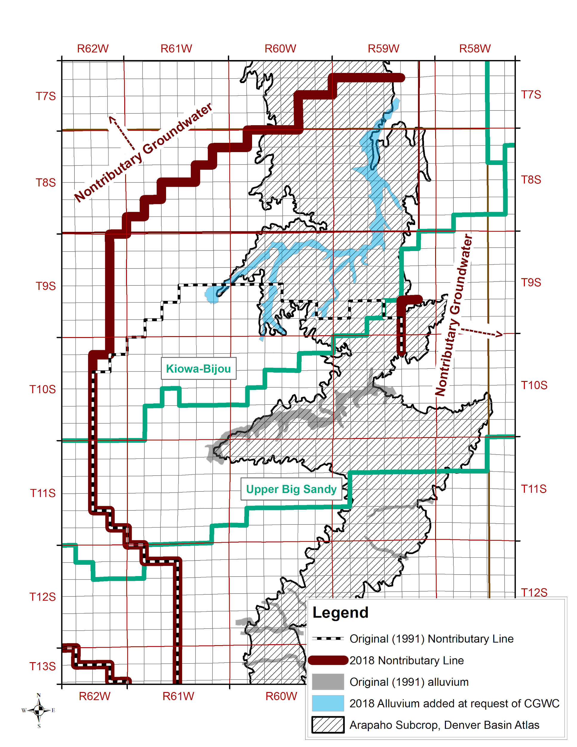
Figure 6 (Figure 7 of January 25, 2013 Division of Water Resources Interoffice Memorandum concerning revisions to location of nontributary ground water in the Laramie-Fox Hills Aquifer in the Lost Creek Basin; See Rule 5.3.6.1.F)
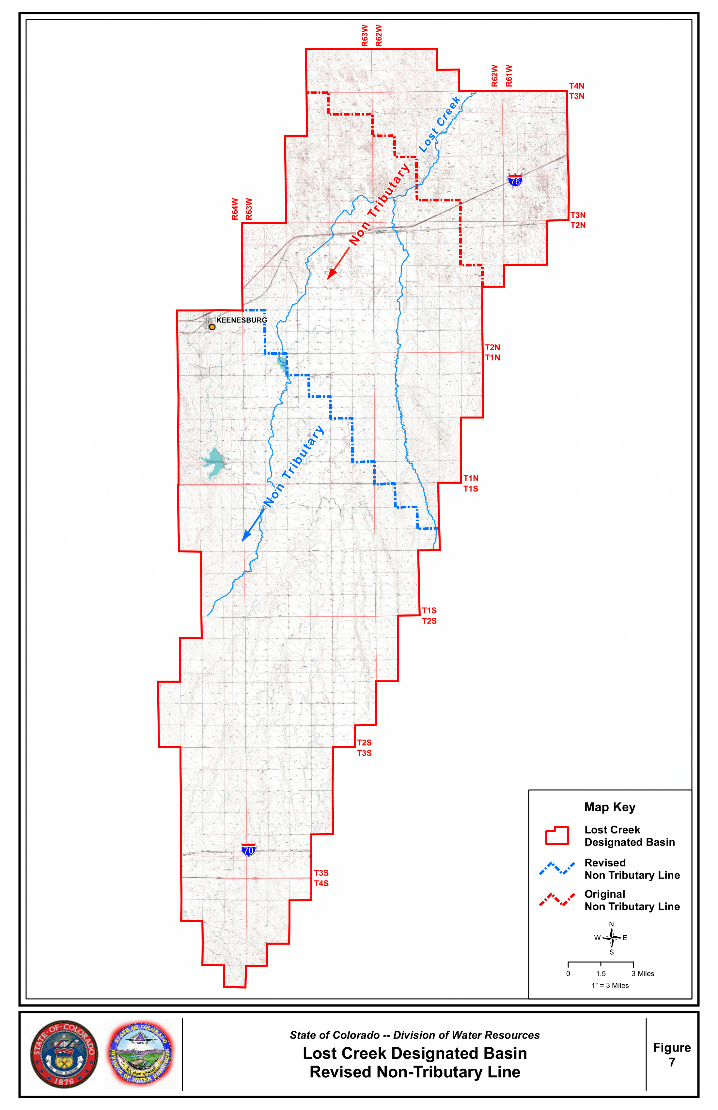
Figure 7 (Figure 3 of the November 29, 2018 Division of Water Resources interoffice Memorandum concerning revisions to the location of nontributary groundwater for the Laramie-Fox Hills aquifer in the Kiowa-Bijou Basin; See Rules 5.3.1.1 and 5.3.6.1.F)
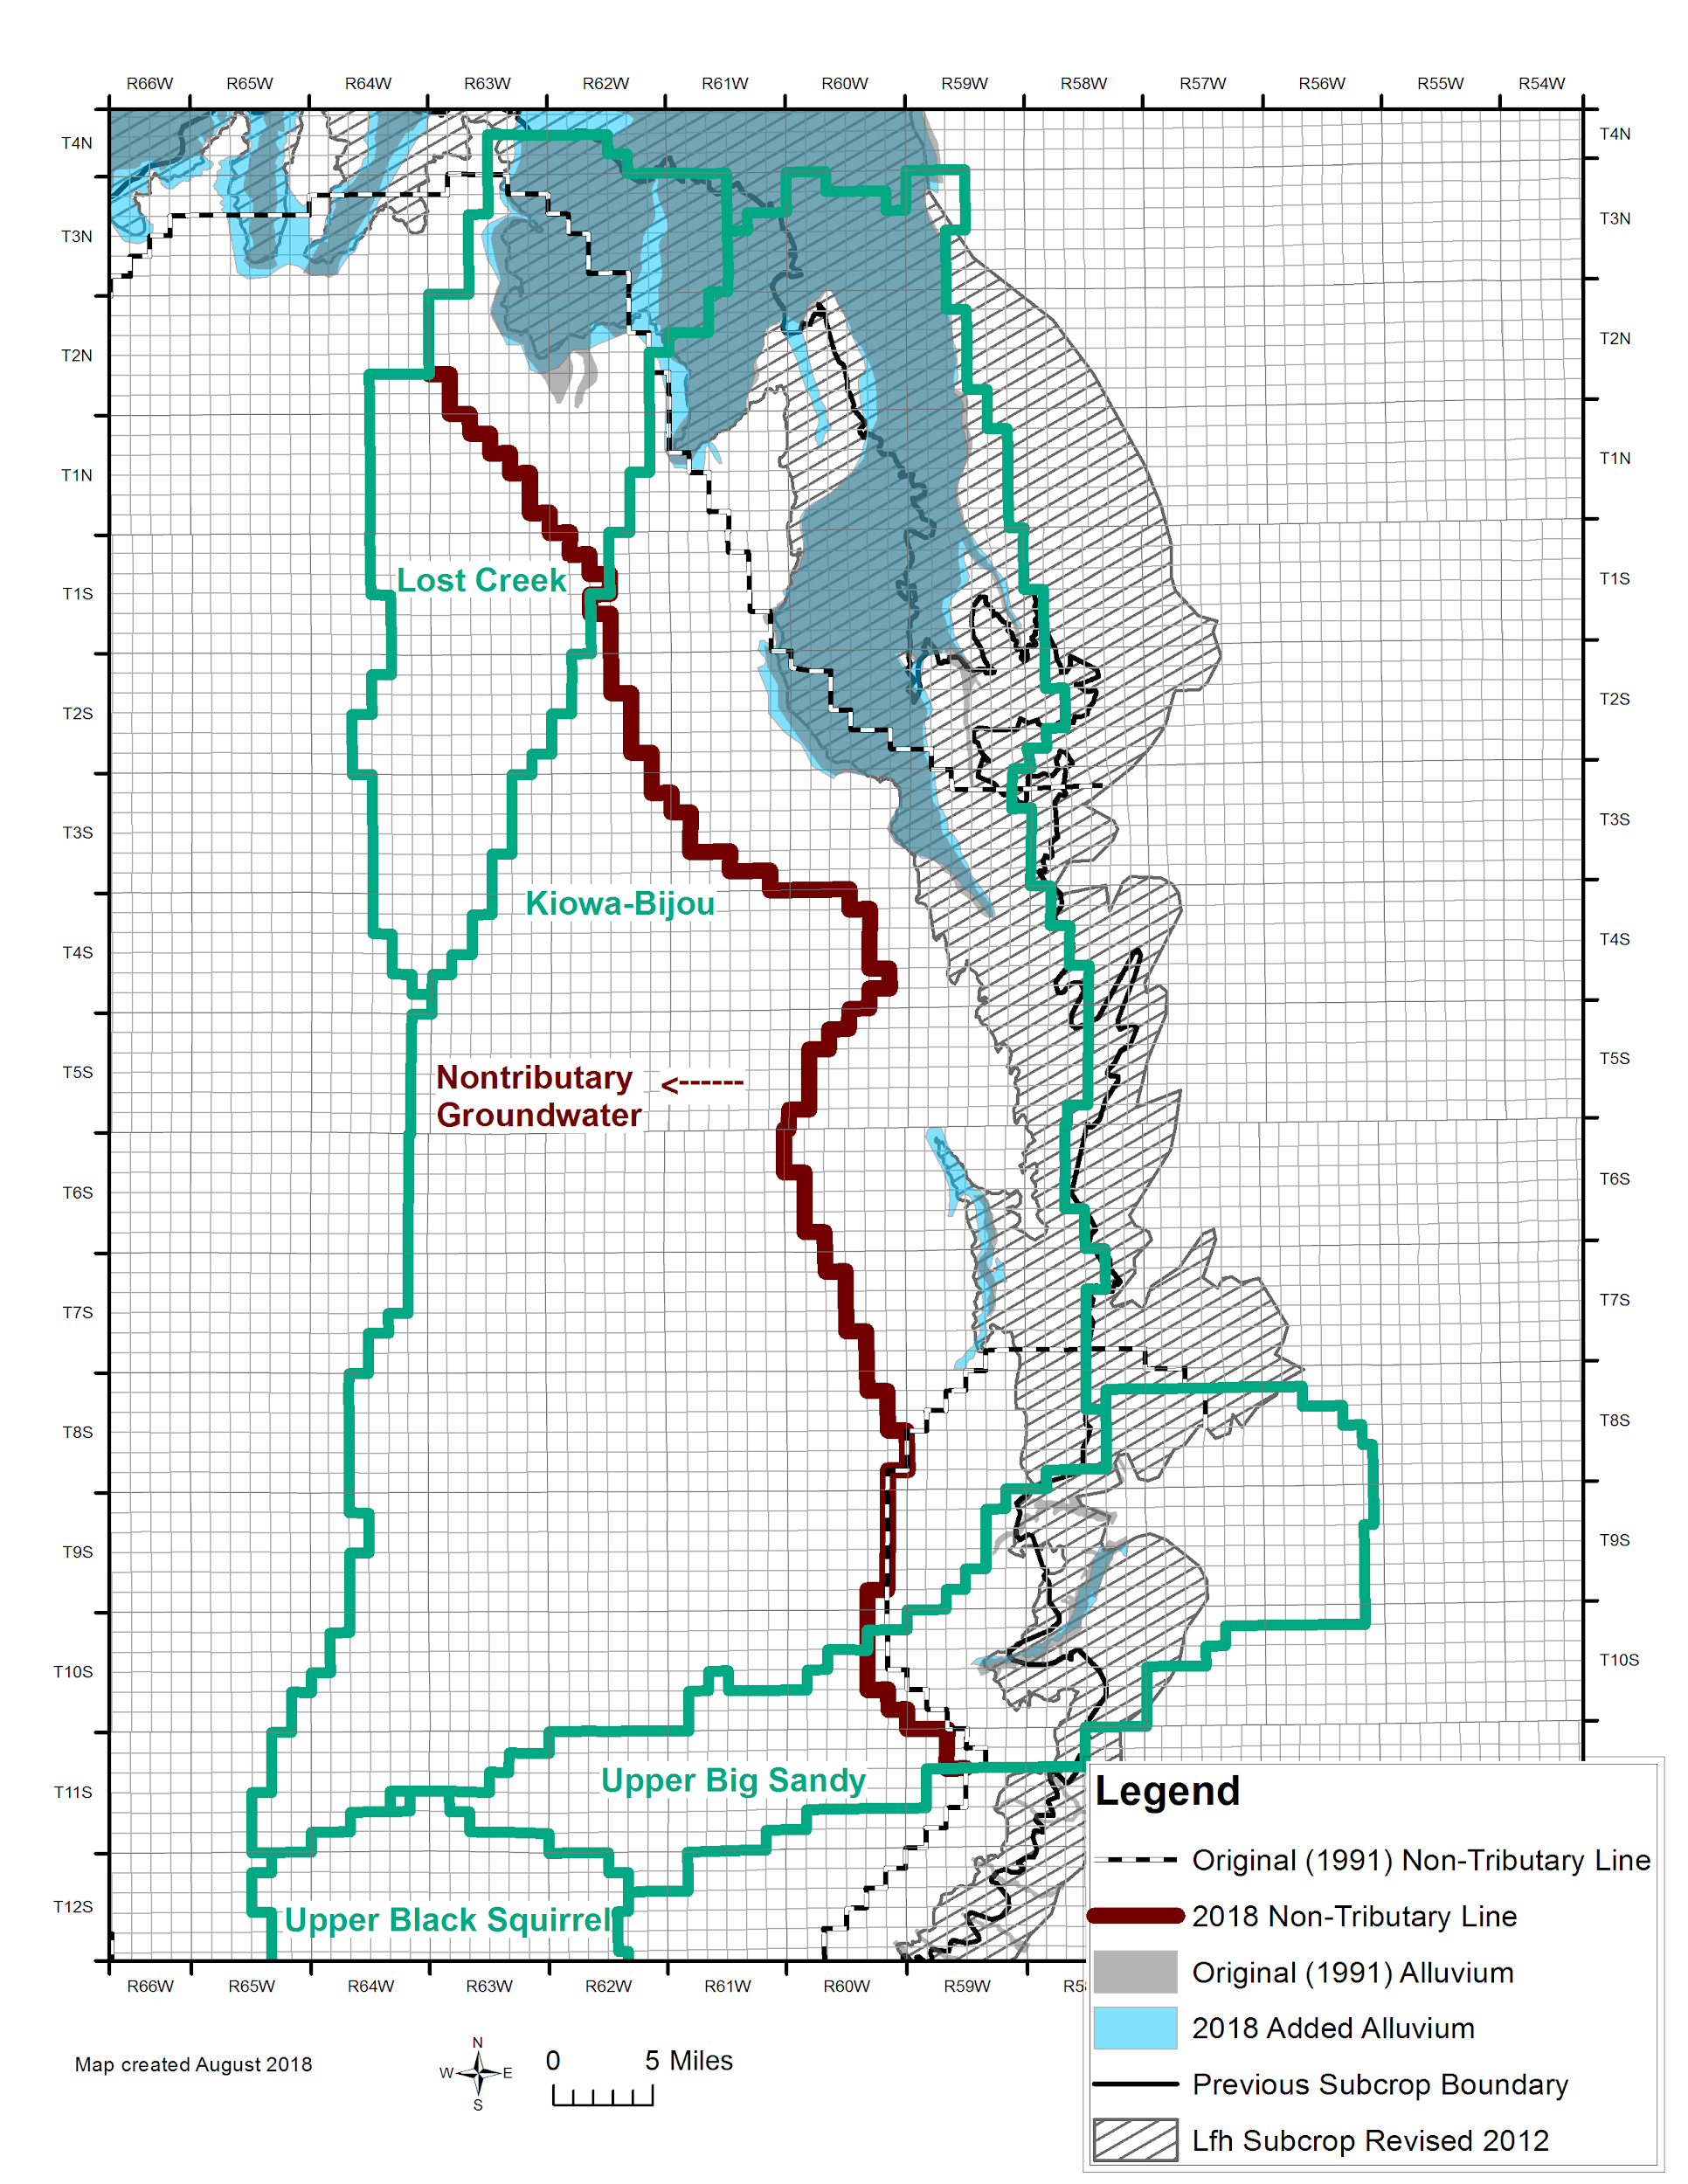
Figure 8 (Figure 4 of the November 29, 2018 Division of Water Resources interoffice Memorandum concerning revisions to the location of nontributary groundwater for the Laramie-Fox Hills aquifer in the Upper Big Sandy Basin; See Rules 5.3.1.1 and 5.3.6.1.F)
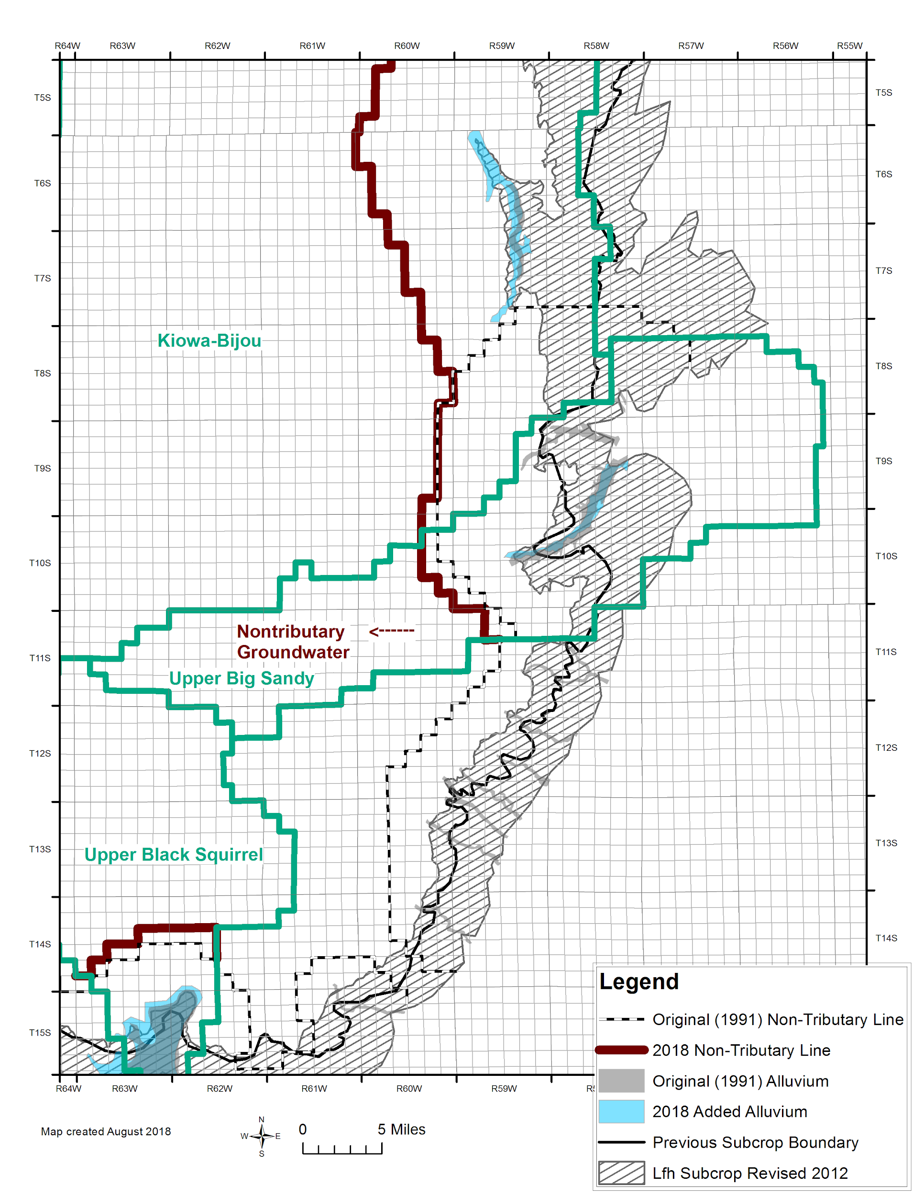
Figure 9 (Figure 5 of the November 29, 2018 Division of Water Resources interoffice Memorandum concerning revisions to the location of nontributary groundwater for the Laramie-Fox Hills aquifer in the Upper Black Squirrel Creek Basin; See Rules 5.3.1.1 and 5.3.6.1.F)
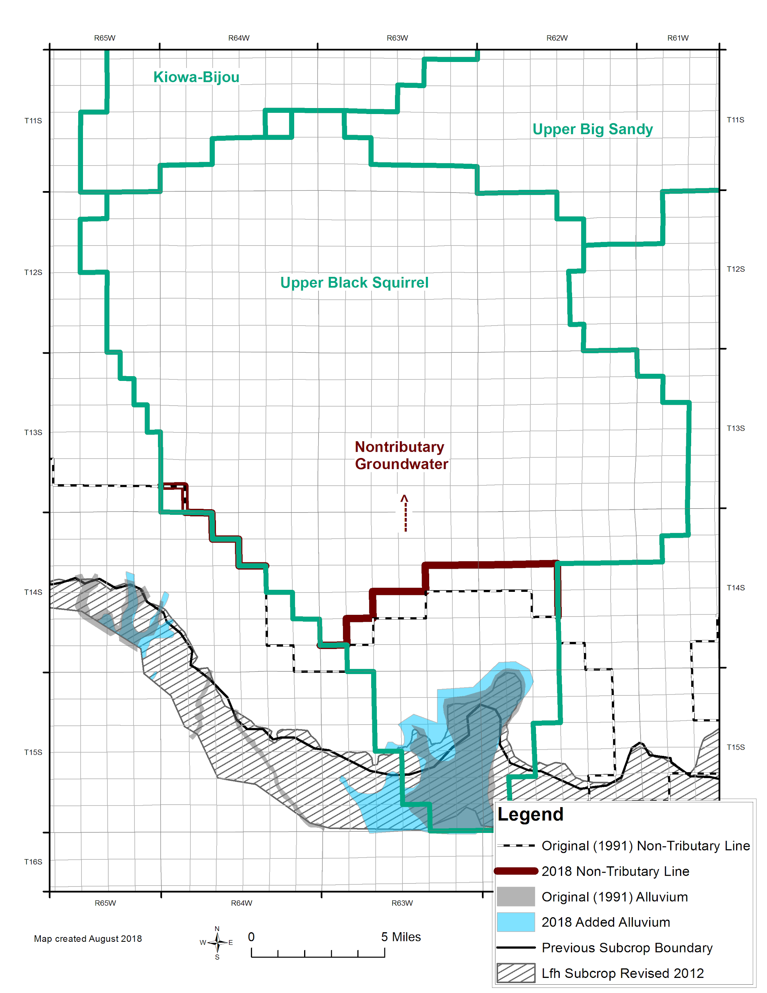

_________________________________________________________________________

Editor’s Notes
History
Rules 4.2, 7.1.2 eff. 04/30/2008.
Rule 7.7.4 eff. 12/30/2008.
Rule 5.2.3 eff. 06/30/2009.
Rule 5.2.5.2 eff. 06/30/2010.
Rule 5.2.7 eff. 09/30/2010.
Rule 5.2.5.2 eff. 12/30/2010.
Rule 5.2.9 eff. 04/14/2017.
Rule 7.4 eff. 05/15/2018.
Rules 5.6, 5.8 eff. 04/14/2019.
Entire rule eff. 01/14/2020.
Rules 4.2.8, 5.3.9, 5.11.5, 5.11.6 B, 7.5.4, 7.5.6-7.5.6.2, 7.11.3-7.11.5, 14 eff. 09/30/2022.

