**Android Client**

**Server**

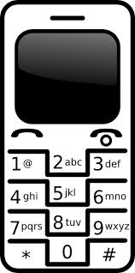

**Client/User Website**

**Service**

**Controller**

**Database**