## **FAQs: Draft Federal Grants Management Data Standards**

## **1. When is public feedback due?**

1. Public feedback should be submitted by January 15, 2019.

### **2. How were the draft data standards developed?**

1. The draft data standards were developed by a cross-agency working group using the Federal Integrated Business Framework (FIBF) methodology format. The group included over 40 representatives from 18 agencies that met monthly for a year.

### **3. Why is public feedback being requested for the draft data standards?**

1. Public feedback will be used to contribute to a future state where grants data are interoperable, there are fewer internal and public-facing grants management systems, and Federal awarding agencies and recipients can better leverage existing data. Detailed feedback including comments or concerns facilitates progress towards the Results-Oriented Accountability for Grants Cross Agency Priority (CAP) Goal and a more modern Federal Government for the 21st century.

### **4. How will public feedback on draft data standards be incorporated?**

1. The Federal Government will review feedback provided through the Grants Feedback Site. Comments will be reviewed and considered by the government-wide Grants Data Standards working group to update the draft data standards.

### **5. Does OMB policy support the use of Federal grants management data standards?**

1. Yes. In 2018 OMB issued a memo (M-18-24) in response to the Digital Accountability and Transparency Act (DATA Act) of 2014 to align agency grant reform initiatives with the PMA. The DATA Act Pilot Program Report to Congress in 2017 demonstrated that grant recipient burden can be alleviated by defining and collecting required data standards in a central repository and reusing data already collected.

### **6. Where can I go to learn more about the Federal Integrated Business Framework (FIBF)?**

1. You can visit [www.ussm.gov/FIBF](http://www.ussm.gov/FIBF) to learn more about the FIBF framework, including the progress other service areas have made in Financial Management, Human Capital, Procurement, and Travel & Expense. To view the specific Grants Management FIBF artifacts, visit [www.ussm.gov/fibf-gm/](http://www.ussm.gov/fibf-gm/).

### **7. How does this relate to the President’s Management Agenda?**

1. PMA CAP Goal #8: Results-Oriented Accountability for Grants aims to rebalance compliance efforts and standardize grant reporting data to reduce reporting burden and focus on results for American taxpayers. Within the Federal Government, the President’s Management Agenda focuses on improving Federal Grants Management through three strategies: 1) defining data standards, 2) using digital solutions to manage risk, and 3) driving risk-based performance management

### **8. What is the naming convention for the draft data standards?**

1. The 418 draft data standards are set out in the order that they first occur in the grants management lifecycle. Data element labels are based on a standard construct composed of the following:
   * Object Class Term (pick from list) +
   * Qualifier Term (optional, based on element) +
   * Property Term (based on element) +
   * Representation Term (pick from list)

For example,

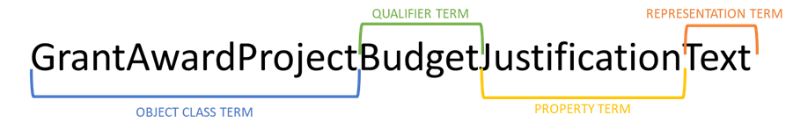

### **9. How else can I provide feedback on the draft data standards?**

1. To maintain transparency and consolidate all feedback, official comments will only be collected through the free GitHub portal. This mechanism allows for a wide audience to provide comments and view the comments others have made, and maintains all feedback in a central repository.

### **10. How can I ask additional questions about the draft data standards, GitHub feedback, or something else related?**

1. To ask questions, call in to one of our Office Hours sessions. These sessions are hosted by the Results-Oriented for Accountability Grants CAP Goal Team to answer any questions you may have.

* November 29, Time TBD
* December 6, Time TBD
* December 13, Time TBD

To join an Office Hour Session use the following number: 1-866-928-2008; 8514834#