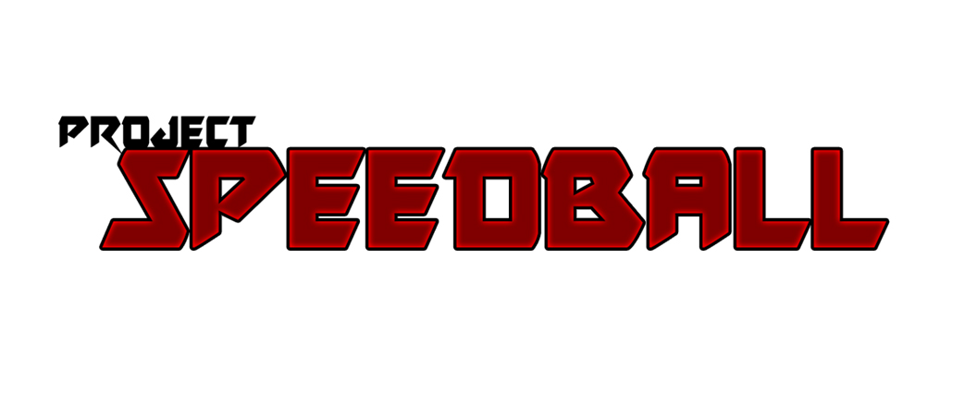

Pitch Document by Team 8Ball

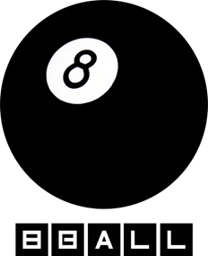

**Overview**

*Project Title:* Speedball

*Genre:* Competitive-Arcade

*Perspective:* Top-Down

*Target Group:* Casual, Competitve, Old school, Party

*Playermode:* Local Multiplayer

*Medium:* Windows PC

**Summary**

Speedball ist ein Gamepad gesteuertes Top-Down PC local Multiplayer Pong-Tournament-Spiel in welchem sich Mönche mit konzentrierter Chi-Energie duellieren.

**Vision**

The vision describes how playing the game will feel like, and how you will achieve that (mostly by describing the mechanics and gameplay options). Shouldn’t be more than ten sentences.

The basic vision is to transform windjammers to a dark fictional setting. The team decided that the fighters are monks with different morals and/or affinities. The gameplay is fast and based on the reactivity and skill of the player. To create an action based gameplay we decided to invent a new score system. The goal should be hard to hit, but you can score by hitting the walls alternatively. The pace of the “ball” can be adjusted upward by blocking it. The block reflects the ball and increases the pace of the ball – The faster the ball is the higher the score.

The local multiplayer feature allows a tournamentsystem (like in Fifa). The players can create a tournament based on the standard KO-system.

**Three Minutes of Gameplay**

As soon as the player starts the game, the start screen appears. After the start screen the background story will be explained. The explanation is very arcade-like and should only explain the backround story (~3 screens). Through the main menu the player can start the game to select his character and start a battle with his friend. The gameplay is a mix-up of Pong, Windrunners and Dragonball. As soon as the match strats, each player has to defend his own side. The chi-energy can damage the opponent. Each player has a fixed energypool which can be “destroyed” by scoring goals (Dart principle). The goal of each match is to defeat the opponent.

**Production Plan**

What do you want to finish when? Plan in Milestones and don’t be too detailed yet - you don’t want to promise something you can’t keep.

|  |  |
| --- | --- |
| Gate 0 | Prototype to represent the gameidea   * Dummy-characters * Dummy-level * General animations and ball-behavior   Presentation |
| Gate 1 (Core Game) | 1-2 Characters  1 Level  Balancing  Collider to frame each players area  Textures  General UI  Assets for Levels  Backgroundstory |
| Gate 2 (Vertical Slice) | 2-4 Characters  2-3 levels  Skillsystem  Specialthrows (modular)  Finished UI  Intro  Tournament system (General)  Balancing |
| Gate 3 (Goldmaster) | 4 up to 6 characters  4 Levels  Tournament system finished  Balancing |
| **The goals are not final yet – We have to check out if the team has appropriate abilities!** | |

**MockUps and Concept Art**

Character/Creature/World/Weapons/… Concept Art, Gameplay/Interface MockUps, Moodboards, ...

**Team**

|  |  |
| --- | --- |
| Teammitglied: Albrecht Kiesewetter  Funktion: Lead Programmer  Seminargruppe: BSII | Teammitglied: Christoph Marschott  Funktion: Programmer  Seminargruppe: BSI |
| Teammitglied: Sergej Meier  Funktion: Lead Artist  Seminargruppe: BSI | Teammitglied: Denice Wagner  Funktion: Artist  Seminargruppe: BSII |
| Teammitglied: Sven Schmid  Funktion: Lead Game Designer (Controls, Assets, Unity)  Seminargruppe: BSII | Teammitglied: Jefferson  Funktion: Game Designer (Level Design, UI)  Seminargruppe: BSI |
| Teammitglied: Denis  Funktion: Game Design (Balancing, Story)  Seminargruppe: BSI | Teammitglied: Sebastian Wyrwall  Funktion: Game Producer  Seminargruppe: BSII |

**Resources**

Blender

Unity

Notepad++

Photoshop