# Network

1 Fully connected layer with N neurons.

# Data

Binary vector with length N, and N * sparsity `1`, rest `0`.

# Parameters

Sparsity = 0.1

Optimizer: ADAM

Learning rate = 0.01

# Maximal number of possible patterns to be generated (=permutations with repetitions)

Ein Bild, das Text, Reihe, Diagramm, Steigung enthält.

# Number of connections in the network

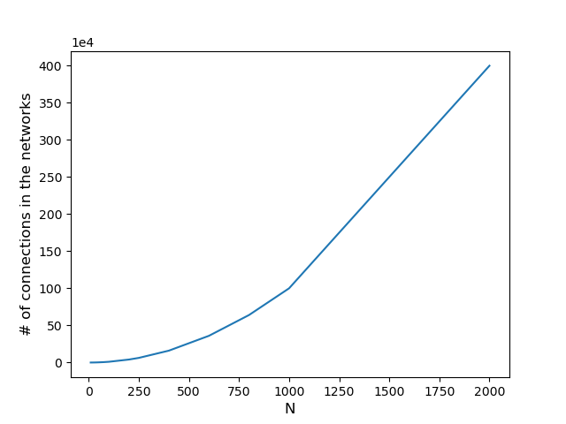

# Used connections depending on N, M and sparsity

N * sparsity * M

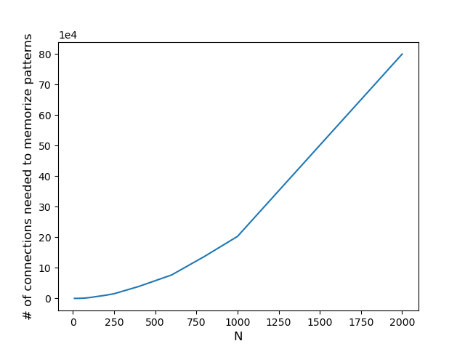

# Number of patterns memorized depending on NEin Bild, das Text, Reihe, Diagramm, Steigung enthält. Automatisch generierte Beschreibung

